
Programme: Master of Business Administration
Module: Marketing Management
Module code: LCMB7024
Lecturer: Taonga Kaonga Sobere-Snithers
Student name : GORANIYA KHODABHAI BALUBHAI
Student id : 2605881
WORD COUNT : 2711
SUBMISSION DATE : 22nd oct. 2026

Assignment Title: Assessment component 1: Marketing Environment Analysis of BROKEN HILL PROPRATRY COMPANY LIMITED BHP (Australia)
Table of Contents
Task 1: Marketing Environment Analysis 3
1.1 Natural Environment Actor 4
1.2 Political-Legal Environment Actor 6
1.3 Customer Environment Actor (Microenvironment) 9
Task 2: Strategic Growth and Competitive Positioning 11
2.1 Porter’s Generic Strategy 11
2.2 Strategic Growth: The Ansoff Matrix Analysis 14
2.2.1 Market penetration for existing products in existing market 14
2.2.2 Product Development 15
2.2.3 Market Development 16
2.2.4 Diversification 17
Task 3: Managerial and Professional Reflection 18
3.1 Key decisions made in the report 18
3.2 Choice of environmental actors and growth strategies 18
3.3 Limitation, gap and viewpoint of management consultant 18
Reference list 20

Task 1: Marketing Environment Analysis
Marketing according to UK Chartered Institute of Marketing (CIM-2026), can be considered as the management process, which involves identification, anticipation and providing satisfaction to customers through maintaining profitability. In this marketing management report, BHP has been selected as the focus company, whose external marketing environment has been analysed based on its transition towards sustainable model.
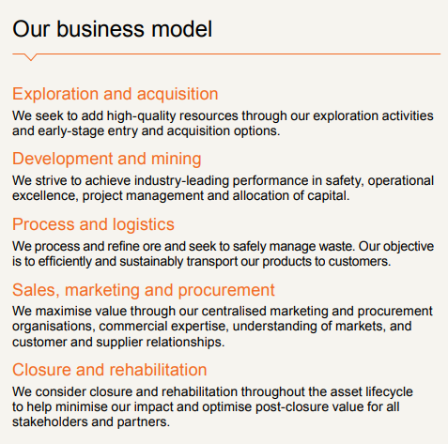
Figure 1: BHP Business Model
(Source: BHP, 2026)
BHP is one of the most resourceful companies around the globe, which deals with metal and mining sector, which accounts for 25% of total Greenhouse Gas emission comprising more than 12,000 large companies (Kotler et al. 2024). During organisational transition towards lowered carbon emission and ethical business practices, BHP’s strategic focus shifted by external environmental actors. As stated by Kotler et al. (2024), three key external actors can modify this environment, which are Natural Environment, the Political-Legal Environment, and the Social Environment. Apart from that, current ecological imperatives can also affect marketing and operational strategies of BHP in 2026 and 2027.

1.1 Natural Environment Actor
Natural environment of a business can be considered as the macro-environmental factors modifying BHP’s strategic realignment. Ecological events such as climate change and resource depletion has a larger impact on the strategic direction of multinational companies (Huo and Peng, 2023). All these factors are primarily considered as peripheral concern, which has changed due to recent concern and strict regulatory activities.
In the words of Ahmad et al. (2024), major environmental actor means existing ecological, geopolitical or environmental conditions that significantly moderates operational choices and surroundings of an organisation. In case of BHP, environmental actors directly modified operational viability through strict regulatory action to reduce carbon emission, water usage, and other resource utilisation (Grigg et al. 2026).
BHP has achieved a record level of iron ore mining of 264.7 million tonnes with 3 million tons of copper in FY 2026, which has been subdued for regulatory scrutiny to maintain ethical responsibility and ecological balance (BHP, 2025). Contradiction in operational and sustainability choices comes for large companies like BHP as vast scale of mining output seen from its current portfolio considering a significant carbon footprint.
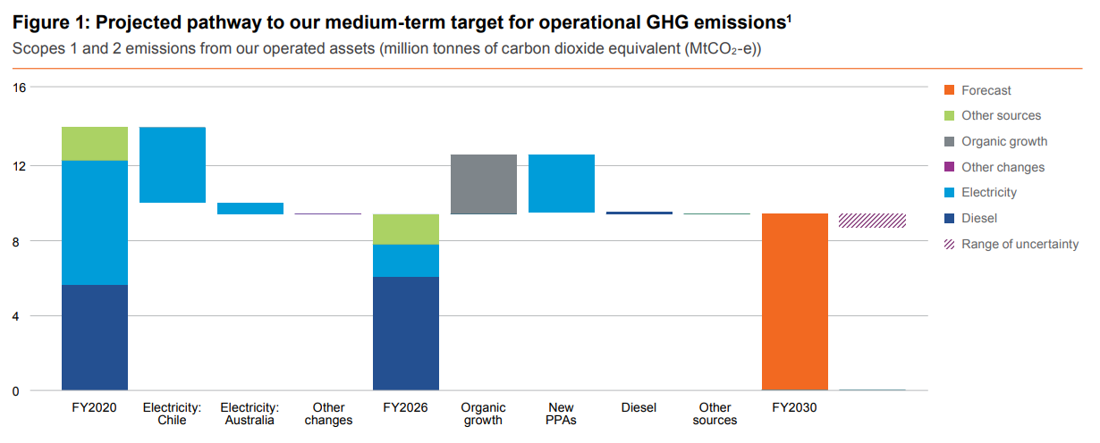
Figure 2: BHP GHG Emission target and pathway
(Source: BHP, 2026)
However, as seen (FIGURE 2) from its current annual report, BHP has consistently maintained its Scope 1 and 3 emission guidelines through utilisation of alternative and renewable energy sources at specific sites like BHP Jimblebar Hub located at Western Australia (BHP, 2026). IN FY 2025, BHP’s Scope 3 emission showed 378 million tonnes generated as iron ore and metallurgical coals are used in traditional downstream blast-furnace steelmaking (IEEFA, 2026).
Current adoption of BHP Operating System (BOS) has significantly improved operational choices through maintaining production guidance more consistently than its competitors. In FY26, 33% less GHG emission has been achieved by BHP through balancing low performing sites like WAIO and Escondida with higher emissions at BMA and NSWEC. Other operational changes are 80% increased use of renewable energy (BHP, 2026)
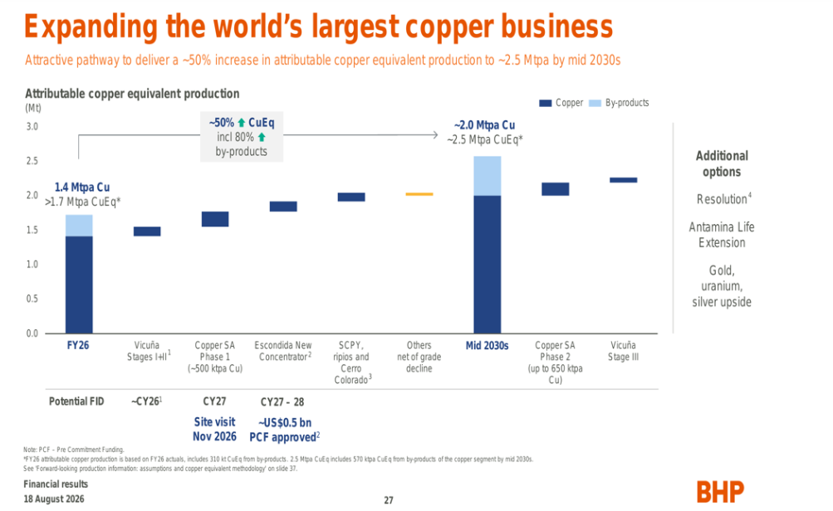
Figure 3: BHP’s plan of copper business expansion
(Source: Investing, 2026)
Consequently, BHP has developed a transition portfolio to become sustainable through "future-facing" commodities. It has also emphasized on copper production from Escondido mine showing a 1261.2 kilotons and Copper South Australia producing total of 320.7 kilotons in FY 2025-2026 (BHP, 2026). All these operational changes direct towards changing ecological demand for global awareness on renewable energy infrastructure.

1.2 Political-Legal Environment Actor
Environmental considerations are highly moderated by structural transitions in political and legal actors, which can change according to regulations. Government in different countries are aiming for stringent regulatory changes for minimising carbon intensity, which has been one of the biggest actor of organisational change. Major mining companies like BHP are navigating through these strict regulatory changes and preparing for transition towards a sustainable future by becoming Net Zero emitters, decarbonised entity and responsible organisation (Grigg et al. 2026). However, organisation has faced various challenges to cope with overhaul of national environmental laws making operational costs higher and litigation risk.
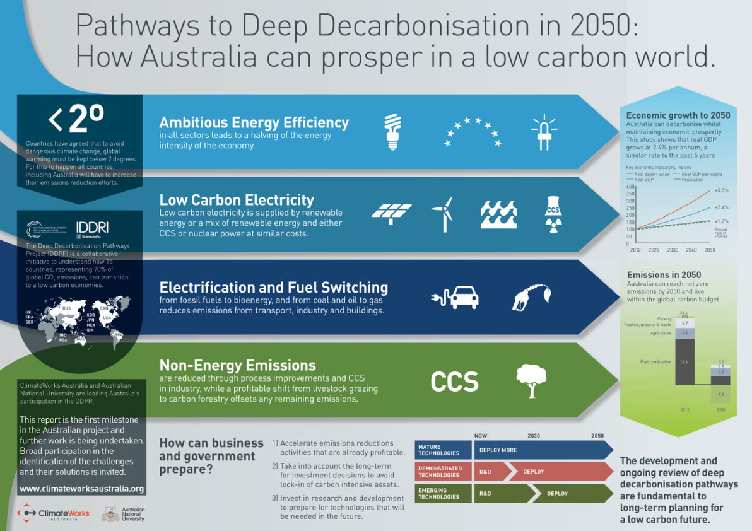
Figure 4: Australia Net Zero Roadmap
(Source: phys.org, 2026)
As per Government Reports (FIGURE-4), reduction of GHG emission has been considered the best way to safeguard future impacts of climate change (dcceew.gov.au, 2025). In case of BHP, Australian government can be considered as its home country where Safeguard Mechanism has been mandated for a 4.9% annual emission reduction for country’s highest carbon emitting facilities within 2030. Australian government has aimed for a 43% carbon reduction below 2005 levels within the year 2030 and 62-70% reduction has been aimed below 2005 levels by year 2035 dcceew.gov.au (2025a). Final emission target selected by the country has been achievement of Zero-emission by the end of 2050. Australian Government has announced a Capacity Investment Scheme (CIS) from 32 GW to 40 GW in July 2025. It has also developed alternative power arrangement through cheaper home batteries program starting from 1 July 2025 (Noor, 2026).
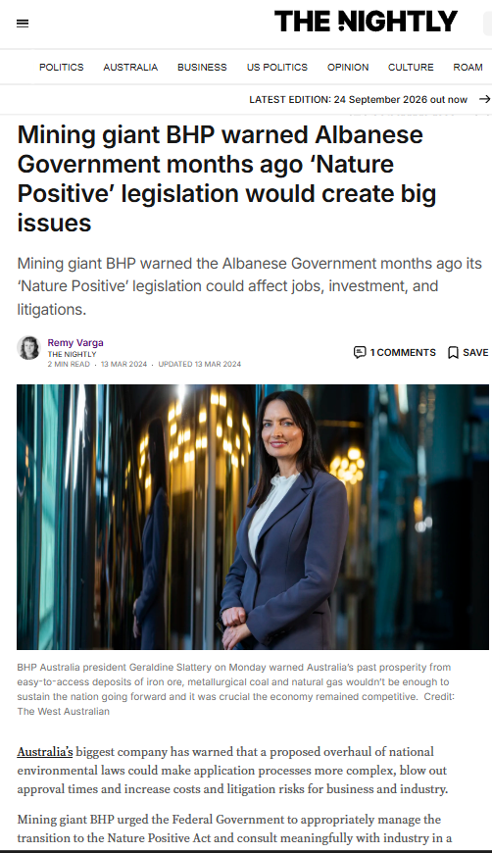
Figure 5: Australian Government’s regulatory pressure
(Source: Varga, 2024)
Mining giant BHP has urged Australian government for appropriate management of Nature Positive Act and application of the law in the industry. As per BHP, national environmental laws can complicate application process, increase cost and elapse more approval time (Varga, 2024). As per BHP Australia president Geraldine Slattery, proposed transition from current process-based EPBC act to the new standards-based Nature Positive Act can increase regulatory burden, longer processing time and operational expense, therefore, BHP is encouraging Australian Government to ensure smooth reformation for stakeholders through offering meaningful consultation (Australian Government, 2025).
As per reports, sudden change in the proposed legislative overhaul can create fears of investment, higher uncertainty and billion dollars of penalty for major companies. BHP has ensured that high environmental standards and social permitting are welcome, however it is important that replacement of Environmental Protection and Biodiversity Conservation Act introduced by John Howard in 1999, can reduce complexity of doing business. Streamlining of approval process without compromising standards has the ability to create jobs and opportunities for small and indigenous businesses.

1.3 Customer Environment Actor
Customers factor has been one of key roles as interplay between ecological constraints are regulatory changes can affect consumer purchasing behaviour. Global steel manufacturers are the primary consumer of BHP, who are undergoing regulatory pressure for manufacturing of ‘Green steel’ (Bluescope, 2026). BHP has already discussed its short and long term goals in its stakeholder report sating its current position. However, impact of this shift is clear from company’s long term relationships with major buyers like China Baowu Steel Group (Jackson et al. 2026). Currently in September 2026, both the companies have entered a five year renewed plan through Memorandum of Understanding (MoU) to jointly contribute towards lower emission in steelmaking technologies. BHP had promised to collaborate in these sustainable partnership from 2020 prioritising customer demand and environmental sustainability.
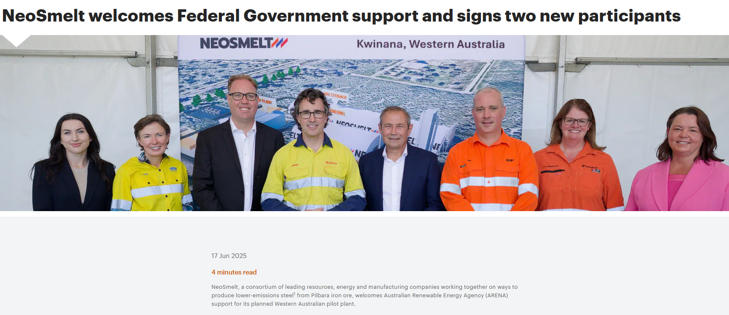
Figure 6: Neosmelt collaboration of BHP
(Source: BHP, 2025b)
Amidst micro-environmental pressure, BHP has partnered with BlueScope Steel and miner Rio Tonto for development of a pilot programme of Electric Smelting Furnace (ESF). Collaborative effort for collaboration with NeoSmelt in 2025 and 2026 has been a major advancement towards decarbonisation from his tripartite agreement. This can significantly reduce carbon footprint from steel value chain through both technical and resource based expertise (transitionasia.org, 2026).
BHP has been effective in reaching out to domestic customers for testing alternate reduction pathway through utilisation of Australian ores without relying on traditional burst furnace. Apart from this agreement, BHP has also partnered with POSCO, a South Korean Steelmaking company in October 25 regarding commercialisation of HyREX technology, which reduces coal use through substituting it by Hydrogen (BHP, 2025).

Task 2: Strategic Growth and Competitive Positioning
Identification of profound environmental, political, legal and customer environment of BHP shows that a structural change in BHP is mandatory in order to thrive as a global leader in Mining and Metal industry (Australian Government, 2025).
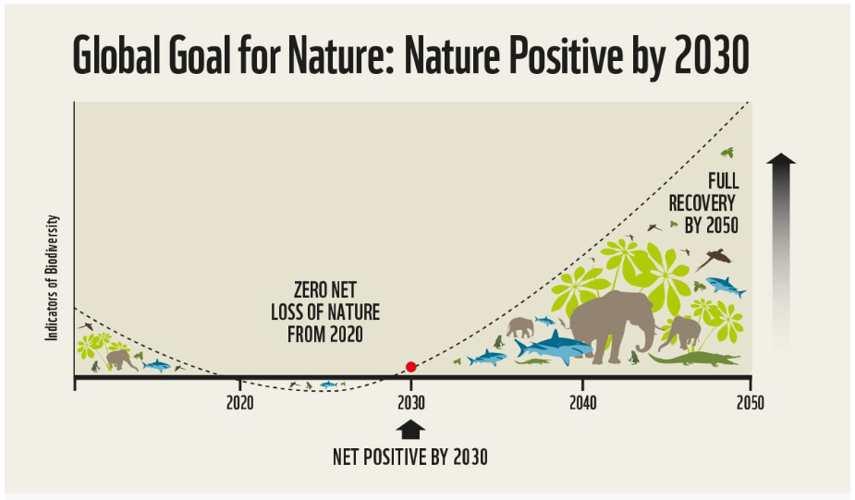
Figure 7: Goal of Nature Positive law by 2030
(Source: Greening Australia, 2024).
Nature Positive Act has contributed to the need for structural change such as biodiversity loss and nature restoration (Greening Australia, 2024). Organisation needs to transition from a legacy miner to a sustainable, future facing commodity provider. In order to evaluate BHP’s competitive advantage, Porter’s Generic Strategy and Ansoff Matrix can be applied.

2.1 Porter’s Generic Strategy
Porter’s Generic Model is a strategic approach towards organisational growth and competitive advantage, which includes four different quadrants, each with a strategic choice (Campbell et al. 2021). BHP has always relied on a Cost Leadership Strategy, which can be easily understood through its enormous economic scale within tier-one assets (Umbrex, 2025).
Tier one asset means large scale, long-life, low cost affordable resources, which are most useful for steady cash flow across commodity price cycle. Western Australian Iron Ore (WAIO) and Escondido (Chile) or Olympic Dam (Australia) are the key Portfolio of BHP’s tier one mining resources. Organisation’s economic pillar is based on these resources as WAIO is going to cost below USD 17.50 by 2028, which is a prime example of BHP’s cost leadership (Arnoldy, 2026).
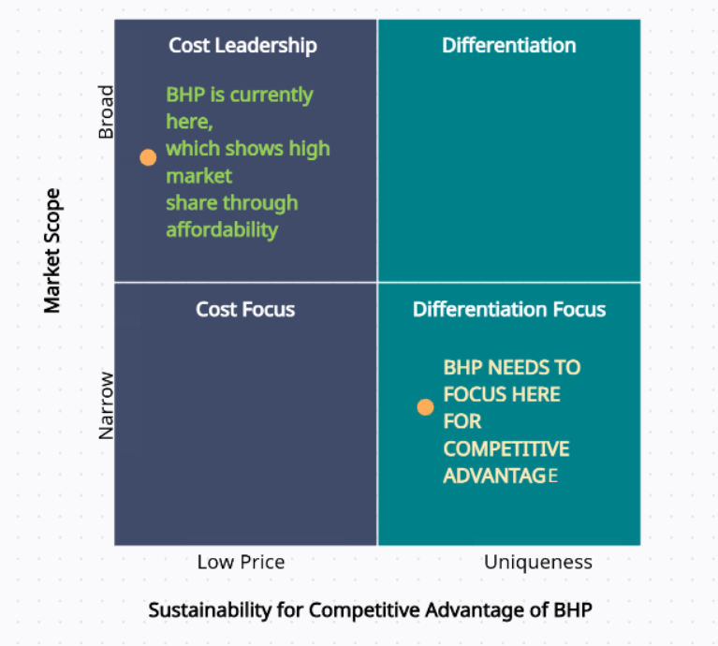
Figure 8: Customised using Porter’s Generic Strategy Model
(Source: Haoting, 2023)
Another reason for changing operational process and diverting towards another product portfolio is that consumers are leaning towards sustainable choices after EU’s Carbon Border Adjustment Mechanism (CBAM), which is landmark regulatory change globally (European Commission, 2023).
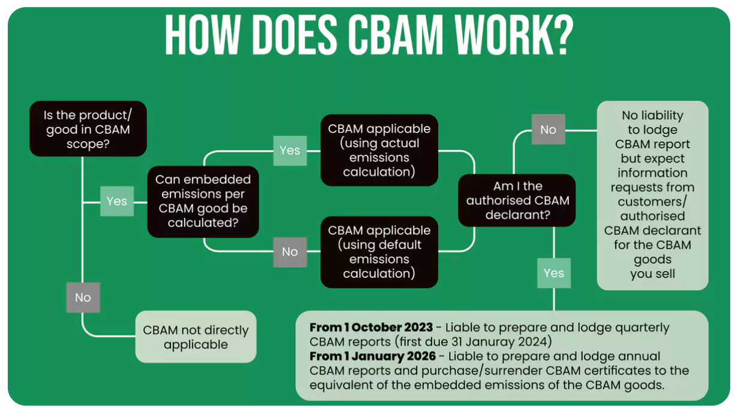
Figure 9: Overview of CBAM Mechanism
(Source: Ramachandran, 2026)
Customers, who in case BHP are metal manufacturer are willing to pay more for a sustainable choice, considered as “Green Premium” (Circluor, 2024). Therefore, cost leadership race is slowly fading away with rise of Green supplier and ethical supply chain. In this situation, competitive advantage of BHP relies heavily on developing a hybrid approach combining Cost Leadership with Differentiation through sustainability and technological integration.

2.2 Strategic Growth: The Ansoff Matrix Analysis
Ansoff matrix has been used to evaluate BHP’s growth and strategic pathway for developing new product portfolio during low-carbonisation modelling. In this transition, BHP has to re-arrange product segments and specification to attract existing and new consumers.
Market Penetration | Product Development
- Iron Ore and Met Coal efficiency  - Western Australian Iron Ore price less than USD 17.50 (Arnoldy, 2026)  - Implementation of decarbonisation scopes at BHP mining sites  - Existing Customer retention | - Development of DRI-grade Pilbara Iron Ore  - Alternative power as Hydrogen based HyREX technology (GMK Center. 2025)  - Integration of POSCO green technology
Market Development | Diversification
- Drifting towards Copper & Nickel assets (Circluor, 2024).  - Investing resource and time in EV battery chain  - Developing renewable infrastructure  - Utilisation of global AI transformation and utility tool | - Investing in sustainable agriculture  - Detachment from direct steel supply to reduce carbon footprint  - Entering eco-friendly market with low-carbon commodity market
Figure 10: Ansoff Matrix of BHP
(Source: Zugay, 2023)

2.2.1 Market penetration for existing products in existing market
Market penetration element in Ansoff matrix stands for understanding organisation strategy to enter and capture a market. In case of BHP, existing market control is more important than expanding to a new market considering company’s long term loyalty and reliability. In Australia and established markets BHP needs to aim for core commodities and existing product offering like Iron Ore and Met Coal (IEEFA, 2026). Therefore, market penetration in existing market solely relies on the product cost reduction maintaining a lower carbon emission.

2.2.2 Product Development
BHP needs to modify existing portfolio to retain existing customer, who consider sustainable choices through re-engineering raw materials for green operation.
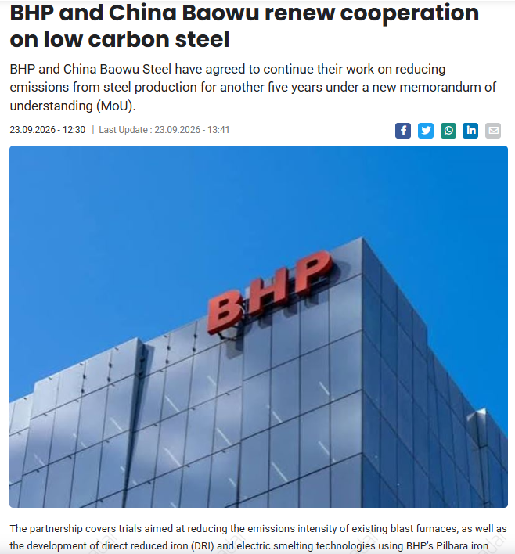
Figure 11: News Source confirming BHP and China Baowu collaboration
(Source: SteelRadar, 2026)
Traditional iron ore needs carbon-heavy blast furnace, which can be avoided through partnership with China Baowu and POSCO as for processing of Pilbara Iron through Direct Reduced Iron (DRI) and Electric Smelting Furnace (ESF) application (BigGo Finance, 2026).

2.2.3 Market Development
Environment conscious buyers can be retained through decarbonisation of metal extraction process. In FY26, BHP has demonstrated this attempt at Escondido mine for demonstration of BHP operating system.
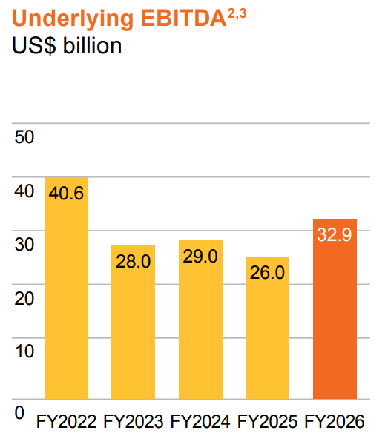
Figure 12: Underlying EBITDA rise of BHP over last 5 year
(Source: BHP, 2025)
BHP noted underlying EBITDA of USD 32.9 billion in FY 2026 which was USD 26 billion in 2025. Global electrification effort has been shown by BHP to move towards lower-carbon economy through leveraging copper and nickel assets (Investing.com, 2026).

2.2.4 Diversification
BHP invested significant capital of US 7 billion aiming for production in mid-2027 for potash production and encouraging green farming (NS Energy, 2025; BigGo Finance, 2026). Therefore, BHP is currently trying for adoption of Differentiation strategy as this can help with alternative resource procurement. De-carbonisation and reduction of operational footprint as seen from above analysis needs a diversification approach for ‘Lower-carbon’ products or ‘Green portfolio’.

Task 3: Managerial and Professional Reflection

3.1 Key decisions made in the report
In this marketing consultancy report, BHP Company has been selected to restructure and adopt a carbon neutral model for survival. Natural, Political-legal and Customer actors have been discussed by me to understand current ecological pressures on BHP. I have put emphasis on the Natural Environment as physical environmental risk and resource scarcity are most crucial challenge for BHP (BHP, 2025). Secondly I selected Political-Legal environment, which show Australian Regulatory pressures on Metal and mining companies as well as policy changes suggested recently to safeguard carbon emission through operational mandates. Replacement of old Environmental Protection and Biodiversity Conservation Act has been controversial as per large companies as this can create approval delays and economic pressure. Lastly, customer actors have been selected by me to demonstrate commercial manifestation of macro-environmental forces. Potential partnerships with downstream clients like China Baowu needed sustainable alternatives rather than old business process of procuring raw materials (Jackson et al. 2026).

3.2 Choice of environmental actors and growth strategies
In this case, I have selected BHP as a multinational entity undergoing strategic shift is crucial for organisational change noticed through strategic decisions and it can align with planned sustainability objectives. Through detailed analysis of BHP’s environment friendly approach and sustainable choices, it is evident that BHP has managed to adopt to a decarbonisation initiative (Skarn, 2024). BHP’s traditional extraction and downstream process remains highly carbon intensive. During marketing environment analysis, three dimensions have been identified, which has the potential to change current sustainability mechanism of BHP. I have used Porter’s Generic strategy for identification of company’s strategic change in the path of becoming sustainable. I have also used Ansoff Matrix to carve feasible strategic path for BHP through radical diversification and rather than aggressive new market development.

3.3 Limitation, gap and viewpoint of management consultant
One of the main limitations of my analysis is to rely upon secondary data sources rather than direct access to organisation strategy, which is note directly available for large MNCs like BHP. External observation of this report can reveal limitations like information bias through selecting successful initiatives only rather than analysis of failed attempt also. BHP published corporate reports, ESG disclosure, newspaper articles can only provide information asymmetry (BHP, 2026). Additionally, Ansoff matrix required geopolitical risk assessment, which has not been done in this report to simplify strategic choices rather than Risk identification. Lastly, proper acknowledgement and learning according to foreign policies is most appropriate.
From a management consultant perspective, it would have been more justified to access internal data from company and other proprietary to track real advancement towards sustainability initiatives. Assessment of financial viability of each investment and strategic plan is the primary responsibility (Gutterman, 2023). After calculation of Return on Investment on the entire electrification arrangement, it becomes mandatory to develop a simulation of scenario modelling, which helps understand reliability of the plan. Another important aspect of consultancy remains in measurement of organisation carbon emission to be matched with industry standards and competitors to ensure market leadership for BHP.

Reference list
Ahmad, H., Yaqub, M. and Lee, S.H., 2024. Environmental-, social-, and governance-related factors for business investment and sustainability: A scientometric review of global trends. Environment, development and Sustainability, 26(2), pp.2965-2987.
Arnoldy, M., (2026). Iron-ore output growth on the horizon for BHP in Australia, Brazil. Available at: https://www.miningweekly.com/article/iron-ore-output-growth-on-the-horizon-for-bhp-in-australia-brazil-2026-02-17 [Accessed: 11 September 2026]
Australian Government (2025). Australia’s 2035 Nationally Determined Contribution. Available at: https://unfccc.int/sites/default/files/2025-09/Australias%20Second%20NDC.pdf [Accessed on 16 September 2026]
BHP (2025). BHP and POSCO partner to advance hydrogen-based ironmaking technology. Available at: https://www.bhp.com/news/media-centre/releases/2025/10/bhp-and-posco-partner-to-advance-hydrogen-based-ironmaking-technology [Accessed: 11 September 2026]
BHP (2025b). NeoSmelt welcomes Federal Government support and signs two new participants. Available at: https://www.bhp.com/news/media-centre/releases/2025/06/neosmelt-welcomes-federal-government-support-and-signs-two-new-participants [Accessed: 11 September 2026]
BHP (2026). BHP Annual Report, 2026. Available at: https://www.bhp.com/-/media/documents/investors/annual-reports/2026/260818_bhpannualreport2026 [Accessed: 21 September 2026]
BHP, (2024). BHP's Climate Transition Action Plan (CTAP) 2024. Available at: https://www.bhp.com/sustainability/climate-change/climate-transition-action-plan [Accessed: 21 September 2026]
BigGo Finance (2026). BHPLF H1 FY2026 earnings call - BigGo Finance. Available at: https://finance.biggo.com/quote/BHPLF/earnings-call/US_BHPLF_2026-02-16 [Accessed on 25 September 2026]
Bluescope, (2026). BlueScope, BHP & Rio Tinto select WA for Australia’s largest ironmaking ESF pilot plant. Available at: https://www.bluescope.com/news/BlueScope-BHP-and-Rio-Tinto-select-WA-for-Australia-s-largest-ironmaking-ESF-pilot-plant [Accessed: 20 September 2026]
Campbell, David. Business Strategy. London, Pearson, 2021.
Campbell, David. Business Strategy. London, Pearson, 2021.
Circluor, (2024). REUTERS: In search of the elusive green nickel premium. Available at: https://circulor.com/articles/reuters-in-search-of-the-elusive-green-nickel-premium [Accessed: 13 September 2026]
dcceew.gov.au (2025). Climate change. Available at: https://www.dcceew.gov.au/climate-change/publications/australias-emissions-projections-2025 [Accessed on 18 September 2026]
dcceew.gov.au (2025a). Net Zero. Available at: https://www.dcceew.gov.au/climate-change/emissions-reduction/net-zero [Accessed on 14 September 2026]
European Commission, (2023). Carbon Border Adjustment Mechanism (CBAM). Available at: https://trade.ec.europa.eu/access-to-markets/en/news/carbon-border-adjustment-mechanism-cbam [Accessed on 17 September 2026]
GMK Center (2025) BHP increased iron ore production to 263 million tons in the 2024/2025 financial year. Available at: https://gmk.center/en/news/bhp-increased-iron-ore-production-to-263-million-tons-in-the-2024-2025-financial-year/ [Accessed: 25 September 2026]
Greening Australia, (2024). What does 'nature positive' mean? Why is it important? Available at: https://www.greeningaustralia.org.au/what-does-nature-positive-mean-why-is-it-important/ [Accessed: 21 September 2026]
Grigg, A., McDonald, A., Wilkinson, M., and Toomey, J., (2026). BHP has pledged to hit net zero emissions by 2050. Inside the mining giant there are doubts. Available at: https://www.abc.net.au/news/2026-05-26/bhp-net-zero-emissions-pledge-four-corners-leaked-documents/106720042 [Accessed: 13 September 2026]
Gutterman, A.S., 2023. Organizational performance and effectiveness. Available at SSRN 4532570.
Huo, J. and Peng, C., 2023. Depletion of natural resources and environmental quality: Prospects of energy use, energy imports, and economic growth hindrances. Resources policy, 86, p.104049.
IEEFA, (2026). BHP: Time to get real about steel technology change and met coal. Available at: https://ieefa.org/resources/bhp-time-get-real-about-steel-technology-change-and-met-coal [Accessed: 13 September 2026]
Investing.com (2026) BHP FY2026 slides: copper drives 54% of EBITDA, targets $50bn FCF. Available at: https://www.investing.com/news/company-news/bhp-fy2026-slides-copper-drives-54-of-ebitda-targets-50bn-fcf-93CH-4865396 [Accessed on 18 September 2026]
Jackson, L., Ngul, Y., and Burton, M., (2026). Top China steelmaker Baowu eyes stake in BHP iron ore mine, sources say. Available at: https://www.reuters.com/world/asia-pacific/top-china-steelmaker-baowu-eyes-stake-bhp-iron-ore-mine-sources-say-2026-09-04/ [Accessed: 20 September 2026]
Kotler, P., Armstrong, G., Harris, L.C. and He, H. (2024) Principles of marketing. 19th edn. Harlow: Pearson.
Noor, R., 2026. Decarbonization in Australia’s Mining Sector: An Integrated Assessment based on Scope 1-2-3 Emissions. Available at SSRN 5947895.
NS Energy (2025) Jansen Potash Project, Canada. Available at: https://www.nsenergybusiness.com/projects/jansen-potash-project-canada/ [Accessed on 25 September 2026]
phys.org, (2026). Australia can get to zero carbon emissions, and grow the economy. Available at: https://phys.org/news/2014-09-australia-carbon-emissions-economy.html [Accessed on 15 September 2026]
Ramachandran, A., (2026). The European Carbon Border Adjustment Mechanism (CBAM). Available at: https://oneclicklca.com/en/resources/articles/european-carbon-border-adjustment-mechanism [Accessed on 17 September 2026]
Skarn, (2024). BHP decarbonisation roadmap. Available at: https://www.skarnassociates.com/insights/bhp-decarbonisation-roadmap [Accessed: 16 September 2026]
SteelRadar, (2026), BHP and China Baowu cooperation of low carbon steel. Available at: https://www.steelradar.com/en/haber/bhp-and-china-baowu-renew-cooperation-on-low-carbon-steel/ [Accessed: 11 September 2026]
transitionasia.org, (2026). JFE AGM 2026 Information Pack. Available at: https://transitionasia.org/jfe-agm-2026-information-pack/ [Accessed on 20 September 2026]
Umbrex, (2025). BHP Strategy and Business Model. Available at: https://umbrex.com/resources/company-profiles/bhp-group-ltd/ [Accessed on 17 September 2026]
Varga, R., (2024). Mining giant BHP warned Albanese Government months ago ‘Nature Positive’ legislation would create big issues. Available at: https://thenightly.com.au/politics/mining-giant-bhp-warned-albanese-government-months-ago-nature-positive-legislation-would-create-big-issues-c-13932763 [Accessed on 18 September 2026]
Yu, Haoting. (2023). Strategies in Corporate Finance and Risks Assessment to Improve Profitability--Taking McDonald’s as an Example. Advances in Economics, Management and Political Sciences. 20. 72-80. 10.54254/2754-1169/20/20230175.
Zugay, B., 2023. Ansoff matrix. SAGE Publications, Inc..

