Chapter Four
Analysis of Results
4.0 Introduction
This chapter aims to complete objective three of the project: ‘To conduct primary research and critically analyse the data collected, engaging the public’s perception on the CED ‘Taser’ and whether the public feels all police officer’s should be appointed one’.
This chapter will present and analyse the data that was sourced through the researchers primary research. An online questionnaire which collected responses from members of the public over a period of 7 days.
An unanswered blank copy of the questionnaire can be found in Appendix A. Due to the restriction limit on word count, not all questions and answers were included, The researcher opted for the most relevant to the research topic.
4.1 Data Analysis
As depicted by Steynberg, data analysis is the interpretation of data gathered through the use of analytical and logical reasoning identifying patterns, themes, relationships, and trends in old and new research. (Steynberg, S. 2024). The data analysis conducted through this chapter will continually address the highlighted research question.
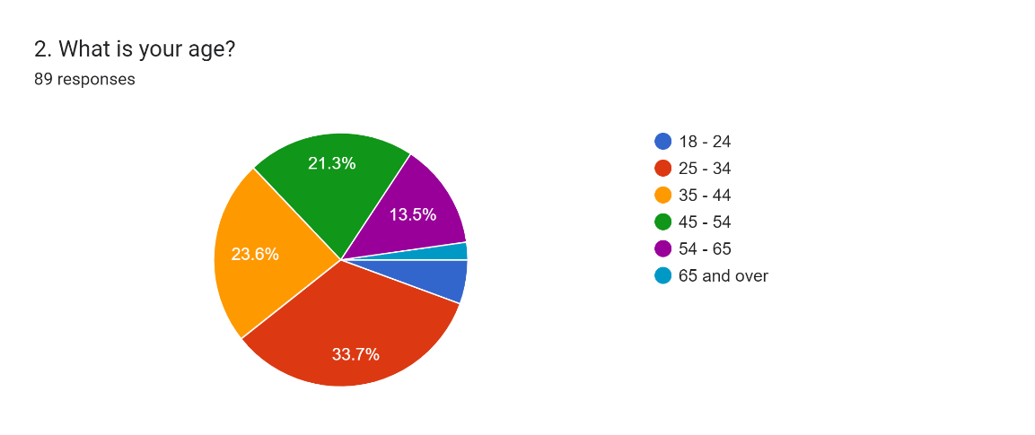
4.2 Participant Demographics
(Figure 1)
Questions 1 and 2 categorised participants by ‘Gender’ and ‘Age’ to investigate the potential differences in respondents views and opinions with regards to the research topic. Demographical information allows the researcher “to better understand certain background characteristics of an audience.” (SurveyMonkey, 2024). Out of 89 responses, 46 respondents were male with 43 were female.
4.3 Questionnaire Findings
4.3.1 Understanding of the Taser
Questions 3 was designed to engage with the publics current understanding surrounding the Taser. Out of 89 responses, 46.1% felt ‘Very familiar and aware’ to knowing the concept of the Taser, with the majority, 49.4% stating they were ‘Partially familiar and aware, but not in great detail’, It could be suggested by the current data that there is still a ‘Misunderstanding of the Taser’ clarified by Steve White in an interview BBC News from the literature review (BBC News, 2013b) against the statistics visible in Figure 2.
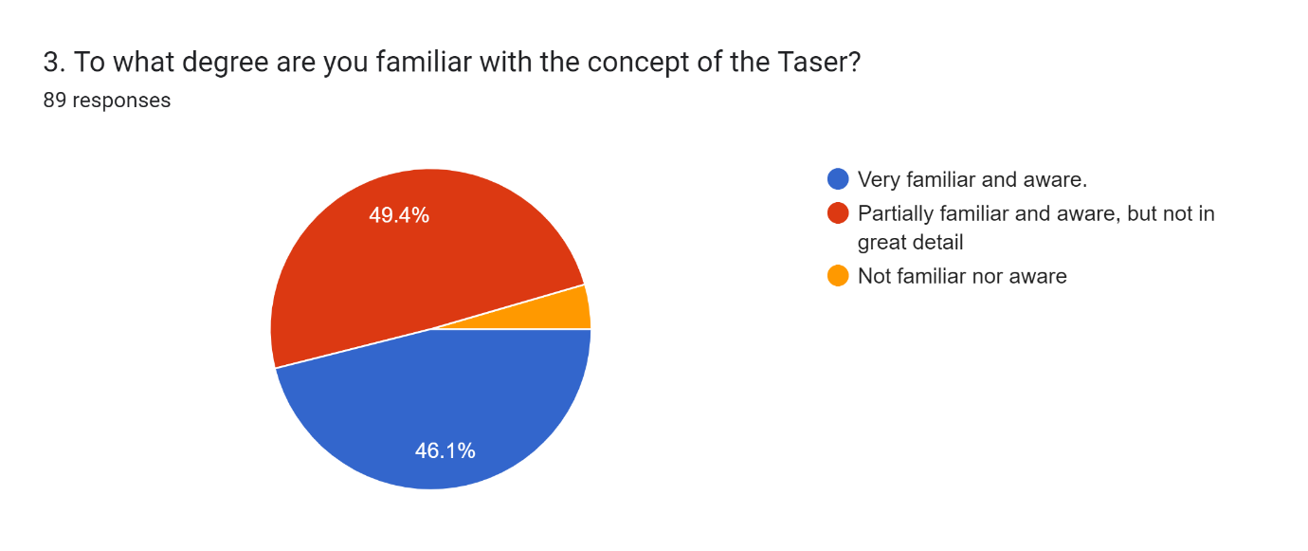
(Figure 2)
4.3.2 Safety of the public
(Figure 3)
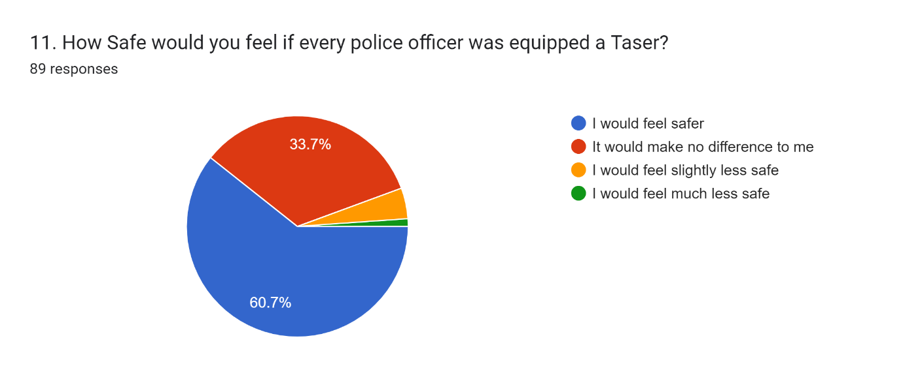

Question 11 (Figure 3) highlights that 60.7% of respondents would feel safer if all officers were equipped with a Taser, with 33.7% stating it would make ‘no difference’ to them which could also be seen as a positive outlook towards the device and it’s potential, with only 5.6% seeing it from a negative perspective. These results are similar to the findings from the literature review where 81% of officers asked the same question stated they would feel safer. (Police Federation, 2019). In this incidents though the potential for Bias has been removed as the question did not solely focus on officers, allowing for a clear understanding to the research area. (Trnka and Smelik, 2020, P. 25).
4.3.3 Should all Police Officers carry a Taser.
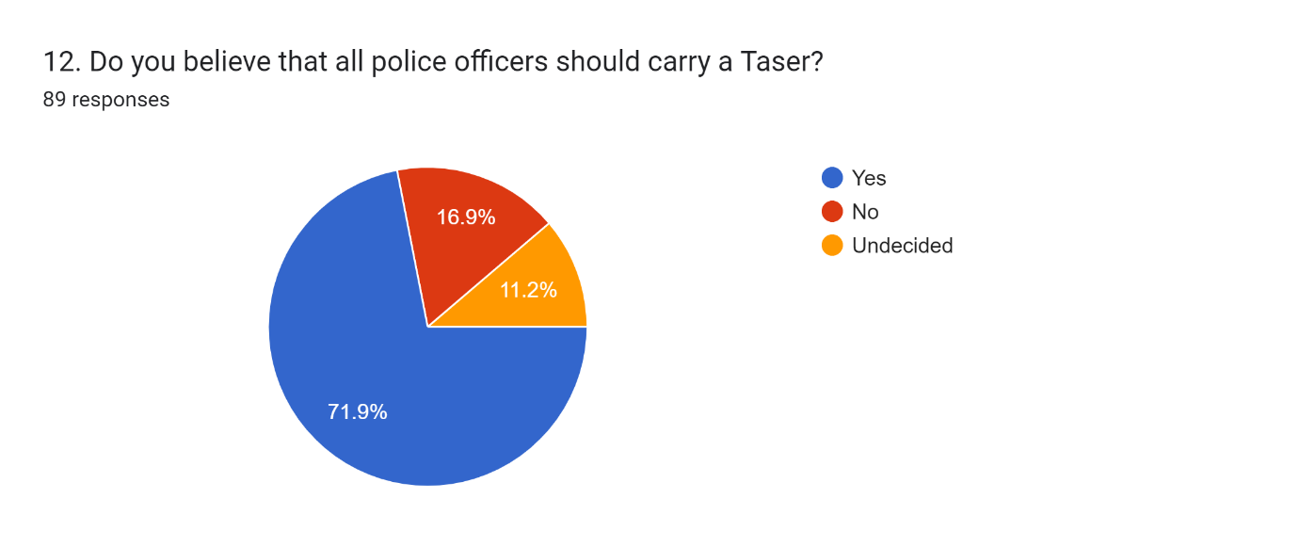
(Figure 4)
When analysing the 89 responses for Question 12, Figure 4, shows 71.9% of believe that Police Officers should be equipped with the Taser, with 16.9% disagreeing and 11.2% being “undecided”. Comparing these results to the (Police Federation, 2019) poll form the literature review, It is clear to see there is a decrease in statistics of the public wanting a full Taser rollout. 2019 highlighted that 73% of participants thought police officer should carry the Taser, whereas a 3 years prior in 2016 showed only 71% of members of the public wanting a full rollout. (Ipsos MORI and The Police Federation, 2016). The new findings also highlighted the National Police Chiefs Council (NPCC, 2016) comments where they state, “There is no justification”, now especially with a highlighted decrease in the publics choice to date.
Question 13 asked a qualitative question; It allowed members on the public to engage the way they felt on the matter. As a website by ‘Provoke insights’ details, qualitative responses will allow for deeper insight, observed emotions and better audience interaction to research. (Provoke Insights, 2021).
Many respondents focused on how ‘Tasers’ would be ‘beneficial to officer safety’ and ‘protection for both officer and the public’ which agrees with Chief Constable Nick Adderley comments from ‘Chapter 2’ (BBC News, 2021).
The concerns of the Tasers rollout also explores fear of the potential ‘Overuse of the Device’, a comment similarly referenced by The Guardian from the literature review stating that 2 Met Police Officers ‘Use of Force’ was “Unnecessary and excessive.” (The Guardian, 2022).
Answer’s regarding the concern of Taser rollout in Question 13, stated the following:
“My only concern is people becoming very attached to the tool, and not using communication.”
Another member of the public also stated,
“Over usage is a major concern and can escalate a situation. Officers maybe too quick to jump to using it”.
These answers suggested the potential for ‘Mission Creep’ as a concern from members of the public and the ‘Use of Taser’ because it is readily available without first considering alternative methods to de-escalate a situation. ‘Mission Creep’ is the gradual addition of new tasks and activities so original purpose of the idea is lost. (Cambridge Dictionary, 2022).
4.3.4 Public Trust and Confidence
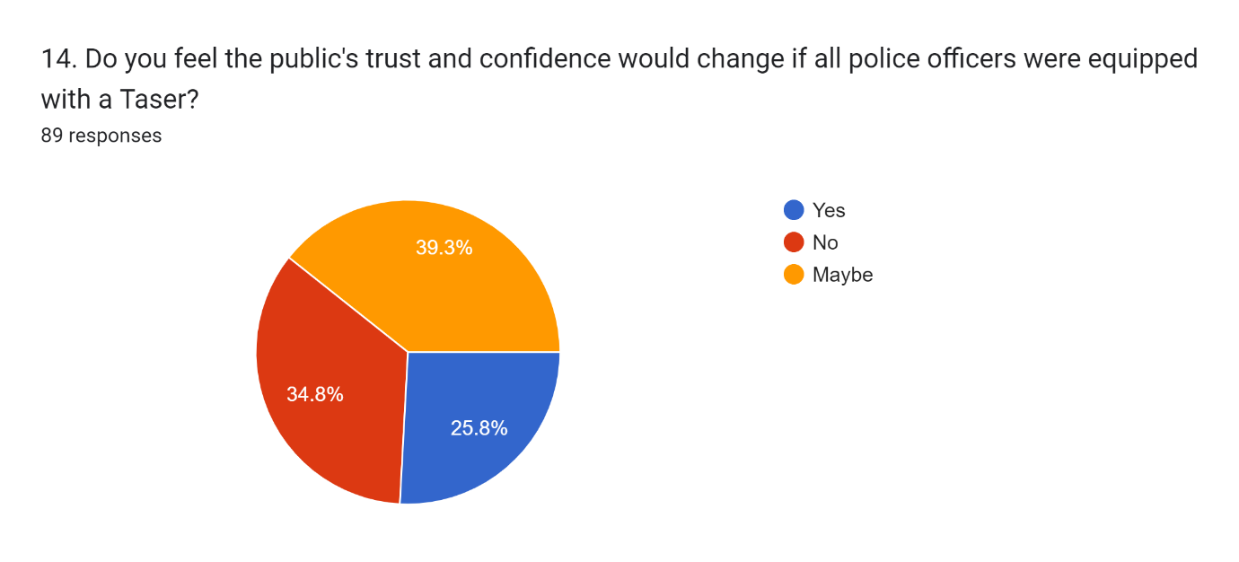
(Figure 5)
Question 14 reflected on how the public’s confidence and trust would fair if all officers were equipped a Taser. The results show out of 89 responses, 39.3% would ‘Maybe’ change, followed closely by 34.8% stating ‘No’ to change with the minority 25.8% stated ‘Yes’ to change. The results highlight that the Taser is very much up for debate amongst the general public as to whether it would better improve the police’s ability to impartially enforce the law, highlighting the IPOC report from 2021 from the literature review with regards to the police potentially losing its legitimacy if public concerns are not addressed (IOPC, 2021).
Question 15 allowed the public to explain their reasoning behind their chosen answer. A common theme explored was the fact that the public are often led by the media.
Answers regarding the concern in response to Question 15 stated:
“I believe the public are led by the media and it would only take a few incidents where less skilled or less confident officers make a mistake which would lead to a drop in trust”.
Other answers also stated,
“I believe negative media around officer use of force, as well as the forces lack of engagement in challenging unsubstantiated negative stories leads to distrust and lack of confidence.”
And,
“Public news of feared safety as there are bound to be stories in the news of people being wrongfully tasered.”
The literature review covered how the Taser has seen scrutiny and controversy with regards to the public and media focusing on high profile reports. A Tom Wood states, “The truth is that the police often depend on the media, especially in serious cases” (Wood, 2022). Thurman (2023) also highlights that the media has a moral imperative to bridge the gap between the government and general population and should focus on an unbiased and accurate report.
However, unprecedented media attention surrounding a topic such as the taser would ultimately impact the public perception as clearly highlighted by Questions 14 and 15. This enforces McKaughan and Snyder, for the public to trust the police they must have the right intentions and deliver competence in their role. (McKaughan and Howard-Snyder, 2022, pp. 1-17).

1,196 Words (1,077 if Qualitative quotes from the public are not included)

Bibliography:
Ablison (2023). Pros And Cons Of Pragmatism 2023 - Ablison. [online] www.ablison.com. Available at: https://www.ablison.com/pros-and-cons-of-pragmatism/ [Accessed 20 Feb. 2024].
Ahmed, I. and Ishtiaq, S. (2021). Reliability and validity: Importance in Medical Research. The Journal of the Pakistan Medical Association, [online] 71(10). doi:https://doi.org/10.47391/JPMA.06-861.
Alamgeer, Z. (2022). Understanding Research Onion for Research Methodology. [online] The Innovidea. Available at: https://theinnovidea.com/understanding-research-onion-for-research-methodology/ [Accessed 7 Feb. 2024].
AXON (2021). The Truth about TASER. [online] Axon.com. Available at: https://www.axon.com/resources/the-truth-about-taser# [Accessed 19 Aug. 2023].
BBC News (2013a). Andrew Pimlott Burns Death Prompts IPCC Taser Inquiry. BBC News. [online] 26 Apr. Available at: https://www.bbc.co.uk/news/uk-england-devon-22316820 [Accessed 21 Aug. 2023].
BBC News (2013b). Tasers ‘are Very Effective tool’. BBC News. [online] 10 Sep. Available at: https://www.bbc.co.uk/news/av/uk-24028651 [Accessed 16 Aug. 2023].
BBC News (2015a). Plymouth Man Caught Fire after Being Tasered. BBC News. [online] 28 Sep. Available at: https://www.bbc.co.uk/news/uk-england-devon-34382270 [Accessed 21 Aug. 2023].
BBC News (2015b). Plymouth Taser Officer Cleared of Misconduct. BBC News. [online] 7 Mar. Available at: https://www.bbc.co.uk/news/uk-england-devon-31774636 [Accessed 21 Aug. 2023].
BBC News (2021). Northamptonshire Police Chief Claims Taser Saved officer’s Life. BBC News. [online] 3 Feb. Available at: https://www.bbc.co.uk/news/uk-england-northamptonshire-55911549.
BBC News (2022). Chelsea Bridge: Man Who Died after Taser Was Holding Firelighter. BBC News. [online] 21 Jun. Available at: https://www.bbc.co.uk/news/uk-england-london-61794542.
Booth, D. (2018). LibGuides: Research Methods: What are research methods? [online] libguides.newcastle.edu.au. Available at: https://libguides.newcastle.edu.au/researchmethods#:~:text=Research%20methods%20are%20the%20strategies [Accessed 20 Feb. 2024].
Brandl, S.G. and Stroshine, M.S. (2016). Oleoresin Capsicum Spray and TASERs. Criminal Justice Policy Review, 28(3), pp.279–306. doi:https://doi.org/10.1177/0887403415578732.
Bushman, B. (2013). The ‘Weapons Effect’. [online] Psychology Today. Available at: https://www.psychologytoday.com/gb/blog/get-psyched/201301/the-weapons-effect [Accessed 16 Aug. 2023].
Cambridge Dictionary (2019). RESEARCH | meaning in the Cambridge English Dictionary. [online] Cambridge.org. Available at: https://dictionary.cambridge.org/dictionary/english/research [Accessed 7 Feb. 2024].
Cambridge Dictionary (2022). mission creep. [online] @CambridgeWords. Available at: https://dictionary.cambridge.org/dictionary/english/mission-creep [Accessed 13 Mar. 2024].
Campbell, M. (2023). 90 Meaningful Open-Ended Questions for Good Conversations. [online] Growth Tactics. Available at: https://www.growthtactics.net/open-ended-questions/#:~:text=In%20another%20study%2C%20researchers%20found%20that%20asking%20open-ended [Accessed 20 Feb. 2024].
Cleave, P. (2023). Advantages of Questionnaires in Online Research. [online] SmartSurvey. Available at: https://www.smartsurvey.co.uk/blog/advantages-of-questionnaires-in-online-research [Accessed 20 Feb. 2024].
College of Policing (2020). Officer and Staff Safety Review: a Review of the Arrangements to Secure the Safety of Police Officers and Police Staff Engaged in Frontline Policing. [online] College of Policing. Available at: https://assets.college.police.uk/s3fs-public/2020-09/CoP-NPCC-Officer-Staff-Safety-Review.pdf [Accessed 16 Aug. 2023].
College of Policing (2022). Professional Standards. [online] College of Policing. Available at: https://www.college.police.uk/app/professional-standards [Accessed 21 Aug. 2023].
Dudovskiy, J. (2021). Inductive Approach (Inductive Reasoning). [online] Business Research Methodology. Available at: https://research-methodology.net/research-methodology/research-approach/inductive-approach-2/ [Accessed 20 Feb. 2024].
Dymond, A. (2021a). Electric-Shock Weapons, Tasers and Policing. Routledge, p.31.
Dymond, A. (2021b). Electric-Shock Weapons, Tasers and Policing. Routledge, p.39.
Emerald Publishing (2021). Using Mixed Methods Research . [online] www.emeraldgrouppublishing.com. Available at: https://www.emeraldgrouppublishing.com/how-to/research-methods/using-mixed-methods-research [Accessed 20 Feb. 2024].
Grad Coach (2022). Saunders’ Research Onion Model: Simple Explanation + Examples (Research Methodology 101 Lecture). [online] www.youtube.com. Available at: https://www.youtube.com/watch?v=Yoq-x4eVn6A [Accessed 7 Feb. 2024].
Hassan, M. (2022). Volunteer Sampling - Definition, Examples. [online] Research Method. Available at: https://researchmethod.net/volunteer-sampling/ [Accessed 20 Feb. 2024].
Home Office (2012). Definition of Policing by Consent. [online] gov.uk. Available at: https://www.gov.uk/government/publications/policing-by-consent/definition-of-policing-by-consent [Accessed 21 Aug. 2023].
Home Office (2022). Police Use of Force statistics, England and Wales: April 2021 to March 2022. [online] GOV.UK. Available at: https://www.gov.uk/government/statistics/police-use-of-force-statistics-england-and-wales-april-2021-to-march-2022/police-use-of-force-statistics-england-and-wales-april-2021-to-march-2022 [Accessed 19 Aug. 2023].
Hunt, N. (2021). LibGuides@Southampton: Primary research: Home. [online] library.soton.ac.uk. Available at: https://library.soton.ac.uk/sash/primary-research#:~:text=Primary%20research%20%E2%80%93%20what%20is%20it [Accessed 7 Feb. 2024].
Indeed (2022). Inductive Research: What Is It? (With Benefits and Examples). [online] Indeed. Available at: https://www.indeed.com/career-advice/career-development/inductive-research#:~:text=Benefits%20of%20inductive%20research&text=Finding%20probability%3A%20Examining%20the%20underlying,to%20operations%20within%20the%20company. [Accessed 20 Feb. 2024].
Informizely (2024). Using open-ended and closed-ended questions in online surveys. [online] www.informizely.com. Available at: https://www.informizely.com/blog/using-open-ended-and-closed-ended-questions-in-online-surveys#:~:text=This%20combination%20of%20a%20closed [Accessed 20 Feb. 2024].
Institute for Work and Health (2015). Cross-sectional vs. longitudinal studies | Institute for Work & Health. [online] Institute for Work and Health. Available at: https://www.iwh.on.ca/what-researchers-mean-by/cross-sectional-vs-longitudinal-studies [Accessed 20 Feb. 2024].
IOPC (2021). IOPC report flags concerns about police use of Taser | Independent Office for Police Conduct. [online] www.policeconduct.gov.uk. Available at: https://www.policeconduct.gov.uk/news/iopc-report-flags-concerns-about-police-use-taser [Accessed 17 Aug. 2023].
Ipsos MORI and The Police Federation (2016). Attitudes Towards the Taser. [online] Ipsos MORI and the Police Federation . Available at: https://www.polfed.org/media/14240/police_federation_taser_research_top_line_summary.pdf [Accessed 16 Aug. 2023].
kswenson (2020). Collecting Diverse Audience Perspectives. [online] Forum One. Available at: https://www.forumone.com/insights/blog/collecting-diverse-audience-perspectives/ [Accessed 20 Feb. 2024].
Lott-Lavigna, R. (2020). Vast Increase in Police Taser Use a ‘Threat to Life’, Report Warns. [online] Vice. Available at: https://www.vice.com/en/article/xg85x4/vast-increase-in-police-taser-use-a-threat-to-life-report-warns [Accessed 19 Aug. 2023].
McKaughan, D.J. and Howard-Snyder, D. (2022). How Does Trust Relate to Faith? Canadian Journal of Philosophy, 52(4), pp.1–17. doi:https://doi.org/10.1017/can.2022.34.
Mcleod, S. (2023). Questionnaire: Definition, examples, design and types. [online] Simply Psychology. Available at: https://www.simplypsychology.org/questionnaires.html [Accessed 20 Feb. 2024].
NPCC (2016). Proportionate Approach to the Number of Taser Trained Officers. [online] National Police Chiefs’ Council (NPCC). Available at: https://news.npcc.police.uk/releases/proportionate-approach-to-the-number-of-taser-trained-officers [Accessed 16 Aug. 2023].
NPCC (2021). Police Chiefs’ blog: IOPC Taser Review Is ‘vague, Lacks Detail and Ignores Extensive Pieces of Work Already underway’. [online] National Police Chiefs’ Council (NPCC). Available at: https://news.npcc.police.uk/releases/police-chiefs-blog-iopc-taser-review-is-vague-lacks-detail-and-ignores-extensive-pieces-of-work-already-underway [Accessed 17 Aug. 2023].
Office for Health Improvement and Disparities (2020). Mixed Methods Study. [online] GOV.UK. Available at: https://www.gov.uk/guidance/mixed-methods-study [Accessed 20 Feb. 2024].
Pandey, A. (2022). How To Use Anonymous Surveys To Get Better Responses & Honest Feedback From Your Employees. [online] Bright Horse. Available at: https://www.brighthorse.co.uk/anonymous-surveys [Accessed 20 Feb. 2024].
Police Federation (2019). Police Officers and the Public Support Taser Roll out. [online] www.polfed.org. Available at: https://www.polfed.org/news/latest-news/2019/police-officers-and-the-public-support-taser-roll-out/ [Accessed 16 Aug. 2023].
Police Federation (2023). Taser. [online] www.polfed.org. Available at: https://www.polfed.org/our-work/operational-policing/taser/ [Accessed 16 Aug. 2023].
Police Oracle (2021). Police Oracle. [online] touch.policeoracle.com. Available at: https://touch.policeoracle.com/news/article.cfm?id=107766 [Accessed 17 Aug. 2023].
Provoke Insights (2021). The Pros and Cons of Qualitative Research qualitative research. [online] Provoke Insights. Available at: https://provokeinsights.com/the-pros-and-cons-of-qualitative-research/ [Accessed 13 Mar. 2024].
Scribbr (2024). What are ethical considerations in research? [online] Scribbr. Available at: https://www.scribbr.co.uk/faqs/what-are-ethical-considerations-in-research/ [Accessed 21 Feb. 2024].
Steynberg, S. (2024). Subject Guides: Research Guide: Data analysis and reporting findings. [online] library.up.ac.za. Available at: https://library.up.ac.za/c.php?g=485435&p=4425510#:~:text=Data%20analysis%20and%20findings [Accessed 5 Mar. 2024].
SurveyMonkey (2024). Gathering Demographic Information from Surveys. [online] SurveyMonkey. Available at: https://uk.surveymonkey.com/mp/gathering-demographic-information-from-surveys/ [Accessed 13 Mar. 2024].
The Guardian (2022). Chelsea Bridge death: Family Say Met Police Wrong to Taser Man. [online] The Guardian. Available at: https://www.theguardian.com/uk-news/2022/aug/22/chelsea-bridge-death-oladeji-omishore-man-tasered-by-police-was-clearly-in-distress-say-family [Accessed 21 Aug. 2023].
The Independent (2015). Police Taser ‘most Likely’ Cause of Fire That Killed petrol-soaked Man. [online] The Independent. Available at: https://www.independent.co.uk/news/uk/police-taser-most-likely-cause-of-fire-that-killed-petrolsoaked-man-a6675851.html [Accessed 21 Aug. 2023].
Thurman, T. (2023). The Media’s Role in Public Perceptions of Police Violence. [online] American Cornerstone Institute. Available at: https://americancornerstone.org/the-medias-role-in-public-perceptions-of-police-violence/ [Accessed 21 Mar. 2024].
Trnka, R. and Smelik, V. (2020). Elimination of bias in introspection: Methodological advances, refinements, and recommendations. New Ideas in Psychology, [online] 56(Volume 56), pp.1–31. doi:https://doi.org/10.1016/j.newideapsych.2019.100753.
tutor2u (2021). Research Methods: Questionnaires. [online] tutor2u. Available at: https://www.tutor2u.net/sociology/reference/research-methods-questionnaires-1#:~:text=Questionnaires%20are%20generally%20considered%20to [Accessed 20 Feb. 2024].
UKEssays (2019). Research Onion – Explanation of the Concept. [online] Ukessays.com. Available at: https://www.ukessays.com/essays/psychology/explanation-of-the-concept-of-research-onion-psychology-essay.php [Accessed 20 Feb. 2024].
University of Cambridge (2018). Carrying Tasers Increases Police Use of force, Study Finds. [online] University of Cambridge. Available at: https://www.cam.ac.uk/research/news/carrying-tasers-increases-police-use-of-force-study-finds [Accessed 16 Aug. 2023].
University of Nottingham (2023). Understanding Pragmatic Research. [online] www.nottingham.ac.uk. Available at: https://www.nottingham.ac.uk/helmopen/rlos/research-evidence-based-practice/designing-research/types-of-study/understanding-pragmatic-research/section03.html [Accessed 20 Feb. 2024].
Wood, T. (2022). Police should realise that the media can be their friends. [online] Tom Wood. Available at: https://www.tomwoodwriter.co.uk/post/police-should-realise-that-the-media-can-be-their-friends [Accessed 21 Mar. 2024].
Wordvice HJ (2021). How To Present Study Limitations and Alternatives. [online] Wordvice. Available at: https://blog.wordvice.com/how-to-present-study-limitations-and-alternatives/ [Accessed 20 Feb. 2024].
Zefeiti, S.M.B.A. and Mohamad, N.A. (2015). Methodological Considerations in Studying Transformational Leadership and its Outcomes. International Journal of Engineering Business Management, [online] 7(10), p.4. doi:https://doi.org/10.5772/60429.

