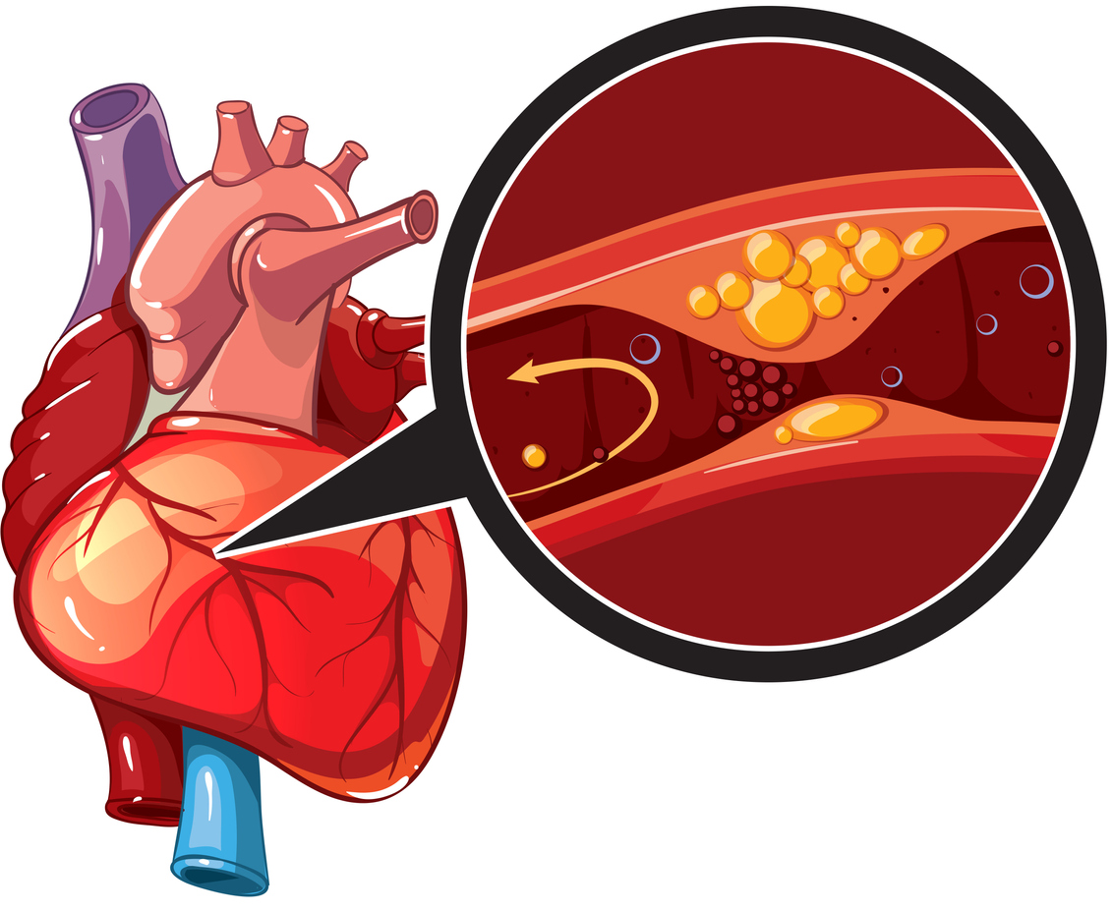
CORONARY HEART DISEASE
CORONARY HEART DISEASE

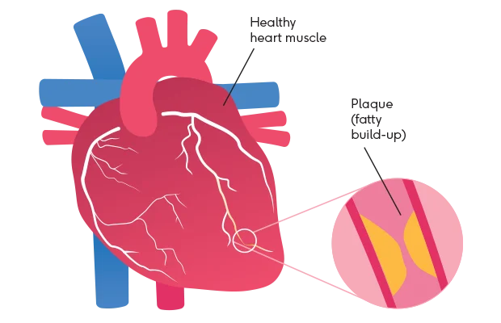

Name: Amit Tiwari
Student number: 2526931
M.Sc. Public health and social care in practice
Module code: LCHS7003
Lecturer: Muhammed Khan
TABLE OF CONTENTS

- Introduction
- Explanation of the long-term condition
- Definition of Coronary Heart Disease
- Pathophysiology of the Disease
- Global Burden and Prevalence
- Prevalence and Epidemiology in the United Kingdom
- Risk Factors and Aetiology
- Impact of Coronary Heart Disease
- Physical Implications for Individuals
- Psychological Implications
- Social Implications
- Evidence-Based Treatment and Management in the UK
- Lifestyle and Preventive Interventions
- Pharmacological Treatments
- Medical and Surgical Interventions
- Cardiac Rehabilitation and Long-Term Management within the National Health Services
- Theoretical Perspectives and Models for Long-Term Condition Management
- UK Model: The Chronic Care Model in the UK Context
- International Model: World Health Organization Innovative Care for Chronic Conditions Framework
- Evaluation of These Models for Improving Patient Outcomes
- Political and Policy Context in Long-Term Condition Management
- National Health Policies and Strategies
- Role of the National Institute for Health and Care Excellence Guidelines
- Local Health and Social Care Initiatives
- Impact of Policy on Coronary Heart Disease Management
- Recommendations for Improving Person-Centred Care
- Person-Centred Care Approaches
- Self-Management Strategies for Patients
- Community and Family Support Systems
- End-of-Life Care Considerations
- Conclusion
- References

- Introduction
Coronary heart disease (CHD), one of the most common chronic cardiovascular conditions, continues to be a significant global public health issue. It occurs when atherosclerotic plaques, which are fatty deposits, build up in the coronary arteries that supply blood to the heart muscle, narrowing or blocking them. This reduced blood flow can cause symptoms including dyspnoea, angina (chest discomfort), and, in severe cases, a myocardial infarction or heart attack. As a result, CHD significantly affects morbidity and death across a range of groups. (Nowbar et al., 2019).
An estimated 17.9 million deaths globally are attributed to cardiovascular illnesses each year. A significant portion of these deaths is attributable to coronary heart disease, highlighting the disease's widespread impact on society and health systems. Despite improvements in medical care and prevention measures, CHD still places a heavy burden on healthcare resources and is a major cause of long-term disability. (Roth et al., 2020).
Coronary heart disease is one of the most prevalent cardiovascular conditions among adults in the UK. Heart and circulation disorders today affect millions of individuals, and national figures show that CHD alone results in tens of thousands of fatalities annually. The burden of the disease is also associated with several modifiable risk factors that are intimately tied to lifestyle choices, such as smoking, eating poorly, being fat, and not exercising. (British Heart Foundation, 2026).
- Explanation of the long-term condition
- Definition of Coronary Heart Disease
A narrowing or blockage of the coronary arteries, which supply the heart with oxygenated blood, causes coronary heart disease (CHD), also known as coronary artery disease, a chronic cardiovascular ailment. Atherosclerosis, or the gradual accumulation of fatty deposits and cholesterol in the artery walls, is the most frequent cause of this constriction. Plaque buildup in the arteries can cause chest pain, fatigue, and dyspnoea by reducing the amount of oxygen-rich blood that reaches the heart muscle. In more difficult situations, myocardial infarction, also known as a heart attack, can happen when there is a complete stoppage of blood flow. (Shahjehan et al., 2024).

CHD is considered a chronic illness since it develops slowly over time and requires ongoing care. People with the diagnosis often need to take medication and make long-term lifestyle changes to prevent the disease from getting worse and reduce the risk of consequences. Therefore, the primary objectives of successful management techniques are to control risk factors and maintain cardiovascular health. (Nowbar et al., 2019).

- Pathophysiology of the Disease
The fundamental pathophysiology of coronary heart disease is closely linked to atherosclerosis. This process starts when the inner lining of the arteries is damaged, which can occur for a variety of reasons, including high blood pressure, high cholesterol, or smoking. Damage causes inflammatory cells and lipids to accumulate in the artery wall, forming plaques that gradually constrict the arteries (Libby et al., 2019). Over time, these plaques may disintegrate. The body creates a blood clot to repair the damage caused by broken plaque. However, the clot may make it more difficult for blood to pass through the artery, which may result in an unexpected obstruction. The heart muscle loses oxygen and nutrients because of this blood flow stoppage. (Shahjehan et al., 2024).
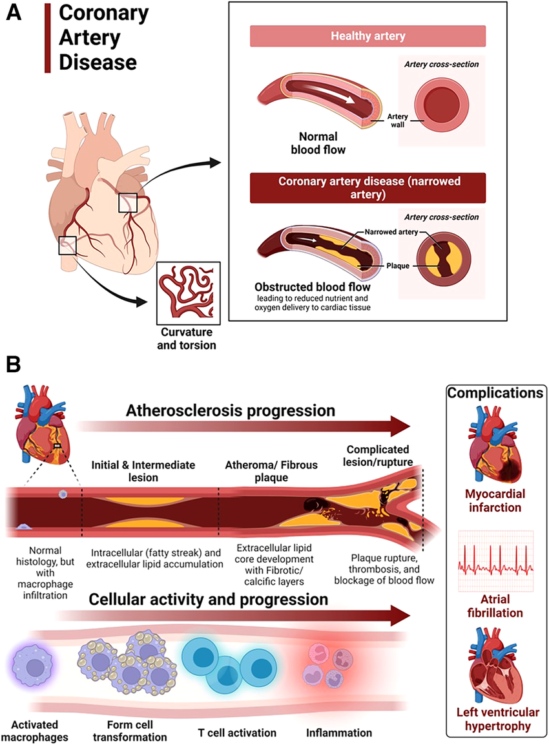
Figure 1: Progression of atherosclerosis in coronary artery disease. (A) Narrowing of the coronary arteries due to advanced fatty plaque. (B) Disease progression begins with fatty streaks and macrophage infiltration; macrophages become lipid-laden foam cells, triggering inflammation. Continued lipid and calcium deposition leads to fibrotic, calcified plaques that may rupture, causing thrombosis and impaired blood flow. Complications include myocardial infarction, atrial fibrillation, and left ventricular hypertrophy, with macrophages and T cells playing key roles. (Adapted from: Masenga, S.K. and Kirabo, A., 2023)

- Global Burden and Prevalence
Coronary heart disease is still one of the leading causes of death worldwide and contributes significantly to the global illness burden. According to global epidemiological research, coronary heart disease accounts for a significant share of the nearly 18 million deaths caused by cardiovascular diseases each year. The number of persons with cardiovascular disease is still rising globally, even though death rates have decreased in certain wealthy nations due to improved prevention and treatment. (Di Cesare, M. et al., 2020).
The increasing prevalence of CHD is largely associated with ageing populations, urbanisation and lifestyle-related factors such as unhealthy diet, smoking and physical inactivity. These factors contribute to the growing demand for healthcare services and highlight the importance of preventive strategies aimed at reducing cardiovascular risk (Yeates, K., et al.,2015).

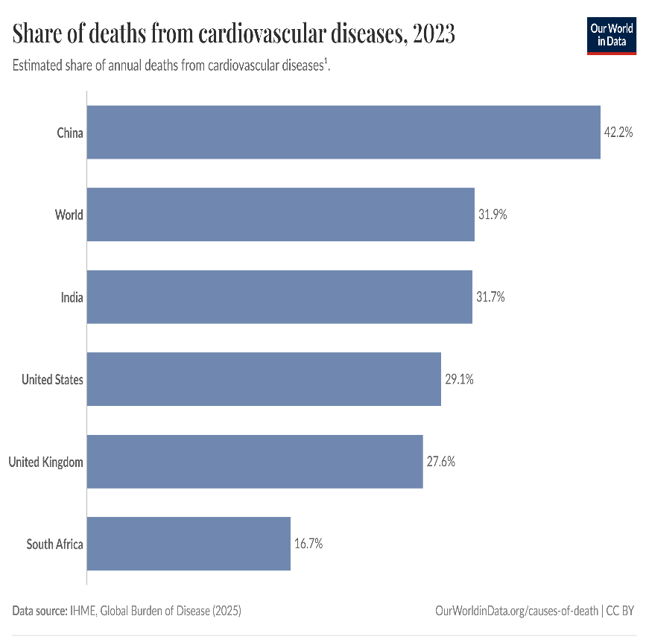
Figure 2: The estimated share of deaths from cardiovascular diseases. (Adapted from: IHME, Global Burden of Disease,2025) Date visited: 17/03/26

- Prevalence and Epidemiology in the United Kingdom
In the United Kingdom, coronary heart disease continues to represent a significant public health challenge. National statistics indicate that millions of people are currently living with heart and circulatory diseases, with CHD being one of the most common conditions affecting adults. Despite improvements in healthcare and prevention initiatives, the disease remains a leading cause of hospital admissions and premature death in the UK (Baker, A.H., et al 2026).
In the UK, several socioeconomic and demographic factors affect the epidemiology of coronary heart disease. The illness is more prevalent in older people and typically affects men more often than women. Furthermore, risk factors like smoking, eating poorly, and having limited access to healthcare are more common in socioeconomically disadvantaged populations, where higher rates of CHD are frequently seen (Majeed, A. and Aylin, P., 2005).

- Risk Factors and Aetiology
It is possible to alter or maintain coronary heart disease risk factors. Examples of non-modifiable factors that may increase susceptibility to the illness but cannot be altered are age, gender, and genetic predisposition. For example, a person may be more likely to develop CHD if they have a family history of cardiovascular disease.(Brown, J.C., et al.,2023)
However, modifiable risk factors can be addressed with preventive measures and are mostly associated with lifestyle behaviours. Among the most important factors in the development of coronary heart disease are smoking, high blood pressure, elevated cholesterol, obesity, diabetes, and physical inactivity. Atherosclerosis risk may also be increased by eating a diet high in processed foods and saturated fats (Hajar, R., 2017).

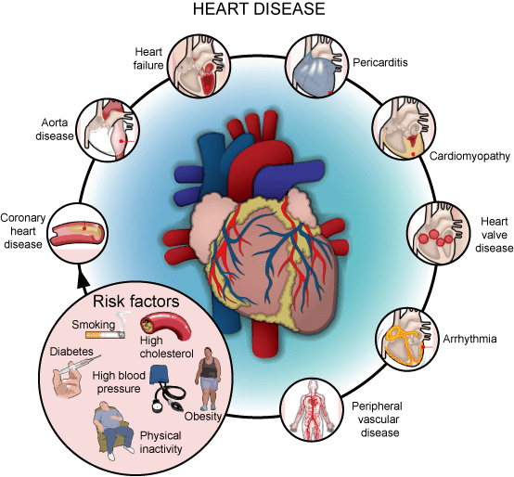
Figure 3: Types of heart disease and risk factors. (Adapted from: Springer Science & Business Media, 2010)
- Impact of Coronary Heart Disease
- Physical Implications for Individuals
From a physiological standpoint, CHD can markedly restrict an individual's functional capacity and quality of life. When blood flow to the heart muscle is cut off, it can cause chest pain (angina), tiredness, and shortness of breath, especially when you are working out. These symptoms can make it hard to do things like walk, climb stairs, or keep a job over time. In more severe cases, CHD can result in myocardial infarction or heart failure, both of which are linked to long-term disability and heightened mortality.(NHS England, 2024)

Nonetheless, the physical burden of CHD varies among individuals. Some patients remain asymptomatic for years, while others experience rapid disease progression. This variability underscores the significance of early detection and ongoing monitoring in clinical practice. Additionally, treatment options like medication, angioplasty, or coronary artery bypass surgery can lead to better results, but they can also create new problems, like side effects, long recovery times, and a need for ongoing medical care. (Netala, V.R., et al.,2024)

- Psychological Implications
CHD can have a big effect on mental health. After being diagnosed, many people feel anxious, depressed, and scared, especially after a heart attack. These feelings are often caused by not knowing what will happen in the future, being afraid of it happening again, and feeling like you have lost control. Depression is very common and is linked to worse overall health outcomes and less adherence to treatment.
Anxiety can also cause people to avoid things, like exercising, because they are afraid it will make their symptoms worse. This can make the condition even worse. Also, mental distress can make things worse by raising stress, blood pressure, and heart rate. Psychological support is not always a regular part of heart care, even though it can have a big effect. (De Hert, M., et al.,2018)

- Social Implications

CHD has significant social ramifications, impacting an individual's capacity to work, sustain relationships, and participate in daily activities. People who can't work anymore because of their reduced physical ability and ongoing treatment needs may also have financial problems. Family members and caregivers often have to do more than their fair share of work, which can be stressful and make them feel like they have too much to do.
There are also big health differences related to CHD, with people from lower socioeconomic backgrounds being more likely to get it. These differences are caused by things like not being able to get to healthcare, living in unhealthy places, and not knowing much about health. This shows that CHD is not just a health problem; it is also a social one that needs more public health and policy action. (Baker, A.H., et al 2026).

- Evidence-Based Treatment and Management in the UK
- Lifestyle and Preventive Interventions
Changing your lifestyle is an important part of managing CHD. UK guidelines say that quitting smoking, eating a healthy diet, exercising regularly, and keeping your weight under control can all lower your risk of heart disease. But the success of these treatments mostly depends on how well the patient follows them, which is often hard because of things like low motivation, financial problems, and a lack of support.(NHS England,2024)
It's important to note that just giving advice isn't enough to bring about lasting change. To help people change their behavior for good and get better results, we need more structured programs like health coaching and community-based programs. (NICE, 2023)

- Pharmacological Treatments
In the management of CHD, pharmacological therapy is of critical importance. The drugs commonly used in the management of the condition include antiplatelets, statins, beta-blockers, and ACE inhibitors. These drugs play a critical role in the reduction of the risk of cardiovascular complications by limiting the formation of blood clots, lowering cholesterol and blood pressure, and reducing heart workload. Evidence of the effectiveness of the drugs in the reduction of cardiovascular complications is convincing. However, the major challenge associated with the drugs is the non-adherence of patients to the treatment regimen. Some patients have the tendency to stop the drugs because of their side effects and the inability to understand the long-term benefits of the drugs. (Kolanu, N.D. et al., 2019)

- Medical and Surgical Interventions
For those suffering from advanced stages of CHD, medical interventions may be necessary to resume proper blood flow to the heart. Among the most common medical procedures for CHD are percutaneous coronary intervention, also referred to as angioplasty, and coronary artery bypass grafting. (Idarto, D., 2026)

In this regard, angioplasty entails the insertion of a stent to widen the artery, whereas CABG is a medical procedure that allows an alternative channel for the resumption of blood flow through the heart using a graft. These medical procedures have been proven effective in alleviating symptoms as well as increasing survival rates. (Sabatine, M.S., et al., 2021)

Nevertheless, these medical procedures have their own disadvantages. Although they may alleviate symptoms in the short term, they do not treat the underlying causes of atherosclerosis. This means that patients are still at risk of suffering further complications unless they adopt a healthy lifestyle as well as pharmacological regimens.

Moreover, medical procedures are also risky since they may lead to complications and infections. (Makover, M.E., et al., 2022)

- Cardiac Rehabilitation and Long-Term Management within the National Health Services
Cardiac rehabilitation is an essential aspect in the care pathway for CHD in the NHS and incorporates aspects such as exercise, education, psychological support, and lifestyle advice. Cardiac rehabilitation has been proven to have benefits for the overall health and quality of life for those suffering from CHD, as well as reducing anxiety and depression.(Mehra, V.M. et al., 2020)

However, the overall rate of participation in cardiac rehabilitation is low due to factors such as lack of awareness and accessibility. This emphasizes the need for flexible approaches to CHD care, such as home-based rehabilitation programs, in conjunction with monitoring and individualized care for CHD patients.(O'Driscoll, et al., 2007)

- Theoretical Perspectives and Models for Long-Term Condition Management
- UK Model: The Chronic Care Model in the UK Context

The Chronic Care Model (CCM) is a popular approach for managing chronic illnesses, emphasizing the interface of well-informed patients and proactive healthcare teams. It encompasses concepts such as self-management support, decision support, and coordinated care, and is incorporated into NHS integrated approaches that are patient-centered. It is also supported by evidence for the quality of care for chronic disease management.
However, it is implemented in an inconsistent manner, requires major organisational changes, and may be difficult in resource-constrained environments. It is also seen as being more health care system-centric than population-centric.( Grudniewicz, A., et al.,2023)
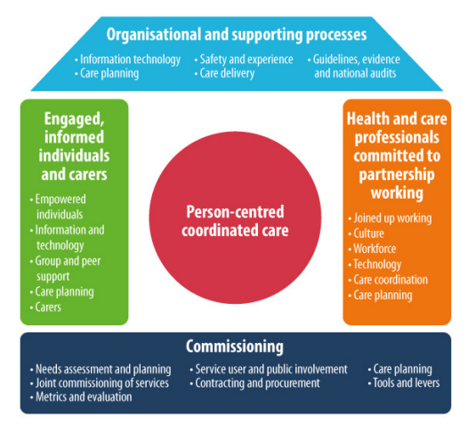
Figure 4: The House of Care Model ( Adapted from: NHS England,2017)

- International Model: World Health Organization Innovative Care for Chronic Conditions Framework
The Innovative Care for Chronic Conditions Framework, which was made by the World Health Organization is based on the Chronic Care Model. It looks at care in three ways: the patient, healthcare organisations and the community and the policies that affect them. The Innovative Care for Chronic Conditions Framework is about working together and making sure everything is connected which helps people get better care take care of themselves and have a better life.

Even though the Innovative Care, for Chronic Conditions Framework is a good idea there is not a lot of proof that it really works on a big scale. Lots of people think it is an idea but we do not really know if it works in all different kinds of healthcare systems.(Epping-Jordan, J.E. et al., 2004)

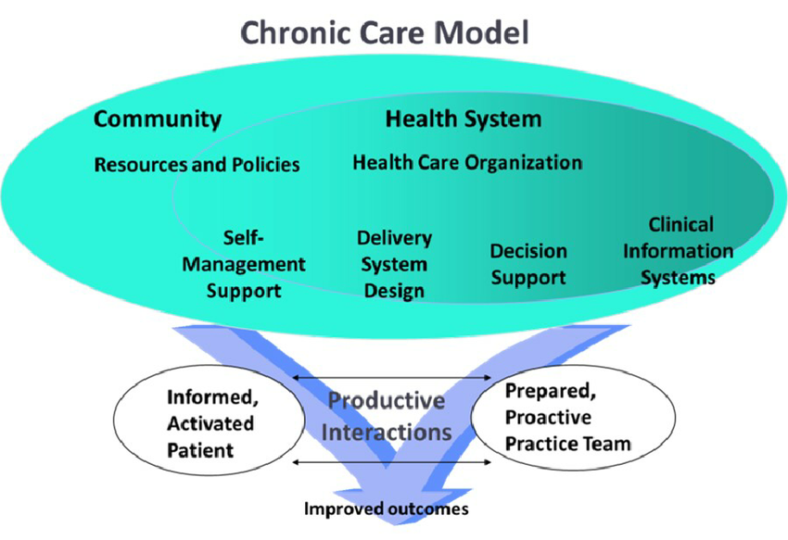
Figure 5: The Chronic Care Model (Adapted from: Gee, P.M., et al., 2015)

- Evaluation of These Models for Improving Patient Outcomes
Both the Chronic Care Model (CCM) and the Innovative Care for Chronic Conditions (ICCC) framework promote a shift from reactive to proactive care, which requires empowerment of patients and cooperation between different medical teams and ongoing medical treatment. The ICCC system delivers an extensive approach that includes both community elements and policy components while CCM presents a practical solution that focuses on clinical matters, thus their combination leads to better patient results and enhanced living standards. The implementation process faces difficulties because of workforce shortages and limitations in funding and unsteady service delivery. The integrated patient-centred care models require local context adaptation according to their current operational needs.(Grover, A. and Joshi, A., 2014)

- Political and Policy Context in Long-Term Condition Management

- National Health Policies and Strategies
National health policies in the UK control how health providers treat chronic diseases, including coronary heart disease (CHD). The National Health Service Long Term Plan focuses on preventing cardiovascular disease through early identification of risk factors, promoting healthier lifestyles and improving access to care. The program provides support for integrated care systems, which enable different healthcare services to deliver coordinated continuous patient care. The system aims to decrease hospital admissions while it improves the long-term health results for patients.(Waterall, J., 2019)

- Role of the National Institute for Health and Care Excellence Guidelines
The National Institute for Health and Care Excellence (NICE) provides evidence-based guidelines that support the diagnosis, treatment and prevention of CHD. The guidelines establish standard clinical procedures that all healthcare providers must follow throughout the United Kingdom. The NICE recommendations include statins as a medication to use with lifestyle changes which will help decrease cardiovascular risk. The guidelines face implementation difficulties because different locations have their own resource availability and service execution methods.(Moss, A.J. et al., 2017)

- Local Health and Social Care Initiatives
CHD management receives substantial support from health services and social care systems which operate at the local level. Community-based programmes such as smoking cessation services health screening and cardiac rehabilitation enable individuals to better control their health condition. The initiatives focus on preventing health problems through early intervention measures which specifically target populations that face higher health risks while aiming to decrease health disparities within various communities.(Local Government Association, 2017)

- Impact of Policy on Coronary Heart Disease Management
The national and local policies that exist in the country have resulted in better CHD outcomes which include both decreased death rates and improved treatment access. The policies face obstacles because funding limitations and workforce deficiencies and geographical disparities restrict their effectiveness. The system needs ongoing policy assessment which should be followed by necessary policy adjustments to achieve fair and successful management of long-term health conditions.(Chowdhury, D. et al., 2021)

- Recommendations for Improving Person-Centred Care

- Person-Centred Care Approaches
The successful treatment of coronary heart disease (CHD) patients needs dedicated efforts to provide them with personalized care. The National Health Service requires health professionals to develop treatment plans which match the specific requirements and personal choices and core beliefs of each patient. The process of shared decision-making between patients and doctors needs to be developed because it helps patients become more involved in their treatment and leads to better health outcomes.(Pardo, Y. et al., 2023)

- Self-Management Strategies for Patients
Long-term care needs self-management support because patients require assistance in controlling their medical conditions. The self-management strategies require users to track their symptoms while they take their prescribed medications and follow their active lifestyle and balanced eating plans. People empower themselves to manage their health through educational programs and access to healthcare resources.(Ogunbayo, O.J.,et al., 2017)

- Community and Family Support Systems
The Community services together with family support systems provide essential support for people to achieve their long-term health needs. The social support system helps people who live with CHD develop emotional strength while they face life challenges. The local programs which include cardiac rehabilitation and support groups lead to improved health results.(Goldfarb, M.J.,et al.,2022)

- End-of-Life Care Considerations
Advanced CHD patients require end-of-life care that focuses on their comfort and dignity and their ability to live their lives. The implementation of palliative care services starts with doctors and patients discussing their preferred treatment options.(Lee, J.H. and Hwang, K.K., 2022)

- Conclusion
Coronary heart disease (CHD) remains a significant long-term condition with wide-ranging impacts on individuals, families, and healthcare systems. This assignment has explored the condition from multiple perspectives, including its pathophysiology, global and UK burden, and the key risk factors that contribute to its development. The existence of CHD as a physical condition demonstrates its effects on both mental health and social interaction which requires complete treatment methods.(Frąk, W., et al., 2022)

The National Health Service present management systems show that medical professionals need to combine three treatment methods which include lifestyle changes and drug therapies and operational procedures together with ongoing patient care that includes cardiac rehabilitation programs. Theoretical models and national policies with National Institute for Health and Care Excellence guidelines create essential frameworks which help achieve effective and consistent patient care. (Laranjo, L.et al.,2024)

Health inequalities and patient adherence problems together with resource limitations continue to create obstacles which prevent people from achieving better health results. The healthcare system needs to focus more on providing person-centred care together with self-management support and community-based assistance programs. The healthcare system needs to develop better prevention methods while making sure that all patients can access medical services because these factors will determine how much CHD will impact people in the upcoming years. (Schwarz, T. et al.,2022)

- References
Baker, A.H., Riley, P.R. and Giacca, M., 2026. The Medical Research Council/British Heart Foundation Centre of Research Excellence in Advanced Cardiac Therapies (REACT).
Brown, J.C., Gerhardt, T.E. and Kwon, E., 2023. Risk factors for coronary artery disease. In StatPearls [Internet]. StatPearls Publishing.
Cardiovascular Biomarkers: Pathophysiology and Disease Management [M]. Springer Science & Business Media, 2010.
Cardiovascular disease: risk assessment and reduction, including lipid modification. NICE guideline NG238 (2023)
Chowdhury, D., Johnson, J.N., Baker‐Smith, C.M., Jaquiss, R.D., Mahendran, A.K., Curren, V., Bhat, A., Patel, A., Marshall, A.C., Fuller, S. and Marino, B.S., 2021. Health care policy and congenital heart disease: 2020 focus on our 2030 future. Journal of the American Heart Association, 10(20), p.e020605.
De Hert, M., Detraux, J. and Vancampfort, D., 2018. The intriguing relationship between coronary heart disease and mental disorders. Dialogues in clinical neuroscience, 20(1), pp.31-40.
Di Cesare, M., Perel, P., Taylor, S., Kabudula, C., Bixby, H., Gaziano, T.A., McGhie, D.V., Mwangi, J., Pervan, B., Narula, J. and Pineiro, D., 2024. The heart of the world. Global heart, 19(1), p.11.
Epping-Jordan, J.E., Pruitt, S.D., Bengoa, R. and Wagner, E.H., 2004. Improving the quality of health care for chronic conditions. BMJ Quality & Safety, 13(4), pp.299-305. ·
Frąk, W., Wojtasińska, A., Lisińska, W., Młynarska, E., Franczyk, B. and Rysz, J., 2022. Pathophysiology of cardiovascular diseases: new insights into molecular mechanisms of atherosclerosis, arterial hypertension, and coronary artery disease. Biomedicines, 10(8), p.1938.. End-of-life care for end-stage heart failure patients. Korean Circulation Journal, 52(9), pp.659-679.
Gee, P.M., Greenwood, D.A., Paterniti, D.A., Ward, D. and Miller, L.M.S., 2015. The eHealth enhanced chronic care model: a theory derivation approach. Journal of medical Internet research, 17(4), p.e4067.
Goldfarb, M.J., Bechtel, C., Capers IV, Q., de Velasco, A., Dodson, J.A., Jackson, J.L., Kitko, L., Piña, I.L., Rayner‐Hartley, E., Wenger, N.K. and Gulati, M., 2022. Engaging families in adult cardiovascular care: a scientific statement from the American Heart Association. Journal of the American Heart Association, 11(10), p.e025859.
Grover, A. and Joshi, A., 2014. An overview of chronic disease models: a systematic literature review. Global journal of health science, 7(2), p.210. ·
Grudniewicz, A., Gray, C.S., Boeckxstaens, P., De Maeseneer, J. and Mold, J., 2023. Operationalizing the chronic care model with goal-oriented care. The Patient-Patient-Centered Outcomes Research, 16(6), pp.569-578.
Hajar, R., 2017. Risk factors for coronary artery disease: historical perspectives. Heart views, 18(3), pp.109-114.
Idarto, D., 2026. The role of primary percutaneous coronary intervention in the management of ST-segment elevation myocardial infarction.
IHME, Global Burden of Disease (2025) – with major processing by Our World in Data. “Share of deaths from cardiovascular diseases” [dataset]. IHME, Global Burden of Disease, “Global Burden of Disease - Deaths” [original data]. Retrieved March 19, 2026 from
https://archive.ourworldindata.org/20260304-094028/grapher/share-deaths-cardiovascular-disease.html (archived on March 4, 2026).
Kolanu, N.D., Syeda, Z.R., Joshi, N., Singh, P., Erukulla, M. and Kolanu, M., 2024. The differential impact of medical therapy and lifestyle modification on cardiovascular health and risk of adverse cardiovascular events: A narrative review. Cureus, 16(4).
Laranjo, L., Lanas, F., Sun, M.C., Chen, D.A., Hynes, L., Imran, T.F., Kazi, D.S., Kengne, A.P., Komiyama, M., Kuwabara, M. and Lim, J., 2024. World Heart Federation roadmap for secondary prevention of cardiovascular disease: 2023 update. Global heart, 19(1), p.8.
Local Government Association (2017) Empowering communities: the role of councils in preventing cardiovascular disease . Available at : https://www.local.gov.uk/topics/social-care-health-and-integration/empowering-communities-role-councils-preventing#:~:text=The%20NHS%20Health%20Check%20also,the%20burden%20of%20cardiovascular%20disease. (Accessed: 19 March 2026). ·
Majeed, A. and Aylin, P., 2005. The ageing population of the United Kingdom and cardiovascular disease. BMJ, 331(7529), p.1362.
Makover, M.E., Shapiro, M.D. and Toth, P.P., 2022. There is urgent need to treat atherosclerotic cardiovascular disease risk earlier, more intensively, and with greater precision: a review of current practice and recommendations for improved effectiveness. American Journal of Preventive Cardiology, 12, p.100371.
Masenga, S.K. and Kirabo, A., 2023. Hypertensive heart disease: risk factors, complications and mechanisms. frontiers in cardiovascular medicine, 10, p.1205475.
Mehra, V.M., Gaalema, D.E., Pakosh, M. and Grace, S.L., 2020. Systematic review of cardiac rehabilitation guidelines: quality and scope. European journal of preventive cardiology, 27(9), pp.912-928.
Moss, A.J., Williams, M.C., Newby, D.E. and Nicol, E.D., 2017. The updated NICE guidelines: cardiac CT as the first-line test for coronary artery disease. Current cardiovascular imaging reports, 10(5), p.15. ·
National Health Service (2017) The Long Term Conditions Year of Care Commissioning Programme Implementation Handbook Available at: https://www.england.nhs.uk/wp-content/uploads/2017/02/ltc-yoc-handbook.pdf (Accessed: 18 March 2026).
National Institute of Health and Care Excellence (2024) Prevention-Coronary heart disease. Available at: https://www.nhs.uk/conditions/coronary-heart-disease/prevention/ (Accessed: 18 March 2026)
National Institute of Health and Care Excellence (2024) Symptoms-Coronary heart disease. Available at: https://www.nhs.uk/conditions/coronary-heart-disease/symptoms/ (Accessed: 18 March 2026)
Netala, V.R., Teertam, S.K., Li, H. and Zhang, Z., 2024. A comprehensive review of cardiovascular disease management: cardiac biomarkers, imaging modalities, pharmacotherapy, surgical interventions, and herbal remedies. Cells, 13(17), p.1471.
NHS England,2017 https://www.england.nhs.uk/wp-content/uploads/2017/02/ltc-yoc-handbook.pdf(Accessed date: 18 March 2026)
Nowbar, A.N., Gitto, M., Howard, J.P., Francis, D.P. and Al-Lamee, R., 2019. Mortality from ischemic heart disease: Analysis of data from the World Health Organization and coronary artery disease risk factors From NCD Risk Factor Collaboration. Circulation: cardiovascular quality and outcomes, 12(6), p.e005375.
O'Driscoll, J.M., Shave, R. and Cushion, C.J., 2007. A National Health Service Hospital's cardiac rehabilitation programme: a qualitative analysis of provision. Journal of clinical nursing, 16(10), pp.1908-1918.
Ogunbayo, O.J., Schafheutle, E.I., Cutts, C. and Noyce, P.R., 2017. Self-care of long-term conditions: patients’ perspectives and their (limited) use of community pharmacies. International journal of clinical pharmacy, 39(2), pp.433-442.
Pardo, Y., Garin, O., Oriol, C., Zamora, V., Ribera, A. and Ferrer, M., 2023. Patient-centered care in Coronary Heart Disease: what do you want to measure? A systematic review of reviews on patient-reported outcome measures. Quality of Life Research, 32(5), pp.1405-1425.
Roth, G.A., Mensah, G.A., Johnson, C.O., Addolorato, G., Ammirati, E., Baddour, L.M., Barengo, N.C., Beaton, A.Z., Benjamin, E.J., Benziger, C.P. and Bonny, A., 2020. Global burden of cardiovascular diseases and risk factors, 1990–2019: update from the GBD 2019 study. Journal of the American college of cardiology, 76(25), pp.2982-3021.
Sabatine, M.S., Bergmark, B.A., Murphy, S.A., T O'Gara, P., Smith, P.K., Serruys, P.W., Kappetein, A.P., Park, S.J., Park, D.W., Christiansen, E.H. and Holm, N.R., 2021. Percutaneous coronary intervention with drug-eluting stents versus coronary artery bypass grafting in left main coronary artery disease: an individual patient data meta-analysis. The Lancet, 398(10318), pp.2247-2257.
Schwarz, T., Schmidt, A.E., Bobek, J. and Ladurner, J., 2022. Barriers to accessing health care for people with chronic conditions: a qualitative interview study. BMC health services research, 22(1), p.1037.
Shahjehan, R.D., Sharma, S. and Bhutta, B.S., 2024. Coronary artery disease. In StatPearls [Internet]. StatPearls Publishing.
Waterall, J., 2019. Health matters: preventing cardiovascular disease. Public Health Matters Public Health England. ·
Williams, E., Round, T. and Jones, N.R., 2024. Cardiovascular disease—risk assessment and reduction: NICE 2023 update for GPs. The British Journal of General Practice, 74(748), p.523.
Yeates, K., Lohfeld, L., Sleeth, J., Morales, F., Rajkotia, Y. and Ogedegbe, O., 2015. A global perspective on cardiovascular disease in vulnerable populations. Canadian Journal of Cardiology, 31(9), pp.1081-1093.

