LCBB4004

Marketing Fundamentals- Blogging to communicate

Student Name: Valentina Stefanovska
Student ID: 2123930

“Blogs on Adidas”

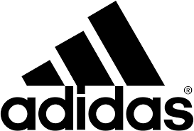
Introduction

Started as an athletic shoe designer and manufacture company, Adidas has marked their success in apparel and accessories products as well. Adidas AG, a German sportswear and sporting goods multinational company is the leading manufacturer in Europe and worldwide it is in the second largest. Adidas is the major supplier of European Football. Its headquarter is located in Herzogenaurach, Germany but its stores are established in major cities around the world. The latest net sale of Adidas worldwide was around 19.84 billion Euros. (Statista, 2021).

Blog 1- The Story of Adolf Dassler and Adidas

Adolf Dassler, also known as Adi Dassler was born in 1900 in Herzogenaurach, Germany. After completing high school, he followed his father’s desire and started his training to be a baker. Baking did not seem appealing to him. So, he decided to gain shoe making skills.

Adi Dassler was passionate about sports. In 1924, he registered their family business along with his brother Rudolf Dassler as ‘Gebrüder Dassler, Sportschuhfabrik, Herzogenaurach’ (‘Dassler Brothers Sports Shoe Factory’, Herzogenaurach).


Their aim was to deliver the finest shoes to the athletes. Adi Dassler saw his first success in 1928 Olympics when Lina Radke, a German distance runner wore his shoes and won Gold medals in Amsterdam.

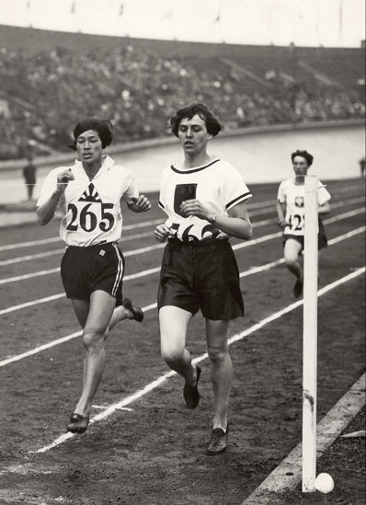
His continuous innovation as well as considering feedbacks from athletes and testing made his products more creative and best in quality. In 1948, Adolf Dassler and Rudolf Dassler split their family business (Walters, 2020).
Lina Radke in Adi Dassler’s shoes

On August 18, 1949, Adi Dassler registered his separate business as Adi Dassler Adidas Sportschuhfabrik with 47 employees in Herzogenaurach. That year he also registered the forthcoming famous Adidas 3-stripes shoe.
Adi Dassler in Gebrüder Dassler
The miracle happened when German National Football Team won the 1954 world cup with the unconquerable Hungary wearing Adidas shoes and this victory spread the name of Adidas everywhere (Adidas-group.com,2022).

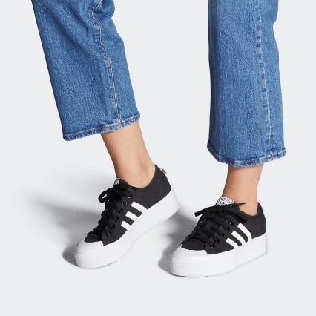
Blog 2- Adidas and its products

Adidas is well known for its quality since 1928. Adidas products can be categorized in 3 parts such as footwear, apparel and accessories and gear. They focus on environment along with their product quality.
Their aim is to provide the best quality in sustainable way. That’s why Adidas use recyclable and sustainable materials in their products. The most used materials are “Better Cotton”, recycled polyester, recycled nylon, recycled rubber, algae-based EVA, TENCEL, water-based polyurethane (PU), and recycled thermoplastic polyurethane (TPU) (Adidas-group.com, 2022).
Nizza Platform Shoes

The top seller shoes of Adidas in UK are Nizza Platform Shoes (Women Originals), Adilette Aqua Slides (Sportswear), Gazelle Shoes, OZWEEGO Shoes (Youth 8-16 Years Originals), Advantage Shoes (Kids 4-8 Years Sportswear) (Adidas-group.com, 2022).

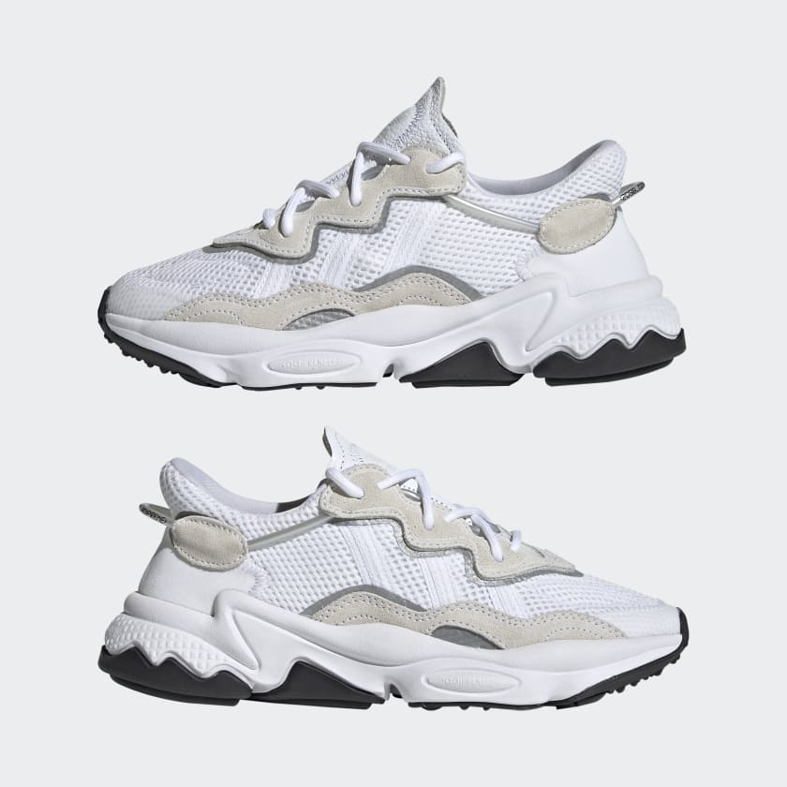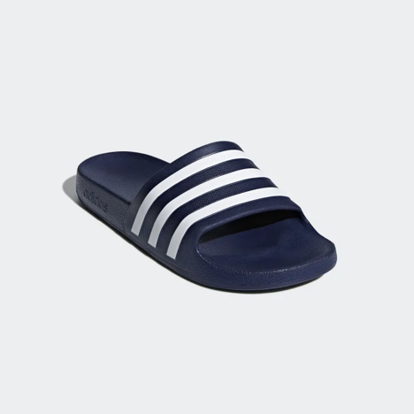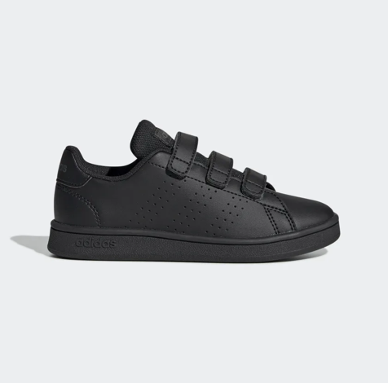
Advantage Shoes
Adilette Aqua Slides
OZWEEGO Shoes

In 2020, approximately 6.56 million people bought Adidas products and thus made Adidas the most beloved shoe products and Adidas sports apparel was placed second by selling 4.96 million customers (Adidas: UK leading products 2013-2020 | Statista, 2022).

Blog 3- Adidas pricing strategy

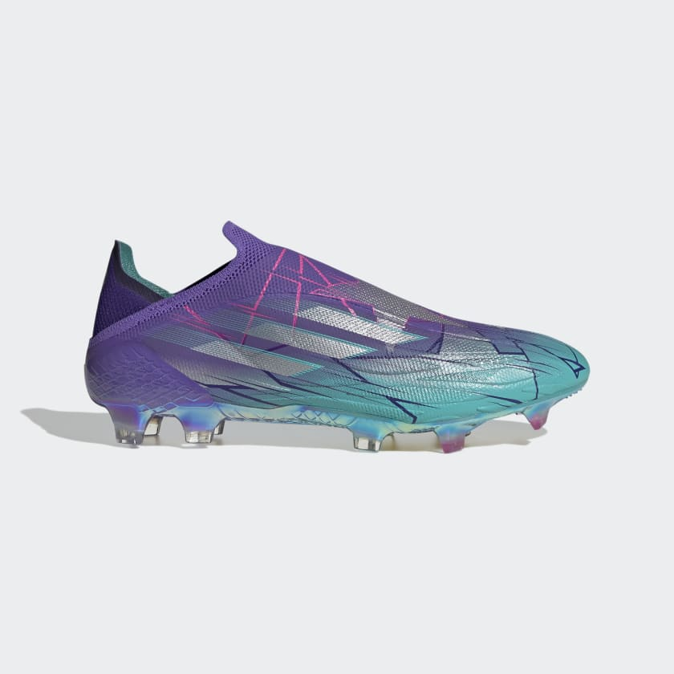
Adidas generally follows two types of pricing strategy. The competitive pricing strategy is for regular products and the skimming pricing strategy is used for new products. Skimming pricing strategy means setting an initial higher price for any new launched product that will be gradually decreased for the price sensitive customers. Adidas’ premium products are mostly targeted for elite users (Nbc News, 2019).

The price list of few Adidas UK products are-
X Speed Flow + Firm Ground Boots
Prime Green Essential 3-Stripes Track Suite | €55
X Speed Flow + Firm Ground Boots | €230
Lightweight Embroidered Baseball Cap | €17
Nizza Platform Shoes | €50
Gazelle Shoes | €70
Advantage Shoes | €28
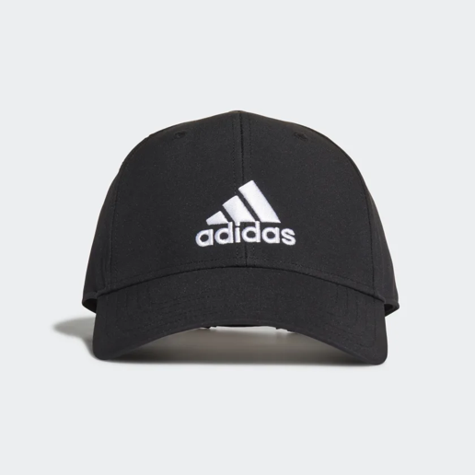

In 2020, Adidas world wide net sales were 56% generated from footwear, 39% from apparel and 5% from accessories (Tighe, 2021).

Lightweight Embroidered Baseball Cap

Blog 4- Sustainability and Adidas targets

Adidas always aim to become a sustainable company that can be more environment friendly. Their root purpose for this sustainability is Adidas believe they have the influence of changing lives through sports.
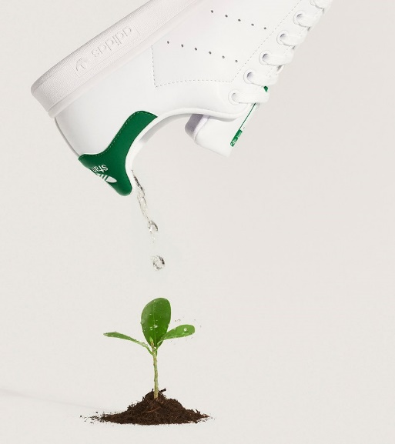

They set few targets to amplify their journey towards sustainability by focusing on-
- Reducing GMH emission by 15%.
- Reducing greenhouse gas emission of their entire value chain by 30% within 2030 and by 2050 they will move toward more climate neutral approach.
- They will focus on identification and management of high risk factors concerned with human rights of their total value chain systems (Adidas-group.com, 2022).

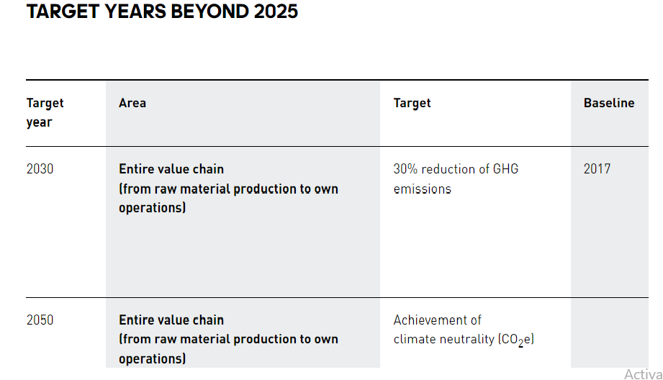
Adidas launched two new style shoes Ultraboost 21 x Parley and Ultraboost 6.0 DNA x Parley which materials are collected from the beach plastic wastages. They also launched Ultraboost Made to be Remade that customers can return after using and Adidas will grind it and make something new from those materials (Bell, 2021).

Blog 5- Adidas distribution strategy

Adidas has a centralized and integrated team and with them they are executing their new business plan- “Creating New” across the 6 global markets. They have more than 2500 own-retail stores, not less than 15000 franchise stores and 150,000 wholesale doors (Forbes, 2018). Their e-commerce channel is giving access to almost 40 countries around the world to order their products through online platform.

From 2019 Adidas emphasized on digital partner investment and spread their partners across Europe, North America, Asia- Pacific and Emerging Markets. This approach is helping them to get continuous sale growth for present and future.

Moreover, in 2019, the expansion in Adidas app that has access over 30 countries around the world is creating a meeting point of customers in Adidas digital network. The app is successfully providing personalized service to the customers. They also offer “Creators Club” a membership program to the customers who can avail diverse benefits.

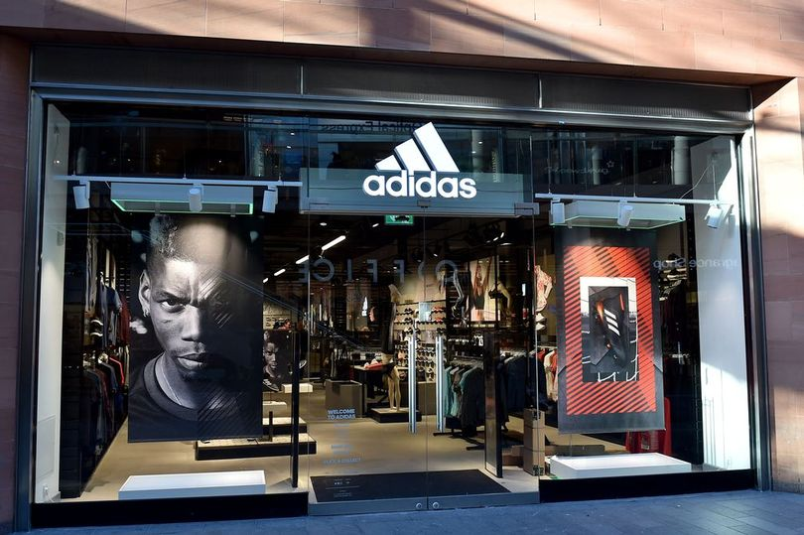

Delivering better customer experience, they took an initiative of “Controlled Space” where they can offer optimal products and control brand values. Controlled space can influence their business by more than 60% revenue generation.

Adidas prioritize key cities to give a holistic brand experience and to achieve double revenue from these zones (Sales and Distribution Strategy - adidas Annual Report 2019, 2019).

It was expected that the industry would see a negative effect rather the Adidas UK saw a post-Covid sales growth due to online services. The turnover of 2020 decreased from €1.1bn to €1.045bn. Adidas stated the move toward digital platform helped them to compensate the pandemic situation (Robinson, 2021).

Blog 6- Adidas Promotion Strategy


The three stripes company have gone through many struggles and that what makes them more attractive. Just like their logo means moving forward in a challenging path, it tells the struggle and success of athletes. From the first success in Olympic 1928 to till now Adidas have shown their magic with athletes and sport lovers.

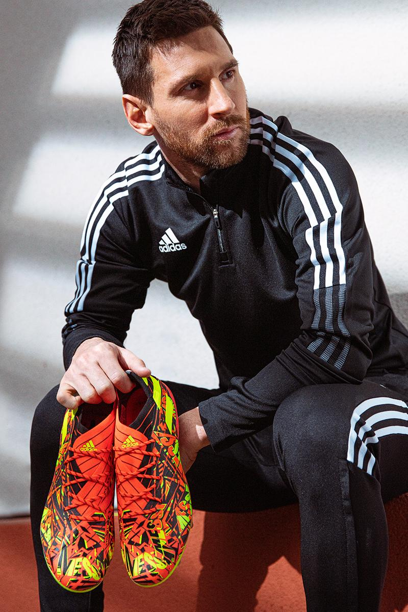


They have endorsed many famous footballers like Leonel Messi from Argentina, Von Miller from America, Vincent Kompany from Belgium, French player Kylian Mbappe, David Beckham. They also endorsed baseball players, golfer and hockey players like Kris Byrant, Carlos Correa, Fred Van Vleet, Justin Rose and Sydney Crosby (Nbc News, 2019).

Adidas have not only collaborated with the sportsmen but also they have collaborated with following stars- Beyonce, Kylie Jenner, Kanye West, Alexander Wang, Donald Glover and many more.
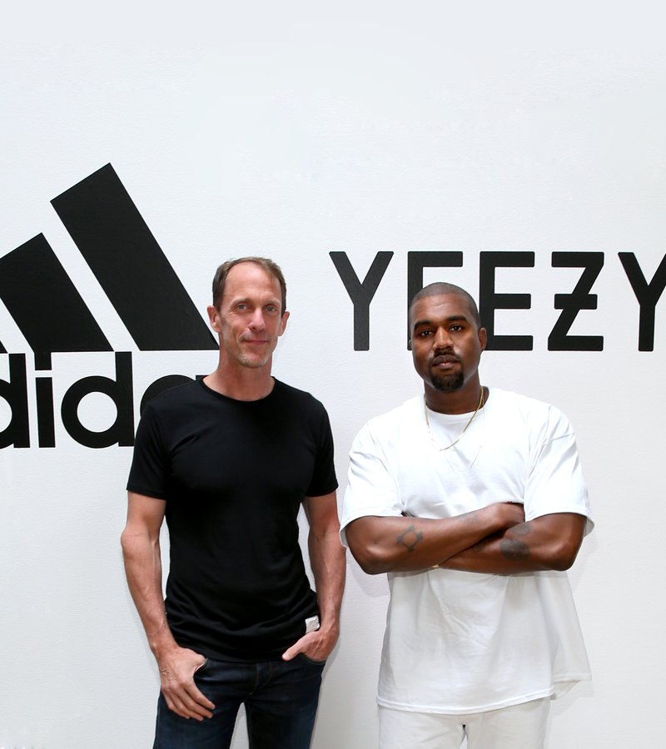

On June, 2016 Adidas and Kanye West made a partnership of developing and creating products for YEEZY. That was a historical partnership between an athletic brand and non-athlete (Adidas-group.com,2016)

In 2018 Kylie Jenner became the brand ambassador of Adidas. She made her appearance with Adidas Falcon sneakers (Forbes, 2018).

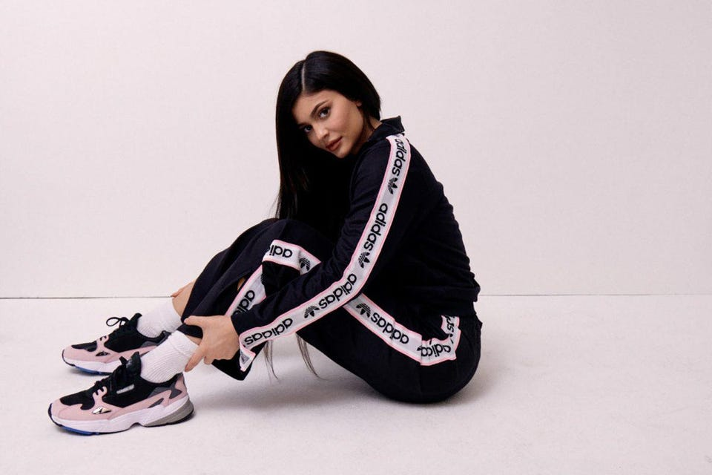
In 2019 Beyonce signed a contract with Adidas as a creative partner to relaunch her Ivy Park Brand (nbcnews.com,2019)

Blog 7- Adidas “Own the Game” strategy

Own the Game strategy will lead Adidas till 2025. This strategy is the plan for building more reliability, enhancing consumer’s positive experiences and creating a more sustainable organization through innovation and digital revolution across every aspect of their business.

People are the core part of this strategy where Adidas believe consumers should be the main focus of everything they will do. They care about their employees and they believe together they can achieve anything. They are optimistic and see enormous possibilities. They are individually trained yet a great team altogether. They strategy stands on three pillars that are leadership, betterment and performance.

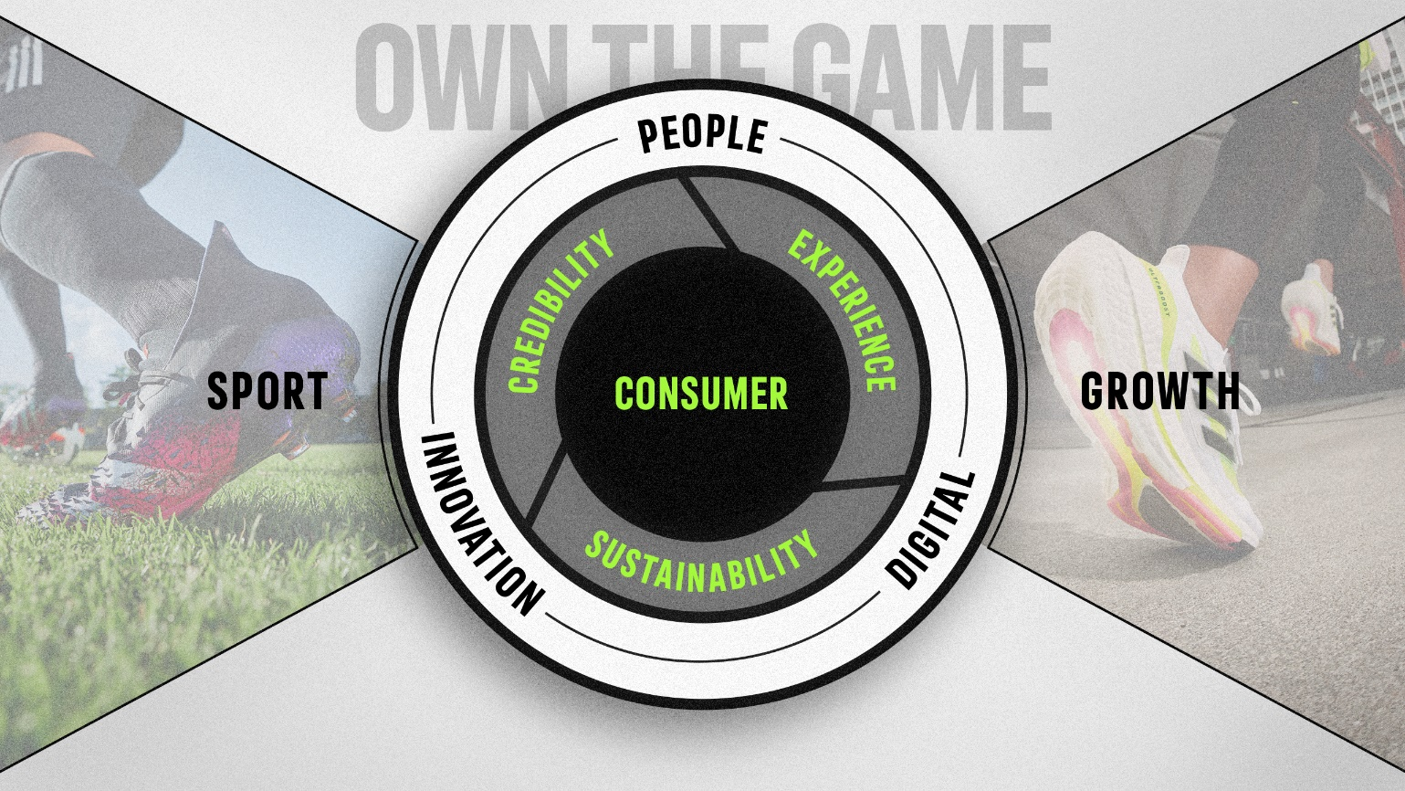

To achieve credibility, they are focusing on Sports, lifestyle, women and partnerships. In sports they categorized Football as a sports of viewership, Training, Running and Outdoor as a sport of participation (Edrawsoft. 2022).
To enhance lifestyle, they are introducing new product name Sportswear and for women consumer they are planning to increase women’s share in their business.

To create a long term relationship with consumers, Adidas enhancing consumer experience by enabling individual digital and store spaces. Launching membership makes customer more engaged with the brand and DTC-led, key cities such as London, Los Angeles, New York, Paris, Shanghai, and Tokyo, by adding Mexico City, Berlin, Moscow, Dubai, Beijing, and Seoul will influence the rest of the world.

To ensure sustainability, Adidas aim to reduce CO2 in their entire system and by 2025 their 90% articles will be about sustainability (Zhu, 2021). From raw materials to product packaging, in every dimensions of their business they will be more sustainable than before.

Innovation and Digitalization will accelerate the success of this strategy. The first one will accelerate the far-reaching mentality and second one will speed up the entire value chain (Adidas-group.com,2022).

Conclusion

Adidas is ambitious about establishing a sustainable environment friendly organization with an aim of delivering the best quality products to customers. During and after Covid-19 pandemic when every organization was expecting higher turnover, in that time in UK market Adidas have seen the less turnover. That was possible because they shift their business into digital platform. The journey of Adidas was never smooth but they could fight back and come back like a winner because they value their consumers, employees. Better culture and continuous product innovation as well as sustainability are their unique features.

References

adidas-group.com. 2022. [online] Available at: < https://www.adidas-group.com/en/> [Accessed 14 March 2022].

adidas Annual Report 2019. 2019. Sales and Distribution Strategy - adidas Annual Report 2019. [online] Available at: <https://report.adidas-group.com/2019/en/group-management-report-our-company/corporate-strategy/sales-and-distribution-strategy.html> [Accessed 14 March 2022].

Bell, J., 2021. Here Are 5 Reasons Adidas Deserves the 2021 Sustainability Leadership Award. [online] Footwear News. Available at: <https://footwearnews.com/2021/business/awards/adidas-sustainability-award-fnaa-2021-1203213901/> [Accessed 14 March 2022].

Edrawsoft. 2022. Adidas Marketing Mix (4Ps) Analysis. [online] Available at: <https://www.edrawmind.com/article/adidas-marketing-mix-analysis.html> [Accessed 14 March 2022].

Forbes., 2018 Available at: <https://www.forbes.com/sites/declaneytan/2018/08/29/kylie-jenner-joins-adidas-as-latest-brand-ambassador/?sh=26dabb661e91> [Accessed 14 March 2022].
https://www.nbcnews.com/news/nbcblk/beyonce-signs-adidas-partnership-lifetime-will-relaunch-ivy-park-brand-n991041

Nbc News, 2019 Available at https://www.nbcnews.com/news/nbcblk/beyonce-signs-adidas-partnership-lifetime-will-relaunch-ivy-park-brand-n991041 [Accessed 14 March 2022].

Robinson, J., 2021. Sports clothes giant eyes sales rise past £1bn. [online] Business Live. Available at: <https://www.business-live.co.uk/retail-consumer/adidas-uk-eyes-sales-rise-21786971> [Accessed 14 March 2022].

Statista. 2022. Adidas: UK leading products 2013-2020 | Statista. [online] Available at: <https://www.statista.com/statistics/312049/adidas-leading-products-in-the-uk/> [Accessed 14 March 2022].

Statista. 2021. Number of adidas stores worldwide 2008-2018 | Statista. [online] Available at: <https://www.statista.com/statistics/268442/number-of-retail-stores-of-the-adidas-group-worldwide-by-store-type/> [Accessed 13 March 2022].

Tighe, D., 2021. Net sales share of adidas worldwide in 2020, by product category. [online] Statista. Available at: <https://www.statista.com/statistics/268444/share-of-adidas-retail-net-sales-worldwide-by-store-format/> [Accessed 14 March 2022].

Walters, M., 2020. Adolf Dassler: The Creative and Innovative Leader Behind adidas | adidas GamePlan A. [online] adidas GamePlan A. Available at: <https://www.gameplan-a.com/2020/11/adolf-dassler-the-creative-and-innovative-leader-behind-adidas/?utm_medium=external%20link&utm_source=adidas-group.com&utm_campaign=adidas-website_adi-dassler-story-> [Accessed 13 March 2022].

Zhu, J., 2021. Analysis on Adidas Marketing Strategies in 4P Model. Scientific and Social Research, 3(5), pp.67-75.

