Rhiannon Thomas
P149985
Agent AI
Search Algorithms
Lecturer: Gordon Dickers

Contents Page No

- Introduction | 3
- Code Descriptions and Screenshots | 3
- User Guide | 10
- Test Schedule | 11
- Appendix | 13
- Bibliography | 18

Introduction
The task is to develop a search algorithm that will meet the requirements of the search AI and write a group of related functions that can be used to implement the program. A program has been created with a start and finish position. The AI bot will start at position ‘S’, find the key at position ‘K’ and then find the door at position ‘D’.

Code Descriptions and Screenshots
This section will explain the code that has been used to produce the program, screenshots are also provided.

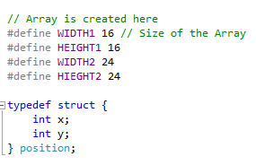
- Line 8 – 16

Four arrays have been created which will be the size of the maze, the first maze will be a 16x16 so the array will be the same size and the second maze will be 24x24, so the array will also be the same size.
A struct has been created called “Position” so this will mark the position x and y. The maze will be made of coordinates so the x and y is needed to determine where the AI bot is in the maze.

- Line 18 – 20
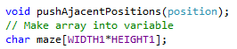

pushAjacentPositions is a function which will be used later in the programme.
The array has been put into variable called maze.

- Creating a stack
Here a stack has been created called “dfsStack”. A stack is needed in this program so the current position can change, for the AI bot to move the x and y current positions will need to change. For example, the x and y positions will be stored in current position then they will be needed to be pushed out of the way for the new x and y coordinated.

- Files
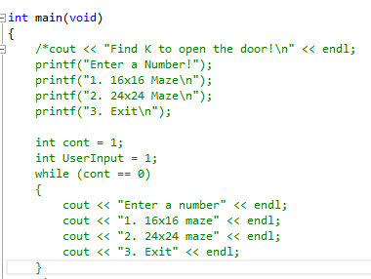

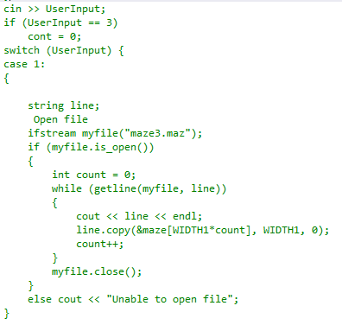

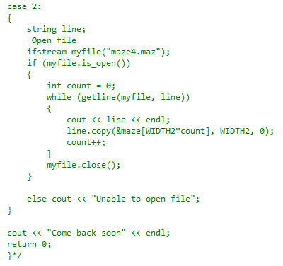

Here is an attempt that players can click the option of having either a 16x16 maze or 24x24 maze. However, this doesn’t work properly, only the files can be outputted [1].

- Initialising positions
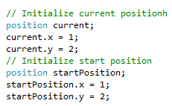
This is where the current and startPosition is initialised using the position structure of x and y.

- Opening file
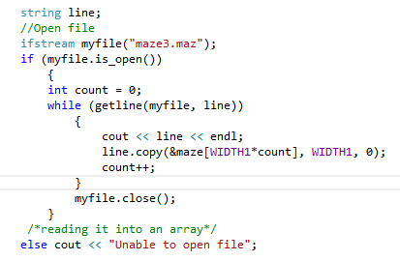

This is where the file called “maze3.maz” is found. The file will be stored in the project file so the program will be able to find the file. If the file is not found then then a message should output saying “Unable to open file”.

- Reading file into array
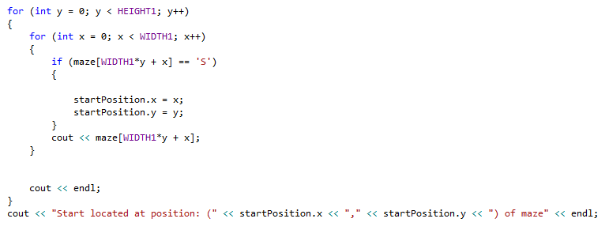
The file “maze3.maz” will be read into the array maze which has been created at the top of the programme. The x and y startPositions will be stored in the WIDTH1 and HEIGHT1 (The array) to determine where the AI bot will start in the array. The coordinates will the be outputted onto the screen.

- Initializing stack with start position
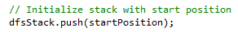
The stack has now pushed the x and y start positions into the stack

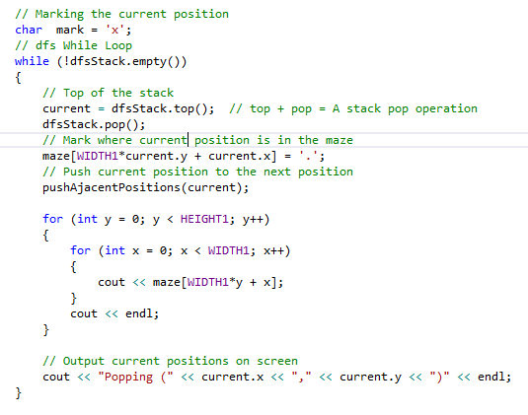
- Popping current positions

Firstly, a char variable has been made so the current positions have been marked.
A while loop has been created so while dfsStack is not empty:
- Make current (current position) at the top of the stack
- Pop the current position (Remove from stack for other coordinates to push into stack)
- Mark where the AI bot currently is, dots will appear on the screen to show where the AI bot is. This will also ensure that the AI bot won’t go back and forth in the same position, once the position is marked the AI bot will move to a different position
- pushAjacentPositions have been called so the current position will be able to move to the next position.
- For loop is used to move the x and y positions in the array
Finally, output the current positions.

- pushAjacentPositions function
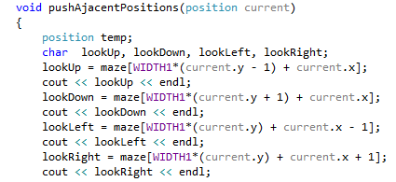
Position current has been passed in through the function so current positions can be used in the function. A temporary position has been created to able to push the position onto the stack. lookUp, lookDown, lookLeft and lookRight variables have been created so the AI bot can look up, down, left and right In the maze to see if there is anything there.
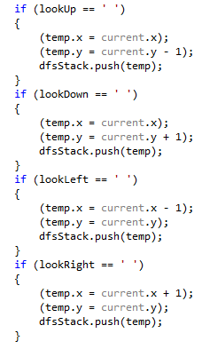

Here are if statements which will allow the AI bot to see whether there is a space available upwards, downwards, right and left. If there is a space, then push the temporary current position onto the stack for the AI bot to move into that space.
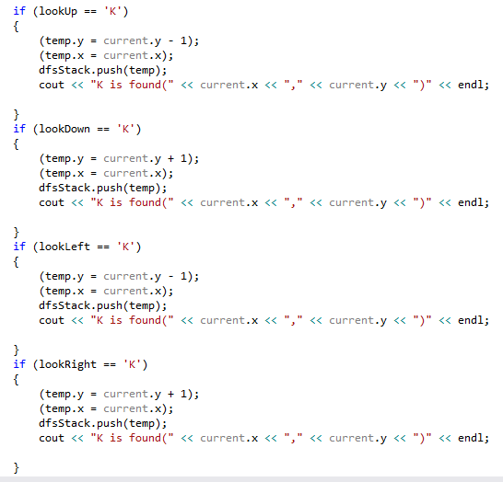
These if statements will let the player know when K is found. A message will output on screen when K is found followed by the coordinates.
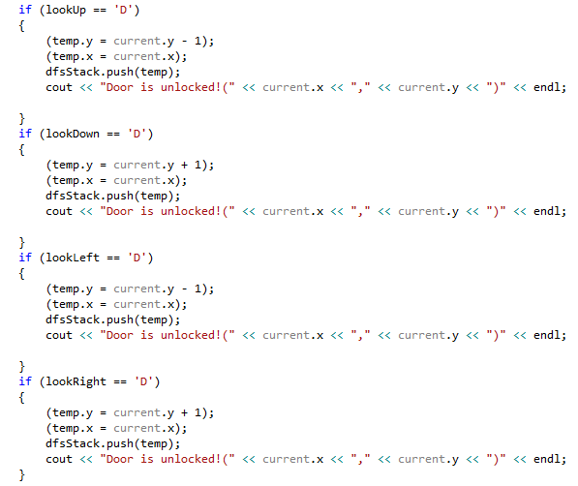
These if statements will let the player know when D is found. A message will output on screen when door is unlocked followed by the coordinates.

Some code has been used from Moodle [2]

User Guide
This will show users how to use the application correctly.

Keyboard Command: | Description: | Screenshot:
1 | This should create a 16x16 maze. However, the maze is created but no AI bot | 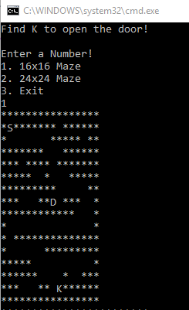
2 | This should create a 24x24maze. However, the maze is created but no AI bot. | 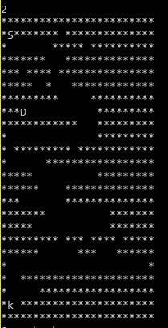

Test Schedule

Name: | Description: | Pass/Fail: | Screenshot:
Opening a 16x16 maze | This will allow the user to choose a 16x16 maze when 1 is pressed. | Fail – Only shows file
Opening a 24x24 maze | This will allow the user to choose a 24x24 maze when 2 is pressed. | Fail – Only shows file
Start Position | This will show the Start Position with the correct coordinates | Pass | 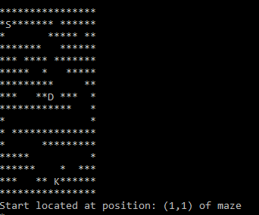
Finding K | This will show that K is found with the correct coordinates. | Pass | 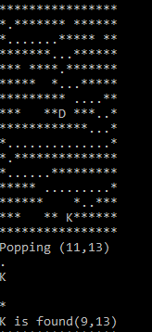
Unlocking Door | This will show that D is found with the correct coordinates. | Pass | 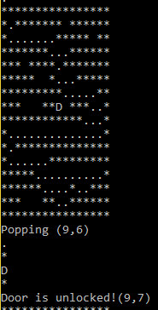

Appendix
#include <stack>
#include <iostream>
#include <fstream>
#include <string>
using namespace std;

// Array is created here
#define WIDTH1 16 // Size of the Array
#define HEIGHT1 16
#define WIDTH2 24
#define HIEGHT2 24

typedef struct {
int x;
int y;
} position;

void pushAjacentPositions(position);
// Make array into variable
char maze[WIDTH1*HEIGHT1];

stack <position> dfsStack; // stack for dfs reaversal

int main(void)
{
cout << "Find K to open the door!\n" << endl;
//printf("Enter a Number!\n");
//printf("1. 16x16 Maze\n");
//printf("2. 24x24 Maze\n");
//printf("3. Exit\n");

//int cont = 1;
//int UserInput = 1;
//while (cont == 0)
//{
// cout << "Enter a number" << endl;
// cout << "1. 16x16 maze" << endl;
// cout << "2. 24x24 maze" << endl;
// cout << "3. Exit" << endl;
//}
//cin >> UserInput;
//if (UserInput == 3)
// cont = 0;
//switch (UserInput) {
//case 1:
//{

// string line;
// //Open file
// ifstream myfile("maze3.maz");
// if (myfile.is_open())
// {
// int count = 0;
// while (getline(myfile, line))
// {
// cout << line << endl;
// line.copy(&maze[WIDTH1*count], WIDTH1, 0);
// count++;
// }
// myfile.close();
// }
// else cout << "Unable to open file";
//}

//case 2:
//{
// string line;
// // Open file
// ifstream myfile("maze4.maz");
// if (myfile.is_open())
// {
// int count = 0;
// while (getline(myfile, line))
// {
// cout << line << endl;
// line.copy(&maze[WIDTH2*count], WIDTH2, 0);
// count++;
// }
// myfile.close();
// }

// else cout << "Unable to open file";
//}

//cout << "Come back soon" << endl;
//return 0;
//}

// Initialize current positionh
position current;
current.x = 1;
current.y = 2;
// Initialize start position
position startPosition;
startPosition.x = 1;
startPosition.y = 2;

string line;
//Open file
ifstream myfile("maze3.maz");
if (myfile.is_open())
{
int count = 0;
while (getline(myfile, line))
{
cout << line << endl;
line.copy(&maze[WIDTH1*count], WIDTH1, 0);
count++;
}
myfile.close();
}
/*reading it into an array*/
else cout << "Unable to open file";

cout << endl << endl << endl;

for (int y = 0; y < HEIGHT1; y++)
{
for (int x = 0; x < WIDTH1; x++)
{
if (maze[WIDTH1*y + x] == 'S')
{

startPosition.x = x;
startPosition.y = y;
}
cout << maze[WIDTH1*y + x];
}

cout << endl;
}
cout << "Start located at position: (" << startPosition.x << "," << startPosition.y << ") of maze" << endl;

// Initialize stack with start position
dfsStack.push(startPosition);

//for (int i = 0; i < 10; i++) // Push lots of positions onto the stack to test it
//{
// for (int j = 0; j < 10; j++)
// {
// current.x = i;
// current.y = j;
// dfsStack.push(current);
// }
//}

// Marking the current position
char mark = 'x';
// dfs While Loop
while (!dfsStack.empty())
{
// Top of the stack
current = dfsStack.top(); // top + pop = A stack pop operation
dfsStack.pop();
// Mark where current position is in the maze
maze[WIDTH1*current.y + current.x] = '.';
// Push current position to the next position
pushAjacentPositions(current);

for (int y = 0; y < HEIGHT1; y++)
{
for (int x = 0; x < WIDTH1; x++)
{
cout << maze[WIDTH1*y + x];
}
cout << endl;
}

// Output current positions on screen
cout << "Popping (" << current.x << "," << current.y << ")" << endl;
}

return 0;
}

void pushAjacentPositions(position current)
{
position temp;
char lookUp, lookDown, lookLeft, lookRight;
lookUp = maze[WIDTH1*(current.y - 1) + current.x];
cout << lookUp << endl;
lookDown = maze[WIDTH1*(current.y + 1) + current.x];
cout << lookDown << endl;
lookLeft = maze[WIDTH1*(current.y) + current.x - 1];
cout << lookLeft << endl;
lookRight = maze[WIDTH1*(current.y) + current.x + 1];
cout << lookRight << endl;

// Tests
if (lookUp == ' ')
{
(temp.x = current.x);
(temp.y = current.y - 1);
dfsStack.push(temp);
}
if (lookDown == ' ')
{
(temp.x = current.x);
(temp.y = current.y + 1);
dfsStack.push(temp);
}
if (lookLeft == ' ')
{
(temp.x = current.x - 1);
(temp.y = current.y);
dfsStack.push(temp);
}
if (lookRight == ' ')
{
(temp.x = current.x + 1);
(temp.y = current.y);
dfsStack.push(temp);
}

if (lookUp == 'K')
{
(temp.y = current.y - 1);
(temp.x = current.x);
dfsStack.push(temp);
cout << "K is found(" << current.x << "," << current.y << ")" << endl;

}
if (lookDown == 'K')
{
(temp.y = current.y + 1);
(temp.x = current.x);
dfsStack.push(temp);
cout << "K is found(" << current.x << "," << current.y << ")" << endl;

}
if (lookLeft == 'K')
{
(temp.y = current.y - 1);
(temp.x = current.x);
dfsStack.push(temp);
cout << "K is found(" << current.x << "," << current.y << ")" << endl;

}
if (lookRight == 'K')
{
(temp.y = current.y + 1);
(temp.x = current.x);
dfsStack.push(temp);
cout << "K is found(" << current.x << "," << current.y << ")" << endl;

}

if (lookUp == 'D')
{
(temp.y = current.y - 1);
(temp.x = current.x);
dfsStack.push(temp);
cout << "Door is unlocked!(" << current.x << "," << current.y << ")" << endl;

}
if (lookDown == 'D')
{
(temp.y = current.y + 1);
(temp.x = current.x);
dfsStack.push(temp);
cout << "Door is unlocked!(" << current.x << "," << current.y << ")" << endl;

}
if (lookLeft == 'D')
{
(temp.y = current.y - 1);
(temp.x = current.x);
dfsStack.push(temp);
cout << "Door is unlocked!(" << current.x << "," << current.y << ")" << endl;

}
if (lookRight == 'D')
{
(temp.y = current.y + 1);
(temp.x = current.x);
dfsStack.push(temp);
cout << "Door is unlocked!(" << current.x << "," << current.y << ")" << endl;
}

}

Bibliography

[1] | “Sending Keyboard Commands,” Stack Overflow, [Online]. Available: https://stackoverflow.com/questions/3410972/sending-keyboard-commands.
[2] | G. Dickers, “Moodle,” [Online]. Available: https://moodle.uwtsd.ac.uk/course/view.php?id=2266.

