Carol Wheelwright – 1811089

Graduate Diploma in Professional Learning SLD/PMLD

Module no: M6X02188

Module Title: Teaching, the Curriculum and Assessment

Does the use of an online programme develop the understanding of the core mathematical concept of time with a group of learners aged 18 and 19 years old with severe learning difficulties?

Contents

Introduction Page 3
Literature Review Page 4
Methodology Page 7
Results and Analysis Page 9
Summary and Conclusion Page 17
Appendix 1 Page 19
Appendix 2 Page 20
Appendix 3 Page 21
References Page 22

Introduction

The focus of this research project is to find out if the use of an online programme supports the development of the understanding of the core mathematical concept of time with a group of learners aged 18 and 19 years old with severe learning difficulties.
This research project will consider the use of Information and Communication Technology in the classroom as an effective teaching method. The participants; eleven young adults, form a whole class and are yet to acquire some of the mathematical concepts and the confidence to use and apply numerical skills in everyday life. The new curriculum in Wales states that “young people will be healthy, confident individuals who have the skills and knowledge to manage everyday life as independently as they can” (Donaldson, 2015, p30). In order to be independent, this group of young people will need to leave school with the ability to tell the time which is considered a basic life skill.
According to the new Professional Standards for Teaching and Leadership, “the teacher will consistently secure the best outcomes for learners through progressively refining teaching, influencing learners and advancing learning” (Learning Wales, 2017). The participants have encountered many teachers and learning experiences during their time at this special school. In order to make progress in telling the time, a new approach to teaching this subject is required.
Children and young people are accustomed to seeing a digital representation of time on smart phones or on other technological devices such as iPads and digital watches. While there may be few instances in which young people have to rely on being able to read an analogue clock, they do help to secure an understanding of the passage of time because they have hands that are consistently moving. Analogue clocks also show time in multiples of five, which is not as transparent with digital clocks.
The online programme that has been selected for this research project uses strategies which support the development of the mathematical concept of time which have been broken down into manageable stages and explained in a way that is much easier to understand. A range of interactive videos and games will help the participants learn every aspect of time, from basic facts to converting digital time into the 24 hour clock.

Literature Review

All children and young people should have access to a broad and balanced curriculum. The curriculum for Wales places a strong emphasis on setting suitable challenges for learners whereby teachers should set high expectations for every learner. It is important to respond to individual learners’ needs and overcome potential barriers to access and participation.
As stated in Successful Futures,
Schools will need to design pedagogical approaches to match the specific learning needs of their individual children and young people. The curriculum will provide scope for creativity and innovation and it will be vitally important that teachers use this scope to develop and deliver programmes of learning that are relevant and meaningful to the children and young people in their schools (Donaldson, 2015, p91).
The curriculum empowers teachers to modify the approaches that are used to “ensure that there is a continuum of learning upon which all children can find their appropriate place and progress, consolidate, or maintain their learning” (Staves, 2001, Introduction).
The use of mathematics is part of everyday life. There have been many debates in recent years between those who believe in traditional methods of teaching mathematics and those who believe that the best way to learn mathematical concepts is through a more practical approach. It is believed that teaching mathematics in an interesting and relevant way enables learners to participate and develop. Traditionally, the teaching of mathematics has included mathematical correctness and precision with a concentration on mastering the basics; particularly for those who may find the acquisition of these basic skills more difficult to comprehend.
Measurement is one of the most difficult concepts to grasp for any learner and the understanding of time as a measurement concept occurs developmentally with learners at approximately 7-8 years old. As detailed in Successful Futures “competence in numeracy is essential for independent living and work” (Donaldson, 2015, p40). The participants who have consented to take part in this action research project are all young adults who are yet to acquire some of the mathematical concepts and the confidence to use and apply numerical skills in everyday life. Knowles argues that “most adult learners want to be in control of their learning” (Bates, 2019, p62). The participants in this project recognise the need to acquire the skills for telling the time which should in turn, motivate them to engage in the learning process and succeed.
The Cockroft Report of 1982, which was written prior to the publication of the UK National Curriculum discusses mathematics as a subject. Even though it makes no reference to children with learning difficulties, it gives valuable advice. It highlights that even conventionally developing children and adults will inevitably learn mathematical concepts at greatly differing speeds due to the complexity of the subject. The report refers to the hierarchical nature of the subject and suggests that the ability to learn mathematics is dependent on understanding and applying one or more concepts and the ability to comprehend the more abstract concepts.
Gelman and Gallistel (1978) established six basic principles of understanding number and insisted “on the cardinality principle being understood before the concept of number can be fully realised” (Imray and Hinchcliffe, 2014, p165). Research that has been carried out with typically developing children shows that cardinality emerges around the fourth birthday. For a significant number of children in specialist schools, they may not ever reach the developmental milestones of a four year old child.
There are a number of factors which affect a person’s ability to learn mathematical concepts. These are wide ranging but research in this field would suggest that they include: the need to do calculations quickly, rote learning facts and procedures, tasks that are beyond the capacity of the learner’s working or short term memory and the extensive use of symbols and inconsistent terminology used.
McConkey and McEvoy (1986) believe that children with Severe Learning Difficulties (SLD) find mathematics difficult due to the multi-dimensional skills needed. They recommend the use of games to teach mathematical concepts in an interesting and motivating way.
Some researchers suggest that interactive whiteboards should be used sparingly. It is believed that when games and songs are shown on a whiteboard that they can become “abstractions and difficult for someone with SLD (who will struggle with abstract concepts) to relate to in a concrete way” (Imray and Hinchcliffe, 2014, p166). The aim is for the online programme that has been chosen for this research project to challenge this view.
During the last 30 years, schools have invested heavily in Information and Communication Technology (ICT) for use by teachers and pupils in the classroom. Information can be presented in different ways when using ICT; this can be a powerful way of presenting or representing information. “Ideas and concepts can be shown dynamically such as in mathematical modelling or by helping to visualise complex processes” (Higgins, 2003, p8).
“Computers have been available in special schools since the early 1980s and have led to progress by learners which could not have been envisaged otherwise” (Lacey et al. 2015, p347). Much of the research in the area of technology tends to focus on a particular device or piece of software as opposed to attempting to understand the ways in which each can be used in an educational context.
Technology can be used to improve the quality of a teacher’s explanations and enhance the way in which new concepts and ideas are modelled; the introduction of a new form of technology will not automatically change the way in which teachers teach. Providing clarity and accessibility to pupils is vitally important. “Interactive whiteboards are a good example highlighting the need to consider the pedagogical rationale for adopting a form of technology, and for carefully planning the training required to enable teachers to use it effectively” (Education Endowment Foundation, 2019).
Technology can be engaging and motivating for pupils. However, the relationship between technology, motivation, and achievement is complex. It is expected that the use of the online programme which has been selected for this research project engages the participants and generates interest in the sessions in order to prepare them to learn by giving them a reason to pay attention to the material.

Methodology

This study will be carried out using action research. According to McNiff (2017, p9) “Action research is a practical form of enquiry that enables anyone to investigate and evaluate their work”. Action research is used to collect new information as opposed to testing a theory. “This new information can be reviewed, evaluated and continue to improve practice after the study has finished” (Bell, 2010).
Prior to conducting the research project, ethical approval was sought from the University’s Ethics committee to ensure that the project did not breach any legal boundaries and that it adhered to accepted ethical standards. Ethical guidelines outlined in the ‘Ethical Guidelines for Educational Research’ and in the ‘Research Ethics & Integrity Code of Practice’ were adhered to throughout the project.
The participants, eleven young people (eight boys and three girls) form a whole class within a school. The research project was conducted in a familiar classroom which the participants use on a daily basis. The learning environment was organised to ensure that the participant’s needs were met; as detailed in Maslow’s work. Consideration was given to seating arrangements, room temperature, group dynamics and reward systems.
In accordance with the Ethical Guidelines for Educational Research “researchers should do everything they can to ensure that all potential participants understand, as well as they can, what is involved in a study” (BERA, 2018). Each pupil was appropriately informed about the research; they received written information (Appendix 1) about what was expected of them and what would happen to the information that they provided. The information was supported by the use of widget symbols; this visual aid supported the pupils understanding of what they had read. The participants in the project were also given the opportunity to ask questions about the project.
An assessment task was used at the start and end of the project to establish a baseline and to measure progress. The assessment task was designed to obtain data from the participants with regard to their level of knowledge and skills; the production of raw data could then be analysed and interpreted. The assessment task was completed by all of the participants to form a baseline assessment of the participant’s ability and skills. The assessment task was given to the participants at the same time; they were given the same amount of time to complete the assessment task and expected to complete it independently.
The raw data was RAG rated i.e. used red, amber and green colours to identify the skills that the participants have achieved (green), partly achieved (amber) or not achieved (red), and presented in a table; this allowed the data for the whole group to be compared and form an analysis. The results from the assessment task were also used to baseline the pupil’s knowledge and skills against the National Literacy and Numeracy Framework (LNF) and PIVATS performance indicators. In this research, quantitative methodology was used to collect and analyse the data obtained from all of the participants.
In order to assure the validity of the research, more than one method of data collection was used. An observation checklist was designed, and then piloted to ensure that observations were recorded in the most objective way possible and to prevent the production of different accounts and eliminate/prevent variations (Appendix 2). The participants were observed during an introductory and final teaching session. The skills that were observed during these sessions were also RAG rated. The structured observations were used to validate the results of the baseline and final assessment and to make comparisons.
The online programme was delivered to the group twice a week for one hour for a total of six weeks. The online programme has been well developed with carefully planned lessons designed around small learning increments and clearly defined and prescribed activities.
At the end of the six weeks, the same assessment task and observation checklist was used to reassess the participant’s ability/skills and gather the data to be compared and analysed. The participants were also asked to complete a questionnaire at the end of the project which was used to obtain their views about the impact of the project on their learning (Appendix 3).

Results and Analysis

The results from the action research project are presented below. Figure 1 shows the results of the assessment task that was completed by the participants at the start of the research project.

Figure 1 – Results of the baseline assessment task
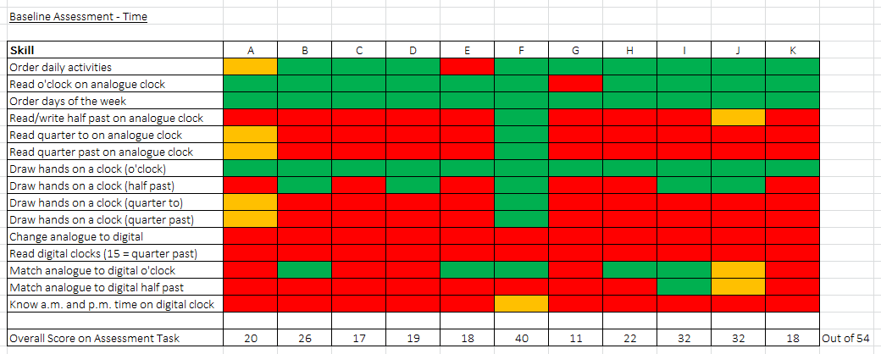

Figure 2 - Results of the final assessment task
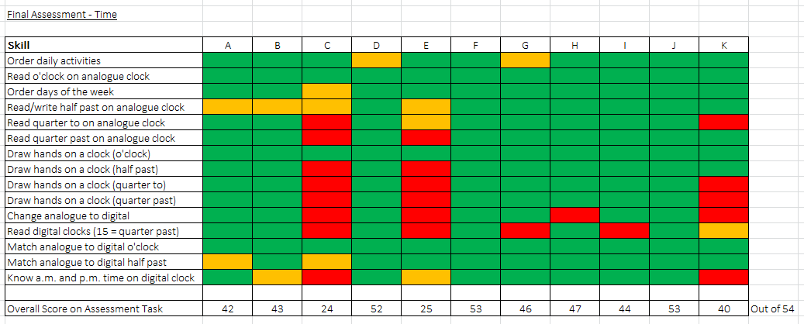

Figure 2 shows the results of the assessment task that was completed by the participants at the end of the project. The results show that all pupils made progress; the colours identify the skills that the participants have achieved (green), partly achieved (amber) or not achieved (red). The data presented in Figure 2 shows a significant increase in the skills which the participants have achieved.

Figure 3 – Comparison of baseline and final assessment task scores
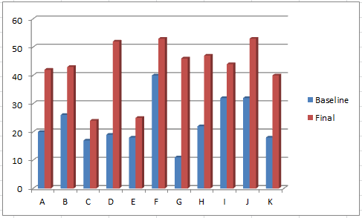

Figure 3 compares the assessment score from the baseline assessment to the final assessment. Participant ‘G’ made the most progress with a baseline score of 11 and a final score of 46. During the observed sessions, Participant ‘G’ was animated and keen to participate. This behaviour during teaching sessions is unusual for Participant ‘G’; he is often very quiet and lacks the confidence to participate in group activities. Participant ‘G’ also has difficulty giving verbal responses to direct questioning. These usual behaviour traits were not observed during the project sessions. Participant ‘G’ is highly motivated by computer games and this is the most likely reason why high levels of interest and engagement were displayed. Participant ‘G’ was also driven by the intrinsic rewards that were given in the programme when the correct answers were given. Vroom’s expectancy theory would support this finding; Participant ‘G’ knew that if he “behaved in a certain way that a specific act will be followed by a desired reward” (Bates, 2019, p136).

John Hattie believed that “how learners see themselves, and what they perceive as most important in terms of their learning, would have a significant effect on their motivation to learn” (Bates, 2019, p152). In other lessons, Participant ‘G’ shows signs of a lack of self-belief resulting in poor motivation towards undertaking tasks. The online programme provided Participant ‘G’ with an opportunity to demonstrate to his peers that he could achieve desired outcomes resulting in increased participation and self-efficacy.

Participant ‘E’ made the least amount of progress in the assessment task. However, the final observation (see figure 5 below) showed that the participant was able to demonstrate the use of the acquired skills whilst using the online programme. One reason for this discrepancy in data could be linked to the participant’s ability to transfer the skills that had been acquired onto paper. The ability to use an acquired skill in a practical manner does not automatically suggest that the participant will be able to demonstrate the same level of skill in a written format. During the group sessions Participant ‘E’ was not always focussed and attentive. Piaget’s theories suggest that “people react differently to learning according to their stage of cognitive development” (Bates, 2019, p50). Participant ‘E’ has a diagnosis of Down syndrome; there is a specific pattern of cognitive and behavioural features that are observed among children with Down syndrome that differs from that seen in typically developing children and children with other causes of intellectual disability. Non-compliant behaviour can be a barrier to Participant ‘E’s learning however, this oppositional behaviour may be a way of Participant ‘E’ communicating frustration or a lack of understanding due to communication/language difficulties. Most children with Down syndrome struggle with basic number skills and their number skills are typically some two years behind their reading skills. Research suggests “using teaching systems that make full use of visual supports to teach number concepts” (DSE, 2019).

The direct instruction that the participants received supports Engelmann’s behaviourist model and the “belief that clear instruction which eliminates misinterpretations can greatly improve academic performance” (Bates, 2019, p40). Teaching the participants as a group allowed me to “provide each individual with the scaffold to establish a sound foundation for further learning” (Bates, 2019, p49). Vygotsky’s social constructivist theory referred to the people that we learn from and the process of learning through social interaction; otherwise known as the Zone of Proximal Development. Based on this theory, it would suggest that by teaching the participants as a group they would be more likely to develop an understanding of the subject that may have been beyond their previous level of comprehension. Bandura’s Social Learning theory suggests that people learn from one another through observation, imitation, and modelling which were essential components of the project’s sessions.

Vygotsky also developed the concept of scaffolding to “describe the teacher’s role in engaging with people and supporting their development while they were in the Zone of Proximal Development” (Bates, 2019, p48).

Figure 4 – Baseline observation checklist
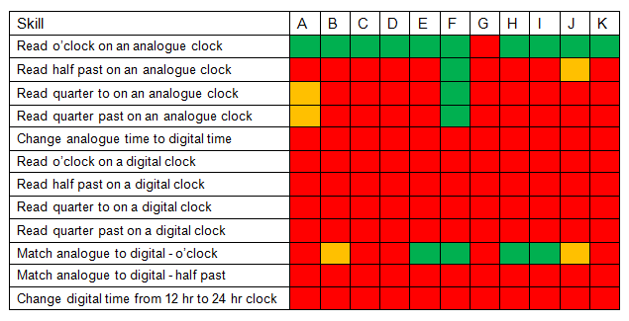

Figure 4 shows the results of the observation that was completed at the start of the project. The colours identify the skills that the participants have achieved (green), partly achieved (amber) or not achieved (red).

Figure 5 – Final observation checklist
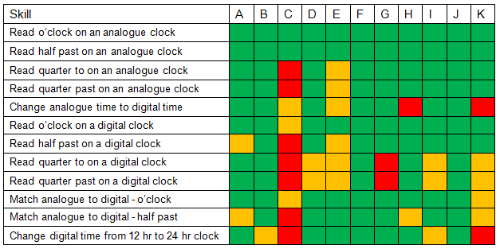

Figure 5 shows the results of the observation that was completed at the end of the project. The results show that all pupils made progress. The structured observations were used to validate the results of the baseline and final assessment however, during the teaching sessions; an unstructured approach to observation was adopted. The structured observations had a clear purpose however the unstructured observations provided opportunities to consider the impact of class dynamics, engagement, interest and motivation. An awareness of the danger of bias was important when adopting the role of an objective observer. Personalities and strengths and weaknesses of the participants were known to the observer; it was therefore crucial that this familiarity did not cause the observer to overlook aspects of behaviour. Over time, changes were observed and the observations greatly assisted in the understanding and analysis of the participants.

Whilst observing the participants during the taught sessions, it was evident that most of the participants were able to retain the skills and knowledge that they had learnt from previous sessions. This group of learners have encountered many teachers and learning experiences during their time at this special school; could the fact that they have been unable to master the skill of telling the time be a result of them not being able to retain the knowledge over longer periods of time rather than not having been taught the skills?

Consideration also needs to be given to the participant’s ability to maintain their attention and fully engage in the taught sessions. Some of the participants had trouble sustaining their attention to the tasks and activities. This may be due to underlying anxiety, frustration and/or distractions. A small number of participants missed some of the teaching sessions which inevitably had an impact on the progress that they made. For Carpenter, engagement is crucial and “without engagement there is no deep learning, effective teaching, meaningful outcome, real attainment or quality progress’ (Carpenter et al, 2015, p20). Where necessary, reasonable adjustments were made to the environment in order to reduce distractions.

As the sessions progressed and the participants were introduced to reading minutes on an analogue clock, it became apparent that without the ability to recall their five times tables, progress was going to be much slower. Therefore, using the same online programme, the participants spent two sessions learning multiplication facts (five times table) to support their ability to read the intervals on an analogue clock face.

The participant’s baseline and final assessments were also plotted against the assessment tool used by the school (PIVATS). Each of the performance indicators which referred to time were used to show the progress that each participant had made.

Figure 6
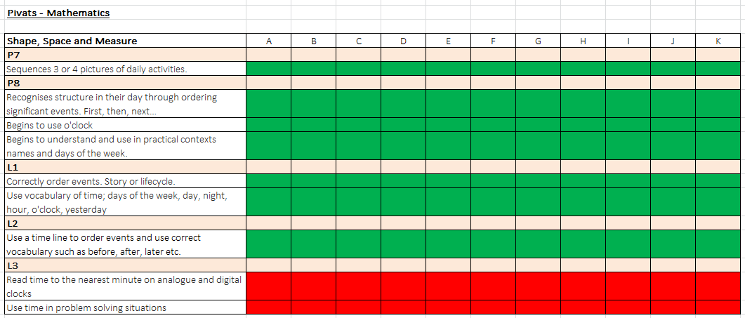

Figure 6 shows that all of the participants had achieved the PIVATS Level 2 Performance Indicators (linked to time) following the baseline assessment task.

Figure 7
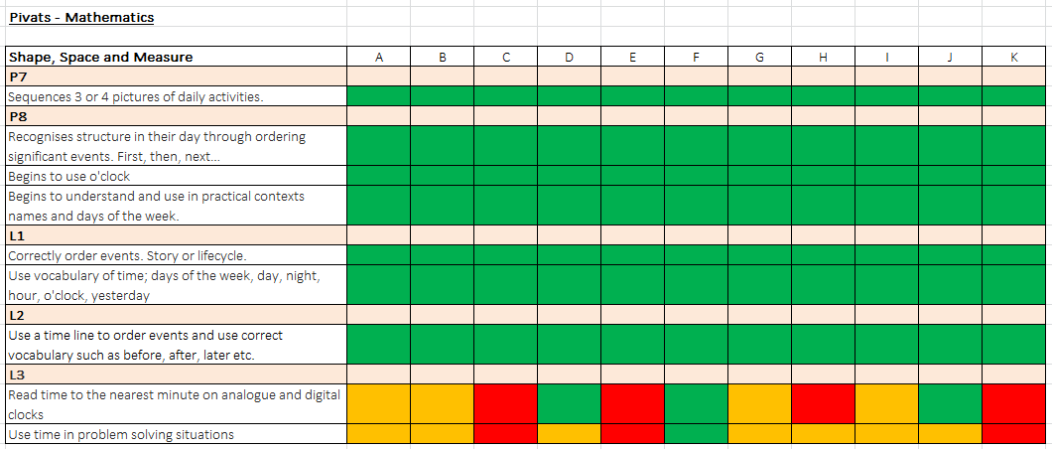

Figure 7 shows that only one of the participants had achieved the PIVATS Level 3 Performance Indicators following the final assessment task. Seven of the participants were ‘working towards’ Level 3 and had made some progress in achieving this level. When comparing the results of the progress that the participants had made against the PIVATS Performance Indicators, it was clear that this did not capture the significant progress that the participants had made with regards to the acquisition of skills that was revealed from the assessment task.

The participant’s baseline and final assessments were also plotted against the National Numeracy Framework. The National Literacy and Numeracy Framework (LNF) is designed to help teachers embed literacy and numeracy into all subjects. The Literacy and Numeracy Framework enables teachers to “identify learners who may benefit from intervention or who are working below or beyond age-related expectations” (Learning Wales, 2016).

Figure 8 – Baseline assessment mapped against the National Numeracy Framework

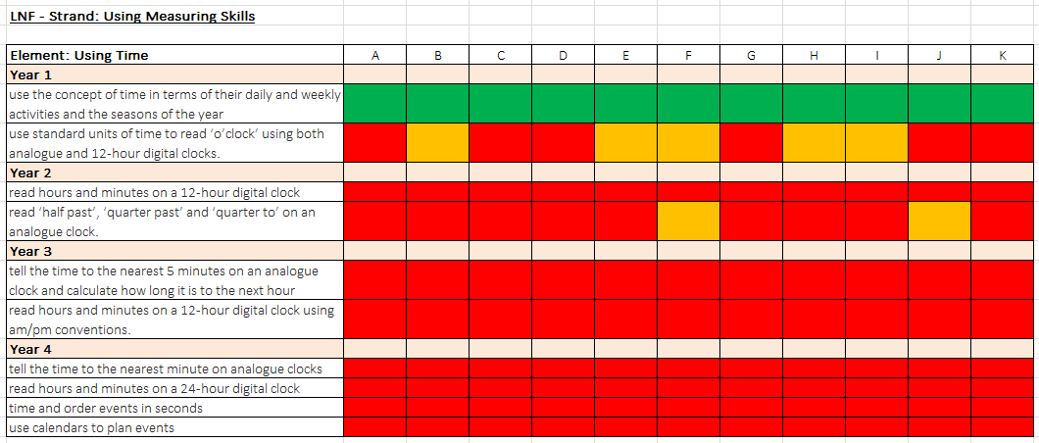

Baseline assessment

Figure 8 shows each of the LNF skills which relate to time. The baseline assessment showed that none of the participants had achieved all of the Year 1 skills (linked to time). Within one chronological year of the LNF, the incremental steps of progress are significant and usually, far too broad for children with Additional Learning Needs to achieve.

Figure 9 - Final assessment mapped against the National Numeracy Framework
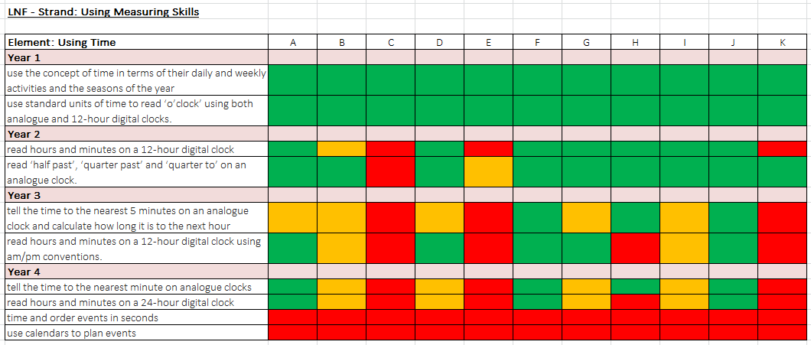

Figure 9 shows each of the LNF skills which referred to time. It shows that all of the participants achieved all of the Year 1 skills (linked to time) following the final assessment task. Seven out of the eleven participants had also achieved all of the Year 2 skills and two participants had achieved all of the Year 3 skills of the Numeracy Framework. Seven participants were ‘working towards’ the skills in Year 4. This amount of progress has exceeded what was expected at the start of this project.

Summary and Conclusion

Overall the results of this study are extremely positive. The overall impact of the participants accessing the online programme has been beneficial to their learning; all participants made progress and developed the skills needed to tell the time and apply these in practical situations. During the structured sessions, all of the participants were engaged, showed an interest in the lessons and made progress, therefore the online programme proved to be an effective teaching tool. The data collected was meaningful and the participant’s achievement was successfully recorded and measured. Using the RAG rating system also proved effective in communicating the progress that the individual participants had made.

Throughout the research project, the participants experienced success and enjoyment, therefore building and maintaining a positive relationship with the programme that was used. Even though the participants were provided with guidance and taught sessions, consideration was given to the philosophy of John Dewey (1859-1952) who emphasised the importance of learners using their positive experiences as a teaching tool and the importance of “learners being provided with quality experiences that engage them” (Bates, 2019, p21). The participants supported each other and took ownership of the sessions.

The online programme which was used in the project was well received by the participants. Feedback from the participants which was given in the pupil questionnaire (Appendix 3) revealed that the participants would like further opportunities to use the programme to continue to develop their understanding of the concept of time; the participants would also like to explore the other areas of learning that the programme offers.

When the National Literacy and Numeracy Framework (LNF) was published, it was recommended that all schools in Wales should “integrate effective Assessment for Learning (AfL) to improve the skills of all learners in these two key areas” (Govwales, 2013). Even though the LNF was adapted to incorporate Routes for Learning (RfL) and A, B and C steps, the results of this research project have shown that for students with Severe Learning Difficulties (SLD) who generally make small steps of progress, the National Numeracy Framework does not allow teachers to track progress effectively and is often too wide to be used for ongoing assessment. For older students, such as the participants in this research project, reporting that they are currently working at ‘Year 2’ for example is not meaningful for either the student or their parents.

The LNF is primarily a curriculum planning tool however it can also function as an assessment tool. Formative assessment against the LNF allows for flexibility in learners’ progress. It is not intended to be a ’best-fit’ approach however, it is intended that progression through the LNF will demonstrate how learners are performing against the expectations for literacy and numeracy at the end of each academic year. It is also expected that most typically developing children will progress through the annual national expectations for literacy and numeracy however, it is unlikely that learners with Additional Learning Needs will follow the same pattern of progress, for example, participants who are in Year 14 of the education system are working at Year 2 of the Literacy and Numeracy Framework.

The findings from this research project have identified the need to develop an assessment tool that is appropriate for all pupils with Additional Learning Needs. An assessment tool which allows teachers to identify and record even the smallest of achievements is necessary. Existing assessment systems do not show the often small steps of attainment achieved by students with SLD.

The current assessment tool that is used in the school where the research project took place is designed to “provide a structured approach to assessing, planning for learning, tracking and measuring small steps in attainment” (Lancashire County Council, 2019) and provide an assessment framework for students working below the standard of national curriculum assessments. Even this assessment tool has its limitations; there are significant differences in the attainment levels between level 2 and level 3 performance indicators relating to the use of time. The limitations shown within the PIVATS assessment tool used to track and monitor progress and achievement raises concerns about its suitability. All pupils made better than expected progress in their ability to tell the time however, the PIVATS assessment tool does not show the significant progress that the participants made.

To conclude; this research project has highlighted the need to develop an assessment tool that can be used by all specialist schools and organisations. A bespoke assessment tool for learners with Additional Learning Needs would prove beneficial to the assessment and moderation process. There is currently no prescribed statutory assessment tool for learners with Additional Learning Needs; there are several assessment tools available to use but there are significant variations in their recording systems. The development of a bespoke assessment tool would allow teachers to monitor pupils’ individual progress and ensure consistency in terms of raising standards of achievement and assessment outcomes.

Appendix 1 – Participant Consent
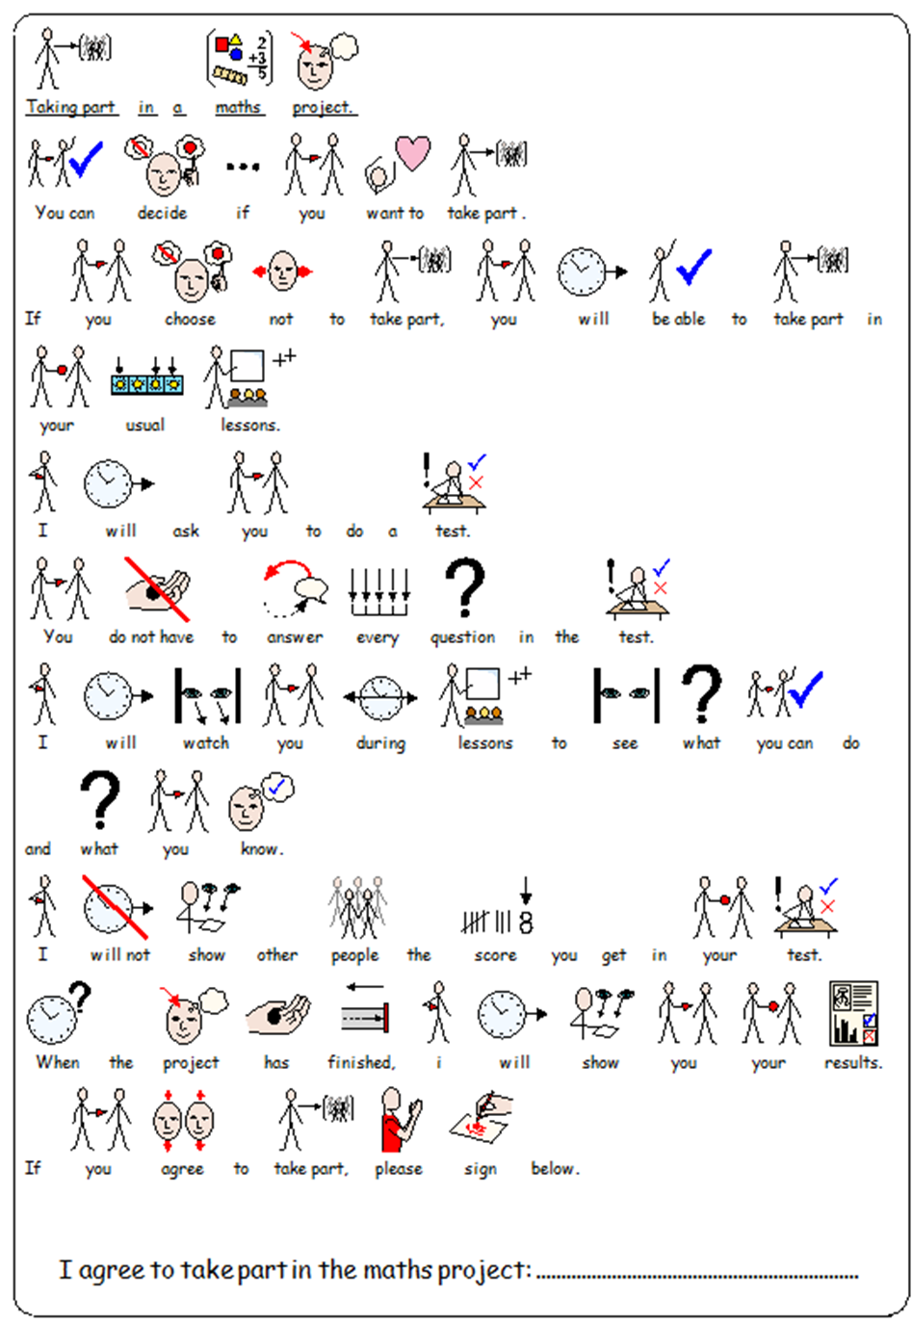

Appendix 2 – Observation Checklist

Action Research
Structured observation checklist
Date: ............................................
RAG rate each skill to identify the skills that the participants have:
achieved (green),
partly achieved (amber) or
not achieved (red)

Skill | A | B | C | D | E | F | G | H | I | J | K
Read o’clock on an analogue clock
Read half past on an analogue clock
Read quarter to on an analogue clock
Read quarter past on an analogue clock
Change analogue time to digital time
Read o’clock on a digital clock
Read half past on a digital clock
Read quarter to on a digital clock
Read quarter past on a digital clock
Match analogue to digital – o’clock
Match analogue to digital – half past
Change digital time from 12 hr to 24 hr clock

Appendix 3 – Pupil questionnaire

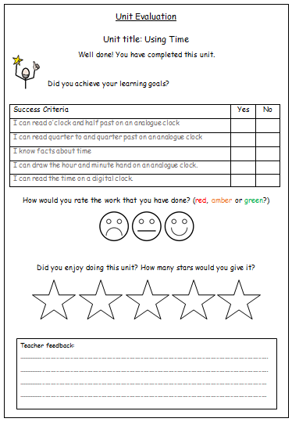

References

Bates, B. (2019) Learning Theories Simplified: Second Edition. London: Sage

Bell, J. (2010) Doing Your research Project: A guide for first-time researchers in
education, health and social science (5th ed.) Maidenhead: Open University Press

Boaler, J. (2015) The Elephant in the Classroom: Helping Children Learn and Love Maths. London: Souvenir Press

British Educational Research Association [BERA] (2018) Ethical Guidelines for Educational Research, fourth edition, London.

Carpenter, B et al. (2015) Engaging Learners with Complex Learning Difficulties and Disabilities. London: Rouledge.

Donaldson, G (2015) ‘Successful Futures’ [online]. Available at: https://beta.gov.wales/sites/default/files/publications/2018-03/successful-futures.pdf (Accessed 15th April 2019)

DSE (2019) Development and Learning [online]. Available at:
https://www.down-syndrome.org/en-gb/about-down-syndrome/development/
(Accessed 21st July 2019)

Education Endowment Foundation (2019) Using digital technology to improve learning Available at: https://educationendowmentfoundation.org.uk/tools/guidance-reports/using-digital-technology-to-improve-learning/#recommendation-1 (Accessed 1st June 2019).

Higgins, S (2003) ‘Does ICT Improve Learning and Teaching in Schools?’ [online]. Available at: https://www.researchgate.net/profile/Steven_Higgins/publication/232607668_Does_ICT_Improve_Learning_and_Teaching_in_Schools/links/0fcfd50b9fce9c3616000000/Does-ICT-Improve-Learning-and-Teaching-in-Schools.pdf (Accessed 15th April 2019)

Imray, P. and Hinchcliffe, V. (2014) Curricular for Teaching Children and Young People with Severe or Profound and Multiple Learning Difficulties: Practical Strategies for Educational Professionals. Oxon: Routledge

Lacey, P. et al. (2015) The Routledge Companion to Severe, Profound and Multiple Learning Difficulties. London: Routledge.

Lancashire County Council (2019) PIVATS [online] Available at: http://www3.lancashire.gov.uk/corporate/web/?PIVATS/14585 (Accessed 19th May 2019)

Learning Wales (2016) ‘National Literacy and Numeracy Framework’ [online] Available at: https://learning.gov.wales/resources/browse-all/nlnf/?lang=en (Accessed 31st May 2019)

Learning Wales (2017) ‘Professional Standards for Teaching and Leadership’ [online] Available at: https://learning.gov.wales/docs/learningwales/publications/170901-professional-standards-for-teaching-and-leadership-en.pdf (Accessed 16th April 2019)

Mooney, C. et al. (2018) Primary Mathematics. Knowledge and Understanding (8th Edition). London: Sage.

McNiff, J. (2017) Action Research. All You Need to Know. London: Sage.

Staves, L. (2001) ‘Mathematics for Children with Severe and Profound Learning Difficulties’. London: David Fulton Publishers.

Welsh Assembly Government (2013) Assessment for learning and the National Literacy and Numeracy Framework. [online]. Available from:
https://learning.gov.wales/docs/learningwales/publications/131104-assessment-for-learning-and-the-nlnf-en.pdf (Accessed 1st June 2019)

