OSPF Single Area Activity

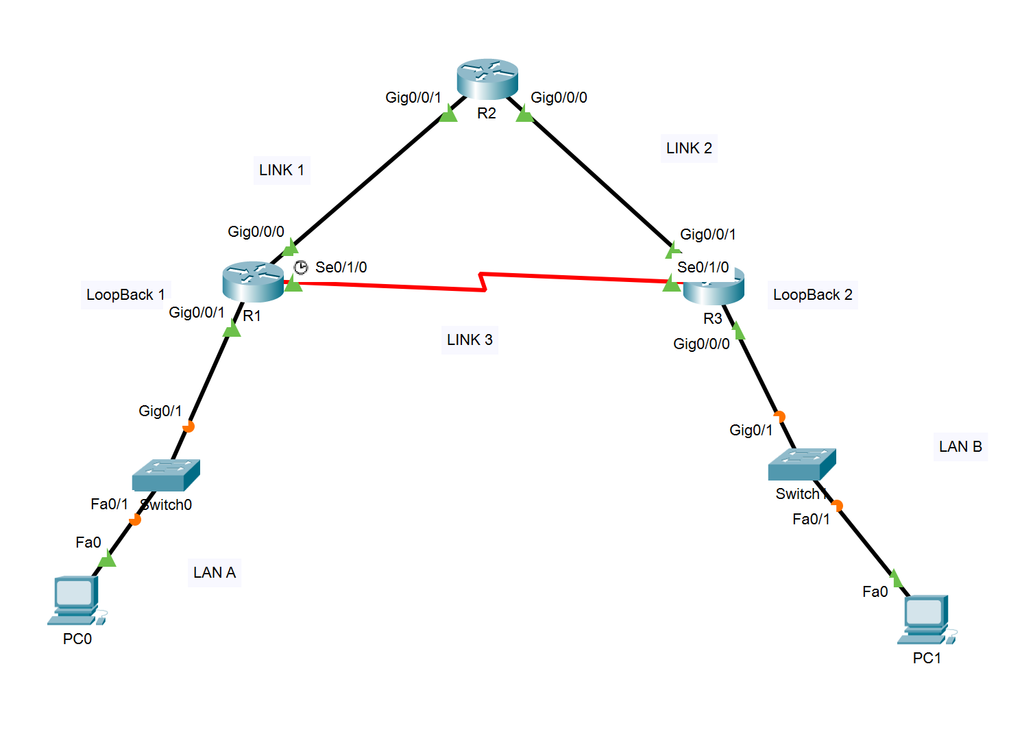
- From The Given Topology Record the Subnet ID for
LAN A
Loopback 1
LAN B
Loopback 2
Link 1
Link 2
Link 3

- Configure OSPF on Routers with ID process 100 using 3 different methods
Use Area 0 in all your OSPF configurations

ON R1 Use Subnet Ids and Subnet Mask . Use Router ID 1.1.1.1
ON R2 Use Interface specific Use Router ID 2.2.2.2
ON R3 Use Subnet Id and Wild-card Mask Use Router ID 3.3.3.3

Make all LAN interfaces passive

- Connect a new Router to R3 via a Serial Link . Name the router ISP_Router. Use the network 209.20.20.0 /30 for your IP addressing.
Configure a static default route on R3 pointing towards ISP Router and use default-information originate command to advertise the static route so that R1 and R2 can be able to direct traffic for the ISP.
- Try the show the commands to verify OSPF configuration
- Show ip protocols
- Shop ip route ospf
- show ip ospf interface brief
- show ip ospf neighbor

