Creative Venture (CW2)
Evaluative Report
Rhys Jones
P150676

Contents:
- Opening Statement
- Review on research and methodology
- Review of Creative and Technical Strategy
- Critical review of final artefact
- Final thoughts and conclusion

Opening Statement
This project by far was one of the most difficult animation projects I had ever produced. As I was coming from completing my bachelor’s degree and going for my Masters it was understandable that the workload would become more difficult. This entire course has put many challenges and obstacles in my way , but the takeaway from this is that I have managed to produce many pieces of work to the best of my ability. This report will highlight key areas from this year and analyse how myself as an animator/3D designer handled these areas and what to learn from them so I can better myself the next time.
First and foremost, I want to talk about how I came to work as a team this year and how at the beginning that affected myself and my other team members. Through the first three years of this course I primarily worked alone on my work, not because I didn’t want to work with others, it was because I would have had potential creative restrictions from whoever I was working with. This means that even though the workload would be spread out we would have to tailor to the other and reach a middle ground and what the final decision will be. I knew that if I were going to work in the industry then it would be a very high chance that I will be working with multiple teams to help deliver what the client would want from our 3D studio. This is why I joined a team this year to get used to the idea of working with others. From previous reports I have mentioned throughout this year how our team came to be during talks within the final weeks of our third-year submissions. To give a summary when I was rendering my third-year project it took a long time to render the shots so to keep myself from not going completely bored and insane I brought in my PlayStation 4. During this time Tommy and Lewis were coming in also to complete their respected projects. We discussed many times about how designs from games that I played looked incredible and it would be interesting to see our rendition of work such as this. Since all three of us had very different preferences for what we wanted to make we went back and forth between many types of ideas. Lewis like myself mostly worked alone throughout his time with the course and wanted to jump on a group project. He was more willing to do any of the ideas thought of. We concluded that we needed to take everything we had learned throughout these years and uses our strengths to influence our final idea. Most of these years my work has been more action-orientated while the others were slower and more atmospheric with their work. I can admit saying that Tommy was creative with his ideas and spoke to myself and Lewis about what direction to go in for the fourth year. He was the first to suggest a monster vs monster scenario. We can use a dark setting to have a confrontation between opposing sides. This developed into our final idea which came to be “Hunter”. As time went on we established how we would work together on this project, taking on separate parts/roles, me leading up environments, Lewis would design the main character and Tommy would create the creature.
Starting with the environment was an intriguing change for me since I was used to creating 3D characters and small models. I have made environments in the past, you only need to look at my second and third-year major projects, but they were all hard-surface models and this new venture was going to be far more difficult. Before I started actual 3D work though I had to understand the type of environment I was going to make which came then into researching.
Review on research and methodology
Research came in a series of different forms to help me with my work. Most came from gameplay in video games and also film. This proved to be the most useful as I gave me tons of reference materials to look at to help create the final design.
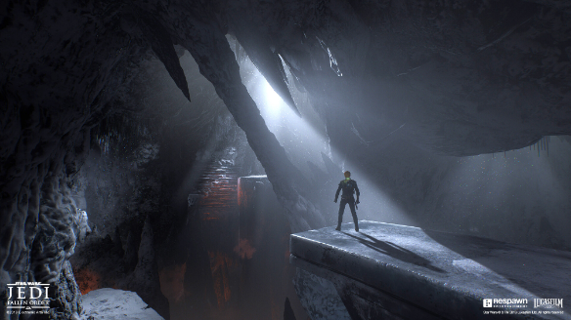
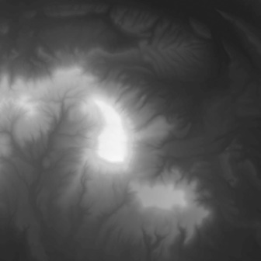
Something else I had to look into was the tutorials and techniques that would help me this year through my work. Tutorials such as one which showed me how to make custom alpha maps by using a map of the world to use in software such as Maya and ZBrush. Work such as this can be shown here with the mountain terrain image and one of the alpha maps. Techniques such as this helped so much throughout the entire side of my production. Using this knowledge, it allowed me to have the resources to push forward with starting the actual 3D modelling of the environments.

Review of Creative and Technical Strategy
This section will discuss how I worked through this project. When I started my side of the project I started primarily on the environments but later I helped and contributed to the other’s sides of the work. Thanks to the experiences with my own project last year I knew what was needed technical wise to help construct things such as textures, UDIMs, and displacement maps. This was vital to the others since they had never done this before with their previous work. I came in when necessary for both and help to the best of my ability. We will discuss this further on but first we will talk about my side of the project.
Going through my research and other materials myself and the team talked about how we wanted to make the audience react to the cave setting and the characters in the feature. We wanted it to feel claustrophobic and no measure of light would come from the cave. It felt somewhat like a metaphor with the main character leading himself into darkness. We knew that lighting would play a huge part narratively. The light source would come from Hunter. Him being somewhat like a beacon in that darkness. As the confrontation with the monster would play out the light would start to die out until he is consumed by it. In other words, when defeating darkness you might become part of the darkness itself.
It’s obvious to state that the creative side always must take priority over the technical side, but I must interject saying that you'd need to think of the technical side as much as the creative. If the creator becomes too ambitious with something they have created it could back-fire on them from the technical side. There are many examples where my statement can be disproved such as Resident Evil 2 on PS1. From reports the game was near or over eighty percent done before the game director scrapped it and went back and made the game that we eventually got. But from past experiences with my work I’ve learned you need to keep yourself grounded because you could get problems down the line of production. The best example for me was my second-year major project, heavily dense poly count in one Maya scene file, plus animation data and a multitude of textures for each piece of geometry, it became a massive headache. If I was to revisit that today those problems wouldn’t exist because I’ve learned so much more over the years after that experience.
Creatively the cave needs to have the right design to convey the message we want to get across to the audience. Technically I was thinking, poly count, UDIM tiles, rendering, etc. When I finally started modelling the environment I prefer to always start with a creative mindset but the technical mindset slowly pushes through as time goes on. The cave was an intriguing task to accomplish because as stated earlier I’m used to making character models but this time I was making the setting where our character would be placed in. Somehow I found this to be challenging because studying cave work from reference showed that there is sometimes no anatomy to it. A basic character model is much easier to make because you know where everything has to be placed, but with a cave in a has no reason sometimes for the way it is. The cave went through several changes over time but it finally became what we had in the final film and I was pleased with the result. What helped me out the most with these environments were the UDIM sets. With this I could make areas of the environment models as detailed using multiple maps instead of one. This allowed me creative freedom to be bold as possible within reason.
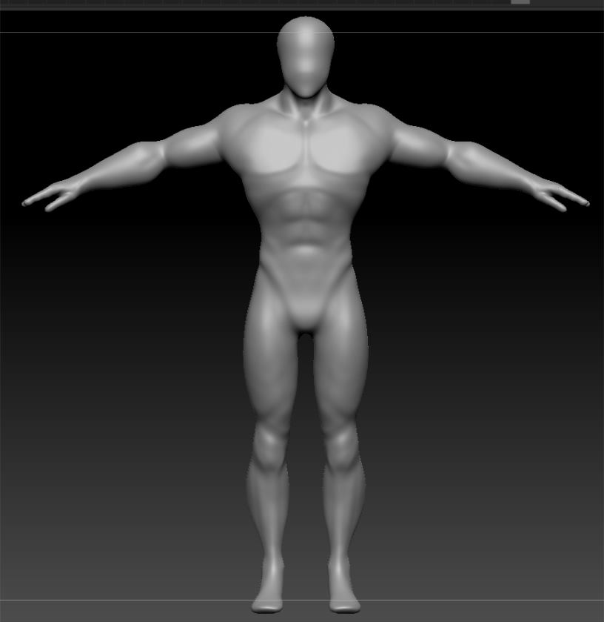
After I completed my section I checked in with the team to see how they were doing. So to do something during the summer before we started back in uni for the fourth-year I thought I would help Lewis out. I made a model ready for him to use as a basis for when he starts working on his section of the project. Through my time in making the environment Lewis showed some promise with his concept art and I was looking forward to what he would produce. At some point I needed to take a break from my side of the work because that was all I was doing. It became too repetitive to work on for a short time. To take a break I decided to go back to the original model and started making my own design for it. Also, at this point I didn’t know really how Lewis's work was going until he finally showed me. Unfortunately, at this point the model he was making would have been an annoying task to rig. I keep on reworking my model and send it over to Lewis when it was completed.
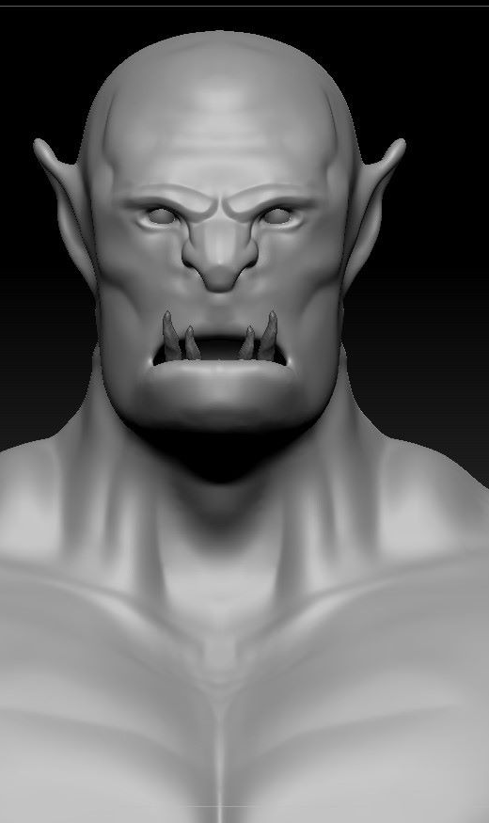
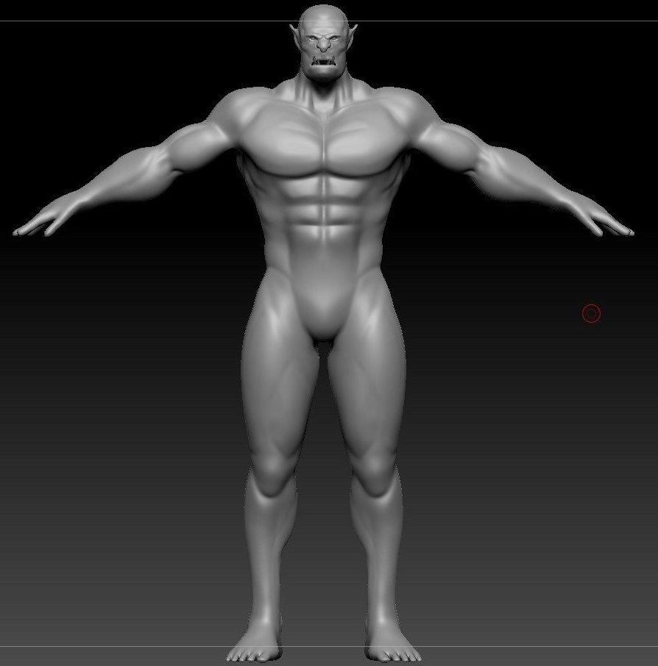
When we got to this section there was a good use of communication between the team. We kept jumping in to help if necessary and since I was coming close to finishing my section with the environments, I was more than happy to help. Upon giving this model to Lewis he tinkered with it and after a period we got the basis for our final model. Once we had somewhat of a final model I started working with the UV sets for him and since each piece of clothing was its own type of geometry it wasn’t so difficult to UV unwrap them ready for substance painter. Looking back now certain aspects of the model could have been part of the base mesh such as the boots and trousers. The only thing to change for that is to set those parts of the model up as them on UDIM type so there would be no overlap with the materials in substance painter. If we realised sooner we could have saved a small amount of time when it came to the paint weighting and rigging stages. During this time Tommy was finalising his final design for the monster. He asked me to help him set up the UVs and also to help him understand how to transfer the high res detail onto the low-res model. Since his model was not too complex, only consisting of three separate pieces, I walked him through the process and helped by setting up the scene file for when the textures were ready to be assigned to.
With both models nearly done and my environments completed I started preparing for the rigging of the main character.
Rigging took a lot longer than anticipated. With the rigs I have made in the past I thought it would be a good idea not to deviate from the methods I have used over time. I used IK handles for the leg controls and everything else was a simple joint hierarchy chain with NURBS CTRL’s to use for animating the character. The reason it took so long was because of paint weights. When painting the influences of each joint it proved difficult because the rig was build-up of multiple different pieces of geometry such as clothing items. Perhaps if all of it was built up as one single mesh instead, or maybe another attempt at redefining the topology it would’ve helped immensely.
We were ready to start animating the rig, however, towards the beginning of this section this was close to when the COVID lockdown started. Communication at this point became difficult since we were not allowed to meet up and discuss what to do. Luckily, there were other ways to communicate such as Discord and Facebook. After setting up the final Maya project window we started animating. Originally the plan was to animate together. The reason for this is because everyone in the team had a very different style of animating. This was to keep continuity so it wouldn’t look too distracting to notice as the viewer. Also having another pair of eyes to judge it would help see if an animation worked or not. That plan went out of the window very quickly unfortunately. What we had to discuss then was how would we work when it came to animating. What I suggested was that in the story there were three locations; and of course three animators. We would divide the locations between us and animate what was needed for that part of the film. I took up the confrontation with the creature. Lewis would take up the scene that was outside the cave and Tommy would have Hunter traveling through the cave until he got up to my section. Tommy and myself discussed how it would be interesting to animate the two characters together so I would specialize in Hunter mostly with some help from Tommy on some of the creature animation.
If everything in our project was its own separate scene files there wouldn’t be a problem, but now it was time to put them all together. Running multiple OBJs with high poly counts is taxing on both the software and the PC itself. Even though we took the poly count down to the best of our ability it was still too high to run everything, especially when you are about to add animation data too. It would have been a nightmare. I came up with a solution that involved retopology and using the create reference function in Maya.
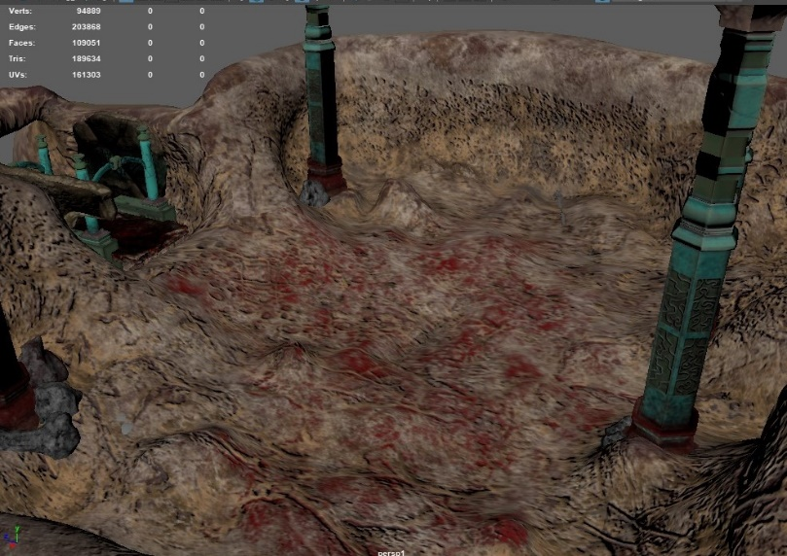
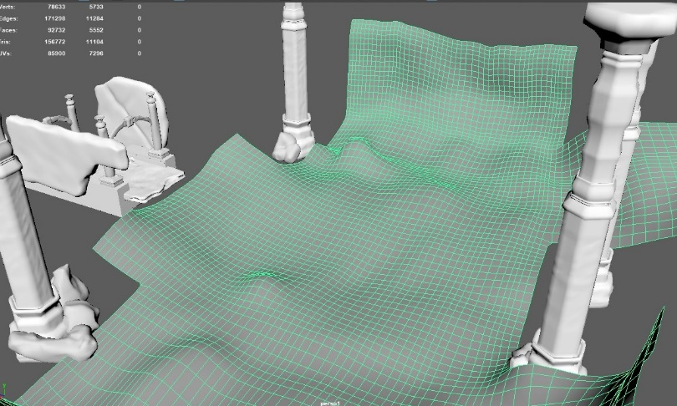
First, I would do a full retopology on the environment, leaving it only with what was needed for the actual scene. This new version would take the same shape and location of the pieces in the environment but drastically reduce the number of polys in the scene. In the Maya scene file, I called each of their lower poly versions as “workspace”. This helps with animating because we can then track where the character will be in the scene when we add the real environment back to the scene. When it came to me animating, I used multiple scene files to animate our character. Each file focussed mostly on one action within the scene. Some overlapped to other animations made. The workspace file was a great help and when I knew it was time to make a new animatic to show my team and ask what they thought. I want to make clear as well that this animatic only contained Hunter and not the creature. At this point I hadn’t received the creature rig from Tommy. The animations shown were some of the shots where we would only see Hunter in them. With their approval I continued and started finalizing shots that I would use with the real environment scene file. After discarding the workspace and replacing it with the real environment scene file I organised my shots and was nearly done with Hunters animation. But I still needed the creature, however. Since I was this far into production at this point, I thought I would check in on the others and see how they were doing with their work.
Somethings are out of people's control. Because of everything that was going on with lockdown etc communication wasn’t there as much as I hoped there would be. When I finally made it through to the others, they said that they haven’t been able to do much work. For me personally it was a bit of a shock because at this point the deadline was getting closer than ever. But it was completely understandable since these changes that happened came so quickly to affect everyone. When I finally got through to Tommy, we discussed how we should proceed. Under the circumstances he was unable to continue to work to the deadline and to not worry us he said to carry on without him but he would help if he could in anyway. This came as a surprise to me because even though we all worked as a team to create this idea I would say that Tommy was the creative head when it came to this project, while myself as the technical lead. With Tommy unable to carry on working I had to make a rig for the creature.
Upon creating the creature rig I spoke to Lewis about how he was doing with his work and stated that he was animating soon. With that statement I carried on and continued with my section of the film by finally adding the creature to the scene to interact with Hunter. The Creature was an interesting specimen to animate since I was always used to animating humanoid character rigs and this took a like snake-approach. The way I approached this rig was like a piece of string or a nerve sending an impulse through itself. An impulse or its influence would be sent from its source and would surge through the rest of the object until it reaches its end.
Also, because Tommy was unable to animate both mine and Lewis’s animation scene would not work seamlessly work together as mine picks up the moment the fight starts, and Lewis is when Hunter enters the cave. To solve this, I added some in-between animations to help. These new animations were of Hunter walking through the cave and finding the creature before he starts his assault. Once all my animating was done with my section, I finally started rendering my side of the project.
During this time while my work was rendering, I asked Lewis how he was doing with his work. Lewis contacted me saying that he did not have the textures for some unknown reason. I asked him to send over his work so I could rectify that issue. He sent over his file and stated that if I wanted to change some of the animation for it. I do not want to be critical, but I had to change his animation. After sending the work back to him I discussed how we would be rendering that work. Lewis did ask me to see if I could render it all since it would be one PC with all the frames but because of the time frame we concluded that each section that we were in charge of animating we would render out ourselves.
When it finally came time to render my work thanks to the FortiClient Application that was set up for us I was able to render all my work from home with ease. Like the other times I did a render job I would make a personal list of what shots were done on which PC and what frames those shots needed. My section consisted of twenty-eight camera shots and roughly took more than a week to render. Since I was home and could access multiple PCs all at once I found this part of the project to be more relaxed than anything because I could keep on checking my render within a matter of seconds at any time in the day or night. When it came to nearly completing all my renders I was surprised to discover how much time I had left before the final film had to be in for deadline day. I asked Lewis because I was done with my rendering and since I had the VPN still set up did he just want me to render the opening animation. With his approval it didn’t take much longer to set up the necessary lights and hit render. Since the opening animation only had seven shots it didn’t take too long to render out and only took two days at the most.
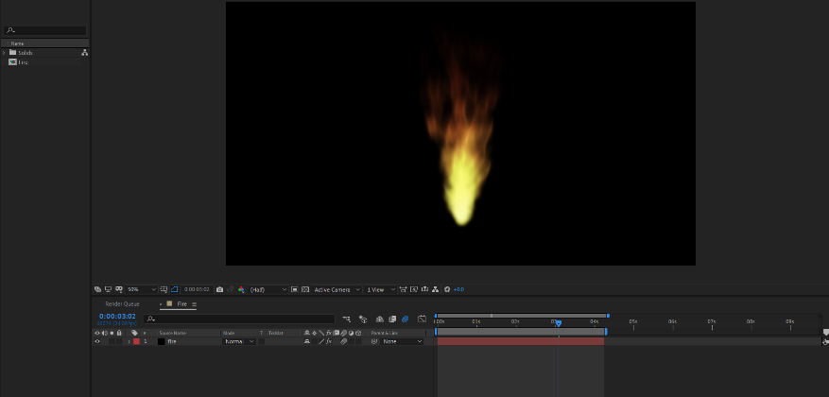
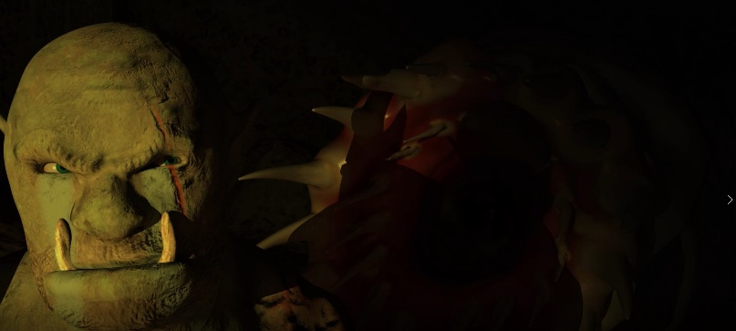
With that being concluded it came time to finally work on the final edit of the film. When editing this it took some time to complete. First, I set up my pipeline from After effects to premier to save a small amount of time for when or if, I decided to change a shot. The data would automatically update in Premier. After that each shot, I could work on individually and start making changes to fit the overall feature. There was one complication I failed to mention earlier but was easily corrected in After Effects. For reasons unknown when doing a test renders the shot would look great because it was created to the controls and attributes you assigned to it to make that shot. However, upon final render, the same shot, with the same variables, would be higher in brightness. After effects the solution was simple to get by changing some brightness and gamma settings the shot would become what it was originally supposed to be. Most shots had this issue but After Effects isn’t just a place to send you renders so they can all come together, it there to help in anyway it can to make the shots look even better than before. A perfect example is this shot displayed on the left. Using Photoshop to add even more black contrast with the shot it gave a better effect of light and darkness as hit slowly reveals the creature. Also, it helped with effects work too. The fire effect in the film was done by creating a point light in Maya as the main light source for the rest of the scene, then using after effects to make the actual flame from where the light source was coming from.
With all the shots edited and finally put together it came time to finally render out the final film.
Critical Review of Final Artefact
When watching the final film I want to say that I was pleased with the result that we made. This film took so much time to make and to be finally done with it gave me a sense of accomplishment. I think the film still has some room for improvement (Animation and pacing), but I want to say that I am pleased with the result of what has been made over the time this year and would be interested to come back to this project someday with a different perspective.
Final thoughts and Conclusion
Looking back on this project as a whole is difficult for me to think about. There were some moments during this production where I thought this could turn out to be a great little thing here. However as time went on it felt as if the high hopes this project had were slowly diminishing. I wonder what this year would have been like if I had just done my very own project this year and not working with a team. I'm not discrediting my team but as time went on it felt as if more and more was put on me. Throughout this report I have mentioned a large amount of information but I believe that if most of the work was spread out more I would have much less to say. I am proud of what has been made as with every difficulty that came in my direction during this project I was able to overcome it with focus and dedication. This demonstrates just how committed I was to the project and also how much more I can give to something if I was able to work in the industry.
The final thought I do want to say is thank you to everyone personal and academic for helping and supporting me throughout these four years of university. To look back at work from first-year compared to this year just shows how much I've grown with my work and artistic vision and I hope to keep improving as time goes on.
Word Count: - 4122

References
Tutorial: Rigging an IK Leg in Maya. (2014). YouTube. Available at: https://www.youtube.com/watch?v=WxogLUq1rd4&list=PLOxROkOn1UYCIVV3vZYkbgp2Efotq5fOW&index=14&t=0
After Effects Tutorial: Animated Fire No Plugins (Beginner). (2013). YouTube. Available at: https://www.youtube.com/watch?v=qWjlPVDxwPo&list=PLOxROkOn1UYCIVV3vZYkbgp2Efotq5fOW&index=113&t=190s
Substance Painter to Arnold Workflow. (2019). YouTube. Available at: https://www.youtube.com/watch?v=g9f0rPC1ENA&list=PLOxROkOn1UYCIVV3vZYkbgp2Efotq5fOW&index=22&t=0s
Using UDIM Tiles As Texture Sets. (2016). YouTube. Available at: https://www.youtube.com/watch?v=k89--dny9mY&list=PLOxROkOn1UYCIVV3vZYkbgp2Efotq5fOW&index=21&t=0s
Maya mountain terrain - by brush. (2017). YouTube. Available at: https://www.youtube.com/watch?v=B6Rozb8qWvA&list=PLOxROkOn1UYCIVV3vZYkbgp2Efotq5fOW&index=4&t=2s
Resident Evil 2 (2019). (2019). [Video Game] Capcom.
Star Wars: Jedi Fallen Order. (2019). [Video Game] EA.

