​I acknowledge the use of Google Scholar, https://scholar.google.com/ on multiple dates to search for papers relevant to my assignment. I used the prompt(s):
1. Poverty statistics UK
2. Joseph Rowntree poverty
3. Theories cognitive development and systemic
4. Parental mental health poverty
5. Childhood trauma poverty
6. Cognitive impacts poverty
7. Allostatic load
8. Government initiatives poverty
9. Culture differences poverty

I confirm that I have not presented any AI generated text as my own work. I confirm I have copies of my drafts, notes, and other resources I used before, and after the use of Google scholar

Good morning
My name is Emma Williams, and this presentation is part of the module Understanding Trauma and the Mental Health Needs of the Child. ECCY7007
Today, the presentation will discuss:
The Impact of Poverty on the child’s lifelong development while exploring relevant Theoretical Frameworks in relation to the specific age range from birth to 11 years old
Slide 2
What is poverty?
Historically, Rowntree defined poverty as the inability to meet basic needs like food, shelter, and clothing. More recently, the Social Metrics Commission (2023) expands this definition to include insufficient resources for essential needs and societal participation.
Poverty significantly impacts children’s growth and development from birth to age 11, often causing mental health issues and developmental delays. Chronic stress disrupts brain maturation, emotional regulation, and academic readiness, with parental financial pressures compounding these effects (Nelson & Gabard-Durnam, 2020; Perrin et al., 2020).
Globally, over 350 million children live in chronic poverty. In the UK, 4.2 million children (29%) were below the poverty line in 2023, driven by rising living costs, job insecurity, and reduced welfare support.
Absolute poverty refers to the inability to meet basic survival needs, such as food, shelter, and healthcare (Wang, 2022). UNICEF (2023) estimates over 150 million children globally live in absolute poverty, with 50% facing severe health issues due to chronic malnutrition and preventable illnesses (Morris, 2022).
Relative poverty, on the other hand is The inability to meet socially accepted living standards (Townsend. 1979). Defined in the UK as living on less than 60% of median household income (Samiyeva, 2022). Children in relative poverty experience a 25% educational attainment gap and are three times more likely to face social exclusion (Chen et al., 2021; Sylva & Eisenstadt, 2024).
This distinction underscores the dual challenge of addressing immediate survival needs in absolute poverty while tackling systemic inequality in relative poverty (Akarçeşme et al., 2024). Focusing solely on absolute poverty risks overlooking the long-term social impacts of relative poverty (Birkmann et al., 2022).
Situational vs. Generational Poverty
Situational poverty arises from temporary financial instability, such as job loss or illness, and often leads to academic and emotional setbacks, with a 30% drop in performance compared to peers (Şengönül, 2021). However, early interventions, such as tutoring and counselling, can help children recover within two years (Johnson et al., 2020).
Generational poverty persists due to systemic barriers like limited education and unstable employment, leaving children with an 80% higher risk of poor outcomes in adulthood (Parolin et al., 2023). Addressing generational poverty requires systemic reforms, but targeted efforts, like scholarships and mentorships, can also disrupt poverty cycles within a single generation (Rahmadi & Rozamuri, 2024).
This comparison highlights the need for both immediate interventions and sustained reforms to address poverty's multifaceted impacts.
Moving on, we will now revisit relative and absolute poverty to explore their prevalence using recent data.
Relative child poverty in the UK as of 2023 stands at approximately 30%, affecting 4.3 million children (Hayre & Pollock, 2023).
Under Labour governments from 1997 to 2011, press targeted policies reduced child poverty from 33% to 27%. However, from 2011 to 2023, press half of this progress was reversed, with relative poverty rates rising, especially among families with three or more children, due to policy changes (Social Metrics Commission. 2023)
Absolute child poverty has shown a steady decline since 1997, while relative child poverty rates have followed a U-shaped trend, rising again after 2013–14 (Samiyeva, 2022). Graph 2 press
In 2013, 34% of children in families with three or more children lived in relative poverty. By 2022–23, this figure had risen to 46%.
This increase correlates with the implementation of the two-child limit, which restricts additional child tax credits or universal credit for most third or subsequent children.
These graphs illustrate the shifting landscape of child poverty, highlighting the interplay between policy decisions, economic factors, and their profound implications for children’s well-being as we delve deeper into its developmental impact.
Slide 5
Piaget's theory of cognitive development highlights how poverty affects children's learning across stages.
Sensorimotor Stage (0–2 years): Restricted access to safe, stimulating environments in poverty hinders sensory and motor development (Tamblyn et al., 2023).
Preoperational Stage (2–7 years): The "word gap" in low-income families (Hart & Risley, 1995) limits language exposure, impacting cognitive growth and engagement (Cave, 2024).
Concrete Operational Stage (7–11 years): Poverty delays logical reasoning and academic skill development due to inadequate resources (Emerson, 2024).
Formal Operational Stage (11+ years): Earlier developmental gaps impede abstract thinking and problem-solving (Navarro, 2024).
However, Piaget's stages have been critiqued for rigidity, as children in poverty may develop resilience and practical skills but struggle with abstract reasoning due to educational constraints (Young, 2024; King, 2024).
Bronfenbrenner’s Ecological Systems Theory provides a broader lens, focusing on environmental factors.
Microsystem influences, like family stress, and exosystem barriers, such as underfunded schools, compound poverty's effects on development (Shaw, 2024).
A systematic review showed that interconnected factors, such as food security and parental education, significantly impact child outcomes (Tong et al., 2024).
Critiques suggest the theory's broad scope complicates targeted interventions and overlooks the unequal weight of societal imbalances (Elliott & Davis, 2020). Its limited empirical testing also challenges practical application (Spear & Kirkman, 2024).
Maslow’s Hierarchy of Needs complements these theories by linking unmet basic needs, like food and safety to disrupted cognitive and emotional development. Together, these frameworks underscore the multifaceted impact of poverty and the need for integrated approaches to support children’s growth.
Slide 6
Piaget’s theory highlights active exploration as vital for cognitive growth, yet poverty-induced stress disrupts this process (Saitadze & Lalayants, 2021)
Research suggests by Age seven, children from low-income households fall behind academically with gaps widening by age 11 (Ayala et al., 2024).
Chronic stress impacts the prefrontal cortex and amygdala, impairing emotional regulation, attention, and problem-solving (Breitenbach et al., 2021). These deficits hinder academic performance and peer relationships (Fagan & Wildfeuer, 2022).
Stress and Emotional Well-being
Research shows that poverty-related stressors, such as postnatal depression which is (40% more prevalent in mothers in poverty), disrupts secure attachment formation, critical for emotional safety and trust (Wang et al., 2021; Speranza et al., 2024).
Insecure attachment fosters withdrawal, aggression, or hypervigilance, a heightened state of alertness that hinders focus, trust, and social skills (Alpuğan, 2024; Bourne et al., 2022).
Chronic Stress
Adverse Childhood Experiences (ACEs), such as maltreatment and poverty, amplify emotional challenges and elevate Allostatic Load , a marker of stress dysregulation across body systems (Davis et al., 2021).
A longitudinal study found that children exposed to high poverty-induced stress had significantly elevated AL, correlating with higher rates of anxiety and depressive disorders into adolescence and adulthood (Breitenbach et al., 2023). These findings underscore the long-term physical and emotional vulnerabilities stemming from sustained poverty-related stress.
Family Stress and Abuse
Financial strain in families often increases the risk of substance misuse as a coping mechanism, leading to neglect or abuse (Meulewaeter et al., 2022).
Children in poverty are twice as likely to face abuse compared to peers, with severe cases often resulting in foster care placements (NSPCC, 2023).
While foster care prioritises safety, unstable placements exacerbate emotional vulnerability, leading to long-term difficulties with trust, healthy relationships and emotional regulation (Sewester, 2024).
Slide 7
Physical and Cognitive Development
Health Challenges and Brain Development
Poverty significantly affects children’s physical health, increasing the risks of malnutrition, stunted growth, obesity, asthma, and cardiovascular diseases (McCabe et al., 2024). Research shows, Children in poverty have a 38% higher prevalence to obesity (McCabe et al., 2024; National Center for Health Statistics, 2024).
A 17-year longitudinal study revealed that lower socioeconomic status (SES) correlates with reduced cortical grey matter, subcortical volumes, and slower subcortical growth, contributing to poorer cognitive, physical and psychiatric outcomes in adulthood (Barch et al., 2022).
Children in poverty often lack opportunities for regular exercise, Limited access to safe outdoor spaces and nutritious food not only compromises physical fitness but also affects brain development, including memory and problem-solving abilities (Ostermeier et al., 2024). Additionally, untreated health conditions like asthma lead to increased school absenteeism, hindering both cognitive development and social participation (Norman et al., 2024).
However, A study on poverty reduction measured brain activity through EEG in 1,000 low-income infants whose mothers received either large or nominal cash gifts. Infants in the high-cash group exhibited increased high-frequency EEG power, suggesting enhanced neuroplasticity (Troller-Renfree et al., 2022).
Critique: While promising, this intervention’s long-term developmental effects are unclear. Uncontrolled environmental and familial factors may also influence outcomes, complicating causal attributions. Ethical concerns about repeated EEG monitoring on infants highlight the need for cautious application.
Slide 8
Social Development and Bullying
Children from low-income families face higher rates of bullying and social exclusion due to stigma associated with their socioeconomic status, negatively impacting self-esteem, social integration, and academic performance (Chen et al., 2021; Kirkbride et al., 2024).
A study found that 45% of children in poverty reported bullying or social exclusion, compared to just 15% from higher-income families. Resource-limited schools in lower-income areas exacerbate this divide (Frazier et al., 2021).
Cultural and Environmental Influences
The impact of social stigma varies across cultural contexts. In Western, individualistic societies, an emphasis on material wealth and personal success often frames poverty as personal failure, intensifying stigma and fostering exclusion (Inglis et al., 2023). In contrast, Asian collectivist societies may provide protective factors through strong family and community support. However, children in these settings can still experience distress due to societal expectations or pressure to contribute financially to their families (Huang et al., 2022).
Theoretical Perspectives and Interventions
Bronfenbrenner’s Ecological Systems Theory emphasises the role of environmental factors, such as access to healthcare and safe play areas, in shaping development. However, Not all children in collectivist societies, such as those in parts of Asia, equally benefit from support structures (Brooks-Gunn et al., 2022).
To summarise, Early support programmes focused on nutrition, physical activity, and healthcare access can enhance resilience, brain development, and social integration. A study revealed that stable caregiver relationships significantly mitigate adverse outcomes (Gou et al., 2024). However, sustained funding and systemic reforms are essential to maximize their long-term effectiveness (Miller et al., 2024).
Slide 9
The long-term impact of childhood poverty spans multiple areas, including educational attainment, health, and social mobility.
Children from low-income households often face significant educational challenges, with many underperforming in subjects like reading and math by age 11, leading to a persistent achievement gap (Keating et al., 2023; Herbaut, 2021). These disparities limit their opportunities for higher education and future employment, as growing up in poverty is linked to lower lifetime earnings and unstable jobs due to inadequate access to quality education and skill-building resources (Green et al., 2023).
Mental health conditions are also more prevalent among children from low-income families, with these issues continuing into adulthood. Children from impoverished backgrounds are twice as likely to develop mental health conditions like anxiety and depression, often exacerbated by Adverse Childhood Experiences (ACEs), which disrupt emotional regulation and increase the risk of PTSD, substance misuse, and emotional instability later in life (Smith et al., 2021).
Chronic stress, reflected in heightened AL, disrupts bodily systems, leading to long-term conditions such as cardiovascular disease, obesity, and metabolic disorders. A longitudinal study found a strong dose-response relationship between household income and mortality, with the lowest-income group experiencing higher mortality rates (Liu et al., 2022).
In Wales, adults in poverty-stricken areas live 17 years less than those in higher-income areas, costing approximately 350 million pounds annually for acute services (Public Health Wales, 2025). Early interventions targeting health inequities can help mitigate these effects, reduce AL, and foster resilience (Finlay et al., 2022).
The cycle of poverty is also perpetuated across generations. Children raised in poverty are more likely to remain impoverished as adults due to limited access to quality education, healthcare, and stable employment opportunities, reinforcing systemic inequalities (Young, 2024). This continuation of disadvantage is supported by Bronfenbrenner’s Macrosystem, which highlights the role of societal structures and policies in maintaining these disparities.
Additionally, Maslow’s Hierarchy of Needs illustrates how the lack of foundational resources, such as safety and food security, inhibits the development of self-confidence and independence, making it more difficult for individuals to break the cycle of poverty.
In summary, childhood poverty has long-lasting effects on education, health, social mobility, and intergenerational outcomes. Addressing these challenges requires a comprehensive approach, including early interventions, improved healthcare, better educational support, and systemic reforms to break the cycle of poverty and promote long-term well-being..
Slide 10
Moving beyond blame
When it comes to the question of who is to blame for the impact of poverty on child development, it’s important to recognise that both parents and governments have roles, but their responsibilities differ.
Parental Responsibility:
Parents have a direct impact on their children's immediate environment, including providing emotional support, discipline, and access to resources like education, food, meeting basic needs as Maslow’s theory pertains.
However, factors like neglect or substance misuse can make poverty’s effects worse (NSPCC, 2023). Parents may also face pressures that limit their ability to focus on long-term goals due to survival-focused priorities (Brady. 2023).
Nevertheless, it’s crucial to note that chronic stress and lack of resources, often caused by systemic inequalities, significantly constrain parents' ability to provide optimal care (Hock et al., 2024).
Government Responsibility:
Governments shape the structural environment affecting families. Economic inequality, inadequate social welfare policies, and poor-quality services, such as education and healthcare in underfunded areas, perpetuate cycles of poverty (Joseph Rowntree Foundation, 2023). A lack of investment in early intervention programmes further worsens long-term impacts (McGowan et al., 2021).
While government policies are critical, their implementation is often hindered by political priorities or bureaucracy (Knill et al., 2024).
In summary, blaming either parents or governments alone oversimplifies the issue. Parents play a direct role, but their capacity to support their children is deeply influenced by systemic factors (Spencer, 2024). Governments must address structural inequities and create an environment that supports families, providing policies that integrate family support with broader systemic reforms to break the cycle of poverty and promote positive child development (NSPCC, 2023).
Slide 11
Addressing the impact of poverty requires effective, multi-faceted interventions. In the UK, early childhood education programs like the Early Years Foundation Stage (EYFS) significantly improve cognitive, social, and emotional outcomes for disadvantaged children. A longitudinal study found that children in EYFS-based settings were more likely to start school with stronger literacy and numeracy skills (Forrester et al., 2022). Sustained parental involvement is crucial to maintaining these benefits (Bamsey et al., 2021). Financial support schemes, such as Healthy Start, enhance child well-being and nutrition while alleviating poverty-related stress (Theis & White, 2021). Despite these successes, broader challenges like access to quality education and healthcare remain unaddressed, necessitating systemic reforms (Friedline et al., 2021). Policies such as the two-child limit exacerbate child poverty, with their removal projected to lift 540,000 children out of poverty at an annual cost of £2.5 billion (Henry & Wernham, 2024). The Pupil Premium improves academic and social-emotional outcomes but varies in effectiveness across regions, while access to affordable childcare and safe play spaces supports low-income families’ development (Gorard et al., 2023; Gemmell et al., 2023). For sustained impact, these initiatives must align within a comprehensive strategy addressing systemic inequalities (Taylor, 2022).
Slide 12
Childhood poverty profoundly affects physical, cognitive, emotional, and social development, with lasting consequences for adulthood, such as mental health issues, chronic illnesses, and perpetuation of intergenerational poverty. Early interventions, including access to education, healthcare, and family support, are critical in fostering resilience and mitigating these effects. Addressing systemic inequalities through government investment in social welfare programs and reforms can create opportunities for all children to thrive. Ultimately, tackling childhood poverty requires a unified effort from parents, communities, and policymakers to ensure positive developmental outcomes and long-term well-being.
Slide 13
Thank you all for your attention and participation today. I hope this discussion has highlighted the profound impact poverty has on children's development and the importance of targeted policies and interventions. If you have any questions or thoughts, I'd be happy to discuss them further.

References
Akarçeşme, S., Aranguiz, A., Lemmens, A., & Cantillon, B. (2024). Reaching the European 2030 poverty target: The imperative to balance the EU social agenda. European Journal of Social Security, 26(3), 347–368 https://doi.org/10.1177/13882627241270404
​Alpuğan, Z. (2024). The Impact of Early Childhood Adversity on Neurodevelopment: A Comprehensive Review. The Journal of Neurobehavioral Sciences, 11(2), 45–59. https://doi.org/10.32739/uha.jnbs.11.1539116
Ayala, M. C., Strasser, K., Susperreguy, M. I., & Castillo, K. (2024). Socioeconomic gaps in specific mathematical skills at different ages in primary school. Journal of Educational Psychology, 116(5), 762.
Back, I. d. C., Barros, N. F. d., & Caramelli, B. (2022). Lifestyle, inadequate environments in childhood and their effects on adult cardiovascular health. Jornal De Pediatria, 98(suppl 1), 19–26. https://doi.org/10.1016/j.jped.2021.09.005
Bamsey, V., Georgeson, J., Healy, A., & ÓCaoimh, B. (2021). Mapping the Landscape: practitioners views on the Early Years Foundation Stage. https://early-education.org.uk/wp-content/uploads/2021/12/Mapping-the-Landscape-survey-report.pdf
Barch, D. M., Donohue, M. R., Elsayed, N. M., Gilbert, K., Harms, M. P., Hennefield, L., Herzberg, M., Kandala, S., Karcher, N. R., Jackson, J. J., Luking, K. R., Rappaport, B. I., Sanders, A., Taylor, R., Tillman, R., Vogel, A. C., Whalen, D., & Luby, J. L. (2022). : https://www.sciencedirect.com/science/article/pii/S2451902221001968
Beasley, L. O., Jespersen, J. E., Morris, A. S., Farra, A., & Hays-Grudo, J. (2022). Parenting challenges and opportunities among families living in poverty. Social Sciences, 11(3), 119. https://doi.org/10.3390/socsci11030119
Birkmann, J., Liwenga, E., Pandey, R., Boyd, E., Djalante, R., Gemenne, F., Leal Filho, W., Pinho, P., Stringer, L., & Wrathall, D. (2022a). Poverty, livelihoods and sustainable development. https://doi.org/10.1017/9781009325844.010
Bourne, S. V., Korom, M., & Dozier, M. (2022). Consequences of inadequate caregiving for children’s attachment, neurobiological development, and adaptive functioning. Clinical Child and Family Psychology Review, 25(1), 166–181.
Brady, D. (2023). Poverty, not the poor. Science Advances, 9(34), eadg1469.
Breitenbach, M., Kapferer, E., Sedmak, C., Breitenbach, M., Kapferer, E., & Sedmak, C. (2021). The unhealthy relationship between stress and poverty. Stress and Poverty: A Cross-Disciplinary Investigation of Stress in Cells, Individuals, and Society, 123-146. https://doi.org/10.1126/science.1251872
Bronfenbrenner, U. (1979). The Ecology of Human Development: Experiments by Nature and Design. Cambridge, MA: Harvard University Press.
Brooks-Gunn, J., Klebanov, P., Liaw, F. R., & Duncan, G. (2021). Toward an understanding of the effects of poverty upon children. In Children of poverty (pp. 3-41). Routledge.
Cave, R. (2024). No title. A Comparative Case Study Analysis of Early Intervention Programs: Closing the Language Gap in Children of Low Socioeconomic Status during Early Childhood. https://www.proquest.com/dissertations-theses/comparative-case-study-analysis-early/docview/3062319037/se-2
Chen, J., Wang, Z., Wong, H., & Tang, V. M. (2021). Child deprivation as a mediator of the relationships between family poverty, bullying victimization, and psychological distress. Child Indicators Research, 14(5), 2001–2019. https://doi.org/10.1007/s12187-021-09835-y
Davis, J. P., Tucker, J. S., Stein, B. D., & D'Amico, E. J. (2021). Longitudinal effects of adverse childhood experiences on substance use transition patterns during young adulthood. Child Abuse & Neglect, 120, 105201. : https://www.sciencedirect.com/science/article/pii/S014521342100274X
Decerf, B. (2021). Combining absolute and relative poverty: income poverty measurement with two poverty lines. Social Choice and Welfare, 56(2), 325–362. https://link.springer.com/article/10.1007/s00355-020-01279-7
Dennis, S. N. (2024). No title. How Post-Trauma-Focused Therapy Helps with Emotional Attachment, Communication, and Trust with Children Adopted from State Custody,
Elliott, S., & Davis, J. M. (2020). Challenging taken-for-granted ideas in early childhood education: A critique of Bronfenbrenner’s ecological systems theory in the age of post-humanism. Research Handbook on Childhoodnature: Assemblages of Childhood and Nature Research, , 1119–1154. https://doi.org/10.1007/978-3-319-67286-1_60
Emerson, A. N. (2024). No title. Unraveling the Puzzle of Developmental Delays: A Case Study of Parent and Educator Perspectives in an Urban Private Childcare Environment,
Fagan, J., & Wildfeuer, R. (2022). Low-income parental risk and engagement in early childhood and child social-emotional functioning in middle childhood. Journal of Child and Family Studies, 31(1), 70–85. https://doi.org/10.1007/s10826-021-02204-x
Finlay, S., Roth, C., Zimsen, T., Bridson, T. L., Sarnyai, Z., & McDermott, B. (2022). Adverse childhood experiences and allostatic load: A systematic review. Neuroscience & Biobehavioral Reviews, 136, 104605. 10.1016/j.neubiorev.2022.104605. https://doi.org/10.1016/j.neubiorev.2022.104605
Forrester, G., Pugh, J., Hudson, R., & Rowley, J. (2021). Understanding the World in the Early Years Foundation Stage: practitioners’ perspectives of best practice and effective provision. Education 3-13, 50(8), 1072–1084. https://doi.org/10.1080/03004279.2021.1930095
Frazier, A. D., Cross, J. R., Cross, T. L., & Kim, M. (2021). “The Spirit Is Willing”: A Study of School Climate, Bullying, Self-Efficacy, and Resilience in High-Ability Low-Income Youth. Roeper Review, 43(1), 7-20.
Friedline, T., Chen, Z., & Morrow, S. (2021). Families’ financial stress & well-being: The importance of the economy and economic environments. Journal of Family and Economic Issues, 42, 34–51. https://doi.org/10.1007/s10834-020-09694-9
Gemmell, E., Ramsden, R., Brussoni, M., & Brauer, M. (2023). Influence of neighbourhood built environments on the outdoor free play of young children: A systematic, mixed-studies review and thematic synthesis. Journal of urban health, 100(1), 118-150. https://doi.org/10.1007/s11524-022-00696-6
Gorard, S., Siddiqui, N., & See, B. H. (2023). Lessons for addressing educational disadvantage from a range of studies. Cogent Education, 10(2), 2262258. https://doi.org/10.1080/2331186X.2023.2262258
Gou, Y., Cheng, S., Kang, M., Zhou, R., Liu, C., Hui, J., Liu, Y., Wang, B., Shi, P., & Zhang, F. (2024). Association of Allostatic Load With Depression, Anxiety, and Suicide: A Prospective Cohort Study. Biological Psychiatry, 10.1016/j.biopsych.2024.09.026. https://doi.org/10.1016/j.biopsych.2024.09.026
Green, K. M., Doherty, E. E., & Bugbee, B. A. (2023). Can early disadvantage be overcome? A life course approach to understanding how disadvantage, education, and social integration impact mortality into middle adulthood among a Black American cohort. Prevention Science, 24(5), 829–840. https://doi.org/10.1007/s11121-022-01408-x
Hart, B., Risley, T. R., & Kirby, J. R. (1997). [Meaningful differences in the everyday experience of young American children]. Canadian Journal of Education, 22(3), 323. https://www.proquest.com/scholarly-journals/meaningful-differences-everyday-experience-young/docview/215377356/se-2
Hayre, J., & Pollock, A. M. (2022). Children in poverty: Time for action to address rising inequalities in the United Kingdom. Poverty & Public Policy, 14(4), 423–436.
Henry, A., & Wernham, T. (2024, October 3). Child poverty: Trends and policy options. Institute for Fiscal Studies. Retrieved January 3, 2025, from https://ifs.org.uk/publications/child-poverty-trends-and-policy-options
Herbaut, E. (2021). Overcoming failure in higher education: Social inequalities and compensatory advantage in dropout patterns. Acta Sociologica, 64(4), 383–402.
Hock, E. S., Blank, L., Fairbrother, H., Clowes, M., Cuevas, D. C., Booth, A., Clair, A., & Goyder, E. (2024). Exploring the impact of housing insecurity on the health and wellbeing of children and young people in the United Kingdom: a qualitative systematic review. BMC Public Health, 24(1), 2453. https://doi.org/10.1186/s12889-024-19735-9
Hoynes, H., Joyce, R., & Waters, T. (2024). Benefits and tax credits. Oxford Open Economics, 3(Supplement_1), i1142-i1181. https://doi.org/10.1093/ooec/odad022
Huang, T., Leung, A. K. Y., Eom, K., & Tam, K. P. (2022). Important to me and my society: How culture influences the roles of personal values and perceived group values in environmental engagements via collectivistic orientation. Journal of Environmental Psychology, 80, 101774. https://doi.org/10.1016/j.jenvp.2022.101774
Hughes, K., & Tarrant, A. (2023). Men, families, and poverty: Tracing the intergenerational trajectories of place-based hardship. Springer.
Inglis, G., Jenkins, P., McHardy, F., Sosu, E., & Wilson, C. (2023). Poverty stigma, mental health, and well‐being: A rapid review and synthesis of quantitative and qualitative research. Journal of Community & Applied Social Psychology, 33(4), 783-806. https://onlinelibrary.wiley.com/doi/pdf/10.1002/casp.2677
Jia, P., Cao, X., Yang, H., Dai, S., He, P., Huang, G., Wu, T., & Wang, Y. (2021). Green space access in the neighbourhood and childhood obesity. Obesity Reviews, 22, e13100.
Johnson, B. T., & Tawfik, A. A. (2022). First, second, and third-order barriers to information literacy and inquiry-based learning for teachers in poverty contexts. Educational Technology Research and Development, 70(4), 1221–1246. https://link.springer.com/article/10.1007/s11423-022-10124-w
Joseph Rowntree Foundation. (2023). Poverty and inequality report. https://www.jrf.org.uk/uk-poverty-2023-the-essential-guide-to-understanding-poverty-in-the-uk
Keating, M., Harmon, T., & Arnold, D. H. (2022). Relations between parental math beliefs and emergent math skills among preschoolers from low-income households. Early Child Development and Care, 192(9), 1359–1367.
King, D. D., Lopiano, G., & Fattoracci, E. S. (2024). A stigma-conscious framework for resilience and posttraumatic change. American Psychologist, 79(8), 1155.
Kirkbride, J. B., Anglin, D. M., Colman, I., Dykxhoorn, J., Jones, P. B., Patalay, P., Pitman, A., Soneson, E., Steare, T., & Wright, T. (2024). The social determinants of mental health and disorder: evidence, prevention and recommendations. World Psychiatry, 23(1), 58.
Knill, C., Steinebach, Y., & Zink, D. (2024). How policy growth affects policy implementation: bureaucratic overload and policy triage. Journal of European Public Policy, 31(2), 324-351. https://doi.org/10.1080/13501763.2022.2158208
Latino, F., & Tafuri, F. (2023). Physical Activity and Academic Performance in School-Age Children: A Systematic Review. Sustainability, 15(8), 6616. https://doi.org/10.3390/su15086616
Li, Y., Wu, W., & Wang, Y. (2021a). Global poverty dynamics and resilience building for sustainable poverty reduction. Journal of Geographical Sciences, 31(8), 1159–1170. https://doi.org/10.1007/s11442-021-1890-4
Liu, L., et al. (2022). Impacts of poverty and lifestyles on mortality: A cohort study in predominantly low-income Americans. American Journal of Preventive Medicine, 67(1), 15-23. https://doi.org/10.1016/j.amepre.2024.02.015
Macassa, G., Rodrigues, C., Barros, H., & Marttila, A. (2021). Experiences of involuntary job loss and health during the economic crisis in Portugal. Porto biomedical journal, 6(1), e121.
Maslow, A. H. (1943). A Theory of Human Motivation. Psychological Review, 50(4), 370–396.
McCabe, R., Pollack, R., Broadbent, P., Thomson, R. M., Igelström, E., Pearce, A., ... & Katikireddi, S. V. (2024). Implications of child poverty reduction targets for public health and health inequalities in England: a modelling study between 2024 and 2033. J Epidemiol Community Health, 78(10), 632-640.
McGowan, V. J., Buckner, S., Mead, R., McGill, E., Ronzi, S., Beyer, F., & Bambra, C. (2021). Examining the effectiveness of place-based interventions to improve public health and reduce health inequalities: an umbrella review. BMC Public Health, 21, 1–17. https://doi.org/10.1186/s12889-021-11852-z
McLoyd, V. C. (2021). Poverty, parenting, and policy: Meeting the support needs of poor parents. In Children of poverty (pp. 269-303). Routledge.
Megari, K., & Miliadi, V. (2024). The neuropsychology of early childhood and infancy. International Journal of Developmental Neuroscience, 84(8), 807–816. https://doi.org/10.1002/jdn.10381
Meulewaeter, F., De Schauwer, E., De Pauw, S. S., & Vanderplasschen, W. (2022). “I grew up amidst alcohol and drugs:” a qualitative study on the lived experiences of parental substance use among adults who developed substance use disorders themselves. Frontiers in Psychiatry, 13, 768802. https://doi.org/10.3389/fpsyt.2022.768802
Miller, E. B., Canfield, C. F., Roby, E., Wippick, H., Shaw, D. S., Mendelsohn, A. L., & Morris‐Perez, P. A. (2024). Enhancing early language and literacy skills for racial/ethnic minority children with low incomes through a randomized clinical trial: The mediating role of cognitively stimulating parent–child interactions. Child Development, 95(4), 1172-1185.
Modi, K., Kasana, S., Azam, A., & Madhavan, L. (2021). Education, poverty and social exclusion: assessment of youth leaving care. SN Social Sciences, 1(4), 82. https://doi.org/10.1007/s43545-021-00102-z
Morris, K. (2022). Faces of hunger: an intersectional approach to children's right to food in the United Kingdom. Journal of Law and Society, 49(4), 726–752. https://doi.org/10.1111/jols.12397
Navarro, B. (2024). Increasing Social-Emotional Development in Early Childhood.
Nelson, C. A., & Gabard-Durnam, L. J. (2020). Early adversity and critical periods: neurodevelopmental consequences of violating the expectable environment. Trends in Neurosciences, 43(3), 133–143.
Newson, L., & Abayomi, J. (2024). Reframing interventions for optimal child nutrition and childhood obesity: the importance of considering psychological factors. Proceedings of the Nutrition Society, 1-31. https://doi.org/10.1017/S0029665124000028
Norman, Å., Malek, M. E., Nyberg, G., Patterson, E., & Elinder, L. S. (2024). Effects of Universal School-Based Parental Support for Children’s Healthy Diet and Physical Activity—the Healthy School Start Plus Cluster–Randomised Controlled Trial. Prevention Science, 25(6), 963-977.
NSPCC. (2023, November 15). Why children must be at the heart of the next government. NSPCC. https://www.nspcc.org.uk/about-us/news-opinion/2023/2023-11-15-why-children-must-be-at-the-heart-of-the-next-government/
Oberg, C., Hodges, H. R., Gander, S., Nathawad, R., & Cutts, D. (2022). The impact of COVID-19 on children's lives in the United States: Amplified inequities and a just path to recovery. Current Problems in Pediatric and Adolescent Health Care, 52(7), 101181.
O’Donnell, A. W., Redmond, G., Gardner, A. A., Wang, J. J., & Mooney, A. (2024). Extracurricular activity participation, school belonging, and depressed mood: A test of the compensation hypothesis during adolescence. Applied Developmental Science, 28(4), 596-611. https://doi.org/10.1080/10888691.2023.2260745
O'Neill, J., Cameron, C. E., Leone, L. A., & Orom, H. (2021). Financial scarcity is indirectly related to multiple aspects of executive function through stress and the strength of association depends on childhood poverty. Journal of Theoretical Social Psychology, 5(4), 464–477.
Ostermeier, E., Gilliland, J., Irwin, J. D., Seabrook, J. A., & Tucker, P. (2024). Developing community-based physical activity interventions and recreational programming for children in rural and smaller urban centres: a qualitative exploration of service provider and parent experiences. BMC Health Services Research, 24(1), 1017. https://doi.org/10.1186/s12913-024-11418-w
Parolin, Z., Schmitt, R. P., Esping-Andersen, G., & Fallesen, P. (2023). The intergenerational persistence of poverty in high-income countries (No. 16194). IZA Discussion Papers.
Perrin, J. M., Duncan, G., Diaz, A., & Kelleher, K. (2020a). Principles And Policies To Strengthen Child And Adolescent Health And Well-Being: Study describes National Academies of Sciences, Engineering, and Medicine reports on poverty, mental, emotional, and behavioral health, adolescence, and young family health and education. Health Affairs, 39(10), 1677–1683. https://doi.org/10.1377/hlthaff.2020.00709
Pfaltz, M. C., & Schnyder, U. (2023). Allostatic load and allostatic overload: preventive and clinical implications. Psychotherapy and Psychosomatics, 92(5), 279–282. https://doi.org/10.1159/000534340
Piaget, J. (1952). The Origins of Intelligence in Children. New York: International Universities Press.
Radosavljevic, S., Haider, L. J., Lade, S. J., & Schlüter, M. (2021). Implications of poverty traps across levels. World Development, 144, 105437. https://doi.org/10.1016/j.worlddev.2021.105437
Rahmadi, G., & Rozamuri, A. M. (2024). From Grassroots to Growth: Strengthening Communities through Financial Support for SMEs. Golden Ratio of Community Services and Dedication, 4(1), 46–56.
Rohmah, L., & Purwanta, E. (2023). Why should children have secure attachments? Literature review of the importance of attachment in child development. Paper presented at the 6th International Conference on Learning Innovation and Quality Education (ICLIQE 2022), 44–55. https://doi.org/10.2991/978-2-38476-114-2_5
Rojas, M., Méndez, A., & Watkins-Fassler, K. (2023). The hierarchy of needs empirical examination of Maslow’s theory and lessons for development. World Development, 165, 106185. https://doi.org/10.1016/j.worlddev.2023.106185
Rowntree, B. S. (1901). Poverty: A Study of Town Life.
Saitadze, I., & Lalayants, M. (2021). Mechanisms that mitigate the effects of child poverty and improve children's cognitive and social–emotional development: a systematic review. Child & Family Social Work, 26(3), 289-308.
Samiyeva, G. T. (2022). Concepts of Poverty, Inequality and Social Exclusion. International Journal on Economics, Finance and Sustainable Development, 4(3), 122–126.
Şengönül, T. (2021). The adverse role of poverty in the socialization processes in the family and in the cognitive development of children and school performance. Pegem Journal of Education and Instruction, 11(2), 1–13. https://doi.org/10.14527/pegegog.2021.01
Sewester, G. L. (2024). Exploring Strategies for Placement Stability Among Foster Care Children (Doctoral dissertation, University of Missouri-Saint Louis).
Shaw, C. (2024). Advancing Inclusive Paediatric Mobility Design; A Child-Centred Investigation of Voice and Narratives (Doctoral dissertation, University of Liverpool).
Smith, M. V., & Mazure, C. M. (2021). Mental health and wealth: depression, gender, poverty, and parenting. Annual Review of Clinical Psychology, 17(1), 181–205. https://doi.org/10.1146/annurev-clinpsy-071219-022710
Social Metrics Commission. (2023). Measuring poverty 2023: A report of the Social Metrics Commission. (P. Stroud, Chair). Centre for Social Policy Studies. https://socialmetricscommission.org.uk/wp-content/uploads/2023/12/SMC-2023-Report-Web-Hi-Res.pdf
Spear, S., & Kirkman, P. (2024). Effectiveness of educational interventions: An ecological systems analysis of initiatives from the UK opportunity areas programme. British Educational Research Journal. https://doi.org/10.1002/berj.4038
Spencer, T. (2024). Exploring the Governmental Intervention, Journalistic Approach, and Theories Involved in Reducing Poverty Journalistic for a Special Project – Feature Story on Non-Profit Organization Called Circles in Northwest Arkansas (Order No. 31242945). Available from ProQuest Dissertations & Theses Global. (3065251355). https://www.proquest.com/dissertations-theses/exploring-governmental-intervention-journalistic/docview/3065251355/se-2
Speranza, L., Filiz, K. D., Lippiello, P., Ferraro, M. G., Pascarella, S., Miniaci, M. C., & Volpicelli, F. (2024). Enduring neurobiological consequences of early-life stress: Insights from rodent behavioral paradigms. Biomedicines, 12(9), 1978. https://doi.org/10.3390/biomedicines12091978
Sylva, K., & Eisenstadt, N. (2024). Transforming early childhood: narrowing the gap between children from lower-and higher-income families.
Tamblyn, A., Sun, Y., May, T., Evangelou, M., Godsman, N., Blewitt, C., & Skouteris, H. (2023). How do physical or sensory early childhood education and care environment factors affect children's social and emotional development? A systematic scoping review. Educational Research Review, , 100555.
Taylor, B. (2022). Pupil Premium for Looked After Children: its allocation, use and impact on educational outcomes for children aged 5-12 (Doctoral dissertation, University of East London). https://doi.org/10.15123/uel.8q6qz
Theis, D. R., & White, M. (2021). Is obesity policy in England fit for purpose? Analysis of government strategies and policies, 1992–2020. The Milbank Quarterly, 99(1), 126-170. https://doi.org/10.1111/1468-0009.12498
Tong, P., & An, I. S. (2024). Review of studies applying Bronfenbrenner's bioecological theory in international and intercultural education research. Frontiers in Psychology, 14, 1233925. https://doi.org/10.3389/fpsyg.2023.1233925
Townsend, P. (1979). Poverty in the United Kingdom: a survey of household resources and standards of living. Univ of California Press.
Troller-Renfree, S. V., Costanzo, M. A., Duncan, G. J., Magnuson, K., Gennetian, L. A., Yoshikawa, H., Halpern-Meekin, S., Fox, N. A., & Noble, K. G. (2022). The impact of a poverty reduction intervention on infant brain activity. Proceedings of the National Academy of Sciences, 119(5), e2115649119.
UK, G. (2023, January). PM speech on building a better future: 4 January 2023.
https://static.poder360.com.br/2023/01/Sunak-discurso.pdf
Unicef. (2021). The state of the global education crisis: a path to recovery: a joint UNESCO, UNICEF and WORLD BANK report. Paris: UNESCO, cop. 2021.
Upadhyaya, S., Blocker, C. P., Houston, H. R., & Sims, M. R. (2021). Evolving two-generation services to disrupt the intergenerational effects of poverty and promote family well-being. Journal of Business Research, 125, 324-335. https://doi.org/10.1016/j.jbusres.2020.12.019
Visser, S. S., Edzes, A., Merx, E., & van Lanen, S. (2022). “It All Starts with Family”: Mechanisms of Intergenerational Poverty in the Veenkoloniën, the Netherlands. Journal of Poverty, 26(6), 520-548. https://doi.org/10.1080/10875549.2021.2010872
Wang, Z., Liu, J., Shuai, H., Cai, Z., Fu, X., Liu, Y., ... & Yang, B. X. (2021). Mapping global prevalence of depression among postpartum women. Translational psychiatry, 11(1), 543. https://doi.org/10.1038/s41398-021-01663-6
Wang, X. (2022). On the relationship between income poverty and multidimensional poverty in China. In Multidimensional Poverty Measurement: Theory and Methodology (pp. 85-106). Singapore: Springer Nature Singapore.
Whitfield, K., Betancur, L., Miller, P., & Votruba-Drzal, E. (2021). Longitudinal links between income dynamics and young adult socioeconomic and behavioral health outcomes. Youth & Society, 53(7), 1181–1210. https://doi.org/10.1177/0044118X21996382
Wimer, C., & Wolf, S. (2020). Family Income and Young Children's Development. The Future of Children, 30(2), 191–211. https://www.jstor.org/stable/27075021
Yang, B., Feldman, M. W., & Li, S. (2021). The status of family resilience: Effects of sustainable livelihoods in rural China. Social Indicators Research, 153(3), 1041–1064. https://doi.org/10.1007/s11205-020-02518-1
Young, G. (2024). Comparing two major approaches to unifying psychology: Different goals, different outcomes. Current Psychology, 1-41.

​
Please see Slides Below:

Slide 1
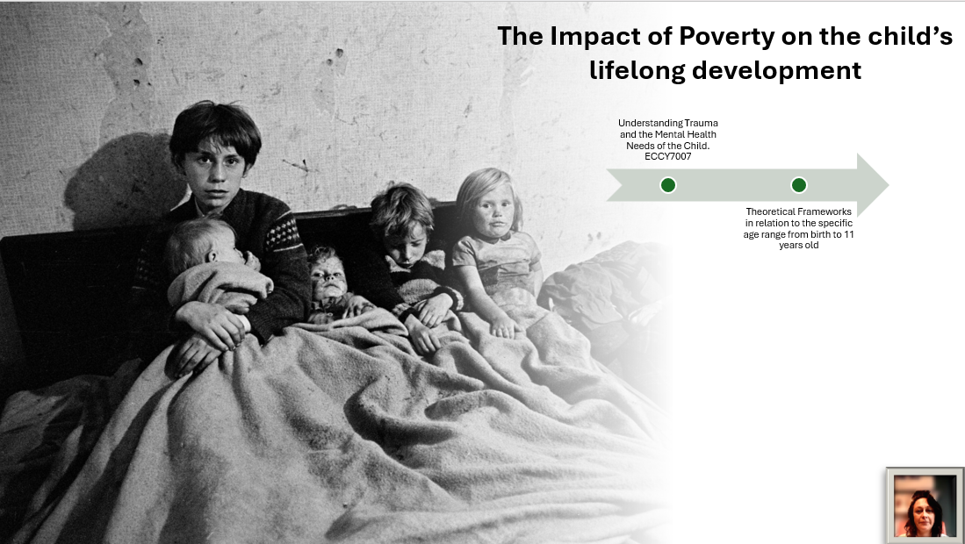
Slide 2
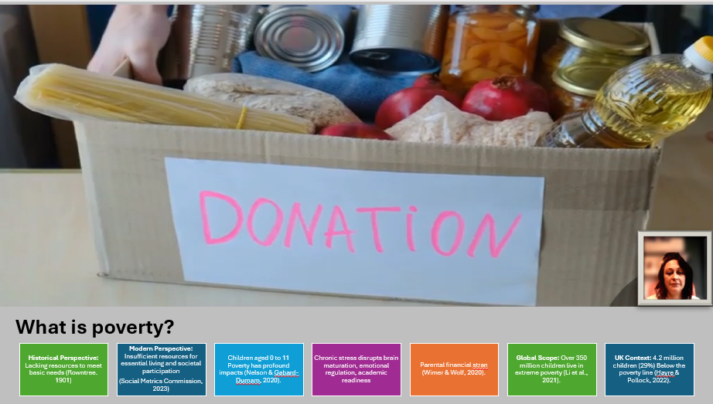
Slide 3
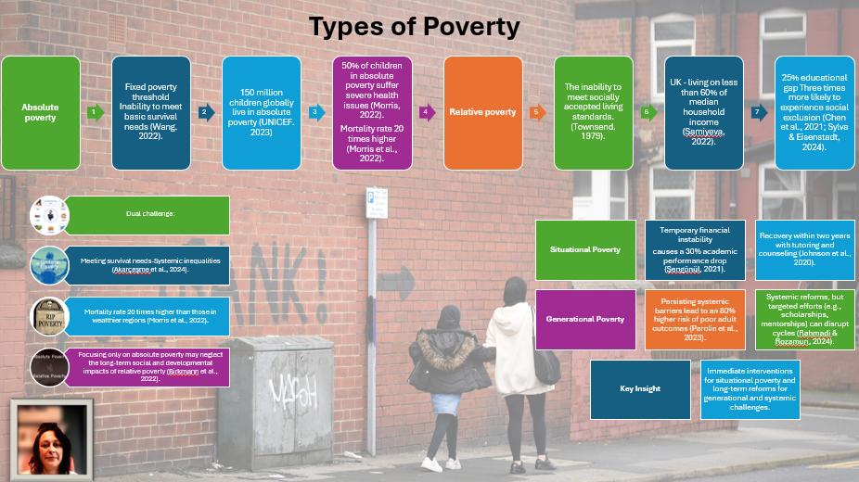
Slide 4
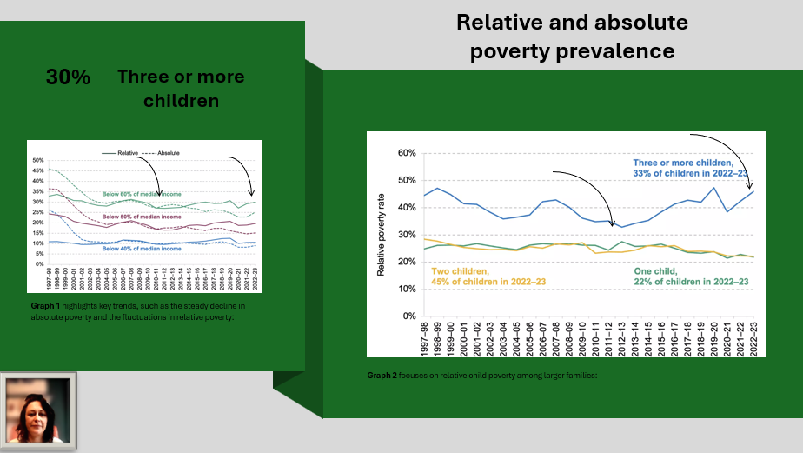
Slide 5
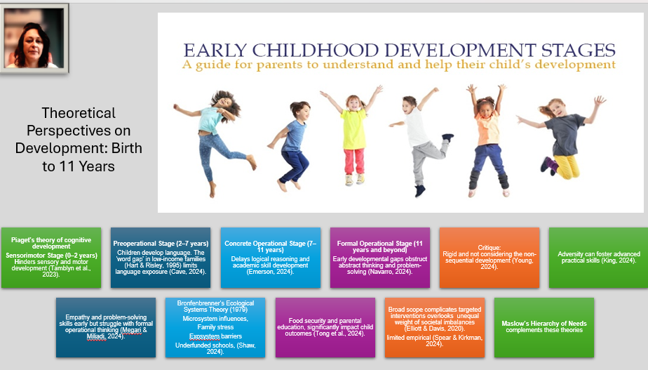
Slide 6
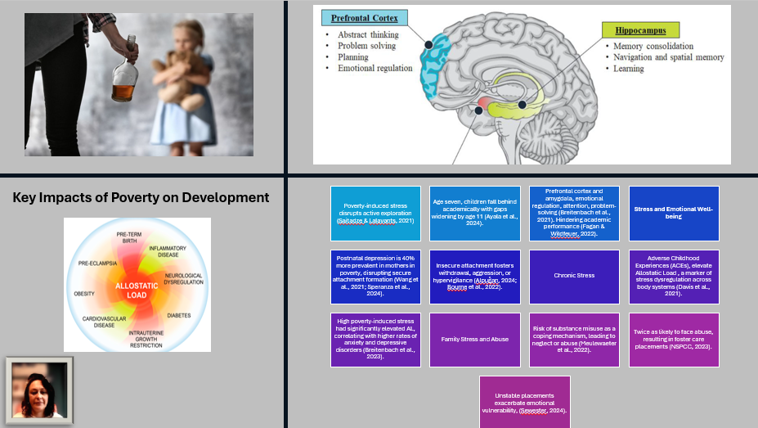
Slide 7
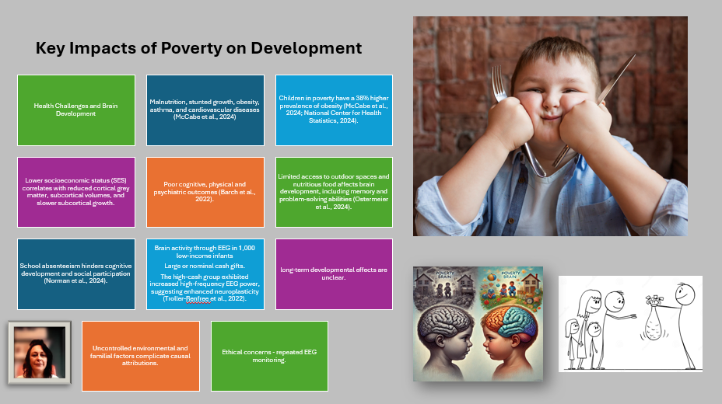
Slide 8
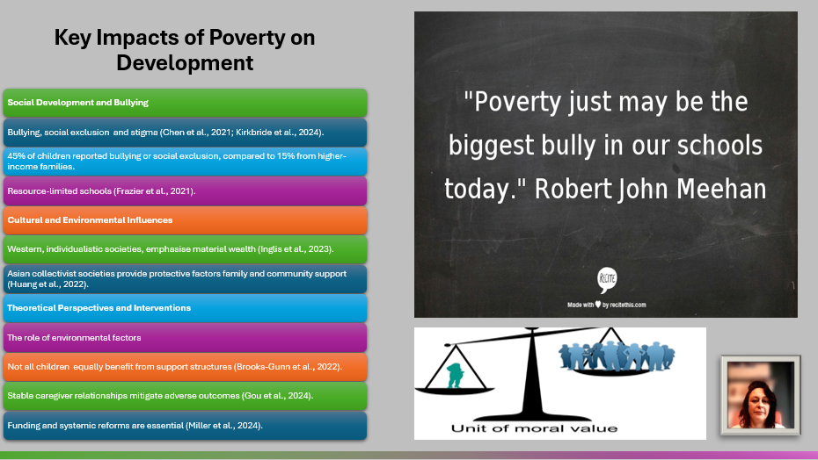
Slide 9
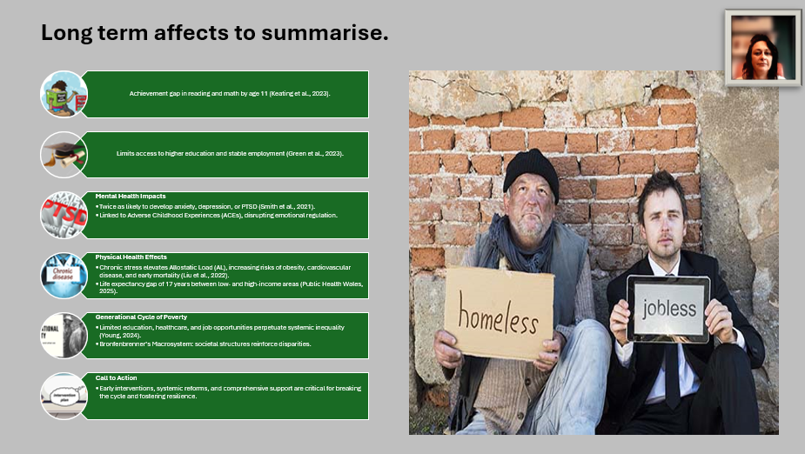
Slide 10
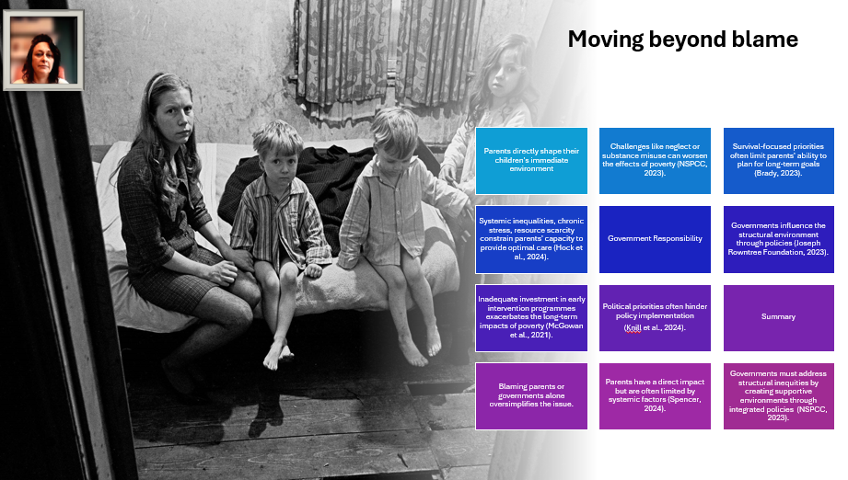
Slide 11
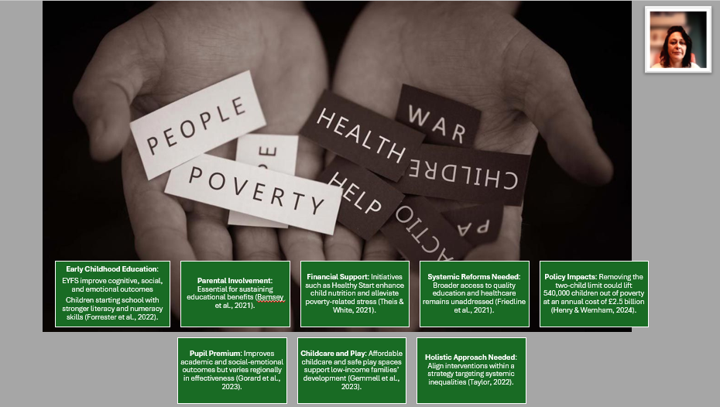
Slide 12
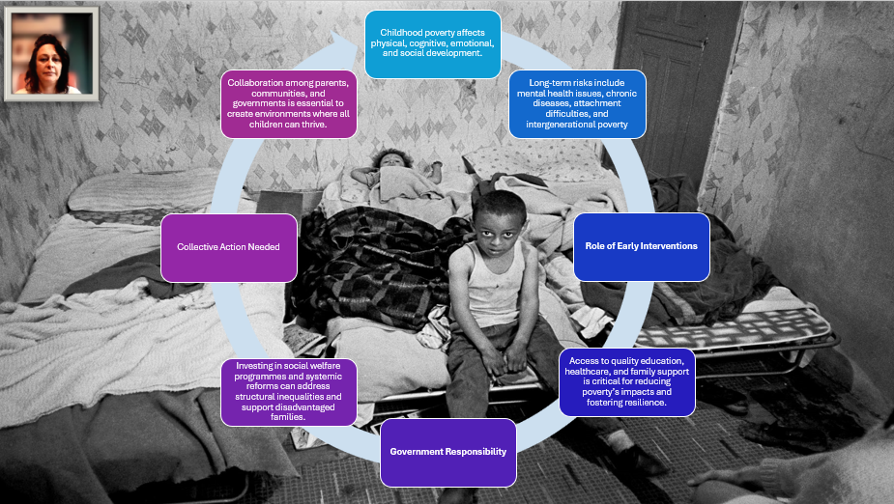
Slide 13


