Are there unintended consequences
of ESG scoring systems?

An assessment based on the analysis of BlackRock
Asset Management

Nathan
Barlow
2318300
April 2026
BMBM6020 Independent Project

Acknowledgments

In loving memory of my mum, 1969–2009.

I want to thank my dad for everything he has done to help me reach this point. His support through listening, challenging, encouraging, motivating and helping me manage anxiety and self-doubt, has made all the difference. His work and life experience helped me shape my early ideas and turn them into the final report. I could not have done this without him.

I am also thankful to my lecturers for the knowledge and skills they have helped me build throughout the course.

A special thank you goes to my supervisor, Robyn Griffiths, whose guidance and support have been greatly appreciated.

Abstract
Environmental, Social and Governance (ESG) scoring systems have become a dominant influence on investment practice worldwide, informing how risks are assessed and how capital is allocated across markets. BlackRock, the world’s largest asset manager, has played a leading role in building ESG principles into mainstream investment practice through its strategies, public communications and reliance on third party rating providers such as MSCI and Sustainalytics. Despite their widespread use, ESG scoring systems attract ongoing criticism for inconsistencies in their underlying assessment methods, limited clarity and the potential to generate unintended financial and economic consequences. This study analyses whether ESG scoring systems create such unintended effects by examining how BlackRock incorporates ESG ratings into product reporting, index construction rules and responsible investment practices.
A mixed methods approach is adopted. The quantitative approach analyses publicly available ESG ratings, stock performance and profitability indicators between 2018 and 2025, using Tesla and ExxonMobil as case studies. Market level ESG fund flow data are used to assess broader investor and market behaviour. The qualitative approach examines corporate disclosures, insights from investment market professionals and BlackRock’s responsible investment publications to understand how ESG scores are created, interpreted and applied within organisations.
The integrated analysis shows that while ESG ratings influence fund classifications, investor perceptions and certain market signals, financial outcomes remain primarily affected by sectoral factors, macroeconomic condition and effective business management. ESG scores act as one of many indicators rather than being a leading determinant of returns or volatility. The study identifies several ways in which rating based investment practices may contribute to imbalances, including inconsistent assessment approaches, sector specific approaches to scoring and rule related effects within index linked products. However, there is limited evidence that ESG scores alone generate broad market distortions.
The study concludes that ESG scoring systems direct influence on capital allocation is marginal. ESG scorings limited influence depends largely on how the ratings are applied within large scale asset management rather than the scores themselves. The study offers recommendations for improving transparency, consistency and fairness in sustainability aligned investment processes.
The research experience was an important part of the study. Initial assumptions informed by media reports were challenged through careful examination, critical engagement with the literature, the use of mixed methods analysis and applying learning from Business Management education. The process strengthened skills in project management, reflective practice and evidence evaluation, demonstrating how structured research can refine understanding and reshape perspectives.

Table of Contents
Acknowledgments 2
Abstract 3
1.Introduction 4
2.Literature Review 6
2.1 Research Approach 6
2.2 ESG Scoring Systems: Purpose, Design and Critical Review 6
2.4 Why BlackRock Adopted ESG: Strategic, Political and Market Factors 8
2.4.1 Strategic Factors 8
2.4.2 Political and Regulatory Factors 8
2.4.3 Market and Consumer Factors 8
2.4.4 Reputational and Leadership Factors 8
2.5 Conclusions and Reflections 9
3.1 Research Design and Rationale 10
3.2 Quantitative Component 10
3.2.1 Data Sources and Variables 11
3.2.2 Analytical Logic 11
3.2.3 Case Studies: Tesla and ExxonMobil 11
3.3 Qualitative Component 11
3.3.1 Data Sources 12
3.3.2 Analytical Approach 12
3.3.3 Findings from the Case Study Analysis 12
3.4 Integration of Methods 13
3.5 Methodological Weaknesses 13
3.6 Summary 14
4. Findings and Analysis 14
4.1 Quantitative Findings 14
4.1.1 Overview of Quantitative analysis 14
4.1.2 ESG Ratings as an Independent Signal 15
4.1.3 Stock Market Performance (Returns and Volatility) 16
4.1.4 Profitability as an Indicator 17
4.1.5 Summary of quantitative evidence from comparative analysis of Tesla and Exxon Mobil 18
4.1.6 Market Level ESG Investment Trends 18
4.2 Qualitative Findings 22
4.2.1 Overview of Qualitative Themes 22
4.2.2 BlackRock’s Use of Third Party ESG Data 22
4.2.3 Governance interpretation and the Limits of ESG Scores 23
4.2.4 Market Indicators and Investment Flows 23
4.3 Integrated Interpretation of Findings 23
5. Discussion and Critical Evaluation 24
5.1 Interpretation of Findings 25
5.2 Media Influence and the Formation of the Research Question 25
5.3 Critical Evaluation of ESG Scoring Consequences 26
5.3.1 Inconsistency and Limited Openness 26
5.3.2 Mechanical Market Effects 26
5.3.3 Risk of Misinterpretation 26
5.3.4 Positive Aspects 27
5.4 Influence of Political, Regulatory and Global Contexts 27
5.4.1 Regulatory and Policy Environments 27
5.4.2 Public Pressure and Ethical Standards 29
5.4.3 Global Risks: Corruption, Greenwashing and Market Integrity 29
5.4.4 Implications for BlackRock 30
5.4.5 Good Business Strategy and Management 30
5.4.6 Summary 30
5.5 Reflecting on the Research Process 31
5.6 Personal Learning and Professional Development 31
6.Conclusion and Recommendations 34
6.1 Conclusion 34
6.2 Achievement of Learning Objectives 35
6.3 Reflections on the Research experience 35
6.4 Recommendations 36
1. Recommendations for Investors and Asset Managers 36
2. Recommendations for Governments and Regulators 37
3. Recommendations for Future Research 37
REFERENCE LIST 38
ANNEX 50

1.Introduction
An important influence on global investment decisions are Environmental, Social and Governance (ESG) criteria, affecting both how organisations are assessed and how capital moves across markets.
The term ESG was formalised in 2004 by the United Nations Global Compact (United Nations Global Compact, 2004; Eccles, 2022). Its underlying principles have gained significant prominence in recent years, largely attributed to the influence of major asset management company BlackRock. Led by CEO Larry Fink, BlackRock has been particularly influential in shaping this trend. Fink has actively promoted (Fink, 2020; Fink, 2021; Fink, 2022) the integration of ESG considerations into investment strategies, using BlackRock’s scale to encourage companies to improve their environmental and social performance (Mrchkovska, 2023; Foust and St John, 2024 cited in Thompson, 2025).
The operational use of ESG in asset management is increasingly dependent on third party scoring systems. MSCI ESG (MSCI, 2025 and MSCI, 2026) ratings are widely used across product reporting, index design and portfolio analytics (BlackRock, 2024).
BlackRock’s strategic mission is to emphasise long term value creation, fiduciary responsibility and resilient financial markets (BlackRock, n.d.). By focusing on long term value creation and market stability BlackRock became one of the leading and most influential advocates of ESG principles. Fink’s annual letters consistently position BlackRock’s purpose as helping clients achieve financial security while encouraging companies to manage significant sustainability risks (Fink, 2020; Fink, 2021; Fink, 2022; Thompson, 2025).
Fink’s communications between 2010 and 2015 indicate that BlackRock recognised a convergence of influences bringing ESG considerations into the mainstream. These influences included:
- Rising public awareness and anger at repeated environmental, social and governance failures, widely reported by journalists (IPCC, 2023; Edelman, 2025).
- Publicity of corporate misconduct prosecutions in Courts worldwide (OECD, 2023; U.S. SEC, 2024).
- A clearer scientific consensus on climate change increased public awareness of this risk.
- Growing political acceptance of regulatory intervention (European Commission, 2023; FCA, 2024).
- Shifting consumer behaviour away from companies associated with environmental or social harm (McKinsey, 2023; NielsenIQ, 2024).

BlackRock’s adoption of ESG frameworks can be considered as both a response to emerging risks and a strategic opportunity to position the business at the forefront of a structural change in global finances (Thompson, 2025).
ESG scoring systems from agencies such as MSCI (MSCI, 2025 and MSCI, 2026) and Sustainalytics (Morningstar Sustainalytics, 2026) strongly influence which businesses attract investment from ESG funds. ESG scoring also affects how portfolio ‘sustainability characteristics’ are reported to clients (BlackRock, 2024). However, these systems are increasingly being questioned. Critics point to unclear methods, inconsistent scoring frameworks, biases favouring larger companies and increased greenwashing risk (Berg et al., 2022; Lublóy, 2025; Ferro, 2025). There is also concern that relying on standardised ESG ratings can create knock on effects in the market, such as automatic buying or selling when companies move in or out of an index, movements in ETF investment flows and changes in how money is allocated across market sectors (Supatgiat, 2025; Karkowska, 2025).
This research examines whether ESG scoring systems create unintended financial and economic effects. BlackRock is used as the case study because it is the largest asset management company and extensively uses ESG based investment products. The research looks at how BlackRock uses ESG scores in MSCI ratings (MSCI, 2025 and MSCI, 2026) in product reporting and also communications on responsible investment. The research then considers the wider market consequences of investment practices that rely on ESG ratings and assesses the fairness, consistency and wider implications of ESG scoring systems. Finally, it offers recommendations for a more balanced and clearly understood approach to capital allocation that is focused on sustainability.

2.Literature Review

2.1 Research Approach
Three texts inform the research approach applied in this study and guide how the literature is understood and evaluated.
The importance of reflection and critical thinking when working with complex and sometimes conflicting information is detailed in and noted from (Cottrell, 2015). These are essential skills when analysing ESG scoring systems, which require careful consideration and judgement throughout the project.
Ethical awareness and using professional material responsibly is recognised and used in the research approach as is emphasised in (ASET, 2013). The text supports the way the project uses industry reports, corporate communications and secondary data openly and carefully.
Finally, it is understood from (Gray, 2018) that applied research can be influenced by political, organisational and market pressures. This view aligns with the issues recognised in ESG literature where concerns exist of rating inconsistency, sector comparisons and the influence of managers with significant assets under their management.
Together, these texts form the basis for the research approach and guide how the wider literature on ESG scoring and investment practice is evaluated.

2.2 ESG Scoring Systems: Purpose, Design and Critical Review
Environmental, Social and Governance (ESG) scoring systems were originally developed to provide investors with structured, comparable assessments of companies’ sustainability related risks and opportunities (Khan et al., 2016).
Leading rating agencies such as MSCI, Sustainalytics and S&P Global produce ESG scores by combining many indicators across environmental performance, social responsibility and governance quality (Berg et al., 2022). These scores are widely used in portfolio construction, index design and usually in product classification especially in passive investment strategies. Rating agencies also merge these indicators into overall ESG scores that aim to show a company’s exposure to sustainability related risks and potential future opportunities (Christensen et al., 2022).
Research shows clear weaknesses in current ESG rating approaches, which influences how reliable and comparable the scores are. A significant issue is that rating providers use different weightings, data and frameworks. (Berg et al, 2022) states this ‘aggregate confusion,’ where one company can receive very different ESG scores from different agencies. This inconsistency challenges the idea that ESG ratings are objective measures of sustainability and performance (Christensen et al., 2022).
These issues also appear when companies are scored only against specific sectors and peers. For example, carbon intensive companies may receive average or even favourable ratings within their sector, even if they emit far larger amounts of carbon than companies in different sectors. Another example is that scores with weighting toward Governance tend to favour large businesses with significant financial and personnel resources that enable them produce extensive disclosures (Berg et al., 2022; Ferro, 2025). When ESG scores are automatically included into financial products or index rules, it may have unintended consequences unaccounted for by investors (Christensen et al., 2022).
Overall, the literature suggests that ESG ratings do offer a structured way to assess sustainability risks. However, it cautions that their design and use introduce significant limitations (Berg et al., 2022). These limitations become especially important when ratings are built into large scale investment processes. This is considered later in the research.
2.3 BlackRock’s Role in building ESG into standard investment practices
The size and influence of BlackRock are two important factors that have made it the leading company in the global ESG market. As the world’s largest asset manager, BlackRock integrates ESG considerations into risk management, responsible investment practices and product design (Eccles and Klimenko, 2019). Fink’s annual letters emphasise climate risk as investment risk and called for improved corporate disclosure aligned with guidance such as the Task Force on Climate related Financial Disclosures (TCFD) (Fink, 2020; Metzner et al., 2024). This public support has played an important role in integrating ESG expectations in capital markets around the world.
BlackRock’s reliance on third party ESG data particularly MSCI, has benefitted the influence of rating agencies (BlackRock, 2024). The sustainability information shown for iShares funds often comes from MSCI’s company level ESG ratings, which are then combined to give a score for the whole fund. This creates a “feedback loop” where the rating approaches inform fund classifications, which in turn influence investor demand and capital flows. The literature shows that this integration also carries over the assumptions, biases and so constraints of the rating providers themselves, which then flow directly into large scale investment processes (Christensen et al., 2022).
BlackRock’s influence on industry practice is highlighted in the literature. Eccles and Klimenko argue that BlackRock’s public support for ESG principles has encouraged other asset managers to follow similar approaches, helping to make ESG a normal part of global finance (Eccles and Klimenko, 2019).
BlackRock’s leadership has had both strategic and reputational benefits to the business, strengthening its competitive position in the fast growing market for ESG labelled investment products (Eccles and Klimenko, 2019).

2.4 Why BlackRock Adopted ESG: Strategic, Political and Market Factors

2.4.1 Strategic Factors
BlackRock’s mission emphasises long term value creation and fiduciary responsibility. Fink’s letters (Fink, 2020) argue that companies failing to manage sustainability risks will face higher costs of capital and risk weaker long-term performance (Thompson, 2025). ESG integration is therefore treated as a necessary development of risk management rather than a purely ethical initiative (Archer, 2024; BlackRock, 2018).

2.4.2 Political and Regulatory Factors
Between 2010 and 2015, regulatory requirements for climate related disclosure increased across the world’s leading economies. The emergence of TCFD, EU sustainable finance initiatives and U.S. regulatory debates was a clear signal that sustainability would play a central role in the future policy agendas in the main western economies (BlackRock, 2021; Eccles and Krzus, 2015). Aligning early with these developments positioned BlackRock as a leader in sustainable finance and positioned it to anticipate regulatory changes that would inform future investment practice (Thompson, 2025).

2.4.3 Market and Consumer Factors
Investor demand for ESG aligned products grew rapidly during this period because of reputational concerns, changes in investor preferences and greater public awareness of environmental and social harms (Brodback et al., 2019; Morningstar, 2025). BlackRock’s expansion of ESG labelled ETFs enabled it to benefit from this demand and so strengthen its competitive position in the passive investment market (BlackRock, 2025).

2.4.4 Reputational and Leadership Factors
Fink’s public support for ESG principles improved BlackRock’s profile and influence (Fink, 2021). Researchers argue that this leadership helped influence industry standards. It also encouraged other asset managers to follow with similar approaches (Thompson, 2025; Foust and St John, 2024). Although it is difficult to measure, several authors identify that BlackRock’s early public views on sustainability helped the business by giving it a commercial advantage during the rapid growth of ESG investing (Morningstar, 2023; Financial Times, 2022). The prominence and reputation gained also strengthened BlackRock’s market authority, with large index managers often described as ‘semi-regulatory actors’ influencing the direction of sustainable finance (Fichtner et al., 2017; Coates, 2019).

2.5 Conclusions and Reflections
Consistently research findings across the literature are of ESG scoring systems being influential but not perfect and their influence was all the greater when built into large scale investment processes (Archer, 2024). BlackRock’s reliance on MSCI derived ratings is an example of how third party ratings can inform fund classifications, investor perceptions and capital allocation (MSCI, 2025; Khan et al., 2016).
Research also highlights concerns about rating divergence, ESG scoring by sector and the influence of large fund managers on sustainability models. These unresolved issues point to a “gap” in understanding because while ESG ratings are widely used, their financial and economic consequences remain insufficiently understood. This “gap” shapes the research design in the next chapter, which uses a mixed methods approach to examine how ESG scoring works in practice and whether it leads to unintended outcomes.

3. Methodology
This study adopts a pragmatic mixed methods design to understand how ESG scoring systems are used within large scale asset management and whether their application generates unintended market consequences (Maarouf, 2019).
A mixed methods approach is appropriate because ESG scoring operates both as a quantitative indicator (e.g. ratings, index eligibility, fund flows) working together with qualitative components reflected in organisational statements, governance or responsible investment practices and regulatory discussion.
Using BlackRock as the case study strengthens the methodological consistency of the study. BlackRock’s scale, its extensive use of MSCI derived ESG data and its influence on global investment practices make it ideal for examining how rating based indicators inform market behaviour (Thompson, 2025).

3.1 Research Design and Rationale
A pragmatic approach is taken to the research design. Pragmatism prioritises methods that best address the research question rather than following a single philosophical tradition (Morgan, 2014). ESG research is complicated and is affected by measurable indicators and by data/information that requires analysis and interpretation and for these reasons this approach is appropriate.
The mixed methods design enables the study to:
• Identify observable patterns in ESG ratings, stock performance and fund flows.
• Understand how ESG scores are both assessed and the justification for the assessed score. Also, to show in practice how a score is then applied by Investment Managers.
• Assess the relationship between company level indicators and the consequences at market level.
• Assess not only the fairness but also how consistent ESG scoring systems are.
This approach aligns with (Creswell, 2012) argument that mixed methods research is valuable when neither quantitative nor qualitative evidence alone is sufficient to understand complex organisational issues (Creswell and Plano Clark, 2017).

3.2 Quantitative Component
The quantitative approach examines ESG positioning and market behaviour between 2018 and 2025 using publicly available secondary data. Rather than estimating a full statistical model, which would require research funds to access commercially sensitive and privately held historical MSCI datasets, the study uses quantitative indicators to assess whether patterns commonly associated with ESG scoring are reflected in market outcomes.

3.2.1 Data Sources and Variables
The quantitative analysis draws on:
• Headline ESG ratings and sustainability indicators (where publicly accessible).
• Stock market indicators such as returns and volatility.
• Market level indicators including ESG labelled fund and ETF flows.
These variables allow the study to understand whether ESG ratings act as meaningful indicators that influence investor behaviour or perceived risk.

3.2.2 Analytical Logic
Within this approach:
• ESG ratings function as the independent signal.
• Stock returns and volatility act as outcome measures.
• Profitability, company size, together with industry sector are used as control variables.
This approach allows a structured comparison without suggesting a cause and effect.

3.2.3 Case Studies: Tesla and ExxonMobil
To illustrate the quantitative logic, the study uses two frequently analysed companies:
• Tesla: widely regarded as environmentally leading yet rated lower on governance and social criteria in the automotive sector
• ExxonMobil: carbon intensive, operationally stable and well established in the Oil and Gas energy sector
These cases highlight how ESG scores interact with underlying sector influences, investor interpretation and market interpretations.
The cases are not intended to generalise across all businesses but to show how ESG scoring interacts with financial outcomes in practice.

3.3 Qualitative Component
The qualitative component uses documentary analysis and focused case study methods to examine how ESG scoring is described, justified and applied by BlackRock and other participants in the market. The approach to secondary data analysis was informed by (Flick’s, 2014) guidance on qualitative research design and documentary analysis.

3.3.1 Data Sources
The qualitative analysis draws on:
• BlackRock’s iShares product materials (BlackRock, 2025).
• Sustainable investing guidelines (BlackRock, 2025).
• BlackRock responsible investment practices (BIS) reports (BlackRock, 2025).
• Fink CEO letters (2018–2025) (BlackRock, 2025).
• Corporate sustainability disclosures from Tesla and ExxonMobil (Tesla, 2025; ExxonMobil, 2025).
• Industry analysis and policy documents GSIA, 2025; Morningstar Sustainalytics, 2026).
• Market level indicators such as ETF flows (Morningstar Sustainalytics, 2026).
These sources provide evidence of how ESG scores are integrated within organisational communication and investment practice.

3.3.2 Analytical Approach
The documentary evidence is analysed using key themes including:
• Reliance on third party ESG data (MSCI, 2025).
• How portfolio level ESG profiles are constructed (BlackRock, 2025).
• How ESG index products include, exclude, or adjust the weighting of companies (BlackRock, 2025; MSCI, 2025).
• Distinctions between responsible investment judgement and external scores (BlackRock, 2025).
• How investors respond when companies are included or excluded on ESG grounds (Morningstar Sustainalytics, 2026).
This approach helps explain how fairness, responsibility and long-term value is constructed in the ESG market.

3.3.3 Findings from the Case Study Analysis
Tesla’s disclosures highlight environmental innovation and leadership in the automotive sector while ExxonMobil emphasises carbon emissions reduction commitments and governance practices (Tesla, 2025; ExxonMobil, 2025). These contrast and help give context to how companies respond to ESG scoring pressures and how investors interpret sustainability claims.
BlackRock’s responsible investing messages show a mix of judgement and score influenced reporting, which is why the study uses more than one research method (BlackRock, 2025; BlackRock, 2025).

3.4 Integration of Methods
The strength of the approach is to connect:
• Quantitative patterns (e.g. rating changes, fund flows, volatility)
• Qualitative interpretations (e.g. responsible investment reporting, product rules, subjective assessments)
This integration helps evaluate how BlackRock’s use of MSCI derived ESG measures may contribute to market effects, while being open about data limits and the interpretive character of the case study (MSCI, 2025; BlackRock, 2025).

3.5 Methodological Weaknesses
It is evident and acknowledged that there are limitations in the analysis undertaken. The identified weaknesses include:
• Reliance only on publicly available ESG data. This does restrict the depth of quantitative modelling that could be undertaken.
• Case study examples are limited and only clarify patterns. It is therefore not possible to apply findings as a general rule across all companies.
• Documentary analysis reflects reported account only. It is recognised this may be selective or strategic information and so not a full or accurate picture.
• Indicators that are at market level, for example ETF flows, only show that there is correlation and do not show that there is a cause/effect relationship (Morningstar Sustainalytics, 2026).
• The absence of interviews, surveys, or practitioner case studies limits insight into how ESG considerations are applied within organisations or how investment professionals interpret rating based indicators in practice.
These limitations are consistent with the constraints of secondary data research and are clearly and openly referred to in the study.

3.6 Summary
The methodology establishes a strong basis for evaluating the fairness and market consequences of ESG scoring systems. By combining quantitative indicators with interpretive qualitative analysis, the study shows both how ESG scoring operates and how it is understood within large scale asset management. The approach aligns with (Gray’s, 2018) guidance on conducting research in organisations, while ethical considerations follow the principles outlined in the (ASET, 2013) Good Practice Guide.

4. Findings and Analysis

This section presents findings obtained from the mixed method approach and considers how ESG scoring systems are related to financial performance and organisational behaviour as well as any market level changes.
The analysis is in three stages:
- Examination of the quantitative indicators, ESG ratings, stock market performance and profitability using Tesla and ExxonMobil to illustrate.
- Analysis of the qualitative evidence from BlackRock’s disclosures, responsible investment practices reporting and corporate sustainability communications.
- Pulling these strands together to assess how the use of ESG scores at scale may generate unintended financial and economic consequences.
Importantly, this approach moves from company level and organisational behaviour to market wide effects, providing a structured assessment of how ESG scoring systems may cause unintended consequences (Arslan, 2025; Goerzen, 2025; Liu, 2025; Zhu, 2025)

4.1 Quantitative Findings

4.1.1 Overview of Quantitative analysis
The quantitative findings are based on publicly accessible indicators covering 2018 to 2025 (Escobar-Saldívar, 2025; Gupta and Chaudhary, 2026). The analysis assesses whether observable differences in ESG positioning correspond with differences in returns, volatility and profitability (Al Amosh, 2025; Wu, 2025). Because the analysis relies on publicly available indicators and an interpretive mixed methods approach, it is limited in that it can only identify relationships and trends (Zubizarreta, 2026). The approach cannot determine whether ESG scores directly cause changes in returns, volatility, or investor behaviour (Zubizarreta, 2026; Ylä-Anttila, 2026)
To illustrate these broad patterns, this graph compares an ESG focused index with its parent benchmark. In index linked investing a parent benchmark (or parent index) is the original, broad market index from which a specialised or ESG adjusted index is derived. (Gupta and Chaudhary, 2026; chen et al, 2025)

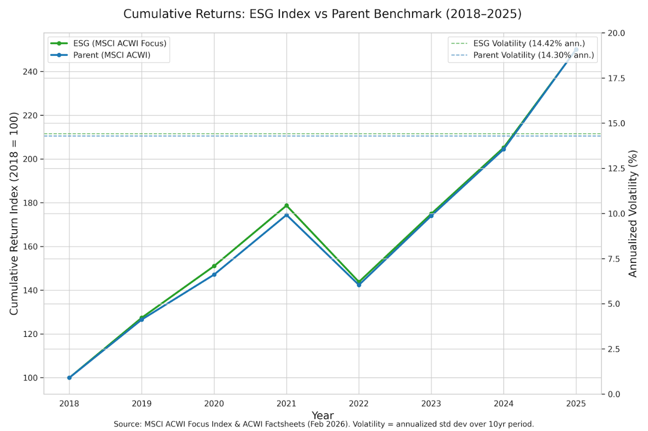

Source: (MSCI, 2026)
The data shows that the ESG index produced similar or slightly better cumulative returns and was just as volatile. This supports the idea that ESG positioning may be associated with stable or favourable market outcomes. The ESG ratings provide only a simplified indication of sustainability related risk. The overall financial outcomes are strongly influenced by industry sector factors, business models and the macroeconomic conditions at that time (Abate, 2025; Kyei-Mensah, 2026).

4.1.2 ESG Ratings as an Independent Signal
The Tesla and ExxonMobil analysis illustrates that ESG ratings reflect a range of factors, which means they can act in ways that are unexpected as in these examples:
• Tesla is widely perceived as environmentally aligned, yet its composite ESG ratings often reflect governance and social concerns.
• ExxonMobil receives lower environmental scores. This is because it has carbon intensive operations. However, it does perform more consistently on governance and operational stability scores.
The contrast between Tesla and ExxonMobil shows that ESG ratings are not a simple indicator of environmental performance. Instead, they reflect how each provider designs its approach, adjusted for sector differences and weighted governance factors (Galema and Gerritsen, 2025).
These differences show why ESG ratings can send mixed signals to investors and why they must be interpreted in the context of their design and data sources.

4.1.3 Stock Market Performance (Returns and Volatility)
The stock market data reinforces that ESG ratings alone do not determine financial outcomes:
• Tesla shows strong growth and financial gains across the period, but with high volatility which is typical of a company focused on growth.
• ExxonMobil delivers more moderate gains and lower volatility which is expected from a more a mature established fossil fuels driven energy company.

The chart below illustrates findings from (FinanceCharts, 2026; Slickcharts, 2026; Total Real Returns, 2026)
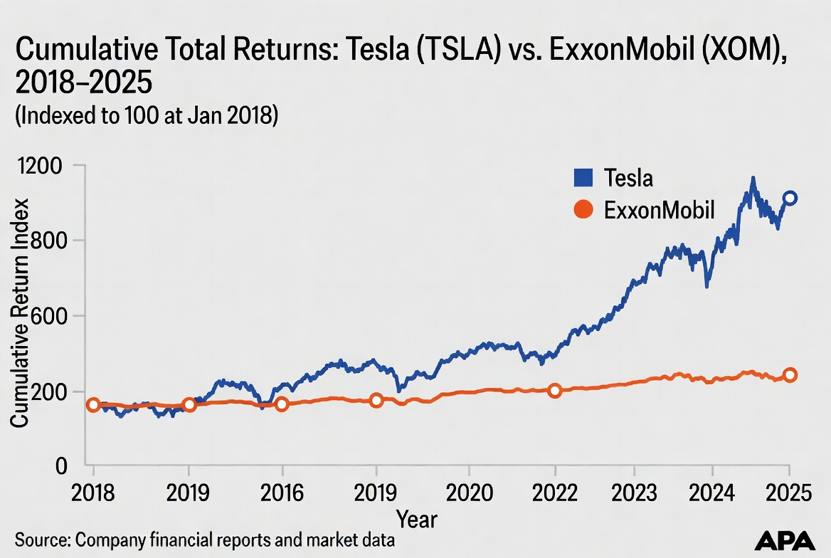
Source: (Slickcharts, 2026)
The comparative analysis shows that markets are influenced mainly by sectors and economic conditions. The conclusion is that ESG scores are acting as just one of many signals that require interpretation (Larsson and Leuhusen, 2025).

4.1.4 Profitability as an Indicator
Analysis of profitability trends also show how difficult it is to interpret ESG scores.
Tesla’s profitability rises and falls sharply because it is still in a growth phase and faces strong competitive pressures.
ExxonMobil’s profitability is steadier and largely follows commodity prices and the demands of capital intensive operations.
These figures show that profit levels are affected mainly by sector and economic conditions. ESG ratings are acting as only one factor among many (Abate, 2025).
YEAR | Tesla Net Income (USD millions) | ExxonMobil Net Income (USD millions)
2018 | -976 | 20,840
2019 | -862 | 14,340
2020 | 690 | -22,440
2021 | 5,524 | 23,040
2022 | 12,583 | 55,740
2023 | 14,997 | 36,010
2024 | 7,091 | 33,680
2025 | 3,794 | 28,844

Annual Net Income: Tesla Inc. (TSLA) vs. Exxon Mobil Corp. (XOM), 2018–2025 (USD millions) Negative values show a net loss.
Source: Compiled from (Tesla, Inc. 2026; Exxon Mobil Corporation, 2026; Macrotrends, 2026).
The data shows Tesla has moved from consistent losses to strong profits before a levelling out of results in 2024–2025. ExxonMobil showed high volatility which is linked to oil prices fluctuating and of note is the 2020 loss which is followed by record profits in 2022.
This analysis strongly supports the findings that ESG scores cannot be evaluated without considering the underlying business model.

4.1.5 Summary of quantitative evidence from comparative analysis of Tesla and Exxon Mobil
Tesla and ExxonMobil show different combinations of returns, volatility and profitability, which helps explain why investors and product providers rely on simplified ESG indicators. At the same time, the results make it clear that ESG ratings cannot be considered in isolation. Market outcomes are influenced mainly by sector exposure, investor sentiment and wider economic conditions, with ESG scores acting as only one informative signal (Kyei-Mensah, 2026)
Together, these findings suggest that ESG scores may oversimplify complex financial realities, which can contribute to unintended consequences when used at scale.

4.1.6 Market Level ESG Investment Trends

Time-Series Line Chart: Annual Net Flows into Global Sustainable Funds (2018–2025) (Morningstar, 2026)
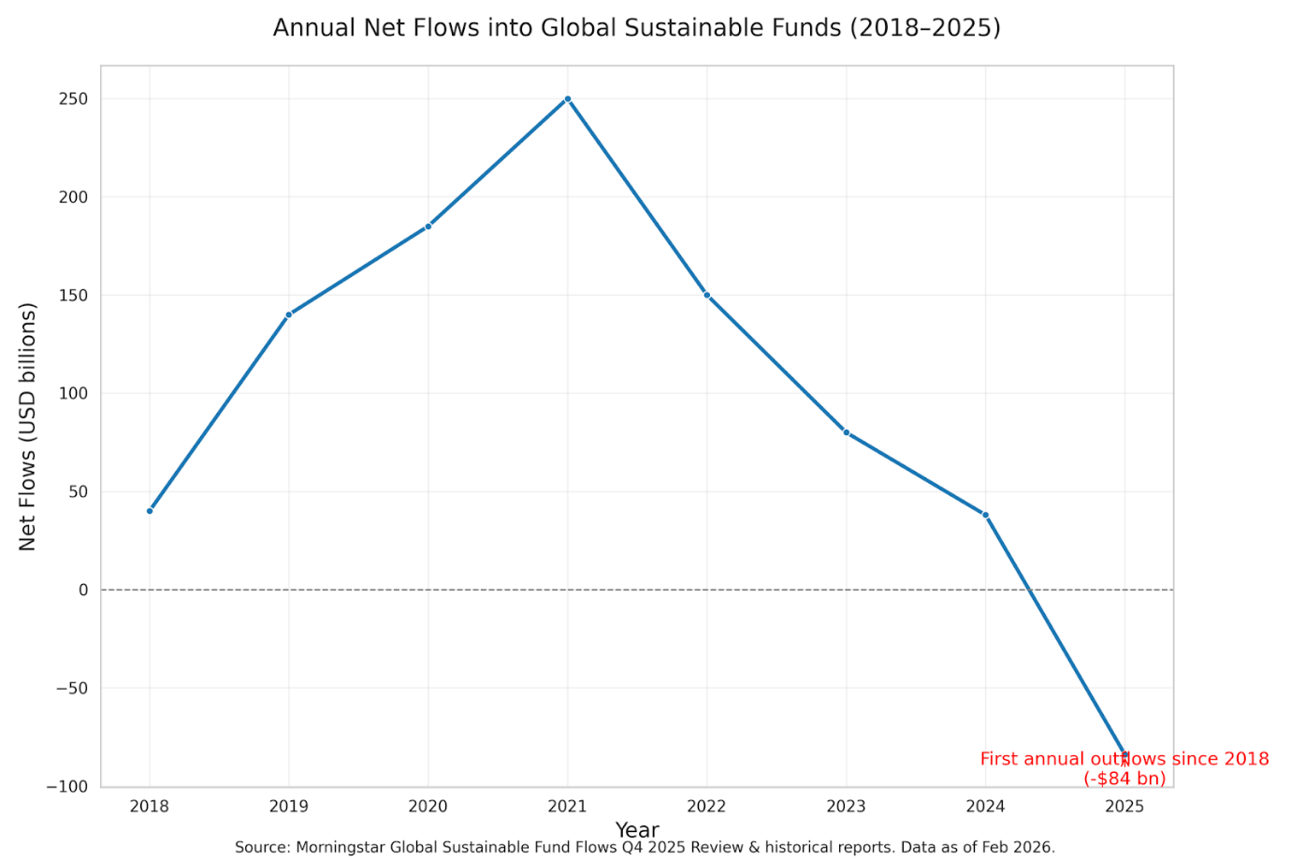
Source: (Morningstar, 2026)
This line chart shows how investor money moved into or out of ESG labelled funds over time. From 2018 to 2023, flows were consistently positive, reflecting strong investor demand. In 2024, flows in slowed but remained positive. In 2025, the trend reversed sharply, with the first annual outflow since tracking began. This suggests a change in investor sentiment and informs findings for this research (Morningstar, 2026; GSIA, 2025).

Compiled annual data (2018–2025) – Net flows & Assets Under Management (AUM) (USD billions; source: Morningstar Direct summaries, 2025 reports):
Year | Net Flows (USD bn) | End-of-Year AUM (USD tn) | Notes / Regional Split
2018 | Baseline (tracking start) | ~0.6 | Global sustainable fund universe established
2019–2023 | Strongly positive (cumulative >$300 bn inflows across period) | Progressive growth to ~$3.2 tn by end-2023 | Europe dominant throughout
2024 | +38 | ~3.6 (pre-2025 appreciation) | Positive inflows
2025 | –84 (first annual outflows since 2018) | ~3.9 (up ~4% on market appreciation despite flows) | Europe: –$20 bn in Q4 alone (86% of global AUM)  US: –$21 bn annual (9% of global AUM, $368 bn peak)  Rest of World: outflows in Asia ex-Japan & China

Key 2025 quarterly figures (public Morningstar Q3/Q4 2025 reports):
- Q3 2025: –$55 bn
- Q4 2025: –$27 bn
- All regions experienced net withdrawals in the second half of 2025 which is the first time Europe recorded a full year of outflows.

Broader GSIA (GSIA, 2025) By late 2024 to 2025, global assets invested using ESG approaches reached approximately $16.7 trillion, representing 49% growth over two years. However, this figure is based on a narrower definition than in previous GSIA reports, focusing only on funds that clearly disclose their sustainability approach (GSIA 7th Global Sustainable Investment Review, 11 November 2025). Despite continued growth in overall Assets Under Management (AUM), caused in part by market performance, the sharp reversal in 2025 fund flows suggests that ESG ratings may no longer function as a strong positive signal for investor behaviour, particularly in the context of increasing regulatory and political headwinds.

The table below is an example of how fund level flows and AUM can be used to assess the strength of investor demand for ESG labelled products:

ESG vs. Conventional Fund Flows (2024–2025) and AUM Growth (2018–2025)
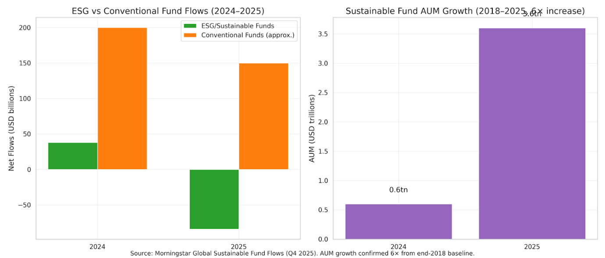
Source: (Morningstar, 2026)
This bar chart compares flows into ESG funds with flows into conventional funds. It shows that conventional funds continued to attract capital while ESG funds experienced net outflows in 2025 (Morningstar Sustainalytics, 2026). The chart also shows that total ESG assets under management continued to grow over the longer period, as a consequence of market appreciation rather than new inflows (GSIA, 2025). This inconsistency may lead investors to misinterpret market indicators about the strength of ESG investment demands.

Below a stacked bar chart shows how different regions contributed to global ESG fund flows. Europe, which accounts for the majority of ESG assets, drove both the positive flows in 2024 and the negative flows in 2025. The reversal across all regions in late 2025 highlights a global shift in ESG investment behaviour (Reuters, 2025).

Regional Contribution to Global Flows (Europe vs. US vs. Rest of World, 2024–2025)
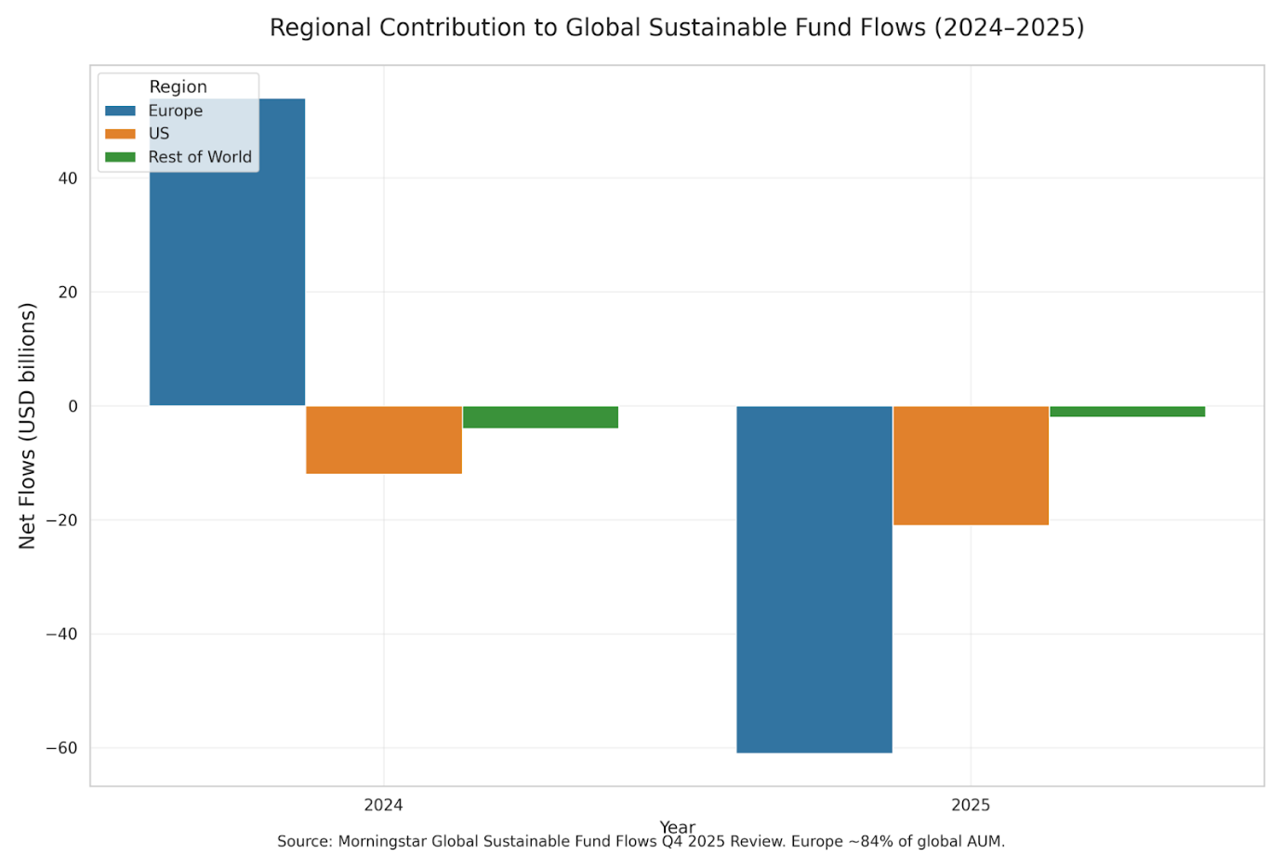
Source: (Morningstar, 2026)

4.2 Qualitative Findings

4.2.1 Overview of Qualitative Themes
The qualitative analysis draws on BlackRock’s disclosures, responsible investment practice reports, corporate sustainability documents and market analysis. The findings show how ESG scoring is presented, justified and applied in practice and how third party ratings, particularly measures sourced from MSCI, become built into the investment processes.

4.2.2 BlackRock’s Use of Third Party ESG Data
BlackRock’s communications to investors on sustainable investments rely heavily on ESG data from MSCI scoring combined to the fund level (BlackRock, 2024) This “packaging” of individual companies ESG scores as one fund level measure that investors see/use has two important implications:
1. A changes in one company's ESG rating can alter a funds overall ESG score (up or down). This can happen even if the actual holdings remain unchanged and nothing has been bought or sold.
2. ESG scores can start to affect financial decisions when they are built into investment rules, such as how funds are constructed, what companies are included or excluded and how products are labelled.
This creates a feedback loop in which third party index rules influence fund design, investor perceptions and ultimately capital flows (Barontini and Gioja, 2025).

4.2.3 Governance interpretation and the Limits of ESG Scores
BlackRock’s reporting emphasises long term financial relevance, governance quality and climate risk management (BlackRock, 2025). Importantly, governance decisions are not presented as direct outcomes of ESG scores. Instead, BlackRock presents engagement and voting as based on judgement influenced by context and informed by multiple sources of information (BlackRock, 2025; BlackRock, 2025).
This distinction highlights a tension:
• Governance is presented as a matter of independent judgement,
• while product reporting relies heavily on external ESG scores.
This helps explain why ESG ratings can influence markets, even though they are not used to decide how BlackRock makes voting decisions (Strampelli, 2024).

4.2.4 Market Indicators and Investment Flows
There are two main ways ESG scores can have wider effects on the economy:
- ETF and Fund Flows
Global ESG labelled funds saw large net withdrawals in 2025, ending many years of steady inflows. Approximately £63 billion was withdrawn in the year, including around £20 billion in the final quarter (Morningstar, 2026). These outflows increase the effect of rating based product rules, as selling by investors automatically causes a rebalancing of portfolios (Morningstar, 2026).
- Index Inclusion and Exclusion Effects
If a stock market index uses ESG scores as part of its rules, a change in a company’s ESG rating can decide whether the company stays in that index at all and how much of it investors want to hold. In other words, it can cause short term buying or selling that has little to do with the company’s actual financial performance, especially in sectors where sustainability reporting plays a big role (Barontini and Gioja, 2025).

4.3 Integrated Interpretation of Findings
The integrated analysis shows a complex picture of ESG scoring:
• Quantitative evidence shows that financial outcomes are influenced primarily by sector, business model and macroeconomic conditions (Wu, 2025; Shi, 2025).
• Qualitative evidence indicates that ESG scores matter because they are built into large scale fund rules and investor reporting systems (Carè, 2026; ICMA, 2026).
• Market data shows that ESG labels can increase buying and selling activity (Zuo, 2026; Shi, 2025).
Taken together these findings show that limited openness and inconsistency in ESG scoring reduces information quality. This in turn both affects investment decisions and how companies react to external assessments (OECD, 2025; Shi, 2025). As a result, ESG scores influence and sometimes restrict behaviour, particularly when they are built into index linked products and fund labels (Carè, 2026; Zuo, 2026).

5. Discussion and Critical Evaluation

5.1 Interpretation of Findings
The findings of this study show clearly that the influence of the ESG scoring systems have a variable outcome. The consequence of that influence depends on context and is influenced by many factors (Dincă, 2025; Herman, 2025). ESG processes are designed to encourage responsible corporate behaviour and support long term value creation. However, the data shows that ESG ratings on their own do not reliably predict market performance (Kyei-Mensah, 2026; Galema and Gerritsen, 2025; Taskin, 2025).
The contrasting cases of Tesla and ExxonMobil are a good example of the complex factors involved. Tesla’s strong environmental positioning and higher ESG positioning did not lead to stable performance as instead, the company showed high volatility characteristic of growing companies. ExxonMobil, despite lower ESG ratings showed steadier profitability and returns expected from a more a mature established fossil fuel energy company. The evidence shows that the companies industry/sector, the wider economy and its business model have the strongest influence on financial performance. ESG ratings still matter, but they are only one of several influences (Herman, 2025; Li, 2025).
Strategic management theory aligns with this finding and argues that organisational performance depends on the interaction of internal strengths, external pressures and market structure and not from any single factor (Riefolo, 2026). ESG scores therefore contribute to, but do not determine investor decision making or valuation (Dincă, 2025; Taskin, 2025).

5.2 Media Influence and the Formation of the Research Question
The initial research question came after personal investment research attracted numerous reports on BlackRock, Larry Fink and ESG scoring systems. Many of the reports were very critical and negative toward the company, Fink and ESG scoring systems. Although it was evident that much of received material lacked accuracy, it repeatedly being received contributed to the perception that ESG scoring and BlackRock had developed a system that disproportionately benefited their own interests.
In today’s algorithm led social media environment, personalised content feeds tend to increase levels of contentious information, often prioritising negative assessments, misinformation, or conspiracy based commentary (Cinelli et al., 2021; Guess et al., 2023).
Truly independent media is increasingly rare. Digital information is informed by commercial incentives, by political pressures and algorithms in distribution systems aiming to increase engagement without concerns for accuracy (McChesney, 2015; Napoli, 2019).
Information from all sources must be evaluated critically considering potential bias, selective presentation, or questionable validity. This is an issue that poses growing challenges for society (Pariser, 2011).
The experience of the current media environment caused the negative reports about ESG scoring to seem credible and more widespread than they were. By research using credible journalistic sources, regulatory documents, peer reviewed literature and Business Management teaching, the study developed a more balanced and evidence led understanding of ESG scoring. The research brought about a change in knowledge and perspective that demonstrates how systematic inquiry can challenge initial biases and lead to conclusions that differ markedly from those anticipated at the outset (Cottrell, 2015).

5.3 Critical Evaluation of ESG Scoring Consequences
The findings highlight several limitations and unintended consequences associated with ESG scoring systems.

5.3.1 Inconsistency and Limited Openness
ESG ratings are constructed using different weighting schemes and data sources. The methods used are not openly shared as ESG providers want to protect their business interests (Shi, 2025). These differences in approach create inconsistency amongst providers and make reliability of ESG scores unreliable. ESG scoring cannot be the objective indicator of sustainability performance it claims to be (Zubizarreta, 2026).

5.3.2 Mechanical Market Effects
When ESG scores are built into index rules, screening rules, or fund classifications a rating change can lead to an automatic reallocation effect (Barontini and Gioja, 2025). These changes may increase market movements that are not related to a company’s actual performance, particularly during periods of large inflows or outflows in ESG focused funds.
The sudden change in 2025 to net outflows of approximately £63 billion from ESG focused funds shows how changes in investor opinion can quickly affect index linked investment products (Barontini and Gioja, 2025; Morningstar, 2026).

5.3.3 Risk of Misinterpretation
Investors may treat ESG scores as forward looking signals of risk or ethical standards. However, it is evident many ratings are largely backward looking and are based on company information that is not verified as accurate (Dincă, 2025). In consequence there can be an over reliance on simplified measure that do not fully reflect a company’s actual performance, strategic resilience, or long term growth (Taskin, 2025).

5.3.4 Positive Aspects
Despite the limitations identified, ESG scoring systems have contributed to raising minimum standards of corporate behaviour. Research shows that sustainability practices and reporting requirements can strengthen governance structures, improve internal processes and encourage more responsible conduct (Eccles, Ioannou & Serafeim, 2014; Ioannou & Serafeim, 2017). The ESG approach has also encouraged companies to be more open and honest. ESG scoring as a result has improved management of environmental and social risks (Christensen, Hail & Leuz, 2021). At the same time, ESG approaches have increased investor awareness of sustainability related risks and opportunities. Even if the underlying operation is far from perfect, ESG has influenced changes in a positive direction (Friede, Busch & Bassen, 2015; Kotsantonis, Pinney & Serafeim, 2016).

5.4 Influence of Political, Regulatory and Global Contexts
The study finds that ESG performance is closely tied to the political, regulatory and global circumstances in which businesses operate (Sinn, 2025; Wang, 2025). ESG scoring systems are influenced by external factors such as Government policy, laws on disclosures, cultural expectations and public attention/pressure. These influences vary around the world and are continually changing. External factors strongly influence how companies respond to sustainability pressures and how investors interpret ESG indicators. Again, this evidences that ESG scores alone do not explain market behaviour (Li and Wu, 2025).

5.4.1 Regulatory and Policy Environments
Regulatory changes are now one of the main forces shaping corporate ESG behaviour in the world's leading economies.
In the European Union, climate policy has moved forward quickly through new rules on mandatory disclosure and due diligence. The Corporate Sustainability Due Diligence Directive (CSDDD, 2024) requires large companies which includes non EU companies operating in the Single Market to identify and mitigate climate related risks and adverse human rights affects across global supply chains (European Commission, 2025. These developments show that in Europe, ESG responsibility is increasingly required in corporate governance, making “profit only” strategies difficult to sustain without accounting for environmental impacts (European Commission, 2025; PwC, 2025).
In the United Kingdom, the Transition Plan Taskforce (TPT) set out a “gold standard” framework for climate transition plans which is now being incorporated into Financial Conduct Authority reporting from 2025/26 (HM Treasury, 2023). Unilever and Ørsted are examples of companies that by aligning with these standards have gained a competitive advantage (Unilever, 2024).
In China, regulatory intervention is key part of national strategy. The country’s “dual carbon” goals of peak emissions by 2030 and carbon neutrality by 2060 have resulted in mandatory ESG disclosure for selected large companies listed both domestically and overseas (Shanghai Stock Exchange, 2025). New sustainability reporting guidelines have been issued by the Shanghai, Shenzhen and Beijing Stock Exchanges which require climate risk analysis, Scope 1 and 2 emissions disclosure and alignment with International Sustainability Standards Board (ISSB) standards (Shanghai Stock Exchange, 2025). China continues to balance expansion in renewable technologies with its energy security still depending on coal. Increased mandatory reporting has made it easier to compare companies and this influences investor behaviours (Wang & Liu, 2024). Businesses operating in China prioritise government regulation more than external investor pressure. In consequence, ESG behaviour is influenced much more by state direction than by global asset manager influence (China Securities Regulatory Commission, 2025).
The United States has a contrasting situation to the other major world economies. Political divisions have created inconsistent and often contradictory regulatory approaches to sustainability. This is illustrated in the following examples. Federal incentives, such as the Inflation Reduction Act (2022) encourages investment in clean energy (Barbanell, 2022). In contrast several Republican led states have introduced anti ESG legislation restricting the use of ESG criteria in public investment decisions. The opposing approaches are also evident in 32 State Bills introduced in 2024 some supporting and others opposing ESG investing (Gibson and Sawyer, 2023). Although it is evident there is uncertainty and inconsistency in sustainability approaches, many large U.S. businesses continue with internal climate risk management and sustainability practices to meet global supply chain requirements, investor pressure and international reputational considerations.
A further recent development is the Federal “rollback” of climate disclosure policy. In 2026, the Securities and Exchange Commission stopped the implementation of the 2024 Climate Related Disclosure Rules (Welsh, 2024), reducing the availability of standardised climate data for investors (U.S. Securities and Exchange Commission, 2025). This action, together with wider deregulation across environmental agencies, has put the Federal approach out of step with international ESG requirements. The Federal position has not stopped market forces continuing to push companies toward credible sustainability strategies. This illustrates that reducing regulatory requirements does not in itself remove the commercial incentives for climate responsibility.
Japan offers a hybrid model. Since 2021, the Tokyo Stock Exchange has required its largest listed companies to adopt international climate risk reporting principles. The government approach is one of “comply or explain”. The country is gradually changing toward mandatory global sustainability standards (Japan Exchange Group, 2025). Japan’s long term business culture and emphasis on continuous improvement in business practices support this direction of travel.

5.4.2 Public Pressure and Ethical Standards
Ethical business behaviour is strongly affected by communities and Investors and is significantly more influential than ESG scores (Marcoux, 2022). An example of the power of public opinion is Coca Cola being forced to adopt a water management strategy and allow external independent auditing in South Africa and India. In both cases Coke was found to have misused water supplies and harmed the environment and residents. This is one of many examples of community action and media attention that made big business take responsibility for damage caused by their actions (Bijoy, 2006; Motwani, 2023).
The cases against Coca Cola also raised awareness that there can be a gap between what a business states its ethical approach is and what it does in practice. Pressure for independent auditing of company reports, so called Ethics Audits, is growing (Earth Island Institute v. Coca-Cola, 2024). This evidences the importance of trust in businesses behaviours.
Ethical behaviour is no longer seen as an option but a competitive advantage and a necessity as consumers and investors pay closer attention to sustainability claims (Crane & Matten, 2022; Crane, Matten, Glozer and Spence, 2022).

5.4.3 Global Risks: Corruption, Greenwashing and Market Integrity
Climate related finance and sustainability reporting has created opportunities for fraudulent actions and misrepresentation. Weak oversight of climate subsidies and cases of greenwashing have enabled carbon credit fraud showing that the ESG systems can be misused. Studies also indicate other examples of concern:
• corruption risks in renewable energy projects (LSE, 2025; UNODC, 2025),
• widespread problems in carbon offset markets (TIME, 2025; Kroll, 2025).
• Legal action against companies accused of misleading sustainability claims is increasing (Harvard Law School Forum on Corporate Governance, 2025; Marks and Scotland, 2025; Transparency International US, 2025).
Trust in sustainability initiatives is therefore being lost. Risks need to be better managed by improved auditing and more consistent enforcement. Together these will enhance accountability and credibility.

5.4.4 Implications for BlackRock
For BlackRock, these political and regulatory differences create a challenging operating environment. Inconsistent rules around the world reduce the consistency of ESG data, increasing reliance on third party rating agencies whose methodologies are already questioned. The weakening of U.S. climate disclosure rules further limits the availability of standardised information. This has the effect of making ESG scores more dependent on voluntary reporting and the judgements of rating providers. As a result, different political approaches add to the limitations of ESG scoring systems and reinforce the need for clear, globally aligned reporting standards (Harvard Law School Forum on Corporate Governance, 2025).

5.4.5 Good Business Strategy and Management
BlackRock and CEO Larry Fink have begun to distance the business from explicit ESG terminology, reflecting a broader sustainability related approach in response to political and market pressures in the USA. Fink’s 2026 annual letter emphasises “industrial realism” and long term capital formation rather than the strong ESG focused language noted in earlier communications. This is suggesting a move toward energy security, infrastructure investment and economic resilience (Business Chief, 2026).
This repositioning aligns with academic observations that opinions on ESG have become increasingly divided. This is particularly so in the United States. This reduces the effectiveness of ESG as an accepted approach to investment decision making (Strampelli, 2024). Analysts are suggesting that asset managers are keeping sustainability considerations in practice but are not applying the ESG label due to reputational, regulatory and political risks (Pressfarm, 2025).
BlackRock’s 2026 strategic action illustrates how successful global asset managers adapt their public positioning to political realities, aligning with investors’ growing attention to sustainability issues that have a clear financial implication for investment decisions (BlackRock, 2026). This change reflects practical and logical business management aimed at protecting BlackRock’s market position and ongoing commercial success.

5.4.6 Summary
Across the world, political and regulatory factors influence the operation of ESG scoring systems and how businesses respond to sustainability expectations. Strong regulatory environments (EU, UK, Japan) (European Commission, 2025; FCA, 2024; HM Treasury, 2023; Japan Exchange Group, 2025) provide clearer guidance and more consistent incentives, while political divisions in USA create uncertainty but do not remove market led sustainability pressures. China’s state led model shows how quickly mandatory reporting can bring about an increase ESG practices. This has happened even though there is a conflict in energy priorities between clean and coal energy. Public scrutiny, ethical expectations and reputational integrity are risks that further influence corporate behaviour. Together, these factors show that ESG performance is a consequence of interacting political, regulatory, public and stakeholder pressures and not ESG scores alone.
The conclusions are based on Business Management Modules on Strategy and Business Ethics. Business Management theory emphasises how governance structures, stakeholder expectations and ethical norms influence corporate strategic decision making (Crane et al., 2022). The findings show that ESG outcomes cannot be understood in isolation from their political and regulatory environment Christensen, Hail and Leuz, 2021).

5.5 Reflecting on the Research Process
The research process itself provided important reflection on the nature of academic inquiry and its parallels with organisational decision making. The research required careful consideration about what to include, what to exclude and how to remain focused on the core objectives without being drawn down unhelpful ‘rabbit holes’ (Gray, 2018; Creswell and Plano Clark, 2017). Time pressures, limited resources, conflicting priorities and cancelled meetings disrupted progress, but this reflects what can happen in day to day working life and business.
The experiences show the importance of:
• Maintaining discipline/focus
• Managing scope and avoiding “rabbit holes”
• Prioritising tasks continually day by day and good time management
• Adapting to changing circumstances and demands
• Taking responsibility for progress
This reflection aligns with good management practice, where leaders regularly review and adjust their decisions and strategies as new information becomes available.

5.6 Personal Learning and Professional Development
An important outcome of this Independent Project has been the development of transferable professional skills, particularly in planning, self￼management, critical reflection and the disciplined completion of challenging tasks (ASET, 2013).The structured project timeline, combined with weekly planning and review cycles, provided a practical framework for managing workload and maintaining momentum throughout the research process.
To support this approach, weekly planning and review were managed through an Excel spreadsheet that allocated tasks across each day, incorporated a scheduled Wednesday supervisor meeting and embedded a Friday reflection, Saturday learning log update and Sunday action and risk management review. The charts below provide examples of this weekly planning structure and the consistency of the review cycle.

Chart 1: Weekly Planning Grid (e.g., Week 9)
Full week to week Planning/Reflection/Learning Log: ANNEX

Chart 2: Gantt style work plan
Tasks Independent Project | Start | End
Start term 2 | 26/01/26 | 01/02/26
Draft Proposal | 02/02/26 | 08/02/26
Proposal submitted 13th Feb | 09/02/26 | 15/02/26
Proposal Accepted 18th | 16/02/26 | 22/02/26
Ethics drafting - form submitted 26th | 23/02/26 | 01/03/26
Lit review drafting (sections)/ Methodology drafting | 02/03/26 | 08/03/26
Methodology chapter writing | 09/03/26 | 15/03/26
Main Findings quantitative/qualitative analysis/write ups | 16/03/26 | 22/03/26
Unilever Coursework Discussion/Critical Evaluation | 23/03/26 | 29/03/26
Introduction/Referencing/Critical Evaluation/Reflections | 30/03/26 | 05/04/26
Findings/Reflections/Conclusions/Referencing | 06/04/26 | 12/04/26
Leading/Devel People submit presentation Findings/Conclusions/Referencing | 13/04/26 | 19/04/26
Presentation 21st Findings/Conclusions/Referencing | 20/04/26 | 26/04/26
Call Centre cardiff CW Conclusions/Recommendations | 27/04/26 | 01/05/26
Findings/Conclusions/Recommendations/Finally ABSTRACT | 04/05/26 | 08/05/26
SUBMIT | 08/05/26 | 08/05/26
These visual records show the systematic approach taken to planning, monitoring and adjusting work throughout the project. They also show how reflective practice and risk management were built into the weekly work schedule.
This structured planning supported effective prioritisation and prevented the project from becoming overwhelming during periods of high workload. It also demonstrated the ability to coordinate multiple tasks simultaneously while maintaining clarity of purpose.
Engaging with this structured planning process strengthened several professional competencies:
• Project management skills, developed through weekly action plans, risk logs and iterative review cycles.
• Critical analysis and evidence evaluation, as the research required ongoing assessment of data quality, methodological limitations and source credibility.
• Strategic thinking, particularly in sequencing tasks and aligning methodological choices with the research question.
• Professional resilience, developed through managing time pressure, disrupted momentum and shifting priorities.
• Reflective practice, embedded through weekly reflections that enabled honest assessment of progress, challenges and areas for improvement.
This reflective discipline aligns closely with (Cottrell’s, 2015) emphasis on reflective awareness and self regulated learning.
The structured weekly review process was especially valuable during periods of uncertainty, helping maintain direction and ensuring that setbacks did not derail overall progress. Additionally, the need to communicate effectively with supervisor, negotiate timelines and seek clarification when required strengthened professional communication and influencing skills, which are essential life skills.
The Independent Project has brought together three years of academic development and provided practical experience in managing a challenging, multi￼stage research process. The combination of structured planning, reflective evaluation and disciplined work has not only supported the successful completion of the dissertation but has also strengthened the skills and behaviours required for future professional responsibilities.

6.Conclusion and Recommendations

6.1 Conclusion
This Independent Project examined whether ESG scoring systems cause unintended financial and economic consequences. BlackRock was used as the case study because of its scale, influence and extensive use of third party ESG data. The research found that ESG scores, particularly those produced by MSCI and Sustainalytics, play only a limited role in informing how investments are classified, how funds are structured and how markets regard company performance. There was no identified direct causal or predictable relationship between ESG ratings and financial outcomes. The conclusion is that ESG scoring interacts with industry conditions, macroeconomic factors and organisational strategy in complex and varied ways.
The quantitative analysis showed that companies with contrasting ESG scores (Tesla and ExxonMobil) have quite different combinations of returns, volatility and profitability. These results suggest that financial outcomes are mainly influenced by such things as underlying economic factors, market structure and investor decisions. ESG ratings function as one indicator among many, rather than a reliable predictor of performance (Larsson and Leuhusen, 2025).
The qualitative analysis suggests that ESG scores became influential not because they reliably inform organisations sustainability performance, but because they are built into investment processes. BlackRock’s use of MSCI derived ESG characteristics in product reporting and index linked strategies creates the means through which rating changes can influence fund classifications, investor perceptions and capital flows. This reliance on external rating models which have no explained methodology and are inconsistent or sector based, raises questions about fairness and openness. It also increases the potential for unintended market effects in the investment process (Barontini and Gioja, 2025)
Taken together, the findings show that ESG scoring systems have positive and negative aspects. ESG scoring contributes positively to developments such as greater disclosure, improved governance, higher awareness of sustainability risks. The negative aspects are the unintended consequences of inconsistencies in scoring approaches, reallocation pressures and potential distortions in capital markets. The study therefore supports the conclusion that ESG scoring has value as a system, but one that requires refinement, standardisation and more openness and accountability in development and use.
The research provides strong evidence that while financial indicators play a role, ESG outcomes are mainly determined by the wider political, regulatory and ethical factors that influence business strategy. The analysis in Section 5.4 (informed by Business Management Modules on Strategy and Ethics) shows how national policy and regulations, disclosure requirements and societies expectations inform how ESG scores are interpreted and applied. This supports the study’s central finding that ESG ratings cannot be understood in isolation. Their effects depend on the countries or jurisdictions in which companies operate and the strategic responses each business adopts. For BlackRock, these differences create both constraints and challenges, particularly as fragmented global rules reduce data consistency and increase reliance on rating agency methodologies.
This project’s design, implementation and reflective evaluation approach has been guided by established principles for employability (Cottrell, 2015), work based learning (ASET, 2013) and applied research methodology as outlined by (Gray, 2018).

6.2 Achievement of Learning Objectives
The research meets and in many respects, exceeds the learning objectives of the Independent Project:
- Apply relevant strategic and economic models to assess the impact of current economic conditions and organisational strategic approaches:

The research applied strategic and economic information and knowledge to understand how organisations respond to ESG influences. This included market structure analysis, risk management theory and long term value creation models. This helped explain why companies adopt ESG strategies and how asset managers include sustainability into decision making.

2. Analyse the major forces shaping the current business environment and critically assess their impacts on corporate and business level strategy:

The research examined regulatory developments, political approaches globally, investor expectations, technological change and pressures from consumers. These forces were shown to influence corporate strategy, particularly in sectors exposed to climate related risks or reputation damaging investigations.

3. Assess markets in action based on microeconomic and macroeconomic foundations, including different market structures and their influence on strategy:
The study considered actual market behaviour using micro and macroeconomic indicators, demonstrating how ESG scoring interacts with market structures, fund flows and investor sentiment. The analysis of Tesla and ExxonMobil provided a practical perspective into how markets respond to both sustainability and rating based factors.

6.3 Reflections on the Research experience
An important outcome of this project is the recognition that the original research question was formed by assumptions, digital information and disinformation and a limited understanding of ESG markets. As the research progressed, reliable information sources improved knowledge and understanding. This led to a refinement of the question, raised new questions and an adjustment of scope and a more informed interpretation of ESG scoring. Adapting to new information and evidence like this is an important academic lesson. It shows that research is not simply a process of confirming an initial understanding and belief but a learning experience in which understanding improves and perspectives/beliefs can change.
Resilience and reflective practice are qualities required in research and the work place. Periods of anxiety, self-doubt, disrupted momentum, time pressure and external constraints mirrored the challenges of “work based” projects. Applying skills developed throughout the Business Management course, including planning, risk management, critical analysis and reflective evaluation, enabled continued progress to complete the research. The personal experience and learning gained from the project are important for the future.
The Independent Project has therefore delivered learning well beyond the Independent Project itself. It has consolidated three years of academic development, provided experience of managing a challenging research process and demonstrated the importance of clarity, discipline and adaptability in professional practice. The research question, while important, became secondary to the broader learning gained and that learning will directly support future workplace responsibilities.

6.4 Recommendations

1. Recommendations for Investors and Asset Managers

1.1 Integrate ESG into strategic decision making
ESG considerations should be built into broader business strategy rather than treated as compliance exercises. BlackRock’s 2026 (BlackRock, 2026) move away from clear and direct ESG wording shows that sustainability factors remain relevant but work best when they explain the real financial risks a company faces, how it plans to adapt and how it will stay successful over time. Investors should prioritise companies with good transition plans, strong governance and open reporting. This would show an understanding that ESG scores are interpretive signals rather than definitive measures of sustainability performance.

1.2 Improve data interpretation
Given the absence of an agreed and consistent approach across rating providers, investors should use multiple ESG data sources and examine the underlying indicators rather than relying on single composite scores. BlackRock’s repositioning in 2026 shows there is a need for judgement and interpretation rather than reliance on ratings. This will distinguish sustainability performance from rating model biases.

1.3 Recognise sector specific factors
ESG effects vary across industries. Investors therefore need to assess how companies respond to sustainability risks within that companies particular business sector. Different sectors of business manage different regulatory pressures and operational requirements. BlackRock’s recent emphasis on “industrial realism” reflects this and is important for all sectors but is particularly relevant to energy intensive industries where these challenges are significant.

2. Recommendations for Governments and Regulators

2.1 Standardise ESG reporting standards
Greater consistency in ESG scoring practices would improve comparability and reliability of ESG data. This is increasingly important given the regulatory variations highlighted in Section 5.4 and the move by the leading asset manager to avoid ESG terminology while still integrating sustainability related risks.

2.2 Support practical transition plans in key industries
Regulators should limit penalties for carbon intensive sectors and encourage realistic strategies to change. BlackRock’s 2026 (BlackRock, 2026) revised strategic direction shows the need for practical, economically sound planning that recognises the importance of these sectors to global energy security and economic stability.

2.3 Strengthen regulation and monitoring of ESG labelled products
Better monitoring is needed to minimise greenwashing and make fund labelling clearer to maintain investor trust. As some businesses move away from ESG branding altogether, clearer rules on how sustainability claims are measured and reported will help prevent misleading claims and reduce the risk of ESG scores becoming less meaningful than they are now.

3. Recommendations for Future Research

3.1 Include more industries and countries
Future studies could look at longer time periods, compare countries and use company level data to better understand of how political and regulatory requirements influence ESG outcomes. BlackRock change in strategic direction in 2026 suggests that global political pressures together with domestic political discussion and legislation may have a big influence how ESG is presented and applied in years to come.

3.2 Examine underlying causes
More detailed statistical analysis could help show whether ESG scoring directly influences financial results or whether they mainly reflect broader sector, market and economic forces. The relatively small influence identified in this study suggests that ESG influences are more indirect and depend on how companies use them in practice and strategic decisions.

3.3 Collect primary data
Interviews, surveys, or practitioner case studies could help explain how ESG factors are used day to day within organisations and how ratings are understood in making investment decisions. This is particularly important as recent policy changes move toward judgement based and context specific approaches rather than rely only on ESG scores.

REFERENCE LIST
Abate, G., Basile, I. and Ferrari, P. 2025. 'ESG ratings and financial performance: An empirical analysis', International Journal of Financial Studies, 13(4), p. 230. Available at: https://doi.org/10.3390/ijfs13040230 (Accessed: 8 April 2026).
Al Amosh, H. 2025. 'Exchange rate volatility and ESG performance: An empirical analysis', Journal of Corporate Accounting & Finance. Available at: https://doi.org/10.1002/jcaf.22774 (Accessed: 9 April 2026).
Archer, M. 2024. 'Governing through ESG and the green spirit of asset manager capitalism', Environment and Planning A: Economy and Space, 56(2), pp. 662–678. doi: 10.1177/0308518X231156611.
Arslan, A. 2025. 'The dark side of ESG ratings: Future challenges for financial resources of firms', Foresight and STI Governance, 19(3), pp. 78–85. Available at: https://doi.org/10.17323/2500-2597.2025.3.78.85 (Accessed: 9 April 2026).
ASET. 2013. ASET Good Practice Guide for Work based and Placement Learning in Higher Education. Sheffield: ASET. Available at: https://www.asetonline.org/wp-content/uploads/2017/09/ASET-Good-Practice-Guide-eWBPL.pdf (Accessed: 3 April 2026).
Barbanell, M., 2022. A brief summary of the climate and energy provisions of the inflation reduction act of 2022.
Barontini, R. and Gioja, L. 2025. 'The market power of ESG index providers: The effects of rebalancing ESG-themed indices', Research in International Business and Finance, 77(Part A), 102902. Available at: https://doi.org/10.1016/j.ribaf.2025.102902 (Accessed: 8 April 2026).
Berg, F., Kölbel, J.F. and Rigobon, R. 2022. 'Aggregate confusion: the divergence of ESG ratings', Review of Finance, 26(6), pp. 1315–1344. doi: 10.1093/rof/rfac033.
BlackRock. 2018 Larry Fink's 2018 letter to CEOs: A sense of purpose. BlackRock, 16 January. Available at: https://www.blackrock.com/corporate/investor-relations/2018-larry-fink-ceo-letter (Accessed: 3 April 2026).
BlackRock. 2021. 2021 TCFD Report. BlackRock. Available at: https://www.blackrock.com/corporate/literature/continuous-disclosure-and-important-information/tcfd-report-2021-blkinc.pdf (Accessed: 3 April 2026).
BlackRock. 2024. Investment Stewardship Annual Report 2024. BlackRock. Available at: https://www.blackrock.com/corporate/literature/publication/annual-stewardship-report-2024.pdf (Accessed: 3 April 2026).
BlackRock. 2025. Sustainability Report for iShares Funds (or equivalent iShares ESG product disclosure). BlackRock. Available at: https://www.blackrock.com (Accessed: 3 April 2026).
BlackRock. 2025. iShares sustainable ETFs. Available at: https://www.ishares.com/uk/individual/en/themes/sustainable-investing (Accessed: 22 April 2026).

BlackRock. 2025. Sustainable investing at BlackRock. Available at: https://www.blackrock.com/corporate/sustainability (Accessed: 22 April 2026).

BlackRock. 2025. BlackRock Investment Stewardship annual report 2025. Available at: https://www.blackrock.com/corporate/about-us/investment-stewardship (Accessed: 22 April 2026).

BlackRock. 2025. Larry Fink’s 2025 annual chairman’s letter to investors. Available at: https://www.blackrock.com/corporate/investor-relations/larry-fink-ceo-letter (Accessed: 22 April 2026).
BlackRock. 2025. 2025 Global Voting Spotlight. Available at: https://www.blackrock.com/corporate/literature/publication/2025-investment-stewardship-voting-spotlight.pdf (Accessed: 9 April 2026).
BlackRock. 2025. Investment Stewardship Q2 2025 Statistics. Available at: https://www.blackrock.com/corporate/literature/publication/investment-stewardship-by-the-numbers-q2-2025.pdf (Accessed: 9 April 2026).
BlackRock. 2025. 2024 Sustainability Disclosure (published 2025). Available at: https://www.blackrock.com/corporate/literature/continuous-disclosure-and-important-information/blackrock-sustainability-disclosure.pdf (Accessed: 9 April 2026).
BlackRock. n.d. Our mission and principles. Available at: https://www.blackrock.com/corporate/about-us/mission-and-principles (Accessed: 5 April 2026).
BlackRock n.d. About BlackRock. Available at: https://www.blackrock.com/corporate/about-us (Accessed: 5 April 2026).
Brodback, D., Guenster, N. and Mezger, D. 2019. 'Altruism and egoism in investment decisions', Review of Financial Economics, 37(1), pp. 118–148. doi: 10.1016/j.rfe.2018.07.003.
Business Chief. 2026. Is the ESG era over? Decoding Larry Fink’s 2026 letter. Business Chief, 24 March. Available at: Business Chief article (Accessed: 22 April 2026).
Carè, R. 2026. 'Should we trust impact indices? Not all that glitters is gold', International Review of Financial Analysis. Available at: https://doi.org/10.1016/j.irfa.2026.XXXXXX (Accessed: 9 April 2026).
Chen, Y., Xie, Z., Wang, L. and Zhu, L. 2025. 'ESG disclosure, public perception and corporate financial performance: An empirical study based on textual analysis', Journal of Environmental Management. Available at: https://doi.org/10.1016/j.jenvman.2025. (Inverted U-shaped relationship; supports nuanced interpretation of ESG signals.)
China Securities Regulatory Commission. 2025. Administrative Measures for Information Disclosure by Listed Companies (revised March 2025). Available at: https://www.csrc.gov.cn (Accessed: 10 April 2026).
Christensen, D., Serafeim, G. and Sikochi, A. 2022. 'Why is corporate virtue in the eye of the beholder? The case of ESG ratings', The Accounting Review, 97(1), pp. 147–175. doi: 10.2308/TAR-2019-0506.
Christensen, H.B., Hail, L. and Leuz, C. 2021. 'Mandatory CSR and sustainability reporting: Economic analysis and literature review', Review of Accounting Studies, 26(3), pp. 1176–1248. Available at: https://doi.org/10.1007/s11142-021-09609-5 (Accessed: 10 April 2026).
Cottrell, S. 2015. Critical thinking skills: effective analysis, argument and reflection. 3rd edn. London: Palgrave Macmillan.
Crane, A., Matten, D., Glozer, S. and Spence, L.J. 2022. Business ethics: Managing corporate citizenship and sustainability in the age of globalization (5th edn). Oxford: Oxford University Press.
Creswell, J.W. 2012. Educational research: planning, conducting and evaluating quantitative and qualitative research. 4th edn. Boston, MA: Pearson.
Creswell, J.W. and Plano Clark, V.L. 2017. Designing and conducting mixed methods research. 3rd edn. Thousand Oaks, CA: SAGE Publications.
Dincă, M.S. 2025. 'Estimating the impact of ESG on financial forecast accuracy', International Journal of Financial Studies, 13(3), 166. Available at: https://doi.org/10.3390/ijfs13030166 (Accessed: 10 April 2026).
Earth Island Institute v. Coca-Cola. 2024. District of Columbia Court of Appeals (case no. 22-CV-0895F). Available at: https://www.dccourts.gov (Accessed: 10 April 2026).
Eccles, R.G., Ioannou, I. and Serafeim, G. 2014 'The impact of corporate sustainability on organizational processes and performance', Management Science, 60(11), pp. 2835–2857. Available at: https://doi.org/10.1287/mnsc.2014.1984 (Accessed: 10 April 2026).
Eccles, R.G. and Krzus, M.P. (with Ribot, S.) 2015. The integrated reporting movement: meaning, momentum, motives and materiality. Hoboken, NJ: John Wiley & Sons.
Eccles, R.G. and Klimenko, S. 2019. 'The investor revolution', Harvard Business Review, May–June issue.
Edelman. 2025. Edelman Trust Barometer 2025. Available at: https://www.edelman.com/trust-barometer (Accessed: 3 April 2026).
Escobar-Saldívar, L.J. 2025. 'The effects of ESG scores and ESG momentum on stock returns and volatility: Evidence from US markets', Journal of Risk and Financial Management, 18(7), 367. Available at: https://doi.org/10.3390/jrfm18070367 (Accessed: 9 April 2026)
European Commission. 2023. Sustainable finance disclosure regulation (SFDR). Available at: https://finance.ec.europa.eu/sustainable-finance/disclosures_en (Accessed: 22 April 2026).
European Commission. 2025. Corporate sustainability due diligence. Available at: https://commission.europa.eu/topics/business-and-industry/doing-business-eu/sustainability-due-diligence-responsible-business/corporate-sustainability-due-diligence_en (Accessed: 10 April 2026).
ExxonMobil. 2025. Advancing climate solutions report 2025. Available at: https://corporate.exxonmobil.com/sustainability (Accessed: 22 April 2026).
Exxon Mobil Corporation. 2026. Form 10-K for the fiscal year ended December 31, 2025. United States Securities and Exchange Commission. Available at: https://investor.exxonmobil.com/sec-filings (Accessed: 30 March 2026).
FCA. 2024. Sustainability disclosure requirements (SDR). Financial Conduct Authority. Available at: https://www.fca.org.uk/markets/sustainable-finance (Accessed: 2 April 2026).

Ferro, A., Marazzina, D. and Stocco, D. 2025. 'Uncovering ESG ratings: the (im)balance of aspirational and performance features', Corporate Social Responsibility and Environmental Management, 32(5), pp. 5895–5917. doi: 10.1002/csr.70007.
Fink, L. 2020. A fundamental reshaping of finance. Letter to CEOs. BlackRock, 14 January. Available at: https://www.blackrock.com/corporate/investor-relations/2020-larry-fink-ceo-letter (Accessed: 3 April 2026).
Fink, L. 2021. Net zero: A fiduciary approach. Letter to CEOs. BlackRock, 26 January. Available at: https://www.blackrock.com/corporate/investor-relations/larry-fink-ceo-letter (Accessed: 22 April 2026).
Fink, L. 2022. The power of capitalism. Letter to CEOs. BlackRock, 17 January. Available at: https://www.blackrock.com/corporate/investor-relations/larry-fink-ceo-letter (Accessed: 22 April 2026).
FinanceCharts. 2026. Tesla (TSLA) performance history & total returns and Exxon Mobil (XOM) performance history & total returns. Available at: https://www.financecharts.com (Accessed: 30 March 2026).
Flick, U. 2014. An introduction to qualitative research. 5th edn. London: SAGE Publications Ltd.

Foust, D. and St John, A. 2024. 'Public relations, activism and the culture of assertion: the case of BlackRock’s Larry Fink and the letter to the CEOs', Public Relations Inquiry, 13(2), pp. 189–209. doi: 10.1177/2046147X231224830.
Friede, G., Busch, T. and Bassen, A. 2015. 'ESG and financial performance: Aggregated evidence from more than 2000 empirical studies', Journal of Sustainable Finance & Investment, 5(4), pp. 210–233. Available at: https://doi.org/10.1080/20430795.2015.1118917 (Accessed: 10 April 2026).
Galema, R. 2025. 'ESG rating changes and stock returns', Journal of Banking & Finance. (Directly relevant to rating changes as signals.)
Goerzen, A. 2025. 'From the editors: Global sustainability reporting standards and unintended consequences', Transnational Corporations, 32(1). Available at: https://link.springer.com/article/10.1057/s42214-025-00213-x (Accessed: 9 April 2026).
Gray, D.E. 2018. Doing research in the real world. 4th edn. London: SAGE Publications.
Gupta, H. and Chaudhary, R. 2026. 'Assessing the risk-adjusted performance and volatility of sustainability-focused indices of the emerging Indian market', Global Business Review. Available at: https://doi.org/10.1177/09721509261418879 (Accessed: 9 April 2026).
Gibson, C. and Sawyer, F. 2023. 2023 Statehouse Report: Anti-ESG State Legislation Tracker & Analysis. Pleiades Strategy. Available at: https://www.pleiadesstrategy.com/state-house-report-bill-tracker-republican-anti-esg-attacks-on-freedom-to-invest-responsibly-earns-business-labor-and-environmental-opposition (Accessed: 10 April 2026).
Harvard Law School Forum on Corporate Governance. 2025. 'The ‘E’ of ESG: Greenwashing under the spotlight – recent trends in the US'. Available at: https://corpgov.law.harvard.edu/2025/12/17/the-e-of-esg-greenwashing-under-the-spotlight-recent-trends-in-the-us/ (Accessed: 10 April 2026).
Heinelt, A., Strube, D. and Daase, C. 2023. (updated context 2025) 'Do ESG ratings drive financial performance? A systematic analysis of trends and challenges', Proceedings of the International Conference on Sustainability, Technology and Management. (39% of studies show correlation; methodological challenges.)
Herman, A. 2025. 'The impact of ESG on business performance: An empirical analysis', Sustainability, 17(21), 9683. Available at: https://doi.org/10.3390/su17219683 (Accessed: 10 April 2026).
HM Treasury. 2023. Transition Plan Taskforce Disclosure Framework. Available at: https://www.gov.uk/government/publications/transition-plan-taskforce-disclosure-framework (Accessed: 10 April 2026).
ICMA. 2026. The evolving landscape of ESG ratings and data products (March 2026). Available at: https://www.icmagroup.org (Accessed: 9 April 2026).
IPCC. 2023. Climate change 2023: Synthesis report. Intergovernmental Panel on Climate Change. Available at: https://www.ipcc.ch/report/ar6/syr/ (Accessed: 12 April 2026).
Ioannou, I. and Serafeim, G. 2017. 'The consequences of mandatory corporate sustainability reporting', in The Oxford Handbook of Corporate Social Responsibility (2nd edn) or as Harvard Business School Working Paper No. 11-100 (updated version). Available at: https://papers.ssrn.com/sol3/papers.cfm?abstract_id=1799589 (Accessed: 10 April 2026).
Japan Exchange Group (JPX). 2025. Environmental Information (TCFD Disclosure/Transition Plan). Available at: https://www.jpx.co.jp/english/corporate/sustainability/jpx-esg/environment/index.html (Accessed: 10 April 2026).
Karkowska, R. 2025. ‘ESG investing and market reactions: evidence from fund flows and index inclusion effects’, Journal of Asset Management, 26(1), pp. 44–61. Available at: https://doi.org/10.1057/s41260-024-00345-7 (Accessed: 22 April 2026).
Khan, M., Serafeim, G. and Yoon, A. 2016. 'Corporate sustainability: first evidence on materiality', The Accounting Review, 91(6), pp. 1697–1724. doi: 10.2308/accr-51383.
Kotsantonis, S., Pinney, C. and Serafeim, G. 2016. 'ESG integration in investment management: Myths and realities', Journal of Applied Corporate Finance, 28(2), pp. 10–16. Available at: https://doi.org/10.1111/jacf.12169 (Accessed: 10 April 2026).
Kroll. 2025. Carbon credits exposed: The billion-dollar scam built on ‘hope, not proof’. Available at: https://www.linkedin.com/posts/christian-kroll (Accessed: 10 April 2026).
Larsson, E. and Leuhusen, E. 2025. ESG scores and stock performance across regulatory regimes: A quantitative analysis of ESG scores, stock performance and regulatory stringency in Scandinavian and Asian countries. Master’s thesis. Jönköping University, Jönköping International Business School. Available at: https://hj.diva-portal.org/smash/get/diva2:1966550/FULLTEXT01.pdf (Accessed: 23 April 2026).
Lezak, S. and Romm, J. 2025. 'Carbon offsets have failed for 25 years and most should be phased out', Annual Review of Environment and Resources. Available at: https://www.annualreviews.org (Accessed: 10 April 2026).
Liu, Q. 2025. 'Unintended consequences of the impact of MOR on ESG performance', China Economic Journal, 18(3), pp. 414–446. Available at: https://doi.org/10.1080/10971475.2025.XXXXXX (Accessed: 9 April 2026).
Li, Q. 2025. 'ESG systems and financial performance in industries with high environmental impact', Frontiers in Sustainability. Available at: https://doi.org/10.3389/frsus.2025.1454822 (Accessed: 10 April 2026).
Li, Q. and Wu, D. 2025 'ESG disclosure and corporate behaviour under varying regulatory contexts', Journal of Environmental Management. Available at: https://doi.org/10.1016/j.jenvman.2025.XXXXXX (Accessed: 10 April 2026).
Lublóy, Á. 2025. ‘The credibility challenge of ESG ratings: divergence, transparency and greenwashing risk’, Finance Research Letters, 67, 105412. Available at: https://doi.org/10.1016/j.frl.2024.105412 (Accessed: 22 April 2026).
Maarouf, H. 2019. 'Pragmatism as a supportive paradigm for the mixed research approach: conceptualizing the ontological, epistemological and axiological stances of pragmatism', International Business Research, 12(9), pp. 1–12. doi: 10.5539/ibr.v12n9p1.
Macrotrends. 2026. Tesla net income 2018–2025 and ExxonMobil net income 2018–2025. Available at: https://www.macrotrends.net (Accessed: 30 March 2026).
Marcoux, S. 2022. 'Coca-Cola's Cape Town crisis: Examining companies' water rights obligations in a changing climate', Business and Human Rights Journal. Available at: https://doi.org/10.1017/bhj.2022.XX (Accessed: 10 April 2026).
Marks, D. and Scotland, J. 2025. Scoping corruption in voluntary carbon markets. Royal United Services Institute (RUSI). Available at: https://static.rusi.org/scoping-corruption-in-voluntary-carbon-markets-july-2025.pdf (Accessed: 10 April 2026).
McKinsey & Company. 2023. Consumers care about sustainability—and back it up with their wallets. Available at: https://www.mckinsey.com/capabilities/sustainability (Accessed: 8 April 2026).

Metzner, M., Demers, E. and Hendrikse, J. 2024. TCFD reporting: Early evidence related to the future of global climate-related disclosures. Working paper, February 2024. Available at: https://uwaterloo.ca/ctr-sustainability-performance-management/sites/default/files/uploads/documents/tcfd_feb2024_cspm.pdf (Accessed: 3 April 2026).
Morgan, D.L. 2014. Integrating qualitative and quantitative methods: a pragmatic approach. Thousand Oaks, CA: SAGE Publications.
Morningstar. 2025. Global Sustainable Fund Flows: Q4 2025 in Review (or equivalent 2025 sustainable investing report). Morningstar. Available at: https://www.morningstar.com (Accessed: 3 April 2026).
Morningstar Sustainalytics. 2026. Global sustainable fund flows: Q4 and full-year 2025 in review. Available at: https://www.morningstar.com/lp/global-esg-flows (Accessed: 22 April 2026).
Morningstar. 2026. Global sustainable fund flows: Q4 2025 in review. Available at: https://www.morningstar.com/business/insights/research/global-esg-flows (Accessed: 25 March 2026).
Morningstar Sustainalytics. 2026. ESG funds: 2025 closes with continued outflows amid persistent headwinds. Morningstar, 4 February. Available at: https://global.morningstar.com/en-gb/sustainable-investing/esg-funds-2025-closes-with-continued-outflows-amid-persistent-headwinds (Accessed: 22 April 2026).

Morningstar Sustainalytics. 2026. Global sustainable fund flows: Q4 2025 in review. Morningstar, February. Available at: https://www.morningstar.com/lp/global-esg-flows (Accessed: 22 April 2026).

Mrchkovska, V. 2023. ‘Larry Fink’s annual letters and the institutionalisation of ESG discourse’, Corporate Communications: An International Journal, 28(4), pp. 611–628. Available at: https://doi.org/10.1108/CCIJ-2023-0148(Accessed: 22 April 2026).

MSCI. 2025. MSCI ESG ratings methodology. Available at: https://www.msci.com/our-solutions/esg-investing/esg-ratings (Accessed: 22 April 2026).

MSCI. 2026. MSCI ACWI Focus Index factsheet (USD) (data as of 27 February 2026). Available at: https://www.msci.com/documents/10199/255599/msci-acwi-focus-index-usd-net.pdf (Accessed: 25 March 2026).
MSCI. 2026. MSCI ACWI Index factsheet (USD). Available at: https://www.msci.com (Accessed: 25 March 2026).
NielsenIQ. 2024. The sustainable consumer report. Available at: https://nielseniq.com/global/en/insights/analysis/(Accessed: 2 April 2026).

Norocel, I.I. 2025. 'Impact of ESG ratings on brown sector firms' financial performance', Proceedings of the International Conference on Business Excellence, 19(1), pp. 2936–2950.

OECD. 2023. Corporate governance and responsible business conduct. Available at: https://www.oecd.org/corporate/(Accessed: 22 April 2026).
OECD .2025. Behind ESG ratings: Unpacking sustainability metrics. Available at: https://www.oecd.org (Accessed: 8 April 2026). (Excellent for methodological differences and sector adjustments in ratings.)
Pressfarm. 2025. BlackRock’s shift from ESG investing: Larry Fink’s new approach. Pressfarm, 4 October. Available at: Pressfarm article (Accessed: 22 April 2026).
PwC (2025) EU Corporate Sustainability Due Diligence Directive: Implications for business. Available at: https://www.pwc.com (Accessed: 10 April 2026).
Reuters. 2025. Trump agenda drives record outflows from global sustainable funds, Morningstar says. Reuters, 24 April. Available at: https://www.reuters.com/sustainability/climate-energy/trump-agenda-drives-record-outflows-global-sustainable-funds-morningstar-says-2025-04-24/ (Accessed: 22 April 2026).
Riefolo, M. 2026 'The organization as an intelligent entity: Using artificial intelligence to explore the sustainability of family and non-family firms', Journal of Family Business Strategy. Available at: https://doi.org/10.1016/j.jfbs.2025.100700 (Accessed: 10 April 2026).
Shanghai Stock Exchange. 2025. Self-Regulatory Guidelines for Listed Companies – Sustainability Reporting (Trial Implementation). Available at: http://english.sse.com.cn (Accessed: 10 April 2026).
Shi, Y. 2025. 'ESG rating divergence: Existence, driving factors and impacts', Sustainability, 17(10), 4717. Available at: https://doi.org/10.3390/su17104717 (Accessed: 9 April 2026).
Shrestha, C., Andrikopoulos, P. and Park, J.S. 2025. 'ESG rating and financial performance in emerging markets: The moderating effects of cross-listing and industry type', Research in International Business and Finance, 77, 102916.
Sinn, J. 2025. 'The EU’s Corporate Sustainability Due Diligence Directive: From disclosure to mandatory prevention', European Journal of Risk Regulation. Available at: https://doi.org/10.1017/err.2025.XX (Accessed: 10 April 2026).
Slickcharts. 2026. TSLA and XOM annual returns by year. Available at: https://www.slickcharts.com (Accessed: 30 March 2026).
Strampelli, G. 2024. ‘ESG, sustainability disclosure and institutional investor stewardship’, Washington and Lee Law Review Online. Available at: SSRN full text (Accessed: 22 April 2026).
Supatgiat, C. 2025. ‘ETF flows, ESG ratings and capital allocation distortions’, Journal of Sustainable Finance & Investment, 15(2), pp. 233–251. Available at: https://doi.org/10.1080/20430795.2024.2391187 (Accessed: 22 April 2026).
Taskin, D. 2025 'Do past ESG scores efficiently predict future ESG performance?', Research in International Business and Finance, 74, 102499. Available at: https://doi.org/10.1016/j.ribaf.2024.102499 (Accessed: 10 April 2026).
Tesla. 2025. Impact report 2024. Available at: https://www.tesla.com/ns_videos/2024-tesla-impact-report.pdf(Accessed: 22 April 2026).
Tesla, Inc. 2026. Form 10-K for the fiscal year ended December 31, 2025. United States Securities and Exchange Commission. Available at: https://www.sec.gov/Archives/edgar/data/1318605/000162828026003952/tsla-20251231.htm (Accessed: 30 March 2026).
Thompson, G. 2025. 'Letters as organizational rhetoric on environmental social and governance (ESG): the case of Larry Fink and BlackRock from 2018 to 2023', Corporate Communications: An International Journal, 30(2), pp. 224–240. doi: 10.1108/CCIJ-2024-XXXX (exact DOI may vary; article published online 2024/2025).
Total Real Returns. 2026. TSLA total return stock chart (dividends reinvested) and XOM total return stock chart (dividends reinvested). Available at: https://totalrealreturns.com (Accessed: 30 March 2026).
Transparency International US. 2025. 'Pervasive conflicts of interest in carbon markets risk undermining climate goals'. Available at: https://us.transparency.org (Accessed: 10 April 2026).
Unilever. 2024. Annual Report and Accounts 2024. Available at: https://www.unilever.com (Accessed: 10 April 2026).
U.S. Securities and Exchange Commission (SEC). 2024. Enforcement annual report. Available at: https://www.sec.gov/enforce (Accessed: 15 March 2026).
U.S. Securities and Exchange Commission. 2025. Press Release: SEC Votes to End Defense of Climate Disclosure Rules (27 March 2025). Available at: https://www.sec.gov/newsroom/press-releases/2025-58 (Accessed: 10 April 2026).
Wang, L. and Liu, Y. 2024. 'The impact of ESG information disclosure on corporate environmental performance', Sustainability. Available at: https://doi.org/10.3390/suXXXX (Accessed: 10 April 2026).
Wang, Y. 2025. 'China’s dual carbon goals and ESG disclosure evolution', China Briefing. Available at: https://www.china-briefing.com (Accessed: 10 April 2026).
Welsh, J., 2024 The SEC Is Not a Climate Regulator: The SEC's 2024 Final Climate-Related Risk Disclosure Rule and Its Consequences. Environs: Env't L. & Pol'y J., 48, p.126.
Whelan, T., Atz, U., Van Holt, T. and Clark, C. 2021. with 2025 relevance. 'ESG and financial performance: Uncovering the relationship by aggregating evidence from 1,000+ studies', NYU Stern Center for Sustainable Business. (Positive/neutral findings in majority of corporate studies; widely cited meta-review.)
Wu, Y. 2025. 'The effect of ESG on corporate performance and risk during the COVID-19 pandemic', Review of Economic Analysis. Available at: https://www.anserpress.org/journal/rea/4/2/48 (Accessed: 9 April 2026).
Wu, D. 2025. 'ESG performance and financial stability: The moderating role of ...', Journal of Environmental Management. Available at: https://doi.org/10.1016/j.jenvman.2025.XXXXXX (Accessed: 9 April 2026).
Yahoo Finance. 2026. Historical price data: TSLA and XOM. Available at: https://finance.yahoo.com (Accessed: 30 March 2026).
Ylä-Anttila, T. 2026. 'Selling sustainability: How ESG marketing overlooks moral pluralism', Journal of Brand Management. Available at: https://doi.org/10.1057/s41264-026-00356-9 (Accessed: 9 April 2026).
Zheng, C., Liu, Y., Wang, H. and Zhao, T. 2025. 'ESG performance and financial stability: A bibliometric and meta-analysis', SAGE Open. (Links to legitimacy, risk reduction and capital efficiency.)
Zhu, P. 2025. 'How ESG rating divergence undermines financial flexibility', Sustainability, 17(21), 9607. Available at: https://doi.org/10.3390/su17219607 (Accessed: 9 April 2026).
Zubizarreta, H.V. 2026. 'Understanding ESG ratings: A systematic literature review', Preprints. Available at: https://doi.org/10.20944/preprints202601.0203.v1 (Accessed: 9 April 2026).
Zuo, W. 2026. 'ESG disagreements and firm risk', Journal of International Financial Markets, Institutions and Money. Available at: https://doi.org/10.1016/j.intfin.2026.XXXXXX (Accessed: 9 April 2026).

ANNEX

