

Star Trek Fleet Command

BA Computer Games Design
User Experience Design
ACCA6034

User Experience (UX) Design Analysis

Philip Richmond
2212266
Contents
Table of figures 2
Introduction 3
Initial Review of Star Trek Fleet Command 3
UX Design Principles 4
The UX Pyramid 4
UX Analysis 5
Navigation and Information Architecture 6
Visual Design 8
Theme and Style: 8
Icons and Interface 9
Readability and Layout 10
Recommendations 10
User Interaction 11
Accessibility and Inclusivity 11
Responsiveness and Cross Device Experience 13
What works 13
What does not work 14
User Impact 14
Recommendations 14
Performance and Loading 15
Loading time 15
UI Response 16
Ship Location and sync errors 16
User Impact 17
Recommendations 17
Overall Recommendations for Improvement 17
Conclusion 18
Bibliography 19

Table of figures

Figure 1 Star Trek Fleet Command [1] 3
Figure 2 Crowded icon menu/Screen [1] 5
Figure 3 Main Screen STFC [1] 6
Figure 4 Shell Menu for part of STFC [6] 7
Figure 5 STFC Off Brand Ships [1] 8
Figure 6 STFC On ship Brands [1] 8
Figure 7 Icon Usability by Aurora Harley [7] 9
Figure 8 STFC Overcrowded and confusing icons [1] 9
Figure 9 STFC Tap area that take you to different locations [1] 11
Figure 10 STFC PC view [1] 13
Figure 11 STFC Mobile view [1] 13
Figure 12 STFC delayed loading [1] 15
Figure 13 STFC Missing icons [1] 16
Figure 14 STFC Sync issues [1] 16

Introduction
This report evaluates Star Trek Fleet Command (STFC) [1] through core user experience (UX) design principles. It examines how the interface, navigation structure, accessibility, and performance shape the overall user journey. STFC is available on macOS, iOS, Android, and Windows OS, but this evaluation focuses on the Windows OS and Android versions. STFC delivers a large volume of content and complex systems, but the way this information is presented creates friction. Using UX principles, the UX Pyramid, and practical observations, this report highlights where the game succeeds and where its design creates barriers to clarity and accessibility. [2]
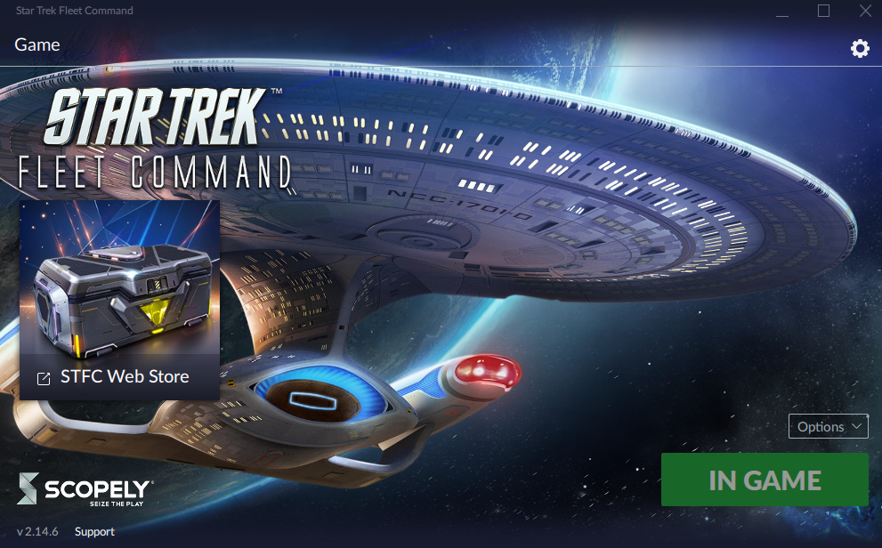
Figure 1 Star Trek Fleet Command [1]

Initial Review of Star Trek Fleet Command
Early gameplay gives a clear start, basic missions, simple upgrades, and an intuitive galaxy map. The theme is strong and the first hour feels guided. Problems appear once the player gains access to the wider system. The UI becomes dense, with too many tabs, submenus, and overlapping tasks. Content is scattered across multiple areas, and similar visuals make it hard to tell features apart. Much of the player’s time is spent searching rather than progressing. The volume of content becomes bloated, and new features are easy to miss. [3]

UX Design Principles

The UX Pyramid
UX Pyramid Summary Star Trek Fleet Command [4]
UX Pyramid Level | Description | STFC Performance
Functional | The game operates and allows base building, mission and combat | Stable core systems consistent performance during regular play
Reliable | Users can depend on consistent outcome | Occasional lag, sync errors reduce reliability during events and gameplay
Usable | The interface is easy to understand and interact with | Most control are learnable, but icon density can be confusing and slow to navigate
Convenient | Tasks are Efficient and streamline | Load times and extra steps reduce flow.
Pleasurable | The design is enjoyable and visually appealing | Strong theme and visuals. Multiple levels slow immersion
Meaningful | The experience feels rewarding and connect to the user goals | Progression and alliance add purpose. But reputation weakens engagement over time

The UX Pyramid summary shows that STFC performs well in the early game levels for user experience, where functionality, reliability, and usability are most important. Players can complete actions, build progress, and interact with the main systems without major barriers. As the levels progress, slow loading times, screen clutter, and repetitive interactions reduce overall engagement. Improving the upper layers of the UX Pyramid would make the experience feel smoother, more rewarding, and better aligned with long term player motivation. This analysis aligns with the UX hierarchy framework described by the Interaction Design Foundation [2].

UX Analysis

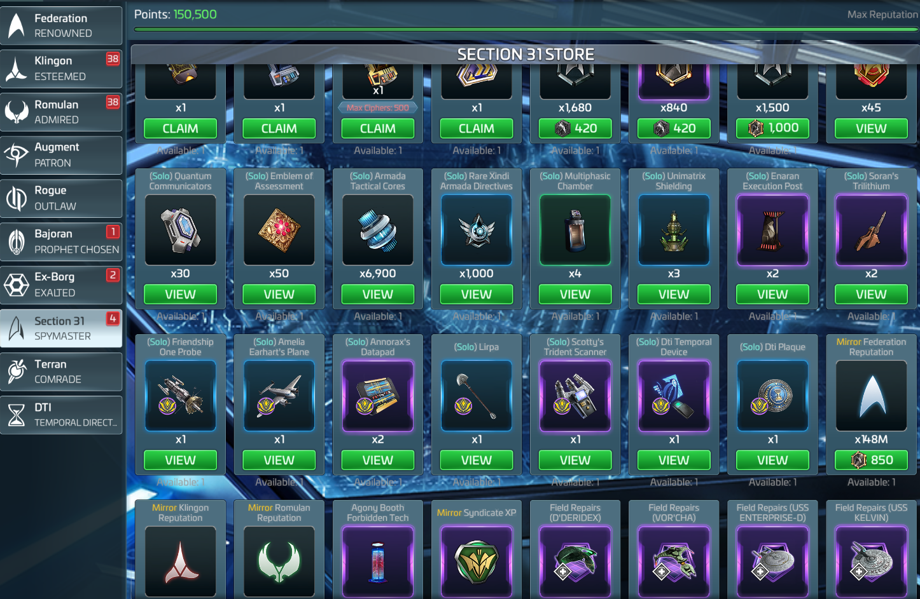
Figure 2 Crowded icon menu/Screen [1]

STFC offers a wide set of features, but the overall user experience feels crowded and demanding. The main interface is dense with icons, alerts, and menus, which slows navigation and makes it harder to stay focused on the game. Many icons share similar shapes and colours, and due to this, players must stop and decode the UI. The visual design captures the Star Trek theme well, but newer ships and certain UI elements look off brand, which affects consistency. Core interactions like tapping and upgrading work, but delays and frequent popups interrupt the flow. Cross device play is supported, with PC offering clearer layout and Android suffering more lag and UI pop ins. Long loading times, sync issues, and timer delays impact reliability, especially during attacks or time sensitive actions.

Navigation and Information Architecture

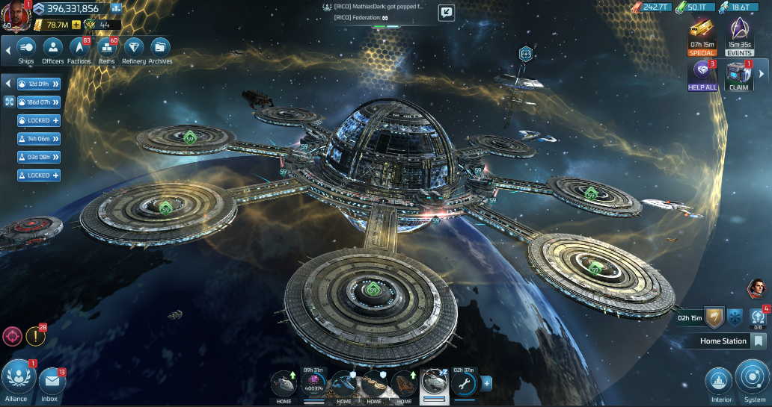
Figure 3 Main Screen STFC [1]

The navigation and information layout in STFC gives players access to a wide range of systems, but the structure is unclear and difficult to follow. Some menus open as full screens while others slide in as panels, which makes the flow inconsistent. Upgrades are spread across multiple tabs and deep submenus, so buildings, research trees, ships, and officers all use separate paths with no central place to manage them. This leads players to jump between areas and spend more time searching than progressing. The UI is cluttered, with too many tabs competing for attention, and many actions can be carried out in multiple locations, which adds confusion. The galaxy map, system map, and interior station views are intuitive (see figure 3), but heavy icon layers sit on top of them and make important markers easy to miss or require long presses, which interrupts the pace. As McKay states, “for exportability, users need to be able to navigate your UI without fear of getting lost or getting stuck,” [5] and STFC often creates the opposite experience. Without a clearer hierarchy, navigation feels slower than it should. Collapsible menus or grouped categories would reduce noise and improve flow.
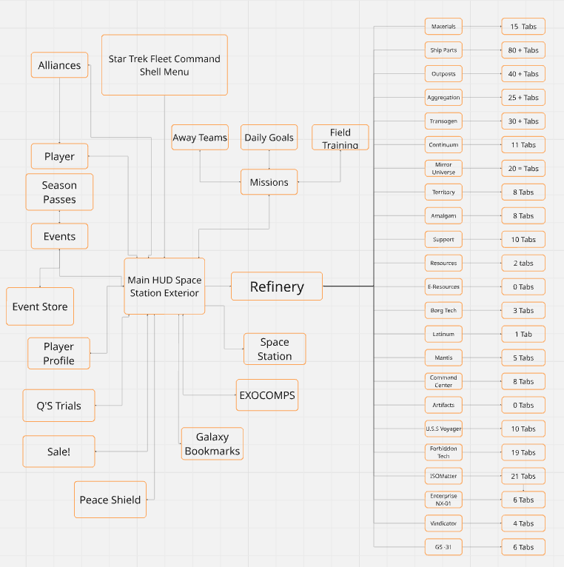
Figure 4 Shell Menu for part of STFC [6]
The diagram visualises (see Figure 4) how the Refinery menu in STFC branches into an extremely large number of submenus. Each category inside the Refinery leads to its own set of tabs, with some sections containing more than 80 individual options. When combined, the Refinery alone contains over 250 submenu paths. This highlights how bloated and fragmented the interface has become. Instead of presenting upgrades and materials in a clear, unified structure, the player is forced to navigate deep, inconsistent menu chains. The visual also shows how the Refinery sits among other major HUD systems, further amplifying the overall complexity of the game’s navigation. This makes it clear why players spend so much time searching for the right upgrade instead of progressing through gameplay.

Visual Design
The visual design in STFC blends the Star Trek theme with a modern mobile game layout, but it does not always hold together. Some elements look strong and authentic, while others feel disconnected from the Star Trek brand aesthetic.

Theme and Style:
- The background visuals, ships, and base environments capture the Star Trek atmosphere well. The lighting and metallic tones suit the sci-fi genre.
- Some newly added ships could be considered off brand. Their shapes and colours do not match the look of the Star Trek universe. They stand out for their visual inconsistency and feel designed for quick release in new updates to push fresh content rather than maintain authenticity.
- This weakens immersion for players who expect visual consistency with the Star Trek franchise.
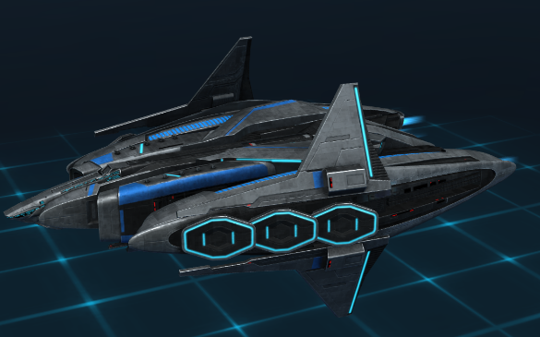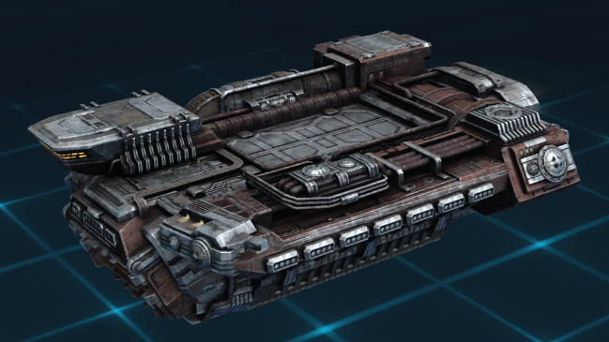
Figure 5 STFC Off Brand Ships [1]

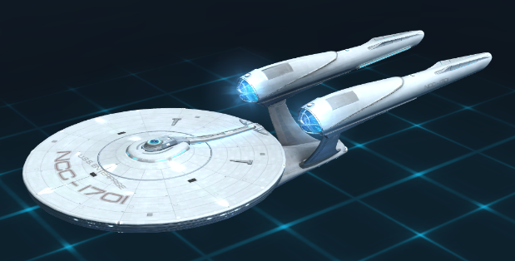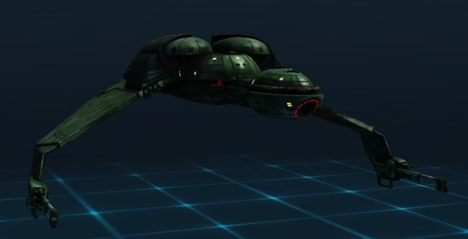
Figure 6 STFC On ship Brands [1]

Icons and Interface
- Many visual icons look too similar. Resource symbols, upgrade buttons, and event markers often share colour and shape.
- The icon design also lacks clear grouping. Features that belong together do not share consistent visual cues.
- The screen is overcrowded with visual icons competing for attention.
- The overall colour palette leans heavy on blues, purples and greys, which blend too easily, reducing visual contrast and clarity.
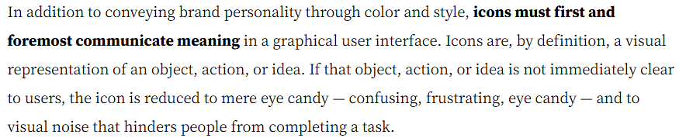
Figure 7 Icon Usability by Aurora Harley [7]
Below you can see 23 tabs in the refinery section with their own sub sections
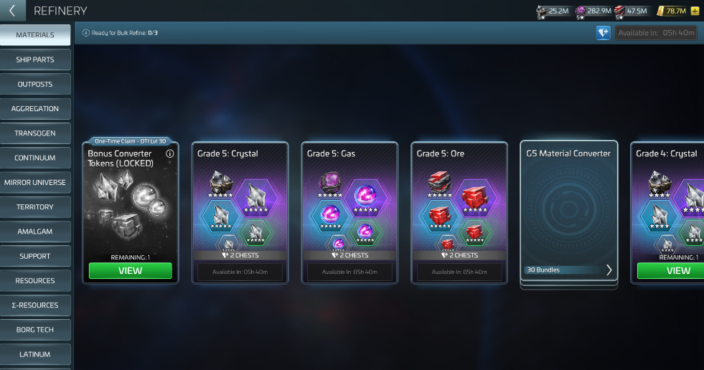
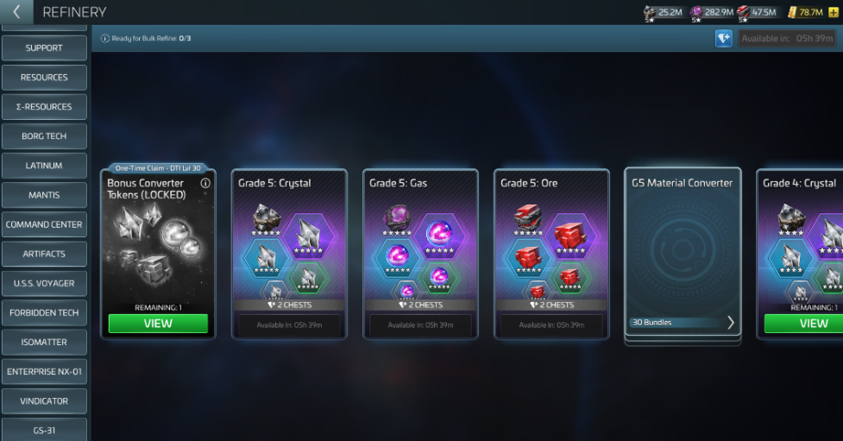
Figure 8 STFC Overcrowded and confusing icons [1]

Readability and Layout
- The overall layout feels overloaded. Too many menus, icons, and alerts compete for space on the screen
- It is easy to lose track of where you are or what you were doing because the interface does not guide your focus.
- The main HUD shows missions, chat, resource bars, offers, ships and events all at once. This constant visual competition makes it hard to stay on task.
- The cluttered layout forces you to pause and reorient, which interrupts the flow of gameplay.
- Over time, this can make players feel disengaged. Instead of enjoying the experience, you spend energy trying to navigate and manage the interface.
- UI spacing and padding need work to separate key areas and improve scanning. Clearer visual hierarchy would help players stay focused on core actions.

Recommendations
- Reduce on screen icon density and prioritise essential information.
- Rework off brand ships to match Star Trek’s established aesthetic.
- Make each icon visually unique to the part of the game it represents so you can identify it instantly without confusion

User Interaction

User interactions in STFC start off well, but the experience is not always reliable. Basic actions like selecting ships, activating abilities, and starting upgrades work as expected. The problems appear when interacting with areas that have unclear tap zones. For example, tapping on the station sometimes moves the camera into a room instead of opening the station view. A small change in tap position can take the player to the wrong screen, which creates confusion and slows down progress. This sensitivity makes it easy to jump between the wrong menus. These small interaction errors add up and make the overall experience feel less stable than it should.

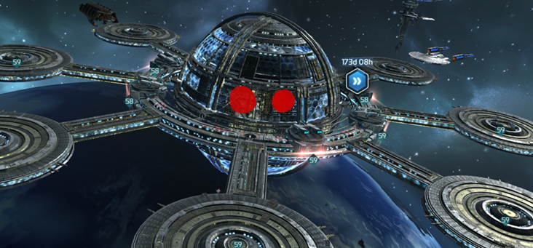
Figure 9 STFC Tap area that take you to different locations [1]

Accessibility and Inclusivity
“Steve Kung said Unless you’re going to make a blanket decision that people with disabilities aren’t part of your audience, you really can’t say your site is usable unless it’s accessible.” [8]

Accessibility in Star Trek Fleet Command is limited, and the game does not provide many options to support a wider range of players. Text size is small across most screens, and there are no settings to scale fonts or increase contrast. This makes timers, resource values, and mission descriptions difficult to read on smaller devices. Colour usage is narrow, with many icons sharing similar shades, which creates problems for colour-blind users. There are no colour-blind modes or visual presets to help distinguish key elements.
Hitboxes on icons are small, which makes precise tapping difficult for players with motor challenges. Players with dyslexia also struggle, as the number of submenus and similar looking icons makes it hard to identify where different materials or actions are located. A screenshot from testing (see Figure 7) shows two tap locations on the station view that sit extremely close together and appear to share the same space, yet they take the player to different areas. This kind of design makes it easy to miss tap and increases confusion. When navigation becomes unclear or overwhelming, players may avoid certain systems or skip content entirely. Clearer labels, scalable UI options, and improved hitbox spacing would make the game more inclusive.

Responsiveness and Cross Device Experience
STFC run on both PC and mobile. The same account can be linked and access from both platforms, but the experience is not consistent.

What works
- The PC version offers better layout spacing. It feels smoother and easer to control with a mouse compared to touch with the mobile.
- The game keeps all UI elements and icons in the same places, which helps when switching between devices.
- Progress sync through the Scopely account, so you do not lose missions and resources.
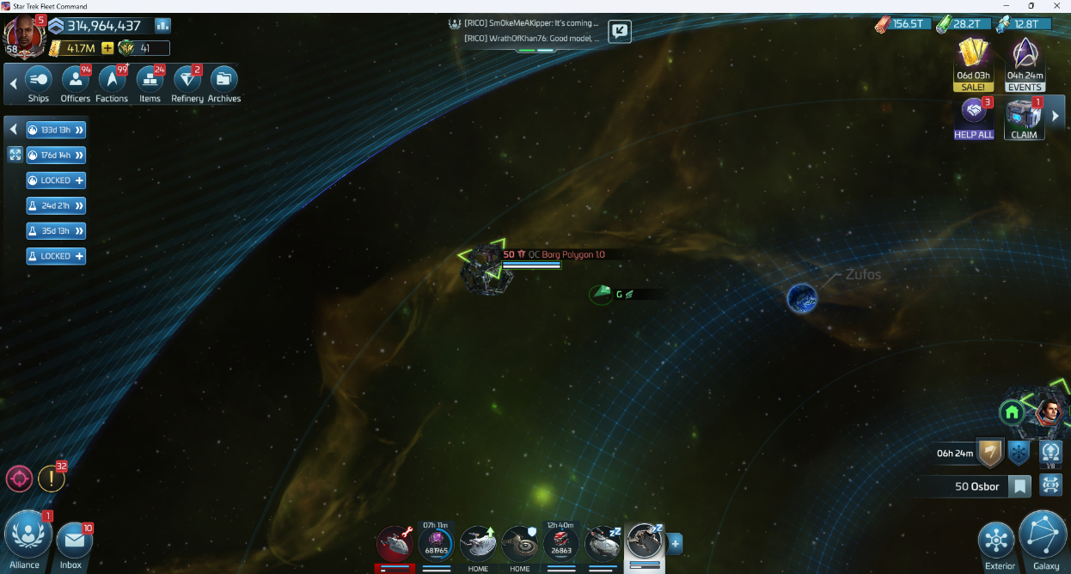
Figure 10 STFC PC view [1]
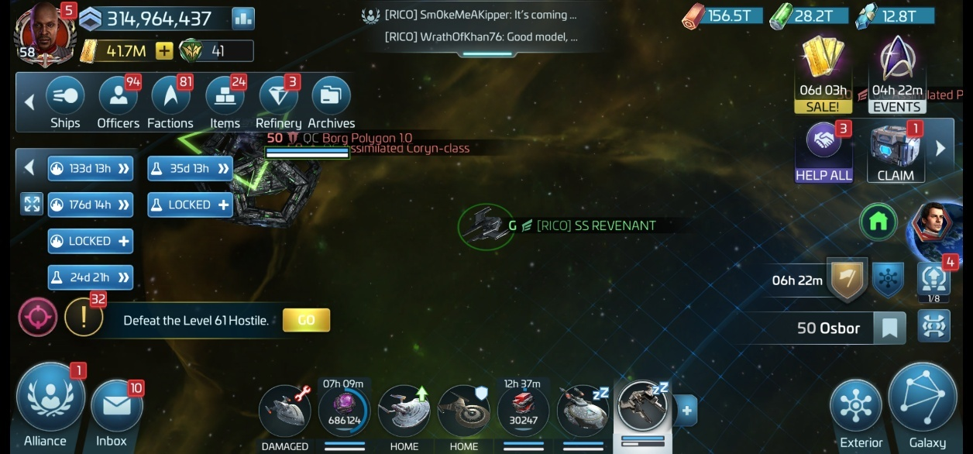
Figure 11 STFC Mobile view [1]

What does not work
- Mobile version struggle with performance in busy server times with lag quite common.
- Interface elements scaled poorly on small screen not leaving much room to play the game with your touch.
- Switching between mobile and PC can cause sync delays or missing notifications.

User Impact
- Lag and loading times create frustration.
- Mobile user lose time waiting for assets to load

Recommendations
- Create platform specific UI layouts instead of resizing the same design
- Improve sync speed between devices and reduce lag times
- Add PC specific controls such as hover tips, key shortcuts, and scalable windows

Performance and Loading
Performance and loading times have a major impact on your experience in STFC. Slow load screens, lag, and visual delays break the games flow and make it feel unstable. When you receive an attack notification, loading delays can stop you from reacting in time, causing you to lose ships or resources before the game even loads. Inconsistent performance affects how you interact with missions, ships, and events. This section looks at how the game handles loading, UI responsiveness, and data sync across sessions.

Loading time
- Startup loading screens are long, especially after patches or event updates.
- Map loading between systems can take 20 - 30 seconds on Android, while PC loads faster but still hangs occasionally
- The delay breaks session flow and reduces engagement.
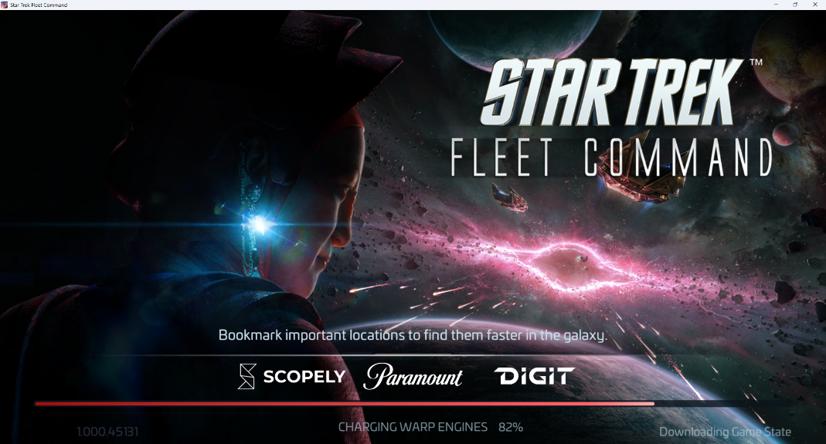
Figure 12 STFC delayed loading [1]

UI Response
- The UI sometimes fails to load key elements like menus or icons after login.
- Buttons may appear blank or unresponsive for a few seconds before appearing correctly.
- These interface stalls lead to user frustration and make you question the system’s stability.
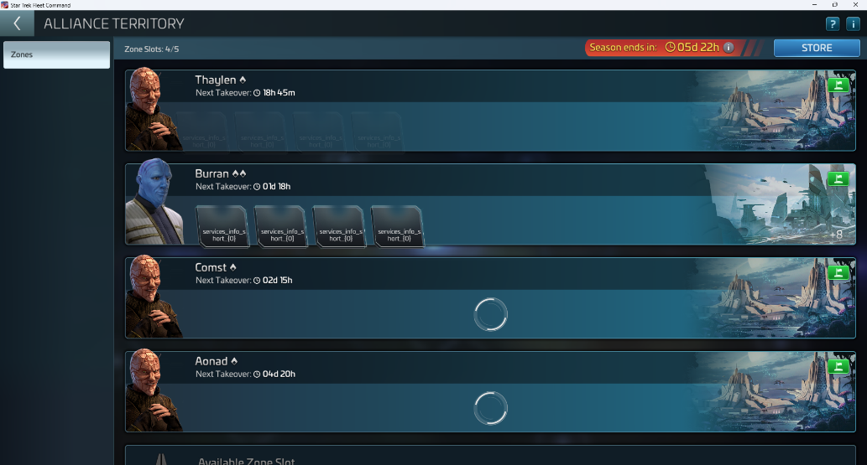
Figure 13 STFC Missing icons [1]

Ship Location and sync errors
- Ships occasionally appear out of sync between the galaxy map and the Armada Location and timer.
- The system shows the ship in one area, but the Armada countdown indicates it is still engaged elsewhere.
- This sync problem creates confusion in time-sensitive missions and alliance battles
- It can cause missed rewards or wasted travel time
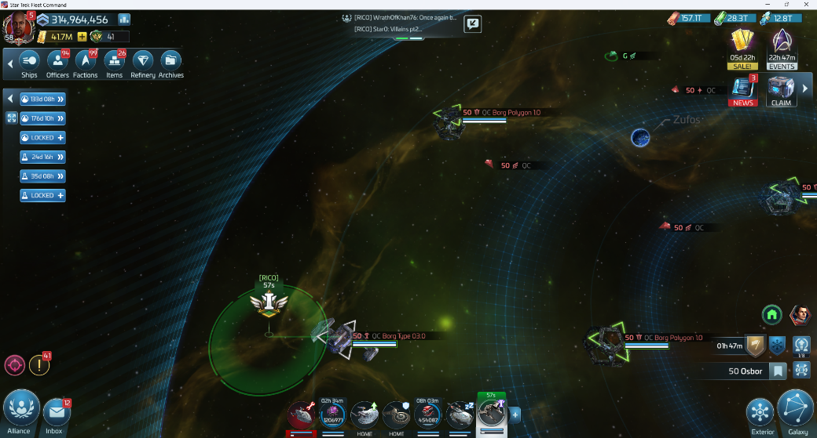
Figure 14 STFC Sync issues [1]

User Impact
- The combined effect of lag, missing UI elements, and sync errors damages trust in the game interface.
- Repeated waiting and inconsistencies turn short play sessions into frustration cycles.

Recommendations
- Offer players a performance mode that reduces visual effects for smoother play on mobile.
- Optimise server client data sync so ship positions update in real time.

Overall Recommendations for Improvement
- Increase text size options and add full UI scaling on all devices.
- Redesign icons so each one is unique, easy to recognise, and clearly tied to its function
- Create a centralised upgrade screen so players do not have to search through multiple tabs
- Improve tap accuracy
- Add optional simplified layouts for players with cognitive or reading difficulties, including dyslexia
- Fix ship position sync issues so timers, locations, and actions match reliably
- Differentiate mission, event, and job icons in the galaxy map so each submenu is visually distinct and easier to recognise.

Conclusion
Star Trek Fleet Command delivers a rich strategy experience with strong Star Trek atmosphere and a wide range of features for players to explore. The game offers solid core systems, intuitive map views, and a clear sense of progression that keeps players engaged. While the interface can feel crowded and some menus need refinement, the foundation of the game is strong and gives plenty of room for improvement. With clearer navigation, better visual distinction, and stronger accessibility options, the overall experience could become far more welcoming and easier to use. The potential is already there, and with focused UX adjustments, STFC could offer a smoother, more enjoyable experience for both new and long-term players.

Bibliography
Bibliography
[1] “STAR TREKTM FLEET COMMAND,” Startrekfleetcommand.com, 2025. https://store.startrekfleetcommand.com/ (accessed Sep. 30, 2025).
[2] “Hierarchy of Needs,” Interaction Design Foundation, Oct. 18, 2022. Accessed: Oct. 02, 2025. [Online]. Available: https://www.interaction-design.org/literature/topics/hierarchy-of-needs
[3] Rev Deuce, “Star Trek Fleet Command DESPERATELY Needs A UI update | New Features & Confusion Reign On Screen,” YouTube, Jun. 30, 2025. https://www.youtube.com/watch?v=xS3EgApExzo (accessed Oct. 17, 2025).
[4] W. Sakai, “UX Pyramid: How to evaluate the design,” Medium, Dec. 14, 2023. https://medium.com/@design.wkn/ux-pyramid-how-to-evaluate-the-design-aa2304df7fb6 (accessed Dec. 09, 2025).
[5] E. N. McKay, Intuitive Design. Black Watch Publishing, 2018, p. 78.
[6 ]“Sign in,” https://miro.com/. https://miro.com/login/ (accessed Dec. 10, 2025).
[7] A. Harley, “Icon Usability,” Nielsen Norman Group, Jul. 27, 2014. https://www.nngroup.com/articles/icon-usability/ (accessed Dec. 09, 2025).
[8] S. Krug, Don’t Make Me Think, Revisited: A Common Sense Approach to Web Usability, 3rd ed. Berkeley, Calif.: New Riders, 2014, p. 173.
[9] Malewicz, “FULL UI Design Mobile Apps Course,” YouTube, Sep. 02, 2025. https://www.youtube.com/watch?v=ThmHV38Ecqk (accessed Dec. 03, 2025).
[10] Tim Gabe, “4 levels of UI/UX design (and BIG mistakes to avoid),” YouTube, Apr. 04, 2025. https://www.youtube.com/watch?v=86PGRyQjdzQ (accessed Nov. 08, 2025).
[11] “Adobe Photoshop,” Adobe.com, 2025. https://photoshop.adobe.com/id?fid=1&promoid=6JMR749P&mv=other (accessed Oct. 03, 2025).

