Answers

a. Database design for Book4U business
Book4U Business System
Bookstore:
- Store Catalogue: Different genres books (history, technical, medicine, literature, etc.)
- Record Database: Papered documents, excel file documents
New Branch Units:
- Branch Unit Locations: Address, contact details
Database Unit:
- Data Storage: Storage location, Secured Access Unit
- Data Processing System: Record customer details, books description, authors and customers’ requests.
- Invoice unit: Automatic invoice prints
- Report unit: Sales record unit, reports
Bookstore app:
- Account register unit
- Catalogue display
- Shopping cart
- Invoice edit/print
- Customer feedback/rate product
- Company contact details
- Price report
- Inventory updates

Database design
D1 | Book4U Data Storage
D1 | Database operating system

Storage Location
Location_id_no | Branch_name
01 | Branch1
02 | Branch2
03 | Branch3
Secured Access Unit
Branch access code
Username | Password
Branch_01 | Book4U_alfa
Branch_02 | Book4U_beta
Branch_03 | Book4U_gama

Customers Account
Customer id | Customer details | Customer security
A1 | Name, Tel. E-mail | User, password
A2 | Name, Tel. E-mail | User, password

Data Processing System
Customers id | Book id | Author/Customers  requests
A1 | B1 | R1
A2 | B2 | R2
A3 | B3 | R3
Author/Customers
requests
Request_no | Details
R1 | Suggestions

Invoice Unit
Invoice ID | Customer ID | Issue Date
I1 | A1 | 01.August.2019
I2 | A2 | 09.August.2019
I3 | A3 | 13.August.2019

Report Unit
Sales record unit | Reports
U1 | Q1, Y1
U2 | Q2 ,Y1
U3 | Q3. Y1

Entity Relationship Diagram is designed in order to establish the right relationship between entities such as:
Customers and Products Catalogue; Products Catalogue and Branch Units or Books4U Database; Management and Books4U Database or Branch Units
The relation between Customers and Products Catalogue established as many-to-many can be simplified with one-to-many or many-to-one relationship by introducing a secondary table with foreign keys that create direct interconnection between general information table and detailed information table.
This relations are simplified in order to create a system that provide accurate information for analysis and mitigate any possible repeating data that may overcharge different systems or block the processes.
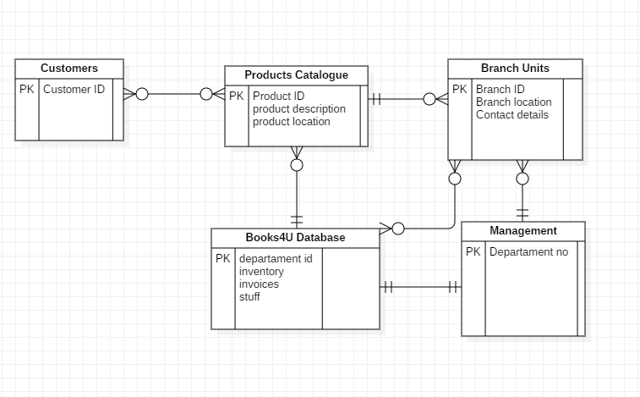

Use Case Diagram is been created to identify the actors who generate the processes, secondary actors who support the processes and how every part of the system interact in order to secure functionality.
Customers are principal actors and they are associated with use cases such as: catalogue, account register, feedback unit, company contact details…mostly integrated in application or website
Secondary actors are stuff and management, the management establishing a generalization relation with the stuff in order to inherit their process access and to support functionality of the process when necessary
Inside the system we can identify certain use cases that include or extend the necessary processes depending by requests.
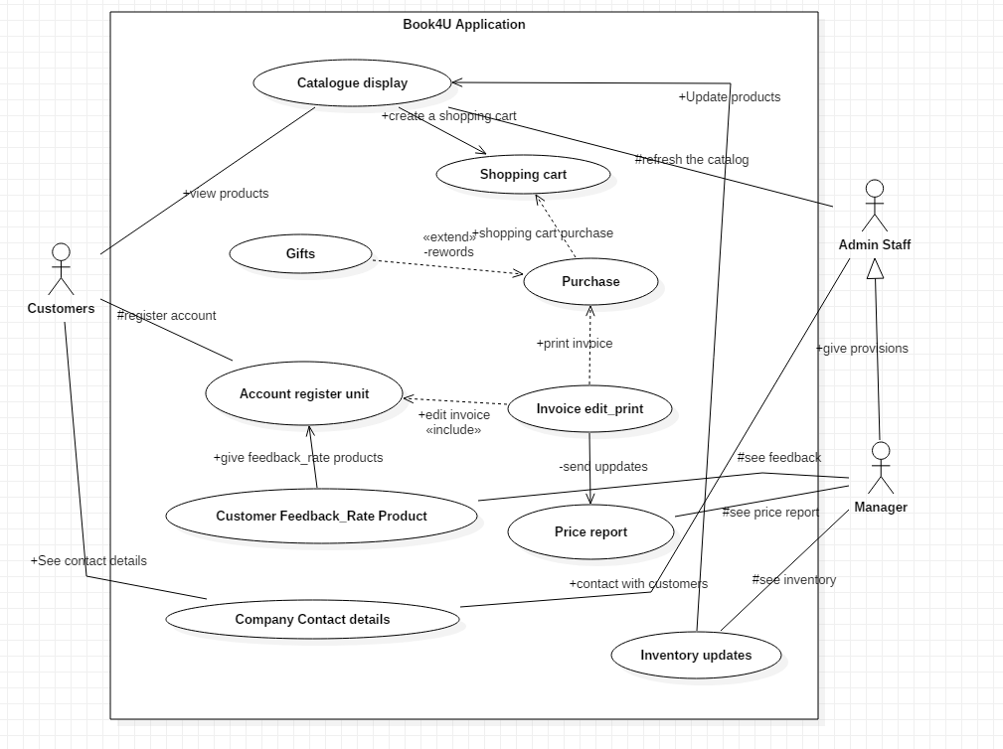

Data Flow Diagram reflect the way each entity share processes in order to keep functionality of the system.


