BIM - Construction Portfolio

Letter & Report

ACBA5010

Steffan Dancey

2014079

2500 words +/- 10%

Client Letter – Suggested 1000 words
Technium Ltd
Unit 12,
Old Road Ind. Estate
Swansea,
SA1 3AA
Tel: 01269 545454
Email: info@technium.co.uk
1st January 2023
Andrew James
Cillefwr Depot
Carmarthenshire County Council
Johnstown,
Carmarthen,
SA31 3RA

Dear Mr Andrew James,

As the lead consultant for the deliverance of the new ‘state of the art’ St Mary’s infant school in Carmarthen, under the joint venture with the Welsh Government. I am writing this letter to firstly thank you for the invitation to tender for this project, but I must also highlight the importance and requirements of BIM Maturity for this project. I would also like to express the reasoning behind the choice of implementing BIM level 2 and its associated advantages.

In this project the BIM maturity levels reflect the level of technical development attained based on the degree of collaboration and information exchange among the parties involved in this project. The BIM Maturity levels begin at the most basic level, where there is no required cooperation to carry out work activities, and then later progresses to the most advanced level, which is distinguished by seamless integration of information and the use of cloud platforms and BIM models.

The Level 2 of digital maturity implemented is defined as a comprehensive collaboration amongst all parties engaged in the design process, according to PAS 1192, which establishes stages of the digital maturity. Working on shared 3D BIM models, which will be loaded with several valuable sources of information pertaining to the full asset lifespan, allows us to collaborate. At each point of the school’s life cycle, the participating parties in this project will have access to an overview of all the information that is accessible and will be able to edit and update it, enabling complete cooperation.

The first requirement of employing BIM level 2 Maturity to this project would be by responding to your EIR provided. To do this we will provide a BIM Execution Plan (BEP), Master Information Delivery Plan (MIDP), and a Task Information Delivery Plan (TIDP).

For this deliverance of the school, a BIM Execution Plan (BEP) will be created to demonstrate our strategy, capacity, and competence to achieve the criteria outlined in the EIR you have provided. The project team members will work together on various project stages with the aid of the BIM execution plan, which also helps to avoid conflicts between project activities and gives the important activities the correct amount of attention. Additionally, it facilitates and encourages real-time communication across all phases of the building project.

The BIM Execution Plan (BEP) implementation will also increase data and project transparency, and the BIM Execution Plan (BEP) will be easily accessible. It adds that aspect of openness, allowing everyone involved, from contractors to yourselves, to have full access to information about how BIM is being implemented, including the file formats, specifics, and model proportions.

A major benefit of the BIM execution plan is sharing the ability of transparency, which is available to all project parties right away from the start of the construction project. Therefore, BIM data including file formats, dimensions, and other specifics are directly accessible to contractors, and others in a way that can be quickly shared and updated.

For this project, all information will be shared through a cloud-based project management software called Viewpoint and this will be used as our Common Data Environment (CDE), this software will enable all parties to stay up to date with the projects progress. Models may be seen, federated, and investigated using a regular web browser, and this software's flexible workflow tool guarantees that BIM protocols for sharing work, such ISO 19650, are followed. We will also enforce a naming standard to all relevant documentation thanks to the softwares flexible naming convention tool.

Technical security considerations are defined by PAS 1192-5 for securely transferring project data between us for this project. This standard indicates that we will implement controls to make sure that all information is transferred in a secure manner. Our software will enable tracking and managing activities as well as regulated access to the data kept in the mentioned Common Data Environment (CDE).

This project will employ the Building-Operations Building Information Exchange (COBie), to illustrate where predominantly the non-graphical data will be safely kept, exchanged, and updated during the construction project. This will eventually be given to you to help the running and upkeep of the school and can also be used to confirm that our data complies with the project's standards.

We will provide you with the required project information upon the project's completion. The steps of the information delivery cycle will be used to generate an asset information model that is as built. This model will contain all the data required for the building's managers and other building-related parties to operate more effectively in the future post hand over.

In accordance with the Government's Soft Landings policy, we will incorporate the facility operating team from the commencement of the project and continue to assist them following handover for a set amount of time. Once the building is finished, this team will be in charge of managing and maintaining it. They will understand the facilities from top to bottom if we involve them during the process.

Once again, I’d like to thank you for the invitation to tender for this project, and if we could be of any further help, please do not hesitate to get in touch.

Kind Regards,

Steffan Dancey.

Table of Contents
Introduction 6
Introduction to BIM 6
Level of Information Need 6
Geometrical information 7
Alphanumerical information 7
Documentation 7
Level of information (LOI) 7
Level of Detail (LOD) 7
Exchange Information Requirements (EIR) 9
RIBA Stages 9
Case Study 11
Conclusion 12
Bibliography 13

Glossary

RIBA – Royal Institute of British Architects
BIM – Building Information Modelling
BEP – BIM Execution Plan
EIR - Exchange Information Requirements
MIDP – Master Information Delivery Plan
LOD – Level of Detail
LOI – Level of Information

Introduction
In this report I will research and explain a clear method of demonstrating level of information need throughout the RIBA stages of a project. I will also provide researched examples to aid you on deciding on what should be included in an EIRs.

Introduction to BIM
BIM is an abbreviation for Building Information Modelling, and is a term used to describe the process of producing and maintaining digitally produced information on the construction of a building. As a project develops, so does the level of detail that’s required. The first case is typically based on the existing data available, then progressing from a basic design model to a complete virtual model, and finally to an as-constructed Asset Information Model (AIM).
(An introduction to Building Information Modelling (BIM) , 2021)

Level of Information Need
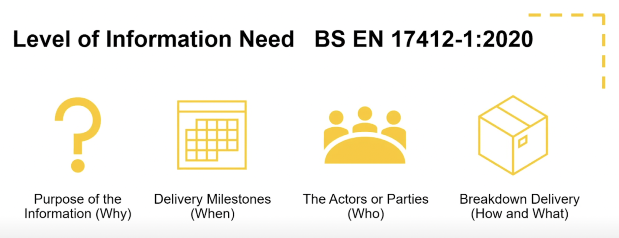
(Catenda, n.d.)

The degree of information need offers ways to describe the information that must be communicated in accordance with those criteria. The desired information exchange is specified by the exchange information requirements. A transmission of information is the end consequence of this operation. A BIM Execution Plan (BEP) should be included in every project to accurately identify the level of information required. Participants are informed about information flow through the BIM Execution Plan, which also should ensure that information requirements adhere to BS EN 17412-1:2020.
(7817, 2021)
The level of information need is split into the following categories:

Geometrical information
Geometrical information signifies the detail required from models, whether that be 0D or 3D. PIM’s, which is the geometric data in a BIM model, is very important in BIM as it ensures all parties involved dissipate information.

Alphanumerical information
Alphanumerical information conveys the data in a project, including documents such as meeting minutes, Specification data and model definitions.

Documentation
Documentation in BIM includes reports, specifications, manuals, photographs, sketches, signed documents, physical information, and handovers. These structed forms of documentation can ensure all parties involved in the project are well co-ordinated, ensuring the project runs smoothly.
(Bimtoolbox, n.d.)

Level of information (LOI)
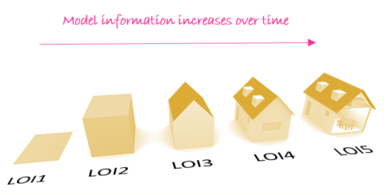
(BIMtoolbox, n.d.)

The Level of Information (LOI) in BIM models stands for a model's non-geometric, technical information. Non-graphical material is provided by model information, for example, the thermal U Value rating of a window. Non-graphic detail will increase as a project progresses. At the beginning of a project, the graphical representation a window will have limited non-graphical data, such as a window categorization. As the project design evolves, performance data like as U Value resistance will be supplied, followed by manufacturer data later in the project.
(Payne, 2015)

Level of Detail (LOD)

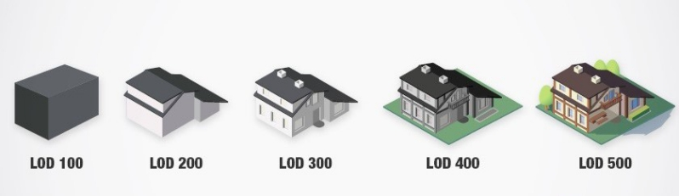
(BibLus, 2022)

The Level of Detail (LOD) is used to specify the quantity and quality of building data that must be included in a BIM model. This contains the data related to the items as well as the visual elements or physical traits. In summary, Level of Detail (LOD) is a framework used to outline the development of the BIM Model, which aids in collaboration and communication with all project teams.
(BIMtoolbox, n.d.)
LOD100 – Concept Design
The model element is graphically represented at this conceptual level using standard forms and symbols. The models element might just be a block that represents the project and lacks any recognisable size or shape. The project's spaces are modelled at this level as generic objects with approximative sizes, forms, and locations.
LOD200 – Schematic Design
Model elements are visually represented as a generic system, object, or assembly within the model at this level, with approximate specifications, numbers, size, shape, placement, and orientation. Any information produced from LOD 200 elements should be regarded as approximate.
LOD300 – Detailed Design
This is a stage in which the model will include correct quantity, size, position, and orientation information, as well as detailing, fabrication, assembly, and installation information. The information provided in LOD 300 models can be utilised during the project's building phase.
LOD350 – Construction Documentation
The same information as LOD 300 is contained in LOD 350, but it additionally has interfaces, supports, or links to other building components. It demonstrates the interactions between various construction systems.
LOD400 – Fabrication & Assembly
Complete fabrication and assembly information may be directly driven from the model at LOD400. The LOD 400 pieces' information and specifications may be sent directly to manufacturers of the architectural components they represent.
LOD500 – As-Built
This model level will include all the necessary geometry and data to support building lifecycle operations and maintenance. They have been finished and installed, their placement has been confirmed by the field, and they contain information that clients may use after construction, such as the model number, dates that the items were made, and dates that the items were purchased.
(United BIM, 2021)

Exchange Information Requirements (EIR)

The Exchange Information Requirements (EIR) give a detailed description of the information needs that must be complied with during an asset's delivery phase.
The PAS 1192-2 standard defines EIR as the "Employer Information Requirements," but ISO 19650, which specifically calls them the "Information Exchange Requirements," has changed this abbreviation to "Exchange Information Requirements." (BibLus, 2022)
In an EIR the appointing party should specify all asset and project information to be provided as part of asset management or project delivery through sets of exchange information requirements (EIR). They should be communicated in a manner that enables them to be added to project-related meetings or instructions and sent across the supply chain.

Several documents flow into the Exchange Information Requirements and contribute to its creation, including:

- Asset Information Requirements, or AIR, details the property's technical operations and management surfaces.

- OIR (Organizational Information Requirements) - provides the data required to identify the proposing party's aims.

- The information required to carry out the objectives in connection to the specific order is contained in PIR (Project Information Requirements).
(Kemp, 2021)

RIBA Stages
The RIBA plan of work is published by the Royal institute of British Architects (RIBA), it is a method that organises the designing, briefing, construction and operating building projects into separate stages. There are eight stages to the plan of work, these describe the outcomes, tasks, and information exchanges necessary at each individual stage. (BIID, 2021)
Please see image below demonstrating the project life cycle with the BIM requirements:
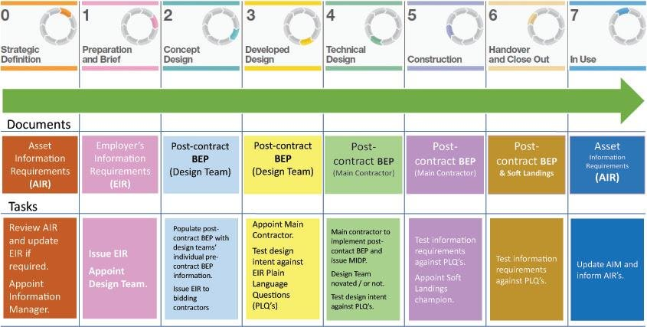
(Ahmed, 2018)

Throughout the RIBA stages of the project, there will be information demonstrated as below:
Stage 0 - Strategic Definition.
Before a formal design brief is developed, Stage 0 strategically evaluates and defines the project. For instance, in the perspective of sustainability, a refurbishment and/or expansion may be more suitable than a new construction. At this stage an information manager is appointed, and the initial AIR is reviewed. If any amendments have been made to the existing AIR, then the EIR will be updated accordingly.
Stage 1 - Preparation and Briefing.
In order to support the creation of the concept design, this stage focuses on creating the first project brief and any associated feasibility studies. It also includes issuing an Exchange Information Requirements (EIR) appointing the projected project team and outlining the roles and responsibilities of each participant.
Stage 2 - Concept Design.
At stage 2, the initial concept design is created and presented to the customer in accordance with the design brief set previously in stage 1. This will most likely be the first time they see what the architect is suggesting, and if the briefing process was followed and presented appropriately. Bidding contractors will be issued a copy of the Exchange Information Requirements (EIR).
Stage 3 – Developed Design.
The concept design from stage 2 is further developed in stage 3 to fulfil the clients' criteria for how they want to utilise the new spaces. Once finished, the planning drawings and paperwork will be created and submitted for approval to the local government. Once accepted, the design will commence development, allowing a main contractor to be appointed and develop a more detailed cost and project budget analysis.
Stage 4 - Technical Design.
The services packages are enhanced at this point to allow for the execution of any specialised subcontractor design. The architect will check with the local building regulations officer before producing the specification and a thorough design package that demonstrates how the buildings secondary elements all come together.
The specification should be viewed as a key for how the building is put together since it will include all of the necessary components for the contractor or builder to carry out the needed planned design. After the bids are received, they will be evaluated and analysed before one is selected and the building work stage commences. At this stage the contractor will implement a post contract BIM Execution Plan (BEP) and issue a Master Information Delivery Plan (MIDP).
Stage 5 - Manufacturing and Construction.
The structure is constructed during this stage in accordance with the plans and information created during the preceding phases, and as stated below, the architect is frequently in charge of overseeing the process to guarantee a smooth delivery.
Stage 6 – Handover.
This plan will assist with the building's effective handover and entails inspecting the finished work for any flaws that need to be fixed before producing the certification that the selected build contract requires.
Stage 7 - Use.
This is the second of the two additional phases that were added to the programme of works in 2013, and it comprises a post-occupancy review that looks at the performance, results, and evolution of the project.
(BIID, 2021)

Case Study
St Helens and Knowsley Hospitals
Vinci Construction UK recognised the value of teamwork and initiated the use of stage one building information modelling during the construction of the St. Helens and Knowsley Hospitals (BIM). The initial goal of this was to coordinate the project spatially in 2D and to achieve zero faults in all production information.
On this project, improved spatial coordination and fit were accomplished, which the construction team felt was attributable to the supply of better-quality information and information sharing. (Excellence, 2010)

A construction excellence report on this project states that a few lessons learnt were identified by Vinci Construction and the team included some of the following:

- “The team learned that disciplined adherence to the collaborative processes has the power to increase the quality of the data they exchange.”

- “The process assists in the achievement of spatial co-ordination i.e. ‘fit first time’ design information; it can provide a greater certainty of physical fit for off-site production and it will enable the delivery of co-ordinated and complete construction information in a timely fashion.”

- “Operation and maintenance information can be derived throughout the project process rather than purely through a dedicated process close to asset handover where timescales are normally such that production of accurate information is difficult to achieve.”

Given the positive experience that Vinci Construction UK have had with integrating BIM into their project, Vinci have stated that “The experience of using the Avanti approach and initial stages of developing a BIM were extremely positive. The use of the ICT is being developed and will be implemented on future VCUK projects”.
(Excellence, 2010)

Conclusion
To conclude this written report from the information gathered through the researched examples, I have established that the Level of Information Needed can vary from project to project and is bound by the client. The EIR provided by the client, must accurately detailed all the crucial information required, failure to include this information within the EIR, could lead to possible project failure further down the line, possibly causing an inaccurate BIM Execution Plan BEP to be created further adding to the information decline.
The level of detail develops as a project progresses through the RIBA stages, please see image below, demonstrating an information delivery life cycle:
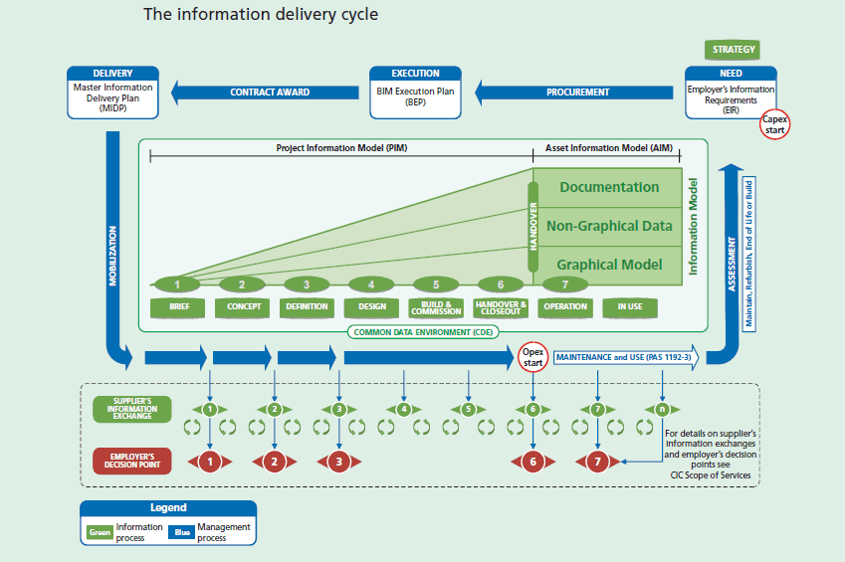
(Majenta, 2023)

Bibliography
7817, I. (2021). ISO. Retrieved from https://www.iso.org/standard/82914.html#:~:text=The%20level%20of%20information%20need,process%20is%20an%20information%20delivery.
Ahmed, S. (2018, June). Researchgate. Retrieved from https://www.researchgate.net/figure/The-project-life-cycle-with-BIM-requirements-source-BIM-riba_fig9_334263553
(2021). An introduction to Building Information Modelling (BIM) . The Institution of Structural Engineers BIM Panel. Retrieved from https://www.autodesk.com/industry/aec/bim
BibLus. (2022, March 14). Retrieved from https://biblus.accasoftware.com/en/what-are-lod-and-loin-in-bim-and-what-are-they-for/
BibLus. (2022, July 6). Retrieved from https://biblus.accasoftware.com/en/exchange-information-requirements-what-is-an-eir-in-bim/#:~:text=Referring%20to%20the%20PAS%201192,the%20%E2%80%9CInformation%20Exchange%20Requirements%E2%80%9D
BIID. (2021, March 4). Retrieved from https://biid.org.uk/resources/riba-plan-work-and-interior-designers
Bimtoolbox. (n.d.). Retrieved from https://bimtoolbox.org/model-requirements/model-detail/
BIMtoolbox. (n.d.). BIMtoolbox. Retrieved from https://bimtoolbox.org/model-requirements/model-detail/
Catenda. (n.d.). Retrieved from https://catenda.com/bim/level-of-information-need/
Excellence, C. (2010). St Helens and Knowsley Hospitals. St Helens and Knowsley Hospitals.
Kemp, D. A. (2021). Information management according to BS EN ISO 19650. UK BIM Framework.
Majenta. (2023, January ). Majenta. Retrieved from https://bim.majentasolutions.com/bim-services/bim-workflow-consultancy/
Payne, T. (2015, July 29). The B1M. Retrieved from https://www.theb1m.com/video/levels-of-definition-explained#:~:text=The%20amount%20of%20non%2Dgraphical,Level%20of%20Detail%E2%80%9D%20or%20LOD.
Sinclair, D. (2019, October 28). RIBAJ. Retrieved from https://www.ribaj.com/intelligence/updates-to-the-riba-plan-of-work-2019-dale-sinclair-gary-clark
United BIM. (2021, February 19). Retrieved from https://www.united-bim.com/practical-approach-to-level-of-detail/

