Health and Lifestyle Report
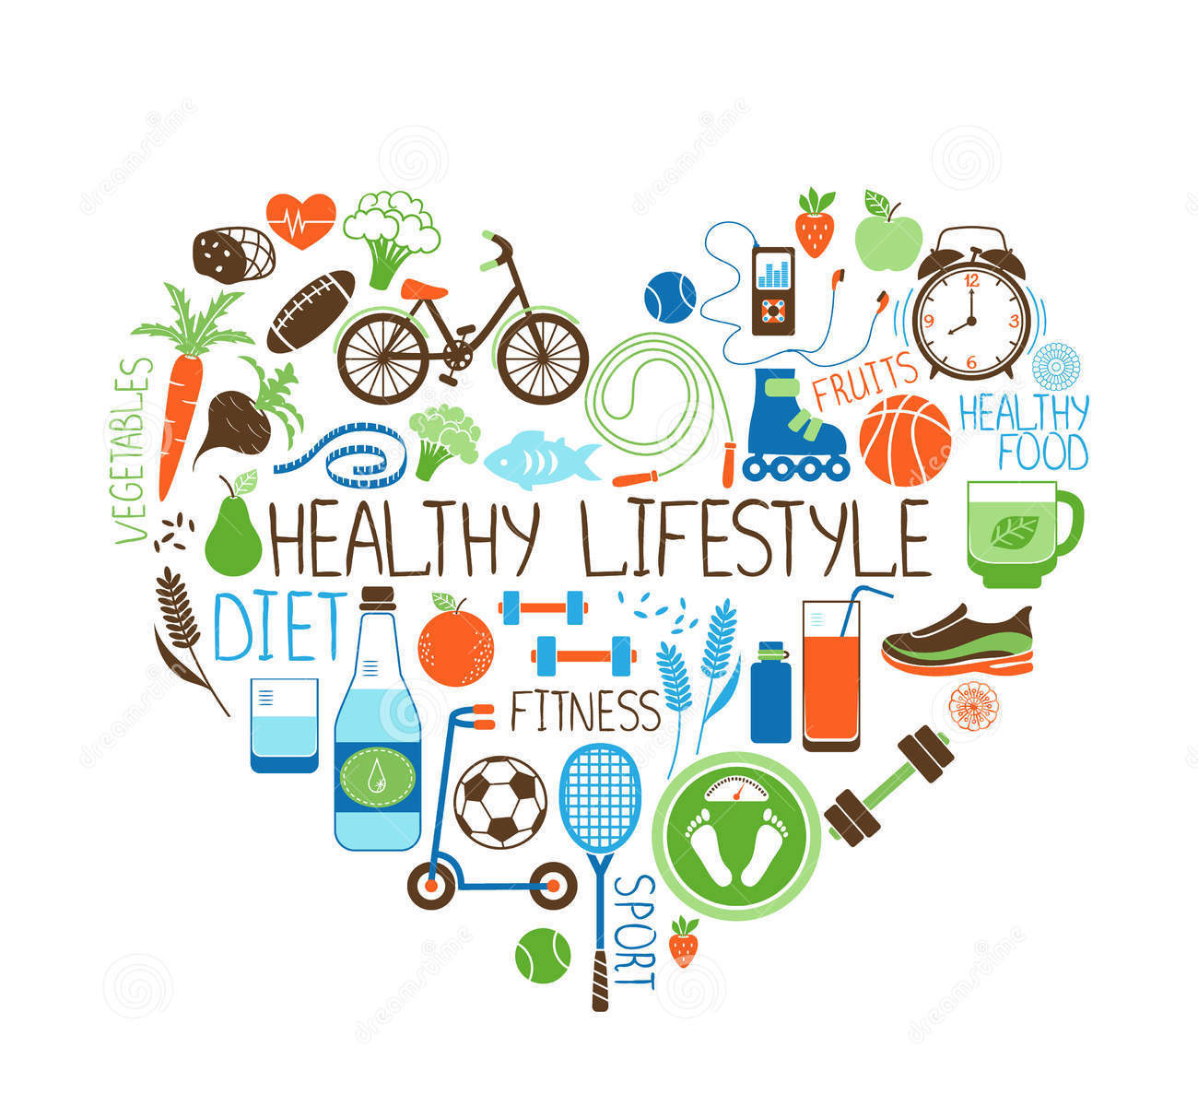

By Katie Snelling
Contents Page

- Page 3 Introduction

- Page 4-6 Evaluation and Recommendations

- Page 7 Conclusion

- Page 8-13 Appendix

- Page 14-15 References

Introduction
The purpose of this report is to assess the physical intellectual, psychosocial needs of an individual. Within this report a questionnaire has been completed by the individual. The questionnaire contains questions about their health and well-being the questionnaire will be analysed, and recommendations will be put foward by current health literatures to advice the individual on how to improve their health and lifestyle. For the purpose of the report the individual name has be changed to protect their identity and confidentiality. Throughout the report the individual will be known as Jane, Jane has given their consent to take part in the questionnaire and for recommendations to be put forward.

Evaluation and Recommendations

The purpose of the first section of the questionnaire was to calculate Janes BMI. Jane is 38, 5.2ft and weighs 15 stone and 4 pounds which means her BMI is 39.3 which classes Jane as obese. Brazier (2018) emphasises how obesity can be extremely dangerous for the body as it increases a number of medical conditions. Who (2013) agree with Brazier (2018) that obesity is dangerous, they also describe the medical conditions that can come into effect when being obese. These conditions can be diabetes type 2, heart disease , stroke, musculoskeletal disorders and some types of cancers. Jane gave us information about her diet and the amount of daily exercise she takes part in. Jane does not have a balanced diet, she only has 2-3 out of her five day and is disorganised when it comes to cooking and meal planning. Jane does walk to work and back but its only 20 minuets a day. Jane would like to participate in some sort of exercise such as Zumba. Jane wants to become healthier, in order to do this jane needs to improve her diet. Jane should follow the Eat Well Guide (2016) which is provided by the government to offer recommendations to have a health and balanced diet. The eat well guide is a visual representation of what types of food contributes to healthy diet. It is important that Jane plans her meals as she will have the right foods in hand, it will also help if Jane cooked in bulk and freeze this will help Jane as she will have health meals ready which will stop her from getting takeaways and snacking. Jane should cut out (NHS Inform 2019). According to the NHS (2018) the recommended daily calorie intake for a woman is 2000, the NHS recommend for weight loss women should have 500 to 600 less calories a day, it is important Jane counts her calories, so she understands what she is eating. Mayo Clinic (2019) recommend we take part in 30 minuet exercise per day and to reduce sitting as it effects our metabolic rate. As jane works in an office, she should take little breaks to sand up and have a little walk round to help her metabolic rate. Jane mentioned she would like to join a Zumba class; Jane could burn between 350-600 calories an hour if she participated in a Zumba class (Fitness Blender 2017). These recommendations will help Jane become healthier and improve her BMI. It will reduce Janes risk of developing serious conditions relating to obesity. Regular exercise will improve Janes quality of life as it lifts your moods, creatives a positive state of mind as it can blocks negative thoughts (Better Health 2018).
Using Harvard Health Publishing (2019) it recognises that the reading of Janes blood pressure as high blood pressure, stage one. High blood pressure puts strain on the heart and blood vessels, this can increase the risk of having a heart attack or a stroke (Blood Pressure UK 2008). Jane was unaware she had high blood pressure, here high blood pressure Is more than likely caused by her family history of high blood pressure her obesity and the amount of units of alcohol she drinks a week (Webmd 2019). To reduce janes blood pressure, she needs to be a healthy weight, exercise regularly, have a healthy diet, cut down on salt intake and drink less alcohol (British Heard Foundation 2019). By Jane reducing her high blood pressure it reduces her risks of a heart attack and stroke (Live strong 2019).
According to BBC (2016) the recommended alcohol intake per week is 14 units a week, however Jane consumes 15-20 a week. Drinkaware (2019) emphasise how dangerous it is to drink too much alcohol as it alcohol will affects your health as it can increase the risk of developing certain medical conditions, as, high blood pressure which she already has, stroke, live disease, cancers, heart disease, heart attack. As jane is obese and drinks a lot of alcohol the risk of her developing these medical conditions are very high. Jane needs to drink under the recommended weekly amount which 14 in order to prevent these medical risks.
Jane has attended the dentist and opticians to the recommended amount however she only goes to here local GP if it is necessary. The GP Is the primary care within the community. it is important Jade attended regular check-ups as they can identify early signs of health issues such as her high blood pressure. This means health conditions will be dealt with quicker and treatment will be more effective (Carers Uk 2014). The doctor would been able to provide Jane with recommendations for her diet and lifestyle which will improve her weight (Better Health 2018). The GP can look at Janes weight and try and find the cause of why she is obese. The GP would identify the blood pressure and link it with her obesity and family history. According to the NHS (2019) the GP could refer Jane to other weight loss services such as weight watchers and slimming world to help loose weight and even offer gym passes. If Jane attend the GP, the doctor and herself could create a lifestyle plan to help improve her weight, diet and exercise. This means jane would be receiving professional advice on how to improve herself, the GP will be able monitor Jane regularly and see if her blood pressure improves too by her lifestyle changes. It will make Jane feel less alone as she is having support by others. If the lifestyle plan, referrals to weight loss classes and gyms are unsuccessful the GP can offer Jane medication as her BMI is over 30, this is called orlistat. It works by preventing a third fat being absorb it and passes through your body out with their faeces. It will Jane as she will not gain weight however this treatment cannot guarantee she will lose weight (NHS 2016 ).
Jane only gets 5 to 6 hours of sleep per night, she also finds it difficult to sleep. Sleep is very important in someone’s lifestyle, it helps your mental, physical health, the quality of energy you have, productivity, emotions, brain, heart, the immune system, creativity, and your weight (Help Guide 2019). The sleep council (2019) recommend that Jane should get between 6-9 hours of sleep per night. The National Sleep Foundation(2019) recommend that Jane does not drink late at night before bed and to avoid alcohol as these effects sleeping patterns. It is important that Jane keeps her bedroom specifically for sleeping, if there is a TV or computer in the room it is a distraction to get to sleep and the bedroom then is not associated with sleep and relaxation. It is also important that Jane remains a reasonable temperature in her bedroom, if the room is to hot or too cold jane will struggle to get to sleep. Jane could open a window, put a radiator on or have a fan in the room before she goes to sleep. This will help her sleep better as her room and body will be a comfortable temperature (Mental Health Foundation 2019). Mayo Clinic (2019) suggest setting a sleep schedule, this means that Jane should have a set time to when she should start relaxing and when she should go to sleep. By Jane creating a pattern she will gradually fall into a good sleep routine. If Jane participated in regular exercise such as more exercise as exercise increases high temperature and after exercise the body temperature decreases which will make Jane feel more tired and may improve her nights sleep (Eight Sleep 2017).
Jane really does lack confidence and is not happy being in her own skin. She describes herself as being quite lonely and she would like to socialise more. Cohut (2018) suggests that humans thrive of social interaction as were born to do so. Socialising has an impact on one’s mental and physical well-being as brings people comfort, confidence and happiness as you have people around you, that can support you through hard times, and have fun through the good by doing fun things and making memories. If Jane socialised more, she would not feel lonely or self-conscious about herself. If Jane went to a Zumba class, she would make friends and interact with others which will have an impact on her mental and physical well-being. Jane could also ask her friends to meet up or ask one of them to go to Zumba with her. By asking Jane will build confidence and have a better bond with her friends. Her friends may feel the same as Jane and would like to see Jane more and do more activities.
Jane is aware that she needs to change her lifestyle quickly as her she knows she obese and is aware that this is dangerous because she has a family history of medical conditions related to obesity and being overweight. However, within the questionnaire Jane said she was not that aware of her health. CDC (2016) emphasise the importance of how important it is to be aware of your health and health literature as it builds knowledge and understand about your needs and your body. It can give Jane confidence about her health and well-being as she can become aware what needs to improve and how she can improve it. This can also save GP’s and other health professionals time as Jane will have the knowledge of where to go in a certain situation.

Conclusion

Jane needs to make some serious lifestyle changes to improve her mental and physical well-being. Jane is classed as obese, she needs to cut down calories, eat better food by following the eat well plate, have her five a day or more. Jane also needs to exercise more regularly, she has mentioned she would like to join a Zumba class, if she takes up this activity she could burn up to 350-600 calories an hour. By changing her diet and fitness it will lower Janes blood pressure and reduce her risks of heart disease and a stroke. It will also improve the risk of her getting type 2 diabetes and she already has a family history of this condition. Jane really needs to lower her alcohol intake as she drinks over the government recommendation of 15 units a week. This affects her weight gain, high blood pressure and sleep. Jane should be sleeping more than five hours per night. Jane needs to create a sleep routine and completely relax in the evenings. Her diet, exercise levels and sleep will all help rise her confidence and self-love however she does need to spend more time socialising with her friends to help boost her confidence. By asking her friends to join Zumba or meet for a coffee will make Jane feel much happier with herself and being in her own skin.

Appendix

Consent Form

I have been asked to participate in a questionnaire conducted by a level 5 student from the university of South Wales Trinity St David which has been devised as part of a module Physiology of the Body Including Nutrition I am free to contact the module lead with any question or concerns I have regarding this questionnaire by contacting felicity.page@uwtsd.ac.uk or (01792) 481255

INTRODUCTION: Below is a description of the research procedures and an explanation of my rights as a research participant. In accordance with the policies of Davidson College, I have been asked to read this information carefully. If I agree to participate, I will sign in the space provided to indicate that I have read and understood the information furnished on this consent form. I am entitled to and will receive a signed copy of this form.

PURPOSE: The purpose of this assignment and the questionnaire is for students of the university to assess the normal and abnormal physiology, health and nutritional status of a chosen individual. Students are required to assess the current health and fitness of a chosen individual. Collected date will be reported on a health and fitness questionnaire designed by the student. The data will be analysed and evaluated and recommendations made, in line with current health recommendations. The evaluation will focus on the physical, intellectual, emotional and spiritual needs of the individual. Recommendations will be made on how the chosen individual can improve their overall health and wellbeing. The student will also discuss current Government, public health and NHS strategies put in place to overcome any health damaging behaviours identified for example high blood pressure, obesity. The student working in agreement with yourself will be expected to perform a variety of health assessment tests; these tests must be within their skill ability and proved to be valid and reliable assessment tools. The test results will be collated, analyzed, and recorded on a data collection form of your own design. In line with the data protection act 1998 it is compulsory that, all reported data will be anonymized and non- identifiable. The collected data will be analyzed and compared to norms for the undertaken test. In the report, please note that students can only work within the scope of their ability and are not a replacement for medical advice or treatment.

POTENTIAL RISKS AND DISCOMFORTS: Should your assessment reveal readings out of the normal range, you will be advised to consult your general practitioner. If you have any questions or queries please contact the course lead.

BENEFITS: A benefit to me of participating in this study is that you will have access to the student’s assignments and recommendation within which will help to identify ways that you can improve your health and well-being. However these are only a guide are a not a substitute for medical advice.

RIGHT TO REFUSE OR WITHDRAW: I understand that my participation is voluntary. I may refuse to participate or discontinue my participation at any time; there will be no penalty for doing so. Some details of this project may not be made known to me until my session is completed. I realize at the completion of the session that I have the option of withholding the responses I have provided from subsequent analysis. .

DURATION AND LOCATION OF STUDY: If I agree to participate in this study, my participation will last for approximately 30 minutes and will take place at my home

PROCEDURES: During this study, I will be asked to respond to a health questionnaire, which will be designed to design my current levels of health and well-being.

CONFIDENTIALITY: I understand the data collected in this study will be kept confidential unless law requires disclosure. : reported data will be anonymized and non- identifiable.

OFFER TO ANSWER QUESTIONS: If I have any questions about this questionnaire and subsequent assignment in the first instance please contact felicity.page@uwtsd.ac.uk or (01792) 481255

*I CERTIFY THAT I AM AT LEAST 18 YEARS OLD AND I AGREE TO PARTICIPATE IN THIS RESEARCH PROJECT.

J.GDavies 15/03/2019
PARTICIPANT'S SIGNATURE DATE

PERSON OBTAINING CONSENT:
I have allowed the individual named above the time to read this consent form and have answered any questions that have been asked. I will provide the participant with a copy of this consent form.

KNSnelling 15/03/2019
RESEARCHER'S SIGNATURE DATE

Debrief Form

Thank-you for agreeing to take part in this questionnaire, which is the basis of an assignment for an anatomy and physiology module.
Aim of this questionnaire: The purpose of this assignments and the questionnaire is for students of the university to assess the normal and abnormal physiology, health and nutritional status of a chosen individual. Students are required to assess the current health and fitness of a chosen individual. Collected date will be reported on a health and fitness questionnaire designed by the student. The data will be analyzed and evaluated and recommendations made, in line with current health recommendations. The evaluation will focus on the physical, intellectual, emotional and spiritual needs of the individual. Recommendations will be made on how the chosen individual can improve their overall health and wellbeing. All data collected will be anonymized and will not contain any identifiable data. Only the student, the first and second marker and external examiner will have access to the data collected.

Withdrawal information: If you wish to withdraw your questionnaire from the study, please inform one of the researchers on the email addresses provided below. Once we have received your withdrawal request, your responses will be removed we will then send you a confirmation email when your data has been removed.

If you have any questions of queries please do not hesitate to contact me on (01792) 481255 of felicity.page@uwtsd.ac.uk

Health and Fitness Questionnaire

Please can you be truthful about the following information you will be asked to provide.

Section One: Physical

Age 38 Height 5.2 ft Weight 15 stone 4 pounds

BMI 39.3 Blood Pressure 138 /87 mmHg

Do you Smoke? Yes/No - If yes can you estimate how many a day and for how many years.

Do you Drink? Yes/ No - If yes can you estimate how many units a week
15 to 20 units a week

Do you have any medical conditions? Yes/No - If yes can you explain and is there any treatments or medication taken?

Is there a family history of any medical conditions? If yes please explain
Father and grandfather have diabetes and family history of high blood pressure

How often do you attend medical appointments/ check-ups?
Attend dentist every 6 months, only go to the doctors when I’m ill. I do attend the opticians once a year.

On a scale of one to ten how aware are you of your health (one being not aware and ten being very aware)
3
How many hours a day do you take part in exercise? Please describe the type of exercise.
Roughly 20 minutes, I walk to work and back, I work in a office so it’s mostly sitting.

Are you apart of any activity clubs such as football, swimming, netball, Zumba ect. How often do you attend?
No
Are you interested in taking up any activities and why?
I would love to do Zumba, I have heard really good things about the classes. I just haven’t got the confidence to go.
Would you consider yourself to have a balanced diet?
I haven’t got the best diet, I don’t like cooking and meal planning.

Do you eat five a day or more?
I have about 2 or 3 a day

On a scale one to ten how happy are you and why? One being really not happy and ten being really happy.
4, I lack confidence and really unhappy about my weight

How many hours of sleep do you get a night? Do you feel that it is enough?
5-6 I really stuggle to sleep

Do you relax and have time to yourself? Please explain
Yes I have plenty of time on my hands

How often do you socialise? Do you feel it is enough?
I socialise with friends about once a month , sometimes more. I do get quite lonely so I would like to socialise a bit more

Do you wish to improve your health and lifestyle? Please Explain why.
Yes, I’m not confident with my body, I would like to lose weight. I also need to improve my health as of my family history of medical conditions.

References
Brazier.J (2018) Medical News Today, What is obesity and what causes it. Available at: https://www.medicalnewstoday.com/articles/323551.php [Accessed 20/04/19]
WHO (2013) What are the consequences of being overweight. Available at: https://www.who.int/features/qa/49/en/ [Accessed 20/04/19]
The Eatwell Guide (2016) Gov.UK. Available at: https://www.gov.uk/government/publications/the-eatwell-guide [Accessed 20/04/19]
NHS Inform (2019) How to lose weight safely. Available at: https://www.nhsinform.scot/healthy-living/food-and-nutrition/healthy-eating-and-weight-loss/how-to-lose-weight-safely [Accessed 20/04/19]
NHS (2018)Cut Down Your Calories. Available at: https://www.nhs.uk/live-well/eat-well/cut-down-on-your-calories/ [Accessed 20/04/19]
Mayo Clinic (2019) How much should the average adult exercise every day?. Available at: https://www.mayoclinic.org/healthy-lifestyle/fitness/expert-answers/exercise/faq-20057916 [Accessed 20/04/19]
Fitness Blender (2017) hype about Zumba Calories Burned - Does Zumba Burn 1000 Calories an Hour? Available at: https://www.fitnessblender.com/articles/hype-about-zumba-calories-burned-does-zumba-burn-1000-calories-an-hour [Accessed 20/04/19]
Live Strong (2019) What are the benefits of lowering blood pressure? Available at: https://www.livestrong.com/article/271740-what-are-the-benefits-of-lowering-blood-pressure/ [Accessed 20/04/19]
BBC (2016)Alcohol limits cut to reduce health risks. Available at: https://www.bbc.co.uk/news/uk-35255384 [Accessed 21/04/19]
Drinkaware (2019) alcohol and heart disease. Available at: https://www.drinkaware.co.uk/alcohol-facts/health-effects-of-alcohol/diseases/alcohol-and-heart-disease/ [Accessed 21/04/19]
Better Health (2018) Physical Activity- its important. Available at: https://www.betterhealth.vic.gov.au/health/healthyliving/physical-activity-its-important [Accessed 20/04/2019]
Harvard Health Publishing (2019) Reading the new blood pressure guidelines. Available at: https://www.health.harvard.edu/heart-health/reading-the-new-blood-pressure-guidelines [Accessed 20/04/19]
Blood Pressure UK (2008) What is High Blood Pressure. Available at: http://www.bloodpressureuk.org/BloodPressureandyou/Thebasics/Whatishigh [Accessed 20/04/19]
Webmd (2018) Causes of High Blood Pressure. Available at: https://www.webmd.com/hypertension-high-blood-pressure/guide/blood-pressure-causes#1[Accessed 20/04/19]
British Heart Foundation (2019) How to reduce High Blood Pressure. Available at: https://www.bhf.org.uk/informationsupport/heart-matters-magazine/research/blood-pressure/blood-pressure-tips [Accessed 20/04/19]
Carers UK (2014) Your GP. Available at: https://www.carersuk.org/help-and-advice/health/looking-after-your-health/your-gp [Accessed 21/04/19]
Better Health (2018) regular Health Check Ups. Available at: https://www.betterhealth.vic.gov.au/health/servicesandsupport/regular-health-checks [Accessed 20/04/19]
NHS (2019) How you gp help you lose weight. Available at: https://www.nhs.uk/live-well/healthy-weight/how-your-gp-can-help-you-lose-weight/ [Accessed 21/04/19]
NHS (2016)Obesity, treatment. Available at: https://www.nhs.uk/conditions/obesity/treatment/ [Accessed 20/04/19]
Help Guide (2019) Sleep Needs. Available at: https://www.helpguide.org/articles/sleep/sleep-needs-get-the-sleep-you-need.htm/ [Accessed 22/04/19]
The Sleep Council (2019)How Much Sleep do we need? Available at: https://sleepcouncil.org.uk/how-much-sleep-do-we-need/ [Accessed 22/04/19]
The National Sleep Foundation (2019) How to get a good night sleep. Available at: https://www.sleepfoundation.org/articles/how-get-good-nights-sleep [Accessed 22/04/19]
Mental Health Foundation (2019)How to Sleep Better. https://www.mentalhealth.org.uk/publications/how-sleep-better [Accessed 22/04/19]
Mayo Clinic (2019)Sleep tips- six tips to help you sleep better. Available at: https://www.mayoclinic.org/healthy-lifestyle/adult-health/in-depth/sleep/art-20048379 [Accessed 22/04/19]
Eight Sleep (2017) How to Get A Good Night's Sleep: The 8 Best Rules. Available at: https://site.eightsleep.com/blogs/news/how-to-get-a-good-nights-sleep [Accessed 22/04/19]
Cohut.M(2018) Medical News Today. What are the health benefits of being social? Available at: https://www.medicalnewstoday.com/articles/321019.php [Accessed 22/04/19]
CDC (2016) Understanding Health Literacy. Available at: https://www.cdc.gov/healthliteracy/learn/Understanding.html [Accessed 22/04/19]

