
responsible marketing
Natalie Griffiths 2316480

Contents
INTRODUCTION 1
Behavioural Change at Christmas. Rational 2
Segmentation, Targeting and positioning 2
Market Research 4
PART 3 5
References 6

INTRODUCTION
This portfolio will look at the social plan aimed at changing behaviour, with three elements held within it.
Christmas can be a joyful season for many, but for others, it can be a challenging time filled with stress, loneliness, and financial strain. This portfolio explores strategies and interventions to positively influence the behaviour of individuals who struggle during Christmas, focusing on community support. Households could have a clear out before Christmas instead of after the Christmas period, to help people with the struggle of buying presents, donating gifts to charity to help give children a better Christmas and help the parent or parents struggling. One solution to this financial strain is to reconsider how we manage the things we already have, as new toys and gifts come into our homes many families face the dilemma of what to do with the old ones, rather than discarding them, donating toys to those in need can make a significant difference. Not only does this help families who may struggle to afford gifts, but it also reduces waste and has a positive environmental impact. Looking at the segmentation, targeting and positioning, using these methods to help understand people’s behaviour and how we could change their perspective. Targeting the right audience to help change this behaviour.

Behavioural Change at Christmas. Rational
The pressure to buy gifts, decorations, and food can lead to overspending, resulting in debt. The financial stress can overshadow the festive spirit, making it difficult for individuals and families to enjoy the season. According to Sky News, one in three households with children will struggle to afford Christmas, (Binns, 2023). The expectations surrounding Christmas can create additional pressure, as people often feel the need to create the perfect Christmas experience, leading to unrealistic standards. According to a parenting website, Mumsnet, 68% of parents are more worried about the cost of the Christmas period than they normally would be (Mumsnet 2023). Many parents are concerned about being unable to afford Christmas presents this year, so they rely on charity shops or even people donating unwanted gifts to help them. It seems understandable that people might feel forced to take out a loan in order to pay for necessities or gifts, but if they are unable to repay the loan, it could make matters worse.
With Christmas approaching, people may already be thinking about which toys they can part with to make space for all the new stuff that will inevitably be heading their way. Instead of throwing them away where they end up in our landfills, consider donating them to charity, or listing them on Facebook groups such as Don’t Dump It Donate It in Carmarthenshire,(Don’t Dump It Donate It Carmarthenshire 2024) and Don’t Dump it donate it in Crosshands, Penygroes and surrounding areas (Don’t dump it in Crosshands 2024) and other social media platforms, you could also look into supermarkets that are asking for donations for instance Dunelm community support ( Dunelm Llanelli Community Support 2024). or check with nearby schools or hospitals to see if they would be grateful for them.

Segmentation, Targeting and positioning
When analysing the behaviour of people who throw away toys instead of donating them, we can apply the concepts of segmentation, targeting, and positioning to understand and influence this behaviour. Behavioural, Psychographic, Demographic and Geographic factors are all bases of segmentation and targeting, (Lynn. 2012).
I have chosen demographic and psychographic as these are effective for understanding and influencing the behaviour of people who discard toys instead of donating them. Demographic factors such as age, income, and family size, will help identify who is most likely to discard toys. Families with young children are most likely to have a large number of toys and may be more likely to discard old toys in preparation for the Christmas period. These families are more likely to emphasize the importance of ensuring that all kids receive gifts during the Christmas period. Higher-income families are often more likely to donate due to convenience, higher income families refer to house holds that earn above the median income, which earns approximately £30.000 per year, (Denton,2023). while lower income families are usually in greater need of donations, which can make a significant difference to them.
Psychographic segmentation focuses on values, attitudes, and lifestyles, targeting individuals and groups who are community-oriented and have a keen sense of charity. These audiences are more likely to be motivated to participate in toy donations, as they value helping those in need. According to Intuit Malechimp (2024) the variables to consider include Attitudes, Social status, Lifestyle Personality and activities, interests and opinions.
Personality section of my target market would be based round people who are like minded and open to the idea of charitable donations young families including young parents and carers, also grandparents. People’s backgrounds can influence attitudes and values, every person has a different perspective for example, families with a background of charitable giving might have a strong value of helping others, this is a reflection of their values and part of their lifestyle.
Positioning is a critical element in marketing, as it helps shape how a product, service, or idea is perceived in the minds of the target audience, ( Team, 2023). In this context, positioning refers to how we would position the concept of donating toys rather than throwing them away. To effectively position toy donations, I have focused on the emotional and practical benefits for families with young children. Positioning can highlight the pleasure and satisfaction that parents have from knowing that their child's unused toys will make another child happy who is in need. Families that place a high importance on values like kindness and community service may find this emotional appeal particularly appealing. Looking at all the research I would put my flyer about changing behaviour at Christmas in places that are convenient and offering easy drop of locations like, play groups, local schools, community centres, but also a post on social media as these platforms can reach so many people, according to Datar portal there are 5.04 billion social media users at the start of 2024, (Kemp, 2024).

Market Research
Market research is a process for understanding people's behaviour and identifying market trends. This research would focus on understanding the market for toy donations. Looking at a Facebook group Don’t Dump It Donate It, this group has 10.9k members (Don’t Dump It Donate It Carmarthenshire 2024). This large community-based organisation was founded to assist with the free donation of toys and unwanted household items. Individuals can ask if anyone has an unwanted item they need or even contribute their own items to the group. A similar Facebook group is Don’t Dump It Donate. Crosshands, Penygroes Ammanford, and surrounding areas have 2.9k members (Don’t dump it donate it Crosshands 2024). Even though this group does not have as many members it is there to help others wanting any household items or looking to donate their unwanted items to help others around the community. Both of these groups have the same motto which is to avoid filling the landfill and that “one man's trash is another man's treasure”. If you have something that you want to give away just post it on these groups, amazing for helping others at Christmas.

Dunelm Llanelli Community Support is a group to come together and get involved in the local community. Dunelm does events leading up to Christmas such as, delivering joy for the CYCA (Connecting Youth, Children and Adults) ( Dunelm Llanelli Community Support 2024). CYCA is a children's and youth charity in Carmarthenshire promoting education, training and wellbeing (CYCA 2024). Dunelm currently do a toy appeal each Christmas, where the community can donate toys in good working condition, Dunelm then advertises that if you are in need you are welcome to take a toy for your children for Christmas (Dunelm Llanelli Community Support 2024).
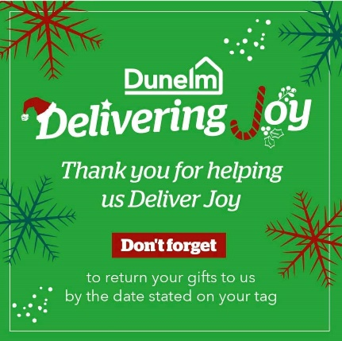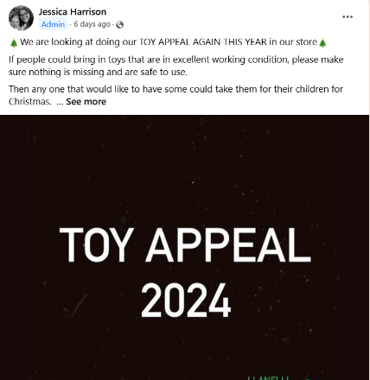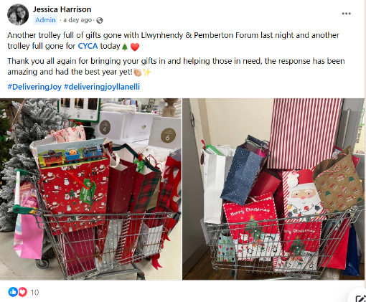

Katie the Tradie Wife on Facebook has 202k followers (The Tradie Wife 2024), and is also know as Sh!t mums club on tiktok with 557.3k followers, and 13.3m likes, (Tradie. 2024). This social influencer is all about charity shopping and refurbishing house hold items. This influencer shows the world that charity shopping is amazing and that all the things you can find to help families, not only at Christmas but throughout the year. On her TikTok page she uploads all videos showing the reality of being a mum on a budget, charity shopping and days out cheaper the better. She has changed peoples attitudes not only about charirty shops but also being a mum having a messy home, the realiaty of a hetic mum life on a budget.
hauls.https://www.tiktok.com/@shit_mums_club?is_from_webapp=1&sender_device=pc
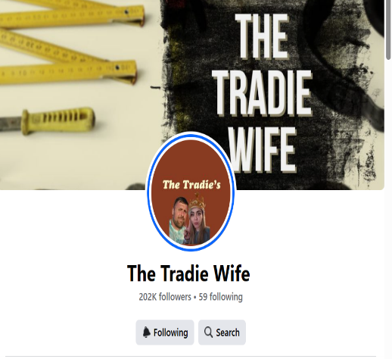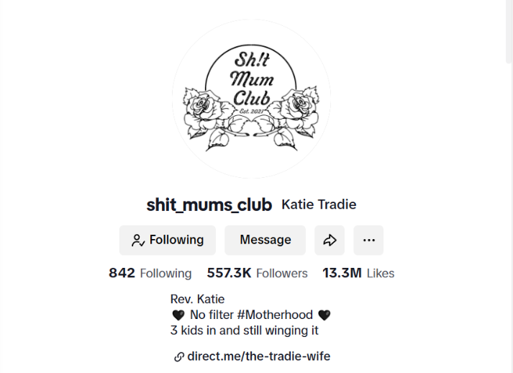

PART 3
My preferred channel for my marketing plan is for a flyer on Facebook, because It is the best method to communicate my message.
https://www.canva.com/design/DAGV5WdUGbw/n44UjOC5OATI7bAITq8veA/edit?utm_content=DAGV5WdUGbw&utm_campaign=designshare&utm_medium=link2&utm_source=sharebutton

References

Binns. D. (2023). One in Three Households With Children ‘Will Struggle To Afford Christmas’. One in three households with children 'will struggle to afford Christmas' | Money News | Sky News

Birt.E. (2023) Carmarthenshire County Council Launches Christmas Toybox Appeal.
Carmarthenshire County Council launches Christmas toybox appeal | South Wales Guardian

CYCA, (2024). Our Story
CYCA - Connecting Youth, Children & Adults

Don’t Dump It Donate It Carmarthenshire. (2024). Facebook,
Don’t dump it donate it Carmarthenshire | Facebook

Don’t Dump it Donate It. Crosshands, Penygroes, Ammanford, Surrounding Areas, (2024).Facebook,. .Dont dump it donate it. crosshands ,penygroes, ammanford ,surrounding areas | Groups | Facebook

Dunelm Llanelli Community Support. (2024) Facebook,
Dunelm Llanelli | Community Support | Facebook

Intuit Mailchimp, (2024). What is Psychographic Segmentation? Examples and Best Practices.
What Is Psychographic Segmentation? Examples and Best Practices | Mailchimp

Jane Denton. (2023). Where Does Your Income Put You Among Britain’s Earners?. The Official Statistics That Reveal Where You Stand.
Where does your income put you among Britain's earners? | This is Money

Kemp.S.(2024). 5 Billion Social Media Users, Data Reportal.
5 billion social media users — DataReportal – Global Digital Insights

Lynn,M.(2012).Segmenting and Targeting Your Market: Strategies and Limitations.Wiley. https://doi.org/10.1002/9781119200901.ch23

Mumsnet. (2024). “We are expecting to be poor, cold and miserable” - Mumsnet research shows ‘Cost of Christmas crisis’ approaching as families share financial fears. “We are expecting to be poor, cold and miserable” - Mumsnet research shows ‘Cost of Christmas crisis’ approaching as families share financial fears | Mumsnet

Royce.L. (2022) All The Ways You Can Donate Toys To Children in Need Across The Valleys This Christmas.
All the ways you can donate toys to children in need across the Valleys this Christmas - Wales Online

Team, M. S. (2023, November 8). Positioning - Definition, importance, types, factors & example. MBA Skool. https://www.mbaskool.com/business-concepts/marketing-and-strategy-terms/2762-positioning.html

The Tradie Wife, (2024).
Facebook

Tradie.K.(2024). Sh!t_Mums_Club TikTok Katie Tradie (@shit_mums_club) | TikTok

Westwater.H. (2020). 1 in 5 Children Won’t Receive a Christmas Present This Year.
1 in 5 children won’t receive a Christmas present this year.

