

BMSW4003

Digital Skills and Research Methods

Assessment 2

Student Name:IIRINA BEATA GYORFI
Student ID:2115390
Lecturer’s Name:KOUSHIK MODAK

Table of Contents
Introduction 2
Questionnaire on VLE (Primary Data) 3
Literature Review (Secondary Data) 10
Development of e-Learning Courses for Subjects 10
Impact of Interactive E-Learning Instructions on Effectiveness of a Programming Course 10
Effectiveness and Impact of E-Learning on Teaching & Learning 11
E-learning Development in Improving Student's Critical Thinking Ability 11
Findings 12
Recommendations 12
Conclusion 13
Reference 14

Introduction
The term "virtual" evokes images of a made-up environment that takes the place of actual life. A virtual learning environment (VLE), does not substitute for classes or present educational procedures. They bring value by expanding the spaces of physical learning. They give students and teachers equally the chance to use their thoughts. A virtual learning environment not only provides an aesthetically appealing area for education and learning, but also a supportive atmosphere for students, instructors, & participants. A great VLE lets people collaborate on the creation of their educational contexts throughout time. This report makes a study report on the influence of VLE - Moodle on learners' educational experiences of the University of Wales Trinity Saint David, London.

Questionnaire on VLE (Primary Data)
- Which of the numerous advantages of employing virtual learning could be taken into account?
- Quick
- Easy to implement
- Flexibility
- Easy to use
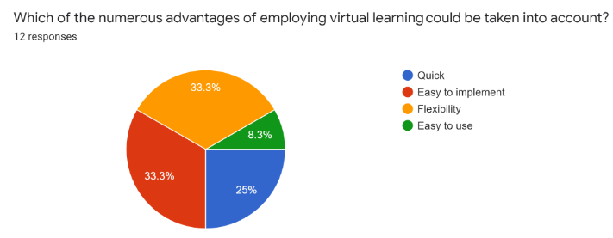
- Which one of the following can be regarded as a virtual learning environment limitation?
- Expensive
- Difficult to use
- Ineffective
- IT competency
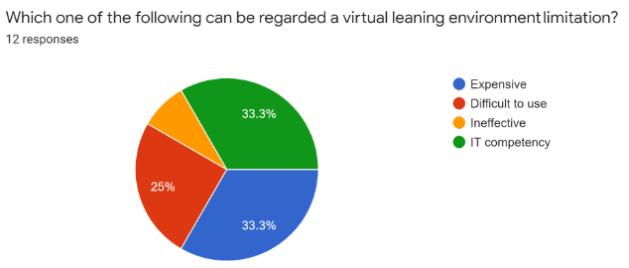
- What does the acronym VLE stand for?
- Virtual Learning Environment
- Visual Learning Environment
- Village Level Entrepreneur
- None of the Above
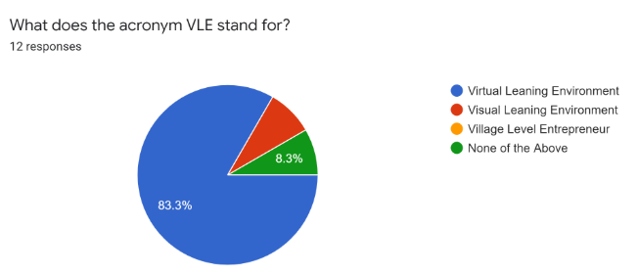
- "A 'hybrid' technique to educating that combines face-to-face, classroom teaching approaches with e-learning." What kind of virtual learning does this statement refer to?
- Distance Learning
- Asynchronous Learning
- Blended Learning
- Synchronous Learning
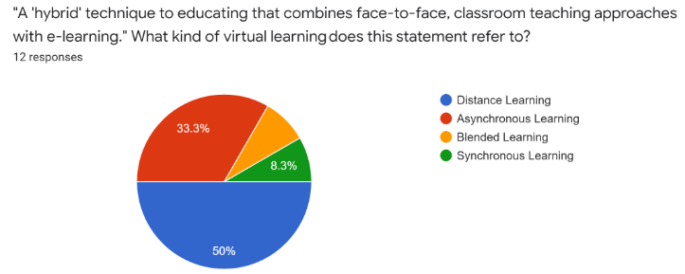
- Which one of the following training exercises do users believe virtual learning would be most useful?
- A new worker's introduction to the organization.
- Learning in Microsoft Excel
- This is a team-building activity.
- At work, anyone can improve their assertiveness skills.
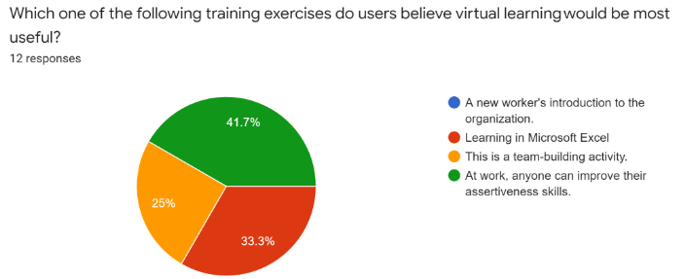
- E-learning is presently one of the most widely utilized training instruments in the UK.
- True
- False
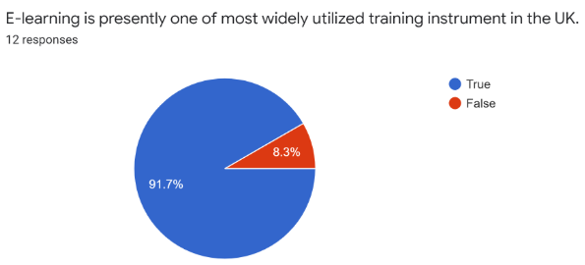
- What is the most accurate description of a virtual classroom?
- Students use technology in a class environment with a tutor.
- A virtual learning atmosphere that may be accessed over the internet (i.e. webinars).
- A self-paced online course.
- A YouTube tutorial-based training session.
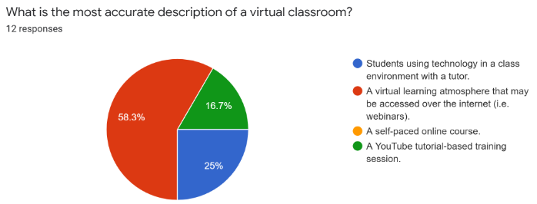
- How many hours shifts per day do you expect students to explore on the internet course of study?
- 1-4 Hours
- 3-5 hours
- 6-8hours
- 10 + hours
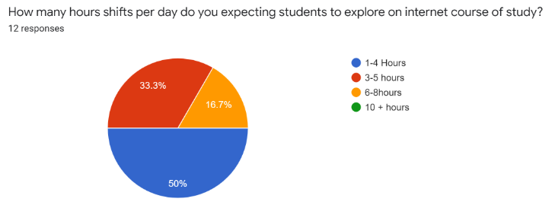
- What gadget do users use the most to learn online or at distance?
- Desktop
- Smartphone
- Laptop
- Tablet
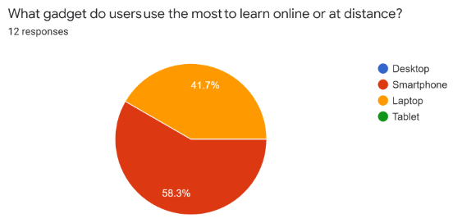
- How supportive has your [College or University] been in providing you with the facilities you need to study from residence?
- A little bit of assistance
- Moderately beneficial
- Very beneficial
- Extremely beneficial
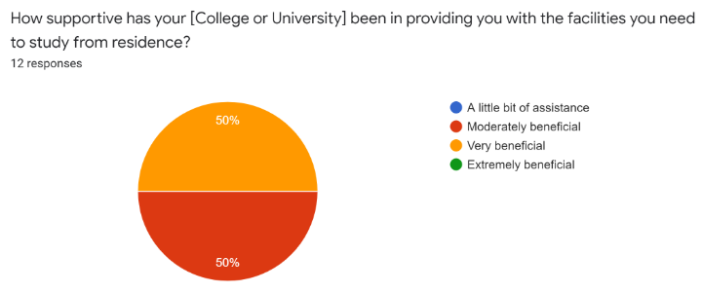
- For you, how beneficial has online education been?
- It is completely ineffective.
- Effortlessly effective
- Effective in a moderate way
- Very efficient
- Exceptionally effective
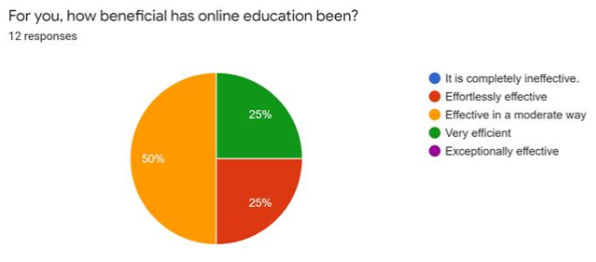
- How supportive are your instructors when it comes to online learning?
- A little bit of assistance
- Moderately beneficial
- Very beneficial
- Very beneficial
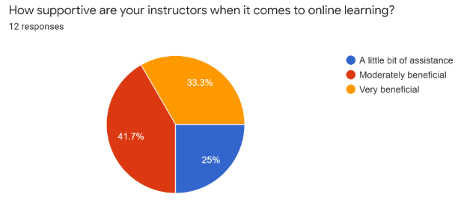
- Are you happy with the web-based learning techniques and software you're utilizing?
- Happy
- Too much satisfied
- Not happy
- Inconvenient
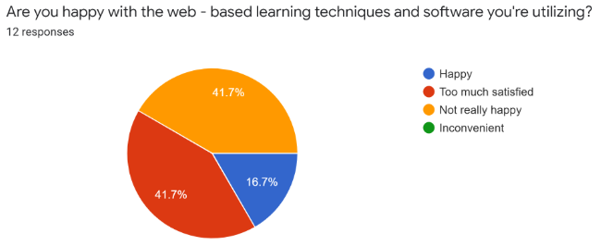
- When you're learning online, how crucial is face-to-face contact to you?
- Required Every time
- Too much necessary
- Sometimes required
- Not crucial at all
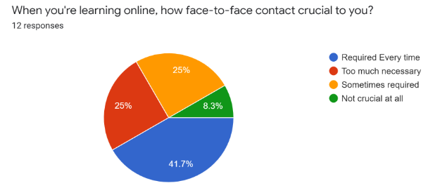
The above questionnaire is used for primary research on the given topic is Virtual Learning Environment. This survey is done so because these survey questions are a cost-effective and fast way to assess the behavior, views, interests, opinions, & intentions of a great number of people. To gather data, a survey frequently employs questionnaires. The ability to collect actual information, make charts, detect patterns, & produce customized findings which can be distributed simply is among the most appealing features of conducting questionnaires or online surveys. Quality of teaching, child views, course evaluation, & student accomplishment can all be measured via surveys. All users' input can help to develop initiatives & solve problems that lead to weaknesses inside an institution (Debois, 2019).

Literature Review (Secondary Data)

Development of e-Learning Courses for Subjects
According to authors Zainul et al. 2020, E-learning is a new topic that is both a potential advanced method as well as a fertile ground for study into its influence on the teaching and learning process. Because e-core learning's structure as an educational channel deviates from face-to-face transmission, it necessitates additional new capabilities for program building, online evaluation, and interactivity. Moodle is a program that allows participants to create online classes & web pages. It is a Learning Platform that helps students, instructors, & kids to work together more effectively. In this article, researchers look at how Moodle is utilized by instructors to create interesting and interactive educational experiences in different universities of technology, as well as how the various aspects of Moodle are being used by instructors to provide engaging & exciting educational opportunities. The accompanying e-Learning cycle paradigm can be used to depict the e-Learning procedure.
- Analyze the Abilities: The training manager gathers the essential significant data & evaluates the learner's current skills as well as the abilities that have been specified as a specific objective. The management then goes on a selection of relevant information.
- Material Research and Development: The content overview structure & practice questions are created by the programmer. Explanation articles are connected to the material structure.
- Educating Yourself: The learner participates inappropriate learning, such as acquiring knowledge for information literacy or cooperative learning for training teaching (Martin and Bolliger, 2018).
- Assessment: The student completes activities & takes exams with questions that are tailored to the learning task. The learning manager assesses each student depending on the outcomes of assignments and tests (Zainul et al., 2020).

Impact of Interactive E-Learning Instructions on Effectiveness of a Programming Course
According to author Nariman 2020, Universities, colleges, as well as training & development specialists are being forced to change quickly from in-person to virtual education because of the COVID-19 epidemic. It became much more critical to provide good e-learning courses. As a result, among the most quickly increasing fields of training and education is the expansion of virtual learning materials as well as the offering of e-learning possibilities. Both through online and offline systems, the rise of e-learning applications. These cutting-edge technologies are altering the picture of education as people understand it. However, because of a lack of rigorous review, what is recognized about these new solutions to developing teaching & learning is restricted. The goal of this research is to see how employing interactive lessons on e-learning might help education courses be more efficient. Blended Learning is an educational & studying system that incorporates both virtual learning as well as traditional methods. Online sessions are reinforced by classes held in regular educational settings. It is the most efficient educational procedure since it combines the classroom method with e-learning. Several researchers looked into learner satisfaction with online learning platforms. Learner satisfaction is impacted by a supportive learning environment as well as high-performance standards, with performance requirements contributing the most to student outcomes. If instructors & students perceive that online learning would assist them to increase their education and learning eﬀectiveness, they would have a good mindset about it (Nariman, 2020).

Effectiveness and Impact of E-Learning on Teaching & Learning
According to author Encarnacion et al. 2021, In university education, the inclusion of E-Learning has dramatically increased as well as enhanced the method of learning. "E-Learning is a phrase for all sorts of technology-enhanced education, where software is employed to support the procedure of learning," as per the researcher. Many academic establishments that use E-Learning and use technology have had a significant impact and have carved out a place in the industry. Owing to the complexity of usage, work overload, lack of technical abilities, as well as absence of face-to-face connection, many learners who utilize E-learning systems have improved learning and performance as well as a good outlook, some have been lesser enthusiastic towards E-learning systems. To produce a comprehensive way of defining effective Online-Learning, past articles and books and also practice guidelines in traditional and digital education had to be reviewed, as well as the elements that best proved successful E-Learning had to be collected (Encarnacion et al., 2021).

E-learning Development in Improving Student's Critical Thinking Ability
As per the authors Supriyatno et al. 2020, this paper seeks to add to the literature on the utilize of complicated VLEs by disclosing the advancement of a package of internet events for a distance learning course utilizing a Moodle-based VLE with message boards, blog posts, wikis, polling data, as well as questionnaires, as well as the assessment of active learning with all these functions over 2 years. The internet portion of the program was created to allow students to develop their language skills through self-study and also interactive exercises with instructors & peers. The fundamental benefit of asynchronous digital training would be that it enables learners to connect in high-quality educational contexts when distances & timetables allow on-the-ground studying exceedingly difficult. Learners could attend lectures from any location on earth as long as it is connected to a laptop as well as Internet access. Furthermore, the online platform gives physically handicapped learners (and professors) greater flexibility in-class participation. Rather than physically attending class, students use their devices to access the Online Lectures. The Virtual Classroom is available 7 days each week, 24 hours each day. An additional advantage of online education is its ability to save time. Professionals managing job, home, & study schedules can join in classroom discussions using asynchronous communication using internet video conferencing tools (Ahmad et al., 2020). There's no doubt about performing the work; simply do it when it's more suitable for everyone. Students get access to their programs at all hours of day and night. They also get access to courses, training materials, as well as classroom discussions at all times. This is especially useful for students who might have to repeat a lesson or spend extra time reflecting on a topic before continuing forward (Supriyatno et al., 2020).

Findings
- The present e-learning model has different potential weaknesses in terms of accessibility, affordability, usefulness, as well as the integrity of the e-learning online platform.
- To use e-learning, physical infrastructure including laptops, computers, as well as telecommunication systems should be available. Furthermore, "the accessibility of technology operating systems & applications are essential.
- Boost Digital literacy & abilities of e-learning participants are among the variables that must be implemented to raise the utilization of virtual learning systems (Herrera, 2017).

Recommendations
- Staff development should be ongoing, according to instructors and learners. During online instruction, they suggested reducing mental workload and increasing interactivities.
- It's a good idea to get at minimum one synchronous meeting in the virtual classroom where learners and teachers can interact on a real-time basis. This could happen at the beginning of the term when everybody is people get to know each other, just at end of term when learners are especially focused on assessments, or at periodic intervals throughout the year.
- It's very vital in online learning to give students advice on how well the subject's evaluation is structured. It can also be used to make no-stakes games, earlier in the lecture hour, learners are provided activities to do, evaluate their comprehension of a subject or develop a skill.

Conclusion
From this report, it is articulated that generally, most participants agreed that the material of the system of virtual earning had a favorable effect & provided a high level of pleasure. The questionnaire survey revealed that three major parts of the considerations can clarify 72.32 percent of the participants' choice for the virtual learning system: the excellence of visual effects as well as the functionality of the digital or virtual textbook, the efficiency of video guidelines, as well as the excellence of sentences in the virtual or digital textbook. The visual effects as well as their interpretations have been good and beneficial for a large number of undergraduates in subsequent the guidelines of the class session, as demonstrated by the detail that 59 percent of the learners were pleased with the level of the visual effects and functionality of the eBook.

Reference
Ahmad, N.L., Ahamad Rapani, N.H., Ismail, Z. and Ahmad, A.S., 2020. Accounting teacher self effication, usage, teaching preference and skill towards virtual learning environment in education. International Journal of Advanced Science and Technology, 29(6), pp.249-264.
Debois, S. (2019). 10 Advantages and Disadvantages of Questionnaires. [online] Survey Anyplace. Available at: https://surveyanyplace.com/blog/questionnaire-pros-and-cons/ [Accessed 8 Jan. 2022].
Encarnacion, R.F.E., Galang, A.A.D. and Hallar, B.J.A., 2021. The impact and effectiveness of e-learning on teaching and learning. Online Submission, 5(1), pp.383-397.
‌Herrera, L., 2017. Impact of implementing a virtual learning environment (VLE) in the EFL classroom. Ikala, 22(3), pp.479-498.
Martin, F. and Bolliger, D.U., 2018. Engagement matters: Student perceptions on the importance of engagement strategies in the online learning environment. Online Learning, 22(1), pp.205-222.
Nariman, D., 2020, July. Impact of the interactive e-learning instructions on effectiveness of a programming course. In Conference on Complex, Intelligent, and Software Intensive Systems (pp. 588-597).
Supriyatno, T., Susilawati, S. and Ahdi, H., 2020. E-learning development in improving students' critical thinking ability. Cypriot Journal of Educational Sciences, 15(5), pp.1099-1106.
Zainul, R., Adri, M., Wahyuningtyas, N., Wedi, A., Surahman, E., Aisyah, E.N., Oktaviani, H.I., Meilanie, R.S.M., Purnamawati, S.N., Listyasari, W.D. and Santoso, Y., 2020, July. Development of e-Learning Courses for Subjects about ‘Learn and Learning’with Moodle-based for Prospective Teacher in Indonesia. In Journal of Physics: Conference Series. Vol. 1594, No. 1, p. 012023.

