
PLANNING AND DELIVERING AN INTERNATIONAL MEETING/EVENT


STUDENT NAME AND NUMBER: MARCELA MANOLE 2111927
MODULE: INTERNATIONAL MEETINGS MANAGEMENT FOR THE HOTEL INDUSTRY BMIH6007
LECTURER NAME: KATHRYN FLYNN

Table of contents

2
Introduction 3
The Event Cycle 3
Event Concept 5
Aim and Objectives of the Event 5
Event Operations 7
Event Budget 8
Industry Trends/Impacts 9
Cultural and Situational Considerations 10
Conclusion 11
Reference List 12

Introduction
The purpose of the report is to elaborate on a sustainability event for planting trees. The name of the event is “Eco-Green Event”. Tree plantation programs are considered effective remedial measures to control noise as well as air pollution. The tree plantation program improves the area maintains sustainability and supports the biosphere. A tree plantation program means the planting of tree seeds over an area (GOV.UK, 2024). The whole program is organized by the corporate institution on National Tree Week.
Reason for the event: The tree planting program is chosen to create more sustainability by the hospitality sector, and it also implements sustainable strategies that can help to reduce the carbon footprint. The event was chosen to analyze the market factors which are responsible for sustainable events such as demands in the market, suppliers, and competitors. The purpose of the event is to provide service trees where a smaller number of trees exist. The event also helps to restore the native species of that particular area where the tree plantation program to going to happen (TCV, 2022). The tree plantation program is going to happen in the Derby. The people of that locality are enthusiastic to join the tree plantation program. The purpose of the event is to encourage more people to participate in tree plantation and spread awareness regarding climate change due to the excessive cutting of trees. The event organizers want to make the locality greener and try to save the native plant species to maintain sustainability and balance in ecology.
Location and background: The program is conducted on 23rd February 2024 which is celebrated on National Tree Week in Derby. The Event is organized in Markeaton Park, Derby England. The event venue is selected as it is a favorable place and considered one of the most popular parks in Derby and the people of East Midlands frequently visit the place. The park was selected as it has a long space for tree plantation.

The Event Cycle
The event cycle is considered as event planner which consists of five important stages. The event cycle helps an organization to conduct the event successfully by doing proper planning and strategy for conducting the event. The five stages of the event cycle are: planning, organizing, measuring, coordination, day-of planning, and sharing. By following those stages an event can be successfully organized (Indeed, 2024).
Plan: It is considered a method of conducting any research, project, event, etc. to make something or achieve the event at the end. Proper planning helps an event to be a successful one (Younts, 2021). A plan for a tree plantation program is made by the corporate institution of Derby to raise awareness among the local people to plant and participate in tree plantation programs which can balance the sustainability in the environment. The authority selected Markeaton Park, where lots of people frequently visit and the space on the ground is huge which is suitable for tree plantation. The event is organized on 23rd February 2024 to celebrate National Tree Week (Inderby, 2023). Different guests are invited who are famous as social workers and concerned about environmental protection. A whole day program is prepared where more than 100 new tree siblings will be planted.
Organise: It means assigning tasks among various departments grouping the tasks or delegating authority and allocating resources across the organization. Organizing means making coordination to successfully execute the plan for an event (Younts, 2021). The corporate institution to execute the plan divided the task among various groups of local people and those plant seedlings will be divided equally among the group and they will plant those seedlings to the park. Some awareness programs are organized where some social workers will aware people of climate change due to deforestation and the increased rate of carbon footprint that damages environmental sustainability. The social workers will also mention the cleanliness of the local area to avoid disease by planting a huge number of trees and saving the native plant species to maintain the ecological balance.
Measure: It is considered an empirical process by using different factors that can make a comparison between an unknown quantity with a known quantity. It can help to measure the success of an event by comparing it with other events (Younts, 2021). The event Eco-Green is going to be a successful one as it will spread awareness about climate change and the event can be a successful one as the Chew Valley Plants organized in South Bristol was a successful one as their aim is to plant trees and grow the people’s own fruits and nuts (Eventbrite, 2023). Another tree plantation event the Hilltpo Centre Tree Planting Day organized by Chiltern Rangers CIC to spread environmental awareness among the people of the UK was successful (Chewvalleytrees, 2021). So Eco-Green will be the successful one.
Coordination and Day of Planning: Analysis means a detailed examination of any program and event and whether the procedure to organize the program will be effective or not (Younts, 2021). The tree plantation event will be successful as people are now serious about environmental protection and maintaining sustainability so the local people will participate in that program to be part of this pious celebration on National Tree Week.
Share: Share means spreading an important event to the people and aware them of the purpose of the event so that they get the enthusiasm to participate in that event (Younts, 2021). The event organizer of the tree plantation has spread the details of the arranged program and mentioned all the activities with invited guests to attract them to join the event.

Event Concept
The Event is about to plantation of trees in an area of Derby in the UK. The purpose of the event is to encourage the local people to plantation of trees to save the environment and decrease the problems of climate change. Climate change is caused due to deforestation and excessive carbon footprint (Bgky, 2022). This event will help the local people to live in a greener environment and it will help to revive the native species of that locality. The event will happen on 23rd January 2024 organized to celebrate National Tree Week at Markeaton Park, Derby England. The area is selected as the park is big, number of people live there who can participate in the program and be a part of the tree plantation. The park also has lots of space which helps the organizer to invite lots of people and plant a maximum number of seedlings (Inderby, 2023).
The Event is organized by the corporate institution which helps the hospitality sector to implement sustainable strategies to reduce the carbon footprint. The local councilor will come as chief guest and various social workers who are concerned with the environment and conduct various awareness programs will come to aware the local people of Derby to plant trees in their house and keep the environment pollution free to live their life healthy.

Aim and Objectives of the Event
Aim of the Event: The event Eco-Green which is a tree plantation program aims to spread awareness among the local people about the positive sides of the tree plantation the event also encourages the negative effects of climate change and the consequences of deforestation. The event also aims to revive the nation's plant species to maintain the ecological balance and create a greener community.
Objectives of the event
Specific | The organizer of the tree plantation event on 23rd February 2024 Environment Day performs its inauguration day of the whole program and if some plants are planted on that particular day the chief guest will inaugurate the program by planting trees.
Measurable | The event can be measurable as the event organizers have selected the environment week to do this important function.
Achievable | The event is achievable because local people are ordinarily invited to attend the event and various social workers are invited to spread awareness about the importance of trees and the negative effects of deforestation.
Relevant | The event is more relevant as on that particular day people will participate by planting trees in Markeaton Park, Derby, and participate in the contribution of plants among the local people to make the locality greenery.
Time-Bound | The inauguration program will take 1 day to complete.

Specific | The organizer has planned to celebrate the whole week by planting more trees and cleaning the whole area of the park to make it comfortable for children, senior citizens, and adults to spend some relaxation time there.
Measurable | Each day organizer for 2-3 hours will conduct the event plant the selective trees carefully and clean the premises by counting the number of new trees can measure the success of the event.
Achievable | The event can be achievable by getting support and cooperation from the local people and the local government body. The government’s agenda can be successfully achieved.
Relevant | Every day they will perform some tree plantation work and more than 100 seedlings are planted in the park which is the agenda of the event organizer.
Time-Bound | It will take 1 week to complete the whole event.

Event Operations
The event is about to plantation of trees which means the organizer and the people must have certain knowledge and skill regarding the plants which is beneficial and good for the environment and the rules and regulations regarding the protection of plants and forests. Some skills are required for the plantation of trees and those are:
Observational skill: Observational skill of a person can help to plant trees and be aware of the quality of the trees and the person needs to be more careful at the time of planting the tree on any land. The person must know the weather suitable for trees (Treesaregood, 2020).
Knowledge about forest regulation: The planter must have proper knowledge about the rules and regulations related to the forest so that any irregularities cannot be followed by the planter (Indeed, 2021).
Knowledge about the growing procedures: The knowledge of nourishing the trees such as watering, mulching, placing, and digging must be known to the planter then only the plants can survive and be beneficial for the environment (MyMajors, 2022).
Patience: For the tree plantation the person must have the knowledge about the growth timelines of a tree and maintain patience and calm and at the time of planting the tree he or she must be more careful about the plants (Indeed, 2023).
Technical proficiency: the nursery professional must have knowledge about various types of trees and their small changes according to the weather and what weather is suitable for growing a tress must be acknowledged by the person dealing with the tree. the person must have the basic knowledge of how to pamper the trees at the time of their plantation (Jim, 2013).
Organizational skill: the person must work with different tools and plants and the organizational skill will help the professional to manage all tools required in tree plantation and the procedure for growing the trees according to the soil condition and proper sunlight on that land (Indeed, 2023).

Event Budget
Start-up cost
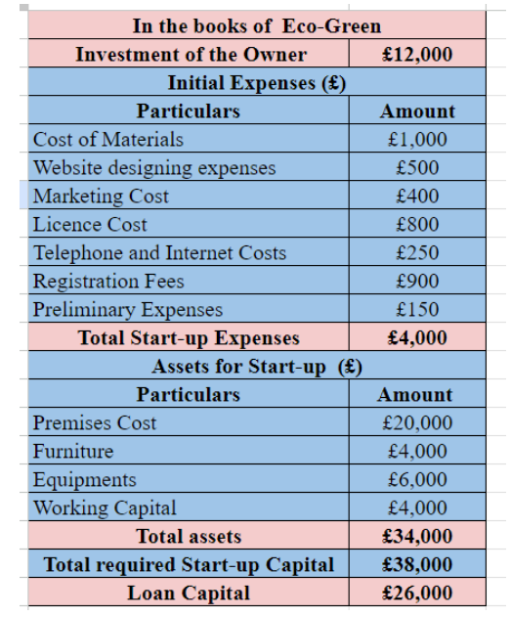
(Source: Self developed)
Income and expenditure account
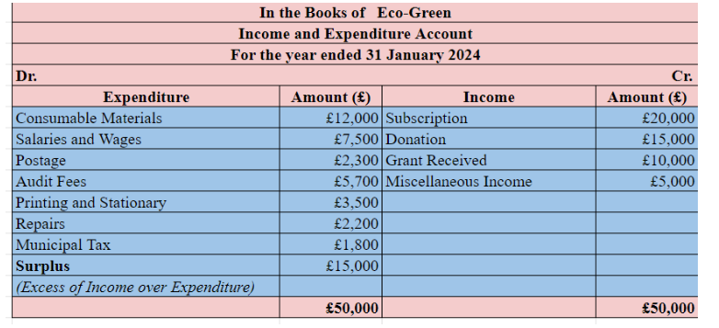
(Source: Self developed)
The budget of the event organized for the tree plantation is £12,000 by the owner. The cost of materials for the event is £1000 and for the advertisement of the event and publishing invitation template is £500. The collection amount for registration fees for the event is £900. Marketing costs and the license for organizing the event costs are £400 and £800. Internet and preliminary costs and other costs together become £4000. The premises or the booking of the selected park is £20,000. The furniture arranged for the guest is £4.000 the equipment costs and the working capital costs in total become £38,000. According to the income and expenditure account, the total amount of expenditure for the event is £50,000. The amount collected from subscriptions, received grants, miscellaneous income, and donations is £50,000 and the above-mentioned budget report mentioned the exact amount of the expenditure for different purposes.

Industry Trends/Impacts
Protect the environment: The main concern of the event is to plant more trees to protect the environment from pollution and maintain sustainability. The hospitality sector is more enthusiastic about doing this as it will help them to perform their corporate social responsibility. The UK government had also fulfilled the preset target of the annual tree-planting program in England. The Department for Environment, Food, and Rural Affairs has mentioned that the government has taken the initiative to plant 30,000 hectares of woodland according to the Environment Act by March 2025 (Assets.publishing.service, 2024).
Develop of economy: The public sector in the UK is responsible for the plantation for a quarter of UK woodland but the government has not instructed the private sector about some plantation strategies. Some of the private sector is performing it to increase their brand reputation (Assets.publishing.service, 2024).
Production of construction materials: Tree planting is considered a vital strategy to emit carbon and maintain biodiversity targets and sustainability in the construction industry. The report of the EAC mentioned that resources such as timber can meet the needs of demand of low-carboned construction materials. This scenario helps to expand the woodland which will cover the demand of the supply of timber for domestically produced softwood timber which will help to achieve the goals of UK climate change and environmental goals. Presently the rate of planting is only covering half of the government’s target (Horton, 2023).
Save environment from disaster: The plantation of the wrong species can cause disaster in nature. According to the report, native broadleaves are the most ideal habitats of nature and conifers help to supply the softwood timber so the balance must be maintained at the time of plantation so the resources must be sufficient for timber. According to the report of Guardian tree-planting rates are now in a good position in the UK. The government also prepared various strategies for tree plantation so that it can improve biodiversity throughout the country and support domestic timber production (Horton, 2023). The event of Eco-Green is completely influenced by the initiatives taken by the government of the UK.

Cultural and Situational Considerations
Cultural consideration: Tree plantation is now considered as a celebration among the people because the trees provide various positive things to the environment, and it also helps the country to financially become stable and protect the environment from critical situations such as climate change. Planting trees can help people to get their fruit and nuts to live a healthy life. Vegetables can be one of the greatest income sources for the rural people of the UK. The initiatives taken by the UK government to achieve net-zero greenhouse gas emissions by the end of 2050 can be achievable as the government has taken the initiative to plan more plants for developing the forest. 70% of the land is used for agricultural production and it helps to control climate change (Westaway et al. 2023).
Situational consideration: Trees can be the economic support for humans as various industries are depending upon the trees. Three plantations are also beneficial for the children as they help to keep them connected with the natural habitat and develop their immunity. Plantation of trees can also help the environment to remain clean and fresh air can help people to live healthy lives. It reduces the pollution and other toxic gases of the environment. People can use the trees for their relaxation and under the shady trees they can arrange picnics with their families. Children can get the knowledge of planting trees. Parks situated in different places of the cities for children and people and plantation of trees in the park can help to develop the greenery and medicinal trees also help the people to get natural medicine from it. Trees provide economic support for timber, resin, rubber, honey, fiber, etc. (Turner‐Skoff et al. 2019).
For tree plantation events situational and cultural considerations must be considered because the tree can help the local people by giving fruits, nuts, and various other products which can make the local people economically stable. It also helps the agenda of the UK government to reduce carbon emissions and control the emission of greenhouse gases.

Conclusion
In conclusion, it can be mentioned that tree plantation is the most important initiative which is taken by the UK government to reduce greenhouse gases and other toxic gases from the environment, and it also helps the environment by protecting it from climate change. Trees also support people economically and people can get various benefits from them. The tree plantation event is organized on 23rd February 2024 to celebrate National Tree Week at Markeaton Park, Derby. England. The area was selected as the park has a large number of people who live there who can participate in the program and be a part of the tree plantation.The park also has lots of space, which helps the organizer to invite lots of people and plant a maximum number of seedlings.

Reference List
Assets.publishing.service, (2024) Environmental Improvement Plan - GOV.UK. Available at: https://assets.publishing.service.gov.uk/media/64a6d9c1c531eb000c64fffa/environmental-improvement-plan-2023.pdf (Accessed: 29 January 2024).
Bgky, (2022) City of Bowling Green, Kentucky, Benefits of Planting Trees - Bowling Green,Kentucky - Official Municipal Website. Available at: https://www.bgky.org/tree/benefits (Accessed: 29 January 2024).
Chewvalleytrees, (2021) Chew Valley Trees. Available at:https://www.chewvalleytrees.co.uk/about (Accessed: 29 January 2024).
Eventbrite, (2023) Eventbrite. Available at: https://www.eventbrite.co.uk/e/hilltop-community-centre-tree-planting-day-tickets-795977920387 (Accessed: 29 January 2024).
GOV.UK, (2024) Tree planting and woodland creation: overview, GOV.UK. Available at: https://www.gov.uk/guidance/tree-planting-and-woodland-creation-overview#:~:text=Urban%20Tree%20Challenge%20Fund,the%20Urban%20Tree%20Challenge%20Fund. (Accessed: 29 January 2024).
Horton , H. (2023) Less than half of annual tree-planting target in England met, say MPs, The Guardian. Available at: https://www.theguardian.com/environment/2023/jul/19/half-annual-tree-planting-target-england-met-mp-report (Accessed: 29 January 2024).
Indeed, (2021) How to get a job planting trees | indeed.com. Available at:https://www.indeed.com/career-advice/finding-a-job/planting-trees-jobs (Accessed: 29 January 2024).
Indeed, (2023) What Does a Plant Nursey Worker Do? Duties, Skills and Salary. Available at: https://www.indeed.com/career-advice/finding-a-job/what-does-plant-nursery-worker-do (Accessed: 29 January 2024).
Indeed, (2024) The Five Career Stages and How To Succeed in Each | Indeed.com. Available at: https://www.indeed.com/career-advice/career-development/career-stages (Accessed: 29 January 2024).
Inderby, (2023) Markeaton Park: Parks: In Derby, Derby Parks. Available at:https://www.inderby.org.uk/parks/derbys-parks-and-open-spaces/markeaton-park/ (Accessed: 29 January 2024).
Jim, C.Y., (2013). Sustainable urban greening strategies for compact cities in developing and developed economies. Urban Ecosystems, 16, pp.741-761. Link: https://link.springer.com/article/10.1007/s11252-012-0268-x
MyMajors, (2022) Tree planter career, Tree PlanterSkills and Knowledge. Available at:https://www.mymajors.com/career/tree-planter/skills/ (Accessed: 29 January 2024).
TCV, (2022) 10 great reasons to plant trees, TCV. Available at: https://www.tcv.org.uk/media_hub/10-reasons-plant-trees/ (Accessed: 29 January 2024). Chewvalleytrees, (2021) Chew Valley Trees. Available at:https://www.chewvalleytrees.co.uk/about (Accessed: 29 January 2024).
Treesaregood, (2020) TreesAreGood.org. Available at: https://www.treesaregood.org/treeowner/plantingatree (Accessed: 29 January 2024).
Turner‐Skoff, J.B. and Cavender, N., (2019). The benefits of trees for livable and sustainable communities. Plants, People, Planet, 1(4), pp.323-335. Link: https://nph.onlinelibrary.wiley.com/doi/full/10.1002/ppp3.39
Westaway, S., Grange, I., Smith, J. and Smith, L.G., (2023). Meeting tree planting targets on the UK's path to net-zero: A review of lessons learnt from 100 years of land use policies. Land Use Policy, 125, p.106502. Link: https://www.sciencedirect.com/science/article/pii/S0264837722005294
Younts, D. (2021) The Perfect Plan: What Are the Five Stages of Event Planning?, Midlothian Conference Center. Available at: https://www.midlothiancenter.com/the-perfect-plan-what-are-the-five-stages-of-event-planning/ (Accessed: 29 January 2024

