Individual report

Submission date: 16.10.2022
Student name and number: Mihaela Sandu Rizea / 2126225
Module code and name: LCBB4003 / Introducing the Modern Workplace
Lecturer’s name: Dr Buddhi Pathak
Assignment title: Individual report
Page numbers: 11

Table of Contents

INTRODUCTION…………………………………………………….…….4
MAIN BODY………………………………………………….……....….4-11
1.Presentation of the organisation, structure and culture …….……….4-8
2.The role of manager in motivating employees. Interview’s report......8-9
CONCLUSION………………………………………………………….….10
REFERENCES………………………………………………………….…..11

INTRODUCTION
The following essay aims to present the organisation Parklands Healthcare Ltd. <www.careservices.org.uk/parklands-redditch>, examining organisation’s structure and culture, and the role of the manager in motivating the employees. In order to understand the organisation’s structure and culture, and the theory that underpin this aspect of shaping organization, I will relate my work to some of the existent studies and theories sustaining my assertions with personal experiences from my working place. I am currently working as senior leader at Parklands, position from I learned about aspects of its activity, about its structure and culture. Interested to find more about how it is the organisation and its management viewed by its employees, I conducted a series of interviews and talks, collecting an interesting data for my report.

MAIN BODY
1.Presentation of the organisation, structure and culture
Parklands is a small private limited company, activating in healthcare sector, which aims to provide its service users with a relaxed, secure, and homely environment (Policies and Procedure Parklands, Statement of purpose).
Parklands is a private limited company, a small business own by a private proprietor, which is the shareholder and the business is managed by a registered manager (PARKLANDS HEALTHCARE LIMITED overview - Find and update company information - GOV.UK (company-information.service.gov.uk).
The organisation’s structure include also, the staff: administrator, deputy manager, seniors shift leaders, care assistants, activities staff, kitchen staff, domestic staff – cleaning and maintenance; in total 29 members of staff providing services for 24 service users (Policies and Procedure Parklands, Statement of purpose). The communication flows in both ways from the top - owners to the managers and staff, and from the bottom to top. The manager keeps the communication open with the external support services like charities and other organisation that can offer support and advice.

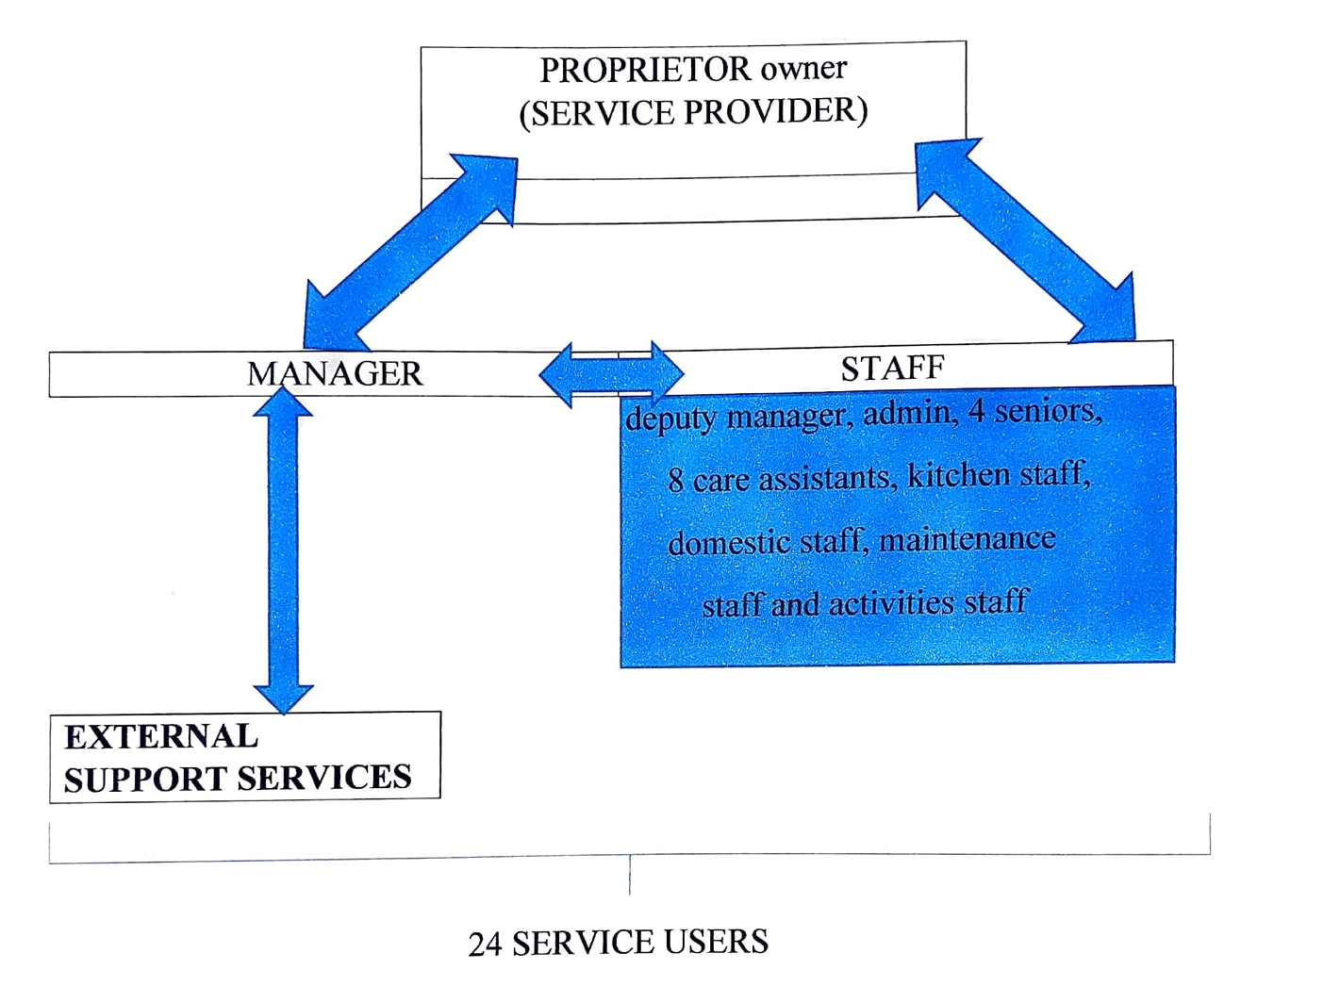
In terms of structure and operations, this healthcare centres are not different from other organizations. The structure is almost the same, simply presented: the owner, the manager and the staff, working throughout a specific task, which has to respect the Code of practice, a set of guidelines and regulations to be followed by the members of an organisation activating in healthcare sector (Nolan, 2011, p41-43). The role of the manager remains similar, to lead and organize the activity in order to achieve its aim, to communicate this objectives, to supervise and control the way this objectives are reached (Hudson, 2015, p16). However, my personal view after more than 6 years of experience working as senior in this organisation, the many aspects of the activity in this sector of healthcare, issues such as: shortage off staff due to minimum wages and a very stressful environment, dealing with health issues, mental health problems and dementia, makes the management a challenging task.
There are four major groups of theories that help us to understand how the organisations are structured and how they are working; the classical organisation theory, the neo-classical or behavioural theory, the modern organisation theory and the contingency theory or decision theory. The traditional theories are those that include administrative, bureaucratic, and scientific management approach (Khorasani & Almasifard, 2017). Henri Fayol, Frederic Taylor, Max Weber or Luther Gulick are known for their contribution to theorises classical managerial approach.
I consider that my working place’s management approach can be described as a combined approach between administrative, theorised by Henry Fayol and human relations, theorised by Elton Mayo. Fayol presented the role of the management to be: planning, organizing, commanding, coordinating and controlling. Later, Luther Gullick added two more functions: Reporting, and Budgeting.
Principles like division of work, authority, discipline, unity of direction, subordination of individual interests to the general interest, order, initiative, esprit de corps, few from those 14 principles described by Fayol, can be observed in my organisation’s activity and structure. I consider, that the fact this organisation is looking after people, and its priority it is to respect people’s rights and to care for people, this culture, it is reflected in the structure of the organisation. The service users are at the core of this organisation, they being considered to be the owners, and the employees are there to offer help and support (Policies and Procedures, Parklands Healthcare Ltd, Statement of purpose, p3-4). Mayo had considered that workers are not motivated just by money, is very much a reality in the healthcare sector (Hudson, 2015, p3).
In my working place, we have more levels of management, the top manager, the deputy manager – middle, and lower levels represented by the seniors, each of them have a specific duty in line with their expertise. Henri Fayol describes this scenario as a division of labour and specialization (The five functions of Fayol's management (bvop.org).
Being a senior care in Parklands organisation, involve to be able to lead a shift, to organise the daily activity during a shift of 5, 8 or 13 hours, to maintain a good working environment, to maintain a good communication within the home and with the exterior, family members, health care professionals or other specialists, to make sure all the residents within the home receive the best care possible and to provide all the residents with their medication at the right time, to pass the essential information to the next shift (Policies and Procedures, Statement of purpose, p10-11).
The unity of command promotes discipline, stability, and order. Every member receive daily tasks and has to report to the senior in shift which has to pass the information to the next staff in shift and to record that information. In this way the manager can also keep himself up dated and intervene when consider required. Some information, such as accidents or major events, have to be reported immediately to the manager. The relation between manager and staff it is open, based on respect and open communication, which reflect that the staff is valued. I consider that in my organisation we can observe aspects of Fayol’s administrative theory and few of those promoted by Elton Mayo.
When speaking about organizational culture we have to reflect on expectations, values, philosophy, and behaviours that create a unique social and psychological ambiance (Glisson, 2015). This means that certain habits, beliefs, mission, norms, and values of an organization are elements that identify or determine organisation’s culture. Trying to explain why the behaviour of people differs from one organization to another, Edgar Schein developed a theory which aim to help understanding the importance of culture. According to Schein (2010a), the culture within an organization is formed over time. The employees change, adapt to the external surroundings, and handle problems, they learn from their mistakes and adopt new habits, which in time becomes the culture of that organisation. The role of the manager is to promote the “right kind of culture” (Schein E. H, p13) within the organisation, and when encounter opposition to find solutions.
According to Schein’s theory, there are three levels of organisational culture represented by: behaviour and artefacts which refer to dress code, furniture, technology used, physical space; values within organisation which refer to the language used, slogans; and basic assumptions circulating about some aspects of the activity.
In my organisation, the physical artifacts are the building, the furniture: hospital beds, special chairs, wheelchairs, specific equipment used to perform the activity. The dress code doesn’t involve wearing an uniform, but specific items and colours, top with short sleeves, and black trousers. One of the principles of the home specific that this building is the home of the residents and the aim is to promote a homely environment. The staff does wear badges with their name and position, so the residents are able to call staff by their names.
The second level of Schein’s model is the organizational values. Every organizations follow some specific rules, norms, and procedures and have a specific philosophy, the aim of the organisation. The employees, it is expected to respect and follow them when perform. The aim of my organisation it is to provide a relaxed, secure and homely environment for the service users, placing them in the centre of their care which has to meet the standards of the Care Quality Commission CQC (Policies and Procedures, p3).
The third level of organisational culture is represented by some basic assumptions. Even these assumptions are invisible and rarely mentioned, this are powerful influencing the company’s culture. For examples, in my organisation, an assumption is that all the seniors are nurses, which is not true and can create frustration within residents feeling neglected.
Studying Schein’s theory about organisational culture, helped me to understand how cultural factors contribute to the formation of a specific culture within every organisation and the importance of a strong organisational culture.
Based on Competing Values Framework, elaborate by Cameron and Freeman, in 1999 Cameron and Quinn, elaborated a framework which set systematic steps, and methods to help managers to adapt to the demands of the environment (Cameron and Quinn,1999, p2).
2. The role of manager in motivating employees. Interview’s report
In the second part of my work I will present some of the challenges and opportunities existing in my working place, regarding manager’s role in motivating employees. In order to understand manager’s role and also to present a more personal view of this subject, I interviewed 10 members of the staff from my working place. I consider, that showing how the employees are thinking it is a good example that can help to understand the manager’s role.
According to Henry Fayol, the ‘right’ relationships between management and staff are essential for the success of an organization (Hudson, p.2), essential aspect which appears also in the interviews with the staff from my organization. More than half from those interviewed mentioned that the main quality of a manager it is being open and fair. Also, the staff consider that a good manager
should be ‘ready to put hands on’ and help if the situation is getting overwhelmed. The staff from Parklands pointed out few examples of practices that can increase employees motivation, such us: offering incentives for good contribution at work, a good working environment to meet the social needs of the staff, modern working conditions, staff room, safety at work, and consideration for your opinions, feeling heard and respected.
The staff expressed thinks that the challenges of this job are: working with people with mental health and dementia, as carer not having a voice, emotional stress working with dying people, working under staff, overworking situations when had to work over 200 hours/month, being treated like unskilled profession, being paid with minimum wages.
There are many studies about management and organisation and over the time few theories resulted: Frederick W. Taylor and the Scientific theory, Henry Fayol and the Administrative theory, Max Weber’s bureaucratic theory, Elton Mayo with human relations theory and Douglas MCGregor with X and Y theory.
According with this theories, the manager is a leader which has to cumulate a series of skills: human relation skills, conceptual skills which refer to the ability of seeing the organisation as a whole, and technical skills which allow them to perform. A manager has to have the ability to adapt to new realities and promote change and improving, which means he has to know how to work with people because they can “encounter ‘resistance to change” from subordinates (Schein, 2010, p8).
The interviews shown that personal motives and wellbeing, are more important for employees. Also, the motivational factors are different, depending on few factors: age, the staff with age between 19 and 50 appear more interested in professional progress, the staff over 50 was more interested by the atmosphere from work and safety, personal history. The majority of those interviewed had a family member with different mental problems, experience which motivated them to choose this job.
As conclusion, I consider that the management from Parklands should improve some aspects, as the staff pointed, such as: frustration having to work under staff or overtime to cover shifts, not having any psychological support, not having bank holiday paid or other incentives for dedicated work, even not having enough support in trainings and professional development.

CONCLUSION
Following the existing scientific literature, in my presentation I have described Parklands organisation, as structure and culture, and pointed out some of the aspects regarding staff motivation and management approach. As many others organisation from this sector, Parklands care home is facing many challenges in finding ideas and solution to keep its staff in work. Even there are good aspects of the management, are still many things to do in order to find viable solutions for the healthcare staff.

References
Policies and Procedure Parklands Healthcare Ltd, Statement of purpose, p1-15
Nolan, Y., Burgess, C., Shaw, C., Railton, D. and Pritchatt, N. (2011). Health & Social Care, p.1-43, p.103-113, p.157-160
Hudson, J.R. (2015). Theories of management, p.1-17
Alverson, M., Understanding organisational culture, 3-6, 71-77,93-108
Cameron, K. S., and Freeman, S. J. (1991). Cultural congruence, strength, and type: Relationships to effectiveness. Research in Organizational Change and Development, 5, 23-58
Cameron, K. S. and Quinn, R.E. (1999). Diagnosing and Changing organisational Culture, 1-8, 181-206
Parker, M., Organizational culture and Identity, 9-12, 81-85
Glisson, C. (2015). The role of organizational culture and climate in innovation and effectiveness. Human Service Organizations: Management, Leadership & Governance, 39(4), 245-250.
Hyacinth, B. T. (2020). Leading the workforce of the future, Inspiring a mindset of passion innovation and growth, 7-19, 110-239.
Khorasani, S. T., & Almasifard, M. (2017). Evolution of management theory within 20 century: A systemic overview of paradigm shifts in management. International Review of Management and Marketing, 7(3), 134-137.
Schein, E. H. (2010a). Organizational culture and leadership. Jossey-Bass business and management series. San Francisco, CA: Jossey Bass.
Schein, E. H. (2010b). Organizational culture and leadership. San Francisco, CA: Jossey Bass.

<a href="https://www.careservices.org.uk/parklands-redditch" title="Parklands">Parklands</a>
<PARKLANDS HEALTHCARE LIMITED overview - Find and update company information - GOV.UK (company-information.service.gov.uk) >
<The five functions of Fayol's management (bvop.org)>

