Daniel Ion Vlasceanu
2214466

E-portfolio report
ADRODDIAD E-BORTFFOLIO
Learning in the Digital Era / Dysgu yn yr Oes Digidol – BMPL4007/BMPS4009
Table of Contents / Tabl Cynnwys

Task 1 – Written summary / Crynodeb Ysgrifenedig 2
Task 2 – Mind map / Map meddwl 3
Task 3 – Presentation / Cyflwyniad 4
Task 4 – Reflection / Myfyrdod 5
Reference list / Rhestr Cyfeirnodi 6

Task 1 – Written summary / Tasg 1 - Crynodeb Ysgrifenedig

Preparing for higher education
Higher education is about education and learning after the completion of the college level. It means talking about the education in university. There are two types of higher education. One is undergraduate degree and another one is post graduate degree. There are different degrees in undergraduate level which can be bachelor degree, foundation degree, higher national certificate and diploma, certificate and diploma of higher education. Along with this, there are different degrees in post graduate level (Scarnati, 2019). These are master’s degree, postgraduate certificate and diploma. Doctorate degree and so on. There are several steps for taking higher education. At the very beginning, a student should have to contact with the voluntary education program which are offered by the different universities. Then, students have to choose a university, or college. Some colleges take direct admission, and some take indirect admission by taking exams. Then students have to convert their military experiences to college credit. And finally, students have to understand their financing option.

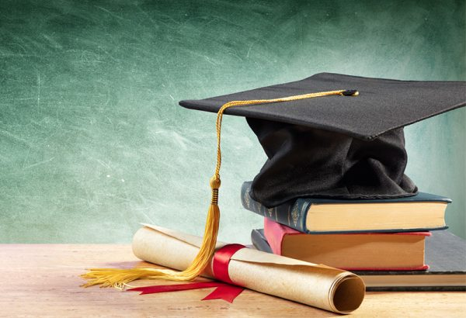
Figure 1: Higher Education (Ronglan and Ertesvåg, 2015)

Universities have always been a boon to both the individuals who have had the opportunity to study there and to society at large. Higher education has never been more valuable in the 21st century, when fresh discoveries keep coming alongside ongoing technological advancement. Specifically, the rising percentage of the population with advanced degrees looks to be an important contributor to the development of the global economy and the betterment of people's quality of life. It is undeniable that young people's lives are improved by enrolling in undergraduate or graduate programs after completing their high school education. This is true not only because of the increased salary and employment prospects, but also because of the opportunity to gain deeper expertise in a particular field, better prepare for a career, and enjoy other personal, financial, and health benefits (Pinzur, 2016). This perk is essential for those who are still trying to figure out what they want to do with their lives professionally. It's completely unreasonable to expect a high school senior to have a clear idea of what they want to do with their lives. In addition, it facilitates the attainment of a handsome pay.

Task 2 – Mind map / Tasg 2 – Map meddwl

Personal identity and becoming a good team player
First of all, I want to say that, currently I am doing my undergraduate degree in a reputed university. If I talk about my characteristic, then I must have to say, I am a confident, disciplined, dedicated, as well as a determined person. But, at the early stage, I was very introvert which used to make me feel shy (Eguara, 2022). It made me less confident. But when I used to meet with a lot of people, it has made me extrovert. Moreover, I had faced a lot of hurdles in my early academic stage. As I had shifted my school from one to the another, I was very nervous about how the new teachers and students will be. It's a fact that today's pupils have more homework than ever before. The educational framework of today is more intricate and comprehensive than ever before. They not only have to lug about an ever-increasing amount of reading and notes, but they also have to continue putting in significant study time even after school is out. For some students, the home economic situation is not stable enough to provide for their needs. A student's ability to concentrate on their studies may be hindered by the constant distraction of hunger. Now, by overcoming all of these, I am right now a team player. There are several ways to become a very good team player. I have applied all of those. I can communicate well with everyone which make me a better team player (Brennan, 2017). Moreover, by taking initiative and by becoming a problem-solving person, I can be a good team player. Along with these, there are different things which made me a better team player. Here are those-
- Accountability: Successful team members are responsible to both themselves and to everyone else. They accept responsibility for their acts or errors and recognize how their decisions effect the team.
- Flexibility: One of the keys to a winning team is its ability to adjust to new circumstances. Excellent team members are not afraid to take on additional responsibilities in order to help their colleagues and are flexible when it comes to deadlines.
- Positivity: High spirits are maintained by maintaining an optimistic outlook. People that bring a positive attitude to the team are highly valued.
- Commitment: The best team members are committed to the methods and aims of the organization as a whole. They are united in support of the group as a whole.
- Integrity: As a team, we must always remember the importance of being honest and trustworthy. A good teammate doesn't merely rubber-stamp everyone's ideas but instead speaks out when they see something that goes against the team's principles.
So, every person who wants to be a better team player have to do these (Bong-Woo, 2016). The more these things are in a person, the better team player they will be.
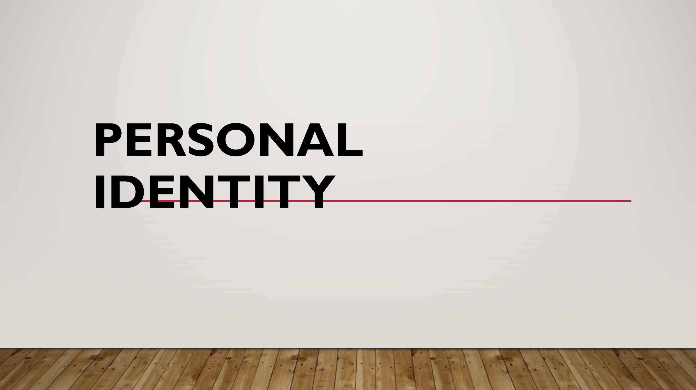
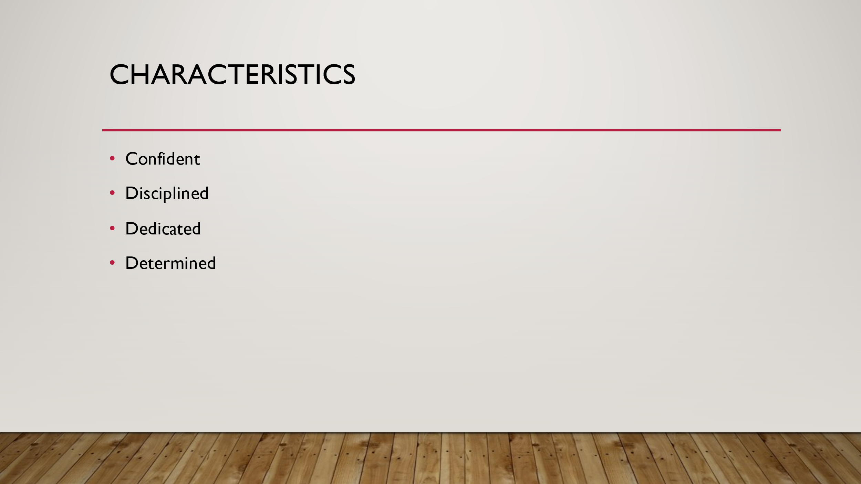

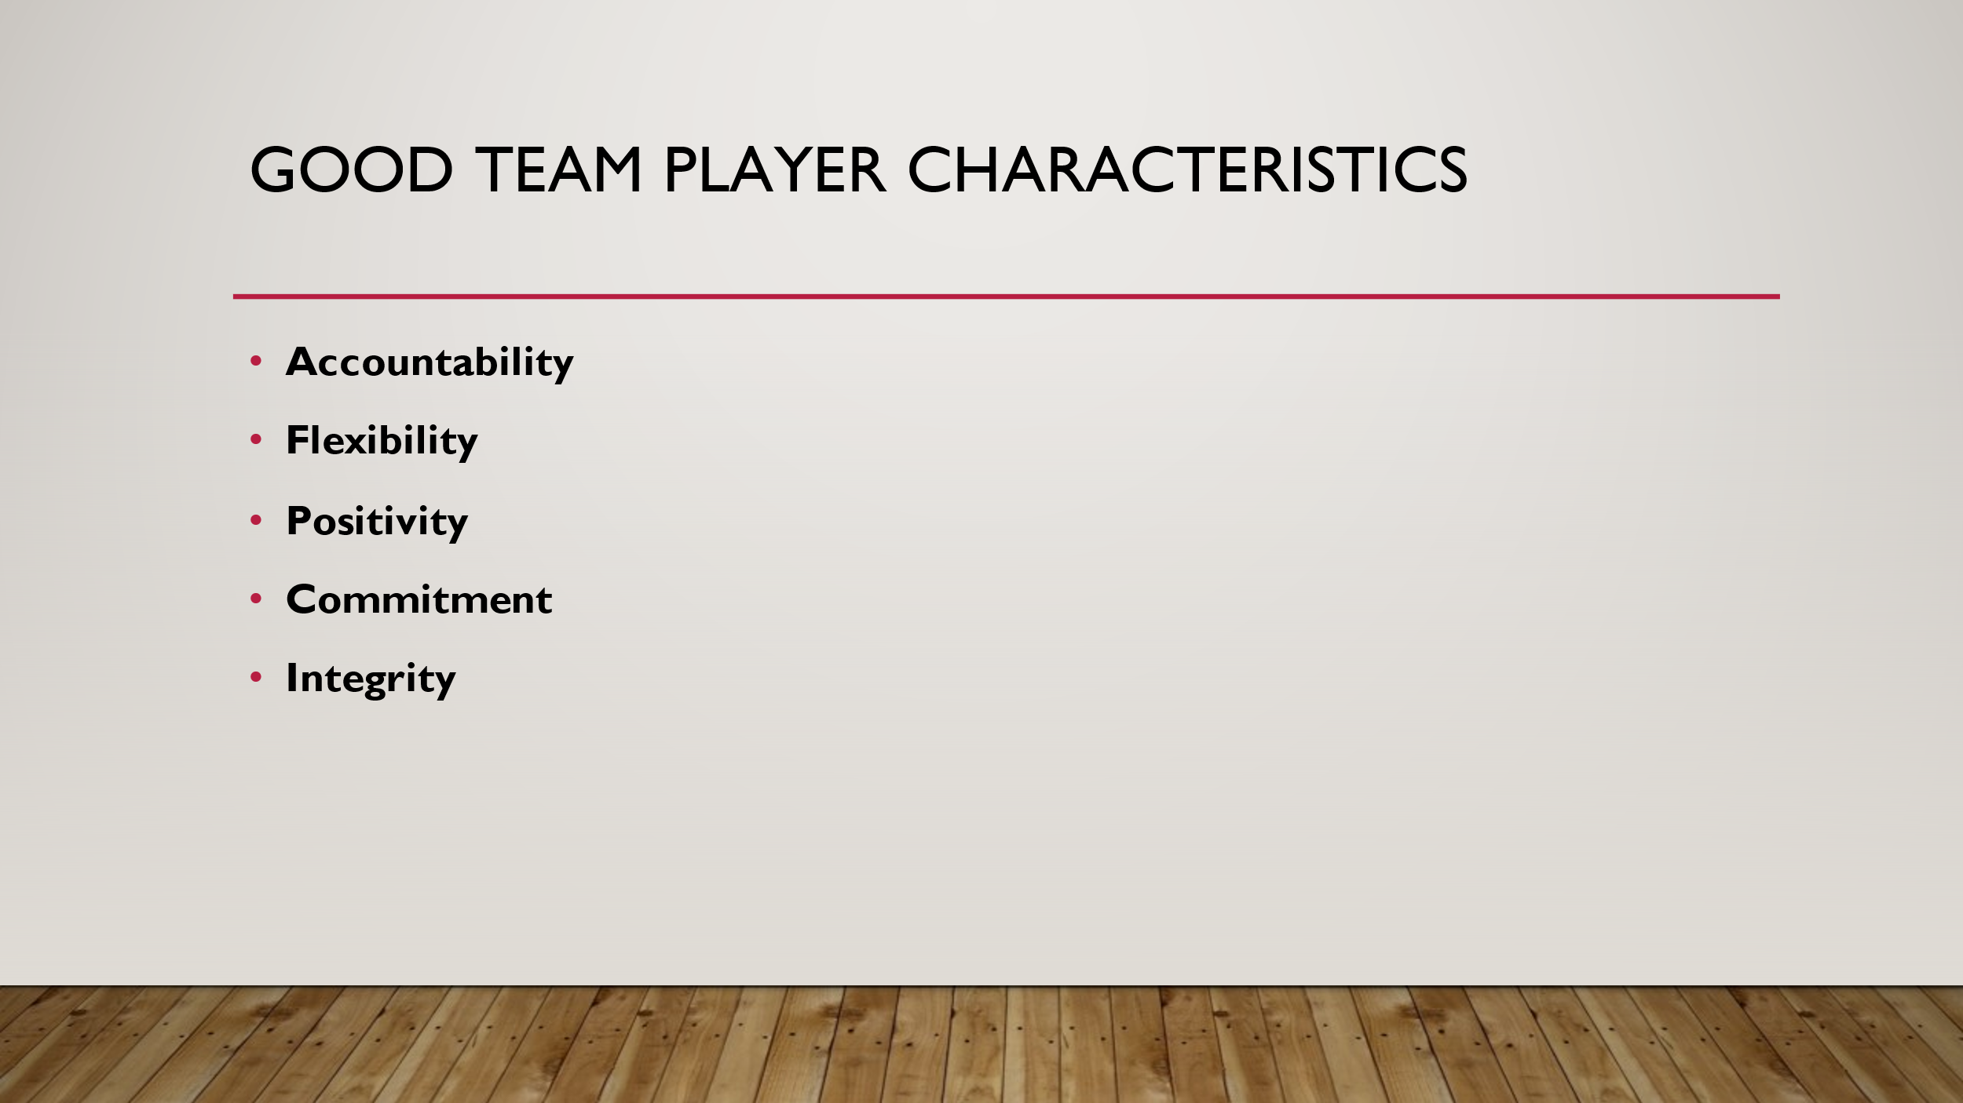

Task 3 – Presentation / Tasg 3 - Cyflwyniad
Please follow this link to view my presentation: / Dilynwch y cyswllt isod i wylio fy nghyflwyniad

https://youtu.be/3MB9QAgCkng

Task 4 – Reflection / Tasg 4 - Myfyrdod

Reflection on starting university, accustomed to online learning and resources
If I talk about starting university on the basis of Borton’s reflective tool-
What: When I have admitted to the university, I was very excited and nervous about my new friends, teachers, and so on. As I was extrovert at that moment, I have seen so many extrovert people like me. And I have tried to make new friends like them. Some people were trying to achieve a high CGPA (Barton, 2019). They were very careful about their academic result. But as I was fond of sports, I used to participate in different sports events.
So what: I just felt like I was doing good with everything. I have made some good friends. Moreover, I was so friendly and maintained a very good relationship with my seniors. I was feeling super at that moment.
Now what: I am facing some differences now. As I was in different kind of sports events, I did not make good result in my university life. My result is average which could be even better. If I had given some pressure and if I had focused on my study a little bit then I could make something better.
Now, if I talk about my grip about online resources-
What: When I was taking online learning resources to learn something, I have faced several issues like coping up with the problems. Sometimes, I was not being able to understand the topic.
So what: I felt that how could I overcome this situation (Atack, 2018). But as I have overcome, so now I know how to overcome these situations.
Now what: If I did not choose to learn through online, I may not be skilled at this moment.

Reference list / Rhestr Cyfeirnodi

Reference list
Atack, L. (2018). Becoming a web-based learner: registered nurses’ experiences. Journal of Advanced Nursing, 44(3), pp.289–297. doi:10.1046/j.1365-2648.2003.02804.x.
Barton, A. (2019). Preparing for Leadership Turnover in Christian Higher Education: Best Practices in Succession Planning. Christian Higher Education, 18(1-2), pp.37–53. doi:10.1080/15363759.2018.1554353.
Bong-Woo, L. (2016). Qualitative Research on Becoming a Diver as an Outdoor Leisure Sports Person. Korean Association For Learner-Centered Curriculum And Instruction, 16(12), pp.1207–1223. doi:10.22251/jlcci.2016.16.12.1207.
Brennan, J. (2017). Preparing students for employment. Studies in Higher Education, 10(2), pp.151–162. doi:10.1080/03075078512331378569.
Eguara, O. (2022). Becoming a networked learner: Unpacking identity development in networked learning communities. Studies in Technology Enhanced Learning. doi:10.21428/8c225f6e.7bfafd3c.
Freeman, M.L. (2016). HEALing Higher Education: An Innovative Approach to Preparing HSI Leaders. New Directions for Higher Education, 2015(172), pp.7–18. doi:10.1002/he.20148.
Oseguera, L. (2020). Preparing for College: Nine Elements of Effective Outreach (review). The Review of Higher Education, [online] 29(2), pp.250–251. doi:10.1353/rhe.2005.0087.
Pinzur, M.S. (2016). Becoming a Team Player. Foot & Ankle International, 37(9), pp.1035–1035. doi:10.1177/1071100716630955.
Ronglan, L.T. and Ertesvåg, V. (2015). Lars Tore Ronglan & Vidar Ertesvåg: Becoming a Team Player? Learning Outcomes from Implementing a Team-Based TGfU Unit in High School. Journal of Physical Education and Sports Management, 2(1). doi:10.15640/jpesm.v2n1a4.
Scarnati, J.T. (2019). On becoming a team player. Team Performance Management: An International Journal, 7(1/2), pp.5–10. doi:10.1108/13527590110389501.

