Cernunnos and his depiction on the Reims Altar: A Key source for understanding religious change in Northern Gaul during the Principate

It is undeniable that some of the greatest sources we have to examine religious change in Roman Gaul are the various artefacts and inscriptions that have been discovered, dating back to the Roman Principate. Newell would agree here and states that these sculptures highlight social customs, economic conditions and religious cults present in those areas (1934, pp.74). The artefact I have chosen to study, as a key source in understanding religious change in Northern Gaul, is the Reims Altar (fig.1). This relief, found in the Musée Saint-Remi, was created around the 1st Century A.D. according to their research. Some would disagree with this date and believe the sculpture to have been created during the Antonine period of the 2nd century A.D. based on the style of carving and coins found nearby alluding to that time period (Bober, pp. 1951). By examining this artefact thoroughly, comparing it to others such as the Pillar of the Boatman and the Gundestrup Cauldron, I will explore whether or not it demonstrates religious change in Northern Gaul.

To begin, it is crucial we investigate the sculpture thoroughly and take into account all the visual information we have. A full analysis of the artefact is key to understanding religious change in the area by examining the iconography and symbolism present on the sculpture. As we can see, three figures are apparent on the relief. The central figure is sat cross legged, appears to have horns and is seen to be holding a sack with money spilling out onto a stag and a bull. This central figure is Cernunnos, the “horned one”, a Celtic deity that appeared primarily on the Pillar of the Boatmen (fig2.). The appearance of Cernunnos on the Pillar of the Boatmen was the first time the figure had been given a name, although he appeared well before the “Romano- Celtic phase in Western Europe” (Green, 1992, pp.87). On the Reims altar, Cernunnos is seen to be flanked by two other figures who, according to Green (2004, pp.177) are two classical deities identified as Apollo (left) and Mercury (right). This identification is due to specific attributes shown on the relief. For instance, Mercury is identified by the caduceus and purse he holds which are constant attributes of his (Newell, 1934, pp.83). Bober believes that the appearance of Mercury is not surprising due to links between the classical god and the Gallic Cernunnos in terms of their roles as chthonic deities and gods of commerce and wealth (1951, pp.43). Furthermore, Caesar mentions that Mercury was revered the most by the Gauls and that they worshipped him above all others (The Conquest of Gaul, 6:17). Therefore, it is not surprising, according to these sources, that Mercury is featured on such a sculpture. It is said however that the presence of Apollo is harder to explain. Bober advises that to suggest any concrete idea as to the relation between Apollo and the horned god is impossible. However, she also advises the affiliation is not a unique phenomenon and has been seen before on the Vendeuvres relief (1951, pp.43)

Having looked at the visual evidence, it is evident that both Roman and Celtic religions are represented on the altar side by side. This relief has been seen as evidence of partnership between Gaul and Rome, symbolising the “harmonious co-existence of the Celtic and Classical Pantheons” (Newell, 1934, pp.82), and the binding of “romanitas” and “gallitas” together (Green, 2012, pp. 236). Bromwich would also agree here, stating that the relief is indeed an example of Gallo-Roman syncretism (2003, pp.322). So how does this show religious change? One possible answer is that it reinforces to us that the people of Reims were open to Roman influence when it came to religion and that they began to include many of the Classical Gods in their worship alongside local deities. The presence of Mercury and Apollo alongside Cernunnos, a god worshipped in Celtic religion long before the Roman occupation would attest to this. MacCulloch would agree here and advises that the Gauls adopted Roman civilisation with apparent ease and agreed to the integration of their deities with those of the Roman empire (2012, pp.22). Therefore, I believe this to be an important source, showing a rare form of syncretism rather than total immersion into Roman religion. Again, the Pillar of the boatmen is another example of this, where both Celtic deities and Roman gods are depicted side by side.

Following on from this, in regard to the syncretism, we must discuss the fact that a major Celtic deity such as Cernunnos seems to have escaped the fate of many of his counterparts,
in that his overall character seems to have escaped full Romanisation. The Reims altar shows that Cernunnos retained many of his Celtic attributes such as the horns, torques and the cross-legged sitting position (Newell, 1934). This possibly shows that Rome accepted the existence of this Gallic god as a god in his own right. This could highlight a key religious change for the Romans as Cernunnos seems to have escaped the usual amalgamation of Roman God with provincial deity that we have seen, i.e. Apollo Grannus, Sulis Minerva. Therefore, this perhaps shows that the Celtic deity has somehow escaped the process of interpretatio romana. It would also be useful to mention the Gundestrup Cauldron (fig.3), an extremely interesting artefact found near its namesake in Denmark. This artefact not only shows the diaspora of Celtic religious iconography, but it also highlights some of these key symbols that link Cernunnos to worship before Roman occupation (Newell, 1934, pp.84). We can see here many similar attributes that appear on both artefacts even though both are dated nearly two centuries apart. This shows that certain attributes of the god survived Roman influence, even though “Romanisation” of religion became more intense, especially from the Augustan period, and many new iconographic ideas had started to be introduced (King, 1990, pp.141). Nevertheless, some would argue that the altar does indeed show a new direction of interpretatio romana in the fact that the Gallic god and his association with money, i.e. the coins pouring from his open sack, show Cernunnos as the Roman God Dis Pater, showing the inherent Romanisation of a Gallic deity (Bober, 1954, pp.44)

The acceptance of the Roman pantheon and its deities is crucial when looking to understand religious change in Northern Gaul. To expand on this, it would be useful to look at the origins of the city of Reims. In 57 B.C. Julius Caesar led a conquest of Northern Gaul, in order to bring the various tribes under Roman occupancy. Some Gallic tribes decided to form an alliance with Rome due to its influence and the level of protection it would bring within Gaul itself (Gilliver, 2004, pp. 34). According to Caesar, the Remi, one such tribe from Gallia Belgica, “placed themselves and all they possessed under the protection and at the disposal of the Roman people.” (The conquest of Gaul, 2:3). Gilliver advises that they believed conquest was inevitable and preferred to fight alongside Rome rather than against them. (2004, pp. 34). Furthermore, during the reign of Augustus, the Remi were encouraged to construct a new town under the name of Durocortorum Remorum (modern day Reims), and that this became one of the largest cities in Gaul (Bromwich, 2003 and King, 1990). This could explain the presence of both Celtic and Roman deities on religious sculpture in the area. One could argue that Roman influences were to be expected due to the cities Roman origins, and that it is possible that religious change was inevitable as a result.

We must also briefly examine the possibility that the relief shows a change in direction from the religious practices of the Druids present throughout Gaul. According to Newell, the anthropomorphic representation of the gods was banned within the Druid Religion and knowledge of the gods was exclusive to the Druidic priests. (1934, pp. 75). Evidence of this can be seen by the lack of pre-Roman aesthetic sources found (Newell, 1934, pp.75). Given the representation of Cernunnos in Reims, this image demonstrates movement away from an aniconic approach to religion. Macleod informs us that in 21 B.C. the emperor Tiberius suppressed the learned classes of ancient Gaul including the Druidic priesthood, forbidding any further training (2012, pp.69). Newell explains this, stating that the Romans considered the Druid religion as an “anti-Roman organisation”. Therefore, the abolishment of the priesthood paved the way for new iconographic styles such as the anthropomorphic realisation of deities, opposing druidic bans on religious imagery (Newell, 1934, pp.74). This can indeed be seen on the relief at Reims in regard to Cernunnos.

One final point that should be considered is in regard to the way the three deities are depicted. Green states that the relief possibly conveys a message that separates old from new (2004, pp.236). Green states that Apollo and Mercury are depicted as young whereas Cernunnos is depicted as old. She believes this communicates the idea of looking forward to a “new order”, by addressing the “ancestral pasts” and promoting the image of Gaul who is “seamlessly incorporated into the Roman empire.” (2004, pp.236). This is an extremely important point to consider in regard to illuminating religious change, as it could explain the theme of the relief in terms of Roman influence against traditional Gallic religion. It could also explain why Mercury and Apollo are depicted in such a way in contrast to the obvious Gallic traits of Cernunnos in the centre of the relief.

As we can see, by the various arguments put forward concerning the iconography of the Reims Altar, this artefact was indeed an important source regarding religious change in Northern Gaul during the Principate. In conclusion, not only does the relief show an acceptance of Roman religious influences, but it also possibly shows the capacity of the Romans to include Celtic deities within their pantheon, without having to resort to interpretatio romana. It also shows a key religious change from the indigenous worship of the Druid religion, to a less aniconic worship of the local deities.

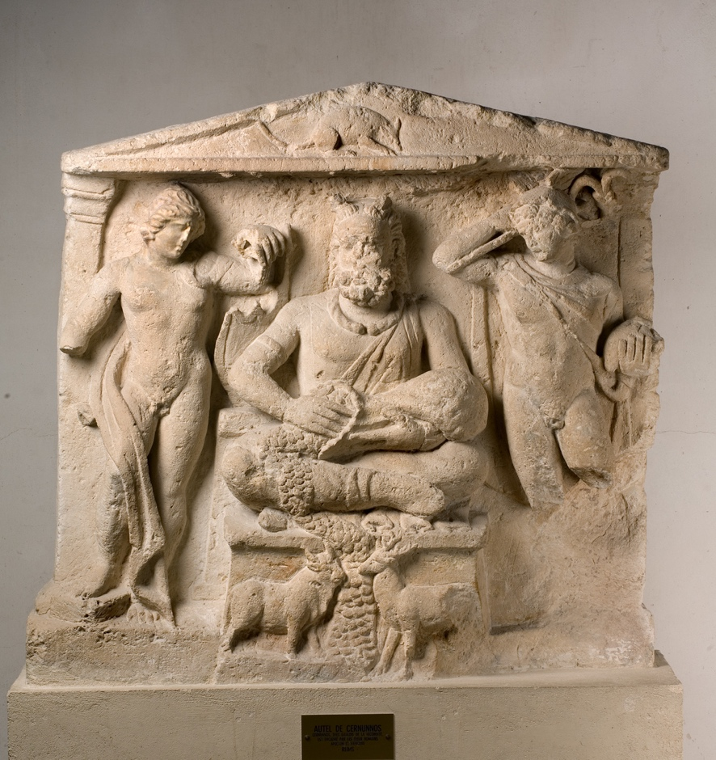

Figure 1. Altar of Cernunnos, Musée Saint-Remi, stone relief depicting Apollo on the left, Mercury on the right and Cernunnos sat cross-legged in the middle.

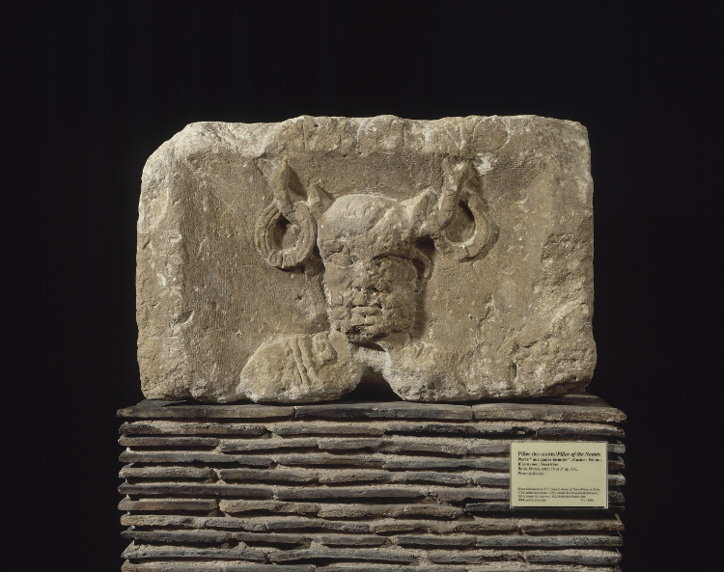

Figure 2. Relief of Cernunnos from the Pillar of the boatmen (Piliar des nautes), Musée de Cluny. You can faintly see the Latin inscription at the top which is CERNVNNOS

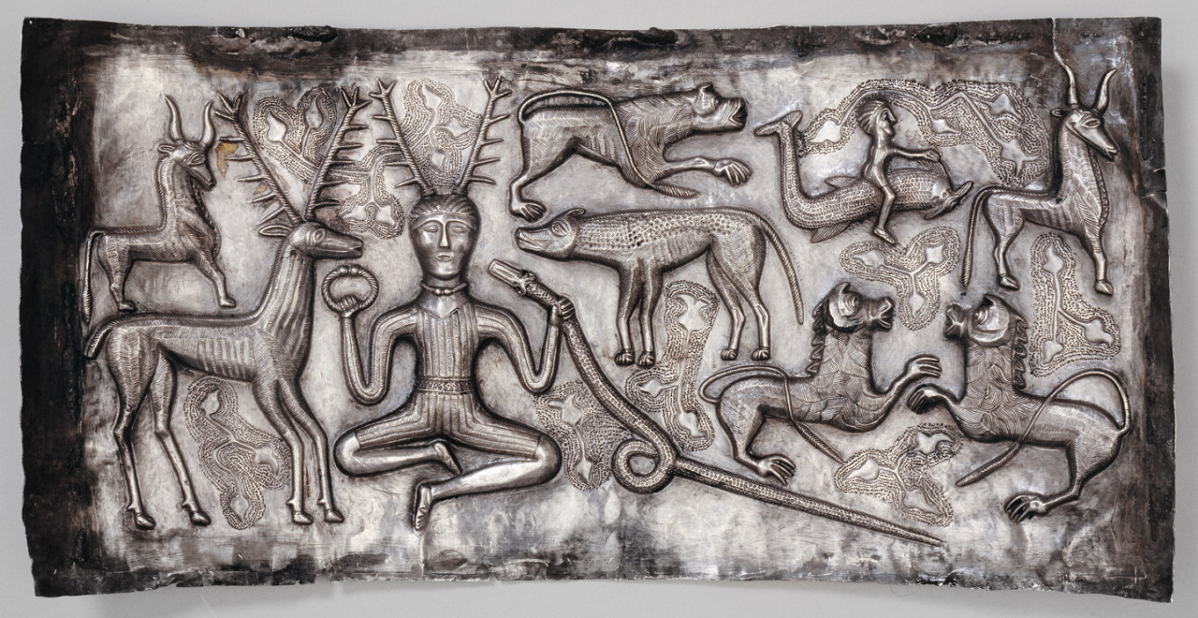

Fig 3. Horned deity on a piece of the Gundestrup Cauldron, possibly identified as the Celtic deity Cernunnos due to the torque he carries and the presence of the ram-headed serpent. National Museum of Denmark, dated between 150 B.C. and 1 B.C.

Bibliography

Ancient sources

Caesar, The Conquest of Gaul, trans. Handford, S. and Gardner, J. (1982), London: Penguin

Contemporary sources

Bober, P.F (1951), Cernunnos: Origin and Transformation of a Celtic Deity, American Journal of Archaeology, 55(1):13-51, Archaeological Institute of America, Found on JSTOR http://www.jstor.org.ezproxy.uwtsd.ac.uk/stable/pdf/501179.pdf , accessed March 20th 2018

Bromwich, J. (2003), The Roman Remains of Northern and Eastern France: A Guidebook, London: Routledge

Gilliver, K.M. (2004), Caesar’s Gallic Wars 58-50 BC, Oxford: Osprey Publishing

Green, M.A. (2004), An Archaeology of Images: Iconology and Cosmology in Iron Age and Roman Europe, London: Routledge

Green, M.A. (1992) Symbols and Image in Celtic Religious Art, London: Routledge

King, A. (1990), Roman Gaul and Germany, University of California Press

MacCulloch, J.A. (2012), The Religion of the Ancient Celts, Library of Alexandria Publishers, Kindle Edition.

Macleod, S. (2012), Celtic Myth and Religion: A Study of Traditional Belief, with Newly Translated Prayers, Poems and Songs, Jefferson: McFarland & Company

Newell, A.N. (1934), Gallo-Roman Religious Sculpture, Greece and Rome, 3(8):74-84, Cambridge University Press on behalf of The Classical Association, Found on JSTOR, https://www.jstor.org/stable/640758?seq=1#page_scan_tab_contents, Accessed on March 20th 2018

Images

Fig. 1: Autel de Cernunnos, digital photograph found on the Musée Saint-Remi website, Musée Saint-Remi, Reims, Accessed 1st April 2018, http://musees-reims.fr/fr/musees/musee-saint-remi/

Fig. 2: Pilier des nautes 12 - N° Inventaire : Cl. 1461 et Cl. 18602 à 1860, digital photograph found on the Musée de Cluny website, Musée de Cluny, Paris , Accessed 1st April 2018, http://www.musee-moyenage.fr/collection/oeuvre/pilier-des-nautes.html

Fig. 3: The Gundestrup Cauldron (2015), digital photograph found on The British Museum Tumblr, The British Museum, Accessed 1st April 2018, https://britishmuseum.tumblr.com/post/132087416007/the-gundestrup-cauldron

