Oliver Bunyan
C&P Engineering Services Ltd

Design of a motorvehicle datalogger
UWTSD - ACDA6002- Electronic System Design
Table of Contents
Introduction 2
Comparison of Existing Products and Parts 3
Data Logger Comparison Table 3
Speed Sensors Comparison Table 5
RPM Monitors Comparison Table 6
Engine Temperature Sensor Comparison Table 7
Gyroscopes Comparison Table 8
Suspension Measuring Components Comparison Table 9
SPST Switches Comparison Table 10
Microcontroller Selection 11
Chosen Components 13
Enclosure 15
Circuit Design for Data Logger 16
Designed Data logger microchip pinout 24
PCB Design 26
Software Design and Structure/Flowchart 33
Prototype Costs 40
Suggested Improvements 42
Appendices 43
References 53

Introduction

Within this report is the research of existing dataloggers and components and the design of a new datalogger in line with the scope of work. The data logger is to be designed to accumulate data on a two-hour test drive of a vehicle that is targeted for the family saloon market. The datalogger design must also be able to be portable and reusable on other vehicles on the market. The datalogger will use sensors to monitor different behaviours of the vehicle such as the speed, suspension, and RPM (revs per minute) for example. Data loggers are widely used in vehicles, especially in the car racing industry. They’re used to track the car’s performance and to tweak them in the correct areas where they may be lacking. If the data isn’t being measured, then the vehicle cannot be controlled. Almost every racing vehicle contains a data logger, and they can highlight the effects of different road conditions and causes of failures to the vehicle. [1]

Comparison of Existing Products and Parts

Research was carried out on existing data loggers that are currently on the market. While researching these data loggers, an insight into what is needed while designing one can be found, such as the common communication protocols used, how memory is stored and collected, the compactness of the systems and the wiring techniques. Below in Table 1 is the comparison of three existing data loggers.

Data Logger Comparison Table

 | 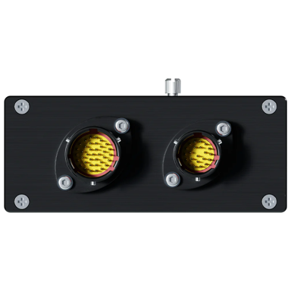  [2] | 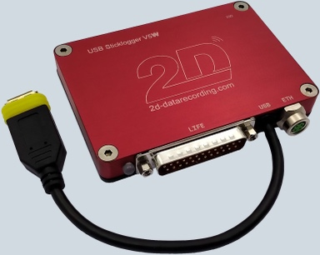  [3] | [4]  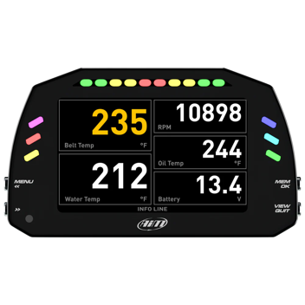
Device - | AIM Evo 5 Car racing data logger | 2D-Recording Stick logger V5 | AiM MXS 1.3 TFT Digital Display and Data logger
Inputs and Outputs - | 8 Analog Inputs  2 Digital Outputs  4 Speed Inputs + Coil RPM (5 Digital Inputs) | 4 Analog input channels (1 input can be switched to hybrid input)  Digital output | 2 Digital Outputs  8 Analog inputs  6 Digital inputs
Communication protocols - | CAN  RS232  K-Line  CAN II | 32 Online Can Channels with a 200Hz sampling rate | CAN Output  Wi-Fi Connectivity  CAN II  RS232  K-Line
Price - | £1600 | Unknown | £2050
Memory Module - | SD Card holder that can connected to the CAN-bus with the Logger  4GB Internal Memory | Data stored directly on to 1000GB USB | 4GB Internal Memory
Special Features - | - Compatible with easy software such as Race Studio 3 where data can be gathered and analysed easier.  - Option for channel expansion.  - Choice of displays to show the Data in real time.  - Ingress Protection of IP65 | - 3 Can lines up to 5Mbit/s each  - Optional extras such as waterproof, USB, WIFI and also ethernet feature  - Can have an extra increased sampling rate of 2000Hz to all channels | - Module can be expanded to add the likes of Smarty Cam HD cameras, TC HUB (4 k thermocouples)  - Channel expansion to add 4 analog inputs, or 2 analog and 2 digital.  - GPS module for real-time data  - Features 5” Compact Display  - Ingress protection of IP65
Table 1 – Comparison of Existing Data loggers

Upon researching existing data loggers, a wide range of designs can be seen. Different designs use different methods of connecting sensors to the logger, such as using wiring harnesses or individual cables. Each data logger has a high ingress protection to protect them from the harsh environments they will endure. Internal components must be able to withstand levels of shock vibration that will occur, and the types of plugs use clips and locking mechanisms. CAN bus is widely used in existing data loggers but the data logger that is to be designed will be required to not be patched into the existing vehicles BUS and ECU.

Research was then carried out to compare different components that would be used while designing a Datalogger. In Table 2 a comparison of speed sensors was carried out.

Speed Sensors Comparison Table

Device - | 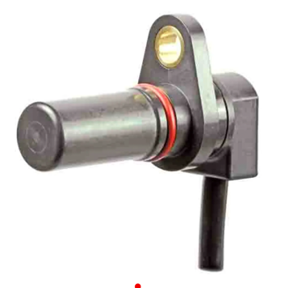  Honeywell Flange Mount Hall Effect Sensor Barrel Body - SNQ-QPLA-000 [5] | 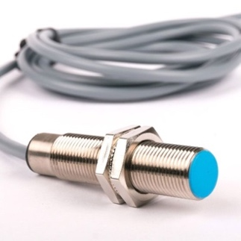  Monit Inductive Wheel Probe – PR001 [6] | 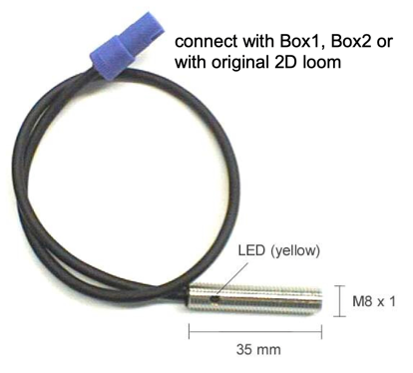  2D-Recording inductive Speed Sensor SD-V01M8-000 [7]
Terminal Details - | 4 wire cable end | Not Specified | Binder 719 4PM
Vehicle Compatibility - | Universal | Universal to any Vehicle  (Signal taken from bolts etc) | Universal to any Vehicle (Signal taken from bolts etc)
Price - | £56 | £32.90 | Not specified
Cable Length - | Not specified | 2m Cable with option for additional cable length | 30cm (Can be extended on request)
Additional info - | - IP69K  - -40 to +150 Temp Range  - Voltage range of 4.5 to 26V  - 3Hz to 20kHz switching frequency | - Max Detection Frequency of 500Hz  - Sensing distance of 2-3mm  - Supply Voltage of 12V | - Optimum distance 1 to 2mm  - Switching Frequency of 800Hz  - Supply Voltage of 12V
Table 2 – Comparison of Speed Sensors

Three-speed sensors were chosen that could be used within the vehicle to measure the speed and log the data onto the microcontroller within the data logger. Each sensor was universal to different vehicles which is in line with the scope of the project. The switching frequencies were high enough to monitor the speed at the sample rate required. Two of the sensors are 4-wire with one already using a Binder 719 4PM plug end. The chosen sensor was the Honeywell Flange SNQ-QPLA-000 sensor. The price of the sensor is £56 but the sensor has an ingress protection of IP69K which is what’s needed for the sensor to be mounted in a road vehicle as per the standards “ISO 20653:2023 Road Vehicles – Degree of protection (IP code)”. [8] [9]

RPM (revs per minute) Monitors were next to be researched and compared. 3 different styles and modules of RPMs were used in table 3 to be compared with the chosen monitor used for the design.

RPM Monitors Comparison Table

Device - | 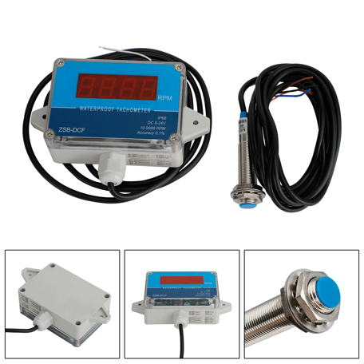  DC 8-24V Hall Tachometer Digital Speed Meter [10] | 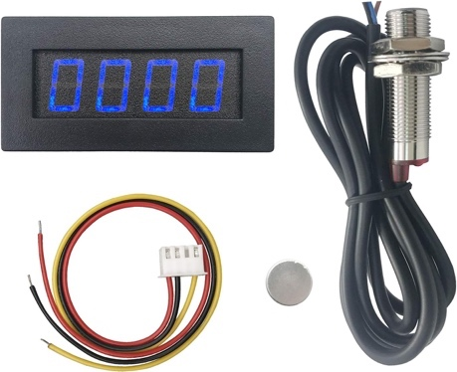  Digiten 4 Digital LED Tachometer RPM Speed Meter+Hall Proximity Switch Sensor NPN Blue [11] | Honeywell Flange Mount Hall Effect Sensor Barrel Body – SNQ-QPLA-000 [5]
Measuring Accuracy - | ±0.1% | Unspecified | Unspecified
Range - | 10-9999RPM | 5-9999RPM | No range as no reading on a tachometer
Price - | £22.77 | £16.99 | £56
Refresh Rate - | 3Hz | 0.2-0.5s at 120-1200RPM  0.25-0.06s at 2400-9999RPM | High switching frequency capability of 3Hz to 20kHz
Additional info - | - 4 Digital display  - Compact  - IP68 Waterproof grade  - 1m Cable length | - 10mm Detection Range  - Proximity output current of 200mA  - Pulse signal, NPN 3 wires N/O | - 4 wire cable end  - IP69K  - -40 to +150 Temp Range
Voltage Range - | - 8-24V | - 8-15V | - 4.5 to 26V
Table 3 – Comparison of RPM Monitors

The Chosen RPM monitor for the design was the same sensor used to monitor the speed. The sensor has all the features required to read and transmit the data as needed. The two other RPM sensors chosen that were potentially to be used are supplied with tachometers that read the RPM value onto a digital screen, this isn’t required in the design. The refresh rate of the Honeywell SNQ-QPLA-000 is a lot larger than the others, the first chosen RPM monitor refresh rate would not be able to keep up with the chosen RPM Sample rate. The voltage range of the two unchosen monitors is also a lot larger than the voltage that’ll be available in the designed data logger.

Engine sensors were researched and the most compatible three were chosen for comparison in table 4 before a final decision was made.

Engine Temperature Sensor Comparison Table

Device - | 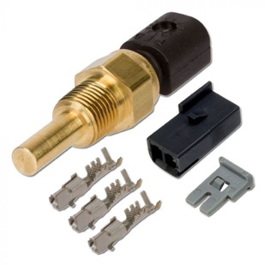  AEM Water/Coolant/Oil Temperature Sensor Kit [12] | 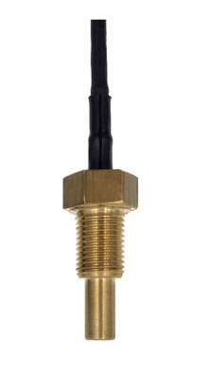  NTC Temperature Sensor M6/8/10 [13] | 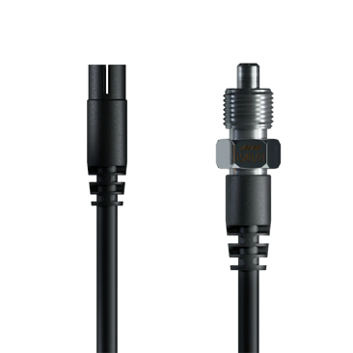  AIM Motorsport Oil / Water (coolant) temperature sensor [14] [15]
Measuring Accuracy - | <2°C | ±0.5% of full range | Not specified
Operating Temperature Range - | -40C to 200C | 0 to 150C | 0 to 150C
Price - | £48 | Unavailable | £70
Supply Voltage - | 5Vdc | 5Vdc | Not specified
Connection type - | Termination is a connector with mating connecter, pins & pin lock | Binder 719 5PM | Male 4 pin Black 719 Binder plug
Additional Information - | - Brass Sensor body | - IP67  - Differet Models available. M10 Brass, M8 Plastic, M6 Stainless Steel | - Sensor cable length 25cm (optional extra length cable)
Table 4 – Comparison of Temperature Sensors

Three temperature sensors were chosen which all had similar specifications. The chosen sensor was the AEM temperature sensor kit due to its large range of operating temperature. The measuring accuracy isn’t as great as the other sensor, but the accuracy of temperature can be marginally swayed. The sensor’s supply voltage is available in the design.
A gyroscope is required within the datalogger to monitor the yaw, pitch, and roll of the vehicle. A comparison table was carried out as shown in table 5.

Gyroscopes Comparison Table

Device - | 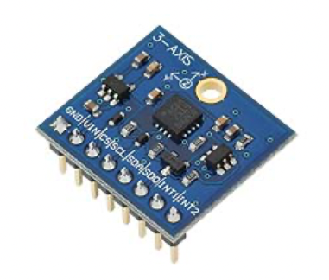  Gyroscope module 3-axis L3G4200D [16] | 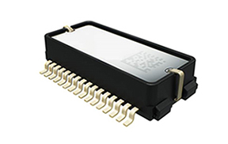  SCHA634-0D3 XYZ-axis gyroscope and XYZ-axis accelerometer for automotive [17] | 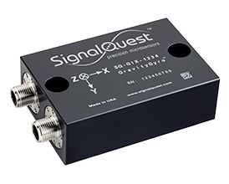  Signal Quest SQ-GIX  -2094 [18]
Communication Protocol - | SPI and I2C | Digital/SPI | RS232  RS485  CAN-BUS
Resolution - | 0.2° | Not specified | - (pitch, roll)
Range - | Either ±250, ±500 or ±2000 degrees per second | ±300°/s  ± 6g Acceleration Range | Pitch = -64.0° to +64.51°  Roll = -64.0° to +64.51°  Yaw = -180° to +180°
Supply Voltage - | 2.7-6.5V | 3.0V to 3.6V | 5-36V
Shock Survivability - | Not Specified (High shock survivability) | Not specified | 1000g
Additional info- | - -40 to +85C temp range  - High shock survivability  - 800Hz response | - Targeted for advanced driving assistant systems  - Amplitude response of 13,20, 46 or 300Hz | - Temp range -40C to 85C  - IP68/IP69k  - Output data rate 0.015 to  100Hz  -M12 male and female  connectors 5 pin
Price | £24.85 | Not specified | Not Specified
Table 5 – Comparison of Gyroscopes

Each gyroscope had its pros and cons. All of the gyroscopes had a large enough number of degrees per second required for the monitoring, the temp ranges were within the needed amount and all of the response times that were required to monitor each angle which was 50Hz were met. The chosen gyro was the L3G4200D due to its ease of connectivity, and its use of I2C. The initial choice was the SCHA634-0D3 chip, but the chosen microcontroller did not have enough SPI Chip selects available therefore I2C was required to be used. The gyroscope also had a high shock survivability which is important while installing within a vehicle.

A potentiometer is required to be used for monitoring each of the four suspensions of the vehicle. In Table 6 3 different models of potentiometers were compared.

Suspension Measuring Components Comparison Table

Device - | 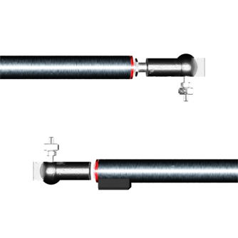  AIM Car Suspension Potentiometer with Pop End Fitting [19] | 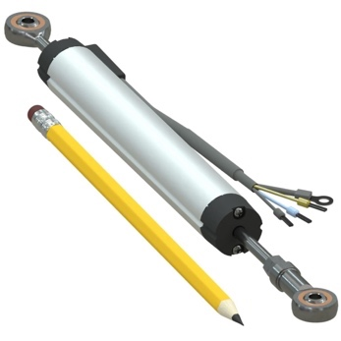  LPPS-22 Series Linear Potentiometer Position Sensor with rod ends [20] [21] |   OBP Motorsport Dual Signal Linear Potentiometer [22]
Connection plug - | 4PIN Binder 719 male Connector Plug | 3 core cable | 6 Core Cable
Sizes - | 50mm, 75mm, 100mm, 150mm | 25mm to 300mm Stroke length | Not specified
Communication protocol - | Can be connected to any analog channel | 3 wire Analog Signal | 6 wire Analog Signal (Dual track)
Supply Voltage - | Max 40Vdc | Max 36Vdc | Max 40Vdc
Operation Speed - | 10m/s max | 5m/s | 10m/s max
Additional info- | IP65  30cm cable length (option to extend)  Temp Range: -40°C to +125°C  Essentially infinite Resolution | Automotive Compatible  IP64  Anodized Corrosion resistant housing  Temp range = -40°C to +95°C  20g vibration rating  50g shock rating  Infinite Resolution | Automotive compatible  Essentially infinite Resolution
Price | £225 (150mm Version) | £180 (175mm Version) | £300.90
Table 6 – Comparison of Suspension Monitoring Potentiometers

Each of the suspension potentiometers in table 6 had key features. All the potentiometers read out a analogue signal with different speeds. The prices ranged from £225, £270 and £300. They each have a max which is within the limits. The chosen potentiometer was the LPPS-22 series linear potentiometer. This is due to the large vibration and shocking rating, the large 175mm range is large enough for the measured range, the high IP rating of IP64 and the lower cost of £180 were all factors.

SPST Switches Comparison Table

Device - | 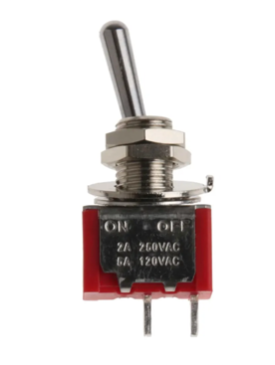  RS Pro toggle switch, Panel mount, On-Off, SPDT, Solder Terminal 28Vdc [23] | 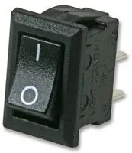  SPST Mini Rocker Switch – PPW01080 [24] | 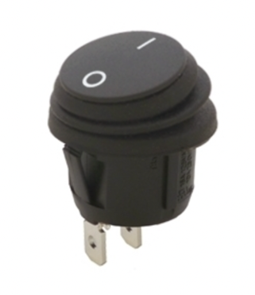  Sinolec Waterproof round rocker switch, ON OFF Single pole [25]
Connection type - | Solder Terminal | Solder Terminals | TAB Terminals
Rating - | 5A @ 28V DC | 3A 250VAC | 10A 250V  IP65 Rated switch
Switch Type - | SPST Latching miniature toggle switch | SPST Latching | Latching
Operating Temperature - | -30C to 85C | Unspecified | Unspecified
Table 7 – Comparison of Switches

A switch was required for isolation. The chosen switch was the Sinolec waterproof switch due to its IP protection which will be required for the design.

Microcontroller Selection

 | PIC18F25J50 [26] | PIC18F24J50 [27] | PIC18F26J53 [28]
Family | 8-bit MCU | 8-bit MCU | 8-bit MCU
CPU Type | 8-bit PIC MCU | 8-bit PIC MCU | 8-bit PIC MCU
Max CPU Speed (MHz) | 48 MHz | 48 MHz | 48 MHz
Operation Voltage | (2-3.6V) | (2-3.6V) | (2-3.6V)
Temp Range | (-40 to 85) | (-40 to 85) | (-40 to 85)
Pin Count | 28 | 28 | 28
Program Memory Size (KB) | 32 Flash | 16 Flash | 64 Flash
SRAM | 3.7109375 KB | 3.7109375 KB | 3.7109375 KB
Low Power | Yes | Yes | Yes
ADC Input | 10 | 10 | 13
Max ADC Resolution (bits) | 10 | 10 | 12
UART | 2 | 2 | 2
SPI | 2 | 2 | 2
I2C | 2 | 2 | 2
No of USB Modules | 1 | 1 | 1
USB Interface | FS Device | FS Device | FS Device
Max 8-bit Digital Timers | 2 | 2 | 4
Max 16-bit Digital Timers | 3 | 3 | 4
Hardware RTCC/RTC | Yes | Yes | Yes
Table 8 – Comparison table of Different Microcontrollers

Above in Table 8 are the comparisons carried out on different microcontrollers suited for the data logger design. Each microchip has 28 pins which is enough and room for expansion if need be. They all have SPI, UART, I2C pins, and a USB module to read sensors and transmit data. They all have a size RAM of 3.7KB which will be sufficient for the data logger. The CPU speed is more than capable of reading the data at the speed required. The main difference between the three chosen is the ROMs (read-only memory). Where one has 32 Flash KB, one has 16 Flash KB and one with 64 Flash KB. The PIC chosen to progress with is the PIC18F25J50. The 32 Flash KB is a balanced amount between the three microcontrollers. The 10-bit ADC resolution is all that’s needed with the number of bits being used by analog sensors therefore there is no need to size up to a 12-bit ADC resolution if using the PIC18F26J53.

For the microchip to store the data while the test drive is being carried out, an external ROM is to be connected which will be an SD card. The memory size of the selected data must be able to withhold the amount of data that is to be stored there within the 2-hour test drive. A calculation was carried out to decide on the memory required. As we know, the amount bytes between all the measured sensors amounts to 12, and the bytes/sec for all sensors amounts to 3902 bytes/sec. We know the test drive is 2 hours long therefore the calculation was carried out below in equation 1.

$$12 Bytes$$
$$x3902 bytes/Sec$$
$$x60 seconds/min$$
$$x60 min/hour$$
$$x 2 hour test drive$$
$$=337,132,800 bytes$$
$$=372MB$$
Equation 1 – Calculation to find out how much ROM is required to store the date from the test drive

Chosen Components

All the components for the Datalogger design were chosen prior to designing the PCB. Each sensor was compared with other sensors and chosen based on compatibility with the needs of the data logger.

The chosen components to monitor the measurements were as selected in the previous section “Comparison of existing products and parts”:

- Suspension - LPPS-22 Series Linear Potentiometer
- RPM & Speed - Honeywell Hall Effect Sensor – SNQ-QPLA-000
- Roll, Pitch & Yaw - Gyroscope module 3-axis L3G4200D
- Engine Temperature - AEM Temperature Sensor Kit
- Microcontroller - PIC18F25J50
- Switch - Sinolec waterproof round rocker switch

Other parts had also been chosen to complete the design for the Datalogger such as:

- TP4056 Micro USB Lithium Battery Charger Board Module. Used to charge the 3.7V battery after the test run using a micro-USB. [29]
- RS PRO, 3.7V, 18650, Lithium-Ion Rechargeable Battery, 2.6Ah. The 2.6Ah battery life is more than enough to power the battery for the 2-hour test run. [30]
- Battery Holder with Wires. Used to hold the battery in place. [31]
- TPS63020 – Buck-Boost Used to voltage regulate the 3.7V to 3.3V for the microcontroller. [32]
- Micro SD Memory Card Reader Module Used to connect an SD Card which will store the data collected on the test run. [33]
- RS PRO Red Panel Mount Indicator IP67 – Ingress-protected indication light to show that the datalogger is turned on. [34]
- Weidmuller Receptacle, USB, Type A, Panel, IP65 – Ingress-protected USB port to collect the data from the SD card after the test run has been completed. [35]
- 1TB San Disk Micro SD Card – Covers the required memory that will be logged. [36]

Panel Plug, Cables and Cable connectors are as below –
- 6x Circular Threaded Panel Mount Connector Socket, 4-Pole, IP68. Datalogger mounted 4 pin female plug for each suspension sensor and both the RPM sensor and Speed Sensor. [37]
- 6x Circular Threaded Connector Inline Socket, 4-Pole, 5-8mm, IP68. Male Cable end to connect to datalogger. [38]
- 16-2-4C 4 Core Screened Cable, 0.2mm, Black, 25m – Cable to be used between the data logger and the 4 suspension monitors, speed monitor and RPM monitor. Screened cable to minimise electrical interference [39]
- 1x Circular Threaded Panel Mount Connector Socket, 2-Pole, IP68 – Datalogger mounted female plug for the temperature sensor. [40]
- 1x Circular Threaded Connector Plug, 2-pole, 5-8mm, IP68 – Male plug for the cable end for the temperature sensor. [41]
- 7-2-2C 2 Core Screened Cable, 0.2mm, Black, 25m – 2 core cable used for connecting the temperature sensor to the data logger.

High ingress-protected equipment has been used to protect the circuitry. The connectors for the sensors are threaded to ensure they cannot be disconnected from the vibrations of the data logger while on the test drive.

The Enclosure housing the PCB and datalogger internals will be mounted under the hood of the vehicle via m6 fixings. The enclosure will be exposed to a lot of vibration therefore the PCBs within will be mounted using the below to dampen the vibration present-

- 24x Anti-Vibration mounds [42]

All the passive components have been carefully selected by calculation to ensure they are the correct size for the components. The chosen sizes are displayed in the schematic diagram in Figure 2 and in the bill of materials in Figure 23

The suspension potentiometers will be mounted parallel to the suspension of each wheel. The Speed sensor will be fixed to the axle of one of the front wheels. The sensor will receive a signal in pulses from a fixed-point rotating past the sensor as the wheel spins. The gyro scope will be mounted within the datalogger and will be calibrated beforehand to ensure all the axis values are correct. The RPM sensor will be mounted on the crankshaft and will count the number of revolutions the crankshafts make per minute.

Enclosure

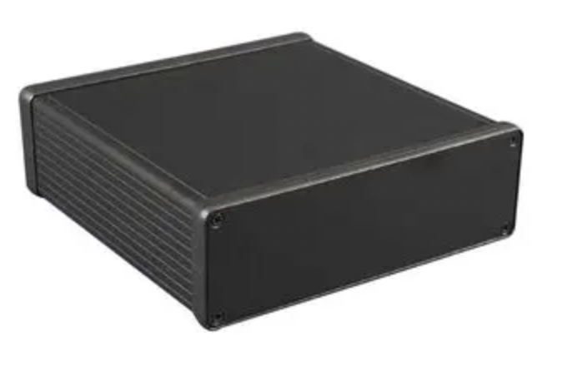
Figure 1 - Chosen Enclosure for Datalogger [43]

Figure 1 is the chosen enclosure for the datalogger. The enclosure was chosen as it was large enough for the PCB size, 112mm x 114mm. The panel sides were also large enough to house all the panel-mounted components and plugs. The box also has an IP rating of IP54.

Circuit Design for Data Logger
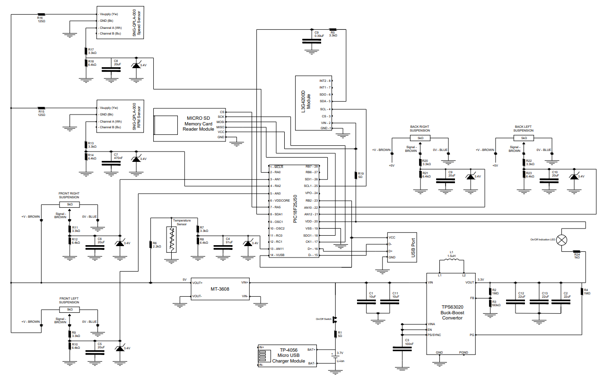

Figure 2 - Designed Data Logger Wiring Schematic
The schematic for the data logger is shown in figure 2 in the previous page. Each of the sections are broken up and described below.

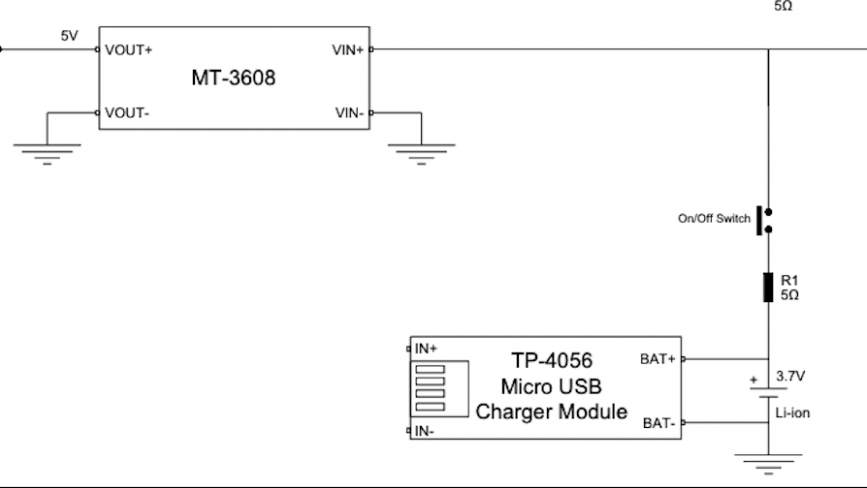
Figure 3 - Battery, TP-4056 Charger Module and MT-3608 Voltage Booster from the datalogger schematic diagram

Figure 3 shows the micro-USB charger and MT-3608. The module is used to convert a 5V micro-USB charge to 3.7V. A latching switch is used as the on/off switch of the data logger. The MT-3608 module is used to convert 3.7V to 5V.

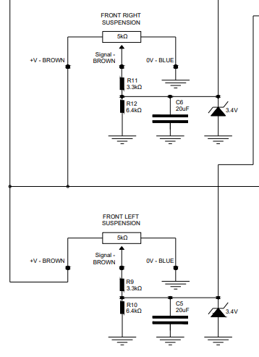
Figure 4 displays two of the 4 suspension monitors. Each of the 4 potentiometers uses a different analogue pin. A voltage divider Is used to limit the voltage to the pin to 3.4V as shown in the equation 5. A Zenner diode with a reverse breakdown voltage of 3.4V is used. The signal goes through a low-pass filter to filter out any unwanted noise. The measured signal is 500Hz therefore a 250Hz FC (frequency cut-off) was used due to the Nyquist theory to calculate the capacitor value shown in equation 2. [53]
Figure 4 - Schematic Diagram of Suspension potentiometers
$$Fc=\frac{1}{2πRC}$$

$$C=\frac{1}{2πFR}$$

$$C=\frac{1}{2πx 250 x 3300}$$

$$C=192nF$$

Equation 2 – Low pass filter for suspension measurement

The closest Capacitor to 192nF is 20uF. Each of the 4 suspension potentiometers uses the same components and sizes.

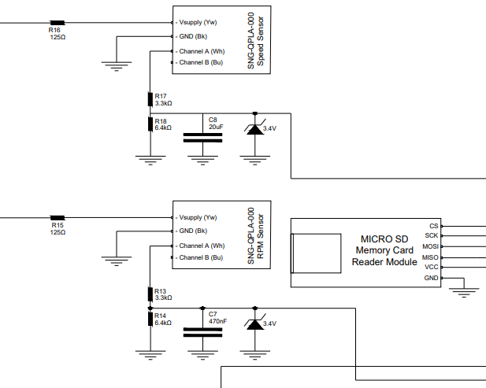
Figure 5 shows the RPM and Speed sensor as well as the MICRO SD Slot. RPM and speed sensor is a digital signal. Each is filtered to remove unwanted noise and use an overvoltage protection such as figure 4. R15 and R16 are to limit the current to each of the sensors to 40mA as per the datasheet. The RPM is measured at 200Hz therefore a FC of 100Hz was chosen. The equation below was carried out in equation 3 to find the needed capacitor value.
Figure 5 - RPM and Speed Sensor + SD Module on Schematic
$$Fc=\frac{1}{2πRC}$$

$$C=\frac{1}{2πFR}$$

$$C=\frac{1}{2πx 100 x 3300}$$

$$C=482nF$$

Equation 3 – Low pass filter for RPM measurement

The speed sensor was measured at 500Hz therefore the same FC of 250Hz was used as used previously in figure 4. The Micro SD card used the SPI Protocol and required a Chip Select, Serial clock and 2 data lines to transmit and receive data from the SD card.
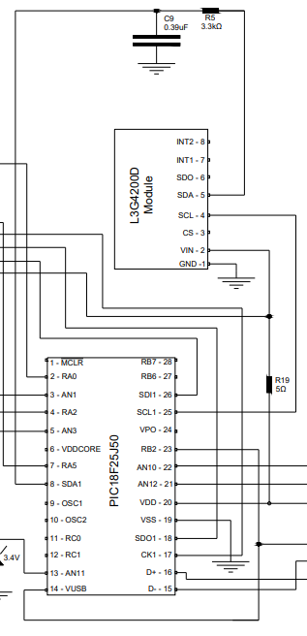
Figure 5 shows the microchip and Gyro. The Gyro uses the I2C protocol. I2C protocol is synchronous therefore the bits sampled by the microchip are synchronous to the output of bits received from the SD card. A serial clock is also connected that carries the clock signal. [52]

Figure 6 - Snippet of the Datalogger schematic diagram showing the Microchip and Gyro chip

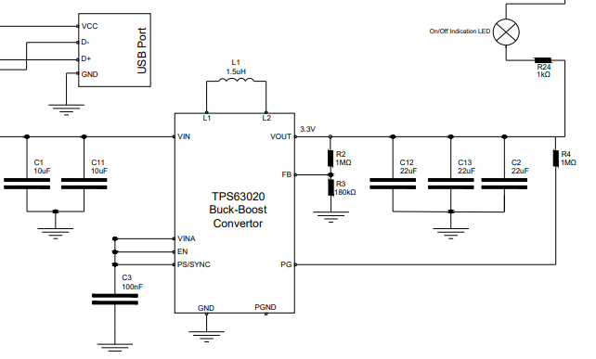
7 - Snippet of the Schematic Diagram showing the Buck-Boost convertor, LED and USB Port

Figure 6 displays the Buck-boost converter, USB port and LED. The LED illuminates when the circuit has power. The buck-boost converter is used to step down the battery's 3.7V voltage and regulate a 3.3V voltage to the microchip so that when the battery life fluctuates, the microchip will still have the desired voltage for functioning.

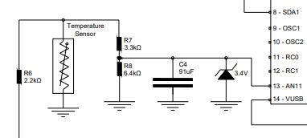
Figure 8 - Temperature sensor within the schematic diagram

Figure 7 displays the Temperature sensor. The temperature sensor gives an analogue signal, which goes through a voltage divider. The calculation is carried out in Equation 5. A low pass filter is also used to limit the noise with a FC of 0.5Hz. The calculation in equation 4 was used to calculate the needed capacitor for the correct frequency cut-off.

$$C=\frac{1}{2πx 0.5 x 3300}$$

$$C=96.47$$

91uF is the closest Capacitor size.

Equation 4 – Low pass filter for Temperature Sensor

The equation used to calculate the resistors required to get the desired output voltage from the voltage divider is shown below in Equation 5.

$$Vout=Vin x \frac{R2}{R1+R2}$$
$$3.3=5 x \frac{R2}{3300+R2}$$

$$\frac{3.3}{5}= \frac{R2}{3300+R2}$$

$$\frac{5}{3.3}= \frac{3300+R2}{R2}$$

$$\frac{5}{3.3}= \frac{3300}{R2}+ \frac{R2}{R2}$$

$$\frac{5}{3.3}-\frac{R2}{R2}= \frac{3300}{R2}$$

$$1.515151-1= \frac{3300}{R2}$$

$$0.5151= \frac{3300}{R2}$$

$$\frac{3300}{0.5151}= R2$$

$$\frac{3300}{0.5151}= R2$$

$$R2=6405.8Ω$$

6.4k was the closest resistor value.

Equation 5 – Equation used to calculate 3.3V output value for the voltage divider

Designed Data logger microchip pinout

Upon researching and reading the datasheet for the chosen microcontroller the pinout below in Figures 8 and 9 is what was used to wire up the circuitry to the microcontroller.

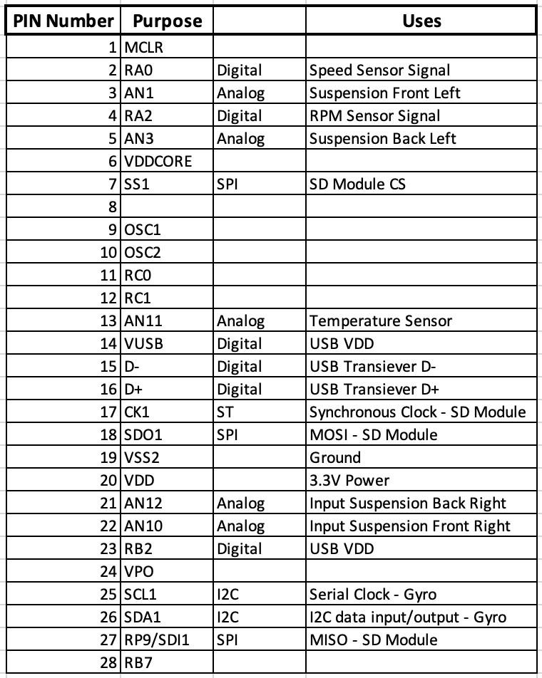
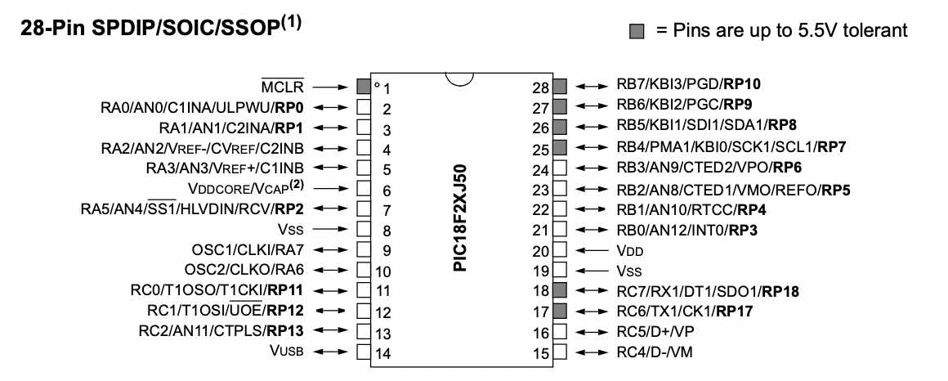
Figure 8 - Microcontroller Pinout occupied pins
Figure 9 - Microcontroller Pinout occupied pins

Figure 9 displays the 28 pins available on the microcontroller. Figure 8 is taken from the datasheet and is the microcontroller pinout. Due to the SPI and I2C both needing to use pin 26. The SPI signal moved to another pin which is a remappable peripheral pin 27 - RP9. Upon reading the datasheet on page 269, I2C must use the dedicated I2C pins, and the SPI can use remappable pins. [44]

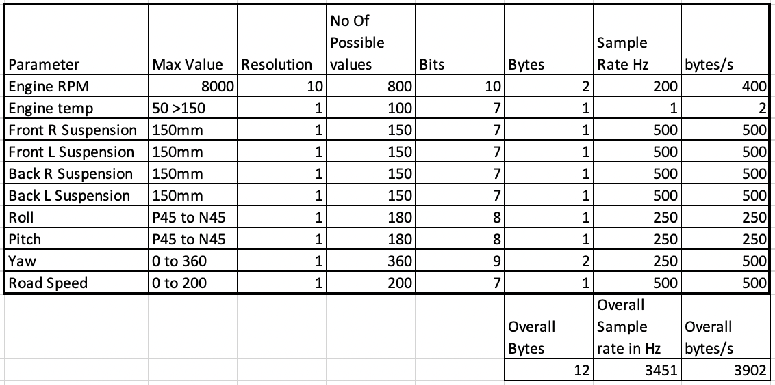
Figure 10 - Datalogger sensors, Resolution, Bits, Bytes, Sample Rate in HZ and Bytes a second

Figure 10 shows the sample rates and how many bytes per second each sensor will produce. Using this table, an SD module size could be chosen as well aiding with the microchip selection. Each sample rate was chosen carefully to ensure the microchip was sampling at a quick enough rate to capture the required measurement changes.

PCB Design

Firstly, using the Easy PC software, a schematic was created to allow the PCB design to be made as shown in figure 10. The schematic was required to be made within Easy PC for the PCB circuit to be designed.
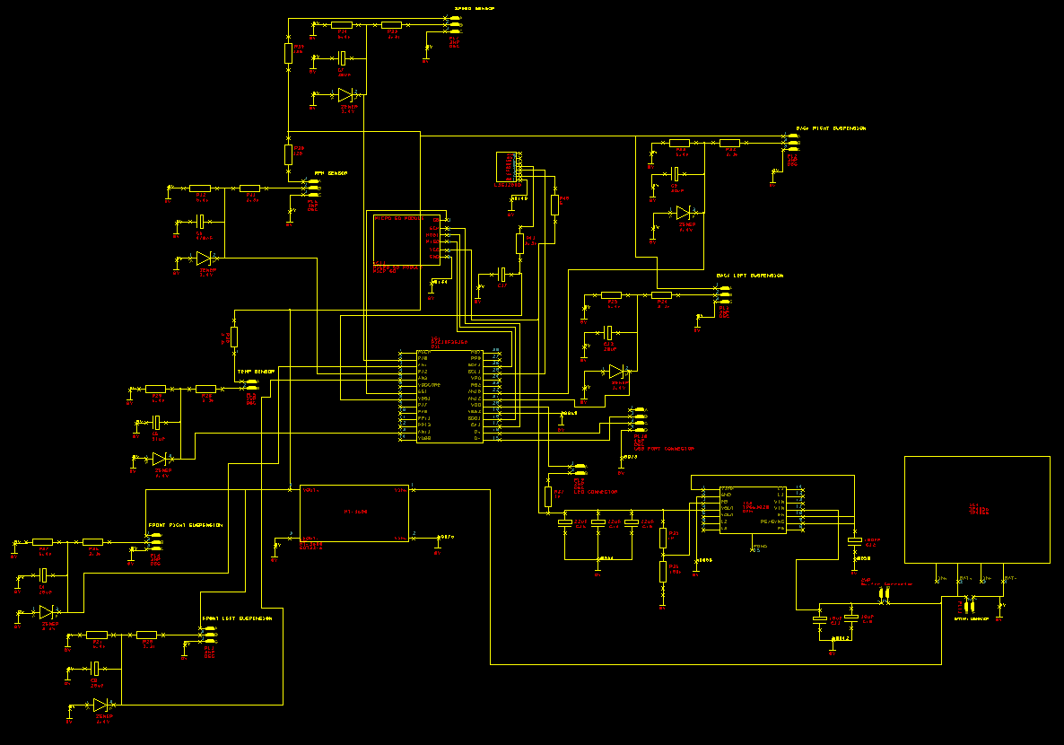

Figure 10 - Easy PC Schematic Diagram

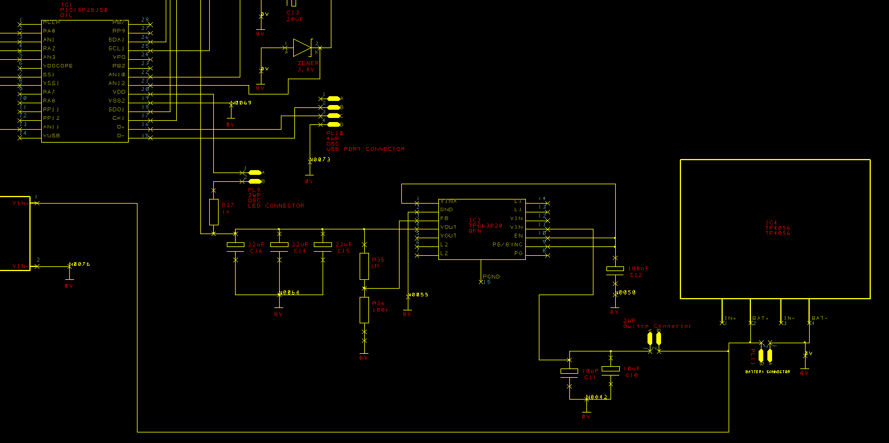
Figure 11 - A closer look at the Schematic within Easy PC
Figure 11 shows parts of the schematic. Connectors are used to connect things like the LED, switch, Battery, and USB port. Each Sensor and part that’s external to the PCB is connected using Molex connectors which plug into the PCB and clip in securely. This is shown throughout Figures 10 to 13.
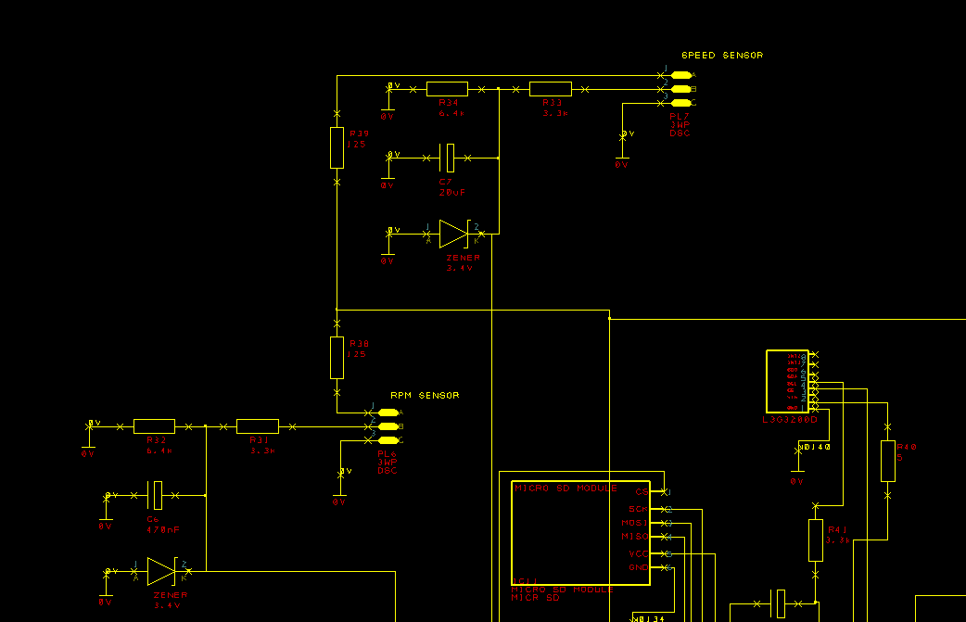
Figure 12 - Closer Look into the Schematic for the Easy PC Design
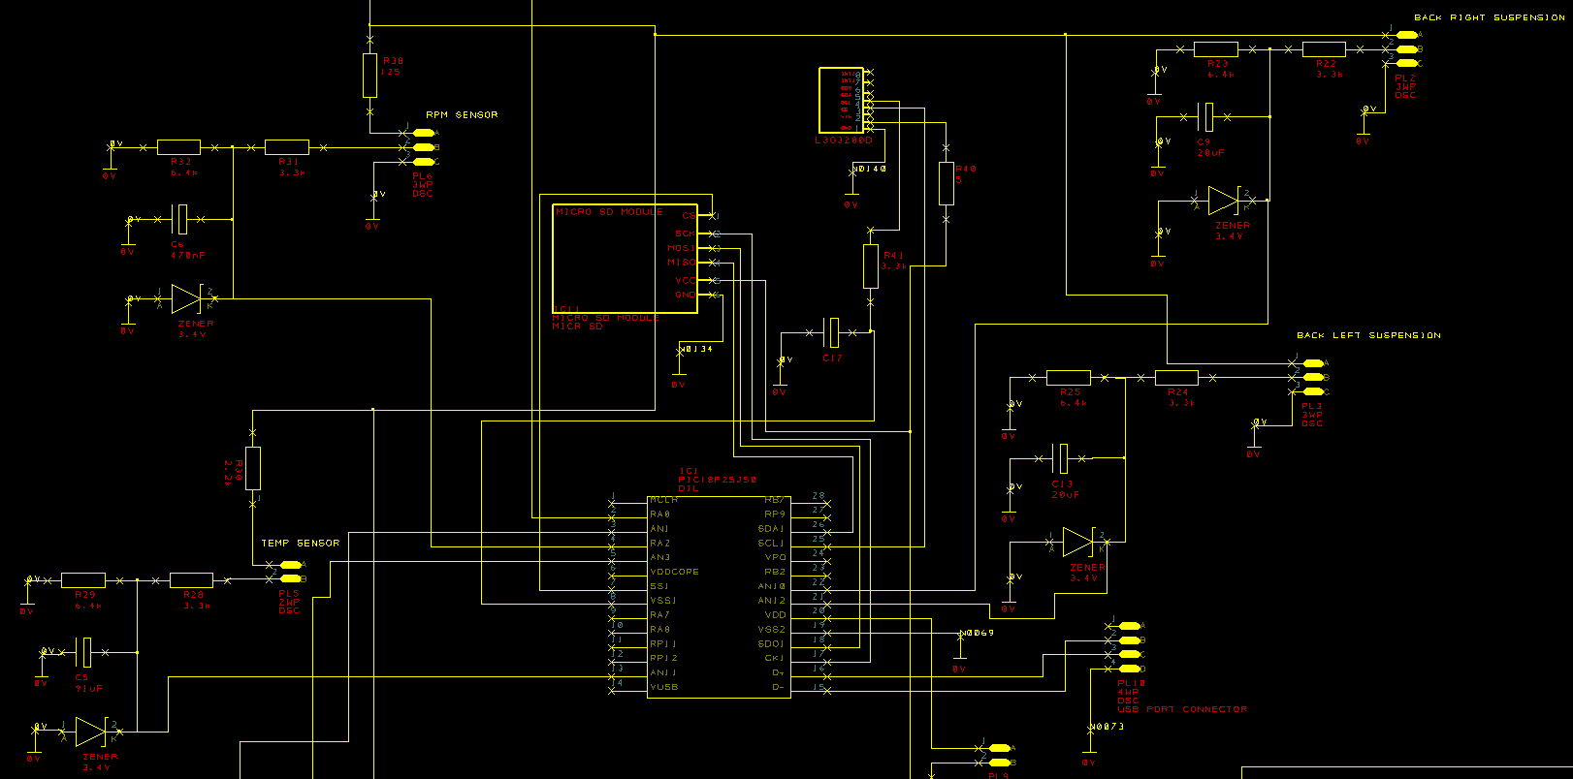
Figure 13 - Further closeup image of Easy PC design

layout could be
When transferring the schematic into a PCB within EASYPC the circuit board layout could be set up shown in figure 14, tracks made between each connection, and then copper poured to link out all the ground connections. The copper pouring also helps minimise noise on the circuit board. The fixings holes are 6mm wide to correspond with the vibration dampeners it’ll be mounted too.
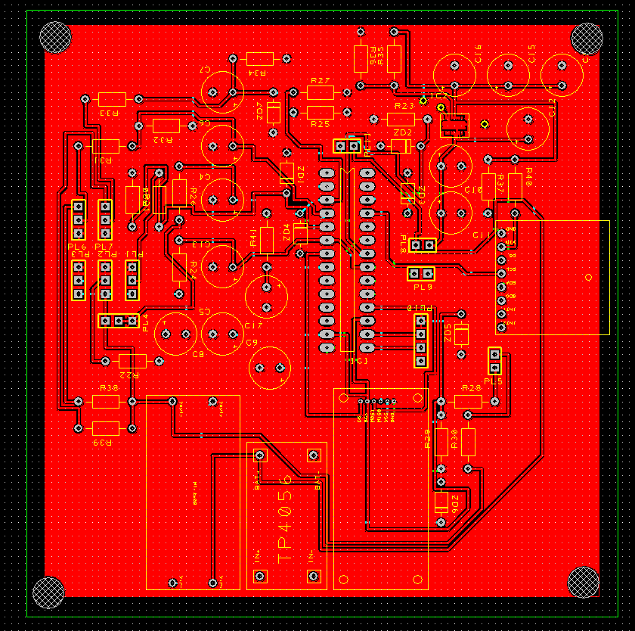
Figure 14 - Easy PC PCB Design of the Datalogger Circuit Board

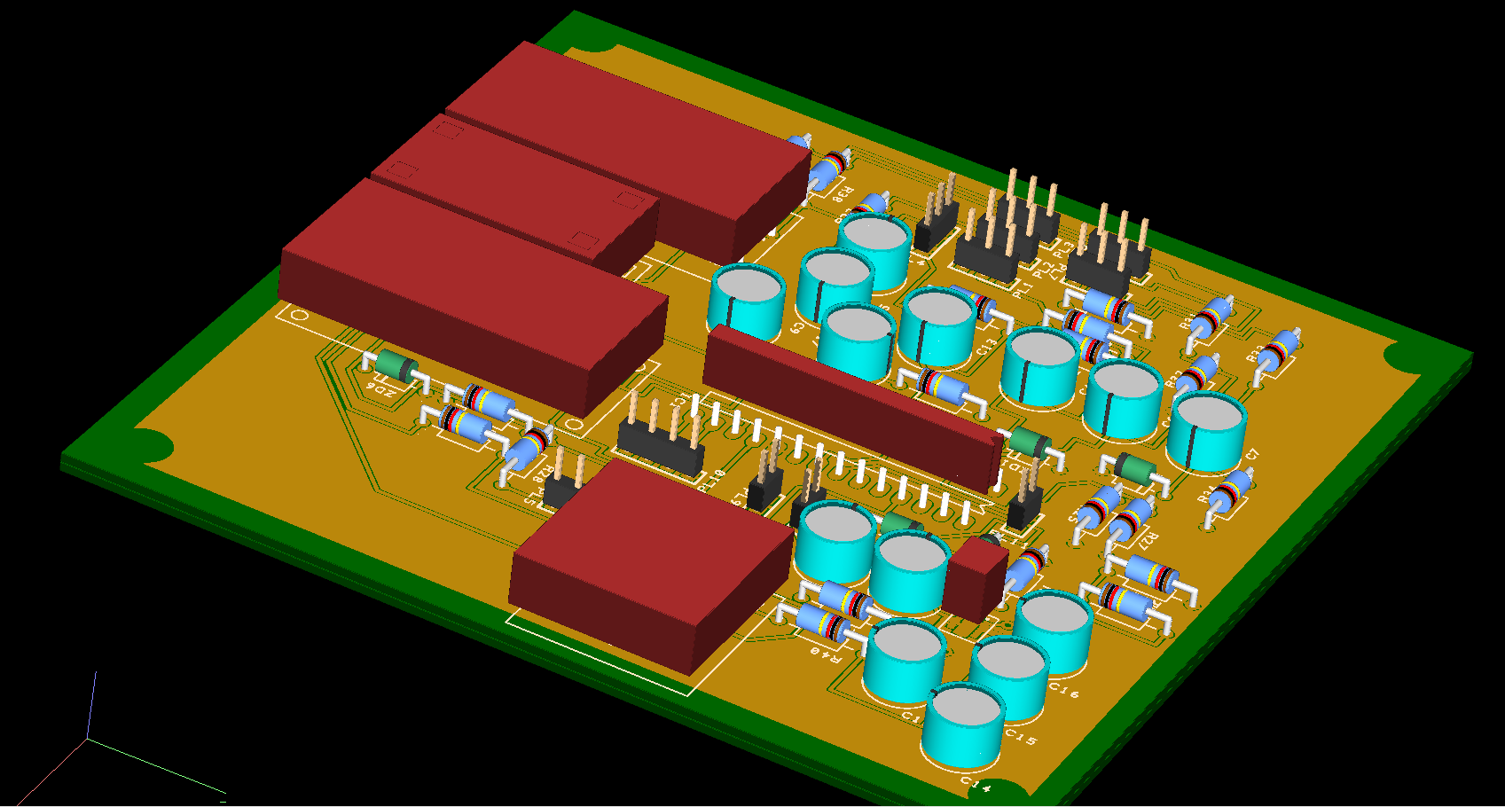
Figure 15 - 3D View of the top of the Datalogger PCB Design

After the circuit PCB design was made it was transferred into a 3D model for viewing which is shown above in Figure 15.
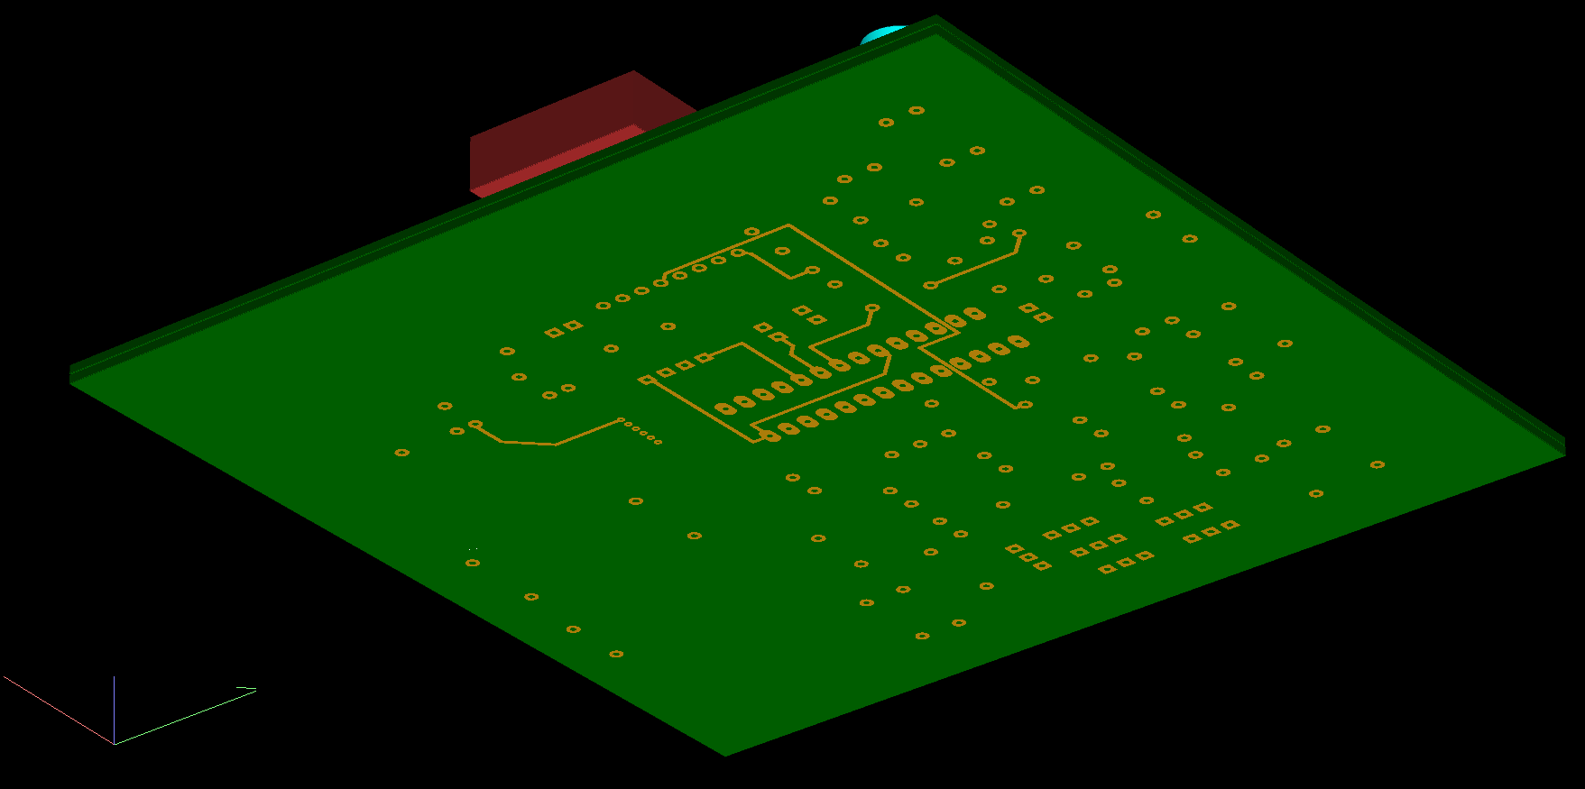
Figure 16 - 3D view of the bottom of the Datalogger PCB Board

Figure 16 displays a 3D model of the bottom of the PCB board.

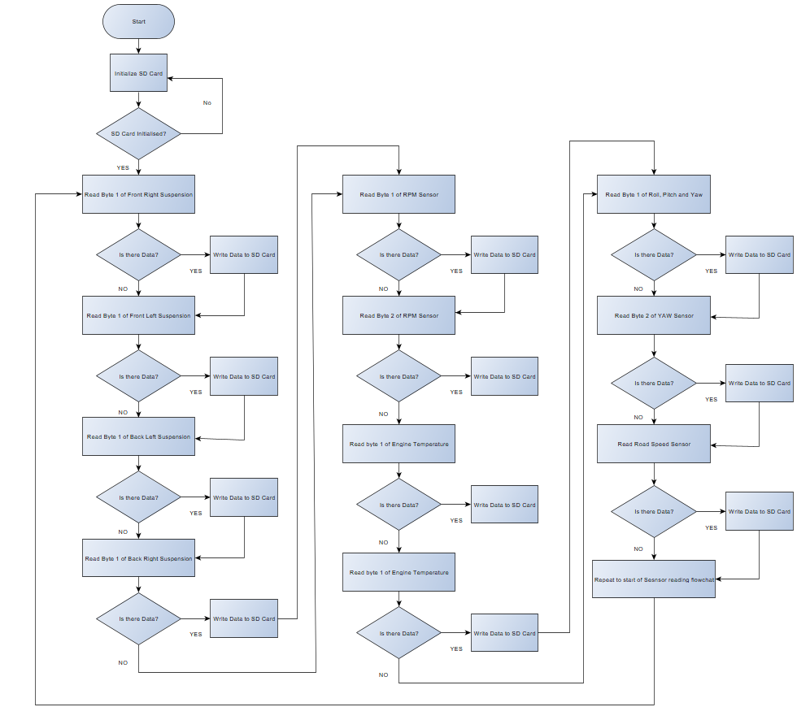
Software Design and Structure/Flowchart

Flowcharts were created to show the flow function of processes within the datalogger. Figure 17 shows the process of reading data from each sensor and writing the data to the SD card.

Figure 17 - Flowchart to show process of transmitting data from sensors to the SD card
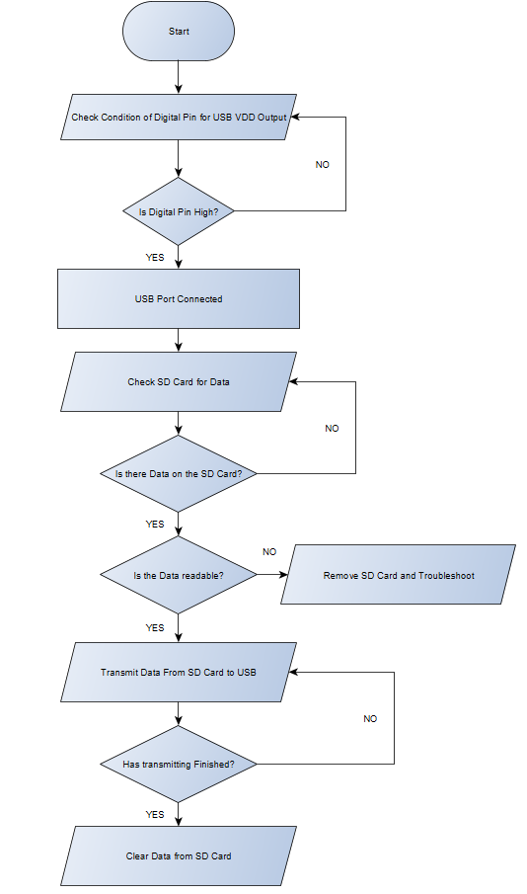
Figure 18 shows the flowchart process of taking data from the SD card and transmitting it to the USB.
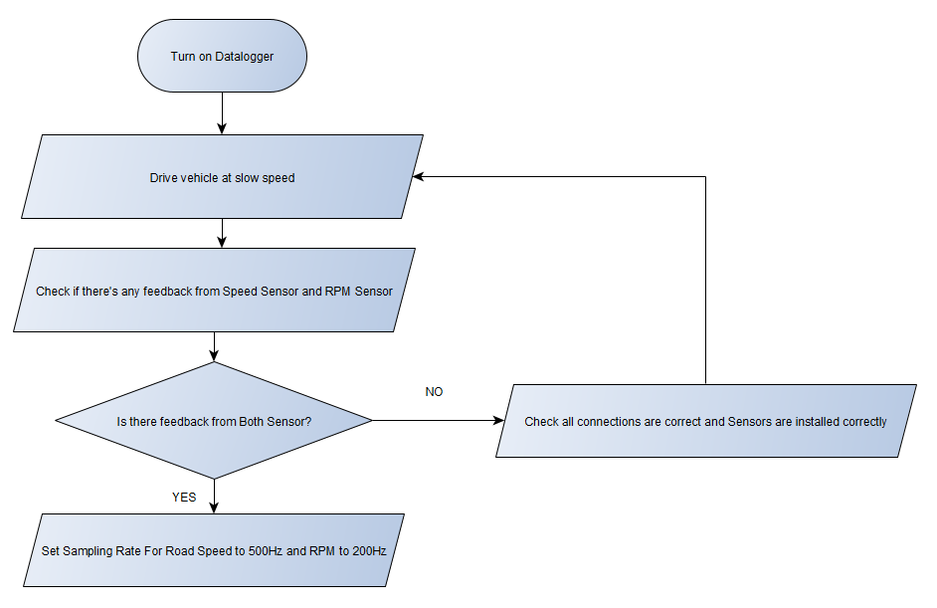
Figure 18 - Flowchart of Transmitting Data from the SD card to the USB
Figure 19 - Flowchart of setting up Road speed and RPM sample rate

Figure 19 shows the flowchart of setting up the sample rate of the RPM and speed sensor. Figure 20 shows the flowchart of setting up the sample rate for the four suspension potentiometers, Figure 21 shows the flow of setting up the gyroscope and Figure 22 shows the setting up of the Engine temperature.
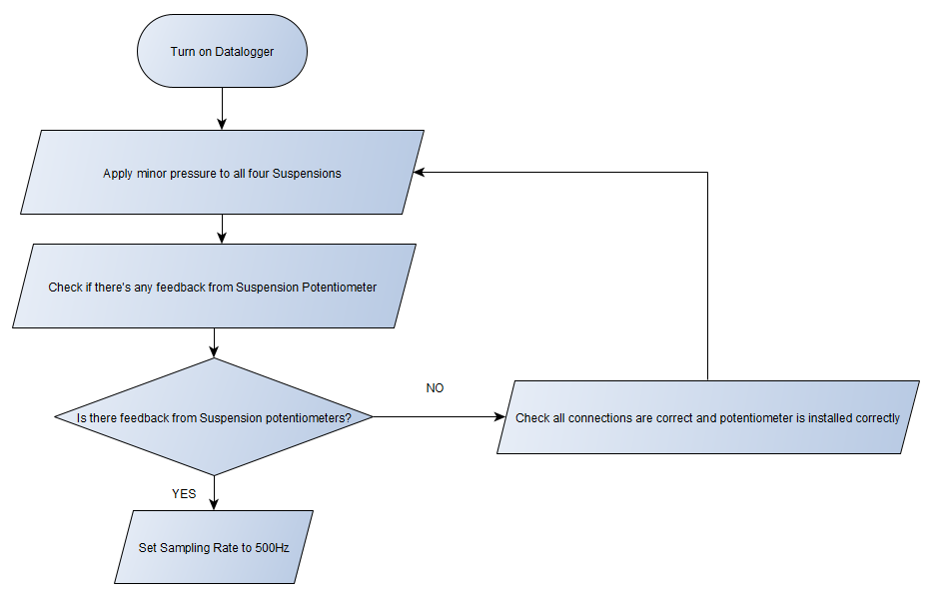
Figure 20 - Flowchart showing setting up the sample rate for the suspension potentiometer

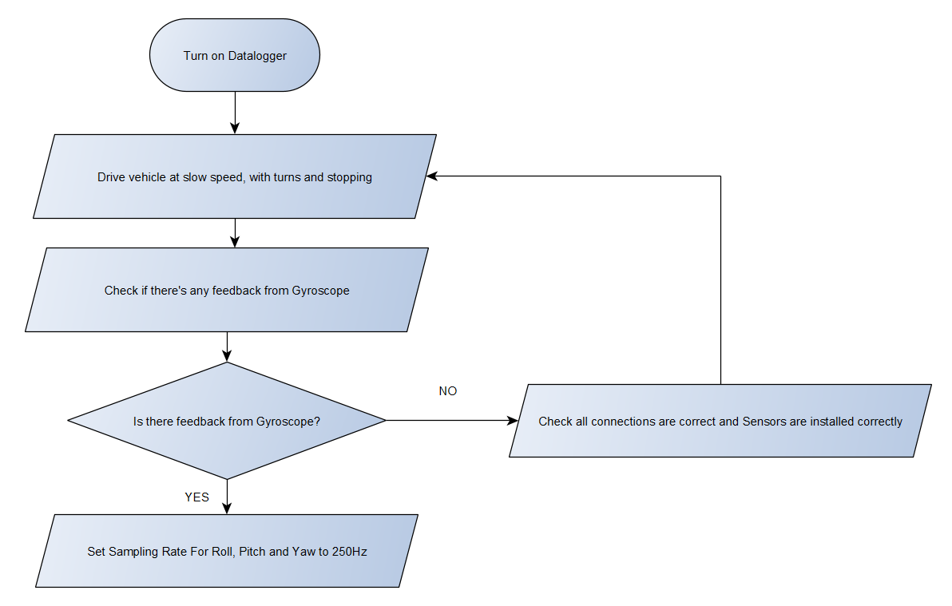
Figure 21 - Flowchart to show setting up sample rate of Roll, pitch and Yaw
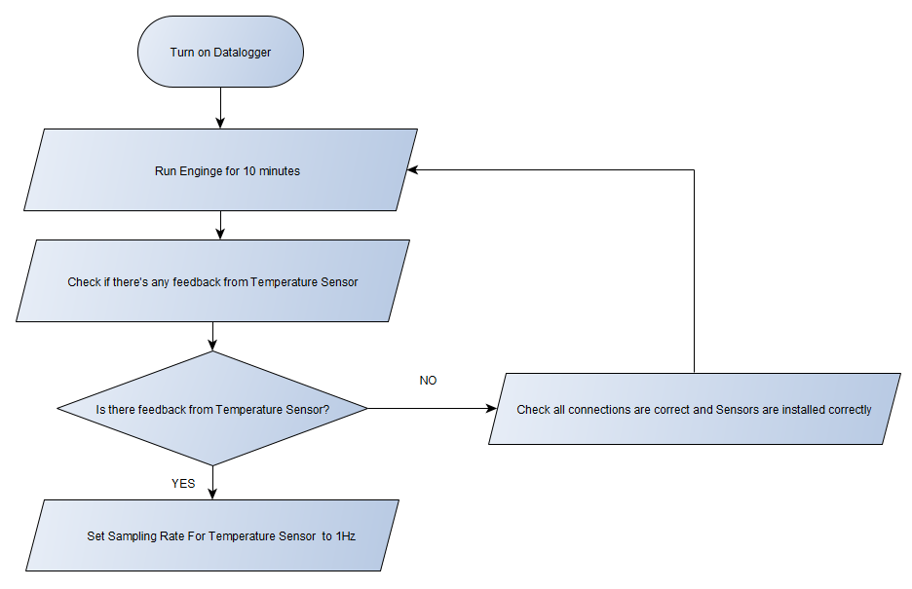
Figure 22 - Flowchart to show the setting of sample rate on the temperature sensor

Prototype Costs
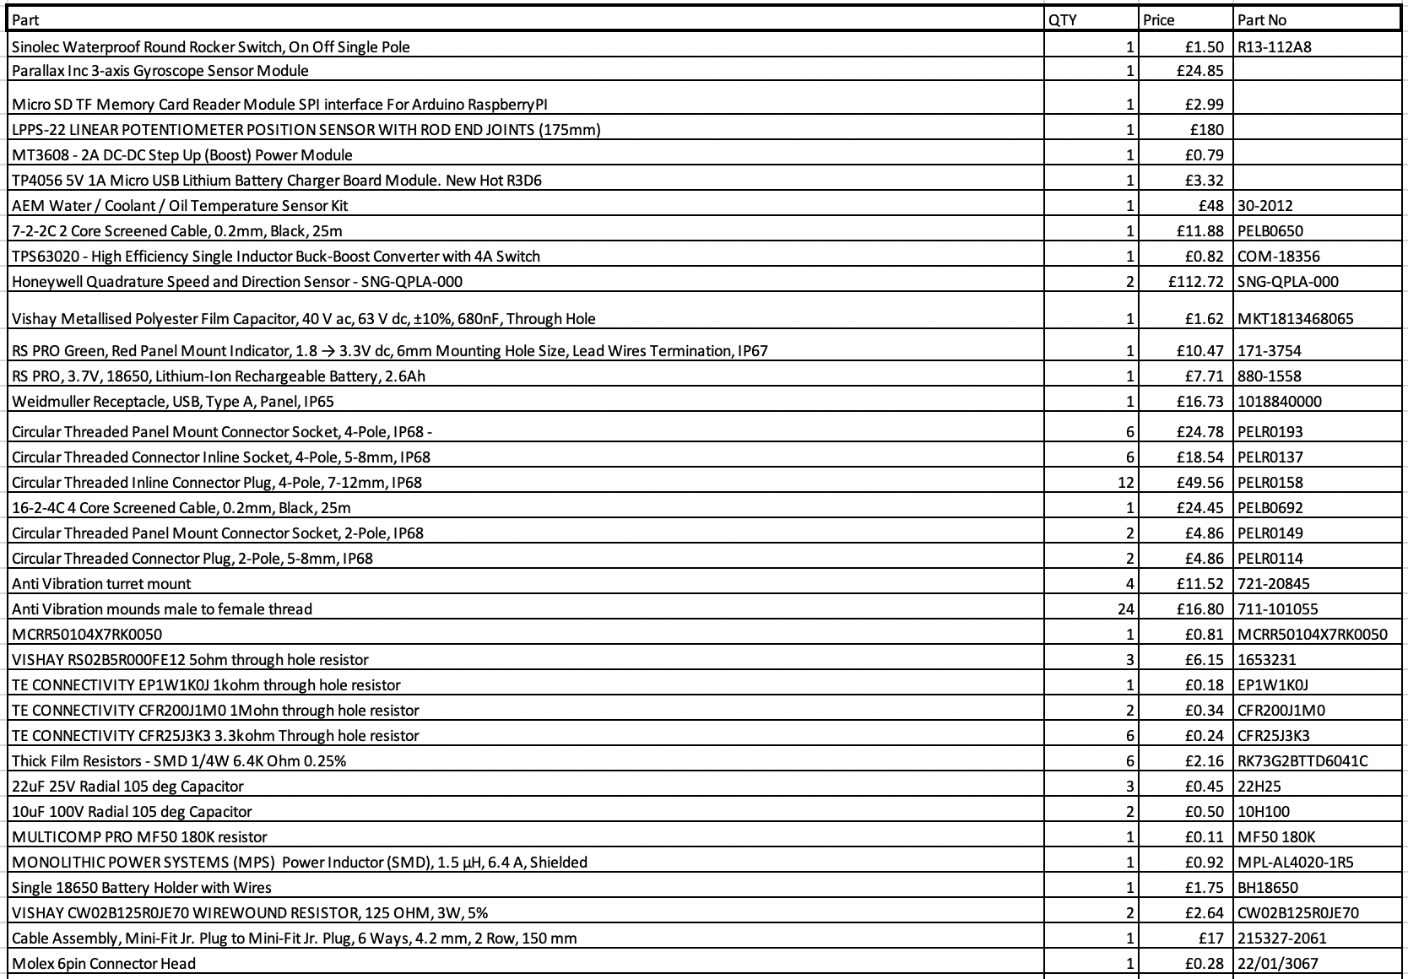
Figure 23 - Bill of materials for the datalogger, continued on the next page..

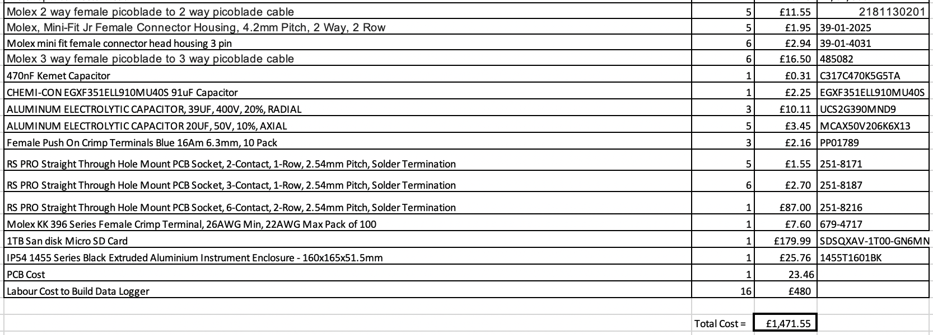

Figure 23 - Bill of materials for the datalogger, continued from the previous page

The overall cost of the Datalogger amounted to £1,471.55 as seen in Figure 23. This cost included the labour and materials. This is a reasonable cost for a good standard datalogger.

Suggested Improvements

Overall, the data logger design went well. Improvements to the design would be carried out if the datalogger had to be redesigned. The first improvement would be to use a large wiring harness that would contain all the sensor wiring in one. This would be a neater approach for the datalogger, and it would take up less room on the datalogger enclosure’s outer casing. In future designs all the components and PCB components would be at the same voltage range would minimise the need for voltage converters and extra components on the PCB. This would minimise the enclosure size and cost of the PCB. In future, a minimal amount of layers on the PCB would be more beneficial to keep down the cost of the datalogger. The designed datalogger has enough of a specification to fulfil the tasks and points set out of the scope of the project.

Appendices

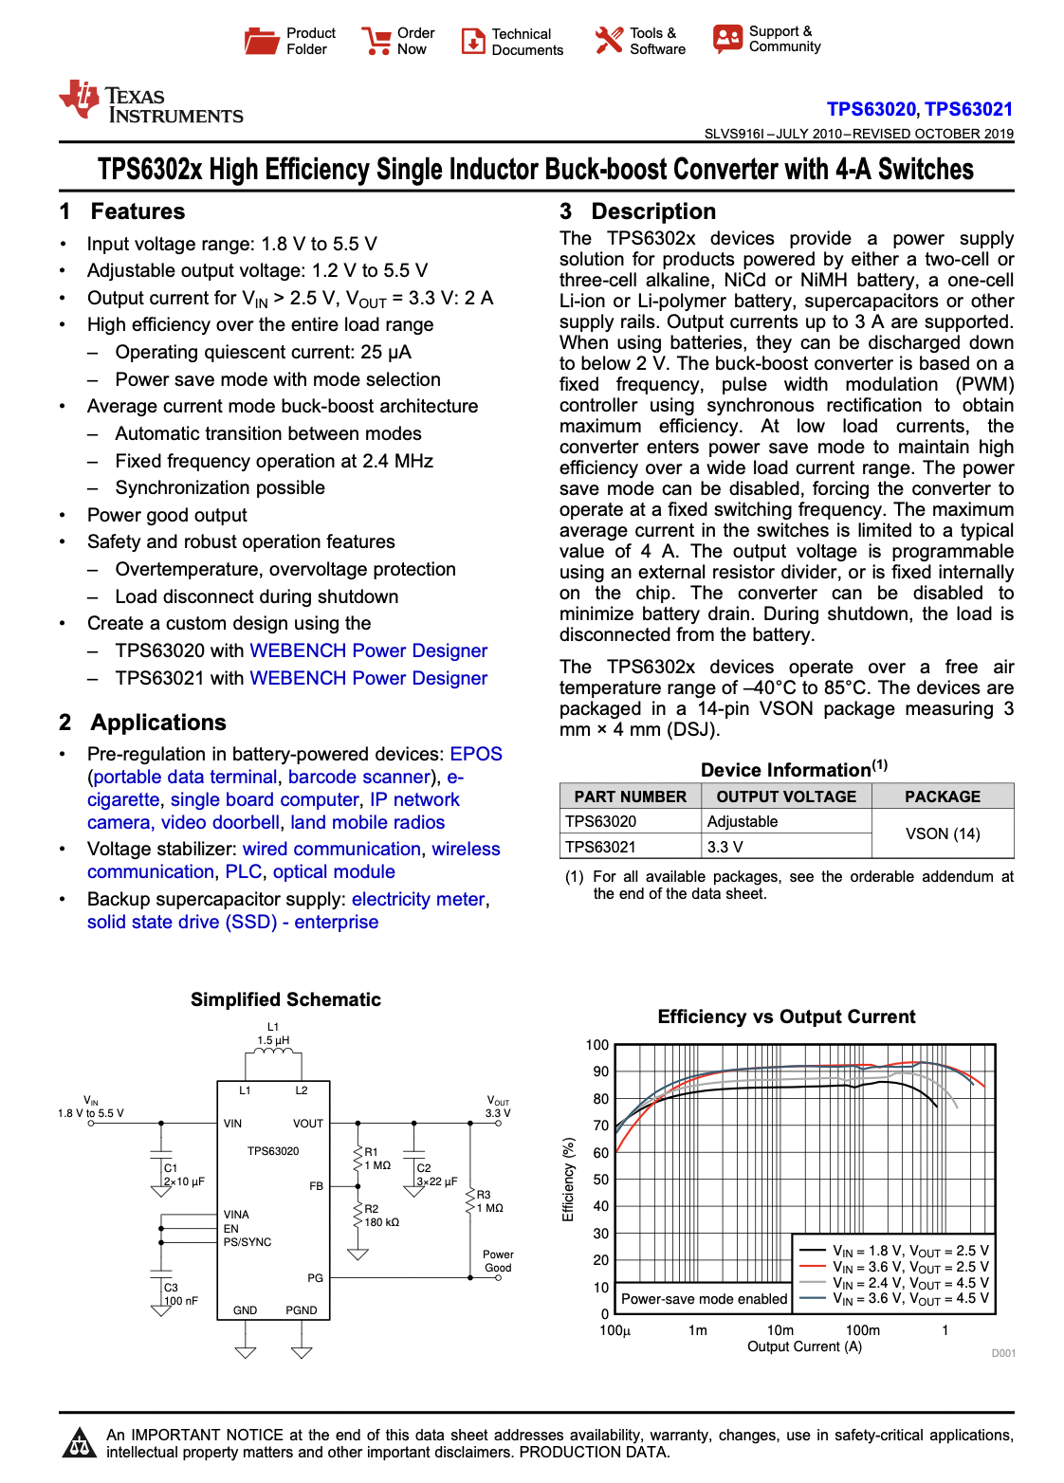
Figure 25 - TPS63020 Voltage Regulator Datasheet

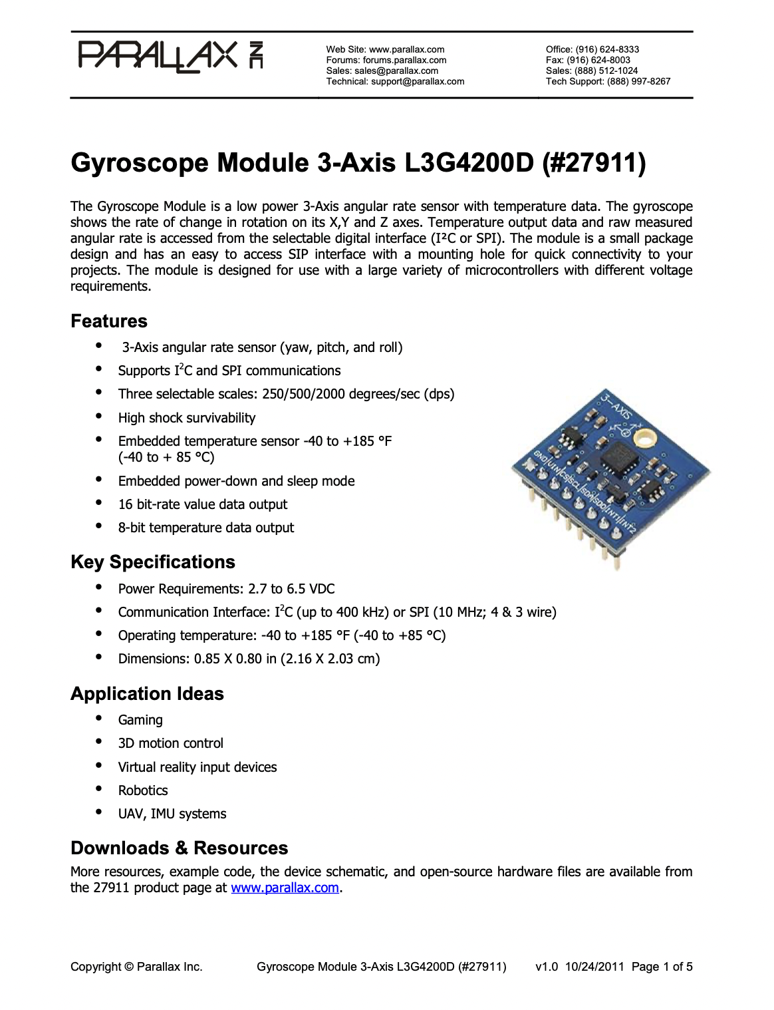
Figure 26 - L3G4200D Datasheet

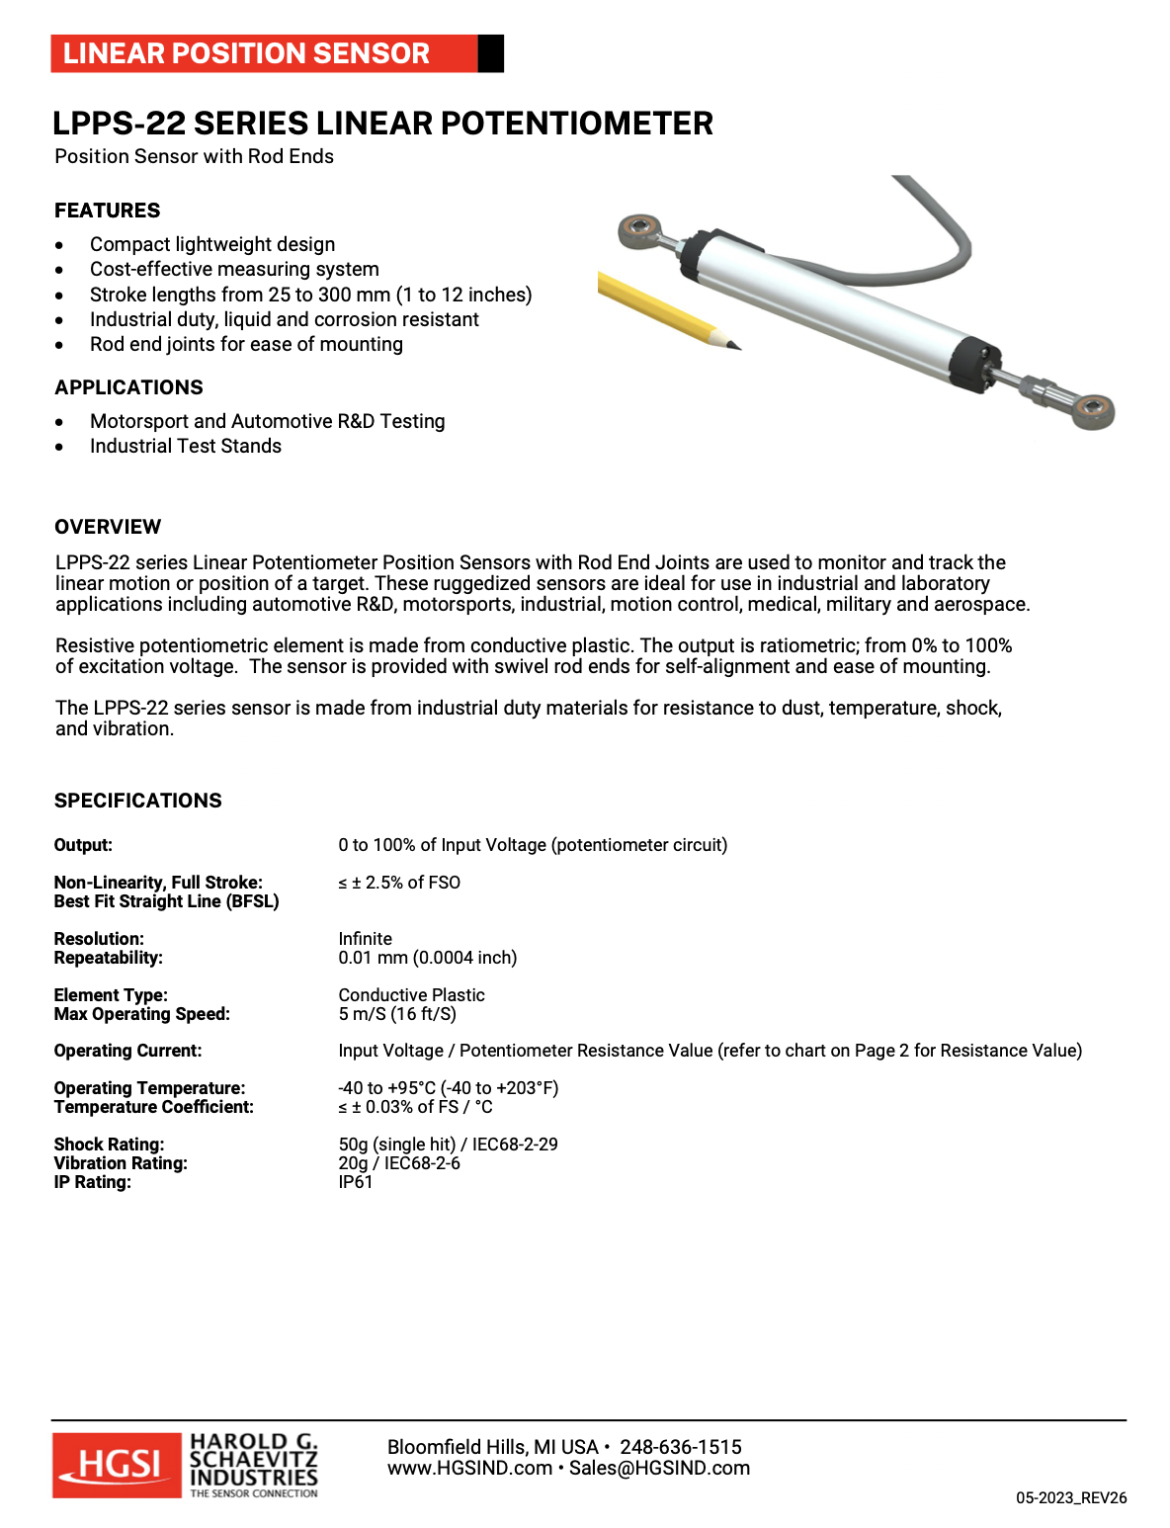
Figure 27 - LPPS-22 Linear Potentiometer Datasheet

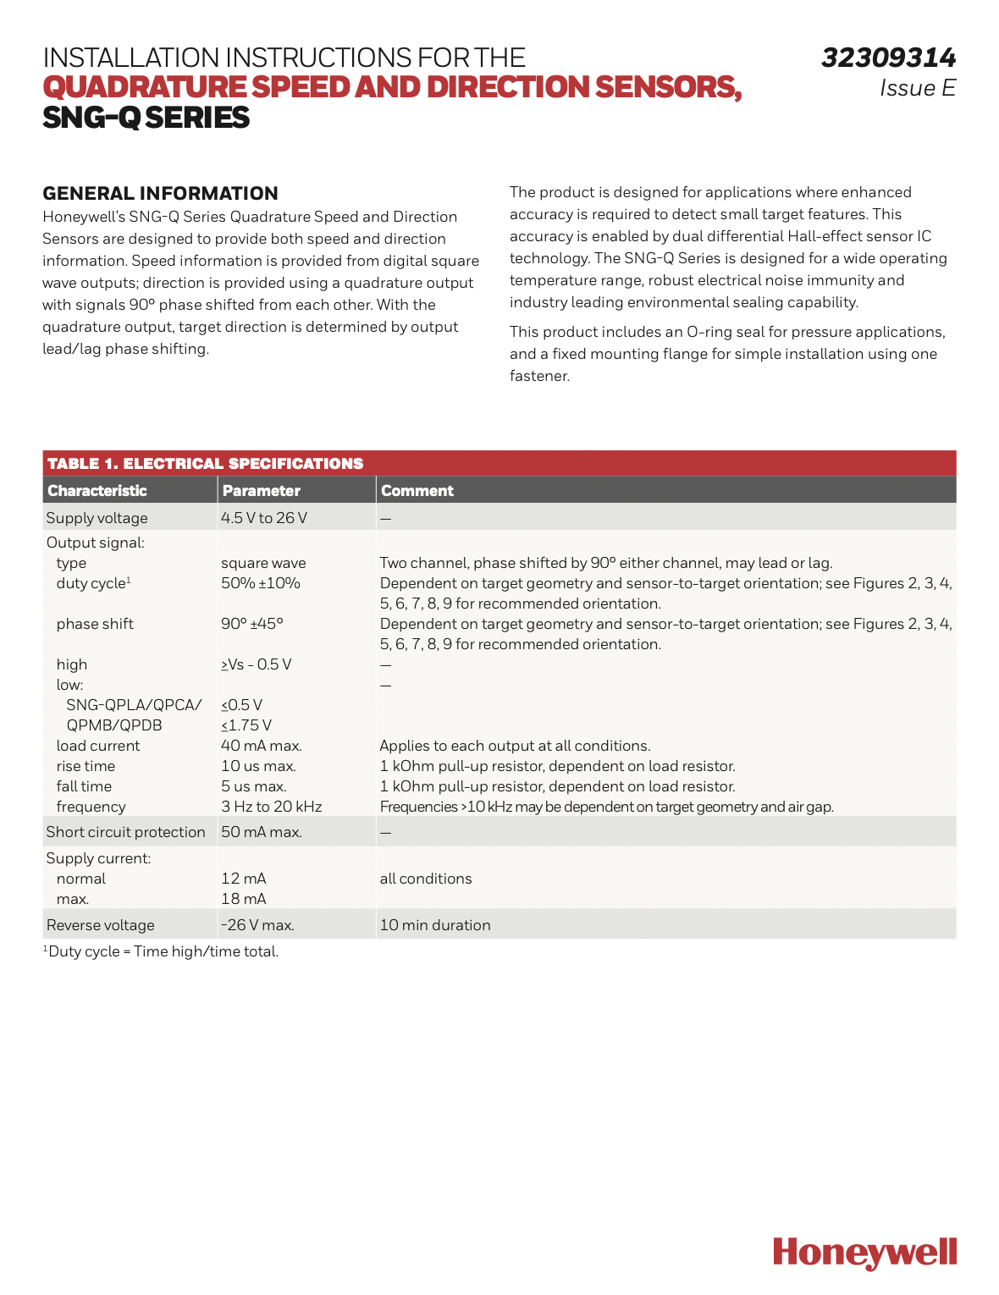
Figure 28 - SNG-Q Series Speed and Direction Sensor Datasheet

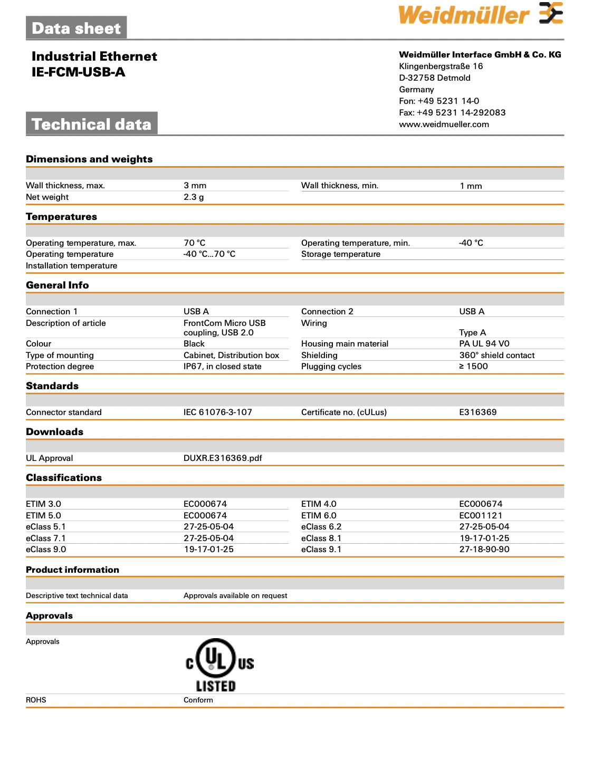
Figure 29 - Weidmuller USB Port Datasheet

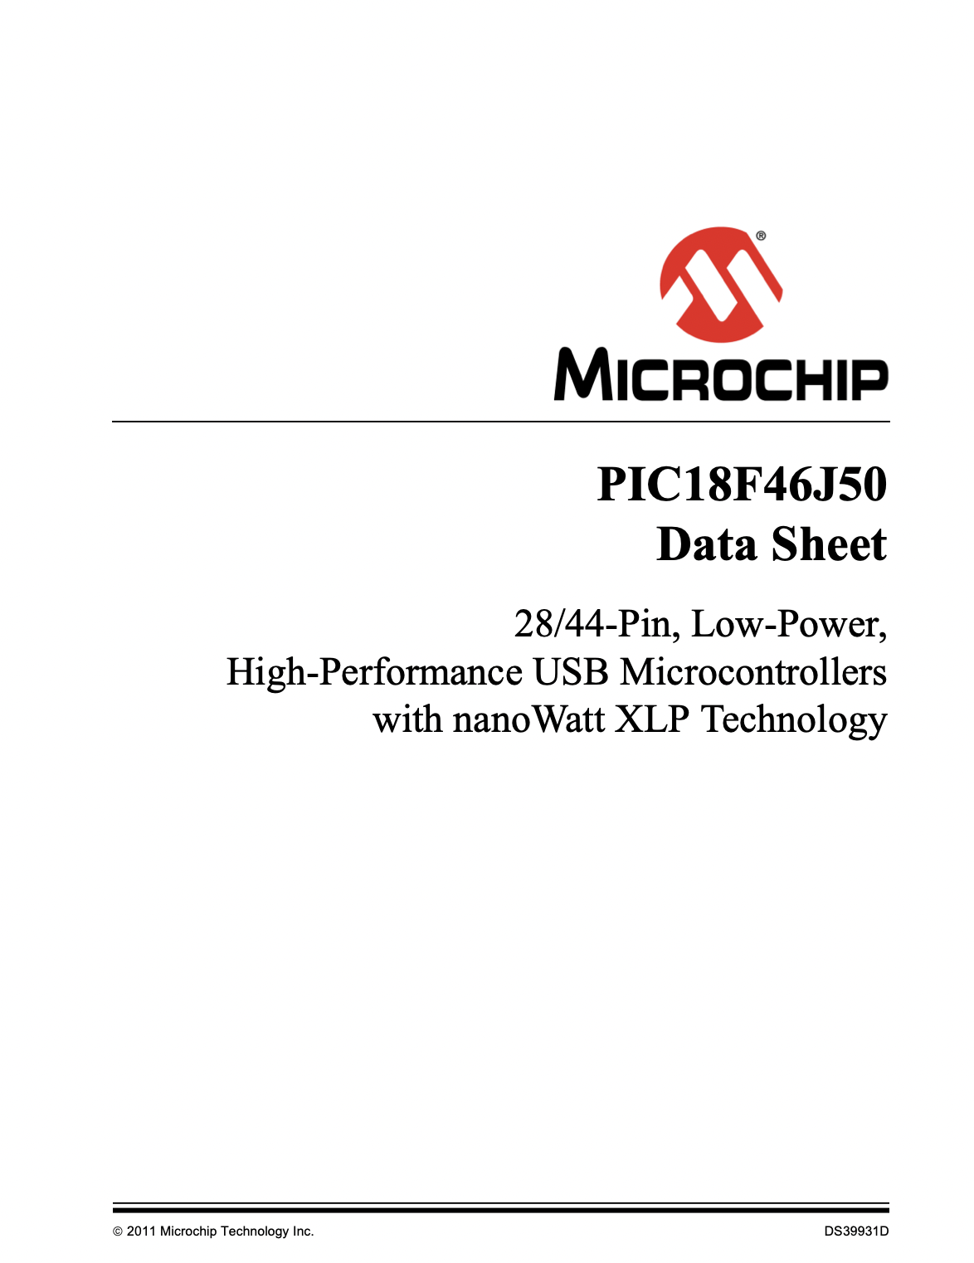
Figure 30 - Microchip Datasheet
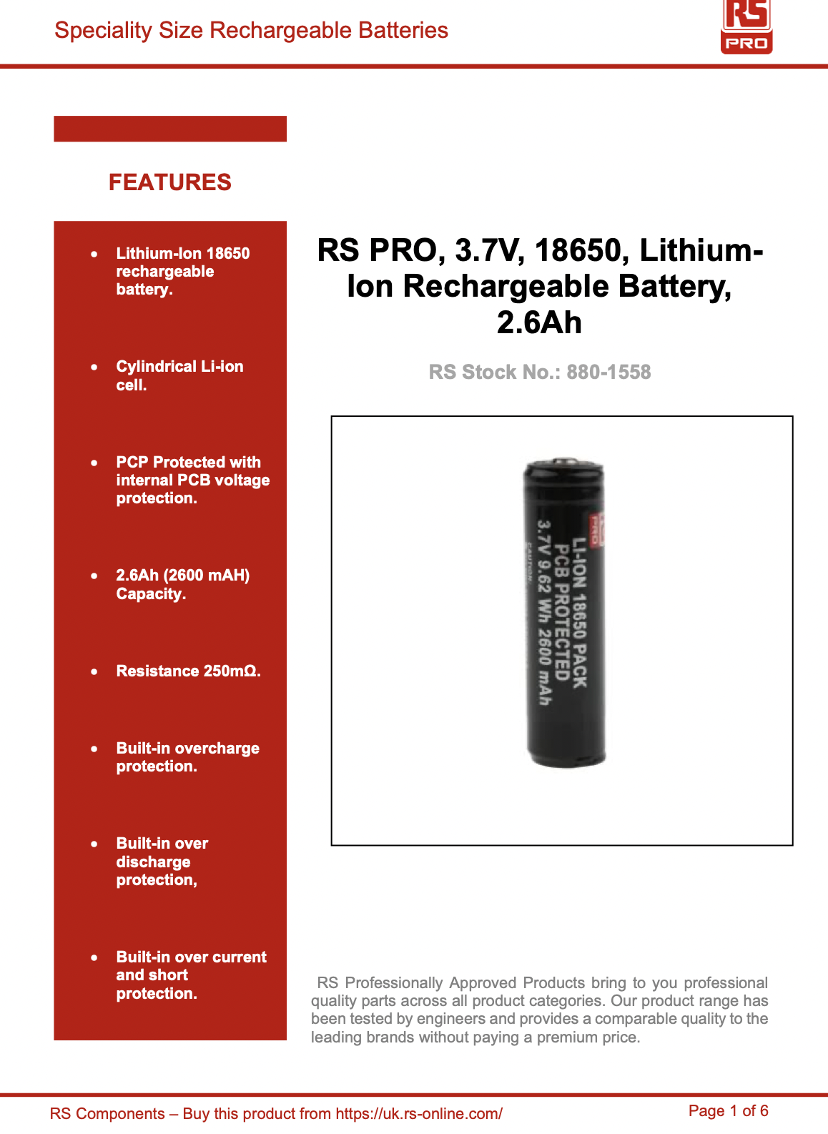
Figure 31 - RS Pro li-ion Battery Datasheet

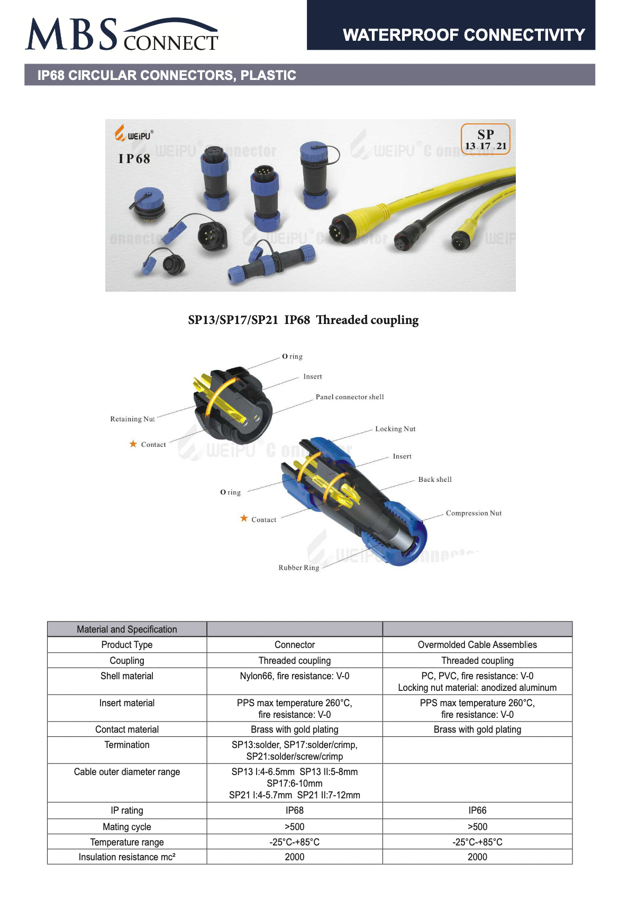
Figure 32 - Male IP68 Connector Plug
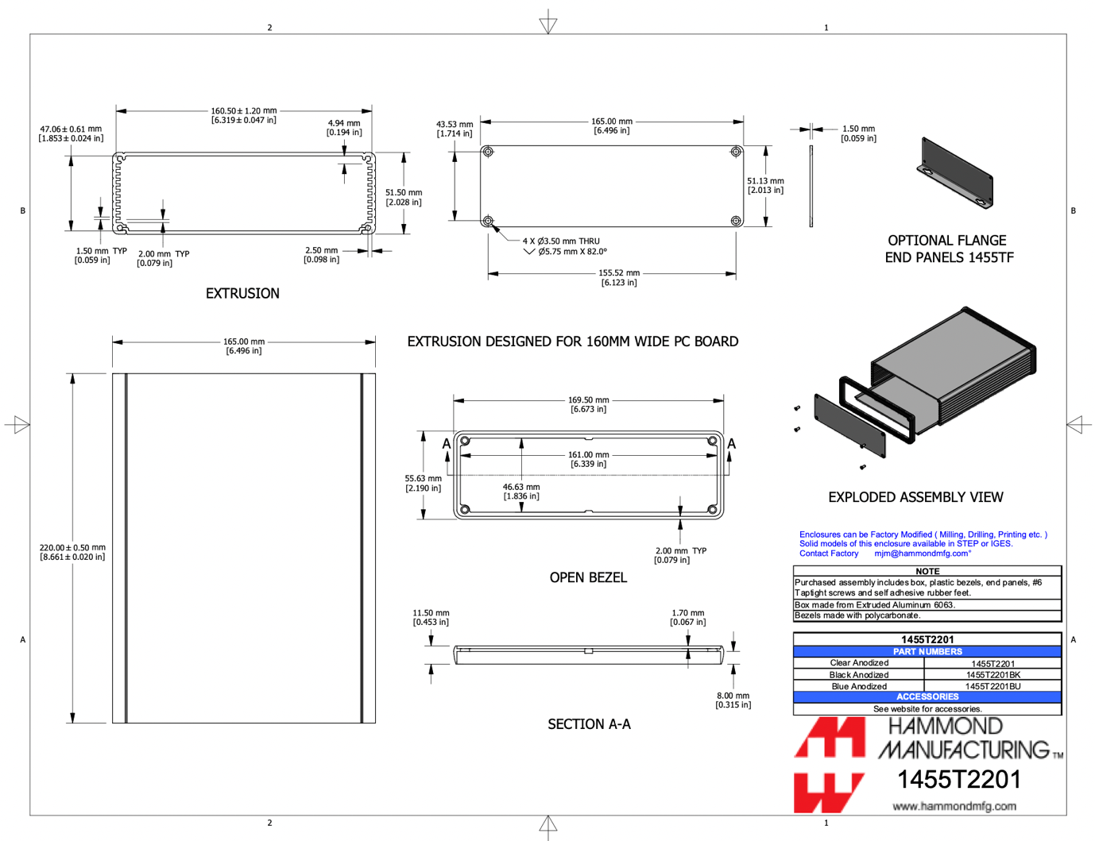
Figure 33 - Dataloggers Enclosure Datasheet

References

[1] | J. Sergers, Analysis Techniques for Racecar Data Acquisition, SAE International, 2014.
[2] | 25 10 2023. [Online]. Available: https://www.aimshop.com/products/aim-evo-5-car-racing-data-logger?currency=GBP&utm_source=google&utm_medium=cpc&utm_campaign=google+shopping&utm_campaign=gs-2021-06-02&utm_source=google&utm_medium=smart_campaign&gad=1&gclid=CjwKCAjwkNOpBhBEEiwAb3MvvVsGADU.
[3] | “2d-datarecording, Sticklogger V5,” [Online]. Available: https://2d-datarecording.com/en/produkte/hardware/logger/sticklogger-v5/. [Accessed 25 10 2023].
[4] | “Aim Shop - Aim MXS 1.2 TFT Digital Display and Data logger,” [Online]. Available: https://www.aimshop.com/products/aim-mxs-1-2-tft-digital-display-and-data-logger. [Accessed 25 10 2023].
[5] | “RS Online - Hall Effect Sensor,” [Online]. Available: https://uk.rs-online.com/web/p/hall-effect-sensors/2132762?cm_mmc=UK-PLA-DS3A-_-google-_-CSS_UK_EN_PMAX_Catch+All-_--_-2132762&matchtype=&gclid=CjwKCAjwkY2qBhBDEiwAoQXK5cqd1A57985ZvwDIwSLJVSatFKUMayjix2JnFlNmtTv3edUVmcbAwhoCfg4QAvD_BwE&gclsrc=aw.ds. [Accessed 2 11 23].
[6] | “Monit motorsport - speed-sensors,” [Online]. Available: https://www.monitmotorsport.com/speed-sensors/. [Accessed 26 10 2023].
[7] | “2D-Datarecording-Datasheet Inductive Speed Sensor,” [Online]. Available: http://2d-datarecording.com/Downloads/Datasheets/Sensors-digital/Pdf/SD-V01M8-000-DINA4.pdf. [Accessed 26 10 23].
[8] | “ISO.org - Standard 20653:2023,” [Online]. Available: https://www.iso.org/standard/76116.html. [Accessed 07 11 2023].
[9] | “RS-Online - IP Ratings,” [Online]. Available: https://uk.rs-online.com/web/content/discovery/ideas-and-advice/ip-ratings. [Accessed 2023 11 08].
[10] | “Carlightbulb - dc 8-24V Hall Tachometer,” [Online]. Available: https://carlightbulb.com/products/dc-8-24v-hall-tachometer-digital-led-motor-speed-meter-tester-ip68-waterproof?currency=GBP&variant=43293587046562&utm_medium=cpc&utm_source=google&utm_campaign=Google%20Shopping&stkn=d7752ef57dbc&gclid=CjwKCAjw7c2pBhAZEiw. [Accessed 27 10 23].
[11] | “Amazon - Digital Tachometer Proximity Switch+Hall Proximity Switch,” [Online]. Available: https://www.amazon.co.uk/DIGITEN-Digital-Tachometer-Proximity-Switch/dp/B00VKATA9G?source=ps-sl-shoppingads-lpcontext&ref_=fplfs&psc=1&smid=A24XC8C8JX8VUO. [Accessed 27 10 2023].
[12] | “Racedom - Water coolat oil temperature sensor kit,” [Online]. Available: https://www.racedom.com/en/water-coolant-oil-temperature-sensor-kit-30-2012. [Accessed 27 10 23].
[13] | “2D-Datarecording - NTC 0...150C,” [Online]. Available: https://2d-datarecording.com/en/produkte/hardware/sensoren/sensoren-temperatur/temperatur-ntc/. [Accessed 27 10 2023].
[14] | “Demon-Tweeks - Aim Motorsport oil water coolant temperature sensor,” [Online]. Available: https://www.demon-tweeks.com/aim-motorsport-oil-water-coolant-temperature-sensor-2015670/?sku=AIMS-T-1/8&istCompanyId=a2904180-3a7d-4e56-b876-cf81c9512180&istFeedId=8414c2a5-1705-4370-95b3-d68f3de84c4e&istItemId=wptiitlmr&istBid=t&srsltid=AfmBOops6Gc49kEt. [Accessed 27 10 23].
[15] | “Aimshop - Water temperature sensor,” [Online]. Available: https://www.aimshop.com/products/aim-water-temperature-sensor-thermo-resistor-1-8th-npt-thread-motorcycle. [Accessed 27 10 23].
[16] | “Docs.rs-online - Gyroscope Module 3-Axis L3G4200D (#27911),” [Online]. Available: https://docs.rs-online.com/257a/0900766b81242189.pdf. [Accessed 06 11 23].
[17] | “Murata - SCHA600 6-DOF XYZ-axis Gyroscope and XYZ-axis Accelerometer for Automotive,” [Online]. Available: https://www.murata.com/en-global/products/sensor/gyro/overview/lineup/scha600. [Accessed 27 10 23].
[18] | “Signal Quest - SQ-GIX-2094,” [Online]. Available: https://signalquest.com/download/SQ-GIX-2094%20Dynamic%20Inclinometer,%20Rugged%20AHRS,%20J1939.pdf. [Accessed 28 10 23].
[19] | “CDN Shopify - Aim Infotech Car/Bike Linear Potentiometer,” [Online]. Available: https://cdn.shopify.com/s/files/1/0214/9392/files/9.4Data_Pop_End.pdf?v=1662993969. [Accessed 28 10 23].
[20] | “The sensor connection - LPPS-22 Series Linear Potentiometer,” [Online]. Available: https://thesensorconnection.com/sites/default/files/2023-02/LPPS-22%20Linear%20Potentiometer_Data%20Sheet_Rev25.pdf. [Accessed 28 10 23].
[21] | “The sensor connection - Absorber suspension travel sensor - potentiometer,” [Online]. Available: https://thesensorconnection.com/product/shock-absorber-suspension-travel-sensor-potentiometer?v=3007. [Accessed 28 10 23].
[22] | “OBPltd product dual signal linear potentiometer,” [Online]. Available: https://www.obpltd.com/product-page/dual-signal-linear-potentiometer/#read-more. [Accessed 28 10 2023].
[23] | “RS-Online - RS PRO Toggle Switch, Panel Mount, On-Off, SPST, Solder Terminal, 28V dc,” [Online]. Available: https://uk.rs-online.com/web/p/toggle-switches/7347154. [Accessed 30 10 23].
[24] | “CPC Farnell - Mini Rocker Switch,” [Online]. Available: https://cpc.farnell.com/pro-power/ppw01080/switch-mini-rocker-spst/dp/SW03237?mckv=s_dc%7Cpcrid%7C605262956782%7Ckword%7C%7Cmatch%7C%7Cplid%7C%7Cslid%7C%7Cproduct%7CSW03237%7Cpgrid%7C138313686895%7Cptaid%7Cpla-2026433491111%7C&CMP=KNC-GUK-CPC-SHOPPING-926. [Accessed 30 10 23].
[25] | “Sinolec - Waterproof Round Rocker Switch, On Off Single Pole,” [Online]. Available: https://sinolec.co.uk/en/waterproof-rocker-switches/1211168-waterproof-rocker-switch.html?utm_source=GoogleShopping&utm_medium=cpc&utm_campaign=ExportPrestashop&gclid=Cj0KCQiAgK2qBhCHARIsAGACuzkKjvEvICqwVxX90G_HuSlarsjpL8ZLCbP7GND1BJdAlQhVkDkVlAYaAjbAEALw. [Accessed 09 11 23].
[26] | “Microchip - pic18f25j50,” [Online]. Available: https://www.microchip.com/en-us/product/pic18f25j50#. [Accessed 01 11 23].
[27] | “Microchip - PIC18F24J50,” [Online]. Available: https://www.microchip.com/en-us/product/PIC18F24J50. [Accessed 01 11 23].
[28] | “Microchip - PIC18F26J53,” [Online]. Available: https://www.microchip.com/en-us/product/PIC18F26J53. [Accessed 01 11 23].
[29] | “MICRO USB MODULE,” [Online]. Available: https://www.ebay.co.uk/itm/364346581556?chn=ps&_trkparms=ispr%3D1&amdata=enc%3A1gbtAzlmzSdeYJX7QJhovIg91&norover=1&mkevt=1&mkrid=710-134428-41853-0&mkcid=2&mkscid=101&itemid=364346581556&targetid=1647205088800&device=c&mktype=pla&googleloc=1007460&poi=&ca. [Accessed 24 11 23].
[30] | “RS PRO 3.7V lithium ion battery,” [Online]. Available: https://uk.rs-online.com/web/p/speciality-size-rechargeable-batteries/8801558?cm_mmc=UK-PPC-DS3A-_-google-_-DSA_UK_EN_Batteries+%26+Chargers_Index-_-Speciality+Size+Rechargeable+Batteries%7C+Products-_-DYNAMIC+SEARCH+ADS&matchtype=&dsa-1592138894539&cq_sr. [Accessed 24 11 23].
[31] | “Battery Holder,” [Online]. Available: https://www.cricklewoodelectronics.com/Single-18650-Battery-Holder-with-Wires.html?gclid=Cj0KCQjw4vKpBhCZARIsAOKHoWR8pyP8N8l_kDZvLewsVqFa5-TMeNl7lKdRQQnU0TOjMEgWIjfMpqEaAjddEALw_wcB. [Accessed 25 10 23].
[32] | “TPS63020 Buck-boost,” [Online]. Available: https://www.ti.com/product/TPS63020#order-quality. [Accessed 23 10 23].
[33] | “MICRO SD CARD MODULE,” [Online]. Available: https://www.ebay.co.uk/itm/265832101025?_trkparms=amclksrc%3DITM%26aid%3D1110006%26algo%3DHOMESPLICE.SIM%26ao%3D1%26asc%3D20231015161851%26meid%3D4be7438f09364b5bba1692fd946085d9%26pid%3D101875%26rk%3D1%26rkt%3D4%26sd%3D294868293314%26itm%3D265832101025%2. [Accessed 25 10 23].
[34] | “Panel Mout Indicators,” [Online]. Available: https://uk.rs-online.com/web/p/panel-mount-indicators/1713754?cm_mmc=UK-PLA-DS3A-_-google-_-CFS_UK_EN_RS+PRO_PO4700199950-_-Displays+%26+Optoelectronics-_-1713754&matchtype=&pla-2115314996095&gad_source=1&gclid=Cj0KCQiAjMKqBhCgARIsAPDgWlz6usxbKy8nR9Ty7wPi. [Accessed 24 11 23].
[35] | “USB Repticle,” [Online]. Available: https://cpc.farnell.com/weidmuller/1018840000/receptacle-usb-type-a-panel-ip65/dp/CN18127?mckv=s_dc%7Cpcrid%7C426684131033%7Ckword%7C%7Cmatch%7C%7Cplid%7C%7Cslid%7C%7Cproduct%7CCN18127%7Cpgrid%7C100371158798%7Cptaid%7Cpla-1432011968056%7C&CMP=KNC-GUK-CPC-. [Accessed 24 10 23].
[36] | “SANDISK EXTREME 1TB Micro SD card,” [Online]. Available: https://www.picstop.co.uk/micro-sdxc/sandisk-extreme-microsdxc-190mbs-uhsi-u3-v30-no-adapter-1tb.html?gad_source=1&gclid=CjwKCAiAsIGrBhAAEiwAEzMlC3vtpbG10KKMwBKine6_s0wo4uPt6y36lcaHkMqLERfdttB39l3mjRoCSVQQAvD_BwE. [Accessed 24 11 23].
[37] | “Circular panel mount socket,” [Online]. Available: https://cpc.farnell.com/mbs-connect/sp2112-s4-1c/circular-panel-socket-4-pole/dp/CN21386?mckv=s_dc%7Cpcrid%7C426684131039%7Ckword%7C%7Cmatch%7C%7Cplid%7C%7Cslid%7C%7Cproduct%7CCN21386%7Cpgrid%7C100371158878%7Cptaid%7Cpla-1252988897517%7C&CMP=KNC-GUK-CPC-S. [Accessed 20 10 23].
[38] | “Inline 4-pole socket,” [Online]. Available: https://cpc.farnell.com/mbs-connect/sp1311-s4iic/circular-in-line-socket-4-p-5/dp/CN21330?mckv=s_dc%7Cpcrid%7C426684131039%7Ckword%7C%7Cmatch%7C%7Cplid%7C%7Cslid%7C%7Cproduct%7CCN21330%7Cpgrid%7C100371158878%7Cptaid%7Cpla-1252988897517%7C&CMP=KNC-GUK-CPC-. [Accessed 19 11 23].
[39] | “4-core screened cable,” [Online]. Available: https://cpc.farnell.com/pro-elec/pelb0692/cable-16-2-4c-shielded-black-25m/dp/CB22670?mckv=s_dc%7Cpcrid%7C426684131036%7Ckword%7C%7Cmatch%7C%7Cplid%7C%7Cslid%7C%7Cproduct%7CCB22670%7Cpgrid%7C100371158838%7Cptaid%7Cpla-1462471996694%7C&CMP=KNC-GUK-CPC-SHOP. [Accessed 20 10 23].
[40] | “2-Pole Panel Mount Connector,” [Online]. Available: https://cpc.farnell.com/mbs-connect/sp1312-s2c/circular-panel-socket-2-pole/dp/CN21342?mckv=s_dc%7Cpcrid%7C426684131039%7Ckword%7C%7Cmatch%7C%7Cplid%7C%7Cslid%7C%7Cproduct%7CCN21342%7Cpgrid%7C100371158878%7Cptaid%7Cpla-1252988897517%7C&CMP=KNC-GUK-CPC-SHO. [Accessed 20 10 23].
[41] | “Circular plug 2-pole,” [Online]. Available: https://cpc.farnell.com/mbs-connect/sp1310-p2iic/circular-plug-2-pole-5-8mm-ip68/dp/CN21307?mckv=s_dc%7Cpcrid%7C426684131039%7Ckword%7C%7Cmatch%7C%7Cplid%7C%7Cslid%7C%7Cproduct%7CCN21307%7Cpgrid%7C100371158878%7Cptaid%7Cpla-1252988897517%7C&CMP=KNC-GUK-CP.
[42] | “Anti Vibration Mounds,” [Online]. Available: https://www.wdscomponents.com/en-gb/anti-vibration-mounts-male-female-thread-711-101055. [Accessed 25 10 23].
[43] | “CPC Farnell - Extruded Enclosure,” [Online]. Available: https://cpc.farnell.com/hammond/1455t1601bk/extruded-enclosure-black/dp/EN84154. [Accessed 23 11 23].
[44] | “Microchip Datasheet,” [Online]. Available: https://ww1.microchip.com/downloads/aemDocuments/documents/OTH/ProductDocuments/DataSheets/39931d.pdf. [Accessed 17 10 23].
[45] | “Holstein Parts - ABS Wheel Speed Sensor,” Holstein, [Online]. Available: https://web.tecalliance.net/holsteinparts/en/parts/GQFV/2ABS0011/ap-detail#@brc/search:Search%2520by%2520brands%2520and%2520article%2520types;brands:GQFV;groups:1912/ap-detail:2ABS0011;brandCode:GQFV;partNumber:2ABS0011. [Accessed 26 10 2023].
[46] | “IFM - Speed Sensors,” [Online]. Available: https://www.ifm.com/us/en/product/MX5050?tab=details. [Accessed 26 10 23].
[47] | “Tester - Sensor Proximity for 461950 Tachometer,” [Online]. Available: https://www.tester.co.uk/sensor-proximity-for-461950-tachometer. [Accessed 27 10 2023].
[48] | “Tester - Extech 461950 Panel Mount Tachometer,” [Online]. Available: https://www.tester.co.uk/extech-461950-panel-mount-tachometer. [Accessed 27 10 23].
[49] | “Signal Quest - SQ-SI2Z-360DA,” [Online]. Available: https://signalquest.com/product/modules/sq-si2x-360da/#:~:text=The%20inclinometer%20module%20performs%20calibrated,voltage%20and%20digital%20serial%20outputs.. [Accessed 27 10 2023].
[50] | “RS-Online -oArcolectric (Bulgin) Ltd SPST, (On)-Off Rocker Switch Panel Mount,” [Online]. Available: https://uk.rs-online.com/web/p/rocker-switches/3297156?gb=s. [Accessed 30 10 23].
[51] | “Ebay - Smart Switch 12V/24V 18mm IP67 Steel LED Illuminated ON/OFF Power Button,” . [Online]. Available: https://www.ebay.co.uk/itm/142264810878?chn=ps&var=441322815448&_trkparms=ispr%3D1&amdata=enc%3A1U3L3RX5ISsip-wq8CY2ECw99&norover=1&mkevt=1&mkrid=710-134428-41853-0&mkcid=2&mkscid=101&itemid=441322815448_142264810878&targetid=1647205089040&device=c&mktype. [Accessed 09 11 2023].
[52] | “Circuit Basics - BASICS OF THE I2C COMMUNICATION PROTOCOL,” [Online]. Available: https://www.circuitbasics.com/basics-of-the-i2c-communication-protocol/. [Accessed 14 11 23].
[53] | E. Robinson and D. Clark, “Sampling and the Nyquist frequency,” The Leading Edge, vol. 10, no. 3, pp. 51-53, 1991.

