Python Exercises 3b – Input and Calculations

1. Write a program to allow the user to enter two temperature readings, in Celsius. The two readings are as follows: 28C and 21C.

Print out the average temperature (ie add them and divide by 2)

Print out the result. All inputs and the output should be of float type.
(Check this by using type())

Sample output:

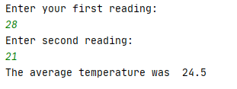

2a. The area of a triangle is calculate by the formula ½ base * height

(Sometimes written base * height )
------------------
2 (base * height) / 2

Write a program to allow the user to enter base * height and calculate the area of a triangle.
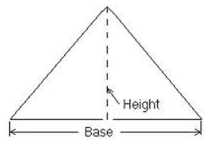

Sample output:

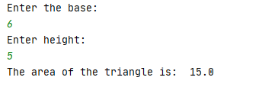

2b. A person would like to calculate how much room there is in their tent. Here is a picture of the tent:

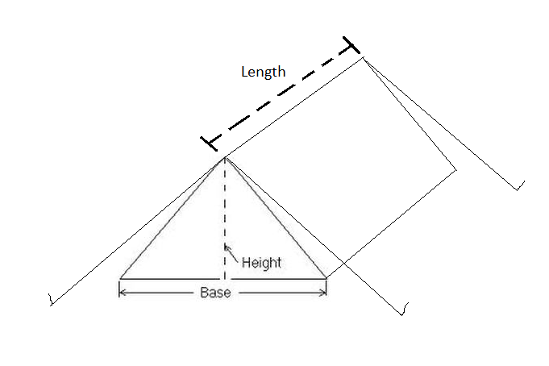
Adapt your program from 2a above to calculate the volume of the tent and print the result on the screen.

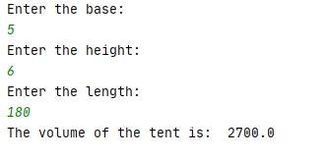

3. Post-Covid, I am going on holiday to USA. I have saved £230.55 to spend on American snacks I want to change my pounds to dollars in advance. Write a program to allow me to calculate the amount in dollars and print the result on the screen.

(Hint: you could use a website such as http://xe.com to look up the current exchange rate)

Sample output:



