Managing Enterprise in the 21st Century

STUDENT NAME : MD SHAHIN AHMOD
STUDENT ID: 1706992
LECTURER NAME : DR HUSAM HELMI

Table of Contents
Executive summary 1
Introduction 2
Business description 3
Market analysis 4
Financing and funding 7
Application of a range of employment skills 8
Conclusion 9
References 10

Executive summary
The UK is a place for growing fast food business and businessmen of this industry are doing good day by day. The main idea of this business is to establish a multilevel fast food restaurant in South west Wales. Though the fast food business is pretty common and trendy in the UK, this type of fast food idea is pretty uncommon and also will be very helpful for every kind of customers. In this restaurant, not only people just can buy food and eat but also can arrange a formal business meeting, throw a small party and so many other things. The initial funding of this business will be done by personal funding and by granting a small amount of loan from the local bank

Introduction
Managing an enterprise in the 21st century, especially in a young age, is a tough challenge for every individual. Entrepreneurship is a much more challenging and freedom based occupation than any other occupation in the world. Entrepreneurs can think of the way they want, they can do anything as the way they want to be done. In addition to that, entrepreneurship also provides all kinds of support to an individual regarding the real knowledge about the enterprise, information regarding be self-employment and information and knowledge regarding the relevant skills that are needed to be a self-employed. In this report, a new type of business plan will be designed and the business idea will be thoroughly evaluated and examined. In addition to that application of a different range of employment, skills will be applied to the business idea.

Business description
The UK is the region where people have the record of consuming highest fast-food in their daily life. This has been possible for only having the diversified culture within the UK region and people of UK are having a busy daily schedule all day long. On the other hand, having different cultural taste, people would love to share each other’s culture by sharing the foods as well. Due to this reason, the UK has the global success in the fast-food business. A recent study says, the fast-food industry in the UK has been grown up by 25.6% and reached to a value of $15.2 billion (Pieroni and Salmasi, 2014). This fast-food industry of UK has been captured by some main players such as McDonalds, Burger King, Greggs, Thurstens, KFC, Pizza Hut, Domino's Pizza, Fish and Chips, Indian and Chinese Takeaway and many other street food restaurants. The fast-food business in the UK is getting very popular due to requiring a less capital than any other traditional business and the number of customers is also very regular in this business.
The business idea of this report is to establish a multilevel fast-food business in the UK especially in the south west Wales. Now the question may come why the idea of fast-food business would be a new idea which already exists in the market of UK and all over the world. First of all, the idea is pretty unique because of its way of providing services to the customers (Hisrich, Peters and Shepherd, 2017). This fast-food restaurant is not going to serve to the customers in a usual manner rather it will follow a different manner from other fast-food business in the UK industry. In a traditional fast-food restaurant, people give order and wait for their foods to be served. Some people finish their food by sitting inside of the restaurant and some other want the restaurant to make the order in a parcel (Stein, 2017). There is such a little place to sit inside of this restaurant and having a meeting whether it is a formal one or not. The percentage of rushing within this restaurant is pretty much high. Whereas in this restaurant, customers will have the opportunity to arrange formal and informal meetings, throw a small party, finish their food comfortably in a simultaneous mode.
The business will be providing both the wholesale and retail services to the customers. In addition to that this restaurant will be a sole-proprietorship business.

Market analysis
The fast-food market of the UK has been analysed through two popular theory of analysis. One is the PESTEL analysis and the other one is Porter’s five-factor analysis. A brief analysis regarding the UK fast-food industry is given below:
PESTEL analysis of the fast-food industry of UK
- Political: The government or the authority of UK had set new rules regarding the genetically modified labelling in the fast-food industry since 2004. By launching this rule, the government of UK has tried to ensure the health safety of the customers. That is why, this industry is also the safest industry for a start-up business (Scott, 2013).
- Economic: The cost of launching a new business in this sector of UK is very much lower than the other sectors. On the other hand, start-up business can be started with the help of several franchises. The most attractive fact of this market is it is the fastest growing market from many sectors in the UK. A recent study says, the fast-food industry in the UK has been grown up by 25.6% and reached to a value of $15.2 billion. The fast-food restaurant business even popular in the time of recession due to its non-stopping sales.
- Social: This industry is a society friendly industry and also pays a close attention to the society in every aspect. People of the UK also love this industry due to saving the time of their busy schedule (Scott, 2013).
- Technological: Technology has a huge role in the success of this industry in the UK. Competitors are using any types of modern technologies in their business operation which is helping them to provide better and healthier services to the customers. The competitors are also providing online delivery and this is a time-saving matter for the operations of the business (Hanaysha, 2016).
- Environmental: Many fast-food outlets such as KFC, Burger King and others are now maintaining the law of animal rights for doing the righteous duty to the environment. These competitors are also putting concentration on producing raw materials and disposing of the wastage in a way so that the environment remains harmless.

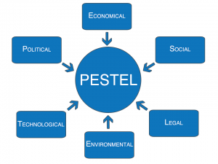
Figure: PESTEL analysis (Scott, 2013).
- Legal: This industry of UK is also concerned with the health and safety guidelines that have been set by the proper authority of UK. To ensure the health and safety issues of general public, the competitors of this business industry needs to follow the regulations of FSA (Food Standard Agency) properly.
Besides PESTEL analysis, the fast-food industry of UK has been analyzed through the helping of Porter’s five factors analysis. A brief explanation is given below:
- Buyer power: Though everybody doesn’t like fast-food like the homemade food, the competitors in the UK fast-food industry are offering a vast range of unique items that are attracting customers. This idea is actually weakening the power of the buyer and making strong the brand loyalty. Customers are also getting attached to the service of these restaurants day by day (Eiteman, Stonehill and Moffett, 2013).
- Supplier power: This industry has around 4600 leading suppliers who are actively working in this market. The power of supplier is increasing within the market because the restaurants have to depend on them because of the raw materials of foods.

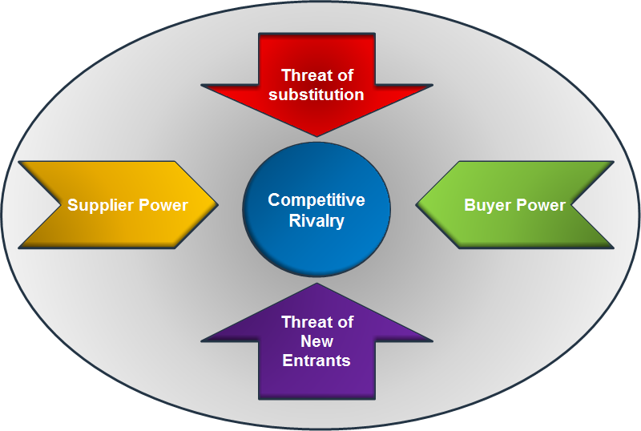
Figure: Porter’s five factors analysis (Eiteman, Stonehill and Moffett, 2013)
- The threat of new entrants: It is difficult to earn profit quickly in this market by competing the established competitors in the market. Moreover, the new entrants have to comply with the rules and regulations of proper authority which will be a limitation for the business. But creating and delivering a unique idea might be a way of surviving within the industry (Hall and Schulz, 2011).
- The threat of substitution: The main substitute products of the fast-food are the frozen foods, ready-to-eat-meals and so on. But, fast-food is cheaper and quicker than these substitutes. This is the main attributes of fast-food to become popular among the people. That is why the competitors don’t need to be worried about the substitute’s products.
- Competitive rivalry: This industry is a place of huge competition. Many established and new start-up competitors are doing business and they are having huge competition among themselves.
So from the above analysis, it can be said that starting a new business in this sector will be a challenging matter and also a profitable one due to its rapid popularity.

Financing and funding
The financing and funding of this business will be a little bit higher than the traditional start-up business due to serving a large number of customers at a time in one place. The total budget for launching the business will be around £45000. A brief scenario of allocating the budget is shown below:
Particulars | Amount
License and registration cost | £2000
Rent of the premises | £13000
Decoration | £20000
Raw materials | £10000

The funding of the business will recover from three sources. A brief explanation is given below:
- Personal source: Personal funding is a great source for a start-up business. This initial stage, 40% of the total fund will be collected from personal savings, relatives and other personal sources.
- Angel investing: Angel investing is that kind of investment into a business by another firm (Hall and Schulz, 2011). The firm will help the start-up business by providing several advice and also provide a report to the bank as a security.
- Loans from the bank: Many banks in the UK provide a loan to start-up business against a little amount of collateral. 60% of the total fund will be collected through the loan.

Application of a range of employment skills
There are certain employment skills that need to have an entrepreneur. These skills will help the individuals conquer anything within the business industry. A brief explanation regarding various employment skills is given below:
- Communication skills: Communication skill helps an individual to understand the mindset and the demands of another party. In the fast-food business, the management of the business needs to understand the demands of the customers and needs to provide according to the demands of the customers. Communication skill will also help to understand the trend of the market and the movement of the competitors as well (McDonough, 2017).
- Technical skills: Technical skill shows the enrichment of the practical knowledge of certain individuals. For the fast-food business, it is important to know about all the technical aspects of the business and how the market is reacting to any technological changes.
- Team working skills: Team working skill is another important skill for any employee or any team leader or for any certain individuals who basically work within a team. Through team working a brief analysis and all the possible solutions to the problems can be found in an easy manner. On the other hand, the success rate of working within a team is much higher than working alone for any project (Tulgan, 2016). In the business like fast-food, people need to work within a team so that any challenges can be faced by having lots of possible solutions and options.
- Organizing and prioritizing: all the works should be done in an organized manner so that the works don’t mix up with each other. After organizing the work, the works must be done by giving proper priority (Austin, 2012).
- Flexibility: Flexibility helps a person to adopt things quickly within an adverse environment. A flexible person is always up to take any challenges and accomplish the task without any failure. Fast-food business must be done in a flexible manner so that it can comply with any situation or challenges that might hamper the operation of the business.
These are most valuable employment skills that a person or an employee must have to make him or she adapt to any situation or any condition.

Conclusion
Managing an enterprise in the 21st century is a tough job especially when an individual wants to start his or her business in such a market where already many established organizations are doing business successfully. To survive in this business industry, the organization or the business idea of the organization must be unique than other business organizations and must be very customer friendly. The government or the proper authority needs to be more helpful to these start-up businesses.

References
Austin, D. (2012). Human services management. New York: Columbia University Press.
Eiteman, D., Stonehill, A. and Moffett, M. (2013). Multinational business finance. Boston [Mass.]: Pearson.
Hall, K. and Schulz, C. (2011). Hospitality. New York: Ferguson Pub.
Hanaysha, J. (2016). Testing the effects of food quality, price fairness, and physical environment on customer satisfaction in fast food restaurant industry. Journal of Asian Business Strategy, 6(2), pp.31-40.
Hisrich, R., Peters, M. and Shepherd, D. (2017). Entrepreneurship. New York, NY: McGraw-Hill Education.
McDonough, T. (2017). Closing the Skills Gap: Key Learnings for Employers and Job Seekers. Employment Relations Today, 43(4), pp.49-54.
Pieroni, L. and Salmasi, L. (2014). Fast-food consumption and body weight. Evidence from the UK. Food Policy, 46, pp.94-105.
Scott, S. (2013). Labour, Migration and the Spatial Fix: Evidence from the UK Food Industry. Antipode, pp.1-20.
Stein, S. (2017). American Fast Food Industry Making Millions for the Medical Industry. Nutrition & Food Science International Journal, 2(2).
Tulgan, B. (2016). Bridging the Soft-Skills Gap. Employment Relations Today, 42(4), pp.25-33.

