Name: samadi Tawfiq
Student number: 2212531
Module name: Marketing essentials BMIH4005
Tutor: Christopher Wilkin
Word count: 1375

Title:

A comparison of the marketing methods of two multinational hotel brands

One of the chosen hotel brand is the Marriott Hotel, the hotel brand started in Washington with a
family business in 1927 then the owners extended their services all over the world. Today the
Marriott International, Iinc. Is a well-known hospitality company in the world. I have chosen this
brand because it is a famous hotel brand and I would like to know more about that what is behind
their success. Marriott international (2022)
The chosen hotel brand is the Premier Inn. The first Travel Inn hotel opened in Basildon,
1987. Then in 2004 travel inn merged with another hotel chain and got the name of Premier Inn. The
chain can be found from north Scotland to South England. I have chosen this brand because as I
guest I know them I have stayed in their hotel several times. I thought it would be nice to know more
about their marketing strategies. Osborne (2004)

Marriott hotel marketing analysis
It is a luxury hotel brand what aim to reach customers who looking for a quiet wealthy
accommodation. They made different target markets withing the industry .The target market is a
group of consumers at which the service is aimed.
Target Market segments of Marriott international: Marriott Courtyard- Road travellers, Ritz Carlton Hotels – Luxury travellers, Marriott Conference Centres- Business meetings, Marriott ExecuStay- people who need month long accommodations, Marriott Vacation Clubs – Travellers who like to shop. Iide (2022)

Marketing Mix
Marketing mix is the combination of advertising, public relationship, personal selling and direct marketing tools what the business uses to reach customers. ( Kotler & Armstrong 2018)
This marketing mix will include the 4Ps: product, price, place, promotion.
1. Product strategy: Their product strategy covers Luxury, Premium, Select and longer stay
categories.
2. Price strategy: Marriott is one of the business who managed to maintain their prices despite
the competitive market. Their price strategy that they go beyond customer satisfaction for
the price they pay.
3. Place strategy: Distribution strategy plays an important rule in the company life. Its
hotels are mainly located in major cities and towns.

4. Promotion strategy: I believe the Marriott hotel International biggest promotion advantage
the brand itself, people know all over the world and it has a good reputation. Also they
promote themselves on digital mediums: website, social media, customer loyalty program.
In the recent years the company started to focus on digital marketing approaches instead of
traditional marketing approaches. The drum (2022)
The president of Marriott International said on his blog “What
social media is allowing us to do is not draw attention to ourselves, but to see our guests in
their own spotlight”. Sorensen
Digital marketing
Digital marketing is getting more popular in marketing. Digital marketing strategy is to establish the internet through online channels like social media, apps, paid ads etc. According to Hootsuite (2022) research the total number of global internet users are 4.72 billion. So it understandable why Marriott try to expand their digital marketing. The next few digital campaigns will show the ways how they are reaching customers through different channels.
In 2015, M live is a social marketing innovation platform what is made to engage customers to share their life moment with other guests. Marriott International (2016)
In 2017 Golden Rule campaign, the centre of the campaign is the human, they celebrate the Marriott’s history of warmth, familiarity, human connection.
In 2019 Marriott it is a loyalty program what gives customers gratuities and discounts. It also gives members access to sport and entertainment events. Marriott International (2022)

Ongoing marketing strategy
The Marriott International ongoing marketing strategy to work within all hotel portfolios and
manage them according to the values of its founders. Now they have approximately ninety million
members internationally. Their newest marketing campaign is the “Stay your way with Marriott” The
campaign inspire customers to travel to Dubai’s and Abu Dhabi’s Marriott hotels by providing
0materials to travel agents to reach their customers. Travelmole (2022)

Covid-19
Covid-19 pandemic has changed the world for everyone. The hospitality industry one of the hardest
hit by the outbreak. During the covid they still tried to engage customers. When the outbreak
happened the CEO realised an emotional video. This honest and inspiring message went worldwide.
The company has offered rooms for Covid responders. They have changed their cancelation policy
for 24 hours during the pandemic. Their main message during covid was “we will travel again”
Their marketing messages after the covid pandemic mainly focused about their commitment of
clean health and safety protocols. Also their new messages about to build confidence with
customers again. Medium (2020)
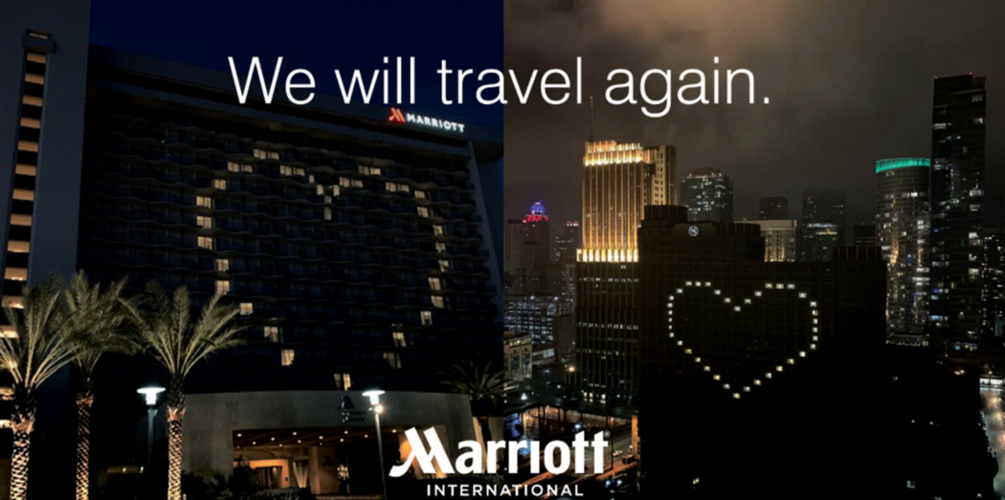 Medium (2020)

Green messaging:
They have launched the serve360 to empower communities through cooperate
social responsibilities. Their goals to achieve by 2025 to reduce environmental footprint: water reduce by 15%, carbon reduce by 30%, waste reduce by 45%, renewable energy to increase to 30%.
Serve360 (2022)

Premier Inn marketing analysis
Now this essay will talk about the premier Inn marketing strategy.
Premier inn segmentations: Businesses, families who looking for budget accommodation.

Marketing mix
Marketing communication mix summaries the main online channel activities what need to be manage as part of digital marketing. Chaffey ( 2022)
Marketing mix of Premier Inn, 4PS
1. Products and services
Premier inn offers a different types of room for different customers. Their family rooms are really
popular. In many of their hotel they have an interconnecting rooms for adults and children. They
provide luxury king size Hypnos bed. Premier in hotels mostly have a bar and restaurant on site.
However Trustpilot shows the customer mixed feelings about their hotel services Trustpilot (2022)
2. Pricing strategies
They use Flex, Semi-flex, Advance, Standard and non Flex rates. They use value pricing strategy,
aiming to give the best experience for the value of money. The company also uses the price
discrimination strategy, giving a lowest rate on Friday Saturday and Sunday.

3. Place and distribution
Premier Inn have 800 hotels across the UK, Ireland, United Arab Emirates, Qatar and Germany. (
Premier Inn 2022) Customers can book over their website or through third parties such as
booking.com.
4. Promotional Strategy
The company mainly focus on promotions. They spend a lot of money to advertise their self. They
aim to spend £20 million to widen their digital reach. They have 337K followers on Facebook (Facebook 2022) but much less on Instagram.
Digital marketing
Premier Inn marketing campaigns focus on digital marketing. They as well use these tools to reach, interact, convert and engage customers in different ways. (Chaffey 2022). Above the essay will shows some of the campaigns in the past.
In, 2015 The “ Wake up Wonderful” They promote the brand’s message of good night sleep. Premier Inn unveils 25m advertising campaign - The Caterer
In 2018 “ the bridesmaid’s tale” It is a romantic and joyful add what is encourage customers to keep their wedding in Premier inn. Campaignlive (2018)
In 2021 “Rest easy” brand platform. The movement was significant as premier Inn used TV advertising again with this campaign after 3,5 years. The main message that Premier inn provide the emotional benefits of the true comfort. Whitbread (2020)

Covid 19
Since Covid 19 their main message is their new enhanced hygiene promise. After the pandemic. They
invested mainly in marketing to expand their digital reach.
Green messaging
Their messages about environment actions Includes the target to reduce their carbon emission intensity. Eliminating unnecessary used plastic bottles, reducing food waste, lower energy consumption. Premier inn (2021)

Conclusion
It was interesting to see these two famous hotel brands how build up their marketing strategy. According to this essay outcome Marriott International has done a very good job on integrating digital marketing into a well organised strategy to turn their brand into a preferred chose withing the luxury hotels. Premier Inn is more available chose for the ordinary peoples and families. Their main marketing strategy focus on promotion as there are many similar budgets hotel chain on the competitive market. The essay explains different marketing mix strategies, different channels what these two hotel chains use to reach customers in the digital world. Marriott International and Premier Inn, both do a successful marketing strategy, however in the changing world it is getting more difficult to stay competitive in the hotel industry.

Reference list
Campaignlive, 2018,Premier Inn "The bridesmaid's tale" by Lucky Generals | Campaign US (campaignlive.com)[accessed 26.10.2022]
Chaffey, D., 2022. The RACE Framework: A practical digital marketing strategy framework. [online] Smart Insights. Available at: <https://www.smartinsights.com/digital-marketing-strategy/race-a-practical-framework-to-improve-your-digital-marketing/> [Accessed 26.10 2022].
Facebook, 2022, Premier Inn official Facebook site [accessed 25.10.2022]
HootSuite, 2022. The Global State of Digital 2022. The Global State of Digital 2022.
Kotler, P., Keller, K. and Chernev, A., 2021. Marketing management. 16th ed. Pearson.
Iide, Strategy of Marriott-Case study Detailed Marketing Strategy of Marriott International - A Case Study | IIDE [accessed 27.10.2022]
Marriott international online Our Story (marriott.com) [ accessed 29.10.2022]
Marriott international,2016, Marriott International Launches M Live Europe, the Company’s Fourth Global Marketing Real-Time Command Centre | Marriott News Center [accessed 28.10.2022]
Marriott international, Discover Bonvoy Discover Marriott Bonvoy | Join The Best Hotel Rewards Program[accessed 29.10,2022]
Medium, 2020,How marriott International’s respond to covid 19, How Marriott International’s Response to COVID-19 Set An Example For The Travel Industry | by Mariana Pinedo | Marketing in the Age of Digital | Medium [accessed 25.10.2022]
Osborne, Alistair (24 July 2004). "Whitbread wins Premier title". The Telegraph. Retrieved 25 March 2016.
Premier Inn, 2022, Premier Inn hotels | Book direct [accessed 26.10.2022]
Premier Inn, 2022, About us | Premier Inn [accessed 26.10.2022]
Serve 360, 2022Sustainable Goals | Marriott International Serve360 - csr-marriott [accessed 28.10.2022.]
The drum, Marriott strategy explained Marriott’s Web3 Strategy Explained: ‘It’s About Amplifying V Replacing’ | The Drum [accessed 27.10.2022]
Travelmole, 2022, If Only, Marriott roll out UAE joint marketing campaign (travelmole.com) [accessed: 29.10.2022]
Trustpilot, 2022, Premier Inn customer reviews, Premier Inn Reviews | Read Customer Service Reviews of www.premierinn.com (trustpilot.com) [accessed 01.11.2022]
Whitbread (2020) ttps://www.whitbread.co.uk/premier-inn-reveals-new-rest-easy-brand-platform-in-first-integrated-campaign-from-leo-burnett/ [accessed 25.10.2022]

