Academic and Employability skills

Student: Mohamed Wasim Samsudeen
Student ID: 1908197
Module Code: BMSW4001
Tutor: Sylvia Hoffmann

Table of Content

- Instructions……………………………………………………. 3
- Findings…………………………………………………………...4
2.1Gibbs Reflective Model (1988) ……………………………4
- Discussions………………………………………….5
  - CV Writing.…………………5
  - Personal development plan….……6
  - Time management: Eisenhower Method...7
  - Report writing………………………….8
- Conclusion……………………………………………………8
- Reference………………………………………………….9
- Appendices………………………………………………….10
9.1 Personal development plan ………….…10
9.2 CV writing………………….…….11
9.3 Time management: Eisenhower Method….…….12
9.4 Report writing……………………………………13

Introduction

Academic and employability skills include several skills that can be applied to both areas. I would like to talk about four different specific important academic and employability topics that I found very meaningful to me. The four topics which I’m going to be discussing and reflecting on will be CV writing, Personal development plan, Time management, and Academic writing. I will briefly explain and describe my own experience on how I felt whilst learning these topics for the first time and the improvements I personally learned to implement in my employability and academic skills. for example, I will be talking about what I liked, disliked, my weaknesses, my strongest points on each of the topics. By, Learning and discovering these topics has given me a new perspective way of looking at how I’m studying and the changes that I must make to succeed in my future goals. Currently, I’m implementing what I have learned and the knowledge I gained on each of these topics into my Education and professional workplace. The reflective model I will be using to describe each topic on the Gibbs Reflective Cycle (1988).

  - Findings
4.1 Gibb’s Reflective Cycle (1988)
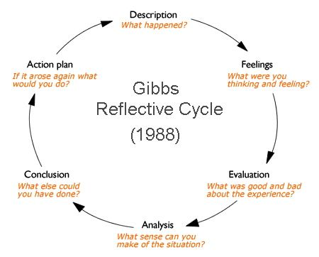

I’m going to be using the Gibbs reflective cycle (1988) to reflect on the topics that I have chosen. The Gibbs reflective cycle is used to make sense of an experience. There are six stages to this specific model such as, description, feelings, evaluation, analysis, conclusion, and action plan. I will briefly explain the topics that I have chosen to talk about on this report using Gibbs reflective model.

- Discussion

  - CV Writing
I have reviewed a poorly written CV to gain a good understanding of how that can be modified into a perfect written CV. The tutor handed out badly written CV to each of the students to find out how the CV should be written and the adjustments that needs to be done to make the CV look presentable to the employers.
For me, the experience was extremely good having discussed about how to write a presentable CV. Since, it was my first time learning to write a presentable CV. I felt great in doing this CV writing task. However, At the beginning of the CV writing task I was feeling a bit of uncertainty within myself. As, I did not know much about CV and what information I should include on the CV for me to get a job. During the session, I was paying attention to the details and listening to the tutor made is very easy for me to write a presentable CV. At the time, in my head I was thinking about my own CV and the changes that I must make instantly.
The negative side of the experience for me is that when writing the professional statement, I couldn’t really make up my mind because I was not looking to work at that moment. So, I just wrote a profile statement which came to my mind not deeply thinking about what I really want my profile statement to be.
This knowledge will be essential to me as a learner because I’m still in the progress of learning. The CV writing session went well for me because the task was clearly explained to me and I was given an extra information on how to write a presentable CV. After, I have reviewed my own CV and I was able to make the appropriate changes. For example, I got rid of few unnecessary information and edited my CV in a professional way.
I have learned that CV is the first presentation and only direct communication you make with your potential employer. It must be very straight forward, and it should only contain information which are relevant to the job role that you’re applying for. I carefully thought about designing my original CV and input only the essential information. After, I made changes to my CV I was able to get job interviews fast.
If I’m working on CV writing again the future. I would plan out how I’m going to write the CV and carefully think and reflect on what I have learned in my employability and academic module. I will include only the most important and accurate information. I will ask questions if I have any doubts or if I’m unsure of what I must do.

5.2 Personal Development Plan
The teacher described the personal development plan to us. He talked about setting short-term, mid-term and long-term time goals. And the time frame how long it will take for me to complete each of the goals that I want to achieve in a specific time and the ways how I’m going to achieve them. The outcome of the experience is that I understand what the personal development plan is and why I should consider using it in my career.
This was one of the useful topics for me because at the beginning of learning this topic I did not know anything about personal development plan. I was felt quite happy and willing to learn about personal development plan. After learning this topic, it has given me a better idea to set my specific goals and how I should go on about achieving them.

What did not go well for me is that during the session, I was asked to set my goals instantly, but I couldn’t really make up my mind to set a specific goal at that time. At this moment in my career, I have set up my short term- midterm and long-time goals. For example, after finishing this course I would like to move to a level 5 business course.

The personal development plan topic went well because it was about myself and what I want to achieve. I was able to know what I need to do right now to get to where I want to go in the future by setting a specific goal for myself.

I have learned that personal development plan is useful when it comes to outline my own personal goals and how I should plan to achieve them. I think the experience could have been more powerful if we spend more time on learning this topic. I need to carefully think and decide what I really want to achieve when I am setting goals for myself. Setting a goal which is not useful will waste a lot of time and energy.

If I get to work on personal development plan in the future. I would think clearly and make perfect decisions to guide me through to achieve my aims and goals. I will need to develop decision making skills to enable me to make proper choices when it comes to developing myself to achieve the best. Now that I have a good understanding of personal development plan, I would use all the knowledge that I have learned in my previous experience. To make my future personal development plan more professional.

  - Time management: Eisenhower Method
We have discussed about Time management using the Eisenhower method. How we are currently spending our time and how to use the time wisely to succeed whilst at university. the time management Eisenhower method has four sections Urgent, Not urgent, not important, and important.
At first, when learning about time management I was feeling happy to learn about this topic because I was struggling managing my time, I did not know how to manage my time and I needed help. I always used to allow things to the last minute. After, learning about time management I managed my time to focus on the task that are priority.
When we were discussing about time management everyone was engaged and we all were discussing about how we spend our time but most of us spend the time in the same way simply by spending a lot of time socializing and on enjoyment. The experience felt good because during the session we practice time management and we get to understand the negative and positive ways we spend our time. The negative part is that even the things that I don’t really need to do but I end up doing it without myself realising.
For me, this was one of the most important experience because as a learner I need to make sure to use the time nicely and I have to know what to do with the time that I have. How to organize and manage time wisely the time management Eisenhower method is very useful for me to manage time in a good manner.
I have learned that managing my time will give me more time to spend to do more stuffs. I must focus on the tasks that are top priority first then move on to do the tasks that are less important I will succeed more easily and quicker than others.

  - Report writing
We have discussed about writing an academic report. The structure of the report is important, and it needs to be presentable for your reader. Report is a document written for a clear purpose and to a specific audience with an accurate evidence and information.
During this report writing session I felt positive and willing to learn about it because the level 4 skills for workplace course assignments are based on writing a report. At first, I questioned a lot of things about writing a report to gain a good understanding. After, completely knowing the features of the report such as, the format, structure, and audience. I felt confidant in myself to go on about writing a report.
At first, I thought this is not going to be easy Writing a report because it must contain the accurate information and evidence. I felt quite stressed at the first stage but getting familiar with report writing enabled me to remove the feeling of difficulty and made me write a report.
I think the report writing went well for everyone because we all were learning about how to write a report focusing on writing a properly structured report. We learned the stages of the report. At first, it felt kind of hard thing to do but learning and practicing made it so much easier.
I think as a learner this knowledge of writing a report will help me in the future. I need to do more practise on writing a report because I’m not good at it as I think I’m currently. I need to develop this report writing skill and reflecting on what I learned to enable me to write a presentable report.

Conclusion
I have discussed about four important topics which I found interesting and useful to me. For example, I have discussed about, CV writing, personal development plan, time management and report writing. Learning these four skills has been very useful and it has helped me to develop myself and enabled me to achieve my short- term goals without any delays. The Topic that I have discussed in this report is vital for my future development.

References
- Alvarez Sainz, M., Ferrero, A.M. and Ugidos, A. (2019) 'Time management: skills to learn and put into practice', Education + Training, 61(5), pp. 635-648. doi: 10.1108/ET-01-2018-0027.

- University of Edinburgh. (2020) ‘ Gibbs reflective cycle’, Available at https://www.ed.ac.uk/reflection/reflectors-toolkit/reflecting-on-experience/gibbs-reflective-cycle ( accessed on 03/05/2020)

- Rolfe A. (2020) ‘Personal development planning: What you need to know’, Reed employment agency. Available at https://www.reed.co.uk/career-advice/personal-development-planning-what-you-need-to-know/ (accessed on 06/05/2020)
- https://www.dayjob.com/what-is-a-cv-622/ ( accessed on 04/05/2020)

- https://www.readingrockets.org/strategies/summarizing ( accessed on 04/05/2020)

Appendix
Personal Development Plan.
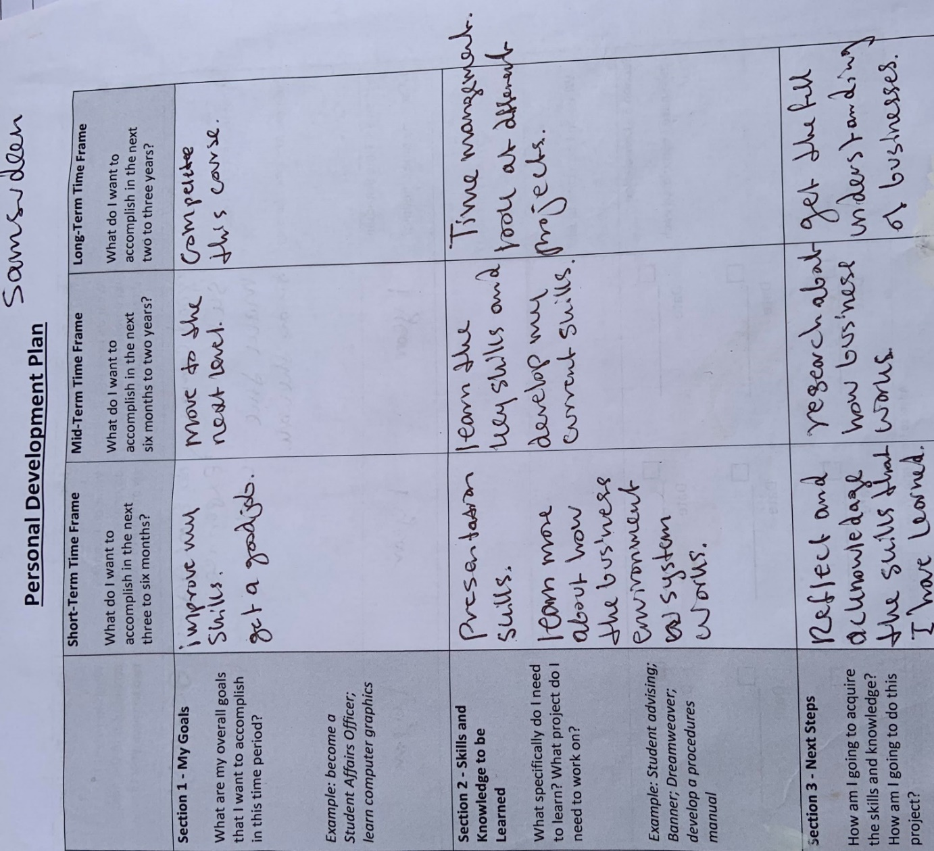

CV Writing
CV wiriting exercise.
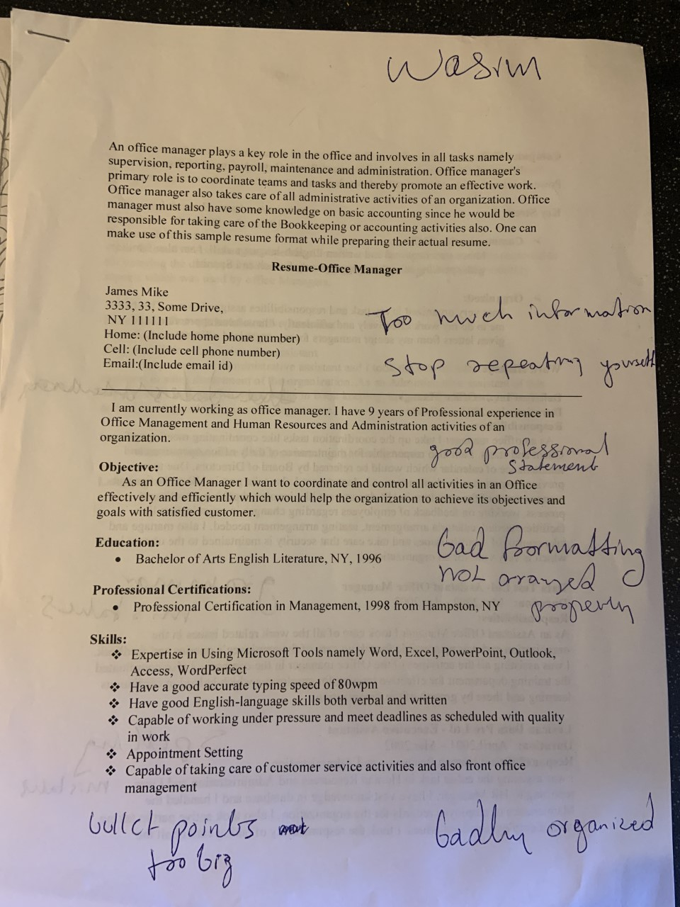

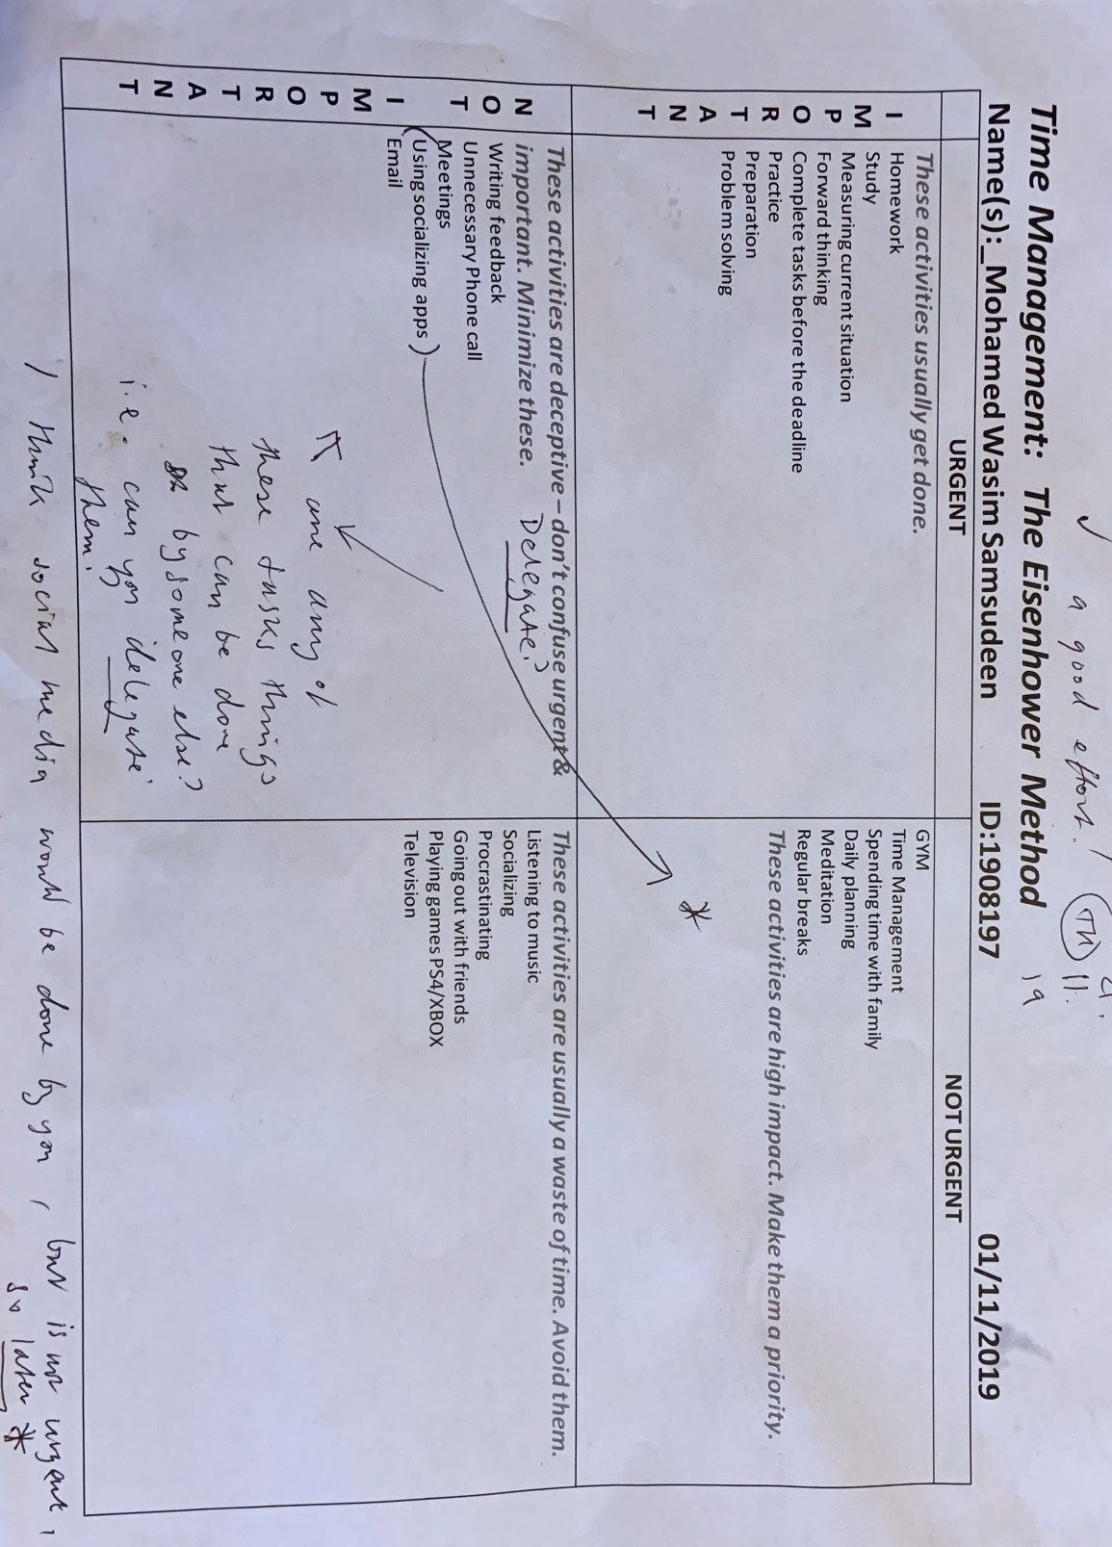
Time management
Time management exercise.

Report writing
Report Exercise.


