

Engineering Design and Materials

ACHA4001

Megan Gwilym
2200683

03/04/2024
Contents
1.0 Introduction 3
2.0 Kawasaki Ninja 1000 SX 4
2.1 Performance edition 4
2.2 Tourer edition 4
2.3 Engine and Gearbox 4
2.4 Suspension 5
2.5 Handling 5
2.6 Brakes 5
3.0 Component Design Specification 6
4.0 Material Selection 8
4.1 Aluminium connecting rods 8
4.2 Titanium connecting rods 8
4.3 Steel connecting rods 8
5.0 Manufacturing Process Selection 10
6.0 Conclusion 11
7.0 Reference List 11

1.0 Introduction
In the written assignment there will be discussions of the different materials to choose from when manufacturing connecting rods. A con rod is a vital part of any engine and can result in different strengths and disadvantages when planning material selection. To help on the decision there is a break-down of popular chosen materials, using information and material property tables.
Focusing on Kawasaki’s industries and manufacturing systems, discussing their ideas and costs, with an in-depth study of forging steel connecting rods.

2.0 Kawasaki Ninja 1000 SX
Kawasaki dropped the Z1000 SX moniker in favour of the Ninja to bring in line all of Kawasaki faired motorcycle range, right from the CBT Ninja 125, to the Ninja H2 and H2R. The press launch for this bike was set in Cordoba, Spain. It was a perfect mix of fast sweepers, tight and technical mountain switchbacks and with some time spent on the motorway and dual carriageway, the perfect environment for the 1000 SX.
When purchasing this bike, there are two options to be selected and fitted at the dealership. Known as the performance and touring packs, you can opt for either pack or go for both together. Hancock’s, S. (2020).

2.1 Performance edition
- Tank pad.
- Smoked screen.
- Frame sliders.
- Colour coded seat cowl.
- Abramovic end can.

2.2 Tourer edition
- Tank pad.
- Large screen.
- 28l colour coded panniers.
- Pannier inner bags.
- GPS bracket.
- TFT screen protector.
- Heated grips.

2.3 Engine and Gearbox
In the bodywork of the Ninja 1000 SX is a 1034cc, four-cylinder, DOHC inline engine. Throughout the years Kawasaki has used this engine, only little amounts of work have been needed making this such a satisfying unit to use.
It got masses of low-down grunt with 80 ft-lbs on offer peaking at 7,500rpm. It seems to have the same amount of show from tick-over as there is in the ‘sweet spot’, with the bike easily pulling away from lights in 3rd gear.
Mated to the gearbox is an updated assist and slipper clutch, running fewer clutch springs than the old model. The result is a clutch lever that is two-finger-light and extremely easy to use. A new item is the up and down shifter and blipper that helps you skip gears through the six-speed box. Hancock, (2020).

2.4 Suspension
41mm forks take care of the front end with rebound damping adjustability only. The rear shock is a horizontal back-link item, with a remote preload adjuster and rebound damping adjustability.
On stock settings the suspension is extremely good, giving the bike a sure-footed feeling in that it’s quick to turn but perfectly stable at any speed.
A new bypass valve in the fork allows the front end to react better to small bumps and undulations at low speeds, something that became instantly noticeable when riding through some of the cobbled roads in Spain’s rural southwest. It’s a minor update but really smooths out those jarring bumps that can make a long ride tiring for both rider and passenger. Hancock, (2020).

2.5 Handling
As with any sports tourer, high-speed stability is key, and the new Ninja is extremely stable. With panniers fitted on the launch and the speeds creeping above 100mph there are no issues at all. Standard fitment on the Ninja is Bridgestone S22 f tyres, built especially by Mr Bridgestone to Kawasaki’s exacting specification. The focus is on more grip, both wet and dry, and increased agility. The hand bars heat up quick, give plenty of grip and gives the bike a silky-smooth demeanour out on the road. Hancock, (2020).

2.6 Brakes
Another new feature is the IMU controlled ABS braking system, with Nissin and Tokiko teaming up to supply the hardware. The back brake is a quality feeling item, helping out with low-speed control via a positively set up and well-placed lever.

3.0 Component Design Specification
Its general knowledge to any vehicle owner that the connecting rods are a key component in an engine. Con rods, also known as connecting rods, transfer the power generated by the engine’s pistons to the crankshaft. Which then operates the machinery its connected to. They travel thousands of times a minute and operate under considerable strain (Perkins, 2024).
The con rod is the vital link between where power is generates in the pistons, to where it is used in the crankshaft. The number of con rods in your engine depends on the number of cylinders there are. This punishing operating environment means there can be no compromise on the quality of the materials used, or on the testing process and the manufacture of the con rod.
While con rods should not need to be replaced regularly. It is advised that they are checked for signs of wear, damage, or distortion – particularly in hard operating environments (Perkins, 2024).
The con rod connects the piston to the crankshaft to transfer combustion pressure to the crankpin. There are bearings portions at both ends, the piston side is called the small end, and the crankshaft side, the big end. Yamagata, H. (2005).
Common causes of connecting rod failure are tensile failure from high engine speeds, the impact force when the piston hits a valve or rod bearing which is usually due to a lubrication problem.
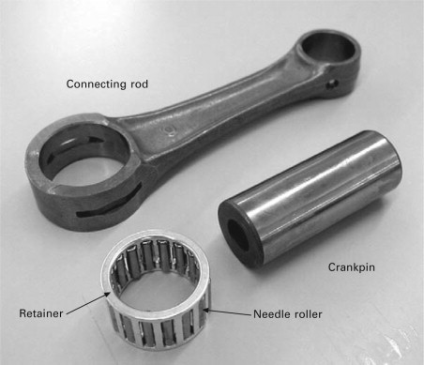
Picture 1. Yamagata, H. (2005)

The three materials commonly used for making connecting rods is steel, aluminium and titanium, which all have different costs, strength, and weight.
The bike chosen for this assignment is the Kawasaki Ninja 1000 SX. The engine block, head, pistons, crankshaft, and other internal components are typically made of various metals and alloys, such as aluminium, steel and cast iron. These materials are chosen for their strength, durability, and heat resistance, which are crucial for the performance and reliability of the motorcycle’s engine.
The connecting rods are high-tensile-strength alloy steel, it depends on which exact part of the crankshaft, but all parts are mostly steel, of various grades.

4.0 Material Selection
When it comes to the manufacture of connecting rods, material selection ensures that the component is durable enough for its purpose. For con rods, there are a few options, such as, steel, aluminium, and titanium, each has advantages and disadvantages.
Material | Pros | Cons
Aluminium | - Flexibility in construction.  - Low cost. | - Less durable in some cases.
Steel | - OEM material. | - Opportunity to improve design.
Titanium | - Most durable.  - Lightweight. | - Expensive.  - Short fatigue life.

4.1 Aluminium connecting rods
Some manufacturers claim that aluminium rods are street-able and can outlive a steel rod. An aluminium connecting rod is a spring, and there is only an X number of times a spring will compress and return to its rest state without deformation. In this case that results in failure, as with any connecting rod.
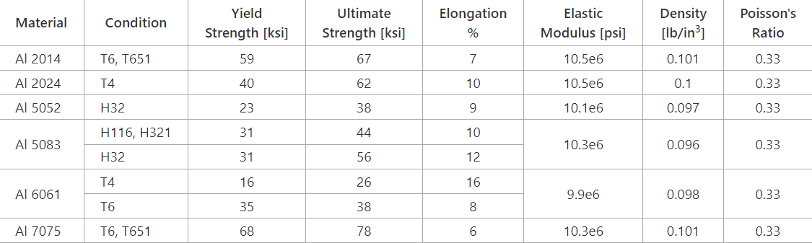
Controlled deformation and its performance as a spring and shock absorber is the reason customers seek aluminium connecting rods, but with extreme cost. Some racers change their aluminium connecting rods religiously every few runs or every season, since typically the cost of a set of rods is less than the cost of the rest of the parts in a race engine. R&R racing products (2024).
Table 1, MechaniCalc (2011).

4.2 Titanium connecting rods
Titanium connecting rods have been used for decades in high-end applications where the strength and longevity of steel is required, but the lightweight characteristics of aluminium are desired. This comes at a price, titanium rods typically are four times the cost of a billet steel rod.

The other drawback is that titanium rods do have a fatigue line in race applications and are typically switched out every 40-80 hours. Cars like the Acura NSX, some Chevrolet Corvette models and Porsche 911 favour titanium rods, but their costs along with the exotic nature of the vehicles, they reside in is reflected in the overall cost of the vehicle. R&R racing products (2024).
Table 2, MechaniCalc (2011).

4.3 Steel connecting rods
Most engines now use some form of forged steel connecting rods for its balance of strength, durability, and weight. Most designs leave room for improvement, for their design to the method of manufacture, to even the bolts that hold the big end of the connecting rod onto the crankshaft.
Most steel connecting rods are manufactured using ‘cracked cap’ technology, making rebuilding these con rods nearly impossible. On the small end, better known as the side with the wrist pin, most rods are bushed with some sort of bushing, typically bass. Wrist pins vary in materials used, thickness, and style some are thin-wall, some thick and others tapered.
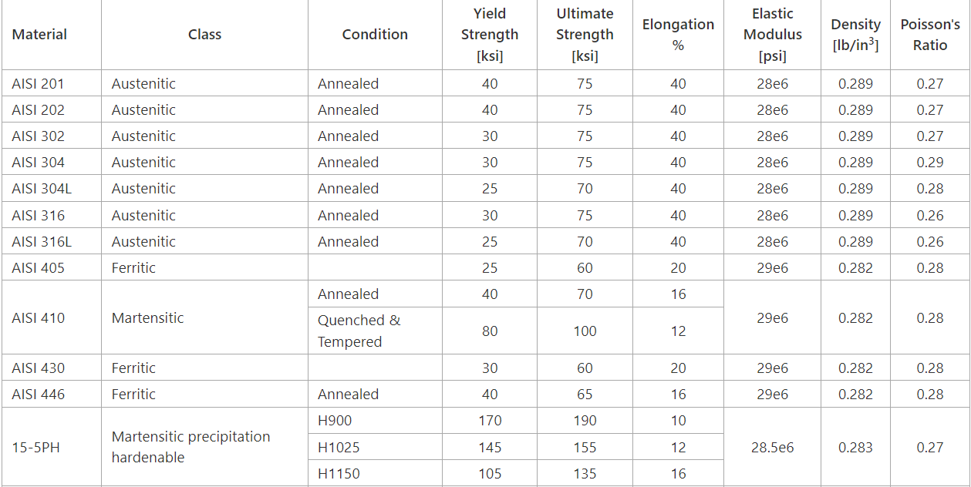
In most cases. A tool steel is used for the wrist pin. When its comes to holding the pin in floating pin setups, there are all kinds of keeper including wire-loc, spiro-loc, true-loc and even aluminium buttons, which are typically used in applications where the engine comes apart rather frequently, allowing for ease of disassembly. R&R racing products (2024).
Table 3 MechaniCalc (2011).

5.0 Manufacturing Process Selection

Kawasaki Heavy Industries Ltd. Is a Japanese public multinational corporation manufacturer of motorcycles, engines, heavy equipment, aerospace, and defence equipment, rolling stock and ships, headquartered in Minato, Tokyo, Japan.
Kawasaki favours steel as an appropriate choice when manufacturing connecting rods. For this it would be common for a company to use forging as a suitable manufacturing process. However, companies can choose from many different manufacturing processes. Some being powder metal, forging and casting.

5.1 Casting
Casting involves heating a metal alloy which will be used until its molten and pouring the molten metal alloy into ‘sprues’. Which are connected to ‘runners’ which channel the molten metal alloy into a multiple cavity mould. Casting does have low costs and a tight dimensional tolerance but can lead to low strength characteristics and porosity.

5.2 Powder metal
Powder metal manufacturing, this involves placing a mixture of metal powder into a preformed die, and then compressing the powder in the die with a compacting press to mechanically bond the powder into a perform. The perform is then sintered to chemically bond the powder in the preform, and the preform is then heated and forged in a press. Powder Matel can lead to high tolerance but has a high cost of powder metal and tooling.

5.3 Forging
Forging involves heating a piece of bar stock or rod stock to a forging temperature, placing the heated forge slug into a two-piece forging dye defining a cavity within. Then continue by, forging the forge slug using a forging press or forging hammers with multiple impacts. The part is then machined to finished dimensions. Anurag Kar (2019).

Forging can be somewhat labour intensive due to the amount of machining necessary to produce the finished article. However, the outcome has strong characteristics, which are superior to those produced by casting or powder metal manufacturing. Anurag Kar (2019).

The steel would be pre-heated by induction up to 1150℃. The bar diameter is 32mm, the time of heating for steel types is estimated at 105s. After the part is finished, the machining part of the process begins.

The main shape will be finished using a turning machine. After that the process continues for the functional parts – piston end bore, crank end bearing surface, bolt holes and threads. Once done the parts including the con rods will be surface hardened.

Brockhouse did a study into the cost of forging. a long-standing customer received a customer enquiry to supply a large quantity of after-market stub yokes to a tier 1 automotive supplier in North America. The customer explored two options: one being forging.
After discussing the requirements and specifications with Brockhouse, it was clear that machining from forging would provide a more cost-effective solution and reduced turnaround time to meet the clients’ deadline. The figures below detail the cost of forging machining from a billet and from forging 2400 stud yoke shafts and sleeves.

- Manufacture of dies and tools = £14,00.00
- Near net shape forging = £9.75 (1.8kg).
- Finish machining = £30.00
- Stress relieve = £5.00
- Total manufacturing cost per part = £50.58

With this information from the Brockhouse case study, it can be considered evidence that the forging for connecting rods will cost approximately the same, being £50.58 per part.
Considering steel is a reasonable price to manufacture and use for connecting rods, it also has a longer lasting life span than titanium and more durable in some cases as aluminium. It’s understandable why Kawasaki would choose stee types to then use forging machines to develop the final product.

6.0 Conclusion
In conclusion, the selection of steel and forging as bot material and manufacturing processes represents a judicious and time-tested choice across various industries, including Kawasaki.
Steels inherent strength and durability make it an ideal candidate for manufacturing connecting rods. Furthermore, the forging process enhances these qualities by aligning the grain structure of the metal, resulting in the superior mechanical properties and resistance to fatigue and impact.

7.0 Reference List

Anurag Kar (2019). Connecting Rod Manufacturing. [online] ResearchGate. Available at: https://www.researchgate.net/publication/330183972_Connecting_Rod_Manufacturing.
Hancocks, S. (2020). Kawasaki Ninja 1000 SX (2020) Review. [online] Visordown. Available at: https://www.visordown.com/reviews/first-ride/kawasaki-ninja-1000-sx-2020-review [Accessed 23 Apr. 2024].
MechaniCalc (2011). Tables of Material Properties | MechaniCalc. [online] Mechanicalc.com. Available at: https://mechanicalc.com/reference/material-properties-tables.
Perkins (2024). Con rods link pistons and crankshaft | Perkins. [online] https://www.perkins.com/en_GB/aftermarket/overhaul/overhaul-components/major-components/con-rods.html. Available at: https://www.perkins.com/en_GB/aftermarket/overhaul/overhaul-components/major-components/con-rods.html.
R&R racing products (2024). Aluminum Vs Steel. [online] Custom Aluminum Connecting Rods. Available at: https://www.rrconnectingrods.com/aluminum-steel-titanium/#:~:text=Steel%20Connecting%20Rods [Accessed 25 Apr. 2024].
Yamagata, H. (2005). Connecting Rods - an overview | ScienceDirect Topics. [online] www.sciencedirect.com. Available at: https://www.sciencedirect.com/topics/engineering/connecting-rods#:~:text=The%20con%2Drod%20connects%20the.

