
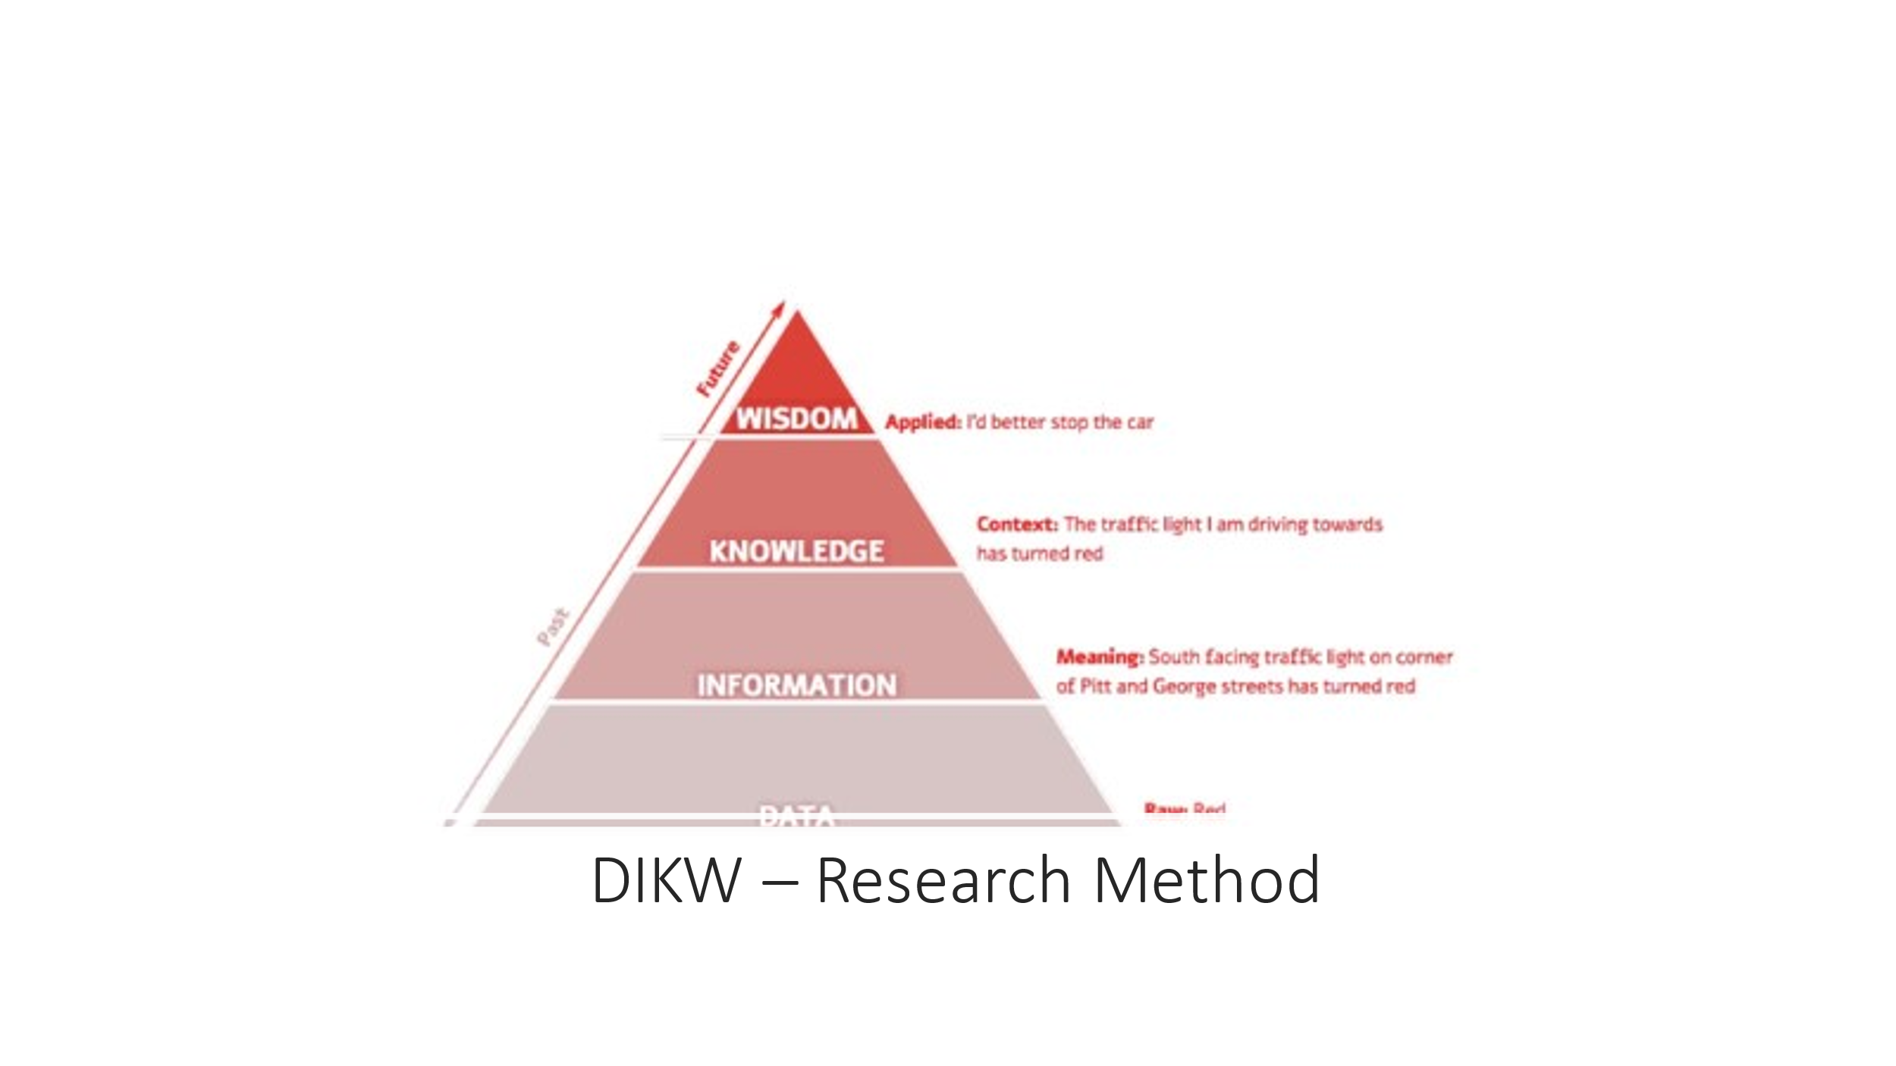

The DIKW model is represented on a pyramid that stands for the relationship existing between data, information, knowledge and wisdom. These components act as the building blocks that one passes through the journey moves from one particular lower step to the highest level. the data level comes first in the hierarchy and followed by the rest up to the wisdom level. basically, these pyramids or levels operate interdependently. However, as you add one level going to a higher position, one has to question about the data level which adds the value the preceded level in the hierarchy. Every level in the pyramid has its significant meaning and value which with the integration of all levels in the hierarchy, they give the true definition of the DIKW research method. This is to say that, the DIKW approach entails the incorporation of all these aspects in order to obtain findings that are substantive and verifiable. This method represents a learning process that is logical and sequential as one begins with the data collection step, the give meaning to the collected data through developing valuable information about the data, provide an explanation of the information on the data by developing understanding which leads to the reasoning process through the gained wisdom (Pertiwi, 2018).

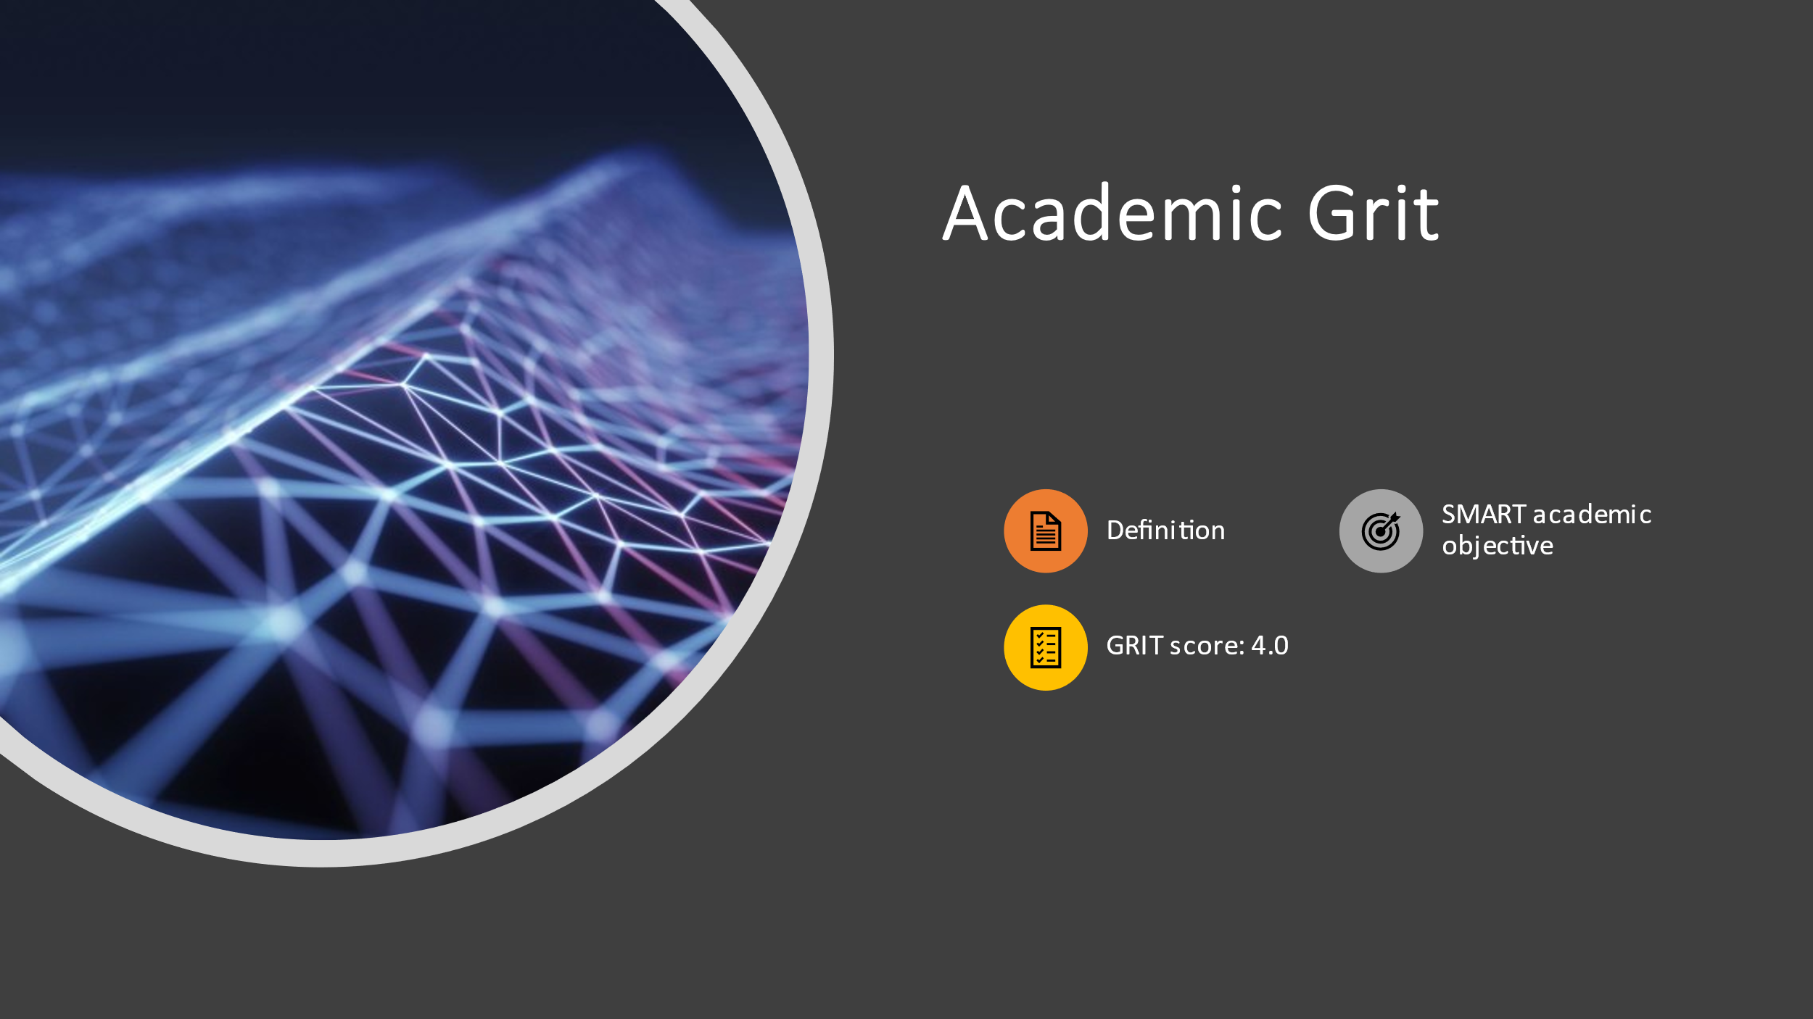
Academic grit is associated with the passion and perseverance among learners when it comes to scholarly work. Most of the Grity students are characterized with great ambitions to achieve better performance and tend to be optimistic towards academic excellence. Grit has been associated with the urge emanating in students as they navigate through their academic journey to achieve success since it is categorized as the instructional approach that accelerates the process of learning and performing the skills obtained. The influence of grit in academic approach is felt through the learning outcomes as learners with great academic grit are characterized with outstanding outcomes. On the other hand, a learner may apply the Specific, Measurable, Achievable, Relevant and Timely goals which are abbreviated to SMART Academic objectives to help them not only achieve what they want, but most significantly give reasons why they want what they want. Also, SMART objectives explain how one will get what they want and know exactly how they know when to get what they want. Grit scale normally provides the grit scores that indicate extent at which students or individuals are able to maintain the academic focus and the learning interest (Merkus & Kusters, 2019). A score of below 5.0 shows the absence of grit thus for 4.0, there is no grit at all.

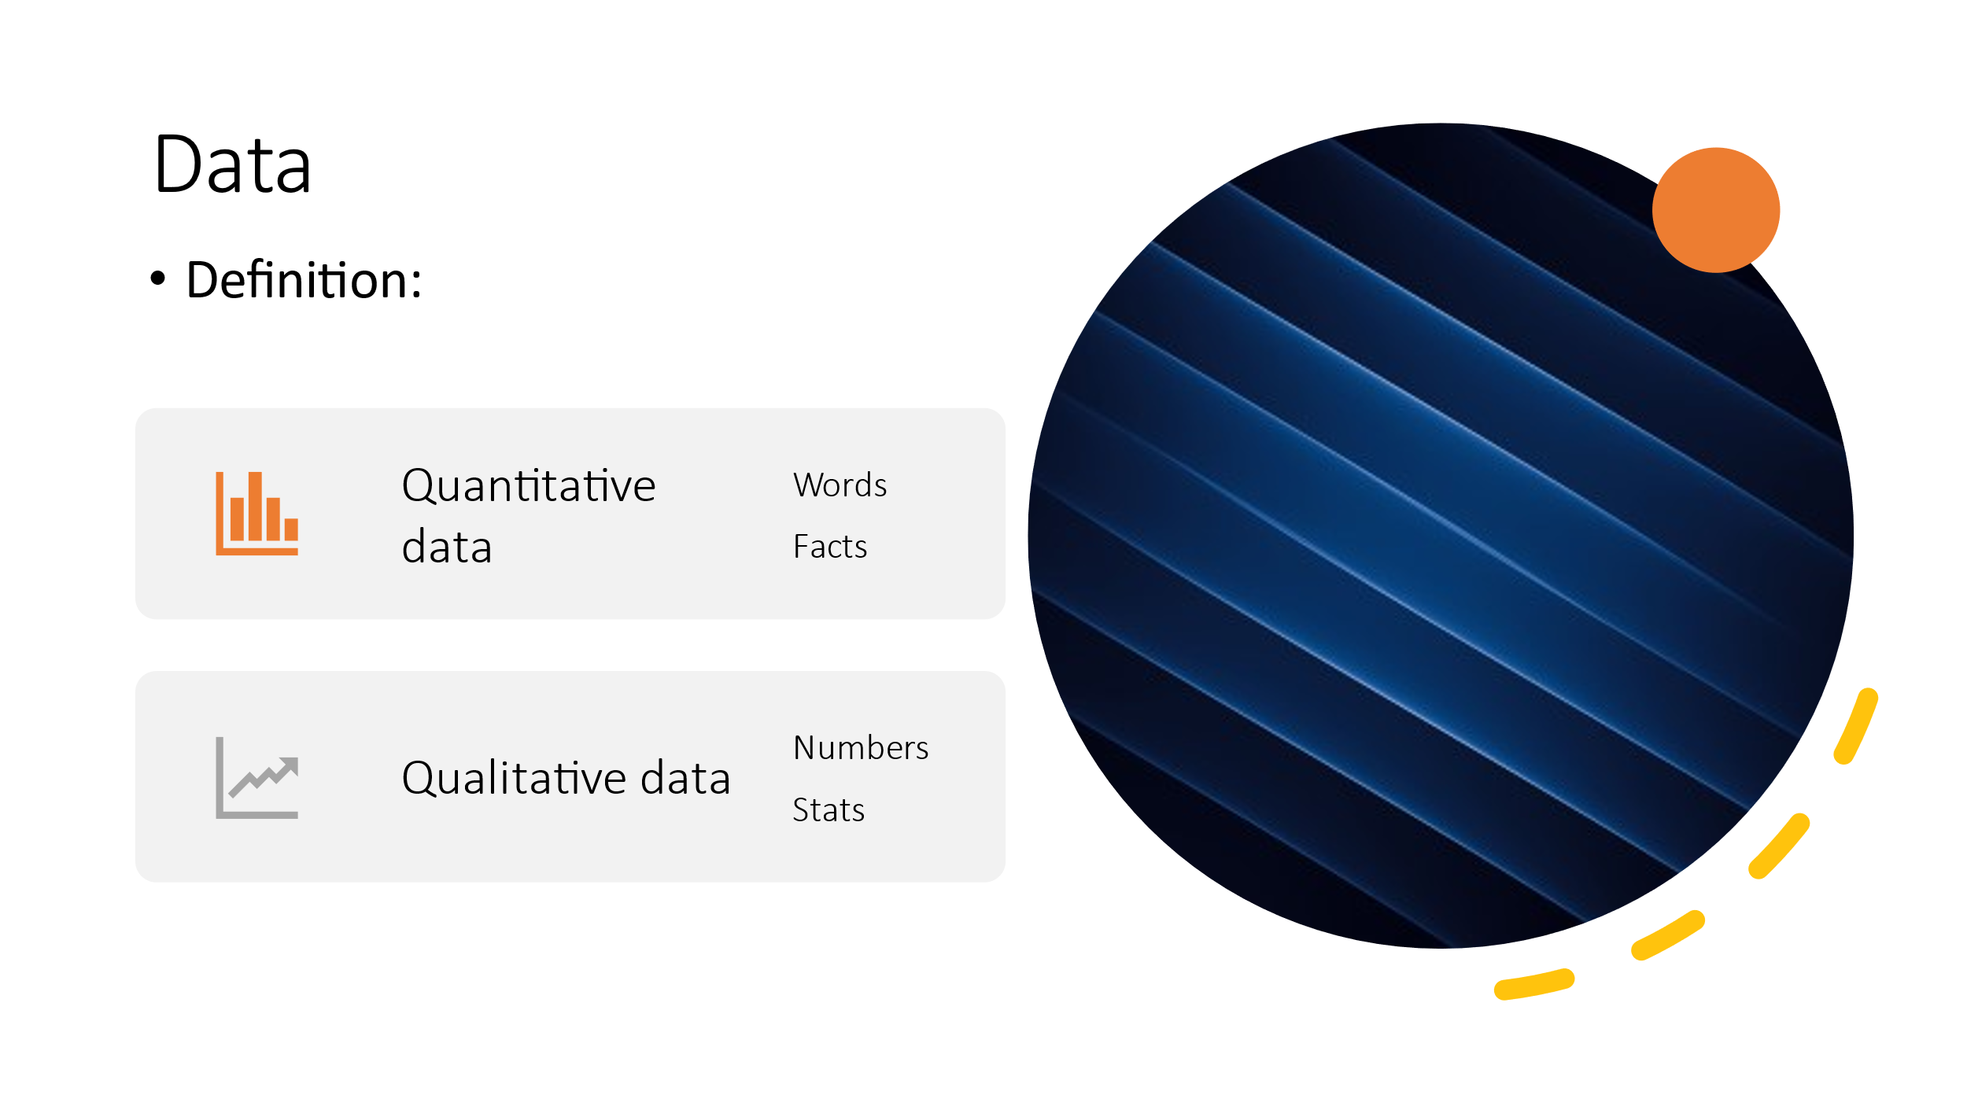

Data can be defined as the collected facts that are still raw or in unorganized form indicated by number or characters. The meaning of data is usually achieved through the presentation of such obtained facts in relation to a specific context. For instance, 12/12/2012 is appear to be just numbers if they are not explained according to the context they represent. However, when date is introduced, then we are able to get the meaning of such figures. Quantitative data is considered as the easiest type of data because, they deal with answering the questions such as; how many, how often and how much. This type of data can be represented in numbers, to stand for quantity or placed on graphical context, charts and scattered plots. In a grit score for example, a student may score 60, 70, 80 or 90 (Yusoff et al., 2017). The other type of data is the qualitative data. This form of data is obtained through measuring of facts and not using numbers. In other words, qualitative data is known as categorical data because the information can only be group in terms of their category but not numbers. Qualitative data answers the questions such; how things happen and why they happen.

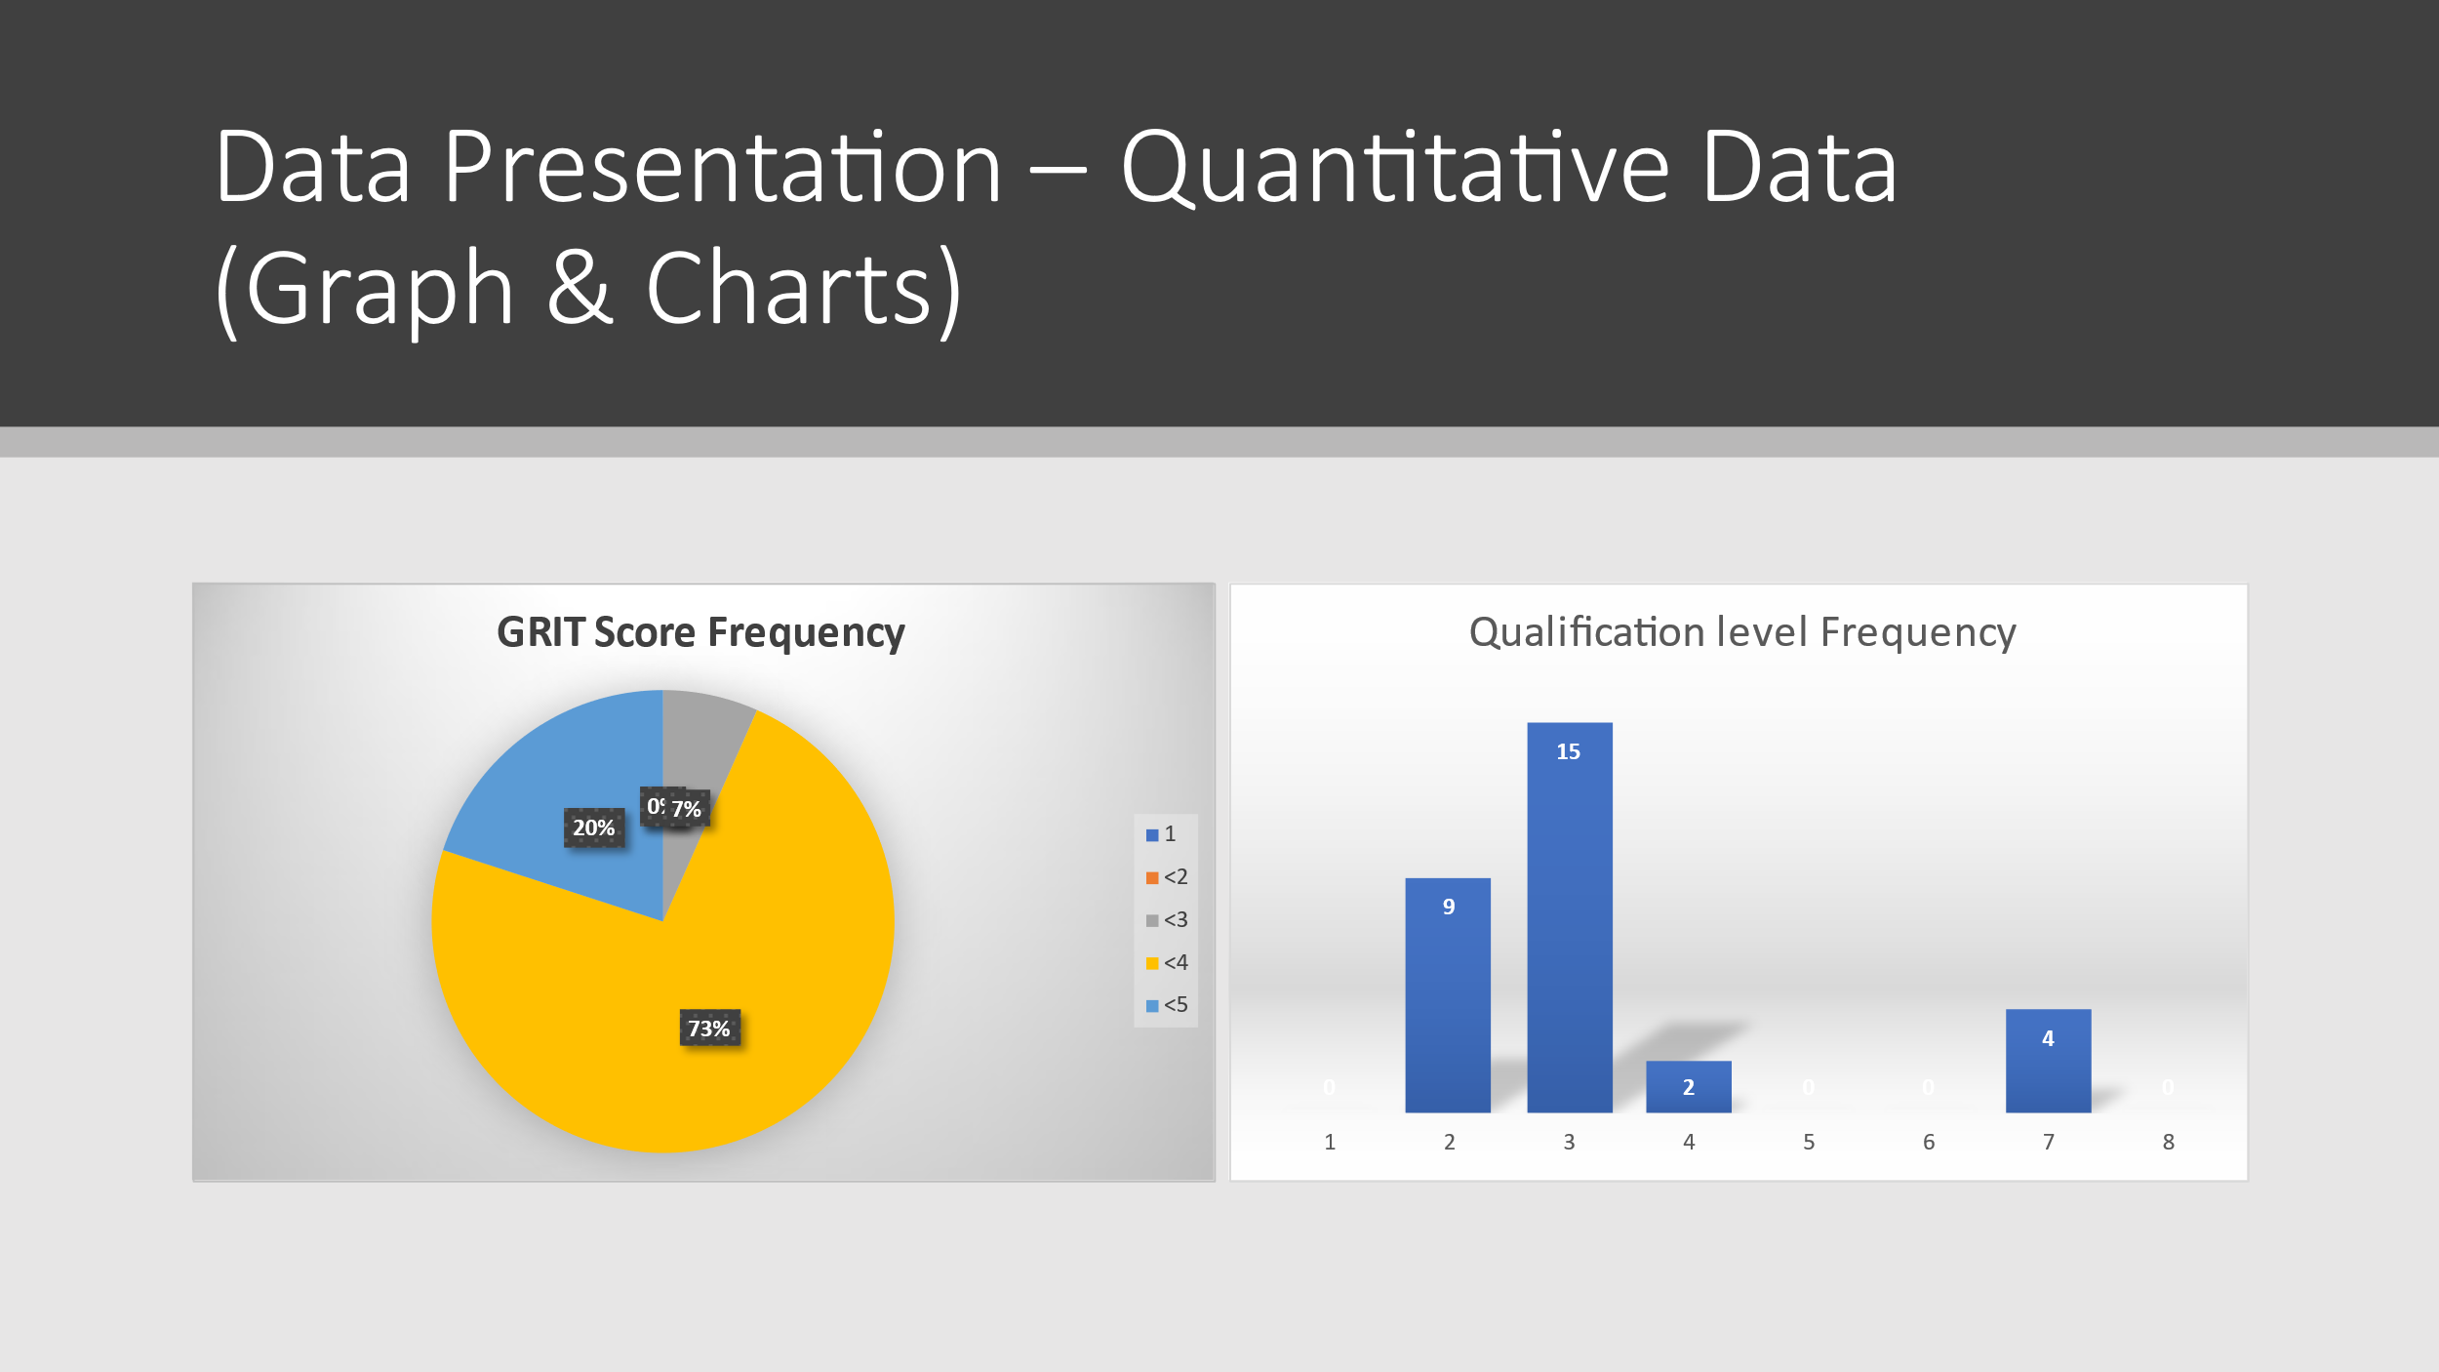
The presentation of quantitative data in both graphs and charts is very common in statistical data presentation. The grit score frequency in learners’ performance can be well presented on a pie chart that is normally used to show the perfomances scale of small values and a summation of the total facts is achievable. On the other hand, graphs can work effectively when expressing the qualification level on a data set up because, the approach normally involve a wide range of figures being tested. For the data presented above, the pie chart shows the frequency of grit scores shown in a percentage while the graph shows data distribution of qualification levels (Pertiwi, 2018). Quantitative data is presented on the graphs or charts because since they represent collected figures and values of the score in numbers, then their quantity and differences in distribution is well presented. It is on the graph above and pie chart that the figures are distributed according to their quantity and sizes identified through frequencies of the bars’ lengths and the surface area covered by the particular percentage as presented on the pie chart. Therefore, quantitative data distribution accommodates all types of figures like graphs and charts to show the exact figures on a scale (Merkus & Kusters, 2019).


Information comes after the data level on the DIKW pyramid. This also forms the critical building block in the hierarchy which represent the data which has been organized and verified to be free from errors. Therefore, this level represents the facts or figures that have been processed and can easily be measured, visualized and subjected to analysis to display a specific purpose (Yang & Lachat, 2019). In this approach, the data to be processed can incorporate various operations like integration of different forms of data, ensuring that the collected data meets the relevance and accuracy in the purpose. This is to mean that, the data may be exposed in a way that they show the relationship between different data in a scale. It is very possible to apply graphs on this level to explain the meaning of plotted values, which is normally done through the data interpretation and analysis to make the figures and numbers presented on a scale communicate the exact purpose to the interpreters. The information level extends on the values of data presented by answering the questions; who, when, what and where. By answering these questions correctly, the value of data is obtained and enable data to convey useful meaning to the intended audience.
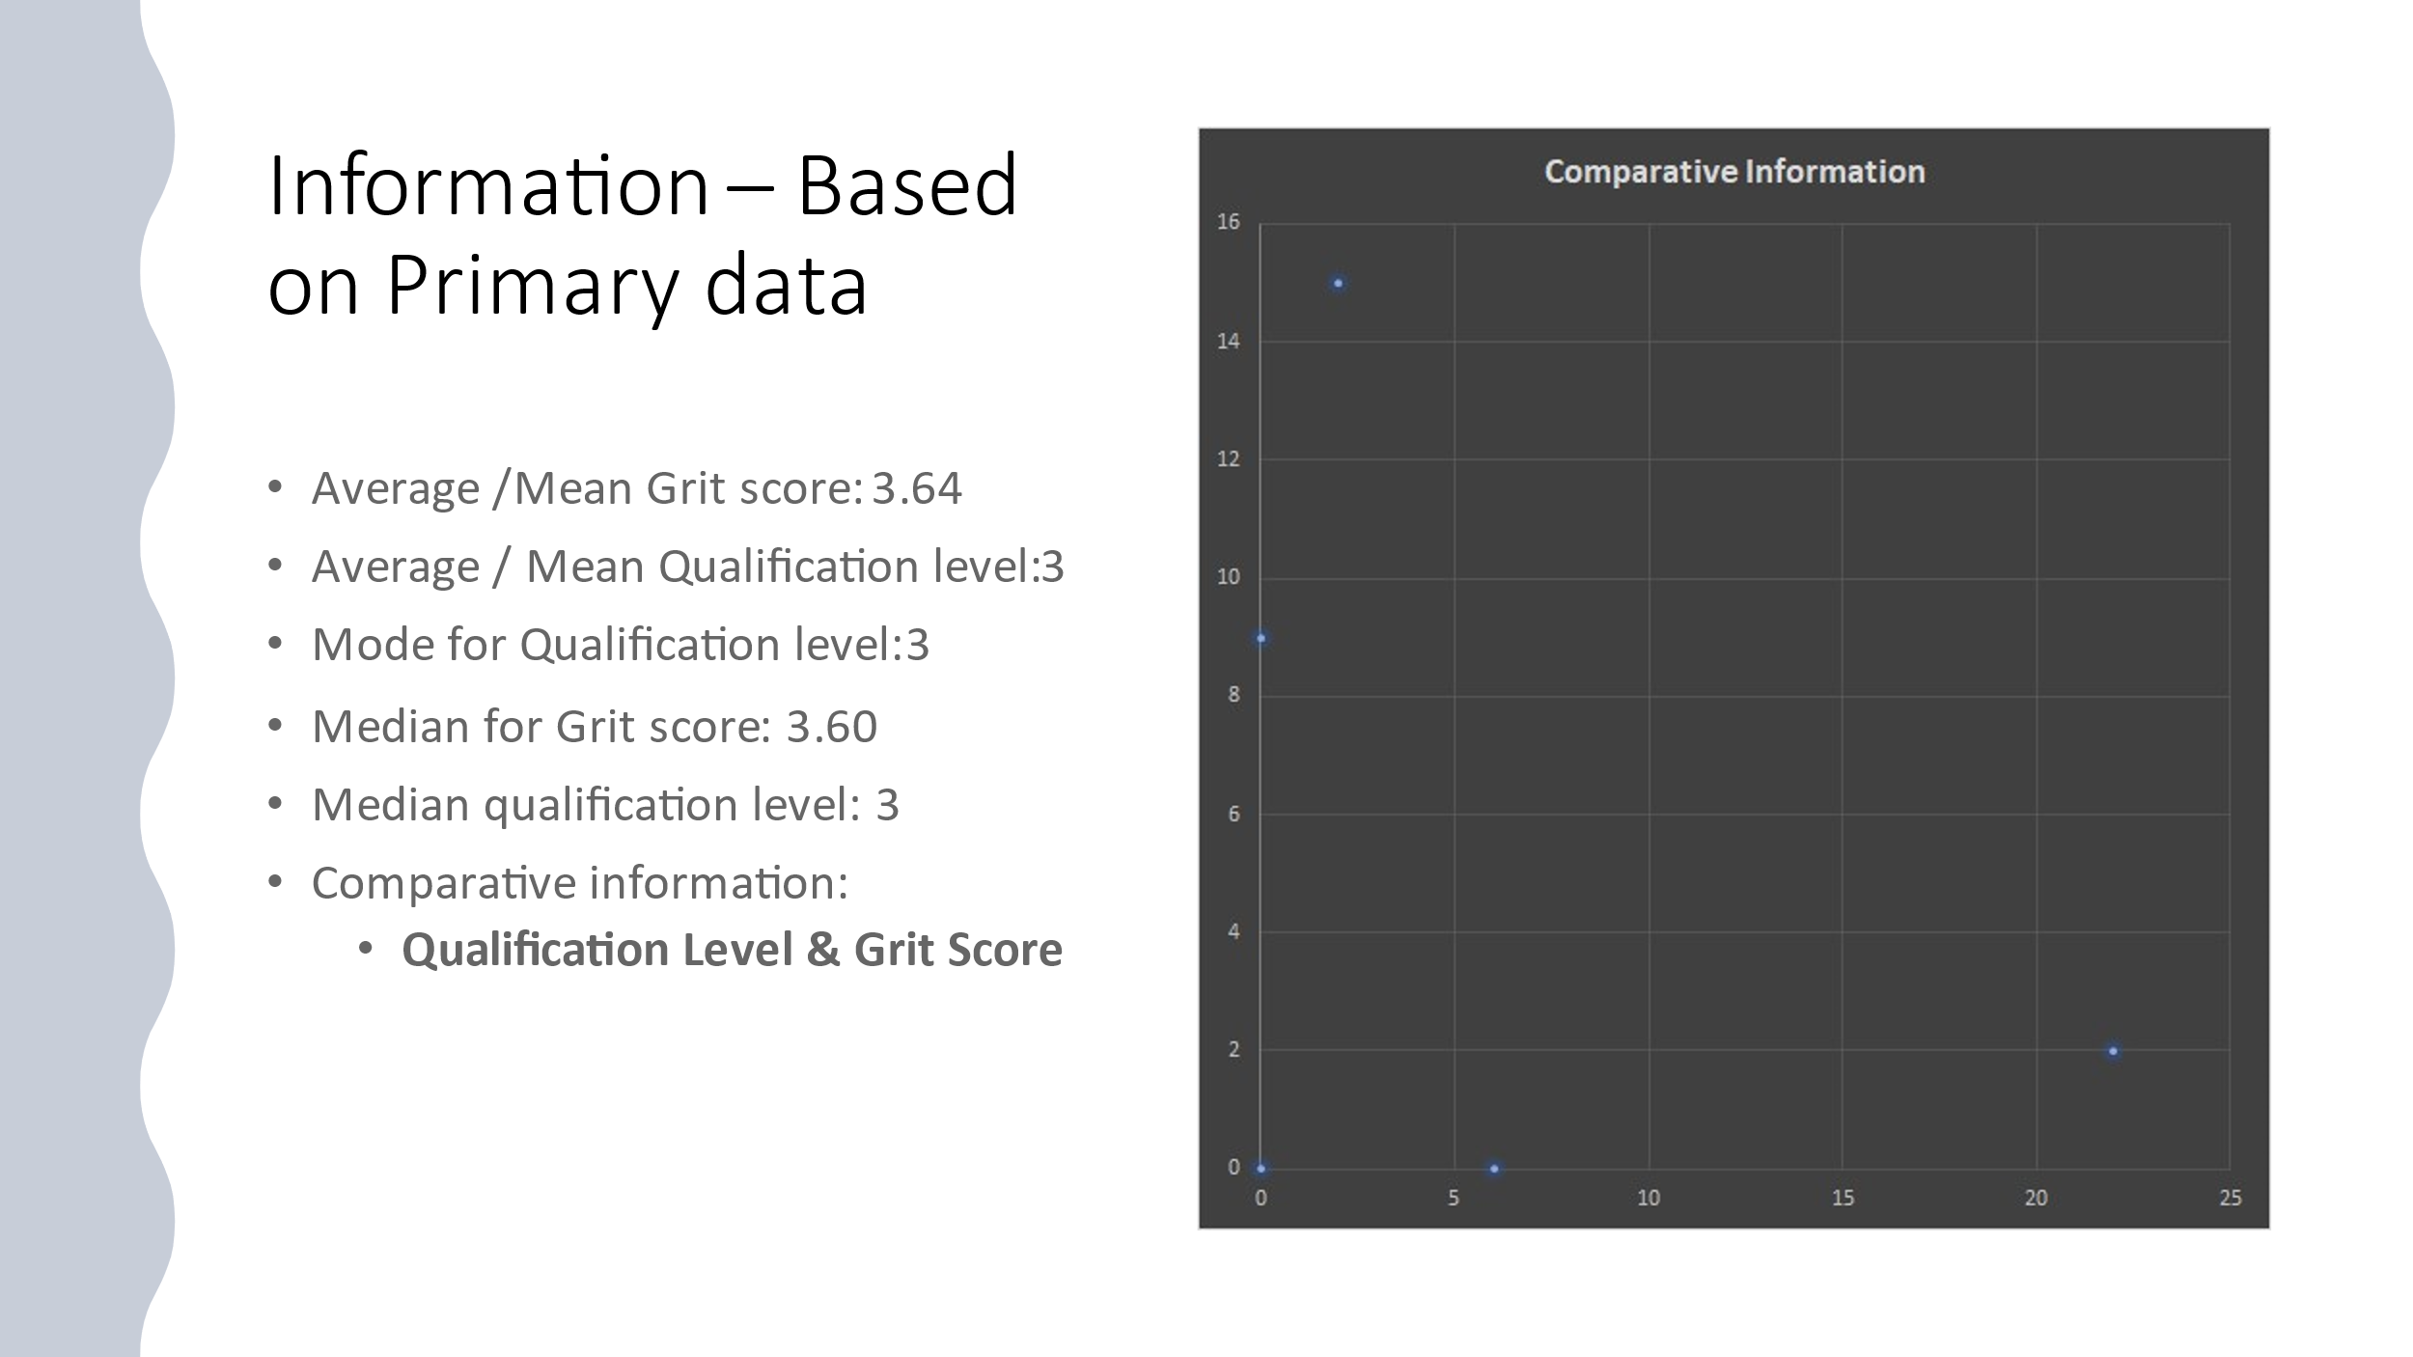

The information presented on data that is obtained from the primary source can also be explained using the mean or average, which the scores and qualifications help identify the actual characteristics of the data collected and also look at the mode for the qualification as well as relating the whole information to other aspects like the median grit score. This approach helps to interpret the meaning of the mean of 3.64 of a grit score to show that, the values investigated or presented has lower passion and perseverance in achieving the target of the task. An average qualification level of 3 also communicates that, the data was collected from a short grit scale because it lies between 1 to 5 scores. The mode qualification level of 3 shows scores that is seemingly of no grit at all. The median for the grit score here is above 5.0 and shows extremely grit because if the value of 3.60 is a product of division that shows the original value to be more than 5.0. The qualification level stands for the value of reliability that defines the rate of performance while the grit score as described earlier is that awarding of performance achievement that is obtained through the spirit of perseverance and passion to fulfil the goals of life (Yusoff et al., 2017).
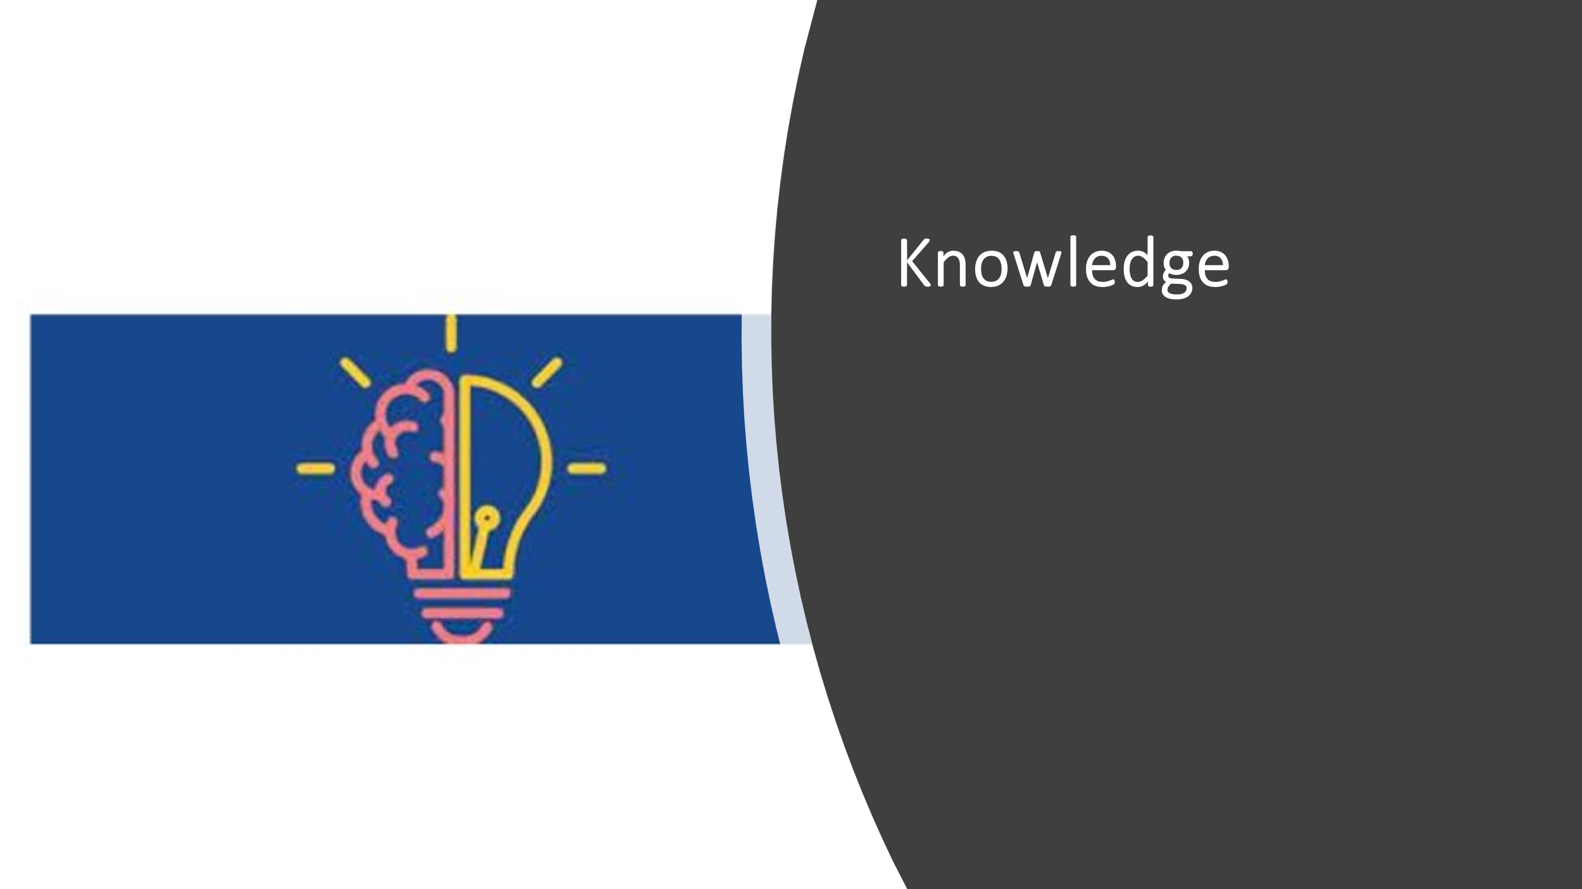

Under this level within the pyramid, the question dominating this part is “how” and this level tries to relate the data to the different areas of application in solving real life situations. The collected data after it has been given meaning, then the relevance of the information is investigated to see if it is in line with the intended goals. This means that, the aim is to identify the connection between the solution and the problem. This is to say that, the information obtained should bring the connection between the piece of data and the value it intends to instill to the individuals (Yang & Lachat, 2019). The individuals normally find the answers to how to apply the information to achieve the desired goals they have developed as a purpose of the study. Information is not only viewed as collected facts that describes certain aspects but indeed try to understand the context of the data to get the target meaning being communicated by the facts and figures. Knowledge therefore is achieved through understanding the relationship between the data and its value. Or the information and its significance when brought under its contextual application. Thus, the usefully of information discovered from a collected data is achieved through the state of understanding of the concepts and how to use them in solving and handling issues in real life.
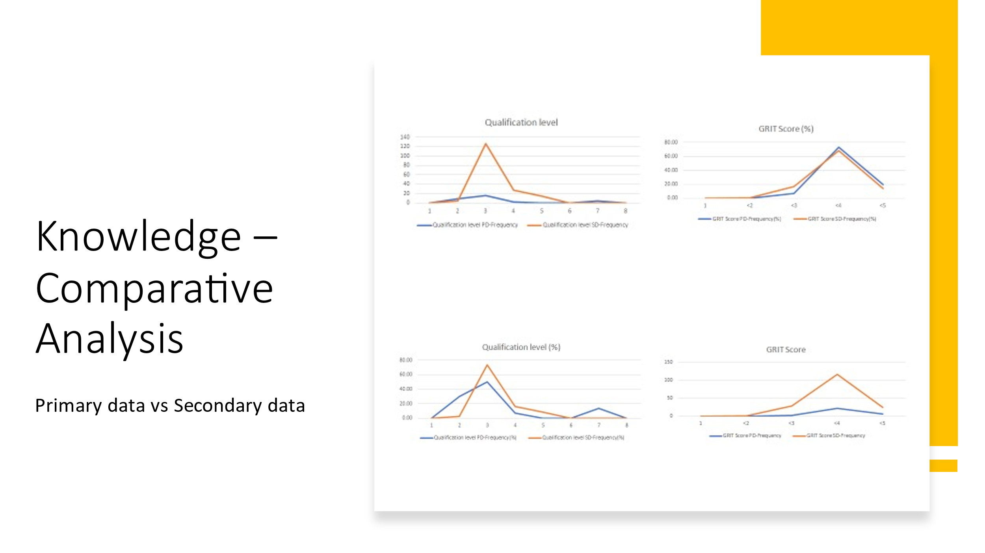

The investigation or understanding of the concepts here is navigated through the knowledge of comparison between the meaning of primary data and the secondary data collected. Primary data entails those facts and figures that are directly collected by the researchers at the field for investigation. On the other hand, the secondary data are those facts and ideas that normally have been collected earlier by someone else during a research exercise. The data presented on the graphs above show the knowledge about the qualification level and grit score values that are graphically presented. This is to say that the primary data collected is represented by the grit scores because one can be able to observe the trends and changes that are displayed on the data than the qualification level which is secondary data because, qualification is observed through a real action that is practical. Methods like surveys, observations, experiments and others are methods that are used by researchers to primarily obtain data from the field. The sites to obtain the secondary data are on websites, books, journals and other that do not involve direct collection of a first-hand information (Yang & Lachat, 2019). Therefore, the graphs show the value of having the relevant knowledge to be able to understand the information being conveyed.


The topmost or highest level in the DIKW pyramid is wisdom. Wisdom is that knowledge applied in action that is used with rationale purpose and the actions are guided by decision-making process. Individuals use knowledge to answer questions like why things happen the way we see them happening, or why we might be engaged into doing anything. This level tries to get the best out of a collection of ideas. The data and information are the stepping blocks to the achievement of wisdom because, one needs to have facts that are explained and understood before making any decision concerning the particular matter. Basically, wisdom does not deal with concentrating with what happens at the moment, but focuses with making the future better than the current situation. For learners therefore, wisdom is achieved through the power of the Grit in them as they pursue their academic goals. This is because, it takes one a wise decision to complete and successfully take all those years in school listening to lectures that do not solve the challenges affecting people at the moment and believe in future achievements. It is therefore very vital to struggle until one reaches the highest level because this is the stage in life that helps to solve complex life challenges (Merkus & Kusters, 2019).

In a nutshell, it is therefore prudent to understand that, the steps followed through the discussion provide a pathway to the approaches that learners can embrace as they navigate through their academic journey because, through the achievement of the highest level of the pyramid, it means that the level of grit is also boosted enormously which accounts for the success of the desired goals of life. chasing a dream in life resembles the hierarchy of DIKW and the entire research methods as enumerated throughout the whole process. When all these steps are well executed and followed effectively, then the individuals’ goals will be guaranteed success.


Yusoff, A., Din, N. M., Yussof, S., Abbas, A., & Khan, S. U. (2017). Predictive analytics for network big data using knowledge-based reasoning for smart retrieval of data, information, knowledge, and wisdom (DIKW). In Big Data and Computational Intelligence in Networking (pp. 209-226). CRC Press.
Pertiwi, A., & Hakim, A. B. (2018). DIKW in e-Learning Model: Adopted from Human Centered Approach. I-STATEMENT, 4(2), 75-81.
Merkus, J., Helms, R., & Kusters, R. J. (2019, May). Data Governance and Information Governance: Set of Definitions in Relation to Data and Information as Part of DIKW. In ICEIS (2) (pp. 143-154).
Yang, C., De Baets, B., & Lachat, C. (2019, December). From DIKW pyramid to graph database: a tool for machine processing of nutritional epidemiologic research data. In 2019 IEEE International Conference on Big Data (Big Data) (pp. 5202-5205). IEEE.

