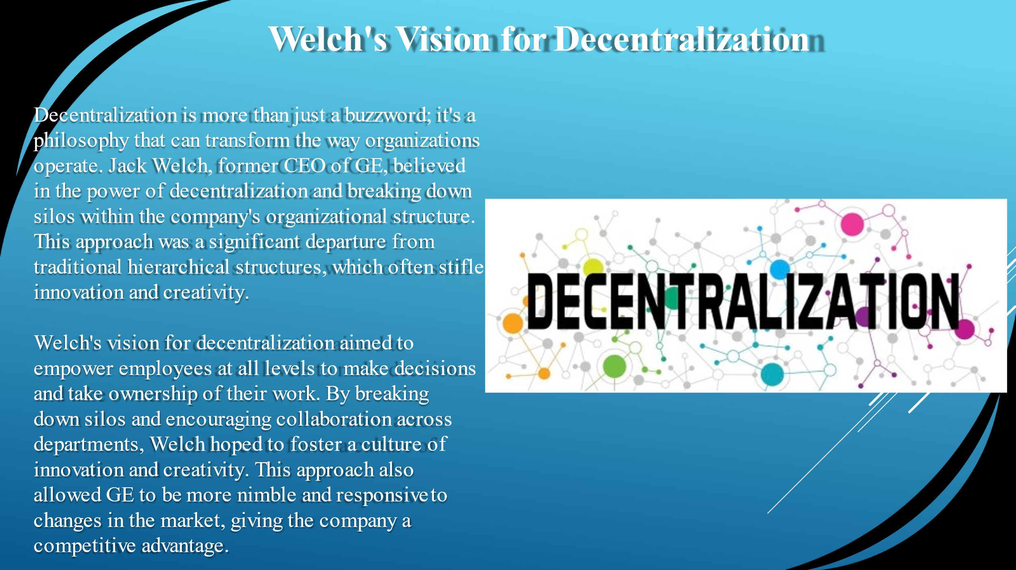
Hello everyone my name is Galabina and I will be presenting the next 4 slides. Decentralization is more than just a buzzword; it's a philosophy that can transform the way organizations operate. Jack Welch, former CEO of GE, believed in the power of decentralization and breaking down silos within the company's organizational structure. This approach was a significant departure from traditional hierarchical structures, which often stifle innovation and creativity.
Welch's vision for decentralization aimed to empower employees at all levels to make decisions and take ownership of their work. By breaking down silos and encouraging collaboration across departments, Welch hoped to foster a culture of innovation and creativity. This approach also allowed GE to be more nimble and responsive to changes in the market, giving the company a competitive advantage.

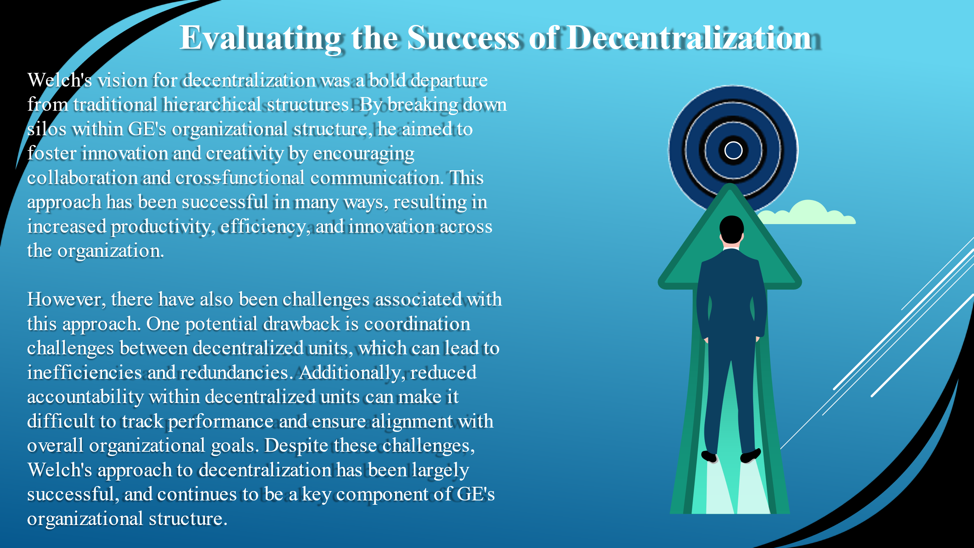
Welch's vision for decentralization was a bold departure from traditional hierarchical structures. By breaking down silos within GE's organizational structure, he aimed to foster innovation and creativity by encouraging collaboration and cross-functional communication. This approach has been successful in many ways, resulting in increased productivity, efficiency, and innovation across the organization.
However, there have also been challenges associated with this approach. One potential drawback is coordination challenges between decentralized units, which can lead to inefficiencies and redundancies. Additionally, reduced accountability within decentralized units can make it difficult to track performance and ensure alignment with overall organizational goals. Despite these challenges, Welch's approach to decentralization has been largely successful, and continues to be a key component of GE's organizational structure.

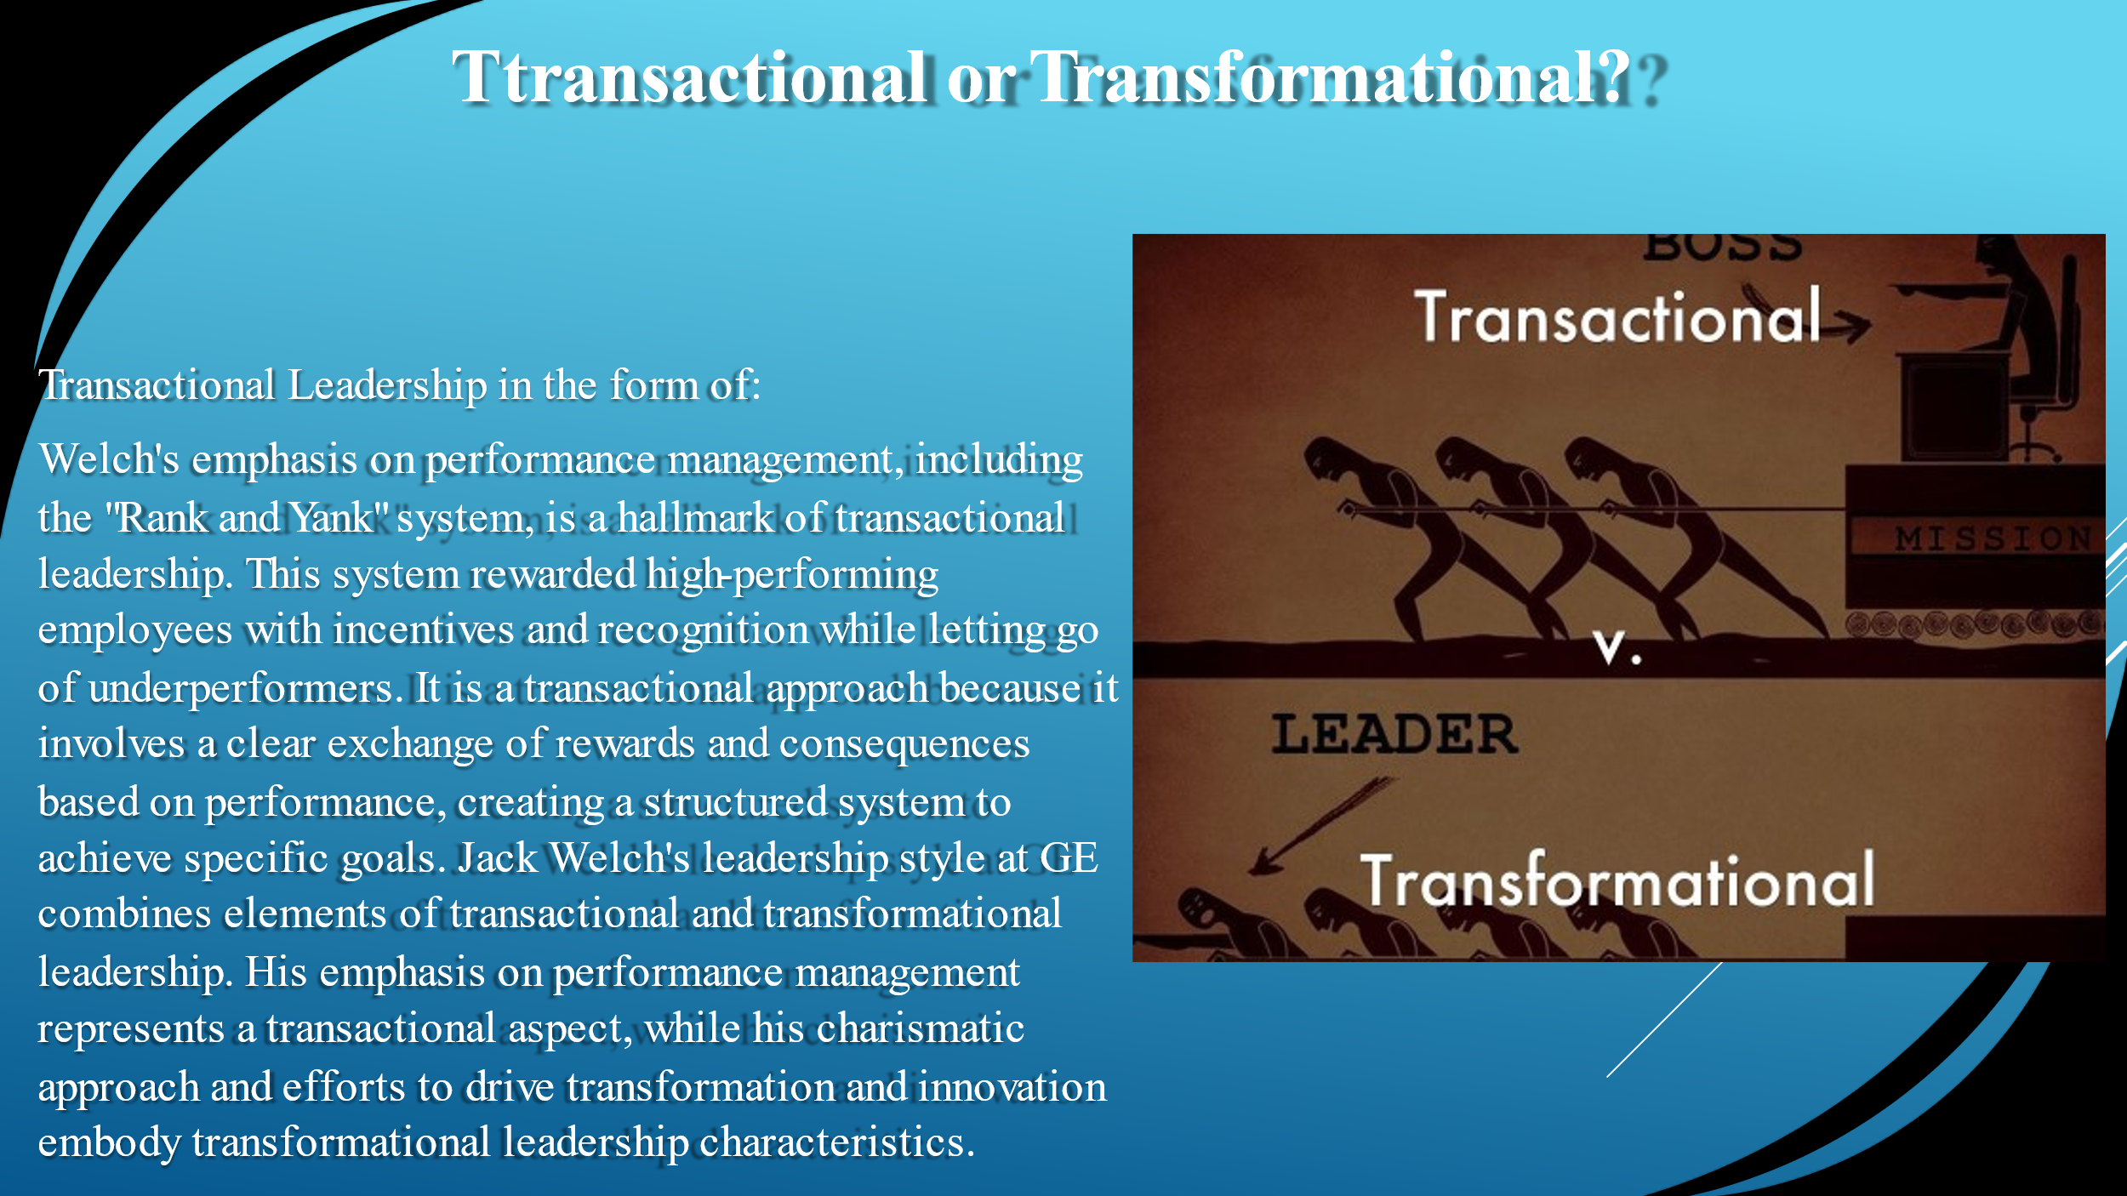
The leadership style exhibited by Jack Welch at General Electric (GE) encompasses elements of both transactional and transformational leadership.
Transactional Leadership:
Welch's emphasis on performance management, including the "Rank and Yank" system, is a hallmark of transactional leadership. This system rewarded high-performing employees with incentives and recognition while letting go of underperformers. It is a transactional approach because it involves a clear exchange of rewards and consequences based on performance, creating a structured system to achieve specific goals. Jack Welch's leadership style at GE combines elements of transactional and transformational leadership. His emphasis on performance management represents a transactional aspect, while his charismatic approach and efforts to drive transformation and innovation embody transformational leadership characteristics.

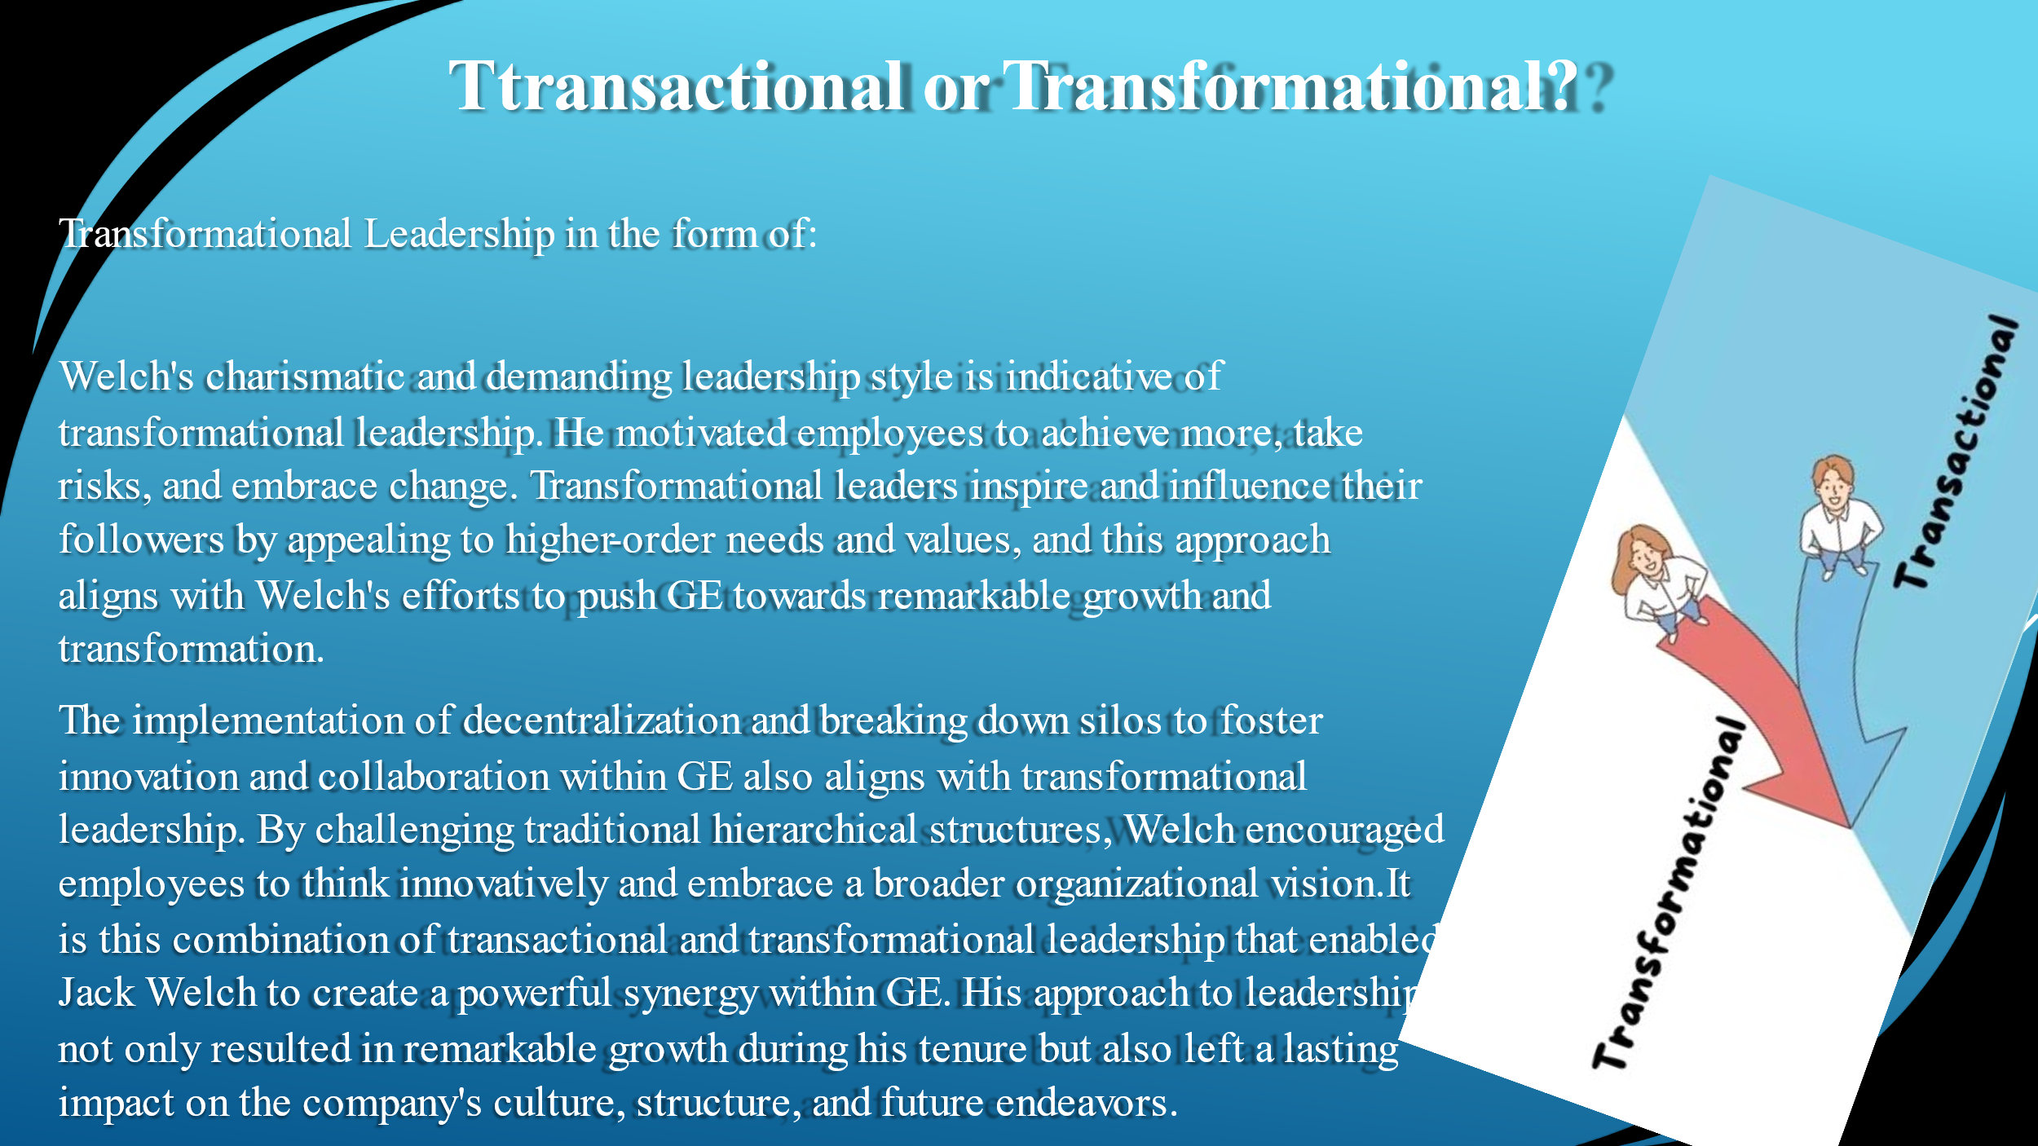
Transformational Leadership:
Welch's charismatic and demanding leadership style is indicative of transformational leadership. He motivated employees to achieve more, take risks, and embrace change. Transformational leaders inspire and influence their followers by appealing to higher-order needs and values, and this approach aligns with Welch's efforts to push GE towards remarkable growth and transformation.
The implementation of decentralization and breaking down silos to foster innovation and collaboration within GE also aligns with transformational leadership. By challenging traditional hierarchical structures, Welch encouraged employees to think innovatively and embrace a broader organizational vision.
It is this combination of transactional and transformational leadership that enabled Jack Welch to create a powerful synergy within GE. His approach to leadership not only resulted in remarkable growth during his tenure but also left a lasting impact on the company's culture, structure, and future endeavours.

