

MODULE CODE: ECDE7013
MODULE LEAD: Dr Catherine Morgan

ASSESSMENT COMPONENT:
Component 2: Exploring Contemporary Issues in Education 2:
Applying critical skills, contributing to knowledge: leading improvement.
RESEARCH REPORT

STUDENT NAME: Laura Emanuel
STUDENT NUMBER: 2308139

Word Count: 12,969 words
Professional Doctorate in Education (EdD)
(Part-time Pathway)

AI Acknowledgement

I acknowledge the use of ChatGPT throughout February and March 2026 to aid research in literature. I used the prompt(s):
1. Please find all and any articles, texts and academic blogs relating specifically to teacher wellbeing surrounding school visits
2. Please repeat in Welsh context
3. Would the lack of results be described as a sufficient “gap in literature”.
4. Please provide me a list of sentence starters for critical statements other than “however”
I acknowledge the use of ChatGPT on 8/6/2026 to proofread my work using the prompt(s):
1. Please check the following text for readability, grammar and syntax.
I acknowledge the use of ChatGPT on 10/6/2026 to proofread my work using the prompt(s):
1. Please ensure my reading list is PERFECT and in line with most recent Harvard guidelines, highlight any issues – include correct use of italics and brackets too please

I confirm that I have not presented any AI generated text as my own work. I confirm that I have copies of my drafts, notes, and other resources I used before, and after the use of AI tools which I may be asked to provide in evidence.

Contents
Chapter 1 - Introduction 5
Chapter 2 – Literature Review 8
2.1 Introduction 8
2.2 Defining Teacher Wellbeing 8
2.3 Emotional Labour and Relational Teaching 11
2.4 Educational Visits and Experiential Learning 13
2.5 Educational Visits Within the Welsh Policy Context 17
2.6 Educational Visits as Professional Demands and Resources 19
2.7 The Research Gap and Research Question 21
Chapter 3 – Research Design and Methodology 24
3.1 Introduction 24
3.2 Epistemological and Ontological Positioning 24
3.3 Theoretical Framework 26
3.4 Researcher Positionality and Reflexivity 27
3.5 Research Design 29
3.6 Sampling Strategy 30
3.7 Data Collection Method and Questionnaire Instrument 31
3.8 Data Analysis 32
3.9 Ethical Considerations 33
3.10 Chapter summary 34
Chapter 4 – Findings and Discussion 36
4.1 Introduction 36
4.2 Educational Visits as Professionally Rewarding Experiences 38
4.3 Strengthened Teacher–Pupil Relationships Beyond the Classroom 41
4.4 Emotional Pressure, Safeguarding and Responsibility 43
4.5 Workload, Staffing and Organisational Burden 46
4.6 Negotiating Contradiction: ‘Worthwhile Despite the Stress’ 47
4.7 Chapter Conclusion 49
Chapter 5 – Discussion 50
5.1 Introduction 50
5.2 Educational Visits as Emotionally Complex Professional Experiences 50
5.3 Professional Fulfilment, Meaning and Teacher Identity 51
5.4 Relational Pedagogy Beyond the Classroom 52
5.5 Emotional Labour, Safeguarding and Responsibility 53
5.6 Workload, Organisational Pressure and Policy Tensions 54
5.7 Contribution to Existing Literature 55
5.8 Chapter Conclusion 56
Chapter 6 – Conclusions and Recommendations 58
Reference List 61
Appendices 68

Chapter 1 - Introduction

"Learning in and through the environment, both locally and beyond,
is an important part of a broad and balanced curriculum."
(Welsh Government, 2022)

Educational visits, including residential experiences and curriculum-linked learning beyond the classroom, have long been associated with positive pupil outcomes such as increased engagement, confidence and social development (Rickinson et al., 2004; Behrendt and Franklin, 2014). Within the Welsh educational context, the Curriculum for Wales (2022) further emphasises authentic and experiential learning opportunities, positioning learning beyond the classroom as an important aspect of holistic education. However, despite increasing policy emphasis on wellbeing and experiential pedagogy, considerably less attention has been paid to the experiences of teachers facilitating these visits, particularly in relation to emotional wellbeing and professional experience – a gap that warrants exploration. Deschamps et al., (2022) explicitly noted that their literature review within their study revealed no existing research on the impact of outdoor educational practice on teacher wellbeing.
The rationale for this research emerged from both professional experience and such gaps identified within the literature. Existing research surrounding educational visits predominantly focuses on pupil outcomes, including academic engagement, social development and outdoor learning experiences (Dillon et al., 2006; Marchant et al., 2019). Although some studies acknowledge the importance of teacher–pupil relationships and teacher attitudes towards visits (Anderson, Kisiel and Storksdieck, 2006; Fuller, Powell and Fox, 2017), limited research explores how teachers themselves emotionally experience educational visits or how such experiences may influence professional wellbeing. This absence appeared particularly significant within Wales, where wellbeing has become increasingly central to educational reform through policies such as the Well-being of Future Generations (Wales) Act (2015) and the Whole-School Approach to Emotional and Mental Wellbeing Framework (2021).
Within this research, wellbeing was understood not as a fixed or purely clinical concept, but as a multidimensional and subjective experience shaped by emotional, relational and professional factors. Previous literature suggests that teacher wellbeing is closely linked to workload, emotional labour, professional identity and interpersonal relationships (Hargreaves, 1998; Day and Gu, 2010). Educational visits may therefore represent emotionally and professionally complex experiences which simultaneously function as sources of fulfilment and sources of pressure for teachers. For example, visits may provide opportunities for strengthened teacher–pupil relationships, professional meaning and shared experiences, whilst also increasing responsibility, accountability, workload and safeguarding concerns. Exploring these tensions formed a central justification for the research.
The research specifically focused on teachers of Year 5 children (age nine to ten) in order to create a more manageable and contextually comparable pilot study, as educational visits and residential experiences are often more prominent within Progression Step Three (“Learners approximately age 8-11”) (Welsh Government, 2022). Narrowing the participant group also strengthened the coherence of the study by focusing upon teachers working within a similar curricular and developmental context, for comparison.
My positionality also informed the development of the study. As an educator with professional experience and interest in educational visits and experiential learning, I recognised that personal beliefs and experiences may influence interpretations of the research process. It was therefore important to establish that the study was grounded in an evidenced gap within the literature rather than personal interest alone. An interpretivist approach was therefore adopted in order to explore the subjective meanings teachers attached to their experiences (Cohen, Manion and Morrison, 2018), recognising that wellbeing is socially constructed (Crotty, 1998) and experienced differently by individuals within specific professional contexts (Lincoln and Guba, 1985).
Consequently, the research explored how Year 5 primary school teachers in Wales perceived the impact of educational visits on their wellbeing, with particular attention given to the emotional, relational and professional dimensions of these experiences. At a time when Welsh education policy advocates learning beyond the classroom (Welsh Government, 2022; Donaldson, 2015) whilst seeking solutions to persistent challenges in teacher wellbeing - including through the introduction of a new Workload and Wellbeing Charter (Welsh Government, 2024) - examining how Year 5 teachers emotionally experience educational visits is not merely timely but necessary, as the relationship between these two policy priorities remains largely unexplored within the existing literature.

Chapter 2 – Literature Review

2.1 Introduction
Whilst educational visits have been widely researched for their impact on pupil learning and development (Rickinson et al., 2004; Behrendt and Franklin, 2014), and teacher wellbeing has emerged as a growing area of concern within educational policy and research (Day and Gu, 2010; Welsh Government, 2021), these two bodies of literature have rarely been examined in relation to one another, with Deschamps et al. (2022) representing one of the few attempts to connect outdoor educational practice with teacher wellbeing. It is within this overlooked intersection that this inquiry is situated, exploring how educational visits are experienced by Year 5 teachers in Wales and how these experiences may influence their wellbeing. This literature review critically examines research relevant to educational visits, experiential learning, teacher wellbeing and workplace factors that influence professional experiences within educational settings, adopting a critical approach that moves beyond description to evaluate competing perspectives, identify conceptual limitations and justify the theoretical framework underpinning the study. Through this process, the review establishes the rationale for the study and identifies a significant gap in existing knowledge regarding the relationship between educational visits and teacher wellbeing.

2.2 Defining Teacher Wellbeing
Teacher wellbeing is a multidimensional and contested concept which lacks a universally agreed definition. Earlier conceptualisations of wellbeing frequently focused on psychological functioning, happiness and positive emotion (Seligman, 2011), whilst more recent educational research increasingly acknowledged the relational, emotional and professional dimensions of teacher wellbeing (Acton and Glasgow, 2015). Within educational settings, teacher wellbeing is commonly associated with workload, emotional labour, professional identity, interpersonal relationships and work-life balance (Day and Gu, 2010). At an international level, Viac and Fraser (2020) identify teacher wellbeing as a multifaceted construct requiring systematic attention across policy and practice, encompassing cognitive, affective, social and physical dimensions that extend beyond the individual teacher to encompass their professional environment.
A significant criticism of some wellbeing frameworks, for use within this context, is their tendency to individualise wellbeing whilst overlooking broader organisational and structural pressures experienced by teachers. Seligman’s PERMA framework, for example, conceptualises wellbeing through positive emotion, engagement, relationships, meaning and accomplishment (Seligman, 2011). Although influential within educational wellbeing discourse, critics argue that PERMA may oversimplify wellbeing by prioritising individual agency and positivity whilst underrepresenting issues such as workload, accountability and institutional pressure (Kern et al., 2015; Acton and Glasgow, 2015; Hascher and Waber, 2021). Within teaching contexts, these limitations are important because teacher wellbeing is often shaped by demands beyond individual control. From a Welsh perspective, PERMA’s emphasis on individual fulfilment is insufficient alone for understanding teacher wellbeing within a profession experiencing sustained structural pressures and changes. The implementation of Curriculum for Wales, alongside persistent concerns regarding teacher workload, recruitment and retention, has created challenges that extend beyond individual psychological functioning. Although PERMA provides a valuable account of the factors that enable individuals to thrive, it offers limited explanatory power regarding how institutional demands constrain opportunities for positive emotion, engagement, and accomplishment. As Estyn (2020) and Evans (2023) demonstrate, many threats to teacher wellbeing arise from organisational and policy-related factors rather than from individual deficiencies. Consequently, an exclusive reliance on PERMA risks depoliticising wellbeing by overlooking the systemic conditions that shape teachers’ lived experiences. This supports the adoption of the Job Demands-Resources (JD-R) model (Demerouti et al., 2001; Bakker and Demerouti, 2007), which provides a more comprehensive account of how workplace demands and resources influence wellbeing within educational settings.
More recent educational research increasingly positions wellbeing as relational and contextually situated. Hargreaves (1998) argued that teaching is fundamentally an emotional practice, shaped through relationships, care and emotional expectations, whilst Nias (1996) contended that teachers frequently invest their sense of self within their professional roles, rendering experiences of success, meaning and belonging, as well as stress and disappointment, matters of personal identity rather than merely occupational performance. Similarly, Day and Gu (2010) suggested that teacher wellbeing is closely linked to emotional resilience, professional identity and supportive professional relationships. Such perspectives move beyond simplistic understandings of happiness and instead position wellbeing as dynamic, socially constructed and emotionally complex.
Within Wales, teacher wellbeing has become increasingly significant amidst concerns regarding workforce sustainability and the capacity of the profession to navigate ongoing educational reform. The Education Workforce Council (2024) identifies recruitment and retention as among the most pressing priorities for Welsh education, suggesting that understanding the conditions which support teacher wellbeing is essential not only for individual practitioners but also for the long-term resilience of the education system. Wahab et al.'s (2024) systematic review of teacher workload and wellbeing further confirms that workload remains one of the most consistently identified threats to teacher wellbeing internationally, with implications for how additional professional responsibilities, including the organisation of educational visits, are experienced. Policies such as the Whole-School Approach to Emotional and Mental Wellbeing Framework (Welsh Government, 2021) and the Curriculum for Wales (2022) position wellbeing as central to educational practice. However, critics such as Brady and Wilson (2021) argue that wellbeing policy can remain aspirational whilst insufficiently addressing the practical and emotional pressures experienced by teachers (Estyn, 2020). This tension is particularly relevant in relation to educational visits, as such experiences may simultaneously support and challenge teacher wellbeing.
Research exploring teacher wellbeing within Wales frequently focuses upon workload, accountability and retention pressures. While such studies are important, comparatively little literature explores how specific pedagogical experiences may influence wellbeing. This absence appears significant given that educational visits unavoidably involve heightened emotional and professional responsibility, particularly within upper primary education where residential experiences become increasingly common (Anderson, Kisiel and Storksdieck, 2006; Tortop, 2012; Wythe, 2024).

2.3 Emotional Labour and Relational Teaching
The emotional pressures of teaching are increasingly recognised within educational research. Hochschild’s (1983) concept of emotional labour refers to the management and regulation of emotions as part of professional work; within teaching, emotional labour may involve demonstrating care, managing behaviour, supporting pupils emotionally and regulating personal emotions in response to professional expectations (Isenbarger and Zembylas, 2006). Emotional labour is particularly relevant within educational contexts because teachers are often expected to present calmness, enthusiasm and emotional availability regardless of personal stress or workload pressures (Smith et al., 2025).
Hargreaves (2000) argued that teaching is emotionally embedded due to the relational nature of educational practice. Teachers are expected not only to deliver curriculum content, but also to create emotionally supportive learning environments and maintain positive relationships with pupils. These relational responsibilities may contribute to professional fulfilment whilst simultaneously increasing emotional pressure and exhaustion. Consequently, emotional labour within teaching cannot simply be understood negatively; rather, it often involves tensions between emotional reward and emotional demand.
Relational pedagogy (understood as an approach to education that positions the interactive relationship between teacher and learner as central to learning, rather than viewing it as the mere, possibly historic view, of transmission of content (Riddle and Hickey, 2023)) provides an important conceptual lens for understanding these dynamics. Bingham and Sidorkin (2004) argued that education is fundamentally relational, with learning shaped through interactions and shared experiences between teachers and pupils. Educational visits may intensify these relational dimensions by moving learning beyond traditional classroom environments and creating opportunities for informal interaction, collaboration and shared experience (Behrendt and Franklin, 2014). Such experiences may temporarily disrupt traditional classroom hierarchies and enable different forms of communication and relationship-building between teachers and pupils, with research suggesting that teacher-pupil discourse during visits differs markedly from classroom patterns, affording greater openness and pupil agency (DeWitt and Osborne, 2010).
Research suggests that positive teacher–pupil relationships may enhance professional satisfaction and wellbeing (Spilt, Koomen and Thijs, 2011). Similarly, Day and Gu (2010) emphasised the importance of emotional connection and professional identity within sustaining teacher motivation and resilience. However, relational teaching can also intensify emotional pressures, particularly when teachers experience responsibility for pupil safety, behaviour and emotional wellbeing outside conventional classroom structures (Zembylas, 2005). Research in occupational health psychology further supports this, suggesting that responsibilities involving heightened accountability and risk represent significant sources of professional stress for teachers (Travers, 2017) and these are dimensions that are arguably intensified during educational visits.
Whilst some research has considered teachers’ experiences of educational visits, the primary focus has typically been on practical, organisational and curricular factors rather than teacher wellbeing. For example, Anderson, Kisiel and Storksdieck (2006) identified issues such as planning demands, curriculum constraints, logistical challenges and teacher confidence as influential factors affecting participation in educational visits. Although such research acknowledges the teacher’s role within visit experiences, it provides limited insight into the emotional and relational dimensions of those experiences or how they may influence teacher wellbeing. Consequently, despite increasing recognition of emotional labour and relational pedagogy within educational literature, limited research explicitly explores how these relational and emotional experiences influence teacher wellbeing during educational visits.

2.4 Educational Visits and Experiential Learning
Educational visits have traditionally been associated with experiential learning theories, particularly based on the work of Dewey (1938) and Kolb (1984), both of whom emphasised learning through direct experience and reflection. Experiential learning theory suggests that meaningful learning occurs through active participation, reflection and engagement with authentic contexts rather than passive acquisition of knowledge. Contemporary literature frequently positions educational visits as opportunities for authentic, memorable and engaging learning experiences (Behrendt and Franklin, 2014). Tortop's (2012) development of a validated instrument measuring teacher attitudes toward field trips similarly identified two dominant dimensions: perceived educational contribution and organisational difficulty, a tool that reflects the broader pattern within the literature of acknowledging pedagogical value whilst overlooking teachers' emotional experiences.
Despite their enduring influence, experiential learning theories have been criticised for implying a somewhat linear relationship between experience and learning. Ord and Leather (2011) contend that experience itself is not inherently educational and may fail to generate meaningful learning without appropriate reflection, guidance, and contextual support. This critique is particularly pertinent to educational visits, where assumptions that participation alone will produce positive professional or educational outcomes risks overlooking the complex conditions required for such benefits to emerge. The effectiveness of educational visits is therefore shaped by factors such as planning, facilitation, teacher–pupil relationships, organisational resources, and institutional support. These considerations align closely with my research focus on how wider workplace conditions influence the extent to which educational visits contribute to teacher wellbeing.
Rickinson et al. (2004) argued that learning beyond the classroom may positively influence pupil engagement, confidence and social development. Similarly, Dillon et al. (2006) identified benefits associated with outdoor and experiential learning, including improved collaboration, learner motivation and social interaction. Within Wales, the Curriculum for Wales promotes experiential and authentic approaches to learning through enquiry-based pedagogy and the concept of Cynefin, a Welsh term referring to the sense of place, belonging and identity shaped by one’s environment, community and cultural heritage (Welsh Government, 2022), encouraging learners to connect their learning meaningfully to local contexts and wider environments.
However, much of the literature surrounding educational visits focuses predominantly on pupil outcomes rather than teacher experiences (Rickinson et al., 2004; Behrendt and Franklin, 2014). Existing studies frequently examine academic engagement, environmental awareness or social development (Dillon et al., 2006; Rickinson et al., 2004) whilst paying little attention in comparison to the emotional or professional experiences of teachers organising and facilitating such visits. This creates a significant imbalance within the literature, as teachers are often positioned as facilitators of pupil outcomes rather than participants experiencing the visits themselves (Anderson, Kisiel and Storksdieck, 2006; Wythe, 2024).
Marchant et al. (2019), one of the few studies conceptually linked to my current research, explored the relationship between outdoor learning and teacher wellbeing within South Wales primary schools. The study suggested that outdoor learning may positively influence teacher wellbeing through increased enjoyment, engagement and professional satisfaction, with one teacher describing a visit as feeling like “a breath of fresh air” that reminded them why they entered the profession. However, the study focused specifically on curriculum-based outdoor learning within or immediately adjacent to school grounds, rather than educational visits more broadly, and did not critically examine the emotional pressures or organisational demands associated with facilitating off-site visits. Consequently, while Marchant et al. (2019) provided useful conceptual insight and represented an important starting point, its direct applicability to educational visits (which may involve transport, external venues and substantially greater safeguarding demands) remained limited.
This distinction between outdoor learning and educational visits is important and although overlaps exist between these areas, educational visits vary considerably in form, duration and pedagogical purpose. Therefore, within this study, educational visits were understood as curriculum-related learning experiences occurring beyond the traditional classroom environment, such as day visits facilitated by Year 5 teachers within Welsh primary schools. Beames, Higgins and Nicol (2012) argue that learning outside the classroom represents a distinct pedagogical practice requiring specific professional skills, institutional support and careful planning suggesting that its effective delivery places meaningful demands on teachers that extend beyond simply relocating instruction to a different environment.
Experiential learning literature frequently frames educational visits positively; however, critics argue that such perspectives may overlook issues of workload, safeguarding, administrative pressure and accountability (Fägerstam, 2014; Waite, 2011). Teachers facilitating educational visits often undertake extensive planning, risk assessments, parental communication and emotional regulation, all of which may influence wellbeing.
Furthermore, the increasing performative culture within education may create additional pressure for teachers to demonstrate the value and success of educational visits. Ball (2003) argues that performativity subjects teachers to a persistent requirement to justify their practice through measurable outcomes, creating a culture in which activities that resist easy quantification (such as the relational, experiential and emotional dimensions of educational visits) may generate professional anxiety rather than confidence. Within this context, teachers may feel compelled not only to organise and facilitate visits but also to continuously evidence their educational value to school leaders, parents and inspection bodies, adding a further layer of professional pressure to an already demanding pedagogical responsibility. Within Wales, this tension is particularly pronounced as the Curriculum for Wales simultaneously encourages experiential learning beyond the classroom whilst maintaining inspection and accountability frameworks through which schools are judged (Estyn, 2020) creating a professional environment in which the value of educational visits must be constantly negotiated rather than assumed.

2.5 Educational Visits Within the Welsh Policy Context
The contemporary Welsh curriculum landscape is currently rooted in Donaldson’s (2015) landmark review, Successful Futures, which provided the blueprint for Curriculum for Wales. Donaldson argued for a move away from a content-driven curriculum towards approaches that prioritise authentic, meaningful and experiential learning, enabling learners to apply knowledge within real-world contexts. This shift is significant because it positions learning beyond the classroom, including educational visits, not as optional enrichment activities but as legitimate pedagogical approaches through which the aspirations of Curriculum for Wales may be realised.
Understanding educational visits in relation to teacher wellbeing therefore requires attention to the specific curriculum framework and professional conditions within which they are organised and experienced. Tinney (2023) argues that the Curriculum for Wales positions outdoor learning and learning beyond the classroom as core pedagogical expectations rather than peripheral additions to school life. At the same time, Tinney highlights persistent implementation barriers including limited practitioner confidence, restricted access to training and resource constraints, suggesting a gap between curricular aspiration and practical reality. Critically, these are the same conditions within which teachers organise and facilitate educational visits, raising important questions about how policy expectations interact with the professional and emotional realities of teaching.
Evans (2023) offers a valuable critical perspective on the early implementation of the Curriculum for Wales, identifying tensions between its founding principle of teacher agency and the inequalities of professional preparation that have accompanied reform. Evans found that teachers’ responses to curriculum change were significantly shaped by workload pressures, professional confidence and the availability of coherent support structures. Although Evans does not address educational visits directly in this paper, the study illuminates an important contextual reality: Welsh primary teachers are experiencing curriculum reform at a time of heightened workload and professional uncertainty.
Ellis et al. (2024) further reinforce this tension, arguing that outdoor learning and learning beyond the classroom, despite strong policy endorsement in Wales, often persist as peripheral practices rather than being fully integrated within mainstream pedagogy. The researchers identify teacher confidence, professional learning and access to appropriate environments as key determinants of how consistently such practices are enacted. The implication is important to my own research: teachers who value educational visits may simultaneously feel under-supported, under-resourced and professionally exposed when facilitating them.
This separation between policy aspiration and professional reality is further evidenced within Welsh inspection discourse as Estyn reports on Welsh primary schools frequently recognise the role of educational visits and community partnerships in enriching the curriculum and supporting pupil engagement. However, these same reports discuss staff wellbeing as a matter of school leadership and organisational culture rather than examining how specific pedagogical responsibilities, including educational visits, may contribute to or detract from teacher wellbeing (Estyn, 2020). This pattern of separation is further evidenced in Estyn's (2019) thematic report on school impact on pupil health and wellbeing, which positions wellbeing as an organisational and leadership concern rather than examining how specific pedagogical responsibilities including the planning and facilitation of educational visits may influence teachers' professional and emotional experiences. The separation reflects a wider tendency to frame educational visits through the lens of pupil benefit whilst overlooking the professional and emotional labour carried by the teachers delivering them.
This Welsh policy context situates educational visits not simply as pedagogical choices, but as professionally and emotionally loaded responsibilities enacted within a specific cultural, curricular and reform context. Understanding how Year 5 teachers experience educational visits in relation to wellbeing requires attention to this context, rather than treating visits as isolated events, as they should be embedded in their practice.

2.6 Educational Visits as Professional Demands and Resources
The Job Demands–Resources (JD-R) model (Demerouti et al., 2001; Bakker and Demerouti, 2007) provided the primary theoretical framework for examining educational visits in relation to teacher wellbeing. The model proposes that workplace experiences may function either as demands, contributing to stress and exhaustion, or as resources, supporting engagement, motivation and wellbeing. Subsequent developments of the model emphasised that resources should not be viewed solely as protective factors. Schaufeli and Bakker (2004) argued that workplace resources can actively promote work engagement, characterised by energy, dedication and absorption in professional activity. This extension is particularly relevant to educational visits, as it provides a theoretical explanation for why teachers may experience such activities as professionally energising and meaningful despite the additional demands they often entail.
Within educational settings, job demands commonly include workload, emotional pressure, accountability and behavioural management, whilst job resources may include collegial support, professional autonomy, meaningful work and positive relationships (Bakker and Demerouti, 2007). For Year 5 teachers specifically, educational visits may involve increased responsibility linked to pupil independence, residential experiences and safeguarding expectations, whilst simultaneously providing opportunities for strengthened relationships, professional fulfilment and enhanced pupil engagement.
The JD-R model is particularly relevant to this study because it accommodates contradiction and emotional complexity. Rather than positioning educational visits as either positive or negative experiences, the model allows them to be understood as multifaceted professional experiences shaped by both emotional fulfilment and emotional demand. This conceptual framing aligned closely with the interpretivist nature of the study, supporting exploration of how Year 5 teachers themselves perceived and interpreted these experiences. Unlike more individualised approaches to wellbeing, the JD-R framework acknowledged structural and organisational pressures alongside emotional and relational experiences, making it particularly appropriate for examining educational visits.
Deschamps, Scrutton and Ayotte-Beaudet (2022) conducted one of the first empirical studies to examine the association between school-based outdoor education and teacher subjective wellbeing. Whilst Deschamps et al. did not adopt the JD-R model as their theoretical framework, drawing instead on Subjective Wellbeing theory (SWB), their findings may nonetheless be interpreted through a JD-R lens to illuminate points of connection. Their exploratory cross-sectional study found that teachers who regularly engaged in outdoor pedagogical practice reported higher levels of overall wellbeing, life satisfaction, positive affect and more positive workload experience. These findings provide tentative but significant evidence that learning beyond the classroom may function as a meaningful professional resource for teachers. However, Deschamps et al. (2022) urge caution in interpreting these findings as the cross-sectional design means that causal relationships cannot be established, and individual contextual factors may significantly moderate the relationship between outdoor educational practice and wellbeing. Furthermore, the study examined outdoor education as a broad category rather than focusing specifically on educational visits, which may involve substantially different organisational demands, safeguarding responsibilities and residential dimensions to those that I wish to explore. Consequently, while Deschamps et al. (2022) provide an important indication that learning beyond the classroom may positively influence teacher wellbeing, their findings cannot be directly applied to the educational visits’ context without further investigation.
When looking at a way to measure the teacher’s levels of fulfilment and wellbeing, the JD-R model is not without criticism. Crawford, LePine and Rich (2010) suggest that the same aspect of a role may function simultaneously as both a demand and a resource depending on individual perception, context, and circumstance. For example, responsibility for leading an educational visit may be experienced as a source of professional fulfilment and growth by one teacher, whilst being perceived as an additional burden by another. This limitation was acknowledged within the present study, and the interpretivist approach adopted sought to address it by exploring teachers’ subjective understandings of their experiences rather than treating demands and resources as fixed or universally applicable categories. In doing so, the research recognises that the meaning attached to workplace experiences is socially constructed and may vary considerably between individuals.
Furthermore, the framework supported a more balanced conceptualisation of educational visits. Earlier stages of the research risked framing educational visits as inherently beneficial; however, the JD-R model enabled the study to critically explore both the rewards and pressures associated with facilitating such experiences.

2.7 The Research Gap and Research Question
The literature reviewed across this chapter reveals a clear and significant gap in current knowledge. Research surrounding educational visits is substantial but predominantly pupil-centred, prioritising outcomes such as academic engagement, social development, environmental awareness and experiential learning (Rickinson et al., 2004; Behrendt and Franklin, 2014; Dillon et al., 2006). Teacher experiences are frequently acknowledged within this literature, but typically in relation to practical barriers rather than emotional wellbeing and professional experience (Anderson, Kisiel and Storksdieck, 2006). Teachers are consistently positioned as facilitators of pupil outcomes rather than as professionals whose wellbeing is shaped by the experiences of facilitating those outcomes.
Simultaneously, the teacher wellbeing literature is extensive, examining workload, emotional labour, professional identity, retention and policy context in depth (Hargreaves, 1998; Day and Gu, 2010; Acton and Glasgow, 2015). Within Wales specifically, policy frameworks increasingly foreground wellbeing as central to educational practice, yet the discourse frequently operates at a systemic level rather than examining how specific pedagogical responsibilities, such as educational visits, may influence teachers’ emotional and professional experiences (Welsh Government, 2021; Estyn, 2020).
The space between these two bodies of literature remains largely unexamined. Deschamps et al. (2022) represent perhaps the closest point of connection; however, their study does not address educational visits specifically. Marchant et al. (2019), though conceptually relevant, similarly focus upon outdoor learning within school contexts and do not critically examine the emotional labour involved in facilitating off-site visits. This gap is particularly significant within the Welsh primary context, where the Curriculum for Wales encourages authentic, experiential learning beyond the classroom at a time of increasing concern surrounding teacher workload and wellbeing (Evans, 2023; Ellis et al., 2024).
My research project therefore sought to address this gap directly, exploring how Year 5 primary school teachers in South Wales perceived the impact of educational visits on their wellbeing. The following research question guided the inquiry:
How do Year 5 primary school teachers in South Wales perceive the impact of educational visits on their wellbeing?
In addressing this question, the study aimed to contribute to both the educational visits literature and the teacher wellbeing literature by foregrounding teacher voice and examining educational visits as emotionally and professionally complex experiences. In a Welsh education system that now expects teachers to facilitate increasingly authentic and experiential forms of learning whilst navigating significant wellbeing and workload challenges, the absence of research exploring how educational visits are experienced by the teachers who lead them represents a gap that is both theoretically significant and, arguably, professionally urgent.

Chapter 3 – Research Design and Methodology

3.1 Introduction
Research methodology is fundamentally concerned with how knowledge is generated, interpreted and legitimised, requiring researchers to make explicit the assumptions that underpin their methodological choices (Cohen, Manion and Morrison, 2018). Given that teacher wellbeing is experienced subjectively and shaped by individual interpretation, context and relationships, it was appropriate that I adopted an approach designed to explore participants’ meanings rather than measure objective outcomes. This chapter critically justifies the research design and methodology adopted within this small-scale study, explaining the philosophical assumptions underpinning the research, the rationale for the chosen methods of data collection and analysis, and the ethical considerations that informed the inquiry.

3.2 Epistemological and Ontological Positioning
I adopted an interpretivist epistemological position as interpretivism is concerned with understanding how individuals make sense of their experiences within particular social and professional contexts (Cohen, Manion and Morrison, 2018). This was appropriate because the research question focused on teachers’ perceptions of educational visits and wellbeing rather than attempting to measure objective outcomes or establish causal relationships. The study sought to understand how participants interpreted and attached meaning to their experiences, recognising that these interpretations were shaped by personal, professional and contextual factors.
In contrast to approaches that conceptualise teacher wellbeing as a fixed and measurable construct, my research adopted an understanding of wellbeing as a subjective and contextually situated phenomenon (Hascher and Waber, 2021). Teacher wellbeing was therefore conceptualised as a multidimensional experience shaped by emotional, relational and professional influences, consistent with the work of Day and Gu (2010) and Acton and Glasgow (2015). This conceptualisation aligned with the interpretivist epistemological position underpinning the study, which prioritises understanding how individuals interpret and make sense of their experiences within particular social and professional contexts (Cohen, Manion and Morrison, 2018). From this perspective, teachers' experiences of educational visits were understood to be shaped by factors such as school context, professional experience, workload, relationships with pupils and perceptions of responsibility. Consequently, exploring individual perspectives provided insight into how wellbeing was experienced and negotiated within the specific context of educational visits.
Ontologically, the study aligned with a relativist position, recognising that multiple realities may exist depending on individual interpretation and context (Lincoln and Guba, 1985). The interpretivist position helped address concerns about whether the study risked assuming educational visits positively influence teacher wellbeing, allowing the research to explore complexity rather than presume benefit, something I was cautious of within my positionality. Educational visits were therefore examined as potentially both rewarding and demanding, with their significance dependent upon how participants experienced and interpreted them.
Earlier stages of the research considered broader constructivist and mixed-methods positions. However, continued engagement with methodological literature and supervisory feedback led to a clearer interpretivist stance. Whilst constructivism and interpretivism share an emphasis on meaning and subjective experience, constructivist approaches are often more concerned with how knowledge is collectively constructed through social interaction, whereas interpretivism places greater emphasis on understanding how individuals interpret and make sense of their lived experiences (Crotty, 1998). Given that this study sought to explore how individual Year 5 teachers perceived the impact of educational visits on their wellbeing, interpretivism provided a more precise philosophical fit. This was particularly important because teacher wellbeing was understood as a personally experienced and contextually situated phenomenon, requiring attention to individual meanings rather than the construction of shared realities. Adopting an interpretivist epistemology and relativist ontology therefore provided a philosophically consistent foundation for exploring the complexity, diversity and subjectivity of teacher wellbeing within the context of educational visits (Scotland, 2012).

3.3 Theoretical Framework
Theoretical frameworks do more than provide a lens through which a phenomenon can be understood; they also shape the design of research, influencing what questions are asked, what data are sought and how findings are interpreted – when used correctly. Within my research, the Job Demands–Resources (JD-R) model (Demerouti et al., 2001) functioned not only as a conceptual framework for understanding teacher wellbeing, but also as a methodological tool that informed questionnaire design, data analysis and interpretation. The framework provided a structure through which the potentially competing demands and rewards associated with educational visits could be explored without assuming that such experiences were inherently positive or negative.
The JD-R model proposes that workplace experiences can operate as demands, which may contribute to stress and exhaustion, or as resources, which may support motivation, engagement and wellbeing. Within teaching, job demands may include workload, emotional pressure, accountability, behaviour management, safeguarding responsibility and administrative tasks, whilst job resources may include collegial support, professional autonomy, meaningful work and positive relationships (Bakker and Demerouti, 2007). The JD-R framework therefore offered a useful structure for examining the dual nature of educational visits.
Earlier versions of the research considered several wellbeing frameworks, including PERMA and Self-Determination Theory, after critical consideration, the use of multiple frameworks risked theoretical fragmentation and reduced conceptual clarity (Punch, 2014). The JD-R model was therefore prioritised because it provided a more balanced and comprehensive framework through which both positive and negative dimensions of teacher experience could be examined. Emotional labour and relational pedagogy remained important supporting concepts, but they were used to deepen interpretation of participants’ experiences rather than operate as competing theoretical frameworks.
The questionnaire design reflected this theoretical positioning. Questions were developed to explore experiences commonly associated with both job demands and job resources, including workload, stress, safeguarding responsibilities, enjoyment, professional meaning and relationships with pupils. Consistent with the interpretivist stance adopted within the study, the framework was not used as a rigid classificatory tool but as a sensitising concept (Blumer, 1954) that guided exploration of how teachers understood and experienced educational visits in relation to their wellbeing. The JD-R framework also structured the analysis, providing a means through which the contradictory nature of participants' experiences could be interpreted and understood with quantitative and qualitative response opportunities, to be discussed further in this chapter.

3.4 Researcher Positionality and Reflexivity
Researcher positionality was significant throughout the study. As an educator with a professional interest in educational visits and experiential learning, I recognised that my own positive experiences of educational visits could influence the assumptions I brought to the research. I initially approached the topic with a belief that educational visits may support teacher wellbeing through enjoyment, relational connection and professional fulfilment, as this has been my experience.
Critically, interpretivist research requires awareness that the researcher is not neutral or detached from the research process (Berger, 2015) but that I remain reflexive. Reflexivity in research refers to the researcher's ongoing critical awareness of how their own identity, experiences, values, assumptions and position influence every stage of the research process (Finlay, 2002; Berger, 2015). Reflexivity was therefore important in acknowledging how my professional experiences, values and assumptions might shape the design, analysis and interpretation of the study.
One particularly significant shift of reflexive development occurred during the literature review process. Initial iterations of the study were strongly influenced by literature emphasising the benefits of educational visits and experiential learning, leading me to frame educational visits primarily as positive experiences. Through reflection, feedback and deeper engagement with research on teacher wellbeing, emotional labour and the Job Demands–Resources model prompted me to reconsider this assumption. This resulted in a deliberate redesign of both the conceptual framework and questionnaire to ensure that potential challenges, pressures and negative experiences were explored alongside possible benefits (Denscombe, 2017). Rather than asking only about positive experiences, the instrument included questions relating to workload, barriers, stress, safeguarding responsibilities, professional pressure and perceived challenges, creating opportunities for participants to describe both rewarding and demanding aspects of educational visits in their own terms.
Reflexivity remained important throughout the research process, extending beyond the design stage to the interpretation of findings (Finlay, 2002). Particular care was taken to avoid privileging responses that aligned with my own expectations and to remain open to accounts that challenged assumptions regarding the benefits of educational visits. By recognising and critically examining my own positionality, the analysis sought to enhance transparency, credibility and trustworthiness (Lincoln and Guba, 1985) whilst remaining consistent with its interpretivist orientation.

3.5 Research Design
Although the questionnaire (Appendix B) incorporated both quantitative and qualitative elements, the study remained qualitatively dominant in design and intent (Creswell and Plano Clark, 2011). Quantitative data were used descriptively to contextualise participants' experiences, whilst the narrative responses provided the primary source of interpretation and meaning construction (Bryman, 2016). This prioritisation of qualitative data reflected the interpretivist epistemological position underpinning the study, as the central aim was to explore teachers' subjective perceptions and lived experiences rather than generate statistically generalisable findings.
The scope of the study was shaped by the practical constraints inherent in small-scale practitioner research, including the time and access limitations characteristic of part-time doctoral study (Denscombe, 2017; Thomas, 2017). Whilst a more expansive design incorporating multiple methods and a larger sample would have strengthened the study, such an approach was not feasible within the available timeframe. This reflects a tension commonly experienced in practitioner research between methodological ambition and the realistic parameters within which doctoral researchers operate (Denscombe, 2017). Questionnaires can provide an efficient way of gathering data from participants across different school settings, particularly when participants may also have limited time due to workload pressures (Denscombe, 2017) and reduced the burden on teachers by allowing them to respond at a time convenient to them. A questionnaire also allowed for relatively quick dissemination and gave participants anonymity when discussing potentially sensitive issues such as stress, workload and wellbeing. However, unlike interviews, questionnaires do not allow the researcher to probe responses, ask follow-up questions or clarify meaning (Cohen, Manion and Morrison, 2018), which meant that some responses may have lacked the richness that could have been gained through semi-structured interviews.

3.6 Sampling Strategy
The study focused specifically on teachers of Year 5 within Welsh primary schools; an intentional narrowing of scope designed to create a manageable and contextually coherent pilot study. Year 5 was selected because educational visits and residential experiences are often more prominent in Progression Step 3, and teachers working with this age group may experience particular responsibilities linked to pupil independence, behaviour, safeguarding and preparation for wider learning experiences. Conceptually, Year 5 represents a significant stage within primary education because teachers are often navigating a combination of increasing pupil autonomy, preparation for later Progression Step 3 expectations and growing accountability demands. The coexistence of these professional pressures alongside the organisation and facilitation of educational visits creates a context in which both the demands and resources associated with educational visits may be especially visible (Estyn, 2020), aligning closely with the study’s focus on teacher wellbeing.
Participants were conveniently recruited through a Swansea network of three lead schools, which were asked to disseminate the Microsoft Forms questionnaire link to Year 5 teachers, purposively. This represented a combination of purposive, convenience and voluntary response sampling (Etikan, Musa and Alkassim, 2016). Whilst this approach was practical and appropriate for a small-scale pilot study, it meant findings could not be generalised to all Year 5 teachers in Wales. The purpose of the study was not statistical generalisation but to provide contextually situated insight into how a specific group of Year 5 teachers perceived educational visits in relation to wellbeing.

3.7 Data Collection Method and Questionnaire Instrument
Qualtrics was initially selected as the survey platform because it is a cloud-based research tool widely used within academic contexts for its advanced questionnaire design functionality, conditional logic capabilities and integrated data management (Qualtrics, 2022). Its institutional availability through university licence arrangements also supports data security and ethical compliance requirements. However, access to Qualtrics could not be obtained within the required timeframe, requiring a methodological adaptation. Microsoft Forms, a cloud-based survey tool available through institutional Microsoft 365 systems, offering Likert scale, multiple choice and open-ended question formats with secure institutional data storage, was therefore used as an alternative platform. Whilst Qualtrics may have offered more advanced research-specific functionality, Microsoft Forms provided an accessible, institutionally supported and ethically appropriate means of distributing the questionnaire and collecting responses securely (Denscombe, 2017). Importantly, the transition from Qualtrics to Microsoft Forms did not alter the underlying methodological design of the study; the research question, interpretivist orientation, questionnaire structure and planned analytical approach remained unchanged so rather than representing a change in methodology, the adaptation reflected a pragmatic adjustment to the mode of administration. The methodological constraints encountered of the inability to access the intended survey platform and the need to adapt data collection tools accordingly, reflect the practical realities commonly experienced in real-world research, where researchers must frequently negotiate and compromise rather than enact an ideal methodological design (Robson and McCartan, 2016; Denscombe, 2017).
The questionnaire included three main sections. The first gathered contextual information, including participants’ role, Year 5 teaching experience and involvement in educational visits. The second section used Likert-scale items to explore perceptions of educational visits in relation to stress, workload, enjoyment, relationships, professional fulfilment, safety and support. The third section used open-ended narrative boxes to allow participants to explain their experiences in greater depth.
The inclusion of Likert-scale items allowed broad patterns to be identified across responses. However, Likert scales inevitably reduce complex experiences to fixed categories and cannot fully capture the nuanced and subjective dimensions of wellbeing (Bryman, 2016). For this reason, the narrative boxes were essential for allowing participants to define and describe wellbeing in their own terms rather than restricting their experiences to researcher-generated categories (Braun and Clarke, 2021). The questionnaire asked participants to reflect on educational visits within the last two years, strengthening the credibility of the data by encouraging teachers to draw on recent professional experience. However, some recall bias remained possible, particularly where responses were shaped by especially memorable events (Bryman, 2016). Whilst this may have influenced the precision of recalled details, it was not necessarily inconsistent with the interpretivist aims of the study, which were concerned less with establishing objective accounts and more with understanding how teachers interpreted and attached meaning to their experiences.

3.8 Data Analysis
The qualitative narrative responses were analysed using reflexive thematic analysis (Appendix C) informed by Braun and Clarke’s six-phase approach (2006; 2021). This method was appropriate because it allowed systematic identification and interpretation of patterns across participants’ accounts while recognising my own active role in theme development. The analysis involved familiarisation with the data, initial coding, generating themes, reviewing themes, defining and naming themes, and producing the written analysis. In line with Braun and Clarke’s (2021) later work, themes were actively constructed through a reflexive process of interpretation rather than treated as simply emerging from the data.
Initially, the JD-R framework sensitised the analysis to possible job demands and job resources. Inductively, the analysis also remained open to unexpected patterns in participants’ responses. Neither a wholly deductive nor wholly inductive approach was considered sufficient: a purely deductive analysis would have privileged the categories of the JD-R framework and risked putting constraints on interpretation, whilst a purely inductive analysis may have overlooked the value of an established framework for understanding teacher wellbeing. Adopting a hybrid approach enabled the analysis to be informed by theory without being determined by it (Fereday and Muir-Cochrane, 2006), reflecting the interpretivist commitment to understanding how participants themselves constructed and interpreted the meaning of educational visits in relation to their wellbeing.
The Likert-scale data were analysed descriptively with charts generated by Microsoft Forms. Frequencies and response patterns were used to provide an overview of participants’ perceptions. No inferential statistical analysis was undertaken because the sample was small and the study was exploratory. The quantitative data therefore supported, rather than dominated, the qualitative interpretation.

3.9 Ethical Considerations
Research exploring teacher wellbeing requires ethical sensitivity because it invites participants to reflect on potentially personal and emotionally significant aspects of their professional experience. Discussions of workload, stress, professional pressure and wellbeing may generate discomfort, particularly within a profession currently facing substantial organisational and policy-related demands. Ethical considerations were therefore not viewed simply as procedural requirements but as integral to the design and conduct of the study (British Educational Research Association (BERA), 2024), informing decisions relating to recruitment, consent, anonymity and participant welfare.
Ethical approval was obtained from the university ethics committee (Appendix A) before data collection began. Participants were provided with information about the purpose of the study and gave informed consent before completing the questionnaire (Cohen, Manion and Morrison, 2018). Participation was voluntary, and participants could choose not to answer particular questions. Responses were anonymous, and no names of teachers or schools were collected. Data were stored securely in accordance with GDPR requirements and university ethical guidance, with responses handled through secure institutional systems.
The use of professional networks for recruitment required careful ethical consideration. Whilst professional links enabled access to an otherwise difficult-to-reach participant group, they also created the potential for perceived obligation or pressure to participate — a risk well-documented in research conducted through institutional or professional channels (Cohen, Manion and Morrison, 2018; BERA, 2024). For this reason, the questionnaire was disseminated indirectly through lead schools, and participation remained entirely voluntary and anonymous. The ethical approach adopted within the study reflected the interpretivist commitment to respecting participants' experiences, perspectives and autonomy (Finlay, 2002; Lincoln and Guba, 1985), seeking to minimise potential harm whilst creating opportunities for teachers to share their experiences in a safe and ethically responsible manner.

3.10 Chapter summary
To summarise, the methodological decisions were shaped by theoretical alignment, practical constraints, access issues, ethical considerations and the pilot nature of the study. Whilst the decision to use a single questionnaire limited opportunities for depth and triangulation, it enabled accessible, manageable and ethically appropriate data collection within the available timeframe. Importantly, the methodological approach was not simply a pragmatic response to practical constraints but a philosophically coherent and carefully justified design that remained consistently aligned with the interpretivist assumptions underpinning the study. The integration of an interpretivist epistemology, relativist ontology, qualitatively dominant design, reflexive thematic analysis and the Job Demands–Resources framework provided a coherent and sensible foundation for exploring the subjective and contextually situated nature of teacher wellbeing.

Chapter 4 – Findings and Discussion

4.1 Introduction
This chapter presents the findings generated through the questionnaire responses of ten Year 5 primary school teachers in Wales. Nine of ten participants had thirteen or more years of teaching experience, which, whilst reflecting the voluntary response nature of the sampling approach (Etikan, Musa and Alkassim, 2016), may also suggest that more experienced practitioners felt greater confidence in reflecting critically on their professional experiences. Regardless of the reason for this distribution, the depth of experience represented within the sample lends credibility to participants' perceptions and reflections on educational visits (Denscombe, 2017). In terms of frequency of educational visits, five participants reported undertaking three to six visits per year, three undertook one to two visits per year, and two undertook more than six visits annually. This contextual information indicates that participants were predominantly experienced practitioners with established, sustained involvement in educational visits, lending credibility to their perceptions and reflections.
The chapter adopts a thematic structure informed by reflexive thematic analysis (Braun and Clarke, 2006; 2021) and integrates both qualitative narrative responses and descriptive Likert-scale data, discussed alongside relevant literature from Chapter 2. The Likert-scale data revealed several notable patterns. All ten participants agreed or strongly agreed that educational visits strengthened their relationships with pupils and that visits were helpful to delivering the Curriculum for Wales. Nine of ten agreed or strongly agreed that visits increased professional enjoyment and made teaching feel more meaningful. Simultaneously, eight of ten agreed or strongly agreed that planning and administration increased their stress, and six of ten agreed or strongly agreed that they were more concerned for children's safety on visits than in the classroom. Figure 1 provides a summary of all Likert-scale responses.
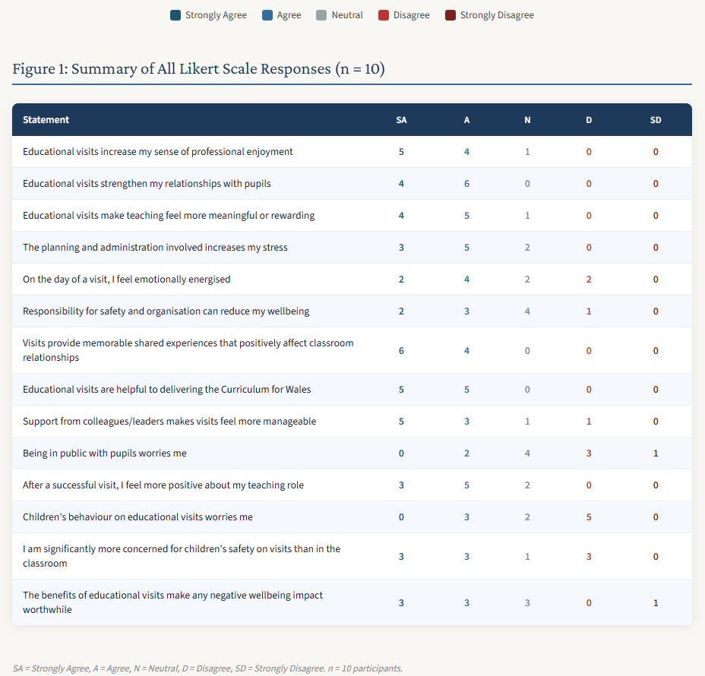
[Figure 1: Summary of All Likert Scale Responses (number of responses = 10)]
Five interconnected themes were constructed through the analysis:
- Educational visits as professionally rewarding experiences
- Strengthened teacher–pupil relationships beyond the classroom;
- Emotional pressure, safeguarding and responsibility;
- Workload, staffing and organisational burden;
- Negotiating contradiction: 'worthwhile despite the stress.'
Although themes are presented separately for clarity, considerable overlap existed between them which is a feature consistent with reflexive thematic analysis (Braun and Clarke, 2006). Teachers frequently moved between experiences of enjoyment and stress, suggesting that wellbeing within educational visits is not easily understood through positive or negative binaries (Demerouti et al., 2001).

4.2 Educational Visits as Professionally Rewarding Experiences
One of the strongest themes constructed throughout the dataset related to the professional fulfilment and enjoyment associated with educational visits. Participants frequently described educational visits as rewarding experiences which enhanced enjoyment of teaching, increased engagement and created opportunities for meaningful professional experiences.
The Likert-scale data strongly supported this theme, as illustrated in Figure 2. Nine of ten participants agreed or strongly agreed that educational visits increased their sense of professional enjoyment, and nine of ten agreed or strongly agreed that visits made teaching feel more meaningful or rewarding. Eight of ten reported feeling more positive about their teaching role after a successful visit. These patterns demonstrate that professional reward was not an incidental feature of educational visits but a near-universal experience across the participant group.
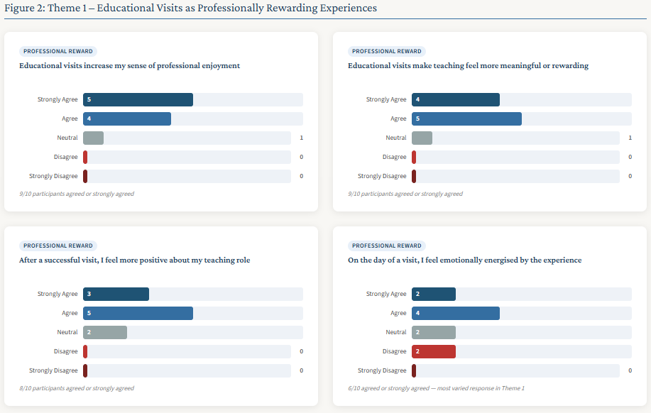
[Figure 2: Theme 1 – Likert Scale Responses: Educational Visits as Professionally Rewarding Experiences (number of responses = 10)]
Several participants described educational visits as opportunities to reconnect with aspects of teaching they considered authentic or enjoyable:
"Educational visits remind me why I became a teacher. Seeing children excited about learning outside the classroom makes the stress feel worthwhile."
Another participant wrote:
"The children engage differently on visits. It feels more natural and rewarding than being confined to the classroom all the time."
These responses reflected literature discussed in Chapter 2 surrounding experiential learning and professional meaning (Dewey, 1938; Behrendt and Franklin, 2014). Teachers appeared to value educational visits because they disrupted routine classroom structures and enabled more active and engaging forms of learning. Importantly, however, enjoyment was rarely discussed in simplistic terms. Participants did not describe educational visits as easy or relaxing experiences. Instead, enjoyment appeared closely connected to emotional investment, pupil engagement and professional identity. This aligned with Day and Gu's (2010) argument that teacher wellbeing is closely linked to professional fulfilment and emotional purpose.
Several participants also linked educational visits to feelings of accomplishment and professional pride:
"When a visit goes well, you feel proud of what the children have experienced."
"It's rewarding seeing children gain confidence and memories they may not otherwise have."
Notably, participants' descriptions of fulfilment were almost entirely mediated through the lens of pupil experience rather than personal enjoyment. Teachers rarely described visits as rewarding in and of themselves; instead, their professional satisfaction appeared contingent upon witnessing positive outcomes for children. As Hargreaves (1998) argues, teachers' emotional lives are fundamentally oriented towards their pupils, and Nias (1996) contends that teachers invest their sense of professional self in the wellbeing and success of those they teach. The data therefore suggest that teacher wellbeing on educational visits is not experienced as an independent phenomenon but as something deeply relational and pupil dependent. This has important implications for how wellbeing policy approaches teacher experience: if teachers' sense of professional fulfilment is contingent upon pupil outcomes, then policies that focus solely on reducing workload without attending to the relational and meaningful dimensions of teaching may fail to address what actually sustains teachers in the profession (Brady and Wilson, 2021; Collie et al., 2015).
The findings also appeared to support aspects of the JD-R model. Educational visits operated as professional resources by increasing engagement, meaning and relational connection. Participants repeatedly described visits as energising experiences which contrasted with the pressures of everyday classroom teaching. However, it is important not to romanticise these findings alongside my positionality. While educational visits were frequently described positively, teachers often qualified these experiences by simultaneously referencing workload or stress. Consequently, professional fulfilment appeared conditional and emotionally negotiated rather than simply positive.

4.3 Strengthened Teacher–Pupil Relationships Beyond the Classroom
Participants consistently described educational visits as opportunities to interact with pupils in more informal, relational and emotionally connected ways than within conventional classroom environments. This theme was the most unanimously supported across the Likert-scale data, as shown in Figure 3. All ten participants agreed or strongly agreed that educational visits strengthened their relationships with pupils, and all ten agreed or strongly agreed that visits provided memorable shared experiences which positively affected classroom relationships afterwards. The unanimity of this finding across a group of predominantly experienced teachers (nine of whom had thirteen or more years of teaching experience) demonstrates that the relational dimension of educational visits represents a particularly consistent and enduring aspect of their professional value.
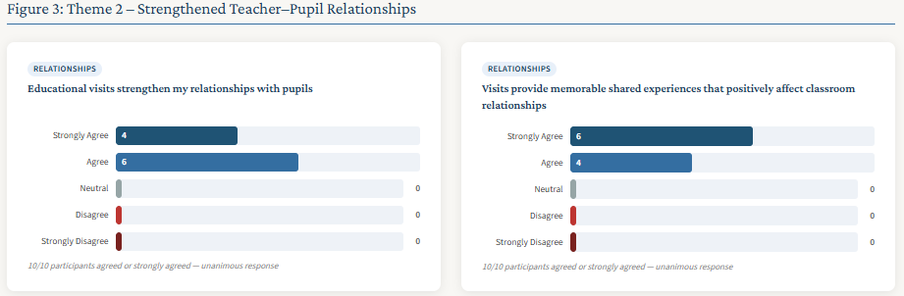
[Figure 3: Theme 2 – Likert Scale Responses: Strengthened Teacher–Pupil Relationships (number of responses = 10)]
Many participants explained that educational visits allowed them to see different aspects of pupils' personalities and behaviours:
"You see children in a completely different light outside school."
"Some children who struggle in class thrive on visits."
Participants described educational visits as spaces where classroom hierarchies became temporarily softened, allowing more natural conversations and interactions to occur:
"You build stronger relationships because you spend real time together outside normal lessons."
This aligned closely with relational pedagogy literature discussed in Chapter 2. Bingham and Sidorkin (2004) argued that education is fundamentally relational, and the findings demonstrate that educational visits intensify these relational dimensions through shared experience and informal interaction. It was also suggested that educational visits strengthened trust and classroom relationships after returning to school:
"The relationships built during residentials continue afterwards in the classroom."
"Children see you differently after a trip. There's more trust and respect."
Interestingly, they described relational wellbeing in collective rather than individual terms. Their wellbeing appeared connected to feelings of community, shared experience and emotional connection with pupils. This supports critiques of individualised wellbeing frameworks discussed earlier in the literature review and reinforces Nias' (1996) argument that teachers' professional identities are rooted in relational experiences rather than personal achievement.
Critically, relational closeness also created emotional pressure. While stronger relationships were frequently rewarding, participants also described increased emotional responsibility linked to safeguarding and pupil wellbeing. One participant noted:
"You become more emotionally responsible for the children during visits because you are together constantly."
"The children rely on you more outside school which can feel emotionally draining."
This reflected Zembylas' (2005) argument that emotional labour within teaching often involves tensions between care, connection and emotional exhaustion. Educational visits therefore appeared to intensify both the relational rewards and relational demands of teaching. Conversely, not all participants described relationship-building positively. A small number suggested that behavioural difficulties or emotional needs could become more visible and more challenging during educational visits:
"Some visits can increase behaviour issues and that changes the emotional atmosphere completely."
This complexity prevents the findings from presenting educational visits as universally relationship-enhancing experiences, but the data demonstrate that relationships during educational visits were emotionally dynamic and context-dependent.

4.4 Emotional Pressure, Safeguarding and Responsibility
Although educational visits were frequently described as rewarding, participants also repeatedly discussed significant emotional pressure associated with safeguarding responsibility, pupil behaviour and accountability.
The Likert-scale data revealed a nuanced picture, illustrated in Figure 4. Six of ten participants agreed or strongly agreed that they were more concerned for children's safety on educational visits than in the classroom, whilst five agreed or strongly agreed that responsibility for safety and organisation could reduce their sense of wellbeing. Notably, however, only two of ten participants agreed that being in public with pupils worried them, and only three agreed that children's behaviour on visits was a source of concern. This distinction suggests emotional pressure was most strongly associated with structural safeguarding responsibility and organisational accountability rather than with visible behaviour or public exposure. Thus, it is not the social or behavioural dimensions of visits that most threaten wellbeing, but the weight of institutional responsibility that teachers carry throughout the experience (Anderson, Kisiel and Storksdieck, 2006; Travers, 2017).
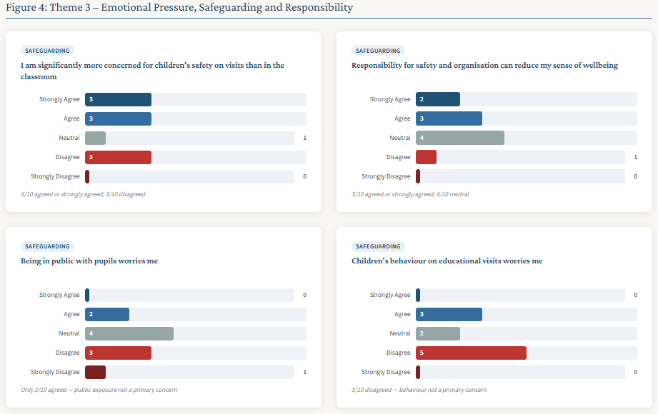
[Figure 4: Theme 3 – Likert Scale Responses: Emotional Pressure, Safeguarding and Responsibility (number of responses = 10)]
Participants stated:
"You never fully relax on a visit because you are constantly aware of health and safety."
"The responsibility feels huge, especially when parents trust you with their children outside."
These findings strongly reflected the JD-R framework, where safeguarding responsibility functioned as a significant professional demand. Emotional pressure appeared particularly intensified during visits, where participants described feeling responsible for pupils continuously rather than during standard school hours. Several participants referred specifically to anticipatory anxiety:
"You worry about accidents, behaviour and things going wrong all the time."
"The anxiety starts before the trip because you're thinking about every possible risk."
This reveals that the wellbeing impact of educational visits extends beyond the physical experience of the visit itself and begins during planning stages. The findings therefore support Hargreaves' (1998) argument that the emotional dimensions of teaching are chronically underacknowledged within policy and professional discourse. Furthermore, teachers described the requirement to perform emotional regulation throughout the visit, remaining calm, positive and emotionally available for pupils despite significant internal anxiety:
"Even when you're stressed, you still need to appear confident and enthusiastic for the children."
This aligned directly with Hochschild's (1983) conceptualisation of emotional labour as the management and suppression of emotion in the service of professional expectations. What the data reveal is that teachers are simultaneously managing heightened safeguarding anxiety, performing emotional positivity for pupils and maintaining professional accountability to parents and institutions, all at the same time. This is a substantial emotional burden that existing wellbeing policy rarely addresses. If teachers are expected to facilitate increasingly ambitious experiential learning through the Curriculum for Wales, the emotional labour associated with safeguarding responsibility must be acknowledged and supported rather than treated as an invisible professional expectation.

4.5 Workload, Staffing and Organisational Burden
A further major theme related to workload and organisational pressure. Participants consistently described educational visits as involving substantial administrative preparation and logistical responsibility. The Likert data clearly reinforced this theme, as shown in Figure 5. Eight of ten participants agreed or strongly agreed that the planning and administration involved in educational visits increased their stress, with no participants disagreeing with this item. This was one of the strongest areas of consensus across the entire dataset.
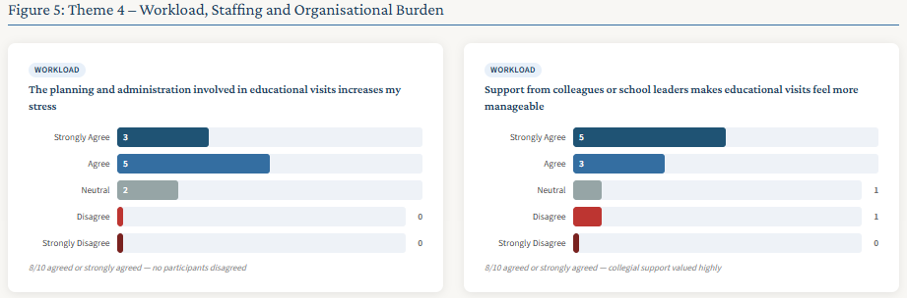
[Figure 5: Theme 4 – Likert Scale Responses: Workload, Staffing and Organisational Burden (number of responses = 10)]
Participants referred to a wide range of administrative and logistical responsibilities including risk assessments, parental communication, transport arrangements, safeguarding paperwork, staffing ratios, venue organisation, medical forms and financial considerations. Comments included:
"The amount of preparation involved is enormous compared to ordinary lessons."
"Visits are rewarding but the paperwork and organisation can be overwhelming."
Staffing concerns emerged particularly strongly throughout the data:
"Finding enough staff and support for visits is becoming increasingly difficult."
Several also referred to financial barriers:
"Cost and transport issues create huge stress before you even get to the visit itself."
Importantly, participants frequently described workload pressures as emotional rather than purely administrative. One participant again explained:
"The emotional load starts weeks before the actual trip."
Administrative tasks were not experienced neutrally; instead, they contributed directly to stress, anxiety and emotional fatigue. This finding is particularly significant in the Welsh policy context. The Curriculum for Wales actively encourages authentic, experiential learning beyond the classroom (Welsh Government, 2022; Donaldson, 2015), yet participants' accounts reveal that the organisational infrastructure required to deliver such experiences is placing considerable strain on teachers who are already managing significant workload pressures. This reflects precisely the tension identified by Evans (2023) and Ellis et al. (2024) that policy aspirations for experiential learning in Wales exist in tension with the professional conditions and organisational support available to teachers enacting those aspirations. The data therefore suggest that sustaining educational visits as a meaningful pedagogical practice requires not only curricular encouragement but practical, structural and institutional support.

4.6 Negotiating Contradiction: ‘Worthwhile Despite the Stress’
The final theme captured the contradictory nature of many participant responses. Throughout the dataset, teachers frequently described educational visits as simultaneously stressful and worthwhile.
As illustrated in Figure 6, six of ten participants agreed or strongly agreed that the benefits of educational visits made any negative impact on wellbeing worthwhile, whilst three responded neutrally and only one strongly disagreed. The absence of straightforward disagreement, even from participants who had reported significant planning stress and safeguarding anxiety, is analytically striking. It reinforces the qualitative picture of teachers who accepted emotional and organisational demands as part of professionally meaningful work rather than as reasons to avoid visits altogether.
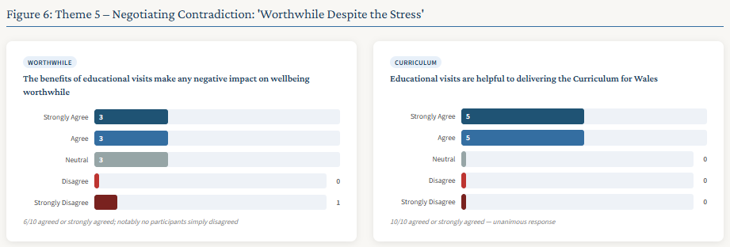
[Figure 6: Theme 5 – Likert Scale Responses: Negotiating Contradiction – ‘Worthwhile Despite the Stress’ (number of responses = 10)]
Participants repeatedly acknowledged the pressures associated with educational visits whilst still strongly valuing them:
"They are stressful, exhausting and difficult to organise, but completely worth it."
"The workload is huge but the memories and experiences make it worthwhile."
"I always feel stressed beforehand but positive afterwards."
The findings strongly reflected the JD-R framework because educational visits simultaneously operated as demands and resources. Importantly, participants did not necessarily perceive stress as evidence that educational visits harmed wellbeing. Instead, stress often appeared normalised as part of emotionally meaningful professional work, aligning with Hargreaves' (1998) argument that emotional investment is central to teaching identity.
Several participants framed educational visits as experiences that pupils would remember long after classroom learning:
"Children remember visits for years."
"The experiences matter more than the stress in the end."
However, there is also a critical dimension to this finding that warrants careful consideration. If stress becomes normalised as an inevitable feature of meaningful teaching experiences, institutional and policy-level wellbeing concerns may be inadvertently minimised. Teachers who consistently accept emotional and organisational burden as ‘worthwhile’ may be less likely to advocate for the structural support they require, and institutions may be less likely to recognise the need to provide it. This tension is again particularly relevant within the Welsh educational context, where the Curriculum for Wales encourages experiential learning whilst simultaneously positioning teacher wellbeing as a professional and institutional priority. The data suggest these two commitments cannot be treated as separate policy concerns; they must be addressed together.

4.7 Chapter Conclusion
This chapter has presented the findings generated through the questionnaire responses of ten Year 5 primary school teachers in Wales. The analysis demonstrates that educational visits were perceived as emotionally and professionally complex experiences involving both substantial rewards and significant demands, simultaneously functioning as professional resources and professional demands within the JD-R framework. Most significantly, teachers frequently perceived educational visits as worthwhile despite the stress involved, highlighting the emotionally negotiated nature of teacher wellbeing within experiential educational practice.

Chapter 5 – Discussion

5.1 Introduction
The findings of this study challenge the assumption that educational visits can be understood as either beneficial or detrimental to teacher wellbeing. Instead, educational visits are emotionally contradictory and professionally complex experiences, simultaneously generating professional fulfilment, relational connection and meaning whilst also creating workload pressures, safeguarding responsibilities and emotional demands. This complexity suggests that the relationship between educational visits and teacher wellbeing is shaped not by the visits themselves, but by the ways in which teachers interpret and experience them within particular professional, relational and organisational contexts.
These findings address a gap identified in existing research, including studies such as Deschamps et al. (2022) and Marchant et al. (2019). By exploring teachers’ perceptions rather than pupil outcomes or organisational processes, the study highlights a previously underexamined dimension of educational visits and offers new insight into how experiential learning initiatives may influence teacher wellbeing within contemporary Welsh primary education. This chapter considers these findings in relation to the literature reviewed in Chapter 2 and discusses their significance through the theoretical lenses of the Job Demands–Resources (JD-R) model, emotional labour and relational pedagogy.

5.2 Educational Visits as Emotionally Complex Professional Experiences
One of the most significant findings of the study was the emotional complexity associated with educational visits. Participants rarely described educational visits as either wholly beneficial or wholly damaging to wellbeing. Instead, teachers frequently positioned educational visits as experiences involving simultaneous enjoyment, stress, fulfilment and anxiety. This finding is important because it challenges simplistic assumptions often implicit within educational visits literature, which frequently frames visits positively through discussions of pupil engagement and authentic educational opportunities (Rickinson et al., 2004; Behrendt and Franklin, 2014). The findings of this study demonstrate that teacher experiences are considerably more layered and emotionally negotiated.
The study therefore supports critiques raised within Chapter 2 that educational visits are often discussed through pupil-centred narratives which overlook the emotional and professional experiences of teachers facilitating them. The findings reinforce Demerouti et al.’s (2001) argument that workplace experiences cannot always be categorised simply as beneficial or harmful because the same experience may operate differently depending upon context and perception. Importantly, participants often normalised this emotional contradiction, accepting stress and anxiety as part of facilitating experiences they considered worthwhile for pupils. However, the normalisation of such pressures warrants critical scrutiny. If emotional strain is routinely accepted as the cost of delivering meaningful educational experiences, responsibility for managing that strain may become individualised rather than recognised as an organisational concern. This finding therefore raises broader questions about how schools and policymakers can support experiential learning whilst also addressing the structural conditions that shape teacher wellbeing.

5.3 Professional Fulfilment, Meaning and Teacher Identity
A major finding throughout the research was that educational visits frequently enhanced teachers’ sense of professional fulfilment and meaning. Participants described educational visits as opportunities to reconnect with aspects of teaching they perceived as authentic, engaging and rewarding, supporting Dewey’s (1938) argument that meaningful learning occurs through direct experience and Day and Gu’s (2010) argument that teacher wellbeing is closely connected to professional identity and emotional purpose.
Participants rarely discussed fulfilment in terms of personal benefit alone; instead, fulfilment appeared closely connected to pupils’ enjoyment, confidence and engagement. This finding suggests that professional fulfilment was often constructed relationally rather than individually. Consistent with Nias’ (1996) argument that teaching is closely intertwined with personal and professional identity, participants appeared to derive a sense of wellbeing not primarily from their own enjoyment of educational visits but from witnessing positive outcomes for pupils. Similarly, Hargreaves (1998) argued that teaching is fundamentally emotional work, shaped through relationships and care. The findings therefore indicate that teachers frequently justified the value of educational visits through their perceived impact on pupils, suggesting that professional fulfilment was experienced as relationally mediated rather than self-directed.
Although educational visits were frequently described as rewarding, participants simultaneously acknowledged emotional strain and organisational burden. There is also a risk that emotional fulfilment becomes used to justify excessive workload expectations, particularly when teachers internalise the belief that worthwhile educational experiences inevitably require personal sacrifice.

5.4 Relational Pedagogy Beyond the Classroom
The findings strongly reinforced the importance of relational pedagogy within educational visits. Participants consistently described educational visits as opportunities to strengthen teacher–pupil relationships through shared experiences, informal interaction and increased trust. The unanimous agreement across all ten participants that visits strengthened relationships with pupils (the strongest quantitative finding in the entire dataset) lends particular weight to this conclusion.
These findings support relational theories discussed within Chapter 2, particularly Bingham and Sidorkin’s (2004) argument that education is fundamentally relational. Educational visits appeared to disrupt traditional classroom dynamics and create alternative spaces for interaction between teachers and pupils. Participants frequently described lasting changes in classroom relationships after educational visits had ended, supporting Spilt, Koomen and Thijs’ (2011) argument that positive teacher–pupil relationships may support teacher wellbeing and professional satisfaction.
Contradictorily, the findings also demonstrated that relational closeness intensified emotional responsibility, reflecting Zembylas’ (2005) argument that relational teaching often involves emotional vulnerability and emotional labour rather than simple emotional reward. Consequently, the findings demonstrate that relational pedagogy is not simply a resource for teacher wellbeing but also a source of emotional demand. The same relationships that generated fulfilment, connection and professional meaning also created heightened feelings of responsibility and emotional investment. This finding is particularly significant within the Welsh educational context, where Curriculum for Wales emphasises relational and experiential approaches to learning. If such approaches are to remain sustainable, greater attention may be required to how teachers are supported in managing the emotional labour that accompanies the relational outcomes these pedagogies are designed to produce.

5.5 Emotional Labour, Safeguarding and Responsibility
The findings highlighted the extent to which educational visits intensified emotional labour and safeguarding responsibility for teachers. Participants repeatedly described heightened anxiety associated with pupil safety, behaviour management and public accountability, strongly reflecting Hochschild’s (1983) concept of emotional labour, where professionals are required to regulate emotions as part of their work.
Importantly, emotional pressure was not limited to the visit itself. Participants frequently described anticipatory anxiety during planning stages, particularly surrounding risk assessments, behaviour concerns and responsibility for pupil safety. This demonstrates that the wellbeing impact of educational visits extends beyond the physical experience of the visit and includes organisational preparation and emotional anticipation beforehand. The findings reveal that much of the emotional labour associated with educational visits remains largely invisible within both policy and professional discourse (Lim, 2016). Whilst teachers publicly enacted confidence, care and reassurance, they frequently described privately managing anxiety, responsibility and emotional pressure long before the visit itself took place (Smith et al., 2025). In a Welsh policy context that increasingly encourages experiential and authentic learning opportunities, the wellbeing implications of this hidden emotional work deserve more explicit recognition. Otherwise, there is a risk that the emotional demands underpinning educational visits become normalised and absorbed by individual teachers rather than addressed through appropriate organisational support (Acton and Glasgow, 2015; Brady and Wilson, 2021).

5.6 Workload, Organisational Pressure and Policy Tensions
Workload and organisational burden were identified as major themes throughout the findings. Participants consistently referred to planning demands, staffing concerns, paperwork, safeguarding procedures and logistical organisation as sources of stress that directly influenced emotional wellbeing through anxiety and mental exhaustion.
The findings also revealed tensions between policy aspirations and practical realities within Welsh education. As noted throughout this research, the Curriculum for Wales strongly promotes authentic, experiential and enquiry-based learning approaches (Welsh Government, 2022), yet participants suggested that limited staffing, funding pressures and workload concerns may reduce teachers’ capacity to facilitate educational visits sustainably. This reflects the analysis offered by Evans (2023) and Ellis et al. (2024), who identify the gap between curricular aspiration and the professional conditions within which teachers must enact policy. Consequently, improving teacher wellbeing in relation to educational visits may require organisational and policy-level responses rather than relying solely upon individual resilience or professional commitment. Whilst caution is required given the exploratory nature of this study and its small sample size, the findings tentatively suggest that greater institutional support is required to support teachers. Future research involving a larger sample and a broader range of school contexts would be necessary to establish whether these patterns are evident across the wider Welsh primary education sector.

5.7 Contribution to Existing Literature
Earlier stages of the research raised questions regarding whether the perceived relationship between educational visits and teacher wellbeing reflected a genuine gap within the literature or was influenced by my own professional interest in educational visits. However, the literature review demonstrated that the gap is both identifiable and evidenced. Research relating to educational visits has predominantly focused on pupil outcomes, experiential learning and curriculum enrichment (Rickinson et al., 2004; Dillon et al., 2006; Behrendt and Franklin, 2014), whilst teacher wellbeing research has largely concentrated on workload, emotional labour, professional identity and retention (Day and Gu, 2010; Acton and Glasgow, 2015). Although studies such as Deschamps et al. (2022) and Marchant et al. (2019) begin to explore related issues, neither explicitly examined how educational visits influence teacher wellbeing. Whilst my positionality may have drawn attention to this omission, the gap itself is demonstrable through the literature.
Firstly, this research directly addresses this gap within the specific context of Welsh primary education, extending the emerging work of Deschamps et al. (2022) by applying a similar concern with teacher wellbeing to the distinct context of planned educational visits, which involve substantially greater organisational, safeguarding and, in some cases, residential responsibilities than school-based outdoor education.
Secondly, it contributes a more nuanced understanding of the relationship between educational visits and teacher wellbeing. Rather than positioning educational visits as inherently positive or negative, the findings demonstrate that teachers experience them as emotionally contradictory and professionally complex, challenging simplistic assumptions within both educational visits and wellbeing literature.
Next, the study contributes specifically to understanding educational visits within the context of Year 5 primary education in Wales. Whilst the findings cannot be generalised beyond the study sample, they provide insight into how educational visits are experienced within a phase of primary education where visits, increasing pupil independence and growing professional responsibilities often intersect.
Finally, my research project demonstrates the value of interpretivist approaches within teacher wellbeing research. Hascher and Waber (2021) note that much existing research on teacher wellbeing has relied upon quantitative and measurement-focused designs that risk reducing complex, contextually situated experiences to standardised outputs. By prioritising teachers' own accounts and interpretations (Cohen, Manion and Morrison, 2018), the present study captured emotional tensions, contradictions and contextual influences that such approaches may overlook (Rich, 2017), contributing to calls for more qualitative engagement with teacher wellbeing as a lived, relational and professionally complex experience.

5.8 Chapter Conclusion
Overall, the findings reveal that educational visits occupy an important yet largely overlooked space within the professional and emotional lives of Year 5 teachers in Wales. The study has shown that educational visits are not simply curriculum-enhancing experiences for pupils but are also emotionally and professionally consequential experiences for the teachers responsible for facilitating them. By demonstrating how educational visits simultaneously function as sources of fulfilment, relational connection, emotional labour and organisational pressure, the findings challenge existing assumptions within both educational visits research and teacher wellbeing literature.
More broadly, the study highlights a tension at the heart of contemporary Welsh education. Whilst Curriculum for Wales encourages authentic and experiential learning beyond the classroom, the professional and wellbeing implications of delivering these experiences have received comparatively little attention. The findings therefore suggest that educational visits represent a significant point of intersection between two major educational priorities within Wales; experiential learning and teacher wellbeing - that have too often been considered separately.

Chapter 6 – Conclusions and Recommendations
The findings of this study demonstrated that educational visits were experienced as emotionally and professionally complex practices involving both substantial rewards and significant pressures. Participants frequently described educational visits as professionally meaningful and relationally valuable, particularly in relation to strengthened teacher–pupil relationships, authentic learning and shared experiences. Simultaneously, teachers identified considerable emotional labour, safeguarding responsibility, workload and organisational pressure associated with facilitating educational visits. Consequently, the study supports Hargreaves’ (1998) argument that teaching is fundamentally emotional practice and suggests that educational visits intensify both the relational rewards and emotional demands associated with teaching.
Several limitations should be acknowledged. Firstly, the study involved a relatively small sample of ten participants recruited through professional networks connected to Swansea lead schools. While this was appropriate for a small-scale interpretivist pilot study, the findings cannot be generalised broadly across all Welsh primary school contexts. Lincoln and Guba (1985) argue that qualitative interpretivist research prioritises contextual depth rather than statistical generalisability; however, future research could expand participation across a wider range of schools and local authorities. Given more time, future research may also benefit from including Year 4 and Year 6 teachers alongside Year 5 participants, which would align more closely with Curriculum for Wales Progression Step 3 and provide broader insight into how educational visits are experienced across upper primary education.
Secondly, although the inclusion of Likert-scale items provided useful descriptive insight, the narrative responses generated considerably richer and more emotionally nuanced data. This reflects Braun and Clarke’s (2021) argument that qualitative approaches are particularly valuable when exploring subjective meaning and complexity. Given more time, the study would benefit from greater emphasis on qualitative methods such as semi-structured interviews or focus groups. Cohen, Manion and Morrison (2018) suggest that interviews allow opportunities for probing, clarification and deeper exploration of participant meaning, which can strengthen understanding of how teachers negotiate emotional pressure and professional fulfilment during educational visits. The reliance upon a single questionnaire also limited opportunities for triangulation; future research may therefore benefit from combining questionnaires with interviews, reflective journals or observational approaches (Denscombe, 2017).
Whilst caution is required given the small-scale and exploratory nature of the study, the findings suggest several tentative implications for practice. Schools may benefit from providing greater organisational support for educational visits through protected planning time, clearer procedural guidance and appropriate staffing arrangements that recognise the workload associated with planning and facilitating visits. At a policy level, there may also be value in ensuring that the wellbeing implications of experiential learning expectations are more explicitly acknowledged within professional guidance and inspection frameworks (Estyn, 2020). However, larger-scale research involving a broader range of schools and educational contexts would be required before such recommendations could be advanced with confidence.
More broadly, the findings suggest that educational visits represent a significant point of intersection between two major priorities within contemporary Welsh education: experiential learning and teacher wellbeing. Educational visits are spaces in which professional identity, emotional labour, relational pedagogy and organisational pressure converge in particularly visible ways. Foregrounding teacher experience within these spaces is therefore not peripheral to discussions of educational quality, curriculum reform or wellbeing in Wales; it is essential to them. If educational visits continue to be promoted as valuable opportunities for authentic and meaningful learning, equal attention must be given to the emotional and professional realities experienced by the teachers who make those opportunities possible.

Reference List
Acton, R. and Glasgow, P. (2015) 'Teacher wellbeing in neoliberal contexts: a review of the literature', Australian Journal of Teacher Education, 40(8), pp. 99–114.
Anderson, D., Kisiel, J. and Storksdieck, M. (2006) 'Understanding teachers' perspectives on field trips: discovering common ground in three countries', Curator: The Museum Journal, 49(3), pp. 365–386.
Bakker, A.B. and Demerouti, E. (2007) 'The Job Demands-Resources model: state of the art', Journal of Managerial Psychology, 22(3), pp. 309–328.
Ball, S.J. (2003) 'The teacher's soul and the terrors of performativity', Journal of Education Policy, 18(2), pp. 215–228. doi: 10.1080/0268093022000043065.
Beames, S., Higgins, P. and Nicol, R. (2012) Learning outside the classroom: theory and guidelines for practice. London: Routledge.
Behrendt, M. and Franklin, T. (2014) 'A review of research on school field trips and their value in education', International Journal of Environmental and Science Education, 9(3), pp. 235–245.
Berger, R. (2015) 'Now I see it, now I don't: researcher's position and reflexivity in qualitative research', Qualitative Research, 15(2), pp. 219–234.
Bingham, C. and Sidorkin, A.M. (eds) (2004) No education without relation. New York: Peter Lang.
Blumer, H. (1954) 'What is wrong with social theory?', American Sociological Review, 19(1), pp. 3–10.
Brady, J. and Wilson, E. (2021) 'Teacher wellbeing in England: teacher responses to school-level initiatives', Cambridge Journal of Education, 51(1), pp. 45–63. doi: 10.1080/0305764X.2020.1775789.
Braun, V. and Clarke, V. (2006) 'Using thematic analysis in psychology', Qualitative Research in Psychology, 3(2), pp. 77–101.
Braun, V. and Clarke, V. (2021) Thematic analysis: a practical guide. London: Sage.
British Educational Research Association (2024) Ethical guidelines for educational research. 5th edn. London: BERA. Available at: https://www.bera.ac.uk/publication/ethical-guidelines-for-educational-research-fifth-edition-2024 (Accessed: 28th March 2026.)
Bryman, A. (2016) Social research methods. 5th edn. Oxford: Oxford University Press.
Cohen, L., Manion, L. and Morrison, K. (2018) Research methods in education. 8th edn. London: Routledge.
Collie, R.J., Shapka, J.D., Perry, N.E. and Martin, A.J. (2015) 'Teacher wellbeing: exploring its components and a practice-oriented scale', Journal of Psychoeducational Assessment, 33(8), pp. 744–756. doi: 10.1177/0734282915587990.
Crawford, E.R., LePine, J.A. and Rich, B.L. (2010) 'Linking job demands and resources to employee engagement and burnout: a theoretical extension and meta-analytic test', Journal of Applied Psychology, 95(5), pp. 834–848. doi: 10.1037/a0019364.
Creswell, J.W. and Plano Clark, V.L. (2011) Designing and conducting mixed methods research. 2nd edn. London: Sage.
Crotty, M. (1998) The foundations of social research: meaning and perspective in the research process. London: Sage.
Day, C. and Gu, Q. (2010) The new lives of teachers. London: Routledge.
Demerouti, E., Bakker, A.B., Nachreiner, F. and Schaufeli, W.B. (2001) 'The job demands-resources model of burnout', Journal of Applied Psychology, 86(3), pp. 499–512. doi: 10.1037/0021-9010.86.3.499.
Denscombe, M. (2017) The good research guide: for small-scale social research projects. 6th edn. Maidenhead: Open University Press.
Deschamps, A., Scrutton, R. and Ayotte-Beaudet, J.-P. (2022) 'School-based outdoor education and teacher subjective well-being: an exploratory study', Journal of Adventure Education and Outdoor Learning, 22(4), pp. 385–397.
DeWitt, J. and Osborne, J. (2010) 'School trips and classroom lessons: an investigation into teacher-student talk in two settings', Journal of Research in Science Teaching, 47(4), pp. 454–473. doi: 10.1002/tea.20346.
Dewey, J. (1938) Experience and education. New York: Macmillan.
Dillon, J., Rickinson, M., Teamey, K., Morris, M., Choi, M.Y., Sanders, D. and Benefield, P. (2006) The value of outdoor learning: evidence from research in the UK and elsewhere. Slough: National Foundation for Educational Research.
Donaldson, G. (2015) Successful Futures: independent review of curriculum and assessment in Wales. Cardiff: Welsh Government. Available at: https://www.gov.wales/sites/default/files/publications/2018-03/successful-futures.pdf (Accessed: 10th January 2026.)
Education Workforce Council (2024) Annual report and accounts 2023-24. Cardiff: EWC. Available at: https://www.ewc.wales (Accessed: 3 June 2026.)
Ellis, C., Ellis, R., Dobson, L., O'Leary, S. and Williams, A. (2024) 'The "Welsh way", outdoor learning within the primary curriculum: a "fringe add-on or mainstream pedagogical practice"?', Wales Journal of Education, 26(2), pp. 140–152. doi: 10.16922/wje.26.2.10.
Estyn (2019) Healthy and happy: school impact on pupils' health and wellbeing. Cardiff: Estyn. Available at: https://www.estyn.gov.wales/system/files/2022-01/Healthy%20and%20Happy%20report%20En_0.pdf (Accessed: 14 December 2025.)
Estyn (2020) Peer support for supply teachers and well-being support for all staff. Available at: https://www.estyn.gov.wales (Accessed: 2 February 2026.)
Etikan, I., Musa, S.A. and Alkassim, R.S. (2016) 'Comparison of convenience sampling and purposive sampling', American Journal of Theoretical and Applied Statistics, 5(1), pp. 1–4.
Evans, G. (2023) 'A new dawn or false hope? Exploring the early implementation of Curriculum for Wales', Education Inquiry, pp. 1–15. doi: 10.1080/20004508.2023.2297506.
Fägerstam, E. (2014) 'High school teachers' experience of the educational potential of outdoor teaching and learning', Journal of Adventure Education and Outdoor Learning, 14(1), pp. 56–81.
Fereday, J. and Muir-Cochrane, E. (2006) 'Demonstrating rigor using thematic analysis: a hybrid approach of inductive and deductive coding and theme development', International Journal of Qualitative Methods, 5(1), pp. 80–92.
Finlay, L. (2002) 'Negotiating the swamp: the opportunity and challenge of reflexivity in research practice', Qualitative Research, 2(2), pp. 209–230.
Fuller, I., Powell, E. and Fox, S. (2017) 'Making gains: the impact of outdoor residential experiences on students' examination grades and self-efficacy', Educational Review, 69(2), pp. 232–247.
Hargreaves, A. (1998) 'The emotional practice of teaching', Teaching and Teacher Education, 14(8), pp. 835–854.
Hargreaves, A. (2000) 'Mixed emotions: teachers' perceptions of their interactions with students', Teaching and Teacher Education, 16(8), pp. 811–826.
Hascher, T. and Waber, J. (2021) 'Teacher well-being: a systematic review of the research literature from the year 2000–2019', Educational Research Review, 34, article 100411. doi: 10.1016/j.edurev.2021.100411.
Hochschild, A.R. (1983) The managed heart: commercialization of human feeling. Berkeley: University of California Press.
Isenbarger, L. and Zembylas, M. (2006) 'The emotional labour of caring in teaching', Teaching and Teacher Education, 22(1), pp. 120–134.
Kern, M.L., Waters, L.E., Adler, A. and White, M.A. (2015) 'A multidimensional approach to measuring wellbeing in students: application of the PERMA framework', The Journal of Positive Psychology, 10(3), pp. 262–271.
Kolb, D.A. (1984) Experiential learning: experience as the source of learning and development. Englewood Cliffs, NJ: Prentice Hall.
Lim, L. (2016) 'Voices from the ground: the emotional labour of English teachers' work', Teaching and Teacher Education, 55, pp. 228–237. doi: 10.1016/j.tate.2016.01.012.
Lincoln, Y.S. and Guba, E.G. (1985) Naturalistic inquiry. Beverly Hills, CA: Sage.
Marchant, E., Todd, C., Cooksey, R., Dredge, S., Jones, H., Reynolds, D., Stratton, G., Brophy, S. and Lyons, R. (2019) 'Curriculum-based outdoor learning for children aged 9–11: a qualitative analysis of pupils' and teachers' views', PLOS ONE, 14(5), article e0212242.
Nias, J. (1996) 'Thinking about feeling: the emotions in teaching', Cambridge Journal of Education, 26(3), pp. 293–306.
Ord, J. and Leather, M. (2011) 'The substance beneath the labels of experiential learning: the importance of John Dewey for outdoor educators', Journal of Outdoor and Environmental Education, 15(2), pp. 13–23.
Punch, K.F. (2014) Introduction to social research: quantitative and qualitative approaches. 3rd edn. London: Sage.
Rich, J. (2017) 'Teacher wellbeing: a review of the evidence', Teacher Development, 21(3), pp. 462–480. doi: 10.1080/13664530.2017.1289641.
Rickinson, M., Dillon, J., Teamey, K., Morris, M., Choi, M.Y., Sanders, D. and Benefield, P. (2004) A review of research on outdoor learning. Shrewsbury: Field Studies Council.
Riddle, S. and Hickey, A. (2023) 'The practice of relationality in classrooms: beyond relational pedagogy as empty signifier', Teachers and Teaching, 29(4), pp. 1–14. doi: 10.1080/13540602.2023.2202389.
Robson, C. and McCartan, K. (2016) Real world research: a resource for users of social research methods in applied settings. 4th edn. Chichester: Wiley.
Schaufeli, W.B. and Bakker, A.B. (2004) 'Job demands, job resources, and their relationship with burnout and engagement: a multi-sample study', Journal of Organizational Behavior, 25(1), pp. 293–315.
Scotland, J. (2012) 'Exploring the philosophical underpinnings of research: relating ontology and epistemology to the methodology and methods of the scientific, interpretive and critical research paradigms', English Language Teaching, 5(9), pp. 9–16.
Seligman, M.E.P. (2011) Flourish: a visionary new understanding of happiness and wellbeing. New York: Free Press.
Smith, K., Carroll, A., Loughland, T. and Sexton, S. (2025) 'Teachers' emotional labour: the joys, demands, and constraints', Teachers and Teaching, 31(2). doi: 10.1080/13540602.2025.2466560.
Spilt, J.L., Koomen, H.M.Y. and Thijs, J.T. (2011) 'Teacher wellbeing: the importance of teacher–student relationships', Educational Psychology Review, 23(4), pp. 457–477.
Thomas, G. (2017) How to do your research project: a guide for students. 3rd edn. London: Sage.
Tinney, G. (2023) Big changes! The Great Outdoors and the Curriculum for Wales. University of Wales Trinity Saint David Repository. Available at: https://repository.uwtsd.ac.uk/id/eprint/2415/ (Accessed: 21 January 2026.)
Tortop, H.S. (2012) 'Development of teacher attitude scale towards the field trip', Energy Education Science and Technology Part B: Social and Educational Studies, Special Issue, pp. 970–972.
Travers, C. (2017) Current issues in occupational health psychology. Chichester: Wiley-Blackwell.
Viac, C. and Fraser, P. (2020) Teachers' well-being: a framework for data collection and analysis. Paris: OECD.
Wahab, N., Ahmad, N., Razali, S.N.A.M. and Nawi, A.M. (2024) 'Workload and teacher wellbeing: a systematic review', Teaching and Teacher Education, 136, article 104353.
Waite, S. (2011) Children learning outside the classroom: from birth to eleven. London: Sage.
Welsh Government (2015) Well-being of Future Generations (Wales) Act 2015. Available at: https://www.legislation.gov.uk/anaw/2015/2/contents/enacted (Accessed: 2 February 2026.)
Welsh Government (2021) Framework on embedding a whole-school approach to emotional and mental wellbeing. Available at: https://www.gov.wales/framework-embedding-whole-school-approach-emotional-and-mental-wellbeing (Accessed: 2 February 2026.)
Welsh Government (2022) Curriculum for Wales. Available at: https://hwb.gov.wales/curriculum-for-wales (Accessed: 2 February 2026.)
Welsh Government (2024) Written statement: reducing workload and bureaucracy for education staff. Cardiff: Welsh Government. Available at: https://www.gov.wales/written-statement-reducing-workload-and-bureaucracy-education-staff (Accessed: 9th March 2026.)
Wythe, J. (2024) 'Trips are the thing we all remember from our school days: the learning value of school trips for children with special educational needs from the perspective of primary school teachers', Journal of Research in Special Educational Needs, 24(2), pp. 389–404. doi: 10.1111/1471-3802.12638.
Zembylas, M. (2005) Teaching with emotion: a postmodern enactment. Greenwich, CT: Information Age Publishing.

Appendices

Appendix A – Ethics Approval
APPLICATION FOR ETHICAL APPROVAL

RESEARCH STUDENTS
This form is to be completed by the student within SIX months for full-time students and TWELVE months for part time students, after the commencement of the research degree or following progression to Part Two of your course.

Once complete, submit this form via the MyTSD Doctoral College Portal at (https://mytsd.uwtsd.ac.uk).

This document is also available in Welsh.

RESEARCH STAFF ONLY
All communications relating to this application during its processing must be in writing and emailed to pgresearch@uwtsd.ac.uk , with the title ‘Ethical Approval’ followed by your name.

STUDENTS ON UNDERGRADUATE OR TAUGHT MASTERS PROGRAMMES should submit this form (and receive the outcome) via systems explained to you by the supervisor/module leader.

In order for research to result in benefit and minimise risk of harm, it must be conducted ethically. A researcher may not be covered by the University’s insurance if ethical approval has not been obtained prior to commencement.

The University follows the OECD Frascati manual definition of research activity: “creative work undertaken on a systematic basis in order to increase the stock of knowledge, including knowledge of man, culture and society, and the use of this stock of knowledge to devise new applications”. As such this covers activities undertaken by members of staff, postgraduate research students, and both taught postgraduate and undergraduate students working on dissertations/projects.

The individual undertaking the research activity is known as the “principal researcher”.

Ethical approval is not required for routine audits, performance reviews, quality assurance studies, testing within normal educational requirements, and literary or artistic criticism.

Please read the notes for guidance before completing ALL sections of the form.

This form must be completed and approved prior to undertaking any research activity. Please see Checklist for details of process for different categories of application.

SECTION A: About You (Principal Researcher)
1 | Full Name: |  | LAURA EMANUEL
2 | Tick all boxes that apply: |  | Member of staff: | ☐ | Honorary research fellow: | ☐
 | Undergraduate Student | ☐ | Taught Postgraduate Student | ☒ | Postgraduate Research Student | ☒

3 | Institute/Academic Discipline/Centre: | IEH
4 | Campus: | IQ SWANSEA
5 | E-mail address: | LAURA.EMANUEL@UWTSD.AC.UK
6 | Contact Telephone Number: | 07772 716335
 | For students:
7 | Student Number: | 2308139
8 | Programme of Study: | Professional Doctorate in Education (EdD)
9 | Director of Studies/Supervisor: | Dr Catherine Morgan

SECTION B: Approval for Research Activity
1 | Has the research activity received approval in principle?  (please check the Guidance Notes as to the appropriate approval process for different levels of research by different categories of individual) |  | YES | ☒ | NO | ☐
 |  |  |  |  | Date
2 | If Yes, please indicate source of approval (and date where known): Approval in principle must be obtained from the relevant source prior to seeking ethical approval | Research Degrees Committee |  | ☐
2 |  | Institute Research Committee |  | ☐
2 |  | Other (write in)  Catherine Morgan |  | ☒ | 15/10/25

SECTION C: Internal and External Ethical Guidance Materials
 | Please list the core ethical guidance documents that have been referred to during the completion of this form (including any discipline-specific codes of research ethics, location-specific codes of research ethics, and also any specific ethical guidance relating to the proposed methodology). Please tick to confirm that your research proposal adheres to these codes and guidelines. You may add rows to this table if needed.
1 | UWTSD Research Ethics & Integrity Code of Practice | ☒
2 | UWTSD Research Data Management Policy | ☒
3 | BERA Ethical Guidelines for Educational Research (BERA, 2024) | ☒

SECTION D: External Collaborative Research Activity
If there are external collaborators then you should gain consent from the contact persons to share their personal data with the university. If there are no external collaborators then leave this section blank and continue to section E.
1 | Institution
2 | Contact person name
3 | Contact person e-mail address
4 | Is your research externally funded? |  | YES | ☐ | NO |  | ☐
5 | Are you in receipt of a KESS scholarship? |  | YES | ☐ | NO |  | ☐
6 | Are you specifically employed to undertake this research in either a paid or voluntary capacity? | Voluntary | YES | ☐ | NO | ☐
7 |  | Employed | YES | ☐ | NO | ☐
8 | Is the research being undertaken within an existing UWTSD Athrofa Professional Learning Partnership (APLP)? | If YES then the permission question below does not need to be answered. | YES | ☐ | NO |  | ☐
9 | Has permission to undertake the research has been provided by the partner organisation? | (If YES attach copy)  If NO the application cannot continue | YES | ☐ | NO |  | ☐

Where research activity is carried out in collaboration with an external organisation
10 | Does this organisation have its own ethics approval system? | YES | ☐ | NO | ☒
 | If Yes, please attach a copy of any final approval (or interim approval) from the organisation (this may be a copy of an email if appropriate).

SECTION E: Details of Research Activity
1 | Indicative title: | Exploring the Impact of Educational Visits on Teacher Wellbeing in Primary Schools in Wales
2 | Proposed start date: | JANUARY 2026 | Proposed end date: | JULY 2026
Introduction to the Research (maximum 300 words per section)
Ensure that you write for a Non-Specialist Audience when outlining your response to the points below:
Purpose of Research Activity
Proposed Research Question
Aims of Research Activity
Objectives of Research Activity
Demonstrate, briefly, how Existing Research has informed the proposed activity and explain
What the research activity will add to the body of knowledge
How it addresses an area of importance.
3 | Purpose of Research Activity  Teacher wellbeing has become a growing priority across education systems, with research showing that stress, workload, and emotional exhaustion continue to impact morale, retention, and classroom relationships (Skaalvik & Skaalvik, 2017; OECD, 2021). While many studies have explored the challenges affecting teachers’ mental health, far less attention has been given to the positive, relational, and restorative experiences that may enhance wellbeing.  One such experience is the school residential visit; a period of shared learning and living between teachers and pupils away from the usual classroom setting. These visits are widely recognised for improving pupils’ confidence, teamwork, and engagement (Learning Away, 2015; ESTYN, 2024), yet there is limited evidence exploring how such experiences affect the teachers who plan and lead them.  This small-scale study aims to examine how primary teachers in South Wales perceive residential educational visits and their influence on teacher wellbeing. It will explore teachers’ attitudes toward these experiences, including perceived benefits, challenges, and the relational or emotional impact of leading visits. The study aims to capture authentic teacher perspectives through reflective questionnaires and follow-up semi-structured interviews.  The research is informed by positive psychology and wellbeing frameworks such as Seligman’s PERMA model (2011) and the Job Demands–Resources model (Bakker & Demerouti, 2007), which suggest that wellbeing is shaped by the balance between emotional demands and available supports. By foregrounding teachers’ voices, this study hopes to contribute to an under-researched area of education in Wales. It will provide practical insights into how school visits may nurture teacher motivation, connection, and fulfilment; factors essential for sustaining a healthy, committed workforce. The exploration will also complement Welsh Government wellbeing priorities set out in the Curriculum for Wales (2022) and the Whole-School Approach to Emotional and Mental Wellbeing Framework (2021).
4 | Research Question  How do primary school teachers in Wales perceive the impact of educational visits on their wellbeing?
5 | Aims of Research Activity  The aim of this research is to explore teachers’ attitudes to, and perceptions of, educational visits, focusing on how these experiences may influence their emotional wellbeing. The study seeks to understand what teachers value about these visits relating to their wellbeing, what challenges on their wellbeing they associate with them, and how such experiences contribute to or detract from their overall wellbeing in the context of primary education in Wales.
6 | Objectives of Research Activity  The objectives of this research activity are:  To distribute self-administered online questionnaires to obtain primary school teachers’ views relating to the impact of school visits on their wellbeing.  To explore patterns in teachers’ wellbeing perceptions through a short questionnaire.  To offer an option for the teachers to expand on their views in a semi-structured interview.  To conduct semi-structured interviews with the willing primary school teachers in Wales to explore their personal perceptions of how educational visits influence their wellbeing in more depth.  To analyse teachers’ reflections thematically to identify key wellbeing-related benefits and challenges associated with planning and leading educational visits.  To examine how emotional, relational, and contextual factors influence teachers’ wellbeing surrounding educational visits.  To synthesise findings in relation to existing research and Welsh wellbeing policy (e.g., Curriculum for Wales and the Whole-School Approach to Wellbeing Framework).
Proposed methods (maximum 600 words)
Provide a brief summary of all the methods that may be used in the research activity, making it clear what specific techniques may be used. If methods other than those listed in this section are deemed appropriate later, additional ethical approval for those methods will be needed. You do not need to justify the methods here, but should instead describe how you intend to collect the data necessary for you to complete your project.
7 | This small-scale mixed-methods study will explore how primary school teachers in Wales perceive the impact of educational visits on their wellbeing and professional experience. The research will involve two complementary methods: a short online questionnaire first and a series of individual semi-structured interviews. The questionnaire will use quantitative data using Likert scale questions and the chance to answer more open-ended questions with detail using qualitative data, thus producing mixed methods replies.  Questionnaire  Participants will first be invited to complete a brief online questionnaire created using Qualtrics. The Qualtrics platform will be used to distribute the questionnaire and securely store anonymised responses, in line with university data management procedures. The questionnaire will gather background information (e.g., years of teaching experience, frequency of educational visits) and include both closed and open-ended questions. A short Likert-style wellbeing self-assessment, based on the Warwick-Edinburgh Mental Wellbeing Scale (WEMWBS), will allow teachers to rate their general sense of wellbeing and their feelings toward educational visits.  Open-ended items will invite participants to reflect on the perceived benefits and challenges of taking part in visits, how such experiences affect their motivation or relationships with pupils, and any barriers that may limit participation. The questionnaire will provide opportunity for the researcher to receive responses across a broad overview of attitudes amongst a range of willing teachers and help identify potential themes for the follow-up interviews.  Participation will be entirely voluntary. Informed digital consent will be obtained at the start of the survey. No personal identifiers such as teacher names or school names will be collected. Responses will remain anonymous and stored securely in encrypted university folders in accordance with the UK GDPR and the Data Protection Act 2018.  Semi-Structured Interviews  A small purposive sample of teachers who complete the questionnaire will be invited to participate in one-to-one semi-structured interviews. These interviews will explore in greater depth how teachers perceive the professional and emotional impact of educational visits, including the relational, practical, and wellbeing dimensions of organising and leading them.  Interviews will be conducted either online via Microsoft Teams or in person, depending on participant preference. Each session will last no longer than 45 minutes. With informed consent, interviews will be audio-recorded using a secure device; recordings will be transcribed by the researcher and deleted within six months. Transcripts will be anonymised by removing any names, school identifiers, or locations. Brief field notes will be taken by the researcher to support reflective analysis but will contain no identifying details.  All participants will receive a clear, Participant Information Sheet and Consent Form before taking part. They will be reminded that they may withdraw at any time without adverse consequences and that their data will be treated confidentially, following BERA (2024) ethical guidelines for educational research.  Data Analysis  Questionnaire responses will be collated and analysed descriptively to identify broad patterns in teachers’ wellbeing ratings and open-ended reflections. Interview data will then undergo thematic analysis following the six-phase framework outlined by Braun and Clarke (2006; 2022). Codes and themes will be generated inductively to reflect participants’ experiences. Throughout the process, I will maintain a reflexive journal in a secure online location to record decisions, reflections, and emerging interpretations, thereby enhancing transparency and trustworthiness of the research.  Additional Notes  This research involves only adult participants and does not include pupils, classroom observation, or video recording. No confidential school data will be accessed, and all collected materials will remain within the university’s secure storage system.
Location of research activity
Identify all locations where research activity will take place.
8 | The research activity will take place in primary schools across Wales.  Data collection (questionnaires and interviews) will be conducted remotely (online via Qualtrics and Microsoft Teams) or in person at participating primary schools, depending on participant preference and accessibility.
Research activity outside of the UK
If research activity will take place overseas, you are responsible for ensuring that local ethical considerations are complied with and that the relevant permissions are sought. Specify any local guidelines (e.g. from local professional associations/learned societies/universities) that exist and whether these involve any ethical stipulations beyond those usual in the UK (provide details of any licenses or permissions required). Also specify whether there are any specific ethical issues raised by the local context in which the research activity is taking place, for example, particular cultural and/or legal sensitivities or vulnerabilities of participants. If you live in the country where you will do the research then please state this.
9 | This research will not involve any activity outside of the United Kingdom.  All participants will be based in Wales, and all data collection will be conducted within Wales or remotely (online) within the UK.  No local international ethical permissions are required.

10 | Use of documentation not in the public domain: Are any documents NOT publicly available? | NO | ☒
10 |  | YES | ☐
11 | If Yes, please provide details here of how you will gain access to specific documentation that is not in the public domain and that this is in accordance with the current data protection law of the country in question and that of England and Wales.  Not applicable.  This research does not involve the use of any documents or materials that are not publicly available. All data collected will come directly from participants via questionnaires and interviews.

 | Does your research relate to one or more of the seven aims of the Well-being of Future Generations (Wales) Act 2015? | YES | NO
12 | A prosperous Wales | ☒ | ☐
13 | A resilient Wales | ☒ | ☐
14 | A healthier Wales | ☒ | ☐
15 | A more equal Wales | ☒ | ☐
16 | A Wales of cohesive communities | ☒ | ☐
17 | A Wales of vibrant culture and thriving Welsh language | ☐ | ☒
18 | A globally responsible Wales | ☐ | ☒
19 | If YES to any of the above, please give details:
Research surrounding teacher wellbeing contributes directly to the Well-being of Future Generations (Wales) Act 2015 by strengthening several of its core aims.
Promoting teacher wellbeing supports the retention and development of skilled professionals, aiming to consider how to achieve a more prosperous Wales through a sustainable, high-quality education workforce. By exploring how potentially positive professional experiences, such as educational visits, can enhance teachers’ motivation and fulfilment, the research encourages a more resilient Wales, where educators are better equipped to manage professional challenges.
A focus on emotional wellbeing aligns with the aim of a healthier Wales, recognising that staff mental and emotional health are essential to effective learning environments. Ensuring that all teachers have opportunities to experience professional joy and balance contributes to a more equal Wales, particularly where stress and workload pressures may disproportionately affect certain groups. Finally, by examining how educational visits can strengthen teacher wellbeing through the use of trips involving pupils; the study supports a Wales of cohesive communities, where schools model inclusion, trust, and belonging as part of the national wellbeing agenda.

SECTION F: Scope of Research Activity
 | Will the research activity include: | YES | NO
1 | Use of a questionnaire or similar research instrument? | ☒ | ☐
2 | Use of interviews? | ☒ | ☐
3 | Use of focus groups? | ☐ | ☒
4 | Use of participant diaries? | ☐ | ☒
5 | Use of video or audio recording? | ☒ | ☐
6 | Use of computer-generated log files? | ☐ | ☒
7 | Participant observation with their knowledge? | ☐ | ☒
8 | Participant observation without their knowledge? | ☐ | ☒
9 | Access to personal or confidential information without the participants’ specific consent? | ☐ | ☒
10 | Administration of any questions, test stimuli, presentation that may be experienced as physically, mentally or emotionally harmful / offensive? | ☐ | ☒
11 | Performance of any acts which may cause embarrassment or affect self-esteem? | ☐ | ☒
12 | Investigation of participants involved in illegal activities? | ☐ | ☒
13 | Use of procedures that involve deception? | ☐ | ☒
14 | Administration of any substance, agent or placebo? | ☐ | ☒
15 | Working with live vertebrate animals? | ☐ | ☒
16 | Procedures that may have a negative impact on the environment? | ☐ | ☒
17 | Other primary data collection methods. Please indicate the type of data collection method(s) below. | ☐ | ☒
 | Details of any other primary data collection method:  Not applicable. The only primary data collection methods will be an online questionnaire (via Qualtrics) and individual semi-structured interviews. | ☐ | ☒
If NO to every question, then the research activity is (ethically) low risk and may be exempt from some of the following sections (please refer to Guidance Notes).

If YES to any question, then no research activity should be undertaken until full ethical approval has been obtained.

SECTION G: Intended Participants
If there are no participants then do not complete this section, but go directly to section H.

 | Who are the intended participants: | YES | NO
1 | Students or staff at the University? | ☐ | ☒
2 | Adults (over the age of 18 and competent to give consent)? | ☒ | ☐
3 | Vulnerable adults? | ☐ | ☒
4 | Children and Young People under the age of 18? (Consent from Parent, Carer or Guardian will be required) | ☐ | ☒
5 | Prisoners? | ☐ | ☒
6 | Young offenders? | ☐ | ☒
7 | Those who could be considered to have a particularly dependent relationship with the investigator or a gatekeeper? | ☐ | ☒
8 | People engaged in illegal activities? | ☐ | ☒
9 | Others. Please indicate the participants below, and specifically any group who may be unable to give consent. | ☐ | ☒
 | Details of any other participant groups:  Not applicable. The study will involve only qualified adult teachers working in primary schools in Wales. All participants will be able to provide informed consent and may withdraw at any stage. | ☐ | ☒

Participant numbers and source
Provide an estimate of the expected number of participants. How will you identify participants and how will they be recruited?
10 | How many participants are expected? | It is hoped and anticipated that approximately 20 primary school teachers will complete the online questionnaire, it will be offered to approximately 50 schools that I have professional contact with across South Wales.  From this group, it is hoped that a smaller subset of approximately 8-12 will offer to take part in follow-up semi-structured interviews to explore individual experiences in greater depth.  Should all 50 schools respond and wish to take part in an interview, up to 12 teachers will be selected according to locality to give a variety of responses i.e. 4 from Cardiff and surrounding areas, 4 from Swansea/NPT and 4 from Carmarthenshire, if possible. If not, a purposive sample of 8-12 participants will be invited as outlined below.
11 | Who will the participants be? | Participants will be qualified primary school teachers in Wales who have recently led, or are planning to lead, an educational visit as part of their teaching role. Participation will be entirely voluntary, with all respondents giving informed consent before completing the questionnaire or interview.
12 | How will you identify the participants? | Participants will be identified through professional networks, direct contact with primary schools in Wales, and voluntary self-selection. An invitation email and information sheet will be shared with schools and teacher contacts, outlining the purpose of the research and how to participate.  The online questionnaire will include an optional box inviting teachers to indicate whether they would be willing to take part in a follow-up semi-structured interview. From those who express interest, a purposive sample will be selected to ensure diversity in school location. Selection criteria will be utilised to reflect a range of contexts (e.g., rural/urban schools, different stages of teaching experience), and those not selected will be thanked and informed that their questionnaire data will still contribute to the overall findings.

 | Information for participants: | YES | NO | N/A
13 | Will you describe the main research procedures to participants in advance, so that they are informed about what to expect? | ☒ | ☐ | ☐
14 | Will you tell participants that their participation is voluntary? | ☒ | ☐ | ☐
15 | Will you obtain written consent for participation? | ☒ | ☐ | ☐
16 | Will you explain to participants that refusal to participate in the research will not affect their treatment or education (if relevant)? | ☒ | ☐ | ☐
17 | If the research is observational, will you ask participants for their consent to being observed? | ☐ | ☐ | ☒
18 | Will you tell participants that they may withdraw from the research at any time and for any reason? | ☒ | ☐ | ☐
19 | With questionnaires, will you give participants the option of omitting questions they do not want to answer? | ☒ | ☐ | ☐
20 | Will you tell participants that their data will be treated with full confidentiality and that, if published, it will not be identifiable as theirs? | ☒ | ☐ | ☐
21 | Will you debrief participants at the end of their participation, in a way appropriate to the type of research undertaken? | ☒ | ☐ | ☐
22 | If NO to any of above questions, please give an explanation
 | (this box should expand as you type)

 | Information for participants: | YES | NO | N/A
24 | Will participants be paid? | ☐ | ☒ | ☐
25 | Is specialist electrical or other equipment to be used with participants? | ☒ | ☐ | ☐
26 | Are there any financial or other interests to the investigator or University arising from this study? | ☐ | ☒ | ☐
27 | Will the research activity involve deliberately misleading participants in any way, or the partial or full concealment of the specific study aims? | ☐ | ☒ | ☐
28 | If YES to any question, please provide full details
 | Audio recording equipment (for example, a secure digital recorder or encrypted laptop) may be used to record interviews with participants’ informed consent.

SECTION H: Anticipated Risks

Outline any anticipated risks that may adversely affect any of the participants, the researchers and/or the University, and the steps that will be taken to address them.

If you have completed a full risk assessment (for example as required by a laboratory, or external research collaborator) you may append that to this form.
1 | Full risk assessment completed and appended? |  | Yes | ☐
1 |  |  | No | ☒
2 | Risks to participants For example: sector-specific health & safety, emotional distress, financial disclosure, physical harm, transfer of personal data, sensitive organisational information
 | Risk to participants:  Emotional discomfort – participants may experience mild emotional distress when reflecting on stressful or challenging aspects of their teaching role or experiences of leading educational visits.  Confidentiality or professional standing – possible identification of participants or schools through comments, examples, or context.  Transfer or handling of personal data – risk of accidental disclosure of identifiable information.  Reputational risk – possibility that participants’ schools could be perceived negatively if examples were traceable.  No physical, financial, or reputational risks are anticipated. | How you will mitigate the risk to participants:  Participants will be informed in advance about the nature of the questions and reminded that participation is voluntary. They may skip any question or withdraw at any time without consequence. Interviews will be conducted sensitively, and I, the researcher, will monitor for signs of discomfort, pausing or stopping the interview if requested. A debrief sheet will include contact details for support services such as Education Support UK and local authority wellbeing teams.  All personal, school, and location identifiers will be removed or replaced with pseudonyms during transcription. No identifiable information will appear in reports or publications. Data will be securely stored and managed in accordance with UK GDPR and BERA (2024) guidelines.  Digital files will be password protected and stored on encrypted university approved drives. Any hard copies will be kept in a locked cabinet accessible only to myself, the researcher (not anticipated to be using hard copies). Data will be retained for the university-required period and then securely deleted.  Case descriptions will be generalised, and quotes will be carefully edited to remove identifiable context.  Not applicable, as no physical or financial elements are involved in participation.
3 | If research activity may include sensitive, embarrassing or upsetting topics (e.g. sexual activity, drug use) or issues likely to disclose information requiring further action (e.g. criminal activity), give details of the procedures to deal with these issues, including any support/advice (e.g. helpline numbers) to be offered to participants. Note that where applicable, consent procedures should make it clear that if something potentially or actually illegal is discovered in the course of a project, it may need to be disclosed to the proper authorities
This research does not involve any topics related to illegal, sexual, or otherwise highly sensitive activities. However, as the study focuses on teacher wellbeing, there is a small possibility that participants may refer to situations involving workplace stress, professional challenges, or pupil safeguarding concerns.

If, during an interview or questionnaire response, a participant discloses information that suggests a risk of harm to themselves or others, or a safeguarding issue, the researcher will act in accordance with the University’s Safeguarding Policy and relevant safeguarding procedures. This may include informing the designated safeguarding officer or another appropriate authority.
Participants will be clearly informed of this boundary of confidentiality in both the Participant Information Sheet and the Consent Form. Contact details for relevant support organisations (e.g. Education Support UK, local authority wellbeing services) will also be provided in the debrief information.

4 | Risks to the investigator  For example: personal health & safety, physical harm, emotional distress, risk of accusation of harm/impropriety, conflict of interest
 | Risk to the investigator:  1. Emotional impact – potential emotional load when listening to participants discuss experiences of stress or wellbeing challenges.  2. Safeguarding responsibility – possible disclosure of risk of harm to self or others.  3. Potential accusation of impropriety or harm during interviews.  4. Personal safety risk when conducting in-person interviews or school visits. | How you will mitigate the risk to the investigator:  The researcher will maintain regular contact with their academic supervisor to debrief and reflect on emotional aspects of the research process. Self-care strategies and reflective journaling will be used to monitor wellbeing. Access to UWTSD Wellbeing Services will be available if needed.  Any safeguarding concerns will be escalated promptly through the University’s safeguarding procedures and in accordance with institutional policy. Participants will be informed of this duty during the consent process.  All interviews will be conducted professionally, either online (via Microsoft Teams) or, if in person, in a visible public or professional environment (e.g., a room with a glass panel). Clear boundaries will be stated at the beginning of the interview and maintained throughout.  Meetings will only take place in pre-approved, safe locations. The researcher will follow university lone-working and safeguarding policies and ensure a colleague or supervisor is aware of interview times and locations.
5 | University/institutional risks  For example: adverse publicity, financial loss, data protection
 | Risk to the University:  This study is considered low risk. However, there is a small potential for reputational risk if the research were perceived as misrepresenting schools, teachers, or the education system in Wales. There is also a potential data protection risk if participant information were not managed securely. | How you will mitigate the risk to the University:  All data will be anonymised and handled in strict accordance with the UK General Data Protection Regulation (GDPR), the Data Protection Act (2018), and the University’s Data Protection Policy. Pseudonyms will be used in all transcripts, notes, and written outputs, and no individual school or teacher will be identifiable in any dissemination of findings.  All research procedures will follow the UWTSD Research Ethics Framework and BERA (2024) guidelines, with clear informed consent processes and transparent communication with participants. These measures will minimise any reputational, legal, or data protection risk to the University.
6 | Environmental risks  For example: accidental spillage of pollutants, damage to local ecosystems
 | Risk to the environment:  None anticipated. This research does not involve physical interventions or field-based environmental activity. | How you will mitigate the risk to environment:  n/a

 | Disclosure and Barring Service
 | If the research activity involves children or vulnerable adults, a Disclosure and Barring Service (DBS) certificate must be obtained before any contact with such participants. | YES | NO | N/A
7 | Does your research require you to hold a current DBS Certificate? | ☐ | ☒ | ☐
8 | If YES, please give the certificate number. If the certificate number is not available please write “Pending”; in this case any ethical approval will be subject to providing the appropriate certificate number. | n/a

SECTION I: Feedback, Consent and Confidentiality

1 | Feedback  What de-briefing and feedback will be provided to participants, how will this be done and when?
Participants will receive a verbal debrief immediately following their interview. This will summarise the purpose of the study, confirm how their data will be used, and remind them of the steps taken to ensure confidentiality and data protection.
All participants will also receive a written debrief via the Participant Information Sheet, which includes contact details for the researcher and supervisor. A dedicated university email address will be provided so participants can contact the researcher at any time for clarification, to withdraw their data, or to request a summary of the study’s findings once the research is complete. Participants will not automatically receive the full report, but a concise summary of key findings will be made available on request. This approach ensures transparency, respects participants’ time, and maintains professional boundaries while keeping them informed of the research outcomes.

2 | Informed consent  Describe the arrangements to inform potential participants, before providing consent, of what is involved in participating. Describe the arrangements for participants to provide full consent before data collection begins. If gaining consent in this way is inappropriate, explain how consent will be obtained and recorded in accordance with prevailing data protection legislation.
All participants will be fully informed about the nature and purpose of the study before providing consent. Each participant will receive a Participant Information Sheet outlining the research aims, procedures, and expected time commitment, as well as clear information on confidentiality, data handling, voluntary participation, and their right to withdraw at any time without consequence.
For the online questionnaire, an electronic consent screen will appear before any survey questions. Participants will be informed that by selecting “Next” they are providing informed consent for their anonymous responses to be included in the study. This process complies with UK GDPR, the Data Protection Act (2018), and the UWTSD Research Ethics Policy.
For the semi-structured interviews, participants will complete a digital or paper consent form before the interview begins. This form will confirm that participants understand the study, agree to take part voluntarily, and consent to the use of audio recording solely for transcription and analysis purposes.
Consent forms and consent screens will be securely stored in encrypted university folders, separate from the research data, to maintain confidentiality. No identifiable personal data will be retained beyond what is necessary for the consent and data management process.
3 | Confidentiality / Anonymity  Set out how anonymity of participants and confidentiality will be ensured in any outputs. If anonymity is not being offered, explain why this is the case.
All participant data will remain strictly confidential and fully anonymised throughout the research process. Pseudonyms will be used in all transcripts, analysis, and written outputs. No personal identifiers such as names, school names, or specific locations will appear in any reporting or dissemination.
Audio recordings of interviews will be stored on a password-protected, encrypted device and deleted immediately after transcription. Transcripts and survey data will be stored in encrypted folders on a secure university server, accessible only to the researcher. Consent forms will be stored separately from research data to protect participant identity.
All reporting will ensure that participants, schools, and local authorities cannot be identified, either directly or indirectly, through contextual information. No raw or identifiable data will be shared outside the research project.
These measures ensure full compliance with the UK General Data Protection Regulation (GDPR, 2018), the Data Protection Act (2018), and BERA (2024) ethical guidance, maintaining the highest standards of confidentiality and participant protection.

SECTION J: Data Protection and Storage

 | Does the research activity involve personal data (as defined by the General Data Protection Regulation 2016 “GDPR” and the Data Protection Act 2018 “DPA”)? | YES | NO
1 | “Personal data” means any information relating to an identified or identifiable natural person (‘data subject’). An identifiable natural person is one who can be identified, directly or indirectly, in particular by reference to an identifier such as a name, an identification number, location data, an online identifier or to one or more factors specific to the physical, physiological, genetic, mental, economic, cultural or social identity of that natural person. Any video or audio recordings of participants is considered to be personal data. | ☒ | ☐
 | If YES, provide a description of the data and explain why this data needs to be collected:
2 | This research involves collecting personal data including:  Audio recordings of semi-structured interviews with participants, to allow for accurate transcription and analysis.  Consent forms, which will include participant names and contact details (if provided).  Qualtrics survey responses, which may include indirect identifiers such as school type, year group taught, or participant comments that reference specific experiences.  Names and school details mentioned in interviews will be anonymised during transcription. Audio data will be deleted after transcription is completed. No names or identifiable information will be used in any published materials.
 | Does it involve special category data (as defined by the GDPR)? | YES | NO
3 | “Special category data” means sensitive personal data consisting of information as to the data subjects’ –  (a) racial or ethnic origin,  (b) political opinions,  (c ) religious beliefs or other beliefs of a similar nature,  (d) membership of a trade union (within the meaning of the Trade Union and Labour Relations (Consolidation) Act 1992),  (e) physical or mental health or condition,  (f) sexual life,  (g) genetics,  (h) biometric data (as used for ID purposes), | ☐ | ☒
 | If YES, provide a description of the special category data and explain why this data needs to be collected:
4 | N/A

 | Will data from the research activity (collected data, drafts of the thesis, or materials for publication) be stored in any of the following ways? | YES | NO
5 | Manual files (i.e. in paper form)? | ☒ | ☐
6 | University computers? | ☒ | ☐
7 | Private company computers? | ☐ | ☒
8 | Home or other personal computers? | ☐ | ☒
9 | Laptop computers/ CDs/ Portable disk-drives/ memory sticks? | ☒ | ☐
10 | “Cloud” storage or websites? | ☒ | ☐
11 | Other – specify: | ☐ | ☒
12 | For all stored data, explain the measures in place to ensure the security of the data collected, data confidentiality, including details of backup procedures, password protection, encryption, anonymisation and pseudonymisation:
All research data (including interview recordings, transcripts, and questionnaire responses) will be stored securely in accordance with the UK General Data Protection Regulation (GDPR, 2018), the Data Protection Act (2018), and the UWTSD Data Management and Retention Policy.
Digital data will be stored in encrypted folders within the University’s secure Office 365 cloud environment and/or on password-protected university computers. No data will be stored on personal or privately owned devices. Backup copies will remain within the same secure university system to maintain data integrity.
Audio recordings of interviews will be stored only for the time needed to complete transcription and will then be permanently deleted. Survey data will be collected via Qualtrics, which operates under GDPR-compliant data handling procedures and within UWTSD systems.
Each participant will be assigned a pseudonym or unique identifier to protect their identity throughout data processing, analysis, and reporting.
Any paper-based materials, such as signed consent forms, will be kept in a locked cabinet accessible only to the researcher. These will be securely destroyed (e.g., cross-shredded or confidentially disposed of) once the project is completed and examined.
All data will be retained securely until the project has been submitted, examined, and passed, after which it will be permanently deleted or destroyed, following the University’s official data retention and disposal schedule.

 | Data Protection
 | Will the research activity involve any of the following activities: | YES | NO
13 | Electronic transfer of data in any form? | ☒ | ☐
14 | Sharing of data with others at the University outside of the immediate research team? | ☐ | ☒
15 | Sharing of data with other organisations? | ☐ | ☒
16 | Export of data outside the UK or importing of data from outside the UK? | ☐ | ☒
17 | Use of personal addresses, postcodes, faxes, emails or telephone numbers? | ☐ | ☒
18 | Publication of data that might allow identification of individuals? | ☐ | ☒
19 | Use of data management system? | ☒ | ☐
20 | Data archiving? | ☐ | ☒
21 | If YES to any question, please provide full details, explaining how this will be conducted in accordance with the GDPR and Data Protection Act (2018) (and any international equivalents, where appropriate):
Data will be collected using Qualtrics (a secure, GDPR-compliant online survey platform), and audio recordings of interviews will be made using encrypted university-approved devices.
These recordings will be transferred to a secure, password-protected folder within the university’s Office 365 cloud storage system. Participant names, school names, and any other identifying details will be anonymised during transcription. No raw data will be shared with anyone outside the research project. Any communication (e.g. for follow-up interviews) will use secure university email, and participants may opt out at any time. Personal data such as email addresses or consent forms will be stored securely and deleted after the project is complete. All processes will comply with GDPR and the Data Protection Act (2018).
22 | List all who will have access to the data generated by the research activity:
 | Laura Emanuel and Dr Catherine Morgan (module lead)
23 | List who will have control of, and act as custodian(s) for, data generated by the research activity:
 | Laura Emanuel
24 | Give details of data storage arrangements, including security measures in place to protect the data, where data will be stored, how long for, and in what form. Will data be archived – if so how and if not why not.
All data collected for this research (including audio recordings, transcripts, survey responses, and consent forms) will be stored in encrypted, password-protected folders within the University’s secure Office 365 cloud storage system.
If any data are temporarily transferred via encrypted USB drive, they will be uploaded immediately to the secure university system and deleted from the portable device once the transfer is complete.
Each participant will be assigned a unique identifier to preserve anonymity. The key linking identifiers to participants will be stored in a separate encrypted file, accessible only to the researcher. No personal or identifying data will appear in analysis, transcripts, or outputs.
Data will be stored securely until the research project has been examined and successfully completed, after which it will be permanently deleted or destroyed in accordance with the UWTSD Data Retention and Disposal Policy and the Data Protection Act (2018).
Participants retain the right to access, review, or request deletion of their data at any time prior to anonymisation, in accordance with UK GDPR. The data will not be archived, as this is a time-limited student research project and there is no institutional requirement for long-term storage.

25 | Please indicate if your data will be stored in the UWTSD Research Data Repository (see https://researchdata.uwtsd.ac.uk/ ). If so please explain. (Most relevant to academic staff)
 | No
26 | Confirm that you have read the UWTSD guidance on data management (see https://www.uwtsd.ac.uk/library/research-data-management/) | YES | ☒
27 | Confirm that you are aware that you need to keep all data until after your research has completed or the end of your funding | YES | ☒

SECTION K: Declaration
The information which I have provided is correct and complete to the best of my knowledge. I have attempted to identify any risks and issues related to the research activity and acknowledge my obligations and the rights of the participants.

In submitting this application I hereby confirm that I undertake to ensure that the above named research activity will meet the University’s Research Ethics and Integrity Code of Practice which is published on the website: https://www.uwtsd.ac.uk/research/research-ethics/
1 | Signature of applicant: | L.Emanuel | Date: 14th October 2025

For STUDENT Submissions:
2 | Director of Studies/Supervisor: | Catherine Morgan | Date:  17/10/25
3 | Signature: |  | Date:  17/10/25

For STAFF Submissions:
4 | Academic Director/ Assistant Dean: |  | Date:
5 | Signature: |  | Date:

Checklist: Please complete the checklist below to ensure that you have completed the form according to the guidelines and attached any required documentation:
☒ | I have read the guidance notes supplied before completing the form.
☒ | I have completed ALL RELEVANT sections of the form in full.
☒ | I confirm that the research activity has received approval in principle
☐ | I have attached a copy of final/interim approval from external organisation (where appropriate)
☐ | I have attached a full risk assessment (where appropriate) ONLY TICK IF YOU HAVE ATTACHED A FULL RISK ASSESSMENT
☒ | I understand that it is my responsibility to ensure that the above named research activity will meet the University’s Research Ethics and Integrity Code of Practice.
☒ | I understand that before commencing data collection all documents aimed at respondents (including information sheets, consent forms, questionnaires, interview schedules etc.) must be confirmed by the DoS/Supervisor, module tutor or Academic Director.

RESEARCH STUDENTS ONLY
Once complete, submit this form via the MyTSD Doctoral College Portal at (https://mytsd.uwtsd.ac.uk).

RESEARCH STAFF ONLY
All communications relating to this application during its processing must be in writing and emailed to pgresearch@uwtsd.ac.uk , with the title ‘Ethical Approval’ followed by your name.

STUDENTS ON UNDERGRADUATE OR TAUGHT MASTERS PROGRAMMES should submit this form (and receive the outcome) via systems explained to you by the supervisor/module leader.

Reference List:
Bakker, A.B. and Demerouti, E. (2007) ‘The Job Demands–Resources model: State of the art.’ Journal of Managerial Psychology, 22(3), pp. 309–328. Available at: https://doi.org/10.1108/02683940710733115
BERA (British Educational Research Association) (2024) Ethical guidelines for educational research. 6th edn. London: BERA.
Braun, V. and Clarke, V. (2006) ‘Using thematic analysis in psychology.’ Qualitative Research in Psychology, 3(2), pp. 77–101. Available at: https://doi.org/10.1191/1478088706qp063oa
Braun, V. and Clarke, V. (2022) Thematic analysis: a practical guide. London: SAGE Publications.
Curriculum for Wales (2022) Curriculum for Wales guidance. Cardiff: Welsh Government. Available at: https://hwb.gov.wales/curriculum-for-wales (Accessed: 12 October 2025).
Data Protection Act 2018, c. 12. Available at: https://www.legislation.gov.uk/ukpga/2018/12/contents (Accessed: 12 October 2025).
ESTYN (2024) Annual report 2023–2024. Cardiff: Estyn. Available at: https://www.estyn.gov.wales (Accessed: 15 October 2025).
Learning Away (2015) Brilliant residentials and their impact on children, young people and schools. London: Learning Away Consortium. Available at: https://learningaway.org.uk (Accessed: 12 June 2024).
OECD (2021) Teachers’ well-being: Stress, workload and job satisfaction in the teaching profession. Paris: OECD Publishing. Available at: https://doi.org/10.1787/59f07a7f-en
Seligman, M.E.P. (2011) Flourish: a visionary new understanding of happiness and well-being. New York: Free Press.
Skaalvik, E.M. and Skaalvik, S. (2017) ‘Still motivated to teach? A study of school context variables, stress and job satisfaction among teachers in Norway.’ Teaching and Teacher Education, 67, pp. 152–160. Available at: https://doi.org/10.1016/j.tate.2017.06.006
University of Wales Trinity Saint David (UWTSD) (2022) Research ethics and integrity code of practice. Swansea: University of Wales Trinity Saint David.
University of Wales Trinity Saint David (UWTSD) (2022) Research data management policy. Swansea: University of Wales Trinity Saint David.
Welsh Government (2015) Well-being of Future Generations (Wales) Act 2015. Cardiff: Welsh Government. Available at: https://www.legislation.gov.uk/anaw/2015/2/contents (Accessed: 15 October 2025).
Welsh Government (2021) Whole-school approach to emotional and mental well-being framework. Cardiff: Welsh Government. Available at: https://gov.wales/whole-school-approach-emotional-and-mental-wellbeing-framework (Accessed: 12 October 2025).

Appendix B – Participant Questionnaire (blank copy)
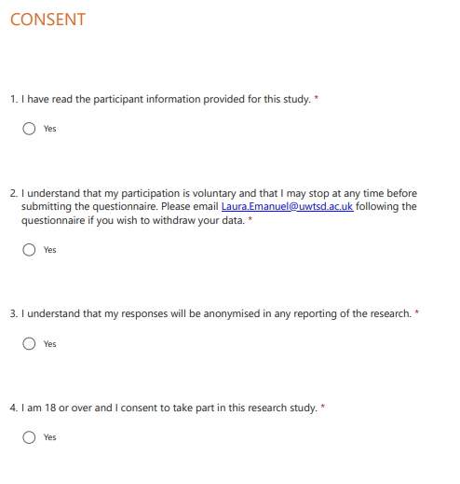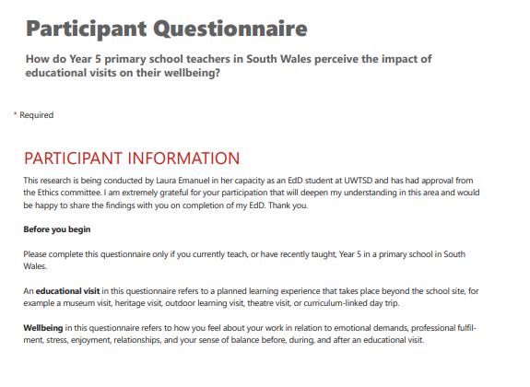

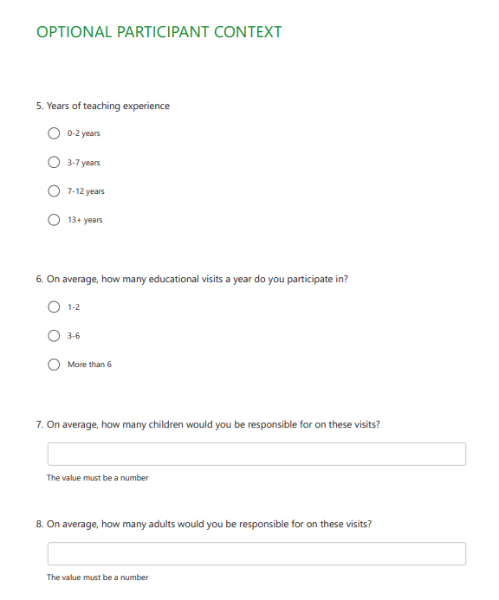


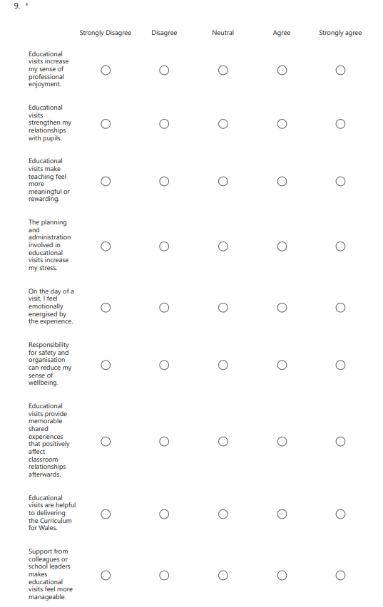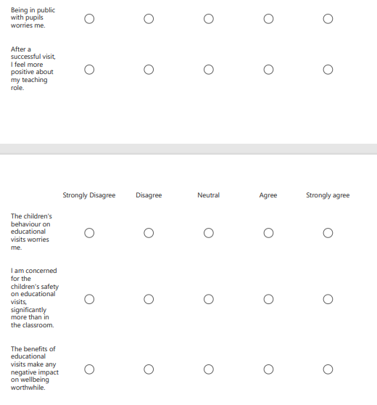
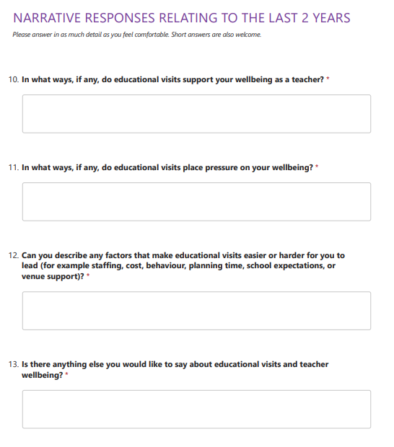

Appendix C – Sample of Thematic Analysis Process
The table below illustrates the analytical process adopted within this study, showing how raw participant responses were assigned initial codes, organised into sub-themes and subsequently constructed into the five overarching themes discussed in Chapter 4. This very brief sample represents selected examples from across all five themes and is intended to demonstrate the reflexive thematic analysis process informed by Braun and Clarke (2006; 2021).
Raw Participant Quote (anonymous) | Summary | Sub theme | Theme heading
"Educational visits remind me why I became a teacher. Seeing children excited about learning outside the classroom makes the stress feel worthwhile." | Professional purpose renewed through pupil engagement | Professional meaning/purpose | Educational visits as professionally rewarding experiences
"The children engage differently on visits. It feels more natural and rewarding than being confined to the classroom all the time." | Authentic learning experienced as more rewarding than classroom | Professional meaning/purpose | Educational visits as professionally rewarding experiences
"It's rewarding seeing children gain confidence and memories they may not otherwise have." | Fulfilment derived from positive pupil outcomes | Pupil =  professional fulfilment | Educational visits as professionally rewarding experiences
"When a visit goes well, you feel proud of what the children have experienced." | Professional pride contingent on pupil experience | Pupil =  professional fulfilment | Educational visits as professionally rewarding experiences
"You see children in a completely different light outside school." | Different dimensions of pupils can be seen beyond classroom | Relationships | Strengthened teacher–pupil relationships beyond the classroom

