

Task 1:
Individual Written Business Plan
DULCE SI DOR – ROMANIAN CAKES & PASTRIES
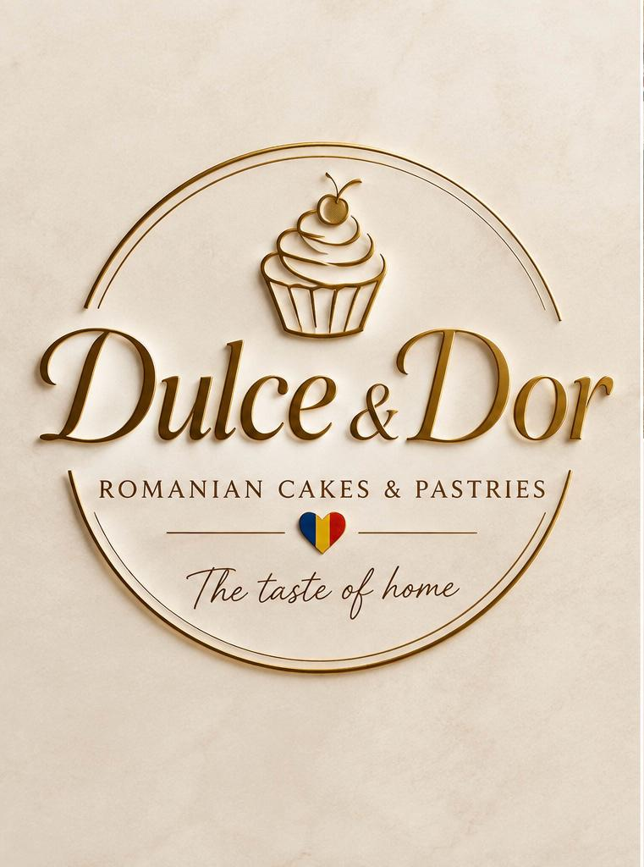
Student name: Anca Matei
Student ID: 2420092
Lecturer: Chung Lai Johnny Wan

1. Executive Summary
DULCE SI DOR – Romanian Cakes & Pastries is a proposed specialist bakery business that will be established in Tyseley, Birmingham. The business will produce and sell authentic Romanian cakes, pastries and celebration products, combining traditional recipes with modern presentation, online ordering and local delivery. The brand concept, represented by the uploaded logo, uses an elegant cream and gold visual identity together with a Romanian flag symbol and the slogan “The taste of home”. This positioning is intended to create an emotional connection with Romanian customers while introducing Romanian patisserie to a wider Birmingham audience.
The core products will include cozonac, amandina, savarina, cornulețe, nuci, Diplomat, pască, celebration cakes and mixed pastry boxes. Customers will be able to order through the business website and social media, collect products from the Tyseley premises or request local delivery. The initial target market will consist of Romanian customers, other Eastern European communities, British consumers interested in international food and customers purchasing cakes for birthdays, weddings, corporate events and cultural celebrations.
Birmingham provides an appropriate market because Census 2021 identified Romania as one of the five most common countries of birth in the city, accounting for approximately 1.1% of Birmingham's population (ONS, 2021). The business will also target customers outside the Romanian community by communicating the quality, appearance and cultural story of its products.
Sustainability will be incorporated through recyclable or reusable packaging, production planning to minimise food waste, responsible sourcing and appropriate redistribution of surplus food. Community support will involve local employment, collaboration with Romanian community organisations and purchasing selected goods and services from Birmingham businesses.
The proposed start-up funding requirement is £35,000, comprising £10,000 founder investment and £25,000 external investor funding. The funding will finance bakery equipment, premises, ingredients, packaging, marketing, staffing and working capital.
Table of Contents

1.Executive Summary 2
Table of Contents 3
2.Overview of the Business Idea 4
2.1 Business Concept 4
2.2 Products and Services 4
2.3 Management and Legal Structure 4
2.4 Environmental Sustainability and Community Support 5
3.Market Research 6
3.1 Market and Customer Analysis 6
3.2 PESTEL Analysis 6
3.3 Competition 7
3.4 Unique Selling Point (USP) 8
4. Marketing Communications 8
5.Financials 9
6. Conclusion 11
References 12

2. Overview of the Business Idea
2.1 Business Concept
DULCE SI DOR will bring the traditional taste of Romania to Birmingham. The name combines the idea of sweetness with dor, a Romanian word associated with a deep feeling of missing home. This supports the brand message, “The taste of home.”
The bakery will sell traditional Romanian pastries, mixed boxes and personalised celebration cakes at competitive prices.
Birmingham provides an appropriate location because the 2021 Census identified Romania as one of the five most common countries of birth among Birmingham residents, representing approximately 1.1% of the city's population (Office for National Statistics, 2021). This creates a potential customer base interested in familiar Romanian products.
2.2 Products and Services
The product portfolio will consist of traditional Romanian cakes and pastries. Cozonac will be an important seasonal product, particularly around Christmas and Easter, while amandina, savarina, Diplomat and other individual cakes will provide year-round sales. The bakery will also produce cornulețe, nuci and mixed pastry boxes.
Celebration cakes will provide an additional higher-value revenue stream. Customers will be able to request personalised cakes for birthdays, weddings, anniversaries, christenings and other occasions. Corporate pastry boxes will also be offered to local offices and organisations.
The business will focus on fresh, small-batch production. Demand information and advance orders will be used to determine production quantities, helping to control ingredient costs and reduce unnecessary food waste.
2.3 Management and Legal Structure
The business will be managed by the founder as Managing Director, supported by a qualified baker or pastry chef, part-time bakery assistants, and an external accountant. The Managing Director will oversee finance, marketing, purchasing, customer relationships and business development, while the pastry chef will manage production and product quality.
DULCE SI DOR will operate as a private company limited by shares. This structure is suitable for a profit-making business seeking external investment because investment can be raised through shares and shareholders' liability is generally limited to their investment (GOV.UK, 2026).
As a food business, DULCE SI DOR must register with the local authority at least 28 days before trading and must have appropriate food-safety procedures (Food Standards Agency, 2026).

2.4 Environmental Sustainability and Community Support
Sustainability will be incorporated into DULCE SI DOR from the beginning. The business will use pre-orders and sales forecasting to reduce unnecessary production and food waste. Where food is safe to consume, suitable surplus products could be discounted or donated rather than discarded. BBC Learning English (2022) discusses food-waste recycling and methods of processing food waste, demonstrating the importance of reducing the amount of food that becomes waste.
Packaging will also be carefully managed. The business will minimise unnecessary packaging and use recyclable or compostable cardboard and paper where appropriate.
BBC reporting about the Birmingham 2022 Commonwealth Games highlighted reuse and repurposing, local and seasonal food, biodegradable food packaging and waste reduction as practical sustainability measures (BBC Sport, 2022). DULCE SI DOR will adapt these principles by purchasing suitable ingredients from local suppliers where possible, using energy-efficient ovens and refrigeration, reducing unnecessary deliveries and encouraging customers to collect orders.
The business could also introduce reusable premium cake boxes for local customers, with a small discount provided when packaging is returned. Community support will include creating local employment opportunities, cooperating with Romanian community organisations and potentially organising Romanian baking workshops.
3. Market Research
3.1 Market and Customer Analysis
The main geographical market will be Birmingham and the surrounding West Midlands. Tyseley will operate as the production and collection base, while delivery will allow DULCE SI DOR to reach customers beyond the immediate neighbourhood. The Romanian community represents our Primary Phase 1 Anchor Segment. Because this demographic has grown rapidly from 0.1% to 1.1% of Birmingham’s population since 2011 to 2021 (ONS,2021), it gives DULCE SI DOR an immediate, highly concentrate, and culturally aligned customer base right at launch. We will utilize this segment to secure rapid initial cash flow, validate our core recipe, and establish steady baseline revenue through authentic Romanian confectionary. Concurrently, our Phase 2 Expansion Segment targets the broader mainstream British market in Birmingham and the West Midlands. By positioning our products as premium, high-quality international celebration cakes and unique flavour profile, we will capture mainstream consumers looking for novelty and luxury dessert. This two-phase approach guarantees immediate revenue while scaling our long-term customer base.
Additional customers will include British consumers interested in international food and people purchasing cakes for celebrations.
3.2 PESTEL Analysis
PESTEL analysis is a strategic business tool used to examine six external factors that may influence a business: Political, Economic, Social, Technological, Environmental and Legal factors. These factors help entrepreneurs understand the external business environment, identify opportunities and threats, and make informed decisions before launching a business (CIPD, n.d.). PESTEL is particularly relevant to DULCE SI DOR because a bakery depends on food regulations, ingredient prices, customer preferences, technology and environmental practices. By analysing these factors, the business can prepare for potential difficulties and develop strategies to remain competitive.
FACTOR | IMPACT ON DULCE & DOR
Political | The UK support small business and DULCE SI DOR could benefit from government and Birmingham’s diverse population to establish and grow in the local market.
Economic | 1.4% of the UK economy; Birmingham is the UK’s second-largest city economy after London (Growth. B’gham GOV.UK). Tyseley present an opportunity to attract local resident and workers looking for low cost freshly made bakery product. Pastries, cozonac, and celebration cakes can attract customer, and good cost management will help keep profits.
Social | Since Birmingham is diverse, there is a chance of attracting Romanians who will try out our desserts. We can attract families through personalized cakes and pastry box.
Technological | Low-budget promotions of goods are possible through social networks like Instagram, Facebook, and TikTok. Ordering online and digital money transfers will be beneficial to increasing sales.
Environmental | Recyclable packaging use, purchasing local ingredients, and cutting down on waste are sustainable approaches that might save money and win over environmentally conscious customers.
Legal | DULCE SI DOR must complete with British food hygiene legislation, food safety legislation, allergens legislation, and labour laws. Compliance will guarantee protection for customer as well as good reputation of the business.
Table 1
Rising ingredient and labour costs are important risks. The National Living Wage for workers aged 21 and over is £12.71 per hour from April 2026 (Low Pay Commission, 2026). DULCE SI DOR will control staff schedules and monitor product margins.
3.3 Competition
DULCE SI DOR will face direct competition from specialist Romanian and Eastern European bakeries in Birmingham and the wider West Midlands. It will also face indirect competition from established UK bakery chains, independent bakeries, supermarkets and home-based cake businesses.
The UK bakery market includes major operators such as Greggs, GAIL's, Patisserie Valerie, PAUL and Cake Box, demonstrating the intensity of competition in the sector (Mintel, 2025). However, DULCE SI DOR will adopt a specialist position by concentrating on Romanian cakes, pastries and cultural celebrations. Its competitive differentiation will be based on authenticity, freshness, personalisation, Romanian branding, online convenience and community involvement.
3.4 Unique Selling Point (USP)
A unique selling point (USP) is the distinctive benefit that differentiates a business from its competitors and gives customers a reason to choose its products or services. A clear USP helps a business establish its market position and communicate its value to its target audience.
DULCE SI DOR's USP is authentic Romanian cakes and pastries that bring the taste of home to Birmingham, combined with personalised celebration orders and environmentally responsible production. Unlike general bakeries that offer a broad range of conventional British products, DULCE SI DOR will specialise in traditional Romanian recipes, including cozonac, amandina, savarina and cornulețe. This specialist identity will help the business appeal to Romanian customers seeking familiar flavours while introducing Romanian baking traditions to a wider audience.
The business will strengthen this differentiation through freshly prepared, small-batch products, personalised cakes, mixed pastry boxes and convenient online ordering. Its brand name, which combines sweetness with the Romanian concept of dor, communicates an emotional connection with home, family and cultural identity. This emotional appeal can help build customer loyalty beyond price alone.
4. Marketing Communications
The marketing strategy will combine digital promotion with community-based marketing, utilizing Instagram, TikTok, and Facebook to showcase high-quality product photography, interactive preparation videos, customer testimonials, and targeted seasonal promotions. This social ecosystem will route traffic directly to our central website, providing frictionless online ordering alongside transparent product details, allergen information, collection options, and delivery logistics.
To maximize early adoption, this digital framework will launch with a signature “Taste of Home Box” campaign- a curated selection of premium Romanian pastries engineered to incentivize user-generated content and spark organic word-of-mouth growth. By combining these strategies local community activations with focused digital touchpoints, DULCE SI DOR can directly engage its target demographic, build long-term relationship, and accelerate brand loyalty in a highly efficient manner (Chaffey and Ellis-Chadwick, 2022).
A loyalty programme called “Dor Club” will encourage repeat purchases through discounts and special offers. The business will also cooperate with Romanian community groups, local events and other businesses. Celebration cakes and corporate pastry boxes will provide additional revenue streams.
The marketing message will focus on authenticity, quality, freshness, Romanian heritage and sustainability. The brand will communicate that customers are not simply buying a cake or pastry but experiencing a taste associated with Romanian culture and home.
5. Financials
The proposed initial funding requirement is £35,000. The founder will contribute £15,000 from personal savings, demonstrating personal commitment to the business. The remaining £20,000 will be injected by founding equity partner, [ALINA], in exchange for an agreed shareholding in the company. This collaborative internal funding strategy ensures the business launches with zero external debt. A private company limited by shares is the ideal structure for this partnership, as it allows for the precise allocation of founder shares and formalizes the long-term commercial commitment of both parties (GOV.UK, 2026a).
The estimated first-month expenditure is shown below.
Table 2
Prices will range from £3.50–£5 for individual pastries, £20–£30 for cozonac,£25 for a box cake and £55–£150 for celebration cakes. The business will monitor sales, ingredient and labour costs, average order value and profit margins, adjusting prices when necessary to maintain financial sustainability.
Conclusion
DULCE SI DOR has the potential to establish a distinctive Romanian bakery brand in Tyseley, Birmingham by combining authentic traditional products with convenient online ordering, collection and local delivery.
Its differentiation will be based on Romanian identity, product quality, personalisation and community connection. Sustainability will be integrated through food-waste reduction, responsible packaging, local sourcing, energy efficiency and reduced transport.
The business will also use digital marketing and community relationships to build awareness and encourage repeat purchases. With clearly defined customers, planned startup funding and controlled expenditure, DULCE SI DOR provides a structured foundation for launching and developing a specialist Romanian bakery in Birmingham.

References
- BBC Learning English (2007). Recycling. Available at: BBC Learning English.
- BBC Learning English (2022). Recycling food waste. Available at: BBC Learning English.
- BBC Sport (2022). Commonwealth Games 2022: Birmingham attempts to leave “carbon neutral legacy”. Available at: https://www.bbc.co.uk/sport/commonwealth-games/62036615?
- Birmingham City Council (2026). Food safety and hygiene. Birmingham: Birmingham City Council.
- Chaffey, D. and Ellis-Chadwick, F. (2022). Digital Marketing. 8th ed. Harlow: Pearson.
- CIPD (n.d.). PESTLE analysis. Available at: https://www.cipd.org/en/knowledge/factsheets/pestle-analysis-factsheet/
- DEFRA and PackUK (2026). Extended producer responsibility for packaging. London: Department for Environment, Food and Rural Affairs.
- Elkington, J. (1997). Cannibals with Forks: The Triple Bottom Line of 21st Century Business. Oxford: Capstone.
- Food Standards Agency (2026). Food business registration. Available at: https://www.gov.uk/guidance/food-business-registration?
- GOV.UK (2026). Set up a private limited company: Types of limited company. Available at: https://www.gov.uk/limited-company-formation/limited-company-types?
- Kotler, P., Keller, K.L. and Chernev, A. (2022). Marketing Management. 16th ed. Harlow: Pearson.
- Mintel (2025). UK Bakeries and Pastry Shops Market Report 2025. London: Mintel.
- Office for National Statistics (2021). How life has changed in Birmingham: Census 2021. Available at: https://www.ons.gov.uk/visualisations/censusareachanges/E08000025
- Growth in Brum Homepage (2023). Birmingham’s Economic Growth. Available at: Growth in Brum homepage

