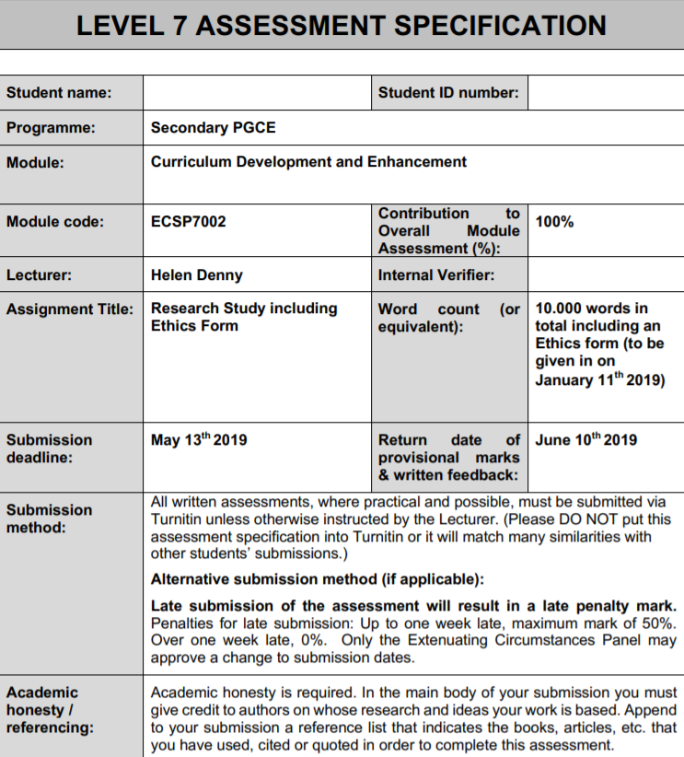
1001484
Amber Howells

1001484
Amber Howells

University of Wales Trinity Saint David

Curriculum Development and Enhancement

ECSP7002

Final Word Count: 8448

Can Slow Writing develop pupils' ability to compose fictional writing?
Introduction
School X is a comprehensive school for both English and Welsh speakers in South Wales with approximately 900 pupils on roll. The school delivers the curriculum to key stages three, four and five (where 126 pupils currently make up sixth form). In the school, 28.6% (243) of pupils are registered with Special Educational Needs (SEN), and with 7.9% (67) being classified as Free School Meals, which currently stands below the national average of 16.6% in Wales for FSM (Mylocalschool.wales.gov.uk, 2019). In terms of results, School X’s most recent results show that 76.2% of pupils achieved the level two threshold at the end of Key stage 4, Whilst this was nearly 10% higher than the national average of 67% for Wales in 2018 (Mylocalschool.wales.gov.uk, 2019), placing it in the lower quartile in its family of schools based on free-school-meal eligibility. The success shown in the results could appear to be as an outcome of one of the school’s main priorities, which is on developing pupils' literacy and numeracy skills throughout the school, and the ongoing approach to developing new and interesting ways to enhance these skills in their pupils. With this in consideration, my research project will specifically focus on one aspect of literacy, which is writing. The key skills in literacy of that are identified in the National Literacy and Numeracy Framework (LNF) (Government, 2019), introduced in 2014, are Reading, Writing and Oracy. The framework provides detailed information and suggestions on the levels of skills pupils should be working at and progressing with as they move through key stages. It is stated that among the two reasons for the LNF being introduced was the concern generated by the disappointing Welsh results under the Programme for International Student Assessment (PISA) in 2009 (Assembly. Wales, 2013). The LNF became compulsory in September 2013, and schools were required to develop the LNF into their curriculum to ensure that pupils had access to these skills. This, in turn, became a key focus in Estyn's inspection framework, where they investigated how such skills were being implemented and assessed pupils progress in their school setting. As per Estyn’s inspection guidance (School X, 2019) the progress of school X’s skills were commented on suggesting that the school has made developments in key areas such as community ethos and taken forward steps in improving key identifiers such as the level 2 indicator of any 5 A*-C grades. However, progress can still be made in the performance of Level 2 inclusive threshold which includes English or Welsh as a first language along with a maths qualification. In the reports feedback, comments are made in response to these prospects of improvement, noting that the school has an ‘over-reliance of worksheets or work booklets which significantly limits the development of writing skills and deeper understanding of subject content' (SchoolX.co.uk, 2013, pg 8). With this in mind, I can see links to my own classroom practice. In my short time as a trainee teacher I provide pupils with a variety of worksheets. These however are mainly used as scaffolding, used to help both support but where appropriate challenge pupils. I have found these worksheets worked well in terms of providing a scaffold for pupils to build their work upon, such as More Able and Talented Learners (MAT) who would often ignore said worksheet and develop their skills further individually. Lower skilled pupils, however, showed a heavy reliance on them, and would usually depend on having a worksheet there to guide them on what to write rather than building up the skills independently. This can be linked to Vygotsky’s notion of advancing ones ‘Zone of Proximal development’ in which learners are provided with a scaffolding element to their work, which is eventually taken away when said pupil can demonstrate their understanding to an independent level (Vygotsky, 1978). To be considered however, is the level of skills that pupils already obtain and whether this would affect the reliance of said scaffolding worksheets.
Consequently, this research project intends to look at the intervention of ‘Slow Writing' to improve pupils' writing skills, in which assessment would be taken in the form of levels outlined by the National Curriculum for English (Learning.gov.wales, 2016).The class of which the intervention will take place in is a year eight mixed ability class who are currently placed in the ‘Welsh Stream' of the school, which involves their humanities lessons being taught through the medium of Welsh. Throughout key stage 3, pupils are taught in mixed ability groups, which can often come with the challenge of providing differentiation for such a wide range of skills in English, which varies from a high level four to a mid-level seven throughout year 7 -9, showing a wide range of ability in the different areas of literacy skills as denoted by the curriculum.
Literature Review
Following Leighton Andrews (previous Minister of Education and skills) statement in 2011 that "raising standards of literacy and numeracy in schools is a priority", there has been a clear focus on implementing and developing literacy and numeracy in Welsh schools. Following on from disappointing PISA results, the LNF was designed to ‘raise the bar' (Learning.gov.wales, 2019) in attainment in pupils from ages 3 - 16 in Wales. Over the past few years, evidence suggests that learners have attained higher standards in reading over writing within key stage 2 and 3. With the new curriculum carrying through the LNF and aimed for implementation in September 2022, it can be said that there is more pressure from schools and the government to address standards within their educational setting in this short timeframe. In recent publications, it had been announced that performance measures at KS4 are due to change to a capped points score system based across the curriculum, with subject-specific requirements in numeracy, science and literacy, alongside a pupils next best six GCSE results (Gov.wales, 2019). This change in performance measures continues to highlight that literacy and numeracy are of a key priority for the Welsh Government and could still link to previous poor performances in PISA tests. (Estyn.gov.wales, 2016). In the most recent results, Wales had the lowest scores in the UK and below the PISA average of 493 (BBC News, 2016). Ministers in Wales have identified improving these results as a key priority, where they are hoping to see Welsh pupils achieve a score of 500 in every subject by 2021 (BBC News, 2017). This target, however, was argued by the Education Secretary, Kirsty Williams, who comments, "We need to make progress in specific areas…It's a much more complex picture [than] just saying we're going to have an individual target" (BBC News, 2017, P.1). In addition to identifying targets for pupils, there is also discussion on the implementation for teachers. When commenting on said targets, Professor David Reynolds, a professor of education and Swansea University said, "If teacher training improves, if we get the knowledge base out there and if we make our teachers master craftsmen and women of teaching which many countries have done, then we could be very, very close to those targets." (BBC News, 2017, p1). It could be said that the growing expectation for pupils and teachers in addressing these results filter down into the planning and delivery of skills in the school setting.
With the impending new curriculum set to be implemented in 2022, it could raise the question on how much the curriculum is being developed to address the importance and need for an improvement of skills across Wales. PISA tests pupils on three areas of knowledge, Reading, Numeracy and Science, however, the skill of writing appears to be less outstanding than reading throughout Key Stages 2 and 3 (Learning.gov.wales, 2010, p.2). Geoff Barton supports this idea stating, "Writing has been one of the weakest areas of teaching. The assumption too often is that imparting knowledge – making sure that pupils know stuff – is enough" (Barton, 2013, p121) This could be caused by a range of factors, as well as raising the question; Does the impending pressure of teaching pupils to do well in the PISA test limit the teaching of writing skills? This question led me to investigate the link between reading and writing, their correlation and what we can do as teaching practitioners to address this. Since the Literacy and Numeracy Framework (LNF) was established in 2014, the three main strands of literacy were stated as Reading, Writing and Oracy. All three would seem of equal importance in terms of the skills learnt and their benefit to a child's education, however, according to Wyse, the current curriculums emphasis on grammar, reading and Oracy can hinder a pupil's ability to take control of their learning style and leave them unable to explore the process of writing (Institute of Education, 2018). This point, furthered by Elliott's (1999) comments that pupils do not seem to have a strong motivation to engage in writing tasks and seem to suggest that writing is seen as something which is just expected of pupils to know and understand, with the emphasis being put on the development of reading and Oracy skills. Timothy Shanahan states that reading and writing should be taught together in order to develop said skills in both areas (Refsnes, 2017). This is further explored by research carried out in efforts to identify instructional practices that improve adolescent’s literacy, such as Reading Next (Biancarosa and Snow, 2004) which outlines fifteen instructional recommendations for an effective literacy programme; instructional practices for improving comprehension of readers (Scammacca, 2007) and the impact of writing on reading (Applebee and Langer, 2006). These discoveries could support the implementation or focus on the skill of writing and therefore the development of reading skills to further pupils' literacy as a whole, but also address the declining results from the PISA tests. From further investigation, Shanahan focuses on three potential ways to enhance the link between reading and writing in three ways. The first being that reading and writing are both functional activities that can be combined to accomplish goals; reading and writing are connected, as they draw upon common knowledge and cognitive processes; reading and writing are both communicative activities that promote insight from the creation of own texts, therefore leading to a better comprehension skill overall (Graham and Herbert, 2010). Seemingly, with these in mind, the implementation of combining the two skills of writing and reading together would create a broad base of knowledge and skills that pupils would develop throughout their time in school.
Writing has often been seen as a secondary system based on speech, as children are able to communicate orally before they are able to write (Mheducation.co.uk, n.d.). The relationship between writing and language acquisition is explored by Everson (1991), primarily looking at the work of Vygotsky. Vygotsky's notion of a ‘Zone of Proximal Development' explores learners having two levels of intellectual development, that of being an actual one and potential one (Vygotsky, 1978). This allows learners to develop an understanding with assistance, eventually leading to them developing independently. This notion has also been observed by Frank Smith, who calls this method the ‘social and collaborative basis of learning' (1988, p.8) where a ‘significant, knowledgeable other' provides a level of ‘scaffolding' to support learners in reaching their ZPD, with the intent to take away the knowledgeable other when the learner no longer needs said support. In similarity to this theory stands Bruner's proposal on learners constructing their own knowledge for themselves (Mcleod, 2018). By the use of guiding, prompt, discussion and stimuli, learners become actively involved in the process of gaining knowledge, and the teacher ‘facilitates the learning'. When considering said theories in the process of planning my intervention task, both appeared to fit into the experiment of ‘Slow Writing', an approach coined by David Didau, (Didau, 2012) which uses a step by step process to create a short piece of writing. This method, similar to that of a writing frame, allows the teacher to provide prompts for learners to use when completing a written piece of work, creating the ‘scaffold' as aforementioned. The process includes drafting which has the aim to include a collection of exercises. The purpose of this task is to allow pupils to slow down and think about the techniques they are using in their writing, some of which they may not have thought to have used prior, as well as ones they would have learnt previously. This concurrently allows those who have a ‘fixed mindset' to include techniques in their writing that they may be comfortable with, but also promoting the ‘growth mindset' (Dweck, 2017) in which they are encouraged to push their skills and extend their level of writing. It can suggested that teaching practitioners themselves follow suit on a growth mindset, with Herbert-Smith (2018) agreeing, "it's more about a teacher's own mindset, the expectations they have for their students, and the way in which they help them to develop an awareness and understanding of their thought processes, i.e. instil in their students a love of learning" (p.1). With this in mind, it can be said that the implementation of writing frames has been a common practice within schools, however, with revised and adapted formats, its popularity of being used in the classroom seems to be on the rise. When providing a writing frame to a learner, it usually gives the ‘skeletal outline' which will often consist of different keywords, techniques or phrases (Wray and Lewis, n.d.) Didau (2012) proposes that teachers use the word ‘draft' when getting learners to write, to infer that the work will be returned to, improved and re-written, with double spaced lines to provide room for feedback and re-drafting. It is noted by Warwick et al., (2003) that multiple benefits can arise from using writing frames. It provides a clear framework of techniques that the pupils can identify with and demonstrate, presuming they have been taught previously. Alongside this, it can also promote the development of metacognition, allowing the pupils to ‘think about what they are thinking' when breaking down their writing. This is explored further by Coutinho and Neuman (2008) on the metacognitive process and the link between academic success, by defining the difference between two goals that learners set themselves. This includes that of the ‘Mastery goal', in which learners aim to demonstrate and fully understand a skill or concept over a period of time; ‘Performance goal' in which the learner only acquires the skills needed to demonstrate ability and ‘avoid negative judgements of competence' (Dweck and Leggett, 1988, p.264). When considering both, it would appear that those with the ‘Mastery goal' would be predicted to have better metacognition and therefore lead to potential higher academic success. With this approach in mind for the application of writing frames, it is important for one to consider how this would be approached to the learners while still maintaining the purpose of the intervention. It could be suggested, such as Light and Littleton (2000) that it could be beneficial to ‘distribute cognitions' in a whole-class setting, supporting learners to take part in “interactive learning taking place in a sociocultural context” (Warwick et al., 2003, p181). It could also be said that this supports the idea of a whole class draft, firstly supported by the ‘knowledgeable other' (Smith, 1988), of which then pupils take this knowledge and develop it independently. This is examined further by Azevedo et al., (2005) who investigates the impact that writing frames have on students and their ability to ‘self-regulate' their learning through the use of writing frames, where they take the scaffolding and turn it into their own piece of work, with eventually affording to have the scaffolding element taken away. Conversely, however, along with scaffolding and writing frames may also come with the limitations they bring, for instance, the freedom for the writer to express without the scaffolding there to potentially hold them back (Roberts, 2003). It appears as though this highlights the importance of differentiating support and independent work when implementing the intervention, to ensure that the learners individual work is still recognised, and therefore allowing them to develop into the ‘Mastery goal' of metacognition.
Although writing frames, Slow Writing and scaffolding are deemed as a positive response to addressing the skill of writing in the learners; it may have adverse effects on those more able and talented. Referring to the ‘scaffold or straitjacket' paradox coined by Warwick et al., stating writing frames may foster “…a formulaic response from pupils that may mask, rather than reveal, understanding” (2003, p184). To explore the distinction between supporting and hindering learners, one should consider the level of understanding from all pupils taking part in the classroom. This could refer back to the ‘whole – class approach' aforementioned by Light and Littleton (2000) by ensuring that all pupils have access to the scaffolding materials, but also encouraged to go beyond those and develop their independent thinking to a greater extent. This could be done through rather giving learners sentence starters, but rather more prompts which still challenge them and push them into their ‘zone of proximal development' regardless of their current level of understanding (Vygotsky, 1978).
School Policy and Practice
Currently, School X's improvement plan does not necessarily address the topic of literacy skills or that of writing skills explicitly. However, on further investigation and discussions with the relevant members of staff, developing their pupils' writing skills is a key aspect they wish to improve on. Upon inspection, the document does state the plan to, ‘stretch and challenge for all pupils, at all ability levels, across each key stage.' This could suggest that the school intends to focus on all aspects of skills identified in the National Literacy and Numeracy framework; however, it does not state on how the school intends to implement this successfully across the school. From previous experience, the school has adopted strategies that promote the use of skills throughout key stage three and four. This involves all form tutors delivering a session during registration each week based on numeracy and literacy skills. The introduction of this strategy could be used to address points made in the 'Successful Futures' document (Donaldson, 2015), which states that, “literacy, numeracy and digital competence should be Cross-curriculum Responsibilities for all teachers and people who work with children and young people.” (Donaldson, 2015, p40). This suggests that literacy and numeracy skills are to be a cross curricular focus which underpins pupils learning, and of which teaching practitioners should implement strategies to focus on developing these in every subject.
A possible flaw as aforementioned is the implementation of said skills and the assessment that the strategy is working. It appears as though the only assessment based on these skills took place in their respective English and Maths lessons as well as the Welsh National tests at KS3, which focus on reading, procedural and reasoning skills (with aims to provide a pre-requisite for GCSE Maths, Numeracy and English). With no prior assessment on this intervention, it could be possible that pupils see it as a one subject responsibility instead of across the school. Within the School X's English department, the scheme of work for key stage three gave opportunities for pupils to learn and create assessed pieces of work which hit Oracy, Reading and Writing through a range of key skills. This follows a similar pattern to which pupils would study at key stage four, where pupils would study skills which they are required to show in their GCSE exams. If one considers Piaget's theorem (Teach-nology.com, n.d.) on learners constructing knowledge individually, when pupils enter key stage four, the focus seems to be on learning the necessary skills deduced by the National Curriculum and assessment on these provided through past exam papers. It could be said that this is, therefore, leading into a more teacher-led framework where the skills required for pupils to know are being taught, not necessarily how pupils can develop these skills individually. This could then lead to a limited way of developing these skills outside the ‘taught' way pupils experience in the school setting. Also, if one considers the criticisms made by Roberts (2017) on the literacy skills of the teachers themselves, it is arguably questionable on how a school could assess that the same standard of knowledge is being applied to all pupils. This could suggest that school X is focused on the implementation of skills that they and ultimately the pupils are going to be measured on at the end of their school career. It seems that School X has the intention of providing opportunities for pupils to develop skills across all three areas of literacy. However, the progression of this is only being assessed within the pupils' English and Maths lessons rather than on a whole school basis. The work that is assessed towards the end of the topic asks for learners to display what they have learnt, rather than the development on the skill itself, furthering the idea from Elliot (1999) that writing is often seen as something which learners are just expected to know. By using Slow Writing, learners will be given the opportunity to develop their skills in writing while still maintaining the ‘scaffolding' element allowing them to further their understanding on the skills they have already acquired.
Methodology & Ethics
When considering the vast amounts of research already prevalent in education, it could be easy to dismiss the role of a teaching practitioner as a stagnant part of the process which simply delivers information for pupils to learn. It could be argued, however, that a teacher is the most significant role of someone who implements aspects of research into their lessons. From the 1st September 2017 the new professional standards for teaching and leadership for school teachers and leaders in Wales was introduced, and explicitly recognises the role of the professional learner. The document identifies the role of teachers too, “consistently extends knowledge, skills and understanding and can show how reflection and openness to challenge and support informs professional learning to progressively develop pedagogy”. Further, it notes for teaching practitioners to have an, “informed understanding of the contribution of research, including small scale action research, to the development of practice.” (Learning.gov.wales, 2017, p49) This suggests that the government is promoting engagement into an action research community with support from wider readings and research findings. This is extended by the independent review of the curriculum undertaken by Professor Graham Donaldson in 2015. The document comments that the new principles of the curriculum design should be evidence-based, “drawing on the best of existing practice within Wales and from elsewhere, and on sound research.” (Donaldson, 2015, p14). With both documents stating a similar focus on the ‘professional learner', this suggests that reading and undertaking research is becoming a critical part of Wales' educational system. When one thinks to include such research into the educational setting, another essential point to consider is how teachers can respond and prepare for the upcoming expectations set by said documents. One increasingly common solution is for schools to create the role of a research lead, whose responsibility is to summarise aspects of research that can develop practice in the school setting. While this may be the case, encouraging busy teachers to implement research could prove to be challenging. A 2016 independent report from the Education Endowment Foundation (EEF) concluding that teachers are not willing to invest the time to engage with education research and senior leaders are not willing to invest in doing so (MacLellan, 2016). Additionally, the disconnect between researcher and practitioner could be seen as a barrier between implementing such research strategies in the classroom. An illustration of this is commented on by researcher Beng Huat See on a research project he implemented, “Throughout the intervention the teachers were excited and keen to use the research. But there was a lot of misunderstanding and misinterpretation of the evidence,” He continues, "The teachers found the language of the research article impenetrable – it was not written for an audience of practitioners." (MacLellan, 2016, p1). It seems, however, that the positives outweigh the possible negatives when implementing research into schools. Konstantinou, sees the benefits of research within schools, stating, "With ever-changing demands, both from stakeholders and a changing economy, teachers need to ensure that they do not plateau….one of the most efficient ways to achieve this is by becoming an almost self-improving practitioner: be informed about research and scholarship in teaching, engage in and with research, be a consumer of research, and be equipped to conduct your own research." (Konstantinou, 2018, p1). The limitations with conducting research may be prevalent in some areas, but as Konstantinou illustrates, with the changing curriculum and frameworks, reflective practitioners engaging in research elements of learning could only benefit themselves and pupils in their class.
When researching within the classroom, one may wish to consider the process of analysis. This could be done through both quantitative (baseline and post-intervention assessment data) and qualitative (questionnaire and focus groups) as acknowledged by Cohen et al. (Cohen, Manion and Morrison, 2007). Often, schools can be seen as data-driven environments, using the quantitative data to measure and influence decisions made to ensure that pupils are achieving. During my research, I mainly use the method of quantitative data collection. However, with the intention to only measure the effects of the intervention through quantitative data, elements of qualitative data could be considered to ensure that the impacts of the intervention that may have on pupils learning experience are considered. Cohen et al. (2013) suggests a ‘pre-test' to ensure that a clear base of pupils' starting abilities prior to the commencement of the investigation, which would then be followed by a ‘post-test' designed to ‘measure achievement' (Cohen et al. (2013, p.481). With consideration to the school curriculum and departments scheme of work, summative testing is often the assessment tool used within school X's English department to identify pupils' progress. The implementation of the research project followed a similar suit, in an attempt to not disrupt the learning process of the school. As previously mentioned, School X's scheme of work focuses on the three literacy skills concurrently, with an assessed piece of work on either reading, writing or oracy per half term. I had chosen to complete the project with a class which were in the process of working towards their writing assessment, which is where I saw fit to introduce my intervention, resulting in the pupils' still obtaining a grade in that skill category. Many variables were considered, as suggested by Vanderstoep and Johnson (2008), primarily the time of and amount of time when the experiments were undertaken. Unfortunately, due to time constraints, the experiments pre and post-test took place on two separate occasions that were dissimilar in timings (two different days of the week and times of lesson). However, I feel that both tests had the same difficulty level, as suggested by Cogen et al (2013, p.493) to ensure that the level of skills determined would be as equal, allowing for a fair test as well as ensuring that pupils develop the skills set out by the department on the basis of the LNF and English curriculum. In order to comply with this, both pre and post testing followed school X's mark scheme for writing assessed pieces of work.
When undertaking research, it is common that the practitioner considers any or at all ethical implications that the study may have on its participants, specifically in this case when working with young people. The characterisation of school-based research involves multiple participants according to Felzmann (2009). These include not only researchers but also the parents, individual children as well as the school itself who should all give their consent in taking part in the research process. Informed consent from pupils and their right to say no to school-based research has been explored by Groundwater-Smith (2007) in which focus on supporting the children through the consent process, furthered by Doyle (2007) on the pupils' vulnerability and how they are positioned in the research process. He considers different scenarios in which a pupil’s consent could be withdrawn, for example, “research may be part of the teacher's professional development, the children are not there for the teacher's professional development” (2007, p75). Doyle argues that the teacher is ultimately there for the development of the children and in the interest of making the teacher a better teacher, but the participation for pupils should not be taken for granted. When one considers this in the process of consent, making the development of both pupils and teacher explicit would prove beneficial in gaining participation. Adhering to the British Educational Research Association (BERA 2018) that "researchers should do everything they can to ensure that all potential participants understand, as well as they can, what is involved in the study" and the right to anonymity (2018, p9).
Furthermore, Cohen et al emphasises the importance that for pupils to give full consent, pupils' need to have “competence, voluntarism, full information and comprehension” (2013 p. 78) Subsequently, prior to carrying out the investigation, I ensured that all information regarding the testing, study use of data and participation, and the opportunity to not participate was clearly explained to pupils in the chosen intervention class. It was clearly explained to pupils that if they chose to withdraw from the intervention, they would in no way face any negative consequences, to ensure that participants did not feel “coerced or pressurized to volunteer” (Cohen et al., 2013, p.80). Ultimately, all pupils in the class gave their full consent to taking part in the intervention including the pre and post testing elements.
Evaluation
When one explores the process of implementing an experiment of research, an aspect of being decided upon is the class in which the implementation will take place. With Korb's (2012) in mind, I wanted the experiment to be purposeful and promote the development of ‘new knowledge' and create the classroom to be an ‘optimal learning space' in which pupils would hopefully benefit from the intervention taking place. As discussed, I decided to go with my Year 8 mixed ability group. The reasoning behind this decision was that looking at the data of the previous assessments, pupils were achieving slightly lower grades in writing. These would often be a lower sub-level or whole level altogether. The class itself contains twelve girls and ten boys, School X's approach to organising classes is for all key stage three to be in a mixed ability group until pupils are set based on attainment in key stage four. For my intervention class, pupil’s levels ranged from a mid-4 to a high 5, with the majority of the class gaining an overall level 5 in the subject of English. When investigating the pupils' previous assessment scores in line with the Literacy strands set out by the LNF (Government, 2014), it appeared as though the writing was the weaker skill within the class. The chart below visualises the previous levels that the class had gained on their writing-based assessment work. Out of the 22 students, 27% received the grade level of four. The most common feedback targets given in line with the LNF often linked to the element to, ‘planning writing make choices about content, structure, language and presentation to suit the purpose' as well as ‘use criteria to identify ways to improve then redraft' (2014). With this in mind, I found that the intervention I had planned for the group, Slow Writing, would address these targets given, and allow the pupils to attempt a higher level. This would be shown in the planning, structural and drafting elements of the intervention, and therefore providing the pupils with a scaffold of which they can eventually hope to take away.
Figure 1. – Attainment in previous writing assessment in percentage.

When considering the implementation of the intervention, I wanted to wait until the class began a new topic. I thought this to be beneficial, as they were due to complete an assessed piece of work based on the skill of reading prior to my taking over of their lessons. This can be supported with findings from Lave (2007) who states the importance of ‘situated learning', allowing pupils' learning to be ‘context dependent' rather than in an isolated study skills session. The topic of which I began the implementation, was ‘The Sea' which overall covered a range of skills, leading up to the final assessed pieces of work which focused on the writing element of the National Literacy and numeracy framework.
Figure 3. Planned scheme of work for intervention group.
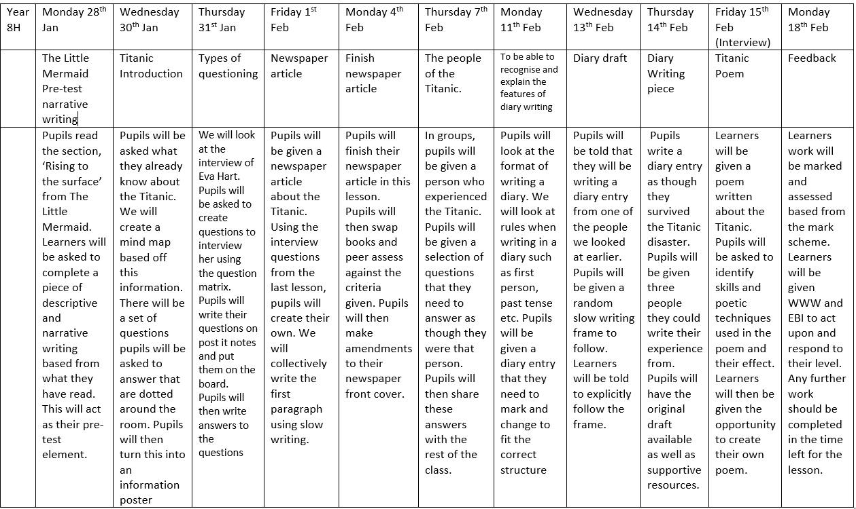
This allowed me to plan my scheme of work effectively considering the application of skills and testing elements of the intervention. Emphasised by Cohen et al. (2013), pupils underwent a ‘pre-test' within the first couple of lessons, which asked them to produce a piece of creative writing, based from an extract of ‘The Little Mermaid' written by Hans Christensen Anderson (2017). Pupils were encouraged, but not explicitly told, to use any literary techniques that they may have learnt in previous lessons. This was then independently marked accordingly following School X's Writing assessment grid, which allowed me to identify skills and apply a level grade to each pupil's work. Ultimately, the pre-test allowed me to create a ‘baseline' of the pupils' current knowledge and skills regarding their writing, as seen in the pre and post-test graph which I will explore later in this essay.
When planning the next few lessons and how I would begin to implement the action of Slow Writing, I looked to Rosenshine's Principles of Instruction (2012) to guide me in how to ensure that I prepare the learners accordingly for the upcoming post-test element of the intervention. With a further reading from Enser (2018), it became clear the key characteristics that should be focused upon when planning my lessons to ensure that they all served a purpose to the final testing. These included the following;
1. Begin each lesson with a short review of the previous learning
2. Present and practice new material in short steps
3. Ask a large number of questions and check the responses from pupils
4. Providing model
5. Check for pupil understanding.
With these into consideration, my following lessons focused on the techniques that the pupils would be asked to demonstrate within the Slow Writing process. To ensure that all pupils had a fair opportunity, I went over them as a class, providing model answers and opportunities for pupils to practice these skills. To ensure understanding, I followed the process of incorporating elements of Bloom's Taxonomy (Kelly, M, 2019) into my questioning within the lessons. This allowed me to fully assess learners understanding of not only the techniques but also the intervention of Slow Writing itself and its purpose to them within the lessons. I think this worked well in terms of getting the learners to take the time and to think about their answers, preparing them for the upcoming post-test in standard reading and writing style lessons. To narrow down the topic of ‘The Sea', I decided to focus upon the Titanic disaster, and develop the pupils' skills around that. To stay true to Didau's initial suggestion of Slow writing, I introduced the prompt element as a whole-class activity, in which pupils were given a range of prompts or writing frames, that as a class we would combine to create a piece of writing. By providing students with an introduction to this method, it allowed them to see me as the ‘knowledgeable other' create this piece of writing with their input. In an attempt to address Piaget's notion of readiness (Mcleod, 2018), in which schools are wasting valuable time trying to find the correct complexity level for all pupils, I aimed to provide a differentiated writing frame of which would be accessible for all learners. Bearing in mind Vygotsky's ‘Zone of Proximal Development' (1978), I wanted to ensure that all learners, no matter their current level, would have the opportunity to extend their knowledge further. From this, I created three different writing frames of which the learners could decide upon, each with varying difficulty. Each frame combined a range of writing skills that the learners would be required to demonstrate in order to reach a higher level of attainment, which was founded from the Literacy and Numeracy framework document. Each writing frame was colour coded to communicate what level each one would signify, for instance, Red would be level 7, Orange would be level 6, and Green would be level 5. Learners were initially asked to draft their first paragraph using this frame, of which they would then share with their peers and have it peer assessed, allowing pupils to identify focusing more on the critical aspect rather than a level, as per suggested by Falchikov (2006).
Figure 4. Differentiated Slow Writing frame used in lesson.
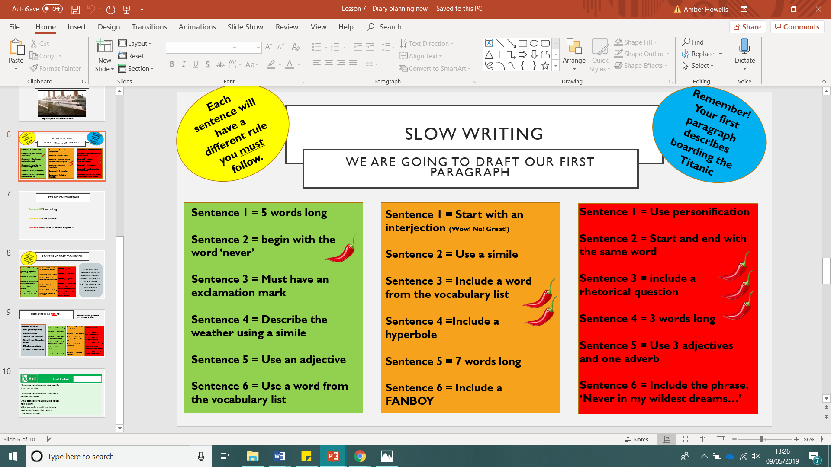
This allowed pupils to identify as well as demonstrate when these skills have been used, not only in their own work but also others. It could be said that with the process of peer-assessment being used, with the Slow Writing frame acting as the success criteria, this allowed the learners to become the ‘more knowledgeable other' that encourages development in these skill areas. Following on from the peer-assessment, learners were then asked to take the scaffolding element away and try to take on the skills they have learnt in the previous lessons and apply it to their work.
Pupils were then asked to complete the piece of written work (A diary entry from a survivor of the Titanic) in assessment conditions. Upon completion, pupils were politely reminded to check that they have completed all activities stated in the writing frame they had chosen, and to indicate what level of difficulty they decided to complete, following the colour coding mentioned previously. Similar to that of the other classroom-based assessments, the marking element of the intervention was based on the mark scheme created from School X's English department, accordingly to the pre-test. As aforementioned, the most common aspects of feedback found in the previous assessed piece in writing concluded that learners were not planning or structuring their work effectively, as well as not drafting their work to ensure that they develop it over time. When marking the post-test element, I considered these within the progress that should have been made, due to the structural and scaffolding component of the intervention. Other skills, outline by the departments marking policy, would be taken into consideration also, such as any literary techniques used, structure, grammar and vocabulary.
Conclusions.
To conclude, the purpose of this investigation being carried out was to explore whether the implementation of ‘Slow Writing' could be used as a means to improve pupils' writing skills in fictional writing. As it would be unlikely to see large jumps in whole levels from two closely completed assessments, I felt that it was important to identify the role in which sub-levels could play in the evaluation of the impact of Slow Writing. To enable me to identify and visualise the progress made, I changed the sub-levels into numbers, in order to show the level of progress that pupils may have achieved. These range from a level 3C which would equal to the number ‘7’ up to level 7A which would equal to the number ‘21’. The table below lists the sub-levels next to the number of which represents it.
Figure 5. Breakdown of Sub levels and equal number.
Sub Level | Number to represent it
3C | 7
3B | 8
3A | 9
4C | 10
4B | 11
4A | 12
5C | 13
5B | 14
5A | 15
6C | 16
6B | 17
6A | 18
7C | 19
7B | 20
7A | 21

I chose to use this method of analysing the date to ensure that sub-levels were also identified as a measure of success, as they could be seen as stepping stones to for pupils to achieve a higher level.

Figure 6. Breakdown of Pupils pre and post-test sub levels.

 | Pupil A | Pupil B | Pupil C | Pupil D | Pupil E | Pupil F | Pupil G
Pre-Test | 5B | 4A | 4B | 6A | 4C | 5B | 5B
Post-Test | 5A | 5C | 4A | 7B | 4A | 6A | 5A
 | Pupil H | Pupil I | Pupil J | Pupil K | Pupil L | Pupil M | Pupil N
Pre-Test | 5B | 5A | 6C | 5C | 5C | 6B | 6A
Post-Test | 6A | 5A | 6C | 5B | 5B | 7C | 7C
 | Pupil O | Pupil P | Pupil Q | Pupil R | Pupil S | Pupil T | Pupil U | Pupil V
Pre-Test | 5C | 5A | 6C | 6C | 4A | 5C | 5C | 4A
Post-Test | 5A | 6A | 6B | 6A | 5B | 5B | 5B | 5C
From looking at the data, only 9 pupils achieved a higher level within this intervention. Many other pupils however, achieved one or more sub-levels within the intervention. The graph below visualises the differences between the pre and post test levels for each pupil in the class.
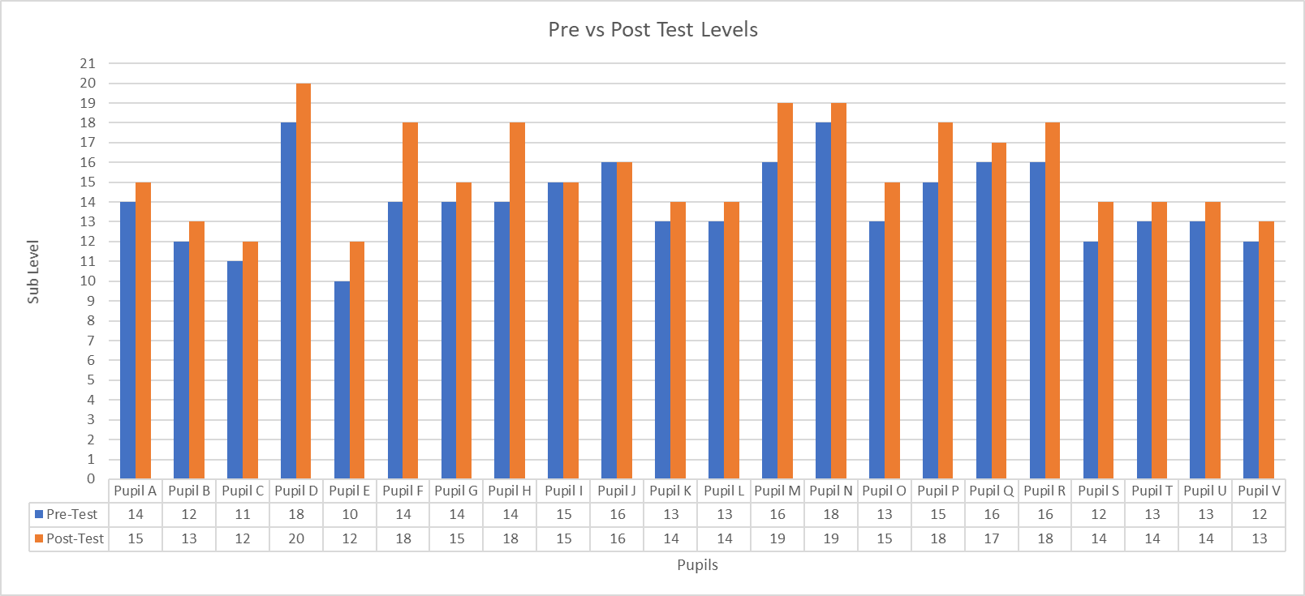
Figure 7. Graph representing the change in sub-levels in pre and post-test.
When looking at the graph, it is clear to see that there has been an improvement in pupils’ performance within the class. Throughout the intervention, we can see that all bar two pupils increased their sub level, but still staying in their current level.
When considering findings from Bereiter and Scardamalia (1987) that the process of ‘Procedural facilitation' takes over the course of many lessons and the process of taking away the scaffolding should happen over a period of time. This is something that could perhaps be encouraged within the English department in School X, with the ongoing implementation being used in lessons consistently with staff may prove to be a positive approach to addressing pupils' attainment in writing. With regards to the implementation of the intervention, allowing it to be a part of a topic proved to be beneficial, when considering the concept of ‘situated learning' founded by Lave (2007). This allowed learners to develop their knowledge into an engaging topic and allow them to take on the role of ‘expert' when demonstrating skills. On reflection and moving forward, taking the opportunity to challenge learners more would be to try and approach Slow Writing with a non-fiction piece of writing. In line with comments made in the Successful futures document (Donaldson, 2015), as a contributor remarks, “There is a real danger that we are teaching the mechanics of writing but giving the children nothing to write about” (p40). This can also be supported with the expectations set in the language elements of the WJEC GCSE's, which challenges pupils to identify and demonstrate different aspects of language through a range of question types (Wjec.co.uk, 2015). With this in mind, to further the success writing frames and Slow Writing have, practitioners could include elements mentioned above to ensure that learners' development does not necessarily be grounded on their knowledge of a topic, but instead applying the skills to any writing piece, fiction or non-fiction.
Further to the suggestions made in the Successful futures document, writing frames can be used across the curriculum, with the method of Slow Writing being not limited to the subject of English. It could be argued that interventions and experiments such as Slow Writing could also address the ‘learner' that Donaldson hopes to develop, particularly the description of the ‘ambitious, capable learner, ready to learn throughout their lives' as well as ‘enterprising, creative contributors, ready to play a full part in life and work' (2015). It can be said that Slow Writing has many aspects of which allow the pupil to become a responsible individual in their learning. Following on from previously mentioned comments regarding the more able and talented pupils by Warwick et al., something to consider in future practice could be the challenging aspect. I found that during the course of the inclusion of Slow Writing, higher skilled pupils found the process rather easy and would often complete the task much more quickly than the others in the class. In light of the enquiry, possible alterations to make in future endeavours is to allow the class to develop the frame as a collective. This could be in line with Didau's first initial recommendations for implementing Slow Writing, in which he states, “Committing curriculum to planning may be useful, but will also be limiting. Eventually, children need to develop effective mental representations of what good writing looks and feels like so this approach must address how students will internalise the idea of planning” (Didau, 2017). Robin Alexander (2012) would appear to agree, suggesting avoiding too much ‘teacher-talk' by collectively addressing learning tasks with specific educational goals in view. This, in turn, would allow for removal of the scaffolding provided for pupils, to enable them to learn the skills and how to apply them to their writing without the constant support. However, as mentioned previously, this would need to happen over a period of time rather than in one session, as there is no guarantee that the pupils feel fully confident in their skill, and whether they feel they are hitting the ‘mastery goal' or simply the 'performance goal' (Coutinho and Neuman, 2008).
Limitations and future development.
When one considers the positive aspects of an investigation, it is also beneficial to consider the negative aspects also, to ensure that an accurate reflection can be made in terms of evaluation. Although I think that overall the implementation of Slow Writing had a beneficial one, I do find that on reflection, there may have been limitations of which I did not previously consider. As briefly mentioned earlier, Roberts (2003) proposes the limitations that using a writing frame may bring to a pupil. When planning the resources for the lesson, I thought that this could perhaps be addressed through the differentiated frames that were available to pupils, and that those who may find as though they are only limited to that they are given could approach their work based upon the differing ability frames. However, when in practice, I feel as though this did not necessarily work as planned, as often the higher skilled or MAT pupils would instantly go for the more difficult frame and thought that they could not stray away from it despite possibly having more creative input. This was the opposite intent that I had from the intervention, as I wanted to promote creative individuality through providing the tools for pupils to use them; however, it appeared as though this did indeed limit some pupils in terms of creativity and therefore not letting them to explore their own skills With this in mind, It would have perhaps been more beneficial to implement the intervention in a set class, to ensure that all learners are approximately around the same level of attainment, and therefore the progression made would be more identifiable. For future implementation, making the pupils decide upon their own frame or success criteria to follow could be beneficial, ensuring that it still contains challenging aspects rather than easier ones, so that they could still enter their ‘zone of proximal development' (Vygotsky, 1978). This would also address a further limitation that I had found during the investigation, which was an over-reliance on the writing frames. During the course of the lessons, pupils were aware of the objectives of the experiment that was being carried out. This perhaps almost carried a sense of ‘Get the job done', and some pupils felt that as long as they completed the writing frame, they had completed the work. This had to be carefully explained that although the writing frames are there to guide pupils, they are not used to be the basis of the work completed. I think that possibly with more opportunities to draft and redraft their work, pupils would see the benefits of using the writing frame as a ‘scaffold' for their work, of which could then be taken away. Another way of which this could be addressed is by giving learners the opportunity to break it down even further and have a ‘frame' for each paragraph that they plan to write, (i.e. Paragraph one must contain a metaphor, Paragraph two must contain two adverbials). With the Slow Writing in this format, it allows the pupils to complete their writing around the prompts, rather than using the prompts to complete their writing.
In terms of implementing the actual research element, I feel that there were a range of variables that, If I carried out the research again, I would address. For instance, the pre and post-tests had to be carried out on different days, and therefore different lesson times. This may have provided me with an unclear sample, as the pre-test was carried out on a Monday lesson after break time, and the post-test was carried out on a Thursday after a lesson. Though similar in timings, the difference between the Monday and Thursday could have brought on a variety of sub-variables such as tiredness, motivation and engagement, and the lesson they had before break (for instance, if they had another writing based lesson in History) which may affect their motivation to perform well. To further explore the limitations that could be considered when implementing Slow writing, is collaborative learning, or the lack of. I found on reflection, that although I was acting as the ‘more knowledgeable other', I wanted the pupils to have more of an input into what they were going to complete and the success criteria of which they would follow. As mentioned previously, Collaborative learning took place between myself and the students, however, as Cohen and Lotan discuss (1997) it can also be explored that student to student interactions can also be developed to enhance learning outcomes. Despite there being some class collaboration in the drafting and model work, I feel that perhaps by giving the learners a responsibility in the role of Slow Writing could prove beneficial, as they would be identifying themselves what would be needed in a creative piece of writing rather than being told, ultimately being ‘active in their own knowledge construction' (Cook-Sather, 2002). I believe that with this approach, learners would still be encouraged to develop their own understanding of the requirements needed in their work, but also allowing them to progress into their ZPD to the point where they no longer need scaffolding from the more knowledgeable other, ultimately promoting the ‘ambitious, capable learners' identified by Donaldson (2015). Overall, I feel that although on reflection there are elements of the research practice that I would adapt, I have gained an insight to the process of research and have found it highly valuable in discovering new ideas and topics when considering further research. I will continue to be a reflective practitioner and hope to continue using interventions such as ‘Slow Writing' to ensure that both myself and the pupils I work with are consistently developing skills within the classroom.

Reference List
Alexander, R. (2012). IMPROVING ORACY AND CLASSROOM TALK IN ENGLISH SCHOOLS: ACHIEVEMENTS AND CHALLENGES. [online] Robinalexander.org.uk. Available at: https://www.robinalexander.org.uk/wp-content/uploads/2012/06/DfE-oracy-120220-Alexander-FINAL.pdf [Accessed 27 Apr. 2019].
Assembly.wales. (2013). Literacy and Numeracy in Wales. [online] Available at: http://www.assembly.wales/Research%20Documents/Literacy%20and%20Numeracy%20in%20Wales%20-%20Research%20paper-03062013-246762/13-039-English.pdf [Accessed 30 Mar. 2019].
Applebee, A. and Langer, J. (2006). The state of writing instruction in America's schools: What existing data tell us. [online] Citeseerx.ist.psu.edu. Available at: http://citeseerx.ist.psu.edu/viewdoc/download?doi=10.1.1.541.4136&rep=rep1&type=pdf [Accessed 9 May 2019].
Azevedo, R., Cromley, J., Winters, F., Moos, D. and Greene, J. (2005). Adaptive Human Scaffolding Facilitates Adolescents' Self-regulated Learning with Hypermedia. Instructional Science, 33(5-6), pp.381-412.
Barton, G. (2013). Don't call it literacy!. London [u.a.]: Routledge, p.121.
BBC News. (2016). UK struggles in global school ranking. [online] Available at: https://www.bbc.co.uk/news/education-38157811 [Accessed 4 Apr. 2019].
BBC News. (2017). Economy 'risk' of poor Pisa test scores. [online] Available at: https://www.bbc.co.uk/news/uk-wales-politics-40385843 [Accessed 6 Apr. 2019].
BBC News. (2017). Pisa test target dropped in Wales. [online] Available at: https://www.bbc.co.uk/news/uk-wales-politics-40288734 [Accessed 4 Apr. 2019].
Bera.ac.uk. (2018). Ethical Guidelines for Educational Research. [online] Available at: https://www.bera.ac.uk/wp-content/uploads/2018/06/BERA-Ethical-Guidelines-for-Educational-Research_4thEdn_2018.pdf?noredirect=1 [Accessed 23 Apr. 2019].
Bereiter, C. and Scardamalia, M. (1987). The Psychology of Written Composition. Hillsdale.
Biancarosa, G. and Snow, C. (2004). Reading Next. A vision for action and research in middle and high school literacy. [online] New York: Carnegie. Available at: https://www.carnegie.org/media/filer_public/b7/5f/b75fba81-16cb-422d-ab59-373a6a07eb74/ccny_report_2004_reading.pdf [Accessed 9 May 2019].
Bryan, H. and Burstow, B. (2016). Understanding Ethics in school based research. [online] Www-tandfonline-com.ezproxy.uwtsd.ac.uk. Available at: https://www-tandfonline-com.ezproxy.uwtsd.ac.uk/doi/full/10.1080/19415257.2017.1361464 [Accessed 23 Apr. 2019].
Campbell, A. and Groundwater-Smith, S. (2007). An ethical approach to practitioner research. New York, NY: Routledge.
Carnegie.org. (2010). Writing to Read. [online] Available at: https://www.carnegie.org/media/filer_public/9d/e2/9de20604-a055-42da-bc00-77da949b29d7/ccny_report_2010_writing.pdf [Accessed 7 Apr. 2019].
Carthew, M. (2015). An investigation into the use of writing frames and writing structures to overcome boys' reluctance to write in geography lessons. The STeP Journal, 2(4), pp.17-37.
Christian Andersen, H. (2017). The Little Mermaid. La Vergne: Dreamscape Media.
Cohen, E. and Lotan, R. (1997). Working for equity in heterogeneous classrooms. New York: Teachers College Press.
Cohen, L., Manion, L. and Morrison, K. (2013). Research methods in education. 7th ed. Routledge ltd, pp.78, 80.
Cook-Sather, A. (2002). Authorizing Students' Perspectives: Toward Trust, Dialogue, and Change in Education. Educational Researcher, 31(4), p.5.
Coutinho, S. and Neuman, G. (2008). A model of metacognition, achievement goal orientation, learning style and self-efficacy. Learning Environments Research, 11(2), pp.131-151.
Learning.gov.wales. (2016). Curriculum for Wales - English Programme of study. [online] Available at: https://learning.gov.wales/docs/learningwales/publications/150717-nc-english-en-v3.pdf [Accessed 9 May 2019].
Didau, D. (2017). What *does* improve children's writing?. [online] David Didau. Available at: https://learningspy.co.uk/writing/improve-childrens-writing-2/ [Accessed 12 May 2019].
Didau, D. (2012). Slow Writing: how slowing down can improve your writing. [online] David Didau. Available at: https://learningspy.co.uk/english-gcse/how-to-improve-writing/ [Accessed 24 Apr. 2019].
Donaldson, G. (2015). pg 40. [online] Gweddill.gov.wales. Available at: https://gweddill.gov.wales/docs/dcells/publications/150225-successful-futures-en.pdf [Accessed 22 Apr. 2019].
Donaldson, G. (2015). Successful Futures Report. [online] Gweddill.gov.wales. Available at: https://gweddill.gov.wales/docs/dcells/publications/150225-successful-futures-en.pdf [Accessed 23 Apr. 2019].
Doyle, D., 2007. Transdisciplinary engagement: researching with rather than on. In: A. Campbell and S.Groundwater-Smith, eds. (2007) An ethical approach to practitioner enquiry: dealing with issues and dilemmas in action research. Abingdon: Routledge, 75–87
Dweck, C. (2017). Mindset. London: Robinson.
Dweck, C. and Leggett, E. (1988). A social^cognitive approach to motivation and personality. Psychological Review, 95(2), pp.256-273.
Elliott, J. (1999). Motivating Students to Write. [online] Available at: http://ler.letras.up.pt/uploads/ficheiros/6021.pdf [Accessed 7 Apr. 2019].
Enser, M. (2017). How can schools use research to better inform teaching practice?. [online] the Guardian. Available at: https://www.theguardian.com/teacher-network/2017/nov/23/how-can-we-make-research-work-harder-in-our-schools [Accessed 23 Apr. 2019].
Enser, M. (2018). Putting theory into practice. [online] Heathfield Teach Share Blog. Available at: https://heathfieldteachshare.wordpress.com/2018/04/23/putting-theory-into-practice/ [Accessed 26 Apr. 2019].
Everson, B. (1991). Vygotsky and the Teaching of Writing. The Quarterly, [online] Vol.13(No.3), pp.9-11. Available at: https://www.nwp.org/cs/public/print/doc/resources/voice_quarterly_issue.csp?pub=The%20Quarterly&year=1991&vol=13&num=3 [Accessed 24 Apr. 2019].
Falchikov, N. (2006). Peer Feedback Marking: Developing Peer Assessment. [online] Taylor & Francis. Available at: https://www.tandfonline.com/doi/abs/10.1080/1355800950320212 [Accessed 9 May 2019].
Felzmann, H. (2009). Ethical Issues in School-Based Research. Research Ethics, 5(3), pp.104-109.
Fitzgerald, J., and Shanahan, T. (2000). Reading and writing relations and their development. Educational Psychologist, 35, 39–50.
Gov.wales. (2019). School performance reporting – Bulletin 6. [online] Available at: https://gov.wales/sites/default/files/publications/2019-02/school-performance-reporting-bulletin-6_0.pdf [Accessed 4 Apr. 2019].
Government, W. (2014). Learning Wales. [online] Learning.gov.wales. Available at: https://learning.gov.wales/resources/browse-all/nlnf/framework?component=literacy&year=6938386_2&selectedYear=col_14&lang=en [Accessed 26 Apr. 2019].
Government, W. (2019). Learning Wales. [online] Learning.gov.wales. Available at: https://learning.gov.wales/resources/browse-all/nlnf/?lang=en [Accessed 30 Mar. 2019].
Graham, S. and Herbert, M. (2010). [online] Carnegie.org. Available at: https://www.carnegie.org/media/filer_public/9d/e2/9de20604-a055-42da-bc00-77da949b29d7/ccny_report_2010_writing.pdf [Accessed 22 Apr. 2019].
Herbert-Smith, K. (2018). Growth mindset: the key to successful teaching?. [online] Blog.irisconnect.com. Available at: https://blog.irisconnect.com/uk/community/blog/5-attributes-of-a-growth-mindset-teacher/ [Accessed 24 Apr. 2019].
Institute of Education. (2018). All is not lost in the art of teaching creative writing. [online] Available at: https://www.ucl.ac.uk/ioe/research-projects/2019/mar/all-not-lost-art-teaching-creative-writing [Accessed 7 Apr. 2019].
Howells, A. (2019). Investigating Contemporary Issues in Secondary Education. 7. University of Wales, Trinity Saint David (Swansea).
Johnson, D. and VanderStoep, S. (2008). Research methods for everyday life. San Francisco, Calif.: Jossey-Bass.
Kelly, M. (2019). Question Stems for Each Level of Bloom's Taxonomy. [online] ThoughtCo. Available at: https://www.thoughtco.com/blooms-taxonomy-questions-7598 [Accessed 26 Apr. 2019].
Konstantinou, I. (2018). The teacher-as-researcher: Making the case for research in schools | BERA. [online] Bera.ac.uk. Available at: https://www.bera.ac.uk/blog/the-teacher-as-researcher-making-the-case-for-research-in-schools [Accessed 23 Apr. 2019].
Korb, K. (2012). Educational Research. [online] Korbedpsych.com. Available at: http://korbedpsych.com/R0bEducationalResearch.html [Accessed 25 Apr. 2019].
Lave, J. (2007). Situated Learning Theory (Lave) - Learning Theories. [online] Learning Theories. Available at: https://www.learning-theories.com/situated-learning-theory-lave.html [Accessed 27 Apr. 2019].
Learning.gov.wales. (2010). Guidance on the teaching of Writing. [online] Available at: https://learning.gov.wales/docs/learningwales/publications/100524writingen.pdf [Accessed 6 Apr. 2019].
Learning.gov.wales. (2017). Professional standards for teaching and leadership. [online] Available at: https://learning.gov.wales/docs/learningwales/publications/170901-professional-standards-for-teaching-and-leadership-en.pdf [Accessed 23 Apr. 2019].
Learning.gov.wales. (2019). Guidance on the teaching of writing skills. [online] Available at: https://learning.gov.wales/docs/learningwales/publications/100524writingen.pdf [Accessed 31 Mar. 2019].
Light, P. and Littleton, K. (2000). Social processes in children's learning. Cambridge: Cambridge University Press.
MacLellan, P. (2016). Why don't teachers use education research in teaching?. [online] Education in Chemistry. Available at: https://eic.rsc.org/analysis/why-dont-teachers-use-education-research-in-teaching/2010170.article [Accessed 23 Apr. 2019].
Mcleod, S. (2018). Bruner - Learning Theory in Education | Simply Psychology. [online] Simplypsychology.org. Available at: https://www.simplypsychology.org/bruner.html [Accessed 24 Apr. 2019].
Mcleod, S. (2018). Jean Piaget's Theory of Cognitive Development | Simply Psychology. [online] Simplypsychology.org. Available at: https://www.simplypsychology.org/piaget.html [Accessed 26 Apr. 2019].
Mheducation.co.uk. (n.d.). [online] Available at: https://www.mheducation.co.uk/openup/chapters/9780335241798.pdf [Accessed 22 Apr. 2019].
Refsnes, H. (2017). How Should We Combine Reading and Writing? | Shanahan on Literacy. [online] Shanahanonliteracy.com. Available at: https://shanahanonliteracy.com/blog/how-should-we-combine-reading-and-writing [Accessed 7 Apr. 2019].
Roberts, M. (2017). Does teaching have a literacy problem?. [online] Tes. Available at: https://www.tes.com/news/does-teaching-have-literacy-problem [Accessed 26 Apr. 2019].
Rosenshine, B. (2012). Principles of Instruction. [online] Aft.org. Available at: https://www.aft.org/sites/default/files/periodicals/Rosenshine.pdf [Accessed 26 Apr. 2019].
Scammacca, J. (2007). Interventions for Adolescent Struggling Readers: A Meta-Analysis with Implications for Practice.. [online] Eric.ed.gov. Available at: https://eric.ed.gov/?id=ED521837 [Accessed 9 May 2019].
SchoolX.co.uk. (2013). [online] Available at: http://www.schoolX.co.uk/wp-content/uploads/2013/07/.pdf [Accessed 31 Mar. 2019].
School X (2019). [online] Available at: http://www.SCHOOLX.co.uk/wp-content/uploads/2013/11/Estyn-Report.pdf [Accessed 8 May 2019].
Shanahan, T. (2006). Relations among Oral Language, Reading, and Writing Development. In C. A. MacArthur, S. Graham, & J. Fitzgerald (Eds.), Handbook of writing research (pp. 171-183). New York, NY, US: The Guilford Press.
Smith, F. (1988). Joining the literacy club. Portsmouth, N.H.: Heinemann.
Estyn.gov.wales. (2016). The Annual Report of Her Majesty's Chief Inspector of Education and Training in Wales. [online] Available at: https://www.estyn.gov.wales/sites/default/files/documents/ESTYN_Annual%20Report%202015_2016_English.pdf [Accessed 9 May 2019].
Teach-nology.com. (n.d.). Piaget's Theory on Constructivism. [online] Available at: http://www.teach-nology.com/currenttrends/constructivism/piaget/ [Accessed 22 Apr. 2019].
Tierney, R., and Shanahan, T. (1991). Research on the reading-writing relationship: Interactions, transactions, and outcomes. In R. Barr, M. Kamil, P. Mosenthal, and D. Pearson (Eds.), The handbook of reading research (Vol. 2; pp. 246–280). New York, NY: Longman.
Vygotsky, L. (1978). Mind in society: The development of higher psychological processes. Harvard University Press.
Warwick, P., Stephenson, P., Webster, J. and Bourne, J. (2003). Developing pupils' written expression of procedural understanding through the use of writing frames in science: Findings from a case study approach. International Journal of Science Education, 25(2), pp.173-192.
Wjec.co.uk. (2015). WJEC GCSE in English Language Specification. [online] Available at: https://www.wjec.co.uk/qualifications/english/r-english-language-gcse-wales/WJEC%20GCSE%20English%20Language%20Specification%202015%20(24-10-14)%20-%20Branded.pdf.pdf [Accessed 27 Apr. 2019].
Wray, D. and Lewis, M. (n.d.). [online] Learning.gov.wales. Available at: https://learning.gov.wales/docs/learningwales/publications/140123-writing-frames-en.pdf [Accessed 24 Apr. 2019].University of Wales Trinity Saint David

