Computer Aided Manufacturing and Design for Additive Manufacturing Technologies
Contents
Computer Aided Manufacturing and Design for Additive Manufacturing Technologies i
1 Introduction 1
2 Background research 1
2.1 Additive manufacturing 1
2.2 Background 1
3 Current processes 2
3.1 How it’s made 2
3.2 Comparisons 2
4 3D printers 2
5 SLS vs FDM 6
6 Types of SLS and material 7
6.1 Selective laser sintering 7
6.2 Materials 7
7 Computer aided design 8
8 Failure mode and effects analysis 9
9 Quality function deployment 10
10 Evaluation 11
11 Conclusion 12
12 References 12
13 Bibliography 13

Introduction
This report will be looking at the viability of a prosthetic leg made by 3D printers. It will be covering the types of 3D printing; which option is the best, as well, as what material that should be used. There will be Quality Function Deployment (QFD) done on the product along with a Failure Mode and Effects Analysis (FMEA). A CAD drawing of the product will be shown as well: This will end with a conclusion. It will also cover what additive manufacturing is along with a brief background on the history of 3D printing.

Background research

Additive manufacturing
Additive manufacturing is a process of adding material to create an object, rather than take away material to create an object. There are a number of different types of additive manufacturing. Some of these include Direct Digital Manufacturing (DDM), rapid prototyping and 3D printing. Some of the benefits of using this type of manufacturing is there is no waste material, this is very good for the environment as it saves material that would otherwise be wasted. The range and geometries of the part are increased, making it possible to make more complex geometries, expanding the possibilities in design, this allows others solutions to be found that otherwise would not be available. The speed that these types of additive manufacturing works are quicker than standard methods of manufacturing. (SPI lasers, 2018).

Background
Hideo Kodama of Nagoya municipal industrial research institute in 1981 published his findings on functional rapid-prototyping system using photopolymers. A model was then printed layer by layer. Three years after the findings were published Charles Hull invented stereolithography, which changed the 3D-printing landscape. 3D Systems Company created the world’s first Stereolithographic apparatus (SLA) machine (Goldberg, 2014). This made it possible to create complex parts as well as reducing the production time of the part significantly. That same year, the first Selective laser sintering (SLS) was invented by startup DTM. The first organ was in planted into the human body when scientists at Wake Forest Institute of regenerative medicine implanted a bladder into a patient. In 2008 a self-replicating printer was created. This opened the door for creators to 3D print anything they desired or at least one element or component of choice (Goldberg, 2014).

Current processes

How it’s made
Currently prosthetic legs are mainly made out of polypropylene, titanium and aluminium. However, recently carbon fibre has started being used alongside the other materials as part of the prosthetic leg. It is possible currently to make a prosthetic leg entirely out of 3D printing but the way most prosthetic legs are made is by vacuum-forming, injection moulding and extruding. Vacuum-forming is when the heated sheet is simply laid over the top of the mould in a vacuum chamber. If necessary, the sheet is heated again. Injection moulding is when a liquid plastic is pushed through a mould and allowed to cool. Finally extruding is when the plastic is pulled through a shaped die. Cases have shown that is possible to create a prosthetic leg throw FDM or also known as FFF as mentioned works by pushing material through a nozzle melting in the process onto a build plate where it solidifies.

Comparisons
The benefits of 3D printed prosthetics is that they are cheaper to make than traditional forms. The cost of a prosthetic leg can very between $5000 (£3859.81) to $50000 (£38598.12) (Turner, 2018) whereas the cost of making a 3D printed prosthetic leg can cost as less than $200 (£154.39) (Schwartz, 2016) (the conversion was compared as of the day this was written). It is becoming easier and easier to be able to produce 3D printed limbs, another benefit of using 3D printed legs is that they are quick to make usually within a day and they are easily customisable. This is especially useful for children needing replacement limbs as the design can be easily changed for each child. Also, to help this 3D scanning and body modelling technologies from companies, such as, Body Labs enable people to 3D scan their limbs and have prosthetics modelled after them, making for more natural fitting and appearance (Schwartz, 2016).
Problems found with using 3D printed designs is that they are not as durable as conventional methods. This means that the prosthetic leg would need to be replaced more frequently. This would not be a problem for children since they are growing, they will need a new prosthetic leg every year to match with their growth. However, this would become a problem as an adult as the price of replacing the limb will become very costly very quickly. Especially for NHS, where conventional ways of making prosthetics last longer and will be a better investment long term. If it was possible to find a system of 3D printing that is cheaper than conventional methods and more durable than current 3D printed prosthetic legs.

3D printers
There are ten types of 3D printing available. Each type of 3D printer has different strengths and weakness regarding what they are suitable and capable of doing. This is what I am going to do first in this assignment is explain the different types of 3D printing and see which of these is the most suitable for my design for a prosthetic leg. The first type is material extrusion; this process involves filament of a solid thermoplastic material that is pushed through a heated nozzle, melting it in the process. The printer then deposits the material on a platform along a pre made path, where the filament cools and solidifies to form a solid object. This process is then repeated, building layer at a time, until the object is finished. Important information on material extraction:
- Types of 3D Printing Technology: Fused Deposition Modelling (FDM), sometimes called Fused Filament Fabrication (FFF)
- Materials: Thermoplastic filament (PLA, ABS, PET, TPU)
- Dimensional Accuracy: ±0.5% (lower limit ±0.5 mm)
- Common Applications: Electrical housings; form and fit testing; Jigs and fixtures; Investment casting patterns
- Strengths: Best surface finish; full colour and multi-material available
- Weaknesses: Brittle, not sustainable for mechanical parts (ALL3DP, 2019).
Vat polymerization; is a form of 3D printing process where a photo-polymer resin in a vat is selectively cured by a light source. The two most common forms of Vat polymerization are SLA and Digital Light Processing (DLP). The difference between the two 3D printing technologies is the light source used to cure the resin. SLA printers use a point laser whereas DLP use digital light projector to flash a single image of each layer all at once. Important information on Vat polymerization:
- Types of 3D Printing Technology: SLA,DLP
- Materials: Photopolymer resin (Standard, Castable, Transparent, High Temperature)
- Dimensional Accuracy: ±0.5% (lower limit ±0.15 mm)
- Common Applications: Injection mould-like polymer prototypes; Jewellery (investment casting); Dental applications; hearing aids
- Strengths: Smooth surface finish; fine feature details
- Weaknesses: Brittle, not suitable for mechanical parts (ALL3DP, 2019).

3Powder Bed Fusion; is a 3D printing process where a thermal energy source will selectively induce fusion between powder particles inside a build area to create a solid object. Many Powder Bed Fusion devices also employ a mechanism for applying and smoothing powder simultaneous to an object being fabricated, so that the final item is encased and supported in unused powder.
- Types of 3D Printing Technology: Selective Laser Sintering (SLS)
- Materials: Thermoplastic powder (Nylon 6, Nylon 11, Nylon 12)
- Dimensional Accuracy: ±0.3% (lower limit ±0.3 mm)
- Common Applications: functional parts; Complex ducting (hollow designs); Low run part production
- Strengths: Functional parts, good mechanical properties; complex geometries
- Weaknesses: Longer lead times; higher cost than FFF for functional applications (ALL3DP, 2019).
Material Jetting; is a 3D printing process where droplets of material are selectively placed and cured on a build plate. Using photopolymers or wax droplets that cure when exposed to light, objects are built up one layer at a time. Material Jetting is a process that allows for different materials to be printed in the same object. One practice for this technique is to fabricate support structures from a different material to the model being produced. Types of 3D Printing Technology: Material Jetting (MJ), Drop on Demand (DOD)
- Materials: Photopolymer resin (Standard, Castable, Transparent, High Temperature)
- Dimensional Accuracy: ±0.1 mm
- Common Applications: Full colour product prototypes; Injection mould-like prototypes; Low run injection moulds; Medical models
- Strengths: Best surface finish; Full colour and multi-material available
- Weaknesses: Brittle, not suitable for mechanical parts; higher cost than SLA/DLP for visual purposes (ALL3DP, 2019).
Material Jetting (MJ) works by putting multiple layers on top of each other to create a solid part. DOD is a type of 3D printing technology that uses a pair of ink jets. One deposits the build materials, which is usually a wax-like material. The second is used for a dissolvable support material, as with typical types of 3D printing technology, DOD printers follow a predetermined path to jet material in a point-wise deposition, creating the cross-sectional area of an object layer-by-layer (ALL3DP, 2019).
Binder Jetting (BJ); is a 3D printing process where a liquid bonding agent selectively binds regions of a powder bed. BJ is a similar 3D printing technology to SLS, with the requirement for an initial layer of powder on the build platform. But unlike SLS, which uses a laser to sinter powder, BJ moves a print head over the powder surface depositing binder droplets. These droplets bind the powder particles together to produce each layer of the object. Once a layer has been printed, the powder bed is lowered and a new layer of powder is spread over the recently printed layer. This process is repeated until a complete object is formed. The object is then left in the powder to cure and gain strength. Afterwards, the object is removed from the powder bed and any unbound powder is removed using compressed air. Types of 3D Printing Technology: BJ
- Materials: Sand or metal powder: Stainless / Bronze, Full colour sand, Silicia (sand casting)
- Dimensional Accuracy: ±0.2 mm (metal) or ±0.3 mm (sand)
- Common Applications: Functional metal parts; Full colour models; Sand casting
- Strengths: Low-cost; Large build volumes; Functional metal parts
- Weaknesses: Mechanical properties not as good as metal powder bed fusion (ALL3DP, 2019).
Metal Powder Bed Fusion is a 3D printing process which produces solid objects, using a thermal source to induce fusion between metal powder particles one layer at a time. Most Powder Bed Fusion technologies employ mechanisms for adding powder as the object is being constructed, resulting in the final component being encased in the metal powder. The main variations in metal Powder Bed Fusion technologies come from the use of different energy sources; lasers or electron beams. Types of 3D Printing Technology: Direct Metal Laser Sintering (DMLS); Selective Laser Melting (SLM); Electron Beam Melting (EBM)
- Materials: Metal Powder: Aluminium, Stainless Steel, And Titanium
- Dimensional Accuracy: ±0.1 mm
- Common Applications: Functional metal parts (aerospace and automotive); Medical; Dental
- Strengths: Strongest, functional parts; complex geometries
- Weaknesses: Small build sizes; highest price point of all technologies (ALL3DP, 2019).
Both Direct Metal Laser Sintering (DMLS) and SLM are types of 3d printing that are applied to the production of metal parts. The differences between DMLS and SLM is that DMLS does not melt the powder but instead heats it to a point so that it can fuse together on a molecular level. SLM uses the laser to achieve a full melt of the metal powder forming a homogeneous part. This results in a part that has a single melting temperature. Distinct from other Powder Bed Fusion techniques, Electron Beam Melting (EBM) uses a high energy beam, or electrons, to induce fusion between the particles of metal powder. A focused electron beam scans across a thin layer of powder, causing localized melting and solidification over a specific cross-sectional area. These areas are built up to create a solid object (ALL3DP, 2019).

SLS vs FDM
There are several ways we can compare FDM to SLS. These include, price, the complexity of the part, how long it takes to make, strength and many others. First of all, complexity would be high with a prosthetic leg, comparing the two types of 3D printing, SLS comes out on top with it easily completing complex parts. It is true that FDM could complete the part but not to the finish quality of SLS. However, FDM is has a better surface finish than SLS. SLS are genially more expensive than FDM this is both in the cost of the printer and the product. The cost of machine is around $800000 (£614,104.00) for an industrial SLS machine (Sculpteo, 2019). This is partly why FDM is currently being used for 3D printed prosthetics since it is so much cheaper to make than conventional methods. This does become a problem with quality since SLS is much better quality and is more durable than FDM. As it comes with time to make the piece, FDM is quicker at making the piece then SLS. The main advantages to SLS is that it’s good for functional parts and has mechanical properties, this is important due to the fact that the part needs to be functional and be able to move on the joints. Whereas FDM is quite brittle and is not very sustainable for mechanical parts. This is the reason why I am picking SLS as my choice of 3D printing (Sculpteo, 2019).

Types of SLS and material

Selective laser sintering
Within SLS there are two different types of SLS processing, one with metals and ceramics, this is sometimes known as DMLS and another with polymers sometimes known as laser sintering.
First DMLS, the uppermost layer of a bed of powdered material is loosely bonded through slight sintering by a scanned laser beam. A new layer of powder is then swept across the surface by a wiper or milling head and the process repeated, building the model layer by layer. Originally, the metal or ceramic powder would be coated in a polymer binder before being placed in an oven to vaporize the binder and sinter the remaining powder. When complete the very porous model is infiltrated with liquid bronze, which wets and is drawn into the porosity. There are other types of DMLS available that use a higher energy laser to melt the outside of the particles. Often the product would be machined after being made to remove the roughness of the surface finish.
Laser sintering is an additive manufacturing process that operates similarly to SLA, but uses a powder such as a thermoplastic or a wax, which is fused together by a scanned laser beam to build the model. A new layer of powder is then swept across the surface by a wiper or milling head and the process repeated, building the model layer-by-layer. After the process is complete the part is often machined down to remove any roughness on the part.

Materials
There is not much difference in each of the of the SLS processes. The type of SLS processing will just come down to the material that the product will be made out of. The material needs to be durable, weather resistant, strong, lightweight and tough. This would suggest that a polymer might be the best option due to the ability not to corrode during cold weather and not be a heat conductor during hot weather. We also would not want a material that is too heavy. This narrows it down to thermoplastics and what type would be best suited to the product. The main polymer currently used is acrylonitrile butadiene styrene ABS plastics. (CES, 2018)
Acrylonitrile butadiene styrene or ABS is an opaque thermoplastic and amorphous polymer. There are many benefits of using ABS. These are
- Resistance to corrosive chemicals
- Easy to machine
- Structurally sturdy
- Stiff
- Strong against external impacts
- Disadvantages of using ABS
- Not suitable for high heat situations
- Not suitable for medical implants
- Damaging to the environment (Rogers, 2015).

This is the biggest problem with ABS, although it is not toxic and is relatively harmless the material is not suggested to be implanted into the human bodies. However, with the design of a prosthetic leg it would use a suction motion with a bottom for release. This would avoid any of the material being implanted within the body.

Computer aided design
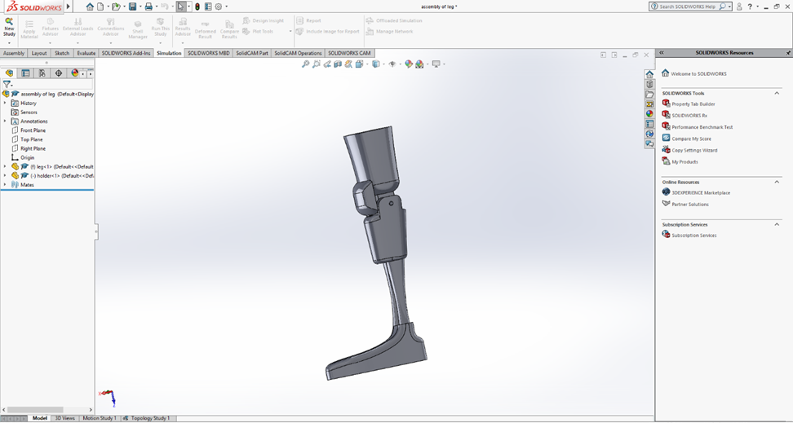
Figure 1 CAD model

This is the concept model of the prosthetic leg; it can be easily adjusted for the size of the person. This is achievable by editing parts with calculations to get the right fit for each person whether this is making the foot smaller or increasing the width or size of the leg. This information could then be saved and stored within the computer so when a replacement is needed the data of the customer would be saved and the part can instantly be printed. The design follows a basic prosthetic leg, with additional of a new cap to protect the joint on the inside. This would be the hardest section of the leg to protect the joint inside the knee from breaking. The leg itself is in two pieces, the upper and lower half. The upper half is to make out the rest of the thigh and the lower half is for the reminder of the leg and foot. These would either be bolted in to allow a bend in the leg or made in such a way that its one piece with the ability to flex at the joint.

Failure mode and effects analysis
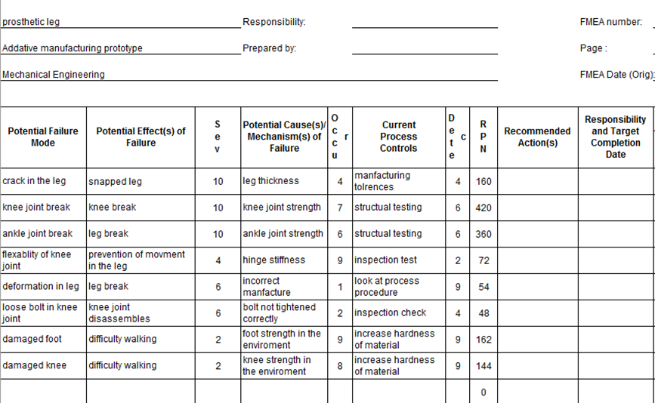
Figure 2 FMEA
These were the possible faults found when using FMEA system on a prosthetic leg using 3D printing technology. This shows the biggest problems that need addressing. This is done by measuring the severity of the problem, the occurrence of the problem and the detection of the problem. All three factors are measured out of ten and then times together to get a RPN value that indicates the most important fault to tackle. As shown in the table above the biggest areas to work on is the strength of the knee joint closely followed by the strength in the ankle joint. The areas that need looking the least at are bolts in the joints and deformation in the leg. No recommended actions have been looked at due to the prototype not being rolled out for general use, however solutions on how to strengthen the design will be looked at. These problems should be dealt with in order. Hoping that it does not affect any of the other part of the design or cause existing problems to worsen.

Quality function deployment
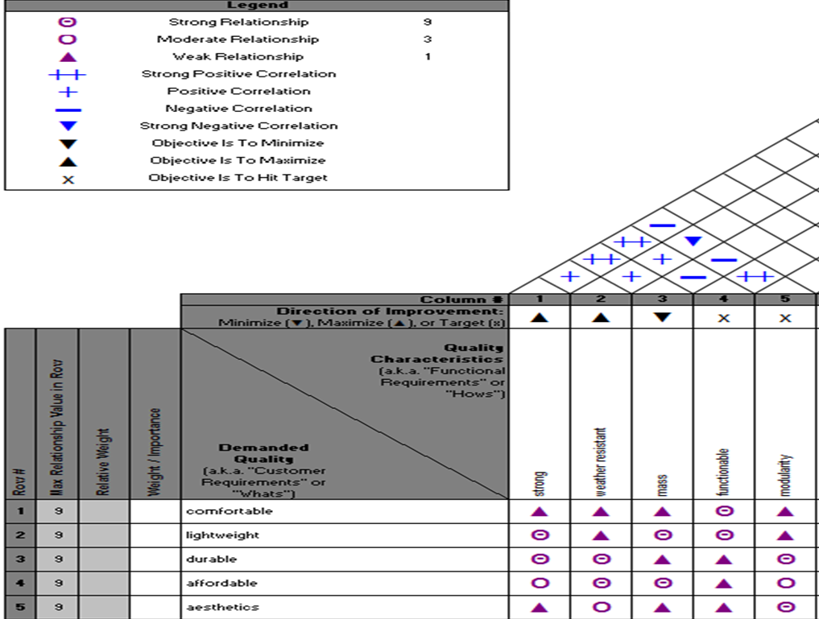
Figure 3 QFD
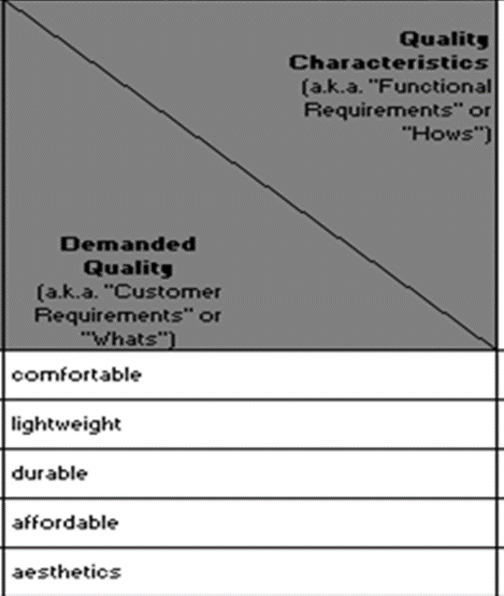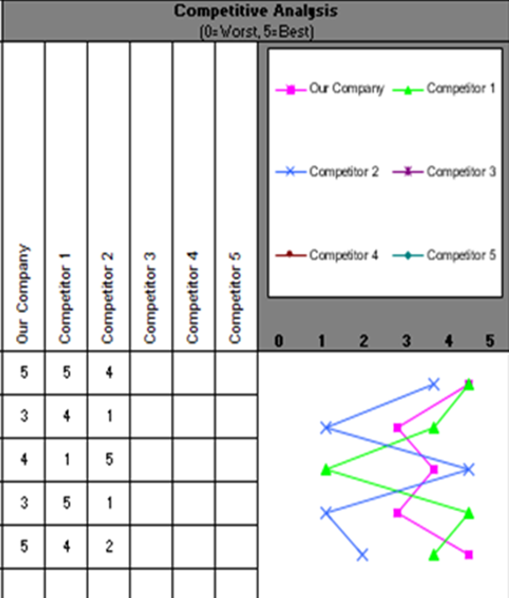
Figure 4 QFD
Figure 5 QFD

The image above depicts a Quality function deployment (QFD) created for the part. This will show the needs of the customer and the needed characteristics of the product. These are then measured with each other and whether they have a weak correlation, a moderate correlation or a strong correlation. This determines how much each section of what is needed and what the customer wants affect each other. This will show which aspect has the most influence on each part of the part. What was shown is that strength is the most influential section of the prosthetic leg and functionality being the least impactful on the prosthetic leg compared to what the customer wants.
A QFD also involves comparing the product to our competitor’s product. We have done this with a mark out of five test; one being the worst and five being the best, using the factors that customers want. A comparison was made between one competitors, which had a traditional way of making prosthetic legs, highlighted in blue and a second competitor, which made his prosthetic legs through FDM, shown in green. As shown by the results my product is the most balanced compared to other competitors, with the product preforming the best in comfortability and aesthetics. However, the product is trailing in the lightweight and affordability to competitor one and trailing to durability with competitor two. These are the areas of development needed on the product.

Evaluation
The idea of this report is to see if it is possible to make a prosthetic leg out of an additive manufacturing process that can last as long as traditional methods and be cheap enough to make. This was first done by looking at the material and process that it was possible. This was done by choosing SLS as the process and ABS as the material. This type of 3D printing is possible and is very good for mechanical parts as well, as a material capable of handling this concept design, the product was then made on a CAD and was compared to other types of prosthetic legs using QFD. This was followed by a throw look at the possible failures of the prototype using FMEA. After taking all this information the conclusion has been made that it would be possible to make a cheap and durable prosthetic leg out of SLS. The market this product would reach is for adults needing prosthetic legs to replace current methods of making prosthetic legs for adults.

Conclusion
Prosthetic legs made by 3D printing are mainly used for children due to their durability being low and causing these prosthetics to break within a year. So the aim was to create a prosthetic leg that is made by additive manufacturing that can last as long as prosthetic legs that current methods of making prosthetic legs are being made. So with the design of the leg, the system of SLS had been chosen because of its higher quality and durability in the making the process. The material was then chosen. The material chosen was ABS this is due to its, resistance to corrosive chemicals, easy to machine, structurally sturdy, stiff and strong against external impacts. A concept was then developed and a FMEA and QFD analysis on the prosthetic leg. Analysing possible problems with the prosthetic leg as seeing what the customer wants and what is needed within the design. These things could help improve and develop the product over time. 3D printing prosthetic legs for adults is a real possibility and is an area that could be developed in the future to produce the cheapest most affordable prosthetic leg, with increase speed in production of a prosthetic leg, this assures waiting for the leg to decrease.

References
(2013, April 25). Retrieved from HSS: https://www.hss.edu/newsroom_prosthetic-leg-cost-over-lifetime.asp
(2018). Retrieved from SPI lasers: https://www.spilasers.com
(2018, May 15). Retrieved from Raise3D: https://www.raise3d.com/blogs/case/3d-printed-prosthetic-legs
(2019). Retrieved from 3D printer power: http://3dprinterpower.com/fff-vs-fdm/
(2019). Retrieved from how products are made: http://www.madehow.com/Volume-1/Artificial-Limb.html
(2019). Retrieved from steatasys: https://www.stratasysdirect.com/materials/selective-laser-sintering
(2019). Retrieved from Formlabs: https://formlabs.com/blog/what-is-selective-laser-sintering/#sls-systems
ALL3DP. (2019). Retrieved from https://all3dp.com/1/types-of-3d-printers-3d-printing-technology/.
CES. (2018).
Christensen, D. (2018, April 16). Retrieved from sciencing: https://sciencing.com/nylons-properties-uses-8627049.html
Goldberg, D. (2014). www.autodesk.com/redshift/history-of-3d-printing. Retrieved from www.autodesk.com.
Hashmi, M. (2014). Comprehensive Materials Processing.
I.Gibson, Rosen, D., & B.Stucker. (2010). additive manufacturing technoligies, rapid prototyping to direct digital manufacturing.
Reidel, H. (2019). Retrieved from Prescouter: https://www.prescouter.com/2017/07/3d-printed-prosthetics/
Rogers, T. (2015, July 13). Retrieved from Creative Mechanisms: https://www.creativemechanisms.com/blog/everything-you-need-to-know-about-abs-plastic
Schwartz, J. (2016). Retrieved from https://techcrunch.com/2016/06/26/the-future-of-3d-printed-prosthetics/?guccounter=2.
Sculpteo. (2019, January 1). Sculpteo. Retrieved from https://www.sculpteo.com/
Turner, R. (2018, May 8). Retrieved from Disabled world: https://www.disabled-world.com/assistivedevices/prostheses/prosthetics-costs.php

Bibliography
(2013, April 25). Retrieved from HSS: https://www.hss.edu/newsroom_prosthetic-leg-cost-over-lifetime.asp
(2018). Retrieved from SPI lasers: https://www.spilasers.com
(2018, May 15). Retrieved from Raise3D: https://www.raise3d.com/blogs/case/3d-printed-prosthetic-legs
(2019). Retrieved from 3D printer power: http://3dprinterpower.com/fff-vs-fdm/
(2019). Retrieved from how products are made: http://www.madehow.com/Volume-1/Artificial-Limb.html
(2019). Retrieved from steatasys: https://www.stratasysdirect.com/materials/selective-laser-sintering
(2019). Retrieved from Formlabs: https://formlabs.com/blog/what-is-selective-laser-sintering/#sls-systems
ALL3DP. (2019). Retrieved from https://all3dp.com/1/types-of-3d-printers-3d-printing-technology/.
CES. (2018).
Christensen, D. (2018, April 16). Retrieved from sciencing: https://sciencing.com/nylons-properties-uses-8627049.html
Goldberg, D. (2014). www.autodesk.com/redshift/history-of-3d-printing. Retrieved from www.autodesk.com.
Hashmi, M. (2014). Comprehensive Materials Processing.
I.Gibson, Rosen, D., & B.Stucker. (2010). additive manufacturing technoligies, rapid prototyping to direct digital manufacturing.
Reidel, H. (2019). Retrieved from Prescouter: https://www.prescouter.com/2017/07/3d-printed-prosthetics/
Rogers, T. (2015, July 13). Retrieved from Creative Mechanisms: https://www.creativemechanisms.com/blog/everything-you-need-to-know-about-abs-plastic
Schwartz, J. (2016). Retrieved from https://techcrunch.com/2016/06/26/the-future-of-3d-printed-prosthetics/?guccounter=2.
Sculpteo. (2019, January 1). Sculpteo. Retrieved from https://www.sculpteo.com/
Turner, R. (2018, May 8). Retrieved from Disabled world: https://www.disabled-world.com/assistivedevices/prostheses/prosthetics-costs.php

