Corporate Social Responsibility in the Public Sector
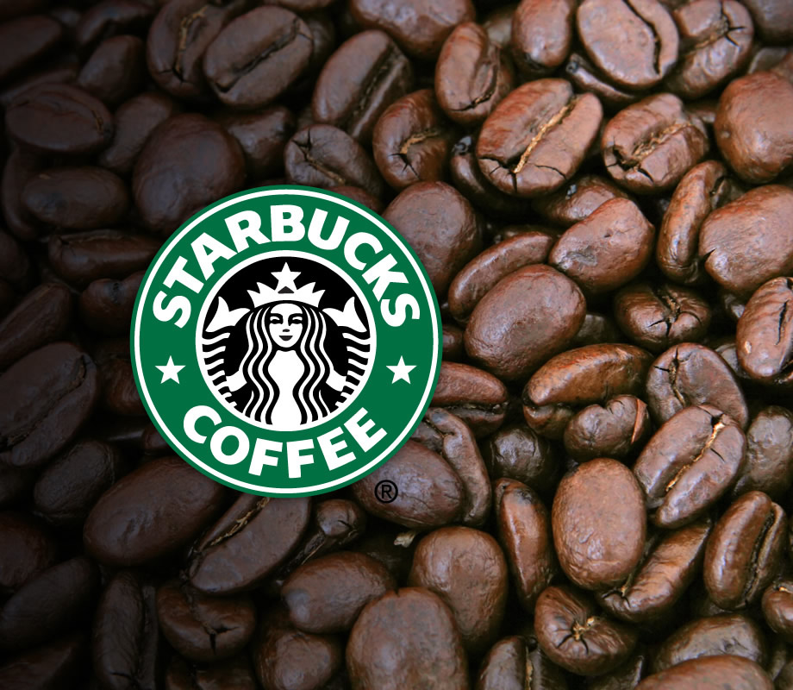
Investigating CSR in an organisation
(Starbucks)

By Sophie Winter
P150643

Corporate social responsibility (CSR) is a concept that does not have a universally accepted definition (Crane et al, 2008). One of the early definitions of CSR is by Archie Carroll (1977) which stated that the social responsibility of business encompasses the economic, legal, ethic and discretionary expectations that society has of organisations at a given point in time (Carroll, 1977). The CSR is defined by the UK Government (2014) as the responsibility of impact of decisions on society and the environment by an organisation. It has legal obligations to go above and beyond through its transparent and ethical behaviour (Gov, 2014). According to European Commission (2011) CSR has been defined as a concept where companies integrate social and environmental concerns in their business operations and in their interaction with their stakeholders on a voluntary basis (European Commission, 2011). Corporate social responsibility has a good repetition for succeeding in the business world by increasing sales and brand awareness (Crane et al, 2008).

Starbuck is one of the biggest coffee house in the world. Starbuck has a good name in the business world of CSR, it has been committed to being a fully responsible company within communities. Starbucks first went into the corporate responsibility paradigm in 2000 (Starbucks, 2017). CSR is an important part for Starbuck’ management strategy, this philosophy has allowed Starbucks to create a strong and trustworthy relationship with its customers and is also very competitive than other brands. CSR marketers view the practises as a competitive advantage and a mechanism for improving performance (Kang & Namking, 2018). Starbucks can also have a ripple effect on CSR practises because they run large number of coffee branches across the world and there projects are from many aspects of the world which mean helping with the environment, animal welfare, human health, labour issues and fair trade (Andersen & Skjoett, 2009). The focal point is on sourcing high quality coffee, decreasing the environmental impact, and also supporting the community as best the company can (Mukhlis, 2012).
Starbucks CSR responsibility strategy is based on three pillars which are community, ethical, sourcing and the environment. The positive impact Starbucks has on communities is that it develops community stores that are partnered up with local non profit, and the stores offer services that have a goal to meet the needs of the communities. Starbucks will also donate $0.5 to $0.15 per service to the non profit partner. According to Vandeveld (2015) Starbucks has pledged by 2025 to hire 10,000 veterans and military service men and women, and to focus on diversity and inclusion in the workplace (Vandeveld, 2015). Starbucks has already hired over 21,000 veterans and military service people since 2013. The goal for 2025 have almost been reached in hiring exactly 12,876 veterans and service people which has been stated in there performance report (Starbuck, 2018). Starbucks has even created the Starbucks Foundation with the aim to strengthen communities.
The second pillar is Ethical Sourcing meaning that Starbucks are committed to responsibly and ethically producing and purchasing their coffee, tea, cocoa and other goods. The company have stated that they will only purchase products from farms and manufacturers that only agree to a certain standard of ethical treatment.
The third pillar is environment which the company mentioned as there most important business partner and takes on a approach that shows a all aspects approach to dealing with reducing environmental impact. By reducing the their environmental footprint they have LEED certified stores which are which are dedicated to recycling and conserving water and energy within its stores, this is to create better strategies that address climate change on a global level. In every way Starbucks works they always try to be eco friendly.

The Starbucks mission is to inspire and nurture the human spirit, one person, one cup and one neighbourhood at a time. Starbucks has always built its brand name on things that tend to be out of the box. While other companies were advertising constantly Starbucks decided not to advertise. Unlike most companies Starbucks cares for its employees by offering stock options and health insurance. Starbucks do this by using their world-class benefits and programs that include health coverage that covers medical, dental and vision plans as well as life insurance and accidental coverage all provide from the company (Starbucks Careers, 2018). Stock and savings are giving when retiring within the company that offers discounted company stock as well as the equity reward program and bean stock. Starbucks brand philosophy is to be responsible and socially ethical company which includes where they purchase their goods, which includes supporting farmers loans, forest conservations programs as well as giving opportunities through education, training, and employment. The company also have programs to reduce its environmental footprint and doing it by recycling, green construction, energy and water conservation. These show a great consistency, attention and customer orientation in practice.
Starbucks launched a ethical sourcing program called Coffee and Farm Equity (CAFE) practises programme in 2004 which is a green sourcing standard used by the company to purchase their coffee. This standard was developed in partnership within the Conservation International and other third party company known as SCS. The CAFE Practises standard ensures that the company is sourcing maintainable grown and processed coffee. Starbucks rely on the SCS to ensure that the CAFE Practises are up to standards and the quality of the third party verification process. The practise operates with a points system that is awarded for being compliant with individual indicators (SCS, 2018). Over the past 10 years the CAFE Practises have made a incredible amount of impact to millions of workers and helped to improve long term environment and social conditions of thousands of farms around the world (Starbuck, 2014).
The values of Starbucks are “to create a culture of warmth and belonging, where everyone is welcome. Acting with courage, challenging the status quo and finding new ways to grow our company and each other. Being present, connecting with transparency, dignity and respect. Delivering our very best in all we do, holding ourselves accountable for results” (Starbucks, 2019). The reason of the Starbucks’ aims is to provide a high effective organisation that strives off customer satisfaction. Another one of the brands strategies is focusing on the experiences the store has created, this is always been been seen as a big foundation in Starbuck’ strategy. Another one of the brands strategies which is taking advantage of customers engaging platforms, the company has a website called mystarbucksidea.com which encourages customers to leave ideas and how the company can do better to improve themselves eg improving its products, customer experiences, engaging with community and social responsibility (Roll, 2017).

According to Harper (2017) within a large business like Starbucks holds a even bigger responsibility which claims to be eco friendly and aware of its environmental cup print. The paper cups that the company sell to customers are not recyclable (Harper, 2017). Every year in America 16 billion paper coffee cups are sent to a landfill, the amount of waste from each cup is not environmentally sustainable in practise (Ziada, 2009). Starbucks’ paper cups are currently made with a 10% post consumer recycled fiber, with a thin liner in the inside of the cups to prevent leaks. But this causes the paper cups not easy to recycle (Flager, 2019). Starbucks have fallen dramatically low on meeting their commitments in 2008 which meant making 25% percent of it cups reusable by 2015 (Harper, 2017). Apparently Starbucks have been trying to encourage reusable cups for years but there has only been little attempt which should be an easy policy to follow. According to MacKerron (2017) the senior vice president of As You Sow stated that there are many different ways to encourage people to use their reusable cups cups such as offering a ceramic mug for people who are ording in, he has also added to always encourage customers to keep pressuring Starbuck by voicing concerns in whatever store the customer might be in (Harper, 2017). On March 2018 the Starbucks chain has promised $10 million to a competition to create a better single use coffee cup which can me composted or recycled. Starbucks have been known to underperform in goals for waste reduction in the past which also included their pledge to make 100% of their cups reusable or recyclable by 2015 which never happened and never even came close to achieving (Houck, 2018) . According to Starbucks (2014) Global Responsibility Report, Starbucks state that raising awareness on reusable cups are a big component for the company's overall strategy for waste reduction. Their goal was to serve in store at least 5% of drinks in mugs and tumblers brought in by the customer which in 2014 47.6 million times the customers did which increased from the year before from 46.9 million (Starbucks, 2014). Starbucks also sell $2 reusable cups that are very similar to the classic white paper cup given, and give a 10% discount to anyone who bring a reusable cup in store (Flager, 2019).

With Starbuck being very successful in the United Kingdom. During the 15 years of Starbucks being in the UK the company have only paid UK corporate income tax once. Doing this by a combination of legal tax avoidance, the company have successfully shift their taxable income to other Starbuck controlled by a holding company in another country where the tax is at a lower rate (Campbell & Helleloid, 2016). There was an uproar about Starbucks over the failure to pay the British corporate income taxes, although Starbuck isn’t the only multinational company that avoids this. By Starbucks portraying themselves as as socially responsible and a good citizen of the communities by paying fair wages, and fair wages to the coffee growers in other developing countries but still this company was not being fair by not paying these taxes while having these coffee shops all over the UK. This situation seemed to have a great deal of media attention for tax avoidance as Starbucks tried to respond to the criticism from the media, custiners, politicians and UK based businesses that have always paid their corporate tax. As the UK had major budget cuts to social services, protesters decided to bring attention to the bigger picture which is the impact of corporate tax avoidance. Starbucks become the big topic for protesters as Starbucks’ UK stores were reported to billions of pounds for sales, while no UK income tax since coming over to the UK in 1998. (Campbell & Helleloid, 2016). These characteristics the company suggests public perceptions about corporate tax minimization strategies (Campbell & Helleloid, 2016). In 2014 Starbucks announced that it will be moving regional headquarters from European HQ to London following the tax avoidance scandal and vowed to pay more tax in the UK. But are under fire as the company have only paid 2.8%of their tax in 2017, in 2012 Starbucks paid only £8.6 million corporate tax in Britain over the past 14 years despite gaining a £3 billion profit (Sheldrick, 2018).

CSR and organisational stakeholders management approaches in Starbucks are based on different programs within CSR. The company is a supporter of the CSR movements especially to those that involve making business (Weber, 2008). CSR in Starbucks needs to account for the demand and interest of stakeholders because Starbucks is not just seen as a profit making company but also a citizen within the society. This is why Starbucks must contribute improvements to society which it does within the Starbucks CSR Plans and programs for its stakeholders. The company already shows the efforts it does to include stakeholders within its strategies and successes. The main different stakeholder groups within Starbucks are Employees, Customers, Suppliers, Environments, Investors and Governments. The company has successful stakeholders but Starbucks also needs to surpass’ its CSR performance to reach 100% CAFE certified supply chain to enhance environmental benefits (Thompson, 2017).

The future for Starbucks shows that building stores with the aim to minimise the environmental footprint that will continue to be a goal for 2020 and the years to follow. Starbucks are always thinking of new ways to get the customers more eco friendly which the idea of discounted drinks for customers who bring their reusable cups in. Starbucks have always been one step ahead of new materials in creating ideas to reduce packaging in a environmental way, which came up with the idea of the cup sleeve to stop double cupping (Jeong et al, 2014). Also becoming the first coffee house to have post consumer in hot cups in 2006. In 2017 Starbucks introduced more recyclable cup lid making it easier to recycle. Starbuck has planned to have a greener cup by 2020, by having the set goals to achieve each year is making a difference within the environment as they are experimenting with different options and materials that will work welland are safe for customer usage (Starbucks, 2017). Starbucks have stated that they are working with local governments and stakeholder to increase better recycling systems within communities. By 2020 Starbucks are trying to do more strawless lids. Starbucks have been challenged to do the NextGen Cup Challenge which is a campaign launched in 2018 with a goal of finding a solution for a widely recyclable or compostable cup. and have been announced as the winner of the challenge. The company have has reached the next step in creating a more sustainable cup (NextGenCup, 2018).

Starbucks have the ability to communicate its CSR efforts effectively analysed. The importance of the environment is seen as improving by the complany not reaching their reusable cups goal that Starbucks set themselves. Which in the future escalated to winning the NextGen Cup Challenge, this shows that Starbucks are enhancing their knowledge on the topic and creating the CSR initiatives as part of its strategy through the company's corporate website. With Starbucks having long term commitments to numerous CSR programs as well as an approach to economic motives as part of the overall strategy (Bruhn-Hanson, 2012). The CSR improvements are in place to better society as the company itself is seen as one, which means making plans to improve the society without making profit. The positive way Starbucks has involved themselves is by purchasing fair trade coffee which will affect their profits but chose to purchase coffee as it was ethical and everyone would benefit from its trading such as farmers, environment and even public image. Starbucks has run its whole business on CSR as a tool in which covers the company in every aspect (Matten & Moon, 2008).

Bibliography

Andersen, M., & Skjoett-Larsen, T. (2009). Corporate social responsibility in global supply chains. Supply Chain Management: An International Journal, 14(2), 75-86.

Bruhn-Hasen, (2012), Corporate social responsibility - A case study of Starbucks’ CSR communication through its corporate website’, [Online], Available:
http://www.sustainicum.at/files/projects/315/en/additional/Corporate%20Social%20Responsibility%20%20A%20case%20study%20of%20Starbucks%20CSR%20communication%20through%20its%20corporate%20website.pdf, [28/02/19].

Campbell, K & Helleloid, D. (2016). Starbucks: Social responsibility and tax avoidance. Journal of accounting education (2016), 36, 28-60.

Carroll, A.B. (1977). Managing corporate social responsibility, London: Scott Foresman & Co.

Crane, A & Matten, D & Spence, L. (2008) Corporate Social Responsibility. London: Routledge.

European Commission (2011), ‘Communication from the commission to the european parliament, the council, the european economic and social committee and the committee of the regions, [Online], Available:
https://www.employment.gov.sk/files/slovensky/ministerstvo/spolocenska-zodpovednost/new-communication-on-csr-2011-2014.pdf, [27/02/19].

Flager, M (2019). Starbucks announced the nextgen cup challenge winners, [Online], Available: https://www.delish.com/food-news/a26552951/starbucks-mcdonalds-compostable-cup-nextgen-challenge/, [27/02/19].

Geereddy, N (2017), Strategic analysis of Starbucks corporation, [Online], Available:
https://scholar.harvard.edu/files/nithingeereddy/files/starbucks_case_analysis.pdf, [27/02/19].

Gov, (2014), ‘Corporate responsibility’, [Online], available:
https://www.gov.uk/government/consultations/corporate-responsibility-call-for-views, [25/02/19].

Houck, B. (2018). We’re buried in Starbucks cups. What are they doing about it?, [Online] Available:
https://www.eater.com/2018/3/28/17172556/starbucks-cup-waste-sustainable-compost-recyclable, [26/02/19].

Jeong, E & Jang S & Day, J (2014). The impact of eco-friendly practise on green image and customer attitudes: An investigation in a cafe setting: International Journal of hospitality Management (2014), 10(12).

Kang, J.W & Namkung, Y. (2017). The effect of corporate social responsibility on brand equity and the moderating role of ethical consumerism: The case of Starbucks. Journal of hospitality & tourism research (2018), 42(7), 1130-1151.

NextGenCup, (2018), The Challenge. [Online], Available: https://www.nextgenconsortium.com/, [26/02/19].

Matten, D & Jeremy Moon, (2008), Implicit and explicit CSR: a conceptual framework for a comparative understanding of CSR’. Academy of Management Journal (2007), 33(2).

Mukhlis, A (2012), Starbucks social responsibility, [Online], Available: https://www.scribd.com/doc/106854487/Starbucks-Social-Responsibility, [26/02/19].

Roll, M (2017), The secret to Starbucks’ brand success, [Online], Available:
https://martinroll.com/resources/articles/strategy/secret-starbucks-brand-success/, [27/02/19].

Vandeveld, K. (2015), ‘Corporate social responsibility: How Starbucks is making an impact’, [Online], Available:
http://www.whywhisper.co/the-blog/2015/9/24/corporate-social-responsibility-how-starbucks-is-making-an-impact, [25/02/19].

SCS Global Services, (2018). Starbucks C.A.F.E. Practises. [Online] Available:
https://www.scsglobalservices.com/services/starbucks-cafe-practices?scscertified=1, [25/02/19].

Sheldrick, G. (2018). Fury as Starbucks pays just £4.5m tax on £162m profits’, [Online], Available: https://www.express.co.uk/news/uk/1020131/starbucks-accused-corporation-tax-avoidance, [28/02/19].

Starbucks Careers, (2018). Benefits and Perks, [Online], Available:
https://www.starbucks.com/careers/working-at-starbucks/benefits-and-perks, [02/03/19].

Starbucks (2019). Starbucks social impact, [Online], Available: https://www.starbucks.com/responsibility, [26/02/19].

Starbucks, (2017). Global social impact. [Online], Available:
https://globalassets.starbucks.com/assets/8c1f8c07efde407e9d48bfaf518c0b45.pdf, [28/02/19].

Starbucks (2014), ‘Global responsibility report’, [Online] Available:
http://globalassets.starbucks.com/assets/ea2441eb7cf647bb8ce8bb40f75e267e.pdf, [27/02/19].

Thompson, A. (2017), Starbucks coffees stakeholders: A CSR analysis, [Online], Available: http://panmore.com/starbucks-coffee-stakeholders-csr-analysis , [05/03/19].

Weber, M. (2008), The business case for corporate social responsibility: A company level measurement approach for CSR’. European Management Journal, (2008) 26(4), 247-261).

Wilson, M. (2019). Starbucks and McDonald’s are testing these radical cups of the future’, [Online], Available:
https://www.fastcompany.com/90311549/starbucks-and-mcdonalds-are-testing-these-compostable-cups-of-the-future, [28/02/19].

Ziada, H (2009). Disposable coffee cup waste reduction study, [Online], Available:
https://www.eng.mcmaster.ca/sites/default/files/uploads/disposable_coffe_cup_waste_reduction.pdf. [26/02/19].

