University of Wales Trinity Saint David



Module Code: LCHS 4003 – Component 2
Module name: Introduction to Health and Social Care
Name of Student:Ashfaq Mohammad
Student ID:2504711
Lecturer Name: Mumtaz Goolam

Table of Contents
1. Introduction 3
2. Importance of Effective Communication in Mr Ahmed’s Care 3
I. Application of Equality Act 2010 4
3. Importance of Administrative Skills in Professional Practice 5
II. Application of Data Protection Act in 2018 6
4. Importance of Collaborative Working in Mr Ahmed’s Care 7
5. Conclusion 8
6. References 9

Introduction
Health and social care practice depends on effective communication, proper administration and effective collaboration working among the professionals. These factors are especially significant in work with people with complicated health conditions and communicational difficulties. Mr Ahmed is a 68 year old male who has recently been released out of hospital after he had suffered a stroke. He is living with his wife and is assisted by a domiciliary care agency three times a day. Mr Ahmed struggles to communicate in English and usually uses his wife to address healthcare providers due to the impacts of his stroke as well as communication difficulties caused by language barriers. There are a number of professionals that participate in his care which include his GP, district nurse, speech and language therapist and workers in the care. This report will explain the significance of good communication in the care of Mr Ahmed, will touch upon how professionals need to communicate to him and his family and implement the principles of the Equality Act 2010 and an identified model of communication. It will also observe the administrative skills, which will involve record keeping and data protection requirements as provided in the Data Protection Act 2018. Lastly, the report will address the topic of collaborative working among professionals and the approaches to improving the challenges in multi-agency care.
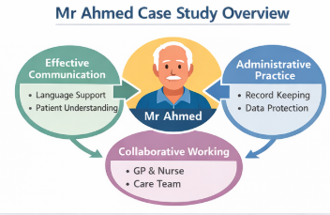
Fig 1: Mr. Ahmed’s Case Study Overview

Importance of Effective Communication in Mr Ahmed’s Care
Health and social care require effective communication since the professionals can interpret the needs of the service users and offer them safe treatment and a trusting relationship. Communication is of particular importance in the case of Mr Ahmed since he suffered a stroke and it may have impact on speech and comprehension, as well as since Bengali is his native tongue. Failure in effective communication among the healthcare professionals may result in misinterpretations, the lack of quality of care and the potential threat to his health. Among the elements to consider when communicating with Mr Ahmed is the understanding of his language requirements. Medical workers are expected to talk in a clear manner and not use complicated medical jargon and also give him time to answer. The simple language and visual materials can be used to make him comprehend instructions on medication, therapy exercises and daily activities. In case of necessity, the use of professional interpreters or translation services is recommended instead of the family members only. Even though the wife of Mr Ahmed speaks fluent English and can facilitate the transfer of information, the professionals would need to ensure that Mr Ahmed is involved in the conversations regarding his treatment. This is in favour of person-centred care and his independence.
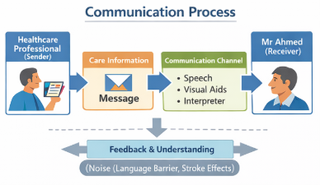
Fig 2: Communication Process

Application of Equality Act 2010
The Equality Act 2010 is also specifically applicable to the case of Mr Ahmed since it hides people against discrimination and encourages equality in the access of services. According to this act, health and social care providers should make reasonable accommodation so that individuals with disabilities or language barriers have access to care as other people. The stroke that Mr Ahmed had can be regarded as a disability under the Act in case it influences his everyday life. Care providers should therefore ensure they change the approaches to communicate with him in his needs. The principle of equality and inclusion of the Act is also reflected in respecting cultural and linguistic differences.
One of the communication models that can be used in this case is the Shannon and Weaver Communication Model (1949). According to this model, communication is described as a process that entails the sender, message, channel, receiver and possible impediments referred to as noise. In the case of Mr Ahmed, a healthcare professional is a sender and a message can contain some information regarding medication or treatment. The channel can either be verbal, written or visual. The receiver is Mr Ahmed who interprets the message. Nevertheless, there are a number of forms of noises that can influence the communication process. These are the language barriers, hearing or speech problems after the stroke and emotional stress about his health condition. In order to eliminate these obstacles, professionals are advised to verify that participants of the understanding process have understood information by asking Mr Ahmed to repeat or demonstrate information, maintain eye contact and use clear body language. The model also involves feedback whereby it determines whether the message has been interpreted in the right way.

Importance of Administrative Skills in Professional Practice

The administrative skills are important in the health and social care due to the support of safe, organised and accountable practice. This is especially crucial with regard to accurate administration in the care of Mr Ahmed since several professionals and services are at stake. Good administrative practice encompasses the upkeep of good records, proper sharing of information and protection of sensitive personal data. Record keeping is one of the most crucial administrative functions in the healthcare sector. Records contain an elaborate description of the care and treatment a service user gets. In the case of Mr Ahmed, the care workers are to record every visit he takes, taking medication, personal care and issues related to his condition. As an illustration, the case of the missed home visit by the care agency recently shows the need to have right records and monitoring systems. Without the appropriate documentation or verification of visits, the service users might not receive the necessary services e.g. medication, which can have severe implications on their health. Continuity of care is also supported through records that are accurate. As Mr Ahmed is under the care of various professionals including the GP, district nurse and the speech and language therapist, each professional should be in a position to access the appropriate information concerning his condition and treatment regimen.

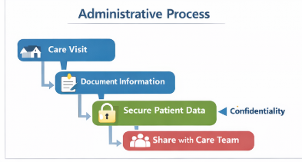

Fig 3: Administrative Process

Application of Data Protection Act in 2018
The administrative practice should also be conducted according to the Data Protection Act 2018 which governs the collection, storage and sharing of personal data. Medical records, addresses and treatment details are some of the sensitive information that health and social care organisations deal with. According to the Act, personal data should be handled in a manner that is lawful, fair and transparent. This is in the sense that the information that Mr Ahmed has provided, should not be disclosed to unauthorised individuals and should only be used in the process of providing legitimate care. Confidentiality is another important concept of the Data Protection Act 2018. The professionals should make sure that the personal information of Mr Ahmed is secure regardless of whether the information is stored electronically or on paper. Accuracy and minimisation of data is also highlighted in the Act. This implies that the records should always be updated and that only pertinent data should be captured.
In the case of Mr Ahmed, recording the change in his blood pressure, communication or medication schedule is significant to check his recovery following the stroke. Besides legislations, administrative practice is guided by professional standards and organisational policies as well as legislation in health and social care. These practices bring in accountability and contribute towards high standards of care. By observing appropriate administrative practices, the staff can minimize the chances of making mistakes, guard the rights of service users and facilitate effective interactions among the professionals. In general, proper administrative skills make sure that Mr Ahmed will get secure, synchronized and legally adequate care.

Importance of Collaborative Working in Mr Ahmed’s Care

Teamwork is a necessary activity within health and social care due to the necessity of numerous service users to get the assistance of a variety of professionals having dissimilar knowledge. Mr Ahmed has a number of professionals such as his GP, district nurse, domiciliary care workers and speech and language therapist in his care. Every professional provides professional knowledge and skills which facilitates his recovery following the stroke. The GP is the key player in the overall treatment of Mr Ahmed, i.e., prescribing medication and keeping track with long-term illnesses such as blood pressure. Clinical care is also offered at home by the district nurse and is done in the form of checking of blood pressure and taking care of the wound. Domiciliary care workers provide all the day-to-day care like personal care, medication support and meal preparation. The speech and language therapist aims at enhancing the communication and swallowing skills of Mr Ahmed after the stroke. In order to achieve efficient cooperation, professionals should interact on a regular basis and exchange pertinent information. Among the methods is the multidisciplinary team (MDT) meeting, in which the professionals communicate on the needs of the service user and review the progress and change the care plan.

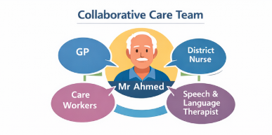

Fig 4: Collaborative Care Team

The communication between various services is also supported by shared care records and digital health systems. Nevertheless, working in multi-agencies may be challenging in a number of ways. They can be communication failure, variation in the professional roles, time limitation and organisational limit. In the case of Mr Ahmed, such as the lapsed domiciliary care visit, the failure to align or interrelate communication can influence service delivery. These challenges can be overcome by a number of strategies. The role definition provides clarity that every professional is aware of his/her role within the care team. With good information sharing systems, professionals will be able to get the right information about the status of the service user. Trust and cooperation among the members of the team are also encouraged through regular meetings and mutual decision-making. All the collaborative work should continue to focus on person-centred care. This implies that Mr Ahmed and his wife should be engaged in the planning of their care and their preferences and culture should be respected. Professionals can offer integrated and comprehensive care to the service user when they collaborate in addressing their needs to enhance health outcomes and quality of life.

Conclusion

Finally, the key elements of quality health and social care include effective communication, good administration practice and a team-based working practice. Communication is critical in this case of Mr Ahmed to make him aware of his care and treatment despite the language barrier and impact of his stroke. The use of the equality act of 2010 and communication models principles can assist the professional to change their communication strategies and facilitate inclusion in care. The application of good administrative skills, especially proper record keeping and data protection are what will make the care provided to Mr Ahmed safe, organised and within the confines of the law. Adhering to the standards of the Data Protection Act 2018 will ensure the preservation of his personal data and professional responsibility. Lastly, teamwork among the GP, district nurse, domiciliary care workers and speech and language therapist enables the coordinated service and better health outcomes. These factors combined help healthcare providers to provide person-centred care that is safe and effective to individuals such as Mr Ahmed.

References

- Department of Health and Social Care (2018) Data Protection Act 2018. London: The Stationery Office.
- Equality Act (2010) Equality Act 2010. London: The Stationery Office.
- Glasby, J. and Dickinson, H. (2014) Partnership working in health and social care. Bristol: Policy Press.
- Health and Care Professions Council (2022) Standards of conduct, performance and ethics. London: HCPC.
- National Health Service (NHS) England (2023) Working in multidisciplinary teams in healthcare. London: NHS.
- Shannon, C. and Weaver, W. (1949) The mathematical theory of communication. Urbana: University of Illinois Press.
- Tuckman, B. (1965) ‘Developmental sequence in small groups’, Psychological Bulletin, 63(6), pp. 384–399.
- Thompson, N. (2016) Effective communication: A guide for the people professions. 3rd edn. London: Palgrave Macmillan.
- Hargie, O. (2011) Skilled interpersonal communication: Research, theory and practice. 5th edn. London: Routledge.
- Banks, S. (2021) Ethics and values in social work. 5th edn. London: Macmillan Education.
- Naidoo, J. and Wills, J. (2016) Foundations for health promotion. 4th edn. London: Elsevier.
- Royal College of Nursing (RCN) (2021) Record keeping guidance for nurses and health professionals. London: RCN.
- World Health Organization (2021) Framework on integrated people-centred health services. Geneva: WHO.

