October 2012
Dynamic link libraries
Distributed Enterprise Applications
Tim Bashford

Creating and accessing a dynamic link library
Distributed Enterprise Applications

Introduction
This tutorial illustrates the methods through which a dynamic link library may be created and accessed. Also included is a recap for creating and accessing a local SQL file.

Tutorial
Create a new Visual Studio 2012 ClassLibrary named StudentRecordsDLL. The DLL needs to provide the following functionality:
- Add a new course
- Add a student linked to an existing course
- Remove a student
- Take a course ID and return the name of that course
- Return a comprehensive list of courses
- Generate and return a comprehensive report of students, including the name of the course on which they are enrolled
The new project should use the:
- Class Library Template
- C# as the language

Create a new Class Library application in Visual C#. Name the Project “StudentRecordDLL”.
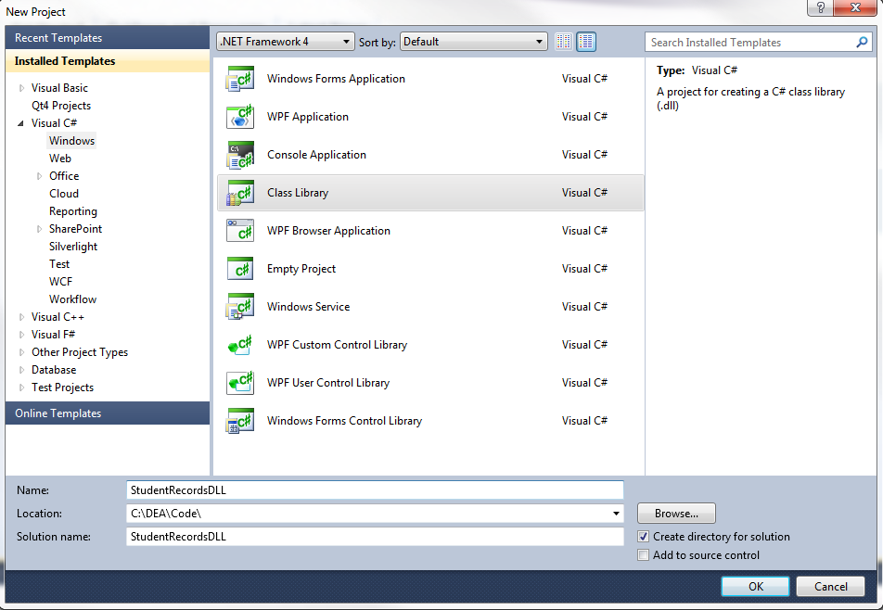
Add a Service Based Database to your project. Name it StudentRecords.
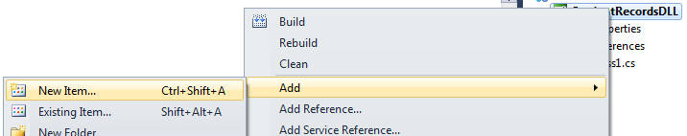
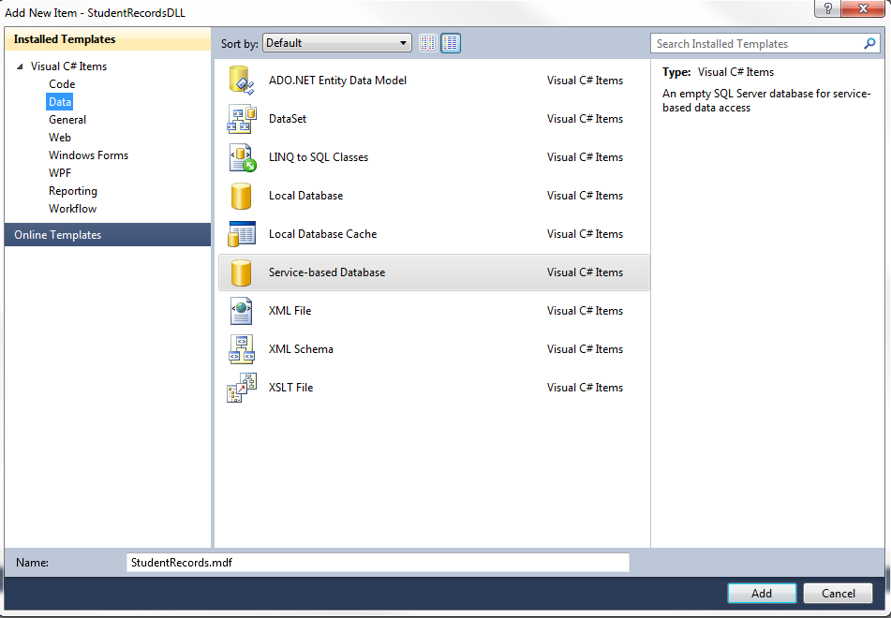

Select the “Dataset” model.
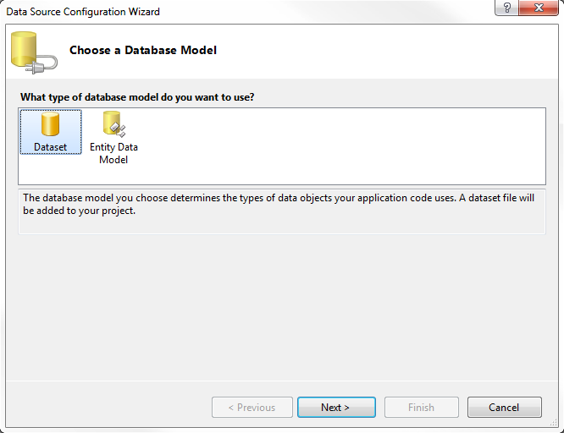

You will be warned that there is no data; this is to be expected as this is a new Database. Click “Finish”.
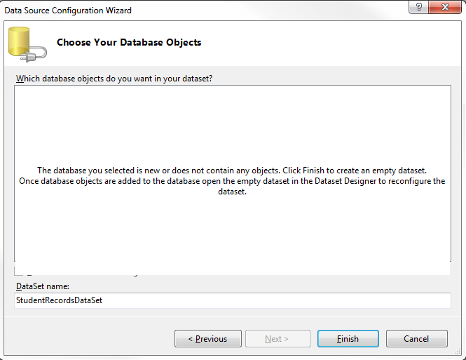

Double click the newly created “StudentRecords.mdf” Database. The Server explorer should open. Add the following tables by right clicking “Tables” and selecting “Add New Table”:
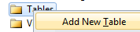
Course
Name | Data Type | Attributes
CourseID | Int | Not null, Primary key, Auto number*
CourseName | VarChar(50) | Not null
CourseDescription | VarChar(MAX) | Not null
* You can set an auto number by selecting the CourseID row and setting the“Identity Specification” property to “Yes”. Identity Seed defines the start point of the auto number, Identity Increment defines by how much this identity will increase.
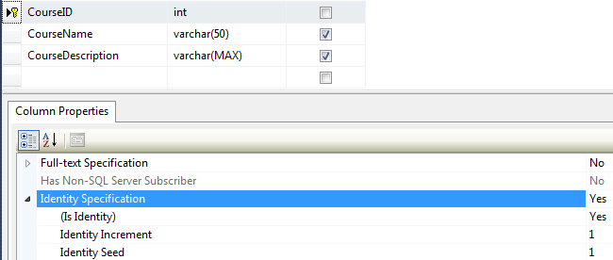
Save this table as “Course”.
Student
Name | Data Type | Attributes
StudentID | Int | Not null, Primary key, Auto number
CourseID | Int | Not null, Foreign Key (Course.CourseID)**
Name | VarChar(MAX) | Not null
Address | VarChar(MAX) | Not null

** To create a foreign key:
Right click the CourseID row, select “Relationships”. Click “Add”. Expand the “Tables and Columns Specific” field. Click the “...” box.
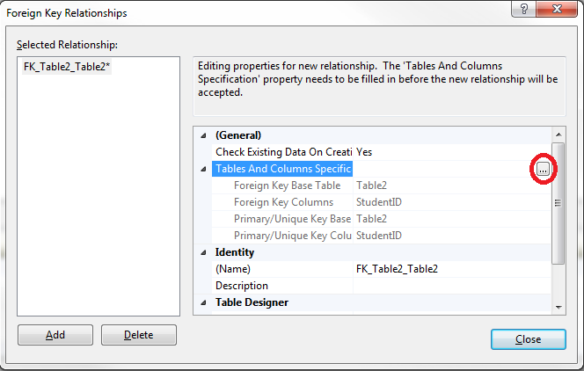
Now select the “Course” table and the “CourseID” field. Name this relationship “FK_Student_Course”.
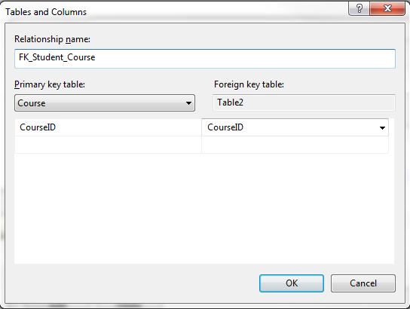
NB: “Table2” is referenced because the Student table has not been saved and thus has not been named. This will update automatically when the table is saved.

Programming the DLL
The database may now be mounted in an instance of SQLEXPRESS (this will happen as a part of the connection process detailed below) and used.
Add the SQL libraries:
using System.Data;
using System.Data.SqlClient;

Rename the class to StudentRecords then create the following method:
public string AddCourse(string CourseName, string CourseDescription)

When using a local database file, the SQLConnection and SQLCommand objects utilised in the previous tutorial remain relevant. There is, however, a variation in how the connection string is written. The Data Source parameter will now take the instance of the server (in this case “.\SQLEXPRESS”) and three new parameters will be specified:
AttachDbFilename | The path and name of the file to be mounted and used. Drag the database file into the code window to easily obtain this.
Integrated Security | Will use Windows authentication (i.e. your network login) as server verification credentials rather than requiring the specification of a username and password. This almost always uses Microsoft’s Security Support Provider Interface (SSPI) API, although may use NTLM in older versions. May be set to “SSPI” or “true”, these are largely interchangeable in recent versions.
User Instance | Create a new user instance when a user connects. Set to “true”.

As such, a connection string may be formed as follows:
SqlConnection conn = new SqlConnection(
@"Data Source=.\SQLEXPRESS;
AttachDbFilename=C:\DEA\Code\StudentRecordsDLL\StudentRecordsDLL\StudentRecords.mdf;
Integrated Security=True;
User Instance=True"
);

The conn object may now be utilised in exactly the same manner as was detailed in the previous tutorial:
try
{
conn.Open();
}
catch(Exception e)
{
return e.ToString();
}

SqlCommand cmd = new SqlCommand("INSERT INTO Course (CourseName, CourseDescription) VALUES('" + CourseName + "', '" + CourseDescription + "')", conn);

try
{
cmd.ExecuteNonQuery();
}
catch (Exception e)
{
return e.ToString();
}

return "Course created successfully.";

Remember, the CourseID field is an autonumber, attempting to insert a value into it will result in an SQL error.
Build your project. Note how the output is a .dll file with no executable code:
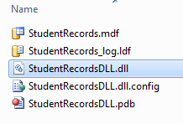

Exercise
Add the following methods to the DLL:
public string AddStudent(string StudentName, string StudentAddress, int CourseID)
public string RemoveStudent(int StudentID)
public DataTable StudentList()
public DataTable GetCourses()
public string GetCourseName(int CourseID)

And implement them. You should be able to implement the AddStudent, RemoveStudent and GetCourses method using the previous tutorial for reference. Remember that a DataTable may be created as follows:
SqlCommand cmd = new SqlCommand("SELECT * FROM Course", conn);

SqlDataReader reader;

try
{
reader = cmd.ExecuteReader();
}
catch
{
return null;
}

DataTable dt = new DataTable();
dt.Load(reader);
dt.TableName = "CourseList";

return dt;

The GetCourseName method is going to return a single string and, as such, a DataTable is unnecessary. There is an SqlDataReader method for retrieving a single value, ExecuteScalar. This may be used as follows:
SqlCommand cmd = new SqlCommand("SELECT CourseName from Course WHERE CourseID = " + CourseID.ToString(), conn);
string result;

try
{
result = (string)cmd.ExecuteScalar();
}
catch (Exception e)
{
return "Error querying Database.";
}

return result;

For the StudentList method, two tables will need to be queried simultaneously. For this, a piece of SQL syntax known as a JOIN is required. There are several formats of join, for this case, where we want every student record and any course records which relate to them, we will require a LEFT OUTER JOIN.
The select query may be formed as follows:
SqlCommand cmd = new SqlCommand("SELECT StudentID, Name, Address, CourseName" +

While the start of this query looks relatively standard, note that we have taken fields from both the Student and Course tables simultaneously.
"FROM Student LEFT OUTER JOIN Course" +

We have selected a table as usual, but added a second through our JOIN statement. We must now select the fields which will join the tables.
"on Student.CourseID = Course.CourseID", conn);

NB: a WHERE clause may still be added if required.
The result of this query may be written to a DataTable as normal.

Building the client
Add a Windows form project (StudentRecordsClient) to the Solution.
Add the following controls:
- Six labels
- Four TextBoxes (two multiline)
- One ComboBox
- Five Buttons
- One DataGridView
  - Set SelectionMode to “FullRowSelect” in properties
  - Set MultiSelect to “False” in properties
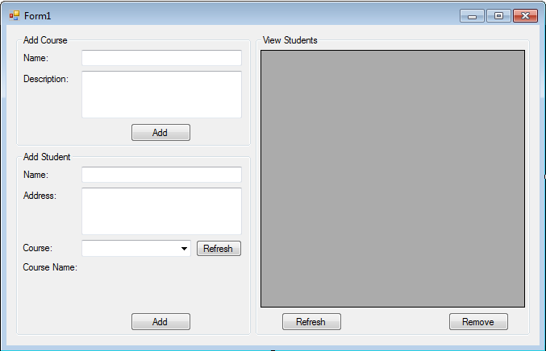

The DLL’s namespace must now be referenced. Right click the client project and select “Add Reference”.

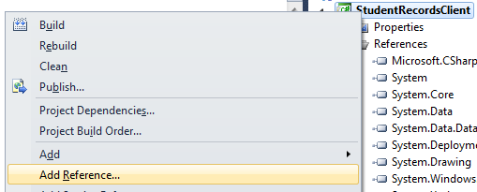

Select the “Projects” tab. StudentRecordsDLL should be selectable. Note that DLLs from outside the solution may be added through the “Browse” tab.
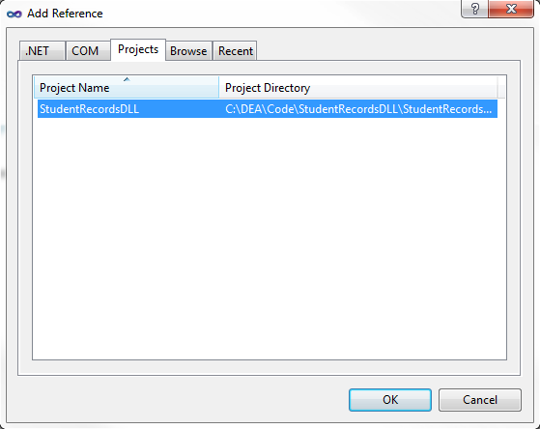

The namespace may now be referenced, a class created and utilised:
using StudentRecordsDLL;

public partial class Form1 : Form
{

StudentRecords records;

public Form1()
{
InitializeComponent();
records = new StudentRecords();
}
}

Implement the Add Course function and test this by adding a few course records through the client.
Creating a student requires a course index, which is not necessarily an immediately informative piece of information. To make this easier for the user, implement the Add Student “Refresh” button, and a click event for the ComboBox:
private void buttonRefreshCourse_Click(object sender, EventArgs e)
{
DataTable dt = records.GetCourses();
comboBoxAddStudentCourse.Items.Clear(); //Clear the combo box

foreach (DataRow row in dt.Rows) //Loop through each row
{
string res = row.ItemArray[0].ToString(); //0 is the index of the CourseID field.
comboBoxAddStudentCourse.Items.Add(res);
}
}

You may wish to call this method on the form load to automatically populate the ComboBox.
private void comboBoxAddStudentCourse_SelectedIndexChanged(object sender, EventArgs e)
{
int cID = int.Parse(comboBoxAddStudentCourse.SelectedItem.ToString());
string cName = records.GetCourseName(cID);

AddStudentCourseName.Text = "Course Name: " + cName;
}

- Implement the Add Student function. Note that you will need to use the ComboBox SelectedItem method:
int CourseID = int.Parse(comboBoxAddStudentCourse.SelectedItem.ToString());

- Implement the View Students “Refresh” button.
- Implement the “Remove” button. This will need to obtain a StudentID from the DataGridView as follows:
int StudentID = int.Parse(dataGridViewStudents.SelectedRows[0].Cells[0].ToString());
//SelectedRows[0] will take the first selected row - with the Multiline property, only one may be selected regardless.
//Cells[0] will take the first column, which, due to the order of columns in the query is StudentID.

