BSC Applied Computing
Business and Web Management
Module Code: ACCA5019

Component 1 – Website Redesign for Online Business Presence
WellCare Connect Website Redesign

Student Name: Sana Quyyam
Student ID: 2312087
Module Lecturer: Dr Mobolanle Bello
Assessment Component: Component 1

Table of Contents
1.0 Introduction 3
3.0 Responsive Design Implementation 5
4.0 IMPLEMENTATION SECTION 6
Moodboard Screenshot 6
Wireframe Screenshots 7
Homepage Wireframe Screenshot 7
Appointments Wireframe Screenshot 7
Consultations Wireframe Screenshot 8
Specialists Wireframe Screenshot 8
Records Wireframe Screenshot 9
Web Design Screenshots 9
Homepage Web Design Screenshot 9
Page 2 Web Design Screenshot 10
Page 3 Web Design Screenshot 10
Page 4 Web Design Screenshot 11
Page 5 Web Design Screenshot 11
4.1 Moodboard and Wireframe Design 11
5.0 Conclusion 12
References 14

1.0 Introduction
WellCare Connect is a digital health platform which will enable patients to schedule appointments, communicate with physicians via virtual consultations, view medical records, and even order prescriptions from their phones. Such digital tools could provide improved accessibility to health services information and allow patient-oriented interactions. For instance, patients can have access to the patient portal services, including booking appointments, e-communication, and prescription ordering, but what makes all these features useful is whether or not patients will be able to use them effectively [1].
The existing WellCare Connect website faces certain usability issues including the complexity of navigation, outdated design, bad mobile usability, low accessibility, inconsistency in the brand, and confusion in the booking procedure. In other words, due to the mentioned vulnerabilities, patients might face difficulties in finding the necessary services and in accomplishing their tasks in time and in an effective way. This redesign project is based on the UI/UX design process of 'moodboard', 5 'wireframes' and 5 'web-design prototype pages'. Moodboard allows creating visual consistency around the theme of healthcare, while wireframe provide navigation, hierarchy of the content and page structure. All these elements are transformed into the web-design prototype, which provides a consistent interface. Redesign goals include improving usability and accessibility, increasing patient trust and responsiveness, and taking advantage of crucial activities including appointment scheduling and service registration.

2.0 Navigation
Navigation plays an important role in website design, as it enables users to navigate through the site without confusion to find information and access services. WellCare Connect's navigation is key as patients might need to schedule a visit, locate a specialist, connect with a virtual consultation or check medical history. The navigation system should be clear so that patients can do these things quickly and without assistance.
The WellCare Connect website will have five key pages: Home, Appointments, Consultations, Specialists and Records. These pages are those that patients will likely be using as their primary services. The navigation menu should be consistent throughout the website to help people navigate between services without having to learn a new layout. Website is easier to understand with clear headings, visible buttons and organised content. The structure and navigability of web-based EHRs are important for enhancing the usability of patient-accessible EHRs, as noted by the research of Hägglund and Scandurra [5].

2.1 Why Is Navigation a Problem?
When the information or services users are looking for is hard to find they have navigation issues. There are a number of usability issues with the current WellCare Connect site, such as complicated navigation, limited mobile usability and not-so-sound appointment-booking process. The impact of these issues can have a harmful effect on patients' experiences and dissuade them from utilising on-line healthcare services. A big issue is that the crucial services might not be conspicuously marked. For instance, a patient seeking appointment may not be able to find the right page or may need to click on multiple links till they hit a booking form. This adds to the time it takes to do a quick job and can lead to frustration. Then there's the area of navigation inconsistency. Patients might get mixed up in what part of the site they are in if menus or buttons vary from section to section, or if the layout of a page varies as well. This is particularly challenging for older adults, first-time users and people with limited digital skills. Another worry is mobile navigation. Many patients are getting information about their healthcare on a smartphone. The small buttons, congested menus, and content layout structure can make it more difficult to choose the services on smaller screens. Those with a visual impairment or other special needs may also have accessibility issues. These challenges are important because a lot of information that's personal and medical is present on healthcare websites. Users should be able to use essential services without any unnecessary complications. Yin et al. [10] make this connection between patient portal usability, comfort and trust, reinforcing the importance of navigating patient portals simply.
2.2 What Is the Proposed Solution?
The suggested plan is to implement a simple, consistent and easy to use navigation system across WellCare Connect (the system). The new website will have a simple horizontal navigation menu with five key sections: Home, Appointments, Consultations, Specialists and Records. There will be a description of each option that will be attached to it so patients will know exactly what it is and its uses. The buttons like Book Appointment and Start Consultation will be featured large on the homepage. These buttons will be available to give quick access to crucial services, thus reducing needless clicks. Users will also be able to easily find a healthcare information or find a specialist service using a visible search bar.
A similar header, navigation menu and footer will be used throughout five pages to increase consistency. There will be distinct steps to the appointment booking process and the patient will have the opportunity to choose services, specialist, date and time before confirming their booking. The mobile responsiveness will also be given priority. This will enable navigation to change to a small menu and buttons and service cards to be easily selected, on smaller screens. The text will be clear, there will be appropriate colour contrast and readable fonts to support accessibility. Last but not least, the navigation will be redesigned with clearly marked links to contact details, privacy policy and technical support. The enhancements are designed to minimise confusion as well as boost the confidence of patients and make health services more accessible. Overall, the proposed navigation structure will help to make WellCare Connect a more organised, accessible site for patients to navigate between important services on the site.

3.0 Responsive Design Implementation
The responsive web design technique enables one to have content, layout, images, interactive elements and other things which will adapt to the various screen sizes and orientation (Frain, 2025). Kumar [8] explains that a responsive website must offer similar experiences for all devices regardless of screen sizes and the use of a mobile-first approach can provide consistency in the application of usability techniques.
Implications of Responsive Design in E-Commerce Websites for Improving User Experience
Responsive web design improves user experience by ensuring that websites function effectively across smartphones, tablets and desktop computers. It automatically adjusts layouts, images, navigation menus and buttons according to screen size. This reduces unnecessary scrolling, zooming and navigation difficulties. Kumar (2023) highlights the importance of responsive interfaces in maintaining usability across different devices. For WellCare Connect, responsive design can help patients book appointments, search for specialists and access medical records conveniently. Clear navigation, readable text and accessible buttons can improve satisfaction and encourage continued website use.
Implications of Responsive Design in E-Commerce Websites for Increasing Sales
Responsive design can also improve sales by reducing barriers during online transactions. Mobile-friendly websites allow customers to explore products, access information and complete purchases more easily. Poor navigation and complicated checkout processes may discourage users from completing transactions. Research by Tandon et al. (2017) identifies website functionality and usability as important factors influencing online customer satisfaction. For WellCare Connect, the equivalent of increased sales is improved service conversion, including successful appointment bookings, patient registrations and virtual consultation requests. A responsive interface can reduce abandonment and encourage patients to complete these activities, supporting better engagement with digital healthcare services.

4.0 IMPLEMENTATION SECTION

Moodboard Screenshot
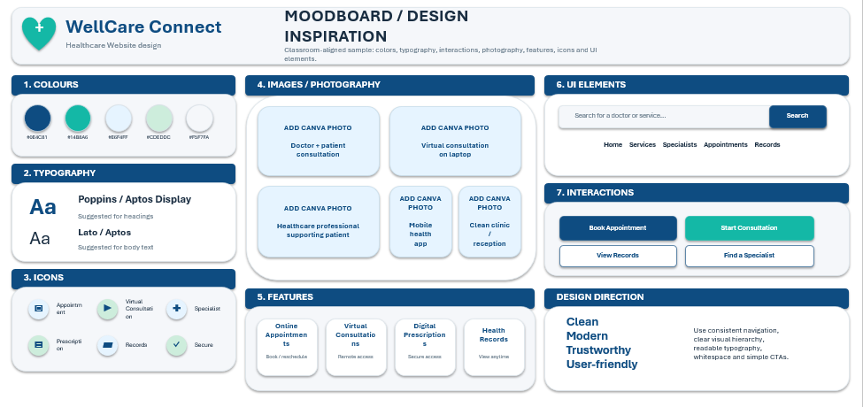

Wireframe Screenshots

Homepage Wireframe Screenshot
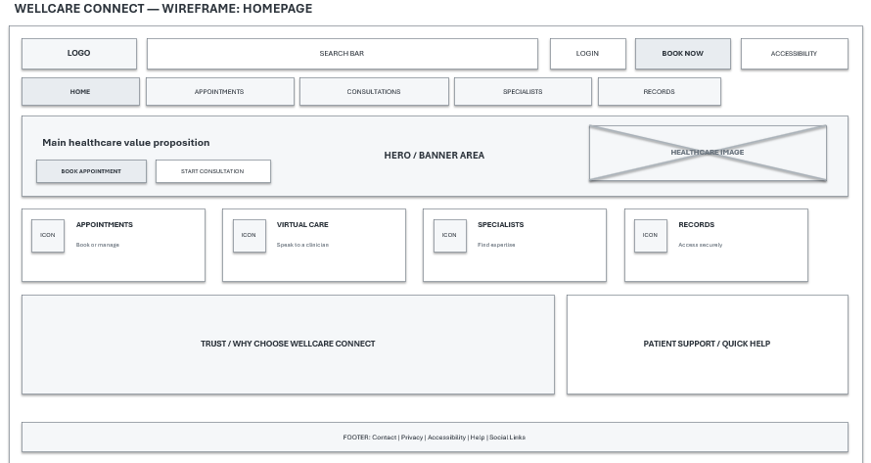

Appointments Wireframe Screenshot
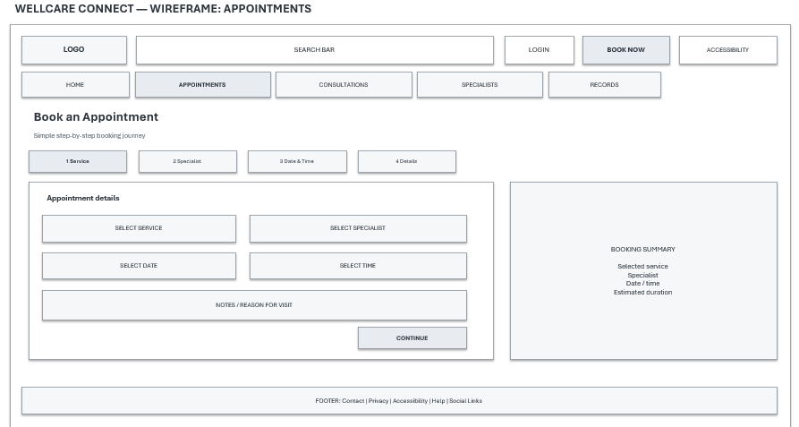

Consultations Wireframe Screenshot
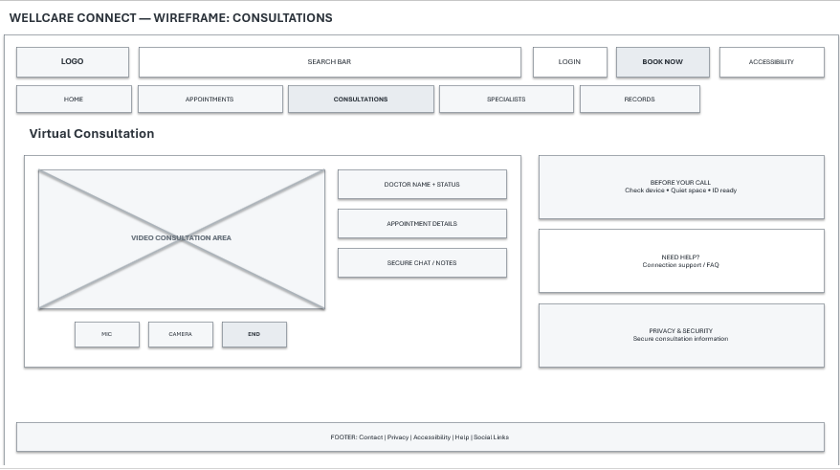

Specialists Wireframe Screenshot
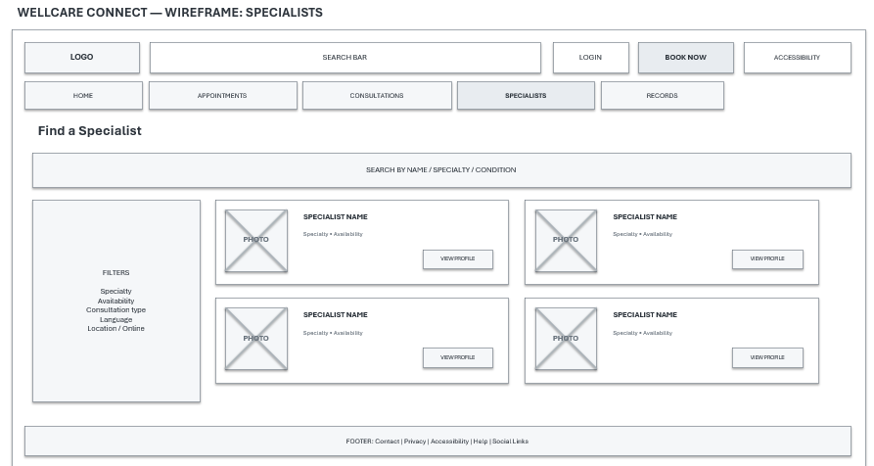

Records Wireframe Screenshot
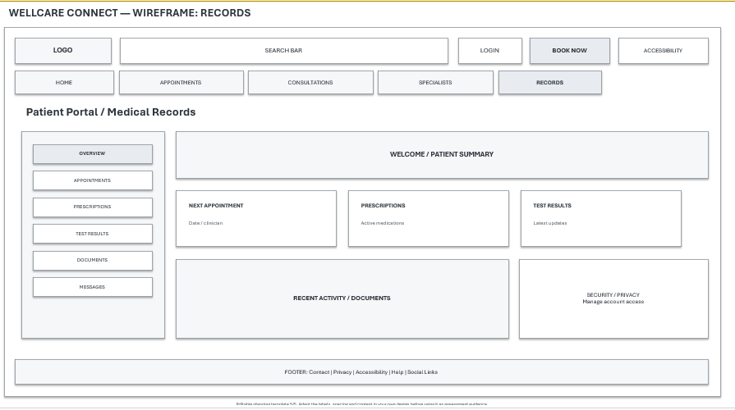

Web Design Screenshots

Homepage Web Design Screenshot
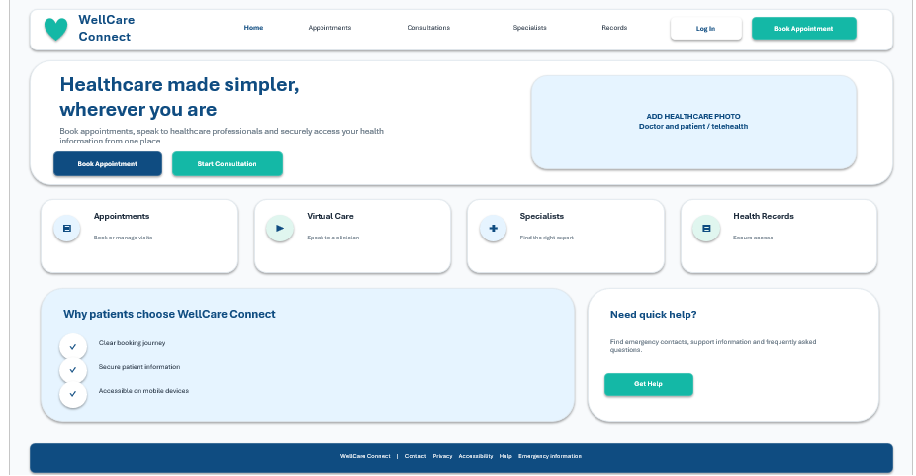

Page 2 Web Design Screenshot
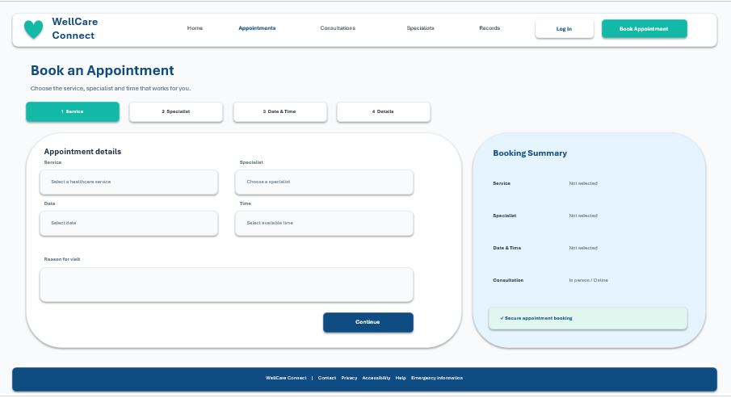

Page 3 Web Design Screenshot
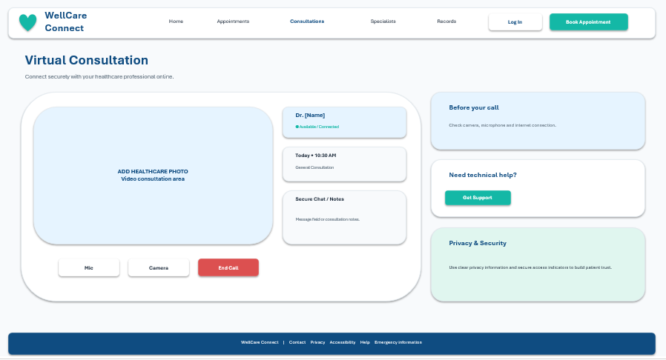

Page 4 Web Design Screenshot
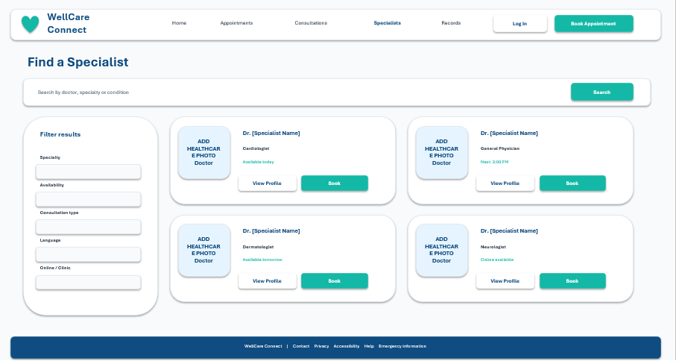

Page 5 Web Design Screenshot
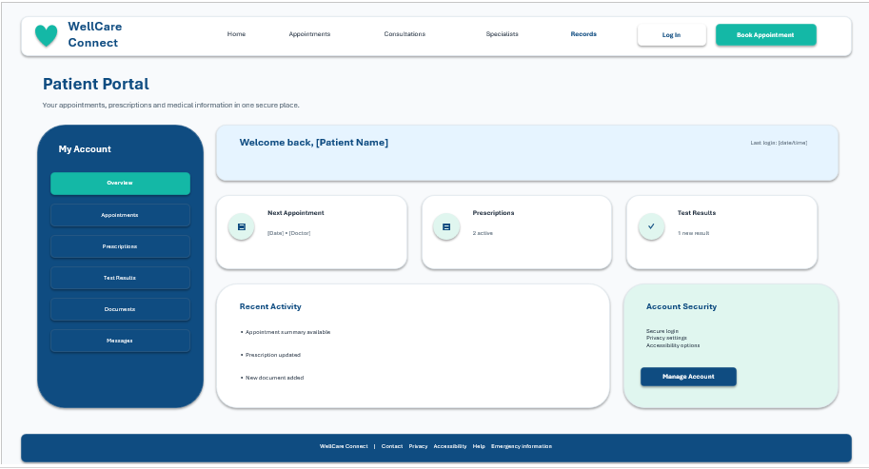

4.1 Moodboard and Wireframe Design
Moodboard
The moodboard was created to set a clear visual direction for the redesign of WellCare Connect's Website. It consolidates colors, typography, icons, images and UI elements into a single file that will be applied throughout the five website pages. The ultimate goal of the mood board is to design a professional, welcoming and consistent environment that will enhance the ease with which patients can access healthcare services. Selected colour scheme includes navy blue, teal, white and light neutral colors. The navy blue is a professional and trusty color, and the teal gives it a relaxing and inviting look. White backgrounds offer a clean layout and readability of information. These colors are used throughout navigation menus, buttons, headings and service cards.
In addition, the moodboard also features simple medical icons, rounded cards and images of health care and medicine to convey the purpose of the website. A choice of clear sans-serif fonts such as Poppins and Arial was chosen to ensure readability on various screen sizes. The important buttons (Book Appointment, Start Consultation) are highlighted visually to enable patients to identify the essential services. In general, the goal of the moodboard is to serve as a basis for the web site wireframes and eventual page designs. It provides visual consistency, accessibility and user confidence whilst maintaining a simple and modern healthcare identity.
Wireframe Design
The wireframes represent the overall structure, layout and navigation of the WellCare Connect website, prior to the production of the final visual designs. Five wireframes were created for the Homepage, Appointments, Consultations, Specialists and Patient Records pages. Every wireframe illustrates the placement of important content, buttons, menus and service features to facilitate easy navigation.
The home page wireframe has a clear navigation menu, service cards and appointment booking buttons. The Appointments page displays the appointment booking form, and the Consultations page features video consultation controls along with patient support information. Patients can use the Specialists page to search or filter for healthcare professionals who are appropriate for them. All appointments, prescriptions and medical information appear in an organised way on the Records page. The headers, navigation menus and footers are consistent throughout all five wireframes. In conclusion, these wireframes are a valuable resource for creating a user-friendly and accessible healthcare website that is responsive and user-friendly.

5.0 Conclusion
Overall, the WellCare Connect website redesign seeks to create a structure that is clear and responsive, enhancing the usability and accessibility of the site, as well as the overall patient experience. The project revealed several problems with the existing website, such as the navigation setup, the design, the lack of a mobile user-friendly version and the inability to access the most critical health services. These issues need to be resolved to improve the ease and reliability of the website for patients. The proposed redesign has five main pages: Home, Appointments, Consultations, Specialists and Patient Records. Every page designed to facilitate easy navigation, organisation and access to necessary services. The moodboard helped to develop a visual consistency in the website while the wireframes illustrated the layout and placement of key website elements.
Responsive design was taken into account as well, to make sure that patients can have access to healthcare services through various devices, especially smartphones and tablets. Accessibility and user satisfaction should be enhanced with clear buttons, readable text and consistent navigation. In conclusion, the proposed redesign offers a realistic and contemporary base for a healthcare website. Moving forward, testing of website functionality, collecting user feedback, and further development to continually improve the website to meet patients' needs should be continued.

References
A. Alturkistani, A. Qavi, P. E. Anyanwu, G. Greenfield, F. Greaves, and C. Costelloe, “Patient portal functionalities and patient outcomes among patients with diabetes: Systematic review,” Journal of Medical Internet Research, vol. 22, no. 9, Art. no. e18976, 2020. [Online]. Available: https://www.jmir.org/2020/9/e18976/
B. A. Kumar, “Mobile-first usability guideline for responsive e-commerce websites,” International Journal of Web Portals (IJWP), vol. 14, no. 1, pp. 1–12, 2022. [Online]. Available: ResearchGate publication
D. J. Damen, G. G. Schoonman, B. Maat, M. Habibović, E. Krahmer, and S. Pauws, “Patients managing their medical data in personal electronic health records: Scoping review,” Journal of Medical Internet Research, vol. 24, no. 12, Art. no. e37783, 2022. [Online]. Available: https://www.jmir.org/2022/12/e37783/
E. Carini, L. Villani, A. M. Pezzullo, A. Gentili, A. Barbara, W. Ricciardi, and S. Boccia, “The impact of digital patient portals on health outcomes, system efficiency, and patient attitudes: Updated systematic literature review,” Journal of Medical Internet Research, vol. 23, no. 9, Art. no. e26189, 2021. [Online]. Available: https://www.jmir.org/2021/9/e26189/PDF
Frain, B., 2025. Responsive Web Design with HTML5 and CSS: Build future-proof responsive websites using the latest HTML5 and CSS techniques. Packt Publishing Ltd.
Kumar, B.A. (2023) ‘Mobile-first usability guideline for responsive e-commerce websites’, International Journal of Web Portals, 14(1). https://doi.org/10.4018/IJWP.310060
M. Hägglund and I. Scandurra, “Usability of the Swedish accessible electronic health record: Qualitative survey study,” JMIR Human Factors, vol. 9, no. 2, Art. no. e37192, 2022. [Online]. Available: https://humanfactors.jmir.org/2022/2/e37192
N. S. Gregory, A. P. Shukla, J. J. Noel, L. C. Alonso, J. Moxley, A. J. Crawford, P. Martin, S. Kumar, J. P. Leonard, and S. J. Czaja, “The feasibility, acceptability, and usability of telehealth visits,” Frontiers in Medicine, vol. 10, Art. no. 1198096, 2023. [Online]. Available: https://www.frontiersin.org/journals/medicine/articles/10.3389/fmed.2023.1198096/full
P. Hulter, W. Langendoen, B. Pluut, G. G. Schoonman, R. Luijten, F. van Wetten, K. Ahaus, and A. M. Weggelaar-Jansen, “Patients’ choices regarding online access to laboratory, radiology and pathology test results on a hospital patient portal,” PLoS ONE, vol. 18, no. 2, Art. no. e0280768, 2023. [Online]. Available: https://journals.plos.org/plosone/article?id=10.1371/journal.pone.0280768
R. Yin, K. Law, and D. Neyens, “Examining how internet users trust and access electronic health record patient portals: Survey study,” JMIR Human Factors, vol. 8, no. 3, Art. no. e28501, 2021. [Online]. Available: https://humanfactors.jmir.org/2021/3/e28501/
S. H. Henni, S. Maurud, K. S. Fuglerud, and A. Moen, “The experiences, needs and barriers of people with impairments related to usability and accessibility of digital health solutions, levels of involvement in the design process and strategies for participatory and universal design: A scoping review,” BMC Public Health, vol. 22, no. 1, Art. no. 35, 2022. [Online]. Available: https://link.springer.com/article/10.1186/s12889-021-12393-1
T. L. Reynolds, N. Ali, and K. Zheng, “What do patients and caregivers want? A systematic review of user suggestions to improve patient portals,” AMIA Annual Symposium Proceedings, vol. 2020, pp. 1070–1079, 2021. [Online]. Available: PubMed Central article
Tandon, U., Kiran, R. and Sah, A.N. (2017) ‘Customer satisfaction as mediator between website service quality and repurchase intention: An emerging economy case’, Service Science, 9(2), pp. 106–120. https://doi.org/10.1287/serv.2016.0159

