8/17/2026
Assessment 2

Module NaMe: Changemakers, Creativity and Value creation
Module Code: ACCA 5033
Student NAME: afroza siddique
Student ID: 1818786
Lecturer: Fahad ahmed

University of Wales Trinity Saint David
London campus
Table of Contents
Introduction: 2
Main Body 2
Task 1 2
Q1. Project Management & Planning: 2
Task 2 6
• T2-Enterprise: 6
Task 3 11
Project Reflection 11
Conclusion 13
Reference 14

Introduction:
Digital technologies have transformed how parents access information and support their children’s education, health, and overall wellbeing; however, many existing solutions remain fragmented, requiring parents to switch between multiple applications for school updates, health records, schedules, and communication. This lack of integration can reduce efficiency and make it more difficult for parents to identify issues affecting their child’s development at an early stage. In response to this challenge, this project proposes a Smart Parenting Support system that aims to provide a single platform for monitoring educational progress, managing daily routines, tracking wellbeing, and facilitating communication between parents and schools. While such a solution has the potential to improve parental engagement and support informed decision-making, its success depends on addressing critical issues such as data privacy, cybersecurity, accessibility, and the ethical use of personal information. This report critically examines the planning, design, and potential implementation of the proposed system, evaluating how it can create value for families while recognising the practical and ethical challenges associated with developing a technology that manages sensitive information about children.

Main Body

Task 1

Q1. Project Management & Planning:

Project scope

Project scope management helps ensure that a project remains focused on its purpose, deliverables, time and available resources. For Smart Parenting Support, the scope will focus on developing key features such as learning resources, homework support, progress tracking, notifications and AI-based assistance. Clear requirements and project boundaries will help prevent unnecessary features from increasing development time, cost and complexity. The project should remain flexible enough to make useful changes based on testing and feedback, while avoiding uncontrolled scope changes. This will help ensure that the final system remains achievable and meets its intended purpose. [1]

Proposal solution

A suitable solution for Smart Parenting Support is to use a clear governance approach that supports innovation while protecting users. Key concerns include privacy, bias, ethical decision-making and the responsible use of AI. Flexible guidelines, regular monitoring and cooperation between developers and other stakeholders could help ensure that the system remains safe and trustworthy. This approach would allow Smart Parenting Support to develop while adapting to new AI risks, regulations and best practices. [2]

Technologies/resources

Smart Parenting Support would require mobile application technology, databases, AI tools, cloud services and secure information resources to provide personalised support. These technologies would help manage learning resources, progress tracking and user information. However, privacy, reliable data processing and secure integration of different technologies must also be considered when developing the system. [3]

Project timeline

A structured timeline will help keep Smart Parenting Support organised by dividing the project into clear stages and setting realistic deadlines. The project will include requirements gathering, research, system design, development, testing, evaluation and final documentation. The timeline should remain flexible so tasks can be adjusted if unexpected problems occur, while regular progress reviews can help identify delays early. This approach will help ensure the project remains manageable and progresses towards its planned outcomes. [4]

Project timeline plan

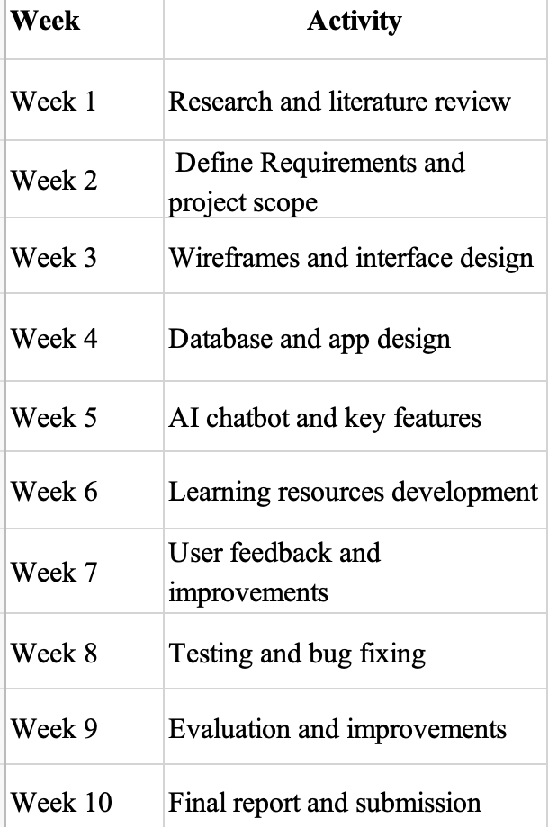
Schedule & Constraints

The Smart Parenting Support project will need a realistic schedule that considers available time, resources, deadlines and task dependencies. The main constraints may include limited development time, technical resources, budget, cybersecurity requirements and the complexity of integrating AI features. Planning these factors together will help organise development and ensure that tasks are completed in the correct order. The schedule should also remain flexible because unexpected technical issues or changes in requirements may affect progress. [5]

Gantt chart

A Gantt chart will help organise Smart Parenting Support by showing the start and finish dates of each project activity. The project can be divided into requirements gathering, research, design, development, testing, evaluation and final documentation, with some tasks overlapping where appropriate. This will make the project schedule easier to understand and help monitor progress. The Gantt chart will mainly be used as a planning and monitoring tool to keep the project on track. [6]

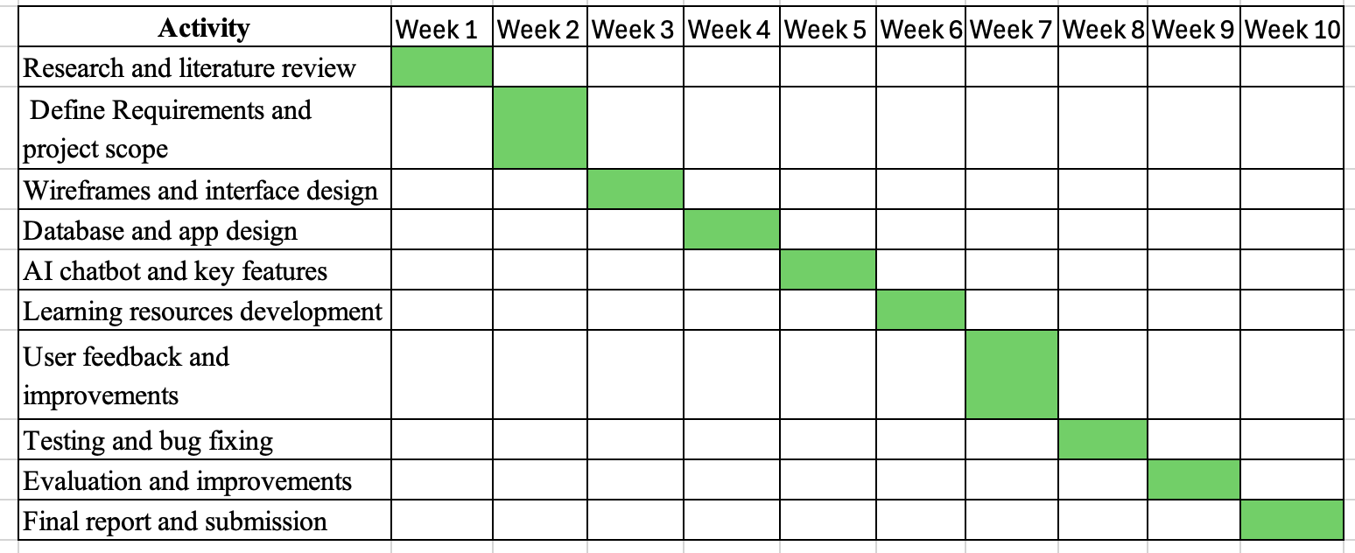

Figure 1: Gantt Chart

Development method

Agile development would be suitable for Smart Parenting Support because it uses a flexible and iterative approach, allowing the system to be developed and improved in smaller stages. The project could begin with the main requirements and user interface, followed by features such as child profiles, learning resources, progress tracking and AI support. Each stage can be tested and reviewed before further development, helping identify problems early. However, changes must be controlled to prevent scope creep and delays. Agile will therefore be managed alongside the project scope, timeline and Gantt chart. [7]

Wireframes
The wireframes for Smart Parenting Support show the planned layout of the login page, dashboard, AI chatbot, learning resources and progress tracker. They help plan navigation and how information will be presented before development begins. The wireframes can also identify design and usability issues early, allowing improvements before implementation. However, they only show the proposed interface and would need to be tested and refined with user feedback. [8]

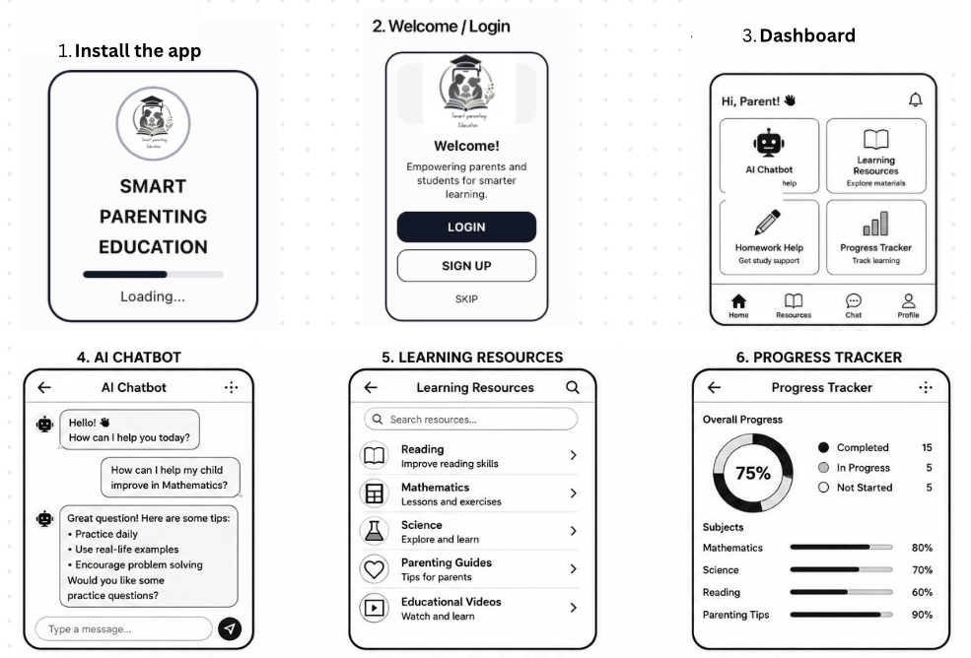

Figure 2: Wireframes [13]

Storyboard

The storyboard for Smart Parenting Support shows the planned journey of a parent through the application, including the welcome screen, dashboard, AI chatbot, learning resources, homework support, progress tracker and notifications. It helps show how these features connect and whether the navigation is clear and logical. The storyboard can also identify unnecessary steps before development begins. However, it represents the planned user experience, so user testing and feedback would be needed to improve the design and ensure it meets parents’ needs. [9]

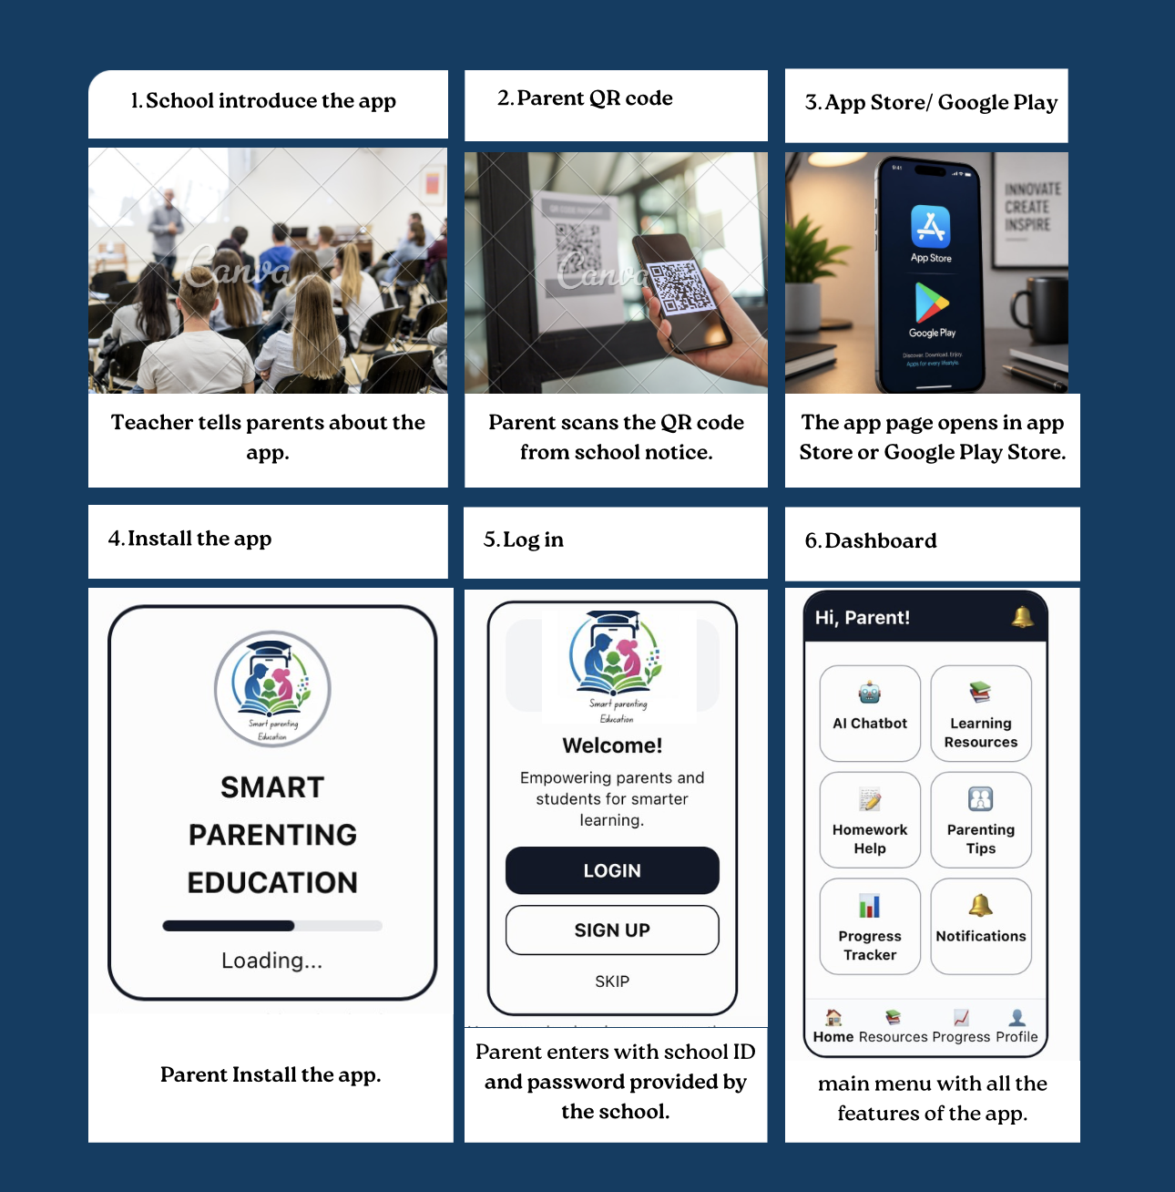

figure 3: Storyboard [13]

Task 2

• T2-Enterprise:

PEST Analysis

Political Factors
- UK government policies and regulations relating to artificial intelligence, children's online safety and data protection could affect how Smart Parenting Support is designed and operated.
- Government initiatives supporting digital education and technology innovation could create opportunities for the project to develop further.
- Changes in regulations concerning children's use of online services could require the application to update its privacy, security and safeguarding measures.
- Public-sector organisations such as schools may have strict requirements before allowing external technology platforms to interact with their users.

Economic Factors
- Development costs could include software, cloud hosting, AI services, cybersecurity, testing and maintenance.
- As Smart Parenting Support is intended to be free for parents, the project would need alternative sources of financial support.
- Grants, university funding, educational partnerships and investment could help finance development.
- Limited funding could restrict the number of features that can be developed within the initial version.
- Rising costs of cloud computing and AI services could increase the long-term cost of operating the platform.

Social Factors
- Parents may benefit from having educational resources, homework support and progress information available through one platform.
- Increasing use of digital technology in education creates an opportunity for Smart Parenting Support to support parental involvement.
- Some parents may have concerns about AI accuracy, privacy and the use of children's personal information.
- Different levels of digital literacy mean that the application should have simple navigation and clear instructions.
- Accessibility should be considered so that the service can support parents and children with different needs.
- Parents may be more likely to use the application if it is trustworthy, easy to understand and free of charge.

Technological Factors
- Developments in artificial intelligence, mobile applications, cloud computing and databases could improve the functionality of Smart Parenting Support.
- AI could provide parents with immediate assistance with general educational questions.
- Cloud technologies could support secure storage and access to information across different devices.
- Cybersecurity threats could create risks to personal and family information stored within the system.
- Dependence on third-party AI and cloud services could create technical and availability risks.
- Regular software updates, security testing and maintenance would be required as technologies and potential threats develop.

SWOT Analysis

Strengths
- Free digital service that does not require parents to pay a subscription.
- Combines several useful functions, including learning resources, homework support, progress tracking, notifications and AI assistance.
- Provides parents with a central platform rather than requiring them to use several separate applications.
- Focuses on privacy, cybersecurity and responsible use of AI.
- Could encourage greater parental involvement in children's education.
- The system could be developed using an Agile approach, allowing improvements to be made through user feedback and testing.

Weaknesses
- The project may have limited development time and financial resources because it is initially an academic project.
- Developing several functions within one application could increase technical complexity.
- AI-generated information may not always be accurate or suitable for every child.
- The project may initially have limited opportunities for large-scale user testing.
- Dependence on external AI, cloud and software services could affect reliability.
- Maintaining security and protecting children's information could require significant technical resources.

Opportunities
- Partnerships with schools, universities, charities and educational organisations could support testing and development.
- Grants and university innovation funding could help finance future development.
- Increasing use of digital learning could create demand for tools that support parents.
- Future versions could introduce additional educational resources and accessibility features.
- The project could potentially be expanded to support a wider range of families and educational needs.
- Collaboration with teachers and education professionals could improve the quality and relevance of the application's content.

Threats
- Cybersecurity attacks or data breaches could damage user trust and expose sensitive information.
- Changes in UK data protection, children's online safety or AI regulations could require modifications to the system.
- Established educational and parenting applications could provide competition.
- Parents may be reluctant to use the application because of concerns about privacy or AI-generated information.
- Incorrect or biased AI responses could negatively affect user confidence in the service.
- Technical failures involving cloud hosting, databases or third-party AI services could interrupt access to the application.
- Digital exclusion could prevent some families from benefiting from the service because of limited access to suitable devices or reliable internet.

Using both approaches provides a broader view of the factors that could affect Smart Parenting Support and can help identify areas that should be considered when planning the project. [10]

Legal & Ethical Considerations

Legal considerations
Smart Parenting Support must consider the legal risks of using AI and processing information about parents and children. Privacy, data protection and fairness should be considered throughout development. The system should collect only necessary information, protect data from unauthorised access and regularly review AI-generated recommendations for possible bias. Human oversight should also be maintained where AI could affect a child's education or wellbeing. [11]

Ethical considerations
An important ethical consideration for Smart Parenting Support is the level of independence given to AI. AI-generated responses may not always be accurate or suitable for every child, so the system should support parents rather than make important decisions about education or wellbeing. Human involvement should remain important when reviewing AI recommendations, and users should be informed when content is AI-generated. This would help reduce the risks of relying too heavily on automated decisions. [12]

Start-up name: Smart Parenting Education
The name reflects the purpose of the project by combining parenting support with educational technology. The proposed application would provide parents with access to learning resources, homework support, progress tracking, notifications and AI based educational assistance through one platform. The aim would be to make educational support easier to access while helping parents become more involved in their child’s learning.

Logo
The proposed logo would use a simple and recognisable design representing parents, children and education. Colours such as blue and green could be used to communicate trust, learning and development. A consistent logo could be used across the mobile application, website and promotional materials to create a recognisable identity for the start up.

Figure 4: logo [13]

Business type: Private Limited Company
The proposed business type for Smart Parenting Support is a Private Limited Company. This would provide a formal business structure while allowing the company to develop and manage the application. A private limited company is legally separate from its owners, and shareholders generally have limited liability, reducing their personal financial risk. This structure could also support future growth by attracting investment and establishing partnerships with schools, universities, charities and educational organisations. Funding could be used for software development, AI services, cloud hosting, cybersecurity, testing and maintenance. Smart Parenting Support would remain a free digital service for parents, rather than using subscription fees. Although this business type involves additional legal and administrative responsibilities, it would be suitable if the project developed into a technology start-up.

Business strategy
Smart Parenting Support is intended to be a free digital service for parents, providing learning resources, homework support, progress tracking, notifications and AI-based assistance in one platform. The strategy focuses on privacy, security, accessibility and responsible AI to build trust among users. Instead of charging parents, the project could be supported through educational partnerships, university funding, grants and charitable organisations.

Funding
Several funding options could support the development of Smart Parenting Support. Initially, personal savings and university funding could be used to develop and test the application. Further funding could come from grants, crowdfunding, angel investment and partnerships with schools, universities or charities. These funds could support software development, AI services, cloud hosting, cybersecurity and maintenance. As Smart Parenting Support is intended to be free for parents, sustainable external funding would be needed rather than paid subscriptions.

Task 3

Project Reflection

Developing New Skills
The Smart Parenting Support project would provide an opportunity to develop technical, professional and personal skills while applying knowledge from my programme of study. One of my main goals would be to improve my software development skills, including designing an application, working with databases and integrating AI functionality. I would also develop User Interface and User Experience (UI/UX) design skills by creating wireframes and storyboards that make the application simple and accessible for parents.
The project would also improve my project management and problem-solving skills. Creating a project scope, schedule and Gantt chart would help me understand how a larger project can be divided into manageable stages. Using an Agile approach would allow me to work through smaller development cycles, test features and make improvements based on feedback. I would also gain a stronger understanding of cybersecurity, data protection and responsible AI, which are particularly important because the application may process information relating to children and families.

Positive Impact on Society
Smart Parenting Support could contribute positively to society by providing parents with a free digital service that brings together educational and parenting support in one platform. The application could include learning resources, homework assistance, progress tracking, notifications and AI-based educational support. Having these features together could make it easier for parents to become involved in their children’s education and monitor learning activities.
The progress tracker could help parents identify areas where their child may need additional educational support, while the AI chatbot could provide general assistance with learning-related questions. The application could also promote digital accessibility by using simple navigation, clear information and an easy-to-use interface. Providing the service without a subscription could make the core features accessible to a wider range of families.
However, the system should support rather than replace parents, teachers or other professionals. AI should be treated as an additional source of information rather than a replacement for human judgement, particularly where decisions could affect a child's education, development or wellbeing.

Risks and Challenges
One of the main challenges would be data privacy and cybersecurity because the system could process personal information about children and families. Unauthorised access or data breaches could reduce user trust and cause serious problems. This risk could be reduced through secure authentication, access controls, encryption, data minimisation, regular security testing and appropriate backups.
Another risk would be inaccurate or inappropriate AI-generated information. The AI chatbot may provide incomplete or unsuitable responses, so the system should be tested regularly and its limitations clearly explained to users. Parents should also be encouraged to seek appropriate professional advice where necessary.
Scope creep could create another challenge because many additional features could be suggested during development. To control this, the main requirements should be identified at the beginning and the most important features prioritised. The Gantt chart could then be used to monitor progress and identify delays.
User acceptance may also be difficult if parents are concerned about privacy, security or the reliability of AI. Clear privacy information, transparent explanations and user testing could help address these concerns. Technical problems involving databases, cloud services or third-party AI tools could also affect development, so regular testing, backups and maintenance would be required.
Overall, developing Smart Parenting Support would allow me to strengthen my technical, design, project management and communication skills while working on a project with potential educational and social benefits. It would also help me understand that successful technology development requires more than functional software; user needs, accessibility, privacy, security, ethics and responsible use of technology must be considered throughout the project.

Conclusion
The Smart Parenting Support project demonstrates how an integrated digital platform could address current challenges faced by parents in managing children's education, wellbeing, and everyday activities. Throughout the report, project planning, system design, enterprise considerations, and personal reflection have highlighted both the opportunities and the complexities involved in developing such a solution. Although the proposed system has the potential to improve parental engagement and support more informed decision-making, its success will depend on delivering a secure, accessible, and user-centred application that complies with legal and ethical requirements. Future development should focus on incorporating continuous user feedback, strengthening data protection measures, and refining features to meet the evolving needs of families. By balancing technological innovation with responsible design, the project has the potential to create meaningful value for parents, children, and the wider community.

Reference

[1] Q. H. S. Al-Rubaiei, F. A. A. Nifa and S. Musa, "Project scope management through multiple perspectives: A critical review of concepts", in AIP Conference Proceedings, pp. 020025.

[2] O. J. Erdélyi and J. Goldsmith, "Regulating artificial intelligence: Proposal for a global solution", in Proceedings of the 2018 AAAI/ACM Conference on AI, Ethics, and Society, pp. 95–101.

[3] A. Rivero-Rodriguez, P. Pileggi and O. A. Nykänen, "Mobile context-aware systems: technologies, resources and applications," vol. 10, no. 2, pp.25–32, 2016,

[4] K. Hande and J. Phillippi, "Project timeline template: A guide for successful completion," Nurse Educ., vol. 43, no. 3, pp.115, 2018,

[5] R. Barták, M. A. Salido and F. Rossi, "Constraint satisfaction techniques in planning and scheduling," J.Intell.Manuf., vol. 21, no. 1, pp.5–15, 2010,

[6] K. K. Ramachandran and K. K. Karthick, "Gantt chart: An important tool of management," vol. 8, no. 7, pp.140–142, 2019,

[7] P. Abrahamsson, O. Salo, J. Ronkainen and J. Warsta, "Agile software development methods: Review and analysis," 2017,

[8] J. S. Milutinovic, P. O. Milic and S. S. Vucetic, "Wireframe Modelling of Web Based Open Data Applications," 2024,

[9] R. Walker et al., , "Storyboarding for visual analytics," vol. 14, no. 1, pp.27–50, 2015,

[10] C. Torres-Ceclén, W. F. Rubio-Cabrera, J. E. Plasencia-Latour, A. D. Epifanía-Huerta and V. Á Ancajima-Miñán, "Neutrosophic PEST-SWOT Analysis on the Impact of ICT on the Academic Training of Systems Engineering Students," vol. 69, no. 1, pp.23, 2024,

[11] J. A. Gerlick and S. M. Liozu, "Ethical and legal considerations of artificial intelligence and algorithmic decision-making in personalized pricing: JA Gerlick, SM Liozu," vol. 19, no. 2, pp.85–98, 2020,

[12] G. Yang et al., , "Medical robotics—Regulatory, ethical, and legal considerations for increasing levels of autonomy," vol. 2, no. 4, pp.eaam8638, 2017,

[13] Canva, “Canva,” Canva. [Online]. Available: https://www.canva.com. [Accessed: Aug. 15, 2026].

