Motion Simulation & FEA

Christos David Zois
P146231
University of Wales Trinity Saint David
School of Engineering
Advanced Computational Methods
M6X00408
25/01/19

Abstract
In this assignment, an assembly of a rear shock tower of a 1/10 scale Remote Control Desert Truck was modelled in Solidworks. It was then simulated to drive over a bump at speed. The data regarding the forces acting on the shock tower was collected from the motion simulation and imported into FEA, where the shock tower was then developed through an iterative process of designing, testing and analysing.

Table of Contents
Motion Simulation & FEA 1
Abstract 2
1 Introduction 5
1.1 Aims 5
1.2 Objectives 5
2 Background Research 6
2.1 Motion Simulation 6
2.2 Finite Element Analysis (FEA) 6
2.3 Von Mises Stress Criterion 6
3 Methodology 7
3.1 Reference Geometry 7
3.2 Assembly Creation & Motion Simulation 8
3.2.1 Measuring 8
3.2.2 Modelling 9
3.2.3 Assembling 9
3.2.4 Simulating 10
3.3 Motion Loads & Initial FEA 11
3.3.1 Loads 11
3.3.2 Static Study (FEA) 13
3.4 Part Development using FEA 14
3.4.1 Results & Analysis 15
4 Conclusion 20
5 Recommend Further Work 20
6 References 21
7 OneDrive Link 21

Figure 1. Reference Geometry (Traxxas Slash 4X4 Ultimate) 7
Figure 2. Rear shock tower 7
Figure 3. Measuring parts to be modelled 8
Figure 4. Street wheel and tire 8
Figure 5. Solidworks model of rear shock tower part (blue) and gear case (grey) 9
Figure 6. Rear right corner of the truck assembly and bump 9
Figure 7. Spring parameters of assembly 10
Figure 8. Solid body contact of assembly 10
Figure 9. Linear motor direction in assembly 11
Figure 10. Loads acting on shock tower during the motion simulation 12
Figure 11. Design History Graph: Von Mises Stress 12
Figure 12. Static study fixtures (green) and forces (pink) 13
Figure 13. Static study mesh 13
Figure 14. Static study von Mises stress 14
Figure 15. Design 1 von Mises stress & displacement contours 15
Figure 16. Design 2 von Mises stress & displacement contours 15
Figure 17. Design 3 von Mises stress & displacement contours 16
Figure 18. Design 4 von Mises stress & displacement contours 16
Figure 19. Design 5 von Mises stress & displacement contours 17
Figure 20. Design 6 von Mises stress & displacement contours 17
Figure 21. Design 7 von Mises stress & displacement contours 18
Figure 22. Diagonal plate addition to model (red) 18
Figure 23. Design 8 von Mises stress & displacement contours 19
Figure 24. Initial & final design visual comparison 19
Figure 25. Design 9 von Mises stress & displacement contours 20

Introduction
The times we live in come with a rapid increase in computational power available to the public. This allows for new ways and methods to be developed using computers to do the calculations in seconds, that would take a human years to complete. Wanting to increase the efficiency of the design process and product development, engineers came up with a method called Motion Simulation.

Aims
The aims of this project are:
- To develop a new rear shock tower design for a 1/10 Scale Remote Controlled (RC) Desert Truck, using 7075-T6 aluminium as the material of choice (commonly used in the RC sector for upgraded parts).
- The design is to be developed using Computer Aided Design (CAD), Motion Simulation and Finite Element Analysis (FEA).

Objectives
The objectives of this assignment are:
- To create an assembly including all parts interacting with the rear shock tower (entire rear right corner of the truck).
- To generate a simulation of the truck rolling over a bump at a certain speed, to gather the peak forces, their location and their moments about each axis.
- To transfer forces into FEA analysis of the rear shock tower.
- Develop the rear shock tower design to be lighter than the first iteration and to minimize deflection and stress concentrations, to prevent the part from bending/cracking under tension.

Background Research

Motion Simulation
Rigid Body Dynamics, or as most people know it, Motion Simulation, is a simulation method used to understand the dynamics and kinematics of new designs/products before the creation of the actual physical prototypes. Not only can you animate how a product works, but thanks to the increasing processing power available to engineers, you can gather useful data regarding the loads being applied during the simulation process. (Solidworks, 2008)
Using this data in conjunction with Finite Element Analysis (FEA), allows for the product to be designed and developed at a significantly increased rate compare to the past, when you would have to physically build and test each iteration of the design.

Finite Element Analysis (FEA)
FEA is a digital method for anticipating how a product/design will perform when vibration, heat, real-world forces, fluid flow and more are applied to it. FEA will predict if a product will fail or work how it’s supposed to.
FEA separates a model into to a number of finite elements (little cubes), from thousands to millions depending on the mesh density. Using a computer, mathematical equations are added to the analysis to help envision the reaction of each element, and finally the entire model.
FEA is used to predict Mechanical Stress, Fatigue, Heat Transfer, Fluid Flow and more. (Autodesk, 2019)

Von Mises Stress Criterion
When using ductile materials, such as 7075-T6 aluminium in this project, one of the main criterions to predict if the design will yield or fracture under load is the von Mises criterion.
It states that: If the von Mises stress of a material, when a force is applied to it, is exceeding that of the yield limit of the same material under simple tension, then it will yield. (Simscale, 2019)
This criterion will be used in the FEA analysis part of this project to help detect the stress concentrations in the designs.

Methodology

Reference Geometry
The part to be developed is the rear shock tower of a 1/10 scale RC desert truck. Specifically, the truck used for this project was the Traxxas Slash 4X4 Ultimate. The rear right corner of the truck was modelled, assembled and simulated using Solidworks CAD.
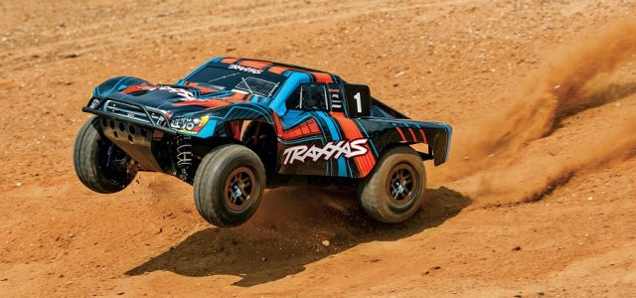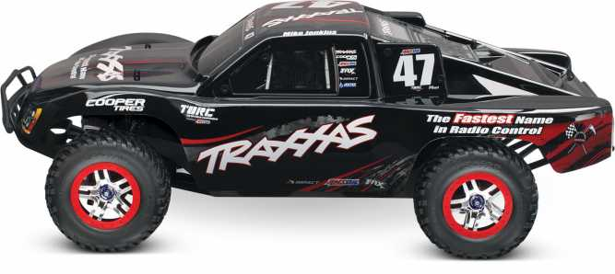
Figure 1. Reference Geometry (Traxxas Slash 4X4 Ultimate)
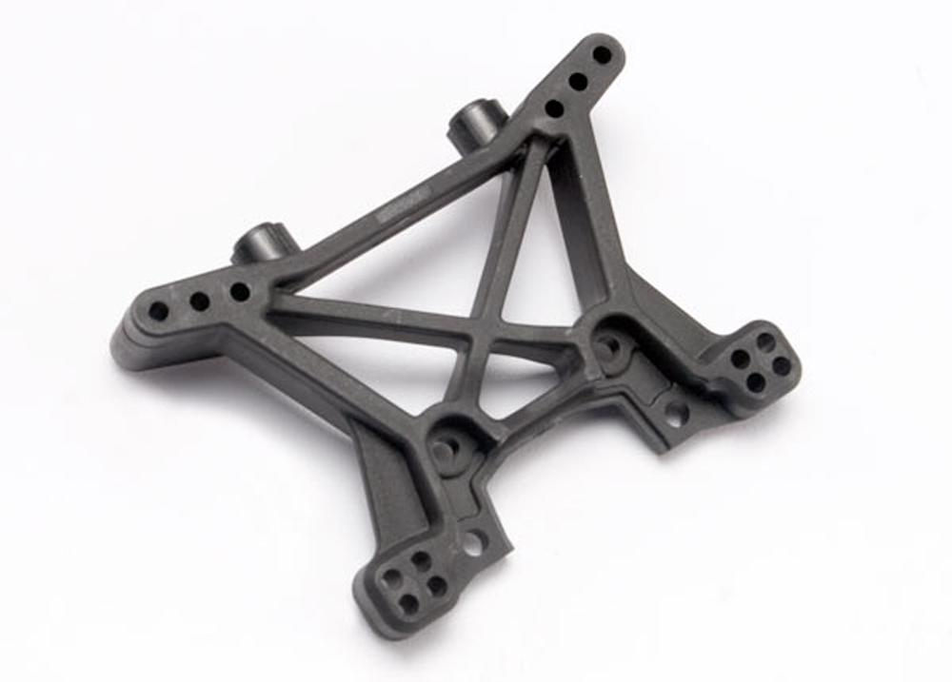
Figure 2. Rear shock tower

Assembly Creation & Motion Simulation

Measuring
The rear right corner of the truck was disassembled. Each part needed to be modelled was measured using a Vernier calliper.
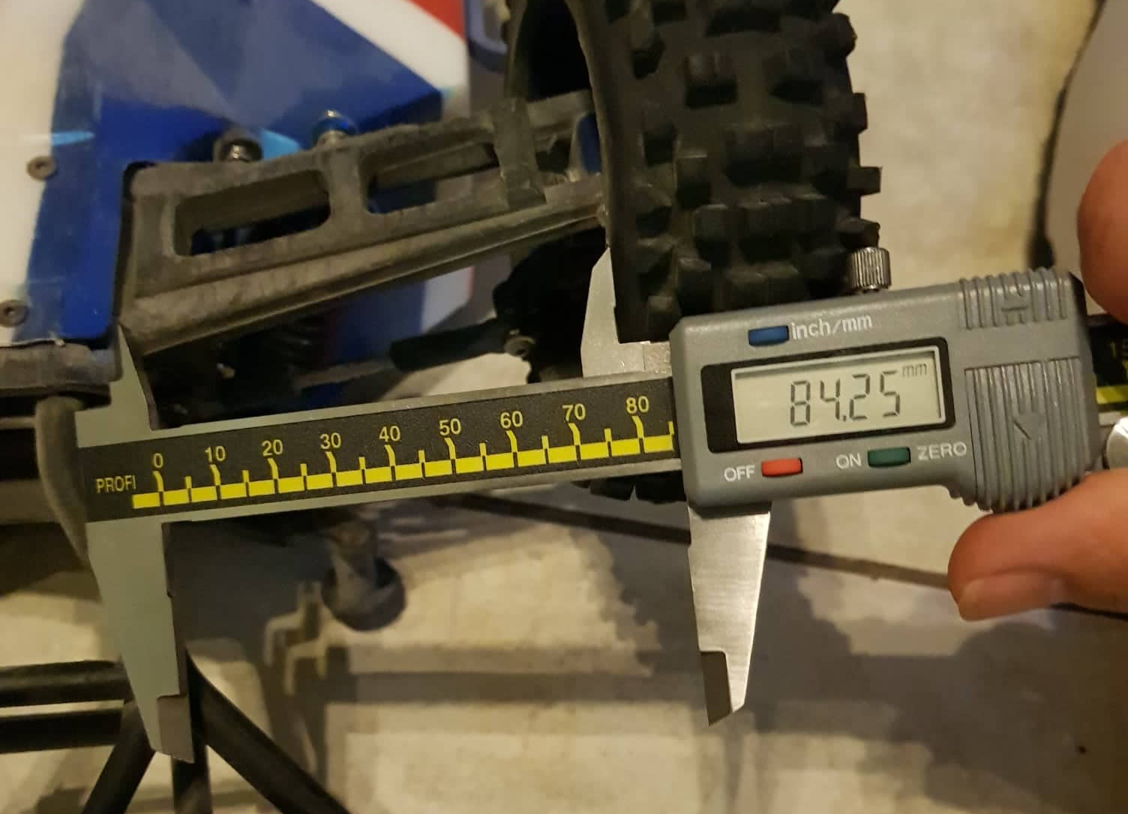
Figure 3. Measuring parts to be modelled
The wheels measured wore street tires, since the simulation generated for this assignment involved the truck rolling over a bump on a flat road, and to keep the model simple, since off-road tires would require longer to model and would be harder to simulate realistically.
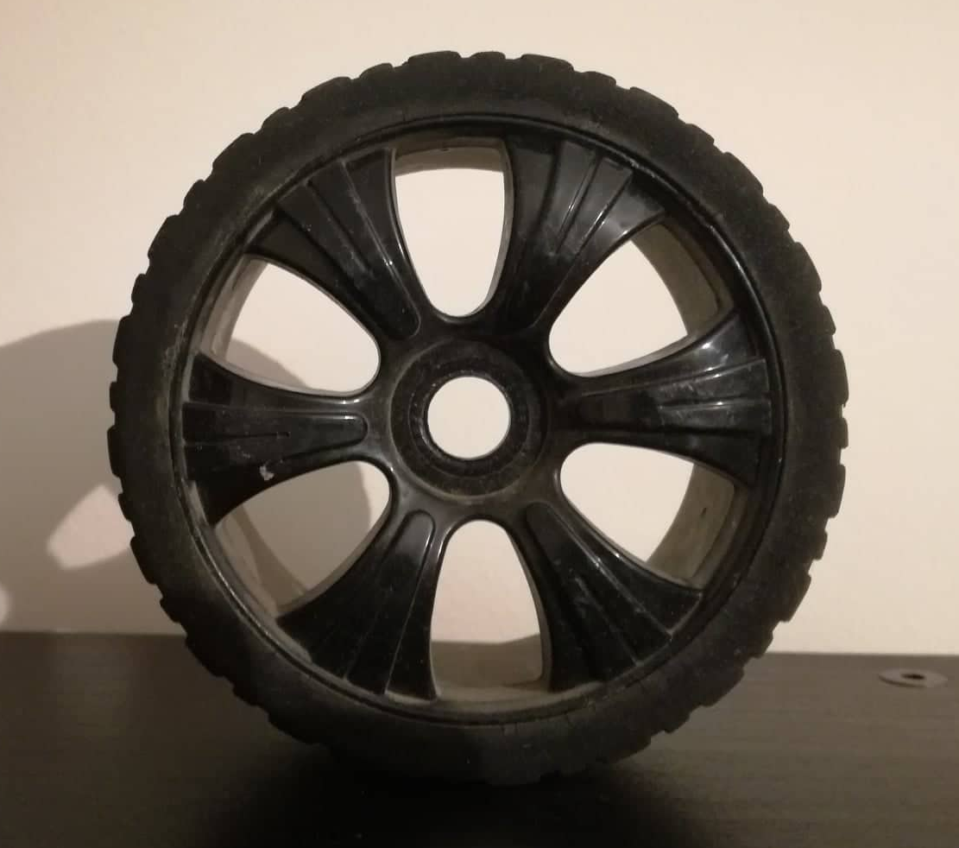
Figure 4. Street wheel and tire

Modelling
Each part of the rear right corner of the truck required for the assembly was modelled in Solidworks CAD. The parts were all simplified versions of the original parts but keeping all the proportions and dimensions identical to the original to not compromise the Motion Simulation.
In Figure 5 below, the blue surfaces marked in blue colour dictate the part (shock tower) that is going to be tested and developed. The shock tower was modelled onto the gear case, to keep the geometry and the assembly as simple as possible. Furthermore, when the truck is assembled, the shock tower is integrated into the gear case.
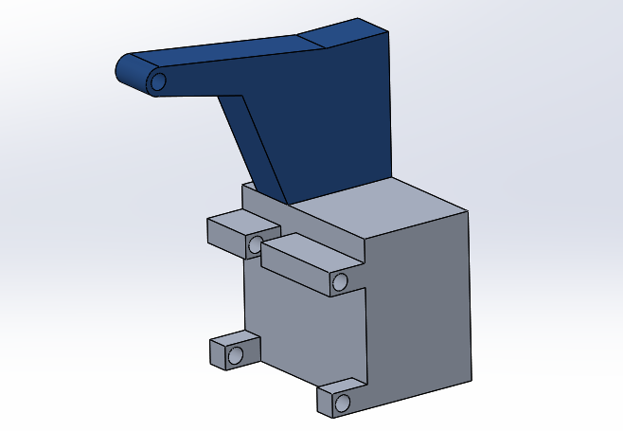
Figure 5. Solidworks model of rear shock tower part (blue) and gear case (grey)

Assembling
When all the individual parts required were modelled, an assembly of them was created using mates in Solidworks. Mechanical mates (hinge) were added where possible to keep the redundancies low.
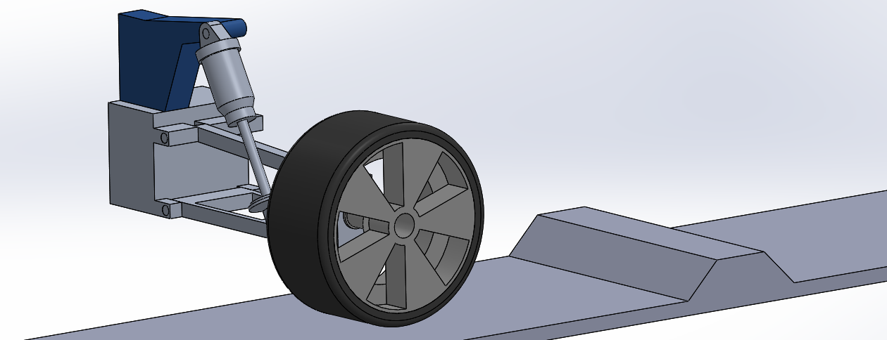
Figure 6. Rear right corner of the truck assembly and bump

Simulating
Once the mates were added, a spring was added to the shock assembly. The spring constant (k) was set to 2 N/mm and the damping constant (c) to 0.7 N/(mm/s). In Figure 7 below, the spring parameters (contact points) can be seen.
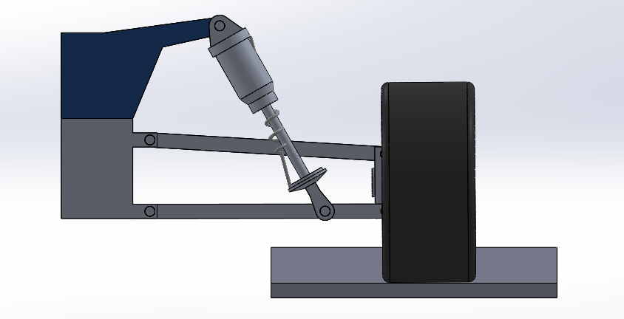
Figure 7. Spring parameters of assembly

A solid body contact was added between the tire and the road, as seen in Figure 8 below.
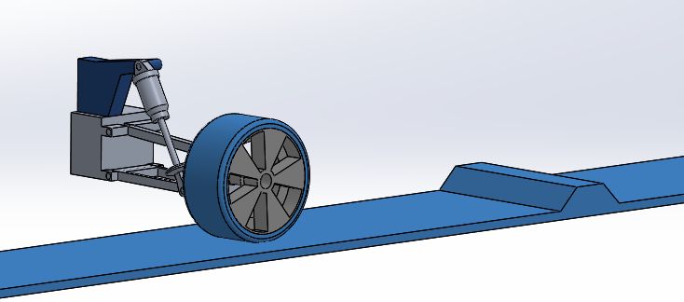
Figure 8. Solid body contact of assembly

For the simulation, the assembly remained fixed, while the road was set to move beneath it at 1500mm/s or 5.4km/h. To accomplish this a linear motor of constant speed was added to the road, the direction of which (Z axis) can be seen in Figure 9 below.
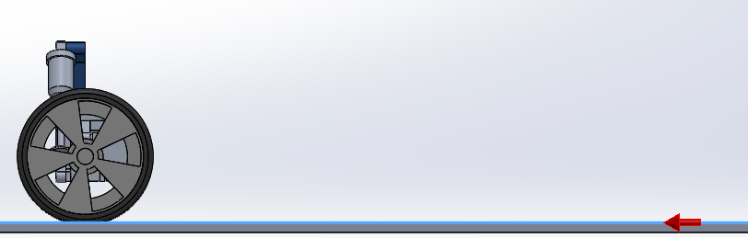
Figure 9. Linear motor direction in assembly
Note: The simulation seems to have some limitations, as initially the road speed was set at 30 km/h (average speed of truck around a track) and it would fail to import motion loads, not allowing for the correct magnitude of the loads to be predicted.
To try and predict the forces acting on the shock tower as accurately as possible, the corresponding material properties were added to the parts:
Shock Tower: 7075-T6 Aluminium
A Arm: 7075-T6 Aluminium
Hub: 7075-T6 Aluminium
Turn Buckle: 7075-T6 Aluminium
Shock Body: 7075-T6 Aluminium
Shock Base: 7075-T6 Aluminium
Pin: 7075-T6 Aluminium
Rim: PBT General Purpose
Tire: POLYURETHANE (11671)
7075-T6 Aluminium is commonly used among Remote Control Vehicles.
Finally, gravity was added to the simulation.

Motion Loads & Initial FEA

Loads
Once the motion simulation was set up and calculated (run), the motion loads for the shock tower were generated. This predicts the force magnitude and direction acting on the shock tower during the motion simulation. This data is then transferred into the static study (FEA) for further analysis.
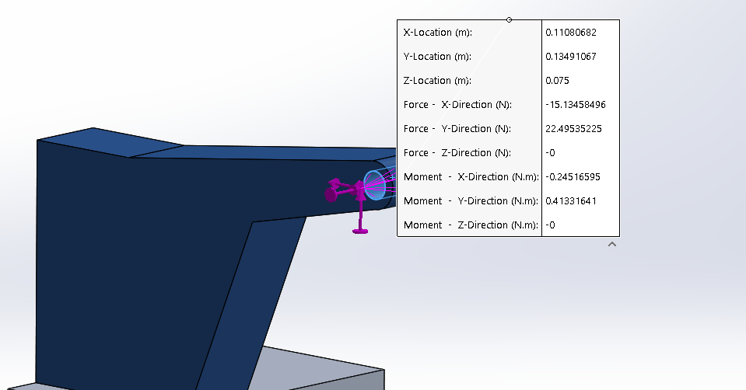
Figure 10. Loads acting on shock tower during the motion simulation

Observing Figure 10 above, the following data can be gathered:
Forces are acting in the -X and +Y directions. Both forces are acting on the outer ring of the hole on the shock tower. The magnitude of -X is 15.1 N and of +Y is 22.5 N.
This data is input into to a static study analysis.
Following that, a Design History Graph was defined. The graph below clearly shows the point at which (scenario 7) the wheel came in contact with the bump, hence the spike in the results at that point.
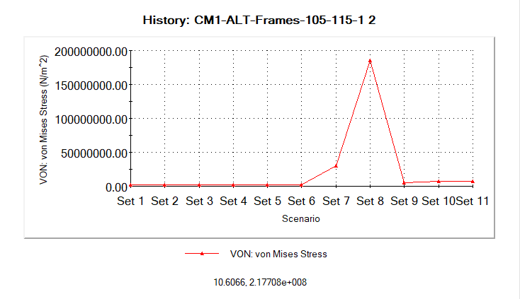
Figure 11. Design History Graph: Von Mises Stress

Static Study (FEA)
A static study was created. The body was fixed as shown below (green arrows= fixed surface) to analyse only the shock tower part, and not the gear case. The pink arrows indicate the direction of the forces added, the magnitude of which is found in the previous paragraph.
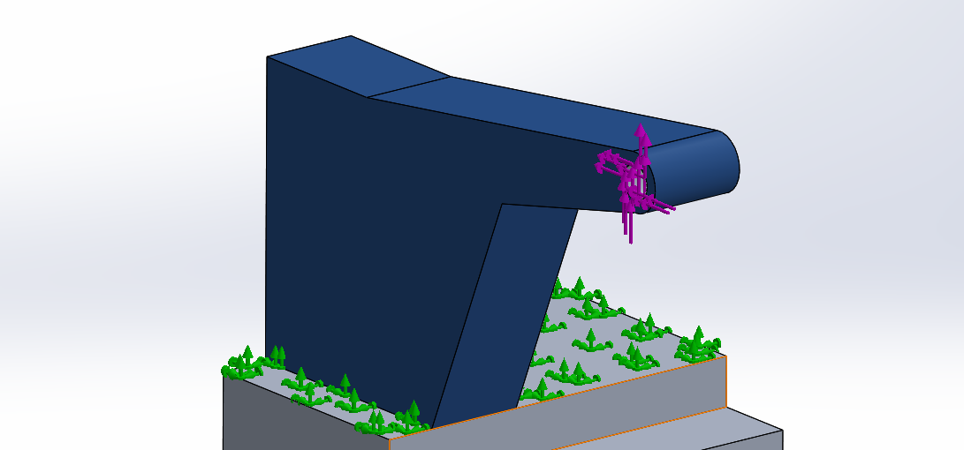
Figure 12. Static study fixtures (green) and forces (pink)

The geometry was then meshed, using a fine mesh in Solidworks CAD. The mesh can be seen below.

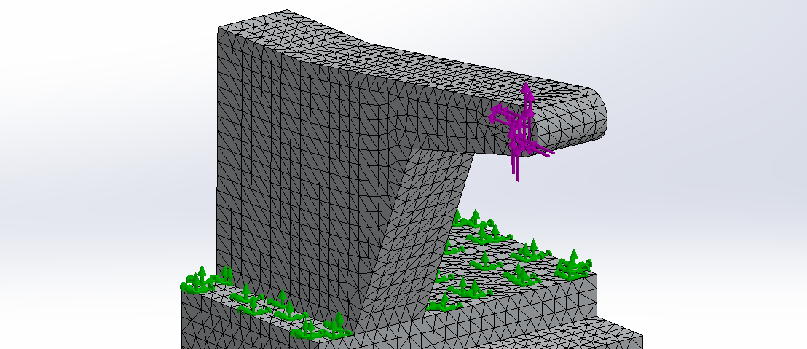
Figure 13. Static study mesh
Once the mesh was created the study was run and the results were analysed. As mentioned previously, the main criterion for development in this project is the von Mises stress. As seen below, the part currently is well within its elastic range.
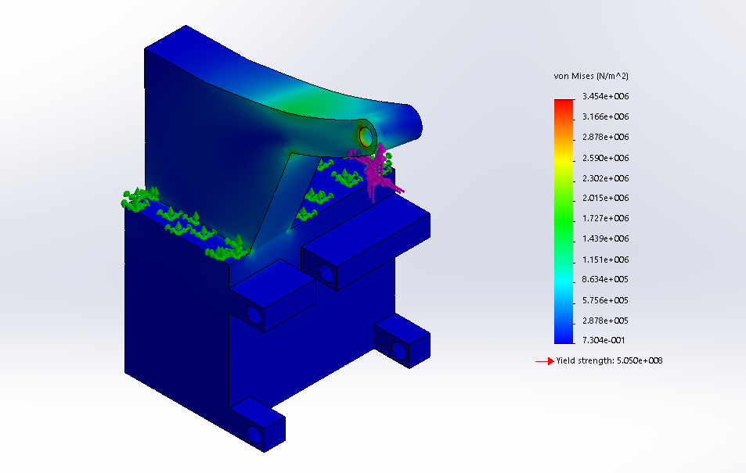
Figure 14. Static study von Mises stress
The aforementioned process will be used iteratively throughout the development stage of the part at hand.

Part Development using FEA
The rear shock tower of the truck will be developed and tested in this section using FEA (static studies). Its criteria for success are:
- Lighter than initial model
- Minimize deflection in shock tower
- Minimize stress concentrations to avoid cracking under higher loads
To accomplish the above an iterative process of designing the model, testing it and analysing the results was performed.

Results & Analysis

Design 1
Design 1 is the initial design used in the paragraphs above.
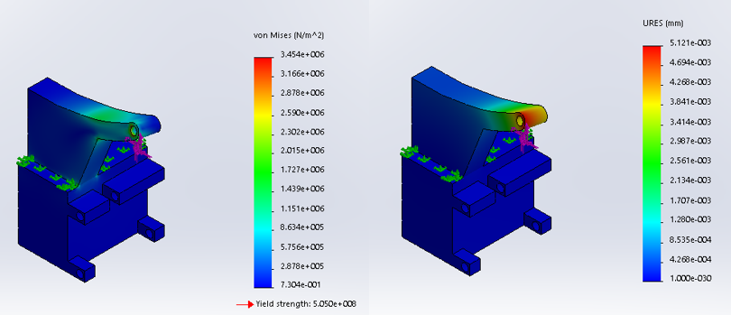
Figure 15. Design 1 von Mises stress & displacement contours
In the figure above, on the left the von Mises stress criterion contour is displayed and on the right the displacement caused by the forces acting on the model during the study (this figure setup will be kept throughout the design development process).
The contours both demonstrate what is expected, the highest stress and largest displacement are on the arm of the shock tower.

Design 2
In the 2nd iteration of this design it was decided to remove a significant portion of the main body of the shock tower to see the results.
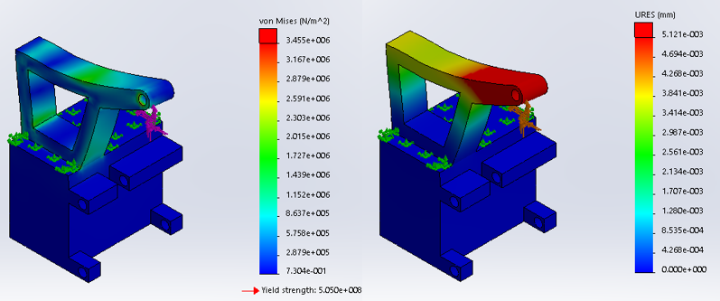
Figure 16. Design 2 von Mises stress & displacement contours
In the figure above, the maximum and minimum values of the legend were maintained identical to the original design.
By removing that centre section, new areas of higher stress were introduced to the part and the displacement was significantly larger overall.

Design 3
In design 3, a beam was added, connecting the inner lower corner to the top outer corner of the shock tower.
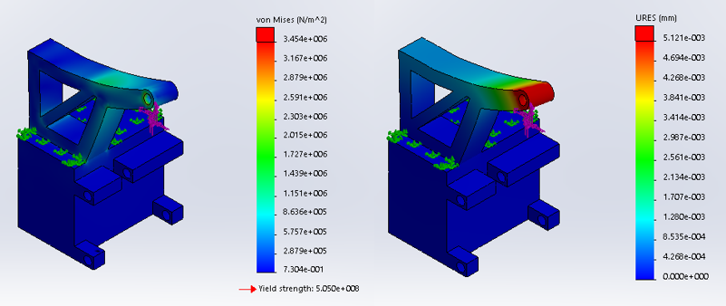
Figure 17. Design 3 von Mises stress & displacement contours
By adding the diagonal beam to the model, the stress on the inner side of the shock tower reduced, as well as the displacement on the inner upper part of it.

Design 4
For design 4, a diagonal beam was added but at a 90-degree angle compare to that of design 3.
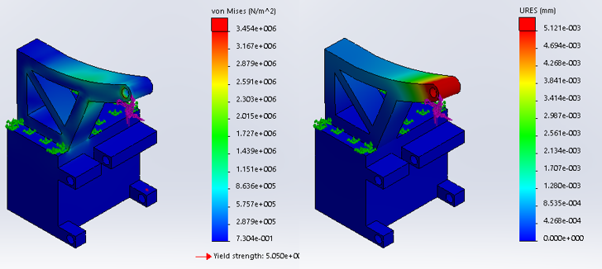
Figure 18. Design 4 von Mises stress & displacement contours
This angle of the beam seems to have spread the stress on the upper part of the shock tower compare to design 3, even though the displacement seems to be unaffected.

Design 5
For design 5, it was decided to half the width of the shock tower to reduce its overall mass. The beam from design 3 was kept to try and reduce the increased displacement that will occur due to removing half of the shock towers width.
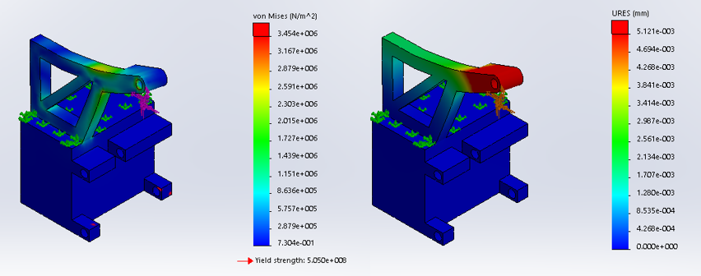
Figure 19. Design 5 von Mises stress & displacement contours
Observing the figure above, it is clear that the stress where the arm of the shocks tower meets its body has increased, and the displacement on the upper beam is significant.

Design 6
For design 6, an additional beam perpendicular to the already existing one was added, creating an X in the centre section of the shock tower.
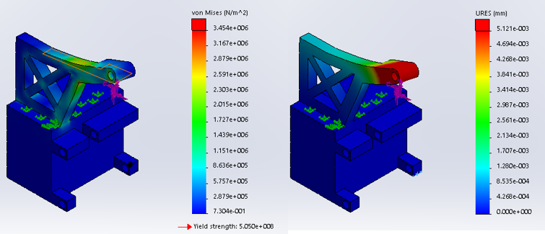
Figure 20. Design 6 von Mises stress & displacement contours

Studying Figure 20, there seems to be a stress concentration forming on the underside of the shock tower arm. The displacement of the upper part of the shock tower was reduced.

Design 7
To try and avoid that stress concentration forming under the shock tower arm, as seen in the previous design analysis, the beam under the arm was moved further out to reduce the leverage of the arm. The packaging of the model allowed for this change in geometry without interference of other moving parts.
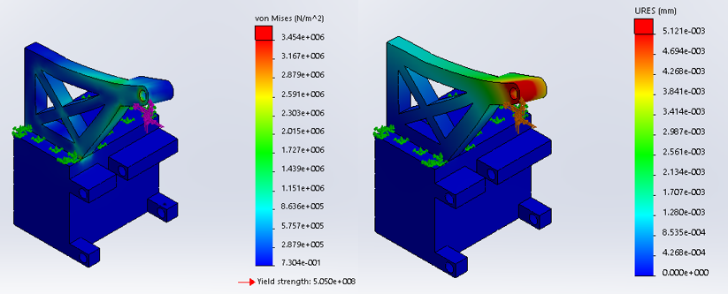
Figure 21. Design 7 von Mises stress & displacement contours
Moving the beam to decrease the leverage of the arm, eliminated the stress concentration that was forming and decrease the stress in the shock tower overall. The displacement didn’t seem to be affected.

Design 8
For design 8, it was decided to ad diagonal plate perpendicular to the shock tower and the gear case, with the goal of reducing the displacement on the upper part of the shock tower.
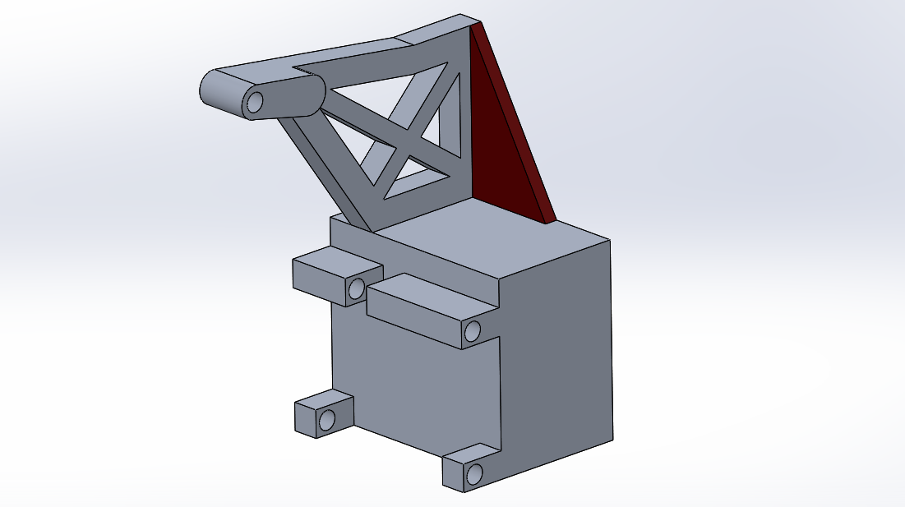
Figure 22. Diagonal plate addition to model (red)
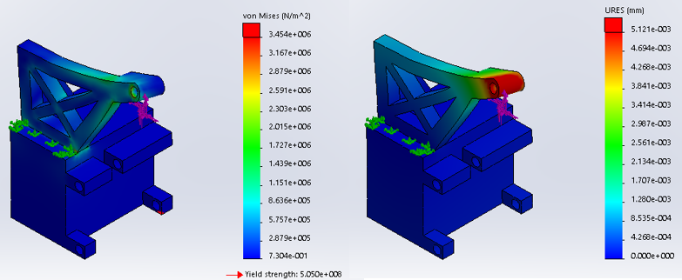
Figure 23. Design 8 von Mises stress & displacement contours
Adding the perpendicular plate did not affect the stress dispersion in the model. It did however reduce the displacement of the upper beam of the shock tower.

Design 9
For the final design, design 9, all the edges were filleted, including the inner X section of the tower. This of course would mean a significant increase in production cost due to the extra work and equipment needed to add such fillets. Additionally, another two holes were added to allow for extra suspension setups, as it would be on a production part.
Below is a visual comparison of the initial and final designs.
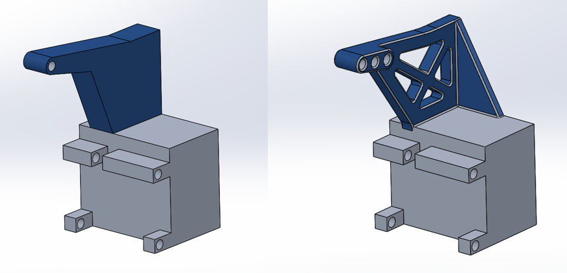
Figure 24. Initial & final design visual comparison

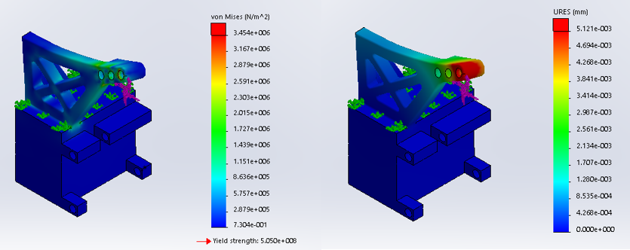
Figure 25. Design 9 von Mises stress & displacement contours
Adding the fillets seemed to diffuse the stress concentrations in the model overall, allowing for a lower overall von Mises stress. Finally, it did not affect its stiffness, hence the displacement remained the same.

Conclusion
To conclude, Motion Simulation in conjunction with FEA are a very powerful engineering tool. It allows for products to be tested, analysed and developed before even producing a physical prototype. This helps reduce the duration of the design process significantly.
A rear shock tower for an RC desert truck was developed. The final design was just as strong and rigid as the initial one and weighing in at less that half its weight, which was the aim of this project.

Recommend Further Work
Due to the limitations of Solidworks, using a perhaps a different Motion simulation program would allow for a more precise prediction of loads acting on the part.
Further development could have been implemented, meaning more designs could have been tested and in greater detail.
Using a program specifically designed for FEA would allow for a more detailed analysis and development of the final design.

References
Autodesk. (2019, January 25). Finite Element Analysis Software. Retrieved from Autodesk: https://www.autodesk.co.uk/solutions/finite-element-analysis
Merriam-Webster. (n.d.). merriam-webster. Retrieved from Dictionary: http://www.merriam-webster.com/dictionary/evolve
Simscale. (2019, January 25). von Mises Stress. Retrieved from Simscale: https://www.simscale.com/docs/content/simwiki/fea/what-is-von-mises-stress.html
Solidworks. (2008). Understanding Motion Simulation. Concord, USA: Dassault Systèmes SolidWorks Corp.

OneDrive Link
https://uowtsd-my.sharepoint.com/:f:/g/personal/czois_146231_student_uwtsd_ac_uk/EjEqJ3WzU6tApGZxTkIWskoBRqWtmrqX3u98_QWYx8KIyw?e=GvDSlG

