Table of contents
Part 1- Personal development plan- pages 2-4
Part 2- Briefing paper powerpoint- pages 4-5
Part 3- Written essay- pages 5-8
Reference list- pages 8-9

Personal Development Plan
The thinking, knowledge, skills and behaviours that I will change and develop in order to achieve my vision and goals, adhere to my values and become as resilient as possible
No | Improvement and Development Goals | Success Criteria  (How I will know when I have made this change) | The actions I will take to achieve the goal | Timelines | What will this help me to achieve? | Achievements  (3 monthly review)
1 | Adjust my lifestyle to make it healthier | I have a more balanced lifestyle, which includes habitual physical, mental, social and relationship activity, regular rest and a balanced diet. | Eat more healthy foods instead of eating junk food in a rush, allow myself time for physical activities, allow myself time to relax, balance my work, studies and family time to ensure all needs are met. | Although this is something which can be started right away it will take time to see the results of these actions. Hopefully improvements will be seen by the time the 3 month review is due. | Maintaining a healthier lifestyle will improve my mental and physical health which may in turn have a positive effect on my personal life and work/studies.
2 | To complete this degree to a decent standard | I will know that I have achieved this when I come to the end of this degree and am told that I have gained the desired marks to achieve a pass. | I am trying my best to complete all work that I receive by the due date and to the best of my abilities. Spending time gaining knowledge of the subject and utilizing the knowledge in work to improve my performance. | I am keeping to the deadlines for work and so should be able to achieve this in line with the course duration which ends in July 2028. | Completing this degree will help me gain a better understanding of the sector which I work in which will help me to improve my practice and provide a better learning environment.
3 | Work on building my own confidence in every aspect. | I will know that I have made this change when I feel more confident in all aspects of my life both personal and work related. | To help me achieve this goal I am making a conscious effort to speak more to both parents and other staff members with regards to the children I work with and also my own role within the class. Discussing my daily routines and goals with my class lead to ensure I am fully aware of the expectations and whether I am delivering that standard and if not what I can improve on. | I have already implemented this since starting my most recent position in September and feel that this is something which can always be improved upon so there wouldn’t necessarily be a deadline for it as such. | I feel that building my own confidence will help me improve with not only my currently position in work but also all future endeavors both professionally and personally as by having the confidence to speak more openly and directly with my colleagues gives me the opportunity to ask questions and gain knowledge from others which I may not know myself or may not have considered without querying with others.

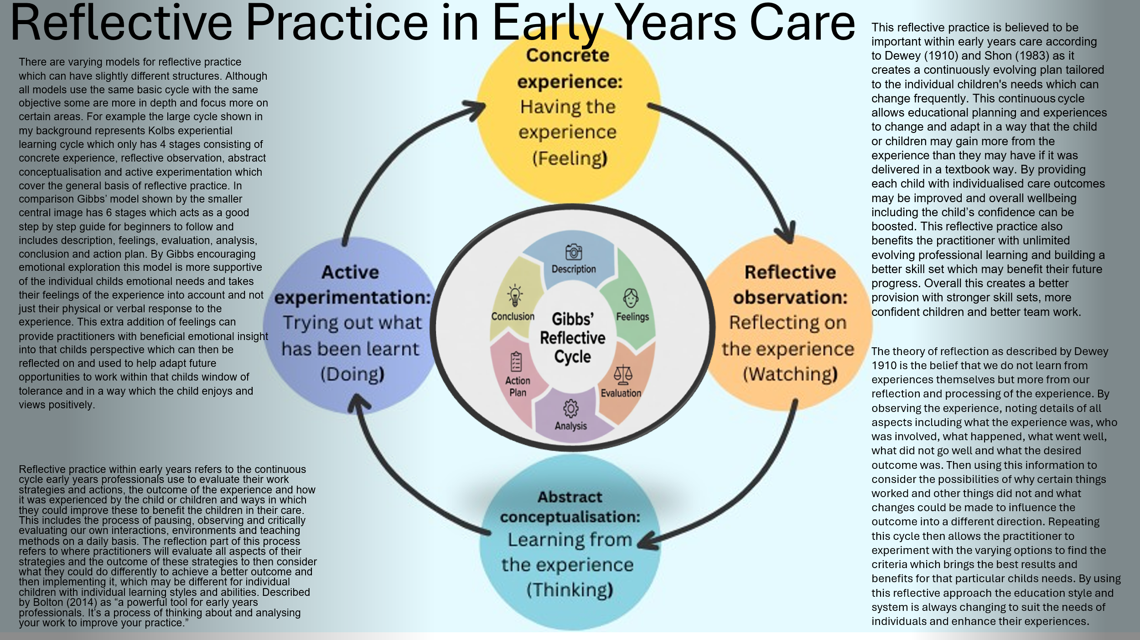
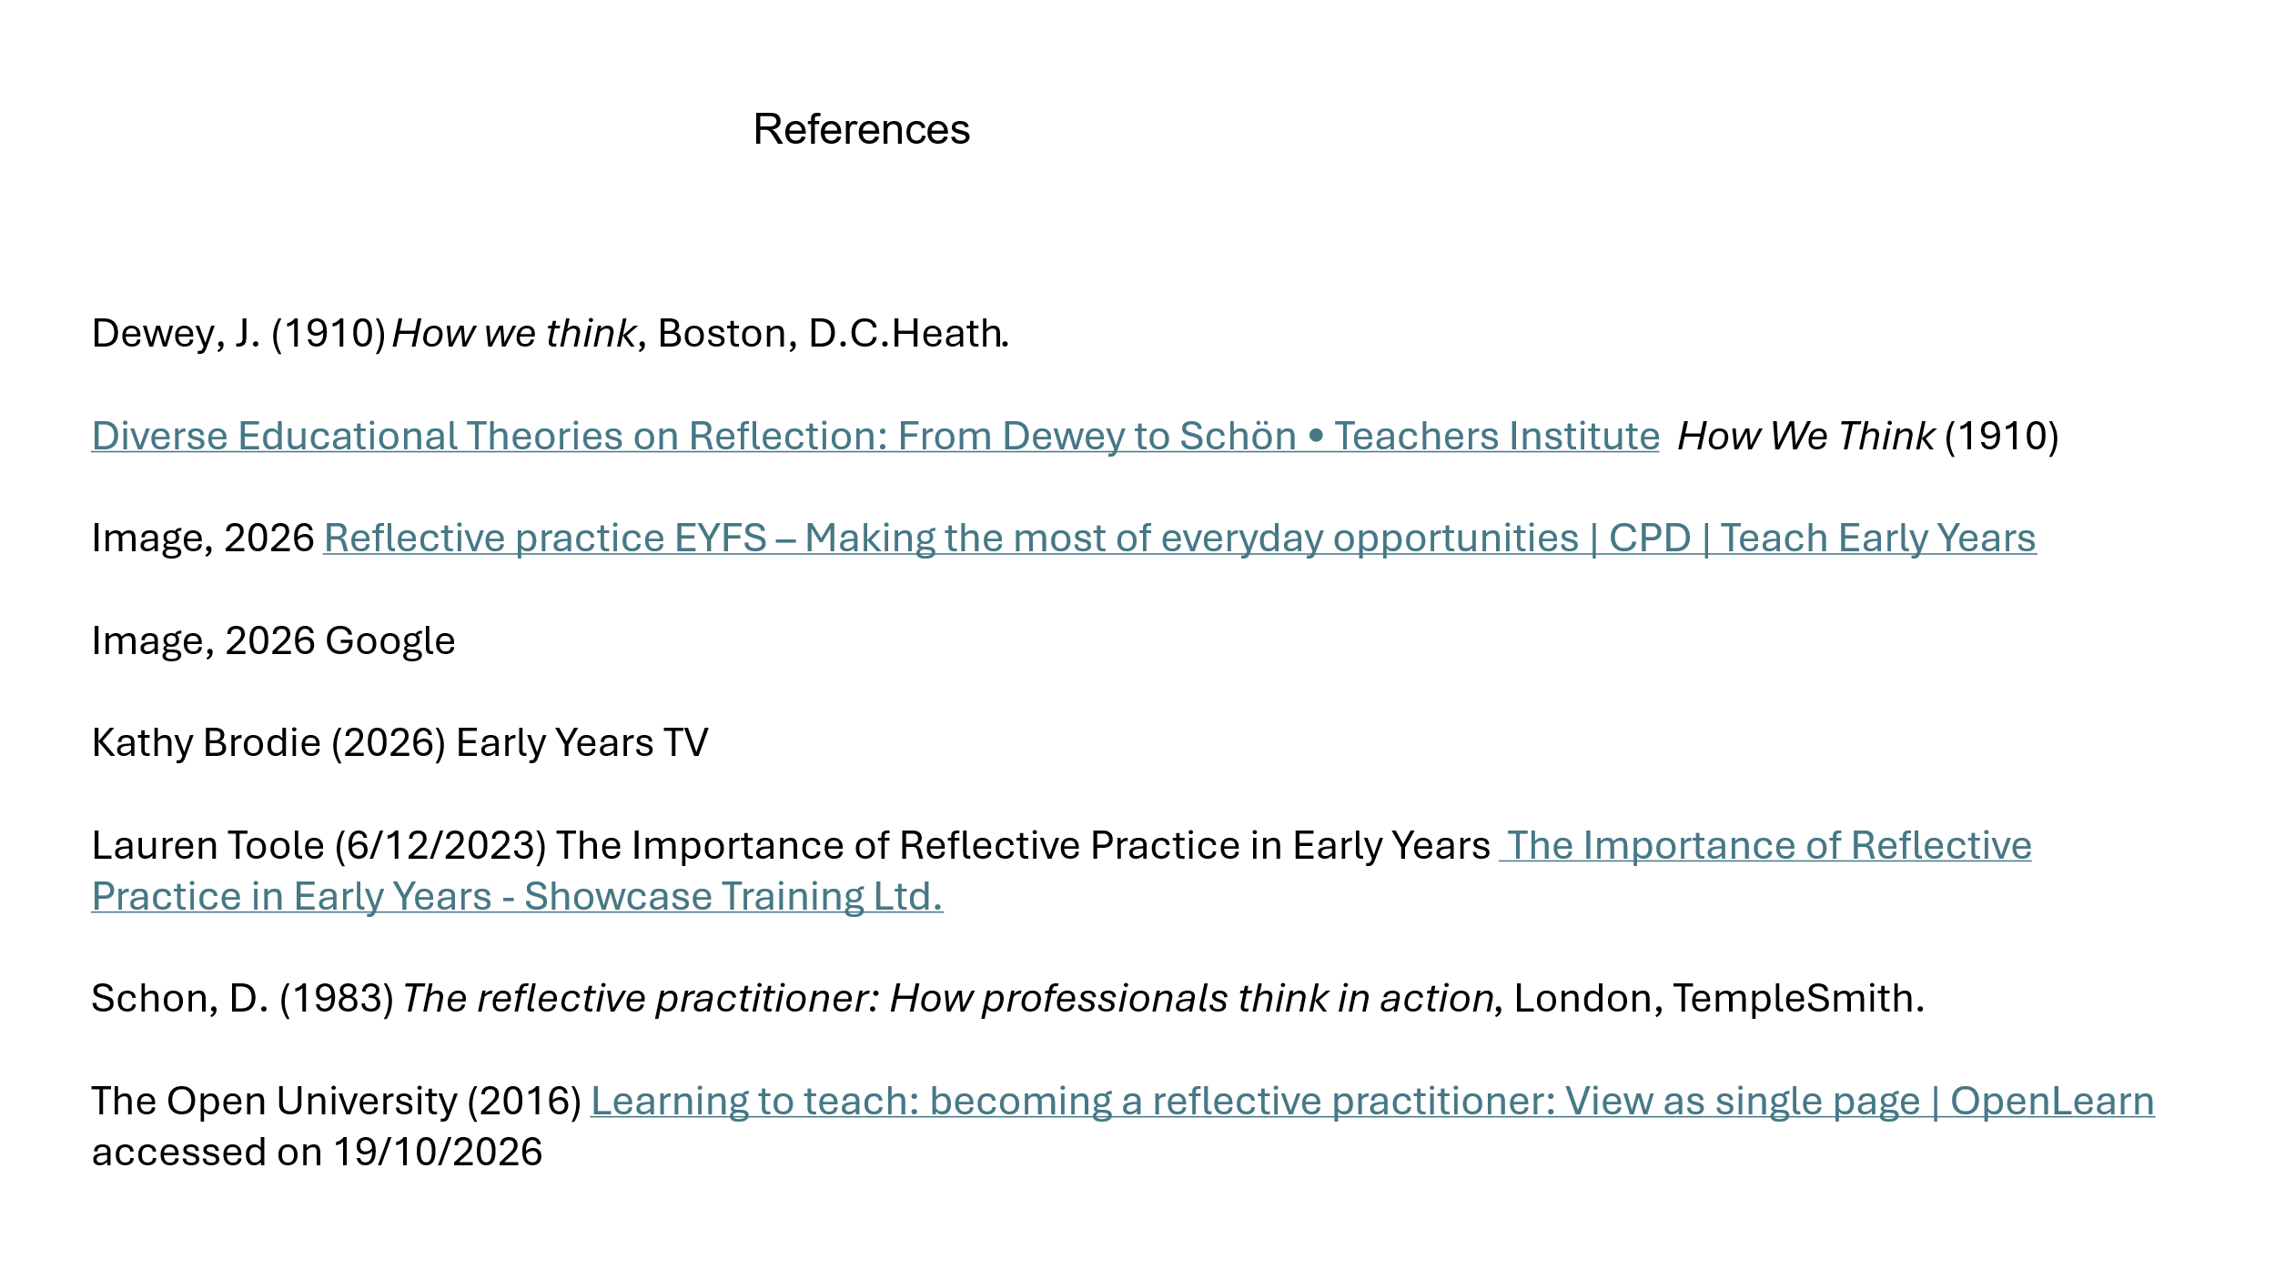

In the context of work a professional is a person who is trained in a specific job and takes their role seriously making sure they perform their duties correctly and to a high standard adhering to the regulations and laws. Professional practice within the early years sector consists of a combination of behaviors, actions, skills, knowledge, ethics and general care which the practitioner provides to the children in their care. This includes a good understanding of safeguarding children which should be priority at all times, knowledge of children’s needs and development and how to ensure these needs are met, knowledge of the EYFS and the skills to provide educational opportunities to meet this criteria, the ability to build good relationships with the children along side good working relationships with the team and also with the parents or carers of the children, keeping up to date on all training and continuing to develop new skills and knowledge to further enhance both the setting and personal career, being ethical and following regulations even if it contradicts personal opinion or beliefs and following legislation and laws such as data protection. All of these aspects are important to maintain good standards of care and remain professional. Safeguarding is paramount within any care setting as it protects vulnerable individuals from neglect, abuse, exploitation and harm as stated by the NSPCC (2026) and ensures that their safety, dignity, rights and overall wellbeing are respected as outlined in the UNCRC, The Children Act 2004 and the statutory guidance Keeping Children Safe in Education (KCSIE). Wales was the first UK country to adopt the UNCRC in 2004 and used it as the basis of their polies for children and young people. Together all of these set clear rules and regulations for how children need to be treated. Having good knowledge of children’s needs and development helps practitioners to meet the needs of the children in their care and understand what children might need at that particular point in their development. Having knowledge of the EYFS helps he practitioner deliver suitable education to the children within their care as stated by the UK government in the statutory guidance and having a set of skills and experience in this area help practitioners think outside of the box and problem solve when trying to deliver this education in a way which the individual children will find engaging. Building good relationships with the children is an important part of not just their emotional development but also their educational development as noted by Bowlby (1988) children who form caring and supportive bonds with their caregivers feel safe and secure and are more open and confident with new experiences due to this feeling of security and safety, this trust helps them not only to build good future relationships but also to experiment more and try new things which is very beneficial to their learning and physical development. Building good relationships with parents and carers helps create collaboration between home and settings providing support and guidance for those involved by offering insight into the child’s behaviors and activities within different environments. It also encourages carers to become involved in their child’s learning and experiences and helps them support their child with their learning at home. Hattie (2008) claims that good relationships between teachers and families or carers is linked to better overall outcomes as children do better academically when their carers and teachers work together to support them. Building good working relationships with colleagues and team members is beneficial to all those involved as it creates a close unit of people who support each other and can provide guidance and feedback to each other as well as sharing new ideas. For example the nurture base where I am currently working consists of myself and 2 other members of staff, we are very close and work well together as a team as we are all on the same page with expectations and are fully aware of everything which needs to be done on a daily basis so if one of us is too busy to take care of something such as an activity at the designated time another one of us will step in and ensure it runs smoothly on time as expected. We have a briefing every morning before the children arrive where we discuss our plan for the day and any concerns or alterations to the plan before we begin, we do communicate throughout the day when we can and then have a check in at the end of the day when the children have been dismissed to discuss how the day went, what worked and what did not work, what we could change for next time and fill in the children’s logs of what they have done that day. I feel that this good working relationships ensures that the children are assessed constantly and any changes to their needs are recognized and changes are implemented swiftly by all of us so we are all in sync with the same knowledge and acting on it at the same time with the same measures. Ensuring up to date training has been undertaken is an important factor to professional practice as rules and regulations can change at any time and training can be updated regularly meaning annually or biannually updates can provide important knowledge which may not have been covered on previous training on the same subject, such as allergy and anaphylaxis training being made mandatory this year for staff working with children. Acting ethically is also a big part of professionalism as abiding by moral principals such as honesty, being fair, showing respect and adhering to the codes of conduct creates trust within the setting and sets a good example for the children with the solid set of morals for the to follow. Individuals can have different beliefs of what is wrong or right so by sticking to the code of conduct for your setting it ensures that there is a strict boundary between personal views and staying professional and unbiased in situations. Multi agency working and collaboration is a very important part to professional practice as it plays a big role in safeguarding the children as well as helping within education. Children may see a lot of different professionals throughout their childhood such as Drs, nurses, teachers, dentist and others who only see the child for a small period of time and are unaware of anything that may be happening outside of that appointment and are unlikely to be in direct contact with other professionals who know the child or have any reasons for concern so it is important that when a professional has a concern regarding a child that multiple agencies are made aware and the information passed on so that all other professionals who interact with the child can be watchful and are aware that there may be a problem that needs reporting or looking into. Without this shared information some things may be overlooked such has been the case with certain child abuse cases including Baby P and Victoria Climbie both of these children were known to social services and were overlooked by a lack of shared evidence between agencies which could have highlighted the high level of danger which they were in before it became fatal. It was Victoria Climbie’s death which pushed authorities to update the Children’s Act to the 2004 version which reinforced accountability and the need for communication between agencies and al professionals involved with children. By multiple agencies sharing any concerns and information others may be made aware of the situation and spot things which may have been overlooked if they were not expecting it. On the other side multiagency working is extremely beneficial to those who may require help but are unsure where to go and what to do. Families first is a good example of this as they work closely with families and can refer them to other agencies which they believe would be helpful and can also play a role in referrals such as assisting children and their families with suspected ASD by collecting information from families and also contacting the child’s school to discuss their needs and gather further information on any concerns or differences before diagnostic referrals are made. This can be very beneficial for the child and helpful to the families as the families first support worker can collect the information from schools and other sources which the family may find difficult to collect and then help get the correct agencies involved and support the family through the process whereas the parents may not have known what to do and how to go through the process without this extra help.

NSPCC. (2026) Safeguarding children and child protection. Available at: https://learning.nspcc.org.uk/safeguarding-child-protection (Accessed: 18/10/2026)

McLeod, S. (2026) John Bowlby’s Attachment Theory. Simply Psychology. Available at: https://www.simplypsychology.org/bowlby.html (Accessed: 18/10/2026)

Bowlby, J. (1953). Child care and the growth of love. London: Penguin Books.

Hattie, J (2008) visible learning

Child Safeguarding Practice Review Panel (CSPRP) (2024) Annual report 2022/23: patterns in practice, key messages and 2023/24 work programme (PDF). [London]: Child Safeguarding Practice Review Panel (Accessed: 18/10/2026)

Goby, J (2026) Safeguarding Children Legislation: What You Need To Know Safeguarding Children Legislation: What You Need to Know (Accessed: 19/10/2026)

No author (2022) updated Children’s Rights In Wales Children's rights in Wales | GOV.WALES (Accessed: 24/10/2026)

Dewey, J. (1910) How we think, Boston, D.C.Heath.
Diverse Educational Theories on Reflection: From Dewey to Schön • Teachers Institute How We Think (1910) (Accessed: 19/10/2026)

Image, 2026 Reflective practice EYFS – Making the most of everyday opportunities | CPD | Teach Early Years (Accessed: 18/10/ 2026)

Image, 2026 Google

Kathy Brodie (2026) Early Years TV

Toole, L. (2023) The Importance of Reflective Practice in Early Years. Showcase Training, 6 December. Available at: https://showcasetraining.co.uk/2023/12/06/the-importance-of-reflective-practice-in-early-years/ (Accessed: 18/10/2026)

Schön, D.A. (1983) The Reflective Practitioner: How Professionals Think in Action. New York: Basic Books.

The Open University. (2016) Learning to teach: becoming a reflective practitioner. OpenLearn. Available at: https://www.open.edu/openlearn/ (Accessed: 19/10/2026)

