Climate change and visual activism
Alex Sage
Vlog Storyboard
30/01/2023
Air Pollution Storyboard

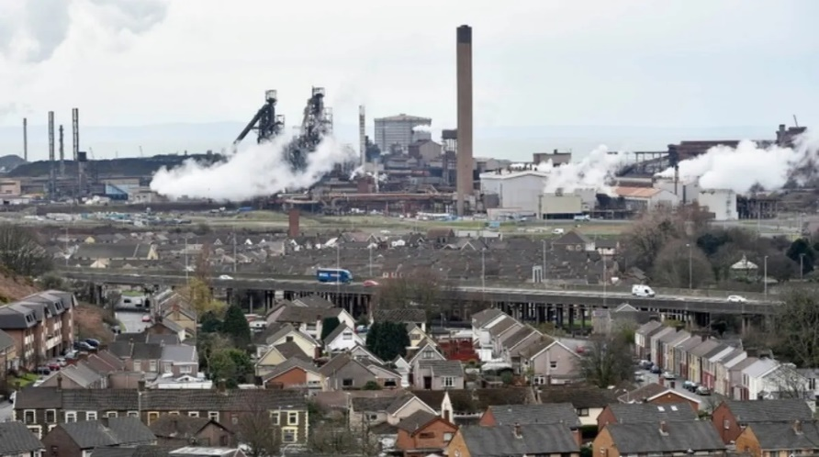
Slide 1 - Air pollution is the contamination of indoor or outdoor air with harmful or poisonous particulates. Since the industrial revolution, the issue of air pollution has continued to get worse claiming more and more lives each year and affecting the health of millions globally. Due to the nature of air, pollution has spread globally and is found at every corner of Earth making the issue extremely difficult to effectively tackle. In 2023 the issue is still worst in developing nations due to the amount of industry still in those nations and their reliance on fossil fuels as well as their more relaxed regulations
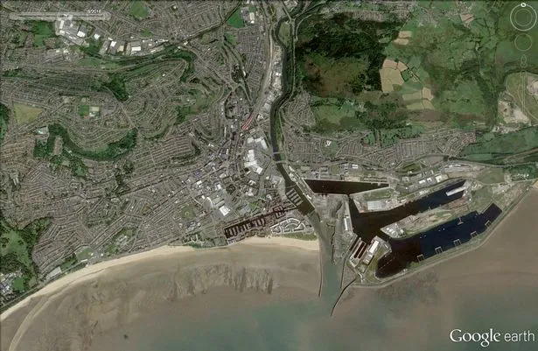
Slide 2 – Air pollution is a massive issue because it affects the health of everyone on Earth and has already been linked to increasing respiratory diseases as well as decreasing life expectancy globally. It is also a highly decentralised issue meaning that the pollution is spread out across a massive area requiring a global effort to fully combat. I’m particularly focusing on air pollution in Swansea as Swansea used to be the global centre of tinplate manufacturing which, as well as bring rapid growth to the area, also bought massive amounts of pollution which has only recently been overcome thanks to regulation and environmental based projects like air quality monitoring and control.
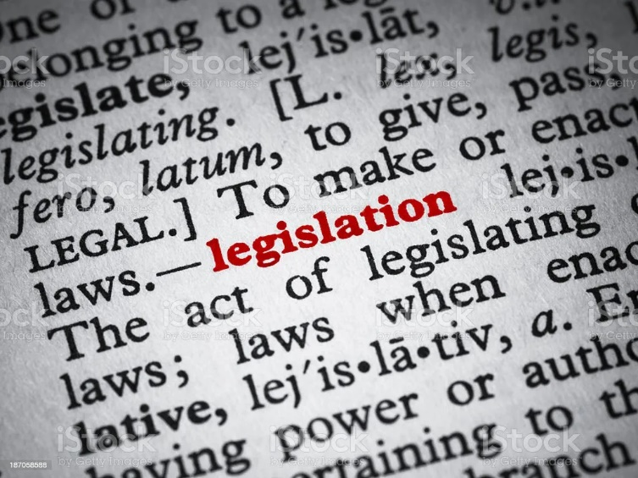
Slide 3 – There has also been lots of regulation passed that targets air quality and pollution as well as enforcement and punishment for those who break the rules such as the clean air plan for Wales which aims to improve the air quality throughout wales.

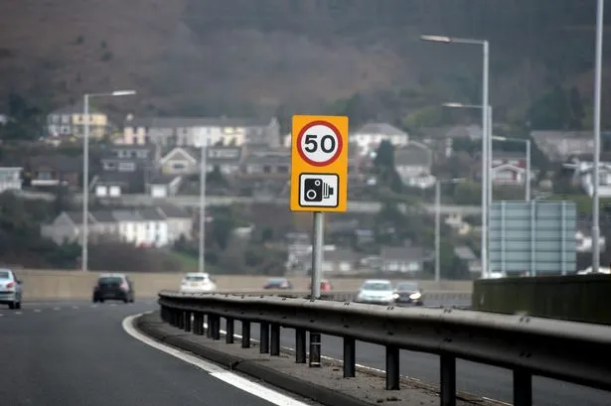
Slide 4- Swansea also has strict 50MPH motorway speeds to help control air quality. Despite Cardiff and Swansea having some of the worst air quality in the UK according to government statistics, there are currently no plans to introduce a clean air zone in either, despite evidence that clean air zones help reduce atmospheric pollution in cities like London and Birmingham as well as providing additional funding which could be used for green projects.

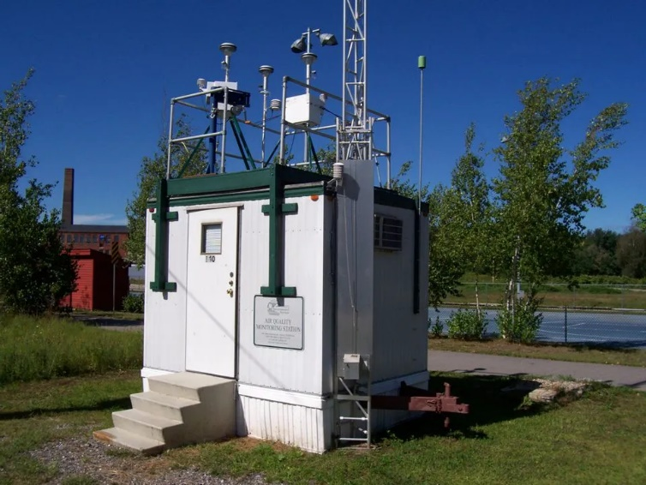
Slide 5 - Air quality monitoring stations have been set up across Swansea to get accurate data readings to allow a fuller picture to be painted about the state of Swansea air pollution. These stations provide valuable data about the quality of air in and around the location it has been set up in. These stations use the Automatic Urban and Rural Network to upload data hourly about the presence of carbon monoxide, nitrogen dioxide, ozone, particulate matter, sulphur dioxide and hydrogen sulphide.


Slide 6 - According to the Welsh governments’ data in 2022, poor air quality in Wales now has the same burden on the welsh medical system that it is equivalent to between 29,000 and 43,000 deaths per year. Clearly this is unacceptable as both the population and healthcare system is suffering due to a fixable problem. Pollutants such as fine particulate matter (called PM 2.5) and nitrogen dioxide can not only cause new health issues but can also cause existing ones to flare up and cause harm.

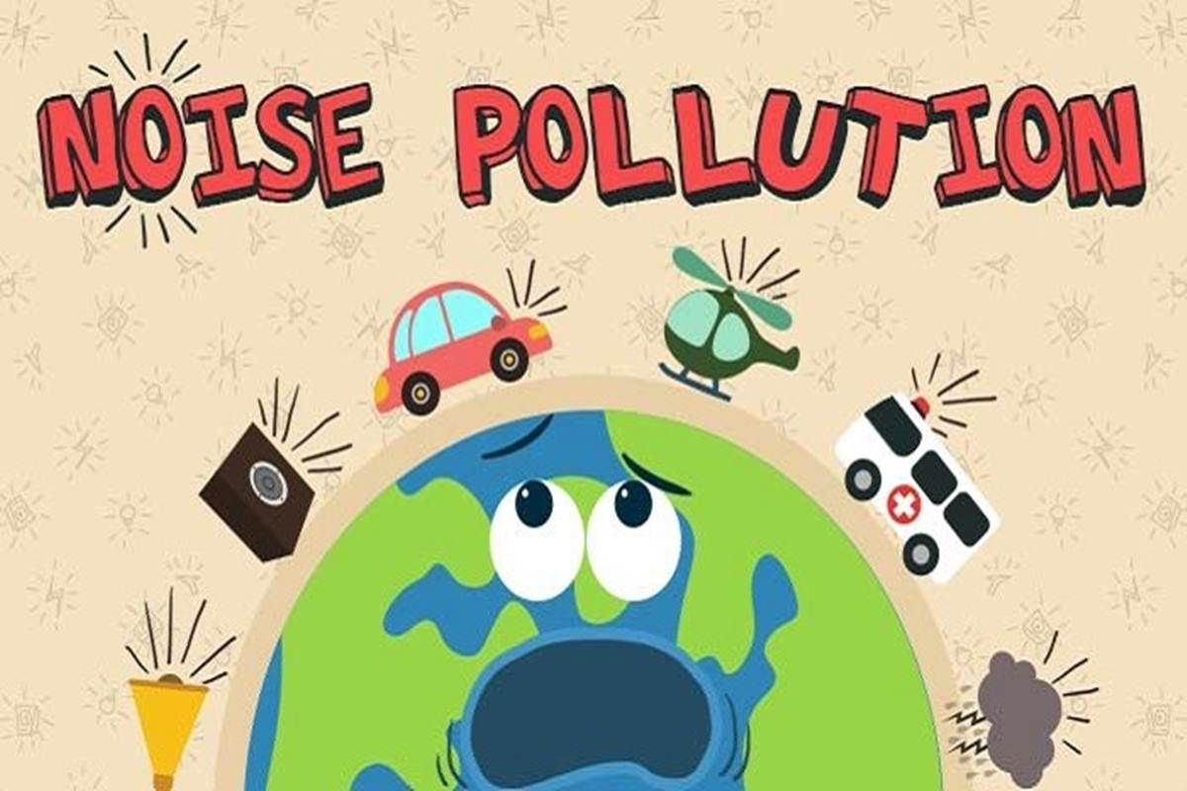
Slide 7 – Noise pollution is unwanted or harmful noise created by industry or transport. It is considered the 2nd biggest risk factor to health after pollutants in the aid and effects both humans and other animals. Noise pollution tends to come from centralised sources meaning the people closest to these sources are often the most affected. Also, the most polluting vehicles or industries are often the loudest too so tackling 1 of these issues often helps resolve the other.
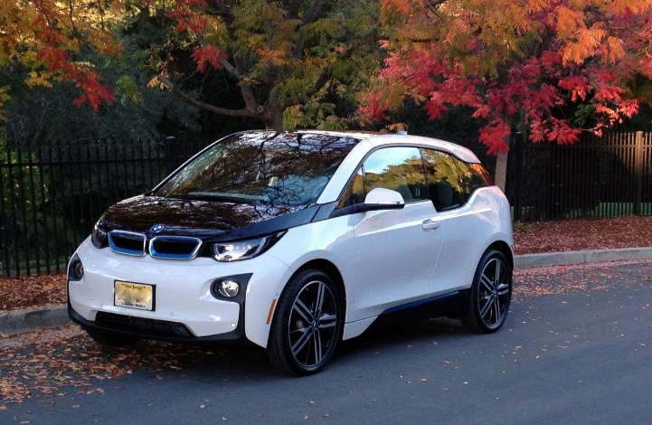
Slide 8 – Electric vehicles are another area the welsh government is focusing on as they reduce both the amount of decentralised air pollution as well as noise pollution. Electric cars reduces emissions by about 37.5% according to government statistics and the UK government plans to end the sale of combustion engine vehicles by 2040. On top of this the weslh government is expanding their rail capacity by 65% in order to accommodate more people on public transport, reducing car emissions and noise pollution.
Why Air Pollution is Important
As talked about in the video log, air pollution is a massively important issue to tackle as it is a global, decentralised issue that has been getting worse and worse for over 150 years now. Since air pollution is a global issue, it is extremely hard to organise plans of action to tackle it as political and social issues may prevent global cooperation. However, we know that cooperation on a global scale is possible as this occurred to ban the use of CFC’s back in 1987 and prevent the damage to the ozone layer they were causing to get any worse. Since then, we have confirmed that the hole created has shrunk and will eventually close.
In 2021, the 2 most cited estimates predicted around 7 million people had died from air pollution related issues however it is possibly higher as the more research is done on the topic the more we realise how many detrimental effects pollution has. In the UK specifically air pollution has long been considered an issue, especially after a young girl died in 2013 from air pollution which made headline news. The UK government estimated in 2017 that over 40,000 people died from pollution. These statistics show just how big an issue pollution is and why it is critical for all of our health that we tackle the issue quickly.
How would I spread this video?
To spread my vlog I would first use different social media platforms to initially get the video out there. I would post to Twitter using relevant hastags so other users can easily find my work; I would use reddit and post the video across multiple different subreddits relevant to the topic such as r/environment and I would use TikTok and Instagram to post my vlog as a short clip to attract more people to my video.
After this, I would focus on more academic site. I would upload and share the video on Linkin again tagging it appropriately to attract interested users and I may also contact already established social media users or corporations to see if they would like to run my video on their channel or account. Doing these things would ensure I am maximising the amount of people who see and engage with my video, increasing the chance of people who are interested or able to do something about this issue.
How the storyboard explores the issue
Air pollution is an issue that effects everyone on Earth so I began my storyboard with a slide generally explaining why and how it is an issue. To show this visually I used an image of port talbort near Swansea as it is very clear that pollution is being created there.
My next slide is an aerial shot of Swansea which I included in order to convey that my vlog is going to focus mainly on Swansea area. I also use some history to explain that Swansea used to be one of the most polluted places on the planet and has taken considerable steps forward away from the infamous state and that air pollution is a fixable issue and my next slide briefly talks about the use of legislation in reaching that goal.
I also talk about Swanseas use of road laws to control and reduce pollution around the city. Limiting the speed of vehicles to 50mph caps the amount of pollution created by these vehicles and is a proven tactic already used in other cities like London and Birmingham in order to create ‘clean air zones’ in these cities. However, Swansea has not gone as far as these other cities as it does not have a clean air zone yet, just strict speed limits. This is definitely an issue that needs bringing to attention so I had to discuss it and float the idea.
My next slides talks about the air quality monitoring stations that are all around the UK; what they measure, how they work, how often the data is uploaded etc. These monitoring stations are extremely useful and provide critical insight into a locations air quality. Without these devices it would be very hard to plan how to fix the poor air quality of a location. I also discuss the impact poor air quality has on human health by talking about statistics from the Welsh governments website about annual deaths caused by pollution and the specific particulates that cause the most damage to health.
Finally, I discuss noise pollution and electric vehicles, two things that go hand in hand. Noise pollution in Swansea is mostly caused by traffic as industry has largely moved out of the city so the adopted of electric vehicles would further cut noise pollution to minimum levels.
Sources and validity
https://www.gov.wales/sites/default/files/publications/2020-08/clean-air-plan-for-wales-healthy-air-healthy-wales.pdf
My first source was the welsh government website as it had lots of useful background information as well as statistics from the governments office for national statistics and digital bills that have been passed. I managed to find a PDF of the Welsh governments ‘Clean air for Wales’ plan that detailed exactly what the main issues were and what the government planned on doing to tackle them. Overall, this source was very useful and trust worthy as it is a government run source.
https://ourworldindata.org/data-review-air-pollution-deaths
I also used OurWorldInData.org in order to find accurate studies with data about deaths caused by air pollution on a yearly basis. This source contained multiple studies with lots of citations and gave a conclusion based on these studies giving averages and other statistics based on them. It was a useful sources with lots of sources of data including the WHO, Institute for health metrics and evaluation and Leliveld et al.
https://www.bbc.co.uk/news/science-environment-55352247
I also used a BBC article in order to find some key statistics and information about how long air pollution has been considered a problem in the UK. The article talks about a teenage girl who died from pollution in 2013 and how this event massively changed the publics perspective of the issue after it made headline news. Whilst sad to talk and think about, these stories help bring to light just how significant this issue is and how critical it is that we take it seriously.
https://wintoncentre.maths.cam.ac.uk/news/does-air-pollution-kill-40000-people-each-year-uk/
Finally, I used a source from the University of Cambridge to get accurate data about how many of the 7 million annual deaths from air pollution are located in the UK. The data provided by this source estimate 40,000 people per year die in the UK which again is a shocking fact most of us wouldn’t think about. It also shows that even one of the richest countries on the planet is not safe from this issue.

