

Module name: Introduction to Independent Research Skills
Module code: BMHP5019
Student name: Joyce Ebihor
Student ID:2323239
Lecturer: Dr Itse Olaoye

Table of contents

Abstract
1. Introduction
2. Background
3. Methods
4. Results
5. Discussion
6. Conclusion and Recommendations
References

Abstract
The study explored how intergenerational relationships influenced the mental health results of disabled elderly individuals in the United Kingdom. As the UK population ages and disability prevalence increases, understanding socially integrated, cost-effective perspectives to mental well-being has become a public health priority. With the help of scoping review methodology, this research explored evidence from peer-reviewed studies published between 2018 and 2025. The search was conducted across databases, including PubMed and Scopus, focusing on intergenerational engagement, disability, and mental health outcomes such as depression, loneliness, and psychological well-being.
Thematic analysis has been done here by developing some major themes on emotional and psychological support as protective factors; the double-edged nature of instrumental and caregiving support; social participation, agency, and meaning making; and barriers, accessibility, and contextual sensitivity. Therefore, the findings signal that emotionally supportive and reciprocal intergenerational relationships increased self-esteem, belonging, and resilience, whereas dependency-reinforcing or inaccessible interactions can worsen distress. Evidence specific to disabled elders remains limited, exploring a significant research gap.
The research summarised that the intergenerational engagement could serve as an effective, community-based strategy to develop the mental well-being among disabled elders when implemented inclusively and accessibly. It suggests that UK health and social care policies prioritise intergenerational programmes, digital inclusion, and training for carers to foster empowerment and mutual respect. Further UK-based, longitudinal research is required to strengthen the evidence base and guide sustainable, person-centred interventions.
Introduction
The study evaluates how intergenerational relationships influence mental health outcomes in disabled elders. Intergenerational relationships effectively influence the mental health outcomes of disabled elders, acting as a double-edged sword that can either give important assistance or contribute to distress. This report has included a definition of the main concepts, such as intergenerational relationships, disabled elderly individuals, and mental health outcomes, as well. Therefore, the study also incorporates the rationale of the research along with research questions and research objectives as well as.
Definition of the main concepts
Intergenerational relationships include sustained interactions between people of different age communities, basically younger and older individuals.
Disabled elderly individuals are especially over age 65 and experience physical, cognitive, sensory, or mobility-related impairments.
Mental health outcomes incorporate psychological states, including depression, anxiety, loneliness, and overall emotional well-being.
Rationale of the research
Mental health conditions in older adults, particularly those with disabilities, are growing in prevalence due to isolation, chronic illness, and decreased mobility. In the UK, disabled elders suffered compounded vulnerabilities: the stigma of disability and the effects of ageing. Research recommended that intergenerational contact could decrease loneliness and promote well-being, yet there is little focused analysis on how these relationships impact disabled elders, particularly (Whear et al. 2023). Given pressures on formal care systems, cost-effective, socially integrated strategies such as intergenerational engagement are worth investigating.
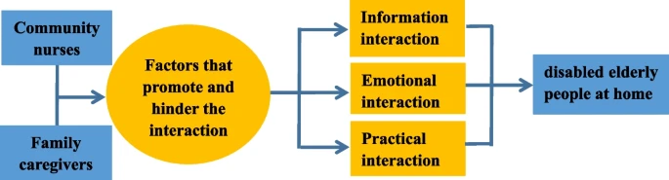
The importance of interaction between community nurses and family caregivers of disabled elderly
(Source: Biomedcentral.com, 2023)
Social isolation is especially so critical, and it is extensively connected with poor mental health outcomes, including cognitive decline and increased rates of depression. It has been noted that the disabled elderly suffer from managing social connections, such as physical inaccessibility, communication difficulties, and a lack of appropriate community support (Earl and Marais, 2023). In this context, the covid 19 pandemic situation influenced social distancing by limiting face-to-face contact and access to services, underscoring the urgent requirements for effective interventions to influence the mental well-being in this population.
Intergenerational relationship is basically defined through sustained interactions between younger and older generations, that have been addressed as a promising social intervention (Jiang et al. 2024). These relationships promote the emotional support, social inclusion, knowledge exchange, and mutual respect, that are all protective elements for mental health. Evidence from Zheng et al. (2024) suggested that intergenerational engagement can reduced the loneliness and increased the psychological resilience among older adults, yet specific research concerning on disabled elders remains sparse. Moreover, disabled older adults can be encounter unique facilitators and challenges in forming and maintaining these relationships, necessitating estimated investigation.
In future, the UK’s ageing population has been measured to increase the substantially over the next decades, alongside developing disability prevalence, and health and social care systems faced mounting pressure to deliver sustainable, low-cost, and effective mental health support (Earl, and Marais, 2023). Intergenerational approaches, community-driven and cost-effective, could complement formal care services by influencing the social connectivity and emotional well-being without significant resource investment.
However, this scoping review focused to achieve a critical gap in identifying how intergenerational relationships particularly impact the mental health of disabled elderly individuals in the UK context (Bai et al. 2021). The findings will inform health and social care practice, navigating the development of inclusive, accessible intergenerational approaches to increase mental health outcomes in this vulnerable population.
Review Question
RQ: How do intergenerational relationships affect the mental health of disabled elderly individuals in the UK?
Objectives
To identify and analyse the existing literature on the mental health benefits of intergenerational connections for disabled older adults.
To evaluate the key types of intergenerational interactions (such as family, community-based, and digital) and their impacts on mental health outcomes.
To understand potential challenges and facilitators to meaningful intergenerational engagement for this population in the UK care environment

Background
Contextual information
The research includes the global trend of population ageing and associated chronic conditions, the socio-cultural context of family support, and different theoretical frameworks which define intergenerational exchange. The demographic environment of the United Kingdom is going through significant changes, with a dynamically ageing population and a concurrent increase in the prevalence of disability among older adults. According to the Office for National Statistics, by 2035, approximately one in four people across the UK will be aged 65 or over, highlighting the increasing significance of addressing the requirements of this demographic. Therefore, the disability, surrounding physical, sensory, and cognitive impairments, disproportionately impacts older adults, with nearly 45% of individuals more than 65 living with some form of disability (Ren et al. 2025). These elements combine to produce a difficult health profile characterised not only by physical challenges but also by developed susceptibility to mental health challenges including depression, anxiety, and social isolation. Social isolation in specifically, is an important determinant of mental health in older adults and is often exacerbated in those with disabilities due to limited mobility, communication difficulties, and decreased access to community resources.
Moreover, the intergenerational relationships incorporate interactions between younger and older generations and have developed identification as a valuable strategy to address the social isolation and promote mental well-being among older adults (Xia et al. 2023). These relationships can take different forms, including familial ties, community engagement programs, and digital communication platforms. Such interactions give emotional support, increase a sense of belonging, and explored the exchange of knowledge and experiences, all of which contribute positively to psychological health. Moreover, some programs, including intergenerational volunteering and community-based initiatives, have demonstrated potential in enhancing mental health outcomes in older populations, yet there is limited research particularly concerning disabled elders (Tang et al. 2022). The unique challenges suffered by disabled older adults, such as barriers to participation, like accessibility issues and technological exclusion, warrant targeted exploration to ensure these interventions are equitable and effective.
Moreover, the policy and practice infrastructure within the UK further contextualise the importance of intergenerational engagement for disabled elders. “The Care Act 2014”
enhances the promoting well-being and social inclusion as core objectives of social care provision. Therefore, the NHS Long-Term Plan investigates for personalised care, that addressed the holistic needs of individuals, including emotional and social dimensions (Zhou et al. 2023). Despite of this model, the implementation of intergenerational programs remains inconsistent, meanwhile, impacted through resource limitations and a lack of tailored approaches for disabled older adults. Identifying the intersection of disability, ageing, and intergenerational relationships is therefore significant to inform the improvement of accessible and sustainable mental health interventions across the UK health and social care practice. This background improved the foundation for investigating how intergenerational relationships effect the mental health outcomes in disabled elders, a topic of developing relevance amid demographic movements and evolving care priorities.

Methods
The study has been incorporated a scoping review methodology to highlights the intergenerational relationships which promotes the mental health results of disabled elderly individuals. These kinds of reviews supported the research work to measure the key concepts, types of evidence, and research gaps in areas which ae difficult or not extensively reviewed (Mishra and Alok, 2022). This method also offers for a comprehensive synthesis of existing knowledge and assist the identification of patterns and gaps in the literature, particularly under-researched topics including intergenerational engagement for disabled elders.
Data collection / Search strategy
The research has been adhered the secondary qualitative data collection strategy, that supported the researcher gain a wider range of information based on intergenerational engagement for disabled elders. The data has been gathered from authentic data sources including Google Scholar and ProQuest (Smith and Nizza, 2022). Moreover, their research has incorporated a framed search strategy across three academic databases, including PubMed, CINAHL, and Scopus. The databases have been chosen due to their strong coverage of health, nursing, and social science literature. Search terms have been included in combinations of key perspectives, like
“Intergenerational relationships” OR “intergenerational engagement”
“Disabled elderly” OR “older adults with disabilities”
“Mental health outcomes” OR “psychological well-being” OR “depression” OR “social isolation” (Thomas and Thomas, 2021)
Boolean operators and database-specific filters have been implemented to refine the findings. Inclusion and exclusion criteria have been included here, which helped the research work to find the appropriate approach regarding the research topic. The search has been limited to peer-reviewed articles published in English between 2018 and 2025 to ensure the inclusion of recent and relevant studies (Tomlinson, 2023). While the focus is on the UK context, studies from comparable healthcare or cultural settings will be considered to increase the contextual understanding where relevant.
Inclusion and exclusion criteria
Studies have been incorporated if they:
Concerned about disabled individuals aged 65 and older.
Evaluate the intergenerational interactions (such as familial, community-based, or digital); (Mishra and Alok, 2022)
Investigate the mental health outcomes (such as loneliness, depression, anxiety).
Are qualitative, quantitative, or mixed methods studies.
They are published in peer-reviewed journals.
Excluded has been
Studies not involving disabled elders.
Articles not in English; (Tomlinson, 2023)
Grey literature, editorials, and commentaries.
Studies that do not provide empirical findings or focus solely on medical/clinical interventions without social dimensions (Gupta and Gupta, 2022).
The data has been extracted from the authentic sources by including an abstract screening and a keyword searching strategy (Evens et al. 2022). Data from selected studies have been extracted by implementing a standardised charting form, capturing authorship, year, country, aims, methodology, population characteristics, type of intergenerational interaction, and key mental health results.
Data analysis
Thematic analysis has been performed to analyse the findings. Adhering to Braun and Clarke’s (2006) guidelines, patterns and recurring themes across studies have been addressed to explore how intergenerational relationships affect the mental health of disabled elders (Mishra and Alok, 2022). The analysis has also explored barriers and facilitators of engagement and evaluated the differences across interaction types (such as familial vs. community-based).
Ethical considerations
As a secondary research study using publicly available data, this review does not need ethical approval. Nonetheless, the research has been conducted to ethical standards by assuring academic integrity, proper citation, and compliance with the Copyright Act (Hadfield & Hadfield, 2025). No manipulation or fabrication of data has occurred, and all included studies have been interpreted respectfully, particularly those involving vulnerable populations (Toliver, 2021). All data has been securely stored and deleted upon project completion. The study strictly followed the inclusion and exclusion criteria to avoid duplication and enable an effective data filtration strategy.

Results
Study characteristics
A summary of the main features of the studies included in the reviews is as follows
Therefore, most of the empirical work compiled explores older adults (age 60+ or 65+) and their intergenerational relationships (basically with adult children or grandchildren) and mental health/wellbeing outcomes (Zhou et al. 2023).
As an illustration, one systematic review of 14 trials from six countries found intergenerational interventions (such as visiting programmes, school volunteering, reminiscence activities) and reported small positive trends on older adults’ self‑esteem (ES = 0.33) and depression (ES = 0.19), though with low confidence due to small sample sizes.
Another review in Eastern Asia estimated that the emotional support and financial support from younger generations are inversely associated with lower depressive symptoms in older adults; instrumental support had mixed results (Sudo et al. 2025).
One study implementing the Chinese CHARLS data (age 65+) found that children’s spiritual comfort assists positively associated with older adults’ physical, psychological and self‑assessed health. Children’s life‑care (instrumental) support had a positive association with physical health but a negative association with psychological and self‐assessed health.
Evidence from UK and international practice/review literature (e.g., intergenerational programmes in care homes) shows older people deriving emotional, social, and cognitive benefits from intergenerational activities (though not always with a robust experimental design), among them decreased loneliness, developed mood and sense of purpose (Guan et al. 2025).
Moreover, some studies are concerned explicitly with disabled elders (i.e., older adults with physical, sensory, cognitive or mobility impairments) AND their intergenerational relationships with younger generations in the UK context. This represents a key gap.
Thematic analysis
From the extracted data, aims and objectives, and research question, four major key themes have emerged to explore the intergenerational relationships' influence on mental health outcomes in older adults.
Emotional/psychological support and belonging are positively associated with mental‑health outcomes in older adults
Positive intergenerational relationships (i.e., frequent, meaningful contact, emotional exchanges) are effectively related to improved mental‑health outcomes in older adults. As an illustration, emotional support and a sense of belonging media the effect of intergenerational relationships on depressive symptoms in older patients with multiple chronic conditions (Dayson et al. 2021). Intergenerational contact can decrease loneliness, boost self‑esteem and foster a sense of value and purpose (Allicock, 2024). For disabled elders, this recommends that when younger generations engage meaningfully (beyond mere care tasks), they might buffer risks of depression, anxiety and social isolation.
The "double-edged" nature of instrumental and caregiving support in intergenerational relationships refers to its potential to strengthen bonds while also creating burdens, conflicts, and challenges to autonomy.
Instrumental assistance includes giving tangible and practical help, including offering financial aid, doing chores, running errands, or providing transportation. Here are some positive perspectives of the double-edged nature of instrumental and caregiving support in intergenerational relations (Dayson et al. 2021). It increases the physical health and well-being by assuring the practical help, including cooking meals or driving to appointments, can be enhanced to develop the physical health and life satisfaction of older adults, especially those with declining physical abilities. It also assures security, where financial assistance from adult children can produced a sense of security for parents, positively impacting their mental health (Delaughter, 2025). Moreover, it also boosts the family bonds by offering tangible aid which might be a profound expression of love and commitment, gathering family solidarity and the feeling of being cared for. Therefore, the "double-edged" nature of instrumental and caregiving gives the assistance to empowers their self-esteem and entire well-being.
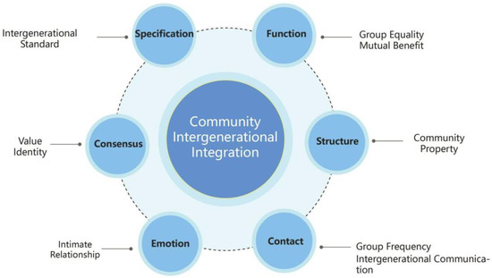
Community intergenerational interaction
(Source: Mdpi.com, 2023)
On the other hand, however, when assistance was overbearing, paternalistic, or framed around dependency, it correlated with loss of autonomy, role strain, and depressive symptoms. Therefore, in some contexts, older adults evaluated guilt or helplessness when receiving care from younger family members, especially when disability limited their ability to reciprocate (Hadi Mogavi et al. 2024). However, this dynamic was more pronounced among disabled elders, for whom daily dependence on others could inadvertently reinforce feelings of burden or uselessness.
Social participation, a person's engagement in interactions and activities within a community, deeply influences an individual's sense of agency and meaning making
Meanwhile, Intergenerational relationships increase a sense of purpose, cognitive stimulation, and social participation. However, some activities, such as storytelling, shared hobbies, mentoring, or volunteering, allowed older adults to evaluate the expertise and engage in reciprocal exchange, reinforcing a sense of usefulness and continuity (Buetow, 2024). Research estimated that intergenerational initiatives, especially community-based or educational programmes, increased cognitive engagement, memory recall, and self-esteem.
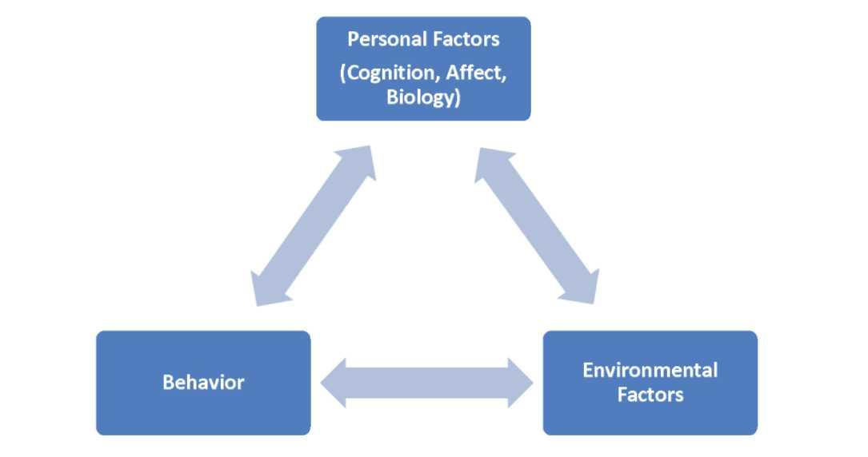
Reciprocal Determinism
(Source: Pressbooks.pub, 2023)
Therefore, the disabled elders who engaged with an inclusive intergenerational programme reported developed confidence and decreased feelings of marginalisation. Thus, there are some opportunities to mentor or teach younger individuals about life skills or cultural traditions that help restore agency and personal identity beyond the label of “disabled.” On the other hand, engagement in digital intergenerational communication, including video calls or online hobby groups, also offered psychological benefits, although technological challenges persisted for some (Hadi Mogavi et al. 2024).
In the case of disabled elders, barriers, accessibility issues, and a lack of context-sensitivity in intergenerational relationships can increase stress and loneliness, which negatively impacts their mental health.
Disabled elders often suffer physical inaccessibility (such as transport, architectural barriers), sensory limitations, and digital exclusion (Xia et al. 2023). These attributes limited their ability to engage consistently and meaningfully with younger generations. The social stigma surrounding both ageing and disability further compounded isolation, especially for those without close family ties.
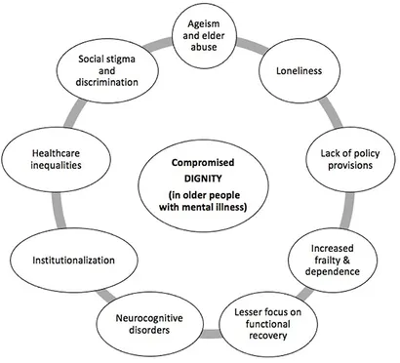
Various factors that impose a threat to dignity in older people living with mental illness.
(Source: Frontiersin.org, 2021)
Programmatic challenges were also identified here. Intergenerational schemes were frequently designed for general older populations without accounting for disability requirements, including sign-language interpretation, adaptive technologies, or mobility aids. This exclusion risks perpetuating inequities rather than alleviating them. However, the context of COVID-19 amplified isolation, as lockdown measures curtailed face-to-face interactions (Ren et al. 2025). While some digital intergenerational initiatives emerged as alternatives, accessibility and digital literacy gaps constrained participation among disabled elders.
Summary of findings relative to disabled elders
Though direct evidence particular to disabled elders (≥65 yrs with physical/cognitive/sensory impairments) in the UK is very limited, the broader literature for older adults strongly suggests that meaningful intergenerational relationships can have a protective effect on mental health (reducing loneliness, depression, increasing life satisfaction, self‑esteem).
The “double‑edged sword” nature is evident: Assistance that fosters agency, belonging and meaningful exchange tends to support; assistance that reinforces reliance or passive receipt might harm mental health (particularly in disabled elders vulnerable to loss of autonomy).
The context matters: programmes or relationships requirements to be accessible (physically, digitally), designed to disability-related needs, and sustained rather than one‑off.
There is some evidence that intergenerational programmes are cost‑effective, socially integrated strategies to complement formal care systems.
Significant gaps remain: Some studies are concerned exclusively with disabled older adults or differentiate by type/severity of impairment; even fewer examine UK‑specificdata, merging intergenerational relationships with disability and also mental health outcomes.

Discussion
Discussion of the findings in relation to the review question
The evidence explored across the reviewed studies explains that intergenerational relationships have both protective and potentially harmful impacts on the mental health of older adults with disabilities (Bai et al. 2021). When relationships are emotionally supportive, reciprocal, and inclusive, they contribute positively to psychological well-being through decreasing loneliness, depression, and anxiety. On the contrary, when they reinforce dependency or are identified by poor communication or exclusion, they can exacerbate distress and feelings of powerlessness.
Zheng et al. (2024) found that intergenerational emotional assistance significantly correlates with lower depressive symptoms and higher life satisfaction among older adults. Similarly, identified that older adults who manage warm, reciprocal relationships with adult children experience lower loneliness and better cognitive activities. These outcomes align with Theme 1 of this review, that defined those meaningful emotional exchanges and a sense of belonging increased psychological resilience among disabled elders (Jiang et al. 2024). Therefore, such relationships give validation and social identity, that are meanwhile threatened through the disability and age-related stigma.
However, the research findings also explored the “double-edged” nature of intergenerational support (Theme 2) (Allicock, 2024). While instrumental assistance, including support with daily activities, can survive independence, it may also summon negative emotions when perceived as controlling or pitying. This aligns with the Intergenerational Solidarity Theory, that makes a distinction between emotional solidarity (affection) and functional solidarity (practical help). The effective balance between these dimensions identifies whether intergenerational engagement assists or undermines the mental health. Studies by Earl and Marais, (2023) and Whear et al. (2023) similarly report that excessive or unsolicited support from younger relatives that can leads to diminished self-esteem and enhanced depressive symptoms among disabled elders.
Theme 3, that developed social participation and meaning-making, highlighted the findings which explained that community-based intergenerational initiatives increased the self-worth and cognitive stimulation among older adults (Earl and Marais, 2023). Therefore, engaging in shared activities, including mentoring or volunteering, assures disabled elders to contribute knowledge and balanced sense of purpose. This sense of agency is important, as loss of role identity is strongly connected to depression in later life.
Nonetheless, Theme 4 highlighted that the effectiveness of intergenerational engagement is constrained by accessibility challenges. Disabled elders faced challenges structural disadvantages, including physical inaccessibility, transportation challenges, and digital exclusion. These barriers are well-documented in previous UK-based research. Ren et al. (2025), boost that older adults with disabilities are disproportionately isolated due to the physical environment, economic inequality, and limited assistive technology access. As noted by Tang et al. (2022), in future the COVID-19 pandemic boosts these inequalities, that estimates that digital communication mitigated loneliness for some but excluded those have poor digital literacy or adaptive equipment.
The review recommends that for this demographic, accessibility, the emotional quality, and reciprocity of intergenerational relationships are empowered predictors of mental health more likely to frequency of contact individually.
Significance of the findings for health and social care
The important study results hold advanced implications for the UK health and social care practice, particularly as services confront developing needs from an ageing, respectively disabled population (Zhou et al. 2023). Moreover, the evidence undermines that social connectedness is an important and effective determinant of mental health, connecting with the objectives of the Care Act 2014, that compulsorily influenced the promotion of individual well-being and social inclusion. Therefore, disabled elders, meanwhile, experience fragmented care and limited opportunities for emotional support outside formal systems. Therefore, Intergenerational engagement, whether by family networks, community programmes, or digital initiatives, highlights a cost-effective, socially developed approached to enhance the mental health outcomes without overburdening formal services (Sudo et al. 2025). Therefore, this result undermines the requirements for cross-sector collaboration and identify the digital exclusion, which is important. Therefore, the quality and inclusivity of intergenerational relationships matter more than quantity.
Gap of the research
The shortage of UK-specific study concerned explicitly on disabled elders limited the profoundness analysis. Moreover, here variability in explanations and measurements posed analytical issues or risk. Therefore, the reliance on cross-sectional designs restricted causal inference. While associations between intergenerational engagement and developed mental health are clear, it remains uncertain whether including relationships directly causes these developments or whether psychologically healthier elders are more likely to maintain such connections.

Conclusion and Recommendations
Summary of the research
The research concludes that intergenerational relationships play a crucial yet complex role in structuring the mental health outcomes of disabled elders in the UK. When such relationships are emotionally supportive, reciprocal, and accessible, they can respectively decrease loneliness, depression, and anxiety while improving self-esteem and a sense of belonging. Moreover, when characterised by dependency, poor communication, or exclusion, they may worsen psychological distress. The evidence signals that the emotional quality and inclusivity of intergenerational contact are more influential than frequency alone.
Recommendations
Here are some major recommendations are such as
Influence the inclusive intergenerational programmes in communities, care homes, and schools to reduce loneliness and increase emotional well-being among disabled elders.
Assured accessibility by addressing physical, sensory, and digital barriers to participation (Guan et al. 2025).
Encourage reciprocal engagement, offering the elders to contribute knowledge and experience rather than solely receive care.
Gives training for carers and professionals to support empowering, dignity-focused intergenerational communication (Allicock, 2024).
Invest in digital literacy and assistive technology to facilitate safe and meaningful online intergenerational contact.

References
Allicock, N.M., 2024. Policing With a Double-Edged Sword: The Associations Between Neighborhood Deprivation, Coping & Substance Use Among Black & Latiné Families.
Bai, L., Gu, S., Gu, H., Xu, X., Nan, C., Li, D. and Di, W., 2021. The impact of disability on intergenerational care needs of the elderly in China. INQUIRY: The Journal of Health Care Organization, Provision, and Financing, 58, p.00469580211018283.
Biomedcentral.com, 2023. A qualitative study of the interaction experiences between family caregivers and community nurses for disabled elderly people at home Available at: http://bmcgeriatr.biomedcentral.com/articles/10.1186/s12877-023-03917-y [Accessed on: 24/10/2025]
Buetow, S., 2024. Ageism and Person-centred Care: Rehabilitating Bias for Age-friendly Practice. Routledge.
Dayson, C., Harris, C. and Woodward, A., 2021. Voluntary sector interventions to address loneliness and mental health in older people: taking account of emotional, psychological and social wellbeing. Perspectives in Public Health, 141(4), pp.237-243.
Delaughter, P.M., 2025. Wellness and Mental Health Among Older Adults and Veteran Older Adults.
Earl, E.J. and Marais, D., 2023. The experience of intergenerational interactions and their influence on the mental health of older people living in residential care. PloS one, 18(7), p.e0287369.
Evens, T.M. and Handelman, D. eds., 2022. The Manchester School: practice and ethnographic praxis in anthropology. Berghahn Books.
Frontiersin.org, 2021. Dignity of Older Persons with Mental Health Conditions: Why Should Clinicians Care? Available at: https://www.frontiersin.org/journals/psychiatry/articles/10.3389/fpsyt.2021.774533/full [Accessed on: 24/10/2025]
Guan, G.F., Wang, L., Ma, D.F. and Luo, P.S., 2025. Research on the impact of delayed retirement on the subjective wellbeing of older adults. Frontiers in Public Health, 13, p.1530613.
Gupta, A. and Gupta, N., 2022. Research methodology. SBPD publications.
Hadfield, J., & Hadfield, C. (2025). Introduction to teaching English. Oxford university press.
Hadi Mogavi, R., Son, J., Yang, S., Wang, D.M., Choong, L., Alhilal, A., Zhou, P.Y., Hui, P. and Nacke, L.E., 2024. The Jade Gateway to exergaming: how socio-cultural factors shape exergaming among East Asian older adults. Proceedings of the ACM on Human-Computer Interaction, 8(CHI PLAY), pp.1-34.
Jiang, Z., Liu, H., Deng, J., Ye, Y. and Li, D., 2024. Influence of intergenerational support on the mental health of older people in China. Plos one, 19(4), p.e0299986.
Mdpi.com, 2023. Intergenerational Integration in Community Building to Improve the Mental Health of Residents—A Case Study of Public Space Available at: https://www.mdpi.com/2076-328X/13/4/292 [Accessed on: 24/10/2025]
Mishra, S.B. and Alok, S., 2022. Handbook of research methodology. Educreation publishing.
Mishra, S.B. and Alok, S., 2022. Handbook of research methodology. Educreation publishing.
Pressbooks.pub, 2023. 3 Social Cognitive Theory Available at: https://openoregon.pressbooks.pub/educationallearningtheories3rd/chapter/chapter-3-social-cognitive-theory-2/ [Accessed on: 24/10/2025]
Ren, K., Lan, J., Ge, L. and Zhou, L., 2025. The impact of intergenerational support on the mental health of older adults: a discussion of three dimensions of support. Frontiers in Public Health, 13, p.1467463.
Smith, J.A. and Nizza, I.E., 2022. Essentials of interpretative phenomenological analysis. American Psychological Association.
Sudo, M., Low, P.H.X., Kyeong, Y., Meaney, M.J., Kee, M.Z., Chen, H., Broekman, B.F., Nadarajan, R., Rifkin‐Graboi, A., Tiemeier, H. and Setoh, P., 2025. Grandparents' and domestic helpers' childcare support: Implications for well‐being in Asian families. Journal of Marriage and Family, 87(1), pp.134-156.
Tang, S., Yao, L., Li, Z., Yang, T., Liu, M., Gong, Y., Xu, Y. and Ye, C., 2022. How Do Intergenerational Economic Support, Emotional Support and Multimorbidity Affect the Catastrophic Health Expenditures of Middle-Aged and Elderly Families?–Evidence From CHARLS2018. Frontiers in Public Health, 10, p.872974.
Thomas, C.G. and Thomas, C.G., 2021. Research methodology and scientific writing (pp. 135-151). Thrissur: Springer.
Toliver, S.R., 2021. Recovering Black storytelling in qualitative research: Endarkened storywork. Routledge.
Tomlinson, B. ed., 2023. Developing materials for language teaching. Bloomsbury Publishing.
Whear, R., Campbell, F., Rogers, M., Sutton, A., Robinson‐Carter, E., Sharpe, R., Cohen, S., Fergy, R., Garside, R., Kneale, D. and Melendez‐Torres, G.J., 2023. What is the effect of intergenerational activities on the wellbeing and mental health of older people?: A systematic review. Campbell systematic reviews, 19(4), p.e1355.
Xia, C., Wei, T., Tang, Q., Zheng, H., Chen, G. and Lu, J., 2023, October. Depression and associated factors among family caregivers of children with disabilities: analysis of intergenerational differences. In Healthcare (Vol. 11, No. 19, p. 2693). MDPI.
Zheng, J., Xu, J., Wu, Y., Xu, S. and Gao, Y., 2024. Intergenerational support, activities of daily living, and the interaction on psychological distress in older adults. Frontiers in Psychology, 15, p.1454662.
Zhou, A., Song, Y., Li, X., Hu, B., Chen, Y., Cui, P. and Li, J., 2023. Functional limitation and happiness among older adults: the multiple mediating role of intergenerational support and intergenerational relationship. Frontiers in Public Health, 11, p.1249216.

