Written Evaluative Report

Hamza Qasim
University of Wales Trinity Saint David
Game Design & Asset Creation 2 // M5X02043
Adam Head
17.05.23

Contents Page
Contents Page 2
Assignment 2: Written Evaluative Report 3
Task 1: Project Management 4
Game Overview 4
Desired Target Audience 4
Design / Theming Choices 5
Research 7
Self-Directed Learning & Research 7
Project Reflection 14
References 16

Assignment 2: Written Evaluative Report
This project report will consist of three parts; In the first part, I will be talking about the game overview, the desired target audience and the theming structure for the game. Following on from that, I will be talking about the all relevant self-directed learning that I have done over the course of this project as well as all research relating to my role. Finally, I will be reflecting on the project as a whole, as well as the research I have done and the methods of research I have implemented in this project. I will also be talking about any problems that have arisen during this project and what I did to rectify those issues or to deal with them.

Task 1: Project Management

Game Overview
From the first moment I opened the template we had to work on, the voice inside my head was screaming Starfox. Starfox 64 in specific. The little nod to Corneria at the start as well as the shapes of the saucers and enemy ships really made me nostalgic. I thought to myself that this, a reprisal, a remake, a nod to the original game is something I want to work on. The project that I wanted to do was to remake Starfox 64. How daunting of a task that was, was yet to be known to me.
The original game was released in 1997 [1] and had a reprisal of sorts in the form of Starfox 64 3D released on the Nintendo 3DS in 2011 [2]. The most upsetting thing to me is the fact that over the course of the past two decades there hasn’t even been an attempt to reboot this amazing game back into existence. Yes, it may already be a great game but it could definitely do with a little more of a graphical update, the years haven’t really been so kind to it. It was and still is, a great game mechanically, but I wanted to give it some sort of a graphical change fit for newer consoles and not handheld ones. Starfox 64 is an on-rails shooting game at its core, but it was so much more back then, it was a story about Fox McCloud and his ragtag team of humanoid animals that have an ongoing issue with the antagonist of the series. All they want to do is save the Lylat System from the tyrant Andross.

Desired Target Audience
I wanted the desired target audience of the game to range from kids of today's generation to adults of the last generation. I wanted the game to appeal to both a younger and a more mature audience at the same time. The main attention grabber for the younger generation would be the advanced graphics and the rework to the sound design of the game. What will appeal to the older generation is to see one of their most memorable games be rebooted, the mechanics will remain the same at heart but the game will feature a more modern look and design to it. I wanted the controls to be more responsive, to be better in every way but to not outdo its predecessor.
By these assumptions, I wanted a game that anyone could play, however, with the thought of in-air combat, comes another challenge, blood. This is an issue I cannot gloss over, I do not want to promote anything with violence or blood to younger children or make a game like that so bloody. Another issue to keep in mind is the skill ceiling. If a younger child cannot get the hang of the game because they aren’t able to manoeuvre in time to avoid projectiles or struggle with bosses then the game is simply not fun for them. I want everyone who plays the game to have fun in the game. With that in mind, by today’s standards the game is to have an ESRB rating of Teen [3] and a PEGI rating of 12 [4], this is because the game at its core does include violence towards fantasy creatures. Restrictions weren’t much of an issue back when Starfox was originally released but they are in today's day and age. I want to make a fun remake but also comply with all legal restrictions for the game and the aforementioned ratings is something I will stand by.

Design / Theming Choices
In regards to the design, the original has a lot of muddy colours with the only thing that’s actually bright is the exhaust of the player controlled ship and the projectiles being shot. This is unfortunate as the game could do with a lot more colour. I want to make it so it’s still thematically the same game but just modernised enough so as to not be able to differentiate from the original. I want it to look visually appealing and a little more realistic with higher poly models and better environment and lighting.
This was something that was on my mind as I worked throughout the project, and I made adjustments along the way to make sure that I was sticking close to that theme. Essentially, I wanted everything to be a little more brighter and appealing to the eyes instead of watered down muddy colours that just wouldn’t look nice on today’s modern machines. The design choice for me was to make a more realistic game, with sharper models and brighter colours. Something that entices players into playing it and keeps them engaged whilst playing it.

Research

Self-Directed Learning & Research
I did a lot of learning when it came to things like sound design and the graphic design of the project. I went out of my way to recreate the logo from the original Starfox 64 game. I used Adobe Photoshop as my software of choice for anything related to graphic design as I have had so much experience using it and I am most comfortable using it. The font was a recreation of the original font and thus the logo was made using the new font. I used a combination of various techniques, as well as Photoshop's 3D tool to make something that I was very very happy with. The logo from the original game is as follows and my recreation will be underneath that:

[5]

I also made a whole splash screen for the game in Adobe After Effect and used my prior knowledge to make a video for the introduction to this project as well as a screen akin to that of the original which shows the Nintendo 64 logo and a Nintendo seal. Once again, the original logos are as follows and my recreations are below them:
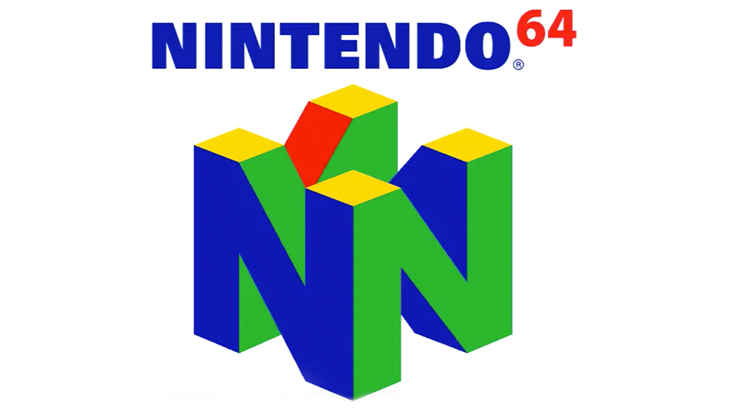

[6]
[7]

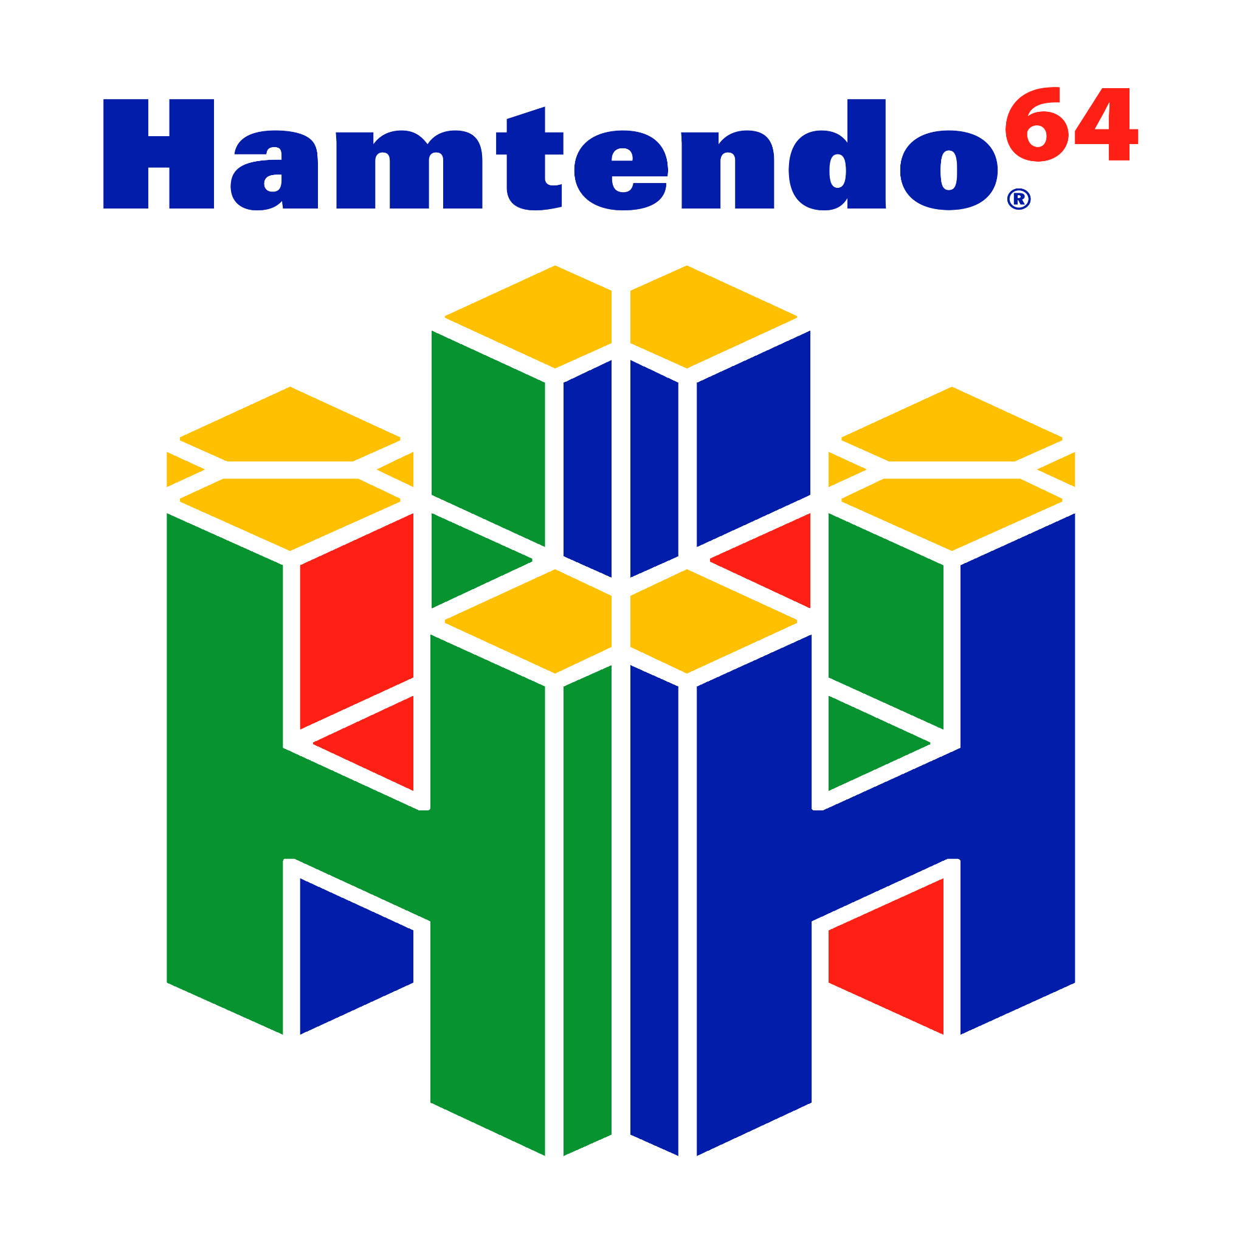

The other set of graphic design that I did was revamping the character portraits that appear in game to their more realistic counterparts. Those are also shown below:
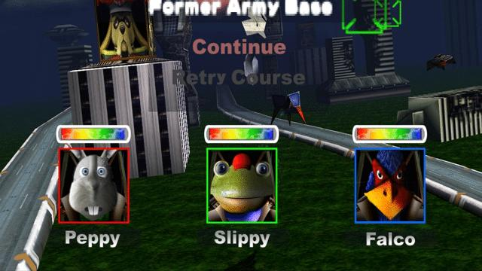
[8]
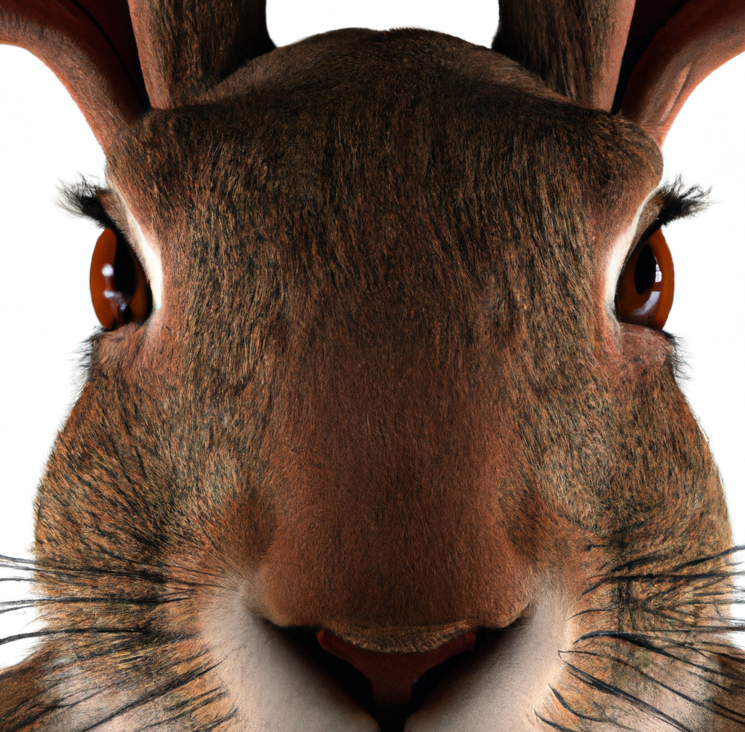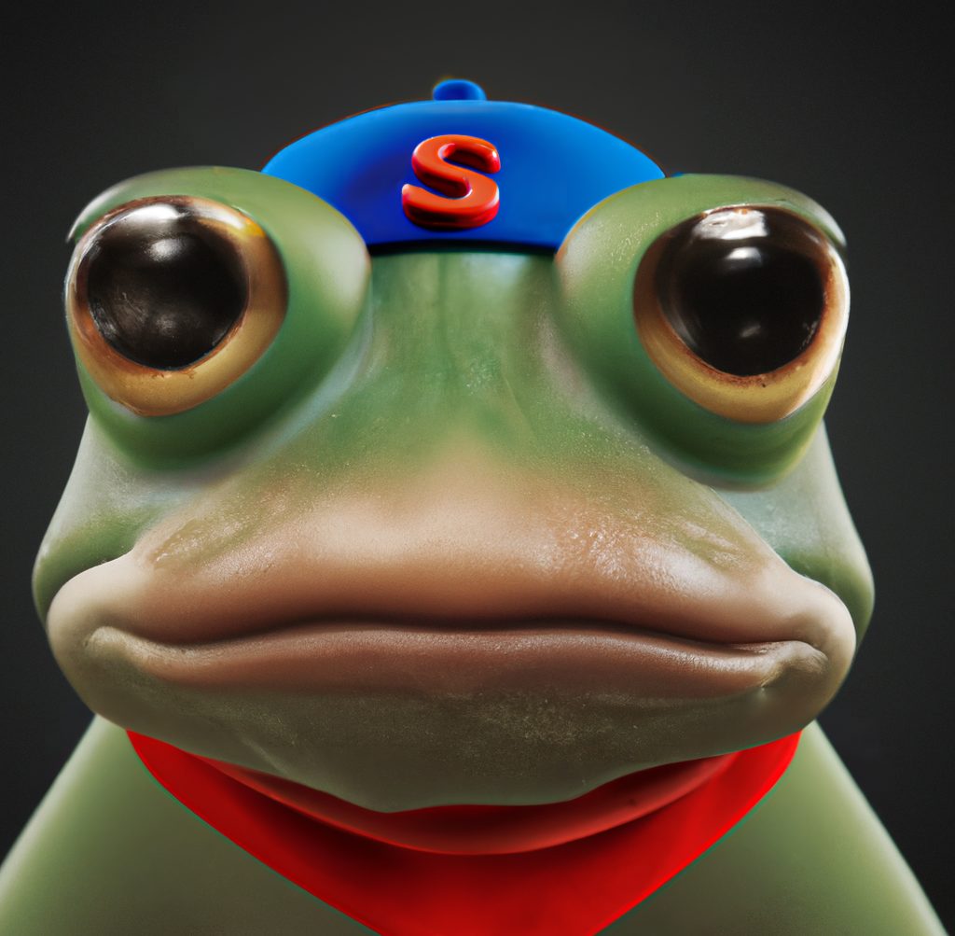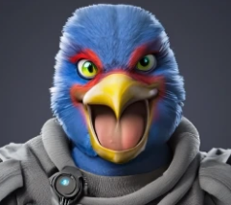
In regards to models within the game, below is a render of my updated Arwing model:
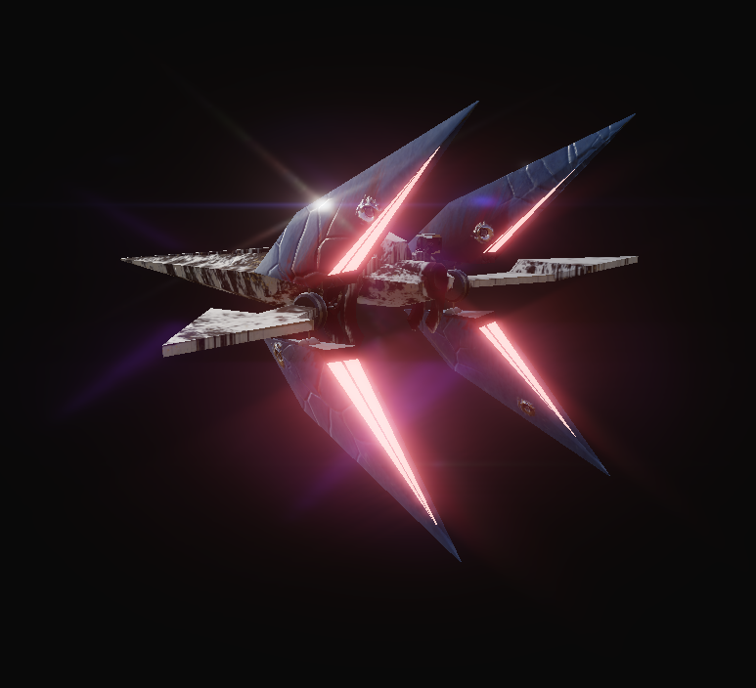
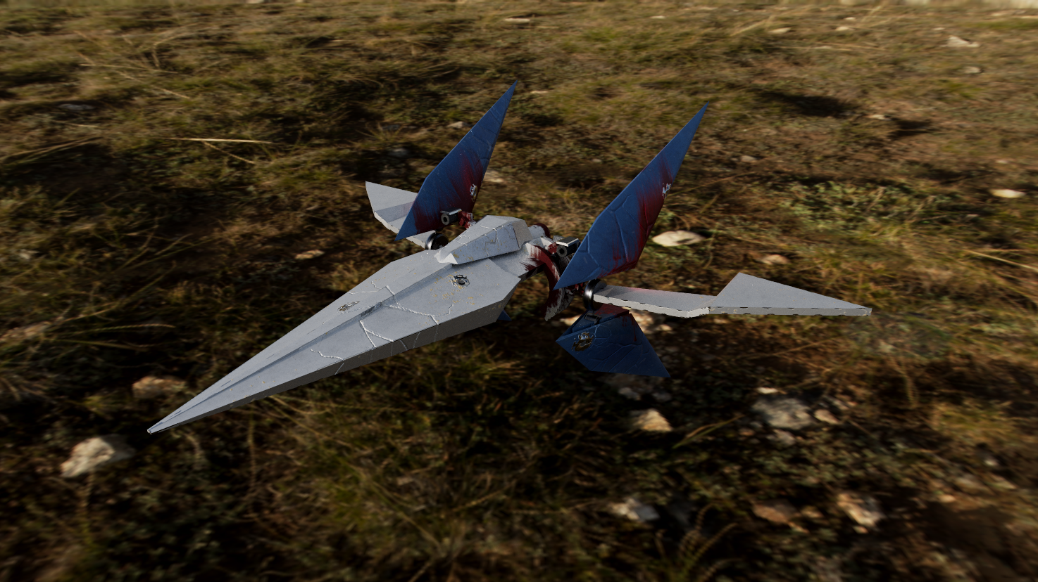
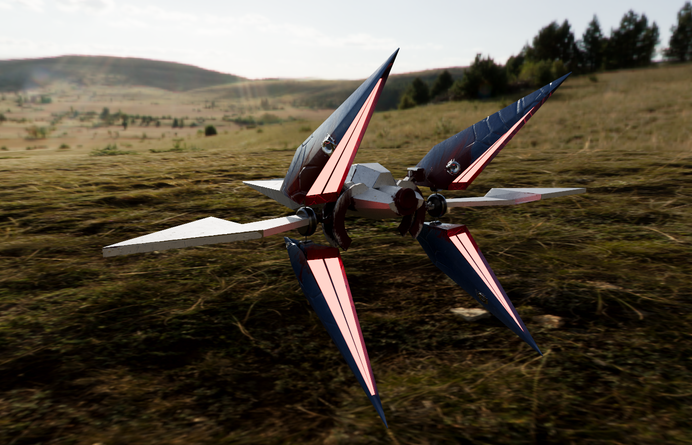
An additional thing that I did was to use FL Studio to create and compose both a main menu track as well as a remix of the original Corneria level soundtrack. I then used these in my project. The Corneria Remix consisted of a chopped and screwed version of the original soundtrack and I added drums and bass on top, essentially making it a drum and bass remix. I did this specifically to keep in line with the theme of the game and to make players feel like they have to be on the edge of their seat at all times. Drum and bass in games has always been something I have had a personal interest towards. My initial inspiration stems from a song called Nocturne by an artist named Keeno, this song is also featured in Forza Horizon 2 [9]. The hard hitting bass just keeps me so engaged when I’m playing any game, let alone FH2.
In regards to actually researching, the majority of the time, I used Google as my search engine of choice. It is regarded as the most widely used or popular search engine and for good reason, it provides me with the most relevant results the quickest. I also used Arwingpedia for all things related to Starfox. This helped immensely as this is where I found most of my information that helped me with things like logos, sound design, and modelling/texturing.

Project Reflection
This project has tested me in more ways than one. As a whole I believe that the practical work and research part of it went okay. I only really had issues with importing my models into Unreal Engine and that is what caused my downfall. If I had done a little more independent learning into Unreal as a program, I may have been able to create something I was proud of. I am still happy, the work that I did do, the models that I did create, look amazing. I am proud of how far I have come in terms of personal growth, however the glaring issue and what upsets me most about this is how I couldn’t get any of my work into the engine.
I wish I spent a lot longer having a proper look into the template and what I was able to change and what I could do with the skills and abilities that I currently have. It was definitely silly of me to think that I could remake a whole game, on my own, within the given timeframe of this assignment. I should have just used my time well and created assets that had nothing to do with an existing game. To modernise something that already exists took a lot longer than if I were to just make my own ideas come to life. Granted this was a thought process but I was so stuck on the idea of Starfox that I couldn’t do anything to get it out of my head, and I was thinking that if I started something else then I wouldn’t have enough time.
In regards to research, I spent a fair chunk of my time on this project researching and making sure everything was going well and kept in theme with the original game and the vision I had for my project. This meant that I was spending days on end just reading about the game, the composing of the music and sound effects, the art and the game design behind it all. I believe that I have done a great job when it came to research as it allowed me to make most of the models with all the information I had and all of it really contributed towards making my work, well, mine. In regards to improving my researching skills I could look into using different search engines or looking at game journals or even attending / watching conferences that talk about the games I have such a keen interest in. These outlets can also help me with any further projects or research I will be conducting. Another method of research I could have implemented is a survey, to ask people I know and their friends, if they know about on-rails shooters and what sticks out in their mind when it comes to a game like this.
After reflecting on these thoughts, it is definitely something I will be implementing in the future and if I am stuck on something, I will be asking for help. No question is a stupid question when it comes to education and the betterment of oneself's knowledge. I want to be able to make use of everything I have learned in order to create something that I am truly truly proud to call my work.

References
[1] “Star fox 64,” Wikipedia, https://en.wikipedia.org/wiki/Star_Fox_64 (accessed May 17, 2023).
[2] “Star fox 64 3D,” Wikipedia, https://en.wikipedia.org/wiki/Star_Fox_64_3D (accessed May 17, 2023).
[3] “ESRB ratings guides, categories, content descriptors,” ESRB Ratings, https://www.esrb.org/ratings-guide/ (accessed May 17, 2023).
[4] I. Harris, “Pegi ratings - what do the labels mean?,” CyberSafeScotland, https://www.cybersafescotland.org/post/pegi-ratings-what-do-the-labels-mean (accessed May 17, 2023).
[5] “Star fox 64,” Logopedia, https://logos.fandom.com/wiki/Star_Fox_64 (accessed May 17, 2023).
[6] I. Dean, “Can you spot the mistake in this iconic N64 logo?,” Creative Bloq, https://www.creativebloq.com/news/n64-logo-fail (accessed May 17, 2023).
[7] “Official nintendo seal,” Super Mario Wiki, https://www.mariowiki.com/Official_Nintendo_Seal (accessed May 17, 2023).
[8] “Star fox 64,” IMDb, https://www.imdb.com/title/tt0241985/ (accessed May 17, 2023).
[9] A. Harrison, “How video games are breaking the Drum & Bass Artists of Tomorrow,” VICE, https://www.vice.com/en/article/4x8vmg/how-video-games-are-breaking-the-drum-bass-artists-of-tomorrow (accessed May 17, 2023).

