Network Operating Systems Assessment
Paper Number Three
Mark L. E. Vaughan
#Undergraduate, University of Wales Trinity St David
Swansea Wales
1909160@student.uwtsd.ac.uk

Abstract— This document is the third of four papers detailing the practical work and observations to install two virtual networks utilising the Microsoft Hyper-V software. As part of the Network Operating Systems assignment.

Introduction
This document details the activities and observations concerning the procedures listed in worksheet no three as written by Lee Cobley. There have been several changes to the demonstrator system as implemented in worksheets one and two. These changes came about as the result of file corruption of the virtual machines. The cause for the deterioration of the data files is in the process of being investigated. As of the time of writing, is undetermined. To save time, the drive files were transferred to a Microsoft Hyper-Visor based virtualisation system that offers almost identical facilities except that it does not natively support USB technology. The virtual machines could be run on extended mode to enable USB use, but it is not used as the time and trouble in implementing it is not worth it for this exercise. The author has added three additional user accounts to the domain. The accounts were added to support three functional areas. Alice Minee-Straytor is a user with administration roles except for domain admin. This user will represent the typical mid-level manager with a degree of responsibility for local policy and site management. Bob Std Euser takes the role of a regular system user with limited accessibility and no administrative function. The role will be used to check standard access policies and restrictions set by group policy. Carol Hakker is the account used to check for denial settings and restricted access rules. The role is essentially the same as a standard user. Still, it is purposely used to assign denial permissions and be excluded from specific policy groups for testing purposes. As the worksheet was performed, the instructions specifically required a new user to be created to check the NonAdminUser policy organisational Unit (OU). Following the alphabetical nature of the new users, the account name given was Dave D'Falt. This account was used exclusively for the testing of this policy.

Configuration
The worksheet details the steps in implementing Active Directory (AD) group policies to control the activities of computers, users, and functional groups to form a secure operational framework upon which the network can be run in a secure manner. As is standard procedure, the worksheet was read, requirements noted, and a plan of action was instituted. Since the early nineteen nineties, the author has experience in installing and configuring numerous network operating systems, including BSD, windows NT 4.0 (client and server), and a limited time with IBM AIX. Other operating systems experience include the use of Unix clones that are mainly GNU based Linux and include Slackware, CentOS, Red Hat Debian and Suse versions. This experience was helpful because the completion of the worksheet process occurred with no problems and was understood completely. This result would make for a concise and boring report, however. So, the author will submit the following observations for evaluation.
The introduction of network-level system management came late in the development of computer operating systems. Early management tools revolved around directory and file access permissions as typified using group and user IDs in Unix based networks. The CHMOD program managed the attributes that used command line parameters to change permissions on a file's Read, Write and eXecute bits in the file header. The program itself having been set as only able to be run by the root's users' group. Directories were treated as files by the operating system. Networks based on these systems were generally small and easy to manage. As computer hardware and storage became cheaper, networks became larger and more diverse. Large networks were spread across multiple locations and lined with dedicated communications links and fledgeling digital subscriber lines. The Management of these networks became harder to manage using the existing file-based management methods. Security was also becoming a major problem as early operating systems were centralised and had little user control. The newer networks were PC based and, if not properly managed, would form a major source of problems from user tampering, the capability for unauthorised access and the new malware threat of worms and viruses. Third-party software solutions were created and did solve some of the problems. However, with the introduction of Windows NT in 1993, an integrated network-based management solution appeared, which allowed the implementation of security and operational policies to be used. Based loosely on the Microsoft registry system, the policy system was managed by the Poledit.exe program that an administrator could run to create and modify a permissions database that ran the network. The range of policies was limited to mainly localised user groups and hardware settings. Some windows command functions could also be controlled. Editing was performed in windows three style dialogue boxes. It was tricky to navigate and with the introduction of NT 4.0 in 1996 became even harder to administer and could not manage multiple domain networks easily. In 1999 with the introduction of Microsoft's first truly server-based operating system called Server 2000, The appearance of Active Directory changed how server-based networks could be managed. At this time, Active Directory was Microsoft's implementation of a design philosophy known as Object Orientation (OO). The introduction and widespread adoption of the C programming language led to the introduction of OO based code into the operating system development. This coding first manifested itself as the Hardware Abstraction Layer that was a new layer at the base of the operating system stack. This change avoided interfacing manufacturer-designed device drivers that presented a wide array of nonstandard interfaces. The use of the HAL hid the underlying rat's nest of re-entrant code points and interrupt calls and forced the manufacturers to code to the OS providers defined standard. This new standard had the effect of disconnecting the functional code from the tyranny of hardware specification. The change also made system programming more reliable as developers could no longer access hardware directly and interfere with the operating system status. It encouraged application developers to simplify code complexity as a standard application programming interface for system devices was now available. With Active Directory, the introduction altered how networks were run. Previously network controls were centred around the file system and user groups. Active Directory now utilised the obfuscation features of Object-oriented programming and hid these functions as a set of primitives within the directory system. Instead, the network was organised as an abstracted system of object groups that contained interchangeable objects which controlled other abstract features of the network such as users and devices. This new hierarchy of controls now meant that administrators could implement policy, set global permissions, and define access rights across groups of networks in different but related domains without prior knowledge of anyone system. As the system was hierarchical, local amendments could be implemented by local domain admins to cope with local conditions and not worry about contravening global directives and restrictions as global settings always had priority. The directory system is so effective that in normal day to day administration tasks, access to the directory security settings is rarely needed. Most of the permissions could be set remotely by Active Directory. In the past Non-Microsoft companies such as IBM, Honeywell and Control Data have tried to adapt their Unix operating systems to provide this kind of network control by incorporating wheel accounts, SNMP and NFS protocols with limited success. The reason for this is that the UNIX operating system was designed around mainframe operation. In contrast, Windows has based on DOS that was exclusively designed for the new personal computers introduced by IBM in 1981. Even as windows has developed, the core of windows is DOS-based, and until Windows 8 could be determined by entering VER on a command line and would display DOS Version 7. With the introduction of Windows 10, the command now displays the windows version. Over the years, the author has experimented with trial versions of Microsoft server systems and found them to be the superior choice from a system administrator view. Microsoft still cannot get clients to synchronise active clients with changes to the policy immediately without logging out the user as experienced when completing this worksheet. The alternative is to wait ninety minutes for the system to run a global refresh.

Observations

Differences between Local Permissions and File Shares.
Before an objective comparison between network shares and local permissions can be made, the design context must first be considered [2].
Local permissions are based on the files and directories that they protect. These files and directories are local to the computer they reside on. The scope of their operation is limited to that computer. These permissions are based on the operating systems inbuilt management structure [8]. With UNIX/Linux operating systems, these are user id's (UID) and Group id's (GID). The Microsoft based operating systems such as Windows and Server Operating systems use a similar and pedantically differently named set of management groups [12]. The origin of this protection system stems from the old operating systems of the past that were conceived using mainframe technology where there was only one main Von Neumann based computer that had facilities that allowed multiple users to access and operate. The files/directory protections being restricted to the computer. Later as technology developed, newer, more capable operating systems like UNIX arrived and offered time sharing and concurrency features, but still used the older file system code, which used local permissions protection. The arrival of the Disk Operating System (DOS), later MSDOS, used a much-reduced version of UNIX, borrowing many of the features of the older OSs in a simplified form. The introduction of NT or New Technology further improved on the existing DOS-based permissions making them more appropriate for the emerging network technologies coming into existence at the time.

The introduction of linked computer networks created new problems and opportunities for file system technologies. The addition of new computers made the complexity and depth of the hierarchical filing system problematical. To access a file on a non-local computer, the user would first have to register their account with the target computer and then navigate their way through the target computers directory tree system to locate the file required. All this would be done assuming that the user knew which computer held the file. The solution to this problem was NFS or the Network Filing System that created a network level of system management [11]. Its most valuable feature is the Shares feature. Network shared obfuscated all the details about file/directory location and provided a single access point for networked users. This link simplifies network access and avoids individual user registration on target computers as the connection is via a dedicated network access account and not the users' account id. The shares are managed from the serving computer by the administrators. They can be created with network-level restrictions such as setting the maximum number of concurrent connections to the file/directory. The share can set limits that reduce network congestion and offers improved network security as the share isolates the asset from network users.
To summarise the differences between local permissions and network shares, the following facts apply:

- Local permissions on directories/ file offer a more granular security method, unlike shares which are easier to manage and more generic.
- When used together, the most restrictive permission will apply when a filesystem asset is accessed.
- Network shares can be applied to non-Microsoft file systems. NTFS is a Microsoft proprietary file system [15] and has no interface with other files systems such as FAT32, ZFS, EXT3 or ReiserFS.
- NTFS file permissions only apply to users logged on the server locally. Network shares do not have this limitation [13].
- Network Share permissions can limit the number of users on a connection. NTFS cannot control the number of users accessing the directory/file.
- Both Shares and NTFS folders can be mapped to a network drive.
- Failure in permissions security affects only that one asset. Failure in shares permissions can affect users across the network.

Network shares also carry their own set of permissions and user access controls. These are accessed through the Advanced sharing button found in the shares properties tab.

3 b) Describe the role of Group Policy Management in the network environment. You can use example policies in your answer.

To define the role of group policy management in a network environment, it would be a good idea to describe what group policy is [9]. Simply put, a group policy is a collection of permissions and restrictions that are assembled as a group to apply to a designated set of users or network devices as part of a general operational policy. System administrators will create group policies to cover the network's unique aspects after implementing a standard policy set if the operating system has no default policy set installed. As implied, there will be many group policies in an operating system, each of which will cover the organisation's security/integrity/confidentiality requirements. A simple example of this is the requirement to restrict powerful system commands to system administrators only. At Swansea University, if a student attempts to open the control panel on any PC attached to the central system, the student will be presented with a skeleton set of controls based on the useability settings. This situation does not apply to SOAC as this is the university authorised den of iniquity used as the training ground for ethical hackers, hardware trolls and cyber geeks. The group policy will not give access to command-line options, drive management or network management controls as these features have been granted only to the administrators' group. Student, teaching, managerial and clerical staff all have these restrictions as the group policies for these user groups all fall into the non-administrator group. This setting highlights a key feature of group policy administration. The ability for a policy group can contain other group policies as a permission/restriction requirement [14]. The use of a 'super group' that operates over other group policies means that applying a broad set of restriction can be made easier to manage by simply adding the subordinate groups to the policy list. This organisational abstraction avoids the need for the administrator to write the new policies into the existing group policies piecemeal. It means that the networks administrator does not necessarily need to know specific details about the settings applied to each group of users or devices to implement policy. As mentioned in the previous section on permissions and network shares, the more restrictive policy element will be applied. Network policy may give read and write access to a network asset. Still, suppose an included group policy has a more restrictive setting. In that case, that component will override the network policy, so if students have a read-only setting in the students' group policy, the write permission is overridden.
So far, group policy has focused mainly on access rights and permissions. From a system administrator's perspective, group policy can be more useful where resource management is concerned. In networks where lightweight clients are predominant, the storage of files and data on the local machine is not allowed. This restriction is because most configurations rely on mandatory roaming profiles [14] that clear all changes to file storage and operating system settings when shut down or when the user logs off. For this reason, the profile will contain a group policy setting that will map the user's documents and other personal directories to a network folder and optionally may assign a standard drive letter for the same. Standard roaming profiles will save all the user's desktop and private directories to NAS storage on disconnection and massively increase network transfer and disk access times, so their use on small networks is not recommended.
The use of group policies can be applied to network resources such as databases and communication assets (webserver, video archive etc.). High demand and speedy access are a prime requirement for these resources by configuring network devices to optimise these resources using a system policy [16]. An administrator can control the availability of the resources to key user groups. Extra bandwidth or capacity is needed. Changes can be easily made to the policy to provide extra routing, service priority, and expanded disk quotas available on the systems refresh of policy settings. Less essential but still problematic is the control of web-based access. Because of web technology's open and straightforward nature, the ease in which script kiddies and trolls can corrupt these services, and the criminal goes without saying. For an administrator, the first line of defence is the expedient of controlling browser access and functionality. A group policy can help define the use and configuration of web browsers by restricting which sites can be accessed using access control lists, disabling browser add-ons, rejecting cookies, and clearing the browsing history on exit. Additional attention will also need to be focused on pop-up applications and self-loading applets. Home page and tab management can also be customised to restrict access for unauthorised users.
.

Give some examples of sound 'password' principles in modern network environments.

Since the invention of terminals on computer systems, the user password has been the first security line for any operating system. The use of passwords allows the users to control access to files, directories, and settings; therefore, any password must be challenging to discover and be ideally unique to the user. Currently, the default for system passwords is for the password to have a minimum of eight characters, at least one uppercase letter and a number. This combination is perfectly suitable for human decoding methods but computational based decoding quite inadequate.
As an entity, a password is a straightforward thing. It is essentially a string of eight-bit binary digits of variable length. This characteristic means that there are two hundred and fifty-five possible characters available for each position within the string. It should be noted that zero is a valid character for a password. The security of the password depends on the mathematical complexity of the password. The definition of complexity is defined as the available number of characters multiplied by the length of the password squared minus one. As an example, an eight-character password would have 8*255²-255 or 62,985 possible combinations of characters. This value would mean that any potential cracker would have to try 62,985 combinations of symbols to discover the password in what is known as a brute force attack. The addition of extra characters to the string will increase the number of combinations, and if long enough, the brute force method would become too long to decode and hence ineffective. From a mathematical point of view, a good approach. However, there is a problem. As humans need to type the password into a terminal, a human-readable ASCII character set would have to be used. This limitation reduces the set of possible characters from 255 to 95. Therefore, the original value of 62,985 is reduced to 8,265 permutations, making for reduced mathematical complexity and a brute force attack more feasible.

An essential consideration in password planning is dealing with the significant security loophole known as humanity. Your average bog-standard issue human has several characteristics that can effectively subvert password security. They often have poor memory, are inherently lazy, often resorting to shortcuts and subject to flawed reasoning. Examples of the latter, including the false premise that swear or socially unacceptable words, are harder to decode. The substitution of characters with numbers is more difficult to decipher, and the omission of vowels would make the password less readable. The fallacy of all of these is the assumption that a human will be doing the decryption. From a computational perspective, all of these 'methods' have no effect [6]. Swearwords are just another series of characters; substitutions do not change the number of characters, and omission simply reduces the mathematical complexity of the password. People find it hard to remember complex passwords or passwords that do not follow a pattern where poor memory is concerned. This deficiency leads to the habit of writing passwords down on paper(insecure) or constant reissuing of new passwords when the user forgets the assigned password.
A brute force attack is not the only method for uncovering a password. With the introduction of GPU core processing, the ability of password crackers has made the traditional password design methods obsolete. The introduction of the Hashcat software now allows up to 16 million passwords to be discovered per second. The primary mechanism for the software is the use of data dictionaries [5]. These dictionaries work by listing artefacts found in passwords that occur because of linguistic characteristics, password methodology, and cultural artefacts. These dictionaries allow the processing to be focused on detecting the patterns rather than a straight brute force approach. The result is that the decryption times can be significantly reduced. Attacks on individual accounts also make use of social engineering methods. Applications such as Facebook and Twitter can hold details about an individual that crackers can use. Human nature being what it is, users have the bad habit of using personal information to create passwords. Examples of this include using birthdays, important dates, national insurance numbers, and children's names, to name a few. Using information gathered from hacking a social media account, cribs based on the details taken can decrypt the password. Other decryption methods [5] include frequency analysis of common letters, the indexing of letter pairs (an artefact of encoding diphthongs) and cyclical pattern detection.
The question now is how to create challenging (strong) passwords. As previously mentioned, older and more traditional methods of password construction are inadequate. The first principle is to make the password long with more than twelve characters in length; this will increase the mathematical complexity of the password. The more characters, the better. The second principle is to avoid using commonly used words that would be contained in data dictionaries. The third principle is to include non-alphabetic characters randomly in the string, preferably replacing the space character to hide the transitions between words. With these three principles in mind, a simple method is to select four words that do not appear on the list of two thousand most used (English) words. Then replace the intervening spaces with three non-alphabetic characters. This method is easy to remember; it will be long (16-25 chars) and make the data dictionary primarily ineffective. It will be still prone to some forms of decipherment but will still be difficult. An example of this method is generic!Hominid" sunhat$161. Kasperski [7] proposes another technique. It relies on a key phrase such as 'I want ice cream! For dinner in Kentucky?' which is modified by taking the first two characters from each word and capitalising the second character. This operation creates the password 'iwAiCcRfOdIiNkE', which is 14 letters long and is quite strong. Additional complexity could be added by adding a unique character and a three-figure number.
The best password creation method would be to remove the human component and rely on a random letter generator that would include uppercase, lower case, numbers, and special characters as part of the selection. Remembering the password would be inconvenient for most people, so that a password manager would be ideal. The use of these managers would secure many passwords and, if secured with a simple password and a hardware encryption key [17], would be very secure. The author uses this method for maintaining password security by using the LastPass manager and a YubiKey USB security key.

Bibliography and References
[1] J. (Director of G. S. E. at N. Melnick and ., “Differences Between Share and NTFS Permissions,” https://blog.netwrix.com/, Accessed: Apr. 29, 2021. [Online]. Available: https://blog.netwrix.com/2018/05/03/differences-between-share-and-ntfs-permissions/.
[2] “Differences Between Share and NTFS Permissions.” https://blog.netwrix.com/2018/05/03/differences-between-share-and-ntfs-permissions/ (accessed Apr. 29, 2021).
[3] (Nottingham University) Prof. Mike Pound, “(216) How to Choose a Password - Computerphile - YouTube,” Computerphile. https://www.youtube.com/watch?v=3NjQ9b3pgIg (accessed Apr. 29, 2021).
[4] (Nottingham University) Prof. Mike Pound, “(216) computerphile passwords - YouTube.” https://www.youtube.com/results?search_query=computerphile+passwords (accessed Apr. 29, 2021).
[5] (Nottingham University) Prof. Mike Pound, “(216) Password Cracking - Computerphile - YouTube.” https://www.youtube.com/watch?v=7U-RbOKanYs (accessed Apr. 29, 2021).
[6] (Nottingham University) Prof. Mike Pound, “(216) How to Choose a Password - Computerphile - YouTube.” https://www.youtube.com/watch?v=3NjQ9b3pgIg (accessed Apr. 29, 2021).
[7] Anon., “Strong Passwords – How to Create & Benefits | Kaspersky.” https://www.kaspersky.co.uk/resource-center/threats/how-to-create-a-strong-password (accessed Apr. 29, 2021).
[8] D. C. S. University), “User Groups/UNIX Groups | Department of Computer Science Computing Guide.” https://csguide.cs.princeton.edu/account/groups (accessed Apr. 29, 2021).

[9] T. ) Thompson, “Group Policy Fundamentals in Active Directory -- Redmondmag.com,” Redmond Magazine, 2016. https://redmondmag.com/articles/2016/01/12/group-policy-fundamentals.aspx (accessed Apr. 29, 2021).
[10] C. Bachmann, H. Bischoff, L. Harris, C. Kaboth, and I. Mingers, “Setting up users and permissions manually,” 2018, Accessed: Apr. 29, 2021.
[11] “Network File System Version 4 (nfsv4) Charter.” https://web.archive.org/web/20080216083308/http://www.ietf.org/html.charters/nfsv4-charter.html (accessed Apr. 30, 2021).
[12] D. Hitz, B. Allison, A. Borr, R. Hawley, and M. Muhlestein, “Merging NT and UNIX Filesystem Permissions Network Appliance (www.netapp.com).” Accessed: Apr. 29, 2021. [Online]. Available: www.netapp.com.
[13] S. Voida, W. Keith Edwards, M. W. Newman, R. E. Grinter, and N. Ducheneaut, “Share and Share Alike: Exploring the User Interface Affordances of File Sharing,” dl.acm.org, doi: 10.1145/nnnnnn.nnnnnn.
[14] A. Frisch, “Beyond File Permissions: Controlling User Actions Windows 2000 Performance Monitoring and Tuning ‘New’ Approach?,” 2001. Accessed: Apr. 29, 2021. [Online]. Available: www.aeleen.com.
[15] “NTFS Permissions vs Share: Everything You Need to Know.” https://www.varonis.com/blog/ntfs-permissions-vs-share/ (accessed Apr. 29, 2021).
[16] “Best practices: sharing folders, NTFS+share permissions and the Everyone permissiion - Microsoft Tech Community.” https://techcommunity.microsoft.com/t5/windows-server-for-it-pro/best-practices-sharing-folders-ntfs-share-permissions-and-the/m-p/673125 (accessed Apr. 29, 2021).
[17] J. Lang, A. Czeskis, D. Balfanz, M. Schilder, and S. Srinivas, “Security keys: Practical cryptographic second factors for the modern web,” Lecture Notes in Computer Science (including subseries Lecture Notes in Artificial Intelligence and Lecture Notes in Bioinformatics), 2017. https://link.springer.com/chapter/10.1007/978-3-662-54970-4_25 (accessed Apr. 30, 2021).

*Access dates set to 29 April 2021 by reference tool. All reference accessed between 15 April onwards.

Screenshot Evidence

New Folder and important Document text file.
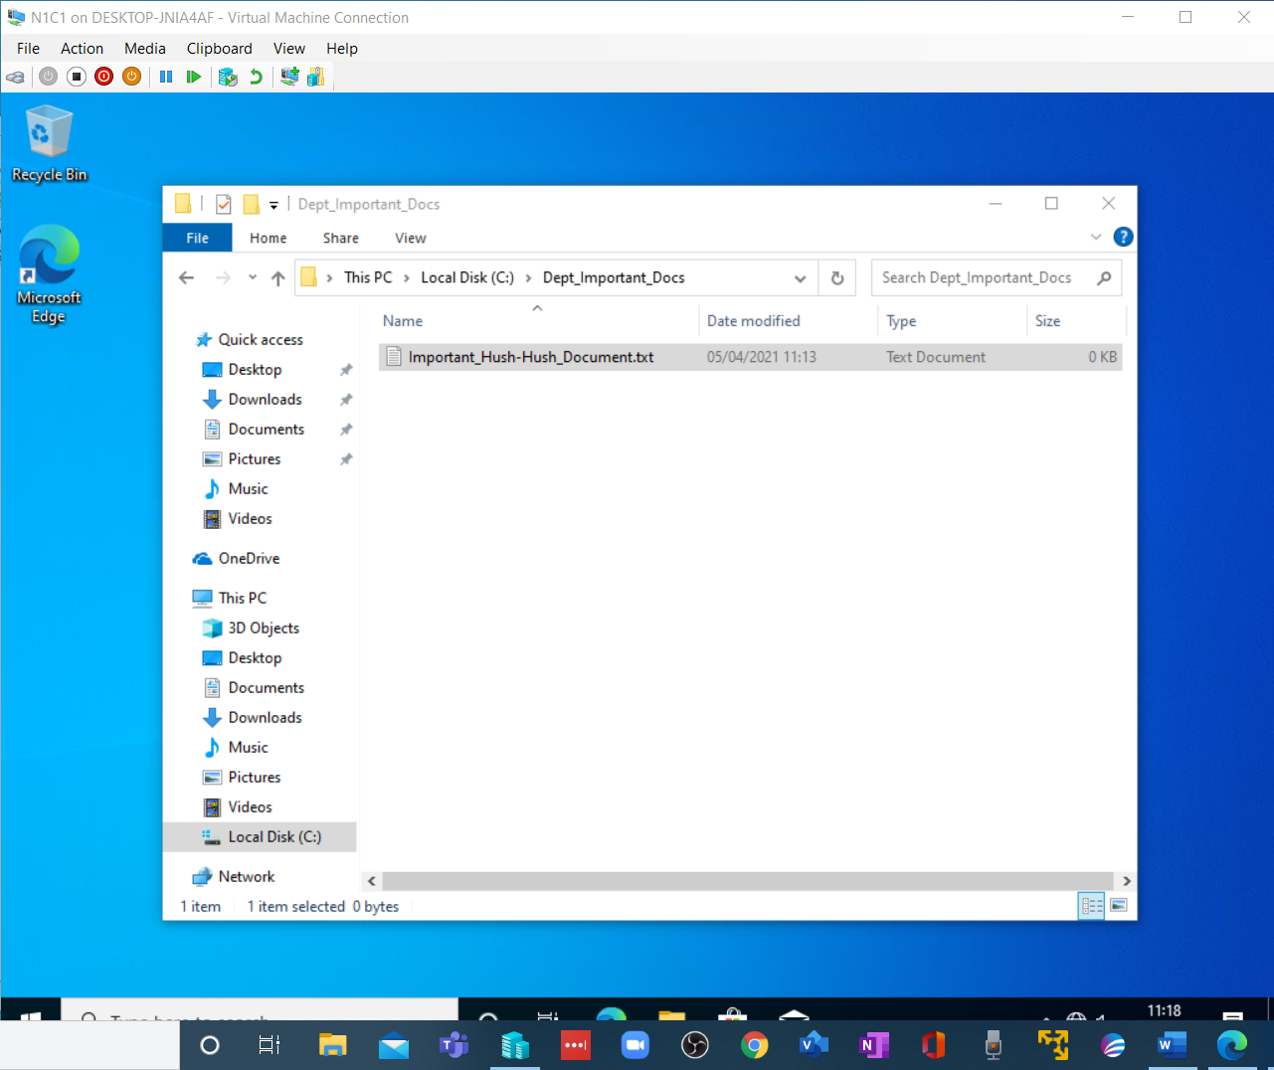

Initial Security Settings
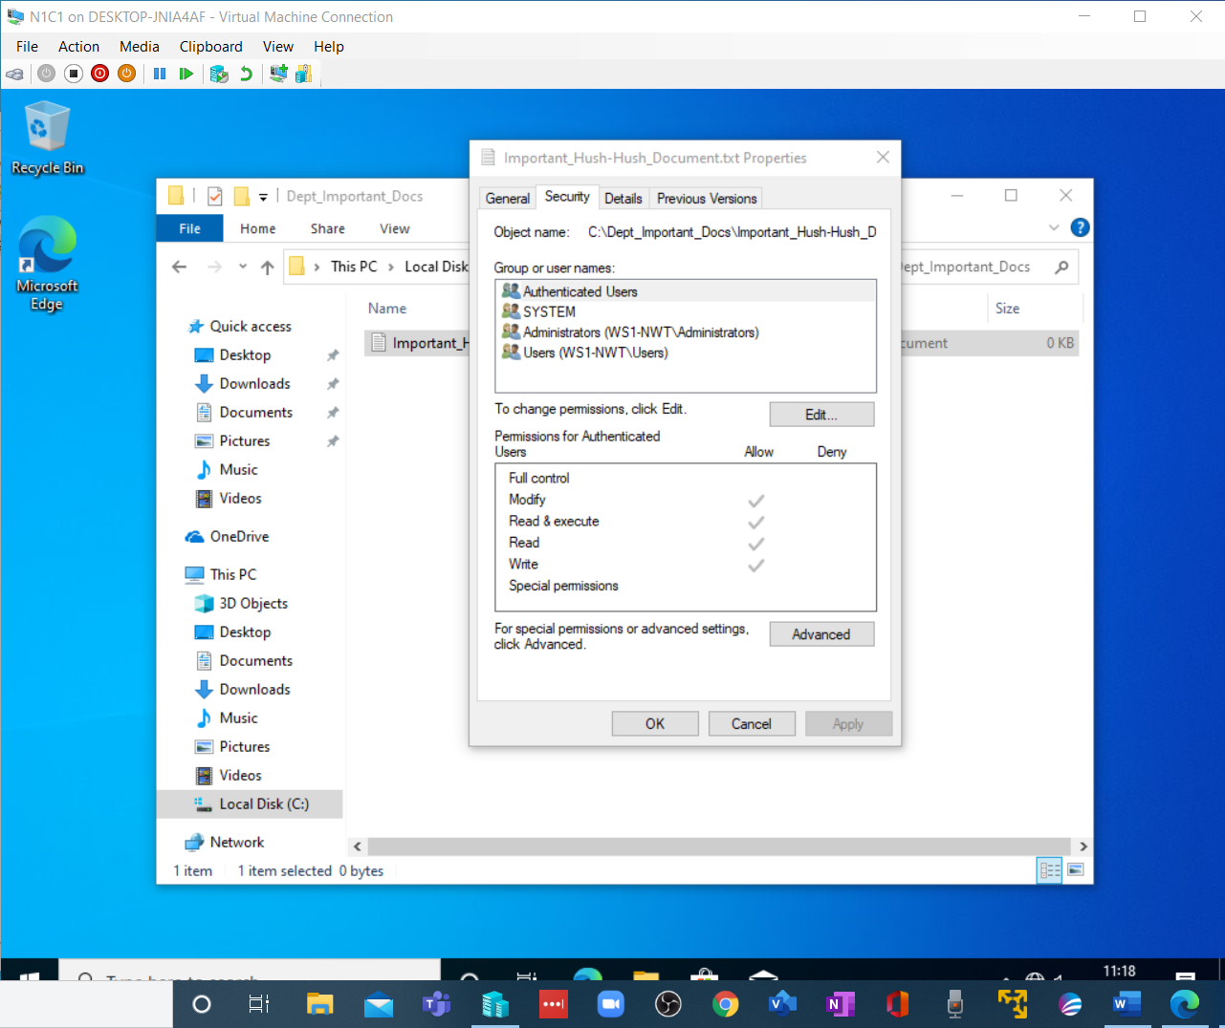

Initial Security Warning for Authenticated Users.
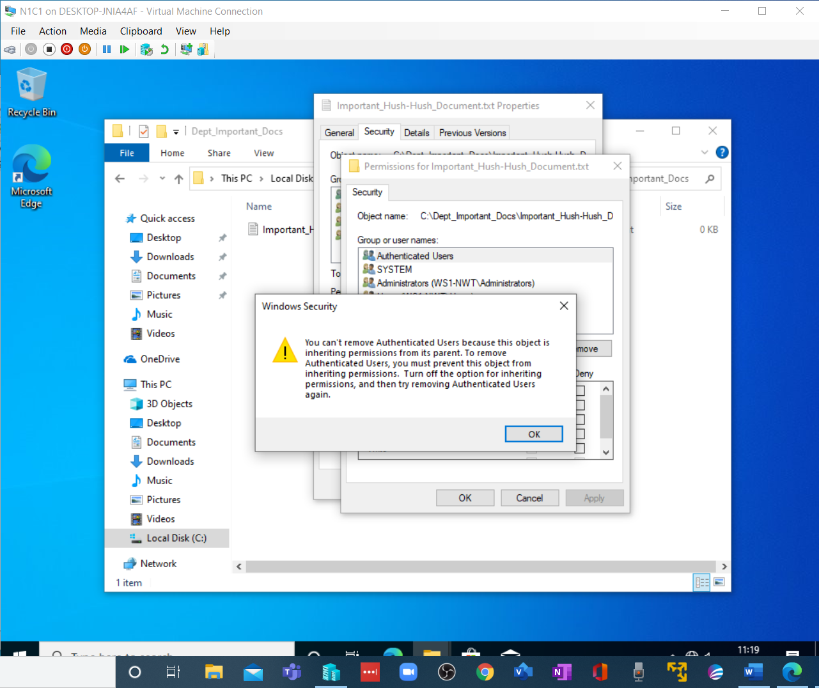

Inheritance Disabling Warning.
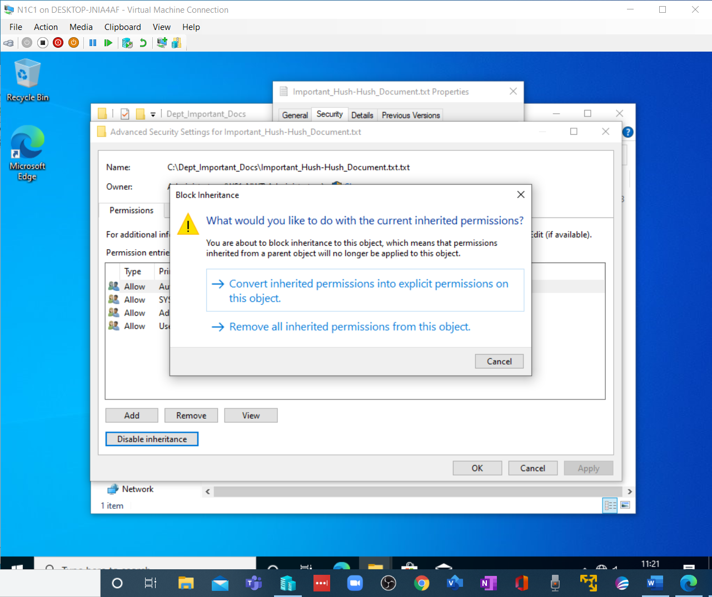

All Permissions Cleared.
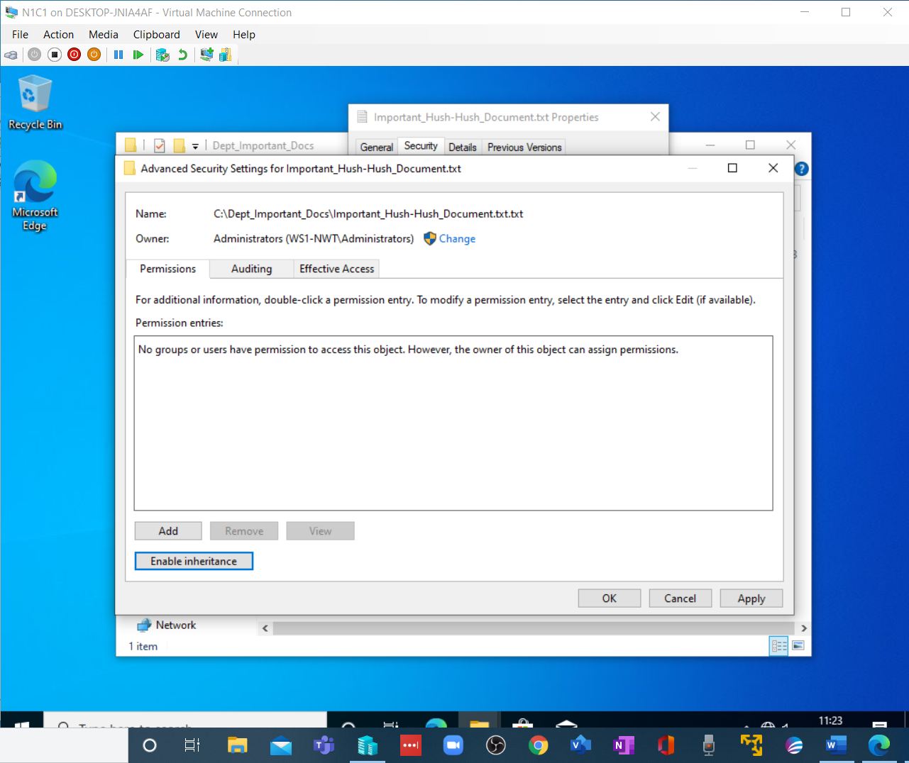

Now that the Administrator Rights have been added.
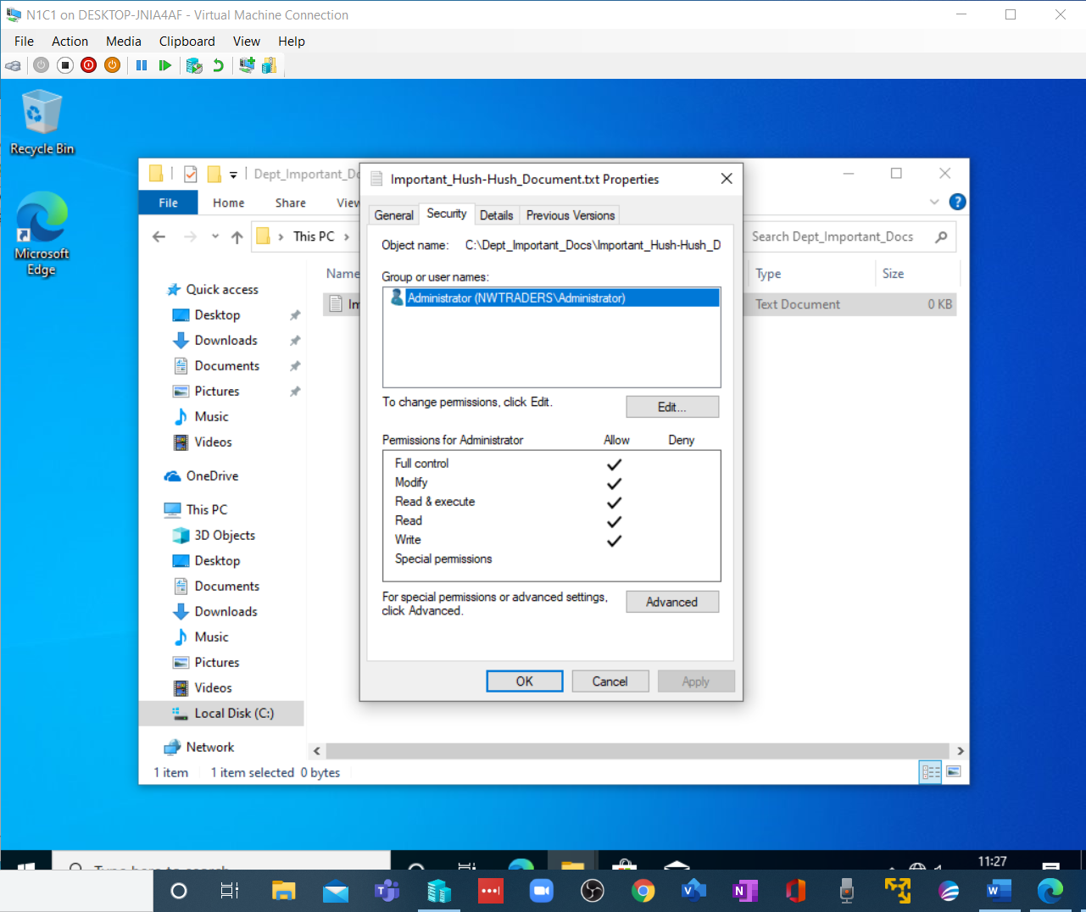

And Bob Has been given network rights, and Carol Hakker has been denied all access.
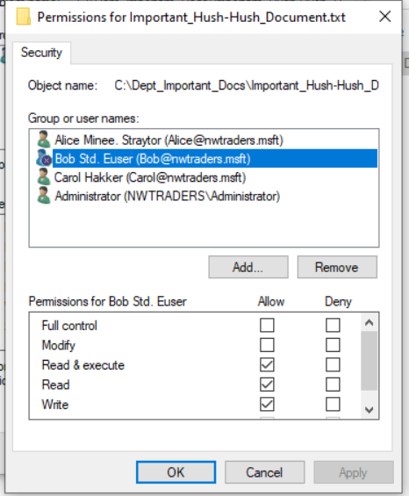
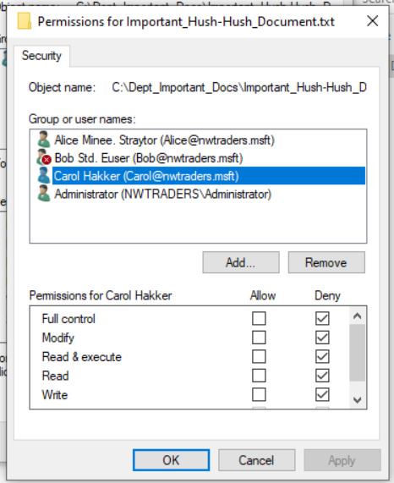

Now logging in as Bob, he can edit the file!
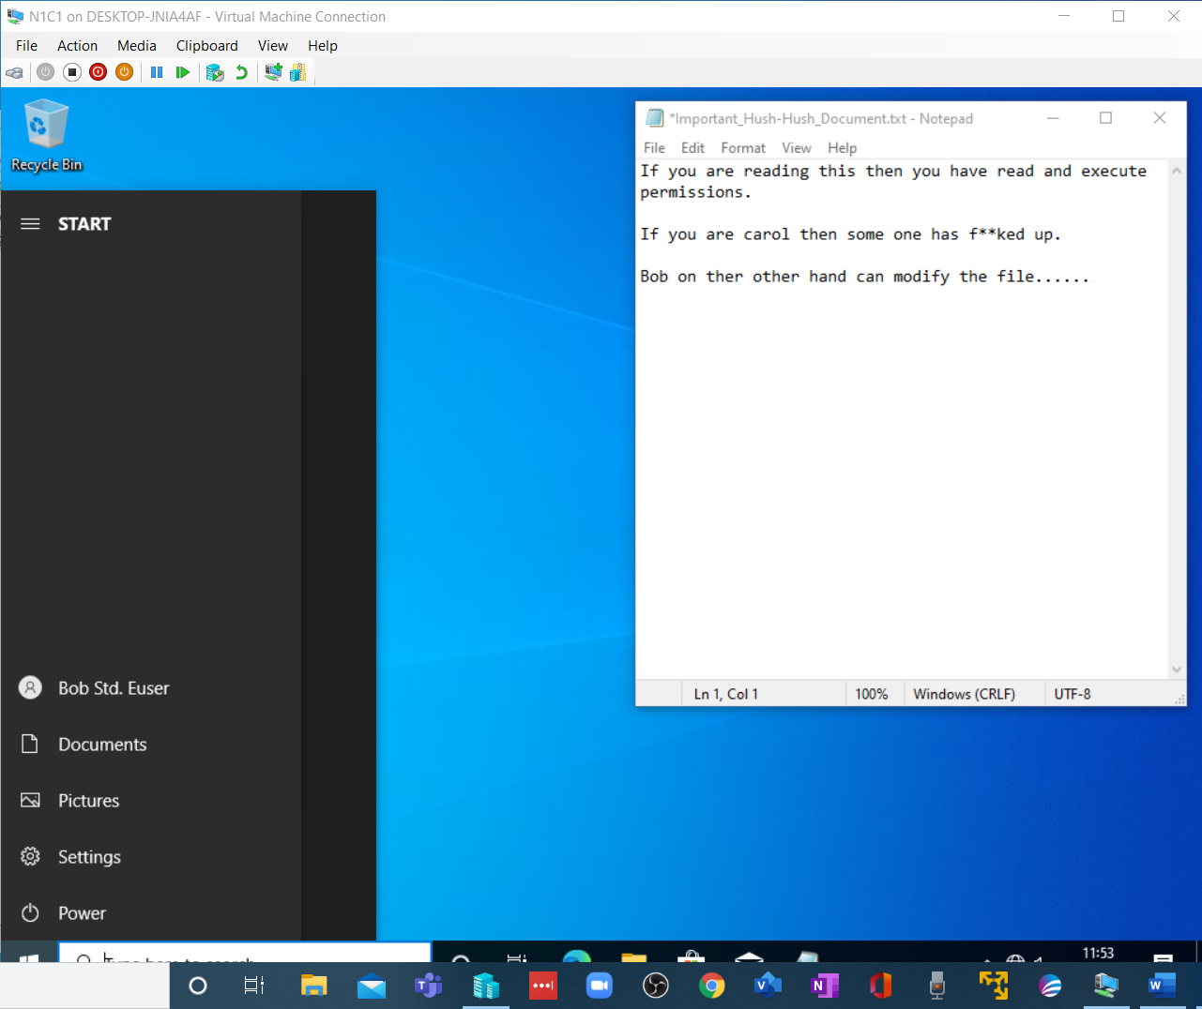

Whereas Carol Hakker Connot.
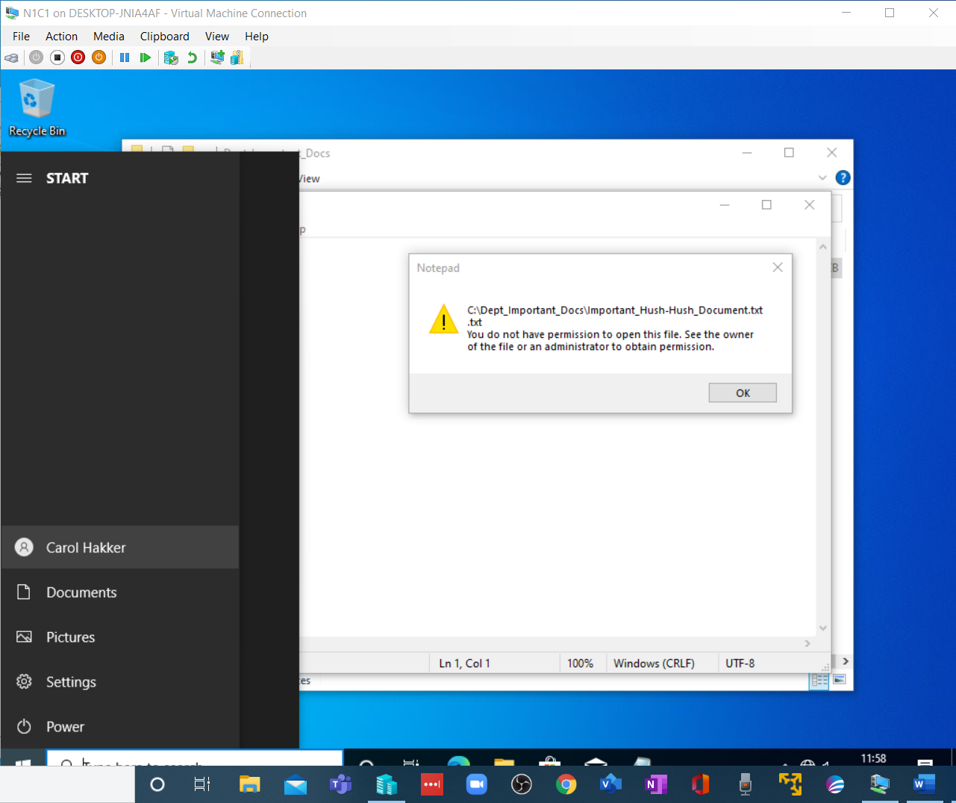

Share Permissions

The New Share Name.
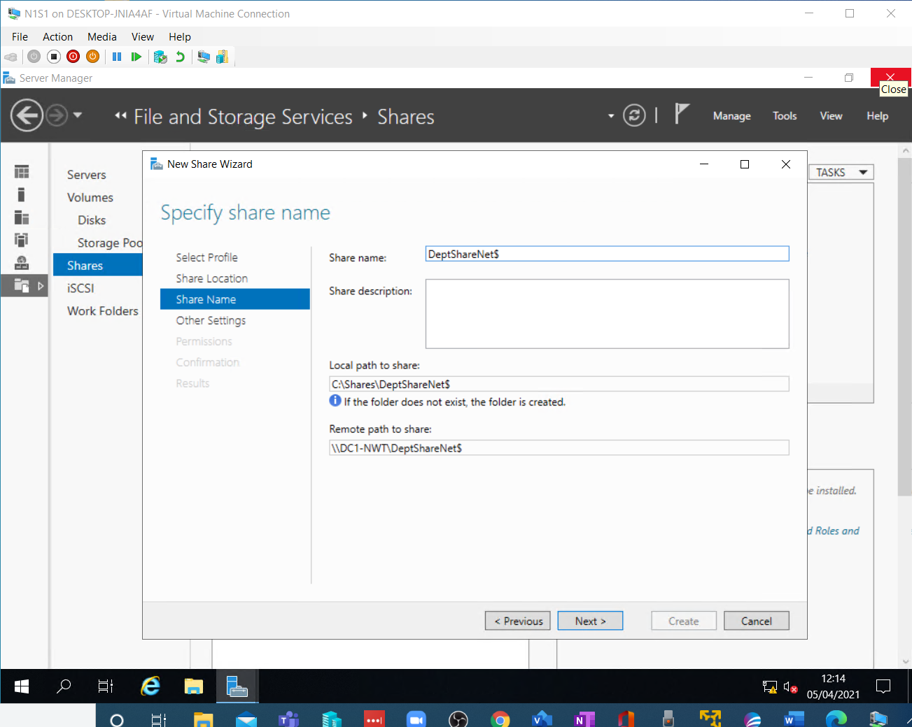

Then Set the Options.
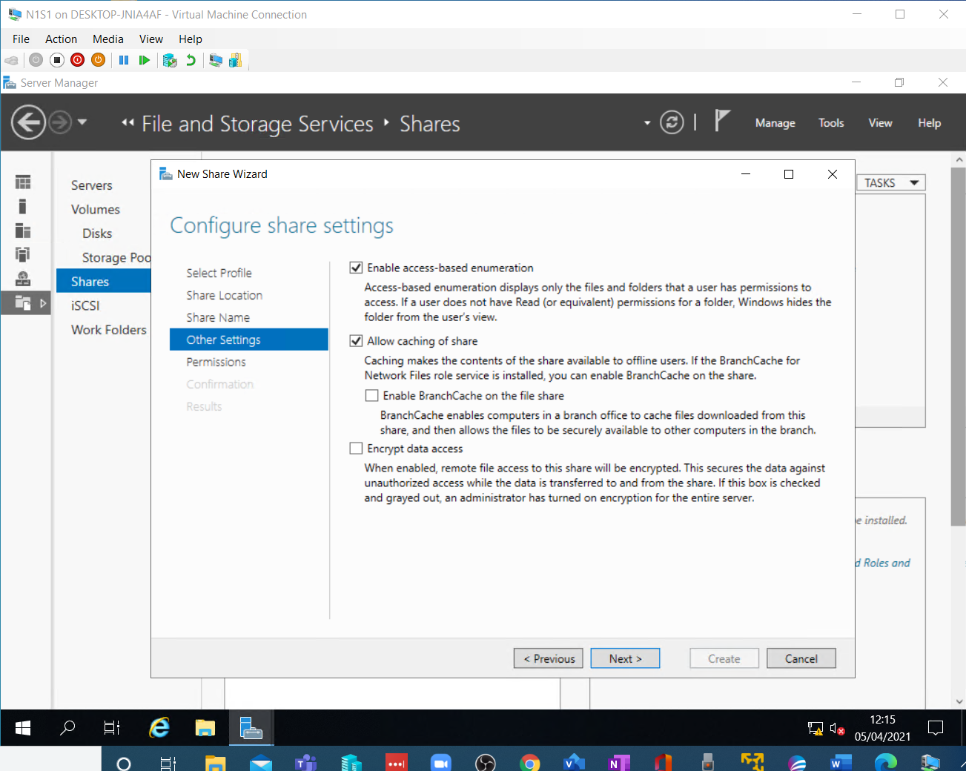

Then Having removed everyone from the permissions table, We add the domain admins and Users.
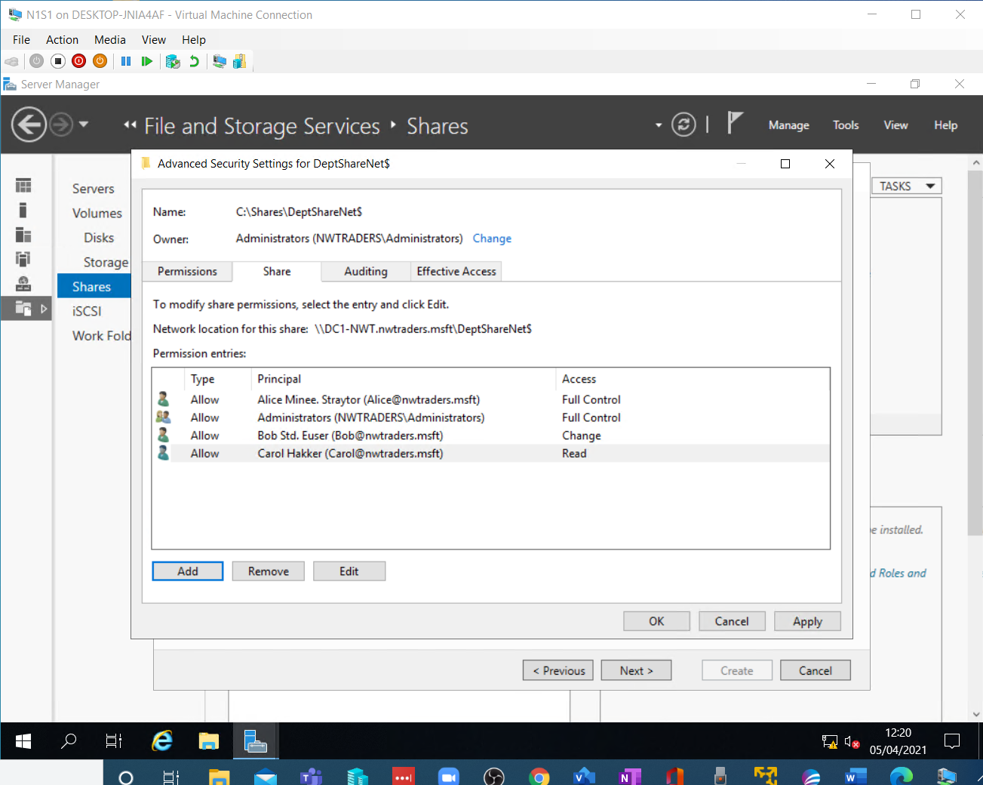

The Confirmation.
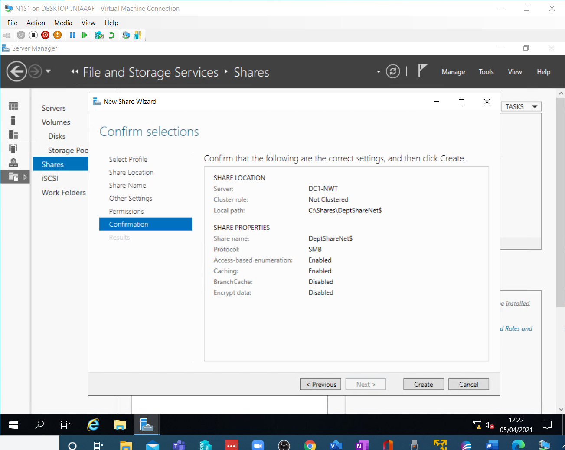

And the Result
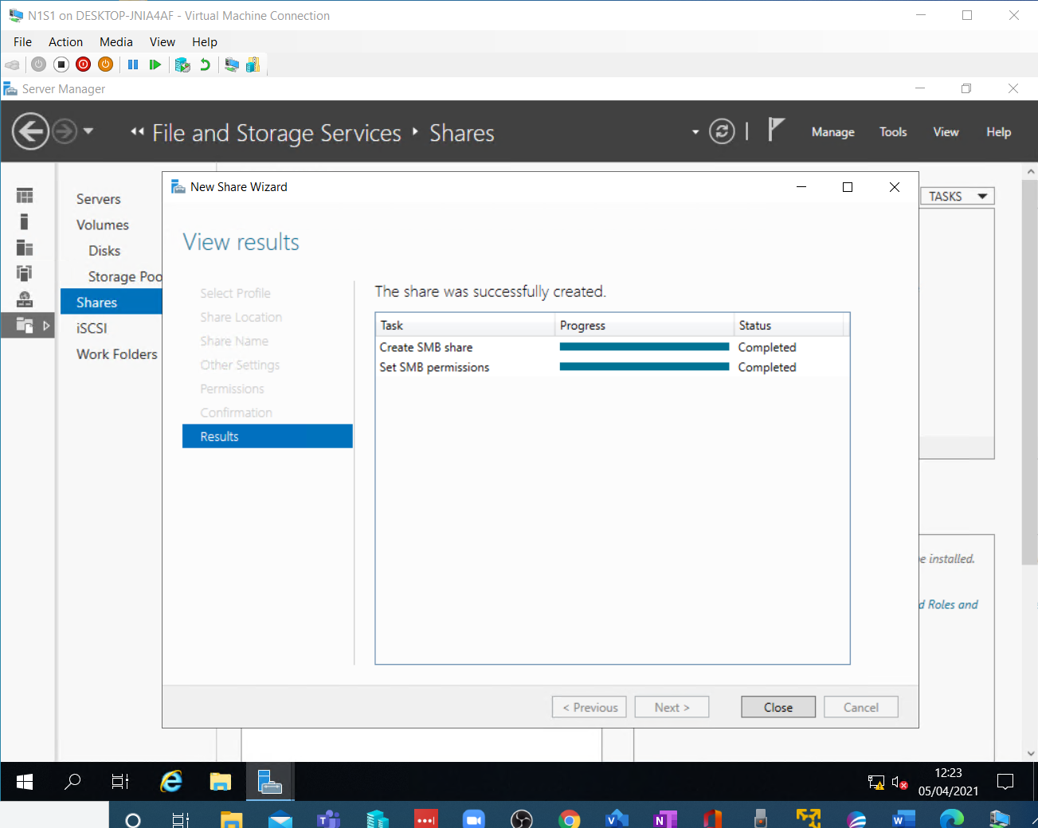

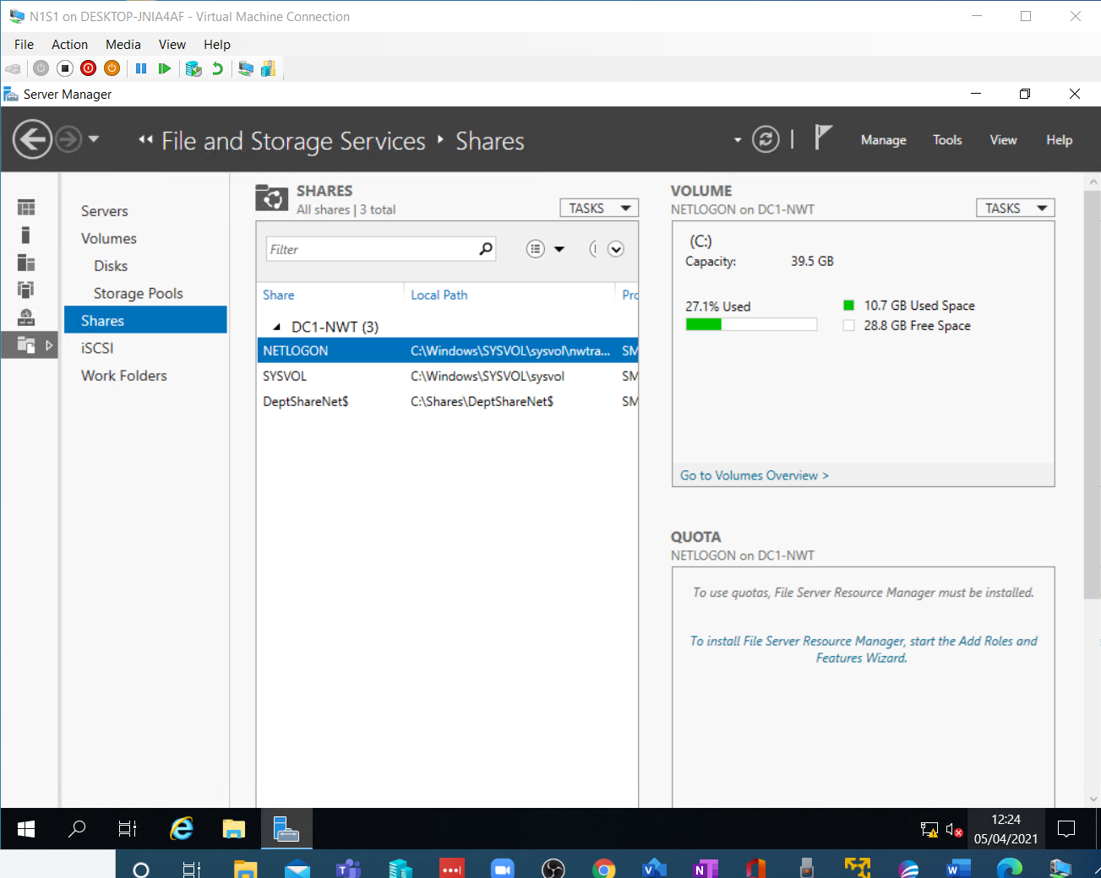

The client is then accessed and the share set up
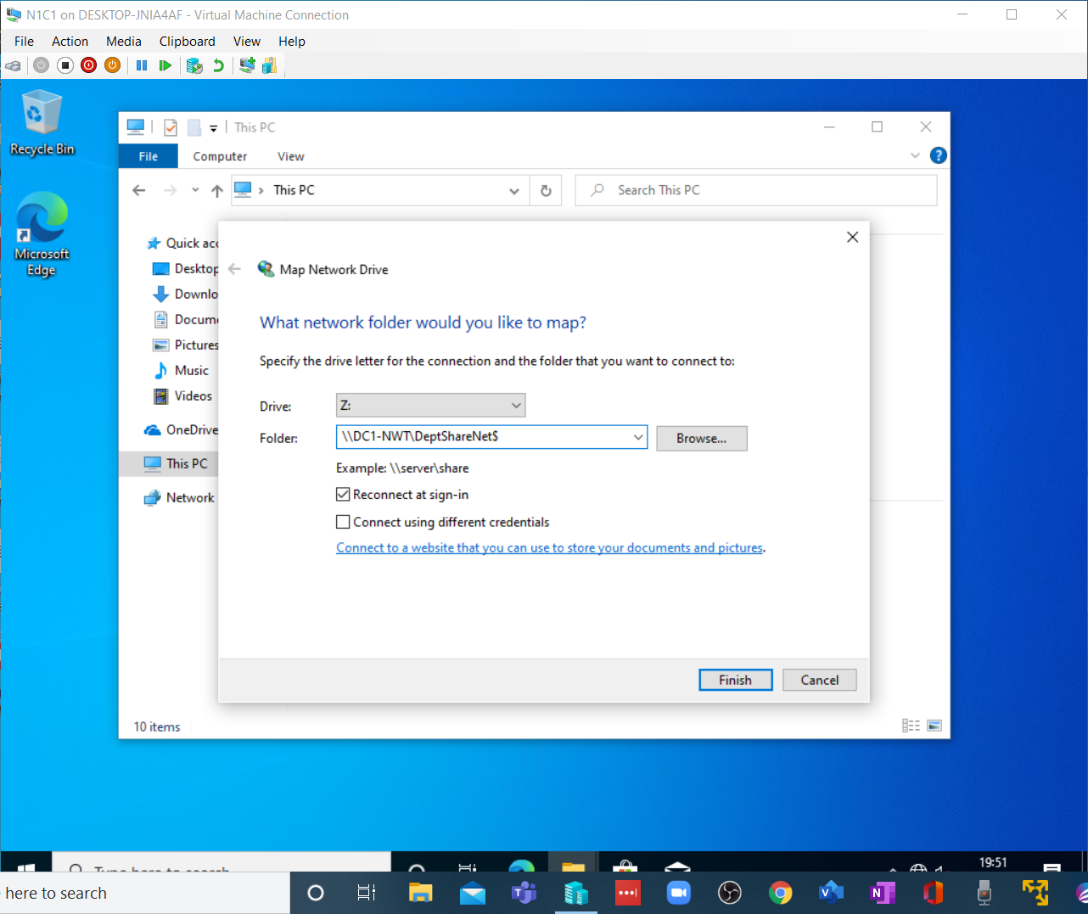

And as it has been done correctly, this window appears.
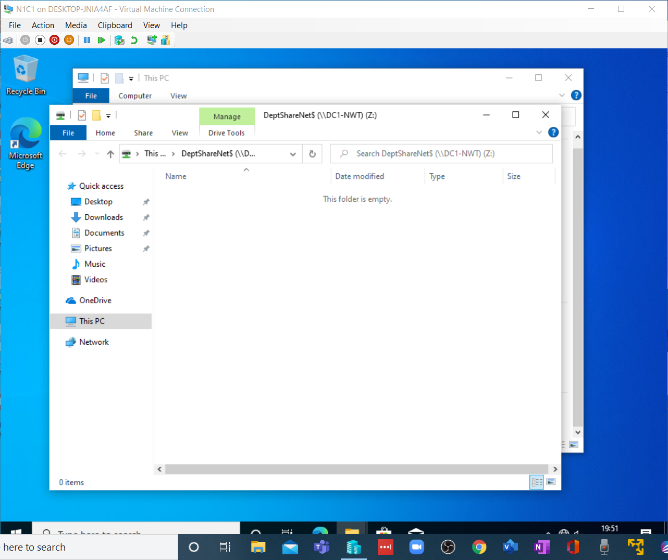

And in the explorer window, the Z: drive appears in the network drives section.
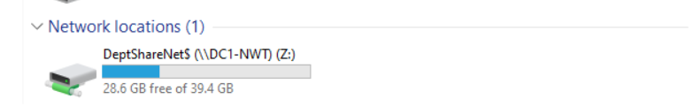

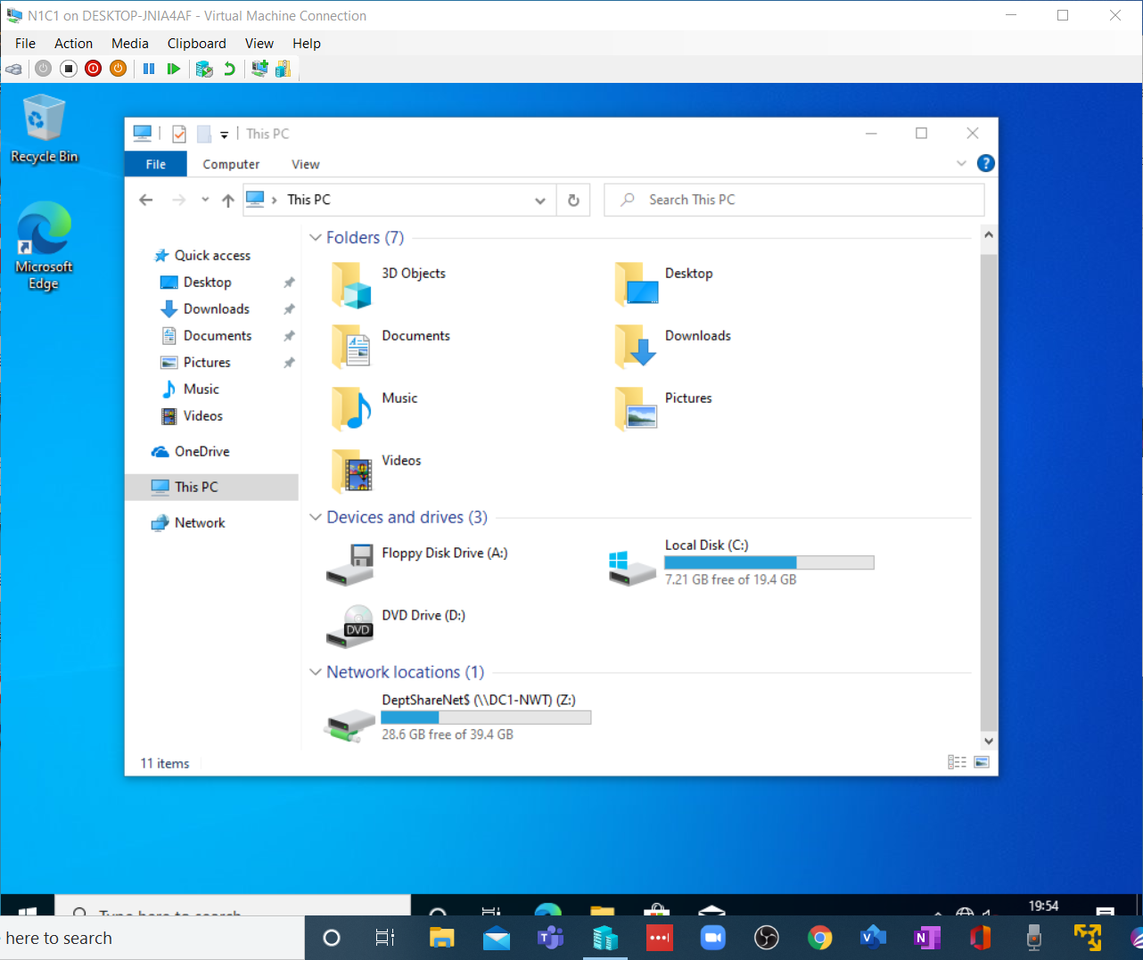

TASK 2
Step one fire up THE AD Console and create a non-admin user OU.
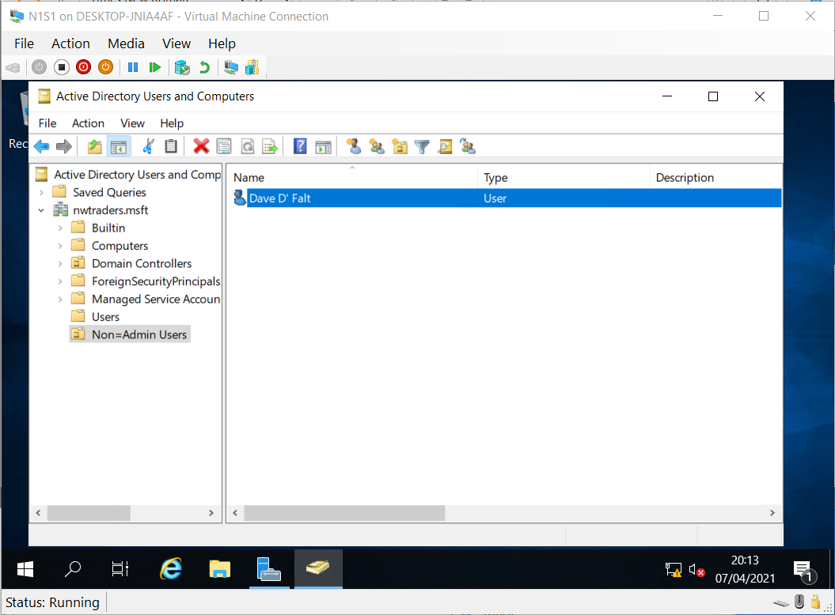

Then load the Group Policy Management Console (GPMC) and navigate to the new OU
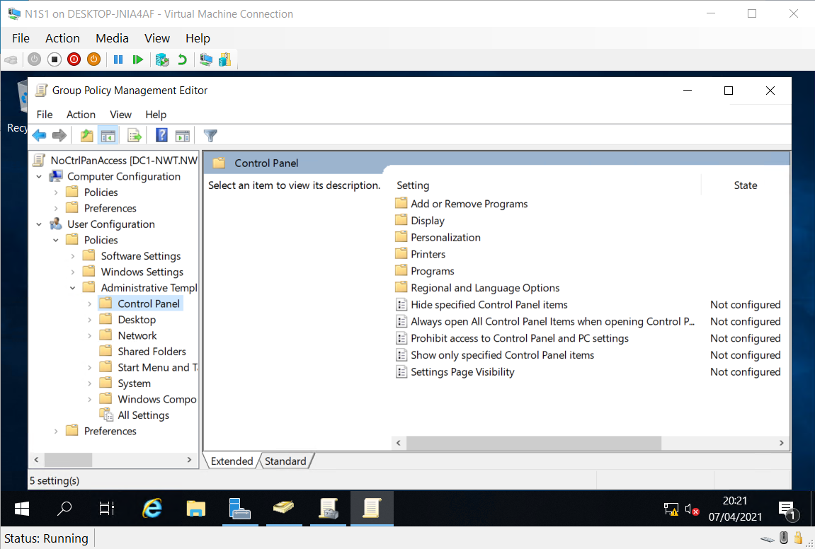

Then using the editor change the policy and implement the control panel lockout.
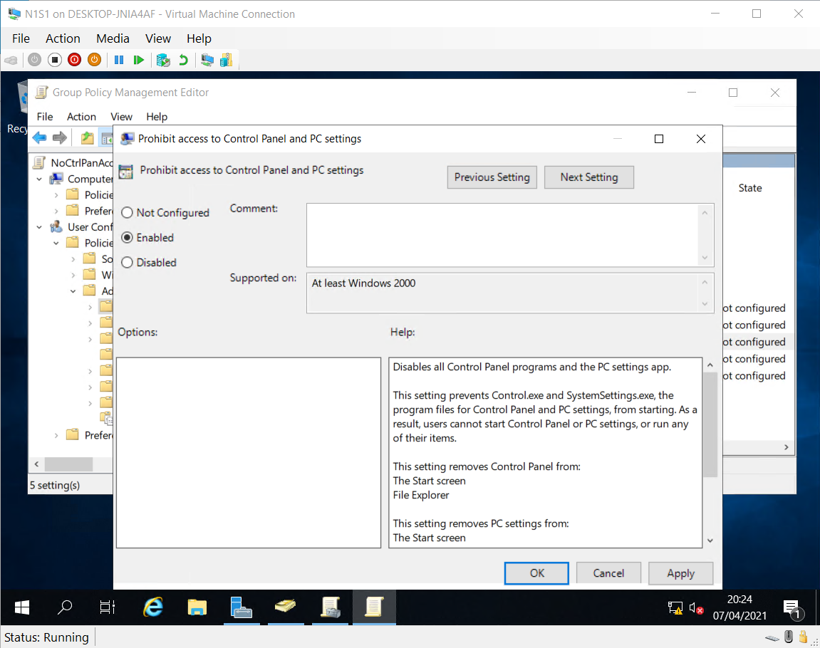

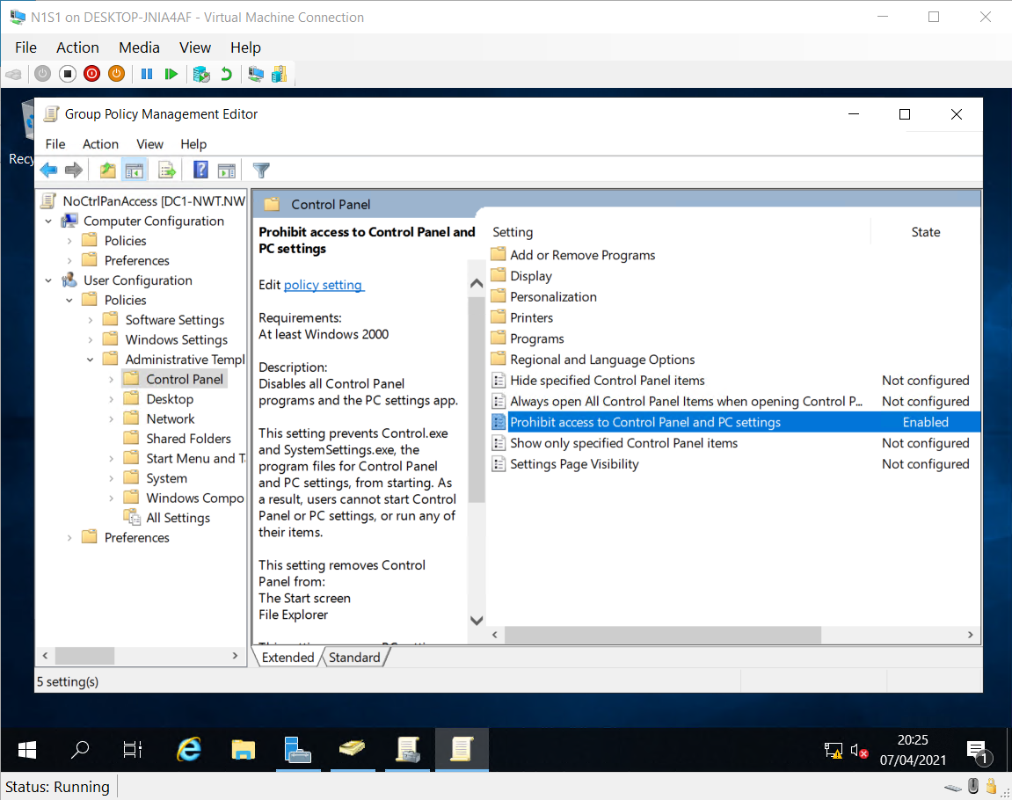

The run the command terminal as an admin.
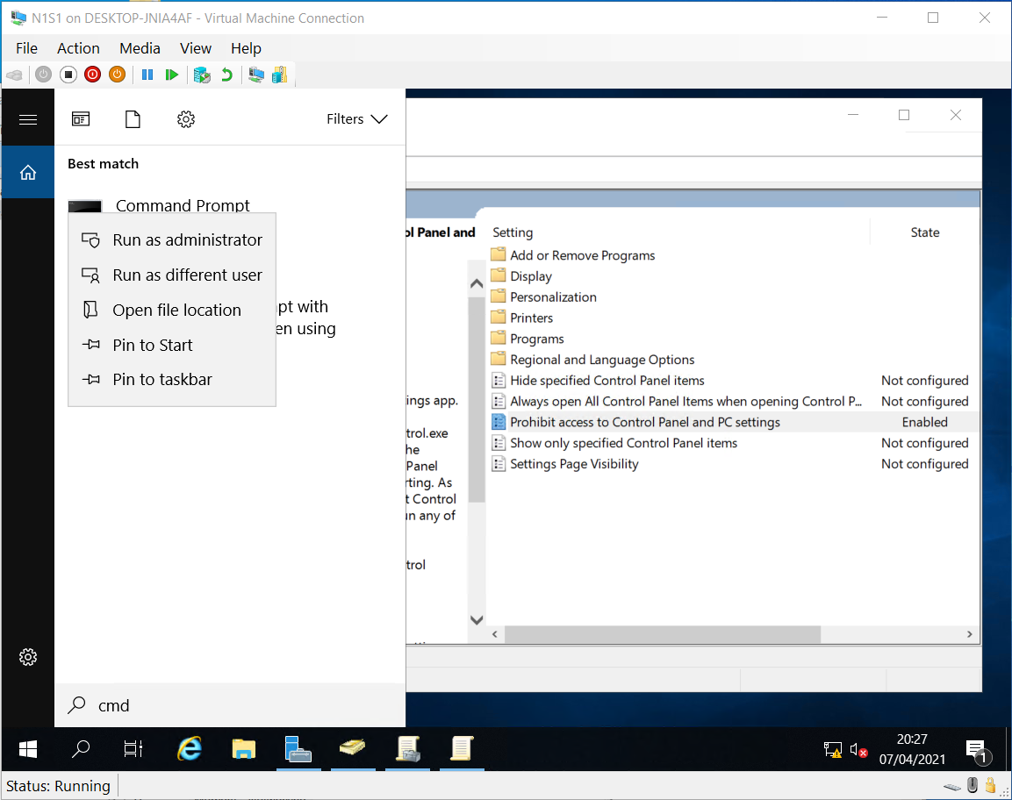

Force the AD system to accept the new setting…
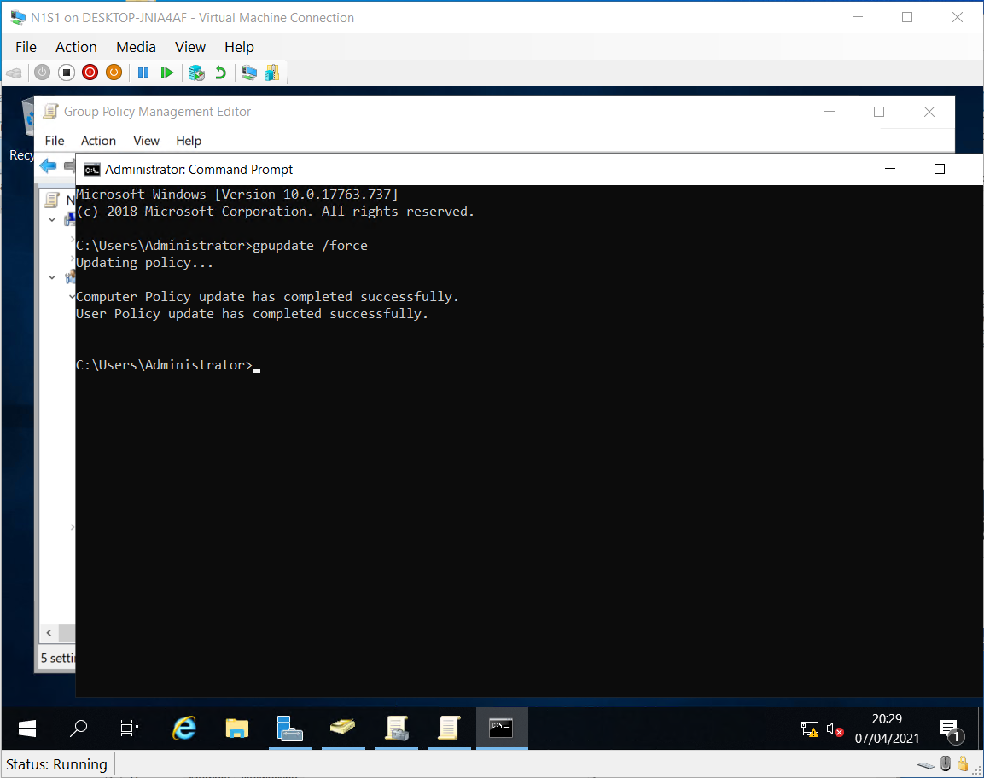

Switching to the client, Dave will log in and attempt to access the command panel.
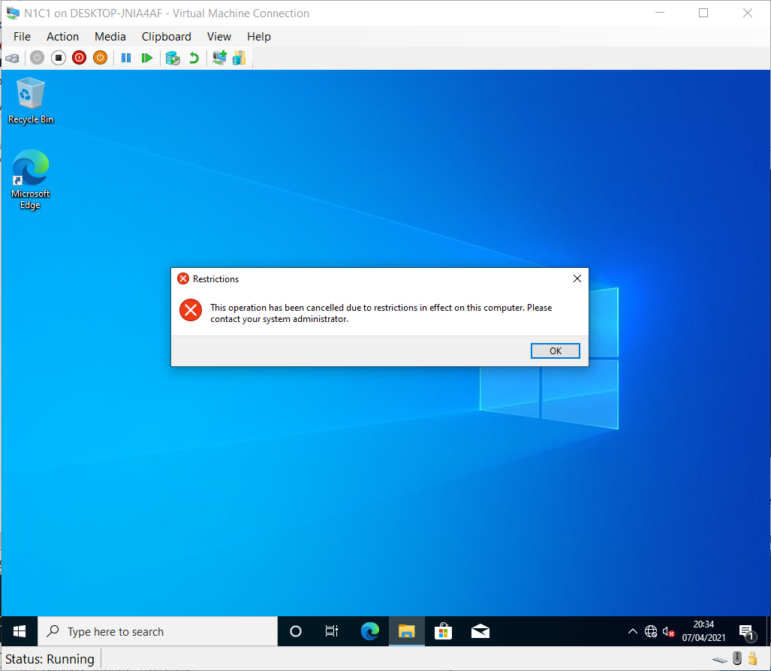
And fails because of the policy restriction dictated by the Active Directory settings on the domain controller.

Accessing the policy editor on the server, the Command line feature will be locked down.
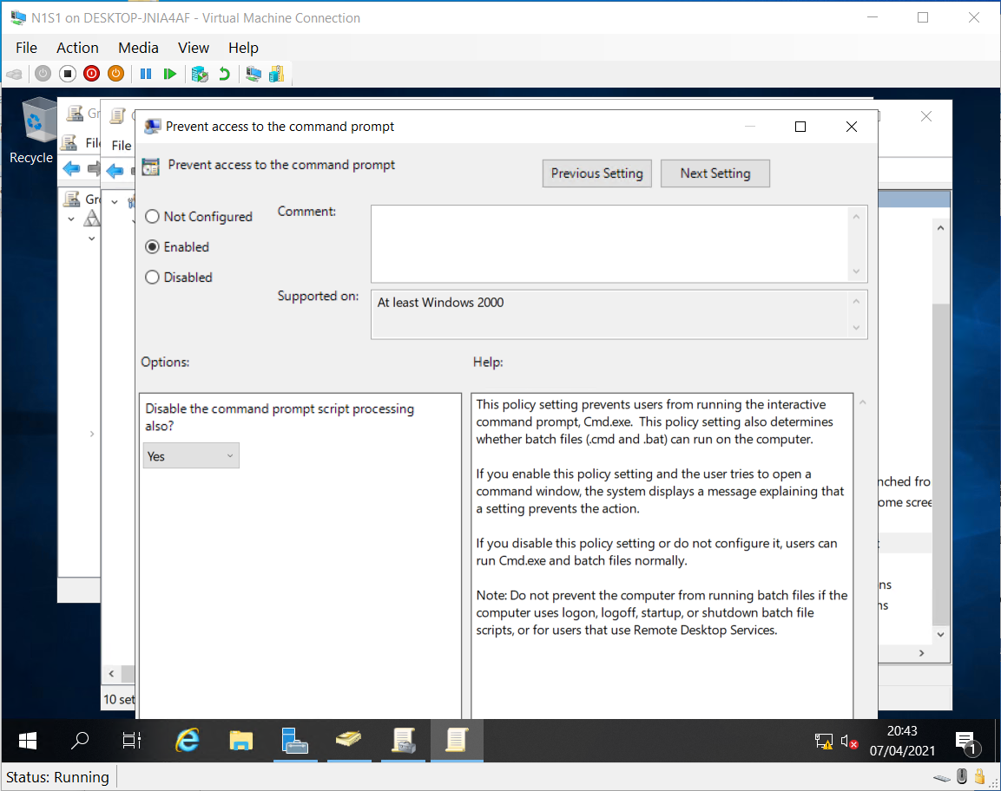

I am using the same procedure as before. Note: The command line script processing option has been disabled to prevent any back-door attempts to process commands.

And the Active Directory Updated.
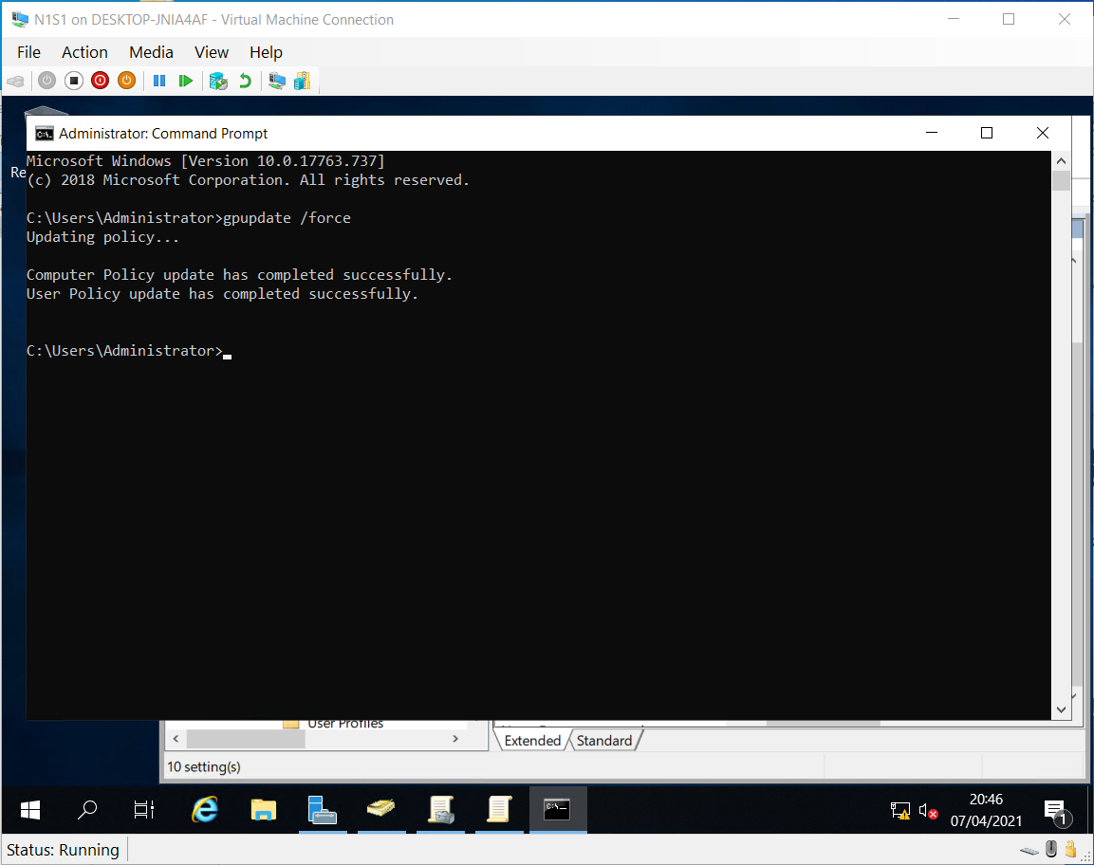

And workstation is then checked for compliance.
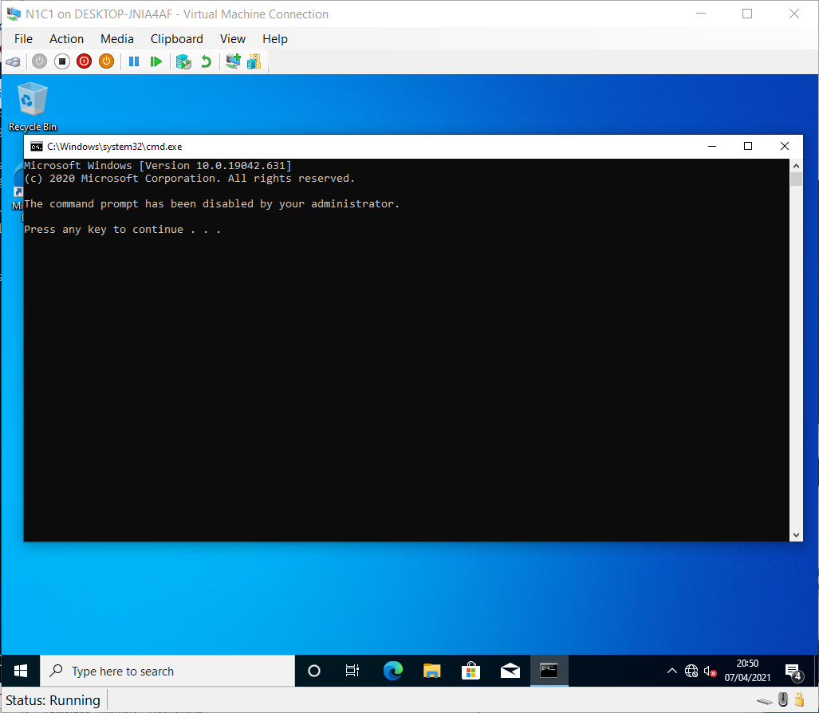

Remembering that policies only come into operation after existing users log out. Changes made during currently logged sessions will not be enacted.

For removable drives, just rinse and repeat using the admin template for all storage classes.
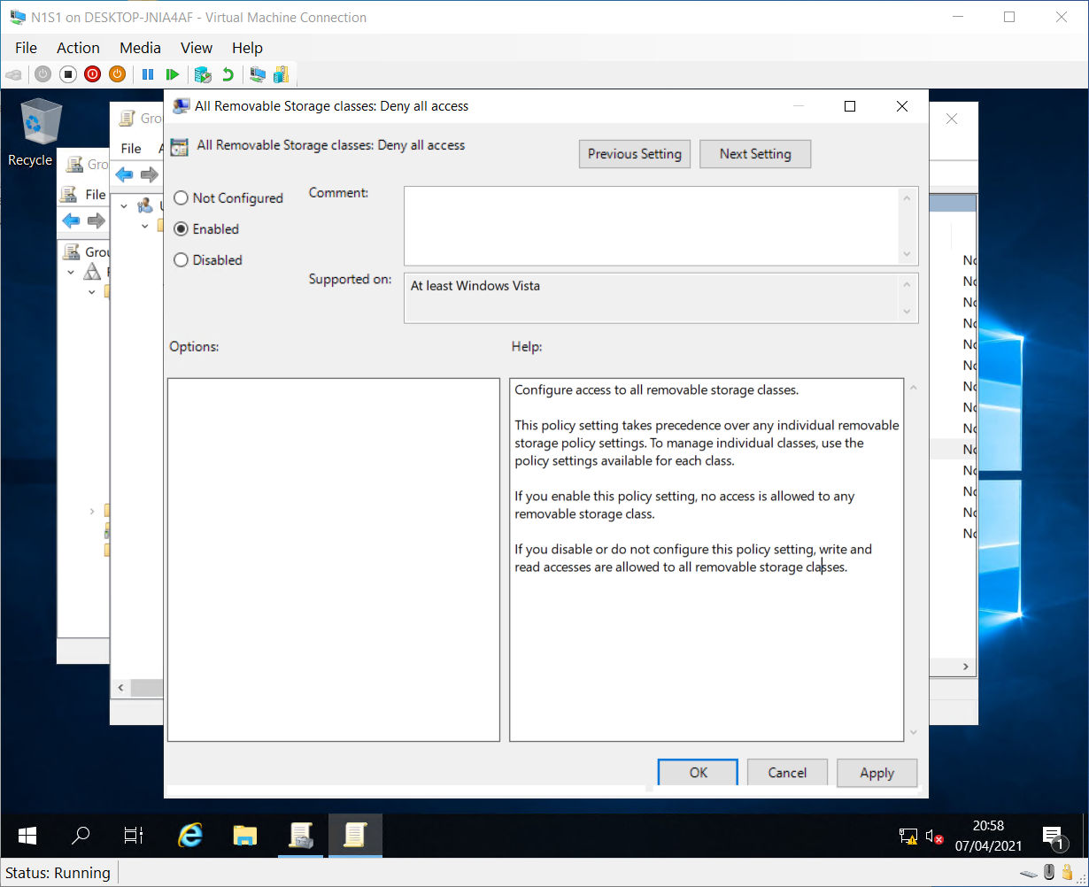

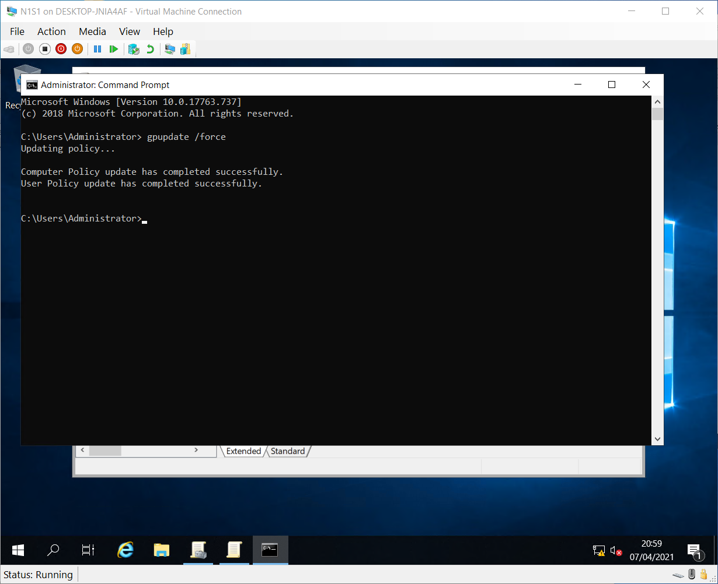

And Verify.
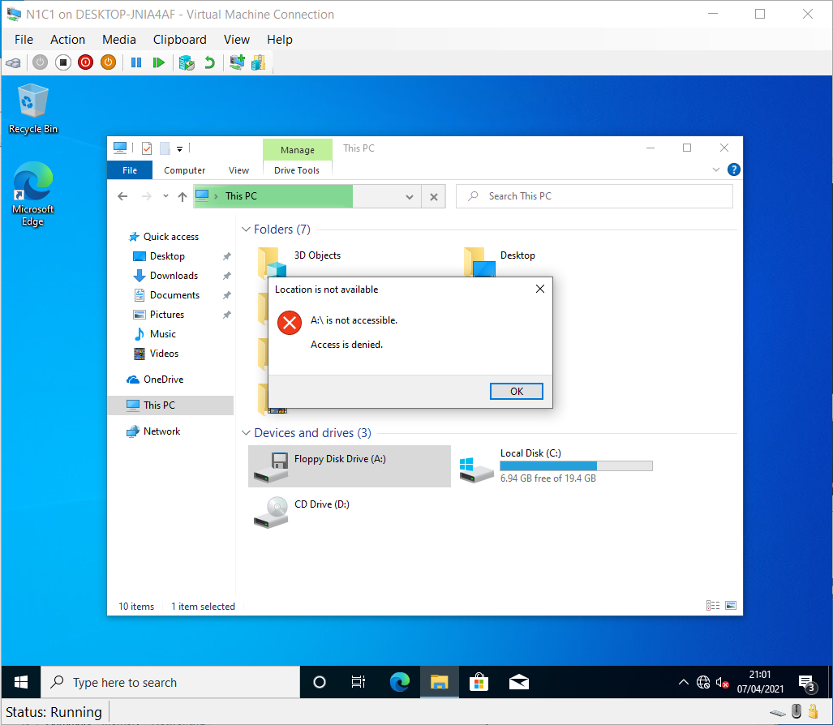

For CD…
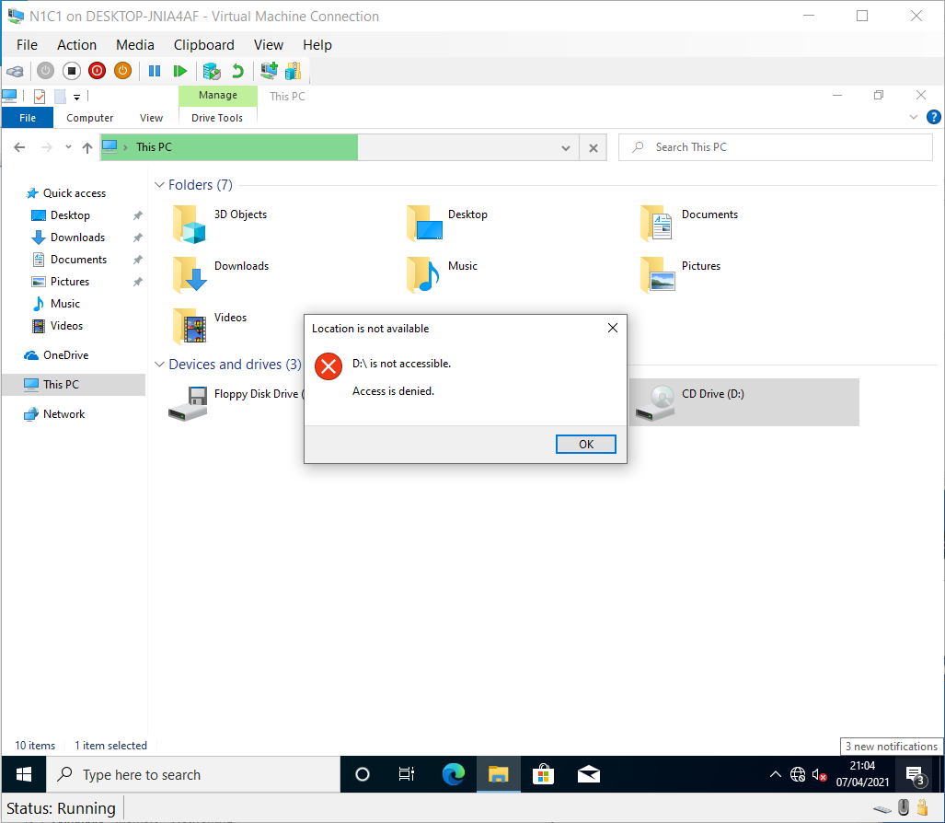

And if Hyper-V supported USB Passthrough natively, these would be blocked too.

The next feature to restrict is the installation of unauthorised software. Access the AD console for domain computers and users. Then transfer the work station to the new OU for NWT.
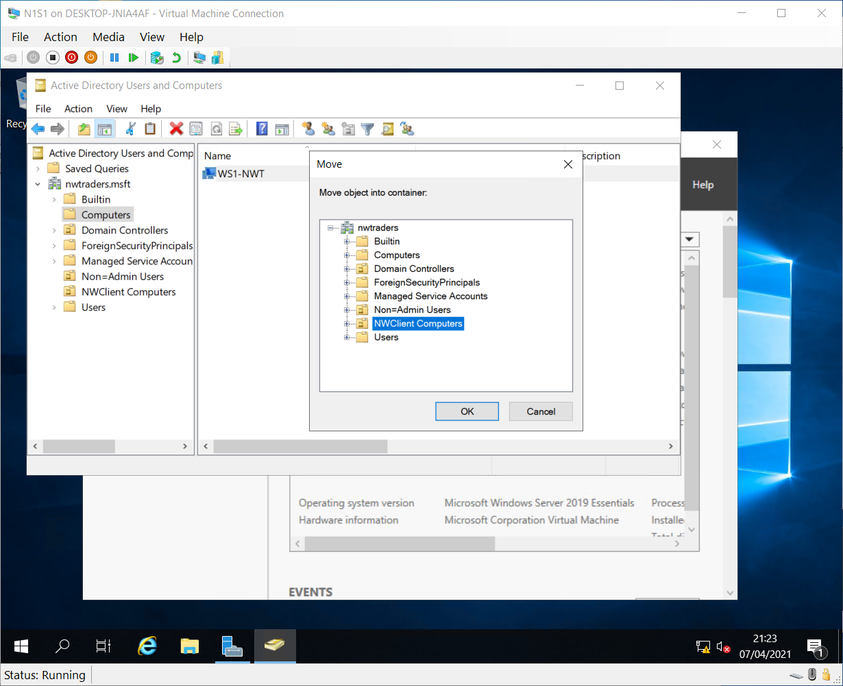

So it appears here.
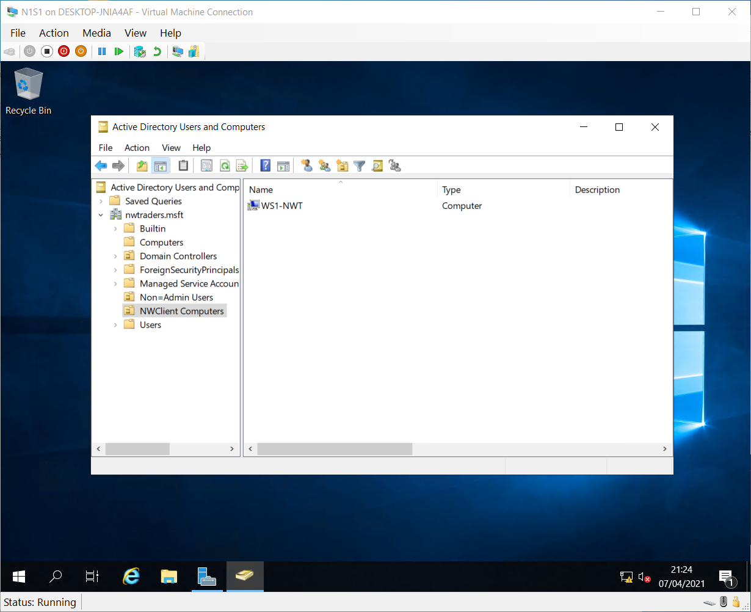

Then in the GP console, Create the no software install policy called NounauthSoftInstallS and apply the template policy.
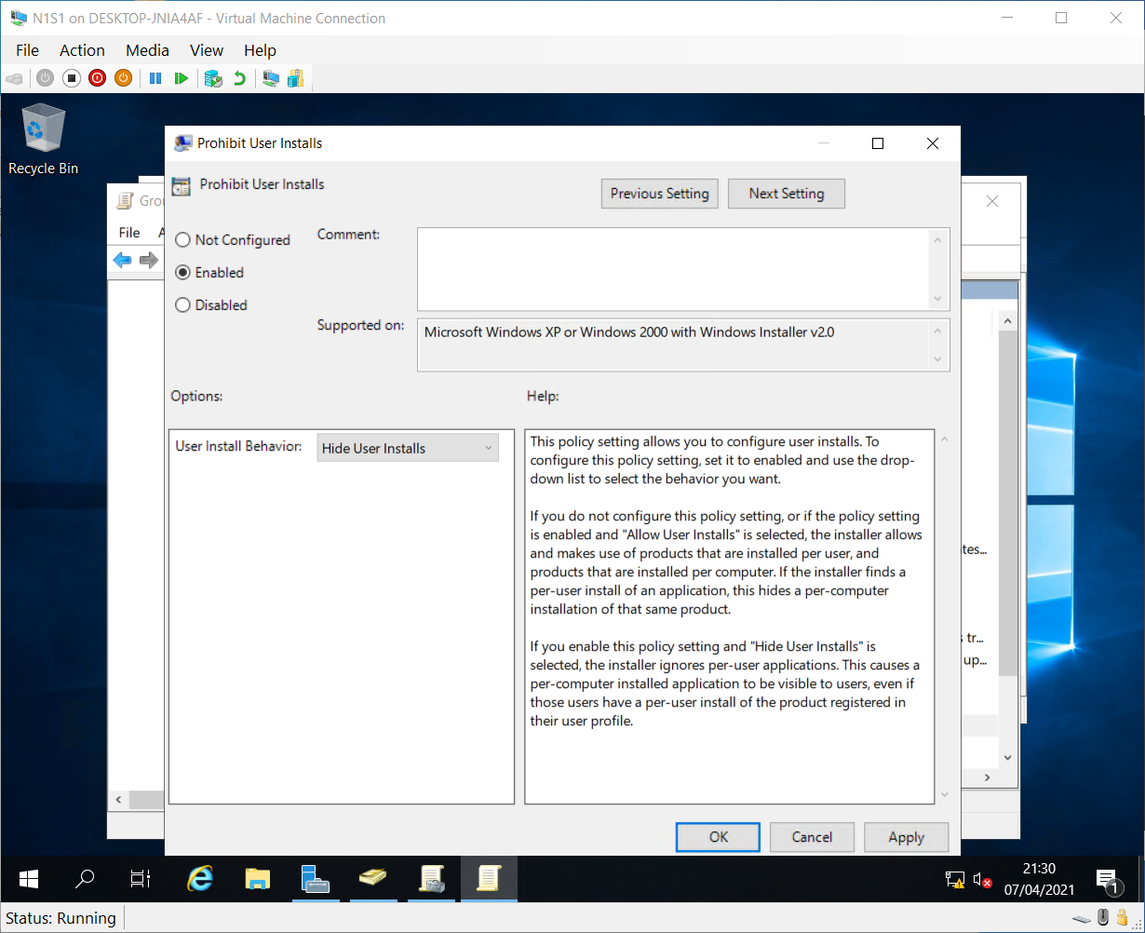

Found Here.
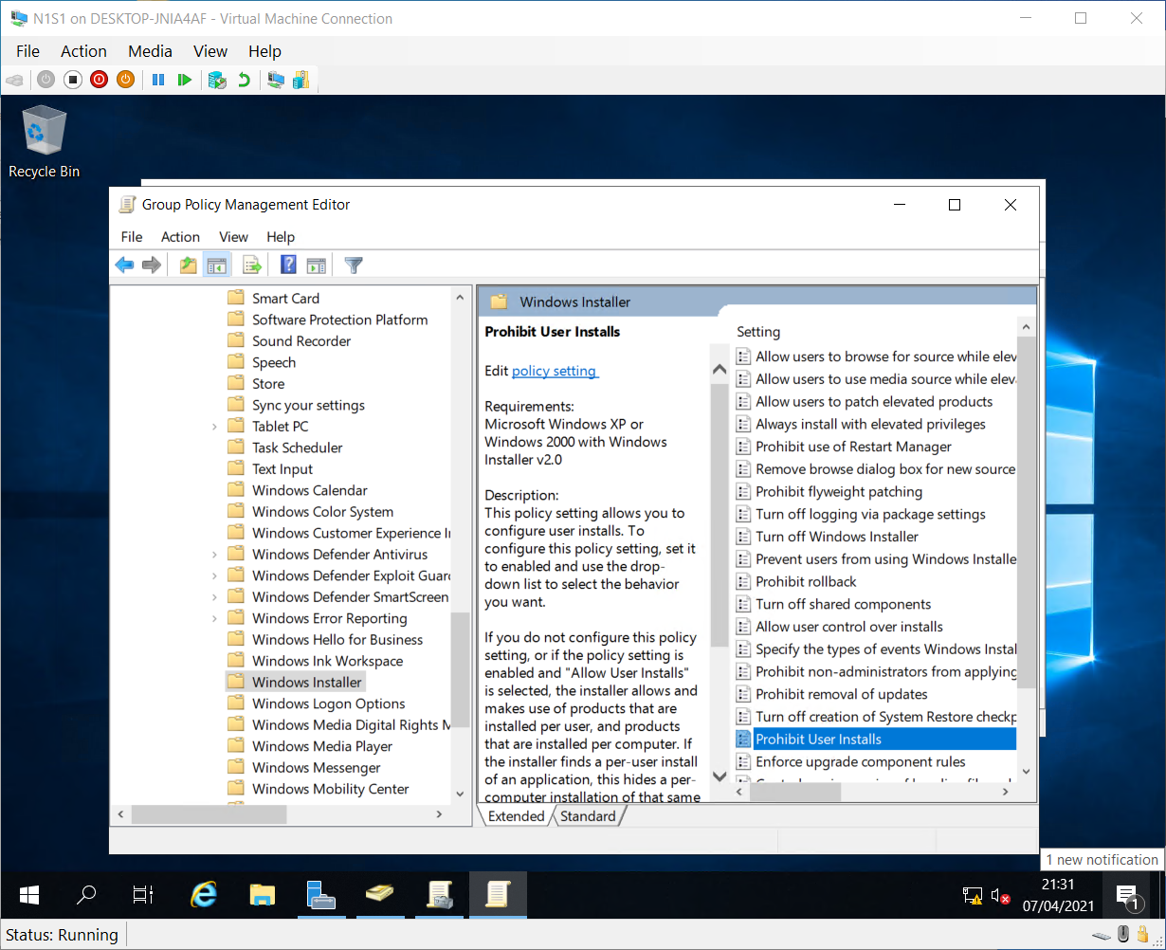

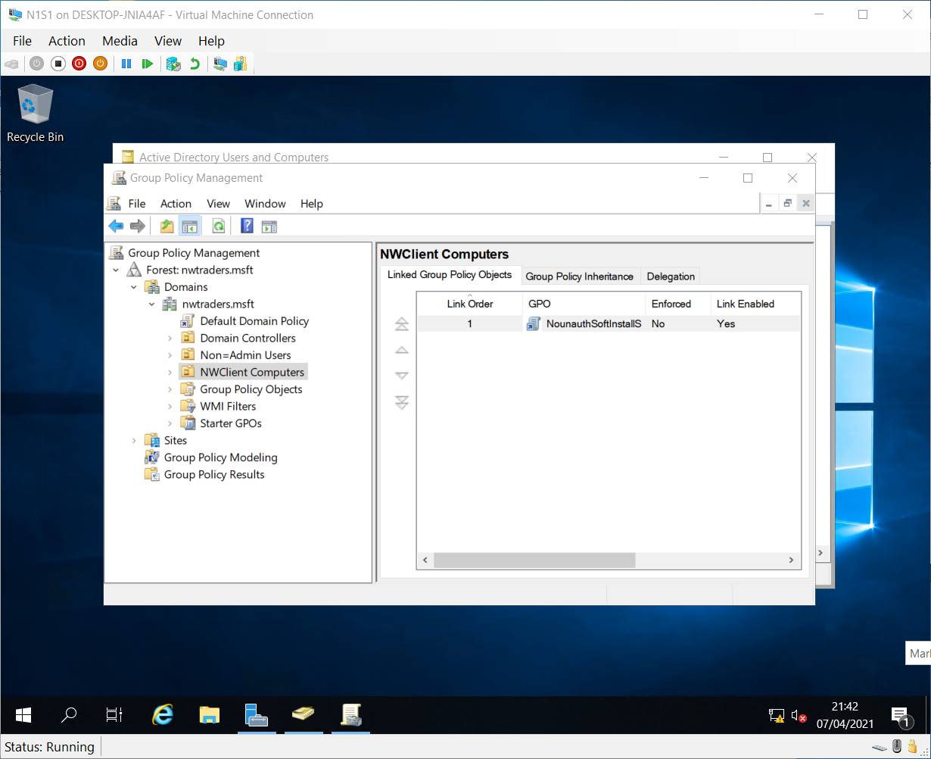

Then update AD as before and Check…
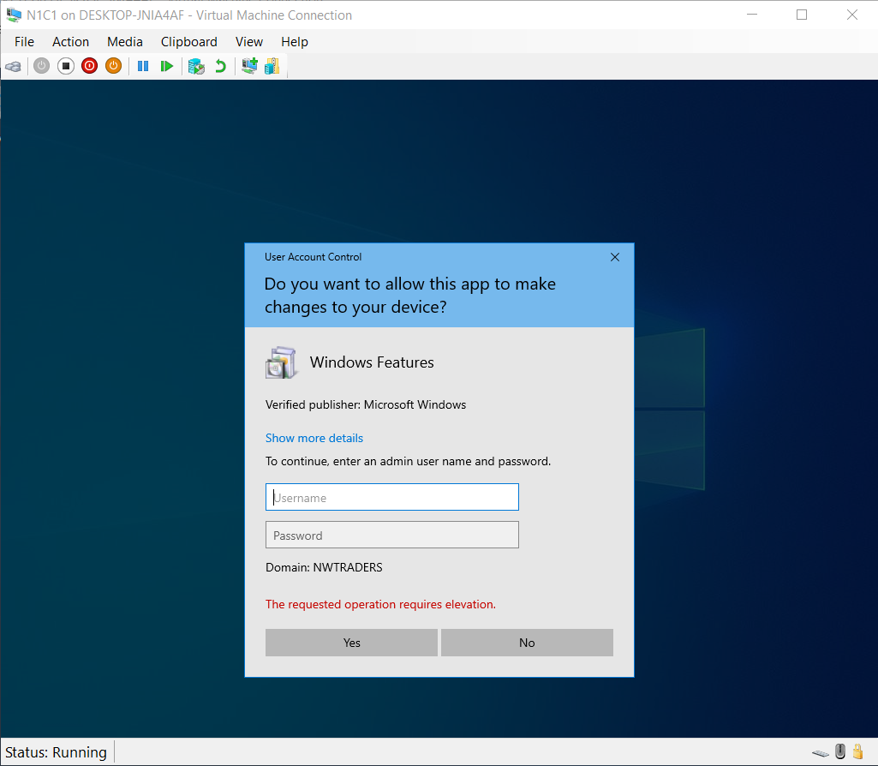

Note the red text!

GPO 5 Domain Level policy setting – Password Enforcement
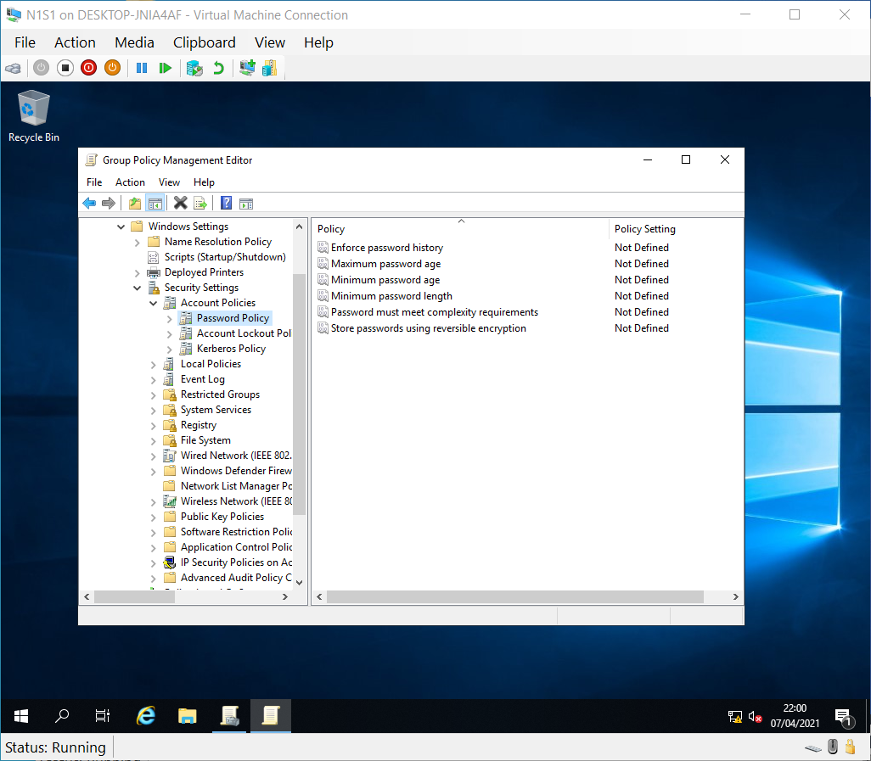

After.
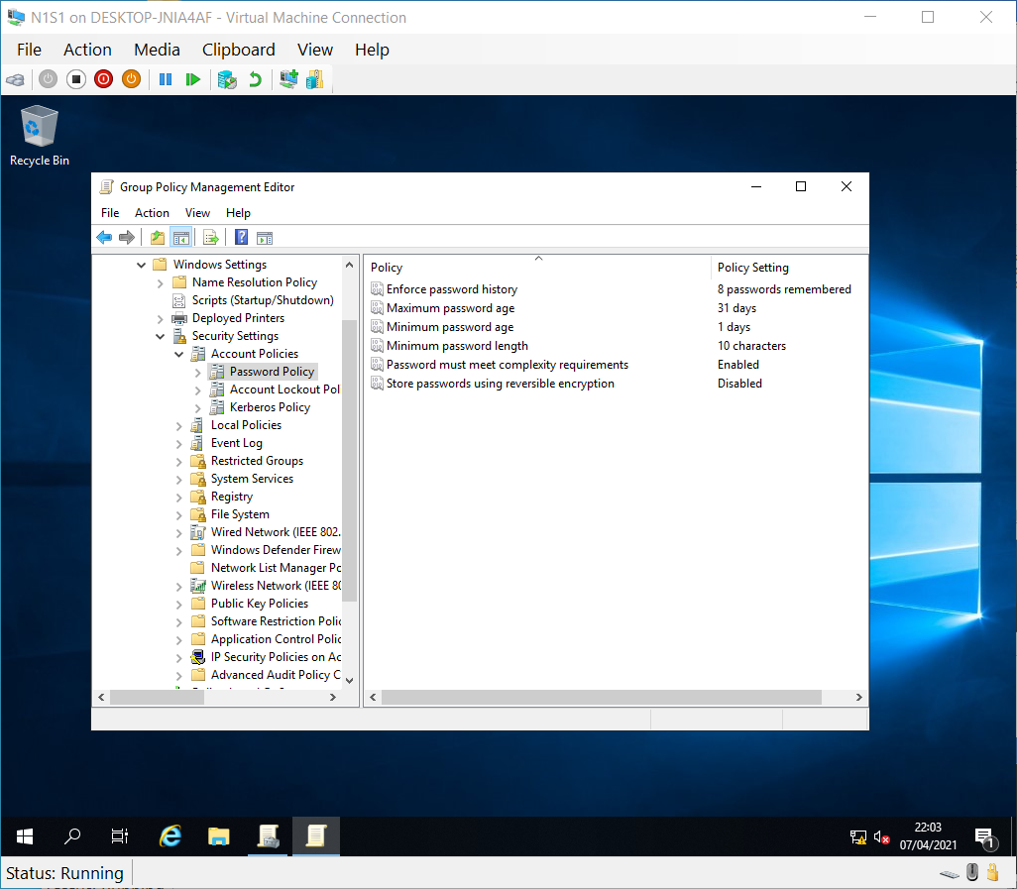

Then Update.


