Concurrency (parallelism)

Texts:
‘Computer Architecture and Parallel Processing’
Kai Hwang and Faye Briggs

‘ Computer Architecture’
Mario De Blessi

Content:

Concurrency;
Functional level concurrency (CPU and Memory Parallelism)

Processor level concurrency (Techniques for implementing these features)

Typical CPU layout (single core) – multi core systems will be dealt with at a later stage

Address and offset to program counter

Floating point arithmetic

CPU
Memory
Segmentation
Instruction
Queue

Cache

Numeric
Co-pro

Last program commands obeyed

Next few bytes of machine code

Typical system layout (single core)
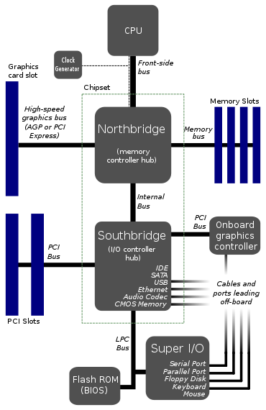
Low Pin Count interface/bus is used to allow legacy I/O. This has helped the industry to transition toward ISA-less systems. Unlike ISA which runs at 8MHz it uses the PCI 33 MHz clock.

Definitions

Before further progression it is useful to ensure that certain definitions are clearly communicated.

Multiprogramming Interleaving CPU and I/O operations

Multiprocessing Two or more processors (CPU,s or cores) executing different processes. NB processes are programs/parts of programs and/or the operating system (OS). The OS when present is always in charge – applications are not usually allowed to control hardware directly – calls are made via an OS routine. There can be issues with communication between different processors and this is discussed in a little more detail at the end of this section on definitions.

Pipelining Overlapping of operations within a CPU which leads to a performance boost and can increase the speed mismatch between the CPU and slower memory.

Array An ordered collection of data, instructions or hardware elements. In this context multiple ALUs (PUs).

Data flow In this context an alternative concept to the Von-neumann architecture or the Harvard architecture. Normally a computer is understood to be a machine that obeys a stored series of instructions one at a time. The execution is controlled by the program counter.

Data flow executes instruction as soon as data items are ready i.e. no program counter! This is an area of continuing research.

Multiprocessors - communication

Before leaving the subject of definitions it is worth returning to the subject of muliprocessors. It has been stated that communication between multiple processors can be a design challenge. If this inter-processor communication is not formalised it will result in operation problems.

The two main mechanisms that are important in this context of communications are listed below;

- Deadlocks
- Semaphores

Deadlocks

Deadlocks cause complete system lockups. This can occur for example when two processes share data. In other words there is some kind of inter-reliability. Maybe one process is waiting for a resource which has not been released by another. The best way to imagine this scenario is to think of a rule based system such as a traffic roundabout. The rule in this type of system, is to give way to traffic from the right; However if all entries to the roundabout are occupied and everyone is trying to obey the rule – then no one will pull away and a deadlock occurs i.e. the traffic is stationary

Cannot go vehicle to the right

No one can go deadlock!
Exactly the same thing can happen with processors!
Cannot go vehicle to the right

Semaphores

Semaphores involve the use of flags to indicate whether a resource is in use or is free. The word semaphore in this context is derived from a nautical term. In the nautical sense semaphore is a method of communication over a distance where line of sight is available using a combination of different flag positions. The analogy is carried over to inter-process communication using flags e.g. ‘busy’ or ‘clear’. The flag in this case is often just a bit set or unset in a register. Software can ‘test’ the status of this bit or flag and act accordingly.

A simplistic example of this mechanism is described below;

Two processes share a task. One process counts students. The other process counts staff. It is not possible for the task to run simultaneously so any combined results have to wait to be presented until both uses of the task is completed. In this case the use of a semaphore can be applied to deliver task availability status – process one can effectively say ‘finished task available now’ – process two can then run the counting task – then release the semaphore. The final results can then be linked formatted and presented as dictated by another task or process.

Processing Speed

Some reliable mechanism is necessary to both measure and compare processor performance. At first glance this may seem a trivial problem. However at closer inspection there are several pitfalls from taking a simplistic view of processor performance.

MIPS Million Instructions Per Second
Problem – which instruction do we measure? Remember that instructions are different sizes – also usually need several clock pulses per instruction – how many? – depends on the instruction! Therefore it is not really suitable to use clock speed as a metric without more knowledge. Even then this is not an ideal method because of the different length of instructions.

The only real way to compare computers is to use a standard ‘Benchmark’ program e.g. sort 1000000 numbers in a sequence, but then which benchmark program should be standardised upon.

MFLOPS Million Floating Point Instructions Per Second

The same applies to this category of performance measurement. This measurement deals with mathematical operations and as such is a little more focussed than a generic instruction measuirement. Clearly math type instructions can be different lengths however arguably they are easier to categorise. MFLOPS tends to be the preferred measurement compared to MIPS. Some examples are listed below;

Transputer (works in multiples e.g. 8 or 64) 2 MFLOPS, 10 MFLOPS
Cray1 240 MFLOPS
Cray X-MP 500 MFLOPS
Cray 2 2000 MFLOPS
Cray C90 16000 MFLOPS
Intel Pentium 4 500 series 5-6 GFLOPS
Intel Pentium D 800 series 10-12 GFLOPS
Intel Core2 Quad Q6000 series 38-42 GFLOPS
Intel i7 800 series 44-49 GFLOPS

As a further illustration consider the speed of the Cray 2. This better than nanosecond performance! Faster than basic electronics switching speed.!

System Classification

It is useful to note that some kind of classification is needed for all systems whether single or multi-core that is generic to how data and processing is conducted.

In 1972 Michael Flynn came up with what was called Flynn’s Taxonomy. He defined a series of four classifications for von Neumann type architecture systems. These classifications are based on the instruction and data streams that such systems process. The classifications are as follows;

SISD Single Instruction Single Data

SIMD Single Instruction Multiple Data

MISD Multiple Instruction single Data

MIMD Multiple Instruction Multiple Data

Taking each in turn;

SISD Single Instruction Single Data
This category covers the classical von Neumann machine and thus the majority of non specialised microprocessor systems. At any one time only a single instruction is being executed, and only a single piece of data is being operated upon. This is where part of the problem arises, since we often want to perform the same instruction on many different pieces of data, and the von Neumann machine requires us to fetch the same instruction many times, once for each piece of data. In fact the situation is much worse since a von Neumann machine will usually require us to create a loop, and so we will need to execute many instructions for each piece of data. This can slow the machine down many times over what the arithmetic unit is capable of performing.
Historically: VAX 11/78, IBM 360/65, IBM 370, Cray1 (last 3 are mainframes) and of course most modern single processors.
SIMD Single Instruction Multiple Data
For problems in which the same operation needs to be performed on many pieces of data, particularly those involving vectors and arrays, SIMD (single-instruction multiple-data) architectures are often capable of high speeds. A single CPU controls many arithmetic units, each of which operates on its own data. Each arithmetic unit executes the same instruction as determined by the CPU, but uses data found in its own memory. Thus all the elements of two vectors could be added together simultaneously.
SIMD architecture increases the speed of the operation many times over compared to a SISD machine.
In practice, the provision of many arithmetic units is expensive, particularly since many of them will not be in use at any given time. Even if a large number of arithmetic units are provided, the size of vectors and arrays will rarely be a multiple of the number of arithmetic units and so some inefficiency in the use of the arithmetic units will arise.
A more effective use of hardware can be obtained by pipelining the arithmetic unit. A hardware floating point accelerator will already contain dedicated hardware for each part of the calculation of a floating point operation. By pipelining the use of this hardware, significant improvements can be made in processor performance. This technique will not give as high a performance as a true SIMD machine, but the improvements can be significant.
E.G. Array processors (multiple ALUs) Illiac, Staran

MISD Multiple Instruction Single Data
The multiple instruction single data (MISD) architecture is the most uncommon one. In this architecture, the same data stream flows through a linear array of processors, executing different instructions on the stream. This kind of architecture is also known as a systolic array for pipelined execution of specific algorithms.
As this classification design introduces an inherent bottle neck no known examples exists.
E.g. None!

MIMD Multiple Instruction Multiple Data
The most general form of von Neumann architecture is the multiple-instruction-multiple-data machine. A MIMD machine is usually a number of separate processors connected together through some interconnection network. The actual format of interconnection between the processors can take many forms, depending on the type of problem, which the machine is designed to solve. This is the most common architecture chosen for multiple processor machines because modern processors have the control logic for parallel systems built in. Therefore, this is attractive since software, replacement parts and additions to the system are easily accessible.
E.G. Transputer Array (used to be manufactured locally in Newport)
IBM 370/68 mp (2 processors)
IBM 30/81 (2 processors)
Cray XMP (2 processors)
Cray 2 (4 x Cray XMP)

The latter was said to be the fastest in the world at the time

The diagram below illustrates Flynn’s taxonomy in visual way;

Diagrammatic Classifications of Computer

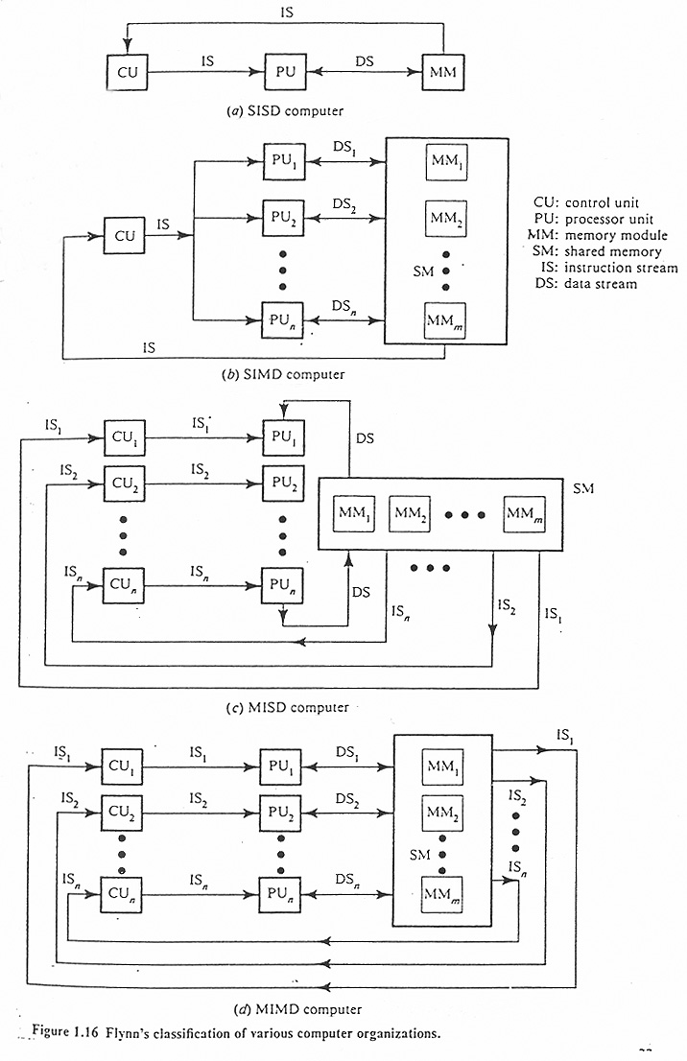

Multiple ALU’s because multiple data

MISD never made but definition still exists!

Transputer!!

Uniprocessor (SISD) Computers

Whilst this classification of device implies a bottleneck by its very nature, there are however techniques which alleviate the problem. There are essentially six parallel processing techniques that can be applied to SISD systems;

- Coprocessors

- Pipelining

- Memory Interleaving

- DMA & FEP (Front End Processors)

- Time Slicing and Multiprogramming

- Cache

It is worth briefly discussing each category in turn (more detail may be added later as when applicable);

1. Coprocessors

This is an additional processor that works in parallel alongside the main CPU. It is usually allocated a specialised duty. The principle example of this is the maths coprocessor. Historically the Intel family of desktop PC’s (80386, 80486) came in system designs both with and without a coprocessor. A socket was available on the motherboard to allow a maths coprocessor (floating point arithmetic) upgrade if the system had been purchased without it. Systems with a coprocessor were designated DX e.g. 486 DX and those without were designated SX e.g. 486 SX. The coprocessor chip was identified as 80387 or 80487. This may seem strange nowadays when processors packing density has increased several fold and corresponding purchase price was much lower. However in the era of the 486 chip systems cost in the order of £2500 in DX guise, and several hundred pounds cheaper in SX guise. These days the maths coprocessor functionality is often built in to an existing core or multicore system. Note that unless software is written to take account of this additional functionality the coprocessor will not be utilised i.e. if a program contains no coprocessor instructions the device will never be utilised and all load will remain on the main processor.

Other coprocessor tasks include graphics and DSP. The latter being useful in communication systems or analysis systems.

Coming up to date the like of Nvidia have a reasonable hold graphics coprocessor however in 2012 this is set to be contended by intels Xeon Phi coprocessor which firmly establishes performance in the teraflop range.

2. Pipelining

A pipeline can be thought of as a set of instruction queues that can overlap. The traditional fetch, decode, execute cycle is still followed. However several cycles can be in operation at once because the pipelines overlap. This leads to a degree of concurrency.

As an example the Atmel AVR and the PIC RISC microcontrollers each have a 2 stage pipeline. More complex microprocessors have a larger degree of pipelining such as 7 10 or even 20 stages (as in the Intel Pentium 4).

The architecture of a pipelined computer is shown in figure 1.11 below. Along with this are shown “space-time” diagrams which compare the operation of both pipelined and non-pipelined computers.

Pipelining and memory interleaving work together to minimise timing mismatches however more on memory interleaving later.

The diagrams below demonstrate the difference between both pipelining and non pipelining;

Non Pipelined
t

Fetch
(Opcode)
Execute
(Operand)

Fetch
(Opcode)
Execute
(Operand)

Pipelined
t

Fetch
(Opcode)
Execute
(Operand)

Fetch
(Opcode)
Execute
(Operand)

Note the overlap on the pipelined diagram. This simplistic approach demonstrates a basic pipeline consisting of two instruction streams. The fetch cycle of stream 2 occurs simultaneously to the execute cycle of stream 1, hence there is a degree of parallelism present.

Pipeline Architecture and Space-Time Diagrams
Operand Fetch
Instruction Decode
Instruction Fetch
Execute

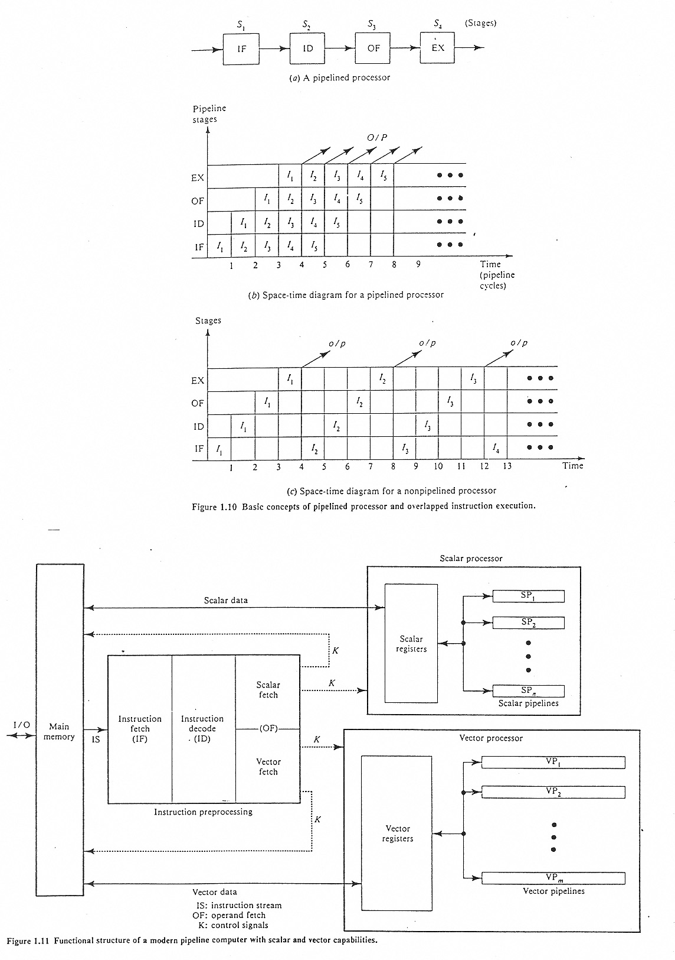

It is useful to note at this stage that the term “vector” in the context of pipelines refers to several data values/streams.

e.g. Arithmetic vector pipeline – the ALU process several (not one) data item pairs.

For reference the Cray computer had 64 levels of vectoring! (arithmetic pipelining) i.e. take 64 pairs of numbers and arithmetically work on them simultaneously to produce 64 numerical results.

Returning to the pipeline theory consider the case depicted below;
t

Fetch
(Opcode)
Execute
(Operand)

Fetch
(Opcode)
Execute
(Operand)

3. Memmory Interleaving

Problem!!! – memory to CPU speed mismatch is now enormous if memory configuration remains unchanged.

Solution – memory interleaving – one pipeline cycle reads from one memory bank/device and another cycle will be supported from an alternative memory bank/device. Note that the memory devices can be virtual in that they can be segmented in firmware. They do not necessarily have to be physically separate memory modules.

Two or more memory devices can be utilised to help address the CPU / Memory speed mismatch. The above example depicts a four stage pipeline so four memory units would be utilised. However it is initially easier to see if we design a memory interleaved system for our earlier two stage pipeline then explore more examples;

Memory interleaving for two stage pipeline (where ‘n’ represents the memory locations);

Even
n (opcode 1)
n+2(operand 1)
n+4
n+6
Odd
n+1(opcode 2)
n+3(operand 2)
n+5

CS
CS

A0
Address Bus Line

In the above model memory appears twice as fast as normal. Mathematically this is described by modulo arithmetic – which is essentially cyclic sequences – think of the clock this is modulo 12. Therefore this example is modulo 2 i.e. it is in cycles of two locations.

The layout of memory or memory map is as follows;

Opcode 1
Opcode 2
Operand 1
Operand 2

n
n+1
n+2
n+3
n+4
n+5
Opcode 1

Operand 1
INTERLEAVING!

Opcode 2
Operand 2
INSTEAD OF

n+i

Numeric Example;

Processor access speed = 50ns

Pipeline access speed = 12.5ns (4 stage pipeline)

Memory access speed = 200ns

Therefore memory = 16 times slower potentially than the pipelined processor!!

50ns
t
Fetch
(Opcode)
Execute
(Operand)
Fetch
(Opcode)
Execute
(Operand)

12.5ns

n+i

Opcode 1
Opcode 2
Operand 1
Operand 2

n
n+1
n+2
n+3
n+4
n+5

Solution; interleaved memory mod 16
Note: 15 for Z80
19 for 8086
23 for 80286
31 for Pentium
40 for 64bit CPU

4 to 16

DEC

Mem 1
CS
CS
CS

Mem 0
Opcode 1
An-A0
Operand 1
Operand 16

Mem 15
Operand 2
Opcode 2
Opcode 16
Dn-D0
A3
A2
A1
A0

Program words are stored in consecutive memory devices (16 in this case);

Opcode 3

Opcode 4

n+3
Operand 1

n+n
Opcode 2

Operand 2

Operand 3

n+1
n+2
n+i
n
Opcode 1

n+n

Example 2

T_{p} = 0.5µs, T_{m} = 1.0µs. Supply the timing diagram for the fetch/execute cycle and accompanying memory interleaving.

Solution;

Fetch/Execute Cycle
T_{p} 0.5 µs
t

Fetch
(Opcode)
Execute
(Operand)

Fetch
(Opcode)
Execute
(Operand)

Memory Interleaving

CS
CS
A0
Address Bus Line
Even
n (opcode 1)
n+2(operand 1)
n+4
n+6
Odd
n+1(opcode 2)
n+3(operand 2)
n+5

Example 3

Complete the following diagrams for T_{p} = 100ns, T_{m} = 400ns;

t

Opcode 1
Operand 1

100ns

2 to 4

DEC
CS
CS

Mem 0

Mem 3

An-A0
Dn-D0
A1
A0

Mem 2

Mem 1

CS
CS

Compiler Produces;

000000

Insert Opcodes and Operands
000001
0000022
000003

000004

000005
000006

000007

Solution;
t
Opcode 3
Operand 3
100ns
Opcode 2
Operand 2
Opcode 1
Operand 1
Opcode 4
Operand 4

An-A0
CS

Mem 2
Operand 3

Opcode 3

A1
A0
2 to 4

DEC
CS
CS
CS

Mem 0
Operand 1
Opcode 1

Mem 1
Operand 2

Opcode 2

Mem 3
Operand 4

Opcode 4

Dn-D0

000001
000006
000007
Opcode 1
000000
Operand 3

Operand 2

Operand 1
Opcode 4

Opcode 3

Opcode 2

000005
000004
000003
Operand 4

0000022

Thus far instruction pipelining has been explored. At this stage it is useful to be aware that pipelining also exists for arithmetic type operations. This will be explored in more detail later.

4. DMA and Front End Processor (FEP)

DMA is short for Direct Memory Access. This is a procedure that a CPU obeys in order to allow I/O direct access to memory thus transfers are independent of the main processor so that it does not get bottlenecked by I/O operations. DMA is covered in detail in a separate handout. However below is shown a diagram of a modified fetch execute cycle in order to accommodate DMA functionality;

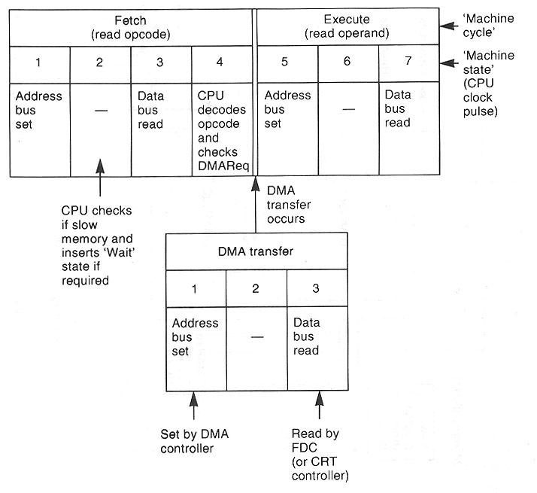

FEP (Front End Processor) An FEP is an additional processor that specializes in dealing with I/O requests. This is analogous to the coprocessor that is used for math functions except that this device only deals with input output requests and subsequent transfers. In this way the CPU is again relieved of slower tasks/transfers. A good example of the use of this type of arrangement is where banking computers may use an i/o processor to service thousands of serial data links to sub branches or dispensers. The diagram below shows how this may work;

‘Front End’ processor could take on this role

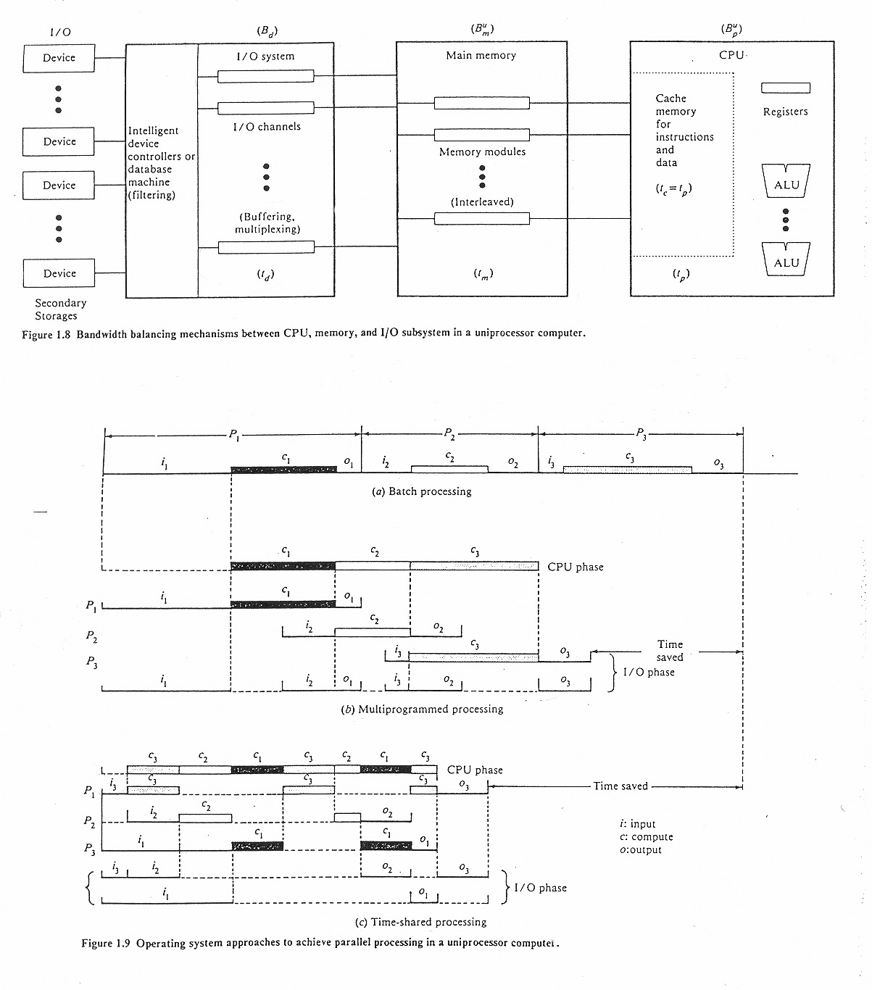
Usually very slow compared to CPU

5. Time Slicing and Multiprogramming

Multiprogramming - Interleaving CPU and I/O operations between several programs/processes ‘time slicing’ is a variation (windows). E.g. DOS has a 18.1ms interrupt. The concept is shown in the diagram below;

6. Cache

Cache is part what is classed as the hierarchical memory model. This structure is shown below in order of performance from fastest to slowest;

Fastest
CPU

REGISTERS

CACHE

MAIN MEMORY

BACKING STORE
HDD, Tape etc

Slowest

Cache memory is usually a high performance type of memory that falls into the static RAM category. Cache memory as such is far more expensive than dynamic RAM that is used for external memory. Because of this relatively smaller amounts of it is used usually on the processor die itself. However it is possible to have some ‘levels’ of cache off die on the motherboard in order to further enhance performance.

Processor specifications usually refer to cache in levels e.g. level 1. Level 2 and it was at one time understood that level 1 cache was on die with subsequent levels off die. However this is not now the case which does give rise to confusion. Different processors can have multiple levels of cache on die. Typical amounts run in to Mbytes.

However cache happens to be incorporated into a system it always serves the same purpose – to hold instructions/data locally to the processor in higher performance memory which leads to a performance boost. This is in contrast with read/writes to external slower dynamic RAM. Cache contents are often described as being instruction queues that are ‘pre-fetched’ which basically means queues that are optimised in advance to minimise slower external memory accesses.

Cache contents are determined by two methods;

- Access method
- Replacement algorithm

Examples of the former include;

- Direct mapping
- Fully associative mapping

Later in the course both types of mapping will be studied however more detail will be explored with the direct mapping system. The objective will be to design several different configurations of direct mapping schemes. Replacement algorithms will also be explored in more detail.

Alternative View of the classification of Computers that Employ Parallel Processing

The following list is generated by technique or type of system and then categorises a particular type into an appropriate Flynn category. In this an alternative or ‘reverse’ perspective is explored;

Pipelined Systems SISD

Array processor systems SIMD several/many ALUs (PUs)

???? MISD Does not actually exist

Multiprocessor MIMD

Arithmetic Pipelines

So far only ‘instruction pipelines’ have been explored. However arithmetic pipelines are also implemented in systems.

An arithmetic pipeline is basically concurrency in the ALU (Arithmetic Logic Unit). Several operations are executed in the ALU at the same (staggered) times. The most involved arithmetic for an ALU is floating point arithmetic. In order to study this branch of arithmetic pipelining it is useful to analyse how this type of operation is conducted in the human brain then compare it to the silicone system;

Add 864 to 0.004

Assumed decimal point

Note that floating point numbers are ‘real’ numbers they can have fractional values. Whereas integer numbers are ‘whole’ numbers and in the computing definition have a relatively low upper limit.

In order to carry out the addition it is useful to write it as;

864.0 + 0.004

Stage 1
Line up points
Stage 2
Add
864.0
000.004

864.004

Stage 3
Adjust for overflow
(if req)
Adjust for
overflow

Example 2 add 864 to 301.2
Stage 1
Line up points
Stage 2
Add
864.0
301.2

1165.2
Stage 3
Adjust for overflow

1165.2

Alternative – use pipelined floating point adder the diagram below depicts a pipelined floating point adder with four stages;

Below for reference is shown the pipelined structure of a typical central processing unit;

The diagrams are quite complex so it is best to study the operation of the pipelined adder by numeric example. However before doing this it is worth reviewing how computers represent floating point numbers. There are basically two parts to the number – the exponent and the mantissa;
Exponent
Mantissa (number)
8 4 2 1
2³ 2² 2¹ 2⁰

0 0 0 1 0 1 . 0 0

Scaling Factor

Assumed Decimal Point
Sign
0 = +VE
1 = -VE

The procedure is; Take the scaling factor(Exponent) and multiply by the number(mantissa). In this example this will result in;

2² X 1 = 4.0 (i.e. 1.000 x 2²)

Mantissa (number)
Exponent
2⁻¹ 2⁻² 2⁻³ 2⁻⁴
$$\frac{1}{2} \frac{1}{4} \frac{1}{8} \frac{1}{16}$$
0 0 0 0 1 1 . 1 0
2³ 2² 2¹ 2⁰

8 4 2 1

2¹ X 1.5 = 3.0 (i.e. 1100 x 2¹)

Need to match exponents (i.e. line up decimal points!) – so take lower value and shift right

1100
RS 0110 i.e. this is now 0.75 (3/4) x 2² (4) = 3

Now that exponents equal can add 1000
0110
Exp
Mant
½ ¼
✓

1110 giving 1. 1 1 0 i.e. 1.75 x 2² (4) = 7

Now lets analyse the same example propagating through a pipelined floating point adder such that;

A = a x 2^{p} B = b x 2^{q}
C = A + B C = 4 + 3
Mantissa Exponent
Mantissa Exponent
C = 1.000 x 2² + 1.100 x 2¹

1100
1000
1
2

Stage 1
Fraction
Selector
Exponent
Subtractor

Fraction of smaller No. 1100
Set numbers to same exponent
(equiv. of lining up decimal point)
1000

1
Right
Shift
Difference of exponents

Stage 2
0110
Fraction of smaller No. 1100
Now set to same exponent 2²

Add Fractions
Fraction
Adder
0110 x 2²
1000 x 2²
1110

2

1110

Stage 3

No
Overflow
Normalise result
0
Yes
If yes take mantissa and make it smaller

Right
Shift
Exponent
Increment

1110
2
✓

Answer (denary) = 1.75 x 2² = 7

Add numbers throughout the diagram to confirm a result of 7!
Repeat the exercise to add the numbers 7 & 6 (should get 13) which should demonstrate overflow;

1100
1110
2
2

Stage 1
Fraction
Selector
Exponent
Subtractor

Set numbers to same exponent
(equiv. of lining up decimal point)

1110

No right shift necessary
0
Right
Shift
Difference of exponents

1110
Stage 2
1100

Add Fractions
Fraction
Adder

2

11010
Stage 3

Overflow
No
Overflow
Normalise result
✓

1
(increase exponent by 1)
Yes
11
(i.e. 3 in binary)

Right
Shift
right shifted
1101
Exponent
Increment

½ ¼ ¹/₈
1 . 1 0 1

= (1 + 0.5 + 0.125) x 8
= 1.625 x 8
= 13 ✓

11 = 2³
1101

Answer (denary) = 1.625 x 2³ = 13

Two types of arithmetic pipeline

- Scalar e.g. single pairs of data items – other pairs may follow
- Vector. many pairs of data items

So far have discussed scalar. An example of a program loop to process scalar items is shown below. The programming language PASCAL is used to illustrate this. The obvious structure to use is an iterative one i.e. a for loop;

For I = 1, 64 do

Begin

Z(i) = x(i) + y(i)
End

This loop will execute 64 times and each time will add together the values stored in the variables x(1 to 64) and y(1 to 64) and store the result in z (1 to 64). Thus resulting in 64 separate answers albeit conducted in sequence.

In a vector processor (e.g. Cray) the above sequence would be performed in one instruction.

So a vector processor, sometimes called an array processor is a cpu that can operate on one dimensional arrays of data called vectors. Note that arrays can be vertical (columnar) or horizontal (row). This allows vector arithmetic to be achieved.

It is worth exploring the history of vector processing at this stage. Vector processor development can be dated back to the 1960s. An organisation called Westinghouse conducted research as part of project named Solomon. The idea of Solomon was to obtain higher math performance from system design. Ultimately this meant experimenting with a large number of relatively simple math coprocessors. These would all be managed by a singular cpu that fed a common instruction to all of the ALUs, one per cycle, but modified with a different data point for each ALU to work on. This allowed the Solomon Machine to apply a single algorithm to a large data set in the form of an array.

This project was cancelled in 1962 until the University of Illinois resurrected it in the form of the ILLIAC IV. This version originally was made up of 256 ALUs with 1 GFLOP performance. However the final version had only 64 ALUs with 100 to 150 MFLOPS. This had proven that the basic concept was sound. The ILLIAC was tested on intensive math applications such as computational fluid dynamics and in this role proved to be the fastest in the world at the time. In spite of this the ILLIAC failed although had proven the concept.

The first successful implementation of vector processing appears to be the CDC (Control Data Corporation) STAR-100 and the Texas Instruments Advanced Scientific Computer (ASC). Performance of the most basic implementation (one pipe) returned around 20 MFLOPS. Expansion came in the form of 2 pipes or 4 pipes. The downside was that the machine took considerable time decoding the vector instructions.

The first commercially successful implementation of the vector technique came about in 1976 in the form of the CRAY-1. This design utilised eight ‘vector registers’ which held sixty four 64 bit words in each. This is in opposition to leaving the day ain memory as with the STAR and ASC. This method is much faster than having to ‘talk’ to memory. The design also used pipelining to implement vector instructions rather than physical multiple ALUs. There were also separate pipelines for different instructions. i.e. addition/subtraction implemented in different hardware to multiplication. The important thing here is that it allowed a batch of vector instructions themselves to be pipelined – a technique that CRAY called ‘vector chaining’. The CRAY 1 performance was in the region of 80 MFLOPS, although with up to three chains executing it could peak at 240 MFLOPS – a respectable figure. CRAY continued to keep the competition at bay with the CRAY 2, CRAY X-MP and CRAY Y-MP.

However since then the supercomputer market has focussed on very large scale parallel processing rather than vector processor enhancements. IBM did recognise the benefits of vector processing though and developed Virtual Vector Architecture for use in supercomputers coupling several scalar processors to act as a vector processor.

It is important to note that vector processing techniques have since been added to almost all modern CPU designs. Although these CPU designs fall mainly into the SIMD category, in these implementations, the vector unit runs beside the main scalar CPU, and is fed from vector instruction aware programs.

In order to summarise this and come full circle it is useful to remind ourselves of the instruction pipeline principle that was discussed earlier in the handout. With instruction pipelining the instructions essentially pass through several sub units in turn. The first sub unit reads the address and decodes it, the next ‘fetches’ the value at those addresses, and the next does the math itself. With pipelining the principle is to start decoding the next instruction before the last one has even left the CPU. It is almost like an instruction assembly line! In this way the address decoder is almost in constant use. This is good as latency is reduced i.e. the typical time taken for an instruction to complete. This time is high when just one instruction is dealt with at any one time as with the standard non-pipelined model of the fetch execute cycle.

Vector processors take this concept even further because they pipeline the data as well as the instructions! In short - instead of just, add A to B for a series of variable values – add all of the numbers from here to here to all of the numbers from there to there - this offers a distinct advantage as CPU reads a single instruction from memory and knows the next address will be one larger than the last – as opposed to having to decode each one first then repeat the whole process again and again. Obviously significant savings in decode time is therefore gained. The pseudo code below illustrates the principle;

Non vector Execute this loop 10 times
Read the next instruction and decode it
Fetch this number
Fetch that number
Add them
Put the result here
End loop

Vector Read the next instruction and decode it
Fetch these 10 numbers
Fetch those 10 numbers
Add them
Put the results here

There are several advantages to this approach;

      - only two address translations are needed
      - the fetching and decoding of the instruction only has to carried out once instead of ten times
      - the code itself is smaller i.e. a memory saving

furthermore, a vector processor may have multiple functional units adding those numbers in parallel. The checking of dependencies between those numbers is not required as a vector instruction specifies multiple independent operations. This simplifies the control logic required, and can improve performance by avoiding stalls.

The Cray supercomputer took this a step further, allowing several different types of math operation to be carried out simultaneously. For example code that adds two numbers and then multiplies by a third. The Cray would fetch all the data items at the same time then execute the addition and multiplication in a single operation. Obviously this meant that the maths result was available much sooner, the limiting factor being the memory transfers. The pseudo code to illustrate this concept is shown below;

Read instruction and decode it
Fetch these 10 numbers
Fetch those 10 numbers
Fetch another 10 numbers
Add and multiply them
Put the results here

Vector processors tend to work more efficiently where large amounts of data needs processing. Correspondingly these types of CPUs were restricted to the domain of the supercomputer which were found generally in weather prediction centres and physics laboratories where large amounts of data required processing.

To finish off by brining things up to date these days the likes of the x86 family uses something called SSE(Streaming SIMD Extensions) instructions to to implement vector instructions. This is basically an instruction set extension and was first introduced in the Pentium III in 1999. This was in competition to AMD’s 3DNow technology which appeared a year prior to this.

SSE contained around 70 new instructions targeted at single precision floating point arithmetic. SIMD instructions can greatly increase performance when performing the same operations on multiple data objects. Applications such as graphics processing and DSP are typical.

SSE was predated by MMX (Multi Media Extensions) which was superceded because of two main problems;

- The reuse of existing floating point registers preventing the CPU from being capable of dealing with floating point and SIMD data at he same time.
- It only worked on integers

SSE was subsequently expanded to SSE2, SSE3, SSSE3 and SSE4. It is also important to realise that many machines also utilised both traditional architecture processors and vector processors. However this did have implications on the complexity of the code used and thus the tasks of the programmer.

Dependency in Pipelines

We have now discussed in quite a bit of depth both scalar and vector arithmetic pipelines. We also discussed instruction pipelines. However now that an appreciation has been gained as to how they work it is worth revisiting instruction pipelines to investigate the issue of ‘dependancy’.

In instruction pipelines there are essentially two types of dependency;

- Control dependency
- Data dependency

Control Dependancy

This is when a subsequent instruction may not be executed depending on a prior instruction or some other event. A typical example is when a DISCONTINUITY occurs such as;

- Jump instruction
- Call instruction
- Interrupt instruction

Under these circumstances a pipeline is of no benefit. So what is the solution??

Normally nothing unfortunately! – the pipeline must be ‘flushed’ in order to initiate a ‘cold start’

Some processors inspect instructions to try and detect a discontinuity and subsequently pre-fetch and start to obey 2 (or correct 1 of 2) queues or instructions.

Data Dependancy

This occurs typically when a second instruction uses or depends on the result of a prior instruction;

LD A,3
ADD A, B

Solution this time is either to delay the second instruction which introduces a performance overhead or alternatively use a technique known as data forwarding;

S1
Fetch
Instruction
S4
Execute

S3
Fetch
Operand
S5
Store
Results
S2
Decode
Instruction

0
Time

I₁
I₂

I₃
Overlapped execution of instructions without branching

I₄
I₅

I₆
I₇
I_{n}

I₇
I₆
I₅
I₄
I₃
I₂
I₁
The effect of branching
On the performance
Of an instruction pipeline
0
Time

