Professional Behaviours and Valuing People

Lisa Jayne Craddock

Word Count;
Task 1 – 2238
Task 2 – 1142

Task One;

- (AC 1.1)

The term professional can be interpreted in many different ways. The Oxford Dictionary (2023) definition is as follows ‘connected with a job that needs special training or skill, especially one that needs a high level of education’.
Smith and Mitchell (2022, in Taylor and Woodhams, 2022) imply that a profession is more than an occupation, and that you become a ‘member of the profession, when you join a professional body’. Both these definitions imply that qualified people practitioners who are members of the CIPD are professionals.

A CIPD (2015) report identified the following core elements ‘of what it means to be professional’;

- Social and ethical responsibility
- Commitment
- A body of expert knowledge and skills
- Continuing professional development (CPD)
- Situational judgement
- Identity

From this report, the CIPD developed their profession map (CIPD, 2022) pictured below;

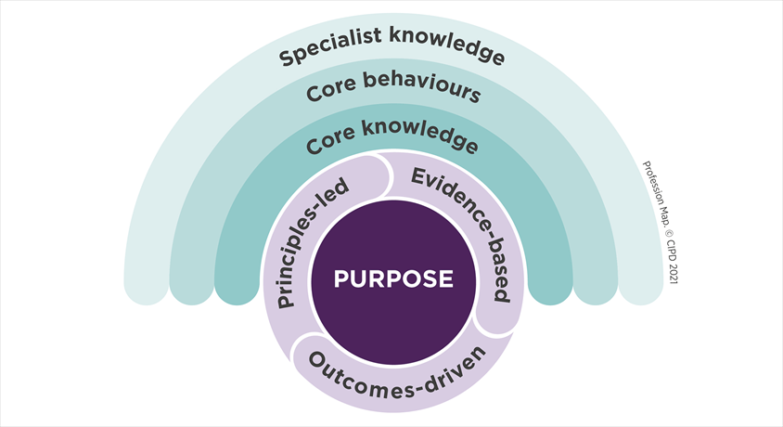

The CIPD (2022) also add that ‘The fundamental purpose of the people profession is to champion better work and working lives’ (CIPD, 2022).

The three core professional values that make up the profession map are;

- Principles-led
- Evidence-based
- Outcomes-driven.

Smith and Mitchell (2022, in Taylor and Woodhams, 2022) allude to the notion that the overarching goal of the CIPD’s profession map is to determine the standard of conduct for people professionals across the globe. It is worth noting however, that membership of the CIPD or other globally recognised professional bodies is not compulsory (CIPD, 2021).

In addition to the profession map, the CIPD (2023) have also developed a Code of Conduct and Ethics. The Code of Conduct and Ethics have five key virtues;

- Positive and active impact on working lives
- Civic virtue and stewardship
- Good Character
- Professional service and competence
- Personal responsibility

Under the professional service and competence virtue, the key points are;

- Develop your professional knowledge, skills and competence
- Provide an insightful, up-to-date and evidence-based service
- Seek advice and support, or refer if needed when operating outside your expertise
- Safeguard all restricted, confidential, commercially sensitive and personal data (CIPD, 2023).

Whilst the knowledge and skills in the CIPD profession map can be taught/learnt, behaviour is a more complex issue. How we behave as professionals can impact the outcome of a situation. Having self-awareness is an important skill for people professionals, as it will allow us to consider our impact, and to ensure we don’t allow our own emotions to dictate our decision making.

- (AC 3.1)

Smith and Mitchell (2022, in Taylor and Woodhams, 2022) advise that as a people professional, it is imperative to continually develop. If a people professional is not keeping up to date with changes in their area of practice, they could quickly find themselves using outdated sources of information, or worse still, breaking the law. This implies that an individual’s CPD is a key priority.
They suggest that the two most important skills of CPD are ‘reflection and feedback’ (Smith and Mitchell (2022, in Taylor and Woodhams, 2022 pg 167).
The CIPD (2022a) recommend a CPD cycle, which can help an individual structure their CPD, which also supports Smith and Mitchell’s (2022, in Taylor and Woodhams 2022) suggestions.

The CPD cycle is as follows;

- Identify: Understand where you've come from, where you are and where you want to be.
- Plan: Plan how you can get to where you want to be, with clear outcomes and milestone to track progress.
- Act: Act upon your plan, and be open to learning experiences.
- Reflect: Make the most of your day-to-day learning by routinely reflecting upon experience.
- Apply: Create opportunities where you can translate theory into practice and put your learning to work.
- Share: Share your learning in communities of practice to generate greater insight and benefit from the support of your community (by sharing, you can gather feedback).
- Impact: Measure the overall impact your learning has had on the work you do (CIPD, 2022a).
Research conducted by Green, Peters and Young (2020), show the following trends to be the most influential by 2030;

- Internal change
- Digital and technological transformation
- Changing demographics
- Diversity and inclusion strategy
- Diversifying employment relationships
- Sustainability, purpose and responsible business (Green, Peters and Young, 2020).

CPD is completely individual, and is something we as individuals are responsible for. In my current people professional role as a Recruitment and Retention Manager, I am already working on many of the trends mentioned above, however my CPD priorities will evolve, as my role will continue to change and develop, in line with workplace evolution, and the desire for hybrid/remote/flexible working continues to rise.

- (AC 1.2)

Ethical values ‘provide the moral compass by which we live our lives and make decisions’ i.e. “doing the right thing” (CIPD,2021a).

Smith and Mitchell (2022, in Taylor and Woodhams, 2022) advise there are three kinds of ethical values;
- Personal – an individual’s ability to judge right from wrong
- Professional – principles held by your profession / organisation
- Public – the idea of the common good

Three ethical values that I consider myself to have are honesty, integrity and courage. I reflect honesty into my work as a people professional by being open and honest in my communication with colleagues/stakeholders. I achieve this by being prepared, so I research and look at all possible outcomes before engaging in a conversation that could have a personal impact on an individual/group of colleagues.

Integrity is another value, and this links well with honesty. Integrity to me means being able to be honest and sincere and having strong moral principles. An example of this would be when a colleague asks me a question, I will always give them an honest answer. This includes times when I do not know the answer. I will stand up and admit I do not know, and will endeavour to assist them in finding out. I also will take responsibility for any mistakes I make, and will take accountability to resolve this.

Lastly, I consider myself to have courage. As a people professional we are often the instigators of transformation/change, so we have to stand up and be brave, have courage and take action, all the while trying to maintain meaningful connections with colleagues, and trying to limit confrontation.

- (AC 1.3):

One of the core behaviours of a people professional is the ability to influence others, and the courage to challenge decisions and actions (CIPD, 2019).

Yemm (2008) suggests that power = influence, therefore you can only influence people if you hold some sort of power.

French and Raven (1959, in Woodhams and Taylor, 2022) developed a concept around six different forms of power;

- Coercive – threat or punishment
- Referent – others respecting you or your work
- Information – gathering information from all sources to cover all eventualities
- Expert – expertise in the subject matter
- Legitimate – the presumed right as the people professional to implement change
- Reward – the benefit (i.e. financial)

In a current role I have recently submit a business case proposal to double the size of my team. In order to do this I needed to present evidence and knowledge to support my proposal; that doubling my team, would have a positive impact on the organisation, and that any additional spend for employees could be mitigated. The proposal included evidence that the improvements my team could make for them (i.e. reducing the time to hire new employees by improving and tightening current processes) could reduce the amount of money spent on agency staff and overtime within the service, and therefore improve the morale of current staff, as they would be less likely to suffer from burnout due to being overworked. Therefore, using French and Ravens (1959) power concept, I was able to use informational, expertise and reward as different forms of power to help me influence my audience.

- (AC 1.4)

Raising concerns is a continual aspect of people practice. There are a few ways that concerns can be raised by employees; informally, formally, or through whistle-blowing (concerns around malpractice or wrongdoing). Although it is not a legal requirement, most organisations have their own whistle-blowing policy in place. Employees are protected under the whistleblowing policy if their disclosure is in the public interest. This is defined under the Public Interest Disclosure Act 1998. (Gov, n.d).

From my previous employment, I can provide a personal example of leadership conflicting with ethical values. In my position as a Team Co-ordinator, I along with two others, were responsible for 30 members of staff. Our manager decided that it was fair to split the members of staff equally between us, resulting in 10 members of staff each to manage. This decision, although could be deemed as fair, actually put me at a disadvantage, as I was part-time due to childcare commitments. I was expected to commit the same about of time to each staff member, providing training, support, 1-2-1 meetings and PADRs, even though I worked substantially less hours that the other two Team Co-ordinators. Once reviewing the impact this decision could have on both myself and the members of staff involved, I decided to raise this with my manager. I was able to raise this in a formal direct way, and outlined the difficulties with the decision, backed up with evidence. My manager agreed with my concerns, and addressed the issue, by ensuring I had a reduced number of staff to manage, to fairly reflect the number of hours I was working. If this wasn’t dealt with and corrected, this could have been seen as indirect discrimination.

The CIPD (2017, in Taylor and Woodhams, 2022) suggests that ‘having the courage to speak up when concerned with an ethical issue, whilst remaining true to your own personal values, is likely to have positive consequences’ (pg: 158).

- (AC 2.1)

Inclusion can be defined as how people feel valued, accepted and supported to succeed at work, regardless of their background, identity or circumstance (Smith and Mitchell 2022, in Taylor and Woodhams, 2022).

David Rock’s (2018) SCARF model describes how the five key domains below influence our behaviour in a social setting (including in the workplace);

- Status – our relative importance to others.
- Certainty – our ability to predict the future.
- Autonomy – our sense of control over events.
- Relatedness – how safe we feel with others.
- Fairness – how fair we perceive the exchanges between people to be
(Rock, 2018)

Rock’s (2018) theory encourages us to consider our interactions with colleagues in the workplace, and by allowing these interactions to be positive, this will leave staff feeling less ‘threatened’. Following the method could also help build trust with colleagues, allowing them to feel valued, and therefore want to stay with the organisation.

Research undertaken by McKinsey (2020) presents evidence to support that ‘companies who have a higher percentage of gender diversity on executive teams, were 25% more likely to experience above-average profitability’ than companies with a lower percentage.

In addition to the above, research undertaken by Great Places to Work (2021) shows that employee retention is higher in an inclusive workplace, and that employees who trust that their organisation will treat them fairly, are more likely to stay a long time with the organisation.

The points above show that the research supports benefits for both the employee and the employer; employees wanting to stay within an organisation is a positive for them and their stability and career development, and is a positive for the business as this reduces employee turnover and recruitment costs.

- (AC 2.2)

In order to introduce a new policy or initiative, there would need to be sufficient evidence to support it, and means of checking that the outcomes of the initiative have been achieved, before agreeing on an implementation strategy.
My hypothetical initiative would be around a 4 day working week, in the hope that the initiative would meet the need of providing employees with a better work life balance, and achieving a reduction in both sickness and employee turnover for the organisation, as it has become clear that there is a strong business case to introduce initiatives that improve health and wellbeing in the workplace (Taylor, 2022 in Taylor and Woodhams, 2022).
In the first instance an online survey would be used, as this will cover the organisations employees in all areas, due to us being spread across numerous buildings. This would be communicated to all colleagues using their work or personal email address, and could also be posted on the internal intranet, and via posters which could be delivered across all building locations – and hung throughout the buildings. For any colleagues who do not have access to emails/intranet for their roles, they could complete a paper questionnaire (asking the same questions) to ensure they are included.
The survey would consist of mostly closed questions, to ensure the information gathered is quantitative, but by adding a ‘free text’ question, this will allow colleagues to expand on any areas they wish to address and allowing me to capture some qualitative data too.
This method would allow me to capture large amounts of data in a relatively short space of time, and will allow colleagues to feel valued.
If/when the policy was implemented, I would continue to engage with colleagues to gauge feedback on whether the initiative has had the desired impact. This again could be done via online surveys (as above). I would also work alongside colleagues and do some analysis to discover whether the implementation of the 4 day working week has had an effect on sickness and employee turnover.
In terms of the business case, Bevan et al (2018: 160-61) states ‘on balance, a healthy workforce is – compared to an unhealthy one – more likely to be alert, vital, agile, resourceful, resilient, innovative, collaborative, motivated, engaged, loyal, in attendance and productive’.

Task Two
Activity One (AC 2.3, AC 3.2)

In order to answer the CIPD core behaviour self-assessment questions, I carried out a SWOT analysis, comparing myself to my current job description and person specification. A SWOT analysis is an acronym for; Strengths, Weaknesses, Opportunities and Threats (CIPD, 2021b). I chose the SWOT analysis as it’s a simple framework to follow, and it helps to facilitate understanding in each area (CIPD, 2021b).
One disadvantage to using a SWOT analysis is that the data input is based on my own assumptions only, which could later prove to be unfounded, so to ensure that wasn’t the case, I decided to ask a colleague I have previously worked with and trust to be honest, to review the questions and reflect on my behaviours. The results are an amalgamation of the two (appendices 1).
Another disadvantage to using a SWOT analysis is that in order to be effective, the analysis has to be completed on a regular basis (CIPD, 2021b).
Next time I complete a self-assessment, I would look to incorporate the 360 feedback method into my results, using anonymised feedback, as this would allow the participants to ensure they can be truthful about the information they provide, without the fear of victimisation as the forms would be completely confidential (Taylor and Ciachir, 2022 in Taylor and Woodhams, 2022a).

Task Two
Activity Two (AC 3.3)

As a result of the self-assessment, there were two key behaviours that I need to focus on, which resulted in me adding 6 activities to my learning plan (appendices 2). Here I will discuss two of those.
Valuing People;
I’ve chosen to add a valuing people course to my CPD as one of the results from the self-assessment showed I scored low on ‘build a sense of team spirit and purpose’.
Working inclusively;
I’ve chosen to add a working inclusively course to my CPD as one of the results from the self-assessment showed I scored low on ‘getting to know people as individuals and building purposeful working relationships, and collaborating with wider colleagues’.

Valuing people and working inclusively are two behaviours I pride myself on, but I do feel it is a true reflection of where I am currently within my role. I have recently started a new role in January 2023, and since joining my team, I have had time off work due to an operation. These two factors have limited my time to get to know my team and wider network of colleagues, and therefore being able build rapport and harness a sense of team spirit has been difficult. This is something I will continue to improve.
In order to improve the new working relationship between myself and my team, I have implemented weekly hour long team meetings. These meetings will be split, the first half will focus on any organisational updates that need to be addressed, and the second half will focus solely on the team and how they are doing. We can use this as a safe space to get to know each other.
I have also implemented a recurring monthly 1-2-1 with each member of my team, so I can start to understand the way they work, and their personal development needs, so I am able to support them with this.

Task Two
Activity Three (AC 3.4)

Development activity one:

Record Name: | Specialist Knowledge
Date: | 12/10/2022
Profession Map Area: | Talent Management
Type of Reflection: | Other Reflections
Type of Learning Experience: | Attended an Event (online)
Grade: | N/A
Supporting material: | N/A

What did I learn?
I learnt about ways in which other organisations across the UK seek out talent for their organisations, particularly around recruiting for digital roles. The course taught me that there is no one size fits all approach when it comes to recruitment. Some areas of organisations such as I.T departments can benefit from avoiding the ‘normal’ application process as a bespoke approach can create a better applicant experience. This is due the acumen of the applicants.

What did the learning experience tell me about myself?
The course taught me that up to this point, I had always gone with the ‘standardised organisational’ approach to recruitment, and that with some knowledge and evidence, I should look to challenge these norms.

How does this learning experience impact my professional practice and the way I'll approach situations in the future?
Going forward I will assess each vacancy request I receive, review with my team, and we can make a collaborative decision on whether to use a ‘standardised’ process, or something unique for the vacancy/department in question.
What do I need to do next for this learning experience to have a wider positive impact (eg on others, my organisation, the sector, the profession, society)?
By reviewing requests and tailoring my approach to suit departmental needs, this could have a positive impact by raising the number of quality applicants applying for the jobs.

Development activity two:
Record Name: | Specialist Knowledge
Date: | 20/06/2022
Profession Map Area: | Passion for learning
Type of Reflection: | Course Reflections
Type of Learning Experience: | Completed a course
Grade: | Pass
Supporting material: | N/A

What did I learn?
The course was a BTEC level 2 course in Counselling Skills, which helped me learn about ways to ‘counsel’ individuals, using a variety of techniques.
What did the learning experience tell me about myself?
One of the key elements of counselling is ‘silence’, which is when you allow the person you are speaking with / counselling space to reflect on and answer your question in their own time, without interrupting. I personally tend to not like silence, so historically would try and fill the gaps with suggestions – unbeknownst to me that this would actual hinder the person from being able to come up with their own solutions.
How does this learning experience impact my professional practice and the way I'll approach situations in the future?
From the course, I have learnt to not always give people the answer immediately. By using a series of open and closed questions (relevant to the situation), I can encourage others to think about the answer for themselves. This will give them a sense of power that they have come up with the answer. This should help increase their confidence and encourage future learning.
What do I need to do next for this learning experience to have a wider positive impact (eg on others, my organisation, the sector, the profession, society)?
I need to take these new found skills and apply them in the workplace (where appropriate). I can also teach my team these skills, so they in turn can use these with others within the organisation with colleagues, and when speaking to applicants who have applied for our job roles.

Development activity three:
Record Name: | Specialist Knowledge
Date: | 23/01/2023 and ongoing
Profession Map Area: | People analytics
Type of Reflection: | Other reflections
Type of Learning Experience: | Something I’ve done / am doing at work
Grade: | N/A
Supporting material: | N/A

What did I learn?
I am required to analyse data relating to retention rates within the organisation. The basis of the data is coming from a staff survey which is looking at reasons why people may look to leave the organisation. This data will then be cross referenced to reasons given by past leavers, to see if there are trends.

What did the learning experience tell me about myself?
So far the experience has taught me that I am more capable of reading and understanding data than I have previously lead myself to believe. I also learnt that I felt slightly ‘out of control’ of the data that was being received, as the piece of work was started before I joined the organisation, therefore I had no input on the questions being asked.
How does this learning experience impact my professional practice and the way I'll approach situations in the future?
It will impact my professional practice by ensuring I am fully immersed in a project/piece of work from the start, so I am best able to put forward suggestions and opinions. There this is not possible, I will strive to make the best out of the situation, and look to seek advice from colleagues who have been involved since the start.
What do I need to do next for this learning experience to have a wider positive impact (eg on others, my organisation, the sector, the profession, society)?
I need to use the information gained from this project to improve policies within the organisation, which will lead to improvements for staff, to ensure we are able to retain our staff. This will have an impact on both the staff and the organisation.

Appendices;

Appendix 1

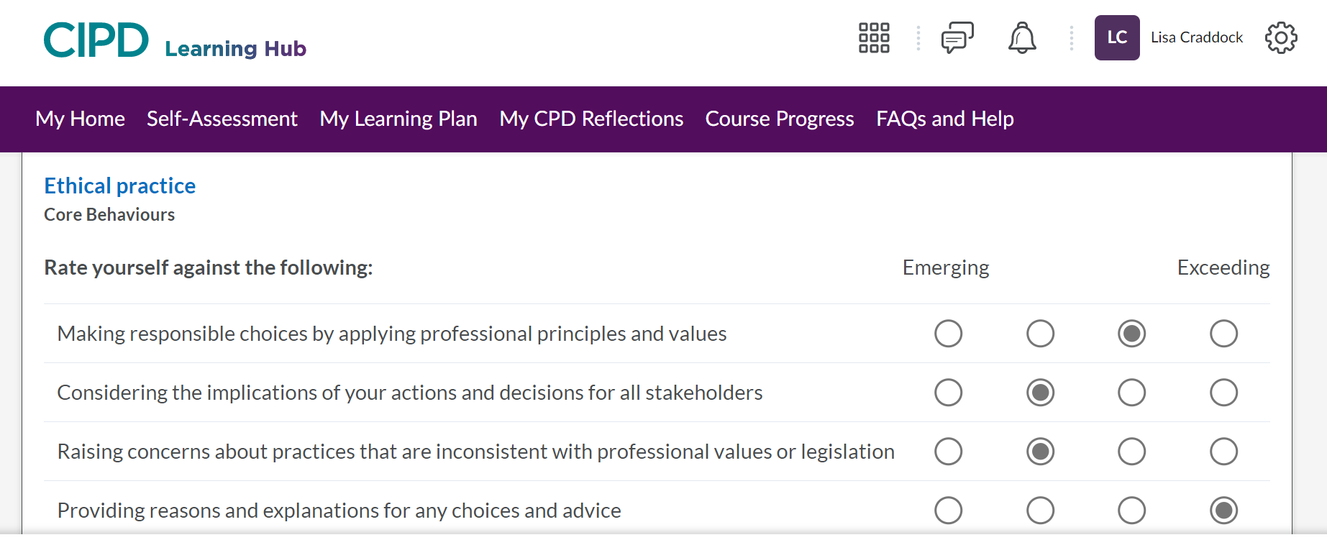

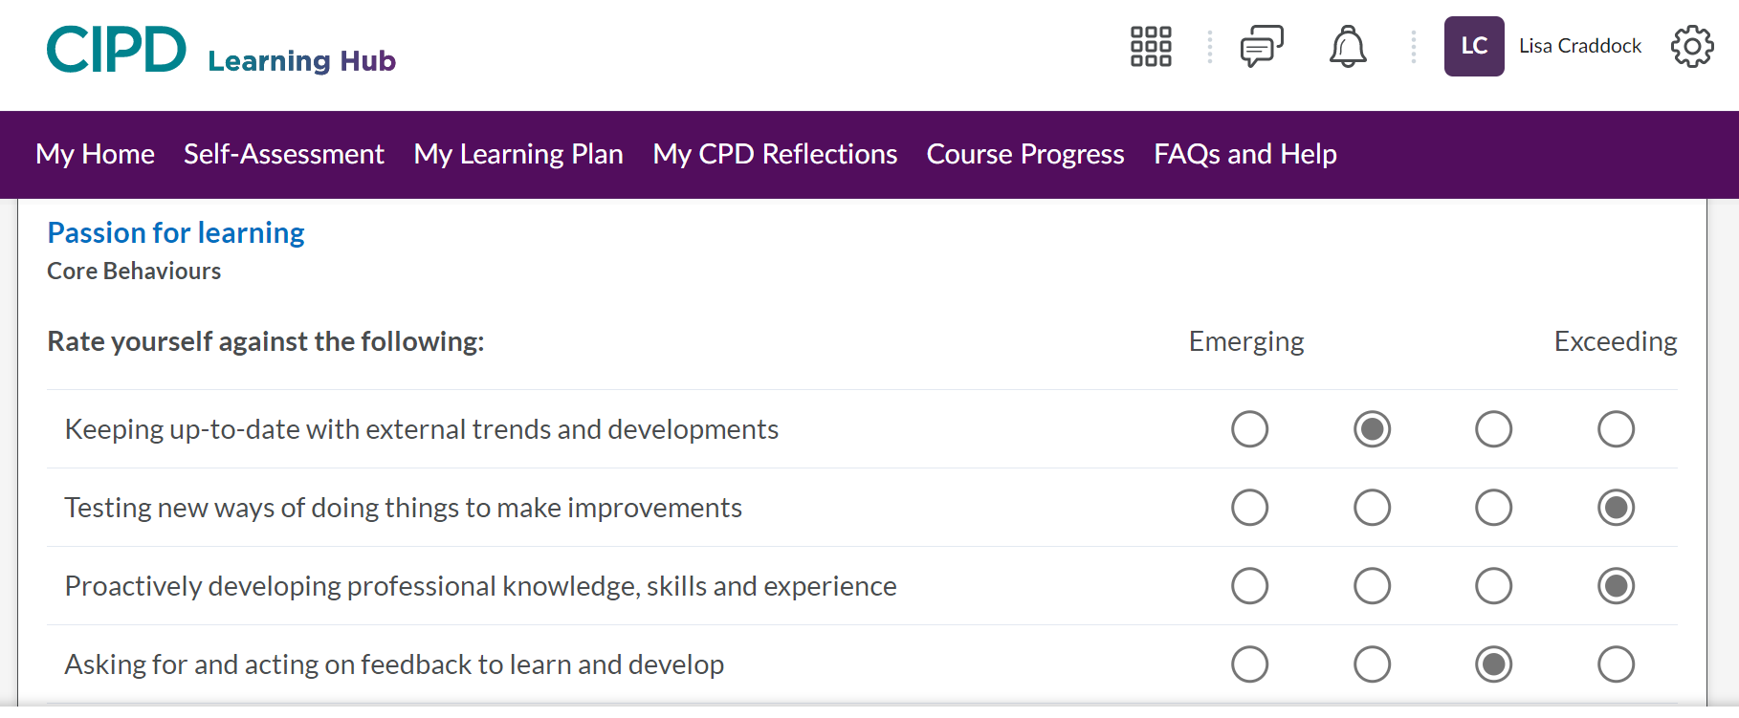
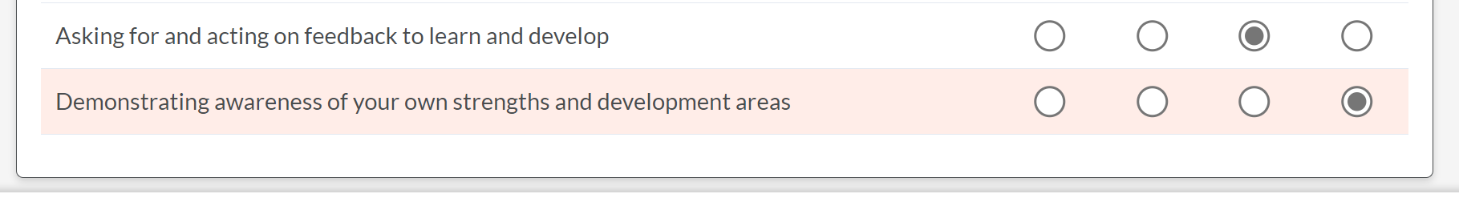

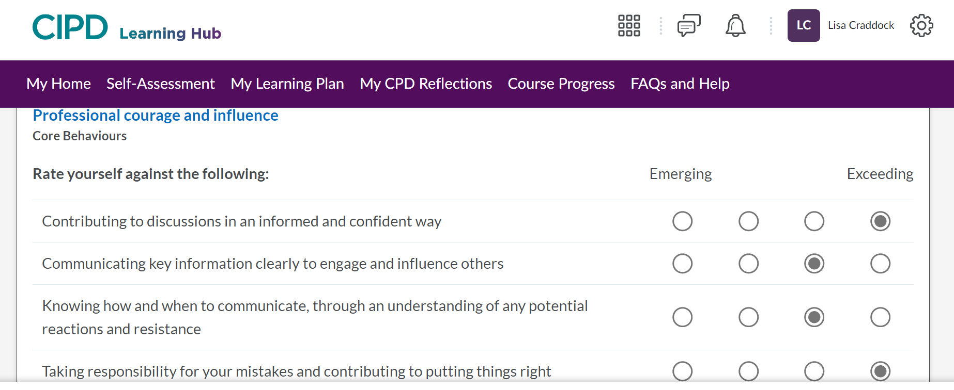

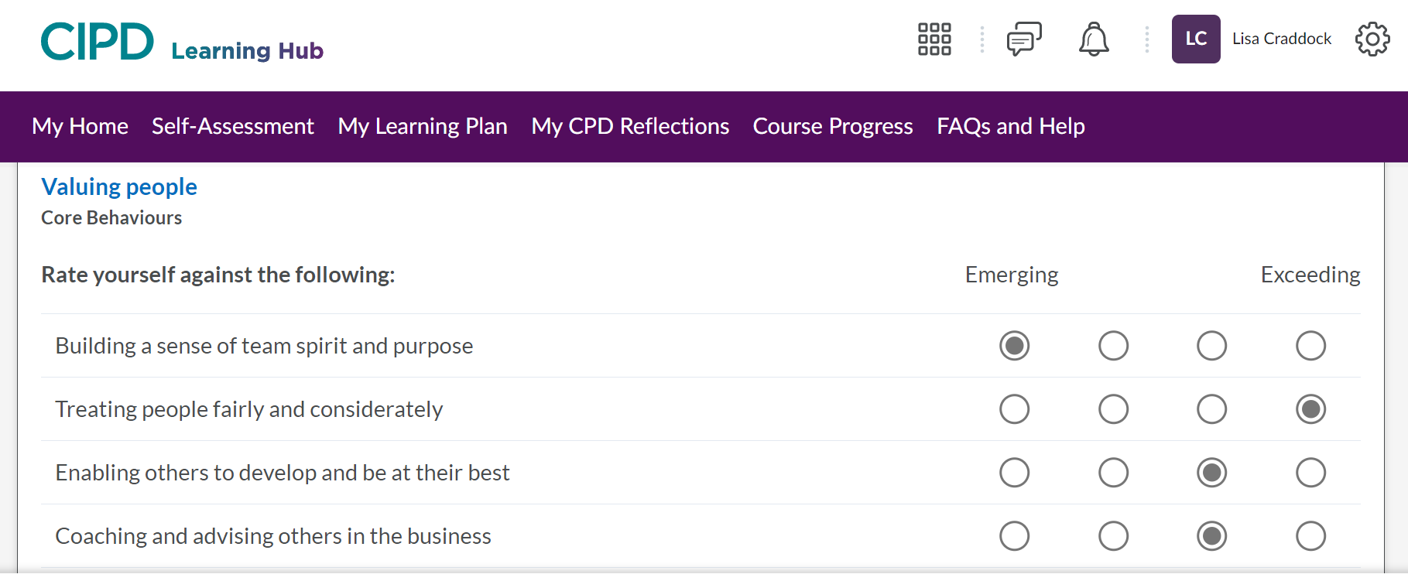
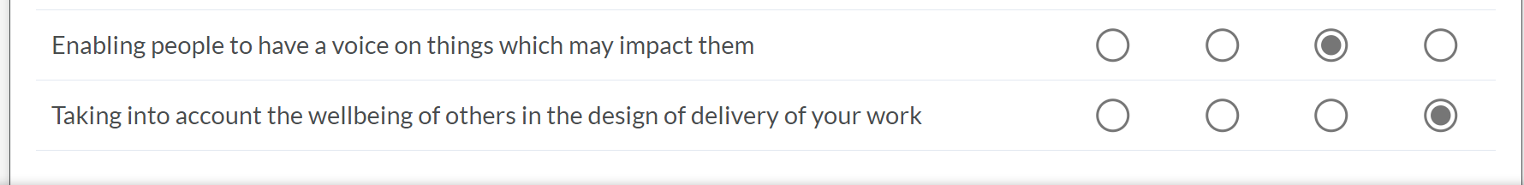

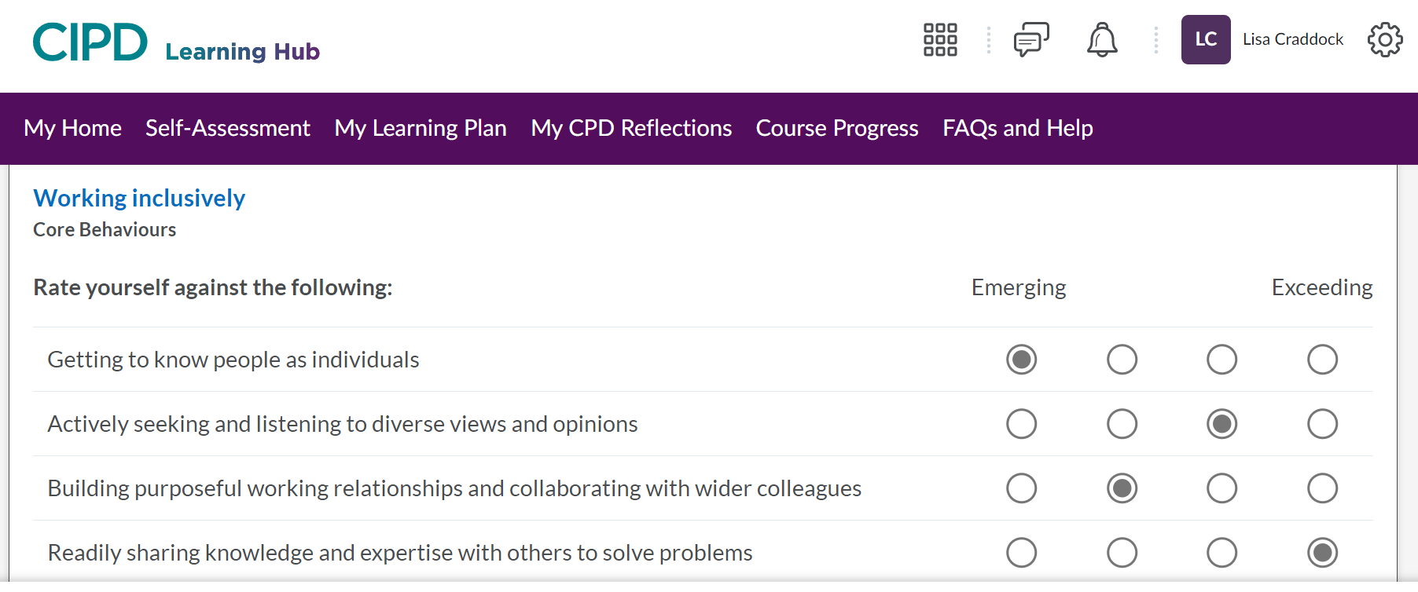
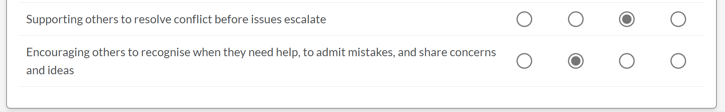

Appendix 2

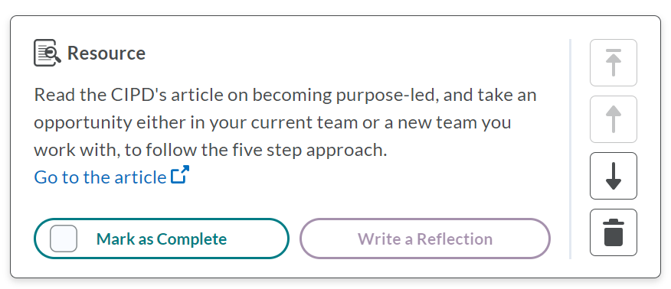

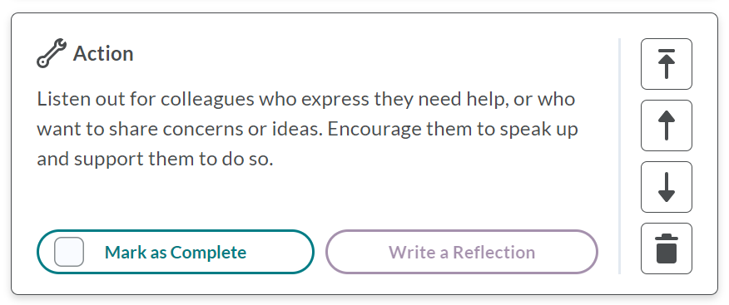

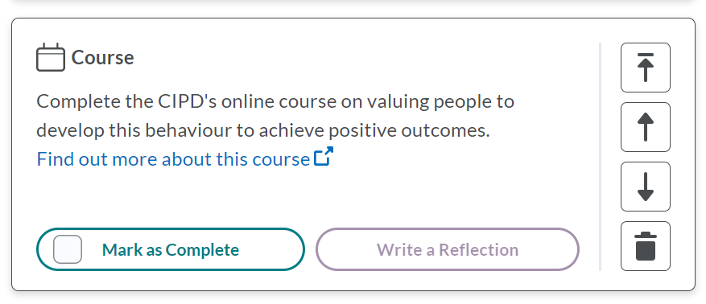

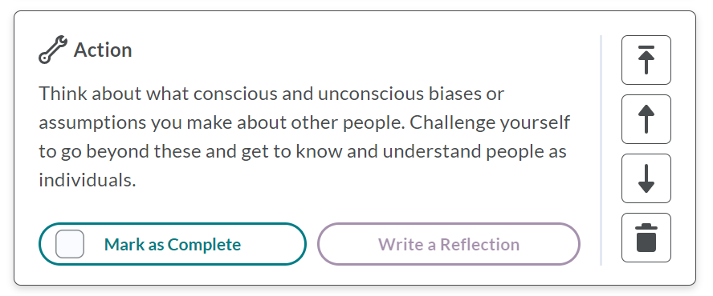

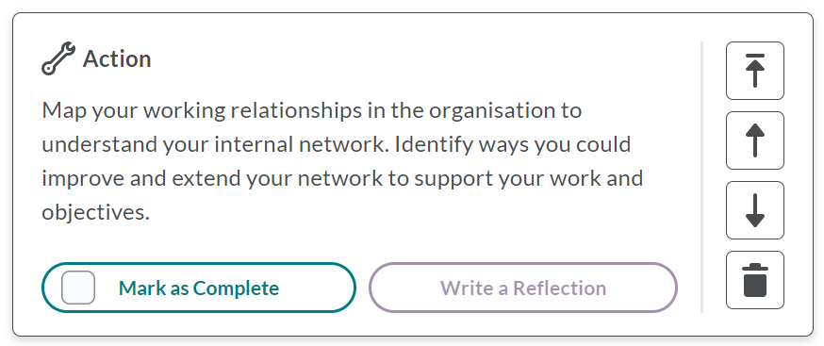

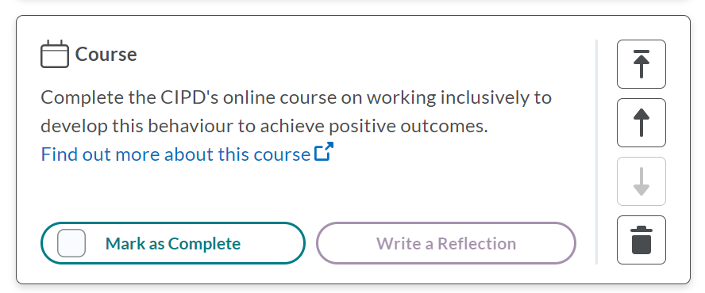

Bibliography

Bevan, S., Brinkley, I., Bajorek, Z., and Cooper, C. (2018) 21st Century Workforces and Workplaces: The challenges and opportunities for future work practices and labour markets, London: Bloomsbury

CIPD (2015) HR professionalism: what do we stand for? professional-identity-research-report-updatedPFFMay20_tcm29-17960.pdf (cipd.org) (accessed online 03/04/2023)
CIPD (2019) Professional Courage and Influence https://peopleprofession.cipd.org/profession-map/core-behaviours/professional-courage-influence (accessed on 04/04/2023)

CIPD (2021) Membership https://www.cipd.co.uk/membership
(accessed on 03/04/2023)

CIPD (2021a) Ethical Practice https://perma.cc/9ZJR-YKFD
(accessed on 04/04/2023)

CIPD (2021b) SWOT analysis https://www.cipd.co.uk/knowledge/strategy/organisational-development/swot-analysis-factsheet (accessed on 04/04/2023)

CIPD (2022) Core Purposes https://peopleprofession.cipd.org/profession-map/core-purpose (accessed online 03/04/2023)
CIPD (2022a) The CPD cycle https://www.cipd.co.uk/learn/cpd/cycle (accessed on 04/04/2023)

CIPD (2023) Code of Conduct and Ethics https://www.cipd.co.uk/Images/cipd-code-of-conduct-and-ethics-v2_tcm18-112336.pdf
(accessed online 03/04/2023)

Gov (n,d) – Whistleblowing for employees: What is a whistleblower https://www.gov.uk/whistleblowing (accessed on 04/04/2023)

Great Places to Work (2021) Why is diversity & inclusion in the workplace important? http://www.greatplacetowork.com/resources/blog/why-is-diversity-inclusion-in-the-workplace-important (accessed on 04/04/2023)

Green, M., Peters, R., and Young, J. (2020) People Profession 2030: A collective view of future trends, London: CIPD

McKinsey (2020) Diversity Wins: How inclusion matters
http://www.mckinsey.com/featured-insights/diversity-and-inclusion/diversity-wins-how-inclusion-matters (accessed 04/04/2023)

Oxford Dictionary (2023) https://www.oxfordlearnersdictionaries.com/definition/english/professional_1?q=professional
(accessed 04/04/2023)

Rock, D. (2008). SCARF - neuroleadership Journal. SCARF - Neuroleadership Journal, [online] 1(1). https://schoolguide.casel.org/uploads/sites/2/2018/12/SCARF-NeuroleadershipArticle.pdf (accessed 04/04/2023)

Smith, J. A (2020) Reflective Practice, Exeter: Exeter University

Taylor and Woodhams (2022) Studying Human Resource Management, 3rd Edition London: Kogan Page

Taylor and Woohams (2022a) Human Resource Management, 3rd Edition, London: Kogan Page

