Title of the research study

A Study of Engaging Omni-Channel Consumers with Interact Customer Experience Touchpoint

Abstract

Purpose – The purpose of this research is to validate a touchpoints-based customer experience (TPE) model in today’s Omni-channel retailing environment. This research studied the impact of consumers' channel choice (single channel VS multichannel) on the proposed TPE model.

Design/methodology/approach – To answer the research question, this study draws on an in-depth longitudinal case study of the developed touch-point-based customer experience (TPE) model in today's Omni-channel retail environment. The research was also conducted using primary (questionnaire and 2 interviews) and secondary data sources. Comprehensive data analysis with SPSS and Tableau software has also been carried out.

Findings – The result shows that all the touchpoints in the TPE model have a positive impact on the overall customer experience and the intention to use the Omni-channel. Process touchpoint shows the most positive relationship with the overall customer experience. Technology touchpoint shows the lowest positive relationship to the overall customer experience. Surprisingly, there are no differences with the overall customer experience and the intention to use the Omni-channel in terms of customer’s gender. Besides, the relationship between the intention to use Omni-channel and the demographics of the customer has also been examined in this research.

Practical implications – The research emphasizes the importance of practical implications for retailers as to how they can benefit by setting up customer experience strategies based on touchpoints and engaging today's omni-channel consumers at these touchpoints during their shopping journey.

Originality/value – This study contributes to channel management and retail research by deepening the analysis of the various Omni-Channel customer experience touchpoints, exploring the nature, relevance and sequence of the strategy on how to engage the customer when moving to the omni-channel environment. As far as knowledge is concerned, it is one of the first studies to examine the retailer's challenges in moving towards an omni-channel strategy for the Hong Kong market.

Assumption and further research – More questionnaires may help to increase the accuracy of the data. Unfortunately, this study needed a place to deal with the crisis of COVID-19 and protest activities in Hong Kong. The number of questionnaires received would also have been affected. Besides, future study efforts could therefore be made to conduct longitudinal research and to explore the relationship between retail drivers on consumer experience at different points of contact as well as on overall experience.

Keywords – Retail strategy, Multi-channel, Channel management, Consumer behaviour, Omni-Channel, Customer experience, Electronic commerce

Table of Contents
Title of the research study 1
Abstract 2
List of Table 8
List of Figures 10
Chapter 1 – Introduction 1
1.1 Background 1
1.2 The trend of Omni-Channel consumer behaviour 3
1.3 Research Questions 10
1.4 Research Aim 10
1.5 Research Objectives 10
There are four key objectives to the analysis. 10
1.6 Dissertation structure 11
1.7 Summary 13
Chapter 2 - Literature Review 14
2.1 Consumer behaviour definition 14
2.3 Consumer behaviour in Omni-channel 15
2.4 Consumer touchpoints for the decision-making process 19
2.5 Customer Experience 25
2.6 Consumer experience measurements 26
2.6.1. Atmospheric touchpoint 27
2.6.2. Communicative touchpoint 29
2.6.3. Product touchpoint 30
2.6.4. Technological touchpoint 31
2.6.5. Process touchpoint 32
2.6.6. Employee-customer touchpoint 34
2.6.7. Customer-customer touchpoint 35
2.7 Omni-channel consumer behaviour 36
2.7.1. Consumer behaviour across channels 36
2.7.2. Impact of channel choice on retail performance 37
2.5 Summary 41
Chapter 3 – Research Methodology 44
3.1 Research Model 44
3.1.1 Triangulation 46
3.1.2 Quantitative research 47
3.1.3 Qualitative research 47
3.2 Data collection 47
3.2.1 Sampling design 48
3.2.2 Conduction of individual depth interview 48
3.2.3 Design questionnaire 49
3.2.3.1 Research Objectives survey Instruments 51
3.2.4 Pilot test 51
3.2.5 Formal questionnaire 52
3.2.6 Target Population 53
3.2.7 Sample size 53
3.2.8 Sampling method 54
3.3 Data analysis techniques 55
3.3.1. Descriptive Analysis 55
3.3.2. Reliability Test 56
3.3.3. Factor Analysis 57
3.3.4. Correlation Analysis 57
3.3.5. Independent T-Test 59
3.3.6. One-way ANOVA 60
3.3.7. Regression Analysis 62
3.4 Ethical Research 63
3.5 Research Methods Limitation 63
3.6 Summary 64
Chapter 4 – Data Analysis 65
4.1 Data Description 65
4.1.1 Individual In-depth Interview 65
4.2 Final Survey 67
4.2.1 Descriptive analysis 67
4.2.1.1 Gender 68
4.2.1.2 Age 69
4.2.1.3 Education level 70
4.2.1.4 Purchase Approach and Age Relationship 71
4.2.1.5 Purchase Approach and Age Relationship 72
4.2.1.6 Purchase Approach and Education Relationship 73
4.2.1.7 Distribution of Means & Std. Deviation 74
4.2.1.8 Relationship of Omni-channel experience by the respondent’s demographic data 76
4.2.2 Reliability Test 77
4.2.3 Factory Analysis 78
4.2.3.1 Summary of Factor Analysis 82
4.2.4 Correlation Analysis 82
4.2.5 Independent T-Test 85
4.2.5.1 Signal-Channel vs. Omni-Channel 85
4.2.5.2 Gender 87
4.2.6 One-way ANOVA 88
4.2.6.1 Shopping Process 89
4.2.6.2 Age 91
4.2.6.3 Education 93
4.2.7 Regression Analysis 95
4.3 Summary of Data Analysis 101
Chapter 5 - Recommendations and Conclusion 103
5.1 Discussion and conclusion 103
5.2 Recommendation 107
5.2.1 Theoretical Implications 107
5.2.2 Practical Implications 108
5.3 Research Limitations & Further Research 111
References 113
Appendix A: Gantt Chart 134
Appendix B: Questionnaire 135
Appendix C: Individual Depth Interview 145
Appendix D: Calculate the questionnaire sample size 147
Appendix E: The highest and the lowest mean of each factor 148

List of Table

Table 1.1 Persons aged 10 and over who had used the Internet during the 12 months 2019………………………………………………………………………………………………8
Table 2.1 Multi-channel versus omni-channel management………………………………40
Table 2.2 Definitions and measurements of the touch point elements…………………....43
Table 3.1 Summary of research hypothesis of this research……………………………....46
Table 3.2 Design of questionnaire with measurement……………………………………...50
Table 3.3 - Pilot Test for 32 data……………………………………………………………...52
Table 3.4 – Reliability Statistics of Pilot Test………………………………………………...52
Table 3.5 - Persons aged 15 and over who had used the Internet during the last 12 months by age and sex – 2019…………………………………………………………………………53
Table 3.6 – The calculation of sample size……………………………………………….…54
Table 3.7 Acceptance level of Cronbach’s Alpha in reliability test………………………..56
Table 3.8 Interpretation of the KMO’s Statistics………………………………………….…57
Table 3.9 Range of Correlation Coefficient Values and the Corresponding Levels of Correlation……………………………………………………………………………………...58
Table 4.1 - Response Rate by Date………………………………………………………..…67
Table 4.2 – Summary of 203 sample respondent’s demographic information……….….67
Table 4.3 - Reliability Test Result…………………………………………………………..…77
Table 4.4 - Reliability Test Result of 203 respondents…………………………………..….78
Table 4.5 - KMO and Bartlett's Test………………………………………………………..…78
Table 4.6 – Eigenvalues with Variance…………………………………………………..…..79
Table 4.8 - Rotated Component Matrix for 8 factors……………………………………...…81
Table 4.9 - Correlation Analysis……………………………………………………………....83
Table – 4.10 The highest correlation of the hypothesis………………………………….....84
Table 4.11 - Group Statistics of the different shopping process………………………..….85
Table 4.12 - Independent Samples Test of the different shopping process…………...….86
Table 4.13 - Group Statistics of the Gender………………………………………………....87
Table 4.14 - Independent samples test of the gender…………………………………...….88
Table 4.15 - Multiple Comparisons - Shopping Process………………………………...….89
Table 4.16 - Multiple Comparisons – Age…………………………………………………....91
Table 4.17 - Multiple Comparisons – Education………………………………………...…..93
Table 4.18 - Regression model summary for Omni-channel intention………………..…..95
Table 4.19 - ANOVA summary for Omni-channel intention……………………………...…95
Table 4.20 - Coefficients summary for Omni-channel intention………………………...….96
Table 4.21 Result of the Research Hypothesis…………………………………………...100

List of Figures

Figure 1.1 Proportion of consumers who use the internet concerning shopping……..……4
Figure 1.2 Flow Chart of this study……………………………………………………………13
Figure 2.1 Different between traditional customer lifecycle and digital customer life cycle………………………………………………………………………………………..……19
Figure 2.2 Consumer Decision-Making Process………………………………………...….20
Figure 2.3 A model of consumer Decision Making……………………………………...…..21
Figure 2.4 The cyclical pattern of Consumer Decision-making process…………………..24
Figure 3.1 Touch points-based experience (TPE) research model………………………..45
Figure 3.2 Flow of collecting primary data……………………………………………………48
Figure 3.3 Correlation Test……………………………………………………………...…….58
Figure 3.4 Independent T-Test - Equal Variances Assumed………………………………60
Figure 4.1 Distribution of respondent's Gender………………………………………..……68
Figure 4.2 Distribution of respondent's Age…………………………………………...….....69
Figure 4.3 Distribution of respondent's Education……………………………………..……70
Figure 4.4 Distribution of Purchase Approach and Age Relationship……………….…….71
Figure 4.5 Distribution of Purchase Approach and Age Relationship………………..……72
Figure 4.6 Distribution of Purchase Approach and Education Relationship………………73
Figure 4.7 Distribution of Means & Std. Deviation…………………………………………..74
Figure 4.8 Distribution of the relationship of Omni-channel experience by respondent’s demographic data ………………………………………………………………………….….76
Figure 4.9 Scree Plot………………………………………………………………………..…80
Figure 4.10 Means Plot - Shopping Process……………………………………………..….90
Figure 4.11 - Means Plot – Age……………………………………………………….………92
Figure 4.12 - Means Plot – Education…………………………………………….…………94
Figure 4.13 Histogram of Omni-channel intention………………………………….……….97
Figure 4.14 Scatterplot of Omni-channel intention………………………………….………97
Figure 4.15 Hypothesis Testing Result…………………………………………….………...99

Chapter 1 – Introduction

This chapter sets out the research background and objectives. Also, the dissertation structure and timeline used for this research are discussed.

Background
“The point of the story is that every single interaction, the most minute details of the interaction you have with your customer, are an opportunity for you to create something remarkable.” Joey Coleman, Customer experience expert.

Before, brick and mortar retailers made it easier for the customer to view and experience the items. Today, e-commerce stores in the web lure customers with more product options, cheaper costs, and more accurate product details. Increasing numbers of customers are motivated by new technology, often check for information, evaluate rates digitally, sample goods in brick and mortar shops, and make final transactions across various platforms. Separate borders across various retail networks are disappearing. Specifically, users move between multiple networks and touchpoints on a normal, compatible, and synchronized basis, and are known to be Omni-channel customers. Firms are attempting to grasp the enormity of the digital opportunity thoroughly and better understand the consumer's path to buy, specifically at what stage on the path, customers can be quickly influenced and how to communicate, especially given the consumer's support devices like smartphones and tablets that are readily accessible to consumers.

Marketers always have relied on consumer insights as to the basis for their sales and marketing strategies. This becomes an especially critical issue in times of rapid change when the assumptions of yesterday are called into question. The challenge to marketers intensifies each year as the advent of digital technologies has created a fast-growing e-commerce channel, while also making it much easier for consumers to conduct research and obtain the price and product information that influences their buying decisions. In many ways, the Internet has put pricing power in the hands of the consumer.

Not long ago, the sales funnel was thought to be simple. In this view, the first step was for marketers to use television advertising, print, and/or direct mail to create awareness of a product, which then led to interest and drove desire before the purchase was consummated in a physical store.

As the digital world evolves, the consumer's path-to-purchase has become anything but straightforward. Although television, print, direct mail, and word of mouth still play important roles, digital now amplifies each of them while also providing marketers and consumers with a plethora of new communication channels. More recently, mobile devices have grown at a rapid rate, fundamentally altering the path-to-purchase by allowing consumers to easily obtain pricing and product information whenever and wherever they want. And, when it comes to purchasing, consumers now have the option of either buying in a physical store or online, the latter often occurring at lower price points. In this world of massively increased complexity, marketers need insights into the consumer path-to-purchase more than ever before if they are to assemble a coherent and effective marketing plan for Omni-Channel consumers.

The trend of Omni-Channel consumer behaviour
Since the advent of Internet technology in 1994, the Internet has become a critical component of modern multi-channel retail, with more customers opting to buy products online each year. According to Forbes' article (Bogaisky, 2014), as online spending continues to grow, retail profit is declining. Since 1991, when the Internet became officially available to the public, electronic commerce (eCommerce) has dramatically changed the retail sector from product search and price comparison to online shopping. Traditionally, e-commerce was associated with data transfers that allowed users to conduct business transactions electronically (Dorman, 2013). With the introduction of online payment systems and more stable connections, consumers were able to conduct online transactions more easily and more securely, and e-commerce was finally able to flourish. After additional technological innovations, e-commerce has grown to include all online purchases (Ecommerce-land, 2013). Mobile commerce (M-Commerce) is part of e-commerce; as the number of mobile users is growing rapidly, M-Commerce transactions are projected to rise to $115 billion in 2015 (Tode, 2015). However, m-commerce is still a small part of e-commerce; hence, it has space for expansion. According to the Mobile Commerce Daily article (Tode, 2015), by 2020 the m-commerce portion will reach 15% of e-commerce sales.

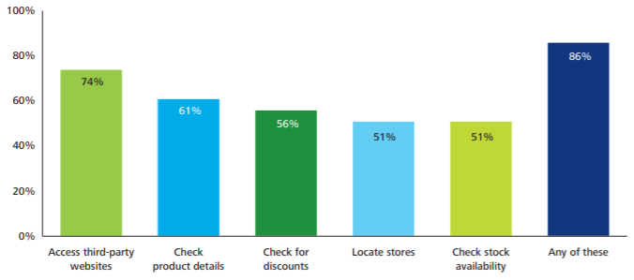
Figure 1.1 Proportion of consumers who use the internet concerning shopping
Source: Deloitte (2014)

Connected shoppers use a variety of resources to identify innovative goods and brands, to perform analysis on product supply and demand, to complete and execute on their orders, and to create affinity with retailers. According to Figure 1.1, 86% of UK and German customers use their laptops, cell phones and tablets for a variety of shopping based research activities; 74% of UK and German customers use third-party platforms such as digital marketplaces, review pages and product comparison sites for shopping.

Also, brick and mortar retail stores are now offering hotel and restaurants, enhanced interior design and high-quality consumer services. The landscape of retailing has shifted dramatically in recent years. The beginning of the online channel and new additional digital outlets, including such mobile channels and social media, rapidly changed retail business models, the performance of the retail mix and the behaviour of shoppers (Verhoef, Kannan & Inman, 2015).
As per Forbes (Newman, 2014), with the exponential rise in internet advertising and the regular usage of social media, advertisers are confronted with more options while deciding whether they choose to meet the customer via social networking platforms (Newman, 2014). Through a smartphone and online users to in-store experiences, individuals are experiencing an omni-channel environment where customers are searching for an omni-channel interaction (Newman, 2014). According to Kim and Park (2005), customers can check the Web for details before they shop for goods. Omni-channel retail (OCR) therefore gives consumers a great opportunity to use all retail channels.

The widespread use of multiple retail platforms across all the world population has created new ways for companies to provide reliable customer knowledge on quality of products, functionality, and exclusive offers. A survey commissioned by Mckinsey and Economistinsights (Edelman and Banfi, 2014) reveals 44% of customers use their smartphones to check coupons, price comparisons and review ratings, and 72% of businesses agree that their customer feedback expenditures may be too small. However, 45% of companies acknowledge that they do not know how their customers digitally relate to them. Famous companies, including Target and Walmart, are decreasing the staff to become more productive, flexible businesses that can adapt to shifts in consumer behaviour, digital-looking and Omni-channel developments (Wahba, 2015b).

However, companies are now gradually seeking to grasp the immense capacity of emerging media and help perceive the consumer’s journey. The stage on the road when the choice of products quickly influences customers. The intervention strategy should be technologically and informatively ideal, especially since consumer support technologies have become tablets, smartphones, and a large variety of apps (Perera, Nayak and Long, 2019).

In 1998, e-commerce represented smaller than 1% of overall retail sales, and in 2015 it rose several years later to around 1% (Oh, 2015). When digital technology evolves, and marketing information is presented increasingly customised, it is both efficient and convenient for consumers to find appropriate information for making purchases online finally. There is no question that so much more money should be invested in digital sales in all areas of the retail industry.

Marketers and analysts have analysed many aspects of online user activity during the past decade. It argues that online customers have more influence and are more competitive than the offline customer, since the online customer may get more details directly from other products users or their friends (Gatautis and Kazakevičiūtū, 2012).

Several variables affect consumer behaviour on the internet, such as regional and demographic knowledge, social impact, perceived danger, personal technical abilities, website design and technology diffusion. Gong and Maddox (2011) suggested five variables that may affect customer offline and online shopping behaviour, including delivery time, price-seeking preferences, channel-risk expectations, evaluation outcome and search outcome.

A survey carried out by Price Waterhouse Cooper reveals that the top reason motivating consumer’s online shopping behaviour is the convenience factor. The consumers can shop whenever they want and wherever they want. Other vital factors that are harboured by consumers are better price, more product choice, easier to compare price, products and offers, as well as free and faster delivery (PWC, 2015).

From the other side, the greatest downside to online retail is that customers are unable to view, feel or experience the goods before making a final order. This lack of face-to-face interaction discourages certain buyers from shopping digitally and choose to shop in brick-and-mortar shops (van Delft, 2013)

Nonetheless, even though experts have revealed the main reasons for online customer activity, marketers have not been able to make effective use of them to increase user loyalty or to automate marketing strategies. For example, according to the Price Waterhouse Cooper report, by providing free shipping, retailers will raise the margin by 8% to 12%, whereas almost 60% of retailers charge handling or delivery fees (PWC, 2015).

The Forrester Consulting and Accenture study further indicate that shipping costs are the most important explanation for the abandonment of supermarket shopping carts. 75 % of customers might switch to another store if the shipping cost is too expensive or not free. Furthermore, as free shipping is a kind of promotion, it becomes the most effective way to increase revenue throughout the holiday season, when customers prefer to spend between 10 % to 15% higher on average order value. Retailers ought to measure how this sales boost would offset the cost of a free delivery program (Magarie, 2014).

Another barrier that prevents consumer moving is the refund charge and an ambiguous return policy. A study by ComScore further shows that ease of return or trade is one of the key important considerations during the check-out phase (Wahba, 2015a)

As of the time, more and more stores began offering free shipping deals. For instance, to contend with Amazon, Target launched a revolutionary strategy in the holiday period e-commerce war: free delivery and free returns, leading to its quarterly growth of 20% in digital revenue (Garcia, 2016).

In terms of educational attainment, Table 1.1 from the Census and Statistics Department (2019) shows that 64.8% of people with primary and lower education have used the Internet for 12 months, 99.3% of people with post-secondary or higher education have used the Internet for 12 months, showing that people with higher education have more intention of using the Internet for purchase.
Table 1.1 - Persons aged 10 and over who had used the Internet during the 12 months 2019
Educational attainment |  |  |  | No. of persons  ('000) | % | Rate*
Primary and below |  |  |  | 876.2 | 15.0 | 64.8
Secondary |  |  |  | 3 159.3 | 53.9 | 96.2
Post-secondary |  |  |  | 1 820.6 | 31.1 | 99.3
Overall |  |  |  | 5 856.1 | 100.0 | 90.5
Source: Census and Statistics Department (2019)
Omni-channel for the retail industry has changed customer decision-making processes and combined with new technology innovation, retailers are working tirelessly to adapt to the increasing marketplace. Forecasts and preparation are facing difficulties in product planning at the SKU level of information, which may contribute to redundant products. The stock life of certain apparel products is so limited that future product and production changes need to be correctly forecast to be able to run a company effectively.

Big data technology, such as machine learning, has been proposed as one of the potential solutions to help forecast customer behaviour. The company had ties to 'massive data.' Currently, there is a shortage of many smart algorithms that can take into consideration the multiple variables that affect buying choices at the point of purchase. The possibility of taking bad business choices based on innovative algorithms or inadequate data processing is growing exponentially. In turn, successful forms of interaction with the customer are constantly evolving as more and more social and socioeconomic variables are being investigated.

The dissertation would take the perspective of Omni-channel consumer engagement, which encompasses and involves analytics and data, marketing and promotional methods, Omni-channel relationships and strategies of the consumer behaviour and touchpoints, which to identify more effective ways for how, when and where to communicate with Omni-channel consumers.

1.3 Research Questions
The following questions are formulated:
- What is the impact of the different customer touchpoint on the consumer's omni-channel experience?
- What is the difference in customer behaviour between the Omni-Channel customer and the single-channel customer?

1.4 Research Aim
In the existing Omni-channel retail environment, this research aims to develop and validate a model of touch points-based experience (TPE). These works would analyse the effect on the emerging TPE model of the user channel preference and restrict the area to a customer experience touchpoint.

1.5 Research Objectives

There are four key objectives to the analysis.

- The primary objective is going to identify the dimension from a new perspective on consumer experience: the touchpoints of the shopping journey for the consumer, when the moment the brand, service or product is engaged by customers. This research established and tested the touchpoint-based consumer experience (TPE) model for Omni-channel retail setting in today. Especially, seven touchpoints involving customer-customer, employee-customer, process, technological, product, communicative and atmospheric will be investigated.

- The second objective is going to identify the dimension of customer demographics data, such as gender, age, education to find out the correlation and insight between the shopping approach and intention to use Omni-channel.

- The third objective is going to assess the interaction across each of the single touchpoints for consumers during the overall shopping experience of consumers and the decision-making process. The research will also explore the effect and relationship of consumer preferences of channels on the conceptual TPE model.

- The last objective is to provide recommendations and implications based on the result of each touchpoint for the TPE model. The research will also explore any further research can be conducted.

1.6 Dissertation structure
The contents of the thesis are organised in five chapters, the first the chapter being the introduction chapter.

Chapter Two first presents a review of previous studies on consumer behaviour, and how consumer behaviour may have changed in today’s Omni-channel retailing environment. Customer experience and its dimensions are also discussed. Objectives of the research were stated along with the literature review. Eight research hypotheses are proposed based on previous literature.

Chapter Three discusses the conceptual model and the underlying hypotheses investigated in this present study. The research methodology includes questionnaire design, sampling design, data collection and the data analysis framework.

Chapter Four illustrates the demographic characteristics of the customers and data analysis results of Research Hypothesis 1-8.

Chapter Five discusses the results of the research hypothesis and makes conclusions, implications, limitations, and future study.

Figure 1.2 is the process flow of this study and the research timeline has shown in Appendix A.

Figure 1.2 Flow Chart of this study
Source: construct by writer

1.7 Summary
The research background and trends in consumer behaviour of Omni-Channel have been clearly described. Questions, objectives, structure, and timelines for this research have also been stated.

Chapter 2 - Literature Review

This chapter presents a comprehensive summary of the research that has gone into the research topic. It lists, describes, summarises, evaluates, and clarifies the previous research objectively with Omni-channel consumer behaviour insights.

2.1 Consumer behaviour definition
Kotler defines consumer behaviour is the physical, mental, and emotional actions that consumers take during the purchase, usage, disposal and selection of services and products that fulfil their wishes and needs (Kotler, Armstrong and Opresnik, 2018).

Schiffman (2010) describes consumer behaviour as customer action in the use, purchase, search, review and disposal of services and products that meet their expectations and objectives. These habits include what buyers are buying, where they are buying, where they are buying, how they are using the products, how they dispose of and examine the products upon purchase, and how experience affects subsequent behaviour.

Consumer behaviour is characterized as a collection of physical and psychological behaviours that individual or corporate consumers display when they need to identify, scan, compare, buy and post-purchase services or goods (Solomon, Søren Askegaard and Hogg, 2019).

The key goal of customer behaviour research is to refine the 5p marketing approach. It was in the mid-1950s that businesses understood, to contend with other firms, they needed to consider the desires, wishes or expectations of particular customer audiences and develop, produce, sell services or goods to meet consumer needs.

Via comprehensive customer study or data collection, businesses can now fully interpret consumer preferences and execute marketing strategies such as positioning, targeting and segmentation (STP), and a marketing mix focused on consumer behaviour. Additional uses involve the usage of social media to enable customer audiences to market goods or to create policy initiatives focused on omni-channel consumer behaviour (Perner, 2018).

2.3 Consumer behaviour in Omni-channel
Multichannel marketing refers to marketing strategies that combine direct and indirect consumer interaction channels such as smartphone, email, direct mail, mail order catalogues, retail stores, websites etc. (SAS, 2020).

Multichannel management is described by designing, implementing, assessing, and evaluating various communication channels to enhance our customer experience through client development, retention, and acquisition (Neslin et al.,2006).

Multichannel consumers typically carry out three patterns of activities (PWC, 2012):
I. Shopping through at least two channels, including mobile, online or brick and mortar
II. Purchase of items from the same seller and more than one channel
III. Take advantage of multiple channels to make one purchase

Verhoef, Neslin, and Vroomen (2007) have historically viewed marketing networks independently and found analysis shoppers to be shopping for products on one platform and making transactions on another platform.

Recently, marketers have increasingly realised that customers won’t know the gap across the various channels. Garcia’s (2016) study shows what buyers worry much about discovering the goods they like to satisfy their desires with tremendous value in terms of price and money.

Earlier, brick and mortar shops made it easier for the customer to feel and touch the items. Online e-commerce retailers, on the other hand, have attempted to fascinate consumers with lower prices, more selection of products, and more comprehensive product knowledge. These days, with even more consumers empowered by online technologies like tablets and smartphones, they are continually comparing prices, searching for information in bricks and mortar shops. The separate border between various shopping channels is disappearing. Omni-channel consumers swap across touchpoints and channels on a simultaneous, interchangeable, and regular basis (Verhoef, Kannan & Inman, 2015).

Showrooming is a trend where customers tour nearby brick-and-mortar shops to try out goods and only buy them online. A study from Khan (2018) reveals that more than 50% of mobile owners have researched retail prices, in which most of such buyers wind up shopping at a rival. The most significant explanation for customer showroom is that many online shops give a lower price. Also, customers do not want to incur any handling or delivery costs to buy the products.

In contrast, a lot of customers were webrooming, exploring items online and only heading to retailers to make a final order. Consumers like to feel and see the goods before purchase and do not want to wait for the product to be shipped (Khan, 2018).

In this customer-driven purchase situation, retailers have correspondingly modified their single-channel marketing approaches to Omni-channel marketing approaches to satisfy the demand of the consumer (Ailawadi and Farris, 2017).

Unexpectedly, despite the increasing importance of Omni-channel in the retail sector, it has not been conceived before. Many researchers and marketers have identified Omni-Channel and multichannel interchangeably and have described Omni-Channel being one of the strategies of multichannel. Nevertheless, a thorough analysis of the Omni-channel approach shows that the Omni-channel differentiates the multichannel from various perspectives (Rouse, 2019).

With that said, the Omni-channel not only broadens the range of the different channels, it also emphasises the convergence of channels (Ansari, Mela and Neslin, 2008). Conventional multichannel approaches isolate channels and allow each channel to be autonomous of other channels and to exchange consumer or product details across channels simply. Within the world of Omni-channel, offline and online channels are combined into product information, inventory levels, consumer information and product categories. For instance, if a consumer picks up the clothes which are out of stock of size, the customer support agent may verify the inventory of the merchandise in the closest brick-and-mortar shops and online retailers instantly. The customer will then select whether to get the merchandise from the closest shops or to purchase it from online shops. The item will either be delivered to the home address of the customer or sent to selected locations waiting for the customer to pick up as long as the customer would not want to travel to another shop or wait for the items to be sent from the online retailers. The store salesperson will instead suggest similar items in the actual store based on the previous goods ordered by the consumer as well as details on the shopping cart.

Furthermore, in the sense of multichannel marketing campaigns, channel performance is assessed by the product revenue or consumer engagement per channel. As far as Omni-channel marketing is concerned, the performance of the channel is calculated by total product revenue and overall customer experience across touchpoint (Verhoef, Kannan & Inman, 2015).

Researchers describe the Omni-channel strategy as a customer-centric retail strategy which combines consumer touchpoints and a wide variety of available channels to deliver consistent and seamless consumer shopping experience, including telephone sales, mobile app stores, mobile stores, online stores, brick-and-mortar stores, etc. Figure 2.1 shows the difference between traditional customer lifecycle and digital customer life cycle.

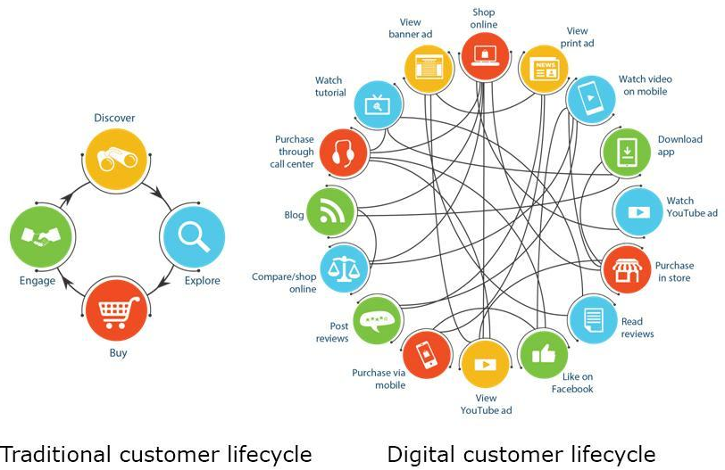

Figure 2.1 Different between traditional customer lifecycle and digital customer life cycle
Source: Singh (2016)

2.4 Consumer touchpoints for the decision-making process
Schiffman and Wisenblit (2019) defined and categorised the consumer decision-making as a “purchase decision-making process based on emotional and cognitive influences, including moods, role models, advertisers, friends, family, impulse and purchase-influencing situations”.

Blackwell, Miniard and Engel (1973) created the process of decision-making pattern (Figure 2.2) consisting of five steps (Hake, 2012):

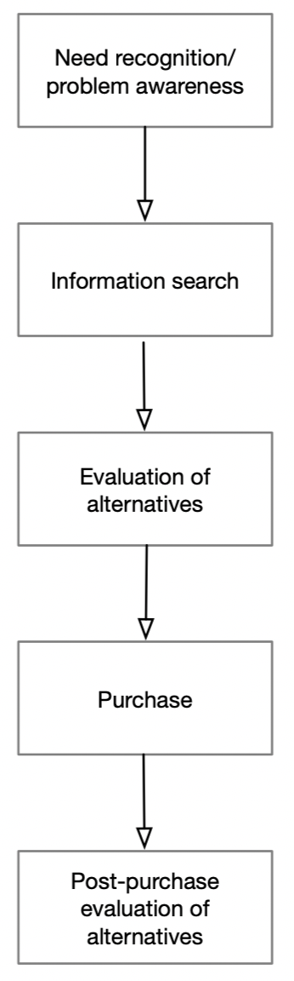

Figure 2.2 Consumer Decision-Making Process
Source: Hake (2012)

In the research from Schiffman, Kanuk and Wisenblit (2010), they recommend the three-stage consumer decision-making model (Figure 2.3) with three-stage - 1) input, 2) process and 3) output.
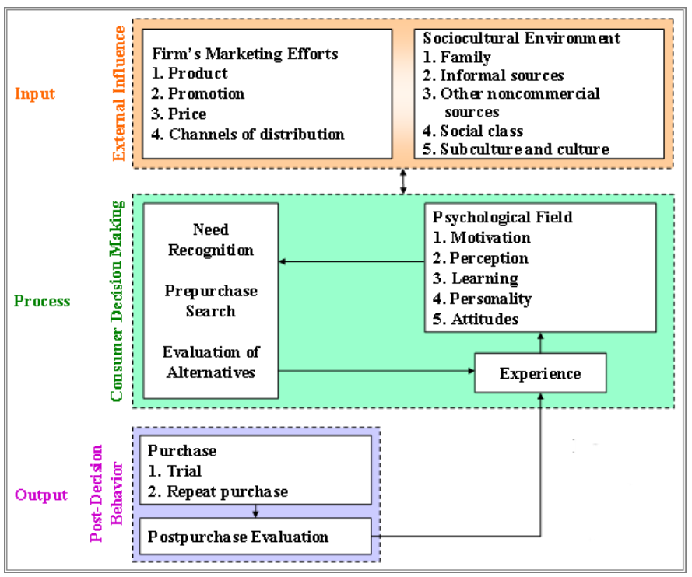

Figure 2.3 A model of consumer Decision Making
Source: Schiffman, Kanuk and Wisenblit (2010)

The stage of input is the external influence of customer decision-making, consisting of two different points of view: the marketing activities of the business and the sociological climate. The marketing activities of companies involve delivery channels, price, promotion, and product. In contrast, the sociocultural environment includes social class, other non-commercial sources, informal sources, friends, family, and culture and subculture (Schiffman, Kanuk and Wisenblit, 2010).
The process stage of the model illustrates how the choices of the consumer are made. The fundamental factors that affect the decision-making process are psychological factors, which are attitudes, personality, learning, perception, and motivation.

Under different psychological circumstances, consumers react differently to behaviour and external inputs during the following processes: evaluation of alternatives, pre-purchase search and the need for recognition. The first is the actual type of state, which services or products do not meet the exact needs of the consumer. The desired type of state is another kind of demand and is a desire for new services or products on the part of the consumer. Some factors can boost consumer search before purchasing, including consumer factors (personalities, geographic and demographic), situational factors (value-related considerations, social products, gift purchase and first purchase) and product factors (long-lasting products, several alternative brands, frequent changes in price and style).

The output stage generally consists of two practices: post-purchase and purchase assessment. Consumer information management approaches can be classified with two categories: 1) rules on non-compensatory decisions and 2) rules on compensatory decisions. The consumer will balance the positive characteristics of the product with the negative characteristics of the product according to the rules of the countervailing decision and make an overall purchase and assessment decision. At the other side, throughout a non-compensatory judgment process, a certain cut-off point is established as a criterion. The three key principles used by the user in the non-compensational decision-making process are the lexicographic rule, disjunctive rule, and conjunctive rule. Nevertheless, consumers have increasingly different decision-making roles, even with a conjunctive compensatory role, during the decision-making process. Eventually, the experience gained from post-decision behaviour and decision-making will begin to change the current psychological status of the consumer. In turn, the experience gained by evaluating alternatives influencing the existing mental attributes of the consumer. Such customers can make a repeat purchase based on the overall perceived product and experience rating identified as affecting the position of referral decision (Schiffman, Kanuk and Wisenblit, 2010).

Court et al. (2009) have suggested a complex cyclical consumer decision-making journey model (Figure 2.4), and the consumer journey is a real-time and non-linear mechanism rather than a conventional linear cycle. With the exponential growth of new media, consumers have exposure to increasingly accurate and reliable knowledge from different organisations, friends, and family. Now buyers are exploring multiple products and actively incorporating and eliminating options along the journey. Consumers are primarily dependent on what other company consumers are looking at – the WOM (Word of Mouth) and eWOM (Electronic Word of Mouth).

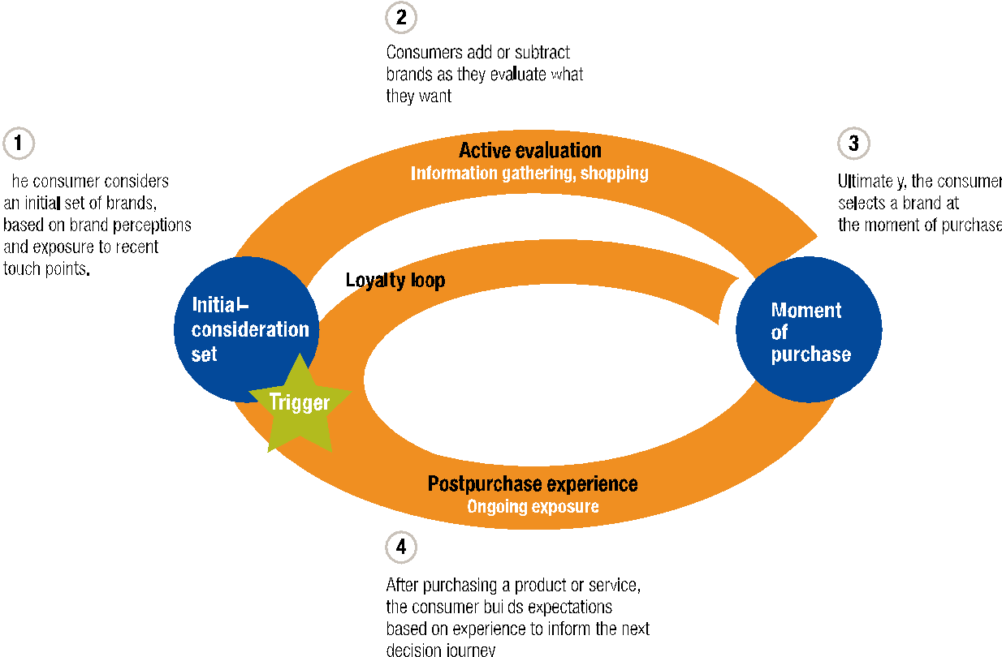
Figure 2.4 The cyclical pattern of Consumer Decision-making process
Source: Court et al. (2009)

McKinsey’s study shows that the marketing budgets of brands are not consistent with the touchpoints where consumers are most affected. The findings suggest that 70% to 90% of 17 marketing costs were expended on promotions and advertising that impact the ‘buy’ and ‘considering’ stages of customers. Nevertheless, customers are also more open to manipulation at the ‘enjoy-advocate-bond’ and ‘evaluation’ periods. Somebody else’s advocacy is the most powerful impulse to buy. Therefore, a negative comment by a company would destroy the assumed impression of a brand by the customer; even with such beautiful advertising, the brand can also permanently lose the customer (Edelman and Banfi, 2014).

McKinsey suggested that decreasing the marketing investment spend on creating awareness and turning more resources on delivering improved customer experience and shortening the process by removing evaluation and assessment phases. The final objective is to turn consumers in the “loyalty loop” (Court et al., 2009).

2.5 Customer Experience
The customers’ experience as a marketing new element was first presented by Holbrook and Hirschman (1982), and the influence of consumer experience on consumer behaviour, including satisfaction and desire, was examined.

Customer experience can be defined as the interaction between the organisation and the customer, which combines the sense and emotion of the consumer and the physical performance of the organisation at all points of contact (Shaw and Ivens, 2008).

Customer experience is described as a cycle by Schmitt (2003), which derives from a sequence of experiences between the consumer and the company, and these encounters cause a series of reactions. Such responses are unique, built up at various stages, including the level of spiritual, physical, emotional, rational and sensor. (Schmitt, 1999).

Customer experience evaluations are focused on a comparison of user preferences and perceived indirect and direct encounters arising from customer interactions (Meyer and Schwager, 2007). Consumers purchase, experience, and evaluate services from an organisation are directly experienced. In contrast, indirect experiences are created all through unforeseen interactions with the company’s marketing touchpoints, including certain advertising and promotional resonances, recommendations, and sales representatives etc.

2.6 Consumer experience measurements
Babin (1994) defines a variety of aspects of consumer experience, particularly components of leisure, relaxation, and hedonistic behaviour, which have overriding functional qualities. Hedonic and utilitarian values represent two dimensions used by previous researchers. The utilitarian values measure the goal-oriented achievements of consumers in terms of investment in time and effort. While the hedonic dimension reflects the values of entertainment and enjoyment that consumers derive from the shopping process. Consumers can therefore be divided into two groups: the utilitarian consumer and the hedonic consumer. Utilitarian consumption is a problem solver that pursues consciously intended goals, and hedonic consumers are fun seekers who emphasize emotional reward during the shopping process. Hedonic consumers are therefore more motivated by the process than by the goal of shopping. Earlier, researchers (Hoffman and Novak, 1996) looked at consumer experience in the online shopping cycle and concluded that hedonic interest is more important to many users than final practical findings in terms of their online actions.

Schmitt (1999) opposes conventional communication approaches and suggests a new approach named experiential marketing. Experienced advertisers find customers to be logical and compassionate human beings obsessed with knowledge. There are five forms of user experience: smell, hear, perceive, conduct, and connect. Sense module relates to the sensory perception provided by light, sound, touch, taste, and smell. Feel element stands for user thoughts and impulses, and advertisers would want to construct meaningful interactions. Think Marketing seeks to construct emotional, problem-solving encounters by dynamically involving consumers by suspense, excitement, and aggression. The associated framework often incorporates elements of the sound, look, thought, and behave processes, which relates to the individual's need for self-improvement.

Gentile et al. (2007) affirm the experiential marketing hypothesis and note that customer engagement is focused on hedonic and functional consumer ideals, as well as on the company's interest. There are six elements in their model: physical, mental, cognitive, analytical, lifestyle, relational.

This research expands the analysis by Stein and Ramaseshan (2016) and introduces a validated touchpoint-based customer experience assessment model (TPE) for omni-channel customers. Touch point-based interaction (TPE) model comprises of seven modules in the qualitative analysis of Stein and Ramaseshan (2016). General concepts and related objectives shall be defined as follows.

2.6.1. Atmospheric touchpoint
Atmospheric touchpoint is described as the physical characteristics and the surroundings that consumers can experience while engaging with the retailer. Numerous atmospheric components exist at multiple communication points, at specific levels of the decision-making cycle, often on different channels. Those involve retail facilities, shop attractiveness, product layout and style, and retail appearance (Stein and Ramaseshan, 2016).

The atmosphere of the store and its impacts is extensively studied across decades, and there have been significant sales effects in store atmospheres (Stanley and Sewall, 1976; Milliman, 1982). The shop atmosphere is also positively linked to the satisfaction of the customer satisfaction (Bitner, 1990). Shop design elements including architecture, colour, music, and lighting can have a major effect on customer preferences, loyalty, perceived quality, and consumption amount (Babin & Attaway, 2000)

Research demonstrates that consumer views of the retail environment, such as lighting and flooring, have a huge effect on customer shopping behaviour (Bagdare, 2014; Terblanche and Boshoff, 2001)

For the Omni-Channel consumer, the atmosphere refers both to the shopping environment and to the digital platform atmosphere, in Brakus (2009) research, which indicates that website content and architecture may influence the brand experience of the consumer.

Consequently, aggregated atmospheric touchpoints from all retail channels, such as the in-store, digital, online, website atmosphere, are projected to affect the purchasing experience of Omni-channel consumers. Driven by this assumption, the following hypothesis is proposed:

Hypothesis 1: Explore the positive impact of the atmospheric touchpoint on the experience of the Omni-channel customer.

2.6.2. Communicative touchpoint
Stein and Ramaseshan (2016) written research on the findings of the thematic qualitative study reveals that customers routinely consider the information and messages received by retailers. These materials or notifications are one-way communications sent from the seller to the consumer. Retailers can, via multiple retail networks, deliver promotional or informational one-way contact to consumers during the consumer journey. For example, advertising or informational communications from distributors may be delivered via email, fax, direct mail, tv ads, telephone calls and other contact platforms. Evidence from their semi-structured study interview that advertising contact plays a significant role in the discovery and assessment processes of the consumer journey.

Communicative touchpoint is some correspondence from the seller to the consumer that contains advertising and informational communications (Stein and Ramaseshan, 2016). It involves quality discounts, exclusive deals, and personalisation. Insightful conversations and promotional efforts have been shown to affect consumer retention positively and impact the loyalty of the brand (Zhang and Tang, 2010).

Bojei et al. (2013) performed research with an impact on marketing campaigns, which shows the strong positive customer loyalty relationship between personalisation and reward/loyalty programs.

Zakaria et al. (2014) analyse different loyalty and marketing programs and conclude that brand satisfaction, brand loyalty and loyalty programs have a huge and beneficial relationship.

It is assumed that the communicative touchpoint in the Omni-channel retail era will continue to influence consumer behaviour. Driven by this assumption, the following hypothesis is proposed:

Hypothesis 2: Explore the positive impact of the communicative touchpoint on the experience of the Omni-channel customer.

2.6.3. Product touchpoint
Product touchpoint applies to indirect and direct connections between customers and key intangible and tangible goods, including product assortment and product quality (Stein and Ramaseshan, 2016). During experiences with retailers, customers encounter product elements that contribute to the evaluation of their experience at the touchpoint. Product touchpoint plays a significant role in the retail experience at different touchpoints across the customer journey.

Consumers are cynical about advertising statements, particularly ones that can only be confirmed by experience (Ford, Smith, and Swasy 1990). Knowledge gained from practice usually does not give rise to scepticism because it is followed by the knowledge gleaned from second-and third-party channels. It is one explanation of why product interaction has a stronger effect on actual perceptions and actions relative to ads and other indirect interactions (Kempf and Smith, 1998).

With the change in retail from conventional brick-and-mortar retail to Omni-channel e-tailing, customers have become increasingly competitive in terms of ease of buying, product quality or touchpoints (Reguraman and Subbiah, 2019).

Product range or assortment refers to the retailer's ability to offer a wide range of options and products. Also, the product assortment is always considered to have a beneficial influence on the experience of the consumer (Verhoef et al., 2009). The study also suggests that quality is a key driver of customer satisfaction (Gomez et al., 2004). Driven by this assumption, the researcher believes that Omni-channel customer experience would have a beneficial effect on the product touchpoint and that the following hypotheses will be introduced:

Hypothesis 3: Explore the positive impact of the product touchpoint on the experience of the Omni-channel customer.

2.6.4. Technological touchpoint
The technological touchpoint is classified as a direct interaction of the customer with any shape of technology and through the purchase journey (Stein and Ramaseshan, 2016). Marketing and branding with technology-based play an extremely significant position in the online shopping business, handheld apps and brick and mortar shops. Retailers are increasingly using technology to improve service quality and productivity.
In addition to internet platforms, consumers also utilize devices in physical locations, such as point-of-sale terminals, kiosks, and tablets in their day-to-day purchases (Fowler and Bridges, 2010; Giebelhausen et al., 2014).

The study from Weijters et al. (2007) have considered four elements for assessing self-service technologies: 1) The technology with the fun associated, 2) reliability, 3) perceived ease of use and 4) perceived usefulness. The research shows that all four of these elements are directly associated and linked to the customer’s approach technology, which influences customer satisfaction and loyalty.

Fransoo, Zhao and Martinelli (2019) noticed that the efficiency of technology-based operation has a substantial positive effect on consumer experience benefits such as customer satisfaction.

Based on past research, the researcher believes that technology-driven touchpoints will be continuing to affect the Omni-channel shopping experience of consumers. The following hypothesis is thus introduced:

Hypothesis 4: Explore the positive impact of the technological touchpoint on the experience of the Omni-channel customer.

2.6.5. Process touchpoint
Process touchpoint stands for the steps or actions that must be taken by the consumer during a journey of shopping with a retailer (Stein and Ramaseshan, 2016). The process that customers take to achieve a particular outcome was found to play an important role in shaping their perceptions and evaluations of retail encounters. In physical retailer settings, the process involves aspects such as the checkout waiting time, the service process and how customers move around the store; while in digital environments, process elements encompass the way customers navigate the site or technology platform.

In digital settings, customers predominantly base their evaluations of the digital processes on ease of use (Kim and Stoel, 2004), and the responsiveness and timeliness of the technology (Yang and Jun, 2002).

Process components cover service, access, operation procedures and waiting time etc. Weijters et al. (2007) demonstrated that the increased waiting and response time was a crucial determinant of customer satisfaction on a shopping journey. As far as online shopping is concerned, both the distribution and a communication channel is part of the website of the company. Shim, Forsythe, and Kwon (2015) noted that favourable online shopping processes have a positive impact on the customer’s sensory experience, which has contributed to brand loyalty. In the digital shopping process, Zhang, and Tang (2010) found that the quality of system and information impacts the experience and trust of users that will change brand loyalty in the future.

Kim and Ah Yu (2016) have found that the relationship between brand loyalty and experience has a significant impact on the level of engagement of smartphone advertising applications. Therefore, the successful interaction with consumer experience and Omni-channel process touchpoints is anticipated. The following hypothesis is thus introduced:

Hypothesis 5: Explore the positive impact of the process touchpoint on the experience of the Omni-channel customer.

2.6.6. Employee-customer touchpoint
Employee-customer touchpoint is an indirect or direct connection between consumers and employees of retailers (Stein and Ramaseshan, 2016). The direct interaction between employees and customers was found to be critical, especially during in-store purchases. Employee-customer interactions are not limited to direct face-to-face encounters in-store; rather, employees interact with customers through many retail channels such as telephone, email, and online forums.

Past findings have demonstrated that consumer understanding of employee interpersonal behaviour, including consumer preference, listening behaviour, these behaviours may affect customer loyalty (Dagger, Sweeney, and Johnson, 2007; Dean, 2007).

Interpersonal relations are also a good indicator of customer satisfaction (Gremler and Gray, 1996). Consumer expectations of workplace success have a strong impact on customer satisfaction and loyalty. Rabbanee, Burford and Ramaseshan (2015) found that the performance of staff has a significant effect on the build confidence, perceived value, and create loyalty of customers.

Based on previous research, the researcher believes that the employee-customer touchpoint would have a beneficial effect on Omni-channel customer engagement to some degree. Therefore, this research examines the following hypothesis.

Hypothesis 6: Explore the positive impact of the employee-customer touchpoint on the experience of the Omni-channel customer.

2.6.7. Customer-customer touchpoint
Customer-customer touchpoint is indirect and direct communication between other customers and customers (Stein and Ramaseshan, 2016). Such social interactions and/or the presence of other customers were found to impact customer experience. This was seen to be especially common in the pre-purchase stage. This could be since when customers are searching for and/or evaluating a retailer, they often rely on word-of-mouth feedback from personal and familiar sources or seek feedback from individuals who have prior experience with the retailer.

During the purchase stage of the customer journey, especially in physical store environments, customers meet other customers directly through specific interpersonal encounters or indirectly as part of the retail environment (Bitner, 1992). Interaction with other customers, whether direct or indirect, can have a significant effect on the customer experience (Söderlund, 2011)

Various types of customer-to-customer connections exist, including online e-word-of-mouth, offline word-of-mouth, and customer reviews etc. Psychologists have established a strong association and link among customer satisfaction and customer-to-customer communication (Arnould and Price, 1993; Harris, Davies, and Baron, 1997). Customer-to-consumer engagement is often directly related to customer experience, word of mouth and brand loyalty, etc. (Chen, Chen, and Lee, 2013).

Haytko and Simmers (2009) also discover that relationships of online customer-to-customer have a positive impact on customer satisfaction. Therefore, in the Omni Channel shopping environment, the researcher expects that the aggregate level of customer-to-customer relationships will have a significant impact. Hence, this research has the following hypothesis:

Hypothesis 7: Explore the positive impact of the customer-customer touchpoint on the experience of the Omni-channel customer.

2.7 Omni-channel consumer behaviour
As per Verhoef (2015), the subjects of Omni-channel consumer behaviour research are divided into three main areas, which are the retail mix between different channels, the influence of channels on performance and consumer behaviour between different channels.

2.7.1. Consumer behaviour across channels
First, various trends in customer behaviour are evolving through consumer demographic, including gender, age, education, and multiple categories of products. A PricewaterhouseCoopers (PWC) report reveals that customers often tend to shop from a single channel for specific product categories. For example, 50 % of consumers prefer to buy food in physical stores because of the ability to identify a product on their own, including vegetables, fruit, fish, etc. Almost two-thirds of participants choose to shop digitally for the categories of books, films and music because of the convenience and familiarity of the items. Customers always utilise different channels for purchase furniture, home, and electronics before the final purchase, which may occur because of a wide choice of products, relatively high cash expenses and the importance of user experience. For apparel and footwear categories, 71% of answerers will purchase through various platforms, in physical store or online store (PWC, 2012).

Some analysts are now segmenting Omni-channel customers based on their demographic statistics and lifestyles. Crosett (2009) suggested three segmentations of customers more likely to be Omni-channel shoppers. 1) Young smartphone shoppers are individuals under the age of thirty who use text messages. 2) Integrated or Omni shoppers prefer to be wealthy, home-oriented, and typically 30-50 years of age. 3) Social networkers are consumers connected to similar topics both on social media as well as regularly.

2.7.2. Impact of channel choice on retail performance
MacDonald, Wilson, and Konus (2012) criticize conventional quantitative polling results as well as experimental approaches, including such focus groups, and suggest that all strategies depend very heavily on user memory, which can degrade rapidly. They are launching a ground-breaking method of monitoring users called Real-Time Tracking Experience (RET).

This program relies on a simple, four-character, SMS-based micro-survey that is conducted by the customer any time a brand considers it. Such interactions involve receiving ads, making a purchase, or exchanging brand knowledge with other customers. The finding indicates that certain touchpoints have a favourable impact on the purchasing purpose of customers. For instance, customers who find a commodity in a friend's house are two times more likely to purchase it than individuals who have not come across the commodity. Their research further shows that in-store engagement has a stronger effect on customer brand choice than other touchpoints (Macdonald, Wilson & Konuş, 2012).

Using secondary data in the retail market, Herhausen et al., (2015) analyse the effect of channel integration on retail performance and conclude a favourable relationship between retail performance and channel integration. Many academics study the effect of mobile use on customer behaviour and found that the use of mobile media influences consumer behaviour across networks and consumers use mobile apps more throughout the quest process.

2.7.3. Channel integration on channel performance
Neslin et al. (2006) had a significant impact on the development of Omni-channel retail analysis within the literature. Neslin et al. (2006) explicitly describe Omni-channel customer management as the planning, implementation, configuration, and review of networks for maximising customer satisfaction by productive customer growth, acquisition, and retention. Consequently, the channel is known to be consumer touchpoints or a means by which the customer and the firm communicate. By emphasising on contact in their grouping, they explicitly restrict the scope to offering 2-way communication channels, excluding conventional 1-way mass-communication channels, for example, television advertising.

Recently, literature has primarily looked at online channels (e.g. internet stores), offline channels (stores), and conventional direct marketing channels, like booklets. For instance, Verhoef, Neslin, and Vroomen (2007) examine these channels in “research shopping”. This study described here as a path the customer browses on one channel (e.g. online) but buys on other channels (Verhoef, Neslin, and Vroomen, 2007). Likewise, Konus addresses multichannel segmentation exclusively based on these three channels (Konus, Verhoef, and Neslin, 2008). Another studied the influence of online channel acquisitions and consumer channel transfer on market interest, retail revenue, customer buying behaviour, the competitiveness of consumers and customer satisfaction (Ansari, Mela and Neslin, 2008). Lately, attention has been given to the impact of channel removal also to the removal of the search channel (Konuş, Neslin and Verhoef, 2014). However, store channel extensions to traditional online players are also discussed (Avery et al., 2012).

The main distinction between the management of multichannel and Omni-channel is shown below (Table 2.1).

Table 2.1 Multi-channel versus omni-channel management
 | Multi-channel management | Omni-channel Management
Channel focus | Interactive channels only | Interactive and mass-communication channels
Channel scope | Retail channels: store, online website, and direct marketing (catalogue) | Retail channels: store, online website, and direct marketing, mobile channels (i.e., smartphones, tablets, apps), social media Customer Touchpoints (incl. mass communication channels: TV, Radio, Print, C2C, etc.).
Separation of channels | Separate channels with no overlap | Integrated channels providing seamless retail experiences.
Brand versus channel customer relationship focus | Customer – Retail channel focus | Customer – Retail channel – Brand focus
Channel management | Per-channel | Cross-channel
Objectives | Channel objectives (i.e., sales per channel; experience per channel) | Cross-channel objectives (i.e., overall retail customer experience, total sales over channels)
Source: Verhoef, Kannan and Inman (2015)

2.7.4. Channel integration on channel performance
Some researchers have tried to clarify the effects on channel performance with channel integration. Herhausen et al. (2015) used both technology diffusion theory and technology acceptance analysis. They found that channel integration success was affected by overall online shopping experience, perceived risk and consumers perceived service quality. The outcome is also proof of the convergence of channel performance instead of cannibalisation in channel integration. Other experiments check whether price promotions on one platform have an impact on revenues from the same commodity on another platform (Gong, Smith and Telang, 2015). Researchers noticed that one channel price promotions could raise brand recognition and compensate for the other channel’s cannibalising impact.
Verhoef, Kannan and Inman (2015) address the research on the effect of the three separate selection approaches on customers perceived buying benefits and expectations of patronage. The first selection approach is not to merge networks, which implies that various outlets sell specific goods. Asymmetrical distribution, also known as long-tail inclusion, is another selection technique utilized by most stores, where online outlets offer specific additional items than store merchandise. The final collection approach is complete convergence where online retailers sell the same items to offline shops. Their analysis indicates that complete integration works stronger than no integration and asymmetrical integration for substitutive ties assortments. However, where the variety includes a broad spectrum of reciprocal interactions, complete integration is not necessarily better than asymmetrical integration (Verhoef, Kannan & Inman, 2015).

According to explained literature, it can be assumed that the decision of the channel of the consumer will influence the behaviour of consumers and the relationship between consumer experience and consumer touchpoints significantly. Therefore, this research has the following objective:

Hypothesis 8: Omni-Channel customer experience has a significant difference in customer behaviour

2.5 Summary
According to the above discussion and assumption, eight hypotheses have been identified and this research is based on these hypotheses to gather data and perform data analysis. This research also discusses the results of the research hypothesis and concludes.

Table 2.2 is the meaning of each of the touchpoint components described by Setin and Ramasehan (2016) and the measurements will be used in the research. Specific definitions and corresponding objectives are discussed as follows.

Table 2.2 Definitions and measurements of the touchpoint elements
Touchpoint Elements | Definition | Hypothesis
Atmospheric | The physical characteristics and surrounding customers observe when interacting with any part of the retailer. | Hypothesis 1: To investigate the positive influence of atmospheric touchpoint on Omni-channel consumer experience.
Technological | A customer's direct interaction with any form of technology during an encounter with a retailer. | Hypothesis 2: To investigate the positive influence of technological touchpoint on Omni-channel consumer experience.
Communicative | One-way communication from the retailer to the customer, including both promotional and informative messages. | Hypothesis 3: To investigate the positive influence of communicative touchpoint on Omni-channel consumer experience.
Process | The actions or steps customers need to take to achieve a particular outcome with a retailer. | Hypothesis 4: To investigate the positive influence of process touchpoint on Omni-channel consumer experience.
Employee–customer interaction | The direct and indirect interactions customers have with employees when interacting with any part of the retailer. | Hypothesis 5: To investigate the positive influence of employee-customer touchpoint on Omni-channel consumer experience.
Customer–customer interaction | The direct and indirect interactions customers have with other customers when interacting with any part of the retailer. | Hypothesis 6: To investigate the positive influence of customer-customer touchpoint on Omni-channel consumer experience.
Product interaction | The direct or indirect interactions customers have with the core tangible or intangible product offered by the retailer. | Hypothesis 7: To investigate the positive influence of product touchpoint on Omni-channel consumer experience.
Source: Stein and Remission (2016)

Chapter 3 – Research Methodology

This chapter presents the methodological procedure used to collect data and the instruments used to measure the variables. Besides, measurement tools and methods used in the research are discussed.

3.1 Research Model
The assumptions for the feasibility and direction of the study framework should be reviewed, based on the above literature review and hypothesis and the conduct and measurement of the impact on the different touchpoints of the study. The theoretical framework (Figure 3.1) emerged as follows:

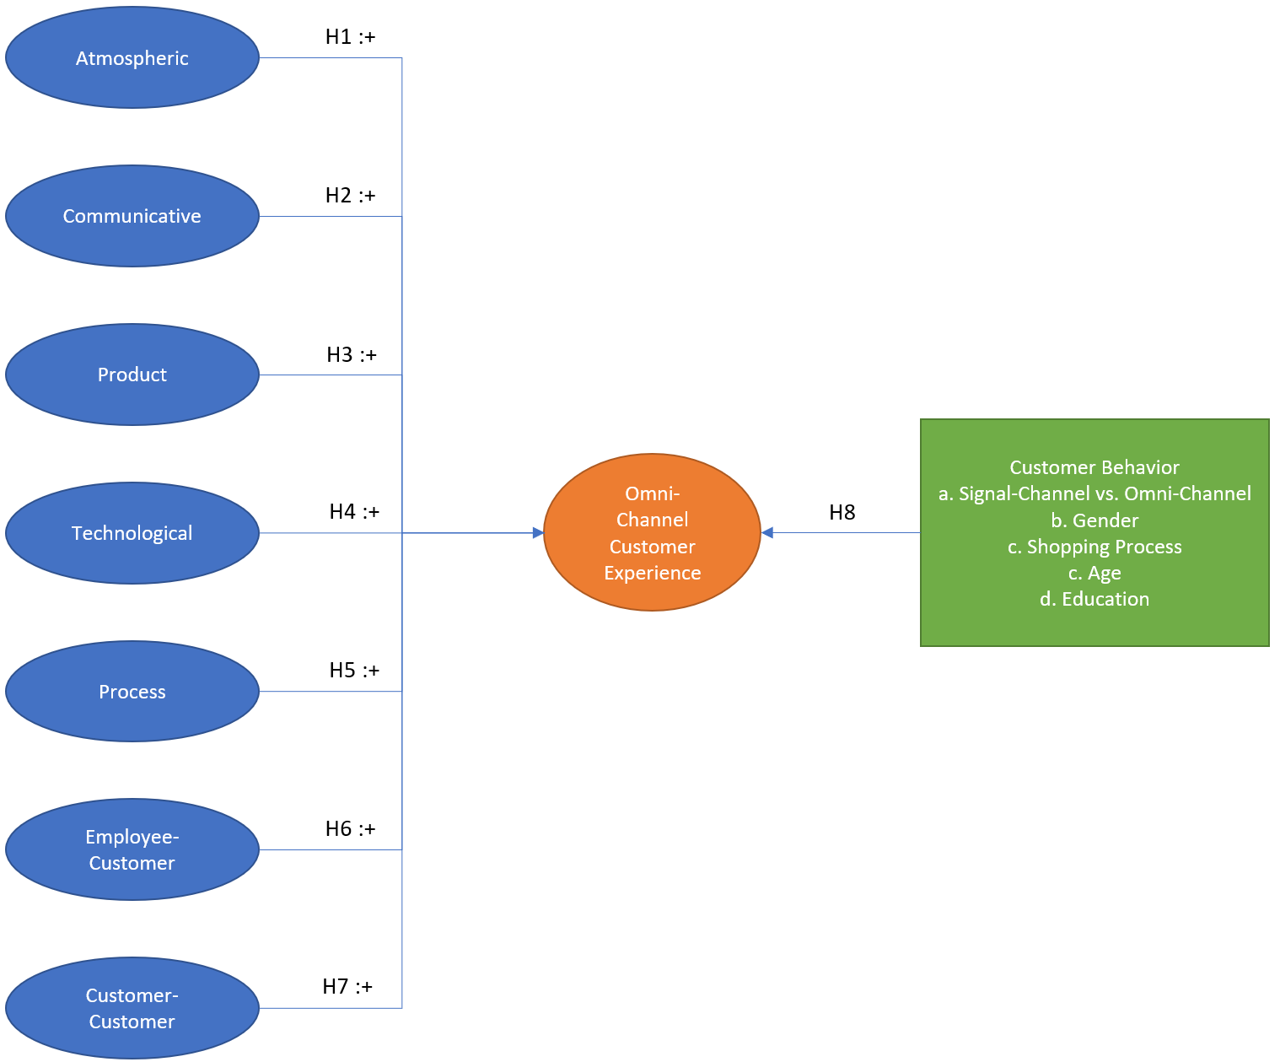
Figure 3.1 Touch points-based experience (TPE) research model
Source: construct by writer

According to the above discussion in chapter 2, the aggregated customer experience touchpoint from all shopping channels, including mobile, online, in-store, are anticipated influencing the shopping experience of Omni-channel consumers. Furthermore, it is indeed reasonable to anticipate that the choice of channel for the consumer could have a significant impact on consumers’ behaviour and the relationship between consumer experience and consumers touchpoints.

Based on these assumptions, this research has the following objective summarized in table 3.1.
Table 3.1 Summary of research hypothesis of this research
Research Hypotheses
a. Explore the positive impact of the atmospheric touchpoint on the experience of the Omni-channel customer.
b. Explore the positive impact of the communicative touchpoint on the experience of the Omni-channel customer.
c. Explore the positive impact of the product touchpoint on the experience of the Omni-channel customer.
d. Explore the positive impact of the technological touchpoint on the experience of the Omni-channel customer.
e. Explore the positive impact of the process touchpoint on the experience of the Omni-channel customer.
f. Explore the positive impact of the employee-customer touchpoint on the experience of the Omni-channel customer.
g. Explore the positive impact of the customer-customer touchpoint on the experience of the Omni-channel customer.
h. Omni-Channel customer experience has a significant difference in customer behaviour
Source: construct by writer

3.1.1 Triangulation
Triangular cross-examination has to be used and involves the application of different methods (object, location, time, things and people), the fusion of quantitative research and qualitative research data to increase the accuracy of the analysis and to modify the experimental design framework to achieve the objective of the data and results (Venkatesh, Brown and Bala, 2013).

3.1.2 Quantitative research
Quantitative research has been conducted to gather information on this dissertation through a questionnaire. Methods focus on objective measurement and empirical, analytical, or predictive analysis of data collected by surveys and questionnaires, or on the processing of pre-existing statistical data utilising computational techniques (Wagenaar and Babbie, 2010).

3.1.3 Qualitative research
Qualitative research has been conducted to gather information on this dissertation through a focus group. It is a type of social science research that collects and deals with non-numeric data and attempts to interpret the meaning of these data that helps to understand social life through the study of locations or target populations (Roenm, 2007).

3.2 Data collection
Given the broad scope of the issue, a dataset with primary and secondary data collection has been obtained for this study in July 2020. Methods for the collection of information are explained in the following section. Figure 3.2 shows the flow chart for the data collection process.

Individual Depth Interview

Questionnaire Design

Pilot Test

Final Survey
Figure 3.2 Flow of collecting primary data
Source: construct by writer

3.2.1 Sampling design
According to the Omni-channel market mentioned in the earlier part of the literature review of this study, quantitative and qualitative research will effectively provide data on the research hypothesis. The research work has been begun, and a focus group has been set up. After analysing the data, the research framework has been drawn up, and the questionnaire has been developed and distributed. The questionnaire has been collected for analysis, and the results of the study have been used as evidence for assumptions, conclusions, and suggestions.

3.2.2 Conduction of individual depth interview
Individual depth interview conducted on 1st August 2020 to get a deeper insight into the research topic. The aim of conducting individual depth interviews was to discuss the important factors related to the influence of different customer experience touchpoints elements and the questionnaire design. The face-to-face interview focused on the thought of the interviewees and comments on the questionnaire. Comments were collected for the modification of the questionnaire design and our further analysis. Two participants were invited. Both have more than 10-years’ experience working in the Omni-channel industry. The interview took place in Hong Kong Taikoo City Plaza coffee shop. Participant profiles and the details discussion were listed in Appendix C.

3.2.3 Design questionnaire
The questionnaire designed (Appendix B) has been used to collect the primary data for research into the consumer insights and preferences of the retailer’s market strategies. The survey has been developed on a free survey platform called Google Forms. A QR code that could be used to guide participants to the web survey has been given. There have been two methods of distributing QR code, the first of which is to distribute QR code for some public Hong Kong forums (such as Uwants, Lihkg etc). And the other way is to spread the QR code from social media accounts (such as Facebook, IG) to my friend and colleague to obtain their information.

The questions were assessed in a five-point Likert scale. Participants were kept secret, and no markers were used to indicate the respondents. Below (Table 3.2) is comprehensive details on the measurement of core structures with the source supporting in this analysis.

Table 3.2 Design of questionnaire with measurement
# | Factor | Type of data | Source | Sample Question
1 | Atmospheric touchpoint | 5-point Likert scale | (Ramya, 2014) and (Mishra, Sinha and Koul, 2014) | 1. Their shopping environment increases my duration.  2. Their shopping atmosphere impresses me.  3. Their shopping environment increases my duration.
2 | Communicative touchpoint | 5-point Likert scale | (Sahin, Zehir and Kitapçı, 2011) and (Ramya, 2014) | 1. I feel positive about their advertising and promotions.  2. Their advertising and promotions are informative.  3. They did an excellent job in advertising and promotions.
3 | Product touchpoint | 5-point Likert scale | (Sahin, Zehir and Kitapçı, 2011) and (Ramya, 2014) | 1. Their products are of high quality.  2. Compared to other retailers/brands, they offer attractive prices.  3. According to what I pay, they provide me with good value.
4 | Technological touchpoint | 5-point Likert scale | (Stein and Ramaseshan, 2016) and (Ramya, 2014) | 1. Their technology makes shopping convenient.  2. They have better technologies compared to other retailers/brands.  3. Their technologies are interactive.
5 | Process touchpoint | 5-point Likert scale | (Stein and Ramaseshan, 2016) | 1. I can easily find the information or products needed.  2. Their service processing (shipping/returning) is convenient.  3. Their service processing (shipping/returning) is convenient.
6 | Employee-customer touchpoint | 5-point Likert scale | (Rabbanee, Burford and Ramaseshan, 2015) and (Sahin, Zehir and Kitapçı, 2011) | 1. Their employees understand my needs.  2. Overall, its employees deliver excellent service.  3. Their employees put themselves in the customers’ place.
7 | Customer-customer touchpoint | 5-point Likert scale | (Ramya, 2014) | 1. Other customers’ opinion affected my opinion of this retailer/brand.  2. Overall, other consumer’s review about this retailer/brand is positive.  3. I observed where my friends were shopping before selecting this retailer/brand.
8 | Omni-channel customer shopping experience | 5-point Likert scale | (Shi et al., 2020) | 1. I will use omnichannel shopping in the future.  2. I intend to make frequent use of omnichannel shopping in the future.  3. I prefer to recommend the shopping Omni-channel to the people around me.
Source: construct by writer

3.2.3.1 Research Objectives survey Instruments
The questionnaire consisted of two sections. The first sections evaluated consumer touchpoints, such as customer-customer, employee-customer, process, technological, product, communicative and atmospheric. The extensive experience of the Omni-channel customer was also assessed in the research. The present dimensions of previous research have been updated or adjusted to quantify designs. The next section contained demographic statistics, such as education, age, and gender.

3.2.4 Pilot test
A pilot test will be conducted for an initial analysis of 20% of the total journal before a thorough study or experiment. This is essentially a rehearsal or trial of a research or a review. The pilot test is a small pilot study designed to determine the cost, time, feasibility, and adverse events without incurring much cost and time to adjust to the refining of more extensive experiments. It could increase the design of the research before undertaking a thorough research study (Eldridge et al., 2015).

Pilot test conducted from 6 to 9 July 2020. Online questionnaire created by google form was adopted to get a deeper understanding from the interviewees and to explain questions that felt unclear. After SPSS testing the reliability, some questions have been updated to enhance the Cronbach’s alpha to get a more reliable result. Table 3.3 and table 3.4 listed the reliability result with the pilot test data. Final Survey’s questionnaire is prepared for further research (Appendix C).

Table 3.3 - Pilot Test for 32 data
Case Processing Summary
 |  | N | %
Cases | Valid | 32 | 100.0
Cases | Excluded | 0 | 0.0
Cases | Total | 32 | 100.0
Source: construct by writer

Table 3.4 – Reliability Statistics of Pilot Test
Reliability Statistics
Cronbach's Alpha | N of Items
0.899 | 32
Source: construct by writer

3.3 Final Survey
This section describes the formal questionnaire, target population, sample size and sampling method for the final data between 13th July and 27th July after conducting the pilot test.

3.2.5 Formal questionnaire
When the pilot test has been fully achieved, the formal questionnaire will be made available to the public. The potential sample size for the questionnaire will be 119. Sampling methods are used to select samples from the general population. Correct sampling is vital to remove the prejudice in the selection process, which may also reduce the cost or time needed to collect samples.

3.2.6 Target Population
Based on data of the Census and Statistics Department (2019), Persons aged 15 and over who had used the Internet during the 12 months before enumeration by age and sex – 2019 (Table 3.5). It has shown that over 60% of people from young to old have been using the Internet for the last 12 months. As a result, all ages of people will be involved. Besides, the male has used the Internet for the last 12 months is 48.3% and the female is 51.7% which has no significant difference. As a result, participants will include all genders.

Table 3.5 - Persons aged 15 and over who had used the Internet during the last 12 months by age and sex - 2019
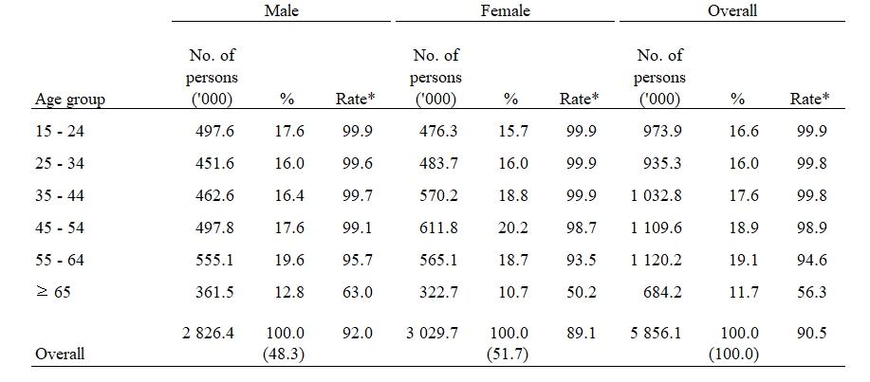Source: Census and Statistics Department (2019)

3.2.7 Sample size
Determination of the sample size is the act of selecting the number of observations or replicates to be included in the statistical sample. The size of the sample is an essential feature of any empirical study that aims to derive the population from the sample. The sample size used in the analysis is based on the cost of collecting data and the need for sufficient statistical power. Several specific sample sizes may be included in an elaborate study (Barlett, Kotrlik and Higgins, 2001).

Bhalerao and Kadam (2010) suggested that the tolerated level of error is at most 10%. Therefore, with a 9% tolerated level of error and a 95% confidence level (Table 3.6), the result of the equation shows there should be at least 191 sample sizes (Appendix D).
Table 3.6 – The calculation of sample size
Equation: | For the calculation
 | Z = 1.96 | Confidence Level 95%
 | e = 6.0% | Error
 | p = 0.23 | Successful value; From pilot test  p = 7/305
 | q= 0.77 | Failure value
Source: Bhalerao and Kadam (2010)

3.2.8 Sampling method
Snowball sampling methods (Goodman, 1961) will be used as sampling methods for analysis, it is a popular business study method and described as a non-probability sampling technique in which samples have features that are rare to find. This is a sampling technique in which existing subjects have recommendations for the recruiting of samples required for a research study.

The formal questionnaire collected and analysed, sorted out, further discussions and modifications with the tutor, etc., will take about two months to complete as time is tight to use a sophisticated sampling method. Therefore, “Snowball sampling” is the most suitable method for this study.

3.3 Data analysis techniques
Data analysis techniques enable researchers to see and infer or determine the data collected from the information. Most techniques focus on the use of quantitative means of data review. After receiving the data from the questionnaire in this analysis, invalid questionnaires will be removed, and the correct questionnaires collected will be graded and scored, and the data will be analysed. The data analysis method used will include Descriptive Analysis, Reliability Test, Factor Analysis, Independent T-Test, One-way ANOVA, Correlation Analysis and Regression Analysis. Below section explains the detailed approach of each technique.

3.3.1. Descriptive Analysis
Descriptive analysis is used to define the specific features of the study results. They have clear summaries on the sample and the measures taken. Along with fundamental graphics analysis, they form the foundation for nearly all quantitative analysis of the results (William, 2020).

Descriptive analysis is usually differentiated from inferential statistics. Through descriptive analysis, you clearly explain what the data indicates or what it is. With inferential statistics, you will be attempting to reach conclusions that go beyond immediate data on your own. For example, inferential statistics can try to infer from the sample data what the population might think. Also, inferential statistics can determine the possibility that the observed discrepancy between groups is a valid one or one that could have existed by chance in this research. Therefore, inferential statistics can draw inferences from the data to more general conditions. Also, it can provide concise statistics clearly to explain what is going on in the data.

3.3.2. Reliability Test
In the early part of this chapter, it was mentioned that the pilot test used a reliability test to collect the data collected from the pilot test. Cronbach’s alpha in reliability test is a statistic that is commonly used to measure the internal consistency or reliability of psychometric tools (Table 3.7). This statistic can be used for the pilot test as well as for data collected from formal questionnaires.

Each hypothesis in this study is counted to test its consistency and reliability. A commonly accepted rule for describing internal consistency with Cronbach’s alpha is that although more items in the test can artificially inflate the alpha value and a narrow range of samples can reduce it; this rule should be used with caution (Cortina, 1993).

Table 3.7 Acceptance level of Cronbach’s Alpha in reliability test
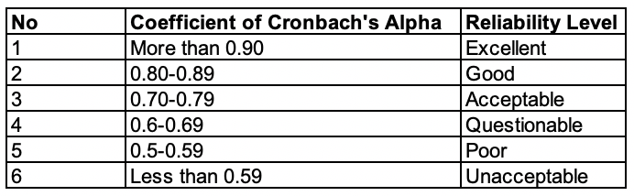
Source: Cortina (1993)

3.3.3. Factor Analysis
According to Field (2018), the aim of using factor analysis was to understand the structure of a set of variables, to reduce a data set to a more manageable size and to retain as much of the original information as possible at the same time.

Kaiser-Meyer-Olkin (KMO) and Bartlett’s Test are two useful methods to determine the acceptability of the samples. The KMO value can be obtained for individual and multiple variables and represent the ratio of the squared correlation between variables to the squared partial correlation between variables. Field (2018) also mentioned that the KMO value should be between 0 and 1. If the value of KMO is close to 1, it indicates that the pattern of correlation is compact, and the factor analysis can be treated as distinct and reliable. Hutcheson and Sofroniou (2006) stated that if the value is over 0.9, that can be treated as marvellous and if the value is below 0.5 that can be treated as unacceptable (Table 3.8). If the p-value of Bartlett’s Test is lower than 0.05, it can be treated as significant.
Table 3.8 Interpretation of the KMO’s Statistics
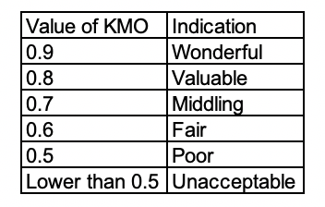
Source: Kaiser (1970)

3.3.4. Correlation Analysis
Correlation analysis is a statistical evaluation method used to study the strength of the relationship between successive variables of two numerical measures. In statistics, it is called the Pearson correlation coefficient. In the article, r or Pearson’s r is used to denote the correlation between two variables X and Y, with a value between -1 and 1.

This analysis is useful when researchers want to determine if there is a possible relationship between variables. Intensity, strong correlation, or high correlation between the two variables means that two or more variables are there is a strong relationship between, and weak or low correlation means that the variables are almost irrelevant such as the above figure 3.3 and table 3.9.
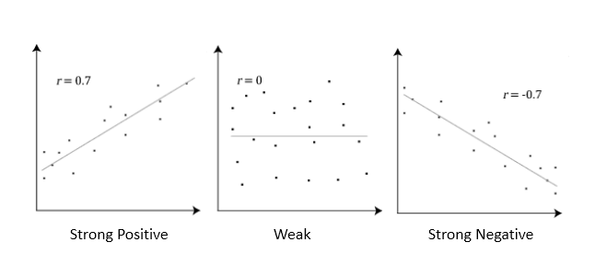
Figure 3.3 Correlation Test
Source: construct by writer

Table 3.9 Range of Correlation Coefficient Values and the Corresponding Levels of Correlation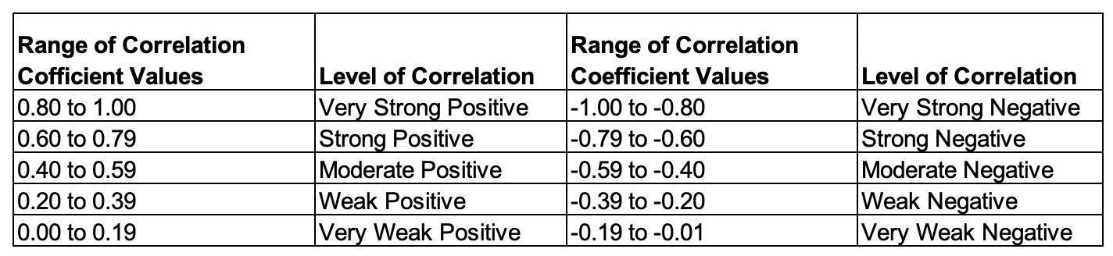
Source: Meghanathan (2016)

If there is a correlation between the two variables, it means that when one variable has a systematic change, the other moves also systematically; these variables change together over time. If a correlation is found, depending on the measured value, this can be positive or negative (Cohen et al., 2015).

Since this research involves the Omni-channel, the touchpoint experience and consumer behaviour and the relationship between customer satisfaction and loyalty, there will be a need for a correlation analysis of the factors related to each other to change the relationship. Therefore, correlation analysis is essential in this review.

3.3.5. Independent T-Test
Independent Samples t-Test contrasts the results of two representative populations to assess if statistical data exists that the related sample measures are substantially different. It's a parametric test (Kent State University, 2018).

The formula of an independent T-Test is as follows once the two independent samples are taken from populations containing similar population variances:
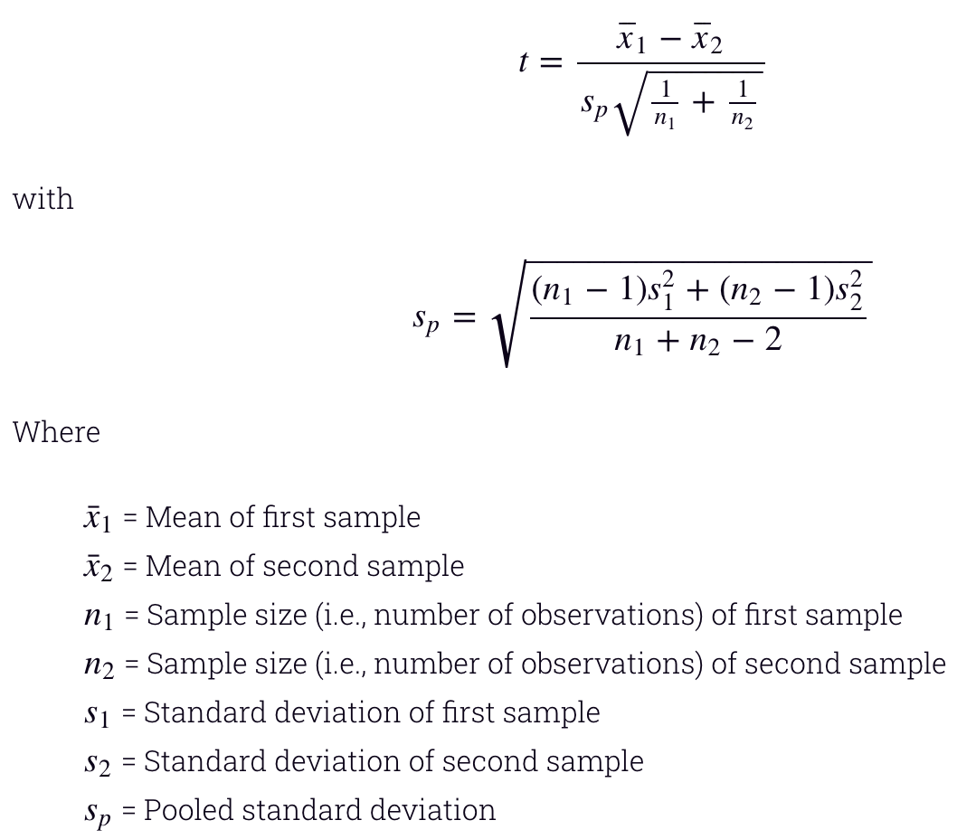
Figure 3.4 Independent T-Test - Equal Variances Assumed
Source: Kent State University (2018)

This data analysis technique will use the gender and education information captured by the questionnaire.

3.3.6. One-way ANOVA
ANOVA is short for Analysis of Variance. The main purpose of an ANOVA is to test if two or more groups differ from each other significantly in one or more characteristics (Statistics Solutions, 2020).

Most statisticians fall into the second category. It is generally assumed that the ANOVA is an ‘analysis of dependencies.’ It is referred to as such because it is a test to prove an assumed cause and effect relationships. In more statistical terms it tests the effect of one or more independent variables on one or more dependent variables. It assumes an effect of Y = f (x1, x2, x3, … xn).

The ANOVA is a popular test; it is the test to use when conducting experiments. This is since it only requires a nominal scale for the independent variables – other multivariate tests (e.g., regression analysis) require a continuous-level scale. This following table shows the required scales for some selected tests.

Post Hoc tests are useful if your independent variable includes more than two groups. If more than two-factor levels are given it might be useful to run pairwise tests to test which differences between groups are significant. Because executing several pairwise tests in one analysis decreases the degrees of freedom, the Bonferoni adjustment should be selected, which corrects for multiple pairwise comparisons. Another test method commonly employed is the Tukey HSD (Honestly Significant Difference) which for pairwise comparisons of the means of k independent equal-n groups. Therefore, this improves the reliability of the post hoc comparison because it increases the sample size used in the comparison.

These data analysis techniques will be used for age and education information captured by the questionnaire.

3.3.7. Regression Analysis
Regression Analysis is a statistical technique used to determine the likely change in one variable for the alteration in another. It implies the unidentified variable can be derived from another variable's established value. The degree to which the variables are associated depends on the Regression Line. It is a single line that best approximates, for example, a line links all the points plotted in such a way that the length from the path to the points is the shortest (Mason and Perreault, 1991).

In linear regression, the model specification is because the variable y1 is a linear combination of parameters. For example, in a simple linear regression modelling n data points, there is an independent variable: x1 and two parameters β0 and β1.

Omni-Channel Experience = β0 + β1 X Atmospheric + β2 X Communicative + .... βn X Customer-customer

Coefficient of Determination (R2) and Variation Inflation Factor (VIF) index were used to analyse the regression model. R2 is a measure of the amount of variability in one variable that is shared by others. The value must between 0 and 1. If the value is 0, meaning that two variables were independent. VIF indicates a predictor has a strong linear relationship with other predictors. If the value is greater than 10, indicating there is a great multicollinearity problem and must worry about the validity to use (Ziegel and Myers, 1991).

This statistical tool clearly shows the causal relationship between variables and is mainly used to explain the predictive power of customer experience on Omni-channel. Therefore, it is essential to analyse the touchpoint elements and consumer satisfaction of Omni-Channel in this study.

3.4 Ethical Research
All the participants for the survey and individual depth interview were kept anonymous and no identifiers could be used to identify the participants.

3.5 Research Methods Limitation
As a result of the limited time necessary to prepare the analysis and the time-consuming preparation of the literature and information, the required time to complete the questionnaire is limited and may directly affect the number of the questionnaire.

More questionnaires result may help to increase the accuracy of the data. Unfortunately, this study needed a place to deal with the crisis of COVID-19 and protest activities in Hong Kong (GOVHK, 2020). The number of questionnaires received would also have been affected.

Also, the limitation of this study is based on the snowball sample to collect data from social media and forums. To improve generalizability, future research could be carried out in other industries with larger random samples.

Finally, statistical analysis is newly used in this research, time is needed to understand and displease the methods of research. Practical is also needed to ensure the accuracy of input data.

3.6 Summary
The research model has been identified in this section. Triangular cross-examination has been used for this study. Quantitative and qualitative research has been conducted to gather information for this dissertation. Details of the data collection with sampling design, questionnaire design and research objectives survey instruments have been discussed. The pilot test has been carried out to ensure that the questionnaire is appropriate for this research. The size of the target sample was defined with the support. Finally, seven techniques for data analysis, ethical research and limitation have also been identified and discussed.

Chapter 4 – Data Analysis

This chapter will explain the results of the data survey using the data analysis technique.

4.1 Data Description
In this study, SPSS (The Statistical Package for the Social Sciences), Tableau (visualization tools) and excel were adopted to analyse the data, including individual in-depth interview, an online survey and qualitative personal depth interview and focus group. Data were represented in graphs and tables to make the variables clearer and easier to understand. In this study, the descriptive statistic was used to analyse the data. Moreover, cross-tabulation and mean with deviation were also shown in this paper.

4.1.1 Individual In-depth Interview
Individual depth interview was conducted on 1st August 2020. Two respondents were invited, and both have more than 10 years of Omni-Channel industry experience (Appendix B). A few questions were formed for them to express their thoughts. The expression of them was similar.

The first respondent Cathy thought that Atmospheric and Product experience touchpoint of the retailer and brand are the most important for Omni-Channel customer experience since the comfortable environment that puts the customer in a better mood for purchase and explorer the product and the product assortment and quality also is the import factors to influence the shopping experience. Besides, Cathy thought that these experiences of a physical or online environment can have a huge impact on customer satisfaction and enhancing the customer experience ultimately increases sales. This finding is the same as the research from Stein and Ramaseshan (2016), The atmospherics and product touchpoint in Omni-channel environments also play a significant role during the touchpoint experience. Atmospheric elements cover the physical characteristics and surrounding that customers observe when interacting with any part of the retailer. Also, product elements, including both direct and indirect encounters, play a significant role in the retail experience at different touchpoints across the customer journey.

Another respondent Tommy thought that the Communicative and Process experience touchpoint of the retailer and brand are the most important for Omni-Channel customer experience which differs from the first respondent opinion. Tommy mentioned that if the retailer did an excellent job in advertising and promotions such as informative advertising with a convenient shopping platform can improve customer experience and loyalty. Besides, Tommy said that one of the key elements of successful customer experience management is to personalize the brand communication. The brand can create personalization by using tools and relevant data to offer more relevant content such as email marketing to track customer data and patterns of behaviour. This finding is the same as the research from Stein and Ramaseshan (2016), The Communicative and Process touchpoint in Omni-channel environments also play a significant role during the touchpoint experience. The communicative elements involve one-way communication from the retailer to the customer (including both promotional and informative messages), are viewed as an important aspect of the experience at different touchpoints. Also, the process element is a critical element of customer experience touchpoints that occurs at different stages across the customer journey.

4.2 Final Survey
In this study, a survey was designed and conducted for collecting data and investigating the relationship between different customer experience touchpoints elements on the consumer experience of Omni-channel. 203 respondents were collected with a 95% response rate and no missing data found.
Table 4.1 - Response Rate by Date
 | Online Survey
Date | Non-response | Response | Response Rate%
13 July to 17 July | 0 | 127 | 100%
20 July to 27 July | 10 | 76 | 86%
Total | 10 | 203 | 95%
Source: construct by writer

4.2.1 Descriptive analysis
This section describes the descriptive analysis by the demographic information and Omni-channel preference of the respondents.
Table 4.2 – Summary of 203 sample respondent’s demographic information
Variables | Information | Frequency | Percent
Gender | Female | 91 | 44.8%
Gender | Male | 112 | 55.2%
Age | 18 – 24 years old | 3 | 1.2%
Age | 25 – 34 years old | 134 | 66.0%
Age | 35 – 50 years old | 41 | 20.2%
Age | 51 – 64 years old | 24 | 11.8%
Age | >=65 years old | 1 | 0.5%
Education | Primary school or below | 8 | 3.9%
Education | Secondary school | 19 | 9.4%
Education | Post-secondary school / Associate Degree / Diploma | 12 | 5.9%
Education | Bachelor degree | 153 | 75.4%
Education | Master degree or above | 11 | 5.4%
Source: construct by writer
The information was conducted via an online survey method. Table 4.2 shows the demographic information of the respondents.

4.2.1.1 Gender
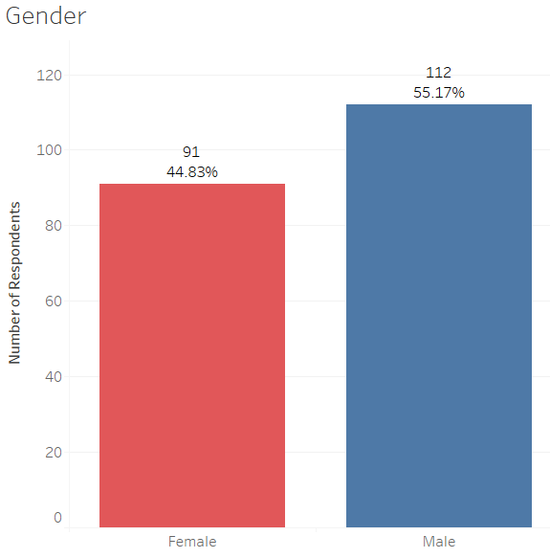
Figure 4.1 Distribution of respondent's Gender
Source: construct by writer

Figure 4.1 shows that 112 respondents (55.17%) are Male and 91 respondents (44.83%) are female in a total of 203 sample sizes. The result reflects that male is more likely to purchase in Omni-channel.

4.2.1.2 Age
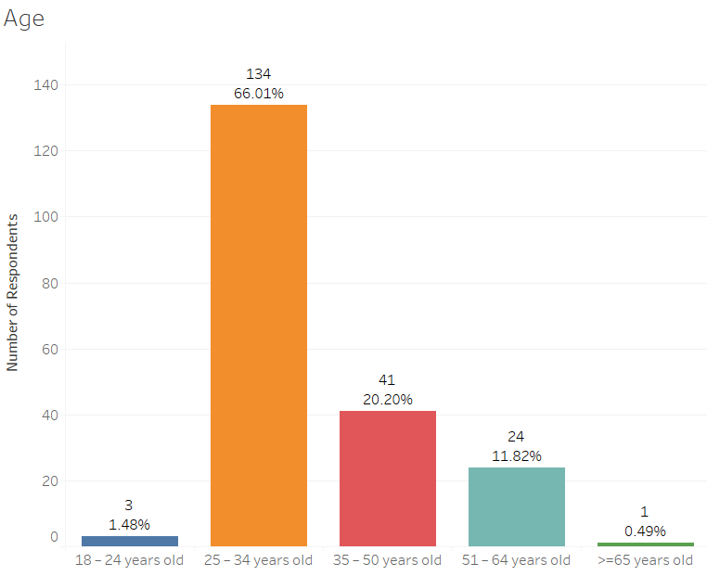
Figure 4.2 Distribution of respondent's Age
Source: construct by writer

Figure 4.2 shows five age groups divided into 203 respondents. In the questionnaire, this research was divided into five age groups, 18-24,25-34,35-50,51-64 and 65 or older. There is only one respondent in the age group of 65 or older which showed that over 65 do not have been interested in buying Omni-Channel. 134 out of 203 respondents are between 25 and 34 years of age and 41 out of 203 are between 35 and 50 years of age. The survey shows that the age between 25 and 50 is the main group involved in Omni-Channel, which is consistent with the outcome of the Hong Kong Consumer Council (2016).

4.2.1.3 Education level
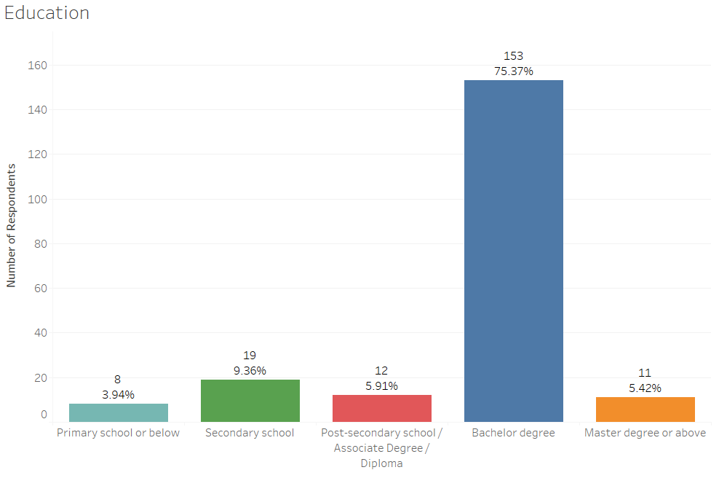
Figure 4.3 Distribution of respondent's Education
Source: construct by writer

Figure 4.3 shows the distribution of the education level of the respondents. 8 out of 203 respondents (3.94%) are from primary school or below; 19 respondents (9.36%) are from secondary school; 12 respondents (5.91%) are from post-secondary school / Associate Degree / Diploma; 153 respondents (75.37%) have a Bachelor's degree; 11 respondents (5.42%) have a Master's degree or higher. This indicates that higher education people are more likely to use Omni-channel to make purchases.

4.2.1.4 Purchase Approach and Age Relationship
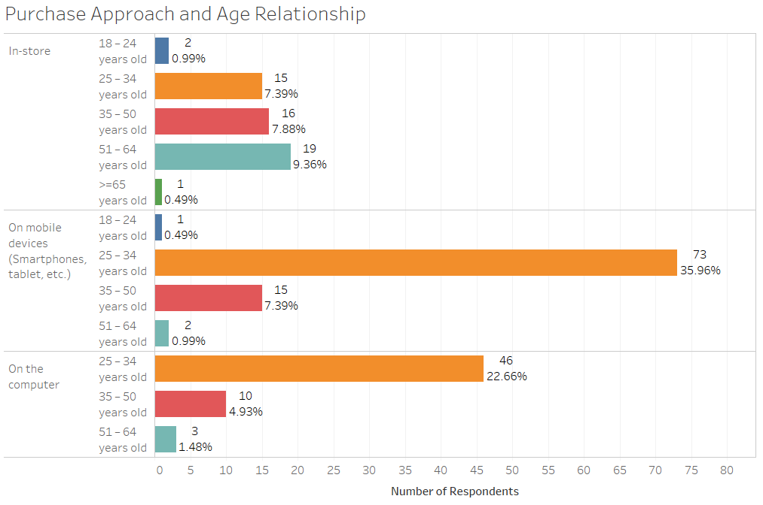
Figure 4.4 Distribution of Purchase Approach and Age Relationship
Source: construct by writer

Figure 4.4 shows that 73 respondents (35.96%) aged 25-34 used mobile phones for purchases and 46 respondents (22.66%) aged 25-34 used computers for purchases. It indicates that young people are more interested in shopping online. 19 out of 53 respondents had shop-in-store and their age group was 51-64; only 1 respondent aged 65 or older had bought in-store. It indicates that old people are more interested in shopping in-store.

4.2.1.5 Purchase Approach and Age Relationship
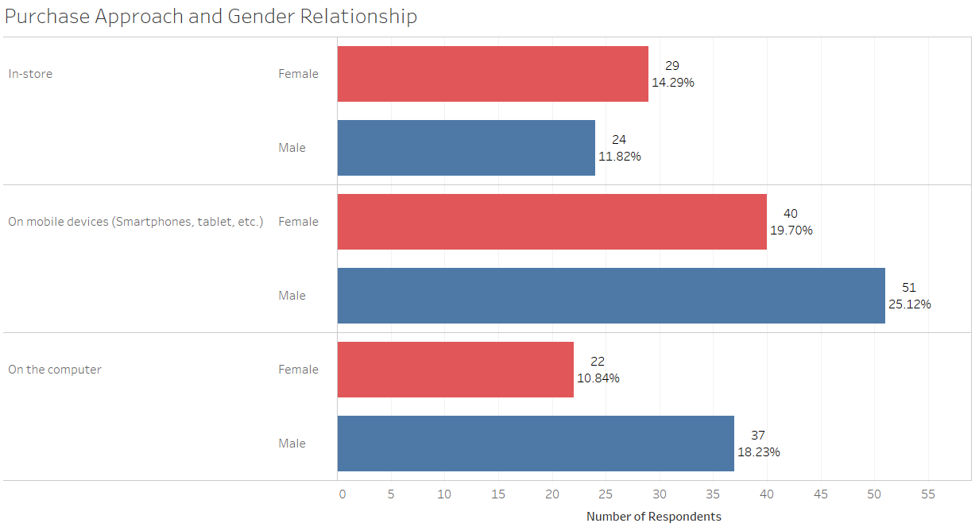
Figure 4.5 Distribution of Purchase Approach and Age Relationship
Source: construct by writer

Figure 4.5 shows the distribution of Purchase Approach and Age Relationship among 203 respondents. 51 respondents (25.12%) are male and purchase by mobile devices; 37 (18.23%) are male and purchase by computer. It indicates that the male has more preferences on the online channel purchase. 29 respondents (14.29%) are female and in-store purchases. It indicates that females have more preference for purchases on the offline channel.

4.2.1.6 Purchase Approach and Education Relationship
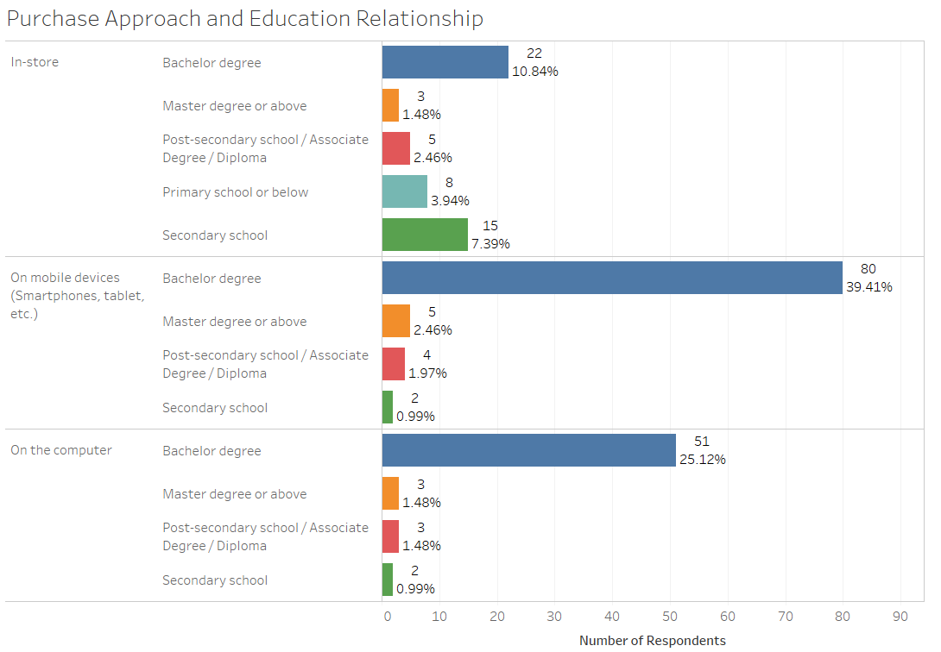
Figure 4.6 Distribution of Purchase Approach and Education Relationship
Source: construct by writer

Figure 4.6 shows the distribution of the purchase approach and the educational relationship among 203 respondents. 90 respondents (39.41%) used mobile devices to make purchases and their level of education is a bachelor's degree; 51 respondents (25.12%) used the computer to make purchases and their level of education is a bachelor's degree. It indicates that people with higher education have a greater preference for making online purchases. Even 22 respondents (10.84%) with a bachelor’s degree purchased offline, but 15 respondents (7.39%) purchased offline only secondary school. It indicates that low-education people are more likely to make offline purchases.

4.2.1.7 Distribution of Means & Std. Deviation

Figure 4.7 Distribution of Means & Std. Deviation
Source: construct by writer

The distribution of mean and std is shown in Figure 4.7 and Appendix E. The General Omni-channel touchpoint was identified as the highest mean of all factors with 4.19 and 0.728 standard deviations. The second highest mean for the process touchpoint was found at 4.04 and 0.656 standard deviations. The third highest mean for the product touchpoint was found at 4.02 and 0.621 standard deviations. These findings indicate that the respondents believe that these touchpoints have a positive impact on the experience of the customer. The touchpoint in the employee-customer has the lowest mean, which is 3.67 with 0.697 standard deviations, indicating that the employee-customer touchpoint has a relatively low positive impact on the customer experience.

These findings indicated that most of the respondents would like to see the process and product touchpoint as the priority that led to their purchase intention from Omni-channel or single channel.

4.2.1.8 Relationship of Omni-channel experience by the respondent’s demographic data
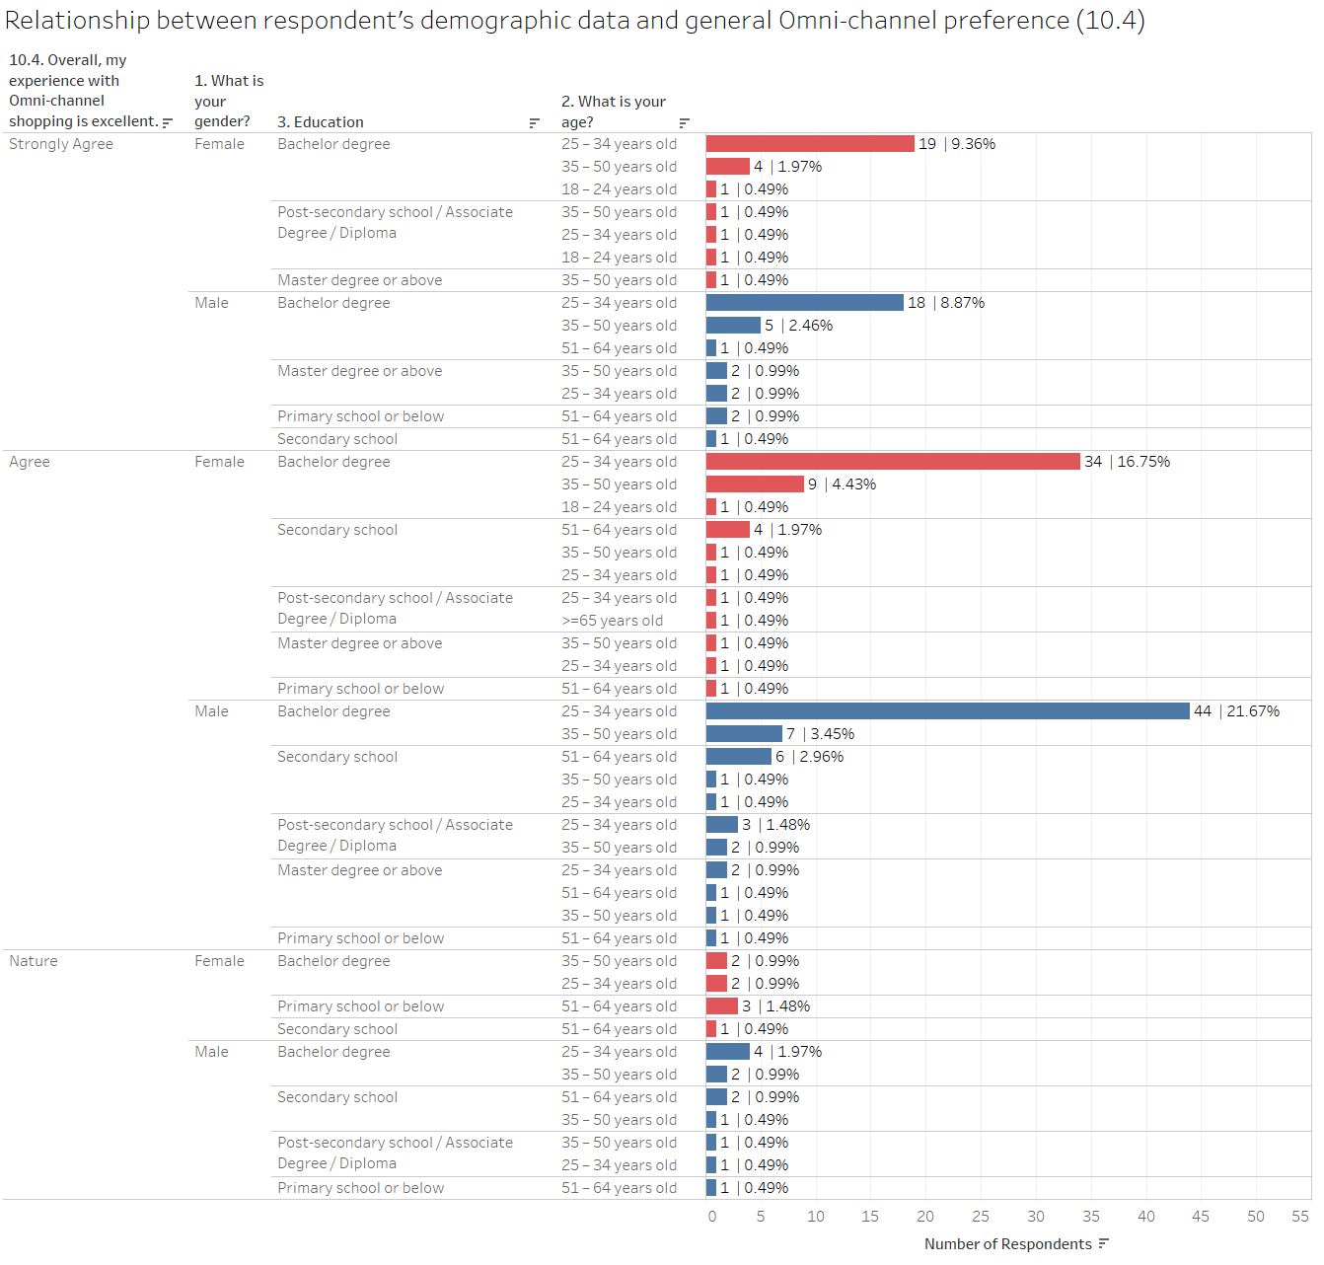Figure 4.8 Distribution of the relationship of Omni-channel experience by the respondent’s demographic data
Source: construct by writer

Figure 4.8 shows the distribution of the relationship of Omni-channel experience by the respondent’s demographic data. 44 respondents (21.67%) agree the overall experience with Omni-channel shopping is excellent and they are male with a bachelor’s degree and their age is between 25-34 years old. 34 respondents (16.75%) agree the overall experience with Omni-channel shopping is excellent and they are female with a bachelor’s degree and their age are between 25-34 years old. 18 respondents (8.87%) strongly agree the overall experience with Omni-channel shopping is excellent and they are male with a bachelor’s degree and their age are between 25-34 years old. 19 respondents (9.36%) strongly agree the overall experience with Omni-channel shopping is excellent and they are male with a bachelor’s degree and their age are between 25-34 years old. It indicates that there is no significant relationship in terms of gender but there is a significant relationship on people who agree the overall experience with Omni-channel shopping is excellent and who are age between 25-34 years old and who have a bachelor degree.

4.2.2 Reliability Test
As mentioned in Appendix H: Data analysis techniques, reliable coefficient reflects the acceptance level of the result. Cronbach’s Alpha under 0.6 indicates as unacceptable; 0.6 indicates as unfavourable; 0.7 indicates as low reliability; 0.8 indicates as average and 0.9 indicates as superb (Cozby and Bates, 2018).
Table 4.3 - Reliability Test Result
Reliability Statistics
Survey Methods | Cronbach's Alpha | N of Items
Online | 0.978 | 32
Source: construct by writer
Table 4.3 shows the reliability on the Online survey methods and it scored 0.978 which was classified as high reliability.
Table 4.4 - Reliability Test Result of 203 respondents
Reliability Statistics
Factor | Cronbach's Alpha | N of Items
Atmospheric | 0.918 | 4
Communicative | 0.904 | 4
Product | 0.918 | 4
Technological | 0.928 | 4
Process | 0.909 | 4
Employee-customer | 0.928 | 4
Customer-customer | 0.901 | 4
General Omni-channel | 0.902 | 4
Source: construct by writer
Table 4.4 shows the reliability of each factor. The Cronbach’s Alpha of different factors was over 0.9 which can be treated as high reliability.

4.2.3 Factor Analysis
Table 4.5 - KMO and Bartlett's Test
KMO and Bartlett's Test
Kaiser-Meyer-Olkin Measure of Sampling Adequacy. |  | 0.959
Bartlett's Test of Sphericity | Approx. Chi-Square | 6543.526
 | df | 496
 | Sig. | 0.000
Source: construct by writer
Table 4.5 reflects the factors analysis was fine as the KMO value reached 0.959 > 0.9 which can be treated as Wonderful. The p-value of Bartlett’s Test was 0.00 which was less than 0.01. This indicates that questions were adequate to support each factor for Omni-Channel customer experience at a 99% confidence level.
Table 4.6 – Eigenvalues with Variance
Factor/Touchpoint |  | Initial Eigenvalues
 |  | Total | % of Variance | Cumulative %
Technological, Process,  Customer-customer | 1 | 19.279 | 60.247 | 60.247
Atmospheric, Communicative, Product | 2 | 1.598 | 4.995 | 65.242
Employee-customer | 3 | 1.266 | 3.958 | 69.199
Omni-Channel Experience | 4 | 1.180 | 3.687 | 72.887
Source: construct by writer
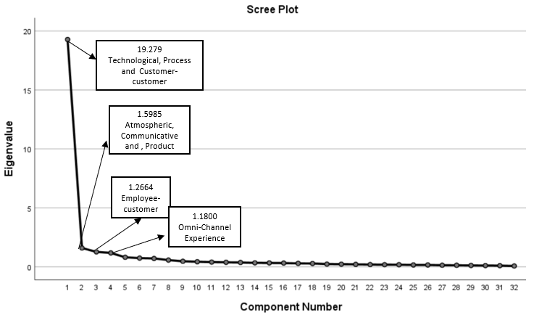Figure 4.9 Scree Plot
Source: construct by writer

Table 4.6 indicates that 72.887% of the variance can be explained by 7 factors, showing that the relationship between variables of the research model can be explained well.
Factor technological, process and customer-customer with eigenvalues 19.279 and 60.247% variance. Factor atmospheric, communicative and product with eigenvalues 1.598 and 4.995% variance. Factor employee-customer with eigenvalues 1.266 and 3.958% variance. Factor omni-channel experience with eigenvalues 1.18 and 3.687% variance. Factors can be classified as important when eigenvalues larger than 1. It can be concluded that the factors of Technological, Process and Customer-customer were the most important in terms of factory analysis (Figure 4.9) which is same the research from Stein and Ramaseshan (2016) and Ramya (2014).

Table 4.8 - Rotated Component Matrix for 8 factors
Rotated Component Matrix
Component | Factor | Questions | Factor Loading value
1 | Technological, Process, Customer-customer | 6.1. Their technology makes shopping convenient. | 0.754
1 | Technological, Process, Customer-customer | 6.2. They have technology that is easy to use. | 0.731
1 | Technological, Process, Customer-customer | 6.3. Their technologies are interactive. | 0.744
1 | Technological, Process, Customer-customer | 6.4. Overall, I'm satisfied with the products I bought. | 0.734
1 | Technological, Process, Customer-customer | 7.1. Their shopping platform is convenient. | 0.591
1 | Technological, Process, Customer-customer | 7.2. I can easily find the information or products needed. | 0.544
1 | Technological, Process, Customer-customer | 7.4. Their service processing time (shipping/returning) is short. | 0.590
1 | Technological, Process, Customer-customer | 9.1. Other customers' opinions affected my opinion toward this retailer/brand. | 0.603
1 | Technological, Process, Customer-customer | 9.2. I actively sought advice/reviews before shopping at this retailer/brand. | 0.602
1 | Technological, Process, Customer-customer | 9.4 Other consumers positively review this retailer/brand. | 0.604
2 | Atmospheric, Communicative, Product | 3.1. They provide a comfortable environment that puts me in a better mood. | 0.745
2 | Atmospheric, Communicative, Product | 3.2. Their shopping environment is visually appealing. | 0.759
2 | Atmospheric, Communicative, Product | 3.3. Their shopping environment increases my duration. | 0.746
2 | Atmospheric, Communicative, Product | 3.4. Their shopping atmosphere impressed me. | 0.734
2 | Atmospheric, Communicative, Product | 4.1. I feel favourable toward their advertising and promotions. | 0.678
2 | Atmospheric, Communicative, Product | 4.2. They did an excellent job in advertising and promotions. | 0.648
2 | Atmospheric, Communicative, Product | 4.3. Their advertising and promotions are informative. | 0.648
2 | Atmospheric, Communicative, Product | 4.4. I react favourably to their advertising and promotions. | 0.639
2 | Atmospheric, Communicative, Product | 5.2. I'm satisfied with their product assortment. | 0.532
2 | Atmospheric, Communicative, Product | 5.3. According to what I pay, they provide me with good value. | 0.519
2 | Atmospheric, Communicative, Product | 5.4. Overall, I'm satisfied with the products I bought. | 0.527
3 | Employee - Customer | 8.2 Their employees solve my needs efficiently. | 0.797
3 | Employee - Customer | 8.1 Their employees understand my needs. | 0.789
3 | Employee - Customer | 8.4 Overall, their employees deliver excellent service. | 0.714
3 | Employee - Customer | 8.3 Their employees put themselves in the customer's place. | 0.702
4 | Omni-Channel Experience | 10.2. I intend to make frequent use of omnichannel shopping in the future. | 0.806
4 | Omni-Channel Experience | 10.4. Overall, my experience with Omni-channel shopping is excellent. | 0.778
4 | Omni-Channel Experience | 10.1. I will use omnichannel shopping in the future. | 0.767
4 | Omni-Channel Experience | 10.3. I prefer to recommend the shopping Omni-channel to the people around me. | 0.734
Extraction Method: Principal Component Analysis.
Rotation Method: Varimax with Kaiser Normalization.
a. Rotation converged in 7 iterations.
Source: construct by writer
Table 4.8 shows the factor loading values of each independent variable if it were sufficient to support the factors and the questions were correlated to each other. Factor Product and Process has the highest score and it shows the positive relationship can be concluded with Product and Process which is same as the research form Sahin, Zehir and Kitapçı (2011).

4.2.3.1 Summary of Factor Analysis
Table 4.6 shows that factor analysis is work Wonderful with the 0.959 > 0.9 and the p-value of Bartlett's Test is 0.00 which is less than 0.05. It shows a strong relationship among variables.
The eigenvalue of the highest factors is technological, process and customer-customer (19.279) with screen plot supported (Figure 4.9); others could refer to table 4.8 shows the rotated component matrix for the research model.

4.2.4 Correlation Analysis
As mentioned in section 3.3.4, correlation analysis is a statistical method used to evaluate the strength of the relationship between two quantitative variables. A high correlation means that two or more variables have a strong relationship with each other, while a weak correlation means that the variables are hardly related (Franzese and Iuliano, 2016).

Table 4.9 - Correlation Analysis
Touchpoint | Question | Pearson Correlation
H1 - Omnichannel intention with Atmospheric + | 3.1. They provide a comfortable environment that puts me in a better mood. | .507**
H1 - Omnichannel intention with Atmospheric + | 3.2. Their shopping environment is visually appealing. | .517**
H1 - Omnichannel intention with Atmospheric + | 3.3. Their shopping environment increases my duration. | .486**
H1 - Omnichannel intention with Atmospheric + | 3.4. Their shopping atmosphere impressed me. | .534**
H2 - Omnichannel intention with Communicative + | 4.1. I feel favourable toward their advertising and promotions. | .551**
H2 - Omnichannel intention with Communicative + | 4.2. They did an excellent job in advertising and promotions. | .509**
H2 - Omnichannel intention with Communicative + | 4.3. Their advertising and promotions are informative. | .544**
H2 - Omnichannel intention with Communicative + | 4.4. I react favourably to their advertising and promotions. | .484**
H3 - Omnichannel intention with Product + | 5.1. I'm satisfied with the quality of their products. | .570**
H3 - Omnichannel intention with Product + | 5.2. I'm satisfied with their product assortment. | .517**
H3 - Omnichannel intention with Product + | 5.3. According to what I pay, they provide me with good value. | .577**
H3 - Omnichannel intention with Product + | 5.4. Overall, I'm satisfied with the products I bought. | .523**
H4 - Omnichannel intention with Technological + | 6.1. Their technology makes shopping convenient. | .509**
H4 - Omnichannel intention with Technological + | 6.2. They have technology that is easy to use. | .500**
H4 - Omnichannel intention with Technological + | 6.3. Their technologies are interactive. | .527**
H4 - Omnichannel intention with Technological + | 6.4. Overall, I'm satisfied with the products I bought. | .510**
H5 - Omnichannel intention with Process + | 7.1. Their shopping platform is convenient. | .538**
H5 - Omnichannel intention with Process + | 7.2. I can easily find the information or products needed. | .539**
H5 - Omnichannel intention with Process + | 7.3. Their service processing (shipping/returning) is convenient. | .544**
H5 - Omnichannel intention with Process + | 7.4. Their service processing time (shipping/returning) is short. | .624**
H6 - Omnichannel intention with Employee-customer + | 8.1 Their employees understand my needs. | .562**
H6 - Omnichannel intention with Employee-customer + | 8.2 Their employees solve my needs efficiently. | .529**
H6 - Omnichannel intention with Employee-customer + | 8.3 Their employees put themselves in the customer's place. | .550**
H6 - Omnichannel intention with Employee-customer + | 8.4 Overall, its employees deliver excellent service. | .596**
H7 - Omnichannel intention with Customer-customer + | 9.1. Other customers' opinions affected my opinion about this retailer/brand. | .565**
H7 - Omnichannel intention with Customer-customer + | 9.2. I actively sought advice/reviews before shopping at this retailer/brand. | .512**
H7 - Omnichannel intention with Customer-customer + | 9.3 I observed where my friends were shopping before selecting this retailer/brand. | .599**
H7 - Omnichannel intention with Customer-customer + | 9.4 Other consumers positively review this retailer/brand. | .560**
**. Correlation is significant at the 0.01 level.
Source: construct by writer

Table 4.10 - The highest correlation of the hypothesis
 | This Research
 | N | R
H1 - Atmospheric | 203 | 0.534**
H2 - Communicative | 203 | 0.551**
H3 - Product | 203 | 0.577**
H4 - Technological | 203 | 0.527**
H5 - Process | 203 | 0.624**
H6 - Employee-customer | 203 | 0.596**
H7 - Customer-customer | 203 | 0.599**
**. Correlation is significant at the 0.01 level.
Source: construct by writer

Tables 4.9 and Table 4.10 show the correlation touchpoint with the intent of the Omni-channel, the top 3 correlation with touchpoint and intent of use The Omni-channel is Process (0.624), Customer-Customer (0.599) and Employee-Customer (0.596). And the lowest correlation with the touchpoint and the intention to use the Omni-channel is technological (0.527). Besides, all correlation scores in the correlation analysis for each question are higher than 0.4 and the Process touchpoint is higher than 0.6, according to section 3.3.4, indicating that these questions and touchpoints have a moderate positive correlation and the process touchpoint has a strong positive correlation with omni-channel intent at a 99% confidence level. Based on the results of the analysis, H1 to H7 is supported.

4.2.5 Independent T-Test
In statistics, the Levene test statistic is an inference, and evaluation of equal variances for two or more groups of the variables calculated. Some common statistical procedures assume that the variance of different samples from different samples is the same. The Levene test evaluates this assumption. It tests the null hypothesis that the overall variance is equal (called variance homogeneity or homogeneity). This section described the findings on signal-channel vs. omni-channel and gender using the Independent T-Test.

4.2.5.1 Signal-Channel vs. Omni-Channel
Table 4.11 - Group Statistics of the different shopping process
Group Statistics
 | 2. Click the approach I am using during the shopping process (Select one only if I use it frequently). | N | Mean | Std. Deviation | Std. Error Mean
10.1. I will use omnichannel shopping in the future. | Single Channel | 53 | 4.04 | 0.733 | 0.101
10.1. I will use omnichannel shopping in the future. | Omni-Channel | 150 | 4.27 | 0.575 | 0.047
Source: construct by writer

Table 4.12 - Independent Samples Test of the different shopping process
Independent Samples Test
 |  | Levene's Test for Equality of Variances |  | t-test for Equality of Means
 |  | F | Sig. | t | df | Sig. (2-tailed) | Mean Difference | Std. Error Difference | 95% Confidence Interval of the Difference
 |  |  |  |  |  |  |  |  | Lower | Upper
10.1. I will use omnichannel shopping in the future. | Equal variances assumed | 0.954 | 0.330 | -2.311 | 201 | 0.022 | -0.229 | 0.099 | -0.424 | -0.034
10.1. I will use omnichannel shopping in the future. | Equal variances not assumed |  |  | -2.061 | 75.868 | 0.043 | -0.229 | 0.111 | -0.450 | -0.008
Source: construct by writer
Table 4.11 and Table 4.12 shows the Independent T-Test analysis with the intention of the customer Omni-channel customer experience by their shopping approach. For Question 10.1, the p-value of Levene's Test for Equality of Variances are 0.33 which is bigger than 0.05, H0 is accepted, which indicate equal variances assumed. Also, the p-value of t-test for Equality of Means is 0.022 which is lower than 0.05, H0 is rejected, which means there is a significant difference between the shopping approach and the satisfying level to Omni-channel. Besides, the mean difference is -0.229, therefore, the mean of satisfaction for Omni-channel is greater than Single Channel at 95% confidence level which is same as the finding from Shi et al (2020). Based on the results of the analysis, H8a Omni-Channel customer experience has a significant difference in customer shopping approach is supported.

4.2.5.2 Gender
Table 4.13 - Group Statistics of the Gender
Group Statistics
 | 1. What is your gender? | N | Mean | Std. Deviation | Std. Error Mean
10.1. I will use omnichannel shopping in the future. | Female | 91 | 4.15 | 0.665 | 0.070
10.1. I will use omnichannel shopping in the future. | Male | 112 | 4.25 | 0.593 | 0.056
Source: construct by writer

Table 4.14 - Independent samples test of the gender
Independent Samples Test
 |  | Levene's Test for Equality of Variances |  |  |  |  | t-test for Equality of Means
 |  | F | Sig. | t | df | Sig. (2-tailed) | Mean Difference | Std. Error Difference | 95% Confidence Interval of the Difference
 |  |  |  |  |  |  |  |  | Lower | Upper
10.1. I will use omnichannel shopping in the future. | Equal variances assumed | 0.240 | 0.625 | -1.088 | 201 | 0.278 | -0.096 | 0.088 | -0.270 | 0.078
10.1. I will use omnichannel shopping in the future. | Equal variances not assumed |  |  | -1.075 | 182.096 | 0.284 | -0.096 | 0.089 | -0.273 | 0.080
Source: construct by writer
Table 4.13 and Table 4.14 and F show the Independent T-Test analysis with the intention of the customer Omni-channel customer experience by gender. For Question 10.1, the p-value of Levene's Test for Equality of Variances is 0.625, which is bigger than 0.05, H0 is accepted, which indicate equal variances assumed. But the p-value of t-test for Equality of Means is 0.278 which is higher than 0.05, H0 is rejected, which mean there is no significant difference in the gender and the satisfying level to Omni-channel. The result is the same as the finding from Table 3.5 and Census and Statistics Department (2019). Based on the results of the analysis, H8b Omni-Channel customer experience has a significant difference in customer gender is not supported.

4.2.6 One-way ANOVA
A one-way variance analysis (ANOVA) is used to determine whether there are statistically significant differences between the means of two or more independent (unrelated) groups (Laerd, 2018). This section described the findings of the shopping process, age, and education.

4.2.6.1 Shopping Process
Table 4.15 - Multiple Comparisons - Shopping Process
Multiple Comparisons
Tukey HSD
Dependent Variable | (I) 2. Click the approach I am using during the shopping process (Select one only if I use it frequently). | (J) 2. Click the approach I am using during the shopping process (Select one only if I use it frequently). | Mean Difference (I-J) | Std. Error | Sig. | 95% Confidence Interval
 |  |  |  |  |  | Lower Bound | Upper Bound
10.3. I prefer to recommend the shopping Omni-channel to the people around me. | On mobile devices (Smartphones, tablet, etc.) | In-store | 0.215 | 0.12 | 0.176 | -0.07 | 0.5
 | On mobile devices (Smartphones, tablet, etc.) | On the computer | .321* | 0.116 | 0.017 | 0.05 | 0.6
Source: construct by writer
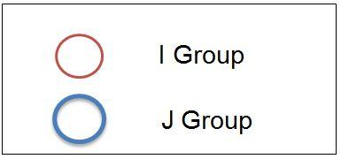
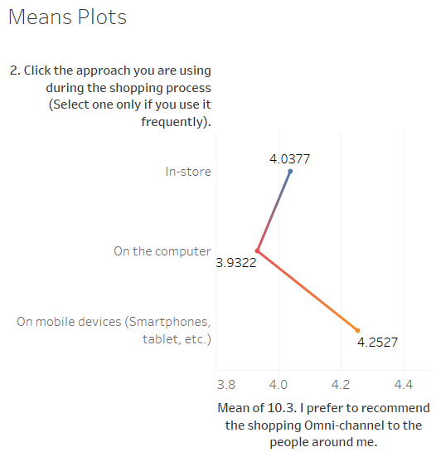

Figure 4.10 Means Plot - Shopping Process
Source: construct by writer

Table 4.15 and Figure 4.10 show the One-way ANOVA analysis with the intention of the customer Omni-channel customer experience with their shopping approach. There is a significant difference in Question 10.3 – “recommend the shopping Omni-channel to the people”. The significant level of purchase with mobile devices and computers is 0.017 which is lower than 0.05, it means there is a significant difference in these customers who use a different approach. Besides, the mean difference between mobile and computer is 0.321 which means people who use mobile have positive intentions than people who use the computer to prefer to recommend the shopping Omni-channel to the people around them at 95% confidence level. The result is the same as the finding from Edelman and Banfi (2014). Based on the results of the analysis, H8c Omni-Channel customer experience has a significant difference in the customer shopping process is supported.

4.2.6.2 Age
Table 4.16 - Multiple Comparisons - Age
Multiple Comparisons
Tukey HSD
Dependent Variable | (I) Age | (J) Age | Mean Difference (I-J) | Std. Error | Sig. | 95% Confidence Interval
 |  |  |  |  |  | Lower Bound | Upper Bound
10.1. I will use omnichannel shopping in the future. | 18 – 24 years old | 25 – 34 years old | 0.784 | 0.360 | 0.134 | -0.15 | 1.72
10.1. I will use omnichannel shopping in the future. | 18 – 24 years old | 35 – 50 years old | 0.732 | 0.369 | 0.198 | -0.22 | 1.69
10.1. I will use omnichannel shopping in the future. | 18 – 24 years old | >=51 years old | 1.040* | 0.377 | 0.032 | 0.06 | 2.02
10.4. Overall, my experience with Omni-channel shopping is excellent. | 25 – 34 years old | 18 – 24 years old | -0.420 | 0.341 | 0.607 | -1.30 | 0.46
 | 25 – 34 years old | 35 – 50 years old | 0.076 | 0.104 | 0.887 | -0.19 | 0.35
 | 25 – 34 years old | >=51 years old | .366* | 0.127 | 0.023 | 0.04 | 0.70
Source: construct by writer

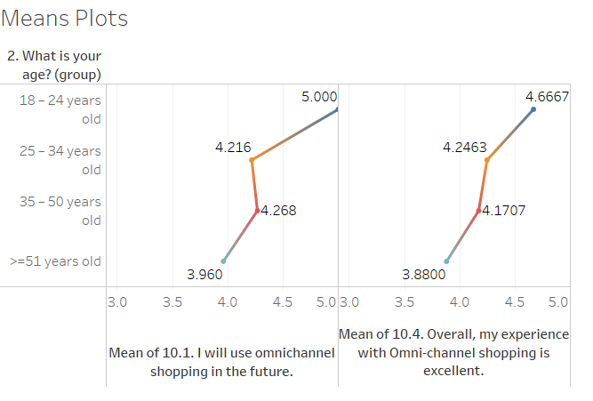

Figure 4.11 - Means Plot - Age
Source: construct by writer

Table 4.15 and Figure 4.15 show the One-way ANOVA analysis with the intention of the customer Omni-channel customer experience with their age. There is a significant difference in Question 10.1 – I will use omnichannel shopping in the future and Question 10.4 – Overall, my experience with Omni-channel shopping is excellent. The significant level of Omni-channel customer intention with 18-24 years old and >=51 years old is 0.032 which is lower than 0.05; Besides, the significant level of Omni-channel customer intention with 25-34 years old and >=51 years old is 0.023 which is lower than 0.05, it means there has a significant difference of these customers in terms of their age. Besides, the mean difference between 18-24 years old and >=51 years old is 1.040, the mean difference between 25-34 years old and >=51 years old is 0.366, which mean people who are between 18-24 years old and 25-34 years old have greater positive intention than people who are equal or greater than 51 years old using Omni-channel at 95% confidence level. The result is the same as the finding from table 3.5 and Census and Statistics Department (2019). Based on the results of the analysis, H8d Omni-Channel customer experience has a significant difference in customer age is supported.

4.2.6.3 Education
Table 4.17 - Multiple Comparisons – Education
Multiple Comparisons
Tukey HSD
Dependent Variable | (I) 3. Education | (J) 3. Education | Mean Difference (I-J) | Std. Error | Sig. | 95% Confidence Interval
 |  |  |  |  |  | Lower Bound | Upper Bound
10.4. Overall, my experience with Omni-channel shopping is excellent. | Bachelor degree | Primary school or below | 0.498 | 0.210 | 0.126 | -0.08 | 1.08
 | Bachelor degree | Secondary school | .406* | 0.141 | 0.035 | 0.02 | 0.79
 | Bachelor degree | Post-secondary school / Associate Degree / Diploma | 0.165 | 0.173 | 0.876 | -0.31 | 0.64
 | Bachelor degree | Master degree or above | -0.206 | 0.181 | 0.784 | -0.70 | 0.29
 | Master degree or above | Primary school or below | 0.705 | 0.269 | 0.070 | -0.04 | 1.44
 | Master degree or above | Secondary school | .612* | 0.219 | 0.045 | 0.01 | 1.22
 | Master degree or above | Post-secondary school / Associate Degree / Diploma | 0.371 | 0.241 | 0.539 | -0.29 | 1.04
 | Master degree or above | Bachelor degree | 0.206 | 0.181 | 0.784 | -0.29 | 0.70
Source: construct by writer

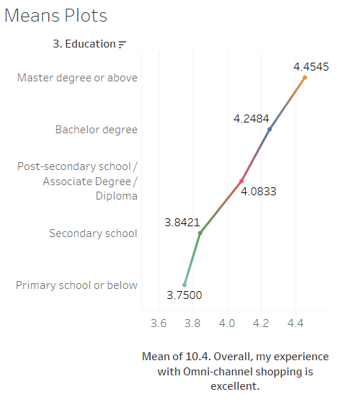

Figure 4.12 - Means Plot - Education
Source: construct by writer

Table 4.17 and Figure 4.12 show the One-way ANOVA analysis with the intention of the customer Omni-channel customer experience with their education level. There has a significant difference in Question 10.4 – “Overall, my experience with Omni-channel shopping is excellent”. The significant level of Omni-channel customer intention with Bachelor degree and Secondary school is 0.035 which is lower than 0.05; Besides, the significant level of Omni-channel customer intention with Master degree or above and Secondary school is 0.045 which is lower than 0.05, it means there has a significant difference of these customers in terms of their education level. Besides, the mean difference between Bachelor degree and Secondary school is 0.406, and the mean difference between Master degree or above and Secondary school is 0.612, which means people who have a Bachelor degree or Master degree have positive intention than people who only have secondary school on feeling Omni-channel shopping is excellent at 95% confidence level. The result is the same as the finding from Table 1.1 and the Census and Statistics Department (2019). Based on the results of the analysis, H8e Omni-Channel customer experience has a significant difference in customer education is supported.

4.2.7 Regression Analysis
Regression analysis may predict the value of a variable based on the value of another variable. Stepwise methods have been used to perform a regression analysis for this research.
Table 4.18 - Regression model summary for Omni-channel intention
Model Summary^{d}
Model | R | R Square | Adjusted R Square | Std. Error of the Estimate
3 | .685^{c} | 0.469 | 0.461 | 0.437
c. Predictors: (Constant), 7.4. Their service processing time (shipping/returning) is short., 8.4 Overall, their employees deliver excellent service., 5.3. According to what I pay, they provide me with good value.
d. Dependent Variable: 10.4. Overall, my experience with Omni-channel shopping is excellent.
Source: construct by writer
Table 4.19 - ANOVA summary for Omni-channel intention
ANOVAª
Model |  | Sum of Squares | df | Mean Square | F | Sig.
3 | Regression | 33.509 | 3 | 11.170 | 58.495 | .000^{d}
3 | Residual | 37.999 | 199 | 0.191
3 | Total | 71.507 | 202
a. Dependent Variable: 10.4. Overall, my experience with Omni-channel shopping is excellent.
d. Predictors: (Constant), 7.4. Their service processing time (shipping/returning) is short., 8.4 Overall, their employees deliver excellent service., 5.3. According to what I pay, they provide me with good value.
Source: construct by writer
Table 4.20 - Coefficients summary for Omni-channel intention
Coefficientsª
Model |  | Unstandardized Coefficients |  | Standardized Coefficients | t | Sig. | Collinearity Statistics
 |  | B | Std. Error | Beta | t | Sig. | Tolerance | VIF
3 | (Constant) | 1.418 | 0.216 |  | 6.564 | 0.000
3 | 7.4. Their service processing time (shipping/returning) is short. | 0.286 | 0.070 | 0.316 | 4.107 | 0.000 | 0.451 | 2.216
3 | 8.4 Overall, their employees deliver excellent service. | 0.232 | 0.061 | 0.272 | 3.791 | 0.000 | 0.519 | 1.926
3 | 5.3. According to what I pay, they provide me with good value. | 0.185 | 0.069 | 0.193 | 2.661 | 0.008 | 0.508 | 1.970
a. Dependent Variable: 10.4. Overall, my experience with Omni-channel shopping is excellent.
Source: construct by writer

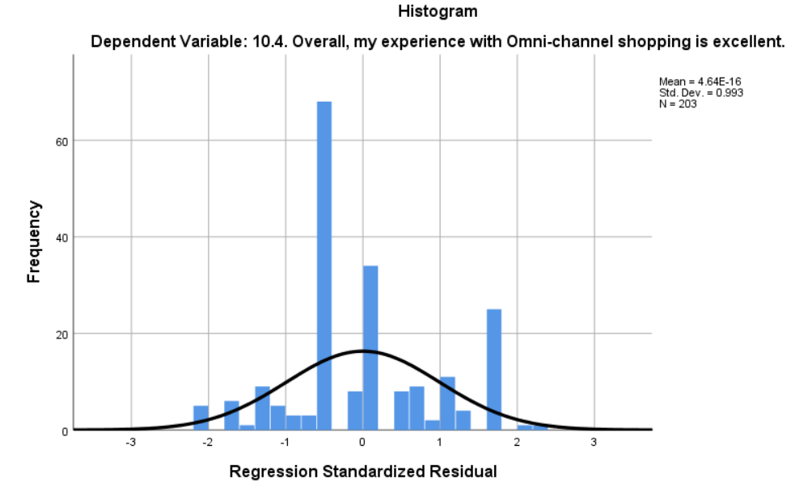
Figure 4.13 Histogram of Omni-channel intention
Source: construct by writer
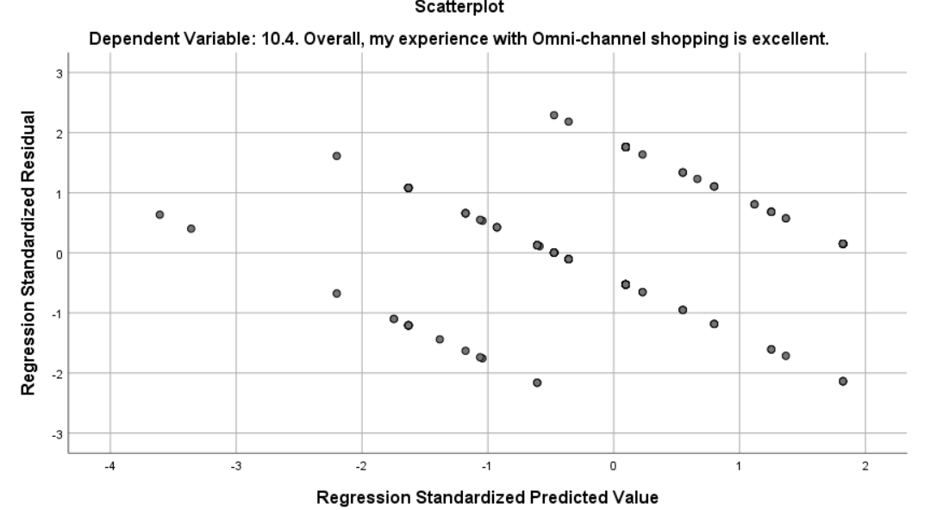
Figure 4.14 Scatterplot of Omni-channel intention
Source: construct by writer
According to table 4.18, table 4.19 and table 4.20, ANOVA table shows all p-values are 0 < 0.05 significant levels (confidence level 95%), showing that all the regression models are valid. For the model summary, it shows that 46.9% of the variation of Omni-channel intention can be explained by perceived value. Coefficients table shows all p-value is 0<0.05, H0 is rejected. β1 is 0.286, β2 is 0.232 and β3 is 0.185 which are not equal to zero, thus, perceived value positively affects Omni-channel intention. VIF indicates a predictor has a strong linear relationship with other predictors and the values are 2.216,1.926 and 1.970 which are less than 10, indicating that there are no multicollinearity problems of the models. Figure 4.13 shows the patterns of the histogram are valid to use a linear regression model. Figure 4.14 shows that the residuals are low negative correlation, so the equation models are appropriate to use. The equation of Omni-channel intention stated as below.
Omni-channel intention (Y1) = 1.418 + 0.286 x Perceived Value (Process) +0.232 X Perceived Value (Employee-customer) + 0.185 X Perceived Value (Product)

4.2.8 Hypothesis Testing Result
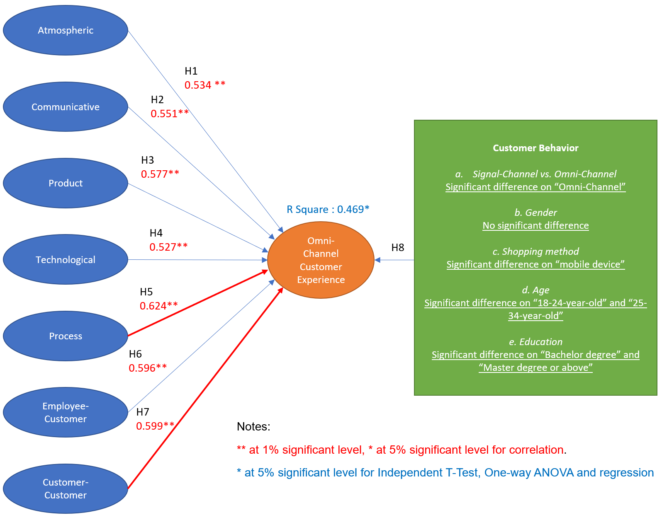
Figure 4.15 Hypothesis Testing Result
(Red line indicates significant impact)
Source: construct by writer

Table 4.21 Result of the Research Hypothesis
Hypotheses |  | Result | Test Result
H1 | Explore the positive impact of the atmospheric touchpoint on the experience of the Omni-channel customer. | R = 0.534 | Supported
H2 | Explore the positive impact of the communicative touchpoint on the experience of the Omni-channel customer. | R = 0.551 | Supported
H3 | Explore the positive impact of the product touchpoint on the experience of the Omni-channel customer. | R = 0.577 | Supported
H4 | Explore the positive impact of the technological touchpoint on the experience of the Omni-channel customer. | R = 0.527 | Supported
H5 | Explore the positive impact of the process touchpoint on the experience of the Omni-channel customer. | R = 0.624 | Supported
H6 | Explore the positive impact of the employee-customer touchpoint on the experience of the Omni-channel customer. | R = 0.596 | Supported
H7 | Explore the positive impact of the customer-customer touchpoint on the experience of the Omni-channel customer. | R = 0.599 | Supported
H8a | Omni-Channel customer experience has a significant difference in customer shopping approach | MD = -0.229  Significant difference on “Omni-Channel” | Supported
H8b | Omni-Channel customer experience has a significant difference in customer gender | MD = -0.096  No significant difference | Not Supported
H8c | Omni-Channel customer experience has a significant difference in customer shopping method | MD = 0.321  Significant difference on “mobile device” | Supported
H8d | Omni-Channel customer experience has a significant difference in customer age | MD = 1.040 & 0.366  Significant difference on “18-24-year-old” and “25-34-year-old” | Supported
H8e | Omni-Channel customer experience has a significant difference in customer education | MD = 0.406 & 0.612  Significant difference on “Bachelor degree” and “Master degree or above” | Supported
Notes: ** at 1% significant level for correlation, * at 5% significant level
Source: construct by writer
According to Figure 4.15 and Table 4.21, the result shows that the R² of the research hypothesis is 46.9% at a 5% significant level. For the hypothesis, all touchpoints (H1-H7) also have a positive influence and the process touchpoint is the most significant factor of 62.4% impact on the customer experience of the Omni-channel. It can be concluded that the touchpoint process leads to the intent of the Omni-channel for the customer. Once the customer feels that the touchpoint process is satisfactory, the intention to use the omni-channel will also increase, which is the same as the findings of Shim, Forsythe, and Kwon (2015). In addition to customer behaviour, the H8a shopping approach, H8c shopping method, H8d customer age and H8e customer education were supported based on the Independent T-Test and One-way ANOVA analysis. However, gender H8b is not a difference based on the outcome of the analysis.

4.3 Summary of Data Analysis
In this chapter, several analysis techniques were used to test the hypotheses. First, all questions have tested the reliability by using a reliability test and all the questions are reliable. Second, factor analysis was used. All factors worked fine, and the initial hypothesis was Accepted. A strong relationship was shown among variables. Also, Independent T-Test was conducted and showing the Omni-Channel customers have a greater Omni-channel intention than a single channel. Also, One-way ANOVA was conducted and showing customer who using mobile devices have a greater Omni-channel intention than using the computer, Bachelor degree or Master degree customer have a greater positive intention than people who only have a secondary school and 18-24 years old and 25-34 years old have greater positive intention than people who are equal or greater than 51 years old. Besides, the correlation test was used and found that all factors had a positive relationship with the intention to use Omni-Channel. Lastly, the regression model was used, and the equation was formed as stated in chapter 4.2.7. It can be concluded that different customer experience touchpoints elements on the consumer experience of Omni-channel have a positive influence on Omni-Channel customer experience and have a significant difference in intention to use Omni-Channel.

Chapter 5 - Recommendations and Conclusion

This chapter provides a summary of research findings, implications of the research both theoretical and managerial implications along with the limitations of the study and the future research directions.

5.1 Discussion and conclusion
Creating a superior customer experience has been gaining increasing attention from the retailers. However, there has been a shortage of academic research on this topic. This research has tried to provide a complete picture of the customer experience and its determinants. The domain of customer experience offers huge opportunities for future research. Research-based answers to the various hypotheses will add significantly to retailing theory and offer practical insights for developing and implementing effective experience-based marketing strategies for the retailers.

This study aims to build a touch-point customer experience model and to examine the relationship between the customer's overall shopping experience and the customer's experience in the seven touch-points proposed by Stein and Ramaseshan's (2016) qualitative study. An individual in-depth interview with two respondents was also conducted to obtain information from the retail industry. The influence of the consumer's choice of shopping channels on these relationships is also examined through the Independent T-Test and One-way ANOVA analysis.

The individual in-depth interview shows that atmospheric, product, communicative and process touchpoints have a significant positive impact on the overall customer experience. It can make the customer in a better mood to buy and explore the product. Another finding is that if a retailer has done an excellent job in advertising and promotions, such as informative advertising with a convenient shopping platform, it can improve customer experience and loyalty. These findings are the same as the research from Stein and Ramaseshan (2016) and Ramya (2014).

The results of the study (Figure 4.19) show that Atmospheric touchpoint experience has a significant positive impact on overall customer experience. This finding consists of past research that suggests that both in-store and online Atmosphere touchpoint influences customer emotion, loyalty, satisfaction, and experience. (Yang & Young, 2009; Bagdare, 2014; Fakharyan et al., 2014; Mishra, Sinha, & Koul, 2014).

Communicative touchpoint experience has been shown to have a significant positive impact on the overall customer experience, as confirmed by Khan and Rahman's research (2016) that mass media impressions have a positive impact on the brand experience as well as the Sahin, Zehir and Kitapçı (2011) research.

The research also reveals a significant positive impact on the overall customer experience of the Process touchpoint experience. This result supports the argument that the convenience of retail services is positively related to customer satisfaction and experience (Seiders et al., 1999; Bagdare, 2014; Thuy, 2011).

Furthermore, the Employee-Customer touchpoint interaction experience has been shown to have a positive impact on the overall customer experience, which verifies past findings that suggest that point-of-sale assistants have a positive influence on retail brand experience (Khan & Rahman, 2016).

Customer-Customer touchpoint experience has a significant impact on the overall customer experience. This is the same as the previous finding that customer-to-customer interaction is an important part of shopping experience and has a positive indirect impact on customer satisfaction (Parker & Ward, 2000; Harris et al., 1997).

The positive impact of Product touchpoint experience on overall customer experience is also supported, which is consistent with the conclusion that perceived consumer quality and price have a positive impact on customer satisfaction and brand loyalty. (Lu & Xu, 2015; Frank et al., 2014; Dapkevičius and Melnikas, 2011).

In addition to having a positive impact on consumer experience, Technological touchpoint experience shows the least significant impact on overall customer experience, even though previous research points out that shopping technology such as customization has a direct impact on positive consumer experience (Yang & Young, 2009). This inconsistency may arise because technologies are the key elements of each touchpoint, and customers may not recognize technologies as experience. For example, the customer may consider the cutting-edge digital fitting room as part of the store's atmospheric experience rather than as an independent technology experience.

Also, this dilemma could be due to the majority of respondents in this study, aged 18 to 34, who are also considered to be Generation Y or Millennial (born from the early 1980s to the early 2000s) and who usually use mobile applications every day, such as social media, so they don't care about the technological touchpoint because they think it's common. Also, the Millennial Generation is concerned about how peers and groups are perceived and reference groups and social media shape and moderate their entire decision-making process, and the Millennial Generation is also eager to express its uniqueness. So, they're more focused on the Customer-customer touchpoint, as they're constantly checking out reviews.

Independent T-Test was conducted to investigate the influence of consumer channel choice (store, online, mobile) and customer gender (female, male) on the relationship between touchpoints and consumer omnichannel experience. It shows that there is a significant difference in the customer shopping approach to people using Omni-Channel which is the same as the finding from Shi et al (2020). However, there is no significant difference between the gender of the customer which is same as the findings of the Census and Statistics Department (2019).

Besides, one-way ANOVA has also been conducted to investigate the influence of consumer shopping processes (In-store, On-Computer, On Mobile Device), Age(18-24,25-34,35-50 and > = 51) and Education (primary school or lower, secondary school, post-secondary school / Associate Degree / Diploma, Bachelor's degree and Master's degree or higher). The result shows that there is a significant difference between the customer using the mobile device for purchase which is consistent with the finding made by Edelman and Banfi (2014). There is also a significant difference in customer age between 18-24-year-olds and 25-34-year-olds, which is consistent with the findings of the Census and Statistics Department (2019). Finally, there is a significant difference in customer education that has a bachelor's degree and a master's degree or higher, which is consistent with the findings of the Census and Statistics Department (2019).

5.2 Recommendation
This section describes the recommendations, implications and future research based on research findings and conclusions.

5.2.1 Theoretical Implications
This research found the key touchpoint to enhance the customer's intention to use Omni-Channel. As an extension of the qualitative study by Stein and Ramaseshan (2016), this research quantitatively examined the experience of seven consumer touchpoints on the overall customer experience. The results confirmed the previous study on the positive impact of atmospheric, communicative, process, technological, product, employee-customer and customer-customer experience on overall customer experience. Technology experiences also show the lowest positive relationship with the overall customer experience. When examining the influence of consumer channel choice, this research contributes to Omni-channel research by finding that the communicative touchpoint and the employee-customer touchpoint differ in the impact on the overall customer experience between single-channel customers and multi-channel customers. In summary, this research provided and verified a different point of view for research into the consumer experience.

5.2.2 Practical Implications
This study had considerable managerial value for the customer's omni-channel intention and touchpoint to enhance the customer's experience. In the first place, retailers could benefit from this research by establishing a customer-based customer experience strategy based on touchpoints and engaging today's Omni-channel consumers in these touchpoints during their shopping journey. Second, this research finds that the impact of touchpoints on overall customer experience is inconsistent, and previous research has argued that omni-channel consumers do not separate channels during shopping (Blázquez, 2014). It is therefore recommended that retailers deliver consistent touchpoint experience across different shopping channels. This includes the synchronization of communicative information such as discount across all channels and the provision of consistent service across all channels.

This research also shows that the process touchpoint has the most significant positive impact on the overall customer experience with the same findings from Stein and Ramaseshan (2016) research. Retail companies should try to develop a touchpoint strategy for the process, such as optimizing mobile shopping and making it easy for companies to navigate the website easily, to have a clear overview of the product and to be able to pay for it easily. The design of the website should be responsive, i.e. adapted to all screen sizes, so that customers can navigate easily. Another smart idea to satisfy customers who are shopping on mobile devices is to develop an app if your online store is larger. Apps provide a greater degree of flexibility and functionality can be made especially for mobile users. When it comes to the checkout part, it can be a great advantage to incorporate different payment methods. Depending on the payment system firm used, the firm may extend the customer's choices as far as possible, i.e. allow the customer to pay by credit or debit card, PayPal, and even ApplePay or Google Wallet.

In addition, another touchpoint strategy process is ordered online, pick-up at the store, if retailers own a physical store but also operate online, you can give your customers a great deal of flexibility when it comes to buying the product they want. Firms can allow their customers to buy the product through their online store, but they can pick it up from a physical location. That way, the customer will be able to see the product before the purchase process is finished and they will feel safer. Also, give customers a return policy, so if the customer doesn't like the product they've bought, they can get their money back. By doing so, firms will leave a good impression, start building customer trust, and possibly win back customers. Starbucks' payment system, which is available through its app, is a great example of flexibility. Simply put, they allowed users to place orders and pay for them without being in the store. As a result, customers could: (1) get their coffee without having to wait in line, (2) place an order on the way to the coffee shop and (3) pick it up immediately.

Besides, customers may prefer to purchase from a physical store for other reasons, apart from just looking at the product. Some users also want to avoid shipping costs, instead of going to a shop near them. Others want to skip waiting for the delivery and get the product right away. Whatever the case may be, according to a study by Ellett (2018), even 70% of in-store purchases precede a certain online activity in product research.

Next, the retailer would be able to let the customer check out on social media. Facebook launched its Marketplace some time ago. This has radically changed things and allowed users to purchase directly while browsing the popular social network. There is nothing new about using Facebook to sell items: you are marketing your products on Facebook, either by posting content on your page or by paying ads; the user is viewing the ad and going to the company's Facebook page; the user is potentially going to your company's website; the user is buying the product. With this new buy-sell option, Facebook has once again made things easier for businesses and customers. Setting up a Facebook store for your business is a great way to reach out to new social media clients.

It is also recommended that the retailer be able to incorporate different payment methods. Customers will change their mind about buying something if the payment process on your website is too complicated or if payment options are too limited. It is always advisable to have different payment options available since consumers can choose the one that works best for them. Entry-level companies may not always have too many options at their disposal from the outset, which is understandable, but they should always strive to broaden the options for customers. Still, the widespread use of payment methods, such as PayPal, is a good place to start. The expansion of choices for developing companies depends to a large extent on the costs of implementing a certain payment solution. The company will then have to decide in which direction its payment strategy will move, depending on what kind of payment solutions users want to use most. Finally, leading companies not only offer a wide range of payment options but also break down the total cost that the user pays into different sections – order summary, shipping costs, VAT, etc.

Finally, this study shows a low positive impact of the technological touchpoint experience on the overall customer experience, which could be caused by the consumer's lack of awareness of the technological touchpoint. Research has indicated that consumers consider mobile phones to be the most important source of in-store technology (Blázquez, 2014). Thus, the adoption of new technologies across all channels may increase consumer awareness, which could, in turn, enhance the overall customer experience.

5.3 Research Limitations & Further Research
Limitation of this study is the non-probability sampling technique used to collect data from the respondents. Usage of a non-probability sample compromises the external validity of a study to a large extent. Therefore, it is advisable to repeat this study with a probability sampling technique.

The influence of moderators such as location, goal and involvement are considered in this study. Future studies can incorporate other moderators such as the attitude of customers - price sensitivity, innovativeness etc.

The study was conducted in Hong Kong and hence the study reflects the perceptions of the urban population. There may be variations in the perceptions of the customers belonging to the tier-II cities which are emerging as the favourite destinations for the organised retailers.

Verhoef et al. (2009) suggest that different retail elements have different impacts on consumer decision-making and that consumer experience should be viewed as the evolution of overall experience over time. Future study efforts could therefore be made to conduct longitudinal research and explore the relationship between retail drivers on consumer experience at different points of contact as well as on overall experience.

References

Ailawadi, K.L. and Farris, P.W. (2017). Managing Multi- and Omni-Channel Distribution: Metrics and Research Directions. Journal of Retailing, 93(1), pp.120–135.

Ansari, A., Mela, C.F. and Neslin, S.A. (2008). Customer Channel Migration. Journal of Marketing Research, 45(1), pp.60–76.

Arnould, E.J. and Price, L.L. (1993). River Magic: Extraordinary Experience and the Extended Service Encounter. Journal of Consumer Research, [online] 20(1), p.24. Available at: https://academic.oup.com/jcr/article/20/1/24/1902154 [Accessed 5 Nov. 2019].

Avery, J., Steenburgh, T.J., Deighton, J. and Caravella, M. (2012). Adding Bricks to Clicks: Predicting the Patterns of Cross-Channel Elasticities over Time. Journal of Marketing, 76(3), pp.96–111.

Babin, B.J. and Attaway, J.S. (2000). Atmospheric Affect as a Tool for Creating Value and Gaining Share of Customer. Journal of Business Research, 49(2), pp.91–99.

Babin, B.J., Darden, W.R. and Griffin, M. (1994). Work and/or Fun: Measuring Hedonic and Utilitarian Shopping Value. Journal of Consumer Research, 20(4), p.644.

Bagdare, S. (2014). Convenience and Atmospherics as Predictors of Retail Customer Experience. International Journal Of Marketing And Business Communication, Volume 3 Issue 2.

Barlett, J.., Kotrlik, J. and Higgins, C. (2001). Organizational research: Determining appropriate sample size in survey research. Information Technology, Learning, and Performance Journal, 19.

Bhalerao, S. and Kadam, P. (2010). Sample size calculation. International Journal of Ayurveda Research, [online] 1(1), p.55. Available at: https://www.ncbi.nlm.nih.gov/pmc/articles/PMC2876926/.

Bitner, M.J. (1990). Evaluating Service Encounters: The Effects of Physical Surroundings and Employee Responses. Journal of Marketing, 54(2), p.69.

Blázquez, M. (2014). Fashion Shopping in Multichannel Retail: The Role of Technology in Enhancing the Customer Experience. International Journal of Electronic Commerce, 18(4), pp.97–116.

Bogaisky, J. (n.d.). Retail In Crisis: These Are The Changes Brick-And-Mortar Stores Must Make. [online] Forbes. Available at: https://www.forbes.com/sites/jeremybogaisky/2014/02/12/retail-in-crisis-these-are-the-changes-brick-and-mortar-stores-must-make/#5df7e3f113f9 [Accessed 12 Aug. 2020].

Bojei, J., Julian, C.C., Wel, C.A.B.C. and Ahmed, Z.U. (2013). The empirical link between relationship marketing tools and consumer retention in retail marketing. Journal of Consumer Behaviour, 12(3), pp.171–181.

Bryant, F. and Yarnold, P. (1995). Principal-components analysis and exploratory and confirmatory factor analysis. In L. G. Grimm & P. R. Yarnold (Eds.), Reading and understanding multivariate statistics (p. 99–136). American Psychological Association.

Census and Statistics Department (2017). Usage of Information Technology and the Internet by Hong Kong Residents | Census and Statistics Department. [online] www.censtatd.gov.hk. Available at: https://www.censtatd.gov.hk/hkstat/sub/sp120.jsp?productCode=FA100109 [Accessed 15 Aug. 2020].

Chen, C.M., Chen, S.H. and Lee, H.T. (2013). Interrelationships between Physical Environment Quality, Personal Interaction Quality, Satisfaction and Behavioural Intentions in Relation to Customer Loyalty: The Case of Kinmen’s Bed and Breakfast Industry. Asia Pacific Journal of Tourism Research, 18(3), pp.262–287.

Cohen, J., Cohen, P., West, S.G. and Aiken, L.S. (2015). Applied multiple regression/correlation analysis for the behavioral sciences. New York ; London: Routledge.

Cortina, J.M. (1993). What is coefficient alpha? An examination of theory and applications. Journal of Applied Psychology, 78(1), pp.98–104.

Court, D., Elzing, D., Mulder, S. and Vetvik, O.J. (2009). The consumer decision journey. [online] McKinsey & Company. Available at: https://www.mckinsey.com/business-functions/marketing-and-sales/our-insights/the-consumer-decision-journey [Accessed 9 Jun. 2020].

Cozby, P.C. and Bates, S. (2018). Methods in behavioral research. New York, Ny: Mcgraw-Hill Education.

Crosett, K. (2009). Omni-Channel Shoppers are Growing in Number. [online] SalesFuel. Available at: https://salesfuel.com/omni-channel-shoppers-are-growing-in-number/ [Accessed 27 Jul. 2020].

Dagger, T.S., Sweeney, J.C. and Johnson, L.W. (2007). A Hierarchical Model of Health Service Quality. Journal of Service Research, 10(2), pp.123–142.

Dapkevičius, A. and Melnikas, B. (2011). Influence of Price and Quality to Customer Satisfaction: Neuromarketing Approach. Mokslas - Lietuvos ateitis, 1(3), pp.17–20.

Dean, A.M. (2007). The Impact of the Customer Orientation of Call Center Employees on Customers’ Affective Commitment and Loyalty. Journal of Service Research, 10(2), pp.161–173.

van Delft, L. (2013). Omni channel shopping behaviour during the customer journey - an empirical study into the contribution of omni channel shopping characteristics during the customer journey by consumer segments.

Deloitte (2014). The omnichannel opportunity Unlocking the power of the connected consumer A report for eBay. [online] Deloitte. Available at: https://www2.deloitte.com/content/dam/Deloitte/uk/Documents/consumer-business/unlocking-the-power-of-the-connected-consumer.pdf.

Ecommerce-land (2013). History of Ecommerce. [online] www.ecommerce-land.com. Available at: http://www.ecommerce-land.com/history_ecommerce.html.

Edelman, D. and Banfi, F. (2014). The funnel is dead. Long live the consumer decision journey. [online] McKinsey & Company. Available at: https://www.mckinsey.com/business-functions/marketing-and-sales/our-insights/the-funnel-is-dead-long-live-the-consumer-decision-journey.

Edelman, D.C. and Singer, M. (2015). Competing on Customer Journeys. [online] Harvard Business Review. Available at: https://hbr.org/2015/11/competing-on-customer-journeys [Accessed 9 Jun. 2020].

Eldridge, S., Bond, C., Campbell, M., Hopewell, S., Thabane, L., Lancaster, G. and Coleman, C. (2015). Defining feasibility and pilot studies in preparation for randomised controlled trials: using consensus methods and validation to develop a conceptual framework. Trials, 16(S2).

Ellett, J. (2018). New Research Shows Growing Impact Of Online Research On In-Store Purchases. [online] Forbes. Available at: https://www.forbes.com/sites/johnellett/2018/02/08/new-research-shows-growing-impact-of-online-research-on-in-store-purchases/#40f7702d16a0.

Fakharyan, M., Omidvar, S., Khodadadian, M.R., Jalilvand, M.R. and Nasrolahi Vosta, L. (2014). Examining the Effect of Customer-to-Customer Interactions on Satisfaction, Loyalty, and Word-of-Mouth Behaviors in the Hospitality Industry: The Mediating Role of Personal Interaction Quality and Service Atmospherics. Journal of Travel & Tourism Marketing, 31(5), pp.610–626.

Field, A. (2018). Discovering statistics using IBM SPSS statistics. Los Angeles: Sage Publications.

Ford, G.T., Smith, D.B. and Swasy, J.L. (1990). Consumer Skepticism of Advertising Claims: Testing Hypotheses from Economics of Information. Journal of Consumer Research, 16(4), p.433.

Fowler, K. and Bridges, E. (2010). Consumer innovativeness: Impact on expectations, perceptions, and choice among retail formats. Journal of Retailing and Consumer Services, 17(6), pp.492–500.

Frank, B., Herbas Torrico, B., Enkawa, T. and Schvaneveldt, S.J. (2014). Affect versus Cognition in the Chain from Perceived Quality to Customer Loyalty: The Roles of Product Beliefs and Experience. Journal of Retailing, 90(4), pp.567–586.

Fransoo, J.C., Zhao, L. and Martinelli, J.L. (2019). Omnichannel and Traditional Retail: Platforms to Seamlessly Connect Retail, Service, and Delivery. Springer Series in Supply Chain Management, pp.341–353.

Franzese, M. and Iuliano, A. (2016). Correlation Analysis - an overview | ScienceDirect Topics. [online] Sciencedirect.com. Available at: https://www.sciencedirect.com/topics/medicine-and-dentistry/correlation-analysis.

Garcia, T. (2015). Why Wal-Mart, Target aren’t growing online as quickly as Amazon. [online] MarketWatch. Available at: https://www.marketwatch.com/story/wal-mart-target-must-play-by-their-own-rules-to-win-the-e-commerce-game-2015-11-20 [Accessed 9 Jun. 2020].

Gatautis, R. and Kazakevičiūtė, A. (2012). CONSUMER BEHAVIOR IN ONLINE SOCIAL NETWORKS: REVIEW AND FUTURE RESEARCH DIRECTIONS. ECONOMICS AND MANAGEMENT, 17(4).

Gentile, C., Spiller, N. and Noci, G. (2007). How to Sustain the Customer Experience: European Management Journal, 25(5), pp.395–410.

Giebelhausen, M., Robinson, S.G., Sirianni, N.J. and Brady, M.K. (2014). Touch versus Tech: When Technology Functions as a Barrier or a Benefit to Service Encounters. Journal of Marketing, 78(4), pp.113–124.

Gómez, M.I., McLaughlin, E.W. and Wittink, D.R. (2004). Customer satisfaction and retail sales performance: an empirical investigation. Journal of Retailing, 80(4), pp.265–278.

Gong, J., Smith, M.D. and Telang, R. (2015). Substitution or Promotion? The Impact of Price Discounts on Cross-Channel Sales of Digital Movies. Journal of Retailing, 91(2), pp.343–357.

Gong, W. and Maddox, L. (2011). Online Buying Decisions in China. The Journal of American Academy of Business1, 17(1),(43–51.).

Goodman, L.A. (1961). Snowball Sampling. The Annals of Mathematical Statistics, 32(1), pp.148–170.

GOVHK (2020). COVID-19 Thematic Website, Together, We Fight the Virus, Home. [online] Coronavirus.gov.hk. Available at: https://www.coronavirus.gov.hk/eng/index.html.

Gremler, D.D. and Brown, S.W. (1996). Service loyalty : its nature, importance, and implications. S.L.: S.N.

Hake, H. (2012). Module: Marketing for Managers Week 2 - Understanding Consumer Buying and Business Buying Behaviour. [online] www.staffs.ac.uk. Available at: https://www.staffs.ac.uk/sgc1/faculty/market-for-mans/week2.html [Accessed 9 Jun. 2020].

Harris, K., Davies, B.J. and Baron, S. (1997). Conversations during purchase consideration: sales assistants and customers. The International Review of Retail, Distribution and Consumer Research, 7(3), pp.173–190.

Haytko, D.L. and Simmers, C.S. (2009). What’s your preference? An exploratory examination of the effect of human vs ATM vs online interactions on overall consumer satisfaction with banking services. Management Research News, 32(4), pp.337–353.

Herhausen, D., Binder, J., Schoegel, M. and Herrmann, A. (2015). Integrating Bricks with Clicks: Retailer-Level and Channel-Level Outcomes of Online–Offline Channel Integration. Journal of Retailing, 91(2), pp.309–325.

Holbrook, M.B. and Hirschman, E.C. (1982). The Experiential Aspects of Consumption: Consumer Fantasies, Feelings, and Fun. Journal of Consumer Research, 9(2), p.132.

Hong Kong Consumer Council. (2016). Online Retail - A Study on Hong Kong Consumer Attitudes, Business Practices and Legal protection. [online] Available at: https://www.consumer.org.hk/sites/consumer/files/competition_issues/online-retail/full%20report_e.pdf.

Hutcheson, G.D. and Sofroniou, N. (2006). The multivariate social scientist : introductory statistics using generalized linear models. London: Sage.

Kaiser, H.F. (1970). A second generation little jiffy. Psychometrika, 35(4), pp.401–415.

Kempf, D.S. and Smith, R.E. (1998). Consumer Processing of Product Trial and the Influence of Prior Advertising: A Structural Modeling Approach. Journal of Marketing Research, 35(3), p.325.

Kent State University. (2018). LibGuides: SPSS Tutorials: Independent Samples t Test. [online] Available at: https://libguides.library.kent.edu/spss/independentttest.

Khan, H. (2018). Consumers Are Showrooming and Webrooming Your Business, Here’s What That Means and What You Can Do About It. [online] Shopify. Available at: https://www.shopify.com/retail/119920451-consumers-are-showrooming-and-webrooming-your-business-heres-what-that-means-and-what-you-can-do-about-it.

Kim, J. and Ah Yu, E. (2016). The Holistic Brand Experience of Branded Mobile Applications Affects Brand Loyalty. Social Behavior and Personality: an international journal, 44(1), pp.77–87.

Kim, J. and Park, J. (2005). A consumer shopping channel extension model: attitude shift toward the online store. Journal of Fashion Marketing and Management: An International Journal, 9(1), pp.106–121.

Kim, S. and Stoel, L. (2004). Apparel retailers: website quality dimensions and satisfaction. Journal of Retailing and Consumer Services, 11(2), pp.109–117.

Konuş, U., Neslin, S.A. and Verhoef, P.C. (2014). The effect of search channel elimination on purchase incidence, order size and channel choice. International Journal of Research in Marketing, 31(1), pp.49–64.

Konus, U., Verhoef, P. and Neslin, S. (2008). Multichannel Shopper Segments and Their Covariates☆. Journal of Retailing, 84(4), pp.398–413.

Kotler, P., Armstrong, G. and Opresnik, M.O. (2018). Principles of marketing. Harlow: Pearson Education Limited.

Laerd (2018). One-way ANOVA in SPSS Statistics - Step-by-step procedure including testing of assumptions. [online] Laerd.com. Available at: https://statistics.laerd.com/spss-tutorials/one-way-anova-using-spss-statistics.php.

Lu, J. and Xu, Y. (2015). Chinese young consumers’ brand loyalty toward sportswear products: a perspective of self-congruity. Journal of Product & Brand Management, 24(4), pp.365–376.

Macdonald, E.K., Wilson, H.N. and Konuş, U. (2012). Better Customer Insight—in Real Time. [online] Harvard Business Review. Available at: https://hbr.org/2012/09/better-customer-insight-in-real-time.

Magarie, A. (2014). A Forrester Consulting Thought Leadership Paper Commissioned By Accenture and hybris, an SAP company Customer Desires Vs. Retailer Capabilities: Minding The Omni- Channel Commerce Gap. [online] Available at: https://www.accenture.com/us-en/~/media/accenture/conversion-assets/dotcom/documents/global/pdf/technology_7/accenture-customer-desires-vs-retailer-capabilities.pdf [Accessed 27 Jul. 2020].

Mason, C.H. and Perreault, W.D. (1991). Collinearity, Power, and Interpretation of Multiple Regression Analysis. Journal of Marketing Research, 28(3), p.268.

Meghanathan, N. (2016). Assortativity Analysis of Real-World Network Graphs based on Centrality Metrics. Computer and Information Science, 9(3), p.7.

Milliman, R.E. (1982). Using Background Music to Affect the Behavior of Supermarket Shoppers. Journal of Marketing, 46(3), p.86.

Mishra, H., Sinha, P. and Koul, S. (2014). Impact of Store Atmospherics on Customer Behavior: Influence of Response Moderators. Journal of Business and Management, 20(1), 45.

Neslin, S.A., Grewal, D., Leghorn, R., Shankar, V., Teerling, M.L., Thomas, J.S. and Verhoef, P.C. (2006). Challenges and Opportunities in Multichannel Customer Management. Journal of Service Research, 9(2), pp.95–112.

Newman, D. (2014). The Omni-Channel Experience: Marketing Meets Ubiquity. [online] Forbes. Available at: http://www.forbes.com/sites/danielnewman/2014/07/22/the-omni-channel-experience-marketing-meets-ubiquity/.

Nyumba, T.O., Wilson, K., Derrick, C.J. and Mukherjee, N. (2018). The use of focus group discussion methodology: Insights from two decades of application in conservation. Methods in Ecology and Evolution, 9(1), pp.20–32.

Oh, S. (2008). The dimensions of customer experience and the effect of customers’ channel choice on customer experience, Purdue University.

Oh, S.J. (2015). Buyer Behavior Trends Driving The Digital Shift Toward Mobile. [online] Marketing Land. Available at: https://marketingland.com/buyer-behavior-trends-driving-digital-shift-mobile-132039 [Accessed 25 May 2020].

Parker, C. and Ward, P. (2000). An analysis of role adoptions and scripts during customer‐to‐customer encounters. European Journal of Marketing, 34(3/4), pp.341–359.

Perera, C.H., Nayak, R. and Long, N.V.T. (2019). The Impact of Electronic-Word-of Mouth on e-Loyalty and Consumers’ e-Purchase Decision Making Process: A Social Media Perspective. International Journal of Trade, Economics and Finance, 10(4), pp.85–91.

Perner, L. (2018). Introduction to Consumer Behavior. [online] www.consumerpsychologist.com. Available at: http://www.consumerpsychologist.com/cb_Introduction.html [Accessed 25 May 2020].

PWC (2012). Understanding how US online shoppers are reshaping the retail experience. [online] Available at: https://www.pwc.com/us/en/retailconsumer/ publications/assets/pwc-us-multichannel-shopping-survey.pdf [Accessed 8 Jun. 2020].

Rabbanee, F.K., Burford, O. and Ramaseshan, B. (2015). Does employee performance affect customer loyalty in pharmacy services? Journal of Service Theory and Practice, 25(6), pp.725–743.

Ramya J (2014). Determinants of customer experience in the various retail formats a comparative study. [online] Available at: http://hdl.handle.net/10603/23862.

Reguraman, M. and Subbiah, G. (2019). Omni-channel E-tailing: Dynamics Of Consumer Purchase Decision Behaviour. [online] Pacific Business Review International,volume 11 issue 7. Available at: http://www.pbr.co.in/2019/2019_month/Jan/1.pdf [Accessed 22 Aug. 2020].

Roen, K. (2007). Review: U. Flick (2006).An Introduction to Qualitative Research. Qualitative Research in Psychology, 4(3), pp.259–260.

Rouse, M. (2019). What is omnichannel? - Definition from WhatIs.com. [online] SearchCustomerExperience. Available at: https://searchcustomerexperience.techtarget.com/definition/omnichannel.

Sahin, A., Zehir, C. and Kitapçı, H. (2011). The Effects of Brand Experiences, Trust and Satisfaction on Building Brand Loyalty; An Empirical Research On Global Brands. Procedia - Social and Behavioral Sciences, 24, pp.1288–1301.

SAS. (2020). Multichannel marketing: What it is and why it matters. [online] Available at: http://www.sas.com/en_us/insights/marketing/multichannel-marketing.html [Accessed 9 Jun. 2020].

Schiffman, L.G., Kanuk, L.L. and Wisenblit, J. (2010). Consumer behavior. Boston, Mass. ; London: Pearson Prentice Hall.

Schiffman, L.G. and Wisenblit, J. (2019). Consumer behavior. Upper Saddle River, New Jersey Pearson Education.

Schmitt, B. (1999). Experiential Marketing. Journal of Marketing Management, 15(1–3), pp.53–67.

Schmitt, B. (2003). Customer experience management : a revolutionary approach to connecting with your customers. New York: Wiley.

Schmitt, B. (2011). Experiential marketing : how to get customers to sense, feel, think, act, and relate to your company and brands. New York: Free Press, Cop.

Seiders, K., Berry, L., Gresham, L. and Babson College. Board Of Research (1999). Attention retailers! : how convenient is your convenience strategy? Babson Park, Mass.: Babson College.

Shaw, C. and Ivens, J. (2008). Building great customer experiences. Basingstoke: Palgrave Macmillan.

Shi, S., Wang, Y., Chen, X. and Zhang, Q. (2020). Conceptualization of omnichannel customer experience and its impact on shopping intention: A mixed-method approach. International Journal of Information Management, 50, pp.325–336.

Shim, S.I., Forsythe, S. and Kwon, W.-S. (2015). IMPACT OF ONLINE FLOW ON BRAND EXPERIENCE AND LOYALTY. [online] Available at: http://www.jecr.org/sites/default/files/16_1_p04.pdf [Accessed 8 Jun. 2020].

Singh, R. (2016). Why Omnichannel Customer Lifecycle Will Take Lead For ECommerce In 2016. [online] Business 2 Community. Available at: https://www.business2community.com/ecommerce/omnichannel-customer-lifecycle-will-take-lead-ecommerce-2016-01453080 [Accessed 15 Jun. 2020].

Söderlund, M. (2011). Other customers in the retail environment and their impact on the customer’s evaluations of the retailer. Journal of Retailing and Consumer Services, 18(3), pp.174–182.

Solomon, M.R., Søren Askegaard and Hogg, M.K. (2019). Consumer behaviour : a European perspective. New York: Pearson.

Stanley, T.J. and Sewall, M.A. (1976). Image Inputs to a Probabilistic Model: Predicting Retail Potential. Journal of Marketing, 40(3), p.48.

Statistics Solutions. (2020). Conduct and Interpret a One-Way ANOVA. [online] Available at: https://www.statisticssolutions.com/Conduct-and-Interpret-One-Way-ANOVA/.

Stein, A. and Ramaseshan, B. (2016). Towards the identification of customer experience touch point elements. Journal of Retailing and Consumer Services, 30, pp.8–19.

Terblanche, N.S. and Boshoff, C. (2001). Measuring customer satisfaction with some of the controllable elements of the total retail experience: An exploratory study. South African Journal of Business Management, 32(2), pp.35–42.

Thuy, P.N. (2011). Using service convenience to reduce perceived cost. Marketing Intelligence & Planning, 29(5), pp.473–487.

Tode, C. (2015). Mcommerce sales to reach $142B in 2016: Forrester | Retail Dive. [online] www.retaildive.com. Available at: https://www.retaildive.com/ex/mobilecommercedaily/mcommerce-sales-to-reach-142b-in-2016-forrester [Accessed 12 Aug. 2020].

Venkatesh, V., Brown, S.A. and Bala, H. (2013). Bridging the Qualitative-Quantitative Divide: Guidelines for Conducting Mixed Methods Research in Information Systems. MIS Quarterly, 37(1), pp.21–54.

Verhoef, P.C., Kannan, P.K. and Inman, J.J. (2015). From Multi-Channel Retailing to Omni-Channel Retailing. Journal of Retailing, [online] 91(2), pp.174–181. Available at: https://www.sciencedirect.com/science/article/pii/S0022435915000214.

Verhoef, P.C., Lemon, K.N., Parasuraman, A., Roggeveen, A., Tsiros, M. and Schlesinger, L.A. (2009). Customer Experience Creation: Determinants, Dynamics and Management Strategies. Journal of Retailing, 85(1), pp.31–41.

Verhoef, P.C., Neslin, S.A. and Vroomen, B. (2007). Multichannel customer management: Understanding the research-shopper phenomenon. International Journal of Research in Marketing, 24(2), pp.129–148.

Wagenaar, T.C. and Babbie, E.R. (2010). The practice of social research : guided activities. Belmont, Cal.: Wadsworth Cengage Learning.

Wahba, P. (2015a). Target’s free shipping policy presents big threat to Walmart. [online] Fortune. Available at: http://fortune.com/2015/10/29/target-free-shipping-returns/ [Accessed 23 May 2020].

Wahba, P. (2015b). Walmart CEO tells staff 450 job cuts aim to make are to become more “nimble” retailer. [online] Fortune. Available at: https://fortune.com/2015/10/02/walmart-ceo-layoffs/ [Accessed 27 Jul. 2020].

Weijters, B., Rangarajan, D., Falk, T. and Schillewaert, N. (2007). Determinants and Outcomes of Customers’ Use of Self-Service Technology in a Retail Setting. Journal of Service Research, 10(1), pp.3–21.

William, M.K.T. (2020). The Research Methods Knowledge Base. [online] Conjointly.com. Available at: https://conjointly.com/kb/descriptive-statistics/.

Yang, K. and Young, A.P. (2009). The effects of customized site features on internet apparel shopping. Journal of Fashion Marketing and Management: An International Journal, 13(1), pp.128–139.

Yang, Z. and Jun, M. (2002). Consumer perception of e-service quality: From Internet purchaser and non-purchaser perspectives. Journal of Business Strategies.

Zakaria, I., Rahman, B.A., Othman, A.K., Yunus, N.A.M., Dzulkipli, M.R. and Osman., M.A.F. (2014). The Relationship between Loyalty Program, Customer Satisfaction and Customer Loyalty in Retail Industry: A Case Study. Procedia - Social and Behavioral Sciences, [online] 129, pp.23–30. Available at: https://www.sciencedirect.com/science/article/pii/S1877042814028250.

Zhang, L. and Tang, S. (2010). An Empirical Study on Impact of Sales Promotion on Brand Loyalty of Service Enterprise. 2010 International Conference on Management and Service Science.

Zhou, T., Li, H. and Liu, Y. (2010). The effect of flow experience on mobile SNS users’ loyalty. Industrial Management & Data Systems, 110(6), pp.930–946.

Ziegel, E.R. and Myers, R. (1991). Classical and Modern Regression with Applications. Technometrics, 33(2), p.248.

‌

Appendix A: Gantt Chart
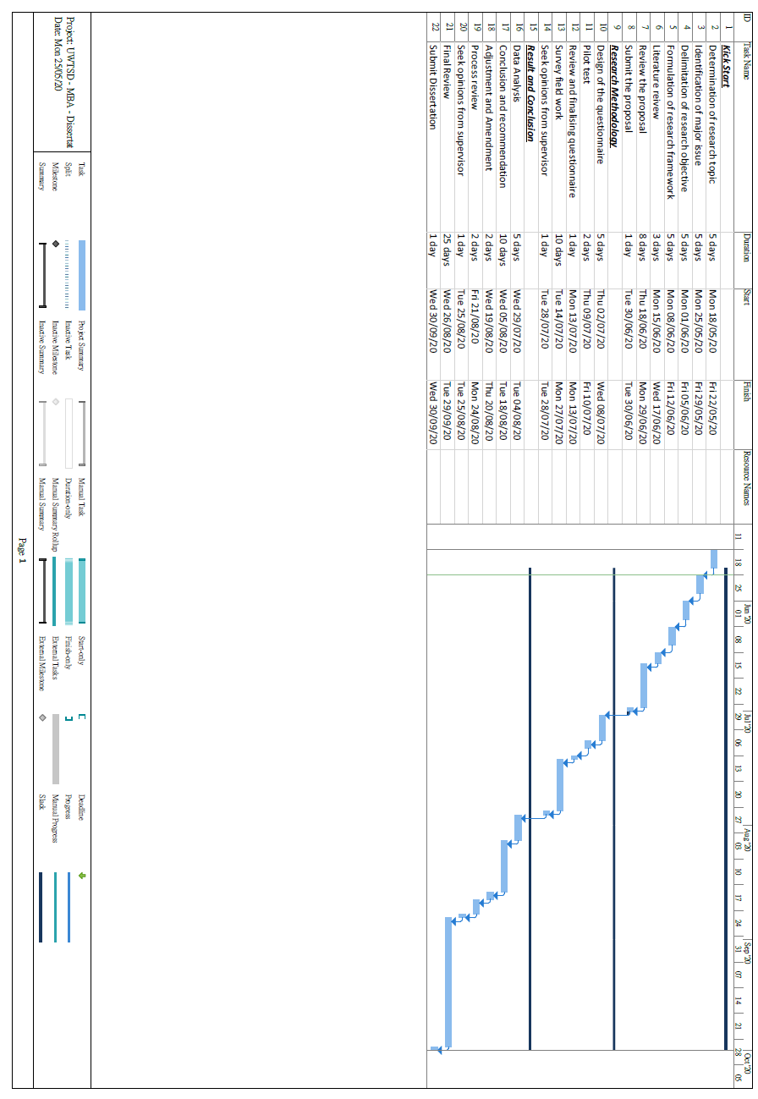

Appendix B: Questionnaire
Omni-Channel Customer Experience Survey:
Thank you for participating in this survey from University of Wales Trinity Saint David. It will take you about 10 minutes to finish the questionnaire. Through this survey, I am interested in investigating customer shopping experience in today’s Omni-channel era.
YOUR PARTICIPATION IS COMPLETELY VOLUNTARY. You are free not to participate or stop participation at any time before you submit your answers. If you have any questions about this survey, please contact Yip Ying Kei by email: yyipkei@gmail.com

Section A
1. Think and write down the retailer or brand you buy have purchased from:
__________________

2. Click the approach you are using during the shopping process (Select one only if you use it frequently)
- In-store
- On the computer
- On mobile devices (Smartphones, tablet, etc.)
- Others _______

Atmospheric experience of this retailer/brand (store atmosphere, web design, mobile apps design) | Strongly  Disagree | Disagree | Neutral | Agree | Strongly  Agree
1. They provide a comfortable environment that puts me in a better mood | 1 | 2 | 3 | 4 | 5
2. Their shopping environment is  visually appealing | 1 | 2 | 3 | 4 | 5
3. Their shopping environment  increase my duration | 1 | 2 | 3 | 4 | 5
4. Their shopping atmosphere  impresses me | 1 | 2 | 3 | 4 | 5

Communicative experience of this retailer/brand (advertising and promotion) | Strongly  Disagree | Disagree | Neutral | Agree | Strongly  Agree
1. I feel favourable toward their advertising and promotions | 1 | 2 | 3 | 4 | 5
2. They did an excellent job in advertising and promotions | 1 | 2 | 3 | 4 | 5
3. Their advertising and promotions are informative | 1 | 2 | 3 | 4 | 5
4. I react favourably to their advertising and promotions | 1 | 2 | 3 | 4 | 5

Product experience of this retailer/brand | Strongly  Disagree | Disagree | Neutral | Agree | Strongly  Agree
1. I'm satisfied with the quality of their products | 1 | 2 | 3 | 4 | 5
2. I'm satisfied with their product assortment | 1 | 2 | 3 | 4 | 5
3. According to what I pay, they provide me with good value | 1 | 2 | 3 | 4 | 5
4. Overall, I'm satisfied with the products I bought | 1 | 2 | 3 | 4 | 5

Technological experience of this retailer/brand | Strongly  Disagree | Disagree | Neutral | Agree | Strongly  Agree
1. Their technology makes shopping convenient | 1 | 2 | 3 | 4 | 5
2. They have technology that is  easy to use | 1 | 2 | 3 | 4 | 5
3. Their technologies are interactive | 1 | 2 | 3 | 4 | 5
4. Overall, I'm satisfied with the products I bought | 1 | 2 | 3 | 4 | 5

Process experience of this retailer/brand | Strongly  Disagree | Disagree | Neutral | Agree | Strongly  Agree
1. Their shopping platform is convenient | 1 | 2 | 3 | 4 | 5
2. I can easily find the information or products needed | 1 | 2 | 3 | 4 | 5
3. Their service processing (shipping/returning) is convenient | 1 | 2 | 3 | 4 | 5
4. Their service processing time (shipping/returning) is short | 1 | 2 | 3 | 4 | 5

Employee-customer experience of this retailer/brand | Strongly  Disagree | Disagree | Neutral | Agree | Strongly  Agree
1. Their employees understand my needs | 1 | 2 | 3 | 4 | 5
2. Their employees solve my needs efficiently | 1 | 2 | 3 | 4 | 5
3. Their employees put  themselves in the customers’ place | 1 | 2 | 3 | 4 | 5
4. Overall, their employees deliver excellent service | 1 | 2 | 3 | 4 | 5

Customer-customer experience of this retailer/brand | Strongly  Disagree | Disagree | Neutral | Agree | Strongly  Agree
1. Other customers’ opinion affected my opinion toward this retailer/brand | 1 | 2 | 3 | 4 | 5
2. I actively sought advice/reviews before shopping at this retailer/brand | 1 | 2 | 3 | 4 | 5
3. I observed where my friends were shopping before selecting this retailer/brand | 1 | 2 | 3 | 4 | 5
4. Other consumers positively review this retailer/brand | 1 | 2 | 3 | 4 | 5

General Omni-channel customer shopping experience | Strongly  Disagree | Disagree | Neutral | Agree | Strongly  Agree
1. I will use omnichannel shopping in the future | 1 | 2 | 3 | 4 | 5
2. I intend to make frequent use of omnichannel shopping in the future | 1 | 2 | 3 | 4 | 5
3. I prefer to recommend the shopping Omni-channel to the people around me | 1 | 2 | 3 | 4 | 5
4. Overall, my experience with Omni-channel shopping is excellent | 1 | 2 | 3 | 4 | 5

Section B
1. What is your gender?
Female () Male ()

2. What is your age?
18 – 24 years old () 25 – 34 years old () 35 – 50 years old ()
51 – 64 years old () >=65 years old ()

3. Education
Primary school or below ( ) Secondary school ( )
Post-secondary school / Associate Degree / Diploma ( )
Bachelor degree ( ) Master degree or above ( ) Other (please specify)____________

-End-

Appendix C: Individual Depth Interview

1.Individual depth interview

Two respondents were selected, aged 30 and aged 32 with in-depth knowledge and experience in the Omni-Channel industry. The purpose is to discuss some of the important factors related to questionnaire design of the influence of touchpoint elements in Omni-Channel. Details are as below.

Date: 1/08/2020
Venue: Taikoo City Plaza - Starbucks
For Cathy Cheung: from 16:00 to 16:20
For Tommy Wong: from 16:20 to 16:40

Detail Discussion:
- Which elements of customer experience touchpoints on Omni-Channel have a positive influence? And Why?
(Perceived value, Trust, Satisfaction or Commitment)
- Any comment on the Omni-Channel customer experience has a significant difference in customer behaviour?

Name | Gender | Age | Detailed Discussion
Cathy Cheung | Female | 35 | Cathy thought that Atmospheric and Product experience touchpoint of the retailer and brand are the most important for Omni-Channel customer experience since the comfortable environment that puts the customer in a better mood for purchase and explorer the product and the product assortment and quality also is the import factors to influence the shopping experience. Besides, Cathy thought that these experiences of a physical or online environment can have a huge impact on customer satisfaction and enhancing the customer experience ultimately increases sales.
Tommy Wong | Male | 33 | Tommy thought that the Communicative and Process experience touchpoint of the retailer and brand are the most important for Omni-Channel customer experience which differs from the first respondent opinion. Tommy mentioned that if the retailer did an excellent job in advertising and promotions such as informative advertising with a convenient shopping platform can improve customer experience and loyalty. Besides, Tommy said that one of the key elements of successful customer experience management is to personalize the brand communication. The brand can create personalization by using tools and relevant data to offer more relevant content such as email marketing to track customer data and patterns of behaviour.

Appendix D: Calculate the questionnaire sample size

Below calculation shows how to calculate the questionnaire sample size.
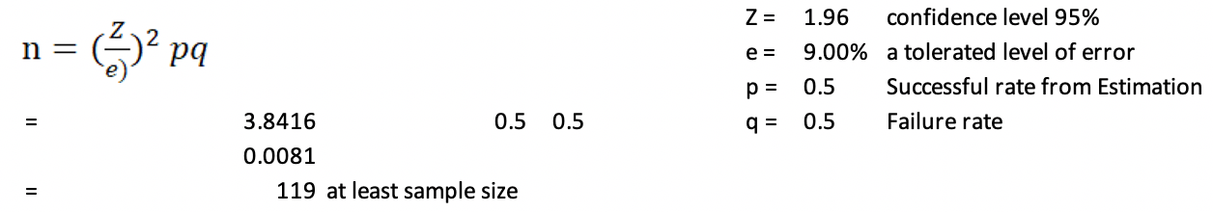

Appendix E: The highest and the lowest mean of each factor
Questions | N | Minimum | Maximum | Mean | Std. Deviation
3.1. They provide a comfortable environment that puts me in a better mood. | 203 | 1 | 5 | 3.82 | 0.772
3.2. Their shopping environment is visually appealing. | 203 | 1 | 5 | 3.86 | 0.734
3.3. Their shopping environment increases my duration. | 203 | 2 | 5 | 3.85 | 0.752
3.4. Their shopping atmosphere impressed me. | 203 | 2 | 5 | 3.94 | 0.661
4.1. I feel favourable toward their advertising and promotions. | 203 | 1 | 5 | 3.87 | 0.722
4.2. They did an excellent job in advertising and promotions. | 203 | 2 | 5 | 3.92 | 0.658
4.3. Their advertising and promotions are informative. | 203 | 2 | 5 | 3.90 | 0.697
4.4. I react favourably to their advertising and promotions. | 203 | 2 | 5 | 4.01 | 0.613
5.1. I'm satisfied with the quality of their products. | 203 | 1 | 5 | 3.96 | 0.692
5.2. I'm satisfied with their product assortment. | 203 | 2 | 5 | 3.99 | 0.641
5.3. According to what I pay, they provide me with good value. | 203 | 2 | 5 | 3.99 | 0.621
5.4. Overall, I'm satisfied with the products I bought. | 203 | 2 | 5 | 4.02 | 0.652
6.1. Their technology makes shopping convenient. | 203 | 1 | 5 | 3.95 | 0.619
6.2. They have technology that is easy to use. | 203 | 1 | 5 | 3.95 | 0.680
6.3. Their technologies are interactive. | 203 | 2 | 5 | 3.97 | 0.682
6.4. Overall, I'm satisfied with the products I bought. | 203 | 2 | 5 | 3.96 | 0.632
7.1. Their shopping platform is convenient. | 203 | 2 | 5 | 3.99 | 0.567
7.2. I can easily find the information or products needed. | 203 | 2 | 5 | 4.04 | 0.591
7.3. Their service processing (shipping/returning) is convenient. | 203 | 1 | 5 | 4.01 | 0.621
7.4. Their service processing time (shipping/returning) is short. | 203 | 1 | 5 | 4.00 | 0.656
8.1 Their employees understand my needs. | 203 | 2 | 5 | 3.67 | 0.748
8.2 Their employees solve my needs efficiently. | 203 | 1 | 5 | 3.73 | 0.789
8.3 Their employees put themselves in the customer's place. | 203 | 2 | 5 | 3.82 | 0.723
8.4 Overall, their employees deliver excellent service. | 203 | 2 | 5 | 3.85 | 0.697
9.1. Other customers opinion affected my opinion toward this retailer/brand. | 203 | 2 | 5 | 3.95 | 0.561
9.2. I actively sought advice/reviews before shopping at this retailer/brand. | 203 | 2 | 5 | 4.00 | 0.601
9.3 I observed where my friends were shopping before selecting this retailer/brand. | 203 | 2 | 5 | 3.83 | 0.686
9.4 Other consumers positively review this retailer/brand. | 203 | 2 | 5 | 3.94 | 0.630
10.1. I will use omnichannel shopping in the future. | 203 | 3 | 5 | 4.21 | 0.627
10.2. I intend to make frequent use of omnichannel shopping in the future. | 203 | 3 | 5 | 4.12 | 0.728
10.3. I prefer to recommend the shopping Omni-channel to the people around me. | 203 | 3 | 5 | 4.10 | 0.707
10.4. Overall, my experience with Omni-channel shopping is excellent. | 203 | 3 | 5 | 4.19 | 0.595
Valid N (listwise) | 203
Source: construct by writer

