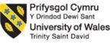

Student Name: Harsh Narendrakumar Barot
Student ID Number: 2025213931
Programme Name: Master of Business Administration
Module Name: Marketing Management
Module Code: LCMB7024
Module Teacher: Laila Maazouz and Taonga Kaonga Sobere-Snithers
Assignment Title: Brand Development Portfolio: Patagonia Renewed-From Outdoor Apparel to Activist Circular Commerce

PATAGONIA RENEWED: FROM OUTDOOR APPAREL TO ACTIVIST CIRCULAR COMMERCE

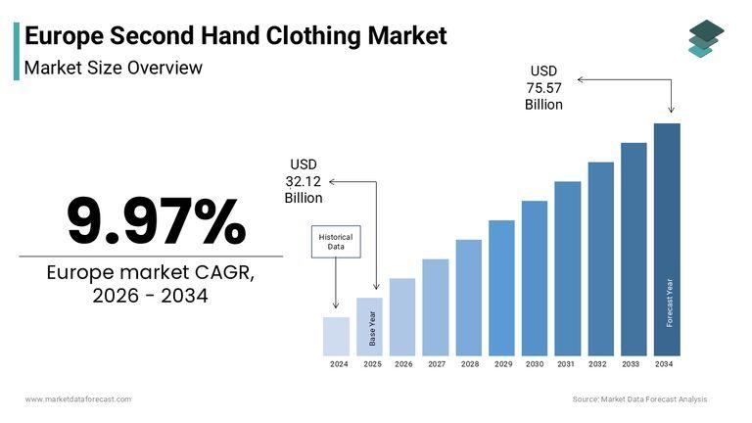 | 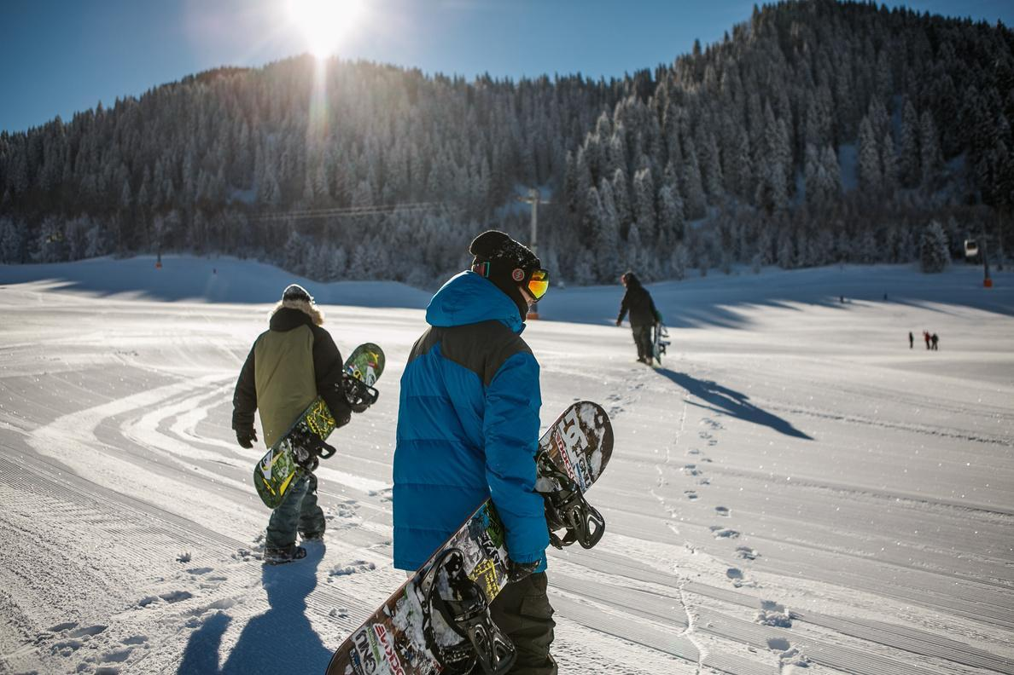  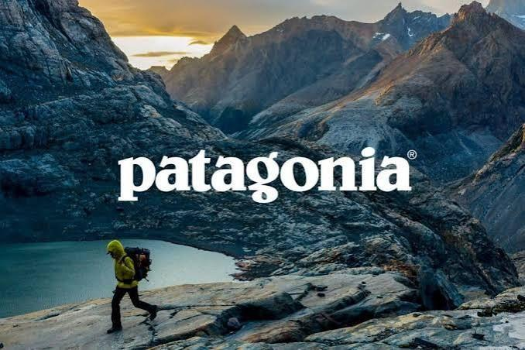  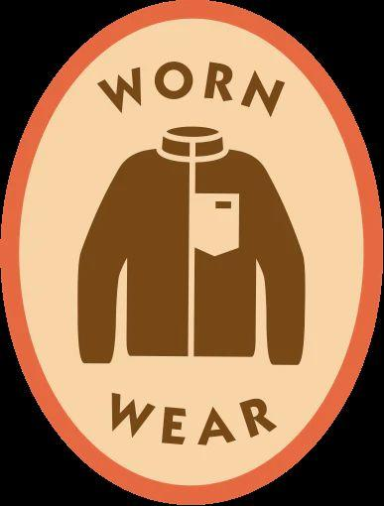  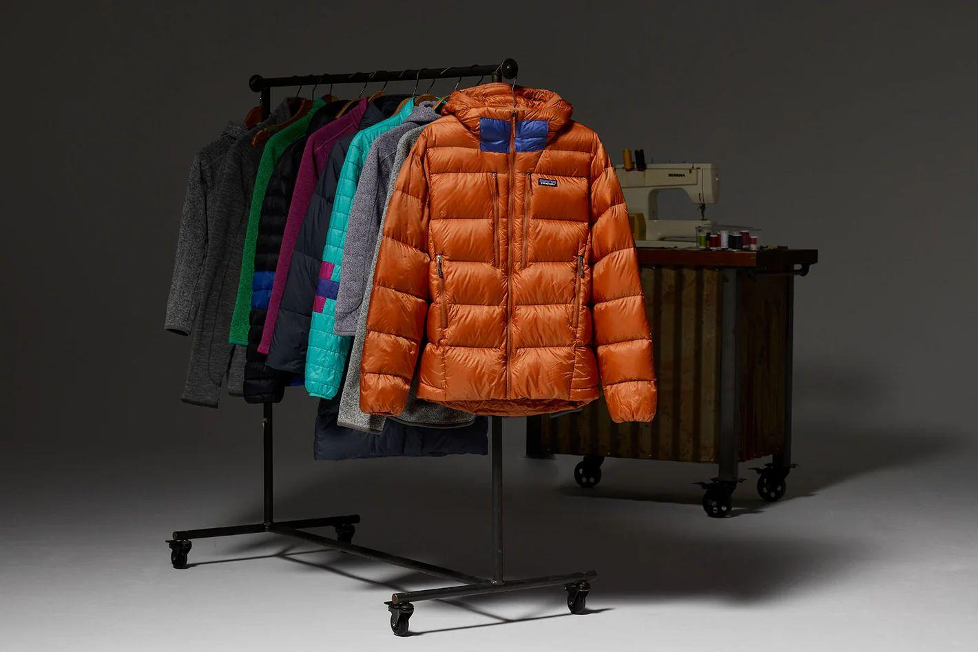  Figure: Europe Second-hand clothing market  Source: (Market Data Forecast, 2026)
  Company Introduction:
  Patagonia is a US-founded outdoor apparel company whose positioning has shifted over recent decades from a manufacturer of technical outdoor gear to what can be described as an activist company, embedding environmental campaigning into its core business identity (Patagonia, 2025). This is reflected in structural decisions such as the 2022 transfer of the company's ownership into a trust and non-profit structure so that profits not reinvested in the business fund climate and environmental causes.
  Sustainability Rationale and Purpose:
  Textile waste and short garment lifecycles remain a significant environmental burden, and a meaningful share of pre-owned Patagonia items are currently resold through unaffiliated peer-to-peer marketplaces rather than through the brand itself (Adams et al., 2025). Patagonia Renewed extends the brand's existing Worn Wear repair ecosystem into a full trade-in, refurbishment and resale e-commerce platform, allowing customers to exchange worn gear for store credit and buy refurbished, brand-authenticated items in return.
  Market Appeal:
  The growing popularity of second-hand and resale clothing is being driven by European and UK consumers, while stricter requirements for environmental marketing practices within the EU and UK have shifted the trend towards companies that are capable of proving their sustainability claims, instead of using unclear labels (Market Data Forecast, 2026). Patagonia Renewed capitalises on this trend, as it offers a brand-verified version of resold products at a reduced cost compared to new ones, yet maintains the high-end image of Patagonia.
  Sustainability Alignment:
  Patagonia Renewed acts on the corporate mission of doing business for solving the environmental problem by increasing the product lifespan, recovering lost resell value to outside entities, and strengthening its position as an activist brand via a circular service that generates income (Patagonia, 2025).
  Hiking in Patagonia
  Two new approaches to sustainable retail — Snowboarding in Hokkaido

References
Patagonia (2025a). Our Footprint. [online] Patagonia. Available at: https://www.patagonia.com/our-footprint/ [Accessed 13 July 2026a].
Adams, C., Alldredge, K. and Kohli, S. (2025). State of the Consumer 2024: What's Now and What's next. [online] McKinsey & Company. Available at: https://www.mckinsey.com/industries/consumer-packaged-goods/our-insights/state-of-consumer [Accessed 13 July 2026].
Market Data Forecast (2026). Europe Second Hand Clothing Market Report. [online] Market Data Forecast. Available at: https://www.marketdataforecast.com/market-reports/Europe-second-hand-clothing-market [Accessed 13 July 2026].
Patagonia (2025a). Patagonia® Returns and Repairs. [online] Patagonia.com. Available at: https://www.patagonia.com/returns.html [Accessed 13 July 2026a].



