
Research Proposal:The Impacts of social media on events.
Mrs. Sarah Louise Hillam P137987
HND Events Management
Submitted to Kathryn Flynn
University of Wales Trinity Saint David
Business School

Contents Page
- Introduction…………………………………………………………………………….. 3
- Aims and Objectives……………………………………………………………………4
- Background Research..………………………………………………………….........5
- Research Methodology………………………………………………………………..6
- Stragegy Chosen……………………………………………………………………....8
- Sampling Framework……………………………………………………………….…9
- Data Analysis Tools………………………………………………………………….10
- Research Ethics………………………………………………………………………11
- Resource Planning…………………………………………………………………...11
- Summary………………………………………………………………………………12
- References…………………………………………………………………………….13

1.0 Introduction
The chosen field of study for this research proposal, is going to be based on the impacts of Social Media and how it can affect events.
Whilst researching into impacts of social media at events, a variety of sources have been used such as websites, books and online journals which provide supporting evidence of the impacts of social media and how it can affect events, an article found online written by “Blair Potter” is all about social media and how it affects events, She says that, “social media is not a trend, it has fundamentaly shifted the way many people in society share their personal and proffessional lives”. Social media has also changed the way people live their lives and socialise, as many people post events on social media. Social media can benefit peoples lives as well as have significant impacts, such as events people attend as things may get posted on social media sites, that you may not want people to see, this can have a negative impact on a persons life. Often on these social media sites, there are close linked groups for an event and they are often posted on facebook so attendes can state if they are going to the event or not and upload pictures of the event and also checkin at the event, so people know where they are. The impact of people checking into an event online is that you don’t know who is watching your facebook profile and it has been proven from online articles and newspapers that people have been burgled whilst at an event, due to posting on social media that they are attending an event (Buono, 2013).

2.0 Aims and Objectives
The aims and objectives for this research proposal, are to find out from event attendees how they rate social media and how they think it affects events. I am going to conduct this research via questionnaires and online surveys through surveymonkey.com
The objectives are
- To analyse if attendees think social media affects events and if so how.
- To determine why social media has changed and do they think its for better or worse
- To analyse if attendees realise how much time social media takes up, whilst they are attending an event, this could be from posting on facebook or instagram or even just chatting on messenger to friends or family.

3.0 Background Research
Social media has become such a big part of everyday life and has increasingly become an everyday occurance for people all over the world to use on a daily basis. Social media is now the new trend on how people communicate with friends and family. The use of social media at events, has significantlly increased over the years, according to the “GWI Social report they interview over 550,000 people per year that are using social media whilst attending an event” These users are aged between 15 and 54 and are a general mix of male and female attendees (GWI, 2018). More than 1 billion people use social media sites such as Facebook so issues are bound to occur when attendees posting the events online for friends and family to see before, From events being posted online thus means that in this sense social media is a huge help towards events around the world but can also have impacts (Potter, 2017).

4.0 Research Methodology
Research methods is a combination of processes used to collect data such as questionnaires, interviews and online surveys for analysis and business purposes. Using a variation of methods called mixed methods will allow the researcher to gain more accurate information.
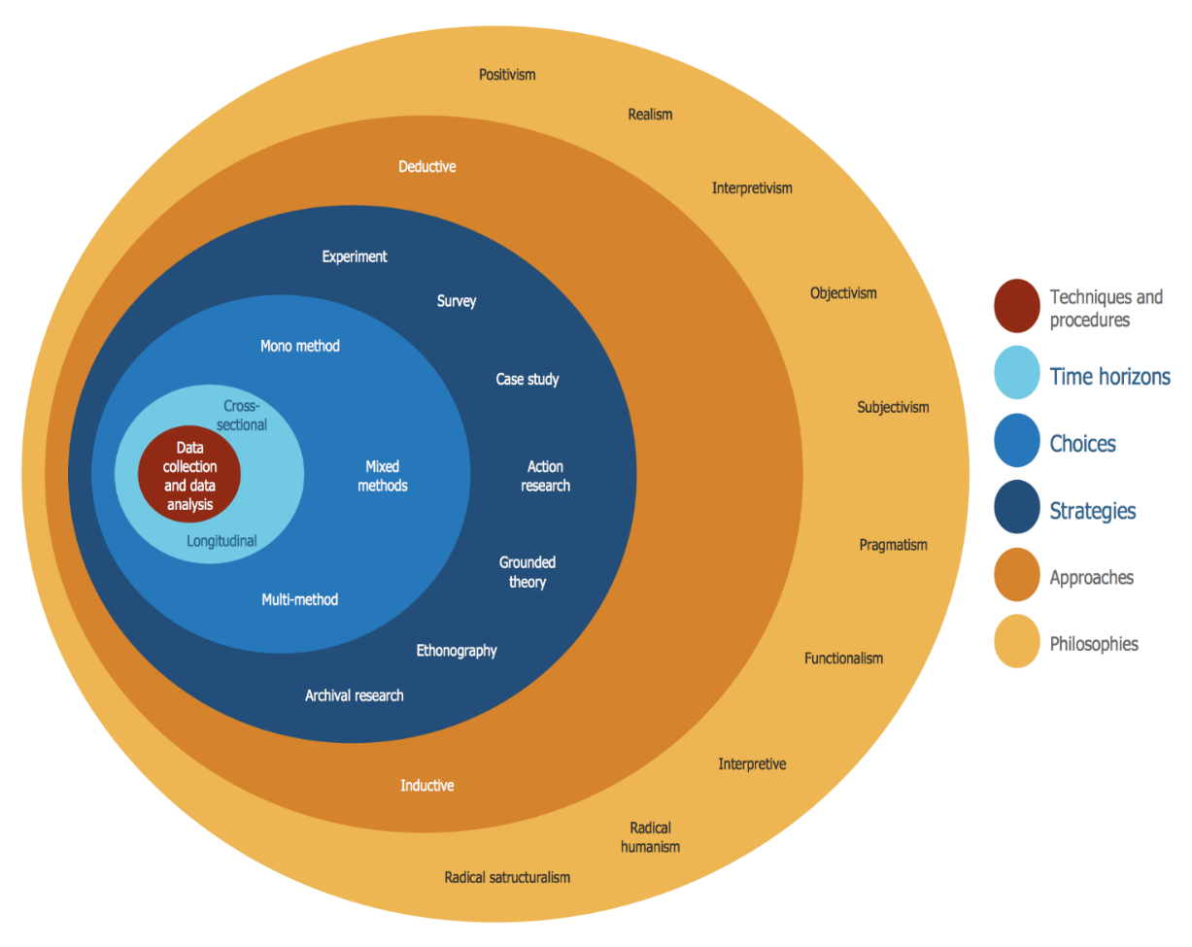
Figure 1 Onion research graph (Images, 2018).
For primary research I am going to be conducting interviews with attendees on a one to one basis at local events and also handing out questionnaires to attendees who don’t want to stand around and chat, the researcher will also be conducting surveys through surveymonkey.com. the researcher will also be using secondary research methods such as government departments and organisational records for data analysis.
By using qualitive and quantitive research methods as well as primary and secondary their will be more indepth detailed results from the interviews, questionnaires and also surveys. “According to Crotty, research methodology is a comprehensive strategy ‘that silhouettes our choice and use of specific methods relating them to the anticipated outcomes, but the choice of research methodology is based upon the type and features of the research problem” Qualiative research can also be unreliable at times as people may answer questions in a bias way.
5.0 Stratagy Chosen
The researcher has chosen to do questionnaires and interviews and surveys, this is called mixed methods, This involves both collecting and analysing the data that has been collected from the interviews and questionnaires and surveys. The questionnaires will be handed out to approximatly 300 people attending various events and they will aim to find out what attendees think about people using social media and the impact it has on events.
By using the research onion which was developed by “Saunders et al. (2007)”, it will illustrate the stages that must be covered while developing a research strategy, each layer of the onion describes in more detail each stage of the research procesess. The research onion provides a more effective way of progress through which a research methodology can be used in various contexts (Bryman, 2012) (Lewis, 2007).
By using questionnaires at the event this will give more reliable results as the researcher will be using open questions and will include questions regarding demographics, such as age, location etc, and the main question been social media and the impact it has on events. The questionnaire will be made using spss software as it is a quick and efficent way to make a questionnaire and this can be sent to people via facebook and handed out to attendees at the event. The online survey will include roughly the same questions but is designed for users who did not want to complete a questionnaire at the event, the survey will be done via surveymonkey.com.
The interviews will be structured and generalised and will be asking the same questions to get the same answers for the data analysis purposes. By using interviews it wil be more likely to gain the truth from the questions so this will be the most positivist way to collect the data, it will also be easier to compare the patterns and trends.
By using these mixed methods of collecting data the hypotesis can be explored in great detail and the results that are collected are going to be more reliable than just conducting questionnaires and surveys (Feilzer, 2010).

6.0 Sampling Framework
For this part of the research for this proposal, the researcher will conduct sampling framework on friends and relatives where they will interview around 20 people so many and hand the rest questionnaires or ask them to complete a survey online, by completing a sampling framework this they know the questions will be answered to a high standard. As the questions asked wont have any impact on their lives their will be no need for a larger sampling to be done. As for the questionnaires, their will be around 300 questionnaires handed out to event attendees, they will aim to find out what attendees think about people using social media and the impact it has on events.

7.0 Data Analysis Tools
The researcher will use spss and excel to gather all the data from the questionnaires and then use metrix tables for the interviews. The researcher will use excell to place the data into then use create bar charts and graphs to make it easier for presentation purposes. All the interviews will be typed up by the researcher to have a hard copy to make reviewing easier and make it easier to find a pattern within the answers given, as well as having the tape recordings.

8.0 Research Ethics
Banister et al (1994) says that “ethical concerns must be part of the fundamental design of any research project, and ideally any proposed research”. The research methods should not cause embarrassment to anyone involved and all interviewees will be asked for their consent, this includes telling them the aims of the research, and how and why they were selected and what will happen to their results. The researcher will then offer confidentiallity to all participants to protect them from any issues in the future.

8.1 Resource Planning

The viability will be all about the consistency of the results from the interviews, questionnaires and surveys.

To be able to complete the task in an effective way, many different resources will be used to complete this task, the researcher will use google scholor, university library, online library, online journals and various books. To enhance the research, the researcher will need to aquire the following items to be able to effectivly complete the research at home, they will require a laptop at home and access to a printer, facebook and surveymonkey.com. the Gantt chart below is to show the tasks for each month, to be able to complete this research proposal.

x. x. x. x x. x x x. x x x. xx x x x x x. x x. x. x x. xx x. x x x

9.0 Summary
From the research undertaken to complete this research proposal, there have been many articles,books,websites and journals to find information on the impact of social media and events, it has been determined that social media can affect events in different ways such as, people using social media too much at events, there has also been reports of problems with attendees getting burgled due to posting images and status updates on social media, these can have serious effects on the people attending the event. As for the impact social media has on events, it can have positive and negative effects depending on the event type and location, but overall social media has mostly positive impact on events, as a lot of attendees share the event so this attracts people to look at the event online and possibly purchase tickets to attend. Since facebook started and they introduced the ability to be able to share media through their social media site, ticket sales for events have increased by 5% which is a sigificant boost to the events industry.

References
Allen, A. B. A. T., 2011. Education Research Methods. 3rd ed. London: Pearson.
Bell, A. B. a. E., 2012. Research Methods. In: Business Research Methods. London: s.n.
Bryman, A., 2012. Social Research Methods. 5th ed. ed. London: Oxford University.
Buono, S., 2013. The affects of social media on attendees. THE AFFECTS OF SOCIAL MEDIA ON ATTENDEES' EXPECTATIONS AND PEERCEPTIONS OF EVENTS.
Feilzer, M., 2010. Doing mixed methods of research. London: Pearson.
Goddard, S. M. a. W., 2004. Research Methods An Introduction. 2nd ed. Oxford London: Blackwell Publishing.
GWI, 2018. Social Media Trend Report 2018. GWI Social .
Images, G., 2018. Research Onion. [Online]
Available at: https://www.google.com/search?q=research+onion+diagram&client=firefox-b&tbm=isch&source=iu&ictx=1&fir=oyl5Y8FX3G3GcM%253A%252CCXtrXZr8Rsa_HM%252C_&usg=__ls1WLVclZCmqGbIWCiXtC8Y48E0%3D&sa=X&ved=0ahUKEwjdhontoqncAhXPVsAKHU3xAdUQ9QEILTAC#imgrc=oyl5Y8FX3G3GcM
[Accessed 18th July 2018].
Jamshed, S., 2017. Qualative Research Methods. [Online]
Available at: https://www.ncbi.nlm.nih.gov/pmc/articles/PMC4194943/
[Accessed 18th July 2018].
Lewis, M. S. a. P., 2007. Research Methods For Business Students. 6th ed. ed. London: Pearson.
Potter, B., 2017. The impacts of social media on events. [Online]
Available at: https://www.mpiweb.org/blog/article/the-impact-of-social-media-on-meeting-design-event-marketing
[Accessed 18th July 2018].
Tashakkori, C. T. a. A., 2011. Qualitative Research. In: The SAGE Handbook of Qualitative Research. London: Sage Publications.

