

Crossrail's Tourism Impacts

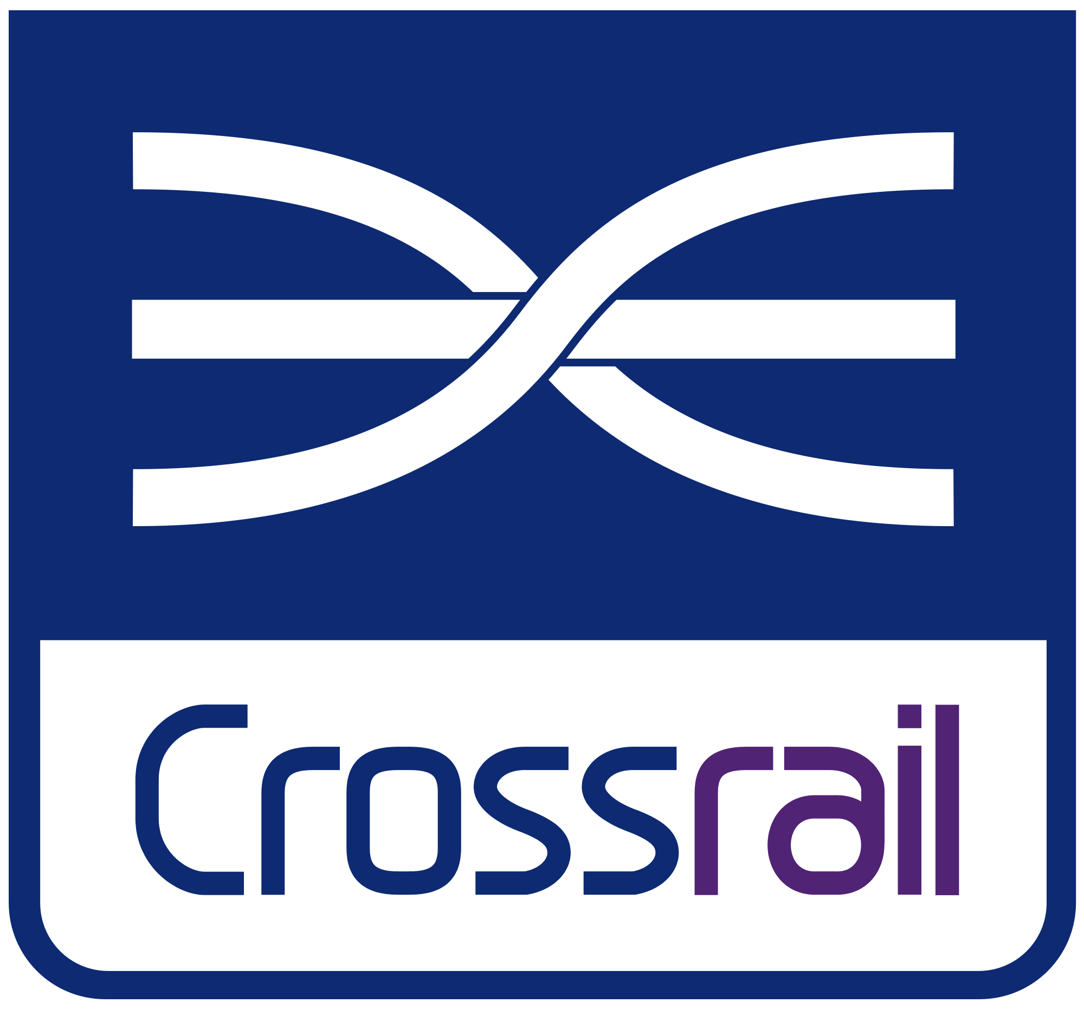

Rhian Cook
1703979

Contents
Introduction 2
The Current Travel and Tourism Sector in London 2
The relationship between Crossrail and tourism 2
Economic Impact 3
SWOT Analysis 4
Porter’s five forces model – Crossrail 5
The Impact of Crossrail on British Airways 6
Conclusion 7
Reference list and bibliography 8

Introduction
Crossrail is Europe’s’ biggest ever engineering project at a cost of £14.8 billion; the new suburban rail service will be fully functional by 2019 and will link Reading to Heathrow and through Central London to Essex. London’s new rail service will link up 40 stations with 21 boroughs, reduce journey times, and reduce congestion on other transport services increasing transport capacity by 10% (Crossrail, 2017).
This report will assess the likely impact that Crossrail will have on the growing travel and tourism industry in London and the effect Crossrail will have on aviation leaders British Airways.

The Current Travel and Tourism Sector in London
“Since 2010 tourism has been the fastest growing sector in the UK in employment terms. Britain is forecast to have a tourism industry worth over £257 billion by 2025” (Visit Britain, 2013).
The travel and tourism market in the UK is growing each year with domestic tourists and inbound tourists coming from around the World. London is the most visited City in the UK by inbound tourists accounting for 53% of visitor spend (Visit Britain, 2017) so the travel and tourism industry in the Capital is vital to the economy of the UK to generate money and to create jobs for a growing population.
Tourism directly and indirectly supported 11.9% of total employment in the UK in 2016 (UNWTO 2017 Annual Research: Key Facts, 2017) it is essential strategic planning is created for transport for tourists to be able to use which will then support employment through tourism.
According to J.Diamond, “Social costs of encouraging mass tourism result from the congestion caused in favoured locations that diminishes their overall attraction. (J.Diamond, 1977). Crossrail will provide 10% more transport capacity for London for both commuters and tourists; taking congestion from existing routes. Transport links to tourist attractions in areas such as the West End, Stratford and Bond Street would potentially see an increase in visitor numbers because of the increased transport capacity that will make it more attractive to the tourists both inbound and domestic that may have avoided those areas pre Crossrail because of the overcrowding of public transport. Crossrail will not only be a rail service but stations will each be unique and offer property and retail opportunities which is needed in London to accommodate residents and tourists.

The relationship between Crossrail and tourism
“Transport is an integral part of much recreational behaviour, both as an aid to access to recreational opportunities, and as a recreational activity in its own right” (Halsall, 1982).
As Halsall explains transport is integral to transporting tourists to leisure activities – with Crossrail travelling through Central London with the Liverpool Street Station and tourism hotspots New Bond Street, Stratford and The West End it is facilitating this need.
Bond Street will have 24 trains an hour running in each direction and 150,000 to 220,000 daily passenger exiting into The West End (Hobbs, 2015). The increase of tourists that will be able to shop and attend theatre shows and participate in other leisure activities in the West End area will grow because of Crossrail and the likely impact will be an increase in profits for the businesses that operate there.
A negative point to consider is that the West End at peak times is extremely busy as is Westfield’s shopping centre in the East End serviced by Stratford station and Bond Street. Crowd control will have to come into consideration; Tourists and Londoners safety is paramount and the tourist experience needs to be protected to keep the growth within London and the UK.
As Halsall also mentions transport is a recreational activity in its own right; with Crossrail being Europe’s biggest engineering project in history this could attract a new audience of transport tourists and those with an interest in engineering which would be beneficial for London as it would increase tourism through a niche market.
The Elizabeth line will reduce journey times from Heathrow Airport to Canary Wharf by 11 minutes (Griffin, 2017). This particular route will likely affect the amount of international business tourism that will come into business district Canary Wharf as it makes it more accessible and the direct route will be easier for visitors to London from Heathrow airport; Heathrow airport could potentially see a growth in passenger arrivals compared to other London airports because of the Elizabeth line.
The impacts of Crossrail are wider than faster commuting and reduced fares as Emily Gosling explains, “Crossrail isn't entirely blind to beauty, it seems. Last night, it unveiled plans for a line-wide arts programme, The Culture Line, which will see the eight central Crossrail stations partner with eight London art galleries to create a series of large-scale artworks when the line opens in 2018.” (Design Week, 2013). This initiative will encourage tourists to use the Elizabeth Line to visit art galleries and will expose the galleries, which will financially benefit them and increase visitor numbers. A report by London and Partners revealed 39% of leisure visitors identified London’s cultural experience as the main driver for their visit to the capital (London’s Cultural Tourists,n.d) so the demand from tourists for arts and culture attractions is prominent and the stop offs will give this tourism market opportunity to expand and improve London’s overall tourism product.

Economic Impact
According to a report produced by City of London Crossrail is predicted to have huge financial impacts on the UK economy “Crossrail is predicted to bring £42bn additional GDP for the UK Economy” (City of London Economic Research, 2015). The additional money that will go into the UK Economy will likely benefit public services and improve infrastructure as well as using profit to improve the transport service in London on projects like Crossrail 2. For tourism, this means a better overall destination experience; if transport in London remains overcrowded, it will deter tourists from using public transport which is not favourable to the Mayors transport strategy.

SWOT Analysis
Strengths | Weaknesses
- Improving accessibility in London  - Decreasing journey times/ the need to change trains  - Reducing congestion on London’s roads  - 10% increase on London’s transport capacity. Taking the strain from the existing tube stations which are heavily used by tourists and commuters  - Retail and property investment in Crossrail stations  - Pushing the price of housing up – Positive for property investors and landlords  - Linking Heathrow Airport to London City Centre in quicker time than it currently takes  - Improving infrastructure around Crossrail stations  - Creating more housing in a demanding market  - Cheaper transport fares  - Better transport for tourists  - Creating more employment opportunities  - Reduce in pollution on roads in London if less cars will be on the road  - Improved infrastructure | - Taking business from private London transport providers eg. Taxi drivers  - The increasing rent prices will possibly displace people  - Outpricing the working class in London when it relies on minimum wage workers highly especially in the hospitality sector, which could leave companies struggling to get a workforce  - Overcrowding in tourist areas that experience overcrowding already e.g. Liverpool Street, The West End, Stratford.
Opportunities | Threats
- Attractive for foreign investment  - Able to accommodate more tourists  - Money spent on transport fares to be invested back into improving travel infrastructure  - Crossrail 2 increasing the transport capacity further running from Surrey to Hertfordshire  - Improving the tourist experience through quicker and cheaper transport  - More flights into London Heathrow from International tourists and business tourists that can reach business districts and central London quicker  - Transport tourists and tourists with an interest in Engineering  - “Europe’s biggest engineering challenge” attracting attention throughout Europe as well as the UK spotlighting the City and possibly drawing in tourism | - London loses its identity. Quirky areas such as Soho will become more commercialised and for the high earners. Part of London’s appeal is the diverse boroughs that attract tourism  - Government will have to spend more in housing subsidies for the working class in London who will not be able to afford rent with wages alone in areas that have become more expensive because of Crossrail  - Increasing terrorism threat – more infrastructure means more targets for terrorism cells  - Protests by industry workers who are losing revenue e.g. London cab drivers  - Underestimate on the amount of use the Elizabeth line is going to see

Conducting the above SWOT analysis shows it is evident that Crossrail has more pros than cons and is likely to benefit the tourism industry in London. Considerations for the public and private sectors that operate in the London tourism industry would be keeping affordable housing for low earners who keep the tourism and hospitality industry in London running as without man power or a lack of workers with the relevant skills will negatively impact the tourists experience.
Positive impacts of Crossrail will include the ease on congestion on other transport services, cheaper fares, and quicker journey times and in particular, for tourists the direct link from Heathrow Airport into the Heart of London.

Porter’s five forces model – Crossrail

  - Rivalry amongst existing competitors
The threat of rivalry among existing competitors is not a going concern for Crossrail as it is managed by Transport for London. TFL will be operating Crossrail along with the Underground, Buses, Cycling, The Emirates Cable Car and more delivering the Mayor Sadiq Khan’s Transport Strategy (Transport for London, 2017). Competition is virtually nonexistent in London transportation as it is run by TFL, companies have contracts with them and the rail lines and buses are franchised so there is no way of rival competitors entering the market.

The main rival for Crossrail from Heathrow is the Heathrow Express service, which costs much more than Crossrail but the journey time is less. The Heathrow Express has already started a marketing campaign to try to maintain their place in the market claiming Crossrail will be overcrowded, have no on board staff and commuters will not get a toilet or newspaper (Lea, 2017).

TFL maintain a loyal database of customers because commuters and tourists have to use the systems they operate to move around the City – TFL work hard to keep costs to a reasonable amount and put money back into developing infrastructure.

  - Threat of new entrants
The barriers to entry would be incredibly difficult for any company to undertake a project similar to Crossrail as the costs would be monumental. As TFL are the integrated transport operators in London the market is not open to all investors it would have to be done through TFL and their franchising schemes.
  - Bargaining power of buyers
31 million journey stages per day is the average that TFL undertake in the Capital (Newsome, 2017). As TFL and its stakeholders, operate most journeys there is not a leading competitor to compare this too or analyse differences.
The prices of journeys are determined and subsidised by TFL. Visitor oyster cards are a good resource for tourists and encourage them to use public transport; Crossrail will be included in the Oyster card system. Tourists receive offers for restaurants and attractions through using the visitor oyster card also the scheme encourages tourists to venture outside of London offering VIP cards for outlets like Bicester Village Shopping Outlet (Visitor Oyster Card Discounts, 2017). This is good for tourism outside of Central London, provides the tourist with a better experience and will encourage tourists to use Crossrail and other public transport.
Crossrail will not only reduce journey times but also make them more cost effective for the consumer. Just 31% percent of people knew that their journey on Crossrail would be cheaper (Hobbs, 2015). This could see a shift from consumers using the tube, taxi’s and buses etc. as it would save time on the majority of journeys and money - a threat to only to transport providers such as taxi’s and minicabs who could lose out on fares with the encouragement from Mayor Sadiq Khan to get cars off London’s roads. Alternatively, the new Elizabeth line could be very busy and existing public transport could remain congested as Crossrail will simply accommodate the extra people and tourists coming into London so no transport provider will see a loss in revenue.
  - Threat of substitute products
The cost of Crossrail has amounted to £14.3 billion (Thomas, 2017). The funding has come from a range of sources such as private investment, transport fares, government subsidy and borrowing (Transport for London, 2017). The Elizabeth line will have to be successful to make this investment worthwhile – if the line fails, substitute transport could start to increase to facilitate the transport needs of London.
  - Bargaining power of suppliers
As previously mentioned approximately 31m journeys per day are run by TFL making it the biggest transport operator in the Capital. It’s suppliers range across the network – companies such as UBER are regulated by TFL although they are privately owned; there operating in London is currently halted pending review following TFL’s decision to remove there operating license for fear of passenger safety not being adhered too (Evening Standard, 2017). Loosing UBER will be a loss to London because of the loss of a big transport courier; it will however encourage more consumers to use public transport, which will be positive for the Elizabeth line.
Crossrail is a unique service for London as no other line has ever been this big or been able to facilitate so many vital tourism and commuting stops on one rail line.

The Impact of Crossrail on British Airways
British Airways operate frequent flights inbound and outbound at Heathrow airport so it is unsurprising that boss Willie Walsh has been pro Crossrail; However under the condition that the Elizabeth Line serves all Heathrow terminals by 2019 which has been agreed (Gerrard, 2017).

The aviation leader should see a rise in international business travel with Canary Wharf journey times reduced by 11 minutes. Research by London Excel published figures saying business tourists and conference and events attendees will be able to get to the Excel center from Heathrow in 45 minutes and Canary Wharf from the Excel center in 3 minutes. From the Excel it is 10 minutes to Liverpool Street station in Central London from the Excel via the Elizabeth line enhancing business travel as it will be easier for business tourists to access central London and it’s attractions during leisure time (Look what’s coming down the track…, 2017).

Currently business travel to London makes up 21.4% percent of reasons to visit (London Tourism Vision, 2017) making business tourists a substantial market already but one that has room to increase. British Airways has been a firm favorite amongst business travelers so it is likely Crossrail will have a positive financial impact on the firm.

Tourists flying into Heathrow can expect to reach the City of London via Crossrail in 35 minutes as opposed to the current 55 minutes which will be the quickest way of getting to the heart of London from Heathrow so it would be expected tourists will utilise the service because it is both convenient and cost effective.
British Airways currently operate in London City airport, which is located in East London but cannot receive international flights through lack of facilities. “London City has won the affection of business travelers because of its proximity to Canary Wharf and the City of London compared to Heathrow and Gatwick airports. Almost two-thirds of London City’s passengers are business travelers.” (ft.com, 2017). Crossrail could be construed as a threat to London City Airport as they can now directly connect passengers to Canary Wharf. British Airways operate 40% of flights at London City Airport so if travelers become more inclined to use Heathrow because of Crossrail the airline should not see any drop in profit. What they lose at London City they should gain at Heathrow creating a balance; the threat to British Airways will be airlines that operate at London airports who offer more competitive pricing rather than a loss of custom through Crossrail.

Conclusion
Overall, it could be suggested that Crossrail will influence British Airways and London positively as it is facilitating more tourists and creating better infrastructure making London more attractive as a destination. British Airways target market is largely business travel; the linking up of the financial and business districts in London on Crossrail will merge well with the customers British Airways targets. As London continues to grow BA are likely to see an increase in profits while London will see an increase in visitor numbers.

Reference list and bibliography

- TOURISM : JOBS AND GROWTH
VisitBritain. (2013). Tourism: Jobs and growth. [online]
Available at: https://www.visitbritain.org/visitor-economy-facts [Accessed 18 Nov. 2017].

- BRITAIN'S VISITOR ECONOMY FACTS
VisitBritain. (2017). Britain's visitor economy facts. [online]
Available at: https://www.visitbritain.org/visitor-economy-facts [Accessed 18 Nov. 2017].

- HOBBS, H. D.
Hobbs, H. (2015). Crossrail visitor impact study, p.4.

- RELATIONSHIP BETWEEN TRANSPORT, RECREATION AND TOURISM
Geography Notes. (2017). Relationship between Transport, Recreation and Tourism. [online]
Available at: http://www.geographynotes.com/essay/relationship-between-transport-recreation-and-tourism/235 [Accessed 18 Nov. 2017].

- NEWSOME, S.
Transport for London
Newsome, S. (2017). Transport for London.

- Tourism's Role in Economic Development: The Case Re-examined
Author(s): J. Diamond
Source: Economic Development and Cultural Change, Vol. 25, No. 3 (Apr., 1977), pp. 539-553
Published by: The University of Chicago Press
Stable URL: http://www.jstor.org/stable/1152656
Accessed: 21-11-2017 21:18 UTC

- A WORLD-CLASS NEW RAILWAY FOR LONDON AND THE SOUTH EAST
Crossrail. (2017). A world-class new railway for London and the south east. [online]
Available at: http://www.crossrail.co.uk/route/ [Accessed 21 Nov. 2017].

- 2017 ANNUAL RESEARCH: KEY FACTS
2017 Annual Research: Key Facts. (2017). Travel and Tourism Economic Impact 2017 United Kingdom, [online] p.5.
Available at: https://www.wttc.org/-/media/files/reports/economic-impact-research/countries-2017/unitedkingdom2017.pdf [Accessed 21 Nov. 2017].

- GRIFFIN, P.
Moving London Forward
Griffin, P. (2017). Moving London Forward.

- Gosling, E 2013, 'Crossrail unveils The Culture Line', Design Week (Online Edition), p. 3, Hospitality & Tourism Complete, EBSCOhost, viewed 22 November 2017

- THE IMPACT OF CROSSRAIL ON LONDON'S ECONOMY
City of London Economic Research. (2015).
The impact of Crossrail on London's economy. [online] Available at: http://colresearch.typepad.com/colresearch/2015/05/the-impact-of-crossrail-on-londons-economy.html [Accessed 22 Nov. 2017].

- LONDON'S CULTURAL TOURISTS
London's Cultural Tourists. (n.d.). [E-book]
London: London and Partners, p.4. Available at: http://files.londonandpartners.com/l-and-p/assets/our-insight-londons-cultural-tourists.pdf [Accessed 22 Nov. 2017].

- WHAT WE DO
Transport for London. (2017). What we do. [online]
Available at: https://tfl.gov.uk/corporate/about-tfl/what-we-do [Accessed 22 Nov. 2017].

- VISITOR OYSTER CARD DISCOUNTS
(Visitor Oyster Card Discounts, 2017)
Visitor Oyster Card Discounts. (2017). .

- THOMAS, N.
Going underground on Crossrail: A 40-year project is taking shape
Thomas, N. (2017). Going underground on Crossrail: A 40-year project is taking shape. The Telegraph. [online]
Available at: http://www.telegraph.co.uk/finance/newsbysector/transport/10254467/Going-underground-on-Crossrail-A-40-year-project-is-taking-shape.html [Accessed 22 Nov. 2017].

- THIS IS HOW MUCH LONGER YOU'LL BE ABLE TO USE UBER FOR IN LONDON
Evening Standard. (2017). This is how much longer you'll be able to use Uber for in London. [online] Available at: https://www.standard.co.uk/news/london/uber-stripped-of-licence-how-did-it-happen-and-how-long-do-londoners-have-left-to-use-the-app-a3641171.html [Accessed 22 Nov. 2017].

- GERRARD, B.
Heathrow's tweaked expansion plans could mean airlines avoid huge rise in charges
Gerrard, B. (2017). Heathrow's tweaked expansion plans could mean airlines avoid huge rise in charges. [online] The Telegraph.
Available at: http://www.telegraph.co.uk/business/2017/07/27/heathrows-tweaked-expansion-plans-could-mean-airlines-avoid/ [Accessed 22 Nov. 2017].

- LONDON TOURISM VISION
London Tourism Vision. (2017). London: London & Partners, p.9.

- LOOK WHAT’S COMING DOWN THE TRACK…
Look what’s coming down the track…. (2017). [ebook] London: Excel London, p.3.
Available at: https://www.excel.london/uploads/crossrail-pdf.pdf [Accessed 22 Nov. 2017].

- LEA, R.
Heathrow Express wastes no time in fighting Crossrail
Lea, R. (2017). Heathrow Express wastes no time in fighting Crossrail. [online] Thetimes.co.uk. Available at: https://www.thetimes.co.uk/article/heathrow-express-wastes-no-time-in-fighting-crossrail-3f7d3gd7lfb [Accessed 22 Nov. 2017].

- BRITISH AIRWAYS THREATENS TO PULL PASSENGER JETS AT LONDON CITY AIRPORT
Ft.com. (2017). British Airways threatens to pull passenger jets at London City airport. [online] Available at: https://www.ft.com/content/7ea08abc-c9b1-11e5-a8ef-ea66e967dd44 [Accessed 22 Nov. 2017].

- HOW WE ARE FUNDED
Transport for London. (2017). How we are funded. [online]
Available at: https://tfl.gov.uk/corporate/about-tfl/how-we-work/how-we-are-funded [Accessed 23 Nov. 2017].

- Crossrail Image: https://londontopia.net/travel/future-tube-ten-interesting-facts-figures-crossrail-londons-newest-tube-line/

