University of Wales Trinity St David Swansea
Student name: Chahir Bentrad
Student ID: 2223851
Module: Introduction to the Web and Database Concepts
Module code: (ACCA4023)
Lecturer: Divya

Design and Implementation of a Database System for the EcoRide Electric Bike Rental

Table of Contents
1. Introduction 3
2. Overview and Purpose of the Scenario 3
3. Task 1: Implementation Guide 4
3.1 Scenario Analysis 4
3.3 Entity - Relationship Diagram (ERD) Description 7
3.4 Data Structure Development 8
3.5 Normalization to Third Normal Form (3NF) 9
4. Sample Data Population 9
5. The Development and Demonstration of Queries 9
6. Validation and Testing 10
7. Design Decisions, Problems and Future Enhancements 10
8. Conclusion 10
References 12
Appendix 14

1. Introduction
The EcoRide electric bikes rental program is a green transport program that seeks to encourage healthy and environmental friendly ways of commuting. With the service spread to parks, railway stations, and college campuses, the efficiency of the operation will be a key factor. At present, EcoRide uses paper-based documents and spreadsheets to operate rider registration, bike availability, and rentals, as well as maintenance (Dunga et al., 2023). Such a manual process causes data discrepancies, low visibility, duplication of bookings and failure to analyse system usage. This report outlines the application of a relational database system implementation and design of relational database system to deal with these problems. The solution proposed is much more accurate, has data integrity, is easy to query, and gives the management practical information about operations, trends of usage, and maintenance needs.

2. Overview and Purpose of the Scenario
EcoRide is an electric bike rental project that is a sustainable urban mobility program aimed at promoting clean, affordable, and healthy ways of transportation to the local population. The system allows registered riders to hire electric bicycles in the specific EcoRide stations that are found in communal places like university campuses, parks and rail stations. At a point of getting a bike, riders scan an identification card, and a bike is released to them. After the journey he can drop the bike at any of the eco rides stations which are situated all around the region, giving flexibility and convenience (Bennett et al., 2022). All the electric bikes in the EcoRide fleet are subject to regular maintenance, servicing, and periodic repairs by trained employees. These services are necessary all to keep the riders safe, increase lifetime of the bikes, and keep the services reliable. But the current operational strategy is based on the use of paper-based forms and separate spreadsheets to capture riders information, hire transactions and service works. This disjointed approach to handling data ends up causing delays, human error, data duplication and lack of real time visibility of the operations (Dunga et al., 2023).
The lack of a combined digital platform produces several efficiency problems in operation. Employees are not able to quickly know what bikes are free, under rent, and those in service. Due to this, the system tends to record cases of double booking, wrong availability reporting and problems of tracking unreturned bikes. Moreover, management cannot create appropriate summaries, performance reports, or analytics about using the data, restricting the process of making evidence-based decisions and planning over the long term (Binatti et al., 2022).
To overcome these obstacles, a structured relational database is suggested. This database system aims to have all data related to the operations of the organization centralized, consistent and reliable into a single platform. Table 1 presents the major goals of the database solution.
Table 1: Purpose of the EcoRide Database System
Objective | Explanation
Digital data management | Replace manual records with a centralized digital database
Data accuracy | Prevent duplicate, inconsistent, or incomplete records
Real-time availability | Enable instant visibility of bike status and location
Reporting and analytics | Support operational reporting and usage analysis
Scalability | Provide a foundation for future expansion and system upgrades
It is also worth mentioning that the database design that has been discussed in this report has been simplified, to suit the requirements of an academic assignment. Although it is realistic in its operational requirements, it lacks advanced capabilities like payment gateways, GPS tracking or live integration with mobile applications that can be expected in a full-scale business system (Machavarapu and Ram, 2022).

3. Task 1: Implementation Guide

3.1 Scenario Analysis
An elaborate examination of the EcoRide scenario indicates that the system is comprised of several components that are interdependent, and they have to cooperate efficiently in order to have smooth operations. The process of interacting with bikes involves the interaction between riders and bikes in form of rentals, the distribution of bikes to different places, the staff members, who inspect and repair bikes, and the management that needs to be controlled with the help of proper records and reports (Binatti et al., 2022). These communications create organized information that should be stored, updated and accessed at any time.
A relational database management system (RDBMS) is the most suitable one given the character of the information as well as the connections among the elements of the system. Relational databases enable the structuring of the data into the tables in which the relation between data is very clear, which provides data consistency, integrity, and scalability. The system can ensure that the invalid data entries are not entered into the system by imposing constraints like primary keys and foreign keys and ensure logical relationships between records (McVicar et al., 2022). The EcoRide database should be able to support below the following core operational requirements:
- Registration: The registration involves the identification of riders.
- Monitoring of bikes, status and location.
- Rental transactions and related costs should be recorded.
- Maintenance recording and employee participation.
- By dealing with such requirements via a structured database, one is able to trace, audit and manage all the operations in an efficient manner.
- This step assumes the identification of key entities in the system.
According to the scenario analysis, there are five fundamental entities which are identified. Every entity is a real life object or actor in the EcoRide system and is characterized by a distinct set of attributes (Raposo and Silva, 2022).
Entity 1: Rider
The Rider object contains personal and identification information of people that are allowed to make use of the EcoRide service. Proper rider data is needed to be accountable, to bill and to make use of.
Table 2: Rider Entity Attributes
Attribute | Description
RiderID (PK) | Unique identifier for each rider
FullName | Rider’s full legal name
Email | Email address for communication
Phone | Contact phone number
IDNumber | Government or institutional ID

Entity 2: Bike
Bike entity denotes every single electric bike in EcoRide fleet. Monitoring bike position and condition is important in availability management and safety.
Table 3: Bike Entity Attributes
Attribute | Description
BikeID (PK) | Unique bike identifier
BikeType | Model or category of bike
Condition | Current physical condition
CurrentLocation | Assigned station
Status | Available, Rented, or Maintenance

Entity 3: Rental
All the instances of bike usage are registered in the Rental entity. It serves as an element of transaction between bikes and riders.
Table 4: Rental Entity Attributes
Attribute | Description
RentalID (PK) | Unique rental transaction
RiderID (FK) | Linked rider
BikeID (FK) | Linked bike
RentalDate | Start date and time
ReturnDate | End date and time
DurationHours | Total rental duration
Cost | Rental charge

Entity 4: Staff
The Staff entity contains the information about the staff members in charge of inspection and upkeep.
Table 5: Staff Entity Attributes
Attribute | Description
StaffID (PK) | Unique staff identifier
StaffName | Full name
Role | Technician or Inspector
ContactNumber | Contact information

Entity 5: Maintenance
All the servicing activities done on bikes are recorded by the Maintenance entity.
Table 6: Maintenance Entity Attributes
Attribute | Description
MaintenanceID (PK) | Unique maintenance record
BikeID (FK) | Serviced bike
StaffID (FK) | Responsible staff
ServiceDate | Date of service
ServiceType | Inspection or Repair
Notes | Additional comments

3.3 Entity - Relationship Diagram (ERD) Description
The EcoRide system is represented in the ERD as a visual representation of the relationship between entities. Rider and Rental have a one-to-many relationship, with each rider having the potential to make several rentals in the long-term. Equally, a single bike can be borrowed on several occasions, and this creates a one to many relationship between Bike and Rental. Bikes are also subjected to one-to-many relationship with Maintenance records, which depicts recurrent servicing. Members of staff can maintain a variety of bikes, and thus another one-to-many relationship happens.
ERD shows how entities relate to each other.
Rider ←→ Rental One rider can have many rentals (1:M)
Bike → Rental: A bike can be rented multiple times (1:M relationship)
Bike, Maintenance: For each bike, there can be many maintenance instances (1:N).
Staff → Maintenance: A single staff can provide numerous maintenance jobs (1:M)
Primary keys are used for identifying records, while foreign keys are used for maintaining referential integrity. They are associated with database tables.
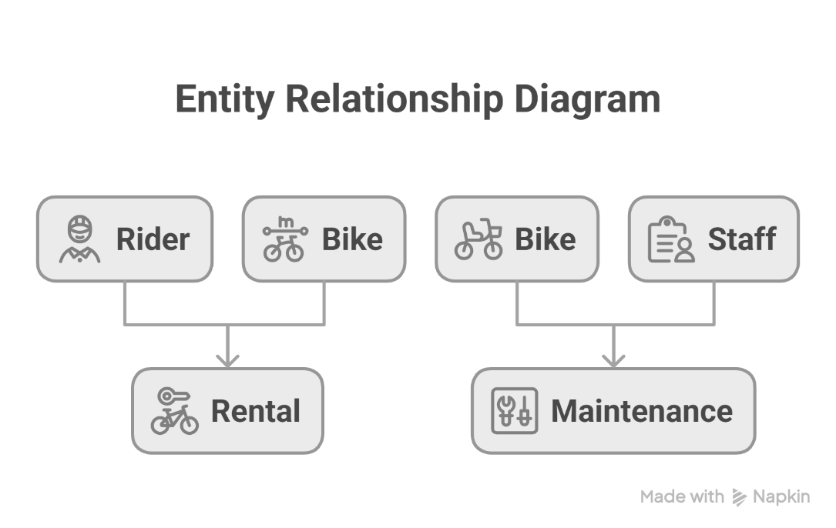
Figure 1: Entity–Relationship Diagram (ERD) for the EcoRide Electric Bike Rental Database System (Source: Created by Self)
Primary keys are used to find each entity unique and foreign keys include referential integrity, which makes all relationships valid and logically consistent. A formal submission would contain a screen shot of an ERD labeled at this point.

3.4 Data Structure Development
This logical information structure is carried out with the help of SQL table definitions which point to the ER model. Every single table contains relevant data types, primary key, and foreign key restrictions to ensure the integrity of the data. The referential constraints ensure that there are no orphan records, like a rental that is associated with a non-existing rider or bike. This is a well-organized implementation that makes sure that the database correctly reflects real-life operations and facilitates the maintenance of trustworthy data (Khang et al., 2022).

3.5 Normalization to Third Normal Form (3NF)
The database design is in total compliance with Third normal form. The atomic values are contained in all attributes, which meet First Normal Form. Meeting Second Normal Form, non-key attributes are completely dependent on the primary key. Lastly, no transitivity dependencies and therefore adherence to Third Normal Form. Such normalization reduces redundancy and storage inefficiencies and enhances data consistency within the system.

4. Sample Data Population
All the table in the database were populated with sample data to illustrate how the EcoRide system would be used in the real environmental conditions of operations. The minimum number of records per table is five, which is sufficient to test the entity relationships, integrity constraints and query performance (Hosen et al., 2024). The sample data consists of several riders with different identification information, a group of electric bikes with different types, conditions, locations and statuses of availabilities, and records of renting that connects riders and bikes at different times. Also, there are maintenance records which record any servicing done by the staff on bikes.
This organized sample data is representative of the real-world situations like bikes that are already occupied by clients, bikes that are present in the various stores, and bikes that are out of use temporarily, due to repair. The system can be tested to be accurate, consistent, and logical by changing the values but keeping control of the various data values (Khang et al., 2022). The fact that the system allows having several rentals of the same bike, as well as several entries of different personnel into the maintenance system, is another indication that the system can handle the recurring transactions across time without duplication and inconsistency of data.

5. The Development and Demonstration of Queries
An example of real-life SQL queries was created to show how the EcoRide database can be used in daily operation and decision-making of the managers. These queries return bikes that are already being used, bikes that are in the maintenance process, rental history of individual bikers, frequency of bike usage and summarise the workload of the staff on the maintenance process. Every query has a different operational need like checking the availability, scheduling a maintenance, or the usage pattern of the system (Guo et al., 2023).
Combined, these queries demonstrate the way the database can convert raw data into information. These outputs enable the management to allocate resources better, minimize downtime, find out which bikes are in demand, and maintain them in time. This is what was able to be generated that demonstrates the efficiency of the relational design and the usefulness of the system other than just simple record storage.

6. Validation and Testing
The database was logically tested to all functional requirements specified under the scenario. The testing performed included insertion of new records, update of existing records and invalid operation to ensure that constraints were imposed accordingly. Foreign key relationships were effective in eliminating orphan records whereas the primary keys ensured uniqueness of records (Lilhore et al., 2022). All functional areas of the system were working correctly and satisfied user and operations requirements, the registration of the riders, bike tracking, rental, maintenance logging, and querying.

7. Design Decisions, Problems and Future Enhancements
The major design choices were the choice of relational database model with the purpose of data integrity, separation of entities with the purpose of normalization, and status fields to provide the opportunity to track the availability of bikes in real time. One of this was the need to balance simplicity and realism without getting too detailed on the data model. In future upgrades, the mobile application integration, bike tracking based on GPS, automated billing system, and role-based access control might be added to improve scalability, security and usability (Guo et al., 2023).

8. Conclusion
This report has provided an elaborate database architecture of the EcoRide electric bike rental plan. The proposed system will substitute the manual processes that are inefficient with a structured and normalized relational database that is able to underpin operational efficiency, proper reporting and expandability in the future. Through this solution, EcoRide would be able to dramatically improve the reliability of the services, the accuracy of the data and the general satisfaction of the user as well as support sustainability goals.

References
Bennett, C., MacArthur, J., Cherry, C.R. and Jones, L.R., 2022. Using e-bike purchase incentive programs to expand the market–North American trends and recommended practices.
Binatti, G., Batalha, Y., de Castro, J. and Oliveira, M.D.S., 2022. Latin american bike sharing ecosystem overview: from data collection to implementation model portraits. Urbe. Revista Brasileira De Gestão Urbana, 14, p.e20210066.
Dunga, S., Oni, O. and Longe, O.M., 2023. Electronic Booking and Payment Platforms for Inter-Campus E-Bikes. Engineering Proceedings, 41(1), p.12.
Guo, Z., Lv, S., Li, J., Luo, X., Ji, Q., Zhang, B., Zhang, H. and Yang, J., 2023, December. Design and Implementation of the Front End for the Transformer State Intelligent Sensing System Based on Ant Design Vue. In 2023 6th International Conference on Electronics and Electrical Engineering Technology (EEET) (pp. 141-146). IEEE.
Hosen, M.S., Islam, R., Naeem, Z., Folorunso, E.O., Chu, T.S., Al Mamun, M.A. and Orunbon, N.O., 2024. Data-driven decision making: Advanced database systems for business intelligence. Nanotechnology Perceptions, 20(3), pp.687-704.
Khang, A., Rani, S. and Sivaraman, A.K. eds., 2022. AI-centric smart city ecosystems: technologies, design and implementation. CRC Press.
Lilhore, U.K., Imoize, A.L., Li, C.T., Simaiya, S., Pani, S.K., Goyal, N., Kumar, A. and Lee, C.C., 2022. Design and implementation of an ML and IoT based adaptive traffic-management system for smart cities. Sensors, 22(8), p.2908.
Machavarapu, P.K. and Ram, S., 2022. Review on public bike share schemes in large developing cities: A case study of Delhi, India. Case studies on transport policy, 10(4), pp.2075-2091.
McVicar, J., Keske, M.A., Daryabeygi‐Khotbehsara, R., Betik, A.C., Parker, L. and Maddison, R., 2022. Systematic review and meta‐analysis evaluating the effects electric bikes have on physiological parameters. Scandinavian Journal of Medicine & Science in Sports, 32(7), pp.1076-1088.
Raposo, M. and Silva, C., 2022. City-level E-bike sharing system impact on final energy consumption and GHG emissions. Energies, 15(18), p.6725.

Appendix
Using the ER model, the following SQL schema is developed:
CREATE TABLE Rider (
RiderID INT PRIMARY KEY,
FullName VARCHAR(100),
Email VARCHAR(100),
Phone VARCHAR(15),
IDNumber VARCHAR(50)
);

CREATE TABLE Bike (
BikeID INT PRIMARY KEY,
BikeType VARCHAR(50),
Condition VARCHAR(30),
CurrentLocation VARCHAR(100),
Status VARCHAR(30)
);

CREATE TABLE Staff (
StaffID INT PRIMARY KEY,
StaffName VARCHAR(100),
Role VARCHAR(50),
ContactNumber VARCHAR(15)
);

CREATE TABLE Rental (
RentalID INT PRIMARY KEY,
RiderID INT,
BikeID INT,
RentalDate DATETIME,
ReturnDate DATETIME,
DurationHours INT,
Cost DECIMAL(8,2),
FOREIGN KEY (RiderID) REFERENCES Rider(RiderID),
FOREIGN KEY (BikeID) REFERENCES Bike(BikeID)
);

CREATE TABLE Maintenance (
MaintenanceID INT PRIMARY KEY,
BikeID INT,
StaffID INT,
ServiceDate DATE,
ServiceType VARCHAR(50),
Notes TEXT,
FOREIGN KEY (BikeID) REFERENCES Bike(BikeID),
FOREIGN KEY (StaffID) REFERENCES Staff(StaffID)
);

